**Reading Gender and Genre from a Distance:**

**Detangling Binaries in the Eighteenth-Century Gothic**

*Introduction*

Literary discussions of gender at the birth of the Gothic novel in the late eighteenth century have grown ever more nuanced and attentive to detail over the years. At its inception and for a long time after, the genre as a whole was often dismissed as unserious due to its perceived alignment with women. In the 1980s, feminist critics such as Juliann Fleenor enabled the Female Gothic, defined as Gothic writing “written and consistently read by women” (*The Female Gothic* 7), to stand as a worthy subject of inquiry regardless of literary status due to its direct relation to a patriarchal paradigm and its ability to “to express the conflict for which patriarchy has no name” (28). Contemporary critics, such as those collected in Diana Wallace and Andrew Smith’s *Female Gothic: New Directions*, have moved from social relationships to intertextual ones, as exemplified in Robert Miles’s complex reading of Ann Radcliffe and Matthew Lewis’s works as making use of both Female and Male Gothic “narrative grammar” (56). However, to accomplish this more sophisticated approach, scholars have of necessity focused in greater detail on smaller numbers of texts. My goal, in applying a large-scale digital methodology to the field of the early Gothic, is not to duplicate the research on individual novels carried out by other scholars, but to open up new ways of understanding the relationships within the broader body of texts. Throughout my essay, I touch upon the implications my findings might have for the way we understand Ann Radcliffe’s works, but my primary interest in is the ‘school of Radcliffe’ itself. This ‘school’ was, evidently, readily identifiable to Radcliffe’s contemporaries, but I argue that its identifying features are not entirely those which seem most notable to modern critics. Over the course of two large-scale literary ‘experiments,’ in which I model the early Gothic novel by means of bibliographic data, I have asked what schools, if any, make themselves apparent, and whether there is cause to believe that the hundreds of women writing Gothic novels wrote observably different books than the hundreds of men doing the same. My preliminary results suggest that male and female schools do indeed exist, but that they do not map neatly to a female/male terror/horror Radcliffe/Lewis binary, and that both gendered schools are dwarfed by a non-gendered Gothic mainstream.

My interest in placing Radcliffe back into the broadest possible context is in keeping with the voracious habits of her readers. Although Radcliffe was, by the time she published *The Mysteries of Udolpho*, widely recognized as a master of her craft, she was not canonized separately from other Gothic writers either on the shelves of the circulating libraries or in the minds of book reviewers the way that ‘literary fiction’ is separated from ‘romance novels’ today. This readerly voraciousness is particularly important in light of John Frow’s articulation of genre as, not a stable set of categories, but an ongoing conversation. Individual texts, Frow argues, “do not ‘belong’ to genres but are, rather, uses of them” (2), framing genre not as a singular stable identifier for a novel but as a set of expectations that an author may strategically fulfill or foil. Genres thus function by being a bridge between the “social situation” of a reader embedded in real and literary contexts, and a text that “realises certain features of this situation, or which responds strategically to its demands” (14). Rather than reading genre simply to categorize “where a text ‘belongs,’” Frow argues, “we read… for those layers of background knowledges that texts evoke” through their genre relationships, which allow an assessment of “which types of meaning are appropriate and relevant,” and therefore how the text can be made to make sense (101). Accordingly, any investigation of Radcliffe’s use of genre must begin with an understanding of what she’s using.

To take the first steps toward that understanding, I have created and carefully examined visualizations of metadata regarding 208 early Gothic texts. My data derives from Ann Tracy’s bibliography *The Gothic Novel 1790-1830: Plot Summaries and Index to Motifs* and Frederick Frank’s *The First Gothics: A Critical Guide to the English Gothic Novel*; my experimental method is informed by Willard McCarty’s “Knowing: Modeling in Literary Studies” and by Lisa Samuels and Jerome McGann’s “Deformance and Interpretation.” After carrying out a wide range of experiments, I have selected two of the most fruitful to discuss in depth: I have charted the gendered use of 70 Gothic ‘motifs’ identified by Tracy, and explored Frank’s classifications of the same novels’ various ‘Gothic types’.[1] Although I will be able to see in less detail, I will see more broadly: my goal is not to examine Radcliffe herself, but to seek out the ‘school of Radcliffe.’

*Critical Frameworks*

In determining my approach, I draw upon McCarty’s framework of the strengths and limits of “modeling,” with influence from Samuels and McGann’s discussion of “deformance,” to allow for models which are sensitive to certain distinctions but not to others. McCarty, in proposing language to discuss literary models and their epistemological implications, elaborates upon a distinction made by Clifford Geertz between models “of” something and models “for” something (n. pag.). Blueprints *of* historical buildings, for example, allow inquiry into the details of something that already exists, whereas blueprints *for* new buildings allow architectural ideas to be explored before they are brought into reality; both ways of modeling “comprise a practical means of playing out the consequences of an idea in the real world” (McCarty), from two different directions. My several attempts to model the Gothic novel, as a genre experienced by its popular readership in the late eighteenth century, are certainly models *of* that genre. As such, their merit at first seems most appropriately evaluated in terms of their compliance with the “fundamental principle” of modeling-of, namely, the “exact correspondence between model and object with respect to the webs of relationships among the selected elements in each” (McCarty). By this principle, my essay ought to focus on those preliminary models which retained the most detail about the texts in question: Tracy’s plot summaries, for example, or even a much-smaller corpus containing full texts of famous Gothics. However, as McCarty ultimately concludes, “modeling is pragmatic” (McCarty); immediately after defining the “fundamental principle” of “exact correspondence,” McCarty describes two reasons it may be violated: when exact correspondence is impossible for practical reasons, and when it has been intentionally distorted in order to study the effects of those distortions.

Exact correspondence is, of course, never a practical option; if there have been no adjustments of scale or materials, the object of study is no longer a model at all, but the thing itself. Tautologically, models are only needed when the thing itself is in some way unsuitable for study— too big, too complicated, or no longer in complete existence— and so models are always ultimately “fictional” (McCarty). Because these fictions have been created with particular goals in mind—because, McCarty says, “modeling is pragmatic”—he argues that “the worth of a model must be judged by its fruitfulness” (McCarty). Stephen Ramsay’s “Algorithmic Criticism” provides a metric for evaluating that fruitfulness: “the robustness of the discussion that a particular procedure annunciates” (Ramsay). This seems to be what McCarty implicitly means when he terms something “fruitful”: whether or not the model has revealed what we expected, it has revealed something with which we must now engage. Exact correspondence is thus less of a “fundamental principle” (McCarty), and more of an imagined destination that spurs valuable journeys. As a model is constructed, it becomes sensitive to some areas of difference while eliding others. Models need not be perfectly accurate, only sensitive to the desired area of difference.

McCarty also describes models which are not merely partial in some particular set of details, but which “deliberately” diverge from their source “in order to study the consequences” of the changes. McCarty terms these intentional manipulations “distortion,” but Lisa Samuels and Jerome McGann might call them “deformance.” I take this term from their essay “Deformance and Interpretation,” which seeks to untangle the mechanics of interpretation as a critical act, and the ways in which interpretation distorts artistic works in service of its own performative operations.[2] Whether the final interpreted meaning is “resident ‘in’ the work, or evoked through ‘reader-response,’ or deconstructable” — whichever framework is used for the method of “reading along thematic lines” — the method itself, they argue, is neither transparent nor the only option (26). Although “criticism… tends to imagine itself as an informative rather than a deformative activity,” both scholarly editions and translations of texts take critical interpretations and write them onto the texts themselves (33). Similarly, “heretical and… nonnormative readings of established cultural artifacts” (35), typically undertaken in service of a particular point, constitute deformation. Placing themselves in this tradition, Samuels and McGann apply several deformative interpretive approaches to the poetry of Wallace Stevens. Each deformation is a procedure for rewriting a poem — reordering its lines from last to first, or deleting all the words but the nouns or the verbs — which spurs a new interpretation of the new version of the text. The key advantage of these deformations is a fruitful defamiliarization of the object of study: the procedure “reinstalls the text — any text, prose or verse — as a performative event, a made thing” (30) by rendering the mechanics of its creation salient. When readers cannot ignore the critic’s act of re-writing, we are implicitly asked to engage again with the author’s earlier act of writing. This defamiliarization allows us to “imagine things about the text that we did not and perhaps could not otherwise know” (36), because we have been re-sensitized to new details of the work.

It is through this new sensitivity that Samuels and McGann begin to echo McCarty. The two essays at first seem to be concerned with very different approaches, but they converge by way of Leah Price. In *The Anthology and the Rise of the Novel*, Price draws attention to the ways in which all reading, and particularly all scholarly writing, must involve a constant re-editing of texts, influenced by memory and argument. In keeping with Samuels and McGann’s classification of “[e]laborate scholarly editions” (33) as deformative criticism, Price argues that any edited text — ‘elaborate’ or not — produces, not a flawed or distorted copy of the original, but a new text. The process of editing a text must always reveal the editor’s “unspoken assumptions about the most efficient way to convey information, and indeed what counts as information at all” (13), and thus gives us a new thing to examine. As Price observes, when scholars examine texts— when we take notes on them, extract quotes for close reading, summarize or categorize scenes, chapters, or books— our act of reading is also one of editing. McCarty allows us to recognize that this mental editing is not a sign of scholarly weakness, but a model, made necessary by the limits of human memory. Price’s project is more interested in the literal anthologizing undertaken by publishers than in the mental anthologizing implicit in the scholarly act of thinking about several books at once; her ultimate argument is about the works of George Eliot, not about the methodology of literary criticism. Nonetheless, her observations, once anthologized in abridged form alongside digital humanities thinkers, allows us to ‘bare the devices’ of literary criticism itself.

My own modeling framework is informed by all of these. My key ideas are sensitivity in data selection, and procedurality in visual representation. My two ‘texts’ – Tracy’s and Frank’s bibliographies – are themselves two very different deformative models of ‘The Gothic Novel,’ and each render different distinctions more or less salient. When forming my research questions, I begin by asking what a given source of information allows me to be sensitive to. Tracy’s motifs emphasize events and singular images, with each detail systematically tallied. In contrast, Frank’s Gothic types emphasize a work’s overall tone, and his evaluations are at times maddeningly qualitative and subtle. The two are thus able to usefully complement each other. As I work with these texts, I dwell upon procedure as a way to meditate upon the implications of earlier critics’ frameworks. Because I must iterate all of my decisions at least 178 times when I decide to include a new axis of distinction in my spreadsheet, much of my ‘research’ has been developing procedures that work *with* each model, deforming books into spreadsheets and then into images in ways that will render their implicit models explicit and obvious. Rather than visualizing data, then, my goal has been to grasp models. The procedure of graphing each bibliography amplifies Tracy’s and Frank’s choices, allowing me to see whether their distinctions are fruitful, and whether their results accord with our expectations.

*Ann Tracy’s Motifs*

I began with the ten-page ‘Index to Motifs’ included at the end of Ann Tracy’s bibliography. Tracy uses the term “motif” broadly to encompass a wide range of plot elements, images, and character types. This index is clearly built for a different kind of scholarly use than that which I have made of it; its intended audience is “scholars with particular interests” (195), who wish to locate new books to close-read that contain difficult-to-find individual story elements, such as “doppelganger” (198) or “garden as a scene of temptation” (200). Accordingly, Tracy has prioritized presenting a wide range of distinctive individual motifs rather than those that constitute the norm. Indeed, her preface to the index indicates that highly popular motifs were intentionally excluded: “the abundance of murders,” she says, “argued for the retention… of specialized murders only” (195), and castles have similarly been ignored. Tracy’s model of the Gothic is sensitive to uniqueness. It treats each individual novel as a collection of discrete elements, only one of which is likely to be of interest to a given scholar. The information presented alongside each novel’s bibliographic entry, by which critics are meant to determine whether they want to read the book, is a plot summary. Her summaries point out distinctive details, such as “a particularly interesting Satan, with molten insides” (74). The bare facts of the plot are thus treated as the primary site of interesting investigation. The motifs themselves — Satans, murders, doppelgangers, gardens — thus become the stable objects of study, which may or may not become visible in individual texts. Intertextual and chronological relationships are minimized in favor of crystallizing motifs. In Tracy’s model of the Gothic, the Gothic is defined by free-floating concepts, which must be examined through the filter of individual novels.

My own adaptation of Tracy’s bibliography accepts this model and elaborates on it. Tracy is always pointing outward to the books themselves, but I have foregrounded the motifs. I turn my attention to those motifs prevalent enough that their multiple appearances constitute an object worthy of study. Due to Tracy’s interest in uniqueness, 138 of the 208 motifs indexed appear in fewer than 20 novels, and have thus been excluded from my study. This leaves me with 70 motifs, which form the foundation of my experiments. Tracy’s Boolean treatment of these motifs has already elided many details; in her index, a motif either exists in a work or it does not, with no attention paid even in the detailed summaries as to how the motif is presented or the importance of its presence. The description of a character as ‘a parricide’ in *Melmoth the Wanderer*, for example, is sufficient to have that work indexed under “parricide” (Tracy 202), placing it on equal footing as novels in which the murder of a father is directly depicted. In many cases, I have further distilled each motif to its simplest case by ignoring the detailed sub-categories which Tracy sometimes provides. “Poison,” for example, is indexed with categories for “blade,” “chaplet,” “kiss,” “letter,” “orange,” “plant on grave,” and “sacrificial wine” (203), but I have elided these nuances in favor of a broader category of “poison (all subcategories).”[3] This new motif applies to 30 novels, a large enough group that it becomes possible to look for patterns within it. This description of my methods emphasizes places where differences between books have been intentionally reduced. However, these elisions do not result in a loss of overall meaning. Instead, I deform her index to produce a model of the Gothic that is sensitive to which particular elements of the ‘Gothic toolkit’ authors are more likely to use. My deformed version of Tracy’s index is now far less useful for locating outlier texts for closer reading, but sensitivity to one thing is traded for sensitivity to another. The various motifs – which Tracy implicitly treats as key to our understanding of the Gothic, but buried within various texts – are now exposed for explicit individual investigation.

Influenced by Joanna Drucker’s warnings that data visualizations too easily give the impression of a quantitative and objective truth which cannot exist, particularly in the humanities (“Humanities Approaches to Graphical Display”), I have made my graphic design decisions 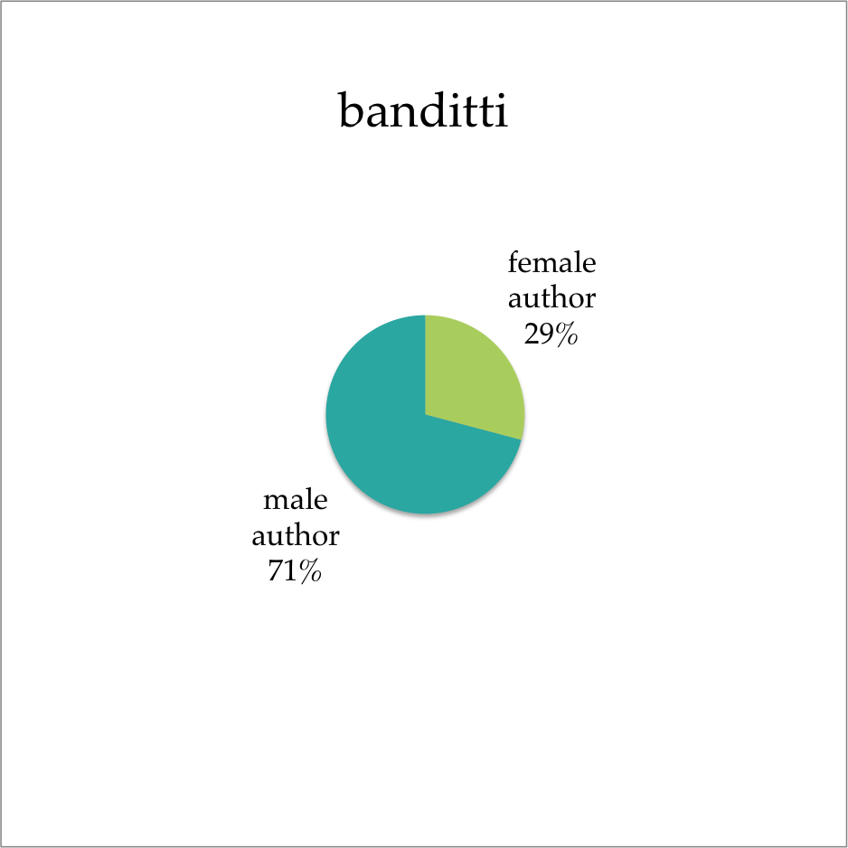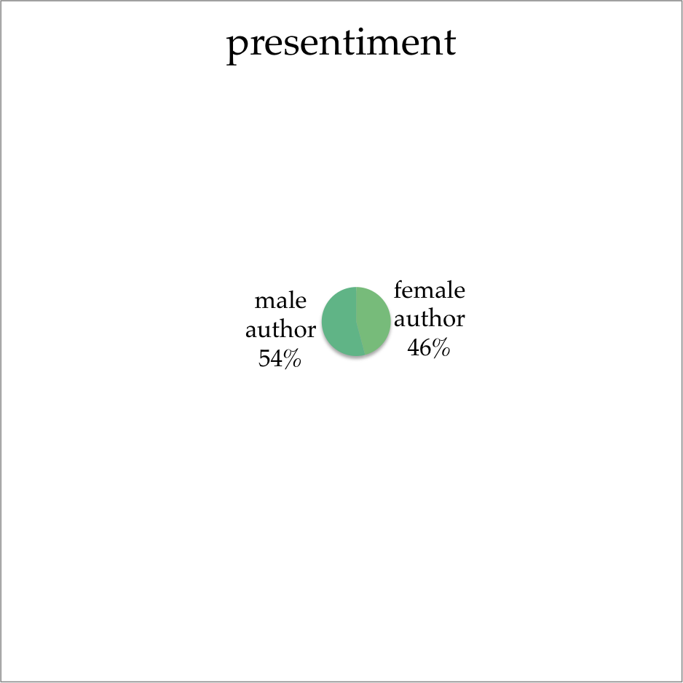procedurally generated. The goal is for the visual presentation of each chart to qualitatively indicate relationships, and thus make them a fruitful body for interpretive readings. I chose pie charts, one per motif, to visually represent Tracy’s treatment of each motif as a self-contained field which may or may not have distinct divisions within it. The size of each circle reflects the prevalence of the motif within the body of indexed novels as whole. More subtly, the difference between the two colors in each chart reflects the difference between the two percentages. I wished to avoid graphs whose labels said that a motif featured a 50/50 split, but whose starkly-contrasted colours nonetheless implied that books by male versus female authors could be easily distinguished from each other. Instead, I wanted my reader's ease in distinguishing between male and female authors to be directly connected to the ease with which a reader in the 1790s might have been able to accomplish the same task if given only the information that a certain motif was present. Accordingly, if the motif itself is not useful as a tool to distinguish between two gendered camps, its chart doesn’t show two camps. All these design choices further emphasize my model’s sensitivity to each motif’s gendered use. Each chart is able to immediately provide an answer to the question, “does knowing that this motif appears in a book tell me anything about the likely gender of that book’s author?”

**Figure 86**: gendered authorship of books containing Italian bandits.

**Figure 35**: gendered authorship of books containing presentiments about the future.

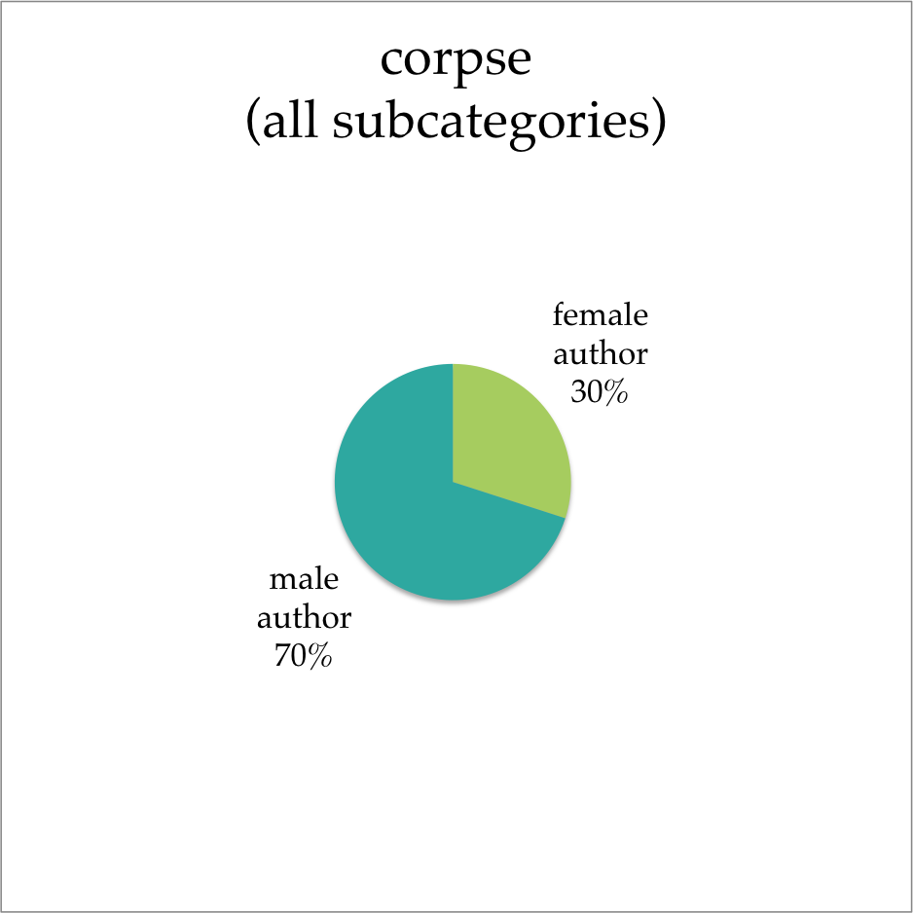And indeed, an identifiable gendered school does emerge at a glance: 38 distinctly male-authored motifs[4] indicate male dominance of largely the things we would expect men to dominate. Reading the motifs in order from ‘most female-dominated’ to ‘most male-dominated,’ as they are arranged in the index, involves a constant escalation. Women may write about libertines (fig. 1), whose ‘seductions’ may be coercive and almost always end poorly for their victims, but men write about the act of rape itself (fig. 91). These motifs suggest that the darkest side of the Gothic was primarily the province of men: death is female-dominated when it is sad or pious (fig. 3), but murder is male-dominated (fig. 73), as are blood (fig. 81), corpses (fig. 84), and skeletons and skulls (fig. 88). When male authors dwell upon death, then, it seems that they dwell not on its emotional impact, but on its more vivid physical results. Similarly, human sacrifice (fig. 72), putrefaction (fig. 90), starvation (fig. 78), and torture (fig. 79) all involve directly depicting that which other novels might merely imply.

**Figure 84**: gendered authorship of books containing corpses (in bed; behind curtain; bleeding; blue; burnt; changing places with; disguised; dragged past heroine’s dungeon; as entertainment for villainess; equestrian; under floorboards; hanging; mangled; naked; physical contact with fresh; physical contact with moldering; plural, in piles; preserved; produced as evidence in trial; in sack; of seduced woman, provoking hysteria in seducer; shut in with; stumbling over; talking; thrown over precipice; in trunk; walking; or waxen representation of).

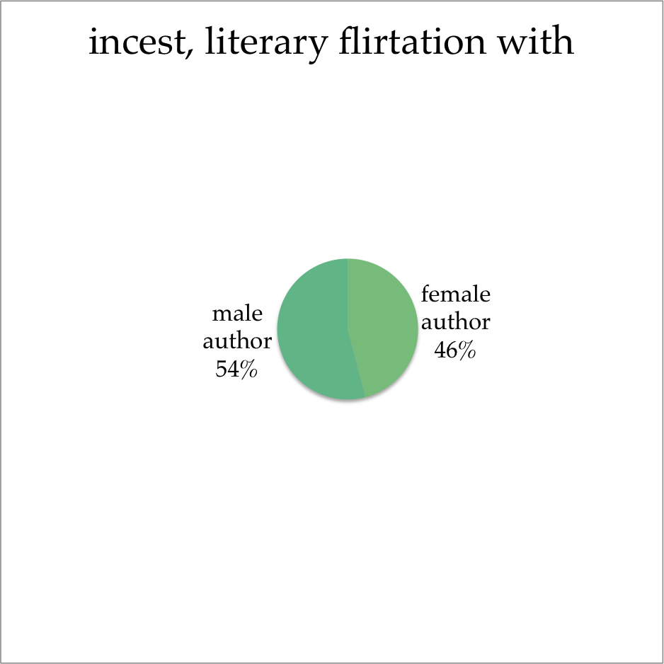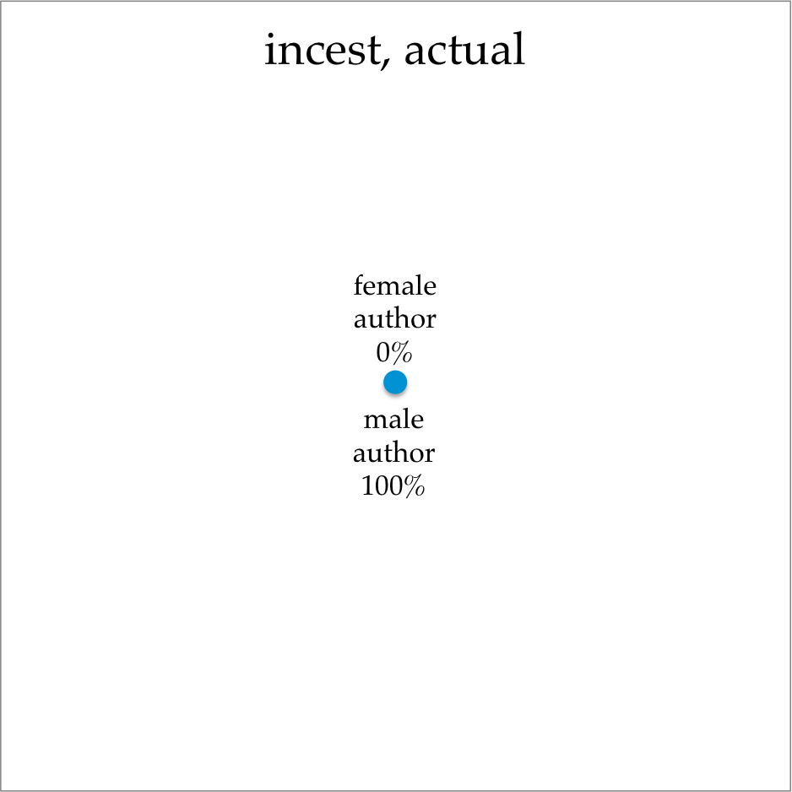The masculine impulse to 'go farther,' to replace coy allusions with unflinching enactments, is most evident in my sample novels' treatment of incest. General themes of incest are widespread, appearing in 51 of the 208 novels under consideration-- nearly a quarter of the works. However, in 45 of those novels, there are no cases of what Tracy terms "actual" incest, only "incest, literary flirtation with (including false alarms, foiled attempts, threats, and unconsummated incestuous passion)." This kind of narrative discretion is employed roughly equally by both male and female authors, and makes up the vast majority of all depictions of incest. However, six cases of actual, no-narrative-flinching incest are documented— and all six are by men. To force one's readers to look directly at the horrors depicted, rather than allowing them to become terrified by their own imaginations, is, of course, the technique of the horror-Gothic, as contrasted with the terror-Gothic. Identifying the horror-Gothic as a predominantly male affair comes as no surprise, and accords nicely with the critical tradition of identifying Lewis as the quintessential horror-Gothic writer.

**Figure 94**: gendered authorship of books containing actual incest.

**Figure 33**: gendered authorship of books containing literary flirtation with incest, which includes false alarms, foiled attempts, threats, and unconsummated incestuous passion.

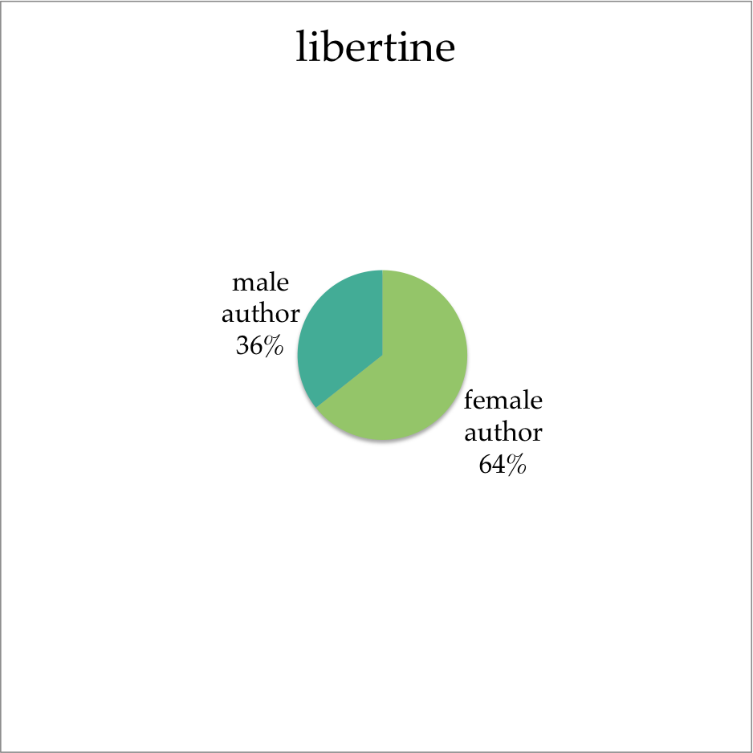In contrast to the wild abundance of male tropes, in my model of the genre, the ‘Female Gothic’ is defined by only four things: libertines (fig. 1), forced weddings (fig. 2), sad or pious deaths (fig. 3), and miniature portraits (fig. 4).[5] The libertines and miniature portraits in particular, as the most common female motifs, immediately suggest a new Female Gothic more like the novels of Jane Austen, whose ordered and rational novels are nonetheless replete with rakes and miniatures. However, the paucity of female motifs also suggests that this immediate response may be too hasty: the Female Gothic is outnumbered not just by the Male Gothic but also by the Everybody Gothic. More than half of the 94 motifs are not strongly gendered. Four — elopement (all subcategories) (fig. 21); dueling and other single combat (fig. 22); fainting, female (fig. 23); and rediscovery of lost relatives (fig. 24) — are even perfect ties. Moreover, the more popular a motif is— i.e., the larger a role it plays in making up the genre— the more likely it is to be non-gendered. In terms of sheer prevalence, the defining features of the Gothic as a genre appear to be fainting (fig. 26), confinement (fig. 38), abduction (fig. 30), storms (fig. 43), and references to suicide (fig. 62). Only one of those five charts (suicide, which is 61% male-authored) shows a gendered divide.

**Figure 1**: gendered authorship of books containing male characters who habitually seduce women.

These results serve as a useful reminder that not all contrasts are necessarily perfect binaries. Indeed, all of the strongly male-dominated motifs are much less common than the more neutral motifs. This model suggests that, rather than a balanced opposition of Radcliffe’s female terror Gothic vs Lewis’s male horror Gothic, the genre as a popular movement was defined by a less-sensationalist (possibly Radcliffean, possibly terror-mode) non-gendered Gothic mainstream, with a subset of male horror Gothic writers making up a minor tradition within it. The existence of a Male Gothic tradition does not require that everything outside that tradition be a 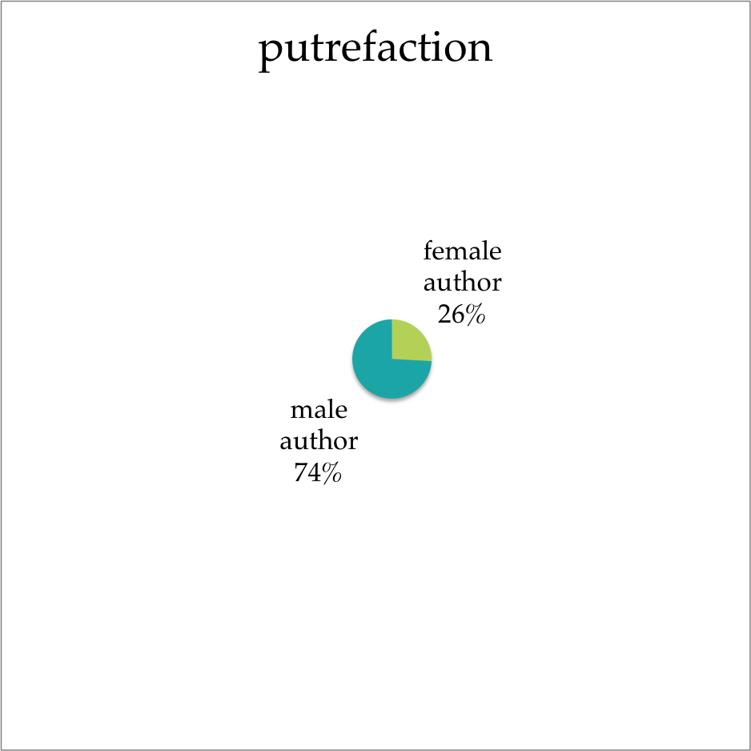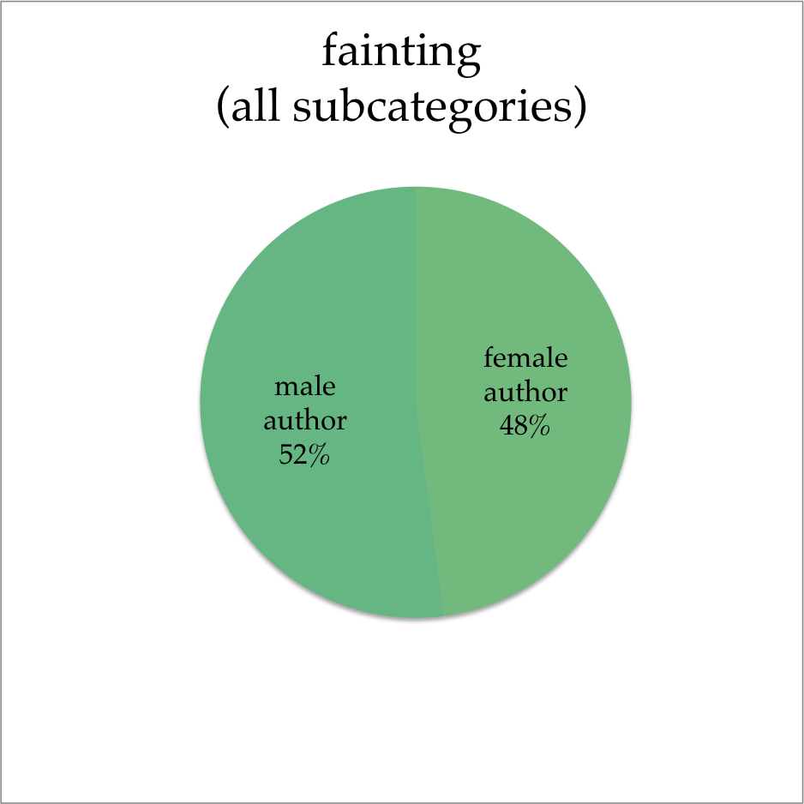perfectly-opposed Female Gothic.

**Figure 26**: gendered authorship of books containing fainting (female or male).

**Figure 90:** gendered authorship of books containing putrefaction.

*Frederick Frank’s Gothic Types*

In order to better define that Gothic mainstream, I turned to a second bibliography, which classified novels by their ‘Gothic type’; here, too, the unbalanced nature of our attempted binary becomes obvious. Frank’s “types” are, like Tracy’s “motifs,” clearly intended for a different sort of scholarly use than my own quantification: for the 178 texts indexed by both authors, Frank provides 131 unique classifications. Many of these are “unique” primarily from the point of view of a spreadsheet: “Domestic fiction (various Gothic elements)” and “Domestic fiction (intermittent Gothic elements),” for example, are distinguished only by a slight gradation of degree. Whereas Tracy treated her motifs as independent and stable, Frank is not interested in his Gothic types in and of themselves. Similarly, his “Critical Synopsis” of each text is not interested in recapitulating the details of the novels’ events. Instead, each synopsis describes the origins of any literary borrowings, briefly discusses the plot in terms of its structural tropes, and places the work’s attitude into a broader context.

The two bibliographies’ treatments of Grenville Fletcher’s *Rosalviva, Or, The Demon Dwarf*, for example, serves as a useful illustration of their differences. Tracy’s summary is a litany of events: it begins matter-of-factly with the sentence “Leontini loves Viola di Morini, but she marries someone else,” and is equally unfazed when the titular dwarf arrives in the third act and when the dwarven appearance turns out to be false (51). Frank, in contrast, spends more than half his words on context, as in his first sentence:

“From Rumplestilskin in the fairytale to the comic evil of Dickens’s Daniel Quilp in The Old Curiosity Shop (1841), the figure of the dwarf was often called upon to perform such demonic services as vengeance, prophecy, child possession, and transformation.” (107)

To this broad literary history he adds Mary Shelley’s story “Transformation” as potential precursor for the disguise in Fletcher’s novel, and includes several assessments of the Gothic’s particular embellishments of “the dwarf as a resolver of dilemmas of identity” (107) and “dwarfs… spin[ning] webs of murderous intrigue for diabolic ladies” (108). All of these details stand in stark contrast to Tracy’s list of seven novels under the index entry “dwarf” (199), which treats the sinister disguise in *Rosalviva* as interchangeable with depictions of non-supernatural and even non-evil little people. Unlike Tracy, then, Frank is interested not simply in what happens, but in *how* it happens. His object of study is not the plot elements used, but the text as a whole and the connections between it and its most closely related texts. His Gothic type for Sophia Lee’s *The Recess*, for example, describes the novels as “Gothified history (terror and sentimental elements)” (204), tying it simultaneously to the “Gothified history” of William Godwin’s *St. Leon*, the “terror mode” of Radcliffe’s novels, and the “sentimental Gothic” of Charlotte Dacre’s *The Libertine* and *The Passions.* These threads cannot be traced systematically — no helpful index like Tracy’s attempts to collect them. Instead, his Gothic types model the Gothic as a shifting history, with each novel as the temporary centre of influences stretching both forward and backward in time.

Just as I had to work against the grain of Tracy’s preference for uniqueness and difference in order to seek connections and correlations between motifs, so too have I worked against the grain of Frank’s model, this time in the reverse direction: I have sought to separate out each strand, to treat it as a category existing beyond the texts it applies to, so that I can examine each one individually. Rather than trying to define a single “Gothic type” for each work, I divided each “Gothic type” into a set of tags,[6] and tallied the use of each tag the same way I tallied Tracy’s motifs. The novel *A Suffolk Tal*e, for example, listed in Frank as “Domestic fiction (various Gothic elements)” (315), was tagged as “domestic” and “Gothic elements.” Similarly, Radcliffe’s *Italian*, listed as “Pure or high Gothic (terror and horror modes)” (302), tagged as “high,” “Gothic,” “terror mode,” “horror mode,” and “Radcliffean.” This process generated 45 tags, most of which had only one or two novels within them. By allowing each individual phrase of Frank’s Gothic types to become its own tag, I allowed the most important categories— and their relationships— to emerge with as little critical intervention as possible. My further analysis of gender followed the same principles as my analysis of Tracy’s motifs: each chart was built to answer the question, “does knowing that this tag is associated with a book tell me anything about the likely gender of that book’s author?” Because Frank’s classifications are subjective attempts to assess the overall tone of a work in context, rather than Boolean checklist items, an answer of “yes” to this question no longer tells us “this motif is a useful predictor of gender,” but rather indicates “the critical identification of this genre tag is responding to a gendered usage.”

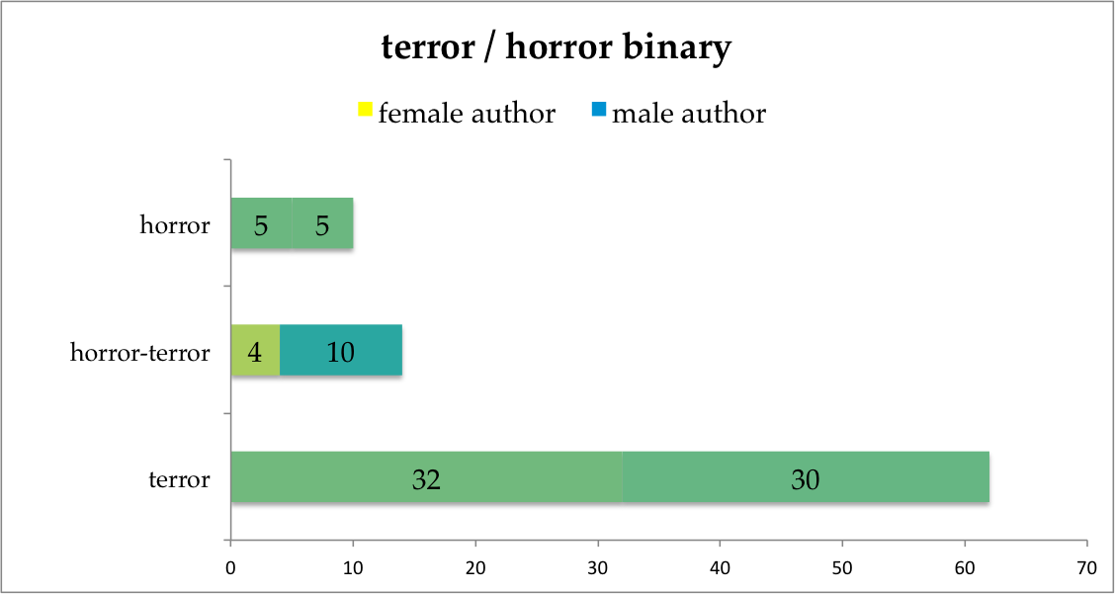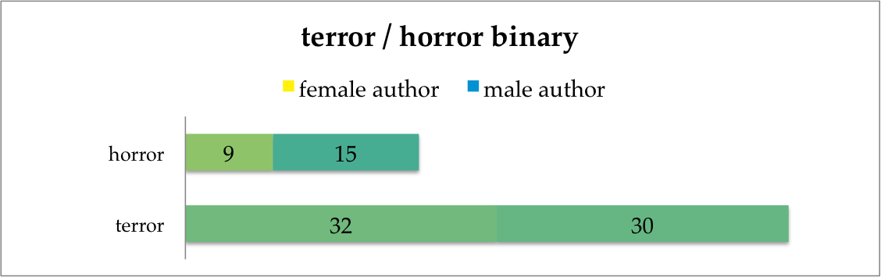My graphic design choices, as I sought to render each chart legible in terms of this driving question, followed similar principles as my motif chart designs, particularly the use of colour contrast to indicate gendered difference.[7] The first thing these design choices make apparent is the unbalanced nature of the terror/horror binary, in keeping with my observations of Tracy’s motifs. The terror mode enormously outnumbers the horror mode, with 62 novels (35% of the sample) tagged “terror” and only 24 (13%) tagged “horror”. The more-popular terror mode is completely non-gendered, while the horror mode tends toward male authorship (62% male). However, of those 24 novels tagged as horror, 14 were also tagged as terror, leaving a mere 10 books as pure “horror mode.” If we attempt to treat the two modes as mutually-exclusive, separating out the “horror-terror” mixed-modes books from the rest, our gendered expectations fall apart: the 10 pure-horror books are precisely split between male and female authors, and it is the horror-terror mode which is most predictive of male authorship. It seems, then, that although the relative popularity of the two schools accords with our expectations based on Tracy, our critical identification of terror and horror does not have a basis in gendered patterns of use.

**Figure 97**: Gendered authorship of horror and terror, this time treating horror and terror as mutually exclusive. The fourteen books described as operating in both modes are no longer counted twice, but instead form a new category.

**Figure 96**: Gendered authorship of horror and terror, when the two modes are not treated as mutually exclusive.

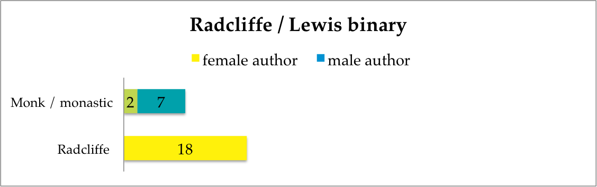And yet, it seems that the Radcliffean novel, as a category, *does* bear scrutiny as a gendered tradition. Frank identifies twelve novels as explicit imitations of Radcliffe; the “Radcliffe” tag includes those twelve, and Radcliffe’s own six novels — and every book included is by a woman. Radcliffe’s opposite in this binary is the “*Monk* / monastic” tag; no works were identified as imitations of Lewis himself, but nine (including *The Monk* itself) are identified as an imitation of *The Monk*, a “monastic shocker,” or both. Of these nine, seven are by men. The ‘school of Radcliffe’ does thus appear to be a female-dominated school which stands in contrast to a smaller, less-distinct but male-dominated ‘school of Lewis’ — which raises the question of why neither Tracy’s motifs nor Frank’s horror and terror Gothic types showed evidence of these schools.

**Figure 98**: Gendered authorship of works identified as Radcliffean and those either imitating *The Monk* or identified as monastic shockers.

An answer is suggested by a broader look at the tags beyond horror and terror which appear most often in Frank’s Gothic types. Mingled in with our Radcliffean and Monk-ian novels are all kinds of schools not generally accorded particular importance for the field as a whole; the eleven tags which correspond to at least nine novels and their respective prevalence are, from most popular to least popular, as follows: “high Gothic” (63); “terror” (62); “history” (29); “domestic” (27); “horror” (24); “sentimental” (24); “Radcliffe” (18); “chapbook” (17); “naturalized,” which refers to “natural Gothic,” “documentary Gothic,” and “explained supernatural” novels which consist of entirely explained or non-supernatural elements, including those based on authentic contemporary murders (11); “Schauerromantik” (10); and “*Monk* imitation / monastic shocker” (9). This variety of ‘types’ suggests a different picture of the main threads of the Gothic, which doesn’t function via binaries at all, and remains mainly non-gendered. However, the bright yellow rectangles of ‘Radcliffe’ and ‘sentimental’ together suggest that the problem, while hunting for the Female Gothic among Tracy’s motifs, was not a lack of a female-dominated tradition — the problem was the method. The particular deformation of the motif-charts allowed my model to be sensitive only to certain types of information, but the gendered trend suggested by Frank’s gothic types is not defined by individual plot-devices like skulls and incest. Instead, the emerging ‘school of Radcliffe’ suggested here is deeply tied to the sentimental novel.

To be precise about the nature of this connection, I made several pivot tables along the same principles of predictive utility that structured my examination of Tracy’s motifs. Approaching from one direction, 50% of Radcliffean novels are also high gothic. If you know a book is Radcliffean, you know it is probably high Gothic, terror mode, and sentimental, in that order. Approaching from the other direction, 25% of sentimental novels are also Radcliffean. Gothic types which are likely to include Radcliffean novels are sentimental, naturalized or explained, and high Gothic, in that order. This particular picture of the Female Gothic may explain the comparison of *Udolpho* to Inchbald’s *A Simple Story* which so puzzled Clara McIntyre in *Ann Radcliff in Relation to Her Time*. In response to a review which declared Udolpho to be “the best composition of this kind since Mrs. Inchbald’s *Simple Story,*” McIntyre is taken aback by the expression “of this kind” (94). She says, “The reviewer must surely be thinking of fiction in general, for, except that they are both fiction, two compositions could hardly be more unlike than *The Mysteries of Udolpho* and *A Simple Story*” (94). McIntyre begins to draw a connection based on “the ethical purpose of the book,” which in Inchbald is “rather too obvious for successful art,” but decides that although Radcliffe’s writing “it is true, was strictly moral,” Radcliffe’s “main interest” does not lie in moralizing, and *Udolpho*’s project is along a different line. However, McIntyre overlooks the importance of moral sentiment.

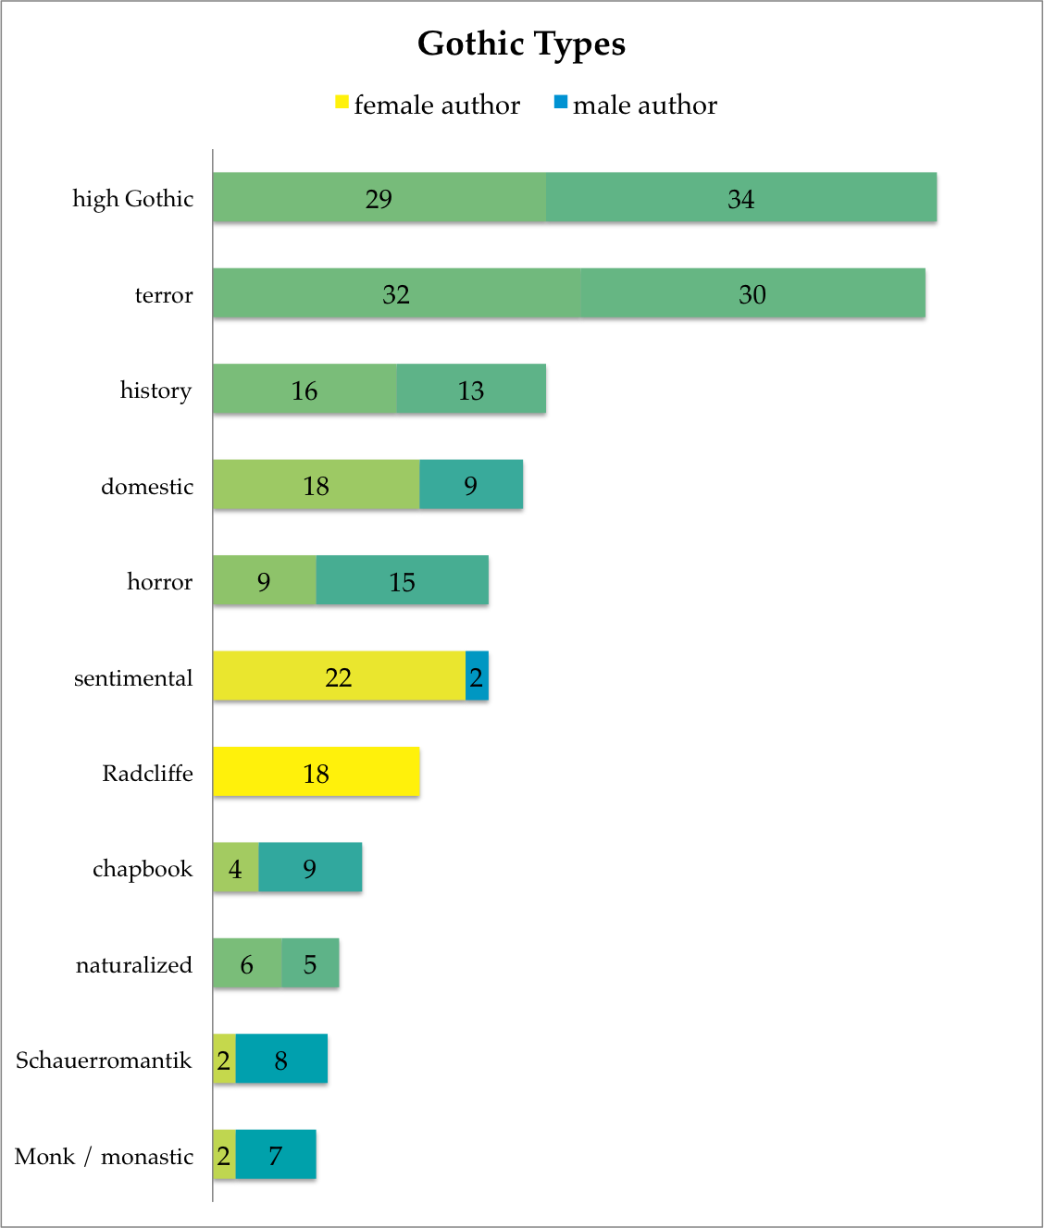

*The Sentimental Novel*

My results here suggest a call back to an older school of criticism, which saw French sentimental novels— rather than German horror stories— as the forbears of the Gothic. Ernest Baker, for example, argues that “[t]he sources of Gothic romance… are to be sought in the popular variant of the fiction of sensibility evolved by the Abbé Prévost and elaborated later on by Baculard d’Arnaud. The exciting adventures, the violent emotions, the gloomy scenes, forests, and antres, castles, dungeons, and graveyards, in the abbé’s novels and the plays and stories of Baculard, were to be the distinctive features of Gothic romance throughout its course. It was all a derivative of the cult of emotion” (175). In this history of the genre, German influences are superficial set-dressing rather than inherent to the genre: “Some novelists sought only to conjure up a witching atmosphere of awe and vague apprehension; others employed the most violent shocks of physical anguish and fear. They all dabbled in the supernatural, either playing upon or playing with feelings of superstition; and, later on, those who had become acquainted with German folk-lore and its ghosts and elves and goblins found their account in satiating the greediest appetites for crime, diabolism, and nameless horrors” (Baker 176). Even the supernatural is relevant primarily because it allows authors to manipulate readers’ “feelings of superstition” in service of varying gradations of fear. What Baker is sensitive to is the emotional content.

Emotional response is salient as a distinguishing factor because Baker, like many of his contemporaries, writes from the teleological assumption that the history of the novel must be the history of the *realist* novel. Baker’s approach to the Gothic is not so obviously mediated as Tracy’s or Frank’s; as we would expect, Baker makes no explicitly deformative moves, but proceeds by discussing to the texts themselves in their entirety. However, as Leah Price observes, it is impossible for human memory to hold an entire novel at once, let alone the whole history of the novel. Baker, like any scholar, must mentally abridge the novels as he writes about them, and his abridgements take for granted the idea that the ‘goal’ of the novel itself is to become realist. Because Baker’s criticism does not “[bare] its devices” (Samuels and McGann 49), his assumptions remain implicit in the moralizing judgments throughout his work. Baker’s excoriation of “that amoral person [Laurence] Sterne” for being a “debauched sentimentalist” who “fondled his sensibility,” “aware of his vice, and voluptuously enjoying all its sweetness” (95), for example, evaluates *Tristram Shandy* along markedly different lines than would now be considered fruitful; his research into the particular connections between works and schools of writing is not easily divorced from its foundations. J.M.S. Tompkins, too, dismisses the Gothic on the basis of these kinds of assumptions: with the rise of the Gothic, she says, “the average novelist paid, on the whole, very little attention to the probable, and the novel in consequence slipped farther away from reality, as though a window on to the other world had been changed to a magic lantern" (57). Both critics model the novel itself as a training-ground for the mind, through which habits of thought are established, and which therefore ought to inculcate the ‘right’ mode of thought. Accordingly, both model the Gothic as a dangerously emotional and disordered mode of thought, notable not for its plots or sets or even the kinds of emotions induced, but for the overpowering nature of the reading experience.

In this model, the Gothic is defined as a spectrum of sentiment, sensation, and sensibility — all of which, Baker argues, are distinguished from each other only by “intensification”, and not in terms of fundamental type (120). Tompkins, too, argues that ‘fantastic’ plot elements did not render the Gothic a fundamentally different sort of story than those which preceded it: in the Gothic, she argues, "the accepted themes were repeated in a shallower tone and overlaid with all the romantic incidents of disguise, abduction, lost heirs and mistaken identity, which had been for hundreds of years the story-teller's stock in trade” (57), rendering these stories functionally the same as what she terms the sensational novel. We can reject their realist teleology without rejecting this sensitivity to emotional response. Doing so allows us to better place the Gothic in context with other eighteenth century works, such that the Gothic participates directly in Enlightenment conversations about human nature and rationality. It also allows us to see the ‘school of Radcliffe’ in a new light, returning to Clara McIntyre’s assessment that “[Radcliffe’s] most important contribution is a matter not of theme, but of structure” (77), in her development of suspense.

[It would be REALLY good to have some more examples here of what all this actually means.]

My method has been, in its assumptions, necessarily historicist — sensitive not to retroactive critical distinctions, but attempting to describe a body of works as it relates to itself. I have chosen not to ask what qualities will cause a novel to be categorized by my bibliographers as ‘Gothic,’ but rather what constitutes ‘normal’ within this pool. In doing so, I have found evidence at various points of both a Male Gothic and a Female Gothic that are in keeping with some critical conceptions. However, I remain persuaded that the most striking result is the large body of works that fall into neither category, and the unbalanced or awkwardly non-parallel nature of any binary distinctions one might wish to draw. McCarty argues that “a good model can be fruitful in two ways: either by fulfilling our expectations, and so strengthening its theoretical basis, or by violating them, and so bringing that basis into question” — of these, he says, “failure to give us what we expect is by far the more important result” (McCarty). Accordingly, my failure to find a an obvious or stable gender divide within the Gothic is valuable as evidence that in the broadest context of the Gothic, the conversation occurring between novels is not driven by authorial gender.

**Works Cited**

Baker, Ernest A. *The History of the English Novel: Volume V, The Novel of Sentiment and the Gothic Romance*. 1929. New York: Barnes & Noble, 1950. Print.

Drucker, Joanna. "Humanities Approaches to Graphical Display." *Digital Humanities Quarterly* 5.1 (2011): n. pag. Web. 17 March 2014.

Fleenor, Juliann E., ed. *The Female Gothic*. Montreal and London: Eden Press, 1983. Print.

Frank, Frederick S. *The First Gothics: A Critical Guide to the English Gothic Novel*. New York: Garland, 1987. Print.

Frow, John. *Genre*. London and New York: Routledge, 2006. Print.

Jones, Stephanie. *Exploring Gothic Fiction: A Corpus-Based Analysis*. Thesis, University of Edinburgh. Edinburgh: Edinburgh Research Archive, 2010. Web. 7 June 2014.

McCarty, Willard. “Knowing: Modeling in Literary Studies.” *A Companion to Digital Literary Studies*, ed. Susan Schreibman and Ray Siemens. Oxford: Blackwell, 2008. N. pag. Web. 27 Jan. 2014.

McIntyre, Clara. *Ann Radcliffe in Relation to Her Time*. New Haven: Yale UP, 1920. Photocopy. Ann Arbor: University Microfilms, 1967. Print.

Miles, Robert. “‘Mother Radcliffe’: Ann Radcliffe and the Female Gothic.” *The Female Gothic: New Directions*. Ed. Diana Wallace and Andrew Smith. Basingstroke: Palgrave Macmillan, 2009. 42-59. Print.

Price, Leah. *The Anthology and the Rise of the Novel: From Richardson to George Eliot*. Cambridge: Cambridge UP, 2000. Print.

Punter, David. *The Literature of Terror: A History of Gothic Fictions from 1765 to the Present Day*. London: Longmans, 1980. Print.

Samuels, Lisa and Jerome McGann. “Deformance and Interpretation.” *Poetry & Politics*. Spec. issue of *New Literary History* 30.1 (Winter 1999): 25-56. *JSTOR*. Web. 24 Feb 2014.

Tompkins, J.M.S. *The popular novel in England, 1770-1800*. Lincoln: University of Nebraska Press, 1961. Print.

Tracy, Ann Blaisdell. *The Gothic Novel, 1790-1830: Plot Summaries and Index to Motifs*. Lexington: Kentucky UP, 1981. Print.

Wallace, Diana and Andrew Smith, eds. *Female Gothic: New Directions*. Basingstroke: Palgrave Macmillan, 2009. Print.

**Works Consulted**

Best, Stephen and Sharon Marcus. “Surface Reading: An Introduction.” *Representations* 108.1 (Fall 2009): 1-21. *JSTOR*. Web. 17 Feb. 2014.

Bowker, Geoffrey C. and Susan Leigh Star. *Sorting Things Out: Classification and Its Consequences*. Cambridge, MA: MIT Press, 1999. PDF e-book.

Clery, E.J. *The Rise of Supernatural Fiction 1762-1800*. Cambridge: Cambridge UP, 1995. Print.

Cohen, Ralph. “Genre Theory, Literary History, and Historical Change.” *Theoretical Issues in Literary History*. Ed. David Perkins. Cambridge, MA: Harvard UP, 1991. 85-113. *Google Books*. Web. 30 January 2014.

Drucker, Johanna and Bethany Nowviskie. “Speculative Computing: Aesthetic Provocations in Humanities Computing.” *A Companion to Digital Humanities*, ed. Susan Schreibman, Ray Siemens, John Unsworth. Oxford: Blackwell, 2008. Web. 27 Jan. 2014

Fitzgerald, Lauren. “Female Gothic and the Institutionalization of Gothic Studies.” *The Female Gothic: New Directions*. Ed. Diana Wallace and Andrew Smith. Basingstroke: Palgrave Macmillan, 2009. Print.

Galey, Alan and Stan Rueker. “How a Prototype Argues.” *Literary and Linguistic Computing* 25 (2010): 405-424. *Oxford Journals*. Web. 27 Jan. 2014.

Garside, Peter, James Raven, Rainer Schöwerling, Antonia Forster, and Stephen Bending. *The English Novel 1770-1829: A Bibliographical Survey of Prose Fiction Published in the British Isles*. Oxford: Oxford UP, 2000. Print.

Jacobs, Edward. “Anonymous Signatures: Circulating Libraries, Conventionality, and the Production of Gothic Romances.” *English Literary History* 62.3 (1995): 603-629. *Muse*. Web. 24 Jan 2014.

Kiely, Robert. *The Romantic Novel in England*. Cambridge, MA: Harvard UP, 1972. Print.

Kraus, Kari. “Conjectural Criticism: Computing Past and Future Texts.” *Digital Humanities Quarterly* 3.4 (2009): n. pag. Web.

Miles, Robert. *Gothic Writing 1750-1820: A Genealogy*. Manchester and New York: Manchester UP, 2002. Print.

Moretti, Franco. “Conjectures on World Literature.” *New Left Review* 1 (2000): 54-68. Web. 17 Feb. 2014.

---. *Graphs, Maps, Trees: Abstract Models for a Literary History*. London: Verso, 2005. Print.

Potter, Franz J. *The History of Gothic Publishing, 1800-1835: Exhuming the Trade*. Basingstroke: Palgrave Macmillan, 2005. Print.

Ramsay, Stephen. “Algorithmic Criticism.” *A Companion to Digital Humanities*, ed. Susan Schreibman, Ray Siemens, John Unsworth. Oxford: Blackwell, 2008. Web. 27 Jan. 2014.

Summers, Montague. *A Gothic Bibliography*. London: Fortune, 1941. Print.

Tufte, Edward R. *Visual Explanations: Images and Quantities, Evidence and Narrative*. Cheshire, CT: Graphics Press. 1997. Print.

1. After much experimentation, I have opted not to pursue analysis of the words of any actual texts, whether literary or bibliographic. Certainly, the early Gothic is uncharted territory for computational stylometry; the one corpus-based analysis which I was able to discover, an MSc dissertation by Stephanie Jones (2010), begins its investigation in 1816, well past the Gothic’s first flourishing. However, full-text analysis relies on having full texts, which are readily available only for the most critically-examined novels. It is the nature of my project to rely on the work of my scholarly predecessors, but I did not wish to replicate this emphasis of attention.
2. For a recognition of the methodologies of “ordinary ‘paper based’ literary criticism” (Ramsay), I could also have taken Stephen Ramsay’s “Algorithmic Criticism” as my foundation. Ramsay argues that “[a]ny reading of a text… relies on a heuristic of radical transformation” (Ramsay), noting that “[t]he critic who endeavors to put forth a ‘reading,’ puts forth not the text, but a new text in which the data has been paraphrased, elaborated, selected, truncated, and transduced” (Ramsay). However, Ramsay ultimately subordinates his computational experiments to “the grander rhetorical formations that constitute critical reading” (Ramsay). I take Samuels and McGann as my starting-place largely for their willingness to treat their created texts seriously as new and separate objects of interpretation.
3. In cases where a sub-category contains more than 20 novels in and of itself, I have graphed that sub-category as if it were its own motif. “Death,” for example, is divided into the sub-categories “emotionally induced,” “pre-nuptial,” and “sad and/or pious,” of which both “emotionally induced” and “sad/pious” include more than 20 novels. Accordingly, “Death” exists as three charts—“death (all subcategories),” “death, emotionally induced,” and “death, sad and/or pious.” Ultimately, the 70 key motifs generated 92 charts.
4. I interpret a motif to be “distinctly male” if 60% or more of its authors are male.
5. Even the Radcliffean plot elements of subterranean passages (fig. 61), caves (fig. 59), and secret doors (fig. 71) turn out to be firmly correlated with male authors, not female. Moreover, if Radcliffe herself is temporarily excluded, and the gendered usage of those three motifs is evaluated based on the 101 other women in my sample, all three become more than two-thirds male-authored (figs. 71, 76, and 87).
6. “Tag” here is a clumsy term for “column of a spreadsheet with Boolean entries.” I sought to treat each individual concept within Frank’s types the same way Tracy treated her motifs, breaking each of Frank’s strings into individual descriptors which could be tracked independently. For each word of a book’s description, I either tallied the book under an existing tag, created a new tag, or (in the case of words like “the” and “mode”) ignored the word. Given that my sample was miniscule in computational terms, I found it simpler to apply myself as a ‘human algorithm’ than to program a parser.
7. Because each chart was specialized to a particular sub-question, each chart has its own slightly different procedure, designed in accordance with the questions that the chart is meant to answer. Across all the charts based on Frank’s information, stacked bar graphs let me compare varying numbers of elements. Showing the raw counts, rather than scaled percentages, allows the size of each bar to convey the relative prevalence of each tag. Although the limitations of Microsoft Excel meant that I had to eyeball the sizes, the width of one book in a bar graph is consistent across all the graphs, allowing them to be accurately compared to each other.