the novels included … for the years 1770–1832 amount to 3,958 titles
The transcription of details from original title pages among other things allows a much clearer view of the ways in which novels were first projected at their readers: all entries include the full title given to the work, the imprint of the original publisher(s), and unmediated information as to how authorship was first signified. -- Highlighted Apr 22, 2017 <— Garside’s model
During this period three descriptive labels, ‘Novel’, ‘Romance’, and ‘Tale(s)’ eventually became predominant, as illustrated in Figure 23.1, showing their percentage usage relative to total output of new titles annually. -- Highlighted Apr 22, 2017
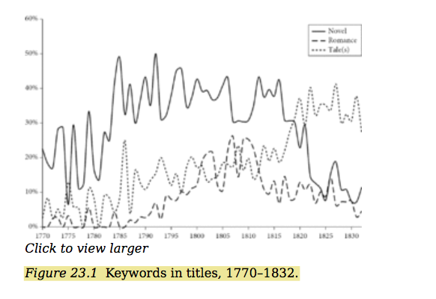
tendency at the end of our period for novels to include no main generic label at all … the genre no longer needed to engage so much in selfidentification.

The early 1800s show the reputation of fiction at one of its lowest points. At the same time, as a form of popular reading matter the genre by now was palpably unstoppable, with an optimum peak of 111 new titles being reached in 1808
In bearing the lead title of Waverley Novels on its spine labels and title pages this employed the same mantle descriptive term as the main body of post-1774 collected sets of ‘classic’ fiction. As such it offered infallible proof that the genre, collectively known as the novel, had now in its contemporary form come to full fruition.

