|  |
| --- |
| Theatrical Genre Prediction Using Social Network Metrics |
| Manisha Shukla1, Susan Gauch1 and Lawrence Evalyn2 |
| 1Department of Computer Science and Engineering, University of Arkansas, Fayetteville, AR, USA  *2Department of English, University of Toronto, Toronto, ON, Canada*  mshukla@email.uark.edu, sgauch@uark.edu, lawrence.evalyn@mail.utoronto.ca |

Keywords: Social Networks, Genre Prediction, Relationship Mining, Social Network Analysis, Network Theory.

Abstract: With the emergence of digitization, large text corpora are now available online which provide humanities scholars an opportunity to perform literary analysis leveraging the use of computational techniques. Almost no work has been done to study the ability of mathematical properties of network graphs to predict literary features. In this paper, we apply network theory concepts in the field of literature to explore correlations between the mathematical properties of the social networks of plays and the plays’ dramatic genre. Our goal is to find metrics which can distinguish between theatrical genres without needing to consider the specific words of the play. We generated character interaction networks of 36 Shakespeare plays and tried to differentiate plays based on social network features captured by the character network of each play. We were able to successfully predict the genre of Shakespeare’s plays with the help of social network metrics and hence establish that differences of dramatic genre are successfully captured by the local and global social network metrics of the plays. Since the technique is highly extensible, future work can be applied larger groups of plays, including plays written by different authors, from different periods, or even in different languages.

# 1 INTRODUCTION

In literary studies, the three key areas of research could be defined as philology (the study of words), bibliography (the study of books as objects), and criticism (the evaluation or interpretation of literary meaning). Our paper presents a distant reading method which may aid in the task of literary criticism, using network graph analysis on social networks generated from the scripts of plays.

Particularly since the advent of New Criticism, “the basic task of literary scholarship has been close reading of texts” (F. Moretti, 2011), which builds textual interpretations from the precise study of specific words. Computational approaches to literature offer an alternate methodology for the work of literary study without close reading. “Distant reading” (F. Moretti, 2011) takes many forms, including statistical topic models (M. L. Jockers and D. Mimno, 2013), character profiling (Flekova and I. Gurevych, 2015), character frequency analysis (G. Sack, 2011), and sentiment analysis (M. Elsner, 2015), as mentioned in Grayson et al., 2017. For computational methods to produce new literary insights, they must provide information about literary texts which is not easily accessible by reading them and must do so for more texts than it is feasible for a person to read. The social networks we examine are implicit in the texts, and thus difficult to access through simple reading, and our technique can easily be applied to more texts than a person may read, allowing our method to contribute novel insights to literary analysis.

Social network analysis is well-established as a way to study social groups. Some scholars have applied social network analysis to literary works for e.g. plot analysis (Grayson et al., 2017), or for discovering character communities (D. Watts, 2001), wherein nodes represent characters, and edges represent interaction between pairs of characters for plot analysis. Because these graphs are handmade for a very small number of plays, however, almost no work has been done to study the ability of mathematical properties of network graphs to predict literary features at scale. We address this gap by exploring correlations between the mathematical properties of networks and dramatic genre. We are particularly interested to see *which* measures are the most effective predictors, to form the basis of literary analysis of the role of social relationships in plays.

In this paper, we study the social networks of Shakepeare’s plays to establish a correlation between social network metrics and genre identification. We distinguish between the three Early Modern theatrical genres of tragedy, comedy, and history, following the identifications provided in the first collection of Shakespeare’s works, the First Folio. Using our generated character networks of Shakespeare’s plays, we found that combinations of some of the global and local network metrics (D. Watts, 2001) were indeed able to distinguish plays belonging to different genres. This work has been used for literary analysis of the ambiguous genre of Shakepeare’s “problem plays” (L. Evalyn, S. Gauch, and M. Shukla, 2018).

# 2 Related Work

## 2.1 Social Network Analysis

A social network graph is a set of vertices and edges (called a sociogram) where vertices represent social actors and edges represent social relations among the vertices. However, a social network is more than just a set of vertices and lines, as its structure contains implicit information about the social actors and their relationships. The graph representation of a social network offers a systematic and mathematical method for investigating these structures. Social network analysis is the process of investigating social network structures and ties through the use of network and graph theory concepts.

As S. M. Billah and S. Gauch observe, “Social network analysis (SNA) is not a formal theory, but rather a wide strategy for investigating social structures” (S. M. Billah and S. Gauch, 2015). These strategies borrow core concepts from sociometry, group dynamics, and graph theory (D. Watts, 2001) (J. Scott, 2000) (S. Wasserman, and K. Faust, 1994).

In social network analysis of human activities, the nodes can be connected by many kinds of ties, such as “shared values, visions, and ideas; social contacts; kinship; conflict; financial exchanges; trade; joint membership in organizations; and group participation in events, among numerous other aspects of human relationships” (Serrat, 2017). However, regardless of the nature of the connection, “the defining feature of social network analysis is its focus on the structure of relationships” (Serrat, 2017). The central assumption in SNA methodologies is that relationships between nodes are of central importance (Serrat, 2017).

Social network analysis has been used in a wide variety of fields, with applications as diverse as disintegration models based on social network analysis of terrorist organizations (D. Anggraini et al., 2015), collaboration of scholars in graduate education (Wang Chuan-yi, Lv Xiao-hong, and Cao Yi, 2016), football team performance based on social network analysis of relationships between football players (Raffaele Trequattrini, Rosa Lombardi, Mirella Battista, 2015), money laundering detection (Rafał Dreżewski, Jan Sepielak, and Wojciech Filipkowski, 2015), and stress disorder symptoms and correlations in U.S. military veterans (Cherie et al. 2017). In this paper we explore the applications of social networks in literary analysis. Specifically, we look for social network metrics that can identify genre without relying on the specific language of the play, which will enable future extension to groups of plays in different languages.

## 2.2 Literary Analysis with SNA

Because dramatic performances enact social encounters, social network analysis translates surprisingly well to fictional societies. Stiller et al. have shown that the social networks in Shakespeare’s plays mirror those of real human interactions, particularly in size, clustering, and maximum degrees of separation (Stiller J., Nettle D., and Dunbar, R. I. M., 2003).

Surveying the field of literary analysis using SNA, Moretti categorizes several types of analyses: “an empirical, quantitative and hierarchical description of literary characters (Jannidis, F. et al., 2016), corpus-based analyses exploring options for historical periodisation of literature (Trilcke, P. et al., 2015) and types of aesthetic modelling of social formations in and by literary texts (Stiller, J., Nettle, D., Dunbar, R. I. M., 2003) (Stiller, J., Hudson, M., 2005) (Trilcke, P. et al, D., 2016).” Moretti himself uses social networks to examine the plots of three Shakespearean tragedies, and to contrast a few chapters of English and Chinese novels (F. Moretti, 2011). Work following Moretti has focused on historical periodization, as in Algee-Hewitt’s examination of 3,439 plays looking only at the Gini Coefficient of each play’s eigenvector centrality to track ensemble casts from 1500 to 1920 (Algee-Hewitt, M., 2017).

Our project focuses on a novel application, the classification of literary genre. When scaled up to a corpus covering a wider historical time span, our approach to genre could also provide insight on the historic periodization of literature.

Moretti also identifies that, in the application of SNA to literature, “methods for the automated extraction of network data (named entity recognition, co-reference resolution) and their evaluation are of particular importance,” (F. Moretti, 2011), which we accomplish in this paper.

## 2.3 Gephi Toolkit

Gephi is an open source software for graph and network analysis, which allows for fast visualization and manipulation of large networks. As a generalist tool, “it provides easy and broad access to network data and allows for spatializing, filtering, navigating, manipulating and clustering” (Bastian, M.; Heymann, S.; Jacomy, M., 2009). Gephi also calculates a wide range of mathematical features for each graph, which we use as the basis for our mathematical analysis (as discussed in more detail in 3.3).

# 3 Our Design

Our system for identifying genre consists of three building blocks: the Play Parser, the Social Network Generator and the Genre Predictor. Figure 1 shows the main components of the system architecture, which are discussed in more detail in the following subsections.

Play Parser

Social Network Metric Calculator

Genre Predictor

Figure 1: Block diagram of our system.

## 3.1 Play Parser

The main purpose of this component is to automatically parse TEI encoded XML format play to extract basic information such as the total number of characters, the name and role of each character, and the total number of acts and scenes in a play. Table 1 shows some details of the TEI encoding. For each scene, we used our parsed information to determine which characters were present in the scene (using stage directions to account for entrances and exits during a scene), and how many lines and words were spoken by each character. We also extracted some “Play Features” (shown in Table 2) which were incorporated into our analysis.

Table 1: TEI encoded XML file information.

|  |  |  |
| --- | --- | --- |
| **XML Tag** | **Information contained** | **Example** |
| <castItem> | Character name and role in the play | <castItem type="role">  <role xml:id="Pedro"> Don Pedro</role> <roleDesc> prince of Arragon </roleDesc>  </castItem> |
| <div> | Act | <div xml:id="sha-man1">  <head>Act 1</head> |
| <div> | Scene | <div xml:id="sha-man101">  <head>Act 1, Scene 1</head> |
| <speaker> | Current speaker | <speaker>Beatrice </speaker> |
| <l> | Line | <l xml:id="sha-man101299" n="299">  And tell fair Hero I am Claudio,</l> |

## 3.2 Social Network Metric Calculator

This component creates each play’s social network graph using the information generated by the play parser described in 3.1 and then calculates its network features. We used the Gephi API to generate graph files. Each file maps characters as node and communication between characters as an edge. Each character stores as an attribute total number of lines and words spoken by that character in the play. After this mapping, each edge is weighted with the sum of total number of words spoken by the two characters in their shared scenes. Once the basic structure is ready, using inbuilt functions of Gephi API we calculate 16 metrics of graph and node features. These are the “Networks Features” of our extracted features, as shown in Table 2.

Table 2: All Extracted Features from Shakespeare’s plays. Here *g* represents a play graph, *c* a character node in a graph, and *e* an edge in graph.

|  |
| --- |
| **Play Features** |
| 1. tot_characters = total number of characters in *g* |
| 2. tot_edges *=* total number of edges in *g* |
| 3. tot_lines = total number of lines spoken by *c* in *g* |
| 4. tot_words = total number of words spoken by *c* in *g* |

|  |
| --- |
| **Network Features** |
| 5. Degree = set of adjacent nodes of *c* in the graph |
| 6. Criticality = A k-critical graph is a critical graph with chromatic number k; a graph G with chromatic number k is k-vertex-critical if each of its vertices is a critical element. |
| 7. EigenVector = A measure of *c*’s importance in a network based on *c*’s connections. |
| 8. Eccentricity = The eccentricity of a node *c* in a connected graph is the maximum graph distance between it and any other node. |
| 9. Closeness Centrality = The average distance from a given node *c* to all other nodes in the network. |
| 10. Harmonic Centrality = In a (not necessarily connected) graph, the harmonic centrality reverses the sum and reciprocal operations in the definition of closeness centrality. |
| 11. Betweeness Centrality = Node Betweenness Centrality measures how often a node appears on shortest paths between nodes in the network. |
| 12. Clustering Coefficient = The clustering coefficient, when applied to a single node, is a measure of how complete the neighborhood of a node is. When applied to an entire network, it is the average clustering coefficient over all nodes in the network. |
| 13. Density = Measures how close the network is to complete. A complete graph has all possible edges and density equal to 1. |
| 14. Diameter = The maximal distance between all pairs of nodes. |
| 15. Path Length = The average graph-distance between all pairs of nodes. |
| 16. Connected Components: A connected component is a maximal set of nodes such that each pair of nodes is connected by a path. |
| 17. Modularity = Measures how well a network decomposes into modular communities. |
| 18. Weighted Degree = for node *c*, the sum of the weights of its edges. |
| 19. Average Degree = for graph *g*, the sum of the degrees of all the nodes in the graph divided by the total number of nodes in the graph. |
| 20. Average Weighted Degree = For graph *g*, the sum of the weighted degrees of all the nodes in the graph divided by the total number of nodes in the graph. |
| 21. Radius = The radius of a graph is the minimum graph eccentricity of any node in the graph. |

### 3.2.1 Extracted Features

As extracted features, we chose to use most simple and easily quantifiable metrics, such as the total number of characters in the play (see Table 2). As our results in 4.3.1 and 4.3.3 demonstrate, despite their simplicity as features, the number of edges and the number of words spoken in a play can play a crucial role in identifying the genre.

### 3.2.2 Network Features

We compute the network features of the graph using the Gephi library. For features that describe an individual node, such as degree or eigenvector, we calculated the network centralized value using the following network level centralization index:

(1) $C= \frac{\sum_{i}{{[c}^{*}- c^{i}]}}{Max\sum_{i}{[c^{*}- c^{i}]}}$

Where

*c\**= maximum value for all the nodes in the graph

*ci* = value of current node

And the denominator is the maximum of the summation over all the possible networks. This method normalizes across the graphs, allowing us to use node metrics as graph metrics for evaluation purposes.

## 3.3 Genre Predictor

The genre predictor is a support vector machine binary classifier. Support Vector Machines (SVMs) are a popular machine learning method for classification, regression, and other learning tasks. Since our classification problem had more than two classes, we combined SVM with One vs One (OvO) classification. This works as follows: choose a pair of classes from a set of *n* classes, which in our case is three (comedy, history and tragedy) and develop a binary classifier for each pair. Create all possible combinations of pairs of classes from *n* and then for each pair develop a binary SVM. The final class is assigned to each unseen play based on the class chosen by maximum number of binary SVM classifiers. By using OvO, our SVM is much less sensitive to the problems of unbalanced datasets, which is particularly helpful given the different sizes of each of our three classes and our small overall sample size (Chang and Lin, 2011).

# 4 EXPERIMENTS

## 4.1 Dataset

Our dataset is comprised of 36 plays by Shakespeare, in TEI encoded XML files. XML format was chosen as it was much easier to fetch required information from the plays along with maintaining accuracy in the extraction. The dataset is that of the WordHoard Shakespeare, downloaded from the website showcases.exist-db.org. We split the dataset into five subsets, evenly balancing each genre in each subset. These were then used to perform five-fold cross validation.

Table 3: The plays in our dataset.

|  |  |
| --- | --- |
| **Play Name** | **Class** |
| All’s Well That Ends Well | Comedy |
| As You Like It | Comedy |
| A Midsummer Night’s Dream | Comedy |
| Love’s Labour’s Lost | Comedy |
| Measure for Measure | Comedy |
| Much Ado About Nothing | Comedy |
| The Comedy of Errors | Comedy |
| The Merchant of Venice | Comedy |
| The Merry Wives of Windsor | Comedy |
| The Taming of the Shrew | Comedy |
| The Tempest | Comedy |
| The Winter’s Tale | Comedy |
| Twelfth Night or What You Will | Comedy |
| Two Gentlemen of Verona | Comedy |
| The First Part of King Henry the Fourth | History |
| The First Part of King Henry the Sixth | History |
| The Life and Death of King John | History |
| The Life of King Henry the Eighth | History |
| The Life of King Henry the Fifth | History |
| The Second Part of King Henry the Fourth | History |
| The Second Part of King Henry the Sixth | History |
| The Third Part of King Henry the Sixth | History |
| The Tragedy of King Richard the Second | History |
| The Tragedy of King Richard the Third | History |
| Antony and Cleopatra | Tragedy |
| Coriolanus | Tragedy |
| Cymbeline | Tragedy |
| Hamlet Prince of Denmark | Tragedy |
| Julius Caesar | Tragedy |
| King Lear | Tragedy |
| Macbeth | Tragedy |
| Othello the Moor of Venice | Tragedy |
| Romeo and Juliet | Tragedy |
| Timon of Athens | Tragedy |
| Titus Andronicus | Tragedy |
| Troilus and Cressida | Tragedy |

## 4.2 Experimental Setup

Our generated network graphs are then used to test our central question: whether the social network of characters in a play can be used as a proxy for features of the play’s narrative content. Can we use social network metrics to distinguish between the dramatic genres of tragedy, comedy, and history? We used 21 different mathematical features as mentioned in Table 2 to test our hypothesis. We first tested how well individual features were able to distinguish between different genres. Our second test considered of all combinations of pairs of extracted and network features, and the third test used combinations of three, four and five feature sets to see if adding on more features would increase accuracy of classifier’s genre prediction. Section 4.3 discusses the result of each test.

## 4.3 Results

The following table shows the calculated average value for each network metric per genre.

Table 4: Average feature value for each genre.

|  |  |  |  |
| --- | --- | --- | --- |
| **Features** | **Comedy** | **History** | **Tragedy** |
| Characters | 23.14 | 44 | 38.333 |
| Edges | 132 | 233 | 217.75 |
| Words | 22426.42 | 27238.2 | 27050.58 |
| Lines | 2586.5 | 3070.2 | 3215 |
| Criticality | 0.03 | 0.022 | 0.020 |
| Eigenvector | 0.34 | 0.59 | 0.52 |
| Eccentricity | 8.63 | 19.11 | 13.01 |
| Closeness | 9.28 | 27.42 | 24.95 |
| Harmonic | 0.19 | 0.31 | 0.29 |
| Betweenness | 0.01 | 0.010 | 0.011 |
| Clustering Coefficient | 0.84 | 0.82 | 0.83 |
| Graph Density | 0.52 | 0.25 | 0.34 |
| Diameter | 2.85 | 4.3 | 3.08 |
| Path Length | 1.516 | 2.02 | 1.71 |
| Connected Components | 1.07 | 1.7 | 1.5 |
| Degree | 0.37 | 0.46 | 0.52 |
| Modularity | 0.14 | 0.25 | 0.16 |
| Weighted Degree | 1306.85 | 1022.02 | 1457.85 |
| Average Degree | 11.31 | 10.39 | 11.38 |
| Average Weighted Degree | 11353.31 | 7349.09 | 9136.53 |
| Radius | 1.78 | 1.3 | 1.33 |

### 4.3.1 Single Feature Accuracy

Our first test attempted to identify genre using only single feature at a time. However, no single feature was independently sufficient to identify the genre. Of the features tested, path length provided the greatest accuracy (66.43%) for genre identification. Even though this metric does not achieve 100%, it is much better than random, which would be 33.3%.

Table 5: Genre prediction accuracy using a single feature.

|  |  |
| --- | --- |
| **Feature** | **Accuracy** |
| Path Length | 66.43 |
| Graph Density | 61.07 |
| Diameter | 58.57 |
| Characters | 55.71 |
| Eigenvector | 55.71 |
| Eccentricity | 55.71 |
| Harmonic | 55.71 |
| Average Weighted Degree | 55.71 |
| Lines | 55.36 |
| Degree | 55.36 |
| Closeness | 52.50 |
| Connected Components | 50.35 |
| Modularity | 50.00 |
| Words | 47.50 |
| Edges | 47.14 |
| Radius | 47.14 |
| Weighted Degree | 44.28 |
| Criticality | 41.43 |
| Clustering Coefficient | 38.93 |
| Average Degree | 33.21 |
| Betweenness | 27.85 |

### 4.3.2 Pair of Features Accuracy

However, when features were used in pairs, the network graphs achieved greater accuracy in identifying the genre of Shakespeare plays. Table 6 shows the pairs of metrics which were able to identify genre with accuracy higher than the maximum individual feature accuracy for genre prediction.

Table 6: Pairs of features which provided above 70% accuracy in genre prediction.

|  |  |  |
| --- | --- | --- |
| **Feature 1** | **Feature 2** | **Accuracy** |
| Harmonic | Diameter | 72.50 |
| Harmonic | Path Length | 72.50 |
| Graph Density | Diameter | 72.50 |
| Graph Density | Path Length | 72.50 |
| Lines | Path Length | 72.14 |

### 4.3.3 Multiple Features Accuracy

If we combine three features, the network graphs again achieve 10% higher accuracy in genre identification. Table 7 shows the triads which were able to identify genre with more than 80% accuracy.

Table 7: Sets of three features which provided above 80% accuracy in genre prediction.

|  |  |  |  |
| --- | --- | --- | --- |
| **Feature 1** | **Feature 2** | **Feature 3** | **Accuracy** |
| Words | Characters | Lines | 83.57 |
| Words | Lines | Eigenvector | 83.21 |
| Words | Lines | Closeness | 81.07 |
| Lines | Eigenvector | Path Length | 80.71 |
| Lines | Harmonic | Path Length | 80.71 |

Adding additional features continued to increase accuracy. The highest observed accuracy was 88.93%, using five metrics that are a combination of play characteristics (Words and Lines) and SNA features (Closeness, Graph Density, and Average Weighted Degree).

### 4.3.4 Discussion

The relevance of path length and graph density in distinguishing genres is visually obvious when individual comedy and history networks are compared.

Our networks reveal that histories feature highly dispersed networks, with large numbers of very minor characters, such as “First,” “Second,” and “Third” members of groups like soldiers and ambassadors (Figure 2). Characters in histories form social subgroups, joined through chains of acquantance. Comedies, in contrast, feature networks with far fewer characters, in which nearly everybody speaks to nearly everybody else at some point (Figure 3). These basic findings offer novel support for literary research on Early Modern histories and comedies (L. Evalyn, S. Gauch, and M. Shukla, 2018).

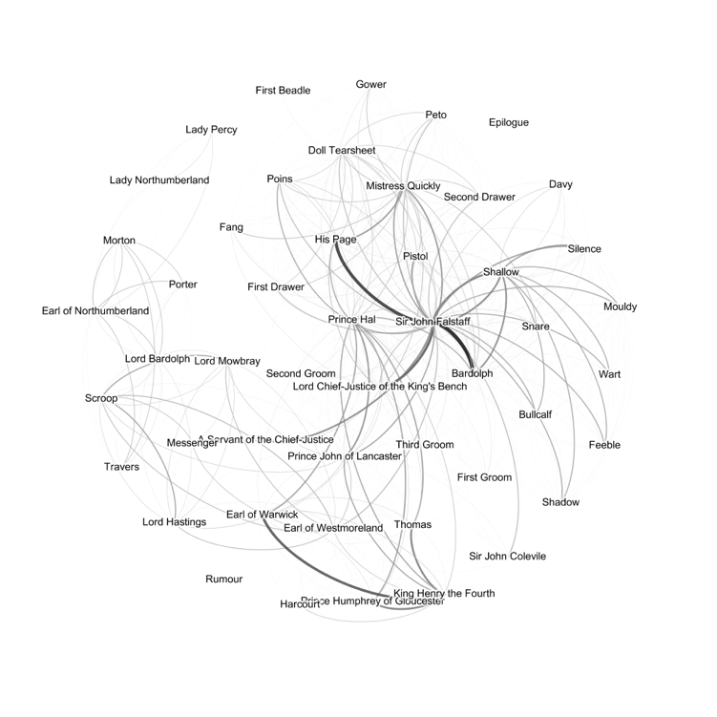

Figure 2: Network graph of *The Second Part of King Henry The Fourth*, a history.

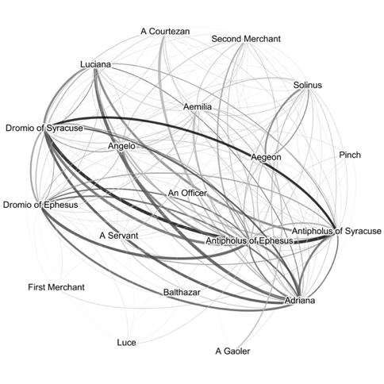

Figure 3: Network graph of *The Comedy of Errors*, a comedy.

Tragedies are more difficult to distinguish. It is of interest to literary scholars to discover that tragedies appear not to have a formula for their social relationships. They feature networks somewhere between history and comedy in their density and show more variety overall (Figures 4 and 5). Therefore, more complex metrics are needed in combination to accurately identify all three genres.

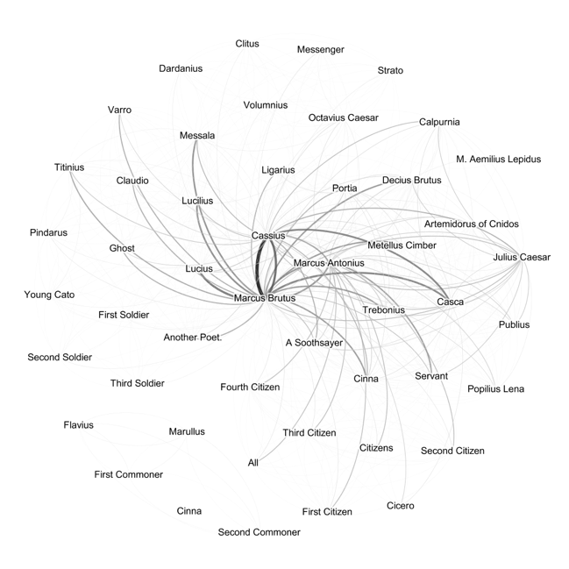Figure 4: Network graph of *Julius Caesar,* a tragedy.

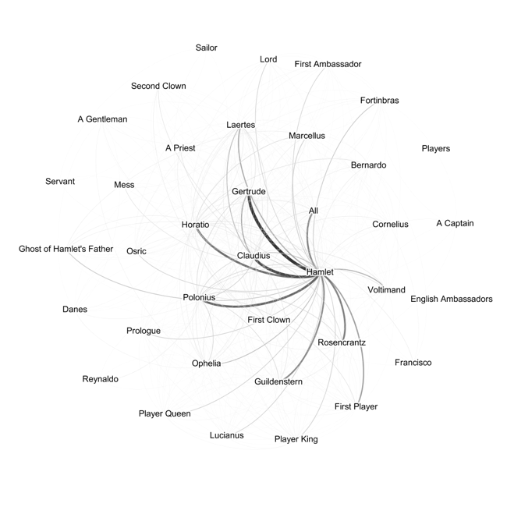Figure 5: Network graph of *Hamlet*, a tragedy.

A comparison of Table 6 and Table 7 shows that the sets of three factors which provide higher accuracy do not necessarily always include the features which were able to provide better accuracy as pairs. Many of the pairs, for example, include graph density or path length as one of the two identifying features, but none of the triples include graph density as a feature for maximizing the accuracy, and the triples instead include the number of words and lines as the most commonly useful feature.

Each metric thus seems to capture a specific kind of information about the play which are more relevant in combination with different other metrics. Closeness, for example, is only able to provide 52.5% accuracy alone, but reaches 88.9% when combined with lines, words, graph density and average weighted degree. Similarly, the harmonic centrality only provides 55.7% accuracy alone, but when considered alongside pairs of other features, the combination is more informative.

Specifically, it seems that classification is most successful when metrics of the play’s size (words, characters, lines) are combined with metrics of the interconnectedness of its social network (density, path length, harmonic or closeness centrality, eigenvector). The non-SNA features of play size are insufficient to identify genre alone, but provide useful context for SNA metrics for classification.

# 5 CONCLUSIONS

In this paper, we successfully classify plays based on their genre without using the actual words of the plays. Our networks of the well-studied works of Shakespeare can provide a baseline against which to contextualize similar studies of other plays. The network graphs themselves provide a new insight into the plays, revealing the hidden shape of social relationships between characters. The application of mathematical graph analysis to these networks provides a dramatically faster and more scalable way to determine important information about them, in this case their genre.

To apply these findings to literary research, we have explored in more detail the genre attributions of Shakespeare’s romances and problem plays (L. Evalyn, S. Gauch, and M. Shukla, 2018). We have also made the network graphs and selected mathematical features available online at http://text.csce.uark.edu:8080/SocialNetworkOfShakespearePlays/.

# 6 Future Work

Since the parser is highly extensible and can be used with any plays encoded in TEI, future work applying these methods to literary analysis does not need to be restricted to plays that are similar to Shakespeare’s but could be used to compare plays over a long period of time. Future work doesn’t even need to be restricted to plays written in English; one future application in development, for example, will study eighteenth century plays written in English, French, and German. As we develop our website, we will add functionality for others to upload their own TEI encoded plays and download the resulting Gephi file, enabling broad applicability of our methods to new literary research problems.

Future refinements to the social network generator could make edges between nodes directional, to better capture imbalanced relationships between characters; this level of detail was not necessary to distinguish between Shakespeare’s plays, but might be important for different identification tasks. Natural Language Processing (NLP) could also be integrated into the parser to more accurately identify the targets of speech, to capture instances where characters are on stage but cannot hear what is being said or are not being spoken to. These kinds of improvements would reduce “false positives” in the creation of edges between nodes, perhaps enabling better analysis of larger or more complicated groups of literary plays.

# 7 REFERENCES

1. F. Moretti. Network Theory, Plot Analysis. New Left Review, 68:80–102, 2011.
2. <http://showcases.exist-db.org/exist/apps/Showcases/index.html>.
3. M. L. Jockers and D. Mimno, 2013. Significant themes in 19th-century literature. In Poetics, 41(6):750–769.
4. Flekova and I. Gurevych, 2015. Personality Profiling of Fictional Characters using Sense-Level Links between Lexical Resources. In Proc. Conference on Empirical Methods in Natural Language Processing, pages 1805–1816.
5. G. Sack, 2011. Simulating plot: Towards a generative model of narrative structure. In 2011 AAAI Fall Symposium Series.
6. M. Elsner, 2015. Abstract Representations of Plot Struture. LiLT (Linguistic Issues in Language Technology), 12(5).
7. Lawrence Evalyn, Susan Gauch, and Manisha Shukla. Analyzing Social Networks of XML Plays: Exploring Shakespeare’s Genres. In Digital Humanities Conference 2019.
8. Siobhán Grayson, Karen Wade, Gerardine Meaney, Jennie Rothwell, Maria Mulvany, and Derek Greene, 2016. Discovering structure in social networks of 19th century fiction. In Proceedings of the 8th ACM Conference on Web Science (WebSci '16). ACM, New York, NY, USA, 325-326.
9. D. Watts, “Small Worlds: The Dynamics of Networks between Order and Randomness”, Princeton University Press, 2001.
10. Chih-Chung Chang and Chih-Jen Lin. 2011. LIBSVM: A library for support vector machines. ACM Trans. In Intell. Syst. Technol. 2, 3, Article 27 (May 2011), 27 pages.
11. S. M. Billah and S. Gauch. 2015. Social network analysis for predicting emerging researchers. In 7th International Joint Conference on Knowledge Discovery, Knowledge Engineering and Knowledge Management (IC3K), Lisbon, 2015
12. J. Scott, “Social Network Analysis: A Handbook”, 2nd ed., Sage Publications, London, 2000.
13. S. Wasserman, and K. Faust, “Social Network Analysis: Methods and Applications”, Cambridge University Press, 1994.
14. Serrat, O., 2017. Social network analysis. In Knowledge solutions (pp. 39-43). Springer, Singapore.
15. D. Anggraini, S. Madenda, E. P. Wibowo and L. Boumedjout, 2015. Network Disintegration in Criminal Network. In 11th International Conference on Signal-Image Technology & Internet-Based Systems (SITIS), Bangkok, 2015, pp. 192-199.
16. Wang Chuan-yi, Lv Xiao-hong, and Cao Yi. 2016. An empirical study on the collaboration of scholars in graduate education: based on the social network analysis. In Proceedings of the 2016 International Conference on Intelligent Information Processing (ICIIP '16). ACM, New York, NY, USA, Article 36, 7 pages.
17. Raffaele Trequattrini, Rosa Lombardi, Mirella Battista, 2015. Network analysis and football team performance: a first application. In Team Performance Management: An International Journal, Vol. 21 Issue: 1/2, pp.85-110.
18. Rafał Dreżewski, Jan Sepielak, Wojciech Filipkowski, 2015. The application of social network analysis algorithms in a system supporting money laundering detection. In Information Sciences, Volume 295, 2015, Pages 18-32, ISSN 0020-0255.
19. Cherie Armour, Eiko I. Fried, Marie K. Deserno, Jack Tsai, Robert H. Pietrzak, 2017. A network analysis of DSM-5 posttraumatic stress disorder symptoms and correlates in U.S. military veterans. In Journal of Anxiety Disorders, Volume 45, 2017, Pages 49-59.
20. Stiller, J., Nettle, D., and Dunbar, R. I. M., 2003. The Small World of Shakespeare's Plays. In Human Nature, 14(4): 397–408.
21. Jannidis, F., Reger, I., Krug, M., Weimer, L., Macharowsky, L., Puppe, F., 2016. Comparison of Methods for the Identification of Main Characters in German Novels. In Digital Humanities Conference Abstracts, Jagiellonian University & Pedagogical University, Kraków, pp. 578–82.
22. Trilcke, P., Fischer, F., Göbel, M., Kampkaspar, D., 2015. In 200 Years of Literary Network Data.
23. Stiller, J., Nettle, D., Dunbar, R. I. M., 2003. The Small World of Shakespeare's Plays. In Human Nature 14, pp. 397–408.
24. Stiller, J., Hudson, M., 2005. Weak Links and Scene Cliques Within the Small World of Shakespeare. In Journal of Cultural and Evolutionary Psychology 3, pp. 57–73.
25. Trilcke, P., Fischer, F., Göbel, M., Kampkaspar, D., Kittel, C., 2016. Theatre Plays as 'Small Worlds' Network Data on the History and Typology of German Drama, 1730–1930. In Digital Humanities 2016 Conference Abstracts. Jagiellonian University & Pedagogical University, Kraków, pp. 385–87.

Algee-Hewitt, M., 2017. Distributed Character: Quantitative Models of the English Stage, 1500-1920. In Digital Humanities 2017: Book of Abstracts. Montreal: McGill University and Université de Montréal, pp. 119–21.

1. Elson, D. K., Dames, N., McKeown, K. R., 2010. Extracting Social Networks from Literary Fiction. In Proceedings of ACL 2010. Uppsala, pp. 138–47.
2. Park, G. M., Kim, S. H., Cho, H. G., 2013. Structural Analysis on Social Network Constructed from Characters in Literature Texts. In Journal of Computers 8.9, pp. 2442–47.
3. Agarwal, A., Corvalan, A., Jensen, J., Rambow, O., 2012. Social Network Analysis of Alice in Wonderland. In Proceedings of the Workshop on Computational Linguistics for Literature. Montréal, pp. 88–96.
4. Fischer, F., Göbel, M., Kampkaspar, D., Trilcke, P., 2015. Digital Network Analysis of Dramatic Texts. In Digital Humanities 2015 Conference Abstracts. University of Western Sydney.
5. Waumans, M. C., Nicodème, T., Bersini, H., 2015. In Topology Analysis of Social Networks Extracted from Literature. Plos One, 3 June 2015.
6. Bastian, M., Heymann, S., Jacomy, M, 2009. Gephi: An Open Source Software for Exploring and Manipulating Networks. In International AAAI Conference on Web and Social Media, North America.
7. https://www.csie.ntu.edu.tw/~cjlin/libsvm/
8. https://gephi.org/developers/
9. https://weka.wikispaces.com
10. <https://www.cs.waikato.ac.nz/~ml/index.html>