The Quality of Life Committee was created to assist with beautification, parking, and security as well as other projects that contribute to the quality of life in downtown. The committee reviews and monitors current programs and projects in each of these areas and makes recommendations to the Board. In addition, the committee will identify ideas for additional programs or projects that would enhance the quality of life in downtown.

The application program was created to assist the committee to review and evaluate requests for funds and make appropriate recommendations. Proposals are selected based on their ability to add to the downtown’s vitality and must benefit the public.

Mission

Ensuring a vibrant, flourishing downtown is the primary mission of the Downtown Knoxville Alliance (DKA). Formed in 1993 as a Central Business Improvement District (CBID), the district encompasses a .67 square mile area. Property owners within the designated area pay a special assessment that is used to make improvements, enhance services and promote downtown. Regardless of the initiative, our focus is clear – create the best experience possible to attract and retain a thriving community of residents, businesses, and visitors in Downtown Knoxville.

What we fund

The DKA is a 501(c)3 charged with making downtown improvements. Any grants that are awarded must benefit the public. The organization’s founding documents provide the direction where DKA’s funds are awarded and/or spent. These areas include:
- Promotion and marketing
- Advertising
- Health and sanitation
- Public safety
- Elimination of problems related to traffic and parking
- Security services
- Recreation
- Cultural enhancements
- Consulting concerning planning, management, and development activities
- Activities in support of business or residential recruitment, retention, and management development
- Aesthetic improvements, including the decoration of any public space
- Professional management, planning, and promotion of the District
- Design assistance

guidelines/criteria

- Grants will be paid upon completion either through reimbursement or direct billing.

- Any required permits for the work must be acquired.

- Projects must be completed within 12 months of grant approval.

- The Quality of Life Committee and Board will evaluate a project(s) based on submittals that meet the established criteria, budget, and mission that give the best overall return on investment to DKA.

- All improvements must conform to the City of Knoxville’s Building Codes, Zoning, if applicable, the D1 or H1 Design Guidelines, and/or approval from the City’s Public Arts Committee.

application

Name: [Your name] — Knox Pick-Me-Up (volunteer coordinator)

Your Mailing Address: [Your mailing address]

Phone Number: [Your phone] Email Address: hello@knoxpickmeup.org

Project Address: District-wide within the CBID — 3 participating bars + 3 coffee shops (Market Square / Gay Street / Old City; final roster at launch)

Requested Amount: $4,000 Total Project Costs: $18,000 (6-month pilot, all-in)

- Describe the project:
Knox Pick-Me-Up is a road-safety thank-you program for downtown Knoxville, designed as a public-private partnership with the City of Knoxville, KPD, KAT, and downtown bars and coffee shops (partner outreach under way). At last call, a patron who shows their bartender proof of a safe ride home — a booked rideshare or taxi, or an activated KAT ticket — receives a serialized Morning Pick-Me-Up Card: a free large coffee at a participating downtown shop the next morning, when they return for their parked car, plus a free KAT ride to get there. The reward is framed as Knoxville saying thanks for keeping our roads safe — warm, not preachy — and capped at a coffee. Full program design: knoxpickmeup.org.
The 6-month pilot runs in 3 bars and 3 coffee shops inside the CBID. Every card is serialized with a QR code; issuance and redemption are scan-logged per venue, so the program reports hard numbers — cards issued, redemption rate, spread across venues — with quarterly data shared back to DKA and the City. Cards are anonymous; no personal data is ever collected.
This request funds the printed kit that is the program: serialized tear-off card books, two-sided bar coasters (the advertising, sitting under the drink at the decision moment), window decals for participating venues, table tents, restroom signs, community flyers, laminated staff references, and bound partner briefing booklets — itemized in Attachment A, with renderings in Attachment B. Printing will be produced locally (quote in process with Graphic Creations, Knoxville).

- If applicable, has the project been submitted and/or approved by the Downtown Design Review Board (D1) or the Historic Zoning Commission (H1)? ☐ Yes ☒ No (n/a — no permanent improvements or public-space installations; all materials are removable print collateral placed inside participating businesses)
- Will you be receiving or asking for any financial incentives/assistance from other sources? Yes — pursuing; none committed yet.
If so, how much:
The remaining ~$14,000 of the pilot: a one-time City of Knoxville seed request toward launch costs, program sponsorships, and a Tennessee Highway Safety Office application (impaired-driving education, March 2027 cycle). The coffee itself is funded in-kind by participating shops and the rides in-kind by KAT — the DKA request is confined to printed materials.

- Anticipated state date: / / Anticipated completion: / / (launch targeted within ~60 days of award, tied to a high-visibility weekend; the 6-month pilot completes well inside the 12-month requirement)

- Has this project received DKA funding in the past? If so, when and amount?
No — this is Knox Pick-Me-Up’s first application to DKA.

- How does your project help enhance the CBID’s mission to make downtown a better place in which to live, work and play?
Play, safely: the program removes the parked car as the reason to drive home impaired — the biggest late-night risk a thriving downtown generates. In the Knoxville region, crashes involving an impaired driver seriously injure about 67 people and kill 27 every year, and one in three Knox County crash deaths involves an impaired driver. Every card handed out is a documented safe ride home from a downtown night out — and a safer, more welcoming downtown evening economy is quality of life, for patrons and for everyone on the road.
Work: member businesses get the benefit directly. Bars receive free coasters, signage, and card books — plus a calmer close to the night; coffee shops gain morning customers they rarely see, as the late-night crowd returns for their cars and the free large coffee rides along on a larger ticket. The morning return converts one downtown visit into two, linking the night and morning economies.
Live: the program loudly advertises a fact that serves every resident and visitor — downtown’s public garages and lots are free evenings and weekends — turning the district’s parking stock into a road-safety asset. It squarely serves DKA’s funded purposes of public safety, elimination of problems related to traffic and parking, and promotion of downtown; it is city-endorsed positive press for the district; and every benefit is public — any patron qualifies, at no cost to them.

Application Checklist

☒ Provide application.

☒ Include project budget.

☒ Include renderings of the project.

No application will be accepted unless all requested information is included.

Return all application packages to:
Michele Hummel
Downtown Knoxville Alliance
mhummel@downtownknoxville.org

If you have any questions, please contact us at 865.246.2654

Attachment A — Project Budget
Printed materials for the 6-month pilot (3 bars + 3 coffee shops), quantities including spares. Figures are planning estimates at trade pricing; a formal itemized quote from Graphic Creations (Knoxville) is in process and will be furnished before any disbursement. Grant to be paid on completion via reimbursement or direct billing, per DKA guidelines.
Item | Specification / quantity | Est. cost
Serialized card books | 2,500 cards in 50 tear-off books, unique QR + serial per card, perforated, 14pt uncoated | $650
Coasters | 7,500 — 4″ round pulpboard, two-sided (night/day designs) | $1,150
Program briefing booklets | 15 — 8.5×11″, 44-page interior + cover, bound | $300
Window clings | 20 — 5.6″ round “Pick-Me-Up Partner” decals | $200
Table tents | 200 — 4×10″ scored to A-frame | $350
Restroom signs | 50 — 8.5×11″, laminated | $180
Community flyers | 250 — 8.5×11″ | $150
Staff kit | 18 laminated reference sheets + 9 laminated register QR cards | $70
Promo stickers | 500 die-cut vinyl (two designs) | $200
Sponsor one-sheets | 40 — 8.5×11″ | $50
Production contingency | Bleed/setup adjustments, samples, proofs | $700
DKA request — total |  | $4,000

Total project cost (6-month pilot): $18,000 — printed materials $4,000 (this request); part-time coordinator for reconciliation, restock, and partner care $9,000; launch marketing and press event $3,000; contingency $2,000. The coffee perk is carried in-kind by participating shops and transit rides in-kind by KAT.

Attachment B — Renderings
Final print-ready artwork (all pieces designed and generated). Live samples of every piece: knoxpickmeup.org/materials · full program book: knoxpickmeup.org/design/Knox-Pick-Me-Up-Program-Details.pdf
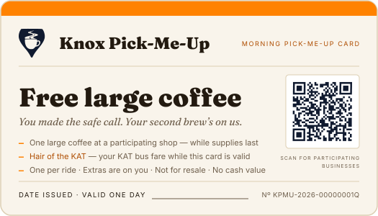
Morning Pick-Me-Up Card — serialized front (3.5″ × 2″)
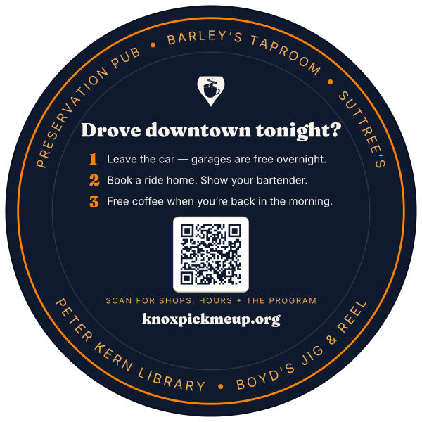
Coaster, night side (bars) — 4″ round
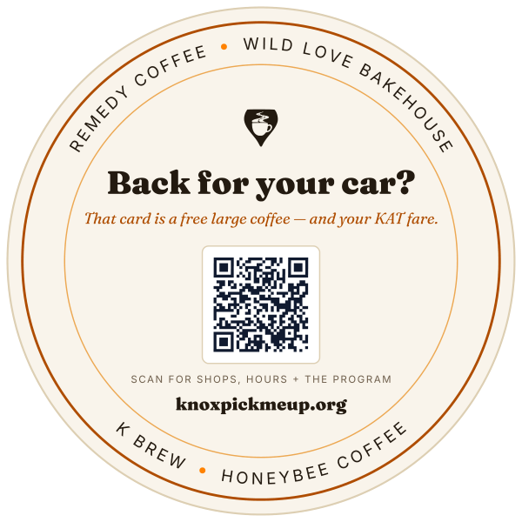
Coaster, day side (coffee shops)
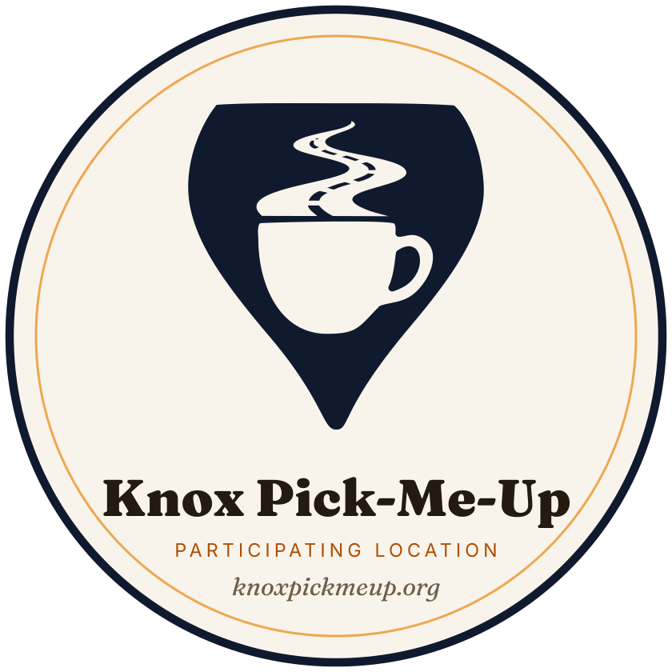
Participating-location window cling — 5.6″ round
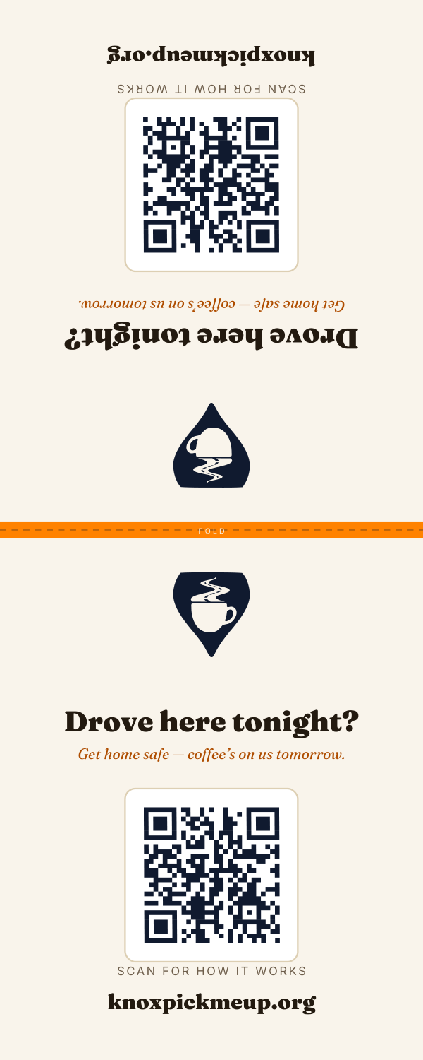
Table tent — folds to 4″ × 5″ A-frame
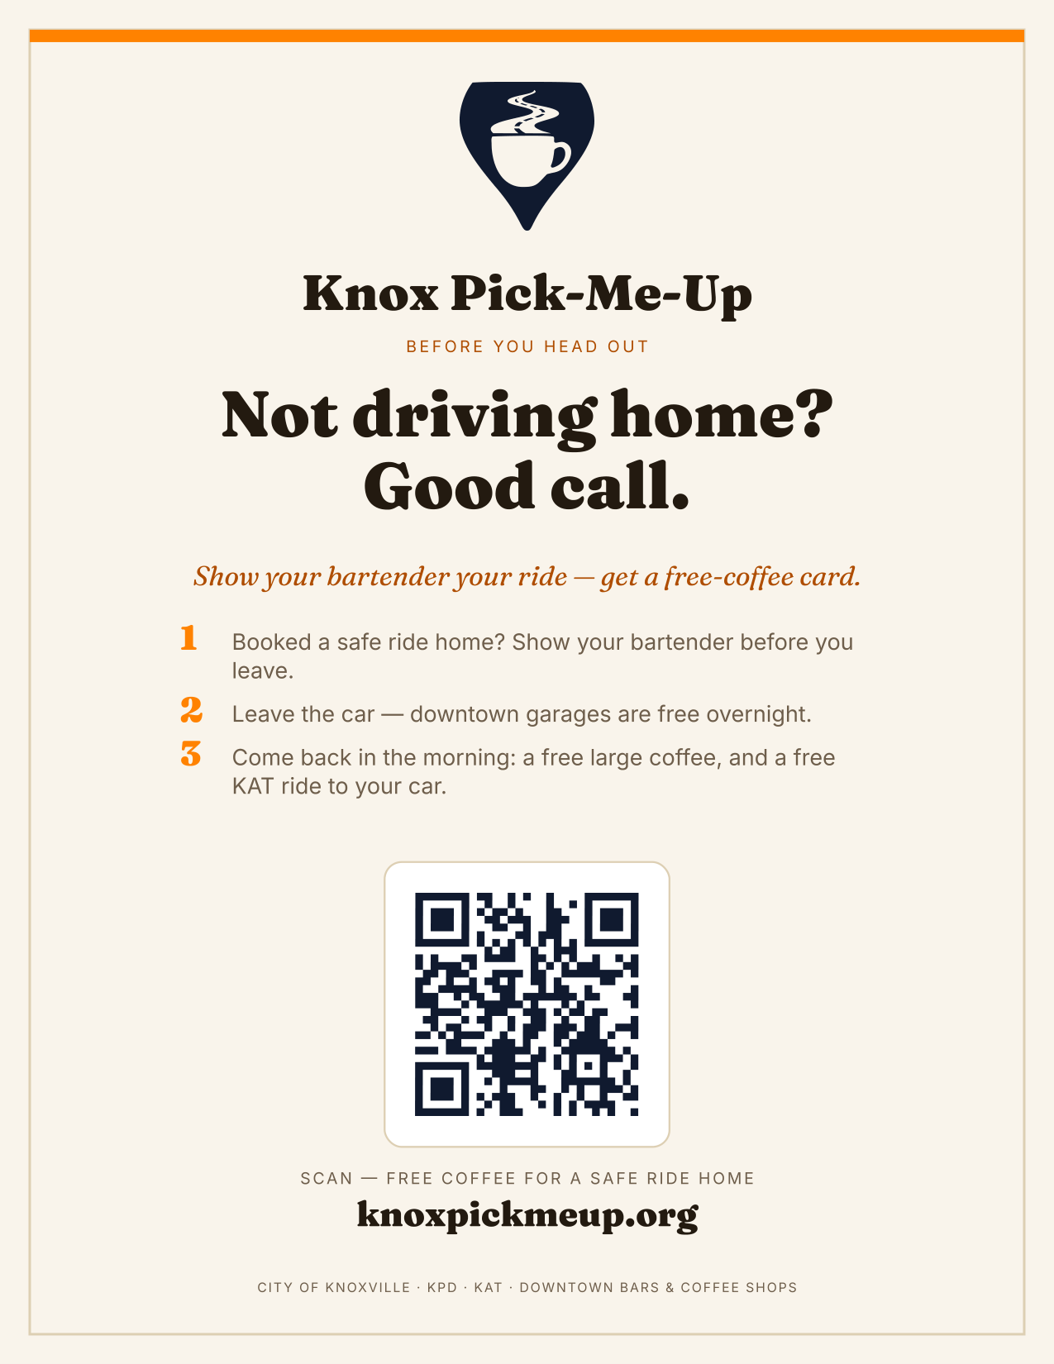
Restroom sign — 8.5″ × 11″
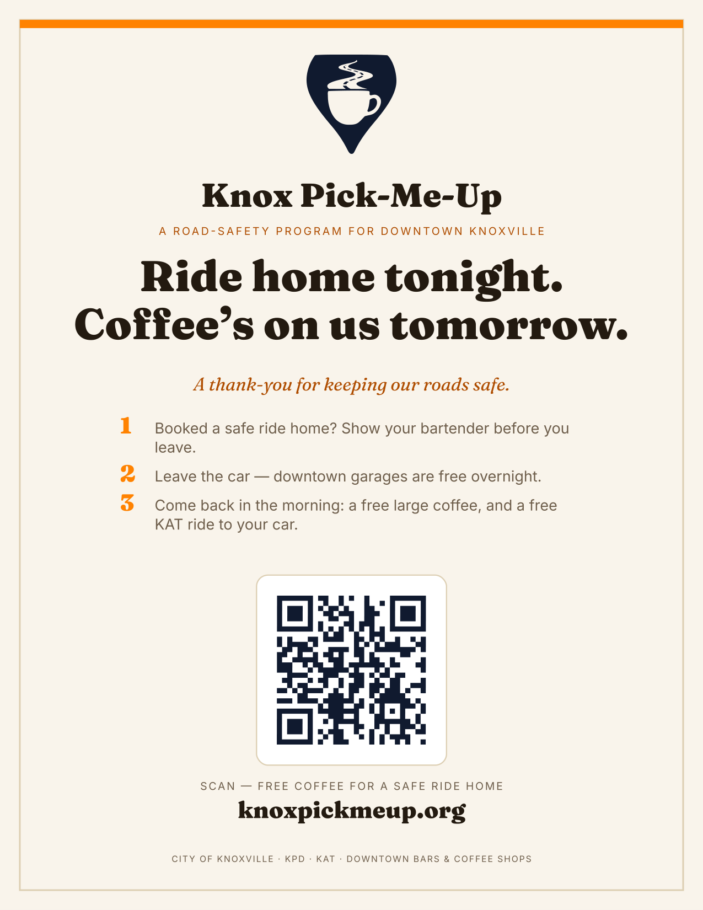
Community flyer — 8.5″ × 11″
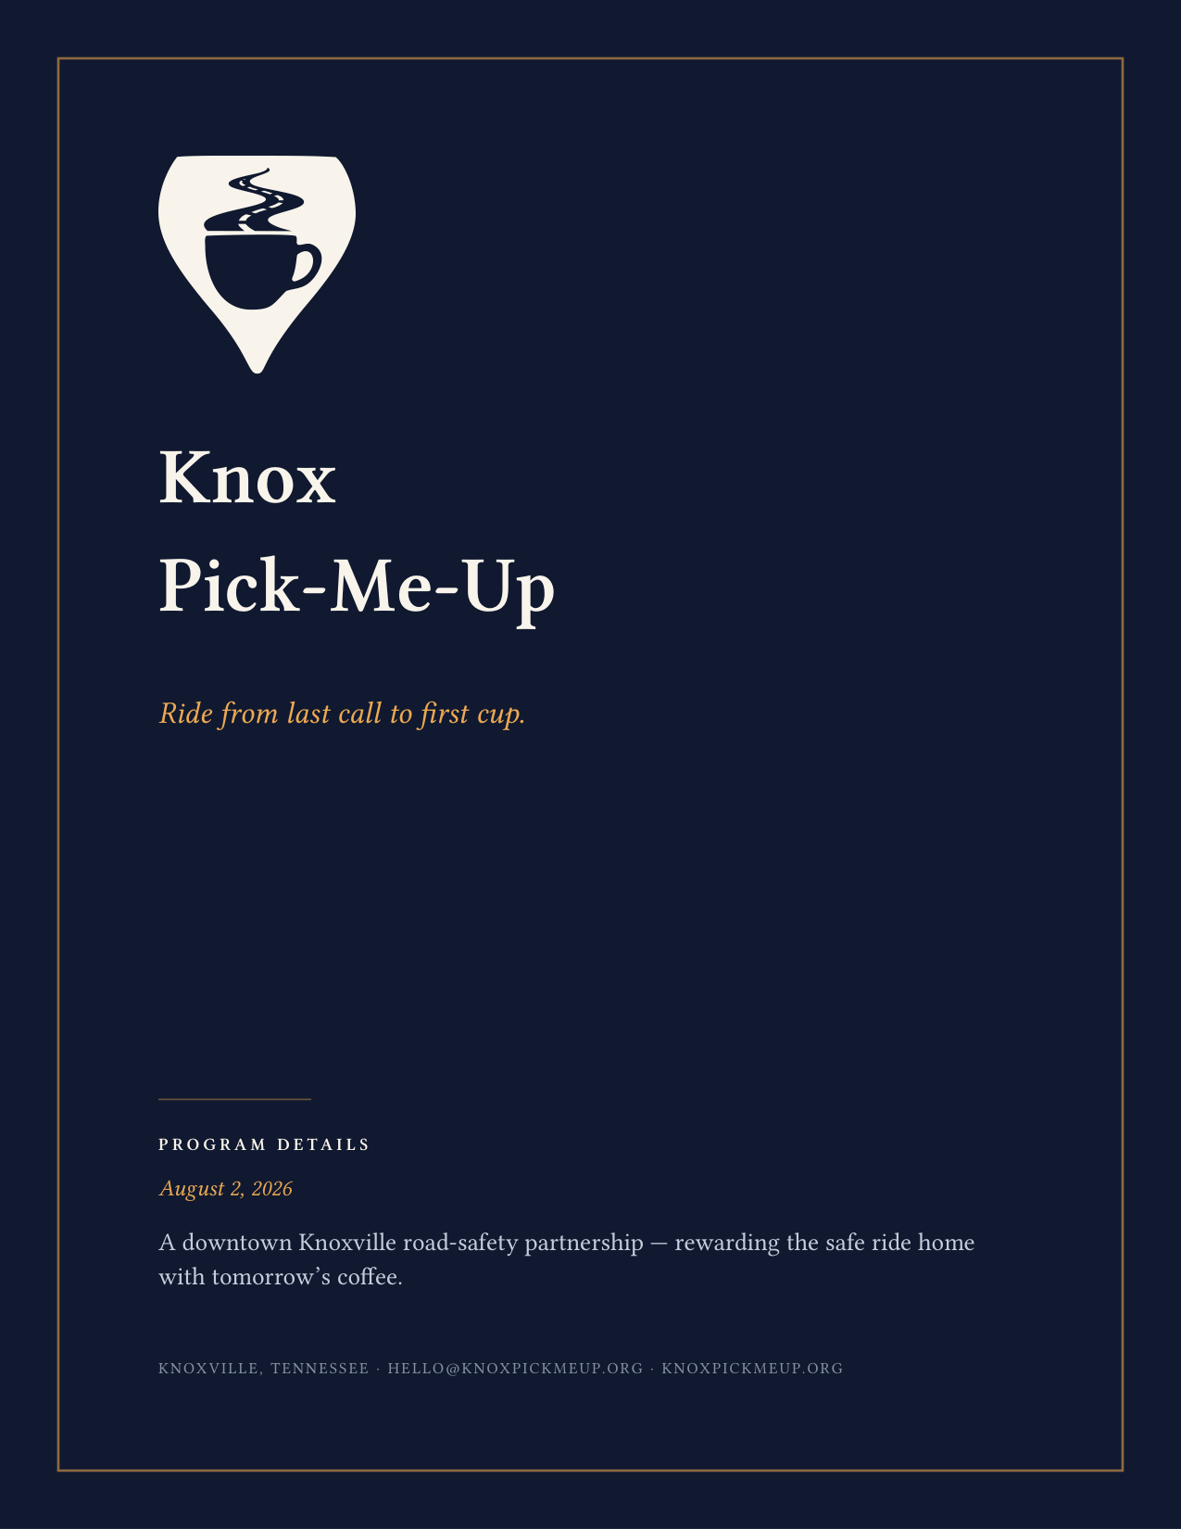
Program Details briefing book — cover (44 pp)

