**RMIT International University Vietnam**

**Assignment Cover Page (INDIVIDUAL)**

|  |  |
| --- | --- |
| **Subject Code:** | COSC2083 |
| **Subject Name:** | Essentials of Information Technology |
| **Location & Campus (SGS or HN) where you study:** | SGS |
| **Title of Assignment:** | Assignment 1: My Profile |
| **Student name:** | Nguyen Luong Le Bao |
| **Student Number:** | s3636073 |
| **Teachers Name:** | Nguyen Ngoc Thanh |
| **Group Number:** |  |
| **Assignment due date:** | 26 Nov 2023 |
| **Date of Submission:** | 25 Nov 2023 |
| **Number of pages including this one:** | 11 |
| **Word Count:** | 1964 |
| **Declaration of Authorship:**  Make sure to read the **Assessment Declaration** [**https://www.rmit.edu.au/students/studentessentials/assessment-and-exams/assessment/assessment-declaration**](https://www.rmit.edu.au/students/studentessentials/assessment-and-exams/assessment/assessment-declaration) | I declare that in submitting all work for this assessment I have read, understood and agree to the content and expectations of the Assessment Declaration |
| **Consent to Use (KEEP ONLY ONE SENTENCE):** | * I do NOT give RMIT University permission to use my work * I give RMIT University permission to use my work as an exemplar and for showcase/exhibition display. This consent will remain valid till________________ (Specify the expiration date of such consent) |

# CONTACT

Name: Nguyen Luong Le Bao

Address: 09 Hung Thai 1, Tan Phong Ward, District 7, Ho Chi Minh City

Nationality: Vietnam

DOB:30/10/1996

Mobile: 0823184220

Email: nguyenluonglebao@gmail.com

LinkedIn: www.linkedin.com/in/nguyenluonglebao

# ABOUT ME

I am a Vietnamese from Ho Chi Minh City currently enrolled in Linguistics as well as Computer Science degrees at RMIT Vietnam with expected graduation date in 2024. As of the moment, I possess good digital literacy skills and intermediate experiences in using Microsoft Office programs such as Word, PowerPoint, Access and Excel. I also have basic graphic editing and designing experiences using Photoshop and Autodesk Maya as well as video editing skills with Adobe Premier and Sony Vegas.

I’m also a bilingual speaker with my mother tongue is Vietnamese and I had a good proficiency in English as a Second Language with an IELT score of 7.5, combined with more than 10 years of learning in a mostly English-speaking environment. For my pastime hobbies, I also try my hands at some basic web designs by creating my own web pages using Wix as well as doing graphic designs in 3D modelling for personal creative projects primarily with programs such as Autodesk Maya and Adobe Photoshop.

After graduation, I look forward to work as either a translator or a video game developer as these jobs are well-suited with the skill set I acquired throughout my years at RMIT as well as related to the pastime hobbies that I often engaged in. While I do not have much experiences in game development and maintenance on mobile platforms, I do have expectations that the company I apply will be able to assist me in acquiring new experiences and skills in fulfilling the requirements that the job required.

# MY INTEREST IN IT

To start off, my interests in IT actually started off with my curiosity with video game modding as well as AI translation program in Linguistics. As IT is about the use of computers and telecom devices to transfer data, process information, and communicate [5] , it is very relevant to the topics of my interest in more than one way. Said topics are about the linguistic translations and secondly, with the field of game development and game design. Both of which involved the storage and retrieval of data, and for game development, it went further with the transmit and manipulate data especially in regards to programming game controls and coding the ingame AI and its algorithm.

For the game development, one of the essential IT knowledges is about programming the in-game AI, designing the interface, and coding the 3D models, these are the skillsets that required a certain IT proficiency level that I still do not have . For the second reason, I studied Linguistics for quite a long period of time as well and this is when I found out about the current developments regarding AI-based translation. While there are many out there, I have yet to see more specialized AI translators regarding English-Vietnamese translator and vice versa.

This is also the reason why I choose to study as RMIT as the open academic environment here allow me to openly sharing, contribute my ideas while also learning about others to improve my knowledges and specialized skills better.

In addition, there is the fact that at RMIT, I could acquire other soft skills such as communication, leadership and teamwork much better as the curriculum of the courses often involved frequent group efforts for projects and assignments. Henceforth, I also hope that by learning IT at RMIT, I could actually participate in the programming of some AI-based translator for the Vietnamese language using both my IT skillset and knowledges of Vietnamese linguistics in both general and professional fields.

Alternatively, I also hope to be able to land a job as a game developer in programming and coding as well as bug fixing, as these are also IT-related tasks that are related to the course and also involved the use of coding programs such as C++, Python, JavaScript, HTML5, etc [4]. These are also related to the animations of 3D models in game as they often require coding and programming to animate and control properly from the player’s perspective. Furthermore, it is usually the task of game programmers and coders to do the bug-fixing using their IT skillset in programming, which is also a crucial part in game development itself.

As such I do hope to acquire as much skills regarding programming in C++, Python, JavaScript and HTML5 as possible. In additions to that, I also expect to acquire new skills in programming for mobile apps regarding translation programs and maybe AI-based-learning so that I could choose to pursue one of the two career choices as mentioned above.

# MY IDEAL JOB

Link to the recruitment page: <https://itviec.com/it-jobs/remote-mobile-games-developer-unity-cocos-ateam-viet-nam-4826?lab_feature=preview_jd_page>

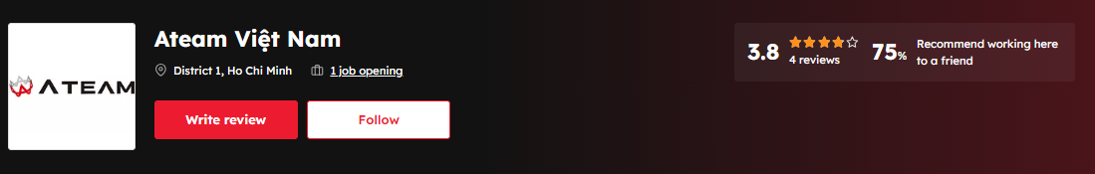

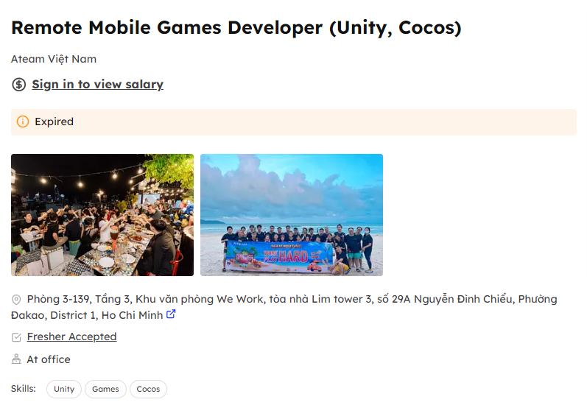

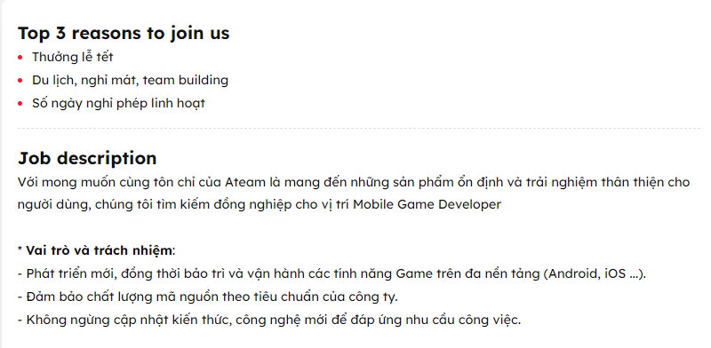

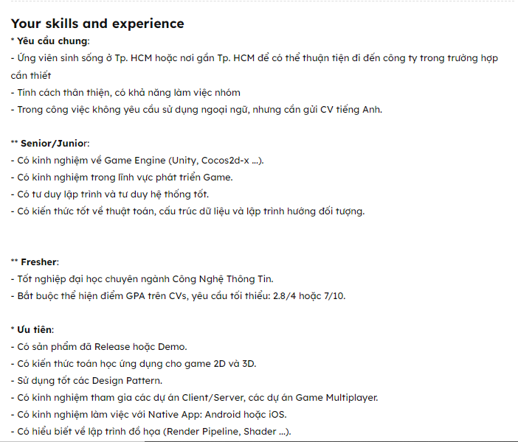

As mentioned above, my ideal kind of job is one that I can be both creative while also be able to use my IT skillsets, this is why I wanted to work in the video game development industry. One of the job advertisements I found from the ITviec site is about game developments. The skillset required are knowledges in IT relating to algorithm, coding, and programming dataset for video game, as well as mathematics for 2D and 3D designs, these are all are very demanding in this kind of field. Other than that, game developers also have to be a bit creative and well-versed in the use and representation of visual and graphic designs, which may also require the use of algorithm and programming.

On this part, the most qualified skills I had as a Fresher Graduate are those that related to graphic designs and I do have some experiences with modding on game engines such as Unity but not by much as Im not that good at programming. While I’m still far from the required skills listed in that list. I do have hope that by spending my time and efforts at RMIT Information Technology and Computing courses, I could acquire the necessary knowledges regarding programming, coding and the usage of AI and algorithms so that I can fulfil these criteria required for a game developer in the video game industry.

# PERSONAL PROFILE

Regarding my personality analysis, there are three websites that I use to help me figuring out how well I will be able to adjust to the IT working environment and, for the moment, how I will be able to coordinate and working with my fellow teammates.

Firstly, I use the Myers-Briggs Type Indicator (MBTI) test, which was developed by the mother-and-daughter team of Isabel Myers and Katharine Briggs [2] to analyze how people identify and understand around how they acquire information and make decisions, as well as observing the patterns of perception and judgment in a normal, healthy behavior. This test is available on the 16Personalities site developed by NERIS Analytics Limited. After answering all the questions, the site provided [1], these are the results:

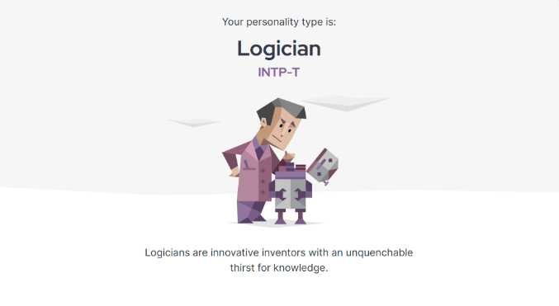

Firstly, according to the website, my personality type is Logician, who often had a thirst for knowledges and are innovative. This is only partially correct however as while I do love learning about something new, I’m not exactly an innovative person.

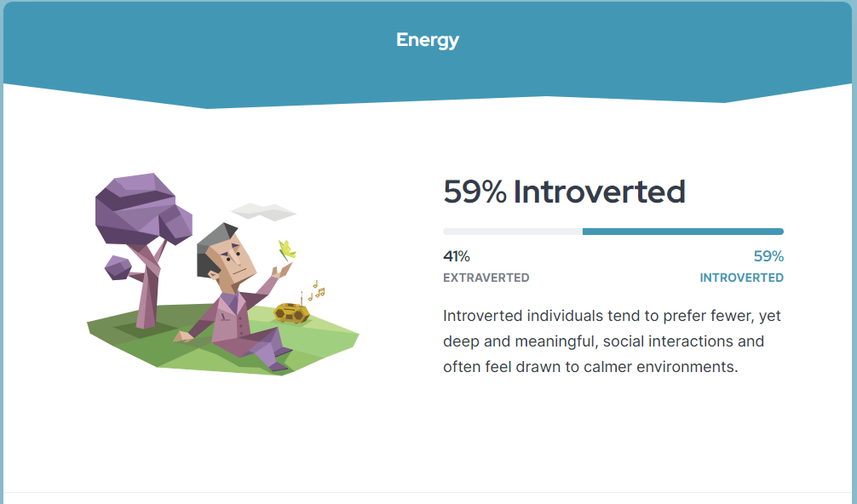

Secondly, in the Energy category, it said I’m introverted, this is actually true as I do prefer fewer networks of friends where I can discuss some of the rather complicated topics and I often prefer more quiet environments when going out for work or hanging out with friends such as in a local café or library.

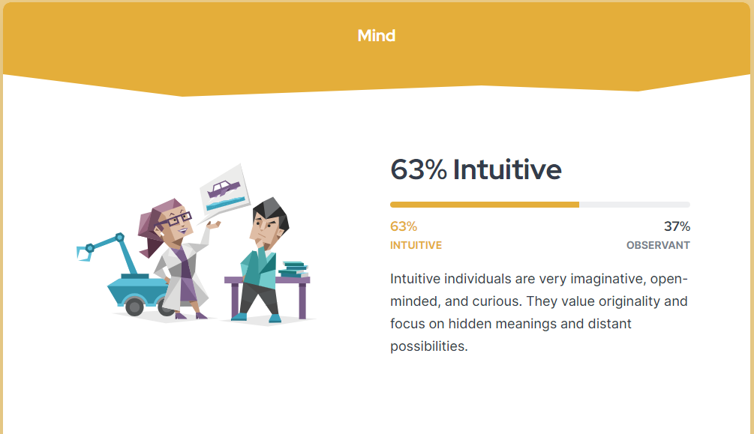

Moving onto the Minds test, the website said I’m an intuitive person. This actually is also true as I have become a lot more open-minded during my time studying in RMIT. I also wanted to try new things outside of my comfort to explore the range of my creativity and learn to be more creative in the kind of contents I wanted to work on when I graduate.

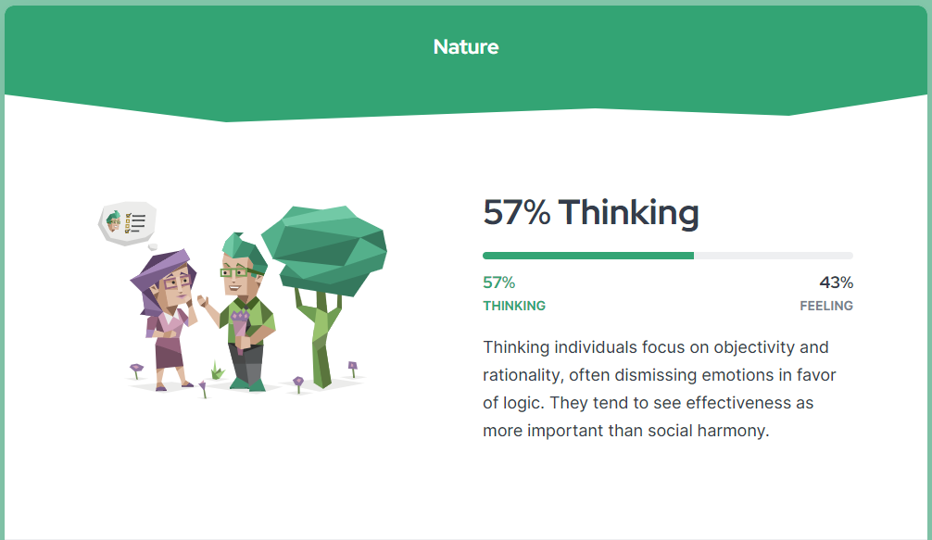

When it comes to the Nature category, it is true that I tend to focus on objectivity and rationality the best as I could. This is due to my time studying in Linguistics course in that I learned the fact that I have to try be unbiased as I can in providing the best possible result with my translation that can be as objective and rational and not catering to any viewpoints.

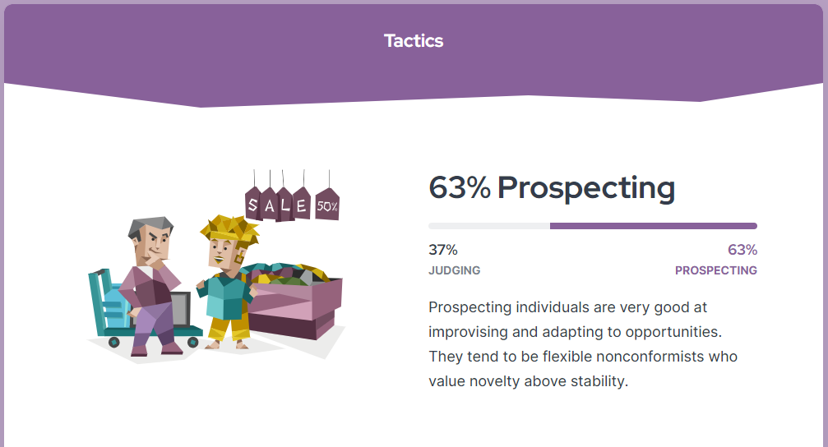

In the Tactics test, it said I’m good at improvise and adapting to opportunities. This is only partly true as while I always tend to improvise and adapt to new opportunities in certain situation, I’m still not exactly that flexible and sometimes I still prefer the comfort of stability in tried-and-true methods.

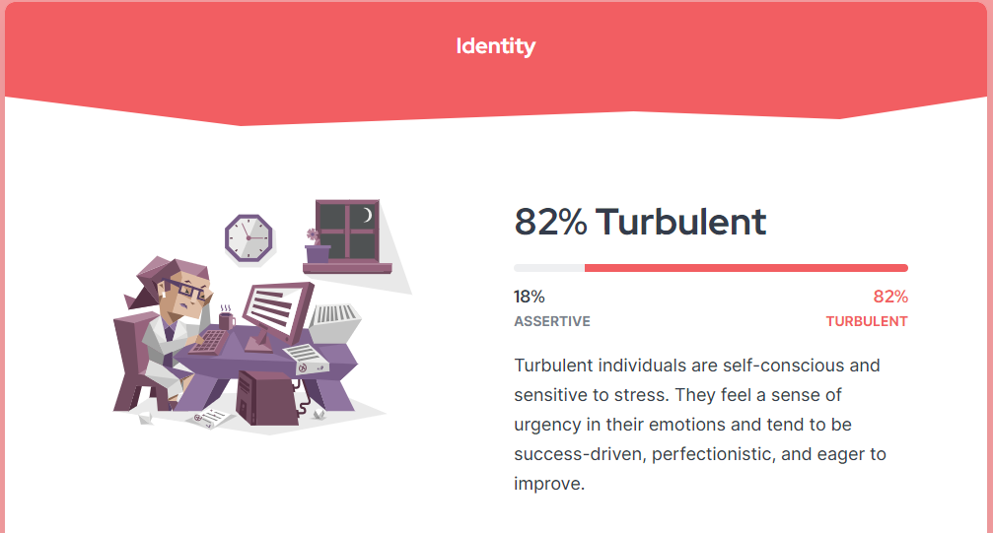

Lastly, the Identity category gave me the Turbulent result. This is actually true as I can be a bit perfectionist when it comes to the teamwork projects, as well as prone to stress at the deadlines of my assignments. Whenever the results came in, I often think that we (the team I’m in) could have done so much better. This has been a persistent thing throughout my years in the Linguistic courses.

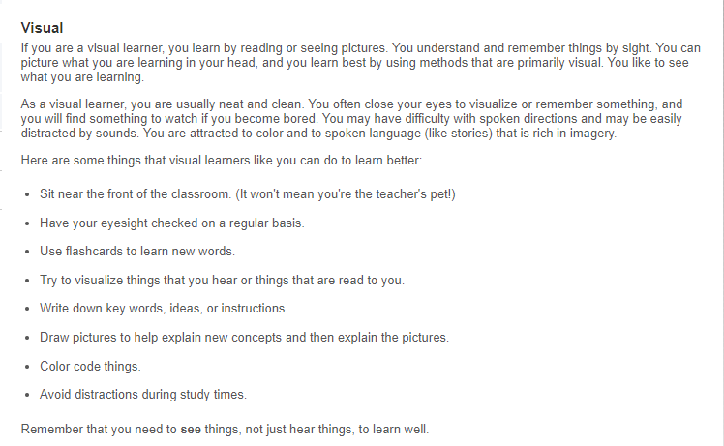



Moving onto the second test regarding my Learning Styles, there are also a lot to talk about. When it comes to my learning style, I did a quiz on what my preferred learning method is on the website of Education Planners organization. The result is that I’m a Visual Learner as I tend to prefer learning with some proper descriptions of items and subjects through pictures [3]. A proper description helped me memorize things better with the visualized details. Also, this is why I tend to exhibit perfectionist tendencies, as I often try to memorize and visualize things to best possible depictions. Once more, this

visual-oriented preference of mine is also why I really like creative works like colorful visual arts and stories and also can be a bit overly detailed when it comes to writing in my assignments.

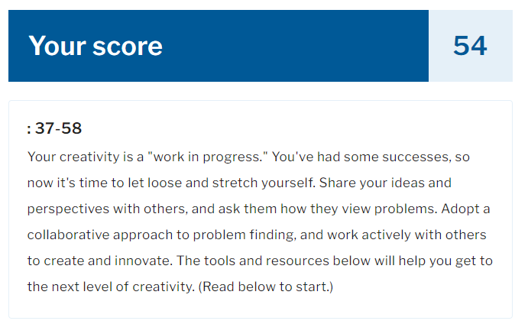

Of course, because I can be a bit of a creative-minded person, therefore I also did another creativity test to see where I would fit. For this I use the Creativity test of the Mind Tools website [7]. The test result for this one is that my mindset is a “work in progress”, I actually do have some of my teamwork projects in previous courses being featured by the course tutors. I also actively engaged to share my ideas and suggestions for teamwork projects, especially those that piqued topic of my interests. While some of the stuff I share may not align with other people’s ideas, I do agree with a common approach in how we should do the projects by combining various good ideas as well as using problem-solving skills and our gained knowledges to the requirements and the problems throughout the various working phases of these projects.

From all of these tests, I can summarize that I am a very creative, intuitive person when it comes to my topics of interests, which can be exceptionally helpful for teamwork as they can make me becoming more active and enhance my communication as well as social skills in my future works. However, my perfectionist mindset and preferences for topics related to my interests may put it at odds with other teammates who has different mindsets and ideas.

To conclude, regarding the team project, I can assure that I will be an active participant and also a helpful teammate for the group efforts with my ideas and dedication to works. I will also have to tone down my expectation regarding my perfectionist tendencies also as because this is a group project, there are some room for errors and evaluations from our tutors. All in all, the team I hoped for would be one with like-minded introverted, creative and intuitive people who can actively discuss and argue with me on how we should do the projects to our best efforts.

# References

1. NERIS Analytics Limited. “Free Personality Test.” 16Personalities. <https://www.16personalities.com/free-personality-test> (accessed Nov 18, 2023).
2. Myers & Briggs Foundation, “Myers-Briggs® Overview.” The Myers & Briggs Foundation. <https://www.myersbriggs.org/my-mbti-personality-type/myers-briggs-overview/> (accessed Nov 18, 2023).
3. “What's Your Learning Style?” Education Planners. <http://www.educationplanner.org/students/self-assessments/learning-styles-quiz> (Accessed Nov 19, 2023).
4. Ateam Vietnam, “Job Recruitment - Remote Mobile Game Developer” ITviec. <https://itviec.com/it-jobs/remote-mobile-games-developer-unity-cocos-ateam-viet-nam-4826?lab_feature=preview_jd_page> (accessed Nov 19, 2023).
5. Harland, J 2017, Introduction to Information Technology COSC1078, 5th edn, Pearson Education, Australia.

<https://slideplayer.com/slide/5063628/> (accessed Nov 19, 2023).

1. “Skills Needed to Be a Game Developer”, Eastern College. <https://www.easterncollege.ca/blog/skills-needed-to-be-a-game-developer/> (accessed Nov 19, 2023).
2. Mind Tools Content Team, “How Creative Are You?”, MindTools.

<https://www.mindtools.com/a57l978/how-creative-are-you> (accessed Nov 19, 2023).