

**Student Violation System**

**(Manual Instructions)**

**Sumbi, Lawrence Guian P.**

**BSIT2A**



## **Introduction**

This manual will guide you on how to use the **Student Violation System** to record, track, and manage student violations in your school. The system is a digital tool that helps teachers and administrators easily log violations, review records, and create reports for better decision-making and discipline management.

## **Significance**

The **Student Violation System** helps create a safer and more organized school environment. It makes it easier to record and manage violations, ensuring that all cases are properly documented. This improves accountability, fairness, and transparency in handling discipline. The system also helps schools understand behavior patterns so they can address issues early and create a positive learning environment for everyone.

## **Benefactors**

* Guidance Counselor/Prefect of Discipline/Administrator

They use the system to review and manage student violations, generate reports, and monitor student behavior patterns. This helps them make informed decisions and implement appropriate actions to maintain a safe and disciplined learning environment.

* Teachers/User

Teachers can easily log student violations, view past records, and assist in managing behavior in the classroom. The system saves time and provides a structured way for teachers to report infractions consistently.

* Students/Subjects of Violations

Students benefit from the system by receiving fair and consistent disciplinary actions based on documented records. It helps them become more aware of their behavior and encourages them to improve, contributing to a positive and respectful school community.



TABLE OF CONTENTS

1. Login………………………………………………………………………………4
2. Register…………………………………………………………………………...5
3. Forgot Password…………………………………………………………………6
4. Admin Dashboard………………………………………………………………..8
5. Student (Admin)………………………………………………………………….9
6. Violation (Admin)…………………………………………………………………10
7. Record (Admin)…………………………………………………………………..11
8. Print Preview (Admin)……………………………………………………………12
9. Users (Admin)…………………………………………………………………….13
10. Account Settings (Admin)……………………………………………………….14
11. Activity Logs (Admin)…………………………………………………………….15
12. User Dashboard………………………………………………………………….16
13. Student (User)…………………………………………………………………….17
14. Violation (User)……………………………………………………………………18
15. View Report (User)……………………………………………………………….19
16. Account Settings (User)………………………………………………………….20



## **How to use the System**

1. **Login**

Upon running the program, a login page will appear.

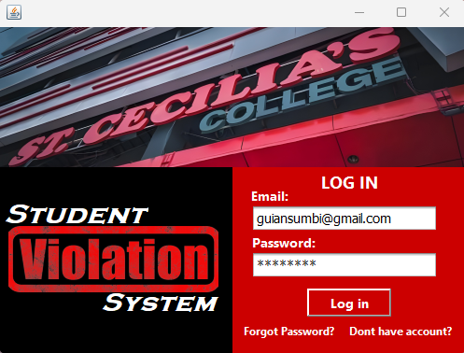

If you already have an account, Input your login details.

Otherwise, Click “Don’t have account?” to register an account.



1. **Register**

This is the form where user can create account.

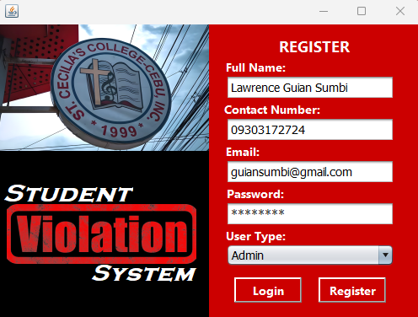

To have an account, you need to fill up the following fields.

Input full name, contact number must be in 11 digits, have a valid email account and password must be 8 digits or more.

If you are a Guidance/Prefect of Discipline in school, select Admin. If you are a teacher, select User.



1. **Forgot Password**

If you forgot your password, this will help you reset your password.

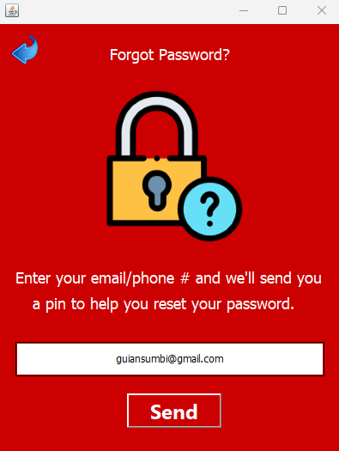 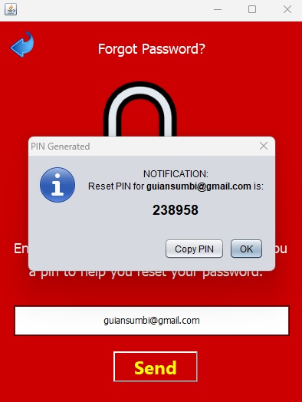

Enter your email/phone number of your account in order to receive a reset pin.

After receiving a reset pin, copy it.



Verification and Resetting Password:

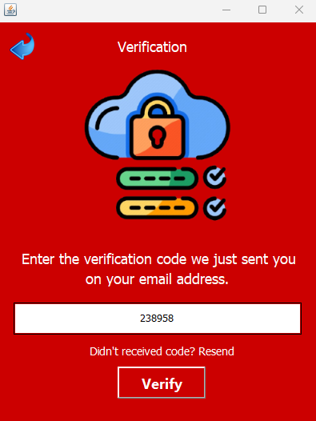 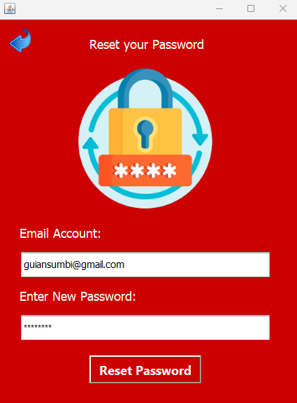

Paste the reset pin on the text field and click verify button.

After successful verification, you can now reset your password.

After that, you will automatically go to the login form.



1. **Admin Dashboard**

This is the landing page if you are an Administrator.

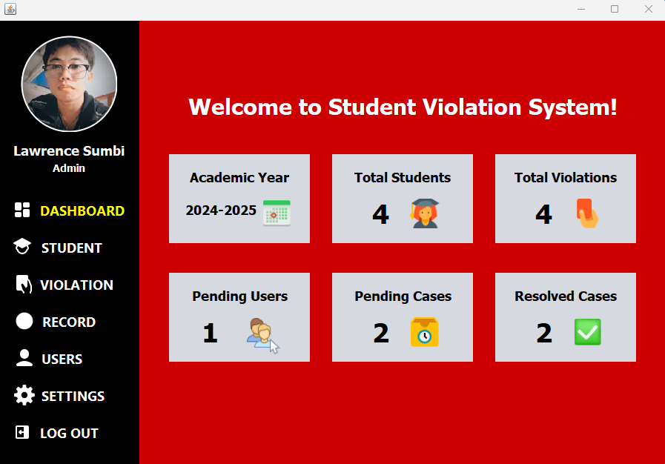

It will display the total enrolled students, total violation committed by a student, total pending users, total pending cases, and total resolved cases.

It will also automatically update if there are changes.



1. **Student (Admin)**

This is the form where admin can add, edit, and delete student details.

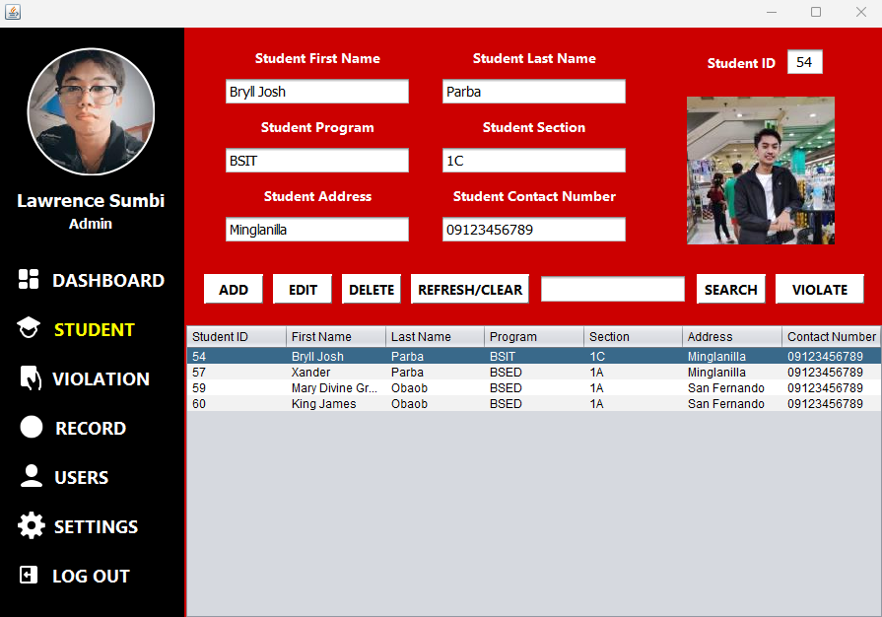

Input Student First Name, Last Name, Program, Section, Address and Contact Number.

You can also upload image for the student, just click the image icon to upload. And if you want to remove or update the image, just click the icon again and the options will pop-up.

Click the column/row of the table to display the full details of the specific student.

Then if you want to violate that student, just click the column/row of the table displaying the specific student and click violate button and it will automatically link to the violation form.



1. **Violation (Admin)**

This is the form where admin can add, edit and delete violation details.

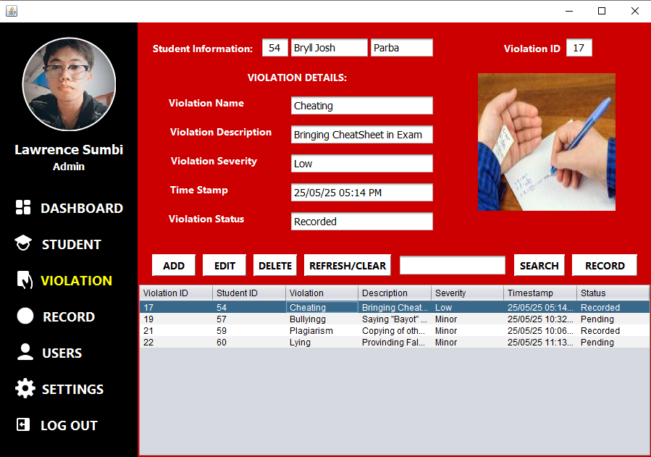

After you click the violate button from the previous form, the student ID will pop-up like the student ID 54 shown above. To display the name of the student automatically, just click the text field after the student ID.

After that, input the violation name, description (specific situation), severity (low/high or minor/major) depends on your preference. You can also add and edit image here to have evidences. And click the add button to record the violation.

Note: You cannot edit and delete the violation if the status is already “Recorded”. Make sure when you edit and delete, it is still in the “Pending” status.

Since you are an Administrator, you can record that violation to add sanction, just click the column/row of the table to display the specific details and click the record button to proceed.



1. **Record (Admin)**

This is the form where admin can add and edit record/report details.

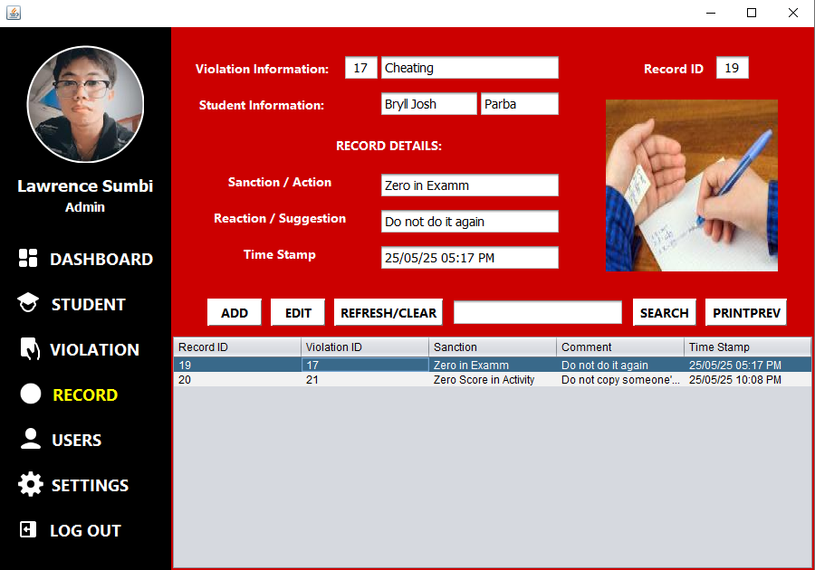

After you click the record button from the previous form, the Violation ID will pop-up just like the Violation ID 17 shown above, same process to display the violation information and student information, just click the text field next after the Violation ID in order to automatically display the information.

After that, you can now input Sanction and Comment. In this part, the image shown will based on the image of the Violation, you cannot edit the image here.

And if you like to view the full details and print it to have a hardcopy, just click the print preview button.



1. **Print Preview / Print**

In this part, you can view the very full details of the record and you can print it.

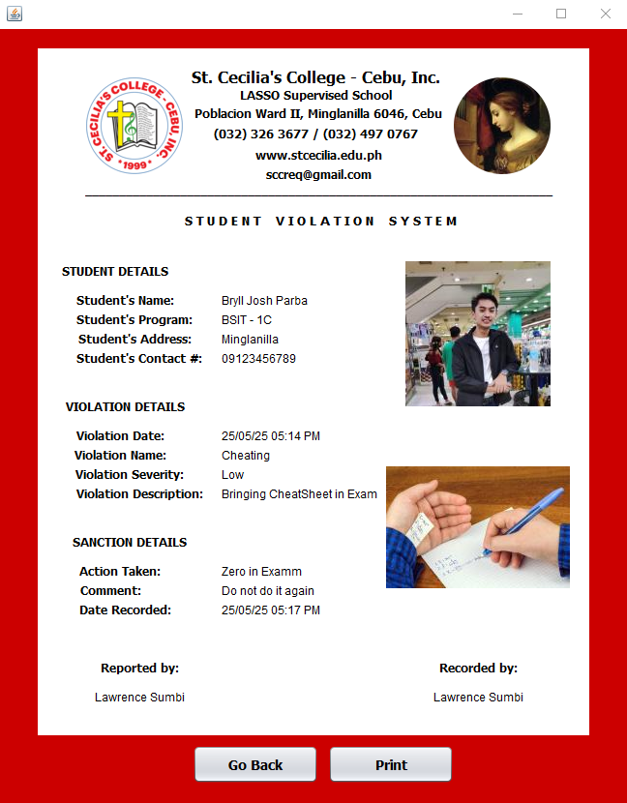

It displays all the information including the images from the student details, violation details and sanction details. And if you want to print/export, just click the print button.



1. **Users (Admin)**

This is the form where admin can add account/user, edit, and delete user.

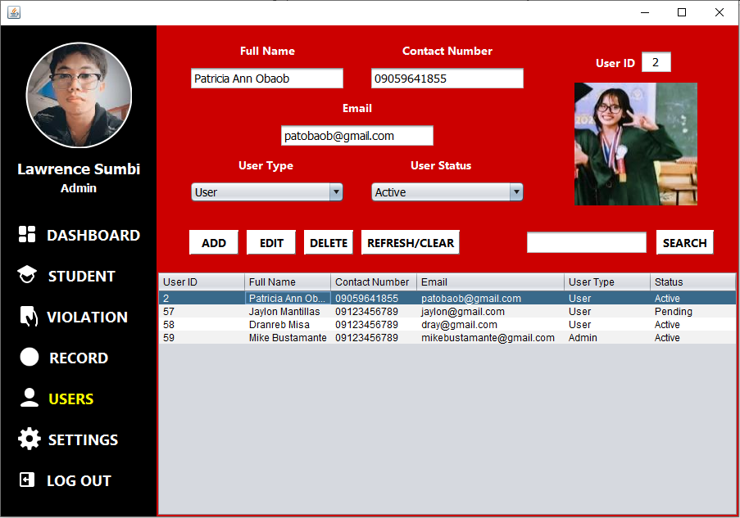

Admin can also create account in this form, the process of this one is same with the registration form.

Input the user full name, contact number, email, select user type and select user status.

You can also upload image, remove image, and update image.

If the status of the user is “Pending” he/she cannot logged in, so you must update his status to “Active”.

The details of the logged-in admin will not display.



1. **Account Settings (Admin)**

This is the form where admin can change his profile and password.

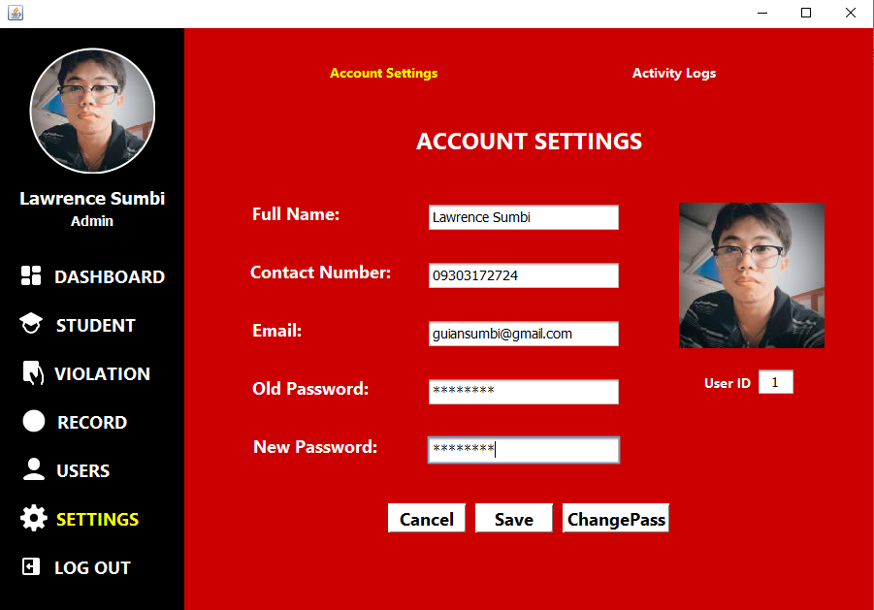

Admin can change his Full name, Contact Number his profile picture and his password.

If you want to change the full name, contact number and image just click the save button.

If you want to change your password, just input the old password that you are using and enter the new password and click the change password button.



1. **Activity Logs (Admin)**

This is the form where admin can see the activities done by the admin and the other users.

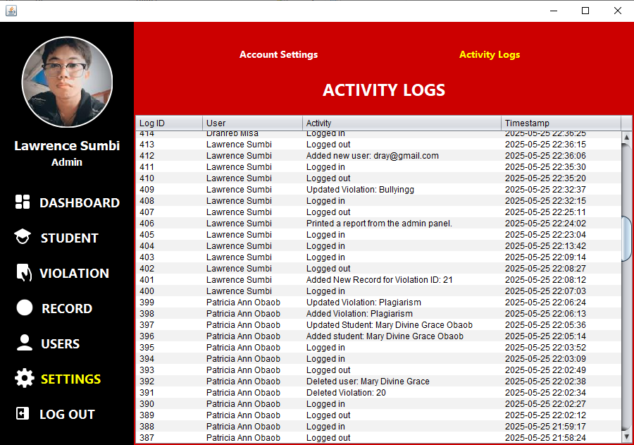

It shows the name of the user, the activity that he/she did and the date and time.



1. **User/Teacher Dashboard**

This is the landing page if you are a User/Teacher.

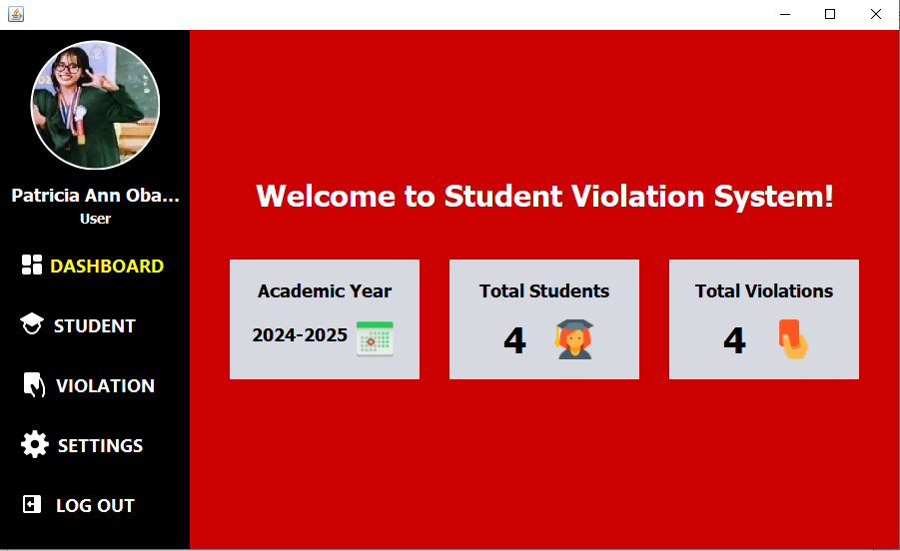

It will display the total enrolled students and the total violations committed by a student.

It will also automatically update if there are changes.



1. **Student (User)**

This is the form where users/teachers can add, edit, and delete student details.

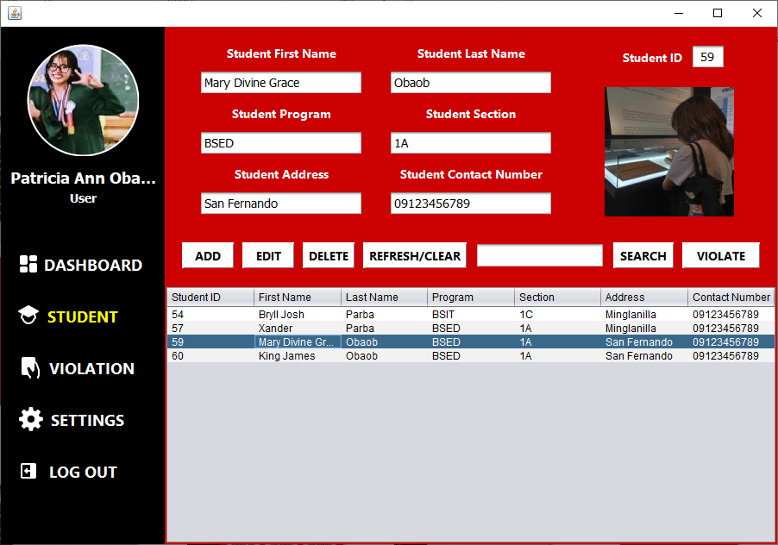

Input Student First Name, Last Name, Program, Section, Address and Contact Number.

You can also upload image for the student, just click the image icon to upload. And if you want to remove or update the image, just click the icon again and the options will pop-up.

Click the column/row of the table to display the full details of the specific student.

Then if you want to violate that student, just click the column/row of the table displaying the specific student and click violate button and it will automatically link to the violation form.



1. **Violation (User)**

This is the form where teachers can add, edit and delete violation details.

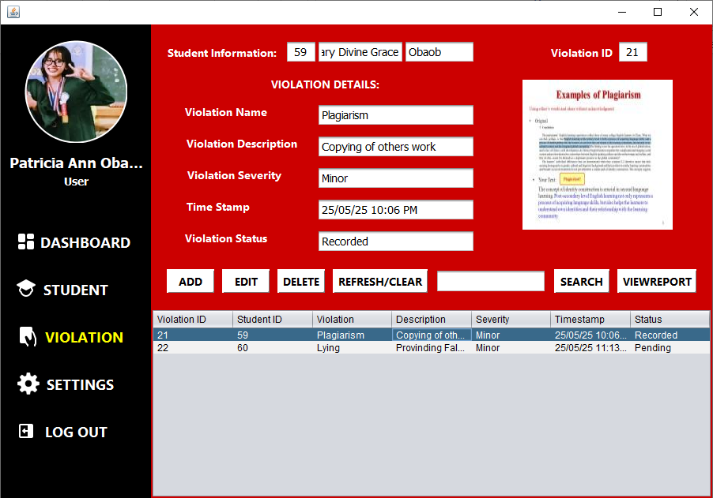

After you click the violate button from the previous form, the student ID will pop-up like the student ID 59 shown above. To display the name of the student automatically, just click the text field after the student ID.

After that, input the violation name, description (specific situation), severity (low/high or minor/major) depends on your preference. You can also add and edit image here to have evidences. And click the add button to record the violation.

Note: You cannot edit and delete the violation if the status is already “Recorded”. Make sure when you edit and delete, it is still in the “Pending” status.

Teachers can also view their own reports when the status is now “Recorded” by clicking the view report button.



1. **View Report (User)**

In this part, teachers can also view the very full details of the record and they can also print it.

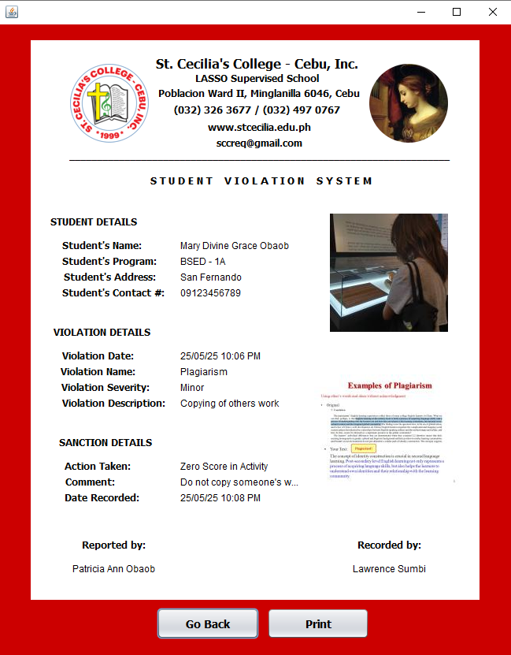

It displays all the information including the images from the student details, violation details and sanction details. And if you want to print/export, just click the print button.



1. **Account Settings (User)**

This is the form where teachers can change his/her profile and password.

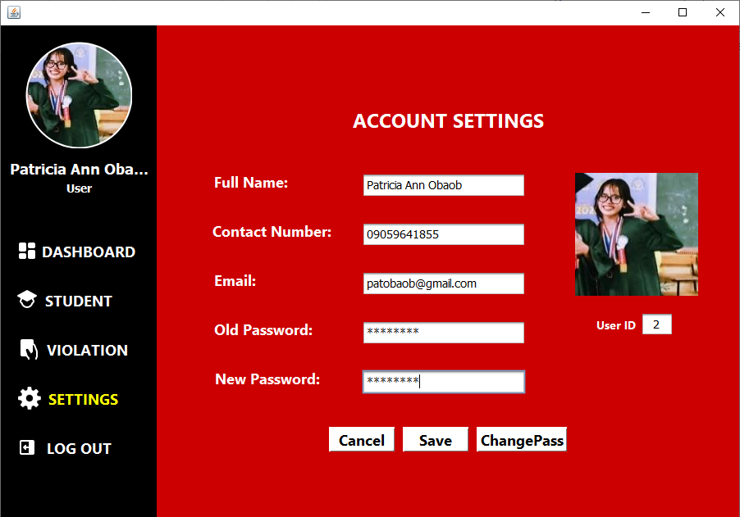

Teachers can change his/her Full name, Contact Number his profile picture and his password.

If you want to change the full name, contact number and image just click the save button.

If you want to change your password, just input the old password that you are using and enter the new password and click the change password button.