Tab 1

Mobile Menu on iPhone

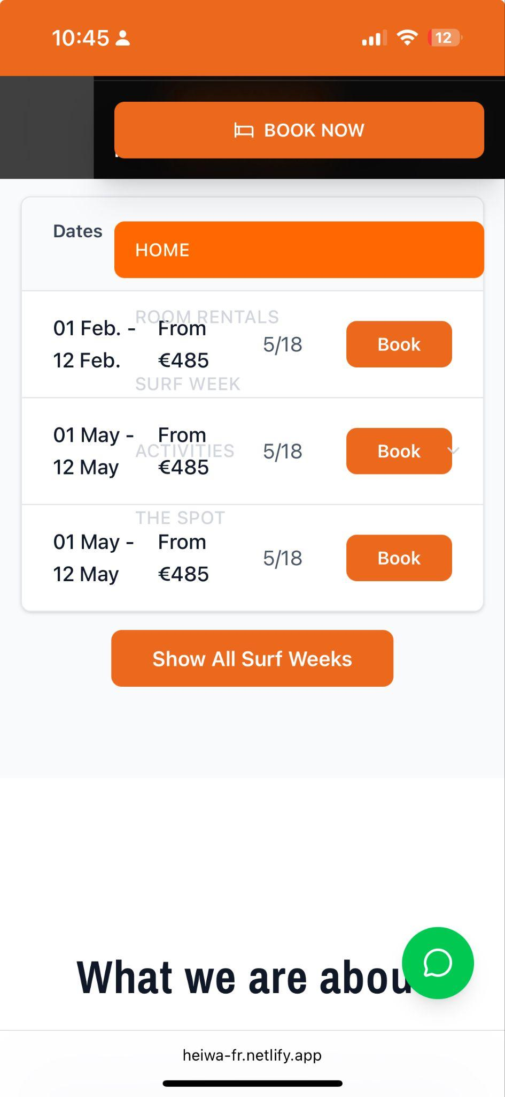

BOOK CTA Buttons

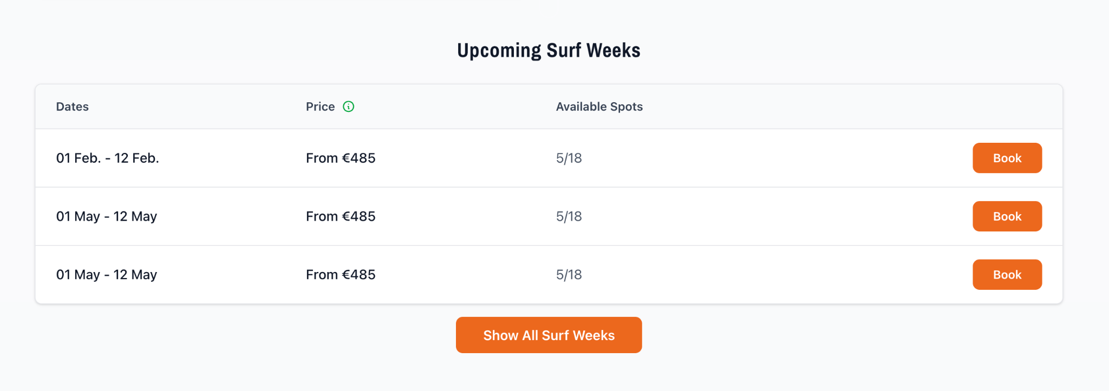
Book for each camp should open the booking engine with that surf week automatically selected in terms of dates. Show all surf weeks goes to the surf weeks page. Currently all 4 link to the same.

Surf Weeks Not Existing

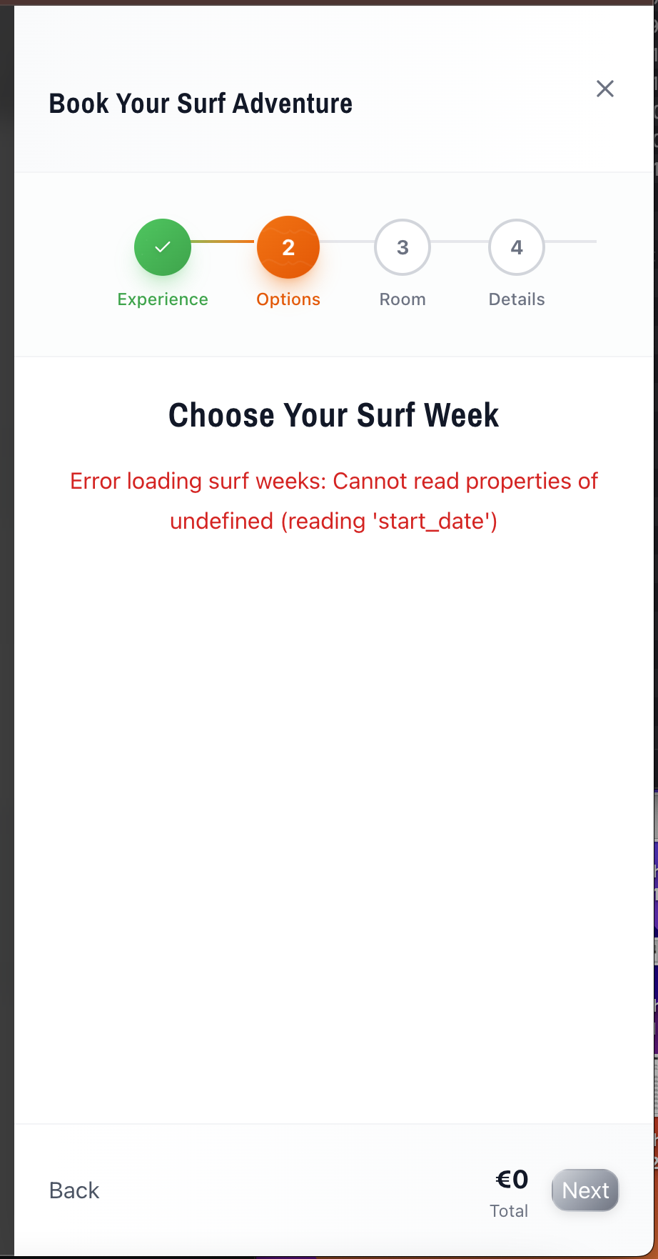

Customer Reviews

What is needed to show the right reviews? I need to get an API key from somewhere?

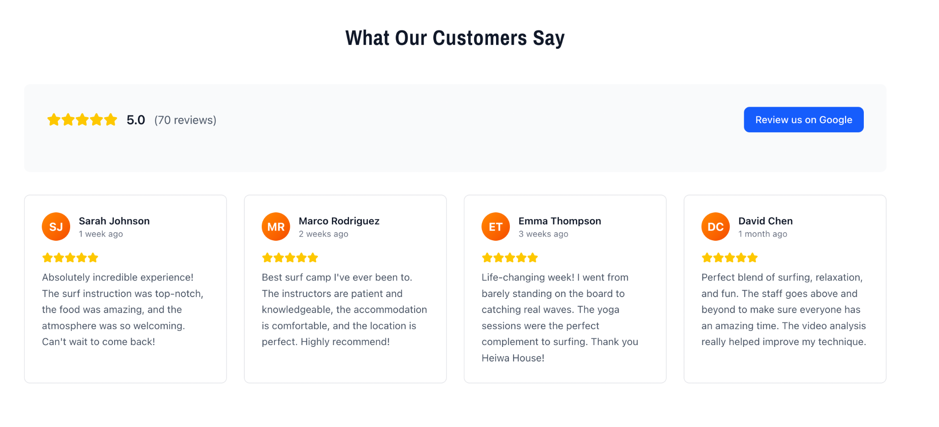

FAQ

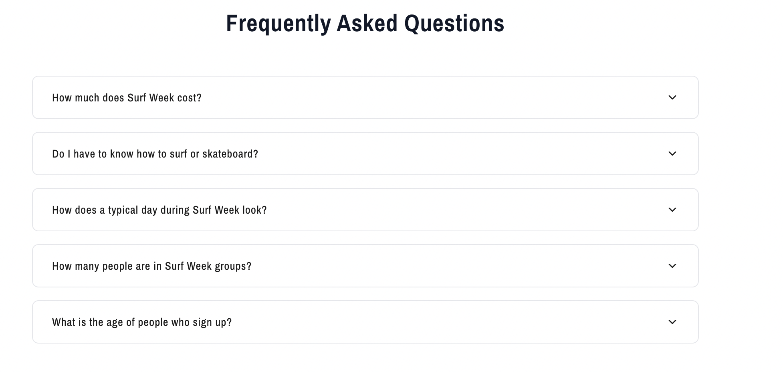

Check availability
https://heiwa-fr.netlify.app/flow the button does not do anything.



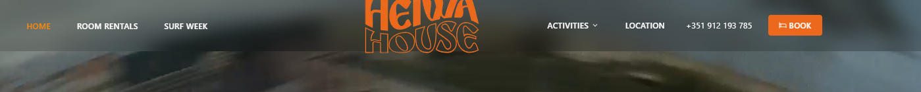
Logo overflowing the menu bar. Please make it around 20% smaller

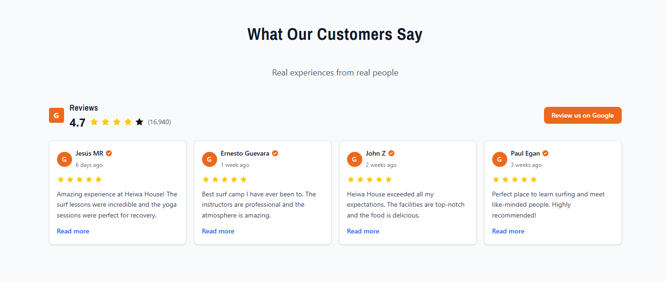
Please remove button “Review us on Google”

When you enter any of pages - the menu does not have surf button. And I think it should stay with same order of menus as main page, so there is less confusion.

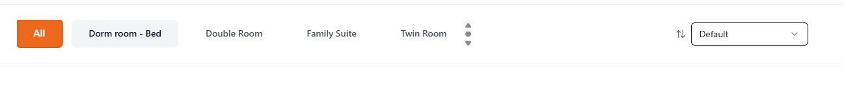
Because we have only 4 rooms, no need for this bar

I think we don't need the section “ THE SPOT” anymore, because all the info is already elsewhere - main page, surf, flow and play

BLOG
- Blog needs H tags, as in, so we can assign H2/H3/H4s to titles.
- When I click on upload the image, it asks me for an image URL, should be an upload?

Avatar for author should be an upload too.

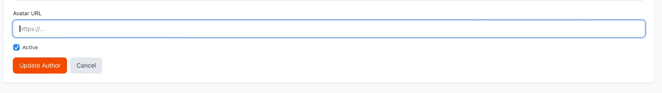

Booking Flow Payment With Bank Transfer

Homepage

Youtube Video - disable controls
That means title is not visible, you should not be able to click on the video title to go to the actual URL.

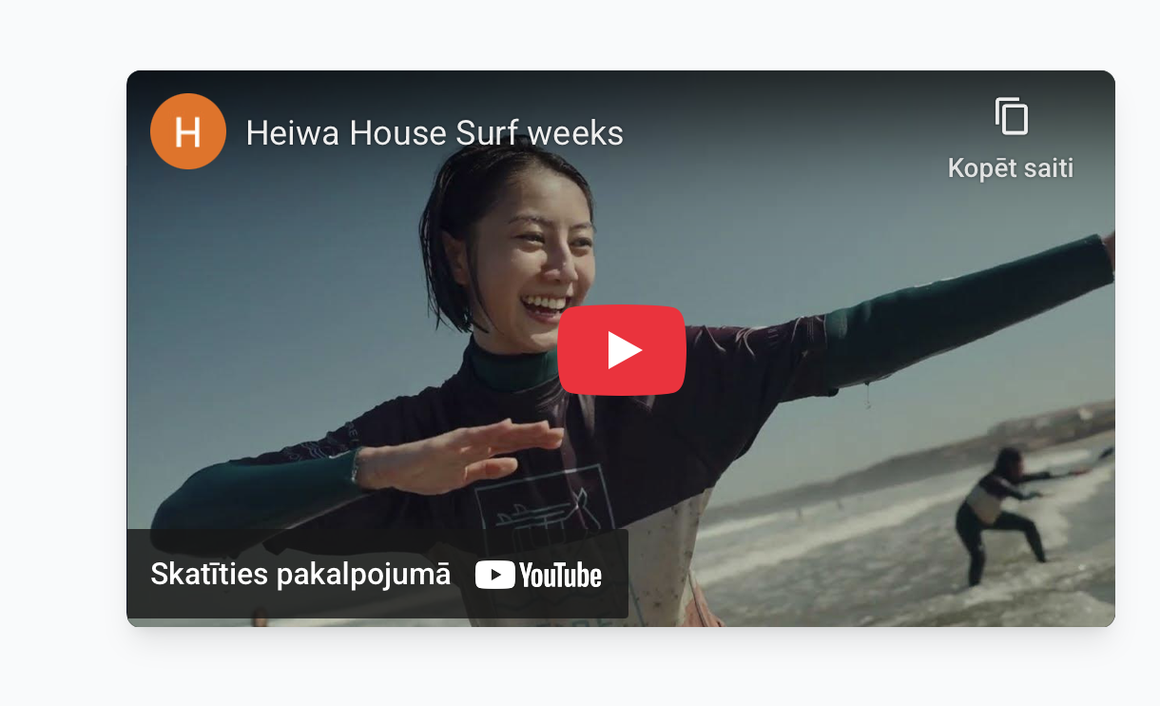

Customer Reviews

What is needed to show the right reviews? I need to get an API key from somewhere?

FAQ

Rooms

Images not loading on individual room pages

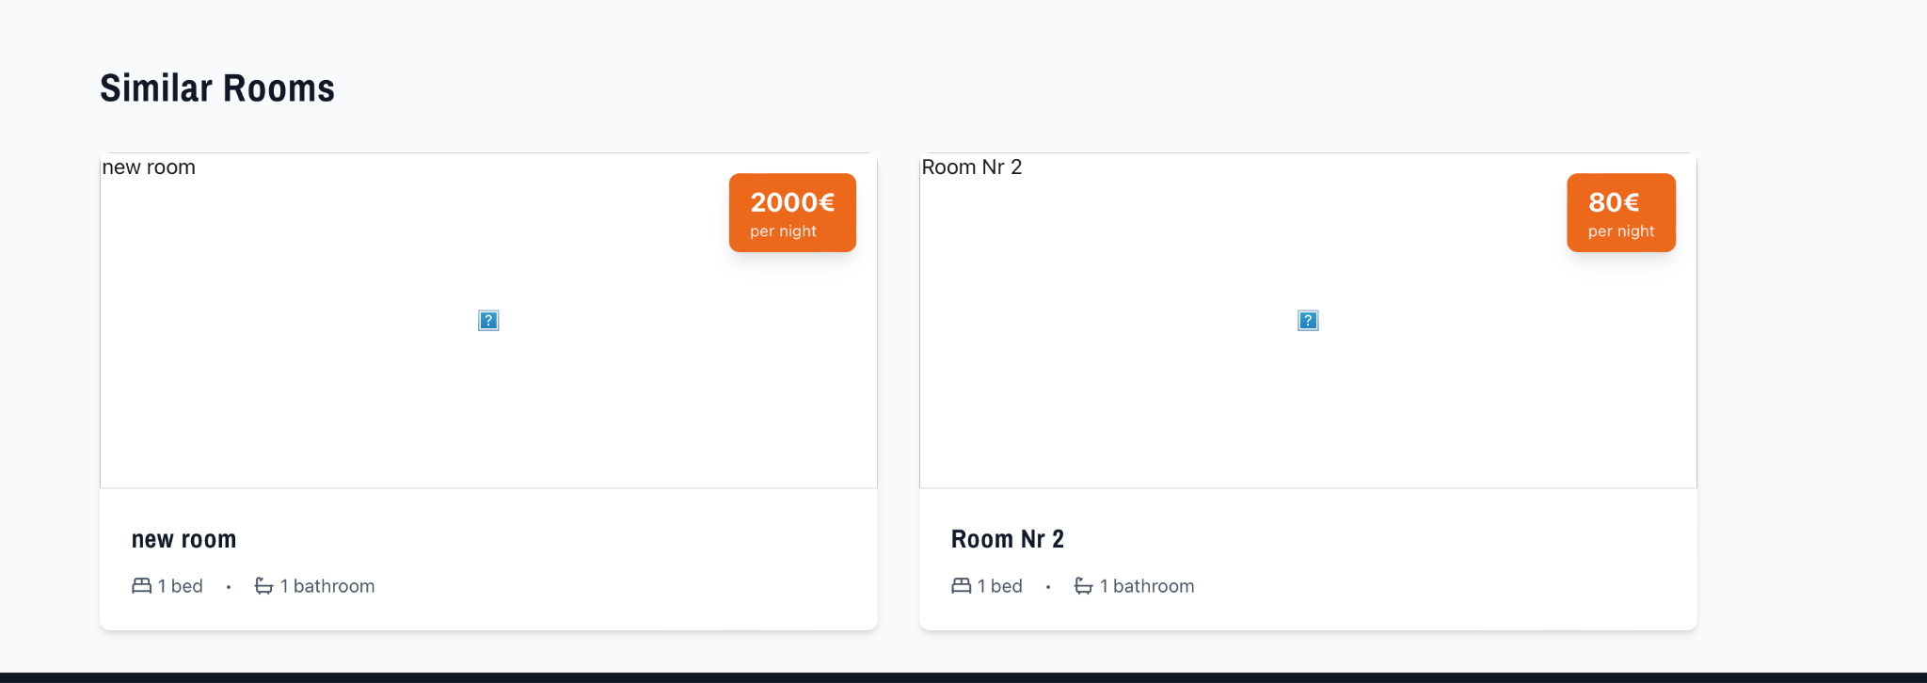

➕ Surf Week

Next Surfweek

What happened to the next surf week feature from the wireframe?

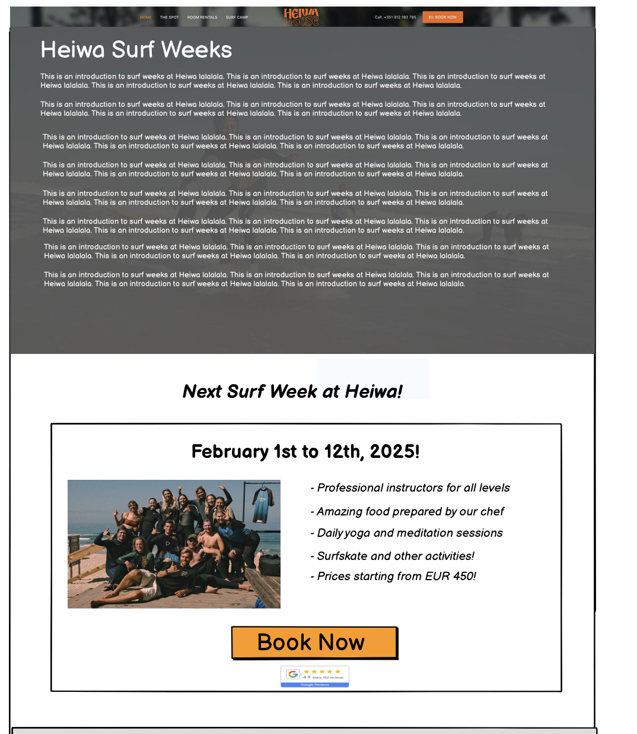

Mobile table UX
You’re doing well on the homepage for this, why not keep that same style?
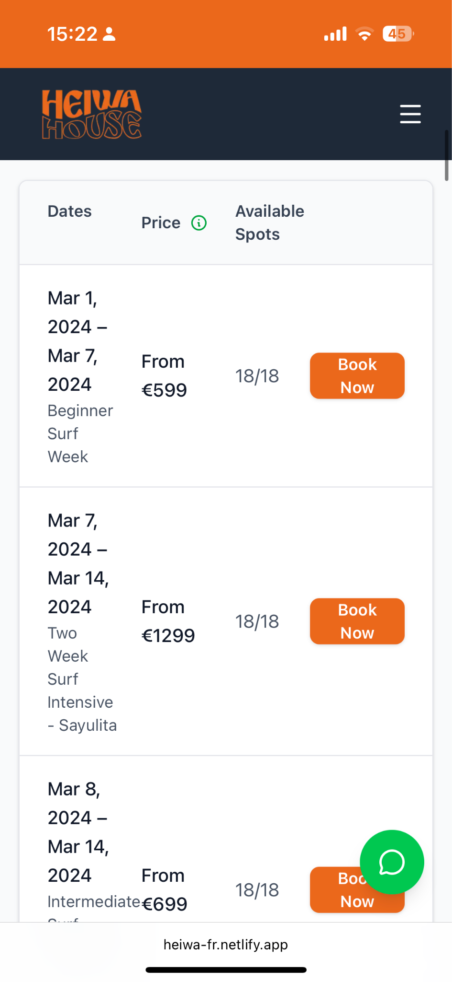

Overall Surf Camps page feels too stretched out. Maybe we can make sections more compact.
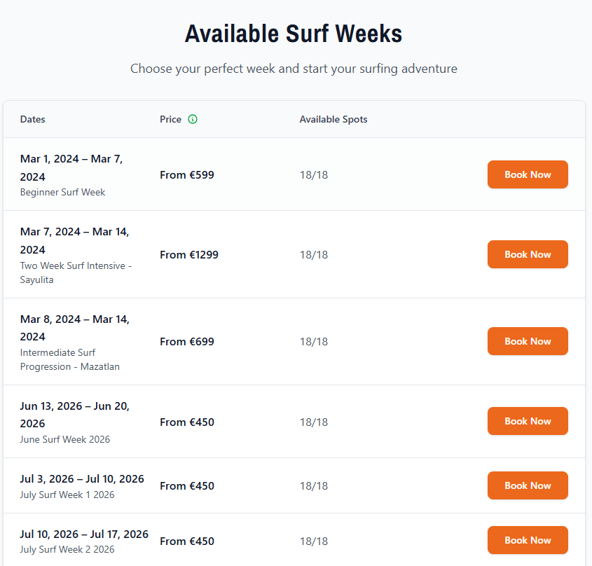
This section should show 4 surf weeks and be expandable to show all.
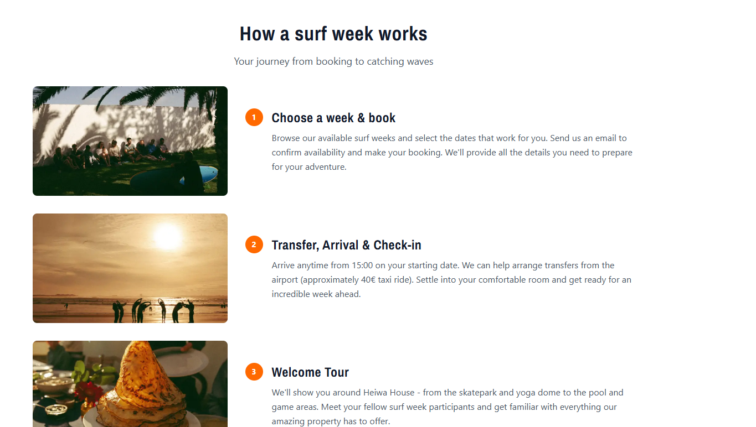
This section maybe can be organized in two or three columns so it is not so long

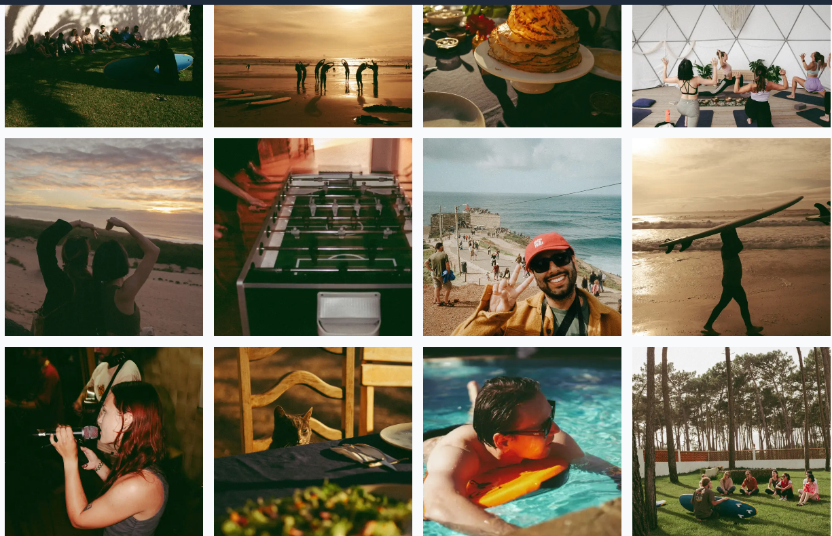
Reduce to two lines and make it scrollable sideways

Heiwa Surf
It makes me sad to see that you decided to completely disregard the wireframe I create and let chatgpt decide on how to structure this page.

As always machine is smarter than human so there actually are some things we can keep IMO

The page should be structured like this (anything I haven’t mentioned here should be removed)

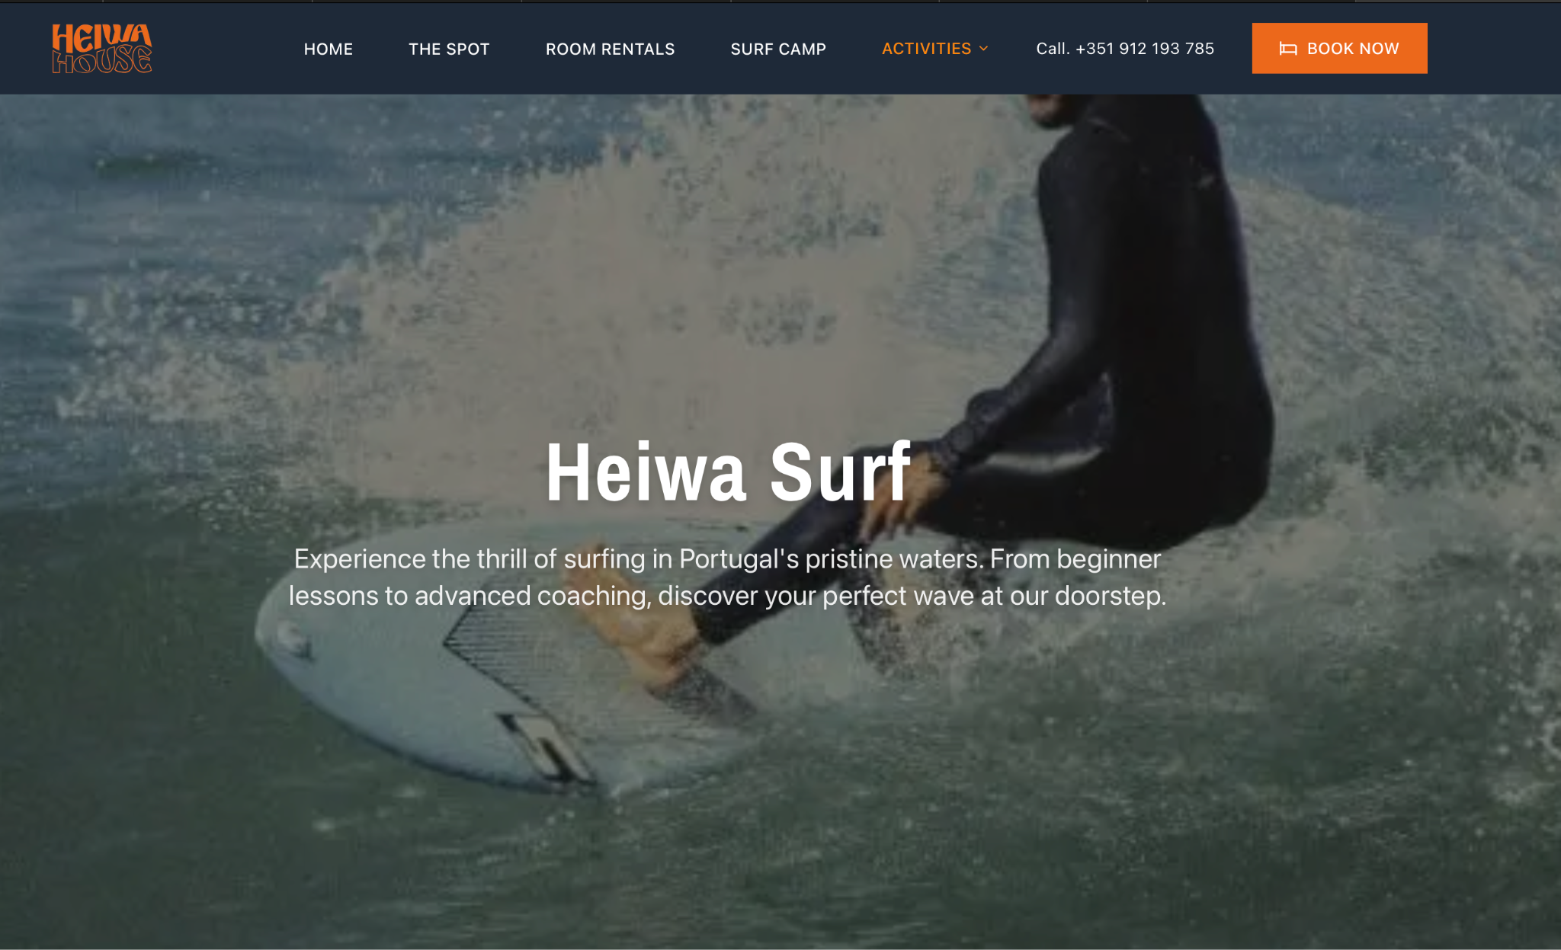

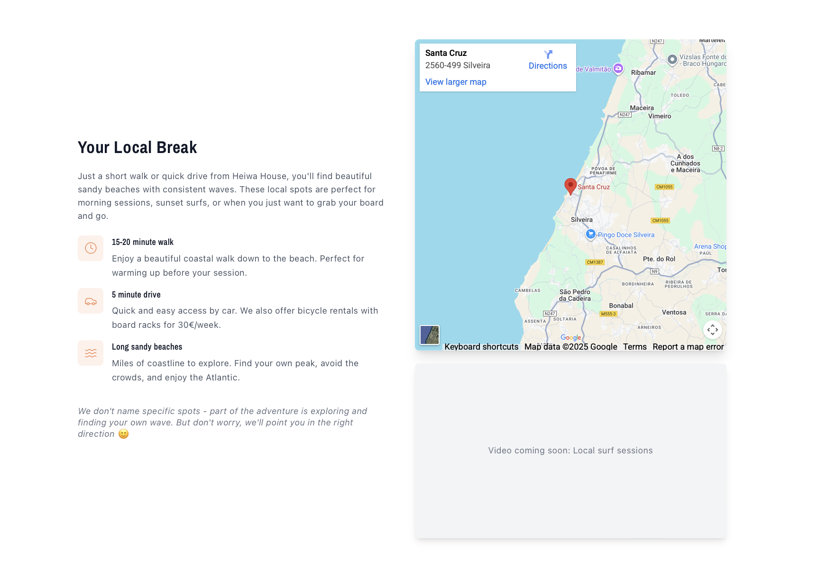

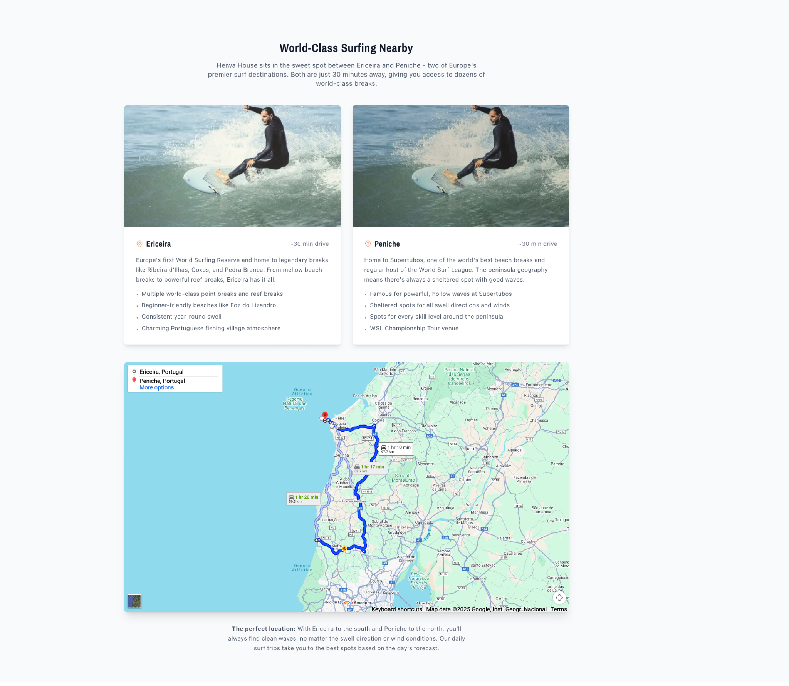
This is also fine, but I think you can replace the map (which btw took like 5min to load) with this glorious image:

https://drive.google.com/file/d/1H66hWrsMge7DJiK0_7WAf-JurEqdTpyo/view?usp=sharing

Surf levels have completely gone missing

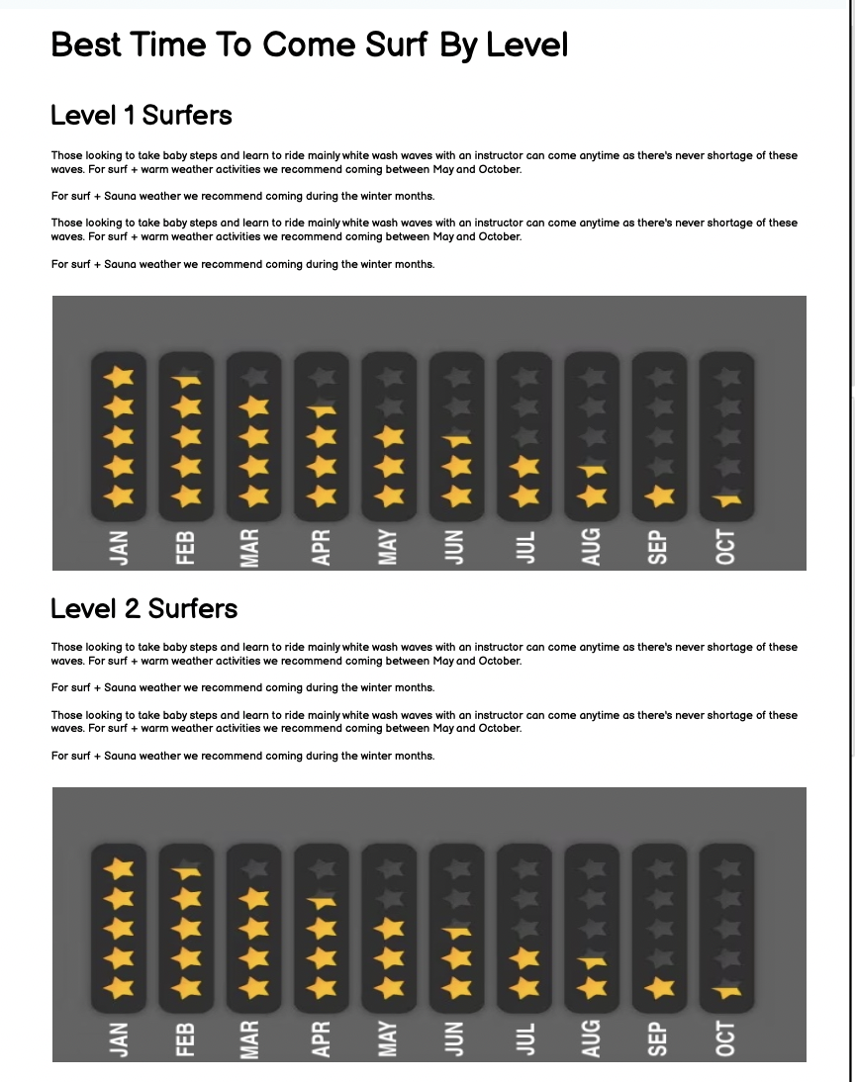

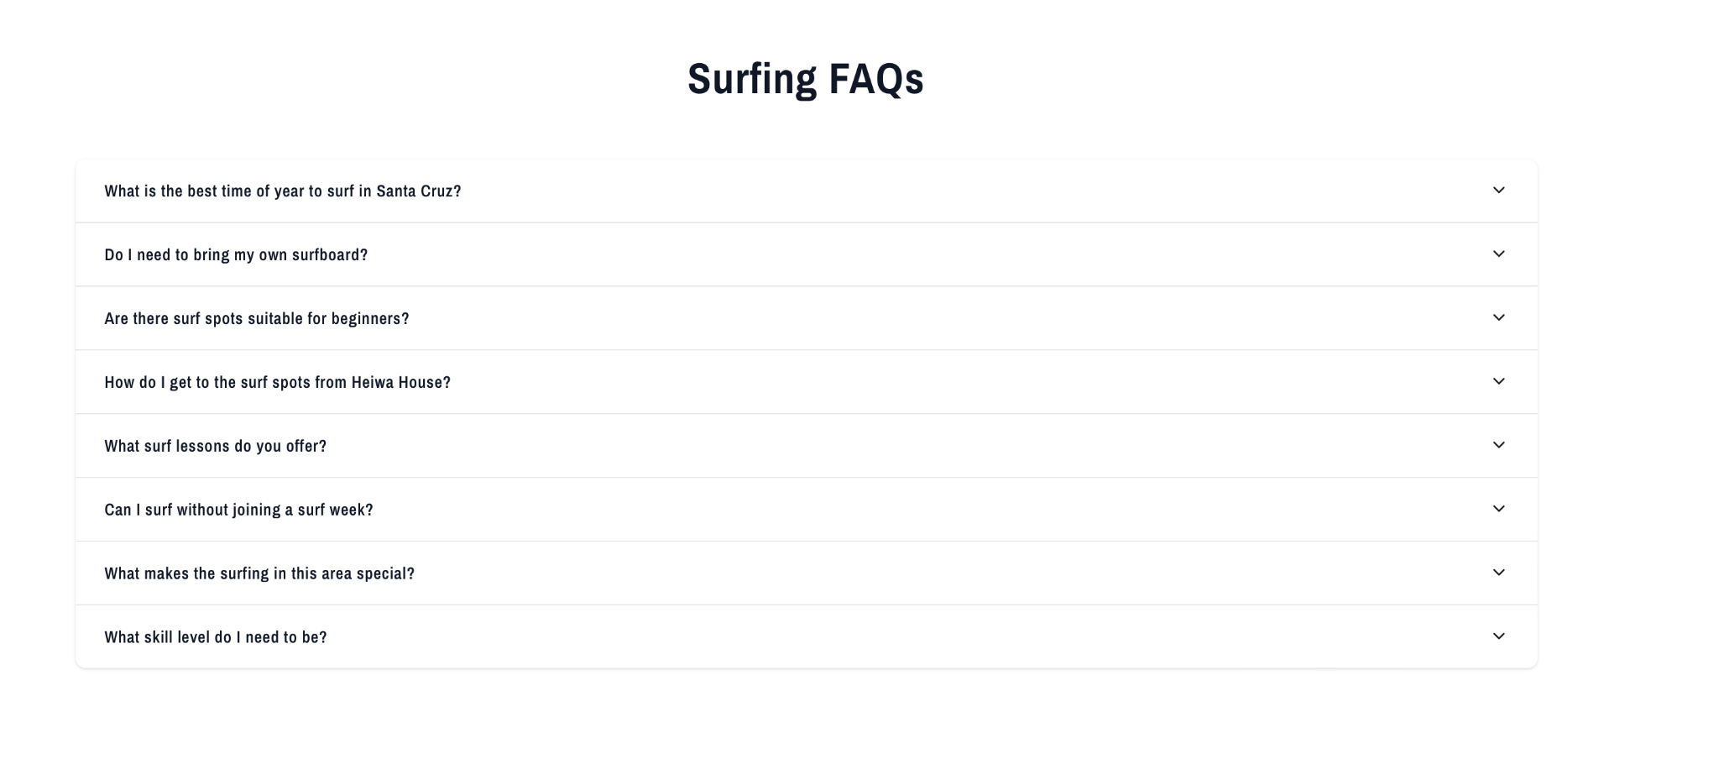
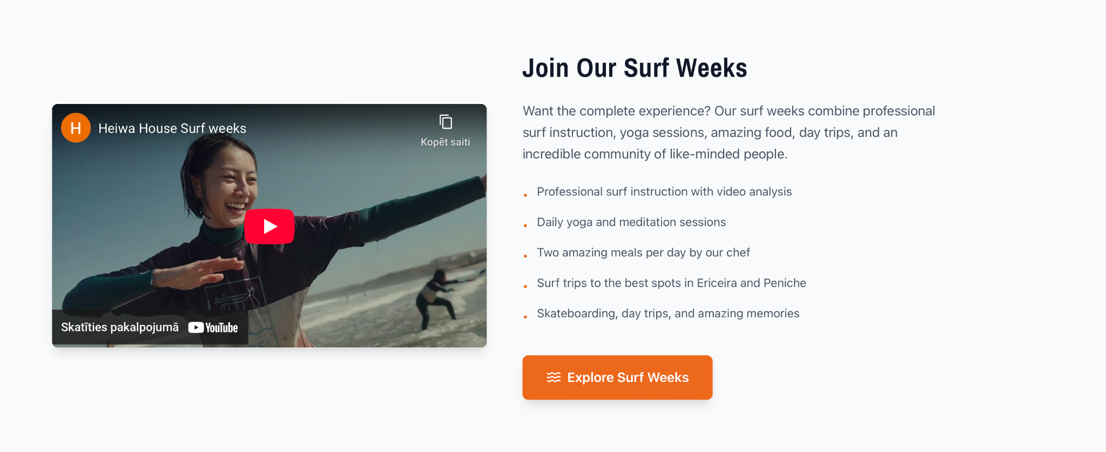
We need to add a section (I believe on top) that has information about surf lessons.
Would need one photo carousel and a text box.
Text would be something like:
“We offer high quality surf lessons in Santa Cruz and Peniche. Professional instructors will help you to take the first steps or improve at whatever level you are. Surf lessons starting from 40 eur etc etc etc etc etc etc etc etcetc etc etc etc”

Heiwa Flow
First section should highlight with videos and images 4 main things we have (similar to first section on heiwa play)
- Yoga dome
- Sauna and Ice Tub
- Yoga lessons
- Massages
And then the second section(available on request) stays as is

Heiwa Play
1.Make a new section on top highlighting Skateboarding and Music
Each should have a video and carousel, title and text
2.Next two sections stay the same, but no need for icons on photos
Names for these sections change to:
Activities On-Site
Activities Around

Booking Flow

Text alignment

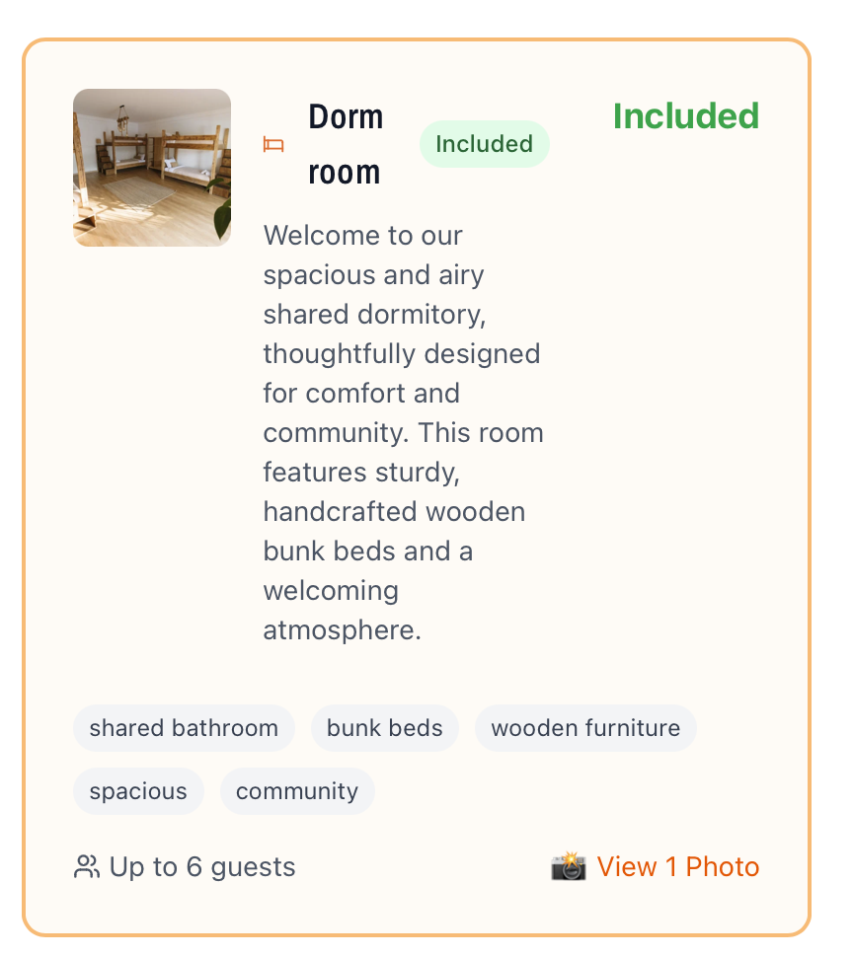
Drop the included mark so that there's more room for text. This is desktop safari.

Booking Flow Payment With Bank Transfer
This is the issue, I meant to record a loom - https://www.loom.com/share/4938f88d12424f84ab8ced848687a526

Backend

Bookings not showing properly
I have made multiple bookings for testing and all of them show unknown guest name, no phone info and basically no meta data even though I input them all correctly.

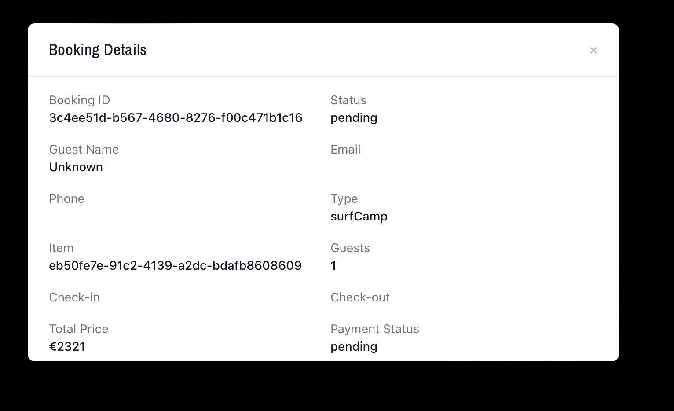

CMS Homepage Update
Get this error trying to update anything on the homepage.
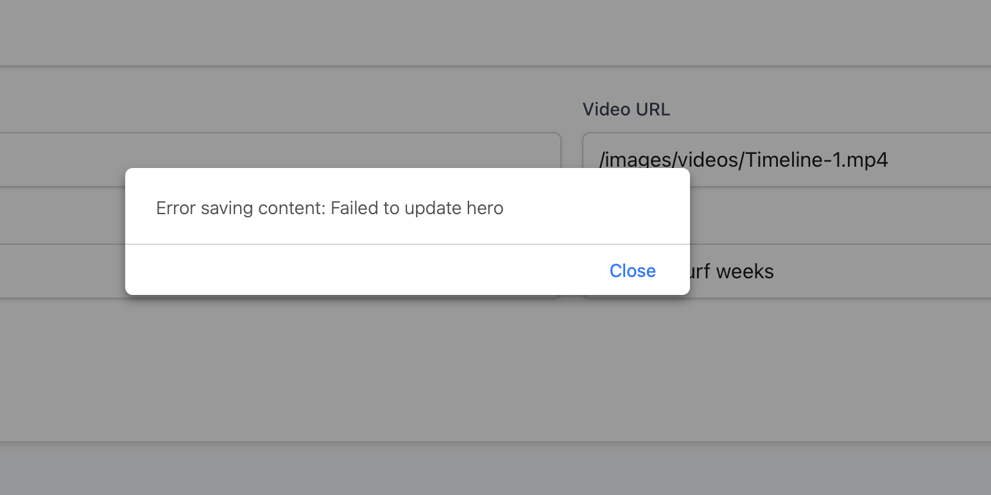

None of the pages exist from the POV of CMS
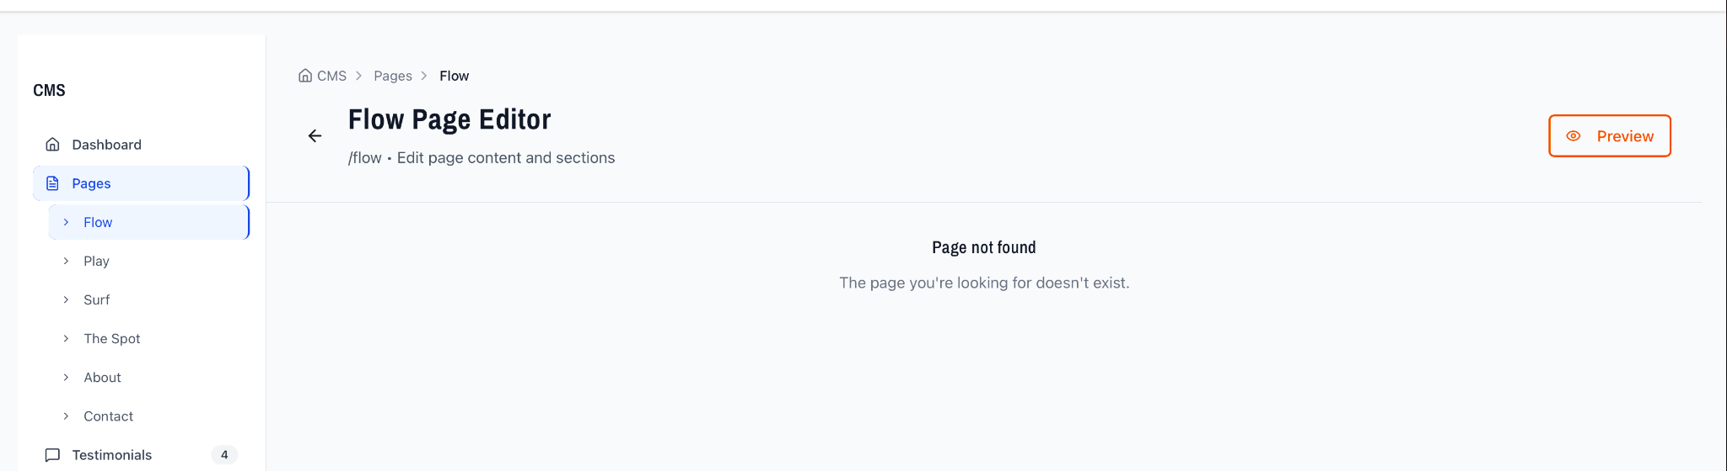

Surf Camps

Where are the surf camps coming from if this is the backend?

