**ENEL102, fall term 2017**

**Assignment 2**

**Writing Matlab Functions Chapter 7**

**Due October 2**

Assignment questions are based on material in the Gilat textbook from chapter 7. Suggest you review this chapter before answering these questions. Fill in the following template with your answers using Matlab plots and screen shots as necessary. Then submit your Word document on D2L.

………………………………………………………………………………………………………………………………..

**Q1.** Write an **anonymous function** , that can calculate the following sum:



Test your function with . (hint – your anonymous function needs to be one command line starting with f = @(x,y)… )   
………………………………………………………………………………………………………………………

**(Matlab input)**f=@(x,y)sum(sin(x.^(1:5))+3*y.^(1:5));

z=f(1,2)

**(Matlab Response)**

z =

190.2074

………………………………………………………………………………………………………………………………..

**Q2.** Use the anonymous function of **Q1** to generate a plot of z=f(x,y) over the range of



Use 400 points for the x variable. Label the axis of your graph.

**(Matlab input)**

x=linspace(-1,1,400);

y=linspace(0.5,0.5,400);

% There is probably a better way to do this,

% but this is an easy hack.

z=arrayfun(f,x,y);

f22 = figure('Name', 'Assignment 2, Question 2');

figure(f22);

plot(z,x);

title("f(x,y) for |x| <= 1, y=0.5");

xlabel("x");

ylabel("z");

**(Matlab Response)**

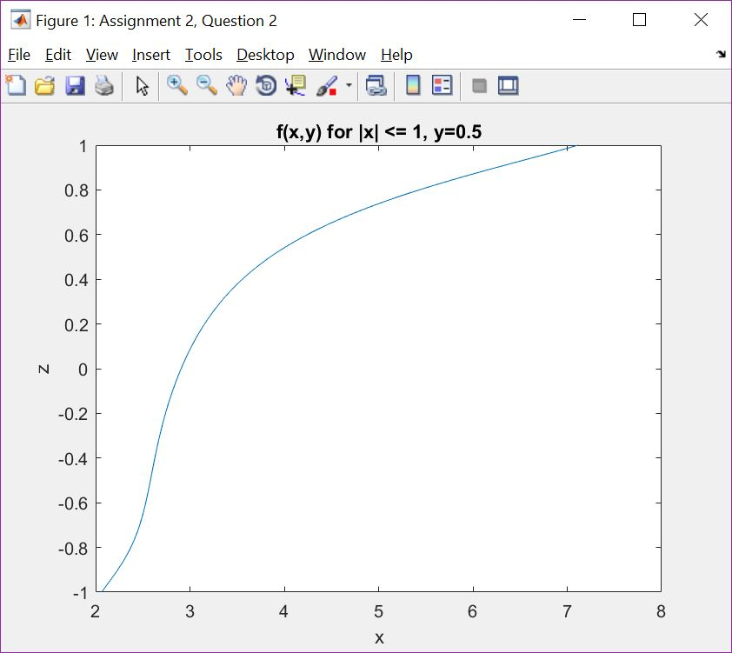

**Q3.** Consider the analog second order band pass filter consisting of a capacitor C, inductor L and a resistor R in series as shown in the figure.

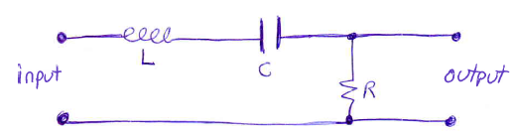

The transfer function is given as



where



Write a function that determines the magnitude of the frequency response of the filter. That is we want a function that determines



The function must be written such that it accepts a vector of frequencies for  and input parameters of R, L and C.

**(Matlab input)**

function [m] = H(w, R, L, C)

m = abs(R./(R+1j.*w.*L+1./(1j.*w.*C)));

end

………………………………………………………………………………………………………………………………..

**Q4.** Use the function that you created for Q3 to generate the magnitude of the frequency response of the bandpass filter with L=1, C=1 and R=10. Produce two plots for this magnitude response. The first is for a range of using a linear frequency scale. The second plot is for  using a log frequency plot. (hint use semilogx)

**(Matlab input)**

f24 = figure('Name', 'Assignment 2, Question 4');

figure(f24);

subplot(2,1,1);

w=linspace(0,10);

m=H(w, 10, 1, 1);

plot(w,m);

xlabel("Frequency, \omega");

ylabel("Frequency response");

subplot(2,1,2);

w=10.^linspace(log10(.01), log10(100));

m=H(w, 10, 1, 1);

semilogx(w, m);

xlabel("Log(Frequency), log_{10} (\omega)");

ylabel("Frequency response");

**(Matlab Response)**

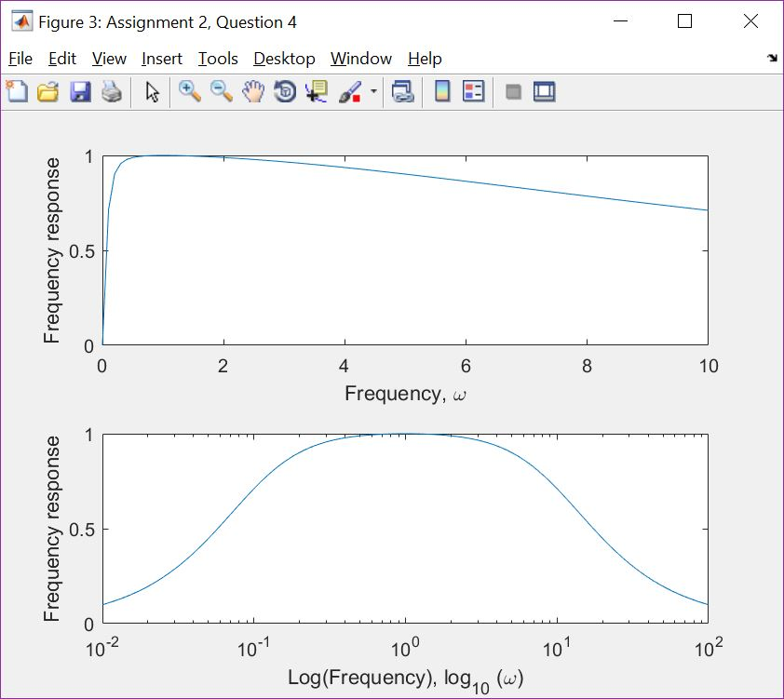

………………………………………………………………………………………………………………………………..

**Q5.** Consider the bandpass filter of **Q3** again and modify the function you created in **Q3** such that it calculates the phase of the transfer function in degrees. Then use this function to generate a plot of the phase shift of the bandpass filter for the frequency range of using a log frequency axis (suggest semilogx()). Use the component parameters of L=1, C=1 and R=10 as before.

**(Matlab input)**

**File P5**

function [x] = P5(w, R, L, C)

x = (180/pi).*angle(R./(R+1j.*w.*L+1./(1j.*w.*C)));

end

**File main**

f25 = figure('Name', 'Assignment 2, Question 5');

figure(f25);

w = 10.^linspace(log10(.01), log10(100));

x = P5(w, 10, 1, 1);

semilogx(w,x);

xlabel("\omega");

ylabel("\Theta (\omega)");

**(Matlab Response)**

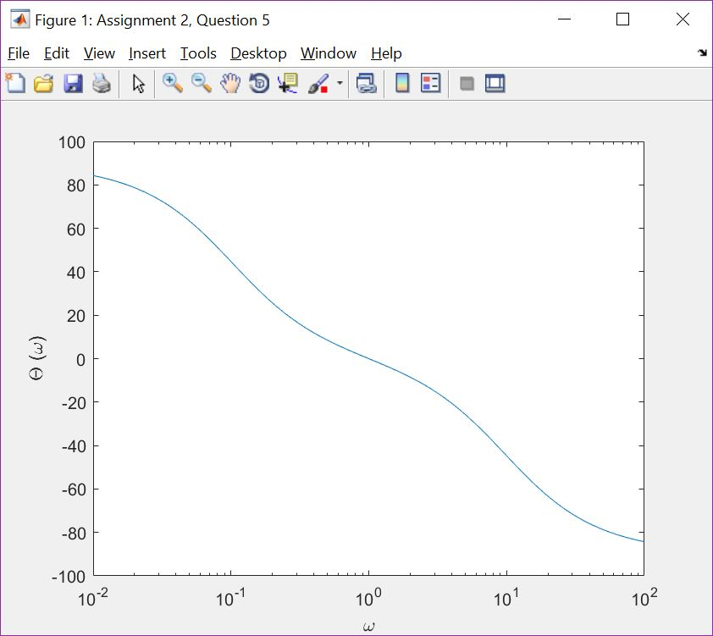

………………………………………………………………………………………………………………………………..

**Q6.** Modify the program in **Q5** such that the parameters of R C and L are global variables and hence do not have to be passed to the function created in Q5 for calculating the phase of the transfer function. List your modified Matlab code (both the function and the main program). As in Q5 plot the phase response for the case of L=1, C=1, R=0.1 and  based on a log frequency axis.

**(Matlab input)**

**File P6**

function [x] = P6(w)

global L6 C6 R6;

x=(180/pi).*angle(R6./(R6+1j.*w.*L6+1./(1j.*w.*C6)));

end

**File main**

w=10.^linspace(log10(.01), log10(100));

global L6 C6 R6;

L6=1;

C6=1;

R6=0.1;

x=P6(w);

f26 = figure('Name', 'Assignment 2, Question 6');

figure(f26);

xlabel("Log(frequency), log\_{10}(\omega)");

ylabel("Frequency response");

semilogx(w,x);

**(Matlab Response)**

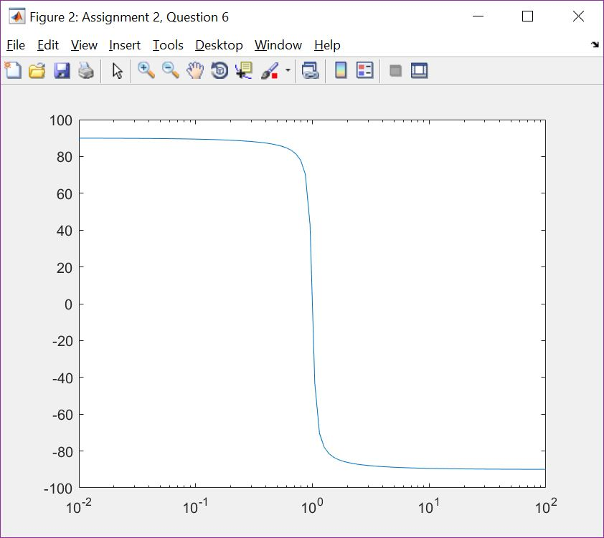

………………………………………………………………………………………………………………………………..

**Q7.** Give a reason why global variables are useful. Then explain why the excessive use of global variables is generally considered to be bad programming.

**(ans)**

My answer: Global variables are useful because they allow you to change the operation of an entire section of code, while only changing a single variable value. Additionally, in Matlab specifically, it allows functions to alter the behaviour of other functions. However, overuse of global variables makes code impossible to read locally, and means that a seemingly simple change may cause extensive, and unintended, effects beyond what could possibly be predicted based on local code.

………………………………………………………………………………………………………………………………..

**Q8**. The signal time delay through the filter described in Q3 is given by the rate of change of the phase shift with respect to excitation frequency. That is, the filter delay, denoted by D, is given as



Write a function that will determine D for a set of parameters L, C, R and. Use a numerical means of approximating the derivative. Hint – evaluate  for two closely spaced frequencies and then determine the change in angle (in radians) from this. That is compute the slope from the ‘rise over run’.

Evaluate the time delay for R=1, C=1, L=1 and .

**(Matlab input)**

**File D**

function [x] = D(w, R, L, C)

x1 = P(w, R, L, C);

x2 = P(w+.01, R, L, C);

x = -(x2-x1)/.01;

end

% Equivalently,

% function [x] = D(w, R, L, C)

% x1 = angle(R./(R+1j.*w.*L+1./(1j.*w.*C)));

% x2 = angle(R./(R+1j.*(w+.01).*L+1/(1j.*(w+.01).*C)));

% x = -(x2-x1)/.01;

% end

**File main**

z=D(1,1,1,1)

**(Matlab Response)**

z =

1.9898

………………………………………………………………………………………………………………………………..

**Q9**. The resonance frequency of the bandpass filter introduced in Q3 is given by



Write a program the calculates the delay of the filter as determined in **Q8**, at the resonance frequency, as a function of the resistance R over the range of 0.1>R>10 and plots this delay. Use L=1 and C=1 such that the delay D is evaluated at .

**(Matlab input)**

**File rf**

function [x] = rf(R,L,C)

wr = 1/sqrt(LC);

x = D(wr, R, L, C);

end

% Equivalently,

% function [x] = rf(R,L,C)

% wr = 1/sqrt(L*C);

% w1 = wr + .01;

% x1 = angle(R./(R+1j.*wr.*L+1./(1j.*wr.*C)));

% x2 = angle(R./(R+1j.*w1.*L+1./(1j.*w1.*C)));

% x = -(x2-x1)/.01;

% end

**File main**

R = linspace(.1,1);

wr = rf(R, 1, 1);

plot(R, wr);

xlabel("Resistance, \Omega");

ylabel("Delay");

**(Matlab Response)**

