**ENEL102, fall term 2017**

**Assignment 3**

**Polynomials and curve fitting Chapter 8**

**Due date Oct 16**

Assignment is based on material in the Gilat textbook from chapter 8. Suggest you review this chapter before answering these questions. Fill in the following template with your answers using Matlab plots and screen shots as necessary. Then submit your Word document on D2L. ………………………………………………………………………………………………………………………………..

**Q1.** Consider the polynomial of



Use polyval() to plot this curve for a range of 0<x<3.

**(Matlab input, must be based on polyval() )**

f31 = figure('Name', 'Assignment 3, Question 1');

figure(f31);

x = linspace(0,3);

y = polyval([0.1 0.1 4 sqrt(5)],x);

plot(y,x);

xlabel("x");

ylabel("0.1x^3 + 0.1x^2 + 4x + \surd{5}");

**(Matlab Response)**

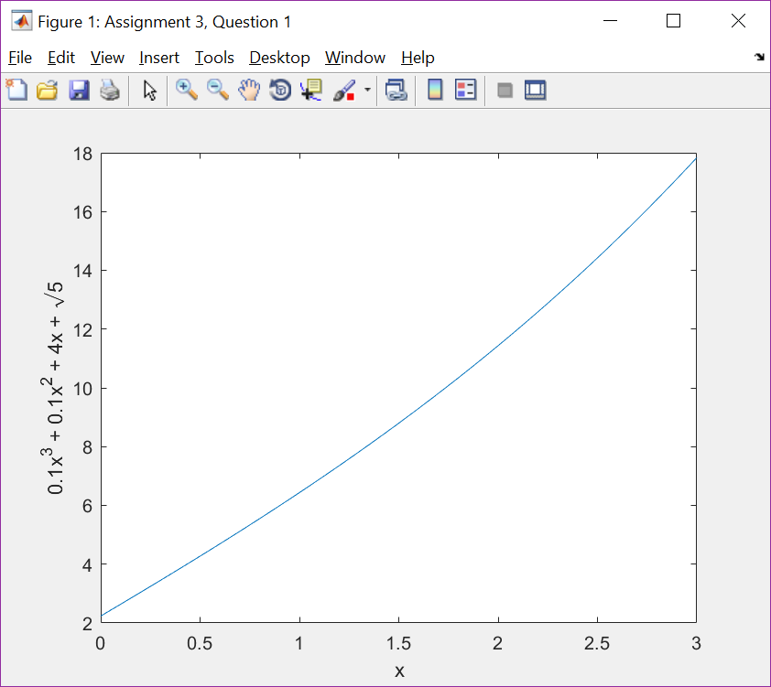

…………………………………………………………………………………………………………………………….

**Q2.** The roots can be determined of the polynomial of f(x) in **Q1** by using roots(). Doing this results in a set of complex valued roots and a real root. Write code to find the root that is real valued. Then verify this real root is accurately determined by roots() by evaluating f(real root) which should be very close to zero.

**(Matlab input)**

rs = roots([0.1 0.1 4 sqrt(5)]);

t = 0;

for r = 1:3

if imag(rs(r)) == 0

t=rs(r);

end

end

z = polyval([0.1 0.1 4 sqrt(5)],t)

**(Matlab Response)**

z =

0

……………………………………………………………………………………………………………………………….

**Q3.** Write a Matlab program using conv() to determine the coefficients of the polynomial



(hint: note that the product of two polynomials can be determined by convolving the sequence of coefficients of the powers of x.)

**(Matlab input, must be based on conv() )**

f = [1 0 1.2 3];

y = conv(f,f)

**(Matlab Response)**

y =

1.0000 0 2.4000 6.0000 1.4400 7.2000 9.0000

……………………………………………………………………………………………………………………………….

**Q4** Suppose we are given five points as



Determine the forth order polynomial that passes through these points using polyfit. Then plot a graph of the fourth order polynomial and indicate the given five points with red x’s and label axis. List the code to find the coefficients and plot the curve as well as the plot.

**(Matlab input)**

f34 = figure('Name', 'Assignment 3, Question 4');

figure(f34);

ps = [0 1; 1 1.5; 2 4; 4 7; 6 9];

cs = polyfit(ps(:,1)',ps(:,2)',4)

x = linspace(0,6);

y = polyval(cs,x);

plot(x,y);

xlabel("x");

ylabel("Fitted 4^{th} order curve");

hold on;

for i = 1:size(ps,1)

plot(ps(i,1),ps(i,2),'xr')

end

**(Matlab Response)**

cs =

0.0625 -0.7708 2.8750 -1.6667 1.0000

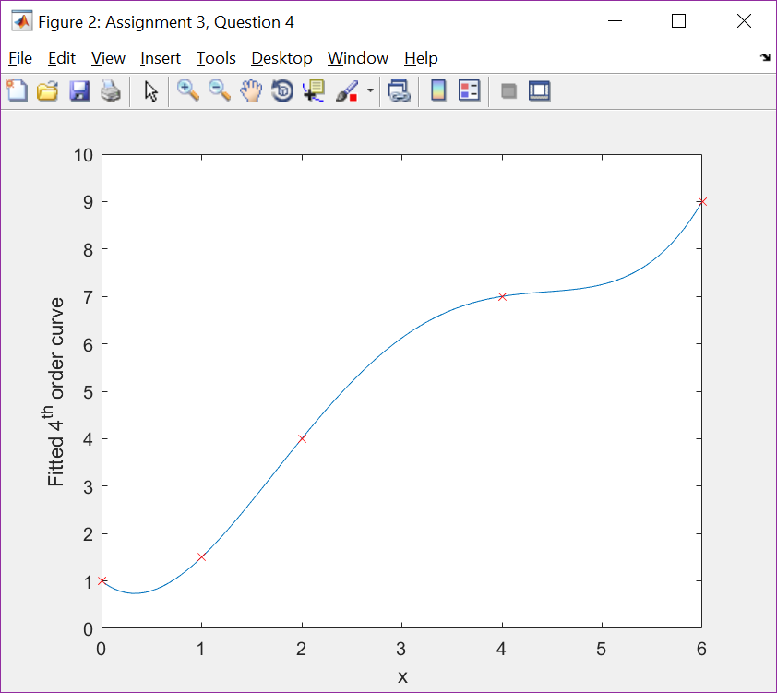

……………………………………………………………………………………………………………………………….

**Q5** Polyfit can be used for curve fitting with known functions that are linearly superimposed with unknown coefficients. As an example we have a function



which is a superposition of known functions  but the coefficients of are not known. Suppose we are given data points as:



that the function must satisfy. Use polyfit() to find these coefficients . Then verify that the calculated coefficients are correct by direct evaluation.

**(Matlab input)**

ps = [0 0; 1 2; 2 5];

nx = exp(ps(:,1)');

cs = polyfit(nx, ps(:,2)',2);

c = cs(1), b = cs(2), a = cs(3)

f = @(x) a + b*exp(x) + c*exp(2*x);

f0 = f(0)

f1 = f(1)

f2 = f(2)

**(Matlab Response)**

c =

-0.0816

b =

1.4675

a =

-1.3859

f0 =

-2.1788e-15

f1 =

2.0000

f2 =

5.0000

……………………………………………………………………………………………………………………………….

**Q6** Consider the analog second order band pass filter consisting of a capacitor C, inductor L and a resistor R in series as shown in the figure.



The transfer function is given as



Find the poles of by determining using roots(). Assume R = 0.1, L = 3 and C = 0.1. From this what is the approximate frequency in Hertz at which the band pass filter will have a peak response?

**(Matlab input)**

R = 0.1;

L = 3;

C = 0.1;

Hd = [L*C R*C 1];

poles = roots(Hd);

F = imag(poles(1))*(2*pi)

**(Matlab Response)**

F =

11.4710

…………………………………………………………………………………………………………………………….

**Q7** Read in the data in the binary file of Q7data.mat. As in **Q5** it is known that this data fits the model of



Use polyfit() to generate the least square regression curve fit to this data determining the unknown coefficients of a, b and c. Then plot the data points and superimpose the regression curve fit on top of this.

**(Matlab input)**

f37 = figure('Name', 'Assignment 3, Question 7');

figure(f37);

ps = load('Q7data.mat');

ps.x = sort(ps.x);

ps.y = sort(ps.y);

nx = exp(ps.x);

cs = polyfit(nx,ps.y,2);

f = @(x) cs(1)*exp(2*x) + cs(2)*exp(x) + cs(3);

ny = f(ps.x);

plot(ps.x,ps.y,'xr');

hold on;

plot(ps.x, ny);

hold off;

**(Matlab Response)**

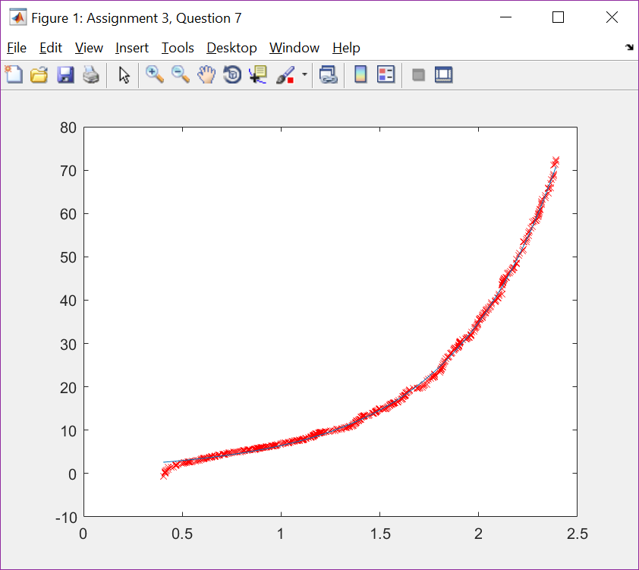

……………………………………………………………………………………………………………………………….

**Q8** Determine the standard deviation of the error of the regression curve fit in **Q7**.

**(Matlab input)**

ps = load('Q7data.mat');

ps.x = sort(ps.x);

ps.y = sort(ps.y);

nx = exp(ps.x);

cs = polyfit(nx,ps.y,2);

f = @(x) cs(1)*exp(2*x) + cs(2)*exp(x) + cs(3);

ny = f(ps.x);

err = ps.y - ny;

s = std(err)

**(Matlab Response)**

s =

0.5713