**CMSC203 Assignment 0**

Class: CMSC203 CRN 30376

 Program: Assignment 0

Instructor: Grinberg, Grigoriy

 Summary of Description: Complete five parts of Assignment 0:

 Due Date: 01/30/2023

 Integrity Pledge: I pledge that I have completed the programming assignment independently.

 I have not copied the code from a student or any source.

**Complete the following five parts of Assignment 0. Name your file as FirstInitialLastName_Assignment0.docx**

**Part1: Setup GitHub:** Provide the screen shots of your GitHub account with Assignment 0 file is uploaded on GitHub:

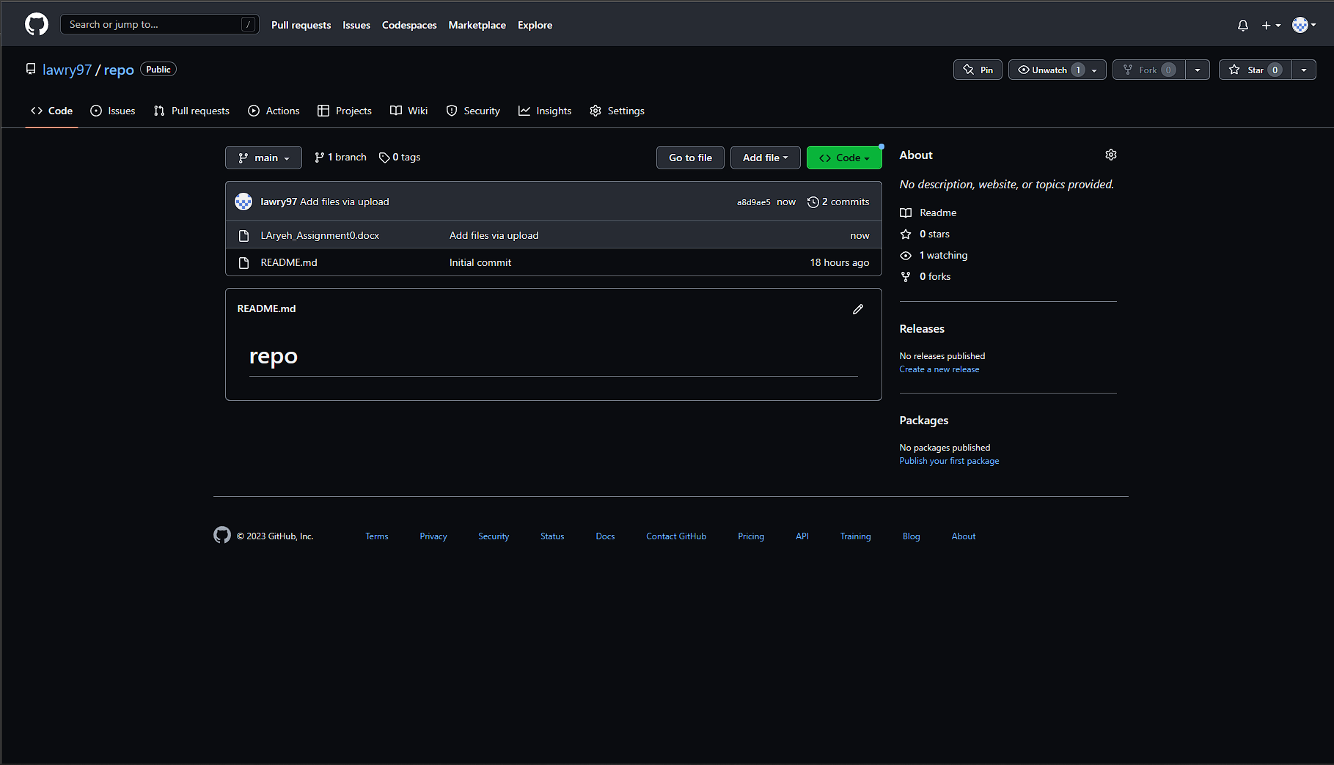

**Part 2 -Install JDK, Test java Application from Command Line**

Provide the screen shots from Step 1 and 2 here:

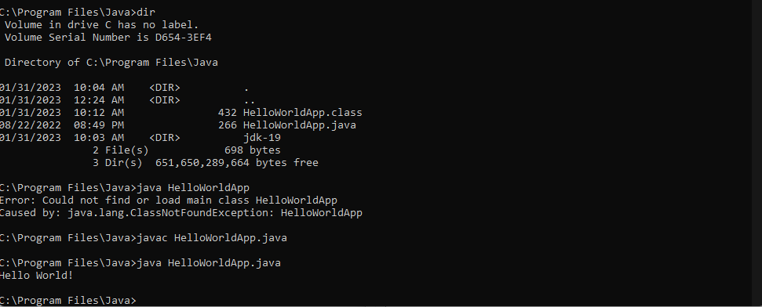

**Part 3 - Install Eclipse, Test Eclipse Java Application**

Provide the screen shots from Step 1 and 2 here:

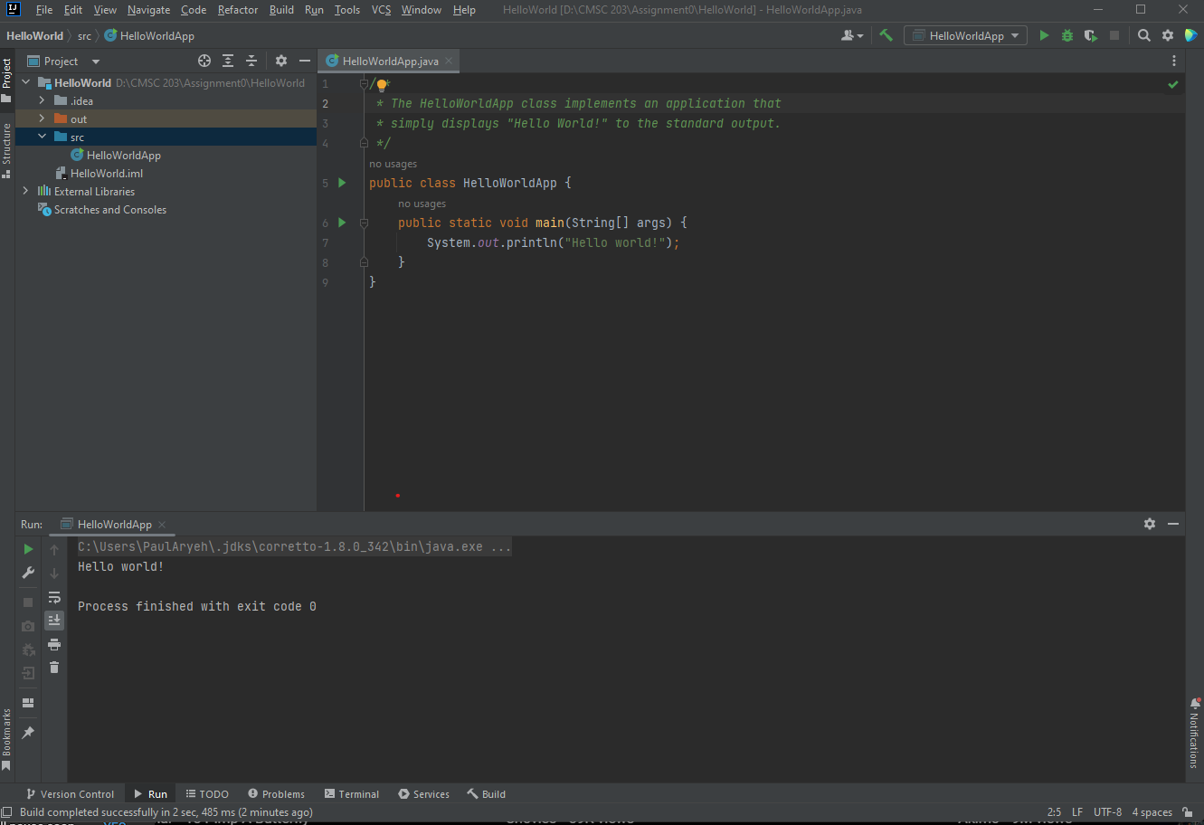

**Part 4 - Install, Setup, Test Junit Program.**

Provide the screen shots showing:

* 1. Eclipse with working JUnit Test example
  2. Project screenshot
  3. Running example screenshot

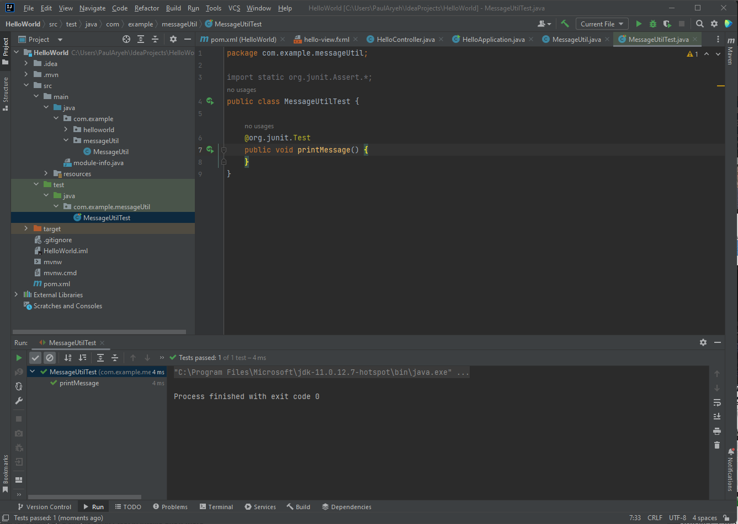

**Part 5 - Install, Setup, and Test JavaFX Application.**

Provide the screen shots showing:

1. JavaFX Project screenshot
2. Running example screenshot
3. Java Source Code File

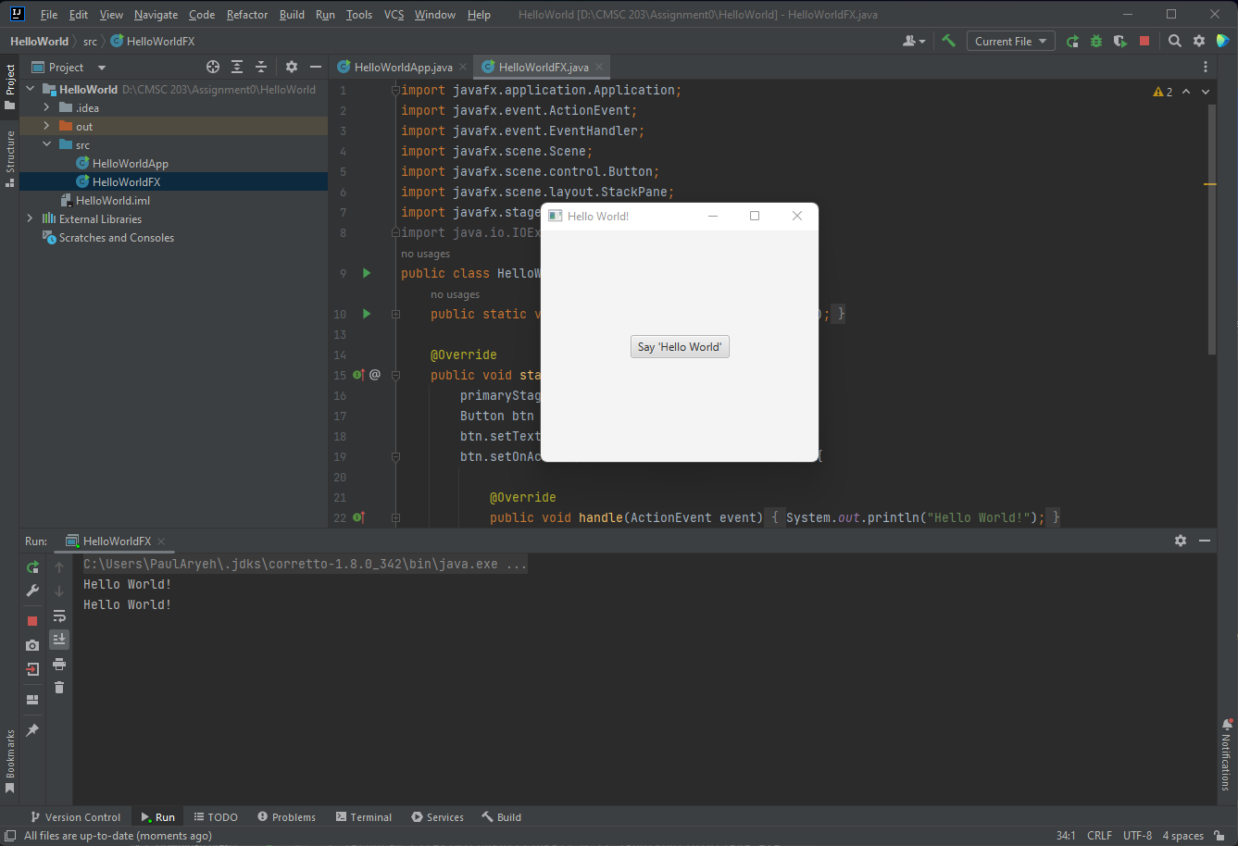

**Lessons Learned** <Provide answers to the questions listed below>**:**

Write about your Learning Experience, highlighting your lessons learned and learning experience from working on this assignment.

What have you learned?

I have done this before in my senior year of high school so I haven’t learn anything other than JUnit test. That’s something that I did not know existed.

What did you struggle with?

I struggled with setting up the jdk, the sdk of javafx because mainly I wasn’t paying attention to what I was doing. Also it was a bit of hassle to set up the JUnit test because I was working on it in Intellij IDE and not Eclipse so I had to figure out how to import the JUnit dependency and I was able to do that with maven build tool.

What parts of this assignment were you successful with, and what parts (if any) were you not successful with? I was successful with the github setup since I already set up in my previous CMSC class.

Provide any additional resources/links/videos you used to while working on this assignment.

[How to set up a simple JUnit4 test in IntelliJ - YouTube](https://www.youtube.com/watch?v=OsCVJX81yIo&ab_channel=SplineGuyTech)

**Check List:** <Provide answers to the column Y/N or N/A >**:**

|  |  |  |  |
| --- | --- | --- | --- |
| **#** |  | **Y/N** | **Comments** |
|  | **Assignment files:** |  |  |
|  | * FirstInitialLastName_Assignment0.docx/pdf | **Yes or No** |  |
|  | * Source java files | **Yes or No** |  |
|  | **Program compiles** | **Yes or No** |  |
|  | **Program runs with desired outputs related to a Test Plan** | **Yes or No** |  |
|  | **Documentation file: Screenshots of** |  |  |
|  | * Part1: Setup GitHub | **Yes or No** |  |
|  | * Part 2 -Install JDK, Test java Application from Command Line | **Yes or No** |  |
|  | * Part 3 - Install Eclipse, Test Eclipse Java Application | **Yes or No or N/A** |  |
|  | * Part 4 - Install, Setup, Test Junit Program | **Yes or No or N/A** |  |
|  | * Part 5 - Install, Setup, and Test JavaFX Application. | **Yes or No or N/A** |  |
|  | * Lessons Learned | **Yes or No** |  |
|  | * Checklist is completed and included in the Documentation | **Yes or No** |  |