**CMSC203 Assignment 1 Design**

Class: CMSC203 CRN 30376

 Program: Assignment 1

Instructor: Grinberg, Grigoriy

 Summary of Description:Build an application that will step through some possible problems to restore internet connectivity. Assume that your computer uses wi-fi to connect to a router which connects to an Internet Service Provider (ISP) which connects to the Internet.

 Due Date: 02/13/2023

 Integrity Pledge: I pledge that I have completed the programming assignment independently.

 I have not copied the code from a student or any source.

Student Name: Lawrence Aryeh

**Part1: Pseudo Code:** Here is a pseudo code for Assignment 2 program:

**Start**

**Scanner input;**

**String answer = “No”;**

**int count = 0;**

**Do while(answer == “No and answer == No)**

**If(count == 0)**

**Print “Reboot the computer and try to connect”;**

**Print “Did that fix the problem?(Yes or No)”;**

**answer = line derived from input;**

**If(answer invalid)**

**Print “Invalid Answer. Try Again.”**

**break;**

**End if**

**End if**

**If(count == 1)**

**Print “Reboot the router and try to connect”;**

**Print “Did that fix the problem?(Yes or No)”;**

**answer = line derived from input;**

**If(answer invalid)**

**Print “Invalid Answer. Try Again.”**

**break;**

**End if**

**End if**

**If(count == 2)  
 Print “Make sure the cables connecting the router are plugged in”;**

**Print “Did that fix the problem?(Yes Or No)”;**

**answer = line derived from input;**

**If(answer invalid)**

**Print “Invalid Answer. Try Again.”**

**break;**

**End if**

**End if**

**If(count == 3)**

**Print “Move the computer closer to the router”;**

**Print “Did that fix the problem(Yes Or No)”;**

**answer = line derived from input;**

**If(answer invalid)**

**Print “Invalid Answer. Try Again.”**

**break;**

**End if**

**End if**

**If(count == 4)**

**Print “Contact your ISP”;**

**break;**

**End if**

**count++;**

**End do while**

**Print “Done”;**

**Print “Programmer: Lawrence Aryeh”;**

**End**

**Part2: Comprehensive Test Plan**

A good test plan should be comprehensive. This means you should have a few test cases that test when the input is in and out of range, division by 0, incorrect Data type, etc. (Provide valid and invalid input)

|  |  |  |  |  |
| --- | --- | --- | --- | --- |
| Cases | Input | Expected Output | Actual Output | Did Test Pass? |
| Case 1 | No | Continue to the next method | Continued to the next method | Yes |
| Case 2 | No  Yes | Finish the program after trying the second method | Finished the program after typing yes for the second method | Yes |
| Case 3 | No  No  No  No | Suggest the user to contact the ISP and exit the program | Suggested the user to contact the ISP and exited the program | Yes |
| Case 4 | Wet | Print “Invalid Input. Try again” and exit the program | Printed “Invalid Input. Try again” and exited the program | Yes |

**Command Prompt**

**Case 1:** 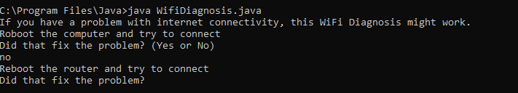

**Case 2:** 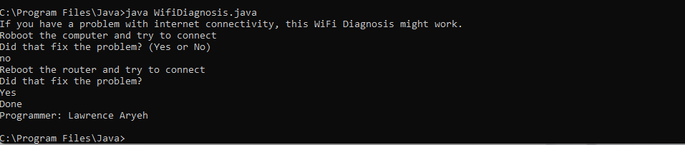

**Case 3:**

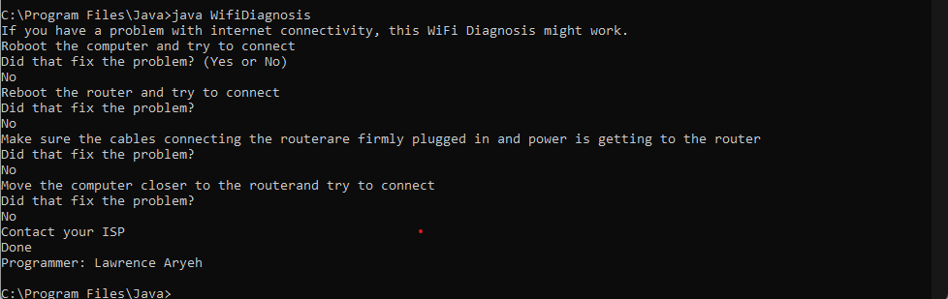

**Case 4:**

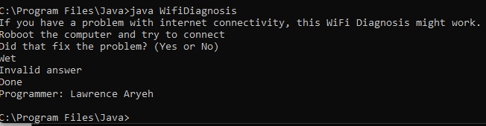

**IntellIJ IDE**

**Case 1:**

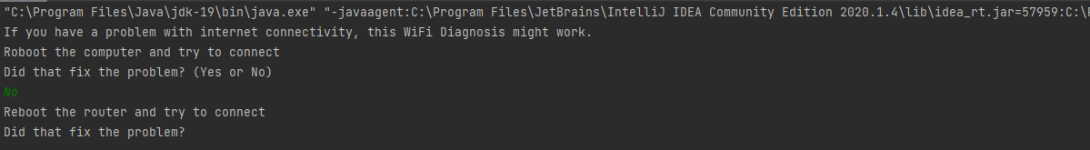

**Case 2:**

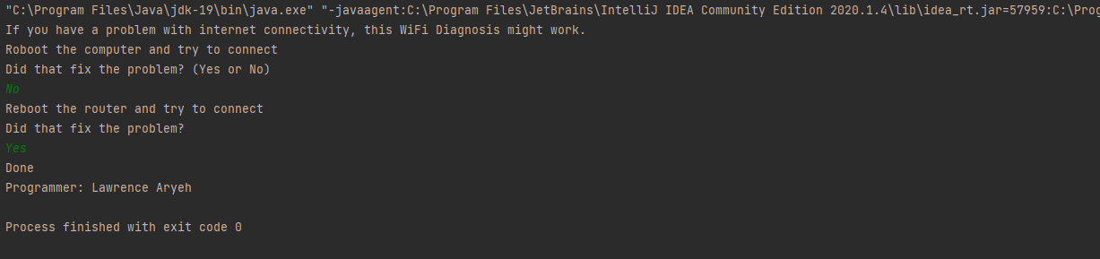

**Case 3:**

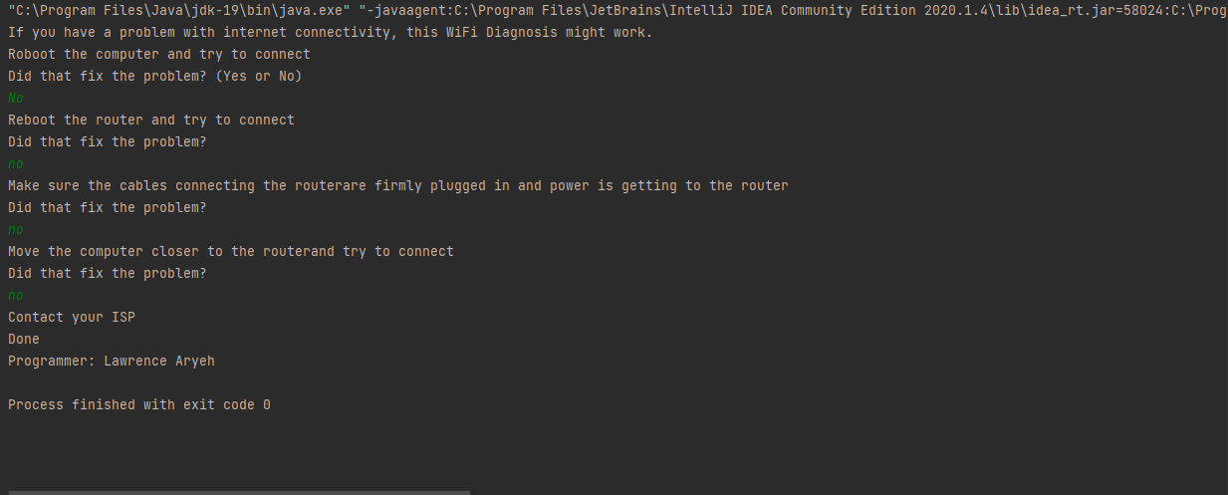

Case 4:

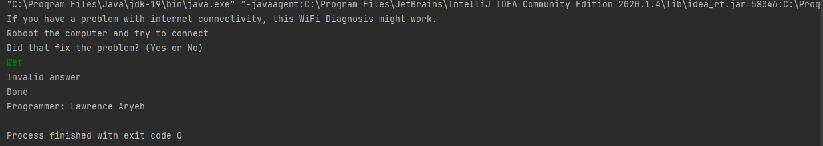

**Lessons Learned** <Provide answers to the questions listed below>**:**

Write about your Learning Experience, highlighting your lessons learned and learning experience from working on this assignment.

What have you learned? I learned nothing new. I have already had the knowledge to do the assigment.

What did you struggle with? I struggled with the jdk part which caused problems running the program.

What parts of this assignment were you successful with, and what parts (if any) were you not successful with? I was successful with all parts of the assignment and I felt very comfortable finishing the program in one session.

Provide any additional resources/links/videos you used to while working on this assignment.

**Check List:** <Provide answers to the column Y/N or N/A >**:**

|  |  |  |  |  |
| --- | --- | --- | --- | --- |
| **#** |  | **Y/N** | | **Comments** |
|  | **Assignment files:** |  | |  |
|  | * FirstInitialLastName_Assignment1_Complete.zip | **Yes or No** | |  |
|  | * FirstInitialLastName_Assignment1_JavaFiles.zip Source java files | | **Yes or No** | **(This folder SHOULD NOT contain any folders and it should contain Java source file only** |
|  | **Program compiles** | **Yes or No** | |  |
|  | **Program runs with desired outputs related to a Test Plan** | **Yes or No** | |  |
|  | **Documentation file: Screenshots of** |  | |  |
|  | One screenshot of the application running from the command prompt line. | **Yes or No** | |  |
|  | One screenshot of the application running in your IDE. | **Yes or No** | |  |
|  | Screen shot of Java file (WifiDiagnosis.java) in your GitHub repository | **Yes or No or N/A** | |  |
|  | * Lessons Learned | **Yes or No** | |  |
|  | * Checklist is completed and included in the Documentation | **Yes or No** | |  |