**CMSC203 Lab 1 Template**

Class: CMSC203 CRN 30376

 Program: Lab 1

Instructor: Grinberg, Grigoriy

Summary of Description: In this lab, you are introduced to multiple classes (a driver class and a data element class). You will write the driver class in order to test the various methods provided in the data element class.

Due Date: 02/20/23

 Integrity Pledge: I pledge that I have completed the programming assignment independently.

 I have not copied the code from a student or any source.

**Complete the following three parts of Lab 1. Name your file as FirstInitialLastName_Lab1.docx**

**Task 1**

Provide the screen shots from Task 1 here:

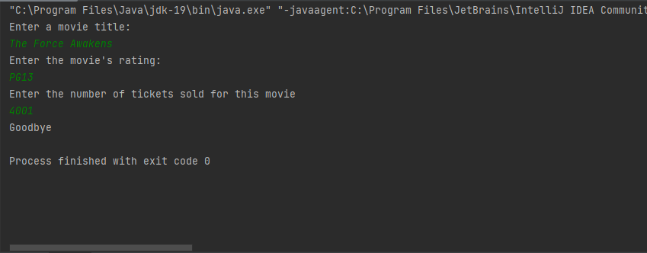

Submit both Java files from Task 1, even though you have not changed Movie.java

**Task 2**

Provide the screen shots from Task 2 here:

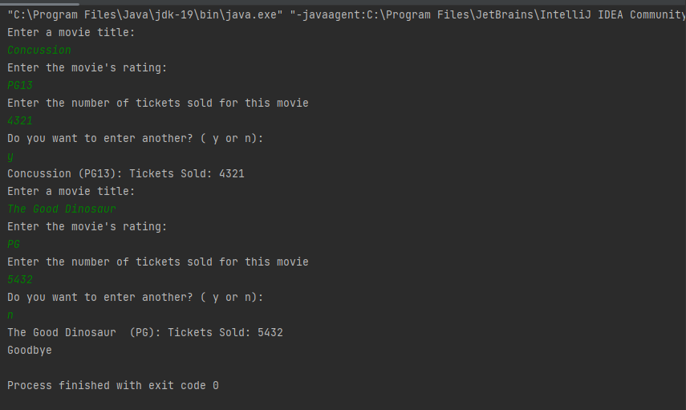

Submit both Java files from Task 2, even though you have not changed Movie.java

**Task 3**

Provide the screen shots from Task 3 here:

**Lessons Learned** <Provide answers to the questions listed below>**:**

Write about your Learning Experience, highlighting your lessons learned and learning experience from working on this assignment.

What have you learned?

What did you struggle with?

What parts of this assignment were you successful with, and what parts (if any) were you not successful with?

Provide any additional resources/links/videos you used to while working on this assignment.

**Deliverables for Lab1:**

Submit FirstInitiallastName_Lab1.zip

  Include the following files in your zip file:

   1.1 FirstInitiallastName_Lab1.doc based on a provided template:

   1.2 both Java files from Task 1 with the names Movie.java, MovieDriver_Task1 (even though you have not changed Movie.java)

   1.3 both Java files from Task 2 with the names Movie.java, MovieDriver_Task2 (even though you have not changed Movie.java)

**Check List:** <Provide answers to the column Y/N or N/A >**:**

|  |  |  |  |
| --- | --- | --- | --- |
| **#** |  | **Y/N** | **Comments** |
|  | **Lab 1 files:** |  |  |
|  | * FirstInitialLastName_Lab1.docx/pdf | **Yes** |  |
|  | * Source java files from Task 1 | **Yes** |  |
|  | * Source java files from Task 2 |  |  |
|  | **Program compiles** |  |  |
|  | **Program runs with desired outputs** |  |  |
|  | **Documentation file: Screenshots of** |  |  |
|  | * Task1 |  |  |
|  | * Task2 |  |  |
|  | * Task3 |  |  |
|  | * Lessons Learned |  |  |
|  | * Checklist is completed and included in the Documentation |  |  |