# 設備類型與拍卡類型

## 設備類型

### Linux盒子 海康同步多設備配置

#### 第一步、定義Linux盒子:

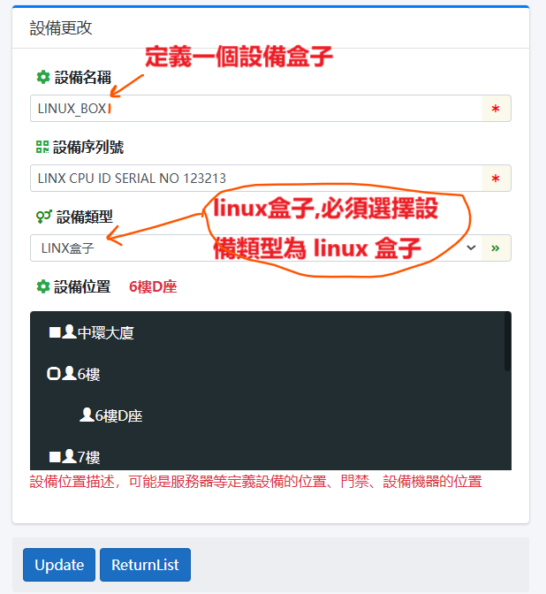

#### 第二步、Linux盒子下掛海康設備:

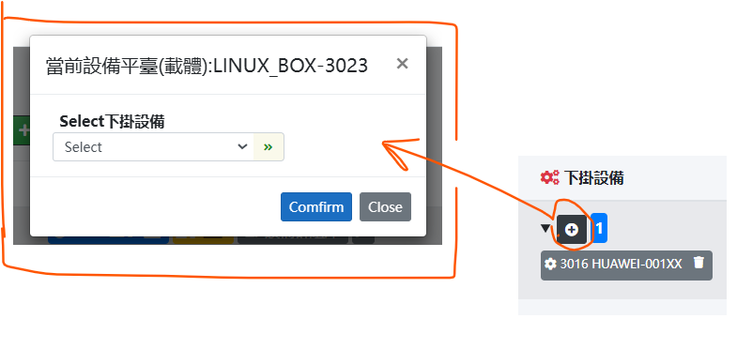

API 獲取 linux 盒子 是否有下掛設備列表,然後批處理下掛設備列表

/// <summary>

/// 設備類型 主要是指設備的 類型 其他實體設備直接以品牌大寫+設備型號大寫為設備名 例如 HIK_DS_KIT341BMW

/// 部分設備的類型引用AttendanceMode

/// 部分是虛擬設備 例如QQ MAP GOOGLE MAP 屬於GPS的虛擬設備

/// </summary>

public enum DeviceType

{

/// <summary>

/// 無定義的 (設備) DEVICE_UNDEFINED_DEVICE

/// </summary>

[EnumDisplayName("DEVICE_UNDEFINED_DEVICE")]

UNDEFINED_DEVICE = -10,

/// <summary>

/// LINX_BOX 基於linux嵌入式加載的程序

/// 目前功能是 linux盒子運行海康拍卡同步多設備程序

/// </summary>

[EnumDisplayName("DEVICE_LINX_BOX")]

LINX_BOX = 999,

/// <summary>

/// Android 拍卡 (設備)

/// </summary>

[EnumDisplayName("DEVICE_ANDROID_NFC")]

ANDROID_NFC = 1001,

[EnumDisplayName("AttendanceMode_DAHUA_CARD_FACE")] //20001為大華設備類型 如何拍卡人臉 DAHUA_CARD_FACE = 1001

DAHUA_CARD_FACE = 20001,

/// <summary>

/// 海康 HIK_DS_KIT341BMW人臉/拍卡 設備類型

/// 改為標準設備類型 VER 1

/// </summary>

[EnumDisplayName("DEVICE_HIK_DS_DEVICE")]

HIK_DEVICE = 10022,

/// <summary>

/// 海康通用門禁(ACS) VER1

/// 為 LINUX版本而設定 2024-11-9

/// </summary>

[EnumDisplayName("AttendanceMode_HIK_GENERAL_ACS_VER1")]

HIK_GENERAL_ACS_V1 = 1000,

/// <summary>

/// 海康 HIK_DS_KIT341BMW人臉/拍卡 設備類型

/// </summary>

[EnumDisplayName("DEVICE_HIK_DS_KIT341BMW")]

HIK_DS_KIT341BMW = 1002,

/// <summary>

/// 海康 HIK_DS_KIT804MF 設備類型

/// </summary>

[EnumDisplayName("DEVICE_HIK_DS_KIT804MF")]

HIK_DS_KIT804MF = 1003,

/// <summary>

/// NFC CIC協會的CHECK SITE模式

/// </summary>

[EnumDisplayName("DEVICE_TYPE_NFCCIC_CHK")]

NFCCIC_CHECK = 1004,

/// <summary>

/// NFC CIC協會的 拍卡模式 mode=9

/// </summary>

[EnumDisplayName("DEVICE_TYPE_NFCCIC_TAP")]

NFCCIC_TAP = 1005,

/// <summary>

/// DESTOP DVR 數字錄像設備/数字录像设备 基於電腦的

/// </summary>

[EnumDisplayName("DEVICE_TYPE_DESTOP_DVR")]

DESTOP_DVR = 1006,

[EnumDisplayName("AttendanceMode_FACE_RECOGNITION")]

FACE = 100,

[EnumDisplayName("AttendanceMode_CAM_GUARD")]

CAM_GUARD = 0,

[EnumDisplayName("AttendanceMode_HIK_CARD")]

HIK_CARD = 1,

[EnumDisplayName("AttendanceMode_STANDARD_CARD")]

STANDARD_CARD = 2,

[EnumDisplayName("AttendanceMode_STANDARD_CARD_AND_FINGERPRINT")]

STANDARD_CARD_AND_FINGERPRINT = 3,

[EnumDisplayName("AttendanceMode_CIC_CARD")]

CIC_CARD = 4,

[EnumDisplayName("AttendanceMode_CIC_CARD_CHECK")]

CIC_CARD_CHECK = 44,

[EnumDisplayName("AttendanceMode_BAIDU_MAP")]

BAIDU = 5,

[EnumDisplayName("AttendanceMode_GOOGLE_MAP")]

GOOGLE = 6,

[EnumDisplayName("AttendanceMode_QQ_MAP")]

QQ = 7,

[EnumDisplayName("AttendanceMode_APPLE_MAP")]

APPLE_MAP = 77,

[EnumDisplayName("AttendanceMode_GPS_MAP")]

GPS = 8,

[EnumDisplayName("AttendanceMode_FINGERPRINT")]

FINGERPRINT = 9,

[EnumDisplayName("AttendanceMode_PASSWORD")]

PASSWORD = 10,

[EnumDisplayName("AttendanceMode_COMBINE_VERIFY")]

COMBINE_VERIFY = 11,

[EnumDisplayName("AttendanceMode_CARD_FINGERPRINT_PASSWD")]

CARD_FINGERPRINT_PASSWD = 12,

[EnumDisplayName("AttendanceMode_FACE_CARD_VERIFY")]

FACE_CARD_VERIFY = 13

}

## 考勤模式

/// <summary>

/// 和DataGuardXcore系統一樣 主導表[HistRecognizeRecord].[Mode]的模式的值

/// ATTENDANCE MODE FOR ATTENDANCE_LOG

/// </summary>

public enum AttendanceMode

{

[EnumDisplayName("AttendanceMode_FACE_RECOGNITION")]

FACE = -1,

[EnumDisplayName("AttendanceMode_CAM_GUARD")]

CAM_GUARD = 0,

[EnumDisplayName("AttendanceMode_DAHUA_CARD_FACE")] //20001為大華設備類型 如何拍卡人臉 DAHUA_CARD_FACE = 20001

DAHUA_CARD_FACE = 20001,

[EnumDisplayName("AttendanceMode_HIK_CARD")]

HIK_CARD = 1,

[EnumDisplayName("AttendanceMode_STANDARD_CARD")]

STANDARD_CARD = 2,

[EnumDisplayName("AttendanceMode_STANDARD_CARD_AND_FINGERPRINT")]

STANDARD_CARD_AND_FINGERPRINT = 3,

[EnumDisplayName("AttendanceMode_CIC_CARD")]

CIC_CARD = 4,

[EnumDisplayName("AttendanceMode_BAIDU_MAP")]

BAIDU = 5,

[EnumDisplayName("AttendanceMode_GOOGLE_MAP")]

GOOGLE = 6,

[EnumDisplayName("AttendanceMode_QQ_MAP")]

QQ = 7,

[EnumDisplayName("AttendanceMode_GPS_MAP")]

GPS = 8,

[EnumDisplayName("AttendanceMode_FINGERPRINT")]

FINGERPRINT = 9,

[EnumDisplayName("AttendanceMode_PASSWORD")]

PASSWORD = 10,

[EnumDisplayName("AttendanceMode_COMBINE_VERIFY")]

COMBINE_VERIFY = 11,

[EnumDisplayName("AttendanceMode_CARD_FINGERPRINT_PASSWD")]

CARD_FINGERPRINT_PASSWD = 12,

[EnumDisplayName("AttendanceMode_FACE_CARD_VERIFY")]

FACE_CARD_VERIFY = 13,

//手动调整 MANUAL ADJUSTMENT FROM [AttRegularMode]

[EnumDisplayName("AttRegularMode_WORK_ON")]

WORK_ON = 994,

[EnumDisplayName("AttRegularMode_WORK_OFF")]

WORK_OFF = 995,

[EnumDisplayName("AttRegularMode_LUNCH_START")]

LUNCH_START = 996,

[EnumDisplayName("AttRegularMode_LUNCH_END")]

LUNCH_END = 997,

[EnumDisplayName("AttRegularMode_OVERTIME_START")]

OVERTIME_START = 998,

[EnumDisplayName("AttRegularMode_OVERTIME_END")]

OVERTIME_END = 999

}