Fast Neutron Scatter Contribution to RSM Response

Lawton Drake
Department of Engineering Physics
Air Force Institute of Technology
Wright-Patterson Air Force Base, OH
lawton.drake@afit.edu

Abstract: The Rotating Scatter Mask is a directional radiation detection system with a nearly 4π field-of-view. The first designs for the scatter mask were tested for their ability to detect a ¹³⁷Cs source via gamma detection. The original design of the Rotating Scatter Mask needed to be altered to ensure detection of neutrons emitted from the source as well as the gamma output. The original sodium-iodine detector was replaced with an EJ-309 detector, whose application uses range from pulse shape discrimination, internal sample counting, and external detection of radiation. In this paper, the use of EJ-309 as a neutron counter and the ability of the detector to detect both direct fast neutrons and back scattered neutrons will be discussed.
Keywords: RSM, neutron detection, neutron back scatter, EJ-309

Introduction
The use of directionally-sensitive radiation detectors can greatly reduce the time it takes to locate a radiation source. This time reduction is an important factor in security missions, when dealing with an unknown location of a radiation source. This mission can run the gamut of locating sources for homeland security missions as well as operations overseas in contingency areas. The original Rotating Scatter Mask (RSM) was designed to detect gamma radiation with a sodium-iodine (NaI) detector; this detector was replaced with a liquid scintillator made of EJ-309 developed by Eljen Technology. The EJ-309 detector allows for the collection of neutrons emitted via radiation from a ¹³⁷Cs source. The RSM is then fitted over the detector and its outer aluminum sleeve, as seen in Fig. 1. The mask is rotated about the detector at a set, constant speed therefore allowing for the generation of unique source positions. As the original detector was designed for gamma collection, the code also had to be modified to support neutron collection. The program utilized by the RSM has been named Spartan, and this code was modified to support the neutron collection. The in-depth code changes will be discussed in Section III, however a few of the changes will be discussed in brief here. The code had to be modified to recognize the new detector material, which was a simple one for one switch. Other modifications included the use of energy cuts to collect direct neutrons; this cut method would allow the detector to pick up fast neutrons at 14 MeV but would kill any neutrons that were introduced below that energy level. This would enable the detector to collect fast neutrons that would travel straight into the detector without any form of scatter. The code was also modified to via geometry manipulations to cut the detector in half that would enable the code to calculate the difference between forward scattered neutrons as well as back scattered neutrons; neutrons that are less than the 14 MeV for direct neutrons and allow for energy lost due to collisions with the detector sleeve and the scatter mask.
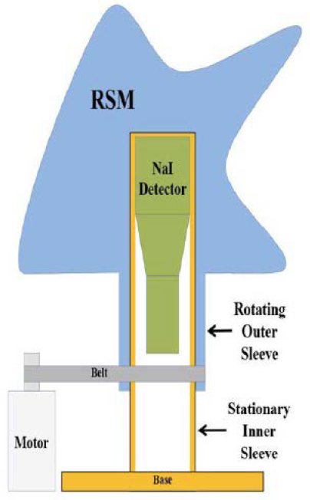
EJ-309
Figure 1: The Rotating Scatter Mask with main components

Problem Description
The problem for the RSM was to create a new code that could quickly and efficiently collect fast neutrons from the ¹³⁷Cs set at a distance of 86.36 cm from the RSM. The new code had to be developed from the existing Spartan code which is comprised of several different code components. The Spartan code consisted of several different code systems. The original sources and geometries were defined in a Python 3 script which had to modified to accept Monte Carlo Neutron Transport (MCNP) 6 scripts. The MCNP codes are the ones that calculated the flux of neutron energies on the detector as well as the front and back scatter neutrons. The MCNP codes also had to be modified to accept both front scatter and back scatter neutrons. This was done by manipulating the geometry of RSM. The geometry manipulations are required to allow the detector to collect neutrons in the fast neutron range (1 keV – 14 MeV) that struck the mask material or detector sleeve and then proceed to the detector. The collection of this data when combined with the already collected and calibrated gamma data will be used to model the detector to be able to pinpoint the source direction

Description of Work
The first step in addressing the problem as to whether or not the RSM could be coded to address neutrons was to change the detector material from the NaI to the EJ-309. This was a simple one for one swap in the MCNP and Python 3 codes. It required replacing the NaI density with that of Ej-309 (0.959 g/cm³) and ensuring that the density number associated with the detector was replaced with the EJ-309 as well.
The next area to address was to look at neutrons in their different energy levels. For this project, only the fast (1 keV – 14 MeV) were considered, as this is the energy range at which neutrons would escape from a fission source. This problem was addressed throughout the Python 3 codes and the MCNP codes by changing the radiation source from gamma to neutrons. Again, this process was another one for one swap from photon detection to neutron detection.
The question of geometry was the next step to address when coding for the RSM. The initial tests for photons were run for a source positioned anywhere from 0º to 360º in 10º increments. This is to ensure comprehensive coverage by the RSM and ensure it is able to correctly identify the source direction. For the test on fast neutrons the azimuthal (Φ) and rotational (θ) angles were incremented at 22.5º angles. This was designed to limit the number of computational runs required, as this project’s main focus was not the 100% accuracy of the source direction detection. To better understand the use of 22.5º angles, the geometry of the mask will need to be described.
The mask can be seen in profile in Fig. 1. however, a 3-dimensional look at it will assist in understanding the description of the mask geometries. As seen in Fig. 2., the side with “steps” is considered the tail side of the RSM while the side with the vertical wall is considered the “wall” side. The tail consists of 16 independent steps each representing a spacing of 22.5º. The wall side was also broken into 16 independent sections to maintain symmetry with the tail side. The azimuthal and rotational angles were calculated using a simple algebraic formula to ensure that the source was always striking one of the 16 sections in the center. The origin for all
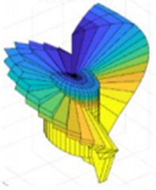
Figure 2: 3-Dimensional view of the RSM

calculations were set as the middle of the wall side, there each 22.5º shift would strike the next section in the center. The two equations used to calculate the azimuthal and rotational angles were:
θ = 11.25 + 22.5n (1)
Φ = 11.25 + 22.5n (2)
where n represents the number of planes that are being calculated. The use of these equations solved the matter of where the location of the source was in the MCNP codes.
After addressing the geometry issues for the source to hit the mask, the next issue to address was how to account for the neutrons as they were detected by the EJ-309 detector directly at the energy level of 14 MeV. The original photon set-up simply had a flux tally for the gammas as they were incident upon the detector. The new code needed to be able to calculate the high energy fast neutrons (14 MeV) without collecting the lower energy scattered neutrons. By accessing the MCNP code for the mask geometry, the detector was able to be manipulated to detect only the fast neutrons. An energy cut code was placed in the material card of the MCNP code that would allow for the 14 MeV neutrons to enter the and pass through the detector for collection in the flux surface tally. The energy cut code would kill any particle that would attempt to enter the detector at less than 14 MeV thus ensuring that the fast neutrons were tallied. The flux tally that accompanied the was an F2 surface flux tally, that when adjusted to the geometry of the detector surface itself would collect the neutrons moving through all three surfaces of the detector. The detector being a cylinder, has three surfaces that were defined in the surface card section of the MCNP code, which was needed to capture all three surfaces for the direct neutrons.
After capturing the direct neutrons, the scattered neutrons needed to be collected to ensure that the RSM was collecting all neutrons propagating from the source. This phase proved to be a challenge because it was required to cut the detector in half using a plane in the MCNP code, which was perpendicular to both the azimuthal and rotational angles. This required the use of an orthogonal plane to the one already bisecting the detector. This orthogonal plane would enable the MCNP code to read the front half of the detector and the back half of the detector as different surfaces which would enable us to calculate both front scatter and back scatter. The orthogonal plane was calculated from three points using azimuthal angles of (22.5º, 112.5º and 202.5º) and rotational angles of (22.5º, 112.5º and 202.5º). Once the detector was cut in half with the plane, a means of detecting the neutrons on just front scatter would need to be made as well as a back-scatter code.
The front scatter code was to be designed using the Weight Window Generator command in MCNP. This command enables the user to place a level of importance on each surface that will experience neutron contact. The importance level can be set at one of two options. The first option is 0, which allows the generator to assign a random importance to the cell using the Russian roulette method. The other importance level is 1, which sets the given cell as a value indicated in the importance cell. In the case of this project, the detector was divided in half using the aforementioned plane and each half was run against the window generator as the following scenarios:
Case 1: the front half of the detector was given an importance of 1, to allow it to collect 13.9 MeV neutrons while the back half was given an importance of 0, allowing it to collect any neutrons scattered throughout the mask in the range of 1 eV to 13.9 MeV.
Case 2: the front half of the detector was given an importance value of 0, allowing the neutrons to go directly into the detector or scatter off the front of the RSM, while the back half was given an importance of 1, again allowing the RSM to collect scattered neutrons.
By collecting the data for the direct neutrons first, and then the scattered neutrons plus direct neutrons second, the data was able to show a comparison between scatter and direct neutrons. In Fig 3. the Direct Neutrons are plotted on a logarithmic scale of energy vs. flux, while Fig. 4. shows the logarithmic plot of energy vs. flux of the Scattered Neutrons.
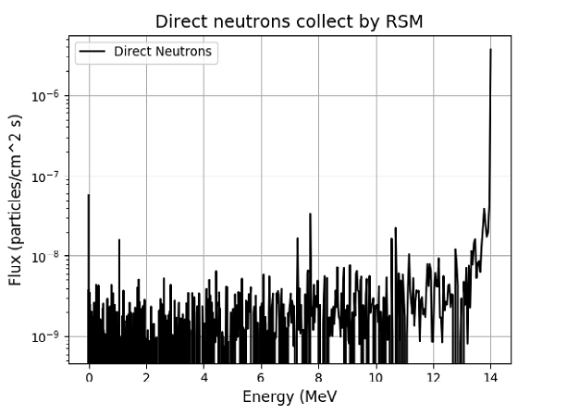
Figure 3: Direct Neutrons collected by the RSM
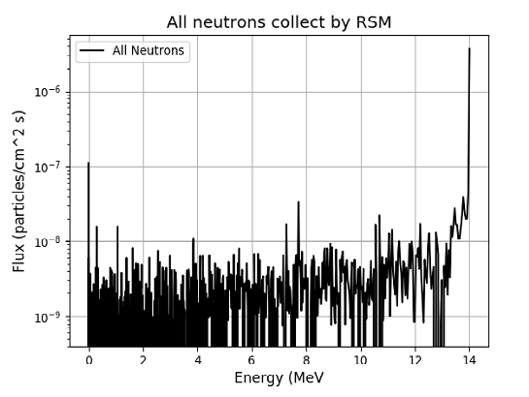
Figure 4: All Neutrons collected by the RSM
These two plots are very similar since they both contain the direct neutrons collected by the detector, therefore in order to see the detector’s ability to capture the scattered neutrons, the data points for these graphs were pulled into Microsoft Excel and the direct neutrons were subtracted from the total neutrons to get the scattered total. Fig. 5. shows the scattered neutron data as pulled from both sets of data as mentioned above.

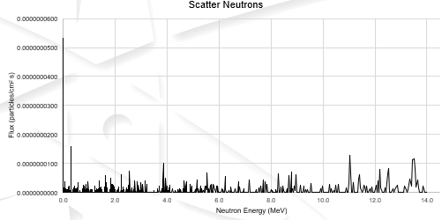
Figure 5: Scattered Neutrons extracted from data

Results
The three plots show that the code designed for neutron capture in the RSM was a success. As stated before, the MCNP code for calculating the direct neutrons was able to successfully identify the high energy (14 MeV) neutrons at the end of the spectrum as shown in Fig. 3. When the full neutron spectrum was coded to allow the detector to capture direct, front scattered, and back scattered neutrons, the code return a plot very similar to the direct neutron plot as shown in Fig. 4. There were several data pieces that were different between the two plots. The most noticeable differences were the higher flux value of the first neutron captured in the total neutron plot. The second difference was a double spike in the flux in the all neutron plot as opposed to a single flux spike in the direct neutrons in the energy level around 1 MeV. When the direct neutrons were subtracted from the total neutron capture count, the scattered neutrons were able to be calculated. In Fig. 5. the scattered neutrons are displayed, and it is noticeable that the flux level of these neutrons is relatively low. The flux was low here due to the amount of RSM material that the neutrons interacted with, causing them to lose energy through atomic collisions. This energy loss was the key factor in determining whether or not neutrons were scattered. Whenever the neutrons interacted with other particles, they lost energy due to atomic interaction, this energy loss correlates to the scatter of neutrons.
The success of this new code to collect neutron data, proves that the RSM can be modified to not only collect photon radiation data but neutron data as well. The neutron data was a simplified collection method, not altering the neutron source or the angle at which the source was found by the detector. Before this neutron scatter method is deemed fit for use, further tests should be run on a wide gamut of differing angles. Further coding would enable simulations to test the neutron detection capability at the 10º angle test done by 1LT Olesen. Running further tests at this smaller angle increment will ensure the detector’s capability to not only detect neutrons but to also pinpoint the source which is the main objective of the RSM.
The changes to the Python and MCNP code proved the ability of the RSM to detect neutrons as well as photons. Through the use of unique energy cuts the detector was able to be modified to detect neutrons that travelled directly from the source to the detector. By modifying the geometry of the detector with a plane, enabled the MCNP code to create a cell for neutrons scattered on the front half of the detector as well as neutrons that were scattered on the back half of the detector. The RSM will continue to undergo tests prior to fielding however the promising results of the photon codes as well as the neutron codes determined in this project show that the RSM is capable of determining the direction of a source in a field environment.

References
- R. Olesen, B. O’Day, D. Holland, L. Burggraf, and J. Bevins “Characterization of Novel Rotating Scatter Mask Designs for Gamma Direction Identification.” Science Direct NUCLEAR INSTRUMENTS AND METHODS IN PHYSICS RESEARCH 00 (2018) 1–15
- D. Holland, provided Python and MCNP codes for photons.
[3] J. Bevins, provided assistance with PuTTY error

