Paramount+ · Subscriber Regression Model
Linear Regression: Predicting Total Signups · Feb–Apr 2026

Channel Efficiency Outperforms Spend
Efficient budget allocation and marketing strategy both have a greater impact on sign-ups. The data shows that average return on ad spend (ROAS) is the strongest predictor of sign-up volume. The goal of this linear regression model was to determine whether sign-ups are influenced by ad spend, plan price, subscriber age, and bundling. By identifying which channels produce the highest ROAS, Paramount+ can focus investment where it drives the most subscriber growth.

Model Performance
R-squared  0.958  95.8% variance explained | RMSE  2.98  ±3 signups avg error | Target (y)  Total Signups  Campaign-level prediction | Train / Test  80% / 20%  Random state = 42

Feature Importance (by Coefficient)
Feature
1. ROAS 287.34 ★★★★★
Higher ROAS leads to significantly more signups.
2. Bundled +0.020 ★★☆☆☆
Bundled subscribers are slightly associated with more signups.
3. Age +0.002 ★☆☆☆☆
Minimal positive effect from subscriber age.
4. Total Spend +0.0009 ★☆☆☆☆
More spend leads to marginally more signups, therefore efficiency matters more than volume.
5. Plan −0.0005 ★☆☆☆☆
Higher price plan does have a slight negative effect on signups.

Correlation with total_signups
Feature | r value | Strength | Direction | Interpretation
total_spend | 0.837 | Strong | Positive ↑ | Highest correlator: spend volume drives signup volume
avg_roas | 0.223 | Moderate | Positive ↑ | Better efficiency correlates with more signups
plan_price | 0.010 | Very Weak | Positive ↑ | Plan pricing has almost no effect on signups
age | 0.006 | Negligible | Positive ↑ | Subscriber age does not predict signups
is_bundled | -0.054 | Very Weak | Negative ↓ | Bundled subs slightly associated with fewer signups

Scatter Plots — Feature vs Total Signups
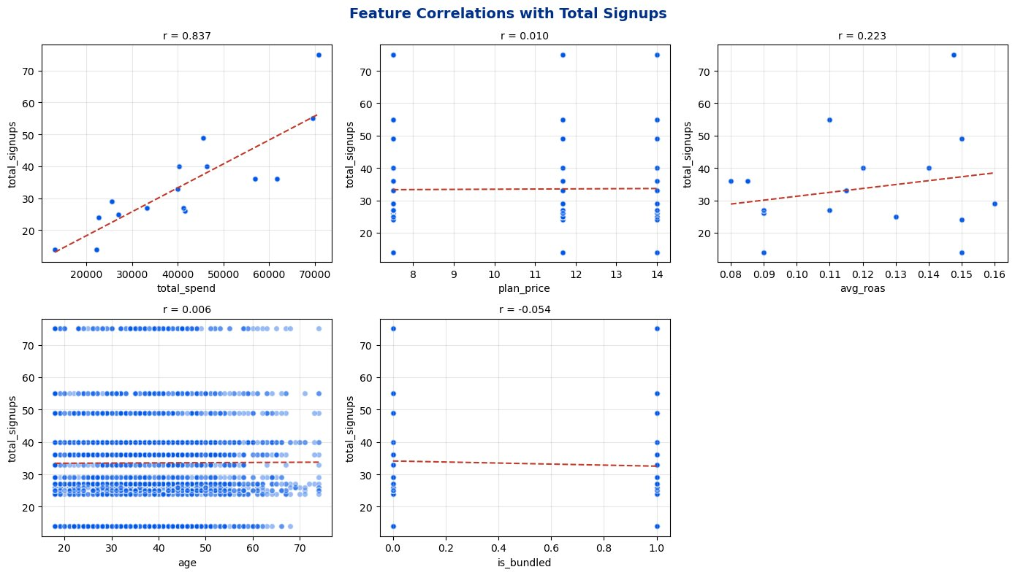

Process & Data Limitations
Process
Generated synthetic data in Claude AI before cleaning and preprocessing data in Python using Pandas train/test splitting. Applied an 80/20 train/test split and fit a multivariate linear regression model using scikit-learn.
Data Limitations
A production model would incorporate adstock decay, seasonality, and 18–24 months of historical spend data to improve predictive accuracy. Statistical significance testing between campaign groups would further validate the regression findings.

