Convert OSM files to .net files (Use
netconvert --osm-files map.osm --output-file wisma.net.xml --lefthand --geometry.remove --ramps.guess --roundabouts.guess --junctions.join --tls.guess-signals --tls.discard-simple --tls.join

Generate Random Trips and Output as .trips file
python "%SUMO_HOME%\tools\randomTrips.py" -n wisma.net.xml -e 1000 -o wisma.trips.xml

Using duarouter to generate .rou file

Create sumocfg files
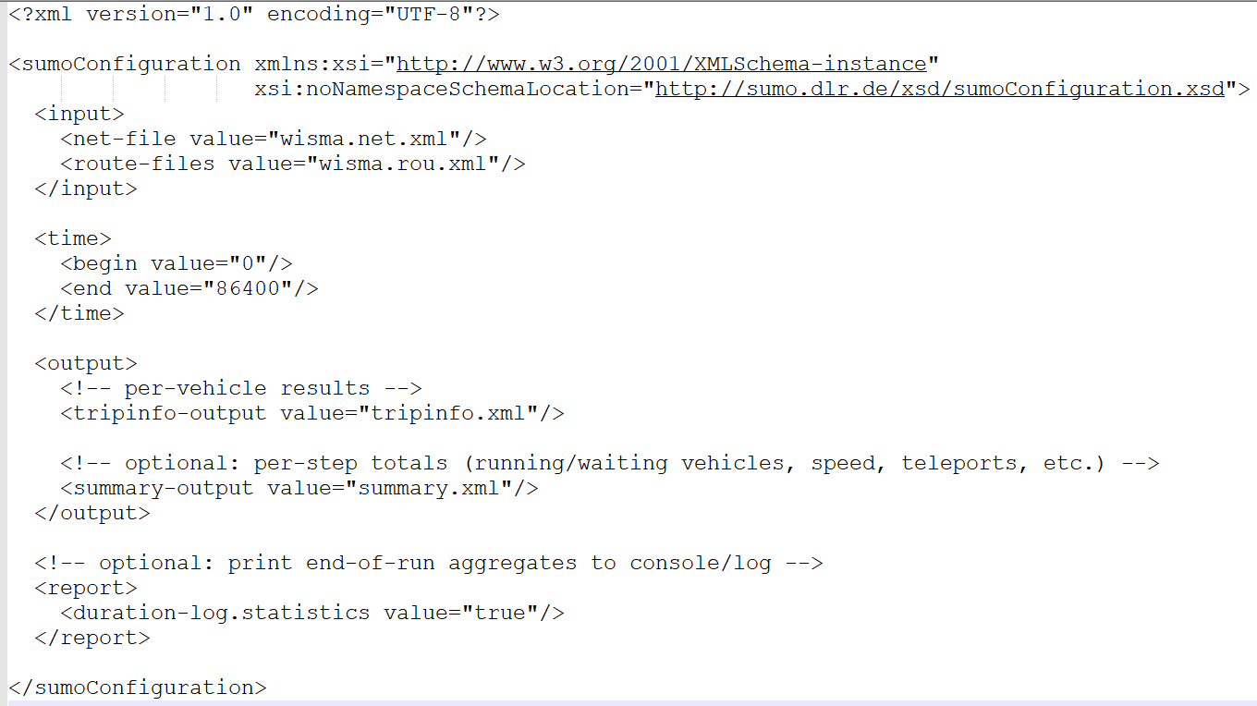

Convert tripinfo to csv files
python "%SUMO_HOME%\tools\xml\xml2csv.py" tripinfo.xml -o tripinfo.csv

Generate Passenger Request
python "%SUMO_HOME%\tools\randomTrips.py" -n osm.net.xml -b 0 -e 3600 -p 100 --personrides taxi --vclass taxi --validate -o requests.rou.xml
Note that:
- Vclass - taxi means only generate request at taxi allowable lane
- b – simulation begin time
- e – simulation end time
- p – trip period (Generate 1 trip every 100 second)

python "%SUMO_HOME%\tools\randomTrips.py" -n wisma_clean.net.xml -b 0 -e 3600 -p 5 --personrides taxi --vclass taxi --validate --min-distance 150 -o requests.rou.xml

python “%SUMO_HOME%\tools\net\netcheck.py” -n map.net.xml

Run the DRT
python "%SUMO_HOME%\tools\drt\drtOnline.py" --sumocfg wisma.drt.sumocfg -s sumo-gui --max-wait 600 --drf 2.0 --sim-step 30

Check Connectivity, Keep Largest Component & Resolve Dead End
python %SUMO_HOME%\tools\net\netcheck.py map.net.xml
netconvert --sumo-net-file map_final.net.xml --no-turnarounds false -o map_final.net.xml
netconvert --sumo-net-file osm.net.xml --keep-edges.components 1 -o map_clean.net.xml

Open OSM Web Wizard to Generate Map
python "%SUMO_HOME%\tools\osmWebWizard.py"

Keep On Resample Valid Trip
Yes — the elegant way is: treat trip generation as “sample → validate reachability → keep / resample”. You don’t need to make the whole map strongly connected; you just ensure your generated OD pairs are reachable.
Here are 3 clean approaches (pick 1):

Option A (Most elegant): Let duarouter validate and filter
Workflow:
- Generate trips (random)
- Run duarouter to compute routes
- Keep only trips that produced a valid route
Commands:
python %SUMO_HOME%\tools\randomTrips.py -n map.net.xml -o trips.trips.xml --validate
duarouter -n map.net.xml -t trips.trips.xml -o routes.rou.xml --ignore-errors --remove-loops
Interpretation:
- If an OD pair is unreachable, duarouter will fail that trip (and with --ignore-errors it continues).
- Result: routes.rou.xml contains only routable vehicles → far fewer/no teleports.
If you still need the same number of trips, you can simply generate a bit more and let filtering drop the bad ones.

Option B: Generate only from “good” edge pools (very effective)
Precompute a pool of edges that are safe for routing (e.g., inside main component + passenger allowed + not dead-end), then tell randomTrips to sample from those.
- Create an edge list file good_edges.txt (one edge id per line).
- Use it:
python %SUMO_HOME%\tools\randomTrips.py -n map.net.xml -o trips.trips.xml \
--vehicle-class passenger \
--edges-file good_edges.txt \
--validate
This is super stable for RL because you avoid fringe/dead ends.
(If your randomTrips doesn’t support --edges-file in your SUMO version, we can instead generate many trips and filter them with Option A/C.)

Option C: Hard guarantee for “trip endpoints mutually reachable”
If your goal is stronger:
“every endpoint can reach every other endpoint (and also starts)”
Then you want to pick endpoints from a single strongly connected set (directed reachability).
Elegant pipeline:
- Find the largest strongly connected component (SCC) of the directed graph (edges with direction).
- Only allow trip from/to edges whose from/to junctions are inside that SCC.
- Generate trips within that set → guarantees any chosen endpoint is reachable from any other.
This is more strict than netcheck’s weak connectivity.
How to do it (practical approach):
- Use a small Python script to:
  - parse map.net.xml
  - compute SCCs on junction graph
  - output good_edges.txt for edges fully inside the biggest SCC
- Then use Option B.
If you want, I can give you that script (it’s short and runs fast).

What I’d recommend for you (RL, minimal hassle)
Option A + generate extra trips is the cleanest:
- Generate e.g. 20–30% more trips
- Run duarouter --ignore-errors
- Use the resulting routes.rou.xml
That way your simulation only inserts routable vehicles and teleports drop massively.

Quick check: “Did any trip fail routing?”
Run duarouter and watch for messages like “no connection between edge …”. If you want a clean number, also write routing logs:
duarouter -n map.net.xml -t trips.trips.xml -o routes.rou.xml --ignore-errors --log duarouter.log

If you tell me your SUMO version (or paste sumo --version) and whether you can run Python scripts, I’ll give you the most compatible exact commands (some flags differ slightly by version).

