F74046242 謝耀賢

Prob1.

Ans:
The binary representation of 0.030000 is [00111100111101011100001010001111]
The decimal representation of [00111100111101011100001010001111] is 0.030000
The binary representation of 2.400000 is [01000000000110011001100110011001]
The decimal representation of [01000000000110011001100110011010] is 2.400000
The binary representation of -5.878000 is [11000000101111000001100010010011]
The decimal representation of [11000000101111000001100010010011] is -5.878000

First, I wrote two functions, NumToSngBin and SngBinToNum, allow me to use it in order to make input number or binary transform. These two functions I use to equation, (-1)^s*2^(127-c)*(1+f) , teacher gave in class to wrote them out. After finishing them, I found three number that homework acquire to input to the function in order to find the another form out. I had written a c program which can transform number to binary or transform binary to number, so that I used this program to check the answer in Prob1 is correct or not.

Prob2.

Ans:
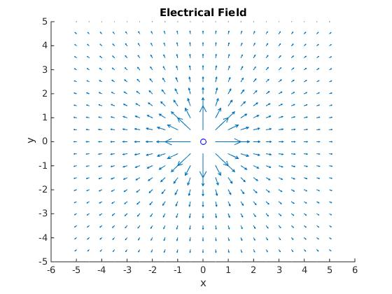

First, I wrote the function PlotArrow to help me plot the electric field, the function PlotArrow need to input two points' x and y position, and it'll plot the arrow from point one to point two. The arrow I use three line to plot, first line is from point one to point two, the second and third line is from point two to the two points I found for drawing the shape of arrow. I found two points by using normals to find them out. Finishing the function, I found every point to make their unit vector to draw the electric field. By comparing my plot and other friends' plot, I thought my plot is correct.

Prob3.

Ans:

The smallest positive root of Prob.3(a) is 0.82449859
The largest negative root of Prob.3(a) is -0.82449858
The smallest positive root of Prob.3(b) is 1.30149801
The largest negative root of Prob.3(b) is -3.37759142
The smallest positive root of Prob.3(c) is 0.90997315
The largest negative root of Prob.3(c) is -0.45896285

First, I plot the three function to find where roots are, and I use bisection method to find the roots out. I check the answers by watching my plots and my roots what I found out by using bisection method to see whether my answers are meet the plots or not.

Prob4.

Ans:

The distance ratio of L1: 0.99
The distance ratio of L2: 1.01
The distance ratio of L3: 1.00

The equation of L1, L2, L3 I found them in wiki, so I think they must be correct!!!

