F74046242 謝耀賢

Prob1:

Result:
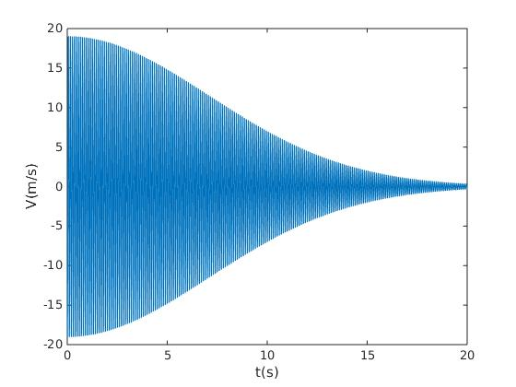
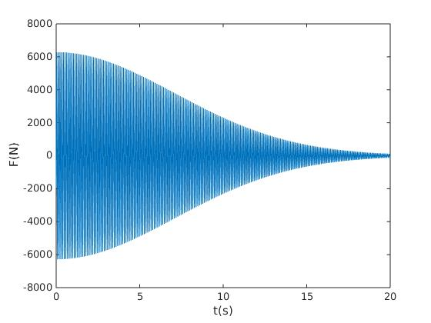

(V-t) (F-t)

F(8) = -1015.772967 N
x(10) = -0.06182336 m
The total travel length from t = 0 to 10 is 95.11019305 m

Method:
(1) diff:central diff
(2) int:trapezoid method

How to cal diff?

Need to input the value of time(t) and step size(h) into the function at(t,h), and it’ll output the diff answer.

How to cal int?

Need to change the value of interval (num,num=int to value – int from value), and the step size(accur), next input the value of low and high(low = int to value, high = int to value + accur),
and it’ll output the int answer.

How to know answer correct?

Try many different number of step size and find out that the answers are almost the same.

Prob2:

Result:

(i) 0.78539815 + 6.71420942 i
(ii) 2.15651299
(iii) 0.32178934

Method: trapezoid method

How to cal int?

Need to change the value of interval (num,num=int to value – int from value), and the step size(accur), next input the value of low and high(low = int to value, high = int to value + accur),
and it’ll output the int answer.

How to know answer correct?

Try many different number of step size and find out that the answers are almost the same.

Prob3:

Result:

A total of 10000000 random points are used and the volume of the ellipsoid is 25.10500000.

How to cal?

Change the range x,y,z , value of num(random points), and the function that need to check, and it
will output the answer needed. One thing is also needed to change – ans, the num of it need to change to the num of range^3.

How to know answer correct?

Try many different number of num(random points) and find out that the answers are almost the same.

Prob4:

Result:

(1) The total flux is 114184837072.443558 (Volt.m)
(2) The total flux is 113563223195.611725 (Volt.m)
(3) The total flux is 113588248395.992096 (Volt.m)
(4) The total flux is -7711278.297052 (Volt.m)

How to cal?

The function – prob4_func, has 5 parameters, center x, center y, center z, cube edge, and dm, and it’ll output the total flux.

How to know answer correct?

Try many different number of the fifth parameter(dm) and find out that the answers are almost the same.

