F74046242 謝耀賢

Prob1

Method : Euler Method
Step size: 1e-5 (h)

coordinate: the place before compress is 0, under this place(compressing) is negative, thus, the other direction is positive.

ans:
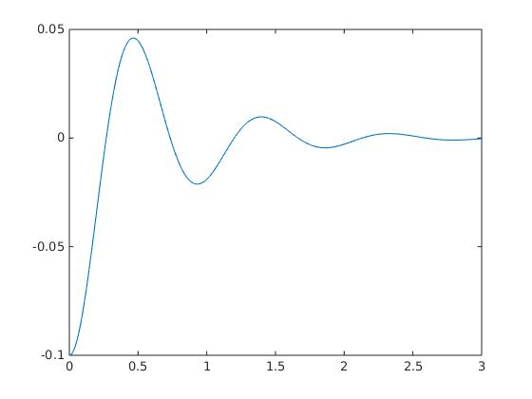

the oscillation frequency of the system is f=1.074275

Prob2

Method : Euler Method
Step size: 1e-4 (dt)

coordinate: where positive, and where negative is same as ε(t).

Ans:
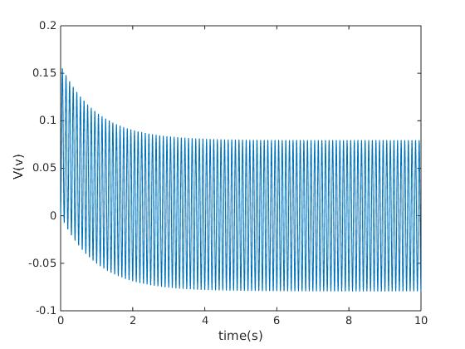
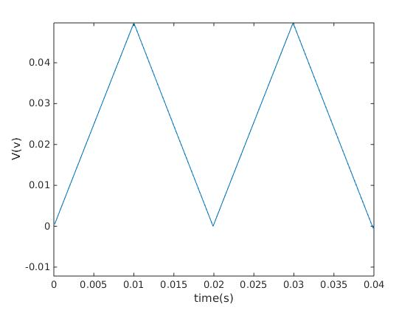

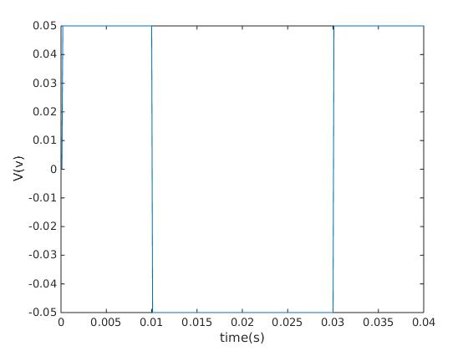

Prob3

Method : central diff, Euler Method
Step size: 1e-6 (h)

coordinate: where positive, and where negative is same as ε(t).

ans:
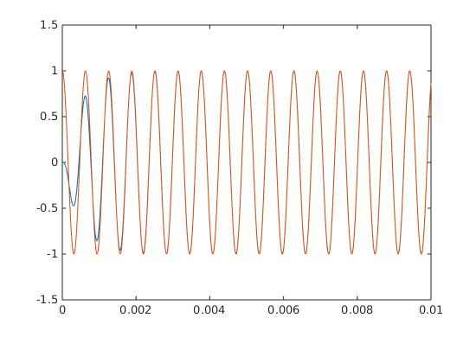
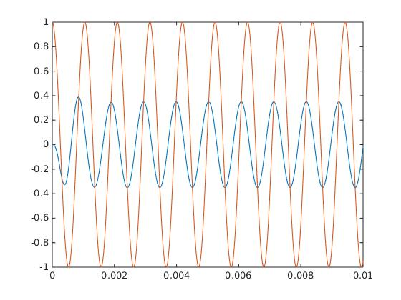
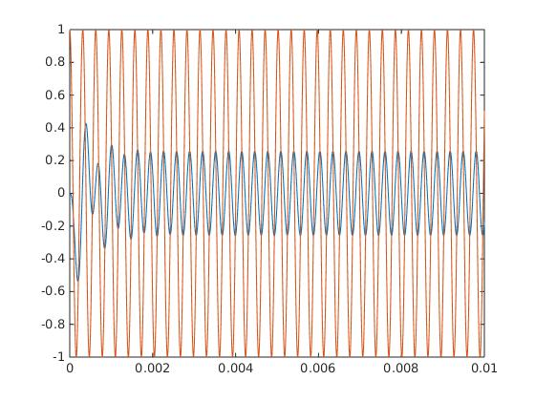

Proof:

