F74046242 謝耀賢

prob1

ans:

(b)
vc = 29830.275448 (m/s)

(c)
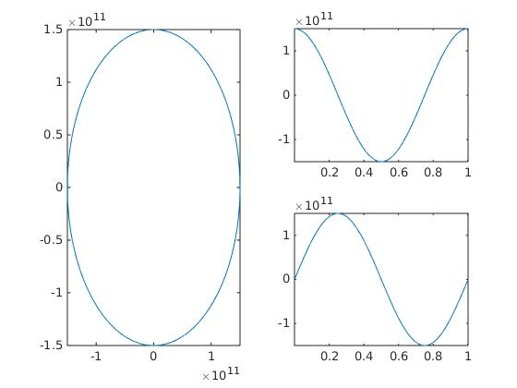

(左圖為x-y圖, 右上圖為x-t圖, 右下圖為y-t圖)

T=1.001861(year)
(d)

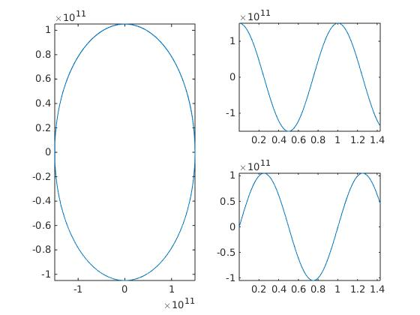

(左圖為x-y圖, 右上圖為x-t圖, 右下圖為y-t圖)

T=1.431229(year)

(e)

error = 0.000813

(f)

prob2

I haven’t finished yet, just do (a) and (b), and just have code...

