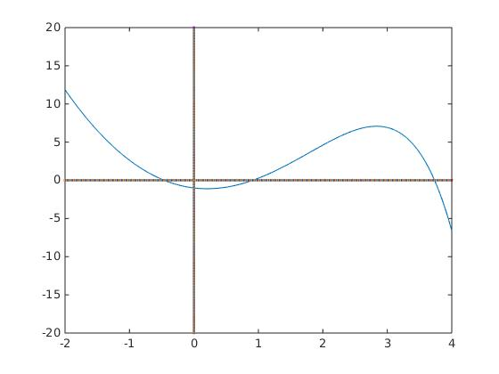
Q2_1

(a) bisection method

(b) [-1,0]

(c) -0.5

(d) -0.4589
(accur = 0.001)

(e) Yes

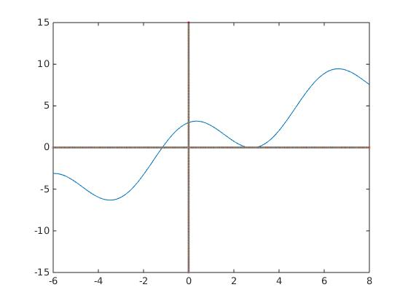

Q2_2

(a) Newton's method

(b) [-2,0]

(c) -2

(d) -1.1704
(accur = 0.001)

(e) Yes

Q2_3

