Figure 1:
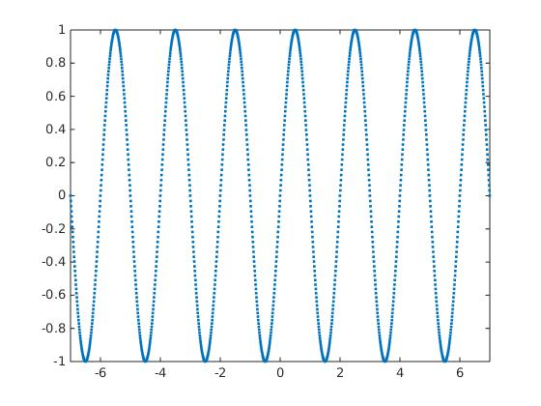

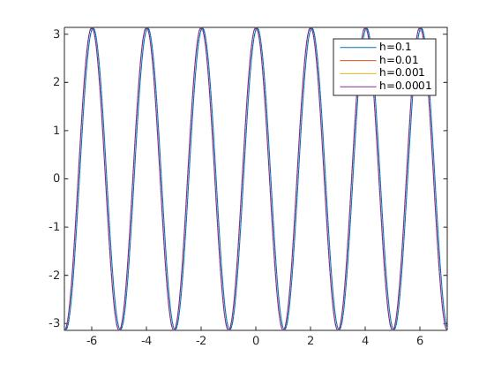
Figure 2:

Figure 3:
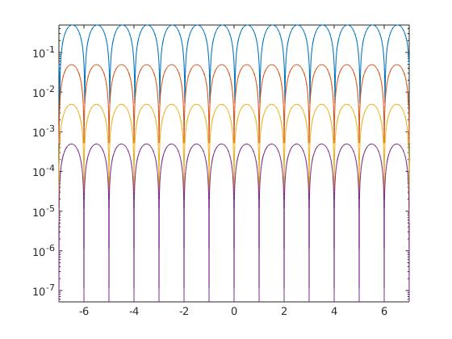

h less, error less

Figure 4:

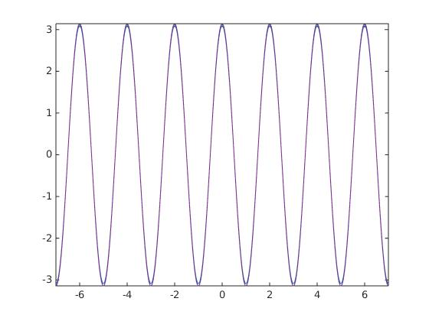

Figure 5:

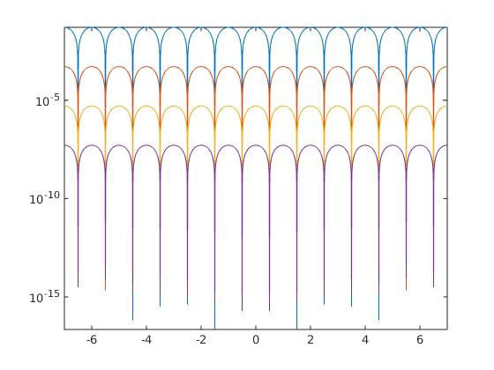

h less, error less

Figure 6:
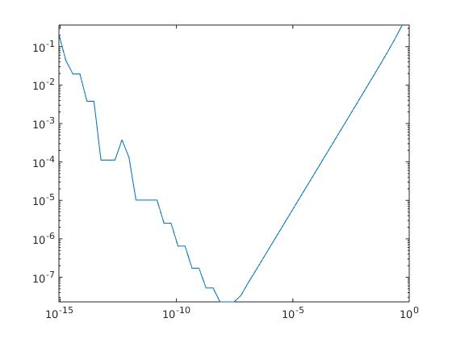

h = 2^(-25), 2^(-26), 2^(-27) could give an optimal answer

Figure 7:
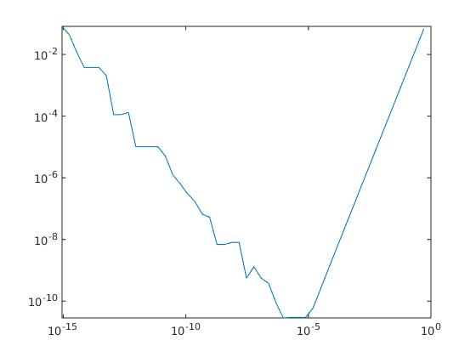

h = 2^(-20) could give an optimal answer

