Figure8:
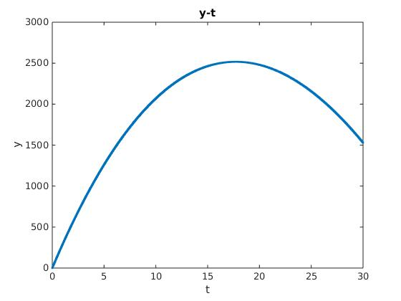

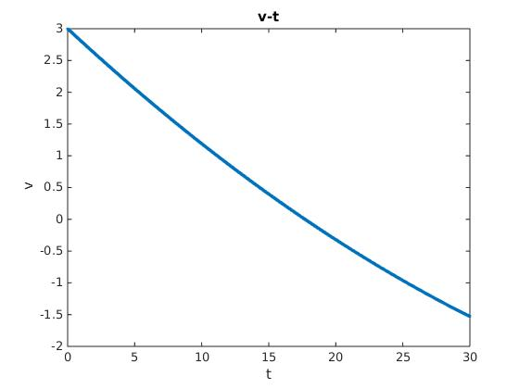
Figure9:

diff the position in order to find velocity out.

Figure10:
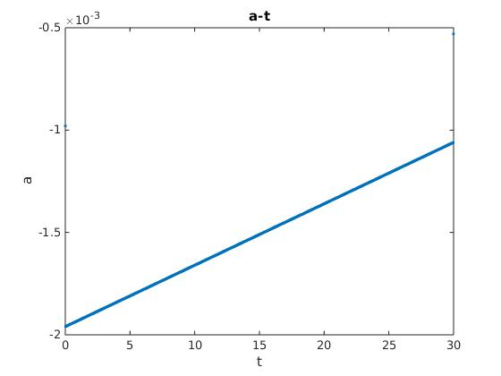

diff the velocity in order to find acceleration out.

Ques11:

Ans: At t=17.71, the thing is at the highest place Y = 2.517020e+03

use binary search to find when velocity may be 0(or to find the closest one).
At this time, the position is the highest!!

