Quiz 5 F74046242 謝耀賢
q1-1:
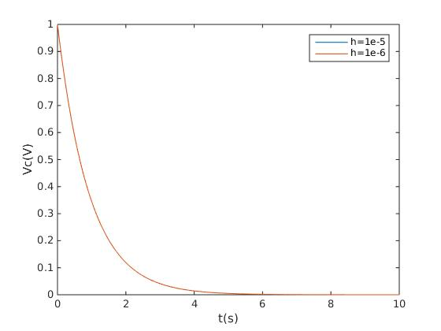

q1-2:

ans:
Vc(0.3) = 0.72676607(V), step size=1.00e-05
Vc(0.3) = 0.72676718(V), step size=1.00e-06

method: euler method

q1-3:

ans:
It take 2.164420(s) for the capacitor’s voltage to drop to 0.1 V (step size=1.00e-05)
It take 2.164429(s) for the capacitor’s voltage to drop to 0.1 V (step size=1.00e-06)

q2

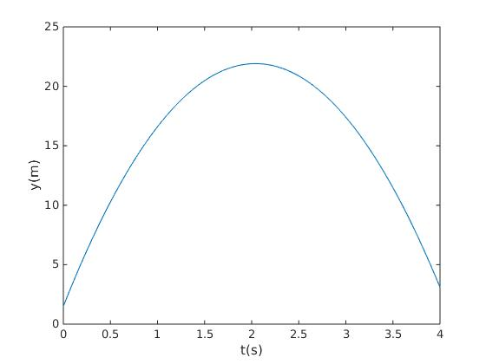
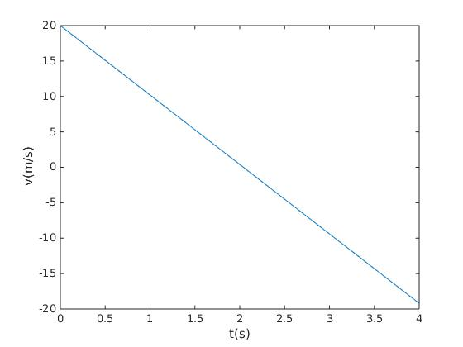
ans:

y'(4)=-19.20000000 (m/s)
y(4)=3.09998040 (m)

method: euler method

step size: 1e-6

q3:

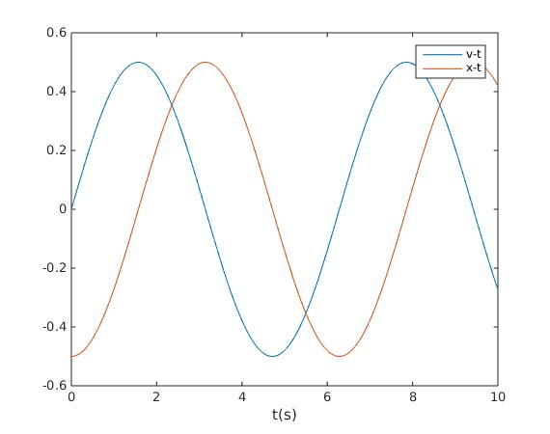
step size: 1e-6

method: euler method

ans:

period = 6.281184(s)

how to find?

In x-t, to find another point same as x(0), and the period time is the time between two points.

