Quiz 4 F74046242 謝耀賢

(1)

Plot the h-error

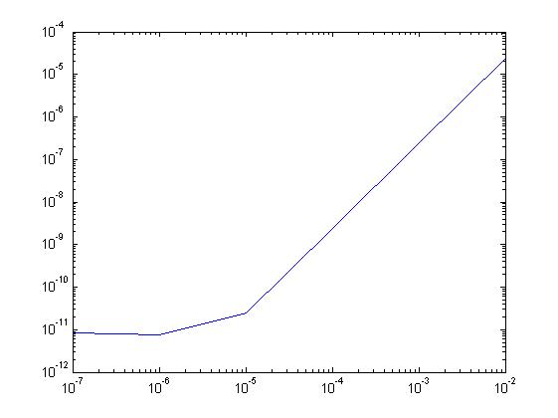

Method : trapezoid

Result:

h=1.000000e-02, ans = 0.29286913, error = 0.00002409

h=1.000000e-03, ans = 0.29289298, error = 0.00000024

h=1.000000e-04, ans = 0.29289322, error = 0.00000000

h=1.000000e-05, ans = 0.29289322, error = 0.00000000

h=1.000000e-06, ans = 0.29289322, error = 0.00000000

h=1.000000e-07, ans = 0.29289322, error = 0.00000000

Optimal choice of h : 10e-4

(2)

Method: trapezoid

Result:

h=1.000000e-02, ans = 0.88208078

h=1.000000e-03, ans = 0.88208138

h=1.000000e-04, ans = 0.88208139

h=1.000000e-05, ans = 0.88208139

h=1.000000e-06, ans = 0.88208139

h=1.000000e-07, ans = 0.88208139

Optimal choice of h : 10e-4

(3)

Estimate the area of the ellipse = 25.13235200