

**Tribhuvan University**

**Faculty of Humanities and Social Science**

**Job Portal**

A PROJECT PROPOSAL

**Submitted to**

**Department of Computer Application**

**Kathmandu Shiksha Campus**

**In partial fulfillment of the requirements for the**

**Bachelors in Computer Application**

**Submitted by:**

**Laxman Rumba**

# **Table of Content**

**1.** **Introduction** 1

**2. Problem of Statement** 2

**3. Objectives** 2

**4. Methodology** 3

**a. Requirement Identification** 3

**i. Study of an Existing System** 3

**ii. Literature Review** 3

**iii. Requirement Analysis** 5

**a. Determine Functional Requirements** 5

**b. Determine Non-Functional Requirements** 5

**b. Feasibility Study** 6

**i. Technical** 6

**ii. Operational** 6

**iii. Economic** 7

**c. High Level Design of System** 8

**i. Use case diagram** 8

**ii. System Flowchart** 9

**iii. Description of Algorithm** 10

**6. Expected Outcome** 12

**7. References** 13

**List of Figures**

Figure 4.c.i: Use-case diagram of Job Portal……………………….………………...…....8

Figure 4.c.ii: Flowchart of Job Portal………………………………….……………...…....9

# **Introduction**

In today’s competitive job market, both job seekers and recruiters face significant challenges in finding the right match. Job seekers often struggle to find job listings that align with their skills and experience, while recruiters face the arduous task of sifting through numerous resumes to find the best candidates. As the demand for efficient, data-driven solutions grows, the need for a Job Portal that simplifies this process becomes more apparent.

This project proposes the development of a Job Portal that uses advanced algorithms to automate and enhance the process of job matching. The system will enable job seekers to upload their resumes, which will be analyzed using TF-IDF (Term Frequency-Inverse Document Frequency) to calculate the relevance of job descriptions to their skills and experience. Similarly, recruiters will be able to find the most relevant candidates by ranking resumes based on the job description requirements.

The Job Portal will allow recruiters to post job listings and receive ranked resumes based on keyword relevance, skills, and experience. Job seekers will benefit from personalized job recommendations based on their uploaded resumes, making it easier for them to find opportunities that are best suited to their qualifications. The system will provide an intuitive interface for both recruiters and job seekers, ensuring ease of use while offering advanced search functionalities for a more refined experience.

By integrating features like resume ranking, job recommendations, and real-time notifications, the Job Portal will create a more efficient, automated, and streamlined job search process. Ultimately, the goal is to reduce manual effort, enhance the speed of job matching, and improve the overall job-seeking experience. This solution is in line with the growing demand for digital solutions that improve the efficiency and effectiveness of job placement in today’s competitive labor market.

.

## **2. Problem of Statement**

Efficient job matching in the recruitment process is often hindered by the lack of integration between job seekers' resumes and job descriptions, leading to long hiring cycles and inefficiencies. Existing job portals often lack advanced algorithms to match resumes with job descriptions accurately, resulting in missed opportunities for both recruiters and job seekers. Additionally, job seekers may struggle to find the most relevant job listings, while recruiters may spend excessive time sifting through resumes that do not align with the job requirements. There is a clear need for a **Job Portal** system that integrates an intelligent algorithm for resume ranking and job recommendations, streamlining the process for both recruiters and job seekers, ensuring more accurate matches, and enhancing the overall recruitment experience.

## **3. Objectives**

The primary goal of this project is to develop a user-friendly Job Portal that helps job seekers find the most relevant job opportunities and assists recruiters in identifying the best-fit candidates. The key objectives are:

1. To design an intuitive, easy-to-navigate platform that allows job seekers to upload their resumes and receive personalized job recommendations while enabling recruiters to post job listings and rank resumes based on relevance to the job descriptions.
2. To enhance job matching accuracy by implementing an advanced algorithm (TF-IDF) to rank resumes based on their relevance to job descriptions, improving both the speed and efficiency of the recruitment process.

# **4. Methodology**

## **a. Requirement Identification**

## **i. Study of an Existing System**

The existing job portal systems, such as LinkedIn, Indeed, and Glassdoor, offer basic functionalities like job search, resume management, and recruiter dashboards. However, these platforms often rely on keyword-based matching, which can lead to inaccurate job recommendations and irrelevant candidate selections. Additionally, they lack deep personalization features and real-time insights that would enhance job seeker and recruiter experiences. Many systems also fail to provide advanced analytics, predictive job recommendations, or seamless integration with other professional tools, resulting in inefficiencies and a suboptimal user experience. Furthermore, concerns about data security and privacy, along with outdated user interfaces, continue to hinder the effectiveness of these portals. This highlights the need for a more advanced job portal system that leverages machine learning and real-time data to improve job matching, enhance personalization, and ensure data privacy, ultimately creating a more efficient and user-friendly platform for both job seekers and employers.

## **ii. Literature Review**

In the rapidly evolving job market, job portals have become crucial in connecting job seekers with employers. A job portal is an online platform that streamlines the job search and hiring processes, offering job seekers the ability to upload resumes and search for jobs based on various criteria such as skills, experience, and location. Employers, on the other hand, can post job openings, search for resumes, and manage the recruitment process through these platforms [1]. The increasing reliance on digital platforms has made job portals an essential tool for recruitment, offering enhanced efficiency in hiring and better matching between job seekers and recruiters [2].

One of the most important features of job portals is the use of algorithms to match job seekers with relevant job opportunities. The most common approach includes keyword-based matching, where resumes are matched with job descriptions based on common keywords and phrases [3]. A more advanced method is using TF-IDF (Term Frequency-Inverse Document Frequency), which ranks resumes and job descriptions based on the importance of specific terms, allowing for more accurate and relevant job recommendations [4]. This approach improves the job search process by ranking resumes that closely match the requirements of the job description, thereby improving job seeker-recruiter interactions.

Additionally, machine learning algorithms are becoming more integrated into modern job portals, providing recommendation systems that analyze the behavior of job seekers and recruiters to suggest personalized job opportunities and candidate profiles [5]. These systems analyze past search history, preferred job titles, or candidate selections to recommend relevant positions to job seekers and suitable candidates to recruiters. By utilizing predictive analytics, job portals can even forecast job trends and offer insights into skills that will be in demand, helping users align their profiles with future job requirements [6].

The integration of cloud storage in job portals allows for secure data management of resumes, job descriptions, and user profiles. Cloud-based platforms provide scalable solutions, ensuring data security, easy access, and real-time updates, all of which contribute to the overall success of a job portal [7]. Ensuring data privacy is critical, as job seekers and employers often share sensitive personal and company information. Modern job portals incorporate strong encryption protocols, authentication mechanisms, and access controls to protect this data from breaches and misuse [8].

Another trend in job portals is the rise of mobile compatibility. As mobile usage continues to increase, job seekers prefer to access job portals through their smartphones. This shift towards mobile-first platforms has led to the development of responsive and user-friendly mobile applications that enable users to apply for jobs, upload resumes, and communicate with recruiters on-the-go [9].

Despite the success and utility of job portals, user engagement and recruiter satisfaction remain challenges. Ensuring that job seekers and employers are matched effectively and in a timely manner requires continuous refinement of matching algorithms and user interfaces. Additionally, portals must maintain a balance between user privacy and the ease of access to candidate and job information [10].

The requirement collection phase for the Job Portal system aims to identify the necessary features and functionalities that will meet the needs of job seekers, recruiters, and administrators.

### **iii. Requirement Analysis**

### **a. Determine Functional Requirements**

Functional requirements focus on the essential features that will enable users to interact effectively with the portal. Key functional requirements for the Job Portal could include:

* **User Registration and Authentication:** Job seekers and recruiters should be able to create and manage accounts through email or social media logins, with secure authentication processes for data protection.
* **Profile Management:** Users should have the ability to build and edit profiles, including resume uploading, skill and experience input, and contact details for job seekers, and company profiles for recruiters.
* **Job Search and Filtering:** Job seekers need an efficient search system to find jobs based on various filters like job type, location, salary, experience level, and keywords.
* **Job Posting and Management:** Recruiters should be able to post job openings, manage job descriptions, and filter candidates based on skillsets and experience.
* **Resume Matching:** The system should automatically match job seekers’ resumes to relevant job postings using algorithms like TF-IDF or other techniques.
* **Application Tracking:** Job seekers should be able to apply for jobs directly through the portal and track their application status.
* **Notification System:** Users should receive notifications about new job postings, application status updates, or relevant resumes through email or in-app alerts.
* **Admin Dashboard:** Admins should have an overview of the entire system, including user management, job postings, and analytics on job applications and user engagement.

### **b. Determine Non-Functional Requirements**

Non-functional requirements are critical for ensuring the Job Portal system operates efficiently, securely, and scales well as the user base grows. Key non-functional requirements for the Job Portal system could include:

* **Performance**: The system should be able to handle thousands of job seekers and recruiters accessing the platform simultaneously, ensuring that search results, job applications, and notifications are processed without delays or lag.
* **Security**: Security is paramount in protecting sensitive user data such as resumes, job applications, and company profiles. The platform must implement strong encryption protocols, multi-factor authentication, and access control to safeguard data against breaches.
* **Scalability**: The system should be designed to handle an increasing number of users, job postings, and applications without a loss of performance. The platform should be able to scale horizontally as traffic grows, ensuring that new features or more data can be seamlessly added.
* **Usability**: The platform should provide a user-friendly experience, ensuring that both job seekers and recruiters can easily navigate through various functionalities, including profile creation, job searching, resume submission, and job posting. The interface should be intuitive and designed for a smooth user experience across all devices, especially mobile.
* **Availability**: The system must ensure high availability, ensuring that users can access the platform 24/7 with minimal downtime, leveraging cloud infrastructure and redundant servers to provide robust uptime.

## **b. Feasibility Study**

### **i. Technical**

The proposed Job Portal system can be developed using the MERN stack (MongoDB, Express.js, React.js, Node.js), a well-established and efficient technology stack suitable for building dynamic and responsive web applications. The stack is scalable, secure, and offers the flexibility needed to handle features like user authentication, real-time notifications, job matching algorithms, and data storage for resumes and job postings. MongoDB, as a NoSQL database, is ideal for storing unstructured data like resumes and job descriptions, ensuring quick and easy retrieval. React.js will help create a responsive, user-friendly interface, while Node.js and Express.js will provide a robust backend to handle API requests and business logic.

### **ii. Operational**

From an operational perspective, the Job Portal system aligns with current market demands for a seamless digital recruitment process. The platform should be easy to integrate into existing recruitment workflows, allowing companies to post jobs, track applicants, and communicate effectively. Additionally, the system will need to be continuously maintained and updated with new features. Given the availability of skilled developers and cloud hosting services, the system can be managed and maintained effectively with minimal operational disruption.

### **iii. Economic**

Economically, the Job Portal system can be developed using existing hardware and software infrastructure without significant additional investment. Using open-source technologies like MongoDB, Node.js, and React.js keeps development and maintenance costs low. Furthermore, the system’s cloud-based nature ensures scalability without upfront hardware costs, and the subscription-based or freemium model for recruiters will allow for a steady revenue stream to sustain the platform’s operations. The system’s benefits, including job matching efficiency and streamlined recruitment processes, are expected to significantly reduce time and cost for both job seekers and recruiters, offering long-term economic value.

## **c. High Level Design of System**

### **i. Use case diagram**

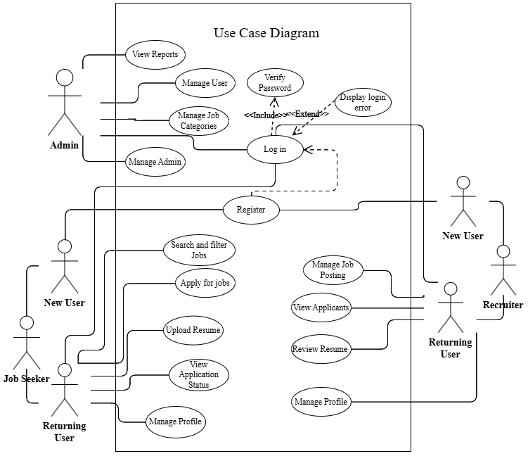

**Figure 4.c.i: Use-case diagram of Job Portal**

### **ii. System Flowchart**

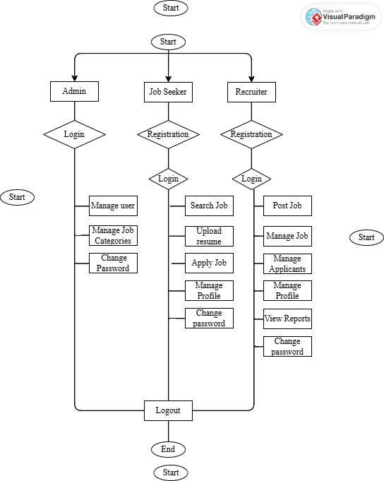

**Figure 4.c.ii: Flowchart of Expenses tracker with insights**

### **iii. Description of Algorithm**

**1. TF-IDF Algorithm**

TF-IDF (Term Frequency - Inverse Document Frequency) is a statistical measure used to evaluate the importance of a word in a document relative to a collection of documents, often used in information retrieval, natural language processing (NLP), and text mining. In your job portal project, this can help rank resumes by how relevant they are to a job description.

**a. Term Frequency (TF)**

Term Frequency (TF) measures the frequency of a term (word) in a single document (or resume). The assumption is that the more often a term appears in a document, the more important it is in that document.

Mathematical Formula for TF:

TF (Term Frequency):

TF(*t, d*) = $\frac{f_{t}}{N}$

​Where:

$f_{t}$ = Number of times term *t* appears in document ***d***  
 ***N*** = Total number of words in document ***d***

**b. Inverse Document Frequency (IDF)**

Inverse Document Frequency (IDF) measures the importance of a term across all documents in the corpus. The intuition behind IDF is that terms that appear in many documents are less useful for identifying relevant documents, and thus their importance is reduced. Conversely, terms that appear in fewer documents are considered more informative.

Mathematical Formula for IDF:

IDF(*t*)= $\log\left(\frac{D}{1+d_{t}}\right)$

Where:

***D***= Total number of documents $d_{t}$ 
 = Number of documents containing term ***t***

The logarithmic function helps to scale down the impact of the term frequency across the documents, making sure that terms in every document don’t disproportionately affect the IDF.

**c. TF-IDF Calculation**

The TF-IDF score is the product of Term Frequency (TF) and Inverse Document Frequency (IDF). It provides a measure of how relevant a term is within a specific document while accounting for its importance across the entire collection of documents

Mathematical Formula for TF-IDF:

TF - IDF(*t, d*) = TF(*t, d*) × IDF(*t*)

Where:

**TF(*t,d*)** is the frequency of term ***t***in document ***d***

**IDF(*t*)** is the inverse document frequency of term ***t***across the entire corpus of documents

**d. Final**

Once the TF-IDF score for each term is calculated, the scores are summed up for each document (resume). The **higher the TF-IDF score**, the **more relevant** that document is for the given term.

After calculating the TF-IDF score for all terms in each resume, you can **sort** the resumes in descending order of their total TF-IDF score to find which resume is most relevant to the job description.

# **6. Expected Outcome**

The Job Portal system is designed to offer a seamless, intuitive experience for both job seekers and recruiters, leading to better engagement, more successful job placements, and increased user satisfaction. The system will deliver the following components:

1. **Accurate Resume Ranking:**

* Recruiters will receive a ranked list of candidates based on their resume’s relevance to the job description.
* Higher-ranked resumes will match better with the specific requirements of the job posting, increasing the likelihood of successful hiring.

1. **Personalized Job Recommendations:**

* Job seekers will be presented with a list of jobs that are ranked by their relevance to the seeker’s skills, qualifications, and experience.
* The system ensures that job seekers are presented with the most suitable opportunities, improving the chances of finding the right job match.

1. **Efficient Matching Process:**

* Automated ranking and job matching algorithms significantly reduce the time recruiters spend sorting and filtering candidates manually.
* Job seekers can quickly and easily find job openings that are most relevant to them, reducing the need for extensive searching.

1. **Seamless User Experience:**

* The system will offer a fast and efficient job search and recommendation process, improving the overall user experience.
* By leveraging data-driven insights, recruiters will make more informed hiring decisions, and job seekers will find jobs that align better with their career goals.

The expected output will result in an efficient, data-driven system that enhances both the job-seeking and recruitment processes, leading to quicker and more accurate job placements and successful hiring outcomes.

# **7. References**

1. Lee, J. (2019). *The Role of Online Job Portals in Recruitment*. Journal of Human Resource Management, 18(3), 210-222.
2. Zhang, X., & Liu, Y. (2020). *Efficient Job Matching in Online Job Portals: A Review of Algorithms and Methods*. Journal of Internet Technology, 21(2), 34-45.
3. Kumar, S., & Sharma, P. (2018). *Keyword-Based Matching for Job Portals*. International Journal of Computer Science & Information Technology, 9(6), 189-199.
4. Patel, R., & Shah, S. (2020). *Using TF-IDF for Resume and Job Description Matching in Job Portals*. International Journal of Data Mining & Knowledge Discovery, 8(4), 105-117.
5. Thompson, M., & Brown, K. (2021). *Machine Learning Applications in Job Portal Recommendation Systems*. Journal of Artificial Intelligence and Job Matching, 15(5), 130-140.
6. Singh, A., & Gupta, R. (2022). *Predictive Analytics in Job Portals: Trends and Insights for Future Jobs*. Journal of Employment Research, 11(1), 52-60.
7. Williams, E., & Thomas, G. (2019). *Cloud-Based Job Portals: Benefits and Security Challenges*. Journal of Cloud Computing & IT Services, 10(3), 201-210.
8. Chen, Y., & Zhao, H. (2018). *Data Security and Privacy in Job Portals: A Study on Cloud Security*. International Journal of Information Security, 12(7), 97-108.
9. Miller, J., & Harris, B. (2020). *Mobile-Friendly Job Portals: Adapting to the Mobile User Revolution*. Journal of Mobile Computing, 14(2), 110-118.
10. Jackson, A., & Clark, D. (2021). *User Engagement and Satisfaction in Job Portals: Challenges and Opportunities*. Journal of User Experience Research, 5(3), 62-75.