SYSTEM DESIGN DOCUMENT

ABC Pharmacy
Medicine Tracking & Sales Application
A microservice architecture built on ASP.NET Core Web APIs and an Angular 19 single page application, with JSON document storage on the server.

Version | 1.0 — For review
Date | 18 August 2026
Prepared for | ABC Pharmacy
Basis | Client brief: "Dot Net Coding Assessment"
Scope | Architecture, service decomposition, API and data design, front-end design, deployment, quality attributes and risks

Contents
If the list below appears empty, right-click it and choose “Update Field” — Word builds the page numbers on first open.

Executive summary
ABC Pharmacy needs an application that shows what medicine it holds, warns staff about stock that is about to expire or about to run out, lets new medicines be added, and keeps a record of every sale. This document sets out how that is built as a microservice system.
The solution is an Angular 19 single page application talking to five ASP.NET Core services through a single API gateway. Each service owns one business capability and one private JSON document store: Medicine Catalog holds the master data and serves the grid; Inventory is the authority on how many units exist; Sales records transactions; Notification raises expiry and low-stock alerts; Identity issues tokens. Services talk to each other synchronously only where a user is waiting for the answer, and asynchronously through a message broker everywhere else.
Three design decisions carry most of the weight. First, the colour rules — red for stock expiring within 30 days, yellow for fewer than 10 units — are evaluated on the server and returned as a status enum, so the rule exists once, is unit-testable at its boundaries, and cannot drift between clients or be broken by a wrong device clock. Red takes precedence when both conditions apply, because an expiry issue is a safety issue. Second, because the brief mandates JSON files rather than a database, the design replaces the guarantees a database would have given: atomic file replacement to survive a crash mid-write, a single-writer lease plus per-record versioning to prevent lost updates, and the transactional outbox pattern so a sale and its stock event can never diverge. Third, selling stock uses a short-lived reservation before the sale is written, which is what stops two counters selling the same last unit.
The design is explicit about what it costs. Write throughput does not scale with replicas while the store is a shared file, and the grid quantity is eventually consistent by up to about a second. Both are acceptable at pharmacy scale and both are measured; §7.7 gives a pre-planned migration to a real database that requires no change to domain, API or UI code. The risk register in §16 states these and eight other risks with their mitigations, and §16.3 lists the six questions that should be put to the client — the most consequential being whether batch and lot numbers are required, since real pharmacy stock usually carries several expiry dates per medicine.
Delivery is proposed in six phases over roughly nine weeks, beginning with a walking skeleton that takes one service end to end into a deployed environment before any breadth is added.

1. Introduction

1.1 Purpose
This document is the System Design Document (SDD) for the ABC Pharmacy Medicine Tracking application. It describes a microservice-based solution built with ASP.NET Core Web APIs on the server and an Angular 19 Single Page Application on the client, with all business data persisted as JSON documents on the server file system, as mandated by the client’s technical constraints.
The document is the authoritative reference for developers implementing the solution, for reviewers assessing the design, and for the operations team that will deploy and run it. It covers the architecture, service decomposition, API contracts, data model, front-end design, cross-cutting concerns, deployment topology, quality attributes and the risks the design carries.

1.2 Scope
In scope:
- Registration and maintenance of medicine master data (name, notes, expiry date, quantity, price, brand).
- A searchable, colour-coded grid listing every medicine held in the system.
- Recording of sales transactions against medicines, with automatic stock adjustment.
- Expiry and low-stock detection, surfaced in the UI and via asynchronous alerts.
- Authentication and role-based authorisation for pharmacy staff.
Out of scope for this release:
- Purchase orders, supplier management and goods-receipt workflows.
- Prescription capture, patient records and any regulated clinical data.
- Payment gateway integration, tax computation and financial accounting.
- Multi-branch / multi-tenant operation (the design leaves a clear extension path, see §16.3).

1.3 Intended audience
Audience | What they should read
Solution / technical architect | Sections 3–5 (architecture and service decomposition), 11 (cross-cutting), 14 (quality attributes), 16 (risks)
Backend developers | Sections 5–7 (services, APIs, data design), 8 (messaging), 11, 15 (testing)
Frontend developers | Sections 6 (API contracts), 9 (Angular 19 design), 10 (colour rules), 15
DevOps / platform engineers | Sections 12 (deployment), 13 (CI/CD), 14 (NFRs), Appendix A
QA | Sections 2 (requirements traceability), 10, 15
Client stakeholders (ABC Pharmacy) | Sections 1–3, 14, 16, 17

1.4 Definitions, acronyms and abbreviations
Term | Meaning
SPA | Single Page Application — the Angular 19 client, served as static assets and driven entirely by REST calls.
BFF | Backend For Frontend — an edge service that shapes and aggregates responses for one specific client.
YARP | Yet Another Reverse Proxy — Microsoft’s reverse-proxy library used to implement the API gateway.
Bounded context | A DDD boundary within which a domain model and its language are internally consistent; each microservice owns exactly one.
Outbox pattern | Writing a domain event into the same store (and same atomic write) as the state change, then dispatching it separately, to avoid dual-write inconsistency.
Optimistic concurrency | Detecting a conflicting concurrent update by comparing a version stamp / ETag rather than by locking.
ProblemDetails | The RFC 9457 (formerly RFC 7807) JSON media type used for all API error responses.
RWX volume | A ReadWriteMany persistent volume, needed so multiple replicas of a service can share the same JSON store.
SLO | Service Level Objective — the internal target for a measurable quality attribute.

1.5 References
- ABC Pharmacy — "Dot Net Coding Assessment" requirement brief (client-supplied, the source of §2).
- RFC 9457 — Problem Details for HTTP APIs.
- Microsoft — .NET Microservices: Architecture for Containerized .NET Applications.
- Angular 19 documentation — standalone APIs, signals, built-in control flow.
- OWASP API Security Top 10 (2023) — used as the control checklist in §11.1.
- WCAG 2.2 AA — used for the colour-indication accessibility rules in §10.4.

2. Requirements
The requirements below are restated from the client brief and given identifiers so that design elements and test cases can be traced back to them.

2.1 Medicine attributes
Attribute | Type (brief) | Storage type | Validation rules
Full name of the medicine | text | string | Required; 2–200 characters; trimmed; unique per brand (case-insensitive).
Notes | text | string (nullable) | Optional; up to 1,000 characters. Not shown in the grid (FR-02).
Expiry date | date | DateOnly | Required; must be a valid date; warning — not an error — if already in the past, so existing stock can still be recorded and flagged.
Quantity | number | int | Required; integer ≥ 0; upper bound 1,000,000.
Price | number, 2 decimals | decimal | Required; > 0; exactly 2 decimal places; stored and computed as decimal, never as float/double.
Brand | text | string | Required; 1–100 characters.
Two system-managed attributes are added by the design: a GUID identifier (id) and a monotonically increasing version used for optimistic concurrency. Audit stamps (createdUtc, createdBy, modifiedUtc, modifiedBy) are also persisted.

2.2 Functional requirements
ID | Requirement | Priority | Design reference
FR-01 | Display the list of medicines available in the system. | Must | §6.3, §9.3
FR-02 | Show the medicine attributes — all except Notes — in a grid. | Must | §9.3, §10.1
FR-03 | Add new medicine details through the application. | Must | §6.3, §9.4
FR-04 | Red background for medicines whose expiry date is less than 30 days away. | Must | §10.2
FR-05 | Yellow background for medicines with quantity in stock less than 10. | Must | §10.2
FR-06 | Maintain sale records of medicines through the application. | Must | §5.4, §6.5, §8.3
FR-07 | Search the grid by medicine name. | Should (good to have) | §6.3, §9.5
FR-08 | Recording a sale decrements the stock quantity of the medicine sold. | Must (implied by FR-06) | §8.3
FR-09 | Reject a sale that exceeds available stock, with a clear message. | Must (implied by FR-06) | §6.5, §8.3
FR-10 | Authenticate users and restrict write operations by role. | Should | §11.1

2.3 Technical constraints (client-mandated)
ID | Constraint | How the design satisfies it
TC-01 | Use .NET Core for the API. | All services are ASP.NET Core Web API projects targeting .NET 10 LTS (§3.3).
TC-02 | Use a JavaScript framework of choice for the UI. | Angular 19 SPA with standalone components and signals (§9).
TC-03 | Data to be stored in JSON on the server side. | Each service owns a private JSON document store on a persistent volume, accessed through a repository abstraction (§7).
TC-04 | The solution must be runnable with plain dotnet CLI commands. | Appendix A gives the exact create / build / run commands; no database installation is required.

2.4 Non-functional requirements
ID | Quality attribute | Target
NFR-01 | Performance — grid load | p95 ≤ 400 ms for a 5,000-row catalogue, server-side; first contentful paint ≤ 1.5 s on a 10 Mbps link.
NFR-02 | Performance — write path | p95 ≤ 300 ms for add-medicine and record-sale, excluding asynchronous follow-up.
NFR-03 | Availability | 99.5% during pharmacy trading hours; no single-instance dependency on the write path other than the JSON volume.
NFR-04 | Durability | Zero committed-sale loss. Atomic file writes plus nightly off-volume snapshots; RPO 24 h, RTO 2 h (§14.4).
NFR-05 | Scalability | Read replicas scale horizontally; the write path per store is serialised by a single-writer lease (§7.5).
NFR-06 | Security | TLS 1.2+ everywhere, JWT bearer auth, role-based authorisation, OWASP API Top 10 controls (§11.1).
NFR-07 | Observability | Structured logs, RED metrics and distributed traces with a correlation id propagated end to end (§11.3).
NFR-08 | Accessibility | WCAG 2.2 AA — colour is never the sole carrier of meaning (§10.4).
NFR-09 | Maintainability | Each service independently buildable, testable and deployable; ≥ 80% line coverage on domain logic.
NFR-10 | Portability | The storage abstraction allows a swap from JSON files to a relational or document database without touching domain or API code (§7.7).

2.5 Assumptions and constraints
- A single pharmacy branch with fewer than 50 concurrent staff users; catalogue size in the low thousands of medicines and sales in the low hundreds per day. This is what makes a file-based JSON store defensible.
- "Expiry date less than 30 days" is interpreted as 0 ≤ (expiryDate − today) < 30 days, inclusive of already-expired stock, evaluated in the pharmacy’s local time zone.
- "Quantity in stock less than 10" means quantity < 10, including zero.
- Prices are held in a single currency; no FX conversion is required. The configuration defaults in Appendix C assume Sri Lanka Rupees and the Asia/Colombo time zone — both are single configuration values and should be confirmed with the client (§16.3).
- The JSON stores are served from a shared persistent volume that supports ReadWriteMany access and POSIX-style atomic rename.
- No regulated patient-identifiable data is stored, so the design does not carry HIPAA/GDPR special-category obligations — only ordinary personal data for staff accounts.

3. Architecture overview

3.1 Architectural drivers
Three forces shape this design. First, the client asked explicitly for a microservice application, so the solution is decomposed into independently deployable services along business capability lines rather than technical layers. Second, persistence is constrained to JSON files on the server, which removes transactional guarantees that a relational database would normally provide — the design compensates with per-store single-writer serialisation, atomic file replacement, optimistic concurrency and the transactional outbox pattern. Third, the domain itself is small, so the decomposition is deliberately conservative: five services, not fifteen. Every additional service is a distributed-systems cost that must earn its place.

3.2 Design principles
Principle | Consequence in this design
One service, one bounded context | Catalogue, inventory, sales, notification and identity are separate contexts with separate models. A "Medicine" in Sales is a priced line item; in Catalogue it is master data.
Database per service | No service reads another service’s JSON files. Cross-context data is obtained via API call or event, never by sharing a file handle.
Smart endpoints, dumb pipes | The broker only transports events; routing logic, validation and business rules live in the services.
Asynchronous where it can be, synchronous where it must be | Stock availability is checked synchronously (the user must be told immediately). Denormalised read models and alerts are updated asynchronously.
Eventual consistency is explicit, not accidental | Every place where the read model may lag is listed in §8.5 with its convergence window and its UI treatment.
The client never talks to a service directly | A single gateway origin gives the SPA one base URL, one CORS policy and one place for authentication and rate limiting.
Storage is an implementation detail | Domain code depends on IMedicineRepository, not on File.WriteAllText. The JSON implementation is one adapter among possible others (§7.7).
Design for failure | Timeouts, retries with jitter, circuit breakers and idempotent consumers are mandatory, not optional (§11.4).

3.3 Technology stack
Layer | Technology | Rationale
Client | Angular 19, TypeScript 5.6, Angular Material or PrimeNG table | Mandated JS framework choice; standalone components and signals remove NgModule boilerplate and give fine-grained change detection.
Edge | ASP.NET Core 10 + YARP reverse proxy | First-party, lightweight, configuration-driven routing; keeps the gateway in the same language and toolchain as the services.
Services | ASP.NET Core 10 Web API (LTS), minimal APIs, C# 14 | TC-01. Minimal APIs keep each service small. .NET 10 is the current LTS; .NET 8 and 9 both reach end of support on 10 November 2026, so a new build must not start on either.
Validation | FluentValidation | Declarative, testable rules that map cleanly to ProblemDetails responses.
Resilience | Microsoft.Extensions.Http.Resilience (Polly v8) | Standard retry / timeout / circuit-breaker pipelines on every outbound HTTP call.
Messaging | RabbitMQ (or Azure Service Bus) via MassTransit | Durable topic-based pub/sub with built-in retry, dead-lettering and outbox support.
Persistence | System.Text.Json over a file-backed repository | TC-03. Source-generated serialisation contexts avoid reflection cost.
Identity | ASP.NET Core Identity + JWT bearer tokens | Self-contained; swappable for Entra ID / Auth0 without changing the services.
Observability | OpenTelemetry SDK → OTLP collector → Seq / Prometheus / Grafana | Vendor-neutral traces, metrics and logs with one instrumentation surface.
Containerisation | Docker, docker-compose (dev), Kubernetes or Azure Container Apps (prod) | Uniform packaging; the compose file doubles as the local developer environment.
CI/CD | GitHub Actions or Azure DevOps Pipelines | Per-service build/test/scan/publish with independent deployability.
Testing | xUnit, FluentAssertions, WebApplicationFactory, Testcontainers, Jest/Karma, Playwright | Full pyramid from unit to end-to-end (§15).

3.4 System context
The context diagram fixes the boundary of the system and names every actor and external dependency it touches.
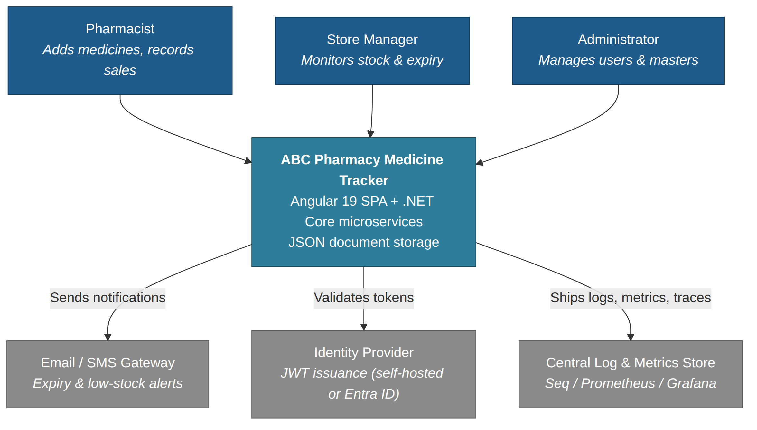
Figure 1 — System context: actors, the medicine tracker system, and its external dependencies.

3.5 Why microservices here — and the honest counter-argument
For a catalogue of a few thousand medicines and a few hundred sales a day, a well-structured modular monolith would be simpler to build, test, deploy and reason about. It is worth stating that plainly. The microservice decomposition is adopted because it is an explicit requirement, and it does buy real properties: the Notification worker can fail without stopping sales; Sales and Inventory can be scaled and released independently; and the blast radius of a corrupt JSON store is one bounded context rather than the whole application.
The design mitigates the cost of that choice by keeping the service count low, by keeping every service in one solution and one repository (a modular monolith deployment profile is available for local development — see §12.5), and by using a shared internal library for cross-cutting concerns so that five services do not mean five different logging conventions.

4. Logical architecture
The container diagram below shows every independently deployable unit, the store each one owns, and the two communication paths between them: synchronous REST through the gateway, and asynchronous events through the broker.
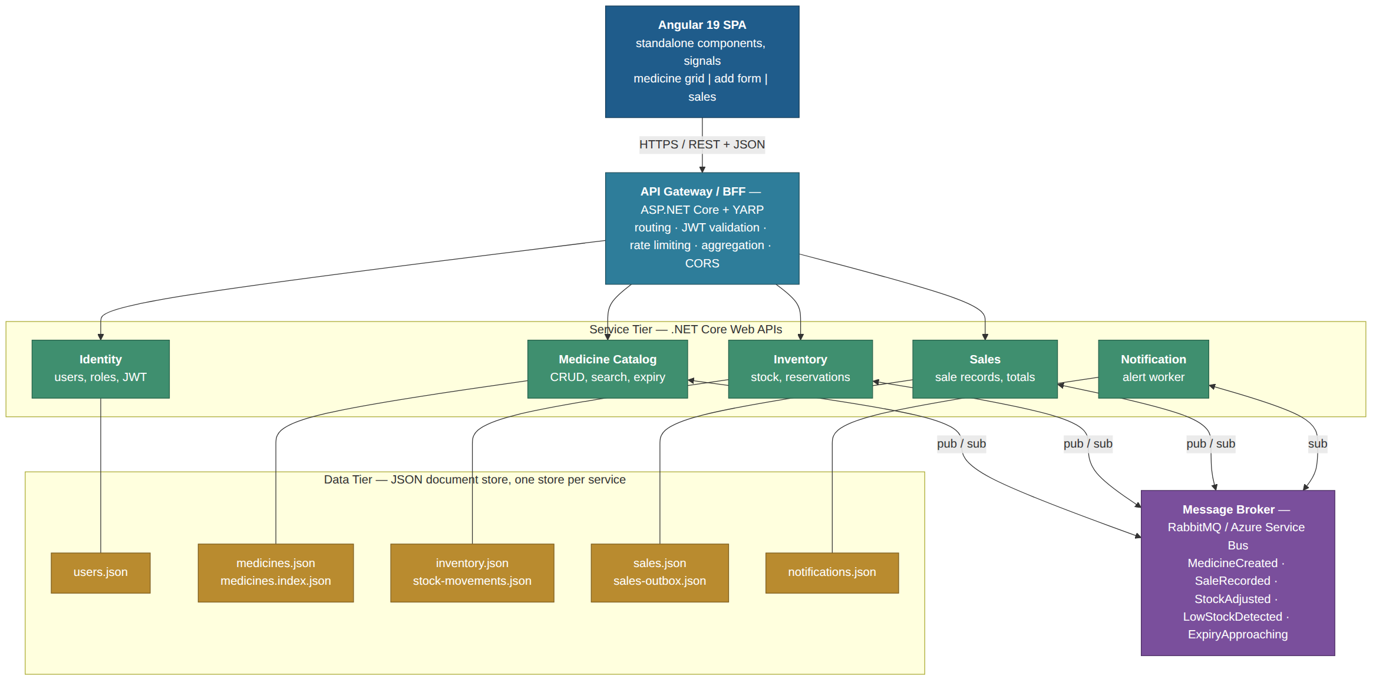
Figure 2 — Container view: SPA, gateway, five services, five private JSON stores and the message broker.

4.1 Tier responsibilities
Tier | Responsibility | Explicitly not responsible for
Client (Angular SPA) | Presentation, client-side validation, colour rules for display, optimistic UI, token storage in memory. | Authorisation decisions, business rules, any calculation that money depends on.
Edge (API gateway) | TLS termination, routing, JWT validation, CORS, rate limiting, request correlation, response aggregation for the dashboard. | Domain logic, persistence, orchestration of multi-step business transactions.
Service | Domain rules, validation, persistence to its own store, publishing and consuming events. | Reading another service’s store; assuming another service is available.
Data | Durable JSON documents, index files, outbox files, snapshots. | Enforcing referential integrity across service boundaries.

4.2 Communication styles
Interaction | Style | Protocol | Why
SPA → Gateway | Synchronous request/response | HTTPS + JSON | A user is waiting; the answer must be immediate.
Gateway → Service | Synchronous, proxied | HTTP + JSON over the cluster network | Simple pass-through; the gateway adds no domain semantics.
Sales → Inventory (reserve stock) | Synchronous | HTTP + JSON, 2 s timeout, retry disabled on non-idempotent POST without an idempotency key | The user must be told at once whether the sale can proceed.
Service → Service (state propagation) | Asynchronous, publish/subscribe | AMQP topic exchange | Removes temporal coupling; the catalogue read model may lag by a second without harming anyone.
Notification worker | Asynchronous consumer + scheduled scan | AMQP + cron-style background service | Alerts are not on any user’s critical path.

5. Service decomposition
Services are carved along business capabilities. Each owns its data, its rules and its deployment lifecycle.

5.1 Service catalogue
Service | Capability owned | Owns (store) | Publishes | Consumes
Medicine Catalog | Medicine master data, search, expiry classification, denormalised stock for the grid | medicines.json, medicines.index.json | MedicineCreated, MedicineUpdated, ExpiryApproaching | StockAdjusted
Inventory | Quantity on hand, reservations, stock movement ledger, reorder level | inventory.json, stock-movements.json | StockAdjusted, LowStockDetected | SaleRecorded, SaleVoided, MedicineCreated
Sales | Sale transactions, sale lines, receipts, daily totals | sales.json, sales-outbox.json | SaleRecorded, SaleVoided | —
Notification | Alert composition, delivery, de-duplication, alert history | notifications.json | — | LowStockDetected, ExpiryApproaching
Identity | Users, roles, credentials, JWT issuance and refresh | users.json | UserCreated | —

5.2 Medicine Catalog Service
The system of record for everything in the medicine brief: full name, notes, expiry date, price and brand. It also holds a denormalised quantity, kept current by StockAdjusted events, so that the grid (FR-01, FR-02) can be served from one store with a single read and no fan-out call to Inventory.
- Key rules: name+brand uniqueness (case-insensitive), price stored as decimal with exactly two decimals, expiry classification computed server-side and returned as an enum so that the UI and any future consumer agree on the meaning.
- Search (FR-07): case-insensitive "contains" match on full name, backed by a lower-cased in-memory index rebuilt on write. Debounced at the client, applied at the server so paging stays correct.
- Why denormalise quantity: the alternative — the grid calling Inventory for every row — turns one read into N and couples the two services on the read path. The cost is a sub-second staleness window, which is documented in §8.5 and is harmless for a stock display.

5.3 Inventory Service
The authority on how many units actually exist. It holds quantityOnHand, quantityReserved and reorderLevel (default 10, matching FR-05) per medicine, plus an append-only stock movement ledger that makes every change auditable and lets the current quantity be recomputed from first principles if a store is ever damaged.
- Reservation model: a sale first reserves stock (a short-lived hold, default TTL 60 s), then the reservation is committed when the sale is written. Expired reservations are released by a background sweeper. This is what prevents two concurrent sales of the last unit both succeeding.
- Ledger over counter: movements are Receipt, Sale, Adjustment and WriteOff. The aggregate quantity is a projection; the ledger is the truth.

5.4 Sales Service
Owns sale records — the "mechanism to maintain the sale records of medicine" of FR-06. A sale is a header (sale number, timestamp, cashier, total) with one or more lines (medicine id, quantity, unit price captured at sale time, line total). Unit price is copied onto the line rather than referenced, because a receipt must not change when the catalogue price changes.
- Idempotency: POST /sales requires an Idempotency-Key header. A replay of the same key returns the original 201 response instead of creating a second sale — essential on a flaky pharmacy Wi-Fi connection.
- Outbox: the sale and its SaleRecorded event are appended in the same atomic write to the sales store; a dispatcher then publishes from the outbox and marks it dispatched. The sale can never be recorded without the event, or vice versa.
- Voiding: sales are never deleted. A void writes a compensating record and publishes SaleVoided, which Inventory consumes to restore stock.

5.5 Notification Service
A background worker with a small API for reading alert history. It consumes LowStockDetected and ExpiryApproaching, de-duplicates by (medicineId, alertType, day) so a manager is not emailed forty times, and delivers via the configured channel. It also runs a nightly scheduled scan of the catalogue to catch medicines that cross the 30-day expiry threshold by the passage of time rather than by an event.

5.6 Identity Service
Issues short-lived JWT access tokens (15 min) and rotating refresh tokens (8 h, matching a shift). Three roles are defined:
Role | View grid & search | Add / edit medicine | Record sale | Void sale | Manage users
Pharmacist | Yes | Yes | Yes | No | No
Store Manager | Yes | Yes | Yes | Yes | No
Administrator | Yes | Yes | Yes | Yes | Yes
Passwords are stored as PBKDF2 (or Argon2id) hashes with a per-user salt; the plaintext never leaves the request pipeline. Signing keys live in the platform secret store, never in appsettings.json.

5.7 API Gateway
A thin ASP.NET Core host with YARP. Its job list is deliberately short: terminate TLS, validate the JWT once so downstream services can trust the claims, apply CORS for exactly the SPA origin, enforce rate limits (a fixed window of 100 requests/minute per user, 20/minute on the sales endpoint), stamp an X-Correlation-Id onto every request, and expose one aggregated endpoint — GET /api/v1/dashboard — that fans out to the catalogue and sales services so the dashboard needs a single round trip.
Listing 1 — Gateway routing configuration.
// appsettings.json — YARP route/cluster configuration (abridged)
"ReverseProxy": {
"Routes": {
"medicines": {
"ClusterId": "medicine-api",
"AuthorizationPolicy": "authenticated",
"RateLimiterPolicy": "per-user",
"Match": { "Path": "/api/v1/medicines/{**catch-all}" }
},
"sales": {
"ClusterId": "sales-api",
"AuthorizationPolicy": "pharmacist",
"RateLimiterPolicy": "sales-window",
"Match": { "Path": "/api/v1/sales/{**catch-all}" }
}
},
"Clusters": {
"medicine-api": {
"HealthCheck": { "Active": { "Enabled": true, "Path": "/health/ready" } },
"Destinations": { "d1": { "Address": "http://medicine-api:8080/" } }
},
"sales-api": {
"Destinations": { "d1": { "Address": "http://sales-api:8080/" } }
}
}
}

5.8 Shared library — and what must never go in it
A single internal NuGet package, Pharmacy.BuildingBlocks, carries genuinely cross-cutting code: the JSON store primitives, the outbox and idempotency helpers, ProblemDetails mapping, correlation-id middleware, OpenTelemetry wiring and the event contract definitions.
What must not go in it: domain entities, business rules, or DTOs shared between two services’ public APIs. A shared domain model is the fastest way to turn five services back into a distributed monolith, where a change in one forces a synchronised release of all of them. Event contracts are versioned additively and treated as a published interface (§8.4).

6. API design

6.1 Conventions
- Base path /api/v{major}/ — v1 throughout this release. Breaking changes take a new major segment; additive changes do not.
- Resource names are plural nouns; verbs appear only as sub-resources for genuine commands (e.g. POST /inventory/{id}/reserve).
- camelCase property names; ISO-8601 dates (yyyy-MM-dd) and UTC timestamps with a Z suffix.
- Money is serialised as a JSON number with two decimals and handled as System.Decimal in C#. Never float or double.
- All errors return application/problem+json per RFC 9457, with a correlationId extension member.
- Collections are paged: ?page=1&pageSize=25 (max 200), returning { items, page, pageSize, totalCount, totalPages }.
- Every mutating endpoint accepts an Idempotency-Key header; the sales endpoint requires it.
- Optimistic concurrency uses ETag on GET and If-Match on PUT; a mismatch returns 412 Precondition Failed.
- OpenAPI 3.1 documents are produced per service and merged at the gateway for a single Swagger UI.

6.2 Standard response codes
Code | When it is used
200 OK | Successful read, or successful update returning the new representation.
201 Created | Resource created; Location header points at the new resource.
204 No Content | Successful delete or command with nothing to return.
400 Bad Request | Malformed syntax or a violated validation rule; the problem document lists field-level errors.
401 / 403 | Missing or invalid token / valid token without the required role.
404 Not Found | The resource does not exist, or the caller is not permitted to know that it does.
409 Conflict | A business-rule conflict: duplicate name+brand, or insufficient stock for a sale.
412 Precondition Failed | If-Match version did not match — someone else edited the record first.
422 Unprocessable Content | Syntactically valid but semantically impossible (e.g. sale quantity of zero).
429 Too Many Requests | Rate limit exceeded; Retry-After header supplied.
503 Service Unavailable | A downstream dependency is open-circuited; Retry-After supplied.

6.3 Medicine Catalog API
Method & path | Purpose | Auth | Success
GET /api/v1/medicines | List medicines, paged and sorted. Query: search, brand, status, sortBy, sortDir, page, pageSize (FR-01, FR-02, FR-07). | Any role | 200
GET /api/v1/medicines/{id} | Full detail including Notes. | Any role | 200 + ETag
POST /api/v1/medicines | Add a medicine (FR-03). | Pharmacist+ | 201
PUT /api/v1/medicines/{id} | Update; requires If-Match. | Pharmacist+ | 200
DELETE /api/v1/medicines/{id} | Soft-delete (sets isActive=false); never removes history. | Manager+ | 204
GET /api/v1/medicines/expiring | Medicines expiring within n days (default 30). | Any role | 200
GET /api/v1/medicines/low-stock | Medicines below the reorder level (default 10). | Any role | 200
GET /api/v1/medicines/brands | Distinct brand list for the filter dropdown. | Any role | 200
Listing 2 — Grid read. Note that daysToExpiry, expiryStatus, stockStatus and rowSeverity are computed server-side so the colour rules cannot drift between clients.
GET /api/v1/medicines?search=amox&page=1&pageSize=2&sortBy=expiryDate&sortDir=asc
Authorization: Bearer <jwt>

HTTP/1.1 200 OK
Content-Type: application/json
X-Correlation-Id: 6b1f0c8e-4a2d-4f13-9d55-77a2c9b1e004

{
"items": [
{
"id": "3f2a9c14-6b7e-4d21-9a8f-1c2d3e4f5a6b",
"fullName": "Amoxicillin 500mg Capsule",
"brand": "MediCore",
"expiryDate": "2026-09-05",
"daysToExpiry": 18,
"quantity": 42,
"price": 12.50,
"expiryStatus": "ExpiringSoon",
"stockStatus": "Ok",
"rowSeverity": "Critical",
"version": 7
},
{
"id": "9d4b1e77-2c58-4a90-8f31-0be6a7c25d13",
"fullName": "Amoxicillin 250mg Syrup",
"brand": "PharmaPlus",
"expiryDate": "2027-02-28",
"daysToExpiry": 194,
"quantity": 6,
"price": 8.75,
"expiryStatus": "Ok",
"stockStatus": "Low",
"rowSeverity": "Warning",
"version": 2
}
],
"page": 1, "pageSize": 2, "totalCount": 2, "totalPages": 1
}

Listing 3 — Add medicine (FR-03).
POST /api/v1/medicines
Authorization: Bearer <jwt>
Idempotency-Key: 8f0e2b6c-31a4-4a7e-9f10-5d0c4b8a1e93
Content-Type: application/json

{
"fullName": "Paracetamol 500mg Tablet",
"notes": "Store below 25 °C. Blister pack of 10.",
"expiryDate": "2027-11-30",
"quantity": 250,
"price": 3.40,
"brand": "HealWell"
}

HTTP/1.1 201 Created
Location: /api/v1/medicines/c47a1f90-8e33-4b52-a1d6-90ff2e7c4b18
ETag: "1"

Listing 4 — Error model (RFC 9457), used identically by every service.
HTTP/1.1 409 Conflict
Content-Type: application/problem+json

{
"type": "https://api.abcpharmacy.local/errors/duplicate-medicine",
"title": "A medicine with this name already exists for this brand.",
"status": 409,
"detail": "'Paracetamol 500mg Tablet' is already registered under brand 'HealWell'.",
"instance": "/api/v1/medicines",
"correlationId": "6b1f0c8e-4a2d-4f13-9d55-77a2c9b1e004",
"errors": { "fullName": ["Must be unique within a brand."] }
}

6.4 Inventory API
Method & path | Purpose | Auth | Success
GET /api/v1/inventory/{medicineId} | Current on-hand, reserved and available quantity. | Any role | 200
POST /api/v1/inventory/{medicineId}/reserve | Hold n units for a sale; body { quantity, ttlSeconds }. Returns a reservationId. | Service / Pharmacist+ | 200 / 409
POST /api/v1/inventory/reservations/{id}/commit | Convert a hold into a permanent decrement. | Service | 204
DELETE /api/v1/inventory/reservations/{id} | Release a hold (sale abandoned). | Service | 204
POST /api/v1/inventory/{medicineId}/adjust | Manual correction; body { quantityDelta, reason }. Always ledger-logged. | Manager+ | 200
GET /api/v1/inventory/{medicineId}/movements | Paged stock movement ledger for audit. | Manager+ | 200

6.5 Sales API
Method & path | Purpose | Auth | Success
GET /api/v1/sales | Paged sale history; filters from, to, medicineId, userId (FR-06). | Any role | 200
GET /api/v1/sales/{id} | One sale with all its lines. | Any role | 200
POST /api/v1/sales | Record a sale. Idempotency-Key required. | Pharmacist+ | 201 / 409
POST /api/v1/sales/{id}/void | Void a sale; body { reason }. Restores stock via SaleVoided. | Manager+ | 200
GET /api/v1/sales/summary | Aggregates by day / medicine / brand for the dashboard. | Any role | 200
Listing 5 — Record a sale (FR-06). Unit prices are snapshotted onto the line at sale time.
POST /api/v1/sales
Idempotency-Key: 2c9a77f1-0b6d-4e39-8c41-b3d7e5a01f22

{
"lines": [
{ "medicineId": "3f2a9c14-6b7e-4d21-9a8f-1c2d3e4f5a6b", "quantity": 2 },
{ "medicineId": "9d4b1e77-2c58-4a90-8f31-0be6a7c25d13", "quantity": 1 }
],
"soldAtUtc": "2026-08-18T09:41:12Z",
"notes": "Counter sale"
}

HTTP/1.1 201 Created
Location: /api/v1/sales/a1b2c3d4-5e6f-4708-9a0b-1c2d3e4f5061

{
"id": "a1b2c3d4-5e6f-4708-9a0b-1c2d3e4f5061",
"saleNumber": "SL-2026-000418",
"soldAtUtc": "2026-08-18T09:41:12Z",
"soldByUserId": "u-1042",
"lines": [
{ "medicineId": "3f2a9c14-...", "medicineName": "Amoxicillin 500mg Capsule",
"quantity": 2, "unitPrice": 12.50, "lineTotal": 25.00 },
{ "medicineId": "9d4b1e77-...", "medicineName": "Amoxicillin 250mg Syrup",
"quantity": 1, "unitPrice": 8.75, "lineTotal": 8.75 }
],
"totalAmount": 33.75
}

6.6 Identity and Notification APIs
Method & path | Purpose
POST /api/v1/auth/login | Exchange credentials for an access token + refresh token.
POST /api/v1/auth/refresh | Rotate a refresh token for a new access token.
POST /api/v1/auth/logout | Revoke the refresh token family.
GET /api/v1/users/me | Current user profile and roles, used by the SPA to shape the menu.
GET /api/v1/alerts | Paged alert history with acknowledgement state.
POST /api/v1/alerts/{id}/acknowledge | Mark an alert as seen by a manager.

7. Data design

7.1 Domain model
The entity–relationship view below is a logical model. Because each service owns its own store, the relationships that cross a service boundary (dashed in practice) are maintained by identifier and by event, not by a foreign-key constraint.
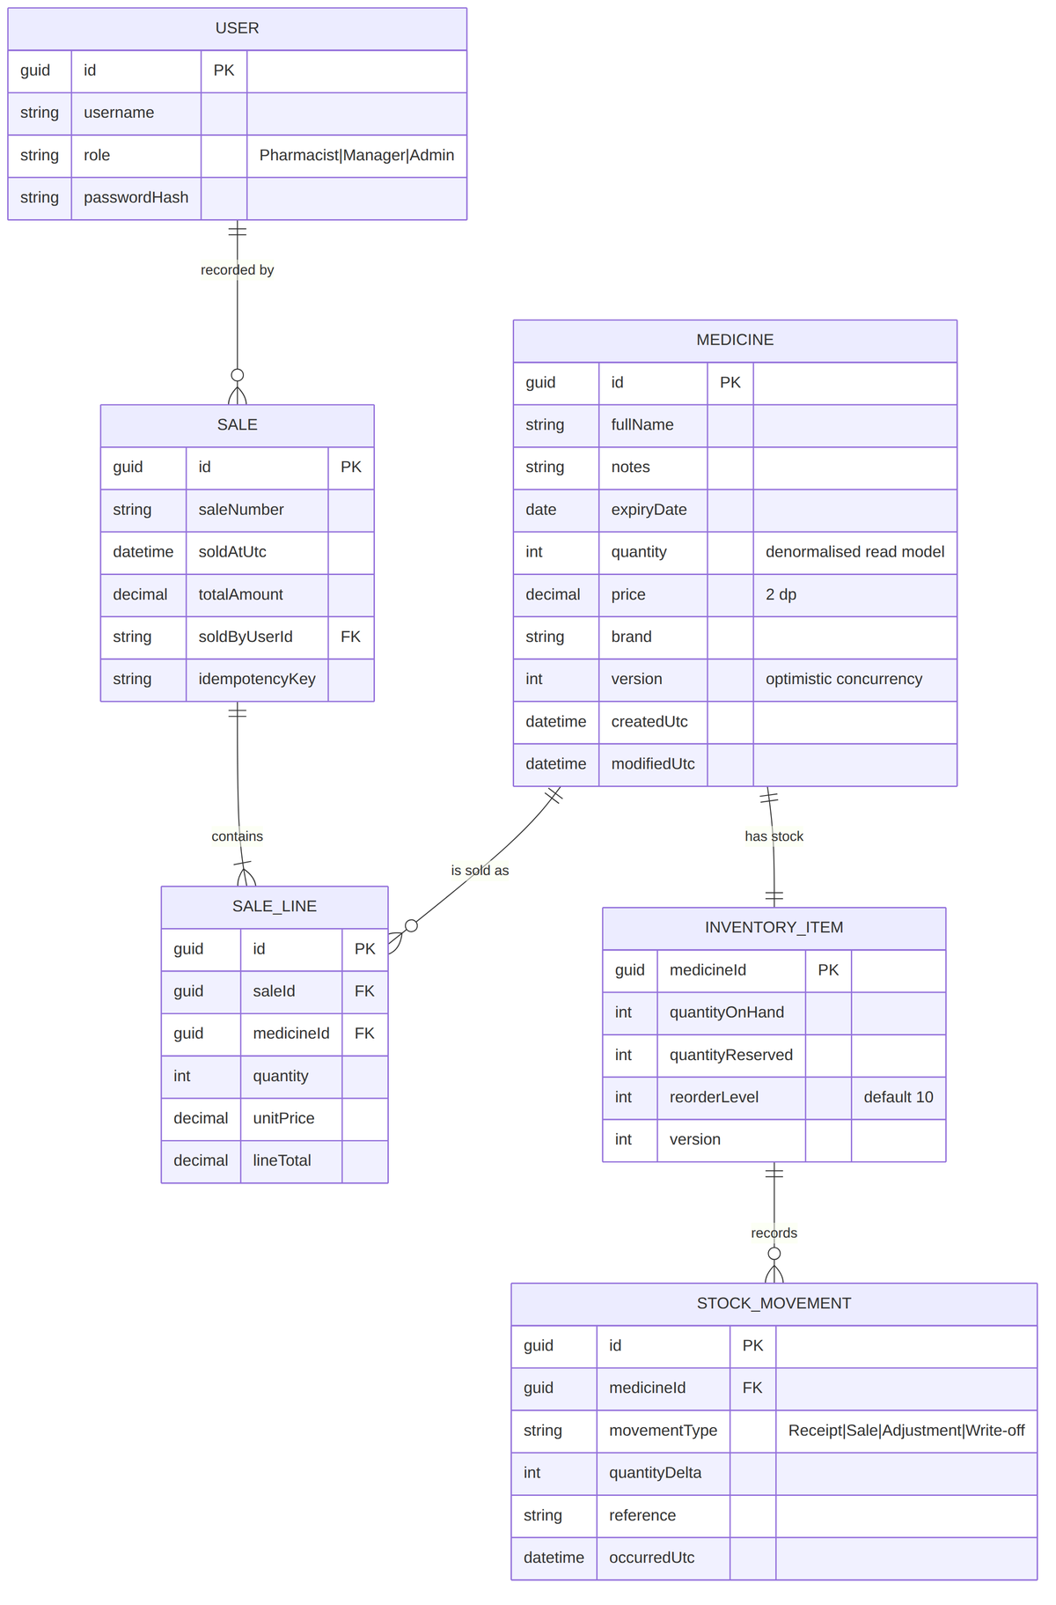
Figure 3 — Logical domain model across the four business contexts.

7.2 Store layout on disk
Listing 6 — On-disk layout. Each top-level folder is mounted only into its owning service’s container.
/data
/medicine
medicines.json # the aggregate document set
medicines.index.json # lower-cased name -> id, for search
medicines.json.lock # single-writer lease file
/snapshots/2026-08-18T02-00Z.json
/inventory
inventory.json
stock-movements.json # append-only ledger
reservations.json # short-lived holds
/sales
sales.json
sales-outbox.json # undispatched domain events
idempotency.json # key -> stored response, 24 h TTL
/identity
users.json
/notification
notifications.json

7.3 Document formats
Listing 7 — medicines.json (Medicine Catalog store).
// medicines.json
{
"schemaVersion": 1,
"items": [
{
"id": "3f2a9c14-6b7e-4d21-9a8f-1c2d3e4f5a6b",
"fullName": "Amoxicillin 500mg Capsule",
"notes": "Keep refrigerated after reconstitution.",
"expiryDate": "2026-09-05",
"quantity": 42,
"price": 12.50,
"brand": "MediCore",
"isActive": true,
"version": 7,
"createdUtc": "2026-01-14T06:22:10Z",
"createdBy": "u-1002",
"modifiedUtc": "2026-08-17T11:05:44Z",
"modifiedBy": "u-1042"
}
]
}

Listing 8 — sales.json and its transactional outbox, written together in one atomic operation.
// sales.json
{
"schemaVersion": 1,
"items": [
{
"id": "a1b2c3d4-5e6f-4708-9a0b-1c2d3e4f5061",
"saleNumber": "SL-2026-000418",
"soldAtUtc": "2026-08-18T09:41:12Z",
"soldByUserId": "u-1042",
"idempotencyKey": "2c9a77f1-0b6d-4e39-8c41-b3d7e5a01f22",
"status": "Completed",
"totalAmount": 33.75,
"lines": [
{ "id": "l-1", "medicineId": "3f2a9c14-...", "medicineName": "Amoxicillin 500mg Capsule",
"quantity": 2, "unitPrice": 12.50, "lineTotal": 25.00 }
]
}
]
}

// sales-outbox.json
{
"items": [
{ "eventId": "e-9f31", "type": "SaleRecorded", "occurredUtc": "2026-08-18T09:41:12Z",
"dispatchedUtc": null, "attempts": 0, "payload": { "saleId": "a1b2c3d4-...", "lines": [ ... ] } }
]
}

Listing 9 — Inventory store and ledger.
// inventory.json
{ "schemaVersion": 1, "items": [
{ "medicineId": "3f2a9c14-...", "quantityOnHand": 42, "quantityReserved": 2,
"reorderLevel": 10, "version": 19, "modifiedUtc": "2026-08-18T09:41:13Z" } ] }

// stock-movements.json (append-only)
{ "items": [
{ "id": "m-8801", "medicineId": "3f2a9c14-...", "movementType": "Sale",
"quantityDelta": -2, "reference": "SL-2026-000418",
"occurredUtc": "2026-08-18T09:41:13Z", "userId": "u-1042" } ] }

7.4 Why JSON files need extra care
A file store gives no transactions, no isolation levels, no query planner and no built-in concurrency control. Three specific failure modes must be designed out, and the design addresses each explicitly:
Failure mode | What happens without a control | Control applied
Torn write | A crash mid-write leaves a truncated, unparseable JSON file — the whole store is lost. | Write to a temp file in the same directory, fsync, then atomically rename over the target. A rename on the same filesystem is atomic, so a reader sees either the old file or the new one, never a partial one.
Lost update | Two replicas read, modify and write; the second silently overwrites the first. | A single-writer lease per store (an OS file lock plus a lease file with a TTL), combined with a per-document version checked on every update (If-Match → 412).
Dual write | A sale is written but the event is never published, so stock is never decremented. | The transactional outbox: state change and event are appended in the same atomic write; a separate dispatcher publishes at-least-once and consumers are idempotent.

7.5 Persistence algorithm
Listing 10 — Read–check–mutate–atomic-replace, the core write path for every store.
public sealed class JsonDocumentStore<T> : IDocumentStore<T> where T : IVersioned
{
private readonly string _path;
private readonly SemaphoreSlim _gate = new(1, 1); // in-process serialisation
private readonly IFileLease _lease; // cross-process / cross-pod lease

public async Task<T> UpdateAsync(Guid id, Action<T> mutate, int expectedVersion, CancellationToken ct)
{
await _gate.WaitAsync(ct);
await using var lease = await _lease.AcquireAsync(TimeSpan.FromSeconds(5), ct);
try
{
var doc = await ReadAllAsync(ct); // 1. read current state
var entity = doc.Items.FirstOrDefault(x => x.Id == id)
?? throw new NotFoundException(id);
if (entity.Version != expectedVersion) // 2. optimistic check
throw new ConcurrencyException(id, expectedVersion, entity.Version);

mutate(entity); // 3. apply change
entity.Version++;
entity.ModifiedUtc = _clock.UtcNow;

var tmp = _path + ".tmp"; // 4. atomic replace
await using (var fs = File.Create(tmp, 4096, FileOptions.WriteThrough))
await JsonSerializer.SerializeAsync(fs, doc, JsonCtx.Default.DocumentOf<T>(), ct);
File.Move(tmp, _path, overwrite: true);

return entity;
}
finally { _gate.Release(); }
}
}

Reads are served from an in-memory cache invalidated by a FileSystemWatcher and by the writer itself, so the common case (rendering the grid) does not touch the disk at all. The cache is bounded and rebuilt on start-up.

7.6 Indexing and search
The search requirement (FR-07) is satisfied by a lower-cased inverted index — medicines.index.json — rebuilt whenever the catalogue is written and held in memory as a Dictionary<string, List<Guid>> of name tokens. For a catalogue of a few thousand rows, a linear scan with StringComparison.OrdinalIgnoreCase would also be fast enough; the index exists so that behaviour stays flat as the catalogue grows and so that the search contract does not change when the store is later swapped for a database.

7.7 Migration path off JSON
The constraint to store data as JSON is a starting condition, not a permanent one. Because every service reaches its data only through an IDocumentStore<T> / IRepository abstraction, moving to a real database is an adapter swap:
- Introduce a second adapter (e.g. EfCoreMedicineRepository over PostgreSQL, or a Cosmos DB / MongoDB adapter that keeps the documents in their current shape).
- Run both adapters behind a feature flag, writing to both and reading from JSON (dual-write shadow mode).
- Backfill history from the JSON snapshots and the stock-movement ledger.
- Compare read results for a soak period, then flip the read path.
- Retire the JSON adapter; the domain, API and UI layers are untouched throughout.
A document database is the lower-friction target because the persisted shapes are already documents; a relational database is the better target if reporting and ad-hoc querying become important.

8. Integration, messaging and consistency

8.1 Event catalogue
Event | Published by | Consumed by | Payload (key fields) | Purpose
MedicineCreated | Medicine Catalog | Inventory | medicineId, fullName, brand, initialQuantity, reorderLevel | Create the matching inventory item so stock can be tracked from day one.
MedicineUpdated | Medicine Catalog | Notification | medicineId, changedFields, expiryDate | Re-evaluate expiry alerting when a date changes.
SaleRecorded | Sales | Inventory | saleId, saleNumber, lines[medicineId, quantity], soldAtUtc | Commit the reservation and decrement stock (FR-08).
SaleVoided | Sales | Inventory | saleId, reason, lines[] | Restore stock for a voided sale.
StockAdjusted | Inventory | Medicine Catalog | medicineId, newQuantity, movementType, occurredUtc | Refresh the denormalised quantity used by the grid.
LowStockDetected | Inventory | Notification | medicineId, quantity, reorderLevel | Raise a low-stock alert (supports FR-05).
ExpiryApproaching | Medicine Catalog | Notification | medicineId, expiryDate, daysToExpiry | Raise an expiry alert (supports FR-04).

8.2 Delivery guarantees
- At-least-once delivery. The broker may redeliver, so every consumer is idempotent: each stores the processed eventId and ignores repeats. Idempotency is a consumer responsibility, never an assumption about the broker.
- Ordering. Per-medicine ordering matters (two StockAdjusted events for the same medicine must not be applied out of order). Messages are partitioned by medicineId so a single consumer handles a given medicine's stream in order.
- Poison messages. Five retries with exponential backoff and jitter, then the message moves to a dead-letter queue with the full context. A DLQ depth above zero raises an operational alert; there is no silent discard.
- Schema evolution. Events carry an explicit version. Only additive changes are allowed within a major version; a breaking change publishes a new event type in parallel until every consumer has migrated.

8.3 The record-a-sale flow end to end
This is the most interesting transaction in the system: it spans three services, must be immediate for the user, must never oversell stock, and must never lose a sale.
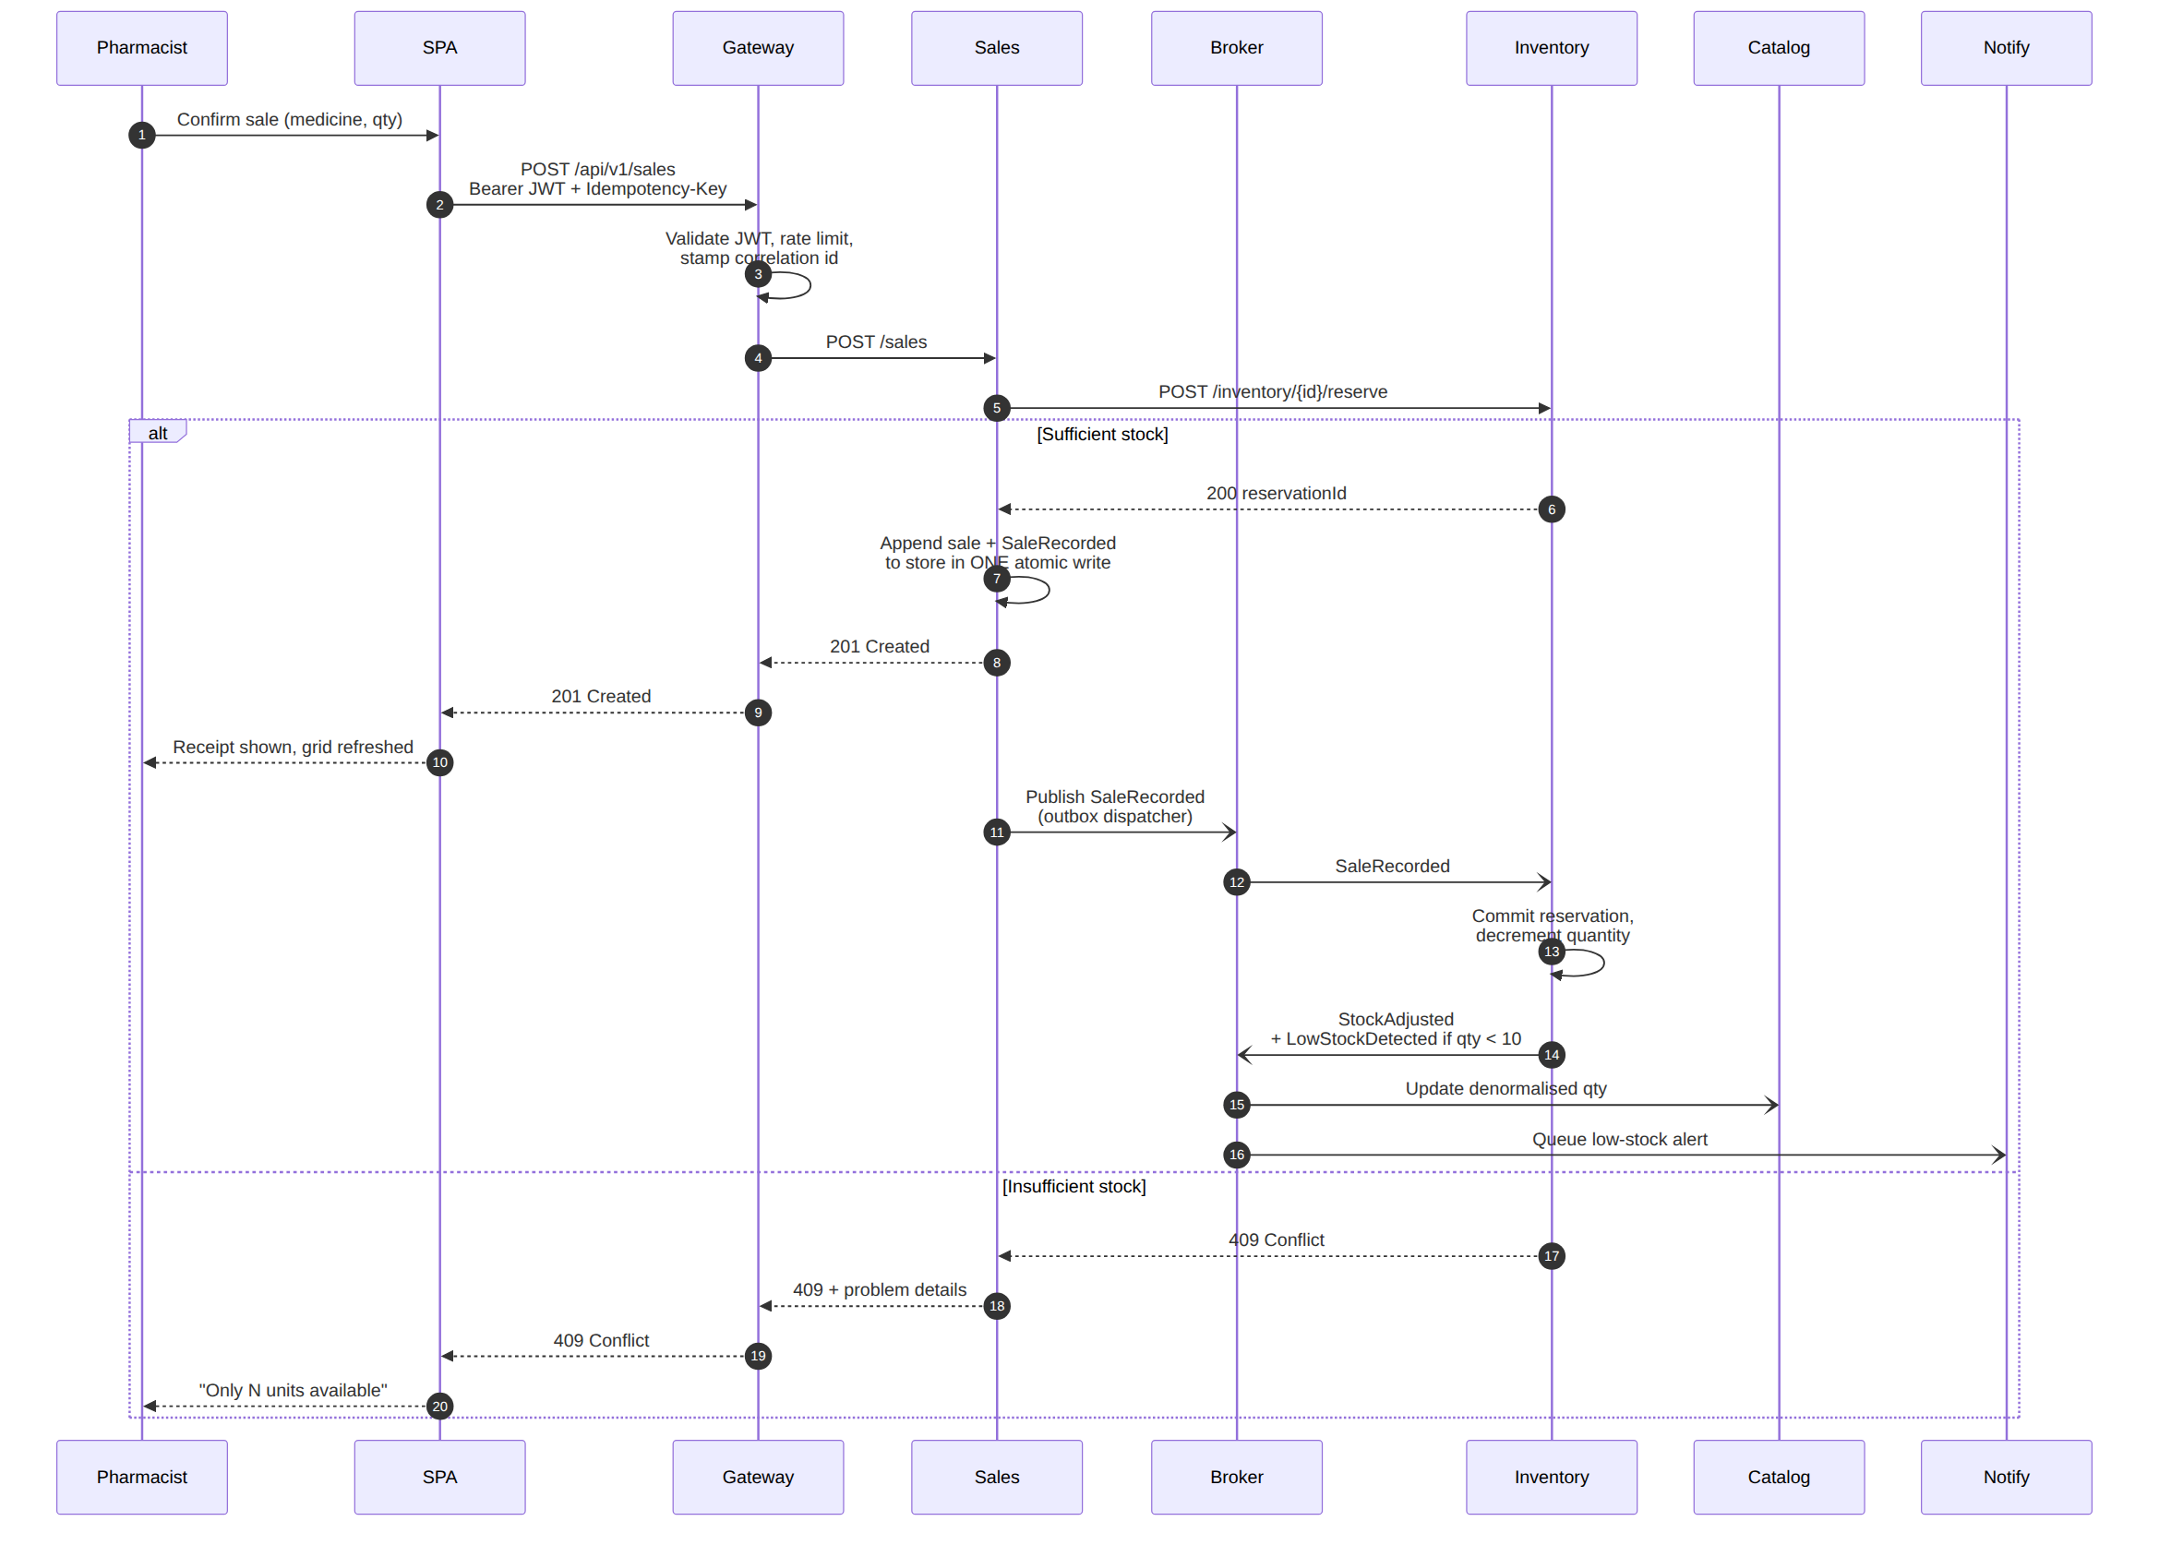
Figure 4 — Recording a sale: synchronous reservation, atomic write with outbox, asynchronous stock settlement.
Reading the diagram against the design decisions:
- The reservation call is synchronous because the pharmacist is standing at the counter and must be told immediately if the stock is not there. This is the one place where Sales is temporally coupled to Inventory, and it is the correct trade.
- The sale and its SaleRecorded event are written in a single atomic file replacement. If the process dies at any point after that write, the event is still in the outbox and will be dispatched on restart.
- The 201 is returned before the event is dispatched. The user is not made to wait for stock settlement, catalogue projection and alerting.
- Everything after the 201 is eventually consistent and each step is independently retryable.
- If Inventory is down when the reservation is attempted, the sale is rejected with 503 and a Retry-After rather than being accepted optimistically — accepting a sale the system cannot honour is worse than making the pharmacist retry.

8.4 Compensation and failure handling
Failure point | Effect | Recovery
Reservation succeeds, sale write fails | Stock is held but no sale exists. | The reservation TTL (60 s) expires and a sweeper releases the hold automatically. No manual action.
Sale written, outbox dispatch fails | Sale exists; stock not yet decremented. | The dispatcher retries on a timer until the broker acknowledges. Alert if an outbox entry is older than 5 minutes.
Inventory consumes SaleRecorded twice | Risk of double decrement. | Processed-event ledger keyed on eventId makes the second application a no-op.
Catalogue misses StockAdjusted | Grid shows a stale quantity. | A nightly reconciliation job replays quantities from the Inventory ledger and corrects any drift; a manual "resync" endpoint exists for immediate correction.
Sale must be reversed | Stock and revenue both wrong. | Void the sale — a compensating record plus SaleVoided. Sales are immutable; correction is always by compensation, never by mutation.

8.5 Where the system is eventually consistent
Read | Consistency | Typical lag | How the UI handles it
Medicine list quantity (grid) | Eventual | < 1 s | The grid refreshes after a sale completes; a "last updated" timestamp is shown on the dashboard.
Inventory available quantity | Strong (authoritative) | None | The record-sale screen reads Inventory directly before confirming.
Sale history | Strong | None | Read from the Sales store, which is the system of record.
Low-stock / expiry alerts | Eventual | Seconds to minutes | Alerts are advisory; the grid colour rules are computed from live data and do not wait for an alert.
The important consequence: the colour rules in the grid (FR-04, FR-05) are never driven by the alerting pipeline. They are computed from the record being rendered, so a delayed or dropped alert can never cause a medicine to display without its warning colour.

9. Front-end design — Angular 19 SPA

9.1 Application structure
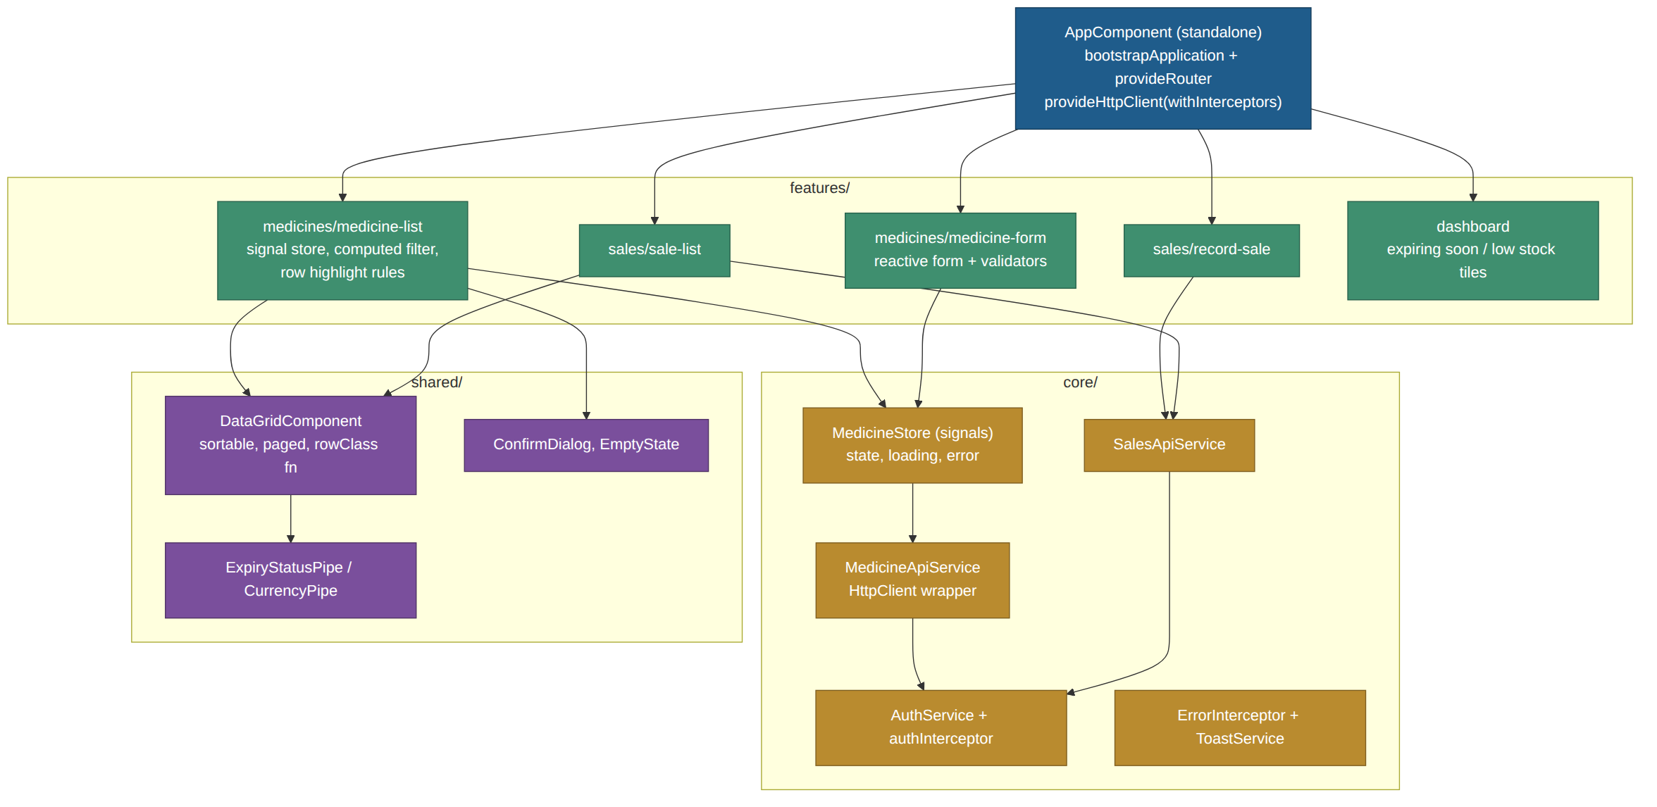
Figure 5 — Angular 19 application structure: standalone feature components over a core services layer and a shared UI kit.
Listing 11 — Folder structure. Feature folders are self-contained and lazily routed.
src/app/
app.config.ts # bootstrapApplication providers
app.routes.ts # lazy-loaded standalone routes
core/
auth/ auth.service.ts, auth.interceptor.ts, auth.guard.ts
http/ error.interceptor.ts, correlation.interceptor.ts
api/ medicine-api.service.ts, sales-api.service.ts, inventory-api.service.ts
state/ medicine.store.ts # signal-based store
models/ medicine.model.ts, sale.model.ts, enums.ts
shared/
components/ data-grid, confirm-dialog, empty-state, severity-badge
pipes/ expiry-status.pipe.ts, money.pipe.ts
directives/ autofocus.directive.ts
features/
dashboard/ dashboard.component.ts
medicines/ medicine-list.component.ts, medicine-form.component.ts
sales/ sale-list.component.ts, record-sale.component.ts
environments/

9.2 Angular 19 features used and why
Feature | Where it is used | Benefit
Standalone components (default in v19) | Every component | No NgModule ceremony; each component declares exactly what it imports.
Signals + computed | MedicineStore, grid filtering, derived row severity | Fine-grained reactivity — filtering 5,000 rows re-renders only what changed, with no manual change-detection calls.
Built-in control flow (@if / @for / @switch) | Grid template, empty states | Smaller bundles and faster diffing than *ngIf / *ngFor, and @for requires a track expression, which prevents accidental full re-renders.
input() / output() functions | DataGridComponent, SeverityBadge | Typed, signal-based inputs that participate in computed graphs.
inject() function | All services and guards | Works in field initialisers and functional guards/interceptors; removes constructor noise.
Functional interceptors and guards | auth, error, correlation | Tree-shakeable and trivially unit-testable as plain functions.
OnPush change detection | Every component | Combined with signals, keeps the grid smooth at large row counts.
defer blocks | Dashboard charts, sale history | Defer non-critical widgets until idle or viewport entry, protecting first paint (NFR-01).

9.3 The medicine grid (FR-01, FR-02)
The grid renders every medicine attribute except Notes, per FR-02. Notes are available on row expansion and on the detail page, so the information is not lost — only kept out of the tabular view.
Column | Source | Format | Sortable
Full name | fullName | Text, truncated at 45 chars with a tooltip | Yes (default)
Brand | brand | Text | Yes
Expiry date | expiryDate | dd MMM yyyy, plus "in 18 days" / "expired 3 days ago" | Yes
Quantity | quantity | Integer, right-aligned | Yes
Price | price | Currency, 2 decimals, right-aligned | Yes
Status | rowSeverity | Severity badge — text + icon, not colour alone | Yes
Actions | — | Edit / Record sale / View notes | No
Notes is deliberately absent from the column set. Paging is server-side (default 25 rows); sorting and searching are also server-side so that the page the user sees is consistent with the total count shown.

9.4 The add-medicine form (FR-03)
- Reactive form with a typed FormGroup mirroring the API contract.
- Validators: required on all fields except notes; maxLength 200 / 1000 / 100; min 0 on quantity; a two-decimal pattern plus min 0.01 on price; a date validator that permits past dates but shows a warning rather than an error.
- Async validator on fullName + brand hits GET /api/v1/medicines?search= to warn about a probable duplicate before submit — the server still enforces uniqueness and can return 409.
- Submission sends an Idempotency-Key generated with crypto.randomUUID() so a double-click or a retry cannot create two records.
- On success the store is updated optimistically and reconciled with the server response; on 409 or 400 the ProblemDetails errors object is mapped back onto the individual form controls.
- The form is disabled while in flight, and a CanDeactivate guard warns on navigation away from a dirty form.

9.5 Search (FR-07)
Listing 12 — Debounced, server-side search wired through signals.
// medicine-list.component.ts (abridged)
export class MedicineListComponent {
private readonly store = inject(MedicineStore);

readonly search = signal('');
readonly page = signal(1);

constructor() {
// debounce the search term, reset paging, then let the store fetch
toObservable(this.search)
.pipe(debounceTime(300), distinctUntilChanged(), takeUntilDestroyed())
.subscribe(term => { this.page.set(1); this.store.load({ search: term, page: 1 }); });
}

readonly rows = this.store.medicines; // Signal<MedicineRow[]>
readonly loading = this.store.loading;
readonly total = this.store.totalCount;
}

Search is applied on the server so that totalCount, paging and sorting all agree. A 300 ms debounce and distinctUntilChanged keep the request rate low; in-flight requests are cancelled via switchMap inside the store.

9.6 State management
A signal-based store per feature, rather than a full NgRx setup. The domain has a handful of entities and no complex cross-cutting state, so the ceremony of actions, reducers and effects would cost more than it returns. The store exposes read-only signals and imperative methods:
Listing 13 — Signal store. If the application later grows a genuinely complex state graph, this store is a clean seam to swap for NgRx SignalStore.
@Injectable({ providedIn: 'root' })
export class MedicineStore {
private readonly api = inject(MedicineApiService);

private readonly _state = signal<MedicineState>({
items: [], totalCount: 0, loading: false, error: null
});

readonly medicines = computed(() => this._state().items);
readonly loading = computed(() => this._state().loading);
readonly totalCount = computed(() => this._state().totalCount);

readonly expiringSoonCount = computed(() =>
this._state().items.filter(m => m.expiryStatus !== 'Ok').length);
readonly lowStockCount = computed(() =>
this._state().items.filter(m => m.stockStatus === 'Low').length);

async load(q: MedicineQuery): Promise<void> { /* set loading, call api, patch state */ }
async add(dto: CreateMedicineDto): Promise<void> { /* optimistic insert + reconcile */ }
}

9.7 HTTP concerns
- authInterceptor attaches the bearer token and transparently refreshes it once on a 401 before replaying the request.
- correlationInterceptor generates and attaches X-Correlation-Id so a UI action can be traced through every service in the logs.
- errorInterceptor maps ProblemDetails onto a typed AppError, raises a toast for unexpected failures, and lets form-level errors flow through to the component that can display them per field.
- Retry with exponential backoff is applied to idempotent GETs only; POSTs are retried only when an Idempotency-Key is present.

10. Colour indication rules (FR-04, FR-05)
These two requirements look trivial and are the most commonly mis-implemented part of a brief like this. Three things need to be pinned down: where the rule is evaluated, what happens when both conditions are true at once, and what happens for users who cannot distinguish the two colours.

10.1 Where the rule lives
The rule is evaluated on the server, in the Medicine Catalog service, and the result is returned as an enum on every row (expiryStatus, stockStatus and a combined rowSeverity). The client maps that enum to a CSS class; it does not re-derive the rule from raw dates.
This matters for three reasons. The "less than 30 days" boundary is computed against the pharmacy's business date, not the browser's clock, so a device with a wrong time zone or a wrong date cannot mislabel stock. A second consumer — a report, a mobile app, an export — gets the identical classification without reimplementing it. And the rule becomes unit-testable in one place, including its boundary cases.

10.2 The rules, stated precisely
Condition | Evaluated as | Result | Background
Expiring soon (FR-04) | 0 ≤ (expiryDate − businessToday) < 30 days | expiryStatus = ExpiringSoon | Red (#F8D7DA, text #842029)
Already expired | (expiryDate − businessToday) < 0 | expiryStatus = Expired | Red — treated as at least as urgent as expiring soon
Low stock (FR-05) | quantity < 10 | stockStatus = Low | Yellow (#FFF3CD, text #664D03)
Out of stock | quantity = 0 | stockStatus = OutOfStock | Yellow, with an "Out of stock" badge
Neither | otherwise | Ok / Ok | Default background

10.3 Precedence when both apply
The brief does not say what to do when a medicine is both expiring within 30 days and below 10 units. The design resolves it explicitly: red wins. An expiring medicine is a patient-safety and write-off issue; low stock is a purchasing issue. The severity ladder is Expired ≥ ExpiringSoon > Low/OutOfStock > Ok, and the Status column always names both conditions in text even when only one colour can be painted.
Listing 14 — The classification rule. ExpiryWarningDays and LowStockThreshold are configuration values, not literals, so the pharmacy can change them without a code change.
public static RowSeverity Evaluate(DateOnly expiryDate, int quantity, DateOnly businessToday)
{
var daysToExpiry = expiryDate.DayNumber - businessToday.DayNumber;

var expiry = daysToExpiry < 0 ? ExpiryStatus.Expired
: daysToExpiry < ExpiryWarningDays ? ExpiryStatus.ExpiringSoon // 30
: ExpiryStatus.Ok;

var stock = quantity == 0 ? StockStatus.OutOfStock
: quantity < LowStockThreshold ? StockStatus.Low // 10
: StockStatus.Ok;

// Red outranks yellow: an expiry issue is a safety issue.
return expiry != ExpiryStatus.Ok ? RowSeverity.Critical
: stock != StockStatus.Ok ? RowSeverity.Warning
: RowSeverity.Normal;
}

Listing 15 — Grid template. rowClass() returns row--critical, row--warning or nothing, based solely on the server-supplied severity.
<!-- medicine-list.component.html -->
@for (row of rows(); track row.id) {
<tr [class]="rowClass(row)"
[attr.aria-label]="row.fullName + ', ' + statusText(row)">
<td>{{ row.fullName }}</td>
<td>{{ row.brand }}</td>
<td>{{ row.expiryDate | date: 'dd MMM yyyy' }}</td>
<td class="num">{{ row.quantity }}</td>
<td class="num">{{ row.price | currency }}</td>
<td><app-severity-badge [severity]="row.rowSeverity" [text]="statusText(row)" /></td>
</tr>
} @empty {
<tr><td colspan="6"><app-empty-state message="No medicines match your search." /></td></tr>
}

10.4 Accessibility of the colour indication (NFR-08)
Roughly one man in twelve has some form of colour-vision deficiency, and red/yellow on white is a common confusion pair. WCAG 2.2 success criterion 1.4.1 requires that colour is never the only means of conveying information. The design therefore pairs every coloured row with a text badge and an icon in the Status column, keeps text contrast well above the 4.5:1 minimum against the tinted background (the pairs chosen measure 7.1:1 for red on #F8D7DA and 7.2:1 for amber on #FFF3CD, so both clear AAA as well), sets aria-label on each row so a screen reader announces the status, and honours prefers-contrast and prefers-reduced-transparency with a stronger left border in place of the tint.

10.5 Worked example
Rendered against a business date of 18 Aug 2026, the grid looks like this:
Full name | Brand | Expiry date | Qty | Price | Status
Amoxicillin 500mg Capsule | MediCore | 05 Sep 2026 | 42 | 12.50 | ! Expires in 18 d
Ibuprofen 200mg Tablet | HealWell | 12 Aug 2026 | 120 | 4.20 | ! Expired 6 d ago
Amoxicillin 250mg Syrup | PharmaPlus | 28 Feb 2027 | 6 | 8.75 | ~ Low stock
Cetirizine 10mg Tablet | MediCore | 19 Aug 2026 | 3 | 2.15 | ! Expires in 1 d
Paracetamol 500mg Tablet | HealWell | 30 Nov 2027 | 250 | 3.40 | OK
Figure 6 — Colour rules applied. Row 4 satisfies both conditions (expires tomorrow, only 3 units); red takes precedence and the badge names the more urgent condition.

11. Cross-cutting concerns

11.1 Security
Control | Implementation
Transport | TLS 1.2+ terminated at the ingress; HSTS; HTTP redirected to HTTPS; mTLS optional between gateway and services inside the cluster.
Authentication | JWT bearer, RS256, 15-minute access tokens, rotating refresh tokens. Tokens are held in memory in the SPA (not localStorage) with the refresh token in an HttpOnly SameSite=Strict cookie.
Authorisation | Role claims checked at the gateway for coarse routing and re-checked inside each service — the gateway is a convenience, not the security boundary.
Input validation | FluentValidation on every request DTO; allow-lists rather than deny-lists; explicit length and range bounds on all six medicine attributes.
Injection | No SQL, so no SQL injection — but path traversal is the equivalent risk for a file store. Store paths are constructed from a fixed root plus a validated GUID; user input never reaches a file path.
Deserialisation | System.Text.Json with source-generated contexts, MaxDepth capped, unknown members rejected on write models, and a 1 MB request body limit.
Rate limiting | Fixed-window limiter at the gateway: 100 req/min per user overall, 20 req/min on POST /sales, 5 req/min on login with progressive lockout.
Secrets | Signing keys, broker credentials and SMTP credentials come from the platform secret store (Kubernetes Secrets / Azure Key Vault). Nothing sensitive in appsettings.json or the image.
CORS | A single allowed origin per environment; credentials allowed; no wildcard.
Headers | Content-Security-Policy, X-Content-Type-Options, Referrer-Policy and X-Frame-Options: DENY set on the SPA host.
Audit | Every mutating call writes an audit entry (who, what, when, correlation id). Sales and stock adjustments are additionally immutable ledgers.
Supply chain | Dependabot / Renovate, dotnet list package --vulnerable and npm audit gating the build; container images scanned with Trivy.

11.2 Configuration
Configuration follows the twelve-factor rule: identical images across environments, differences supplied by environment variables and mounted secrets. Business thresholds are configuration, not code — the pharmacy can change the expiry warning window or the reorder level without a release.
Listing 16 — Service configuration; every value is overridable by an environment variable.
{
"Business": {
"ExpiryWarningDays": 30,
"LowStockThreshold": 10,
"BusinessTimeZone": "Asia/Colombo",
"Currency": "LKR"
},
"Storage": { "RootPath": "/data/medicine", "SnapshotCron": "0 2 * * *", "CacheSeconds": 30 },
"Resilience": { "HttpTimeoutSeconds": 2, "RetryCount": 3, "CircuitBreakerFailureRatio": 0.5 },
"Messaging": { "Host": "rabbitmq", "PrefetchCount": 16, "MaxRetries": 5 }
}

11.3 Observability
- Structured logging. Serilog writing JSON, enriched with correlation id, user id, service name and version. No PII and no token material in logs, ever.
- Metrics (RED). Request rate, error rate and duration per endpoint, plus domain counters — sales recorded, stock adjustments, outbox depth, DLQ depth, JSON store write latency and lock-wait time.
- Tracing. OpenTelemetry spans propagated from the SPA through the gateway, the services and across the broker, so a single sale can be viewed as one trace.
- Health endpoints. /health/live (process is up) and /health/ready (store readable, lock obtainable, broker connected). Kubernetes probes use them; the gateway removes unready destinations from rotation.
- Alerting. Page on: error rate > 2% for 5 minutes, outbox entries older than 5 minutes, DLQ depth > 0, store write latency p95 > 500 ms, or free volume space below 20%.

11.4 Resilience
Pattern | Applied to | Setting
Timeout | Every outbound HTTP call | 2 s per attempt, 5 s total including retries.
Retry with jitter | Idempotent calls and event handlers | 3 attempts, exponential backoff, full jitter to avoid a retry storm.
Circuit breaker | Sales → Inventory, gateway → each service | Break at a 50% failure ratio over 30 s, half-open probe after 15 s.
Bulkhead | Outbound connection pools | Per-dependency concurrency cap so one slow dependency cannot exhaust the thread pool.
Graceful degradation | Dashboard, alerts | If Sales is unavailable, the grid still renders from the catalogue with the sales tiles showing "temporarily unavailable".
Idempotency | POST /sales, all event consumers | Idempotency-Key store with 24 h TTL; processed-event ledger per consumer.
Backpressure | Broker consumers | Prefetch of 16; the consumer stops fetching rather than accumulating an unbounded backlog.

12. Deployment architecture

12.1 Topology
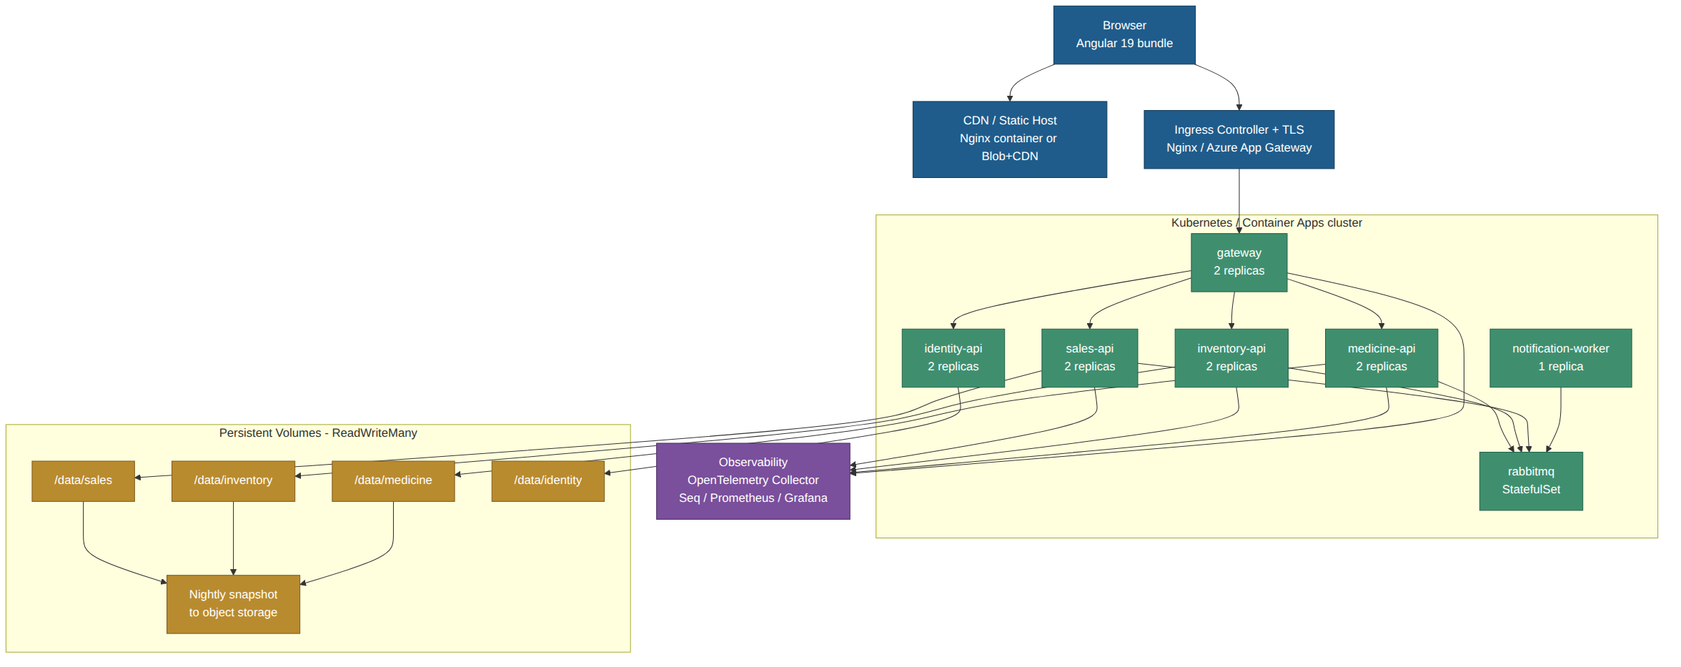
Figure 7 — Production deployment: ingress, six workloads, a broker, per-service persistent volumes and an observability pipeline.

12.2 Environments
Environment | Purpose | Topology | Data
Local | Developer inner loop | docker-compose: all services + RabbitMQ + Seq, single replica each, bind-mounted ./data folder | Seeded sample catalogue, disposable
CI | Automated verification | Ephemeral containers per pipeline run (Testcontainers) | Generated per test, torn down after
Test / UAT | Client acceptance | Same manifests as production, single replica per service | Anonymised copy of production data
Production | Live pharmacy operation | 2 replicas per API, 1 notification worker, broker as a StatefulSet, RWX volumes | Live, snapshotted nightly

12.3 Container strategy
- One Dockerfile per service, multi-stage: SDK image to restore/build/publish, then a chiselled or Alpine runtime image running as a non-root user with a read-only root filesystem apart from /data and /tmp.
- The SPA is built with ng build --configuration production and served either by a small Nginx container or as static assets on a CDN/blob host. It is deployed independently of the APIs.
- Images are tagged with the git SHA; the semantic version is embedded as a label and exposed on /health/ready for traceability.
- Resource requests and limits are set per workload (APIs 200m/512Mi request, 1 CPU/1Gi limit as a starting point), tuned from observed usage.

12.4 The volume problem — and how it is handled
A JSON file store is stateful, and that collides with the usual advice to keep microservices stateless. Two constraints follow, and both are deliberate design decisions rather than oversights:
- Every replica of a service must see the same files, so each store sits on a ReadWriteMany volume (NFS, Azure Files or CephFS). ReadWriteOnce block storage will not work behind more than one replica.
- Concurrent writers must be serialised. The single-writer lease of §7.5 does that across pods, but it means write throughput does not scale with replica count — only read throughput does. For the expected load (a few hundred writes a day) this is comfortable; it is called out in §16 as the primary scaling limit and is the trigger for the database migration in §7.7.
If the platform cannot provide an RWX volume, the fallback is to run each service as a single-replica StatefulSet with a ReadWriteOnce volume, accepting a short unavailability window during a rolling update. That trade is worse for availability and is the second-choice option.

12.5 Local development
A developer needs the whole system running in one command. docker-compose brings up the five services, the gateway, RabbitMQ and Seq with a seeded data folder. For fast iteration, .NET Aspire or a "modular monolith" launch profile hosts every service in a single process with an in-memory broker, so a developer can debug the whole sale flow with one F5 and one set of breakpoints. Appendix A gives the exact commands, including a corrected version of the CLI steps in the original brief.

13. Build and release pipeline
Stage | What runs | Gate
1. Build | dotnet restore / build for the changed service; ng build for the SPA | Zero warnings-as-errors; deterministic restore from a lock file
2. Unit test | xUnit with coverage collection; Jest/Karma for the SPA | ≥ 80% line coverage on domain projects; all tests green
3. Static analysis | Roslyn analysers, ESLint, dotnet format --verify-no-changes | No new violations
4. Security scan | dotnet list package --vulnerable, npm audit, Trivy image scan, secret scanning | No high or critical findings
5. Integration test | WebApplicationFactory + Testcontainers (RabbitMQ, temp volume) | All green
6. Contract test | Consumer-driven contracts (Pact) between SPA↔gateway and between event publishers and consumers | Provider verification passes
7. Package | Build and push the container image tagged with the git SHA | Image signed and SBOM attached
8. Deploy to test | Helm upgrade against the test namespace | Smoke suite passes
9. E2E | Playwright against the deployed SPA — add medicine, verify colours, record sale, verify stock | All scenarios pass
10. Deploy to production | Rolling update, one service at a time | Manual approval; automatic rollback on failed readiness probe or an error-rate spike
Each service has its own pipeline triggered by changes under its path, so a change to the Notification worker does not rebuild or redeploy Sales. Database-free deployment means there is no migration step; schema changes to the JSON documents are handled by the schemaVersion field and an upgrade routine that runs on service start-up (see §16, risk R-06).

14. How the design meets the quality attributes

14.1 Performance
- The grid is served from one store with an in-memory cache; no fan-out call per row. A 5,000-row catalogue serialises to roughly 2 MB, which is held comfortably in memory.
- Server-side paging caps the response at 200 rows; the default page of 25 keeps payloads under 30 KB.
- Search uses a pre-built lower-cased index rather than a scan per keystroke, and the client debounces at 300 ms.
- Angular signals with OnPush change detection mean a filter change re-renders only the affected rows.
- Response compression (Brotli), HTTP/2 and ETag-based conditional GETs cut repeat traffic.
- Budget check against NFR-01: cache read ≈ 1 ms, filter and page ≈ 5 ms, serialise ≈ 8 ms, gateway hop ≈ 3 ms, network ≈ 40 ms — well inside the 400 ms p95 target with a large margin for the JSON write lock.

14.2 Scalability
Dimension | Behaviour | Limit
Read traffic | Scales horizontally — add API replicas, each with its own read cache | Bounded by volume read throughput, far beyond expected load
Write traffic | Serialised per store by the single-writer lease | A whole-file rewrite per write, so throughput falls as the store grows: order of 100/s on a small store, closer to 5–10/s once a store reaches a few MB on network storage. Measure it; this is the real ceiling and the trigger for §7.7
Catalogue size | Whole document held in memory | Comfortable to ~50,000 medicines (~20 MB); beyond that, shard by brand or migrate
Sales volume | sales.json grows without bound | Rolled monthly into sales-2026-08.json with an index; hot file stays small
Users | Stateless APIs, tokens carry identity | No server-side session state to replicate

14.3 Availability
- Two replicas per API behind the gateway; readiness probes remove an unhealthy pod from rotation before it takes traffic.
- Rolling updates with maxUnavailable=0 mean zero-downtime releases for the API tier.
- The Notification worker is not on any user-facing path — it can be down for hours without a user noticing.
- If the broker is unavailable, sales still complete: events accumulate in the outbox and drain when it returns. This is the single most valuable property of the outbox pattern here.
- The honest weak point: the shared volume is a single point of failure for a given store. It is mitigated with a replicated storage class and nightly off-volume snapshots, and it is recorded as risk R-01.

14.4 Backup and recovery
Aspect | Approach
Snapshot | Nightly at 02:00 local, each store copied to object storage with a timestamped name; 30 daily, 12 monthly retained.
Continuous protection | Every write also appends to the stock-movement ledger and the sales file, both append-only, so recent activity is reconstructible even between snapshots.
RPO | 24 hours by snapshot, effectively minutes for sales and stock because of the append-only ledgers.
RTO | 2 hours: restore the volume from the latest snapshot, replay the ledger, restart the services.
Verification | A weekly automated restore into a scratch namespace, with a row-count and checksum comparison. A backup that has never been restored is not a backup.
Corruption | Every store keeps the previous good file as .bak on each write; a parse failure on start-up fails the readiness probe rather than serving partial data.

15. Testing strategy
Level | Scope | Tools | Representative cases
Unit | Domain rules in isolation | xUnit, FluentAssertions, NSubstitute | Severity at 29, 30 and 31 days to expiry; quantity 9, 10 and 11; both conditions true → Critical; price rounding at 2 dp.
Unit (store) | JSON persistence primitives | xUnit + a temp directory | Atomic replace leaves no partial file; version mismatch raises ConcurrencyException; lease blocks a second writer.
Component / API | One service in-process | WebApplicationFactory | POST duplicate name+brand → 409; PUT with a stale If-Match → 412; paging and sorting correctness.
Integration | Service + broker + volume | Testcontainers (RabbitMQ) | SaleRecorded decrements stock exactly once even when delivered twice; outbox drains after a broker outage.
Contract | Publisher/consumer and SPA/API compatibility | Pact | Adding a field to SaleRecorded does not break Inventory; the SPA’s expected medicine shape is honoured.
Frontend unit | Components, store, pipes | Jest or Karma + Angular TestBed | rowClass mapping; debounce behaviour; ProblemDetails mapped to field errors.
End to end | Full stack through the browser | Playwright | Add a medicine expiring in 10 days → the row renders red with the correct badge; sell 5 of 6 units → the row turns yellow.
Performance | Load and soak | k6 or NBomber | 5,000-row grid at 50 concurrent users; 100 concurrent sales of the same medicine must never oversell.
Accessibility | WCAG 2.2 AA | axe-core in CI + manual screen-reader pass | Status conveyed without colour; contrast ratios; keyboard-only grid navigation.
Security | Automated + manual | OWASP ZAP baseline, dependency and image scans | Path traversal against store endpoints; authorisation bypass on a service called directly.
The concurrency test deserves emphasis: 100 simultaneous sales of a medicine with 100 units in stock must result in exactly 100 units sold and zero oversell. That single test exercises the reservation model, the single-writer lease, the outbox and consumer idempotency together, and it is the test most likely to expose a flaw in a file-backed design.

16. Risks, trade-offs and open questions

16.1 Risk register
ID | Risk | Likelihood / Impact | Mitigation
R-01 | The shared JSON volume is a single point of failure and a write bottleneck. | Medium / High | Replicated storage class, nightly snapshots, single-writer lease, and a pre-designed migration path to a database (§7.7). Monitor lock-wait time as the leading indicator.
R-02 | File-store concurrency bugs cause lost updates or oversold stock. | Medium / High | Reservation model, optimistic versioning, the 100-concurrent-sales test in CI, and chaos testing that kills a pod mid-write.
R-03 | Microservice complexity outweighs the benefit at this scale. | High / Medium | Only five services; one repository and one solution; a modular-monolith launch profile for local work; shared building blocks for cross-cutting code.
R-04 | Eventual consistency confuses users — "I sold it but the grid still says 42". | Medium / Medium | The grid refreshes after a sale; a last-updated stamp is shown; the record-sale screen reads authoritative stock, not the projection.
R-05 | Colour rules are re-implemented differently on the client and drift from the server. | Low / Medium | The rule exists once, server-side, and is returned as an enum. The client has no date arithmetic at all.
R-06 | JSON schema evolution breaks an old store. | Medium / Medium | schemaVersion on every document, forward-only upgrade routines that run at start-up, a snapshot taken before upgrading, and a readiness probe that fails rather than serving mis-parsed data.
R-07 | sales.json grows without bound and read latency degrades. | Medium / Low | Monthly rollover into archive files with an index; only the current month stays hot.
R-08 | Broker outage stalls stock updates. | Low / Medium | The outbox holds events durably; sales continue; an alert fires when outbox age exceeds 5 minutes.
R-09 | Money handled as a floating-point number somewhere in the stack. | Low / High | decimal in C#, a two-decimal contract in the API, an analyser rule banning double for monetary types, and rounding tests at the boundaries.
R-10 | Time-zone handling makes the 30-day rule wrong near midnight or across a DST change. | Medium / Medium | A single IClock abstraction, a configured business time zone, all timestamps stored in UTC, and boundary tests at 23:59 and 00:01 local.

16.2 Trade-offs made, stated plainly
Decision | Chosen | Rejected alternative | Why
Architecture style | Five microservices | Modular monolith | Client requirement. The monolith would be simpler; the decomposition is kept minimal to limit the cost.
Grid quantity | Denormalised into the catalogue | Live call to Inventory per request | One read instead of N; sub-second staleness is harmless for a display, and the authoritative value is read at the point of sale.
Consistency for sales | Reservation + outbox + eventual settlement | Distributed transaction / two-phase commit | 2PC is not available over JSON files and couples services at runtime; compensation is the standard microservice answer.
State management (SPA) | Signal store | NgRx | The state graph is small; NgRx ceremony would exceed its benefit. The store is a clean seam if that changes.
Colour rule location | Server-side enum | Client-side computation | One implementation, testable, immune to a wrong client clock, reusable by other consumers.
Search | Server-side with an index | Client-side filter over all rows | Keeps paging and totals consistent and stays flat as the catalogue grows.
Auth token storage | In memory + HttpOnly refresh cookie | localStorage | localStorage is readable by any injected script; an XSS then yields a durable token.

16.3 Open questions for the client
- Should already-expired stock be hidden from the sales screen entirely, or shown and blocked at the point of sale? The design currently shows and flags it, and blocking is a one-line rule change.
- Is the low-stock threshold of 10 global, or per medicine? The design stores reorderLevel per item with a default of 10, which supports both.
- Are batch or lot numbers needed? Real pharmacy stock usually has multiple batches of the same medicine with different expiry dates. The current model holds one expiry per medicine, per the brief. Adding batches is the single most likely future change and would turn Medicine into an aggregate of Batch entities.
- Is multi-branch operation planned? If so, a branchId should be added to the inventory and sales models now rather than retrofitted.
- What are the retention requirements for sales records — a regulatory minimum would change the archiving strategy in §14.2.
- Which notification channel is wanted first: email, SMS, or in-app only?
- Please confirm the trading currency and time zone. The design currently defaults to LKR and Asia/Colombo; both are single configuration values, but the time zone materially affects where the 30-day expiry boundary falls.

17. Delivery roadmap
Phase | Scope | Requirements covered | Indicative duration
0 — Foundation | Repository, solution structure, building-blocks library, JSON store primitives, CI skeleton, docker-compose | TC-01 … TC-04 | 1 week
1 — Walking skeleton | Medicine Catalog service + Angular shell + gateway. List and add medicines with the colour rules. | FR-01, FR-02, FR-03, FR-04, FR-05 | 2 weeks
2 — Sales | Inventory and Sales services, reservation flow, outbox, stock settlement, sale history | FR-06, FR-08, FR-09 | 2 weeks
3 — Search and polish | Server-side search, sorting, paging, dashboard, accessibility pass | FR-07, NFR-01, NFR-08 | 1 week
4 — Security and alerts | Identity service, roles, rate limiting, Notification worker | FR-10, NFR-06 | 1.5 weeks
5 — Production readiness | Observability, backup/restore rehearsal, load and chaos tests, runbooks | NFR-03, NFR-04, NFR-07 | 1.5 weeks
Phase 1 is deliberately a walking skeleton: one service end to end through the gateway to a deployed SPA, with CI and a real deployment, before any breadth is added. It de-risks the whole architecture in the first fortnight.

Appendix A — Local setup and launch commands
The launch steps in the original brief contain a small CLI error and create a console application rather than a Web API. The corrected sequence is given below; the brief’s intent — that the solution can be created, built and run with nothing but the dotnet CLI — is preserved.

A.1 What the brief says, and the correction
Brief | Issue | Correct command
dotnet new console --MyConsoleApp | The name option is -n or --name; --MyConsoleApp is parsed as an unknown switch. A console template is also the wrong template for a Web API. | dotnet new webapi -n MyWebApi
dotnet run --project MyConsoleApp | Correct in form, but needs the project or its folder path. | dotnet run --project MyWebApi/MyWebApi.csproj
Open Preview and enter the application URL | Valid for a hosted preview environment; locally the URL is printed by dotnet run. | Open the https://localhost:{port} URL from the console output, or /swagger for the API explorer.

A.2 Creating the solution from scratch
Listing 17 — Creating the back end with the dotnet CLI only.
# 1. Solution and folder structure
dotnet new sln -n Pharmacy
mkdir src tests

# 2. Services (Web API template, minimal APIs)
dotnet new webapi -n Pharmacy.Gateway -o src/Pharmacy.Gateway
dotnet new webapi -n Pharmacy.Medicine.Api -o src/Pharmacy.Medicine.Api
dotnet new webapi -n Pharmacy.Inventory.Api -o src/Pharmacy.Inventory.Api
dotnet new webapi -n Pharmacy.Sales.Api -o src/Pharmacy.Sales.Api
dotnet new webapi -n Pharmacy.Identity.Api -o src/Pharmacy.Identity.Api
dotnet new worker -n Pharmacy.Notification.Worker -o src/Pharmacy.Notification.Worker
dotnet new classlib -n Pharmacy.BuildingBlocks -o src/Pharmacy.BuildingBlocks

# 3. Test projects
dotnet new xunit -n Pharmacy.Medicine.Tests -o tests/Pharmacy.Medicine.Tests
dotnet new xunit -n Pharmacy.Sales.Tests -o tests/Pharmacy.Sales.Tests

# 4. Wire everything into the solution
dotnet sln add $(find src tests -name "*.csproj") # bash
dotnet sln add (Get-ChildItem -Recurse -Filter *.csproj).FullName # PowerShell

# 5. Key packages (per service, as applicable)
dotnet add src/Pharmacy.Gateway package Yarp.ReverseProxy
dotnet add src/Pharmacy.Medicine.Api package FluentValidation.AspNetCore
dotnet add src/Pharmacy.Sales.Api package MassTransit.RabbitMQ
dotnet add src/Pharmacy.Medicine.Api package OpenTelemetry.Extensions.Hosting

A.3 Building and running
Listing 18 — Build, test and run.
# Build everything
dotnet build Pharmacy.sln

# Run tests
dotnet test Pharmacy.sln

# Run a single service (prints the listening URL, e.g. https://localhost:7191)
dotnet run --project src/Pharmacy.Medicine.Api/Pharmacy.Medicine.Api.csproj

# Swagger / OpenAPI explorer
# https://localhost:7191/swagger

# Run the whole system locally (services + RabbitMQ + Seq)
docker compose up --build

# Front end
npm install -g @angular/cli@19
ng new pharmacy-web --routing --style=scss --ssr=false # standalone is the v19 default
cd pharmacy-web
npm install
ng serve --proxy-config proxy.conf.json # http://localhost:4200
ng build --configuration production # dist/ -> Nginx or CDN

A.4 Seed data
Each service ships a seed file used when its store is empty, so a freshly cloned repository shows a populated, colour-coded grid on the first run — including at least one row in each of the three states (normal, expiring soon, low stock) and one row that satisfies both conditions, which is the case reviewers check first.

Appendix B — Requirements traceability matrix
Req | Design element | Component | Verified by
FR-01 | GET /api/v1/medicines with paging and sorting | Medicine Catalog API; MedicineListComponent | API component test; Playwright grid-load scenario
FR-02 | Column set excludes Notes; Notes available on detail/expand | MedicineListComponent, DataGridComponent | Frontend unit test asserting the column set; visual review
FR-03 | POST /api/v1/medicines with validation and idempotency | Medicine Catalog API; MedicineFormComponent | API component test (201, 400, 409); Playwright add-medicine
FR-04 | Server-side expiry classification, red row | RowSeverity.Evaluate; row--critical CSS | Unit tests at 29/30/31 days; Playwright colour assertion
FR-05 | Server-side stock classification, yellow row | RowSeverity.Evaluate; row--warning CSS | Unit tests at 9/10/11 units; Playwright colour assertion
FR-06 | Sales service, sales.json, POST /api/v1/sales, sale history | Sales API; RecordSaleComponent; SaleListComponent | Integration test; Playwright record-sale-and-verify
FR-07 | search query parameter over the name index; debounced client input | Medicine Catalog API; MedicineListComponent | API test for partial and case-insensitive match; frontend debounce test
FR-08 | SaleRecorded → Inventory decrement → StockAdjusted → catalogue projection | Sales, Inventory, Medicine Catalog | Integration test with duplicate delivery; 100-concurrent-sales load test
FR-09 | Reservation returns 409 when stock is insufficient | Inventory API; Sales API | API test; Playwright insufficient-stock scenario
FR-10 | JWT auth, role claims, gateway policy plus in-service check | Identity API; gateway; every service | Security test suite; authorisation bypass attempt
TC-01 | ASP.NET Core 10 (LTS) Web API projects throughout | All services | Build pipeline
TC-02 | Angular 19 standalone SPA | pharmacy-web | Build pipeline
TC-03 | JSON document stores, one per service | JsonDocumentStore<T> | Store unit tests; on-disk inspection
TC-04 | dotnet CLI create/build/run path | Appendix A | Fresh-clone smoke test in CI

Appendix C — Configuration reference
Setting | Default | Meaning | Owner
Business:ExpiryWarningDays | 30 | Days before expiry at which a row turns red (FR-04). | Pharmacy
Business:LowStockThreshold | 10 | Default reorder level; a row below this turns yellow (FR-05). | Pharmacy
Business:BusinessTimeZone | Asia/Colombo | Time zone used to derive the business date for expiry maths. | Pharmacy
Business:Currency | LKR | Display and rounding currency. | Pharmacy
Storage:RootPath | /data/{service} | Mount point of the service’s private JSON store. | Platform
Storage:CacheSeconds | 30 | Maximum age of the in-memory read cache before revalidation. | Engineering
Storage:SnapshotCron | 0 2 * * * | Nightly snapshot schedule. | Platform
Storage:LeaseTimeoutSeconds | 5 | How long a writer waits for the single-writer lease before failing fast. | Engineering
Sales:IdempotencyTtlHours | 24 | How long a stored idempotent response is replayable. | Engineering
Inventory:ReservationTtlSeconds | 60 | How long a stock hold survives before automatic release. | Engineering
Resilience:HttpTimeoutSeconds | 2 | Per-attempt timeout on outbound service calls. | Engineering
Messaging:MaxRetries | 5 | Consumer retries before dead-lettering. | Engineering
Auth:AccessTokenMinutes | 15 | Access token lifetime. | Security
Auth:RefreshTokenHours | 8 | Refresh token lifetime, aligned to a shift. | Security

Appendix D — Glossary of design patterns used
Pattern | Where it appears | Problem it solves here
API Gateway | §5.7 | Gives the SPA one origin, one CORS policy and one place to authenticate and rate-limit.
Database per service | §7.2 | Keeps bounded contexts independently deployable and stops hidden coupling through shared files.
Transactional Outbox | §5.4, §7.3, §8.2 | Removes the dual-write problem between the sales store and the broker.
Idempotent Receiver | §8.2 | Makes at-least-once delivery safe: a redelivered SaleRecorded cannot decrement stock twice.
Optimistic Concurrency | §7.5 | Detects conflicting edits without locking a whole file for the duration of a user’s think time.
Reservation (pessimistic hold) | §5.3, §8.3 | Prevents overselling the last unit when two counters sell simultaneously.
Compensating Transaction | §8.4 | Reverses a sale without a distributed transaction, keeping sales records immutable.
CQRS-lite / read model | §5.2 | A denormalised quantity in the catalogue serves the grid in one read instead of N.
Circuit Breaker / Retry / Timeout | §11.4 | Stops a slow or failing dependency from cascading into a system-wide outage.
Health Check API | §11.3 | Lets the orchestrator and the gateway route away from an instance whose store is unreadable.
Strangler-ready adapter | §7.7 | Allows the mandated JSON store to be replaced by a database with no change to domain or API code.

Appendix E — Document control
Field | Value
Document title | System Design Document — ABC Pharmacy Medicine Tracking (Microservice Architecture)
Version | 1.0
Status | For review
Date | 18 August 2026
Prepared for | ABC Pharmacy
Basis | Client brief "Dot Net Coding Assessment"
Related artefacts | OpenAPI 3.1 specifications (one per service), Helm chart, docker-compose.yml, Playwright E2E suite
Review cycle | Architecture review before Phase 1; re-baselined at the end of each delivery phase
Revision history
Version | Date | Author | Summary of change
1.0 | 18 Aug 2026 | Solution Architecture | Initial issue for client review.

