**pm2 PROCESS MANAGER FOR NODEJS**

Pm2 is a process manager for Nodejs . pm2is offered as a simple and intuitive CLI, installable via NPM. Just start your application with PM2 to boost your application and to make it ready to handle traffic!

**Installation Steps:**

The latest PM2 stable version is installable via NPM:

npm install pm2@latest –g

**Application Declaration**

process.yml:

apps:

- script : index.js

name : 'api-app'

instances: 4

exec_mode: cluster

- script : index.js

name : 'worker'

watch : true

env :

NODE_ENV: development

env_production:

NODE_ENV: production

Application declaration can be also configured in JSON format.

**Frequently Used Commands**

* pm2 start index.js
* pm2 start index.js -- -a 23
* pm2 start index.js -i 0 # Start maximum processes depending on available CPUs (cluster mode)
* pm2 start process.yml
* pm2 list
* pm2 logs
* pm stop all # pm2 stop pid|name|all
* pm2 moint

**Folder Structure**

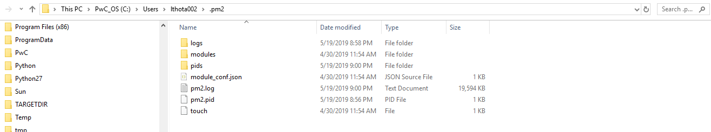

**Sample Application**

