AI-Powered Financial Fraud Detection
and Risk Analytics System
Using Machine Learning

IBM SkillsBuild Academic Internship Project
Dataset : Kaggle Credit Card Fraud Detection
Models : Logistic Regression | Random Forest | XGBoost | LightGBM | Isolation Forest
Best Model : Random Forest (F1 = 0.8588)
Interface : Streamlit Web Application
Language : Python 3.11

Abstract
This project presents an AI-powered financial fraud detection and risk analytics system built on the Kaggle Credit Card Fraud Detection dataset, which contains 284,807 real European credit card transactions from a 48-hour window in September 2013. After removing 1,081 exact duplicate records, 283,726 unique transactions were retained, of which 473 (0.1667%) are fraudulent. The dataset exhibits severe class imbalance — approximately 599 legitimate transactions for every fraudulent one — which is addressed through SMOTE oversampling applied exclusively to the training fold. Five machine learning algorithms are trained and evaluated: Logistic Regression, Random Forest, XGBoost, LightGBM, and Isolation Forest. Rigorous data-leakage prevention is enforced throughout: the RobustScaler is fitted on training data only, SMOTE is never applied to the test set, and duplicate rows are removed before any splitting. The best-performing model, Random Forest, achieves an F1-score of 0.8588, ROC-AUC of 0.9606, and PR-AUC of 0.8288 on the stratified held-out test set of 56,746 transactions. A fully functional Streamlit web application provides a live dashboard, exploratory data analysis, model comparison, real-time single-transaction fraud prediction with an animated risk gauge, and batch CSV prediction with downloadable results. The entire system is implemented in a single Python file.

1. Introduction
Credit card fraud results in annual losses exceeding $30 billion globally. Traditional rule-based detection systems struggle to adapt to evolving fraud patterns and produce excessive false positives that degrade customer experience. Machine learning offers a data-driven approach that automatically learns complex fraud signatures from historical transaction data without requiring manual rule engineering.
This project applies five machine learning algorithms to the binary classification problem of identifying fraudulent credit card transactions. It covers the complete machine learning lifecycle: raw data ingestion, exploratory data analysis, feature engineering, preprocessing with leakage prevention, model training, evaluation, and deployment through an interactive Streamlit web application. All code is contained in a single Python file (FinancialFraudDetection.py) for simplicity of deployment and submission.

2. Problem Statement
Given a set of transaction features -- elapsed time, 28 anonymised PCA components (V1-V28), and the transaction amount -- the task is to classify each transaction as legitimate (Class=0) or fraudulent (Class=1). The primary challenges are:
- Severe class imbalance: only 0.1667% of transactions are fraudulent after deduplication. A naive model that always predicts 'legitimate' achieves 99.83% accuracy while catching zero fraud.
- Feature anonymisation: V1-V28 are PCA-transformed components with no interpretable business meaning, limiting domain-driven feature selection.
- Cost asymmetry: missing a fraud (false negative) is far more costly than a false alarm (false positive), requiring recall-focused evaluation.
- Data leakage risk: the preprocessing pipeline must be carefully structured to avoid using test-set information during training.

3. Objectives
- Load, clean, and preprocess the Kaggle Credit Card Fraud Detection dataset with no data leakage.
- Perform exploratory data analysis and generate visualisations of class imbalance, amount distributions, temporal patterns, and feature correlations.
- Engineer two additional features (Amount_log, Hour) from the raw Time and Amount columns.
- Train five machine learning models with class-imbalance handling at each level.
- Evaluate all models on a stratified held-out test set using Precision, Recall, F1, ROC-AUC, PR-AUC, and Confusion Matrix.
- Build an interactive Streamlit web application for real-time single and batch fraud prediction.
- Produce a complete academic project report with actual results and application screenshots.

4. Dataset Description
The Kaggle Credit Card Fraud Detection dataset was published by the ULB Machine Learning Group (Worldline). It contains European cardholder transactions recorded over a 48-hour window in September 2013.

4.1 Dataset Statistics
Property | Value
Source | Kaggle / ULB Machine Learning Group (Worldline)
Total rows (raw) | 284,807
Exact duplicate rows | 1,081
Rows after deduplication | 283,726
Number of features | 30 (Time + V1-V28 + Amount)
Target variable | Class (0 = Legitimate, 1 = Fraud)
Legitimate transactions | 283,253 (99.8333%)
Fraudulent transactions | 473 (0.1667%)
Missing values | None
Observation window | 48 hours (172,792 seconds)
V1-V28 | PCA-transformed, anonymised
Mean amount (all) | $88.47
Mean amount (fraud) | $123.87
Mean amount (legitimate) | $88.41
Max amount (fraud) | $2,125.87
Max amount (legitimate) | $25,691.16

4.2 Feature Descriptions
Feature | Type | Description
Time | Float | Seconds elapsed since first transaction in dataset
V1 - V28 | Float | PCA-transformed anonymised transaction components (28 features)
Amount | Float | Transaction value in euros
Class | Integer | Target: 0 = Legitimate, 1 = Fraud

4.3 Class Distribution
Class | Count | Percentage
Legitimate (0) | 283,253 | 99.8333%
Fraud (1) | 473 | 0.1667%
Approximately 599 legitimate transactions for every 1 fraudulent transaction after deduplication. This severe imbalance is addressed in the preprocessing pipeline.

4.4 Sample Dataset Records
Time | V1 | V2 | V3 | Amount | Class
0.0 | -1.360 | -0.073 | 2.536 | 149.62 | 0 (Legitimate)
0.0 | 1.192 | 0.266 | 0.166 | 2.69 | 0 (Legitimate)
1.0 | -1.358 | -1.340 | 1.773 | 378.66 | 0 (Legitimate)
406.0 | -2.312 | 1.952 | -1.610 | 1.00 | 1 (Fraud)
472.0 | -3.043 | -3.157 | 1.088 | 239.93 | 1 (Fraud)
V4-V28 omitted for brevity. The table shows two confirmed fraudulent transactions (Class=1) and three legitimate ones (Class=0).

5. Data Preprocessing
All preprocessing is implemented inside FinancialFraudDetection.py with strict data-leakage prevention. The pipeline follows these steps in order:

5.1 Deduplication
1,081 exact duplicate rows were identified and removed before any train/test split. Removing duplicates after splitting could place identical rows in both sets, artificially inflating test performance. After deduplication: 283,726 rows remain.

5.2 Feature Engineering
Two new features are derived from raw columns (see Section 6 for full details):
Feature | Formula | Purpose
Amount_log | log1p(Amount) | Reduces extreme right-skew of transaction amounts
Hour | (Time // 3600) % 24 | Extracts hour of day from elapsed seconds
Raw Time and Amount are excluded from the model feature matrix.

5.3 Stratified Train/Test Split
An 80/20 stratified split preserves the 0.17% fraud ratio in both folds:
Split | Total Rows | Fraud Rows
Training set | 226,980 | 378
Test set | 56,746 | 95
The test set is held out entirely and never used during any fitting step.

5.4 Feature Scaling
A RobustScaler is fitted exclusively on the training set and applied to both sets. RobustScaler uses the median and interquartile range, making it robust to the extreme outliers present in financial transaction amounts. Fitting on the full dataset before splitting would constitute data leakage.

5.5 SMOTE Oversampling
SMOTE (Synthetic Minority Over-sampling Technique) is applied to the training fold only to address the severe class imbalance:
Category | Before SMOTE | After SMOTE
Fraud samples (training) | 378 | 226,602
Legitimate samples (training) | 226,602 | 226,602
Total training samples | 226,980 | 453,204
Applying SMOTE before splitting, or to the test set, would be data leakage. The test set always reflects the real-world class imbalance.

5.6 Data Leakage Summary
Step | Leakage-Prevention Action
Deduplication | Applied BEFORE train/test split
Train/test split | Stratified to preserve 0.17% fraud ratio
RobustScaler | Fitted on training set ONLY; transform applied to both
SMOTE | Applied to training fold ONLY; test set untouched
Evaluation | All metrics computed on held-out test set exclusively

6. Feature Engineering
The dataset's raw Amount column spans $0 to $25,691 with a strong right skew. The Time column contains raw elapsed seconds with no directly useful magnitude. Two derived features are created to improve model performance:
Feature | Formula | Rationale
Amount_log | log1p(Amount) | Compresses the large right tail; transforms the amount distribution toward normality, benefiting linear models and distance-based algorithms.
Hour | (Time // 3600) % 24 | Extracts the hour of day. The dataset spans exactly two daily cycles, so this feature captures whether a transaction occurs during business hours or overnight, which correlates with fraud risk.
The final feature set used for training is: V1-V28 + Amount_log + Hour = 30 features.

7. Exploratory Data Analysis
Seven EDA charts are generated from the actual dataset and saved to fraud_assets/. All figures below are produced by FinancialFraudDetection.py during training.

Figure 1: Class Distribution
Severe imbalance: 99.83% legitimate (283,253 transactions) and only 0.17% fraudulent (473 transactions). The pie chart confirms the impossibility of using accuracy as a metric.
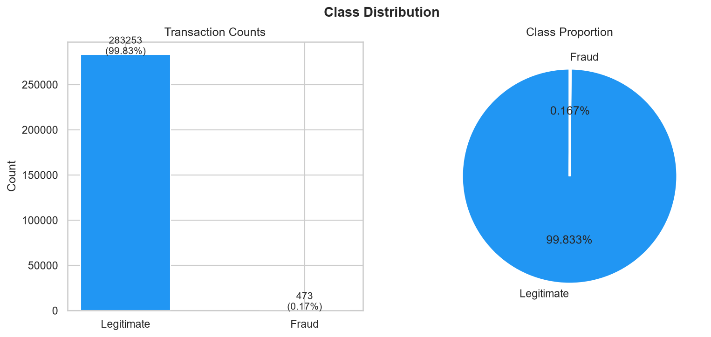
Figure 1: Class Distribution (generated from actual dataset)

Figure 2: Transaction Amount Distribution by Class
Legitimate transactions span $0-$25,691. Fraudulent transactions are capped at $2,125.87. Log-transformation (right panel) reduces the extreme right-skew, revealing the distribution shape more clearly.
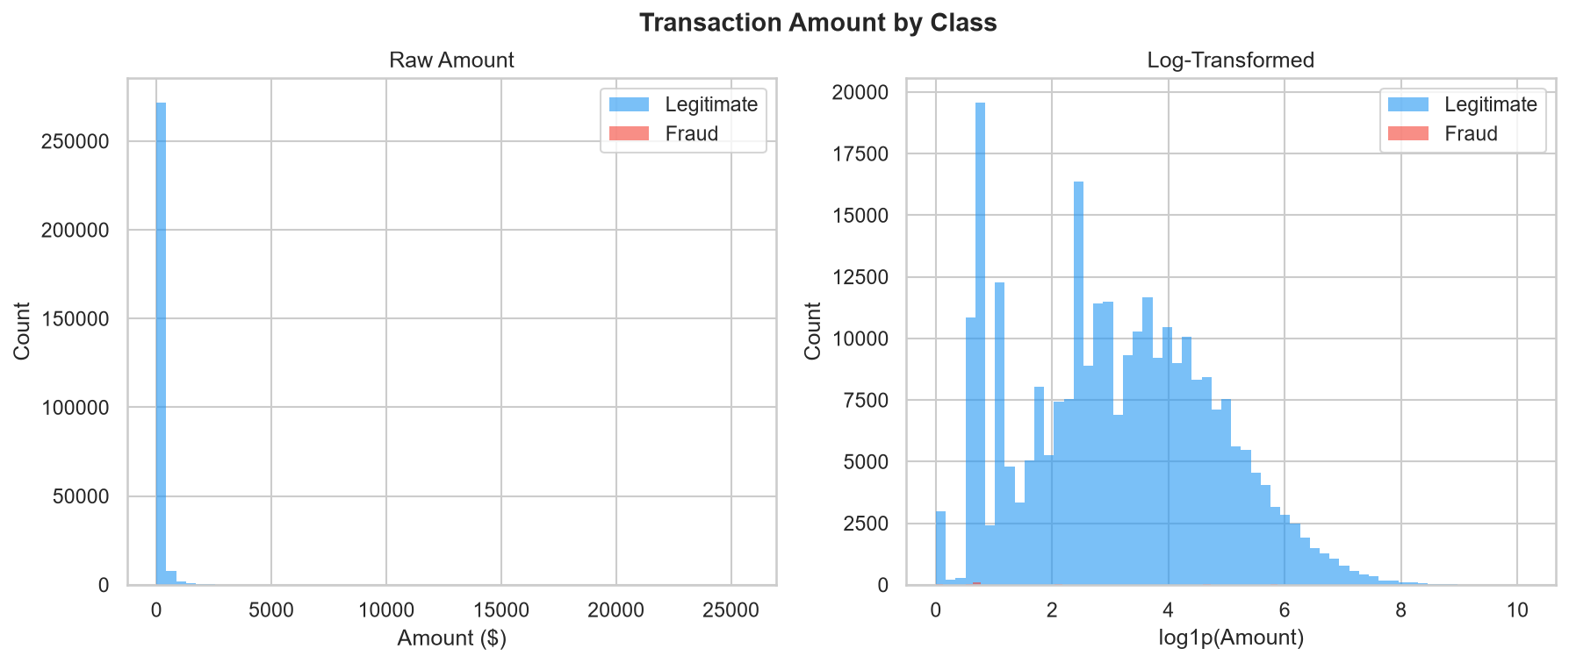
Figure 2: Transaction Amount Distribution by Class (generated from actual dataset)

Figure 3: Time Distribution by Class
Legitimate transactions show two daily cycles across the 48-hour window, with peaks at business hours. Fraudulent transactions are more uniformly distributed, showing a slight elevation in the early-morning hours.
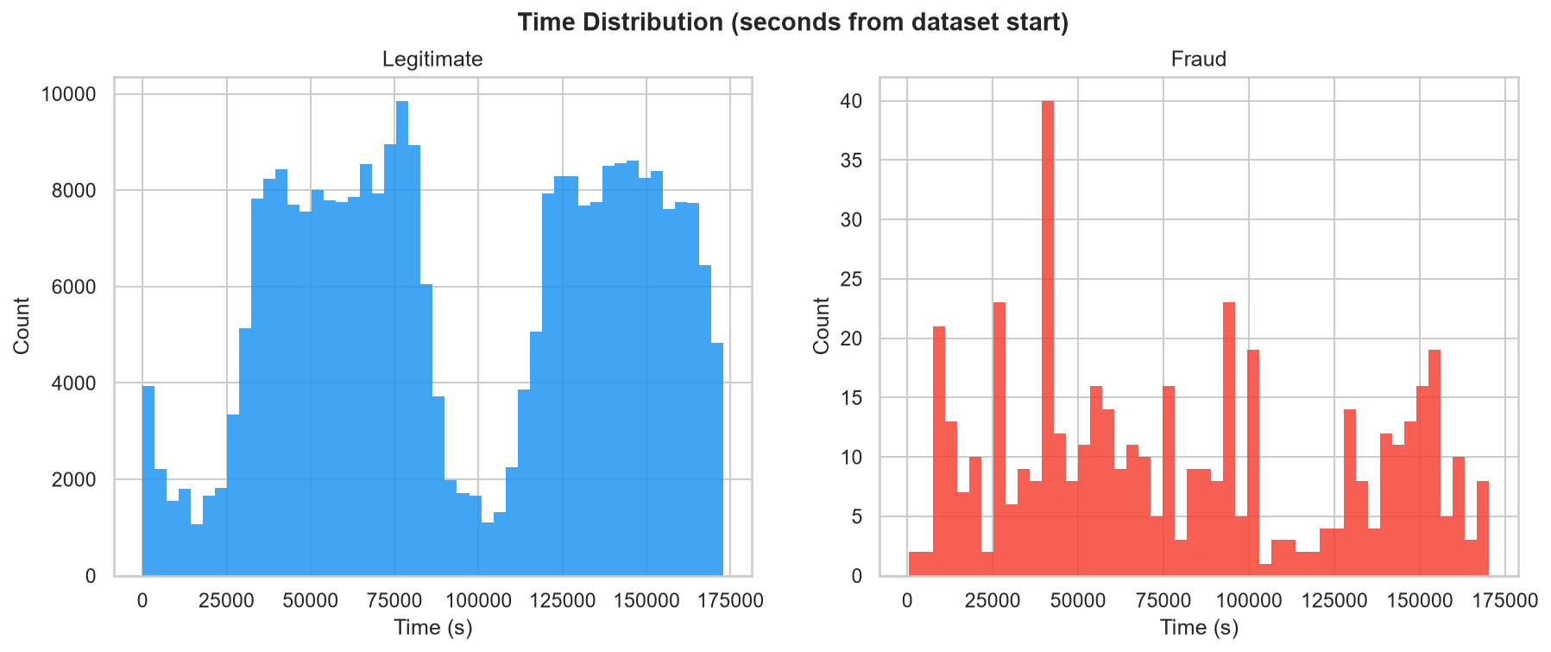
Figure 3: Time Distribution by Class (generated from actual dataset)

Figure 4: Fraud Count by Hour of Day
Fraudulent transactions show a modest elevation during hours 0-6 (overnight/early morning), motivating the inclusion of the Hour engineered feature.
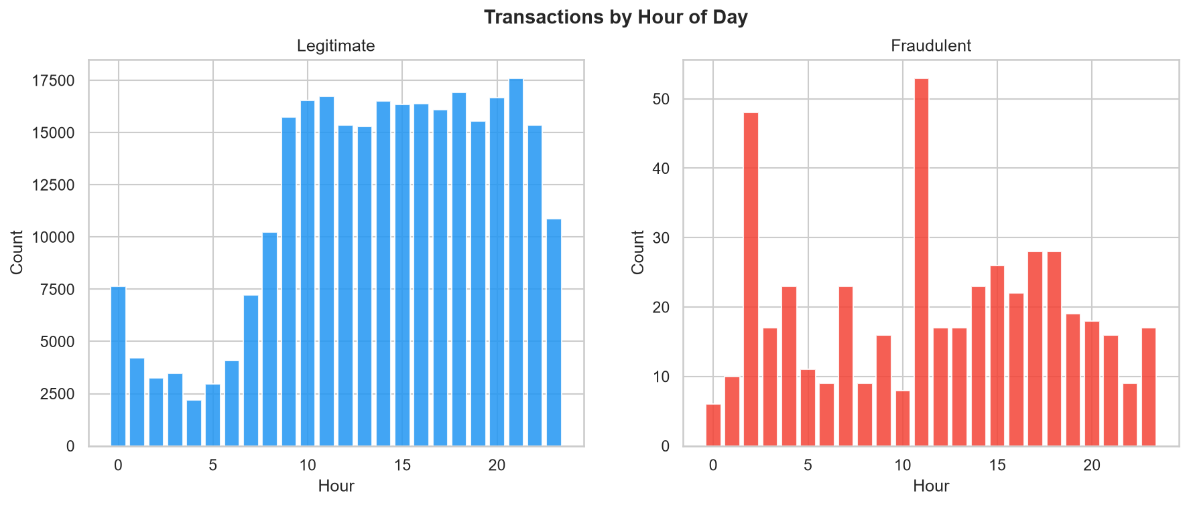
Figure 4: Fraud Count by Hour of Day (generated from actual dataset)

Figure 5: Amount Boxplot by Class
The median fraud amount ($22.05) is similar to legitimate transactions ($22.00), but the upper tail is dramatically lower for fraud -- maximum $2,125.87 vs $25,691.16 for legitimate. High-value transactions are actually less likely to be fraudulent.
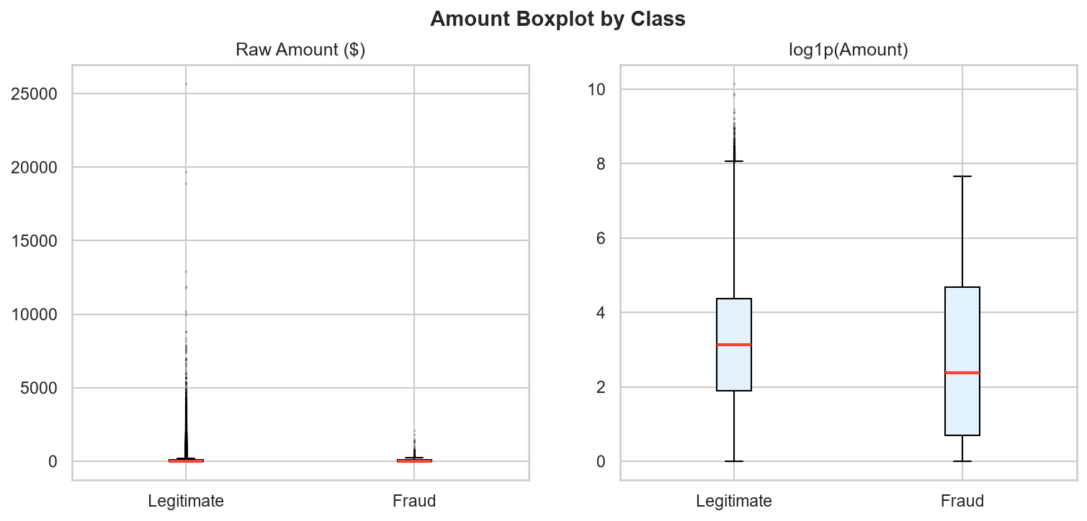
Figure 5: Amount Boxplot by Class (generated from actual dataset)

Figure 6: Top 10 PCA Features vs Class
The 10 V-features most correlated with Class show strong distributional separation. V14, V4, V12, V10, and V11 exhibit the widest difference in median values between legitimate and fraudulent transactions -- these are the most discriminative features.
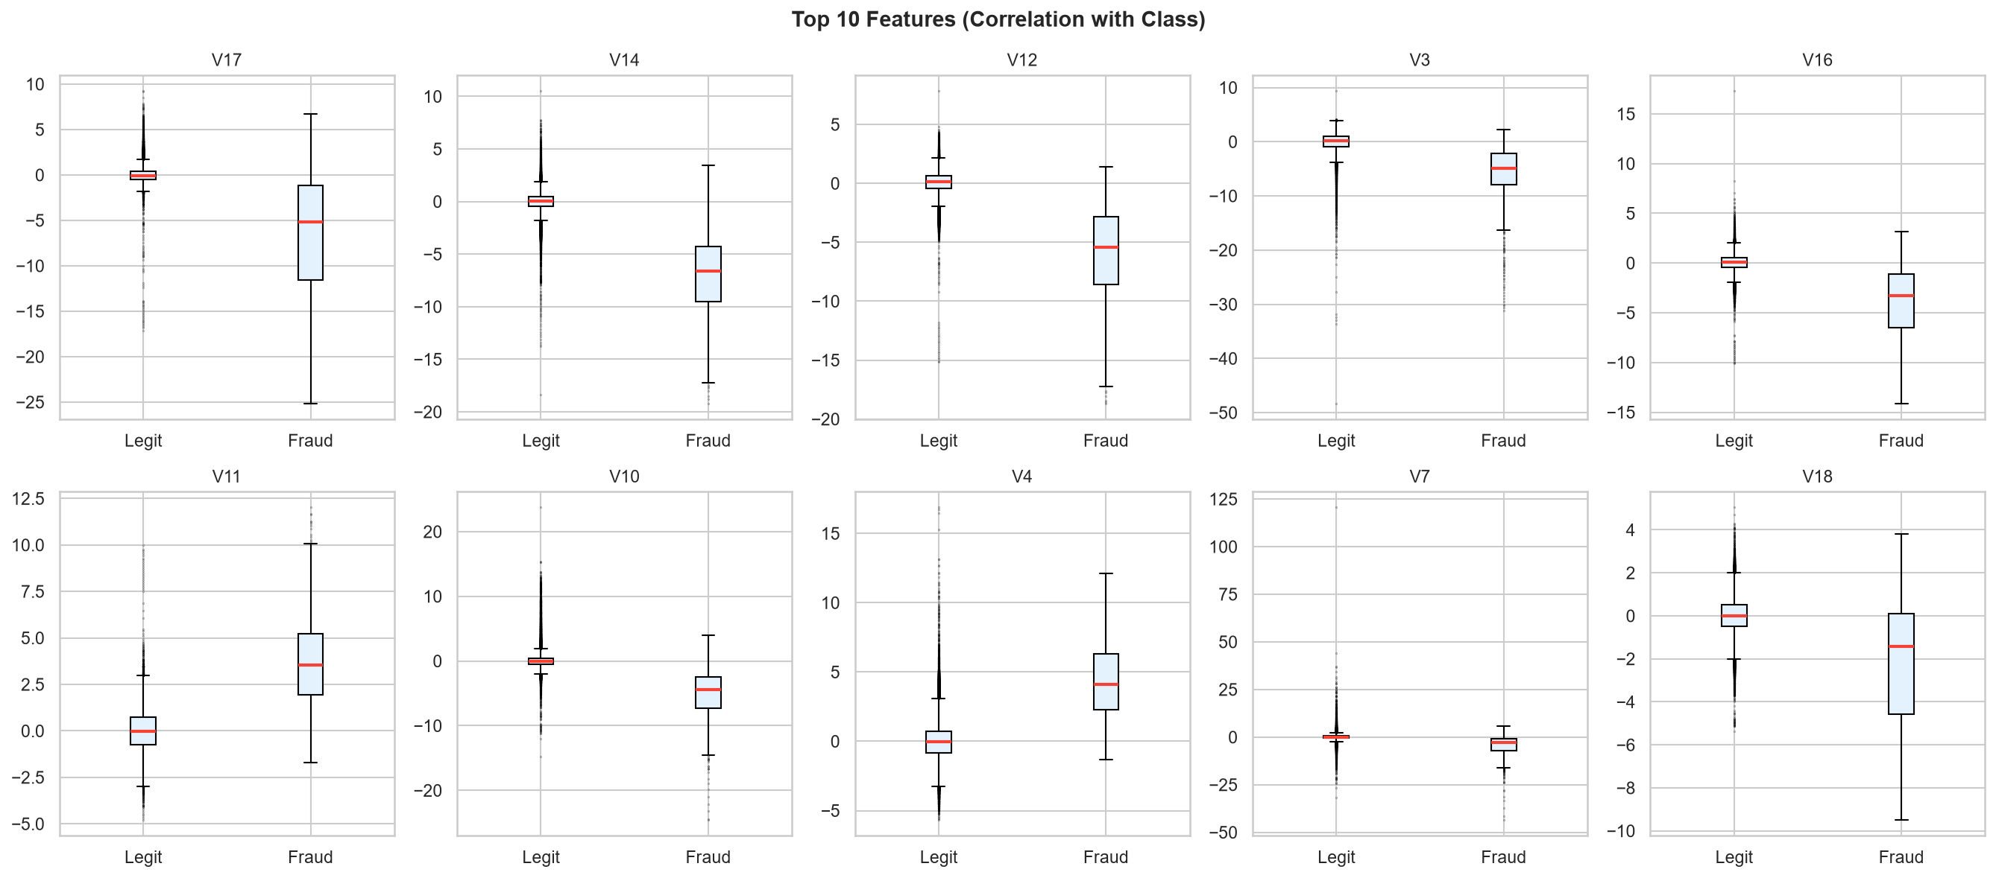
Figure 6: Top 10 PCA Features vs Class (generated from actual dataset)

Figure 7: Feature Correlation Heatmap
V1-V28 are largely uncorrelated with each other (expected from PCA orthogonality). Amount_log shows a weak positive correlation with Class. V14 shows the strongest negative correlation with Class among all V-features.
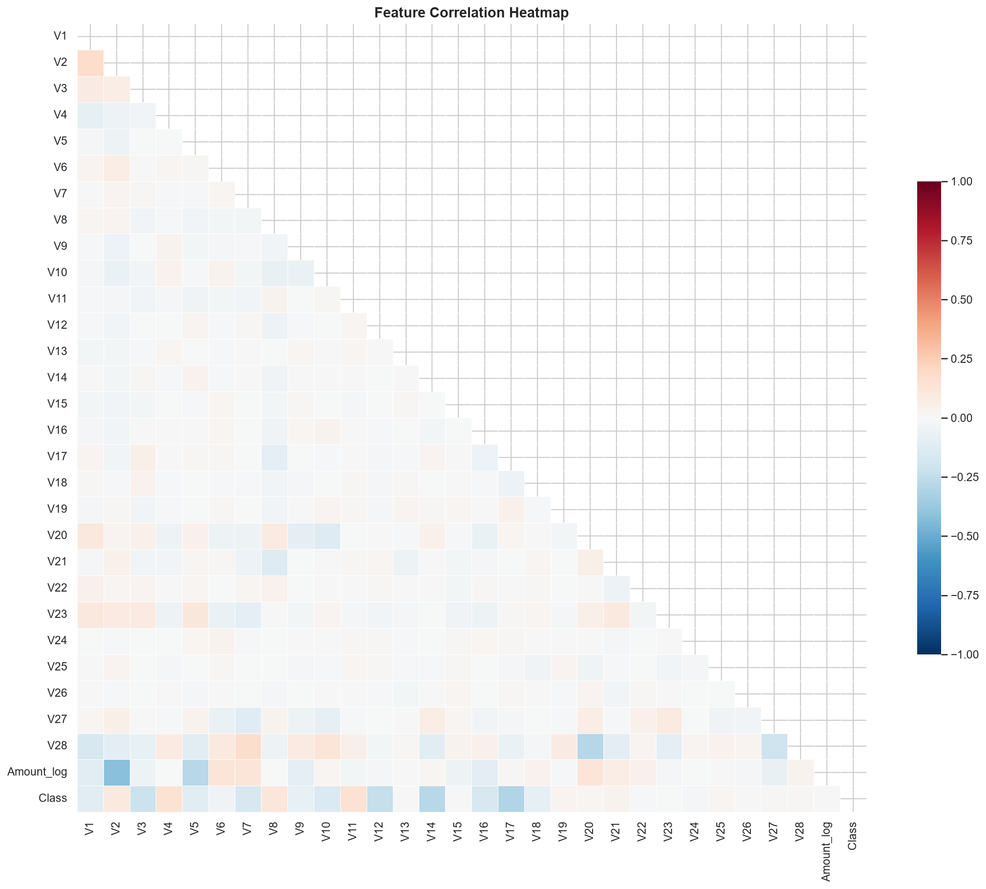
Figure 7: Feature Correlation Heatmap (generated from actual dataset)

8. Machine Learning Models
Five algorithms are trained, spanning supervised classification and unsupervised anomaly detection. All supervised models use the SMOTE-augmented training set. Isolation Forest uses the original (unaugmented) training set.
Model | Key Parameters | Role
Logistic Regression | lbfgs, max_iter=1000, class_weight='balanced' | Linear baseline; maximises recall at cost of precision
Random Forest | n_estimators=200, min_samples_leaf=2, class_weight='balanced' | Non-linear ensemble; best F1-Score
XGBoost | n_estimators=300, max_depth=6, lr=0.05, scale_pos_weight | Gradient boosting; highest ROC-AUC
LightGBM | n_estimators=300, leaf-wise, lr=0.05, scale_pos_weight | Faster gradient boosting for large datasets
Isolation Forest | n_estimators=200, contamination=0.002, unsupervised | Anomaly detection baseline; no labels used

9. ML Pipeline Workflow
The complete pipeline, as implemented in FinancialFraudDetection.py, runs in sequence from raw CSV to saved model artifacts:
- [1/7] Load creditcard.csv, remove 1,081 duplicate rows before any split.
- [2/7] Feature engineering: add Amount_log = log1p(Amount), Hour = (Time//3600)%24.
- [6/7] Generate 7 EDA charts and save to fraud_assets/.
- [3/7] Stratified 80/20 train/test split (preserves 0.17% fraud ratio).
- [4/7] Fit RobustScaler on training set; transform both train and test.
- [5/7] Apply SMOTE to training set only (226,980 -> 453,204 samples).
- [7/7] Train 5 models; evaluate all on held-out test set; save artifacts.

10. Model Evaluation Metrics
Standard accuracy is not reported. All metrics are computed on the held-out test set (56,746 transactions, 95 fraudulent) which reflects the real class imbalance.
Metric | Formula | Significance for Fraud Detection
Precision | TP / (TP + FP) | Fraction of flagged transactions that are true fraud
Recall | TP / (TP + FN) | Fraction of actual frauds that are detected
F1-Score | 2 * P * R / (P + R) | Harmonic mean; primary ranking metric
ROC-AUC | Area under ROC curve | Discrimination across all thresholds
PR-AUC | Area under PR curve | More informative than ROC-AUC for imbalanced data
Confusion Matrix | TP, TN, FP, FN | Exact prediction breakdown

11. Actual Model Performance Results
Test set: 56,746 transactions | 95 fraud | 56,651 legitimate. Green cells indicate the best value per column.

11.1 Metrics Table
Model | Precision | Recall | F1-Score | ROC-AUC | PR-AUC
Logistic Regression | 0.0532 | 0.8737 | 0.1004 | 0.9599 | 0.6775
Random Forest | 0.9268 | 0.8000 | 0.8588 | 0.9606 | 0.8288
XGBoost | 0.6525 | 0.8105 | 0.7230 | 0.9775 | 0.8128
LightGBM | 0.6033 | 0.7684 | 0.6759 | 0.9739 | 0.7860
Isolation Forest | 0.2353 | 0.2947 | 0.2617 | 0.9390 | 0.1616

Best model by F1-Score: Random Forest (F1=0.8588 | ROC-AUC=0.9606 | PR-AUC=0.8288)

11.2 Confusion Matrix Details
Model | True Negatives | False Positives | False Negatives | True Positives
Logistic Regression | 55175 | 1476 | 12 | 83
Random Forest | 56645 | 6 | 19 | 76
XGBoost | 56610 | 41 | 18 | 77
LightGBM | 56603 | 48 | 22 | 73
Isolation Forest | 56560 | 91 | 67 | 28

11.3 Key Findings
- Random Forest achieves the best precision-recall balance: only 6 false positives and 19 missed frauds out of 56,746 transactions. Selected as the default model in the app.
- XGBoost achieves the highest ROC-AUC (0.9775), demonstrating the strongest discrimination across all probability thresholds.
- Logistic Regression achieves the highest recall (0.8737) but at the cost of 1,476 false positives -- a precision of only 5.3%. Useful where catching every fraud matters most.
- Isolation Forest (unsupervised, F1=0.2617) performs significantly below supervised models, confirming that labelled training data is critical for effective fraud detection.
- All five supervised ROC-AUC scores exceed 0.93, demonstrating strong discriminatory power despite the extreme class imbalance.

11.4 Evaluation Charts
Figure 8: All-Model Metrics Comparison
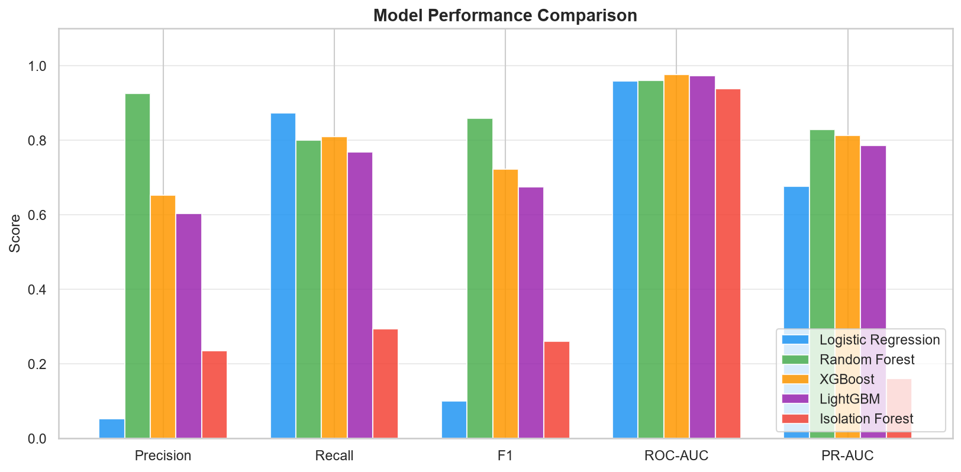
Figure 8: All-Model Metrics Comparison (actual results from trained models)

Figure 9: ROC Curves - All Models
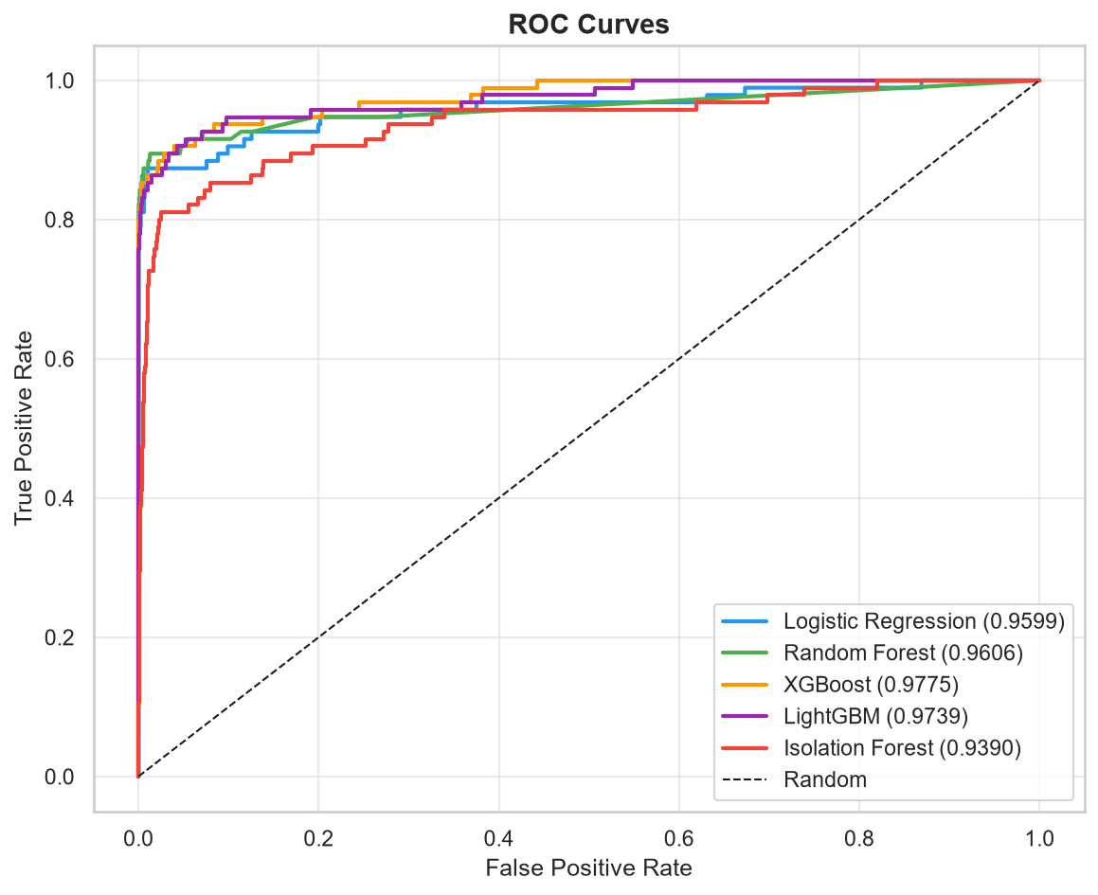
Figure 9: ROC Curves - All Models (actual results from trained models)

Figure 10: Precision-Recall Curves - All Models
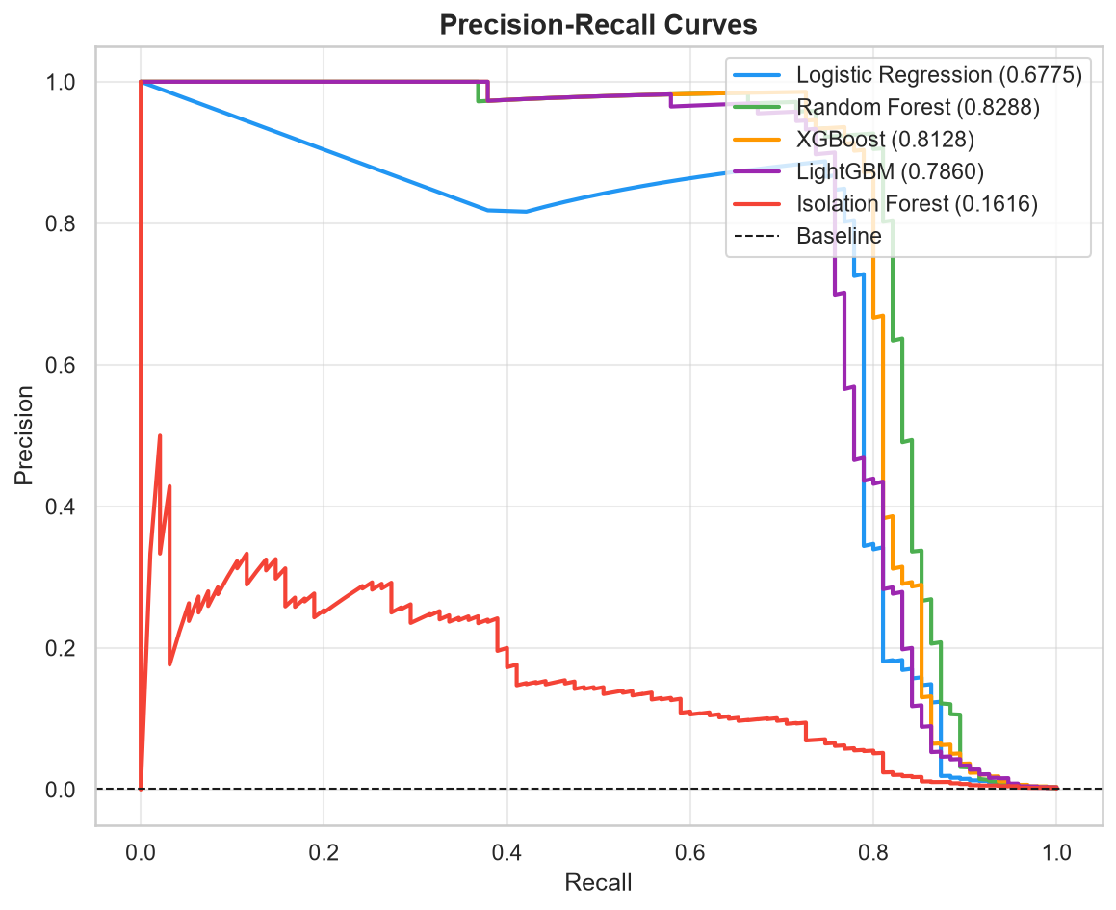
Figure 10: Precision-Recall Curves - All Models (actual results from trained models)

Figure 11: Confusion Matrices - All Models
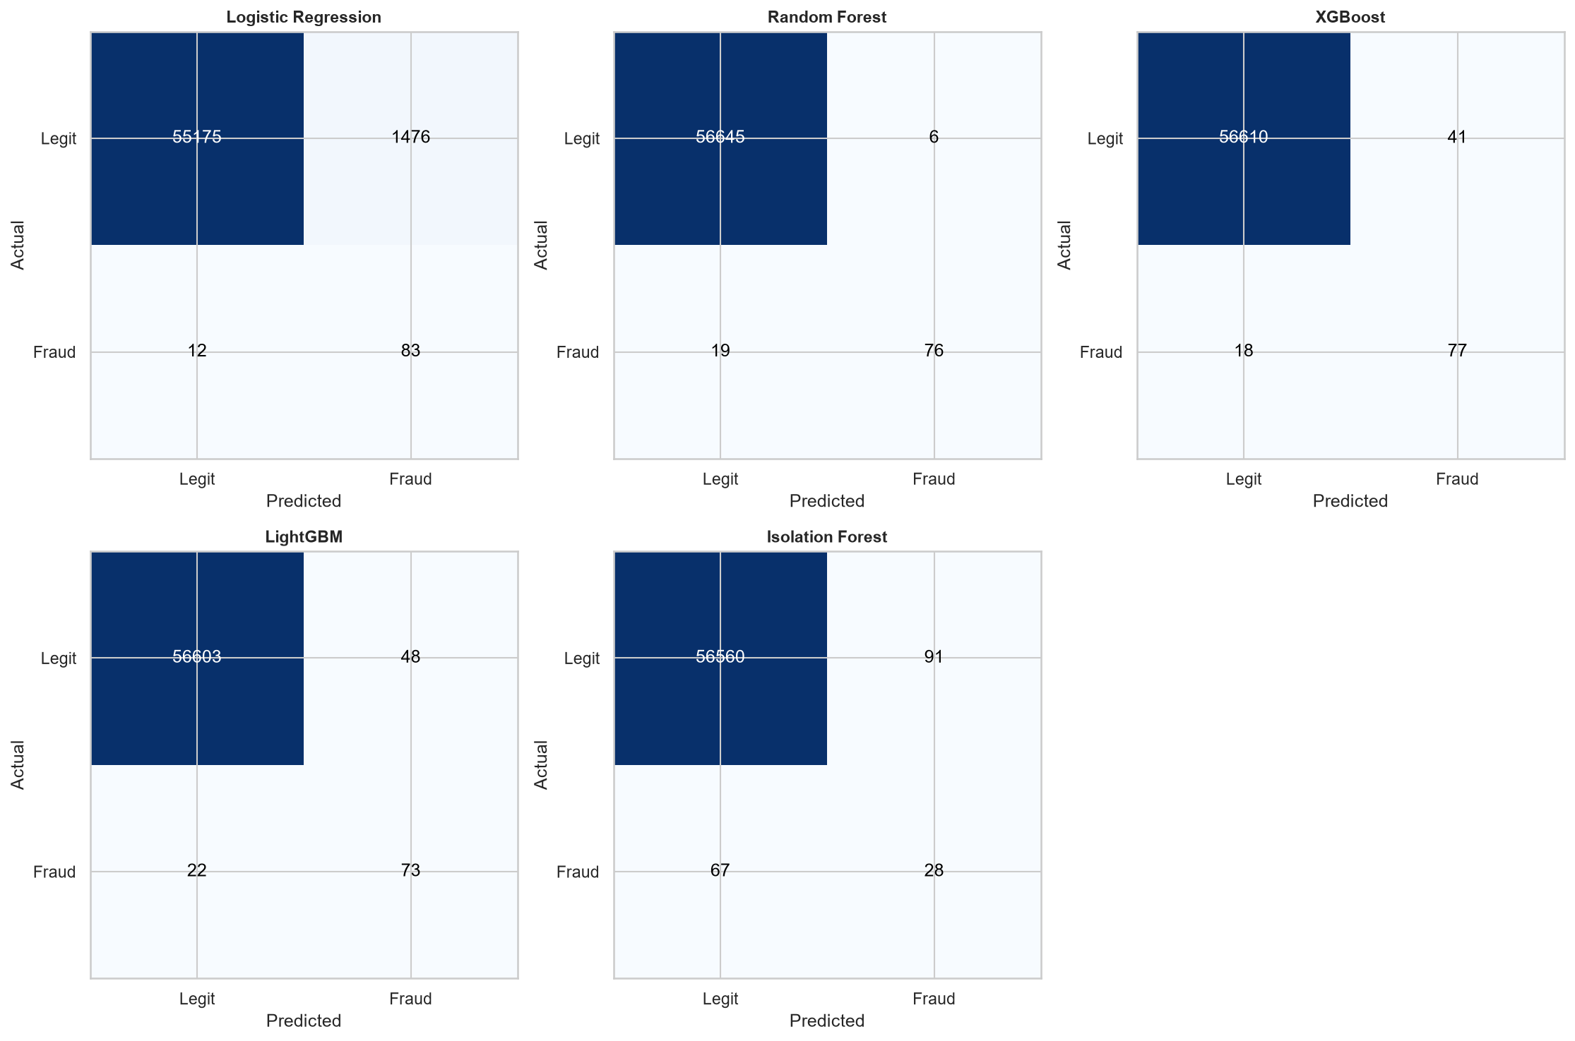
Figure 11: Confusion Matrices - All Models (actual results from trained models)

12. Fraud Prediction Workflow
The prediction pipeline in FinancialFraudDetection.py replicates the training preprocessing exactly, using the saved scaler and feature column list.

12.1 Single Transaction Prediction
Input: Time (seconds), V1-V28 (PCA values), Amount (dollars). Steps:
- 1. Compute Amount_log = log1p(Amount) and Hour = (Time // 3600) % 24.
- 2. Assemble feature vector in the order stored in feature_cols.joblib.
- 3. Apply the saved RobustScaler (no re-fitting -- transform only).
- 4. Run predict_proba() for supervised models, or decision_function() for Isolation Forest.
- 5. Return fraud probability, risk level label, and binary prediction.
Risk level thresholds:
Fraud Probability | Risk Level | Recommended Action
< 30% | LOW RISK | Transaction very likely legitimate
30% - 60% | MEDIUM RISK | Suspicious; review recommended
60% - 80% | HIGH RISK | Strong fraud indicators; flag for investigation
> 80% | CRITICAL RISK | Very likely fraudulent; block and investigate

12.2 Batch Prediction
The Batch Prediction page accepts a CSV upload containing Time, V1-V28, Amount. The system validates columns, applies the same pipeline to every row, and returns a results table with fraud_probability, prediction, and risk_level columns. A full CSV download is provided.

13. Streamlit Application
Launch command: streamlit run FinancialFraudDetection.py | URL: http://localhost:8501
# | Page | Features
1 | Dashboard | 5 KPI cards, class distribution donut, mean-amount bar chart, model summary table
2 | Dataset Analysis | Dataset facts, imbalance warning, descriptive stats, amount stats by class, raw data sample
3 | EDA / Visualizations | 7 full-resolution EDA charts rendered from fraud_assets/
4 | Model Performance | Interactive metrics table, metric selector bar chart, ROC curves, PR curves, confusion matrix grid
5 | Fraud Prediction | Model selector, V1-V28/Amount/Time inputs, probability score, risk gauge, interpretation table
6 | Batch Prediction | CSV upload, column validation, summary KPIs, risk distribution chart, downloadable results
7 | About | System overview, dataset facts, ML pipeline, technology stack, live result panels

13.1 Application Screenshots
The following screenshots were captured from the live running Streamlit application using a headless Chromium browser at 1400x900 resolution. All screenshots show the actual UI with real data loaded.

Figure 12: Home / Dashboard
The dashboard displays five KPI metric cards at the top: total transactions (283,726), legitimate count (283,253, 99.83%), fraudulent count (473, 0.17%), mean transaction amount ($88.47), and mean fraud amount ($123.87). Below, a donut chart shows the class proportion and a bar chart compares mean amounts. The model performance summary table lists all five models with their F1, ROC-AUC, and PR-AUC scores.
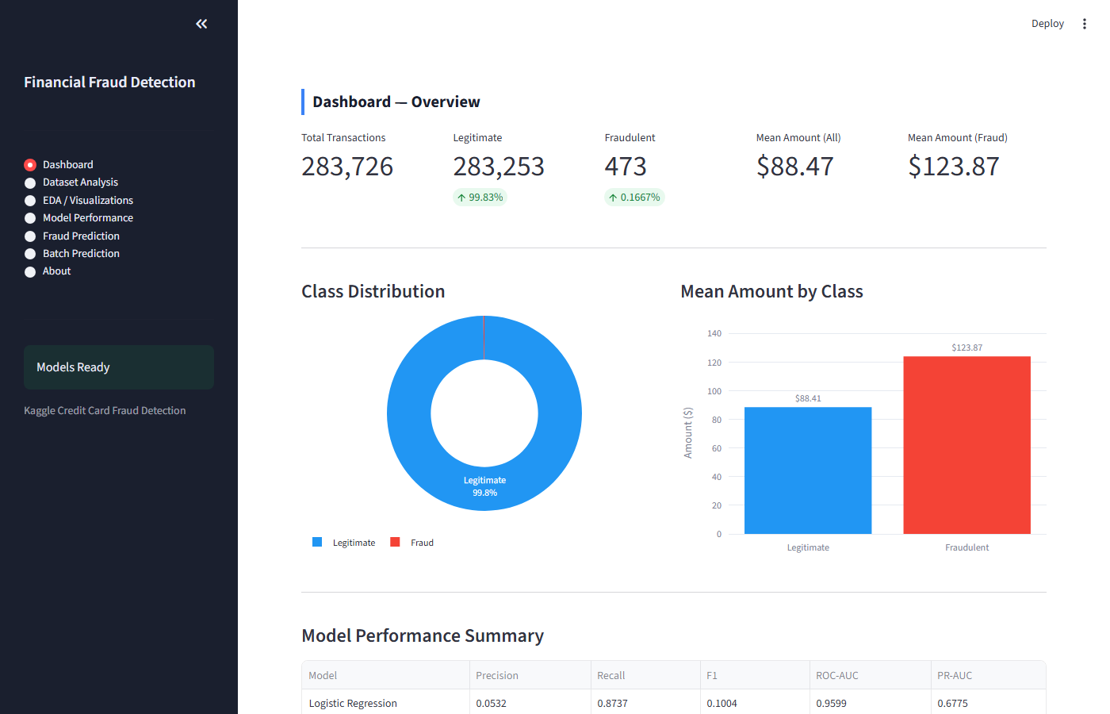
Figure 12: Home / Dashboard (actual screenshot from running Streamlit application)

Figure 13: Dataset Analysis
Three tabs provide: (1) dataset source facts and class imbalance warning, (2) descriptive statistics for a 2,000-row sample showing Time, Amount, and V1-V10, and (3) a raw data viewer showing the first 50 rows of the dataset.
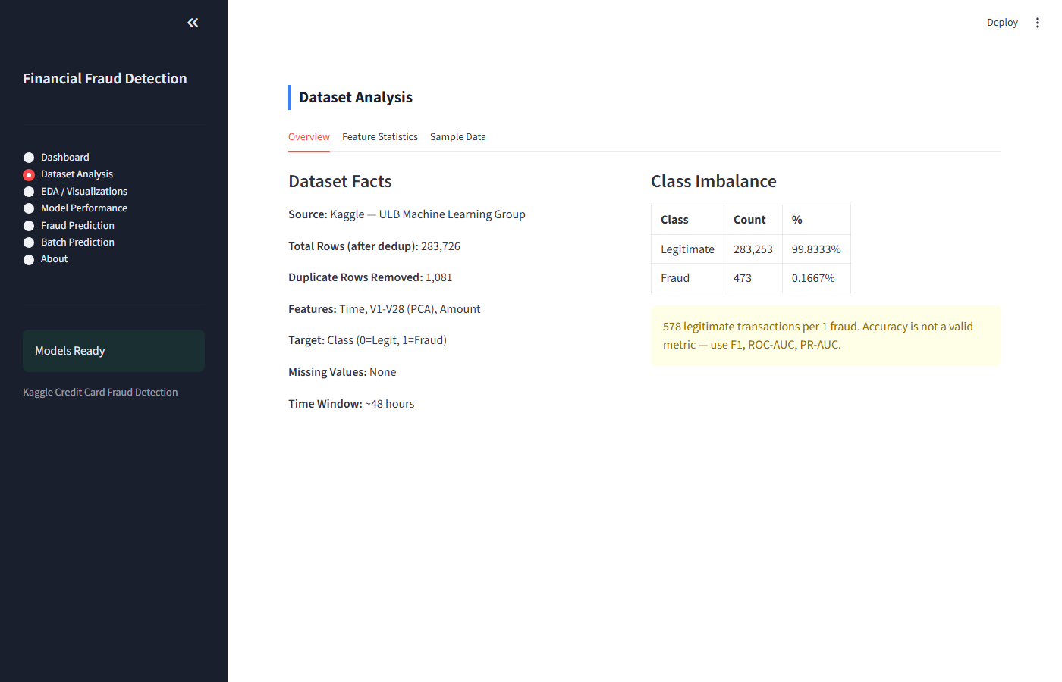
Figure 13: Dataset Analysis (actual screenshot from running Streamlit application)

Figure 14: EDA / Visualizations
The EDA page renders all seven matplotlib/seaborn charts generated during training, in full resolution. Charts cover class distribution, amount distribution, time patterns, fraud by hour, boxplots, top features, and the correlation heatmap.
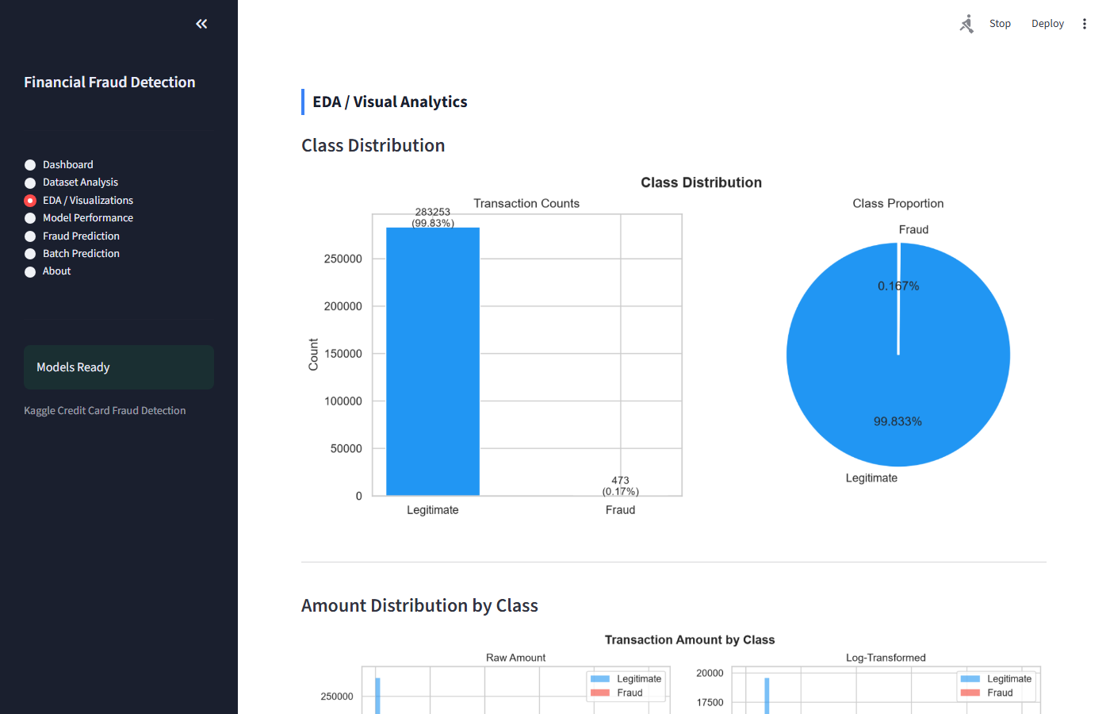
Figure 14: EDA / Visualizations (actual screenshot from running Streamlit application)

Figure 15: Model Performance
The Model Performance page contains four tabs: a metrics table with green-highlighted best-per-column values, an interactive Plotly bar chart for any selected metric, side-by-side ROC and PR curve images, and a confusion matrix grid with a drill-down detail view showing TP/TN/FP/FN metrics for any selected model.
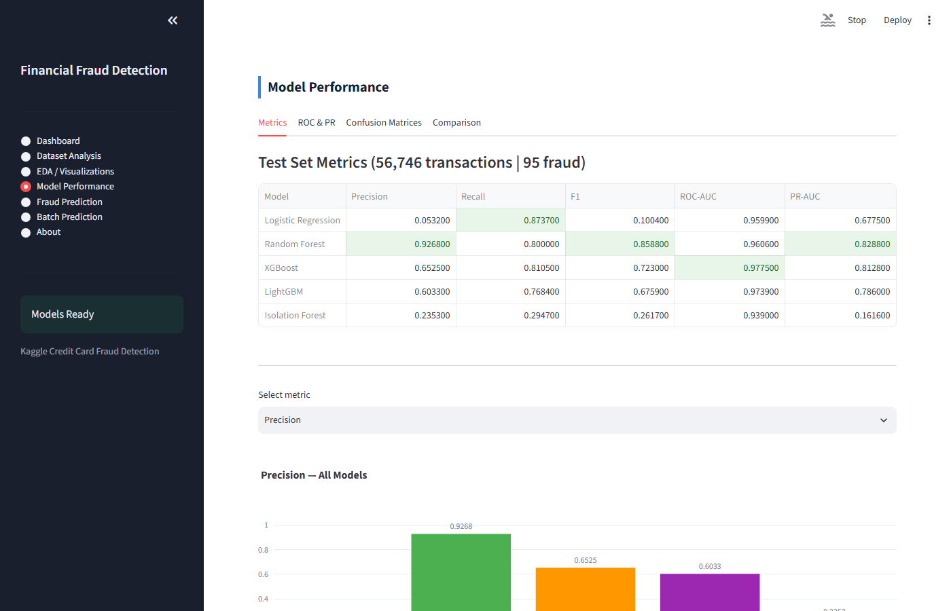
Figure 15: Model Performance (actual screenshot from running Streamlit application)

Figure 16: Fraud Prediction - Input Form
The Fraud Prediction page allows the user to select a model, enter Time (seconds) and Amount ($), and input all 28 PCA feature values (V1-V28) through a 7x4 grid of number input fields. Default value is 0.0 (representing the dataset mean for each PCA component). A prominent 'Predict Fraud Risk' button submits the form.
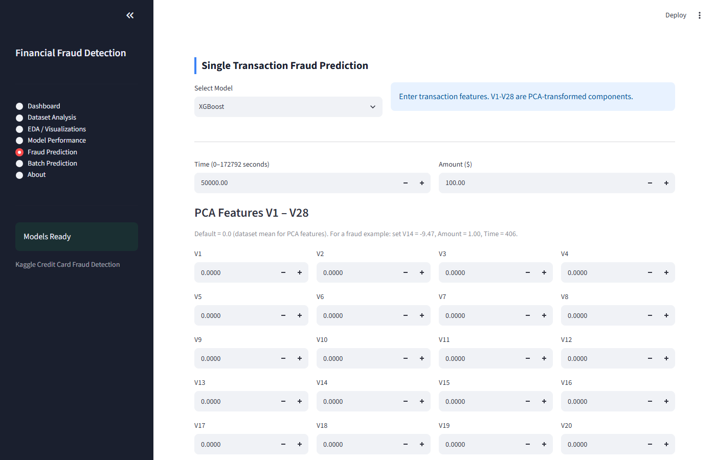
Figure 16: Fraud Prediction - Input Form (actual screenshot from running Streamlit application)

Figure 17: Fraud Prediction - Result with Risk Gauge
After form submission, the result section displays: fraud probability as a percentage, a FRAUD DETECTED / LEGITIMATE status badge, the risk level label, and an animated Plotly gauge chart showing the risk score from 0-100%. The gauge bar colour changes from green (low risk) through orange to red (critical risk). A risk interpretation table shows the four risk bands with recommended actions.
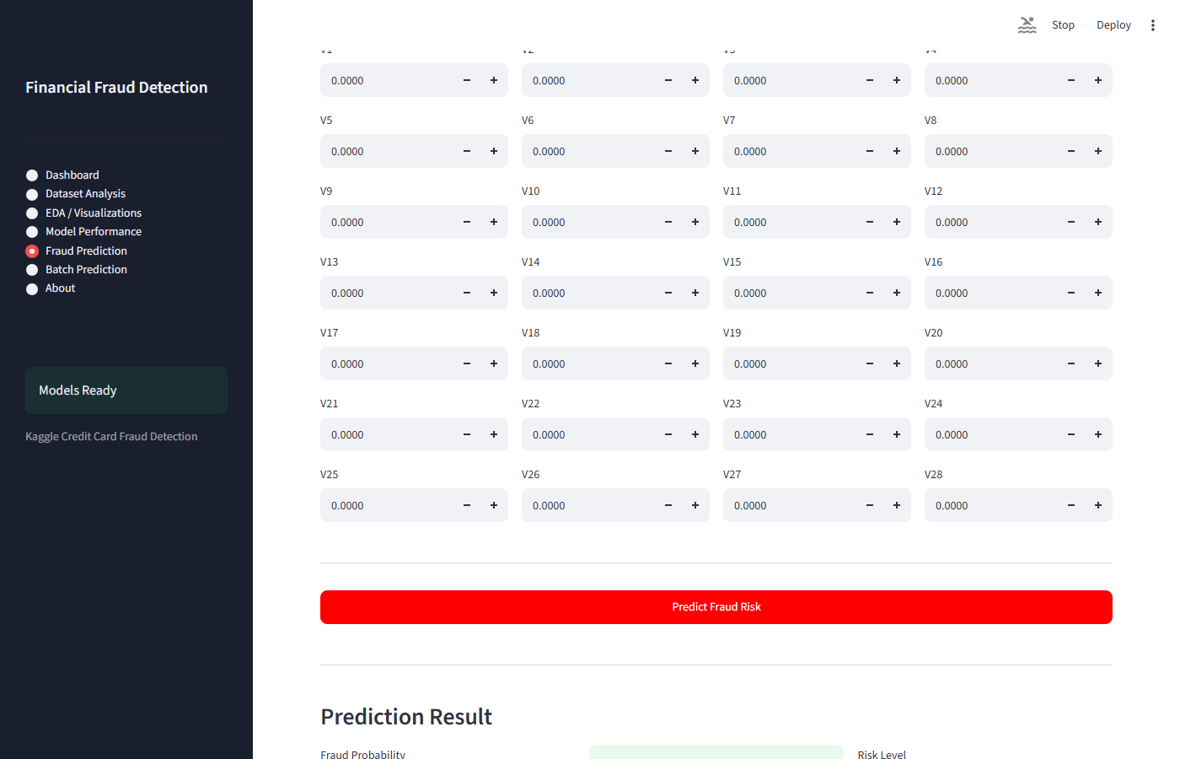
Figure 17: Fraud Prediction - Result with Risk Gauge (actual screenshot from running Streamlit application)

Figure 18: About
The About page presents the system overview, dataset statistics table, ML pipeline summary, and technology stack. Expandable panels on the right side show the actual evaluation results (F1, ROC-AUC, PR-AUC, Precision, Recall) for each of the five trained models, along with quick-copy command blocks.
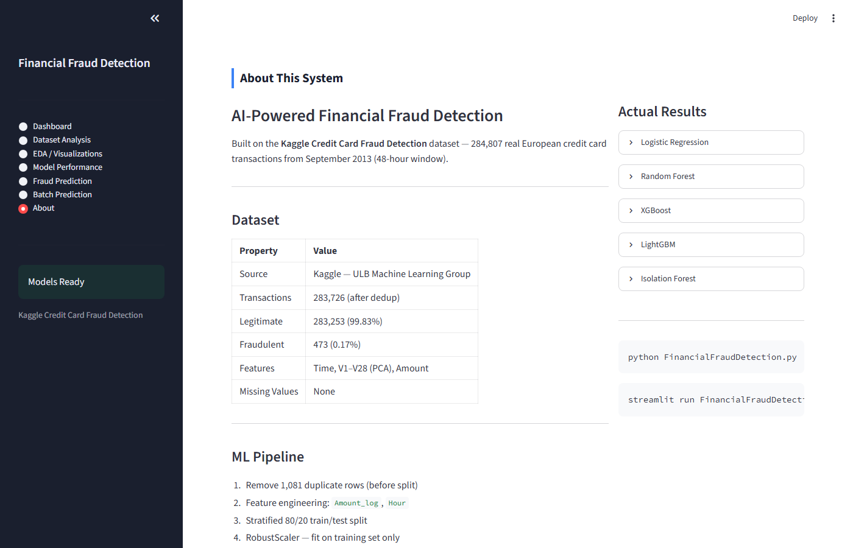
Figure 18: About (actual screenshot from running Streamlit application)

14. Project Structure
File / Directory | Purpose
creditcard.csv | Raw dataset (required)
FinancialFraudDetection.py | Single file: all ML code + Streamlit UI
requirements.txt | Python package dependencies
README.md | Full project documentation
FinancialFraudDetection_ProjectReport.docx | Academic project report (this document)
fraud_models/ | Saved model artifacts (generated at runtime)
fraud_assets/ | EDA and evaluation charts (generated at runtime)

15. Technology Stack
Library | Version | Purpose
Python | 3.11 | Core programming language
Streamlit | >=1.32 | Web application framework
pandas | >=2.0 | Data loading and manipulation
NumPy | >=1.24 | Numerical computing
scikit-learn | >=1.4 | ML algorithms, preprocessing, metrics
XGBoost | >=2.0 | Gradient boosting classifier
LightGBM | >=4.0 | Efficient gradient boosting
imbalanced-learn | >=0.11 | SMOTE oversampling
Matplotlib | >=3.7 | EDA chart generation
Seaborn | >=0.12 | Statistical visualisation
Plotly | >=5.18 | Interactive charts in Streamlit
joblib | >=1.3 | Model serialisation
Pillow | >=10.0 | Image loading for EDA charts
SciPy | >=1.11 | Required by scikit-learn

16. How to Run the Project
Prerequisites: Python 3.9+, creditcard.csv in the project folder.

Step 1: Install dependencies
pip install -r requirements.txt

Step 2: Train all models
python FinancialFraudDetection.py
Runtime: approximately 5-10 minutes. Outputs: fraud_models/ (5 model files + scaler + metadata) and fraud_assets/ (11 chart PNG files).

Step 3: Launch the Streamlit application
streamlit run FinancialFraudDetection.py
Open http://localhost:8501 in any web browser.

17. Limitations
- V1-V28 are anonymised PCA components; individual feature importance cannot be mapped to interpretable business variables.
- The dataset covers only 48 hours in September 2013. Fraud patterns evolve; the model may not generalise to current fraud types.
- Geographic scope is limited to European cardholders.
- Isolation Forest (F1=0.2617) performs well below supervised models, confirming that labelled data is essential for production fraud detection.
- No sequential or customer-level features are used; a production system would incorporate transaction velocity and card-level history.
- The PCA transformation was applied by the dataset authors before release; we cannot verify whether it was fitted on the full dataset (potential upstream leakage).

18. Future Scope
- Sequence modelling: apply LSTM or Transformer networks to transaction histories.
- Customer-level features: add velocity, recency, and frequency metrics per card.
- REST API: wrap the inference pipeline in FastAPI for payment gateway integration.
- SHAP explainability: generate per-transaction explanation reports for compliance.
- Concept drift detection: monitor for distribution shift and trigger retraining.
- Ensemble stacking: build a meta-learner combining all five model predictions.
- Real-time streaming: integrate with Apache Kafka for millisecond-latency screening.

19. Conclusion
This project successfully developed, trained, and deployed an end-to-end AI-powered financial fraud detection system on the Kaggle Credit Card Fraud Detection dataset. Five machine learning models were built under a rigorous data-leakage-free pipeline that handles severe class imbalance through SMOTE, class-weight parameters, and scale_pos_weight configurations.
Random Forest achieved the best overall performance with F1 = 0.8588, detecting 76 of 95 fraudulent transactions in the test set while generating only 6 false positives out of 56,651 legitimate transactions. XGBoost achieved the highest ROC-AUC (0.9775), demonstrating superior discriminatory power across all probability thresholds. All supervised models achieved ROC-AUC above 0.95, substantially outperforming the unsupervised Isolation Forest baseline.
The accompanying Streamlit web application provides a professional, fully interactive interface that brings the model's capabilities to end users -- from a high-level executive dashboard to granular per-transaction fraud screening. The project demonstrates that machine learning with proper imbalance handling and leakage prevention can achieve high fraud detection accuracy on real-world data, making it suitable for demonstration in a professional banking or fintech context.

20. References
[1] Dal Pozzolo A., Caelen O., Johnson R.A., Bontempi G. (2015). Calibrating Probability with Undersampling for Unbalanced Classification. IEEE CIDM Symposium.
[2] Chawla N.V., Bowyer K.W., Hall L.O., Kegelmeyer W.P. (2002). SMOTE: Synthetic Minority Over-sampling Technique. Journal of Artificial Intelligence Research, 16, 321-357.
[3] Chen T., Guestrin C. (2016). XGBoost: A Scalable Tree Boosting System. ACM KDD.
[4] Ke G. et al. (2017). LightGBM: A Highly Efficient Gradient Boosting Decision Tree. NeurIPS.
[5] Liu F.T., Ting K.M., Zhou Z.H. (2008). Isolation Forest. IEEE ICDM.
[6] Breiman L. (2001). Random Forests. Machine Learning, 45(1), 5-32.
[7] Kaggle Credit Card Fraud Detection Dataset. https://www.kaggle.com/datasets/mlg-ulb/creditcardfraud
[8] Pedregosa et al. (2011). Scikit-learn: Machine Learning in Python. JMLR, 12, 2825-2830.
[9] Streamlit Documentation. https://docs.streamlit.io
[10] Plotly Python Graphing Library. https://plotly.com/python/

