PERFORMANCE ANALYSIS OF VARIOUS MULTIPLICATION AND DIVISION ALGORITHMS FOR LARGE NUMBERS

Harpreet Kaur

B.S. Electrical Engineering, Technology Management Minor,
University of California, Davis, 2008

PROJECT

Submitted in partial satisfaction of
the requirements for the degree of

MASTER OF SCIENCE

in

ELECTRICAL AND ELECTRONIC ENEGINEERING

at

CALIFORNIA STATE UNIVERSITY, SACRAMENTO

SPRING
2010

© 2010

Harpreet Kaur

ALL RIGHTS RESERVED

PERFORMANCE ANALYSIS OF VARIOUS MULTIPLICATION AND DIVISION ALGORITHMS FOR LARGE NUMBERS

A Project

by

Harpreet Kaur

Approved by:

___________________________, Committee Chair
Suresh Vadhva, PhD.

___________________________, Second Reader
Manish Gajjar

_____________________
Date

Student: Harpreet Kaur

I certify that this student has met the requirements for the format contained in the University format manual, and that this project is suitable for shelving in the library and credit is to be awarded for the project.

__________________________, Graduate Coordinator _____________
Preetham Kumar, PhD. Date

Department of Electrical and Electronics Engineering

Abstract

of
PERFORMANCE ANALYSIS OF VARIOUS MULTIPLICATION AND DIVISION ALGORITHMS FOR LARGE NUMBERS

by
Harpreet Kaur
This paper provides a detailed study on the algorithms used by an ALU to perform multiplication and division for large numbers, and recommends one algorithm that will give best performance for division and multiplication. The multiplication algorithms that are analyzed are Pen and Paper algorithm, Booth’s algorithm, and Divide and Conquer algorithm. The division algorithms that are analyzed are Radix 2 restoring algorithm, Radix 2 non-restoring algorithm, and Radix 4 restoring algorithm. The algorithms are implemented using Verilog and the timing and area reports generated after synthesis is used to compare the algorithms. This paper concludes that out of the examined algorithms divide and conquer algorithm gives the best performance for multiplication, while Radix 4 restoring algorithm gives the best performance for division.

_____________________________, Committee Chair
Suresh Vadhva, PhD.

_____________________________
Date

DEDICATIONS

To my Mother and Father
ACKNOWLEDGEMENTS

I would like to thank my professors for their guidance and support during my graduate studies. Thank you to my advisors for their support and an opportunity to work on a project that interests me.
Most importantly, I would like to thank Waheguru Ji (God) for providing me a chance to fulfill my dreams, and keeping me on the path of honesty and righteousness. I am indebted to my mother, Shivjot Kaur Bedi, who gave me every opportunity to succeed in life, and put my needs over her own. Her support and encouragement in life have kept me going through hard times and press forward without regret. Her unconditional love sometimes leaves me in awe. Her Will power and encouragement have brought me to this successful platform in my life. I continue to learn from her each and every day and I hope to continue this journey with her by my side as a mother and my best friend. Although my father, Charanjit Singh Bedi, is not with me today, the dreams he painted for me have now been realized, and I feel his guidance and support over me now more than ever. I am grateful for the lessons that I learned from him as they still help me celebrate my successes, learn from my mistakes and stay ambitious about my goals in life. My brother, Rajwant Singh Bedi, will always have a special place in my heart. He has been my mentor, guiding me through school, college and beyond and he is always there to give me a hug when I need it the most. Finally, I want to thank my friend, Vinit Azad. In the few years that I have known him, Vinit has always supported me through good times and bad times as a co-worker and a classmate. I thank him for supporting me and helping me learn some of the more difficult subjects during my graduate studies.
TABLE OF CONTENTS
Page

Dedications vi
Acknowledgements vii
List of Tables ix
List of Figures x
Chapter
1. INTRODUCTION 1
2. MULTIPLICATION 6
Booth’s Algorithm 6
Divide and Conquer Algorithm 15
Pen and Paper Algorithm 30
3. DIVISION 38
Radix-2 Restoring Division 38
Radix-4 Restoring Division 49
Radix-2 Non-Restoring Division 57
4. TIMING AND AREA ANALYSIS 65
5. CONCLUSION 67
Appendix A. Test File Verilog Code 70
Appendix B. Synthesis Script 74
References 75

LIST OF TABLES
Page

Table 2.1 – Booth’s Multiplication for Positive Numbers 8
Table 2.2 – Booth’s Multiplication for Negative Numbers 8
Table 2.3 – 2-Bit Binary Multiplication Table 18
Table 2.4 – Karnaugh Map for C[0] 18
Table 2.5 – Karnaugh Map for C[1] 19
Table 2.6 – Karnaugh Map for C[2] 20
Table 2.7 – Karnaugh Map for C[3] 20
Table 2.8 – Pen and Paper Example 32
Table 3.1 – Radix-2 Restoring Division Example 39
Table 3.2 –Radix-4 Restoring Division Example 50
Table 3.3 – Radix-2 Non-Restoring Division Example 58
Table 3.4 – Radix-2 Non-Restoring Division Example Results 58
Table 4.1 – Time and Area Comparison for Various Multilplication Algorithms 65
Table 4.2 – Time and Area Comparision for Various Division Algorithms 66

LIST OF FIGURES
Page

Figure 1.1 – First Multiplication Hardware Implementation 2
Figure 1.2 – First Multiplication Algorithm Flowchart for 32-Bit Numbers 3
Figure 2.1 – 2-Bit Multiplier Hardware Implementation 21
Figure 2.2 – Pen and Paper Flowchart 31
Figure 3.1 – Radix-2 Restoring Divide Algorithm Flowchart. 41

Chapter 1

INTRODUCTION
Throughout the years, the ALU has gone through many changes in its design. One of these changes was in its multiplication and division algorithms. In a typical computer, an ALU is called upon to do hundreds of multiplication and division operations per second. To perform at its peak, the ALU‘s multiplication and division algorithms need to be as efficient as possible. Throughout the years, mathematicians and engineers have developed many algorithms to multiply and divide numbers. However, some of these algorithms work better when computing the result of the operation by hand than using a computer, and vice versa.
The first multiplication algorithm that was developed for the early computing requirements follow the steps that we use to multiply two numbers by hand [1]. According to Patterson and Hennessy [1], when this algorithm was translated for computer use, it required five hardware components, as seen in Figure 1.1. The components included one register for each number (multiplicand, multiplier, and product), an ALU, and a control. The algorithm involves multiplying each digit of the multiplier with the multiplicand and adding up the individual results [1]. Since binary multiplication involves only 1s and 0s, the multiplication of each digit to multiplicand translates to shifting and adding of the multiplicand.
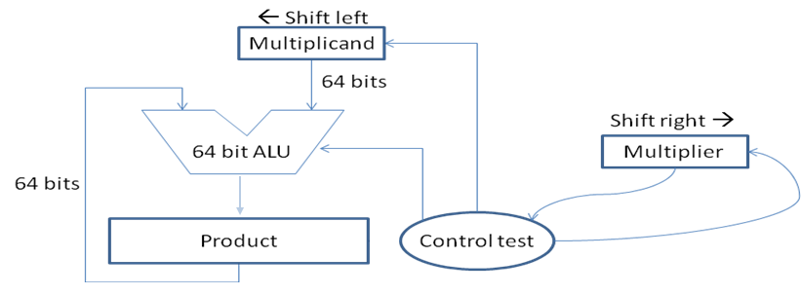Figure 1.1 – First Multiplication Hardware Implementation

As seen in Figure 1.1, the control tests the multiplier’s least significant bit (LSB). If the LSB is 1, it will send a signal to the ALU to add the multiplicand to the current calculated product. The multiplier is then shifted to the right to fetch the next bit and multiplicand is shifted to the left to prepare for the next multiplication iteration. This algorithm, shown as a flow chart in Figure 1.2 [1], is the basis for the pen and paper algorithm implemented in this report.

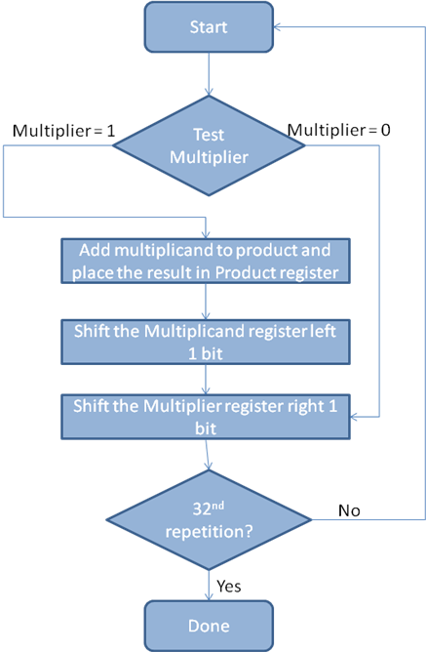
Figure 1.2 – First Multiplication Algorithm Flowchart for 32-Bit Numbers

Many tried to make several improvements to the traditional pen and paper algorithm by reducing the amount of additions being performed in the algorithm. In 1951, based on the idea that computers are faster at shifting bits than adding them [1], Andrew Donald Booth developed an algorithm known as Booth’s algorithm. There were many such discoveries through the years to improve the efficiency and performance of the multiplication algorithms. This report will compare the traditional pen and paper algorithm, Booth’s algorithm, and divide and conquer algorithm, and recommend one algorithm that performs better than the rest.
Similarly to multiplication, there were many developments in the algorithms that compute the result of a division. The tradition pen and paper algorithm, when converted to computer algorithm, resulted in the Restoring Division algorithm [2]. Smaller improvements have been made to the restoring division algorithm, which resulted in Non-Restoring Division algorithm and many high radix algorithms [2]. In many cases, division is performed by taking the inverse of the divider and then multiplying the two numbers [1]. Division methods are divided in five class that include iteration, digit recurrence, very high radix, table look up and variable latency. Each of these classes of division is implemented differently in hardware (using multiplication, subtraction, table look up, etc.) [3]. Some algorithms use multiple classes rather than just one in particular. This report focuses on subtraction-based methods, such as restoring and non-restoring division algorithms [4], to obtain the final answer in a division computation.
Despite the improvement in division algorithms, division remains a complex operation and is therefore not implemented in many low cost or low power ALUs [3]. Division can add more complexity to the computations since it can have invalid inputs such as division by zero. However, for a high performance system, a division operation is an indispensible tool. “A common perception of division is that it is an infrequent operation whose implementation need not receive high priority. However, it has been shown that ignoring its implementation can result in significant system performance degradation for many applications [3].”
This report examines various algorithms, and makes recommendation on which algorithm gives the best performance for each operation. The algorithms examined for multiplication are Pen and Paper algorithm, Booth’s algorithm, and Divide and Conquer algorithm. These algorithms will be able to multiply any 64-bit signed numbers in 2s complement form and provide a 128-bit result. The algorithms examined for division are Radix-2 Restoring Division algorithm, Radix-2 Non-Restoring Division algorithm, and Radix-4 Restoring Division algorithm. These algorithms will be able to divide two positive 64-bit number in 2s complement form. A 64-bit number was chosen for the computation because the latency difference to perform computation on smaller numbers between the different algorithms will be negligible. The criteria used to determine the best performance is the amount of time the algorithm takes to complete one division or multiplication operation, and the area the algorithm needs to implement on the circuit board without any use of pipelining.
Chapter 2

MULTIPLICATION

Booth’s Algorithm
An ALU addition operation can be very time consuming when done repeatedly. Recognizing the fact that computers can shift bits faster than adding bits, Booth developed an algorithm, which reduces the number of additions that take place when multiplying two numbers [1]. Booth’s algorithm multiples two numbers in 2’s complement form [1]. It creates an initial guess for the product, which is zeros followed by the multiplier on the right half of the product [1]. Instead of using one bit of the multiplier to determine whether we need to add and shift or merely shift the intermediate step of multiplication, Booth’s algorithm uses two right most bits of the product to determine the next step [1]. The algorithm [1] for 4-bit multiplier is outlined in this section. This algorithm was expanded to 64-bit when it was implemented in verilog code.
Booth’s Algorithm:
- Let multiplicand = 4 bits, multiplier = 4 bits, and output = 8 bits.
Product: {0000, Multiplier, 0}
- Now, take the two least significant bits of the product and depending on the value proceed with one the following:
- 00: No changes to product.
- 01: Add the multiplicand to the left side of the product.
- 10: Subtract the multiplicand from the left side of the product.
- 11: No changes to product.
- Right shift the product by 1 bit.
- Repeat the process x number of times, where x is the number of bits in the multiplicand.

Table 2.1 gives an example of multiplication of two positive numbers using the procedure outlined in Booth’s algorithm. Table 2.2 gives an example of multiplication of one positive and one negative number.
In example 1, both the multiplicand and the multiplier are equal to four. Concatenating "0000" to the left of the multiplier and "0" to the right, the initial guess for the product is established. Using the last two bits of the product, the next step is determined. Since the two least significant bits of the product are zero, only right shift is performed on the product. Again, the two least significant bits are zero and a right shift is performed on the product. In step two, the two least significant bits of the product are "10", therefore, in step three, the multiplicand is subtracted from the four most significant bits of the product and the product is shifted right 1 bit. Now, the two least significant bits are "01" which translates to adding the multiplicand to the left side of the product and shift 1 bit to the right. The procedure has a total of four steps since the multiplicand is only four bits wide. Shift the product one last time to the right to arrive at the final answer. As a check, 4 multiplied by 4 is equal to 16, which in 10000 in binary.

Booth’s Algorithm Example 1:

Multiplicand: 4₁₀ = 0100₂
Multiplier: 4₁₀ = 0100₂
Product: {0000, Multiplier, 0}
Multiplicand | Step | Product
0100 | Initial | 0000 0100 0
0100 | Shift | 0000 0010 0
0100 | Shift | 0000 0001 0
0100 | Subtract and shift | 1110 0000 1
0100 | Add and shift | 0001 0000 0
Table 2.1 – Booth’s Multiplication for Positive Numbers
In example 2, we use the same procedure to compute (-2) *6. Again, there are only four steps since the multiplicand is only four bits wide.
Booth’s Algorithm Example 2:
Multiplicand: -2₁₀ = 1110₂
Multiplier: 6₁₀ = 0110₂
Product: {0000, Multiplier, 0}
Multiplicand | Step | Product
1110 | Initial | 0000 0110 0
1110 | Shift | 0000 0011 0
1110 | Subtract and shift | 0001 0001 1
1110 | Shift | 0000 1000 1
1110 | Add and shift | 1111 0010 0
Table 2.2 – Booth’s Multiplication for Negative Numbers

Booth’s Algorithm Verilog Code

Shown below is the verilog code used to implement Booth’s multiplier. The inputs to Booth’s multiplier are clock, reset signal, 64-bit multiplier, and 64-bit multiplicand. The multiplier (B) and multiplicand (A) are in 2’s complement form. A and B may be negative or positive. The output of Booth’s multiplier is a 128-bit result of A*B.
The initial guess of the product is made by concatenating 64 zero’s to B, and concatenating 1-bit zero at the least significant position of the guess. Following Booth’s algorithm, A is subtracted or added from the upper half of the initial guess depending on the lower 2-bits of the initial guess. The updated guess is now shifted right. The shift has to be a signed shift. The signed shift is implemented by dropping the least significant bit (LSB) and replicating most significant bit (MSB) to the leftmost position. These instructions are repeated in a loop 64 times since the multiplier and multiplicand are 64-bit numbers. If the multiplier and multiplicand width were different, then the loop iterations would be different.
To obtain the final result, the least significant bit is dropped from the updated guess value, which is the same as right shifting the product and taking the rightmost 128 bits as product. Dropping the LSB would give a 128-bit result of A*B.

module Booth(Clk, Reset, A, B, C);
input Clk, Reset;
input[63:0] A, B;

output[127:0] C;
reg[127:0] C;

reg [128:0] Product;
integer i;
reg[63:0] temp;

always @(posedge Clk, negedge Reset)
begin
if(!Reset)
C <= 0;
else
C <= Product[128:1];
end

always @(*)
begin
Product = {64'h0, B, 1'b0};

for(i = 0; i < 64; i = i+1)
begin
if( Product[1:0] == 1 )
begin
temp = Product[128:65] + A;
Product = { temp, Product[64:0] };
end
else if( Product[1:0] == 2 )
begin
temp = Product[128:65] - A;
Product = { temp, Product[64:0] };
end

Product = {Product[128], Product[128:1]};
end

end

endmodule

Booth Multiplier Simulation Results
Shown below is the result from the Booth’s multiplier simulation. The simulation verifies all the special cases to validate the algorithm. To test the special cases, the simulation module multiplies a 32 and 64 bit number by 0, multiply 0 by 0, and multiply 64-bit number by another 64-bit number. The result of each multiplication is shown below.
Chronologic VCS simulator copyright 1991-2005
Contains Synopsys proprietary information.
Compiler version Y-2006.06-SP1; Runtime version Y-2006.06-SP1; Mar 14 22:22 2010
0 A = x, B = x, C = x
1 A = 2356, B = 124, C = 0
3 A = 2356, B = 124, C = 292144
6 A = 0, B = 1234, C = 292144
7 A = 0, B = 1234, C = 0
11 A = 2, B = -2, C = 0
15 A = 2, B = -2, C = -4
16 A = 72057594037927935, B = 2, C = -4
19 A = 72057594037927935, B = 2, C = 144115188075855870
21 A = 0, B = 0, C = 144115188075855870
23 A = 0, B = 0, C = 0
26 A = 20015998341120, B = 2, C = 0
27 A = 20015998341120, B = 2, C = 40031996682240
31 A = 20015998341120, B = 0, C = 40031996682240
35 A = 20015998341120, B = 0, C = 0
36 A = 20015998341120, B = 72057594037927935, C = 0
39 A = 20015998341120, B = 72057594037927935, C = 1442304682728263949322107187200
41 A = 20015998341120, B = 1, C = 1442304682728263949322107187200
43 A = 20015998341120, B = 1, C = 20015998341120
46 A = 20015998341120, B = -1, C = 20015998341120
47 A = 20015998341120, B = -1, C = -20015998341120
51 A = -20015998341120, B = -1, C = -20015998341120
55 A = -20015998341120, B = -1, C = 20015998341120
$finish at simulation time 251
V C S S i m u l a t i o n R e p o r t
Time: 251
CPU Time: 0.000 seconds; Data structure size: 0.0Mb

Booth Multiplier Timing Analysis

Booth’s multiplier was synthesized successfully with the clock time of 170 ns. 170 ns clock is needed to complete the whole 64-bit multiplication. Since the loop’s iteration is dependent on the previous iteration, all the hardware in the loop is connected serially. Each loop iteration has two multiplexors to test the two least significant bit of the product and an adder or subtractor to compute the result for the next iteration. Due to this serial behavior of the multiplier and the delay associated with the multiplexor and adder/subtractor, the algorithm requires a large clock period. Shown below is part of the timing analysis report generated using design compiler.
****************************************
Report : timing
-path full
-delay max
-max_paths 1
Design : Booth
Version: Z-2007.03
Date : Sat Mar 13 20:07:33 2010
****************************************
Operating Conditions: BCCOM Library: lsi_10k
Wire Load Model Mode: top
Startpoint: A[0] (input port)
Endpoint: C_reg[126] (rising edge-triggered flip-flop clocked by Clk)
Path Group: Clk
Path Type: max
Point Incr Path
--------------------------------------------------------------------------------------------
clock (input port clock) (rise edge) 0.00 0.00
input external delay 0.00 0.00 f
A[0] (in) 0.00 0.00 f
sub_39/B[0] (Booth_DW01_sub_1) 0.00 0.00 f
…
r1291_0/SUM[63] (Booth_DW01_addsub_0) 0.00 168.69 r
U1238/Z (MUX21LP) 0.25 168.94 f
U1240/Z (B4I) 0.21 169.15 r
C_reg[126]/D (FD2) 0.00 169.15 r
data arrival time 169.15
clock Clk (rise edge) 170.00 170.00
clock network delay (ideal) 0.00 170.00
C_reg[126]/CP (FD2) 0.00 170.00 r
library setup time -0.85 169.15
data required time 169.15
--------------------------------------------------------------------------------------------
data required time 169.15
data arrival time -169.15
--------------------------------------------------------------------------------------------
slack (MET) 0.00
1

Booth’s Multiplier Area Analysis
Shown below is the area requirement to implement Booth’s multiplier. This implementation requires a large area because it computes the whole multiplication result in one clock cycle. Since the loop’s iteration is dependent on previous loop and because the multiplier is not a multi-cycle implementation, the same hardware is not re-used in each loop iteration. The hardware has to be duplicated for each loop iteration. Since one loop iteration requires two multiplexors, adder, subtracter, and registers, the replication of the hardware for each loop iteration causes a large area requirement for this implementation.
****************************************
Report : area
Design : Booth
Version: Z-2007.03
Date : Sat Mar 13 20:07:32 2010
****************************************

Library(s) Used:

lsi_10k (File: /titan/software/synopsys07/syn/libraries/syn/lsi_10k.db)

Number of ports: 258
Number of nets: 14444
Number of cells: 10076
Number of references: 93
Combinational area: 143917.000000
Noncombinational area: 1277.000000
Net Interconnect area: undefined (No wire load specified)
Total cell area: 145194.000000
Total area: undefined
1
Divide and Conquer Algorithm
Divide and conquer algorithm breaks down a problem into smaller sets, computes the result of each smaller set and then combines these results to obtain the final solution [5]. For binary multiplication, Divide and Conquer algorithm is used to partition the multiplicand and the multiplier into two halves, right and left until the smallest possible segment of 2-bits each is reached (each number is to be 2-bit long because a 2-bit multiplier is used in this case). Then each of those 2-bit numbers is multiplied to obtain the four parts of equation 2.1, which are further added to obtain the answer to the multiplication [5]. For further clarification and understanding, follow example 2.1.
Let: x→multiplier y → multiplicand
a = left half of x
b = right half of x
c = left half of y
d = right half of y.
n = number of total bits
Equation 2.1 – Divide and Conquer [5]
x*y = (a*c)*2^{n} + (b*c)*2^{(n/2)} + (a*d)*2^{(n/2)} + b*d

Example 2.1:
Let: x = 1000 1010b y = 1000 1000b x*y = 100 1001 0101 0000b
Step 1: a = 1000b b = 1010b c = 1000b d = 0010b
Step 2: Further partition a, b, c and d until each is a 2-bit number.

a = 1000b | b = 1010b | c = 1000b | d = 1000b
  al = 10b | ar = 00b
  bl = 10b | br = 10b
  cl = 10b | cr = 00b
  dl = 10b | dr = 00b
Step 3: Using equation 2.1and the 2-bit multiplier, calculate the following:
Solving this using Divide and Conquer algorithm…
x*y = (a*c)*2^{n} + (b*c)*2^{(n/2)} + (a*d)*2^{(n/2)} + b*d
- a*c = al*cl*2⁴ + ar*cl*2² + al*cr*2² + ar*cr
= 10b*10b*2⁴ + 00b*10b*2² + 10b*00b*2² + 00b*00b
= 0100 0000b

- b*c = bl*cl*2⁴ + br*cl*2² + bl*cr*2² + br*cr
= 10b*10b*2⁴ + 10b*10b*2² + 10b*00b*2² + 10b*00b
= 0101 0000b

- a*d = al*dl*2⁴ + ar*dl*2² + al*dr*2² + ar*dr
= 10b*10b*2⁴ + 00b*10b*2² + 10b*00b*2² + 00b*00b
= 0100 0000b
- b*d = bl*dl*2⁴ + br*dl*2² + bl*dr*2² + br*dr
= 10b*10b*2⁴ + 10b*10b*2² + 10b*00b*2² + 10b*00b
= 0101 0000b

Step 4: Now using equation 2.1 calculate the final answer for x*y.
x*y = (0100 0000b)* 2⁸ + (0101 0000b)* 2⁴ + (0100 0000b)* 2⁴ + (0101 0000b)

0100 0000 0000 0000b
+ 0101 0000 0000b
+ 0100 0000 0000b
+ 0101 0000b
0100 1001 0101 0000b

In this example, the problem begins with two 8-bit numbers, which are sub-divided until each partition is only 2-bits long. Using the 2-bit multiplier, along with the divide and conquer algorithm equation, the intermediate answers are computed. Finally, those intermediate answers are further used to calculate the desired 16-bit solution to the initial problem, again using the Divide and Conquer algorithm equation.
The number can be divided until the original number is down to a size that can be multiplied easily. Divide and Conquer algorithm requires a 2-bit multiplier to obtain the result of the smallest numbers that are then used to reach the final solution. The hardware implementation of this multiplier is shown in Figure 2.1. Each output of this implementation is determined using Karnaugh maps seen in Table 2.4 through Table 2.7. To create the Karnaugh maps, a 2-bit multiplication table was created as seen in Table 2.3.

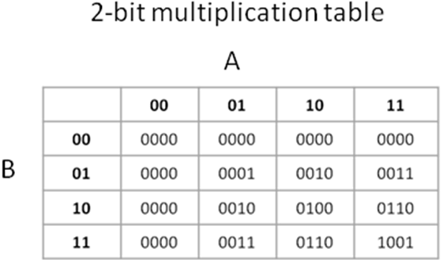
Table 2.3 – 2-Bit Binary Multiplication Table
Above is a 2-bit multiplication table that shows the 4-bit results of two 2-bit binary numbers. For example, 00b*00b is equal to 0000b and 10b * 01b is equal to 0010b.

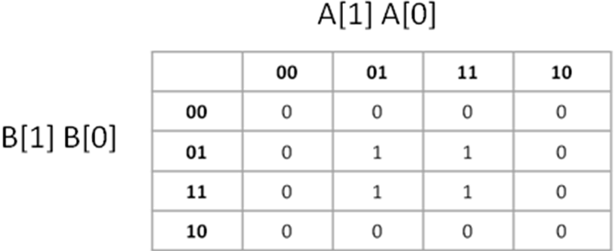
Table 2.4 –Karnaugh Map for C[0]
Equation obtained: C[0] = A[0]B[0]
Table 2.4 is a karnaugh map that develops the equation for the least significant bit of the final result, C[0]. The table is filled with the least significant bits of the 4-bit products from the 2-bit multiplication shown in Table 2.3, which provides four bits that are equal to 1. Therefore, the result for C[0] is A[0]B[0], which means the resulting bit will be one when both A[0] and B[0] are equal to 1.
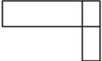
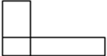
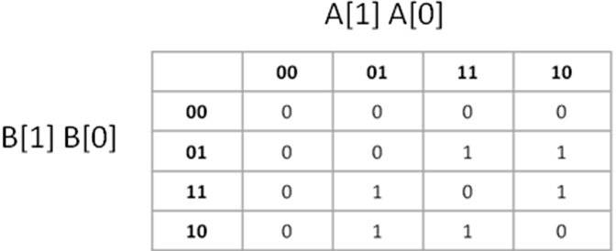
Table 2.5 - Karnaugh Map for C[1]
Equation obtained:
C[1] = A[1]B[0]~B[1] + B[0]A[1]~A[0] + B[1]~A[1]A[0] + A[0]B[1]~B[0]
Following similar procedure as in table 2.4 the equations for C[1], C[2] and C[3] are determined. For table 2.5, the bit 1 of the results in 2-bit multiplication shown in Table 2.3 is used to fill the karnaugh map. Combining all the 1s in the karnaugh map provides the equation for C[1]. For example, result can be 1 if A[1] is 1 AND B[0] is 1 AND B[1] is 0 or the result can be 1 if, B[0] AND A[1] are 1 AND A[0] is 0 and so on.
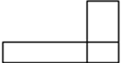
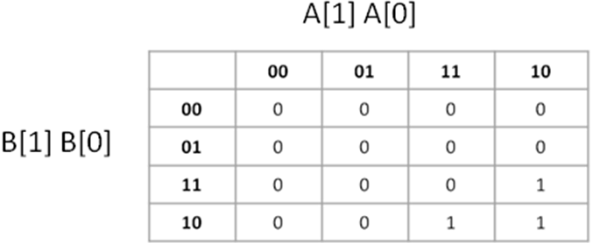
Table 2.6 – Karnaugh Map for C[2]
Equation obtained: C[2] = A[1]B[1]~B[0] + B[1]A[1]~A[0]
The equation for C[2] is produced using bit 2 from the multiplication results shown in Table 2.3.

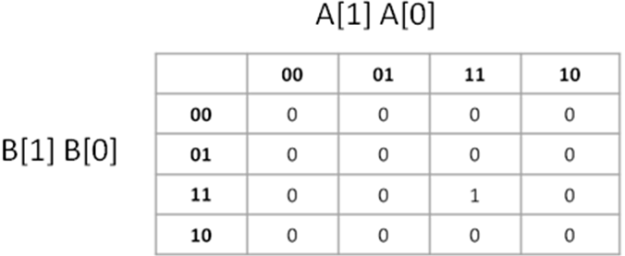
Table 2.7 – Karnaugh Map for C[3]
Equation obtained: C[3] = A[0]A[1]B[0]B[1]
The most significant bit of result C is determined by using bit 3 from the multiplication table shown in Table 2.3. C[3] is 1 if A[0], A[1], B[0] and B[1] are all equal to 1. The outputs from each of the karnaugh maps were used to implement the algorithm in hardware using AND gates, OR gates and INVERTERS, shown in Figure 2.1.
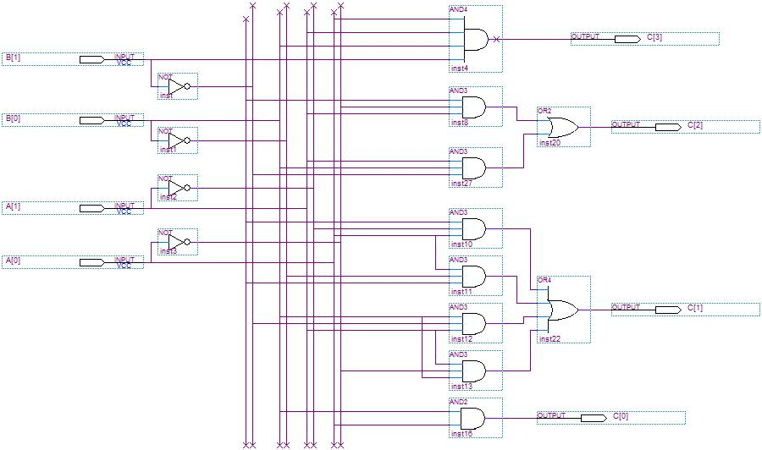
Figure 2.1 – 2-Bit Multiplier Hardware Implementation
Divide and Conquer Multiplication Verilog Code
The Verilog code shown below implements a 64-bit divide and conquer multiplier. The inputs to the module are clock, reset signal, 64-bit 2’s complement multiplicand (A) and multiplier (B). The output is a 128-bit 2’s complement result of A*B.
The divide and conquer code starts by implementing a 2-bit multiplier. The block diagram for the 2-bit multiplier is shown in Figure 2.1. Using Equation 2.1, a 4-bit multiplier is created using four 2-bit multipliers. Using the same equation, an 8-bit multiplier is created using four 4-bit multipliers, 16-bit multiplier is created using four 8-bit multiplier, and so on.
The 2-bit multiplier created in this implementation is for unsigned numbers only. Therefore, a 64-bit multiplier created using this 2-bit multiplier can only handle unsigned numbers. To create a multiplier for both signed and unsigned numbers, extra logic is added to convert the negative inputs to positive. The new positive inputs will be sent through the unsigned 64-bit divide and conquer multiplier. The unsigned result from the multiplier will then be converted to a signed result depending on the original inputs. If the signs of the inputs are different, then the result will be negative. Otherwise, the result will be positive.

module DnC(Clk, Reset, A, B, C);
input Clk, Reset;
input[63:0] A, B;

output[127:0] C;
reg[127:0] C;

reg[63:0] PosA, PosB;
wire[127:0] PosProd;
reg[127:0] Product;

always @(posedge Clk, negedge Reset)
begin
if(!Reset)
C <= 0;
else
C <= Product;
end

always@(*)
begin
if( A[63] == 1 ) //If negative
PosA = ~A + 1; //make it positive
else
PosA = A;
end

always@(*)
begin
if( B[63] == 1 ) //If negative
PosB = ~B + 1; //make it positive
else
PosB = B;
end

Mult64 m8(PosA, PosB, PosProd);

always@(PosProd or A or B)
begin
if( A[63] ^ B[63] ) //If answer should be negative
Product = ~PosProd + 1; //make it negative
else
Product = PosProd;
end

endmodule

//64-bit divide and conquer multiplier
module Mult64(A, B, C);
input[63:0] A, B;
output[127:0] C;
wire[63:0] albl, albr, arbl, arbr;

Mult32 m1(A[63:32], B[63:32], albl);
Mult32 m2(A[63:32], B[31:0], albr);
Mult32 m3(A[31:0], B[63:32], arbl);
Mult32 m4(A[31:0], B[31:0], arbr);

assign C = ({albl, 64'd0} + {32'd0, albr, 32'd0}) + ({32'd0, arbl, 32'd0}+{64'd0, arbr});
endmodule

//32-bit divide and conquer multiplier
module Mult32(A, B, C);
input[31:0] A, B;
output[63:0] C;
wire[31:0] albl, albr, arbl, arbr;

Mult16 m1(A[31:16], B[31:16], albl);
Mult16 m2(A[31:16], B[15:0], albr);
Mult16 m3(A[15:0], B[31:16], arbl);
Mult16 m4(A[15:0], B[15:0], arbr);

assign C = ({albl, 32'd0} + {16'd0, albr, 16'd0}) + ({16'd0, arbl, 16'd0}+{32'd0, arbr});
endmodule

//16-bit divide and conquer multiplier
module Mult16(A, B, C);
input[15:0] A, B;
output[31:0] C;
wire[15:0] albl, albr, arbl, arbr;

Mult8 m1(A[15:8], B[15:8], albl);
Mult8 m2(A[15:8], B[7:0], albr);
Mult8 m3(A[7:0], B[15:8], arbl);
Mult8 m4(A[7:0], B[7:0], arbr);

assign C = ({albl, 16'd0} + {8'd0, albr, 8'd0}) + ({8'd0, arbl, 8'd0}+{16'd0, arbr});
endmodule

//8-bit divide and conquer multiplier
module Mult8(A, B, C);
input[7:0] A, B;
output[15:0] C;
wire[7:0] albl, albr, arbl, arbr;

Mult4 m1(A[7:4], B[7:4], albl);
Mult4 m2(A[7:4], B[3:0], albr);
Mult4 m3(A[3:0], B[7:4], arbl);
Mult4 m4(A[3:0], B[3:0], arbr);

assign C = ({albl, 8'd0} + {4'd0, albr, 4'd0}) + ({4'd0, arbl, 4'd0}+{8'd0, arbr});
endmodule

//4-bit divide and conquer multiplier
module Mult4(A, B, C);
input[3:0] A, B;
output[7:0] C;
wire[3:0] albl, albr, arbl, arbr;

Mult2 m1(A[3:2], B[3:2], albl);
Mult2 m2(A[3:2], B[1:0], albr);
Mult2 m3(A[1:0], B[3:2], arbl);
Mult2 m4(A[1:0], B[1:0], arbr);

assign C = ({albl, 4'd0} + {2'd0, albr, 2'd0}) + ({2'd0, arbl, 2'd0}+{4'd0, arbr});
endmodule

//2-bit multiplier
module Mult2(A, B, C);
input[1:0] A, B;
output[3:0] C;

assign C[0] = A[0] & B[0];
assign C[1] = (B[1] & ~A[1] & A[0]) |
(A[0] & ~B[0] & B[1]) |
(B[0] & ~B[1] & A[1]) |
(B[0] & ~A[0] & A[1]);
assign C[2] = (B[1] & A[1] & ~B[0]) |
(B[1] & A[1] & ~A[0]);
assign C[3] = A[0] & A[1] & B[0] & B[1];
endmodule

Divide and Conquer Multiplication Simulation Results
Similar to Booth’s multiplier, divide and conquer simulation code tests all special cases to validate the algorithm. This simulation also tests the extra code that was added to multiply signed numbers using unsigned multiplier. The result of the simulation is shown below.
Chronologic VCS simulator copyright 1991-2005
Contains Synopsys proprietary information.
Compiler version Y-2006.06-SP1; Runtime version Y-2006.06-SP1; Mar 14 15:00 2010

0 A = x, B = x, C = x
1 A = 2356, B = 124, C = 0
3 A = 2356, B = 124, C = 292144
6 A = 0, B = 1234, C = 292144
11 A = 2, B = -2, C = 0
15 A = 2, B = -2, C = -4
16 A = 72057594037927935, B = 2, C = -4
19 A = 72057594037927935, B = 2, C = 144115188075855870
21 A = 0, B = 0, C = 144115188075855870
23 A = 0, B = 0, C = 0
26 A = 20015998341120, B = 2, C = 0
31 A = 20015998341120, B = 0, C = 40031996682240
35 A = 20015998341120, B = 0, C = 0
36 A = 20015998341120, B = 72057594037927935, C = 0
39 A = 20015998341120, B = 72057594037927935, C = 1442304682728263949322107187200
41 A = 20015998341120, B = 1, C = 1442304682728263949322107187200
43 A = 20015998341120, B = 1, C = 20015998341120
46 A = 20015998341120, B = -1, C = 20015998341120
47 A = 20015998341120, B = -1, C = -20015998341120
51 A = -20015998341120, B = -1, C = -20015998341120
55 A = -20015998341120, B = -1, C = 20015998341120
$finish at simulation time 251
V C S S i m u l a t i o n R e p o r t
Time: 251
CPU Time: 0.010 seconds; Data structure size: 0.2Mb
Sun Mar 14 15:00:37 2010

Divide and Conquer Multiplication Timing Analysis
As shown below, the divide and conquer multiplier needs 36ns clock cycle to complete its operation. Since this is a divide-and-conquer multiplier, there is a large amount of parallel work being done to multiply the numbers. Therefore, the amount of serial path from start to end of the computation is smaller, which results in a faster clock cycle. The path from start to end will include multiple AND/OR gates used in 2-bit multiplier and 5 different sized (8-bit, 16-bit, 32-bit, 64-bit, and 128-bit) adders.
****************************************
Report : timing
-path full
-delay max
-max_paths 1
Design : DnC
Version: Z-2007.03
Date : Sun Mar 14 15:10:23 2010
****************************************

Operating Conditions: BCCOM Library: lsi_10k
Wire Load Model Mode: top

Startpoint: B[0] (input port)
Endpoint: C_reg[124] (rising edge-triggered flip-flop clocked by Clk)
Path Group: Clk
Path Type: max

Point Incr Path
--------------------------------------------------------------------------------------------
clock (input port clock) (rise edge) 0.00 0.00
input external delay 0.00 0.00 f
B[0] (in) 0.00 0.00 f
U227/Z (B4IP) 0.27 0.27 r
add_34/A[0] (DnC_DW01_inc_0) 0.00 0.27 r
…
sub_add_44/DIFF[124] (DnC_DW01_sub_0) 0.00 35.74 f
C_reg[124]/TI (FD2S) 0.00 35.74 f
data arrival time 35.74
clock Clk (rise edge) 37.00 37.00
clock network delay (ideal) 0.00 37.00
C_reg[124]/CP (FD2S) 0.00 37.00 r
library setup time -1.25 35.75
data required time 35.75
--------------------------------------------------------------------------------------------
data required time 35.75
data arrival time -35.74
--------------------------------------------------------------------------------------------
slack (MET) 0.01
1

Divide and Conquer Multiplication Area Analysis
Divide and conquer multiplier also duplicates a large amount of its hardware. However, unlike Booth’s multiplier, divide and conquer multiplier arranges the duplicate hardware in parallel instead of serially. This allows divide and conquer multiplier to get a performance boost despite its large area. If the multiplier design is flattened out, it will result in an implementation using the AND/OR gates used in 2-bit multiplier and the 5 different sized adders used in Equation 2.1.

****************************************
Report : area
Design : DnC
Version: Z-2007.03
Date : Sun Mar 14 15:10:22 2010
****************************************

Library(s) Used:

lsi_10k (File: /titan/software/synopsys07/syn/libraries/syn/lsi_10k.db)

Number of ports: 258
Number of nets: 1088
Number of cells: 576
Number of references: 21

Combinational area: 126705.000000
Noncombinational area: 1280.000000
Net Interconnect area: undefined (No wire load specified)

Total cell area: 127985.000000
Total area: undefined
1

Pen and Paper Algorithm
Pen and Paper algorithm is a popular algorithm usually taught in an elementary school. It includes the basic steps of multiplying two numbers one digit at a time. The multiplicand is multiplied by each digit of the multiplier, starting with the right most digit of the multiplier. After each multiplication the next partial result is shifted left by one. Example 2.2 shows the process of multiplying two numbers using Pen and Paper algorithm and a flowchart is shown Figure 2.2 describes the process in detail.
As seen in Figure 2.2, the multiplier is checked to see if it is positive or negative number. If it is negative, it is converted to a positive number by inverting the number and adding 1 to it. Then the same process is repeated for the multiplicand. The loop starts with examining the least significant bit of the multiplier. If the bit is equal to 1, then the multiplier is shifted by the loop count and added to the partial product. If the bit is 0, then the loop moves on to the next bit. When the 64th bit is reached, the positive multiplication result has been calculated. To obtain the correct sign, XOR the most significant bit of the multiplier and the multiplicand. If the result is 0, the final result has been obtained otherwise, convert the result of the multiplication to a negative value.

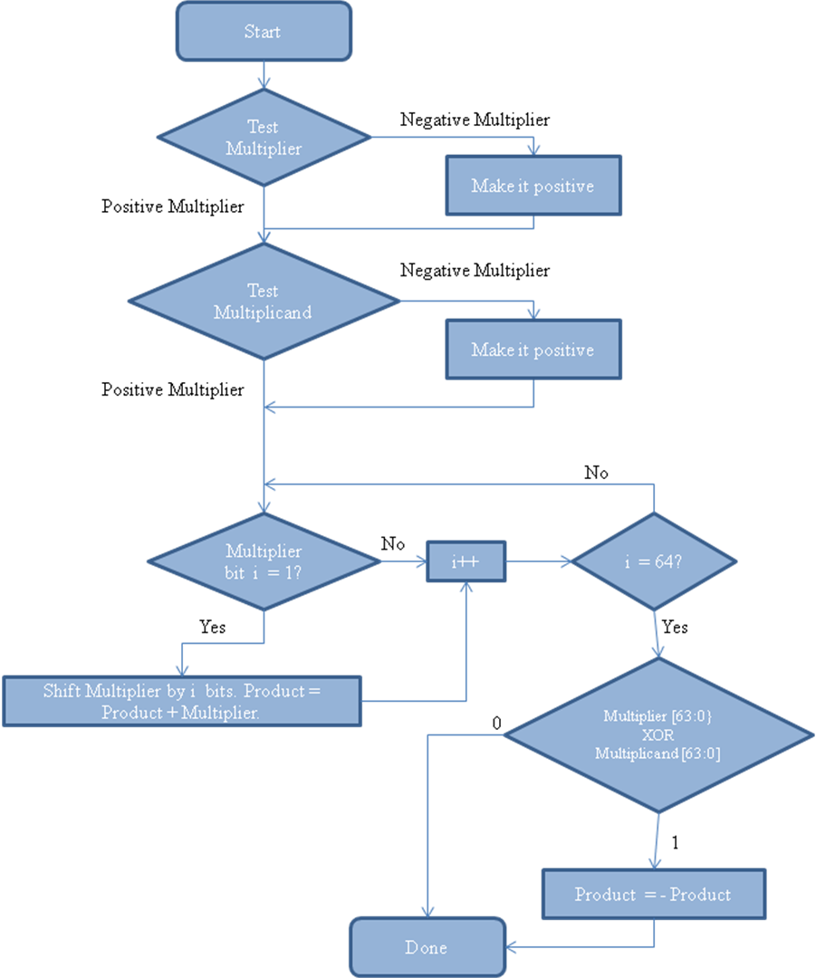
Figure 2.2 - Pen and Paper Flowchart

Example 2.2:
Let: x = 23 y = -16 x*y = -368
Multiplier Sign | Multiplicand Sign | Multiplier | Multiplicand | Partial Sum | Carry Over | Total
Negative | Positive | 16 | 23 | 0 | 0
 |  | 6 | 3 | 18 | 1
 |  | 6 | 2 | 12 | 0 | 138
 |  | 1 | 3 | 3 | 0
 |  | 1 | 2 | 2 | 0 | 23<
 |  |  |  |  |  | 368
Negative | Positive |  |  | Negative |  | -368
Table 2.8 - Pen and Paper Example
Example 2.2 above shows how the pen and paper algorithm is used in base 10. The algorithm starts by taking 1 digit of Multiplier and multiplier the digit with both digits of the multiplicand. It adds the partial results of the multiplication to form the final answer.

Pen and Paper Multiplication Verilog Code

Like other multipliers, Pen and Paper has clock, reset signal, and 64-bit 2’s complement multiplicand (A) and multiplier (B) as inputs. It produces a 128-bit 2’s complement result of A*B as the output.
The multiplier logic keeps a running result of the additions. The bits to be added are decided by looking the multiplier bit and using a shifter to create a new addition. Please refer to Figure 2.2 for algorithm details. Like divide and conquer, this multiplication code only works for unsigned number. Therefore to allow for negative numbers in input, extra logic is added to convert all negative input to positive inputs, and send these modified inputs to the unsigned multiplier. The result from the multiplier will be converted to appropriate sign using the sign of the original inputs.

module PandP(Clk, Reset, A_in, B_in, C_out);
input Clk, Reset;
input[63:0] A_in, B_in;

output[127:0] C_out;
reg[127:0] C_out;

reg [127:0] prod;
reg [63:0] Multiplicand, Multiplier;
integer i;

always@(posedge Clk or negedge Reset)
begin
if( !Reset )
C_out = 0;
else
C_out = prod;
end

always@(A_in or B_in)
begin
//reset registers
prod = 0;

//If input is negative, make it positive
if( A_in[63] )
Multiplicand = ~A_in + 1;
else
Multiplicand = A_in;

//If input is negative, make it positive
if( B_in[63] )
Multiplier = ~B_in + 1;
else
Multiplier = B_in;

//Multiply positive numbers,
for(i = 0; i < 64; i = i + 1)
begin
if( Multiplier[i] == 1 )
prod = prod + (Multiplicand << i);
end

//Check if answer is negative. If it is, put the
// sign back
if( A_in[63] ^ B_in[63] )
prod = ~prod + 1;

end
endmodule

Pen and Paper Multiplication Simulation Results
The simulation results shown below are based on tests for special case numbers and random numbers to validate the algorithm. It also tests the special code that is added to handle the negative numbers in the multiplier. The results of all the multiplication using the pen and paper algorithm is shown below.
Chronologic VCS simulator copyright 1991-2005
Contains Synopsys proprietary information.
Compiler version Y-2006.06-SP1; Runtime version Y-2006.06-SP1; Mar 12 22:16 2010

0 A = x, B = x, C = x
1 A = 2356, B = 124, C = 0
3 A = 2356, B = 124, C = 292144
6 A = 0, B = 1234, C = 292144
7 A = 0, B = 1234, C = 0
11 A = 2, B = -2, C = 0
15 A = 2, B = -2, C = -4
16 A = 72057594037927935, B = 2, C = -4
19 A = 72057594037927935, B = 2, C = 144115188075855870
21 A = 0, B = 0, C = 144115188075855870
23 A = 0, B = 0, C = 0
26 A = 20015998341120, B = 2, C = 0
27 A = 20015998341120, B = 2, C = 40031996682240
31 A = 20015998341120, B = 0, C = 40031996682240
35 A = 20015998341120, B = 0, C = 0
36 A = 20015998341120, B = 72057594037927935, C = 0
39 A = 20015998341120, B = 72057594037927935, C = 1442304682728263949322107187200
41 A = 20015998341120, B = 1, C = 1442304682728263949322107187200
43 A = 20015998341120, B = 1, C = 20015998341120
46 A = 20015998341120, B = -1, C = 20015998341120
47 A = 20015998341120, B = -1, C = -20015998341120
51 A = -20015998341120, B = -1, C = -20015998341120
55 A = -20015998341120, B = -1, C = 20015998341120
$finish at simulation time 251
V C S S i m u l a t i o n R e p o r t
Time: 251
CPU Time: 0.020 seconds; Data structure size: 0.0Mb

Pen and Paper Multiplication Timing Analysis
The loop iteration of pen and paper multiplication depends on previous iteration of the loop. Due to this behavior and the fact that this is not a multi-cycle implementation, the hardware cannot be shared. Therefore, for each iteration of the loop, the hardware is duplicated. Each iteration requires a multiplexor, adder, and shifter. Due to this duplication and serialization of the hardware connection, it takes 174ns to complete one multiplication operation. A partial list of timing analysis produced by Design Compiler is shown below.

****************************************
Report : timing
-path full
-delay max
-max_paths 1
Design : PandP
Version: Z-2007.03
Date : Sat Mar 13 16:19:37 2010
****************************************

Operating Conditions: BCCOM Library: lsi_10k
Wire Load Model Mode: top

Startpoint: A_in[0] (input port)
Endpoint: C_out_reg[127] (rising edge-triggered flip-flop clocked by Clk)
Path Group: Clk
Path Type: max

Point Incr Path
--------------------------------------------------------------------------------------------
clock (input port clock) (rise edge) 0.00 0.00
input external delay 0.00 0.00 f
A_in[0] (in) 0.00 0.00 f
sub_add_31/B[0] (PandP_DW01_sub_1) 0.00 0.00 f
…
sub_add_51/DIFF[127] (PandP_DW01_sub_0) 0.00 173.74 f
C_out_reg[127]/TI (FD2S) 0.00 173.74 f
data arrival time 173.74
clock Clk (rise edge) 175.00 175.00
clock network delay (ideal) 0.00 175.00
C_out_reg[127]/CP (FD2S) 0.00 175.00 r
library setup time -1.25 173.75
data required time 173.75
--------------------------------------------------------------------------------------------
data required time 173.75
data arrival time -173.74
--------------------------------------------------------------------------------------------
slack (MET) 0.01
1

Pen and Paper Multiplication Area Analysis

Due to hardware duplication, this pen and paper implementation requires a large area. Each iteration of the loop requires a multiplexor, adder, shifter, and registers to store the value. This hardware is duplicated for all iterations of the loop; hence a larger area will be used on the circuit board. The area requirements for this implementation are shown below.

****************************************
Report : area
Design : PandP
Version: Z-2007.03
Date : Sat Mar 13 16:19:36 2010
****************************************

Library(s) Used:

lsi_10k (File: /titan/software/synopsys07/syn/libraries/syn/lsi_10k.db)

Number of ports: 258
Number of nets: 21937
Number of cells: 15320
Number of references: 91

Combinational area: 113855.000000
Noncombinational area: 1280.000000
Net Interconnect area: undefined (No wire load specified)

Total cell area: 115135.000000
Total area: undefined
1

Chapter 3

DIVISION

Radix-2 Restoring Division
“Digital Recurrence algorithms use subtractive methods to calculate quotients one digit per iteration [3].” Restoring division algorithm is based on the digital recurrence algorithm that “…retire[s] a fixed number of quotient bits in every iteration [3].” Restoring division follows the same method as the pen and paper long division algorithm [2]. In the long division algorithm, the divisor is compared to the left digits of the dividend. If the divisor is bigger than the dividend numbers being compared, then a 0 in appended to the quotient and divisor is shifted to the right to compare with bigger dividend digits. If the divisor is smaller than the dividend, then the divisor being compared is subtracted from the dividend and the result is stored as remainder, while the number of times the divisor can go into the dividend is appended to the quotient. During the next loop, the dividend and the remainder need to be appended together to form the new dividend. This process is repeated until the dividend cannot be divided further by the divisor. The same process is applied in the Radix-2 restoring division algorithm. To decide whether the divisor is bigger than the dividend bits it is being compared to, it subtracts the divisor from the dividend bits and stores the result in remainder field [2]. If the divisor is bigger than the dividend bits, then the result will be negative. If the result is negative, then the remainder is wrong and it must be “restored” to the previous value and a 0 must be appended to the quotient before the divisor is shifted to the right (or dividend shifted to the left) and subtraction is tried again [2]. If the result is positive, then divisor is bigger than the dividend bits being compared to and the result is valid. Therefore, a 1 is appended to the quotient to indicate that dividend_bits – 1*divisor = remainder. This process is repeated until all bits of the dividend are evaluated.
Using restoring division algorithm in base 10 can be quite lengthy and repetitive since each increment in the quotient is followed by a multiplication and subtract and all nine digits may need to be tested before a restore takes place. In binary restore, however, there are only two choices and a shift can replace multiple iterations required otherwise. The following example uses restoring algorithm to a find a solution to 61 divided by 10. Figure 3.1 presents a detailed flowchart of radix-2 restoring algorithm for 32-bit division, which is further expanded to 64-bit when implemented in Verilog.

Example 3.1 – Restoring Divide example
Dividend z: 0011 1101 ( 61)
Divisor d: 0 1010 (10)
Iteration | P | Q
1 | Shift z left once: 0111 101  Subtract d from left half of z: 1111 1101  Result is negative. Restore to previous value: 0111 101 | 0
2 | Shift z left once: 1111 01  Subtracting d from left half of z: 0101 01  Result is positive. New z is 0101 01 | 01
3 | Shift z left once: 1010 1  Subtracting d from left half of z: 0000 1  Result is positive. New z is 0000 1 | 011
4 | Shift z left once: 0001  Subtracting d from left half of z: 1 0111  Result is negative: Restore to previous value: 0001 | 0110
Table 3.1 - Radix-2 Restoring Division Example

Quotient: 0110 (6)
Remainder: 0001 (1)

Following the Radix-2 restoring division algorithm discussed above, the first step is to shift the quotient 1 bit to the left. Second, subtract the divisor from the left half of the dividend and update the left half of the quotient with the answer. This new dividend value now has the remainder and rest of the quotient appended together. To avoid destroying the initial dividend value, the dividend can be copied into the remainder register and use remainder register as the dividend value. If the new dividend is less than zero, then shift the quotient left 1 bit and restore the previous value of the dividend. Otherwise, shift the quotient left 1 bit and set the least significant bit to 1. Repeat for procedure 4 times to evaluate all bits of the dividend. At the end of the procedure, the quotient value will be the remainder.
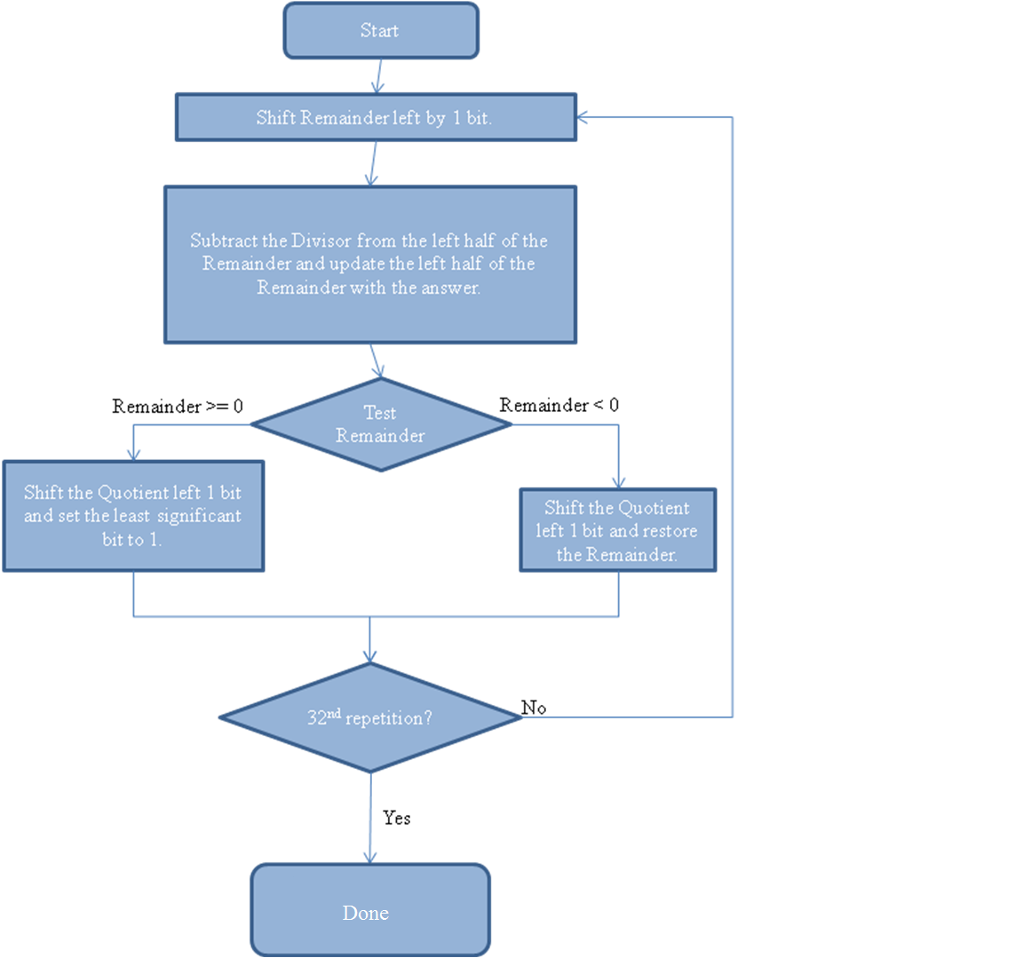
Figure 3.1 – Radix-2 Restoring Divide Algorithm Flowchart
Radix-2 Restoring Division Verilog Code
Shown below is the Verilog implementation for Radix-2 restoring division. The module takes clock, reset signal, 2’s complement positive 64-bit dividend, and 2’s complement positive 64-bit divisor as input. The outputs are 64-bit quotient and remainder.
The algorithm starts by initializing the quotient to the dividend, and remainder to 0. The algorithm initializes the quotient to the dividend instead of the remainder to the dividend as described in the examples below due to ease of computation. The quotient (which has the dividend initially) will feed 1 bit at a time to the remainder, while the quotient bits that are being shifted left will be filled with the quotient result as it gets computed. This avoids subtracting the divisor from the “left” side of the dividend while achieving the same goal. Since 64-bit numbers are being divided, the algorithm loops 64 times to perform the algorithm. Each loop iteration does the following:
- Shift quotient left one bit into the remainder. This is done by saving the MSB of the quotient while shifting left. This saved bit is concatenated to the least significant position of the remainder after shifting the remainder one bit to the left, which allows the dividend to be slowly shifted into the remainder variable. This can be implemented by saving remainder and quotient into one 128-bit register, however it was decided to keep them separate due to ease of computation in rest of the algorithm.
- The remainder is stored into a temporary variable incase it needs to be restored later.
- The remainder register (which has a dividend bit shifted into it from step 1) is subtracted from the divisor to check if the current division is possible.
- If the result of the subtraction is negative, then the divisor was bigger than the remainder register and the division cannot take place with current values. To determine if the result is negative, the algorithm checks the value of MSB. Since the numbers are in 2’s complement form, a set MSB indicates the number is negative. If the division cannot take place, then the old value of the remainder register needs to be restored since it was overwritten in step 3.
- If the result of the subtraction is positive, then the division took place successfully. A 1 is appended to the LSB of the quotient to indicate that the remainder register (which has remainder appended to dividend bits) can be divided by the divisor register 1 times.
At the end of the loop, the remainder and quotient variable will have the result of Dividend / Divisor.
module Restore(clk, reset, Dividend, Divisor, Quotient, Remainder);
input clk, reset;
input [63:0] Dividend, Divisor;

output [63:0] Quotient, Remainder;
reg [63:0] Quotient, Remainder;

reg [63:0] p, a, temp;
integer i;

always @(posedge clk, negedge reset)
begin
if( !reset )
begin
Quotient <= 0;
Remainder <= 0;
end
else
begin
Quotient <= a;
Remainder <= p;
end
end

always @(*)
begin
a = Dividend;
p = 0;

for(i = 0; i < 64; i = i+1)
begin
//Shift Left carrying a's MSB into p's LSB
p = (p << 1) | a[63];
a = a << 1;

//store value in case we have to restore
temp = p;

//Subtract
p = p - Divisor;

if( p[63] ) // if p < 0
p = temp; //restore value
else
a = a | 1;
end
end

endmodule
Radix-2 Restoring Division Simulation Results
The Verilog simulation of the Radix-2 restoring division algorithm tests special cases and random cases to validate the algorithm. Some of the special cases include division by 1 and division by itself. This simulation does not test division by 0 because the algorithm does not support this case. It is assumed the user will only send valid inputs to the algorithm. The result of various divisions simulated is shown below.

Chronologic VCS simulator copyright 1991-2005
Contains Synopsys proprietary information.
Compiler version Y-2006.06-SP1; Runtime version Y-2006.06-SP1; Mar 23 07:40 2010

x / x: q = 0, r = 0
87 / 5: q = x, r = x
87 / 5: q = 17, r = 2
59 / 20: q = 17, r = 2
59 / 20: q = 2, r = 19
18446744073709551615 / 2: q = 9223372036854775807, r = 1
305419896 / 1: q = 9223372036854775807, r = 1
305419896 / 1: q = 305419896, r = 0
305419896 / 305419896: q = 1, r = 0
$finish at simulation time 26
V C S S i m u l a t i o n R e p o r t
Time: 26
CPU Time: 0.010 seconds; Data structure size: 0.0Mb
Tue Mar 23 07:40:36 2010

Radix-2 Restoring Division Timing Analysis
Division algorithms are more complex than the multiplication algorithms and therefore require a much large clock cycle to complete one operation. Shown below is the partial timing analysis generated from Design Compiler. To complete one operation, this implementation of the radix-2 restoring division algorithm requires 324ns clock period.
As seen in the multiplication algorithm, the division algorithm’s loop iteration is dependent on the previous loop iterations. Therefore, the next loop iteration cannot start until the previous loop is complete. Due to this requirement, the path from start of loop to the end is serialized; hence a large clock period is required.

****************************************
Report : timing
-path full
-delay max
-max_paths 1

Design : Restore
Version: Z-2007.03
Date : Mon Mar 22 11:58:27 2010
****************************************

Operating Conditions: BCCOM Library: lsi_10k
Wire Load Model Mode: top

Startpoint: Divisor[1] (input port)
Endpoint: Remainder_reg[59] (rising edge-triggered flip-flop clocked by clk)
Path Group: clk
Path Type: max
Point Incr Path
--------------------------------------------------------------------------------------------
clock (input port clock) (rise edge) 0.00 0.00
input external delay 0.00 0.00 f
Divisor[1] (in) 0.00 0.00 f
sub_41/B[1] (Restore_DW01_sub_63) 0.00 0.00 f
…
sub_41_I64/DIFF[59] (Restore_DW01_sub_0) 0.00 323.75 f
Remainder_reg[59]/D (FD2S) 0.00 323.75 f
data arrival time 323.75
clock clk (rise edge) 325.00 325.00
clock network delay (ideal) 0.00 325.00
Remainder_reg[59]/CP (FD2S) 0.00 325.00 r
library setup time -1.25 323.75
data required time 323.75
--------------------------------------------------------------------------------------------
data required time 323.75
data arrival time -323.75
--------------------------------------------------------------------------------------------
slack (MET) 0.00
1

Radix-2 Restoring Division Area Analysis
Shown below is the area requirement for radix-2 restoring division algorithm. Since the implementation is not a multi-cycle implementation and the loop iteration depends on the result of the previous loop iterations, the hardware cannot be shared because if the hardware was shared, it will lead to combinatorial feedback.
Each iteration of the loop requires 2 shifters, a subtractor, a multiplexor, and registers to store temporary values. This hardware is duplicated for each iteration of the loop causing an increase in area.
****************************************
Report : area
Design : Restore
Version: Z-2007.03
Date : Mon Mar 22 11:58:25 2010
****************************************

Library(s) Used:

lsi_10k (File: /titan/software/synopsys07/syn/libraries/syn/lsi_10k.db)

Number of ports: 258
Number of nets: 14205
Number of cells: 9764
Number of references: 90

Combinational area: 132495.000000
Noncombinational area: 1193.000000
Net Interconnect area: undefined (No wire load specified)

Total cell area: 133688.000000
Total area: undefined
1
Radix-4 Restoring Division
One way to reduce latency in division cycles is to increase the radix [3]. According to Obermaan and Flynn [3], the power of radix is inversely proportional to the latency of overall division time. Therefore, we examine the effect of changing the radix by implementing radix-4 restoring division. The following example lays out the procedure for radix-4 restoring division, however, a direct comparison of radix-2 and radix-4 restoring division is presented in chapter 4. The following shows the Radix-4 restoring algorithm, and example 3.2 uses this algorithm to compute the result of 7300/36.
Radix-4 Restoring Divide Algorithm [2]:
- Shift remainder left 2 bits.
- Do a test subtraction of x*Divisor from the left half of the remainder, where x is 1, 2, and 3.
- If all test subtraction result in negative result, restore the remainder to the original value. Shift Quotient left 2 bits.
- If one of the test subtraction results in a positive result, pick the highest “x” value that results in a positive value. Shift Quotient left 2 bits and add x.
- Repeat for (# of divisor bits)/2 times.

Example 3.2 – Radix-4 Restoring Division Example
z: 0001 1100 1000 0100 (7300)
d: 0010 0100 (36)
2d: 0100 1000 (72 = 36*2)
3d: 0110 1100 (108 = 36*3)
Iteration | P | Q
1 | Shift z twice: 0111 0010 0001 00  Subtracting 3d from z gives best result: z = 0000 0110 0001 00 | 11
2 | Shift z twice: 0001 1000 0100  Subtracting anything*d gives negative result: z = 1111 0100 0100  Restore previous value of z: 0001 1000 0100 | 1100
3 | Shift z twice: 0110 0001 00  Subtracting 2d from z gives best result: z = 0001 1001 00 | 1100 10
4 | Shift z twice: 0110 0100  Subtracting 2d from z gives best result: z = 0001 1100 | 1100 1010
Table 3.2 - Radix-4 Restoring Division Example

Quotient: 1100 1010 (202)
Remainder: 0001 1100 (28)

Radix-4 Restoring Division Verilog Code
The Radix-4 Restoring division minimizes the loop iterations by evaluating 2 bits at a time. The algorithm starts by initializing the remainder to dividend and quotient to 0. It also calculates the value of Divisor*2 and Divisor*3. These values will be used later in the loop to determine how many times the dividend can be fully divided by the divisor. These values are only calculated during the beginning and stored in a register to be used later. No multiplier is used to calculate the value; instead a shifter is used to perform the task as it is faster and occupies smaller area. Divisor*2 is calculated by shifting the Divisor left by 1 bit. Divisor*3 is calculated by adding Divisor to Divisor*2.
Since Radix-4 division evaluates 2-bits at a time, the loop iterations are halved compared to the Radix-2 division. However, more logic is added within each loop iteration. The loop iterations starts by left shifting the quotient register into the remainder register as in the radix-2 division algorithm. However in radix-4 algorithm, 2 bits are shifted in a single iteration. After the shift, three subtractions are performed using the Divisor*x values calculated in the beginning of the algorithm. The subtraction will determine the largest 2-bit value that can be multiplied to divisor and still be able to divide successfully. To determine that, four multiplexors are used:
- If remainder register minus divisor is negative, then the current dividend is too big to perform the division and a shift is needed. A 0 is appended to the two least significant bits of the quotient.
- If the control reaches the second if statement, then that means the current remainder register*1 is acceptable for division. However to determine the most optimal value, other conditions need to be evaluated. If remainder register minus (divisor*2) is negative, then (remainder register*2) is too big to perform the division, however (remainder register*1) is acceptable for division. Therefore, 1 is appended to the two least significant bits of the quotient to indicate that the current remainder register can go into the divisor 1 times.
- If the control reaches the third if-statement, then that means remainder register*2 is acceptable for division. If remainder register minus (division*3) is negative, then (remainder register*3) is too big to perform the division, but (remainder register*2) is acceptable. Therefore, a 2 is appended to the two least significant bits of the quotient to indicate that the current remainder register can go into the divisor 2 times.
- If the control reaches fourth if-statement, then that means remainder register*3 is acceptable for division. Therefore, a 3 is appended to the two least significant bits of the quotient to indicate that the current remainder register can go into the divisor 3 times.
Since two bits are evaluated at once, the loop only needs to iterate 32 times instead of 64 times to evaluate all bits in the dividend.
module R4Restore(clk, reset, Dividend, Divisor, Quotient, Remainder);
input clk, reset;
input [63:0] Dividend, Divisor;

output [63:0] Quotient, Remainder;
reg [63:0] Quotient, Remainder;
reg [63:0] p, a;
reg [63:0] Result1, Result2, Result3;
reg [63:0] DivisorX2, DivisorX3;
integer i;

always @(posedge clk, negedge reset)
begin
if( !reset )
begin
Quotient <= 0;
Remainder <= 0;
end
else
begin
Quotient <= a;
Remainder <= p;
end
end

always @(*)
begin
a = Dividend;
p = 0;
DivisorX2 = Divisor << 1; //Divisor*2
DivisorX3 = (Divisor << 1) + Divisor; //Divisor*3

for(i = 0; i < 32; i = i+1)
begin
//Shift Left carrying a's MSB into p's LSB
p = (p << 2) | a[63:62];
a = a << 2;

//Subtract
Result1 = p - Divisor;
Result2 = p - DivisorX2;
Result3 = p - DivisorX3;

if( Result1[63] ) //Divisor is too big
begin
a = a | 0;
end
else if( Result2[63] )//Divisor*2 is too big, but Divisor*1 is OK
begin
p = Result1;
a = a | 1;
end
else if( Result3[63] ) //Divisor*3 is too big, but Divisor*2 is OK
begin
p = Result2;
a = a | 2;
end
else
begin //Divisor*3 is OK
p = Result3;
a = a | 3;
end
end
end

endmodule
Radix-4 Restoring Division Simulation Results

As in Radix-2 division simulation, Radix-4 division simulation tests special cases and random cases to validate the algorithm. However, division by 0 is not tested since that case is not handled by the algorithm. The simulation results are shown below.
Chronologic VCS simulator copyright 1991-2005
Contains Synopsys proprietary information.
Compiler version Y-2006.06-SP1; Runtime version Y-2006.06-SP1; Mar 23 07:40 2010

x / x: q = 0, r = 0
87 / 5: q = x, r = x
87 / 5: q = 17, r = 2
59 / 20: q = 17, r = 2
59 / 20: q = 2, r = 19
18446744073709551615 / 2: q = 9223372036854775807, r = 1
305419896 / 1: q = 9223372036854775807, r = 1
305419896 / 1: q = 305419896, r = 0
305419896 / 305419896: q = 1, r = 0
$finish at simulation time 26
V C S S i m u l a t i o n R e p o r t
Time: 26
CPU Time: 0.010 seconds; Data structure size: 0.0Mb
Tue Mar 23 07:40:02 2010

Radix-4 Restoring Division Timing Analysis
As in radix-2 division, each loop iteration is dependent on previous loop iteration. Therefore, before an iteration is started, the previous iteration needs to be completed. This behavior serializes the algorithm and is responsible for the large clock cycle. However, Radix-4 algorithm manages to cut the loop iteration in half with the expense of adding extra logic. Due to lower loop iteration count, the clock cycle for Radix-4 division is much faster than the Radix-2 division. The partial report generated by Design Compiler is shown below.
****************************************
Report : timing
-path full
-delay max
-max_paths 1

Design : R4Restore
Version: Z-2007.03
Date : Mon Mar 22 21:15:21 2010
****************************************

Operating Conditions: BCCOM Library: lsi_10k
Wire Load Model Mode: top

Startpoint: Divisor[27] (input port)
Endpoint: Remainder_reg[4] (rising edge-triggered flip-flop clocked by clk)
Path Group: clk
Path Type: max

Point Incr Path
--------------------------------------------------------------------------------------------
clock (input port clock) (rise edge) 0.00 0.00
input external delay 0.00 0.00 f
Divisor[27] (in) 0.00 0.00 f
add_33/A[28] (R4Restore_DW01_add_0) 0.00 0.00 f
…
Remainder_reg[4]/D (FD2) 0.00 209.15 f
data arrival time 209.15
clock clk (rise edge) 210.00 210.00
clock network delay (ideal) 0.00 210.00
Remainder_reg[4]/CP (FD2) 0.00 210.00 r
library setup time -0.85 209.15
data required time 209.15
--------------------------------------------------------------------------------------------

data required time 209.15
data arrival time -209.15
--------------------------------------------------------------------------------------------
slack (MET) 0.00
1
Radix-4 Restoring Division Area Analysis
As mentioned before, Radix-4 division reduces the loop iterations in the algorithm with the expense of extra logic. The extra logic requires quite a lot of extra hardware. Each loop iteration requires 2 shifters, 3 64-bit subtactor, and 4 muxes. Even though the loop is halved, the large amount of extra hardware per loop iteration results in a larger area requirement than the radix-2 division. Shown below is the area requirement report generated by design compiler.

****************************************
Report : area
Design : R4Restore
Version: Z-2007.03
Date : Mon Mar 22 21:15:18 2010
****************************************

Library(s) Used:

lsi_10k (File: /titan/software/synopsys07/syn/libraries/syn/lsi_10k.db)

Number of ports: 258
Number of nets: 23759
Number of cells: 17171
Number of references: 138

Combinational area: 180828.000000
Noncombinational area: 1152.000000
Net Interconnect area: undefined (No wire load specified)

Total cell area: 181980.000000
Total area: undefined
1

Radix-2 Non-Restoring Division
The non-restoring divide does not “restore” the remainder to the correct value but leaves it incorrect until the next cycle [2]. In the restoring divide algorithm,
…if we had restored the partial remainder u – 2^{k}d to its correct value u, we would proceed with the next shift and trial subtraction getting the result u – 2^{k}d. Instead, because we used the incorrect partial remainder, a shift and trial subtraction would yield 2(u – 2^{k}d) – 2^{k}d = 2u – (3*2^{k}d), which is not the intended result. However, an addition would do the trick, result in 2(u – 2^{k}d) + 2^{k}d = 2u – 2^{k}d. [2]
The non-restoring algorithm can result in a negative remainder, which is incorrect. Therefore, a correction step is needed to obtain the correct remainder. The algorithm to perform non-restoring division is as follows:
Radix-2 Non-Restoring Divide algorithm [2]:
- Shift remainder left 1 bit.
- If remainder is negative, add Divisor to the left half of the remainder. Shift quotient left 1 bit.
- If remainder is positive, subtract Divisor from the left half of the remainder. Shift quotient left 1 bit and add 1.
- Repeat for number of bits in divisor.
- Correction step: If remainder is negative, add divisor to the remainder to obtain the correct value.
Example 3.3 demonstrates the above algorithm to compute the result of 10/3.
Example 3.3: Radix 2 Non-Restoring Divide
Divisor (D) | Dividend (Z) | Add or Subtract | New Dividend | Quotient | Remainder
0011 | 0000 1010 | Initial | Initial | 0000 | 0000
0011 | 0001 0100 | Subtract | 0001 0100-0011 0000 = 1110 0100 | 0001 | 1110
0011 | 1100 1000 | Add | 1100 1000+ 0011 0000 = 1111 1000 | 0001 | 1111
0011 | 1111 0000 | Add | 1111 0000+ 0011 0000 = 0010 0000 | 0001 | 0010
0011 | 0100 0000 | Subtract | 0100 0000-0011 0000 = 0001 0000 | 0011 | 0001
Table 3.3 - Radix-2 Non-Restoring Division Example

 | Binary | Decimal
Result | 0011 | 3
Remainder | 0001 | 1
Divisor | 0011 | 3
Dividend | 0000 1010 | 10
Table 3.4 - Radix-2 Non-Restoring Division Example Results

Table 3.3 goes through the Radix-2 non-restoring algorithm. The first loop of the algorithm starts in the 2nd row. Dividend is shifted left once and remainder is tested to determine if it is positive or negative. Since remainder is initialized to 0, it is tested as positive and divisor is subtracted from the left side of the dividend. The new quotient value is set to the result of the subtraction and remainder is updated. The loop is performed again on the updated quotient value. Since remainder was negative in previous loop, the remainder will be added to the left side of the quotient. The new quotient value is set to the result of the addition and remainder is updated appropriately. The rest of the example follows the same procedure to calculate the value. Table 3.4 shows the final result.

Radix-2 Non-Restoring Division Verilog Code
Radix-2 Non-restoring division takes clock, reset signal, 64-bit 2’s complement positive Dividend and 64-bit 2’s complement positive Divisor as its input. The output is 64-bit2’s complement Quotient and 64-bit 2’s complement Remainder. As in the radix-2 restoring divide, the algorithm starts with initializing the remainder with the value of the divisor and the quotient with 0.
The algorithm loop starts with shifting quotient register one bit left into the remainder register. It uses a register to keep track of whether to add or subtract divisor from the remainder. If remainder is negative, then divisor is added to the remainder. If remainder is positive, then the negative value of divisor is added to the remainder, which is the same as subtracting divisor from the remainder. After the addition or subtraction, the remainder bit is checked again to determine the correct quotient.
Since the dividend is 64 bit, the loop is iterated 64 times. After all iterations of the loop, a correction step is needed. If the remainder is negative, then the divisor is added back to it to get the correct remainder.

module NonRestore(clk, reset, Dividend, Divisor, Quotient, Remainder);
input clk, reset;
input [63:0] Dividend, Divisor;
output [63:0] Quotient, Remainder;
reg [63:0] Quotient, Remainder;
reg [63:0] p, a, temp;
integer i;

always @(posedge clk, negedge reset)
begin
if( !reset )
begin
Quotient <= 0;
Remainder <= 0;
end
else
begin
Quotient <= a;
Remainder <= p;
end
end

always @(*)
begin
a = Dividend;
p = 0;

for(i = 0; i < 64; i = i+1)
begin
//Shift Left carrying a's MSB into p's LSB
p = (p << 1) | a[63];
a = a << 1;

//Check the old value of p
if( p[63] ) //if p is negative
temp = Divisor; //add divisor
else
temp = ~Divisor+1; //subtract divisor

//this will do the appropriate add or subtract
//depending on the value of temp
p = p + temp;

//Check the new value of p
if( p[63] ) // if p is negative
a = a | 0; //no change to quotient
else
a = a | 1;
end

//Correction is needed if remainder is negative
if( p[63] ) //if p is negative
p = p + Divisor;
end

endmodule

Radix-2 Non Restoring Division Simulation Results

Shown below is the simulation result for Radix-2 non-restoring division algorithm. Like other division algorithms simulations discussed in this report, it does not take care of division by zero. However, it does test for division by 1 or division by itself. The results are shown below.
Chronologic VCS simulator copyright 1991-2005
Contains Synopsys proprietary information.
Compiler version Y-2006.06-SP1; Runtime version Y-2006.06-SP1; Mar 23 07:38 2010

x / x: q = 0, r = 0
87 / 5: q = x, r = x
87 / 5: q = 17, r = 2
59 / 20: q = 17, r = 2
59 / 20: q = 2, r = 19
18446744073709551615 / 2: q = 9223372036854775807, r = 1
305419896 / 1: q = 9223372036854775807, r = 1
305419896 / 1: q = 305419896, r = 0
305419896 / 305419896: q = 1, r = 0
$finish at simulation time 26
V C S S i m u l a t i o n R e p o r t
Time: 26
CPU Time: 0.010 seconds; Data structure size: 0.0Mb
Tue Mar 23 07:38:56 2010

Radix-2 Non Restoring Division Timing Analysis
Shown below is the partial timing report generated by design compiler. To complete one division operation, Radix-2 non-restoring division algorithm requires 324ns clock cycle. The loop iterations depend on the previous iteration to be completed. As with other division algorithms, the loop operations are serialized from start to end. Therefore, it requires a large clock cycle.

****************************************
Report : timing
-path full
-delay max
-max_paths 1

Design : NonRestore
Version: Z-2007.03
Date : Sat Mar 20 19:02:24 2010
****************************************
Operating Conditions: BCCOM Library: lsi_10k
Wire Load Model Mode: top

Startpoint: Divisor[2] (input port)
Endpoint: Remainder_reg[51] (rising edge-triggered flip-flop clocked by clk)
Path Group: clk
Path Type: max

Point Incr Path
--------------------------------------------------------------------------------------------
clock (input port clock) (rise edge) 0.00 0.00
input external delay 0.00 0.00 f
Divisor[2] (in) 0.00 0.00 f

…

Remainder_reg[51]/D (FD2) 0.00 323.15 f
data arrival time 323.15
clock clk (rise edge) 324.00 324.00
clock network delay (ideal) 0.00 324.00
Remainder_reg[51]/CP (FD2) 0.00 324.00 r
library setup time -0.85 323.15
data required time 323.15
--------------------------------------------------------------------------------------------

data required time 323.15
data arrival time -323.15
--------------------------------------------------------------------------------------------
slack (MET) 0.00
1

Radix-2 Non Restoring Division Area Analysis

Since Radix-2 non-restoring division is not multi-cycle implementation and the logic is serialized in the for-loop, it requires a large amount of hardware duplication. Each iteration of the loop requires 2 multiplexor, an adder, and register to store temporary values. This hardware will need to be duplicated 64 times since the loop is iterated 64 times. Due to this hardware duplication, this implementation of Radix-2 non-restoring division requires a large area.
****************************************
Report : area
Design : NonRestore
Version: Z-2007.03
Date : Sat Mar 20 19:02:22 2010
****************************************

Library(s) Used:

lsi_10k (File: /titan/software/synopsys07/syn/libraries/syn/lsi_10k.db)

Number of ports: 258
Number of nets: 17035
Number of cells: 8457
Number of references: 152

Combinational area: 163336.000000
Noncombinational area: 1266.000000
Net Interconnect area: undefined (No wire load specified)

Total cell area: 164602.000000
Total area: undefined
1

Chapter 4

TIMING AND AREA ANALYSIS

Each of the algorithms were simulated and analyzed for time and area constraints. Table 4.1 compares the timing and area requirements for three different multiplication algorithms.
Multiplication | Time | Area
Booth's Algorithm | 170.0 | 145194.0
Divide and Conquer | 36.0 | 127985.0
Pen and Paper | 174.0 | 115135.0
Table 4.1 – Time and Area Comparison for Various Multiplication Algorithms

Pen and Paper algorithm takes the most amount of time to compute the multiplication results. Since it is the simplest algorithm out of the three analyzed, it takes the least amount of area. However, due to its simplicity, it does the most amount of work which results in the high time to compute the result. The next fastest algorithm is Booth’s multiplier. It avoids the addition at every step as in the pen and paper algorithm by using shifters, which results in a slight increased in speed, but the extra addition and subtraction logic needed require a larger area. Divide and conquer provides the best speed out of the three algorithms with its ability to perform several computations in parallel. Due to the parallel nature of the algorithm, it requires duplication of hardware that results in a large area size as well. Nonetheless, the timing benefits of Divide and Conquer algorithm outweigh the area disadvantages that come with the algorithm.
Table 4.2 compares the time and area requirements for the three division algorithms.
Division | Time | Area
Radix-2 Restoring Division Algorithm | 325.0 | 133688.0
Radix-4 Restoring Division Algorithm | 210.0 | 181980.0
Radix-2 Non-Restoring Division | 324.0 | 164602.0
Table 4.2- Time and Area Comparison for Various Division Algorithms

As seen in the Table 4.2, Radix-4 restoring divide algorithm provides the best performance in terms of time, however it also requires the most amount of area. Radix-2 restoring divide and Radix-2 non-restoring divide have similar timing requirement, which is expected since non-restoring divide is used to avoid timing issues that can occur in restore divide and not to increase performance. The area requirement of Radix-2 non-restoring divide is larger than the Radix-2 restoring divide because non-restoring divide algorithm requires an adder and a subtractor, which adds more hardware. Radix-4 division requires the most area because multiple test subtractions are implemented during each iteration and therefore the algorithm requires multiple subtraction units. Multiple comparisons take place to determine the best quotient value. However, it provides the optimal speed because it can compute 2 bits in one iteration, therefore, reducing the number of iterations used to compute the result. Since Radix-4 restoring algorithm requires a large amount of area, Radix-4 algorithm would have the best performance if area is not a concern. If area needs to be minimized, then Radix-2 restoring division algorithm would be considered the best performance.
Chapter 5

CONCLUSION

This report analyzed three algorithms for multiplication and division for the best performance. The criteria to judge the performance was based on the amount of time it took for the algorithm to compute one result and the amount of area required to implement the algorithm in hardware. The multiplication algorithms that were studied include Pen and Paper algorithm, Booth’s algorithm, and Divide and Conquer. The division algorithm that were analyzed include Radix-2 Restoring algorithm, Radix-2 Non-Restoring algorithm, and Radix-4 Restoring algorithm.
After thorough analyzes of timing and area reports, Divide and Conquer far exceeded the performance when compared to other multiplication algorithm. In division algorithm comparisons, Radix-4 Restoring algorithm shows the best performance if large area is not a concern. If area needs to be minimized, Radix-2 Restoring algorithm seems to be a good compromise of speed versus area.
The algorithms studied in this report can be further optimized to achieve better time and area. Many of these algorithms can be pipelined or run in a multi-cycle configuration. For example, the Pen and Paper would benefit tremendously if it was pipelined. Although, it would not decrease the amount of time it takes to generate one result, it would help increase the throughput of the algorithm. Booth’s multiplication can benefit by running it in a multi-cycle configuration instead of running the whole algorithm in one clock cycle. In addition, other algorithms can be investigated for better speed and area. The Radix-4 algorithm can be taken a step further and converted into a SRT division algorithm [2]. Another division algorithm that can be investigated is the Newton-Raphson division algorithm, which is currently the fastest division algorithm [4].
APPENDICES
APPENDIX A
Test File Verilog Code

Multiplication Algorithm Test File Code

module BoothTest;
reg clk, reset;
reg signed[63:0] A_in, B_in;
wire [127:0] C;
reg signed[127:0] C_reg;

// provide input and output signals to the detector
Booth DUT (clk, reset, A_in, B_in, C);

// track the changes in output z
initial
$monitor($time, " A = %0d, B = %0d, C = %0d", A_in, B_in, C_reg);

always
#1 C_reg = C;

// provide the sequence
initial
begin
reset = 0;
clk = 0;

#1;
reset = 1;
A_in = 64'd2356;
B_in = 64'd124;

#5;
A_in = 64'd0;
B_in = 64'd1234;

#5;
A_in = 64'd2;
B_in = -64'd2;

#5;
A_in = 64'hFF_FFFF_FFFF_FFFF;
B_in = 64'h2;

#5;
A_in = 64'h0;
B_in = 64'h0;

#5;
A_in = 64'h1234_5678_9000;
B_in = 64'h2;

#5;
//same A_in input
B_in = 64'h0;

#5;
//same A_in input
B_in = 64'hFF_FFFF_FFFF_FFFF;

#5;
//same A_in input
B_in = 1;

#5;
//Same A_in input
B_in = -1;

#5;
A_in = -A_in;
//Same B_in input

#200;$finish;
end

initial
forever #2 clk = ~clk;
endmodule

Division Algorithm Test File Code

`include "nonrestore.v"

module test;
reg clk, reset;
reg [63:0] dividend, divisor;
wire [63:0] quotient, remainder;

NonRestore nr(clk, reset, dividend, divisor, quotient, remainder);

initial
forever #1 clk = ~clk;

initial
$monitor("%0d / %0d: q = %0d, r = %0d", dividend, divisor, quotient, remainder);

initial
begin
clk = 0;
reset = 0;

#1;
reset = 1;
dividend = 87;
divisor = 5;

#5;
dividend = 59;
divisor = 20;

#5;
dividend = 64'hFFFF_FFFF_FFFF_FFFF;
divisor = 2;

#5;
dividend = 32'h1234_5678;
divisor = 1;

#5;
divisor = dividend;

#5;
$finish;
end

endmodule

APPENDIX B
Synthesis Script
Shown below is the design compiler script used to synthesize Divide and Conquer algorithm. All algorithms used the same script with different clock period.
####################################################
# Design Vision Script
# Design name "DnC"
# File name Dnc.v
####################################################

#Read the design in

read_file -format verilog {"DnC.v"}

#set the current design
set current_design DnC

#Link the design
link

#Uniquify the design
uniquify

#create clockand constrain the design
create_clock "Clk" -period 37 -name "Clk"

set_dont_touch_network "Clk"
set_max_area 0

#Set operating conditions

#Synthesize and generate report
set_operating_conditions -library "lsi_10k" "BCCOM"
check_design > lint_report
compile -map_effort none
report_attribute > report1
report_area > report2
report_constraints -all_violators > report3
report_timing -path full -delay max -max_paths 1 -nworst 1 > report4
REFERENCES

[1] Patterson, David and Hennessy, John. Computer Organization and Design - The Hardware / Software Interface. San Francisco: Morgan Kaufmann Publishers, 1998.
[2] Parhami, Behrooz. Computer Arithmetic: Algorithms and Hardware Designs. New York: Oxford, 2000.
[3] Oberman, Stuart F. and Flynn, Michael J. "Division Algorithms and Implementations." IEEE Transcation on Computers (1997): 833-854.
[4] Waser, Shlomo and Flynn, Michael J. Introduction to Arithmetic for Digital Systems Designers. New York: Oxford University Press, 1995.
[5] Dewdney., A.K. The (new) Turing Omnibus: 66 Excursions in Computer Science. New York: Computer Science Press, 1993.

