AWS CloudTrail & CloudWatch Monitoring Tasks
CloudTrail → S3 & CloudWatch Logs | SNS Email Alerts | EC2 Metrics | Tomcat & Nginx Monitoring
Practical AWS DevOps Lab Guide
Region example: ap-south-2 (Hyderabad)

1. Objective
This lab configures AWS auditing and monitoring for EC2-based applications. CloudTrail records AWS API activity and delivers audit logs to Amazon S3 and Amazon CloudWatch Logs. Amazon SNS sends email notifications for selected CloudTrail events and CloudWatch alarms. Amazon CloudWatch monitors EC2 performance metrics and application/service health.
2. Architecture
- AWS CloudTrail records management/API activity.
- CloudTrail stores long-term audit logs in an S3 bucket.
- CloudTrail also sends events to a CloudWatch Logs log group.
- CloudWatch Logs Metric Filters convert selected log patterns into metrics.
- SNS provides email notification for CloudTrail-derived alarms and CloudWatch alarms.
- EC2 publishes standard metrics such as CPUUtilization to CloudWatch.
- CloudWatch Agent can collect additional OS metrics and process/service health.
- CloudWatch Dashboards display EC2, Tomcat, and Nginx monitoring information.
3. Prerequisites
- An AWS account with sufficient permissions for CloudTrail, S3, CloudWatch, SNS, IAM, and EC2.
- One running Linux EC2 instance for the monitoring lab.
- Tomcat installed on one EC2 instance and Nginx installed on one EC2 instance (the same instance can be used for both).
- An email address that can receive SNS subscription confirmation.
- AWS CLI installed and configured if CLI commands are used.
- CloudWatch Agent installed on the EC2 instance for OS/process monitoring.
Note: CloudTrail/S3/SNS/CloudWatch resource names in this document are examples. Replace them with your own names.
4. Suggested Resource Names
Resource | Example Name | Purpose
S3 bucket | my-cloudtrail-logs-<account-id> | Long-term CloudTrail storage
CloudTrail trail | devops-monitoring-trail | AWS API auditing
CloudWatch log group | /aws/cloudtrail/devops-monitoring | CloudTrail event logs
SNS topic | cloudtrail-monitoring-alerts | Email notifications
CPU alarm | EC2-CPU-Above-70 | Alert when CPU exceeds 70%
Dashboard | DevOps-Monitoring-Dashboard | Central monitoring
Tomcat alarm | Tomcat-Service-Down | Tomcat health alert
Nginx alarm | Nginx-Service-Down | Nginx health alert
5. Task 1 — Enable CloudTrail Monitoring and Store Events in S3 and CloudWatch Logs
5.1 Create the S3 bucket
- Open AWS Console → S3 → Create bucket.
- Choose the AWS Region you are using.
- Enter a globally unique bucket name, for example: my-cloudtrail-logs-<account-id>.
- Keep Block Public Access enabled.
- Keep Object Ownership as recommended/default and create the bucket.
Note: Do not make a CloudTrail log bucket public. CloudTrail writes audit data to the bucket and the bucket should remain private.
5.2 Create the CloudTrail trail
- Open AWS Console → CloudTrail.
- Choose Trails → Create trail.
- Enter Trail name: devops-monitoring-trail.
- Enable management events. For a basic lab, keep Read and Write management events selected.
- For event storage, select the S3 bucket created above.
- Enable CloudWatch Logs integration and choose/create a log group such as /aws/cloudtrail/devops-monitoring.
- Configure or create the IAM role that allows CloudTrail to deliver events to CloudWatch Logs.
- Create the trail. 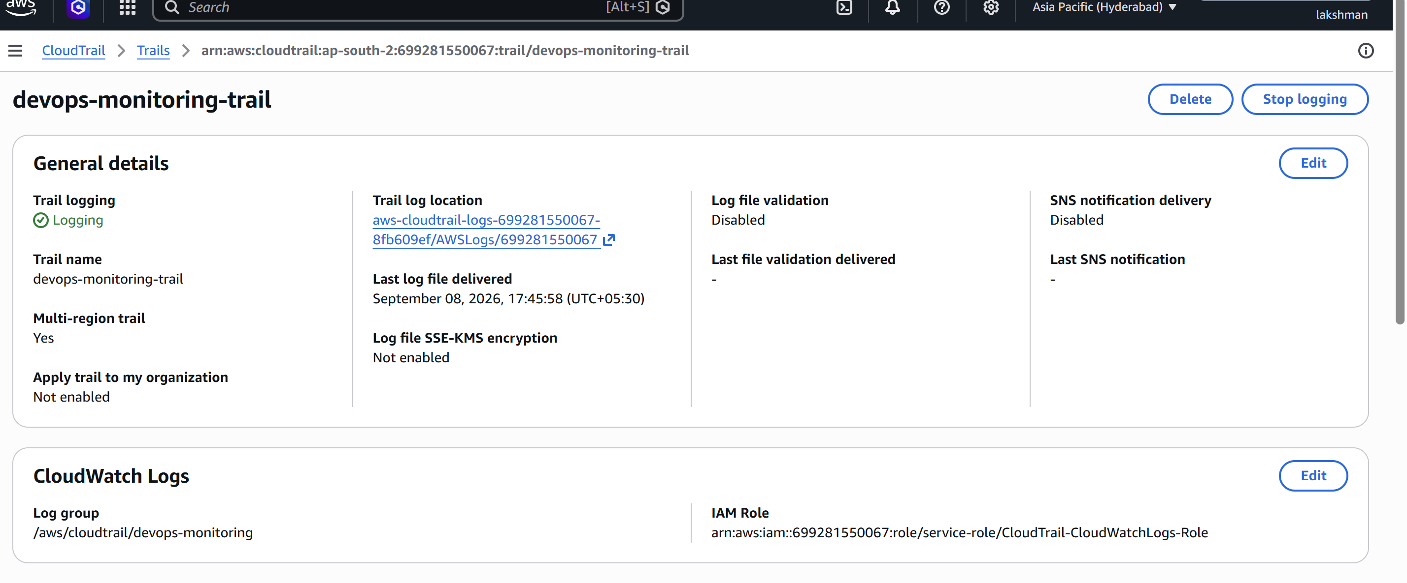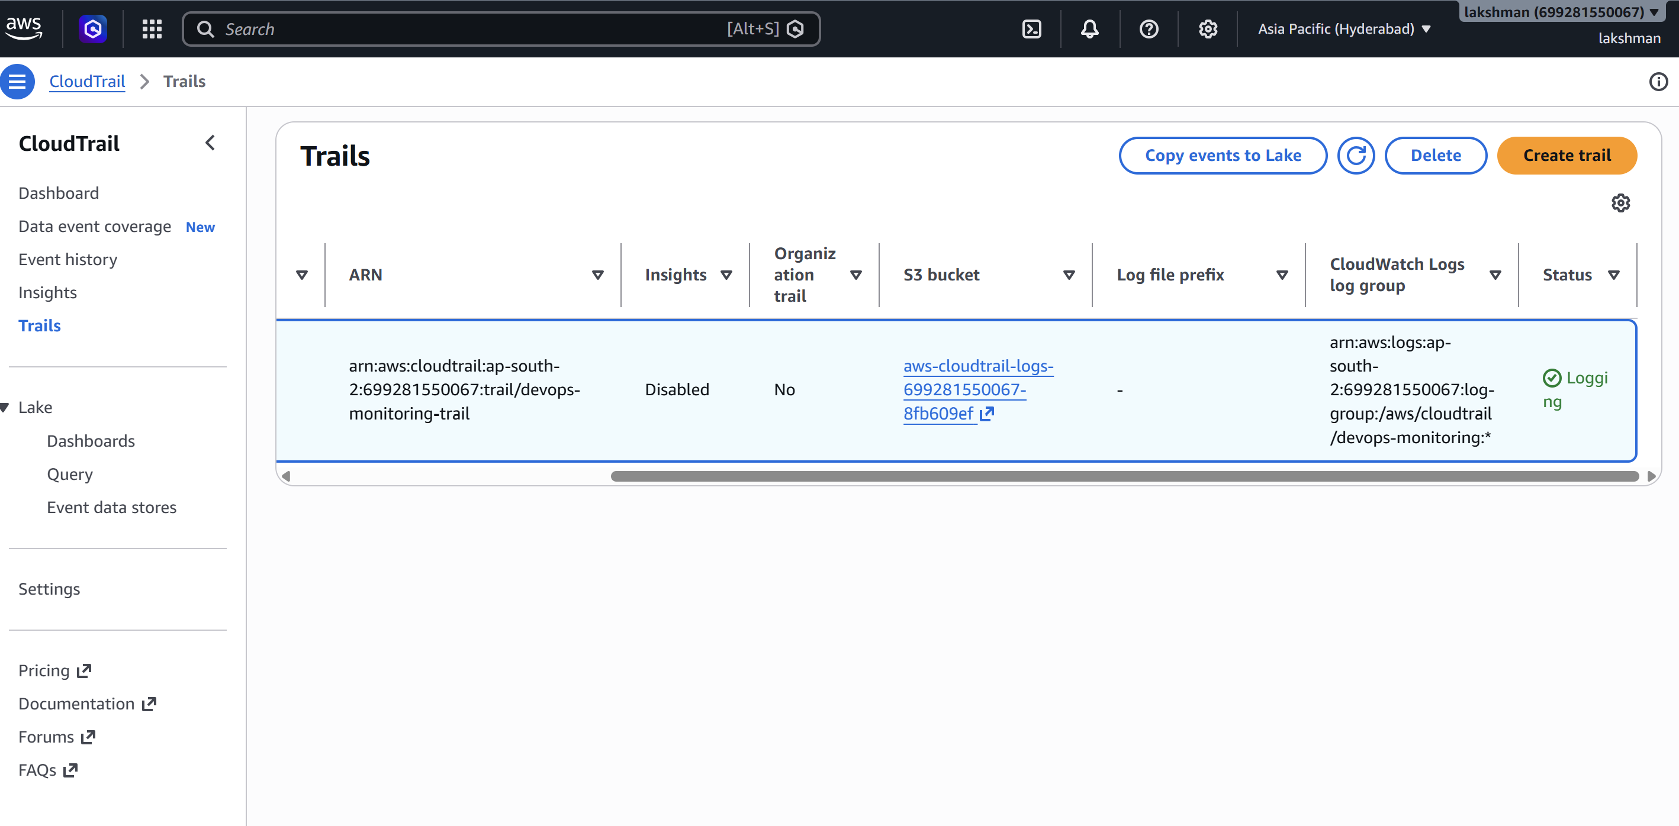
Note: CloudTrail can record management events without requiring a custom CloudWatch Agent. The CloudWatch Logs destination is used for searching, metric filters, and alarms.
5.3 Verify CloudTrail
aws cloudtrail describe-trails --region ap-south-2
aws cloudtrail get-trail-status --name devops-monitoring-trail --region ap-south-2
aws cloudtrail lookup-events --max-results 10 --region ap-south-2
- In S3, verify that CloudTrail creates AWSLogs/<account-id>/... objects after events are delivered.
- In CloudWatch → Logs → Log groups, open /aws/cloudtrail/devops-monitoring and verify events are arriving. 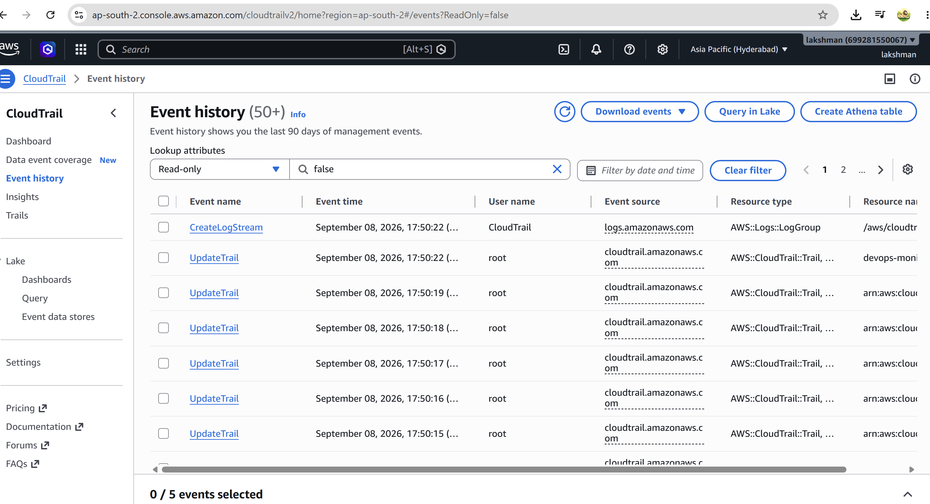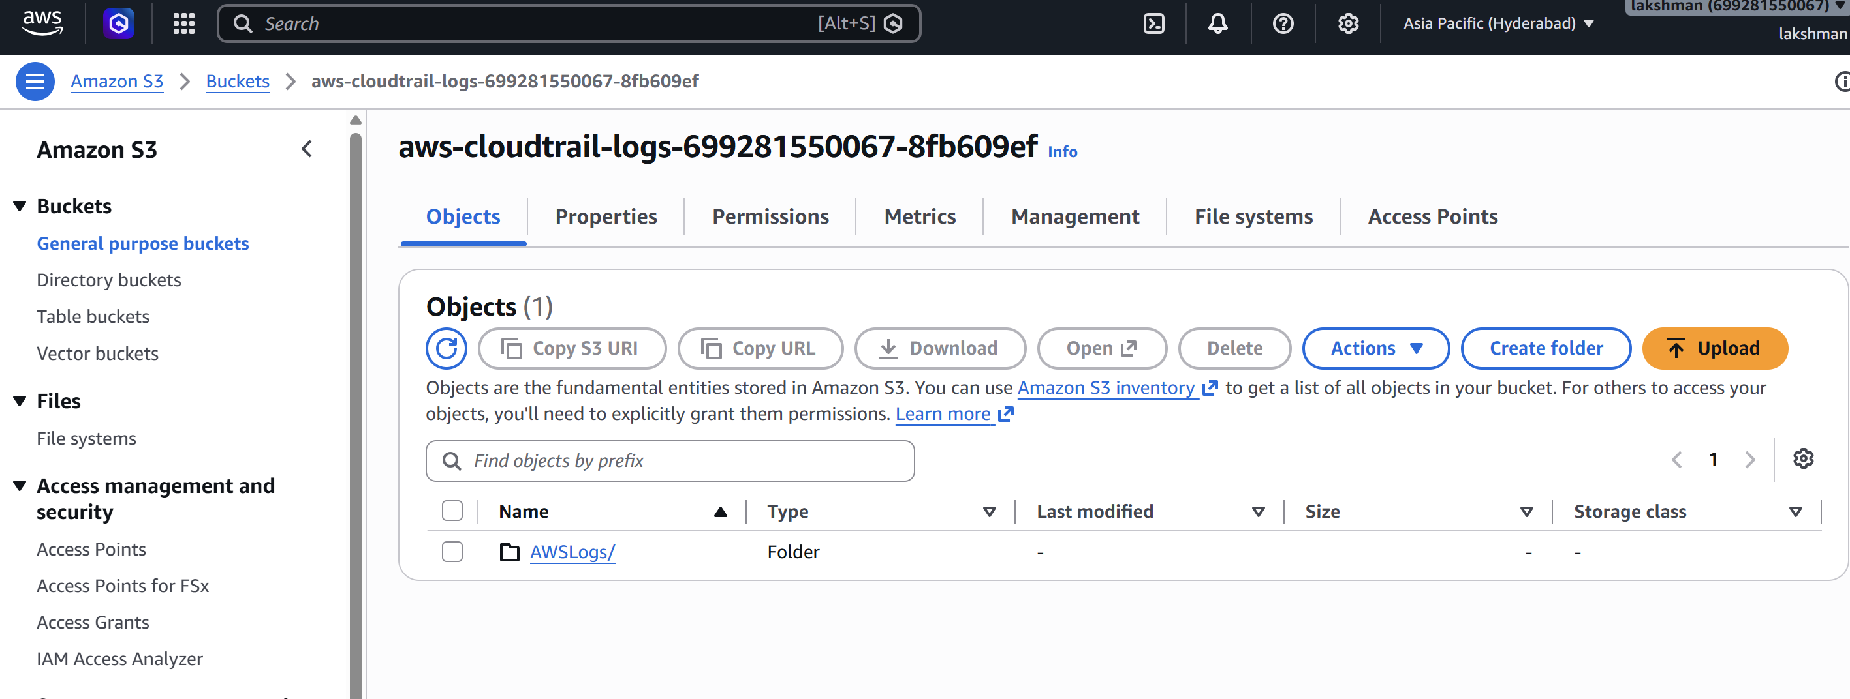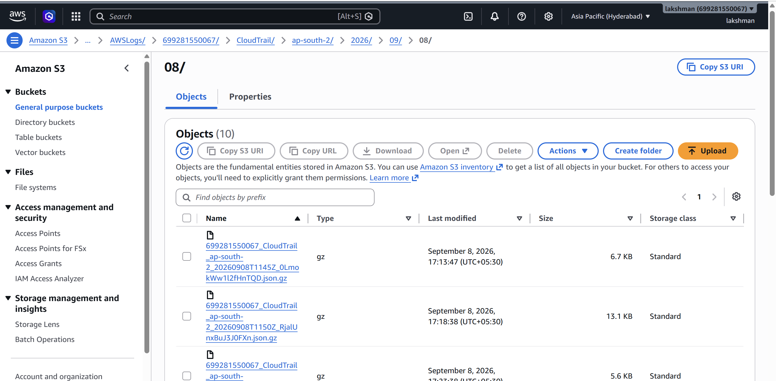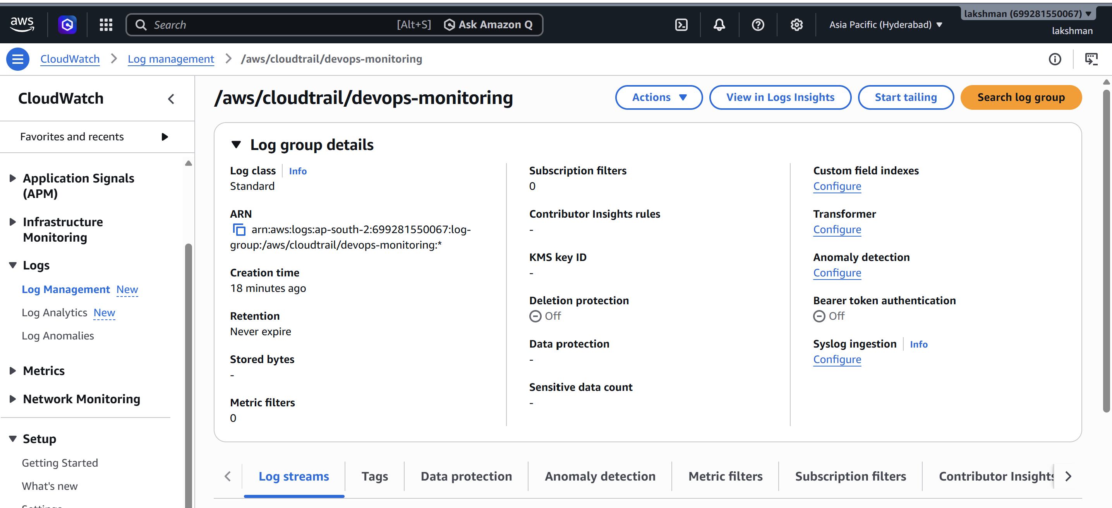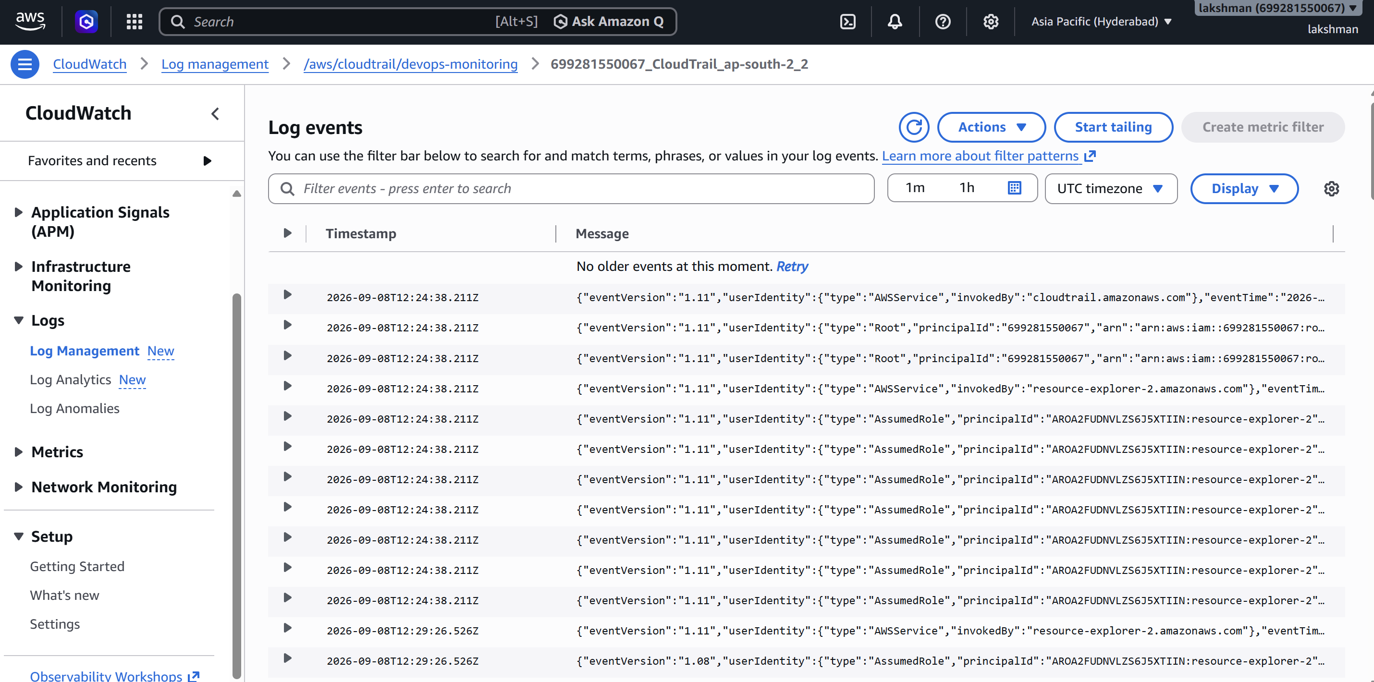6. Task 1A — Configure SNS Email Alerts for CloudTrail Events
6.1 Create SNS topic
- Open AWS Console → Amazon SNS → Topics → Create topic.
- Select Standard topic.
- Topic name: cloudtrail-monitoring-alerts.
- Create the topic. 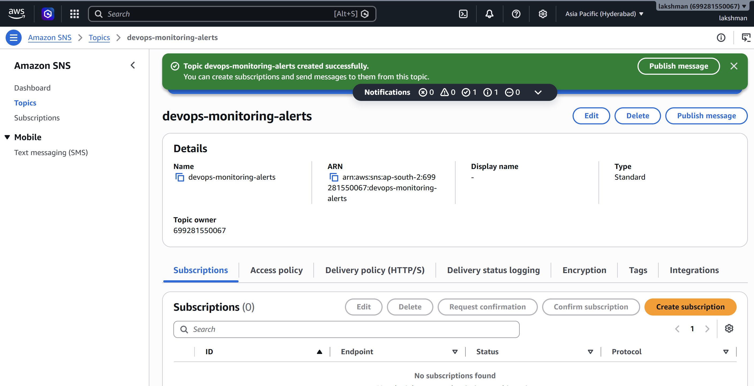
6.2 Create an email subscription
- Open the SNS topic → Create subscription.
- Protocol: Email.
- Endpoint: enter the email address that should receive alerts.
- Create the subscription.
- Open the confirmation email and select Confirm subscription.
Note: SNS email subscriptions do not receive notifications until the subscription is confirmed. 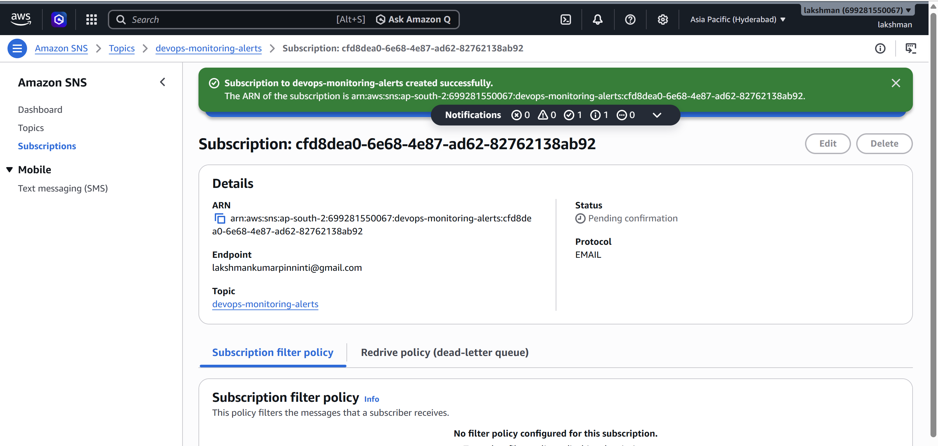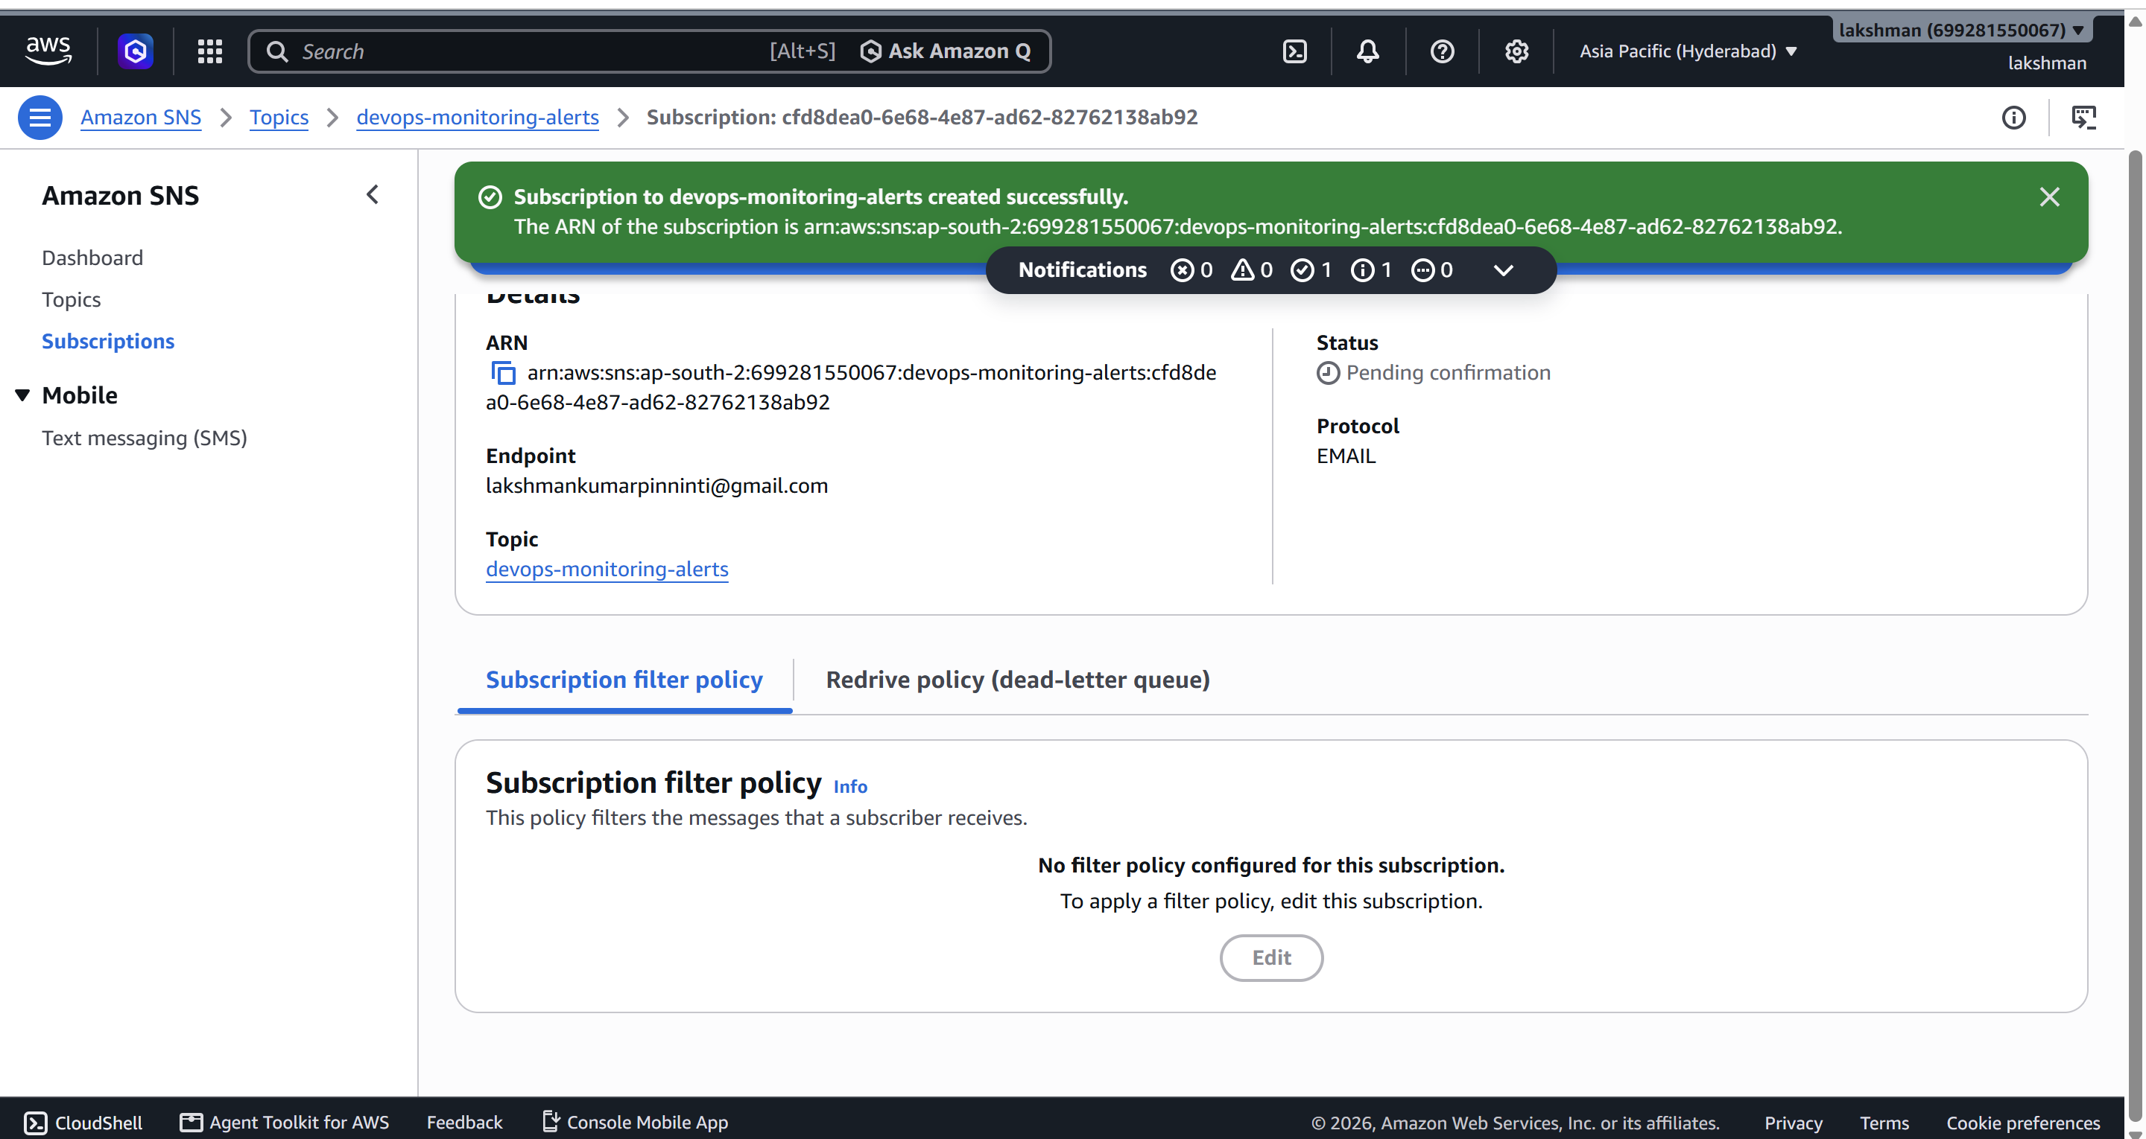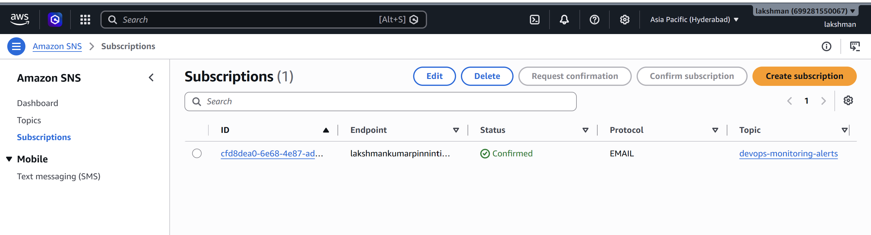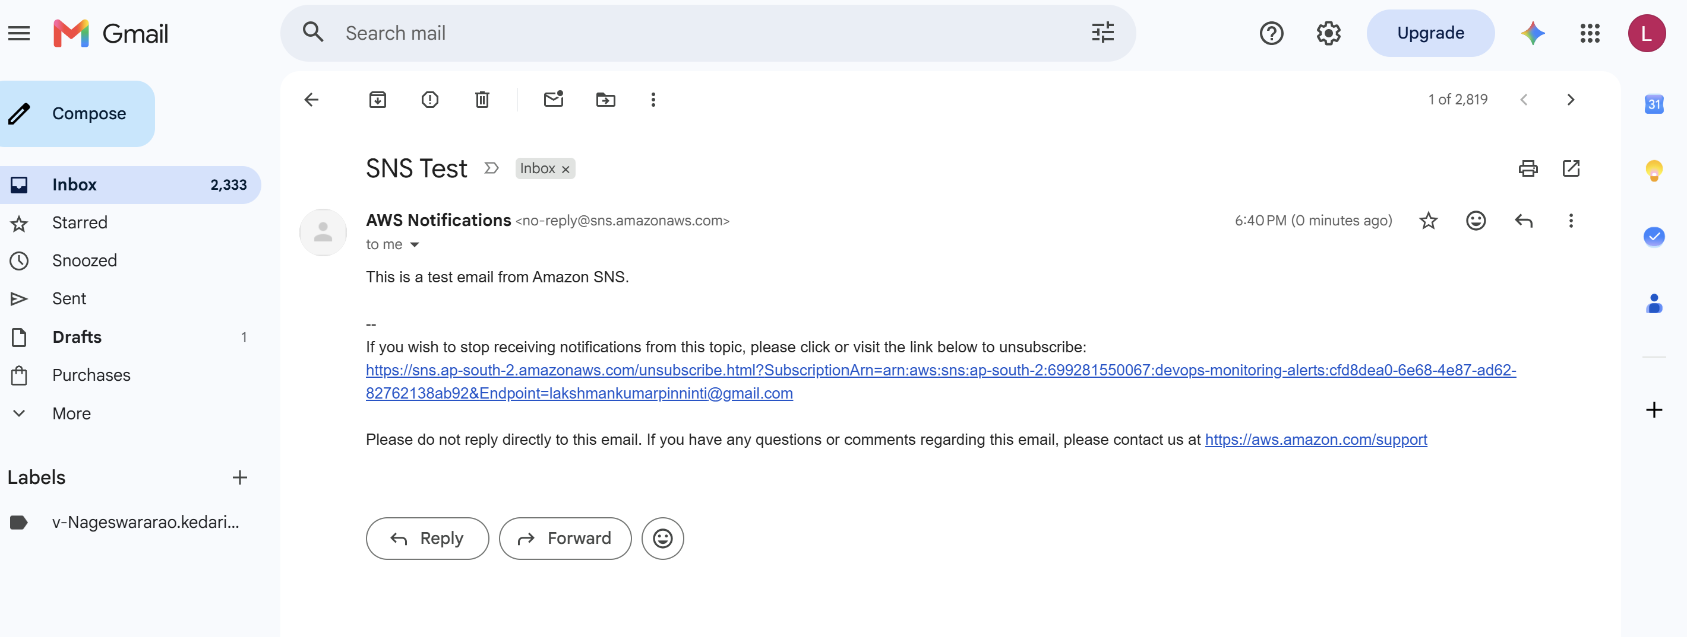
6.3 Send CloudTrail events to SNS
A common design is CloudTrail → CloudWatch Logs → Metric Filter → CloudWatch Alarm → SNS. This allows you to alert on a specific API activity instead of sending every CloudTrail event by email. 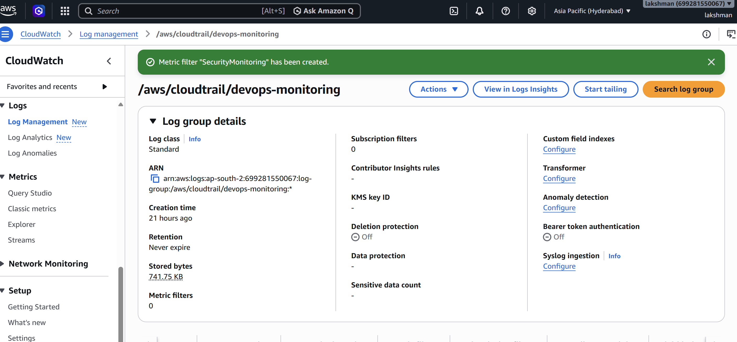
Example: Alert when a security-sensitive API call occurs
- Create a CloudWatch Logs metric filter for a selected CloudTrail event, such as a console login or a security-group modification.
- Create a CloudWatch metric from the filter.
- Create a CloudWatch alarm on that metric.
- Set the alarm action to the SNS topic cloudtrail-monitoring-alerts.
- Test the event and confirm that the email is received. 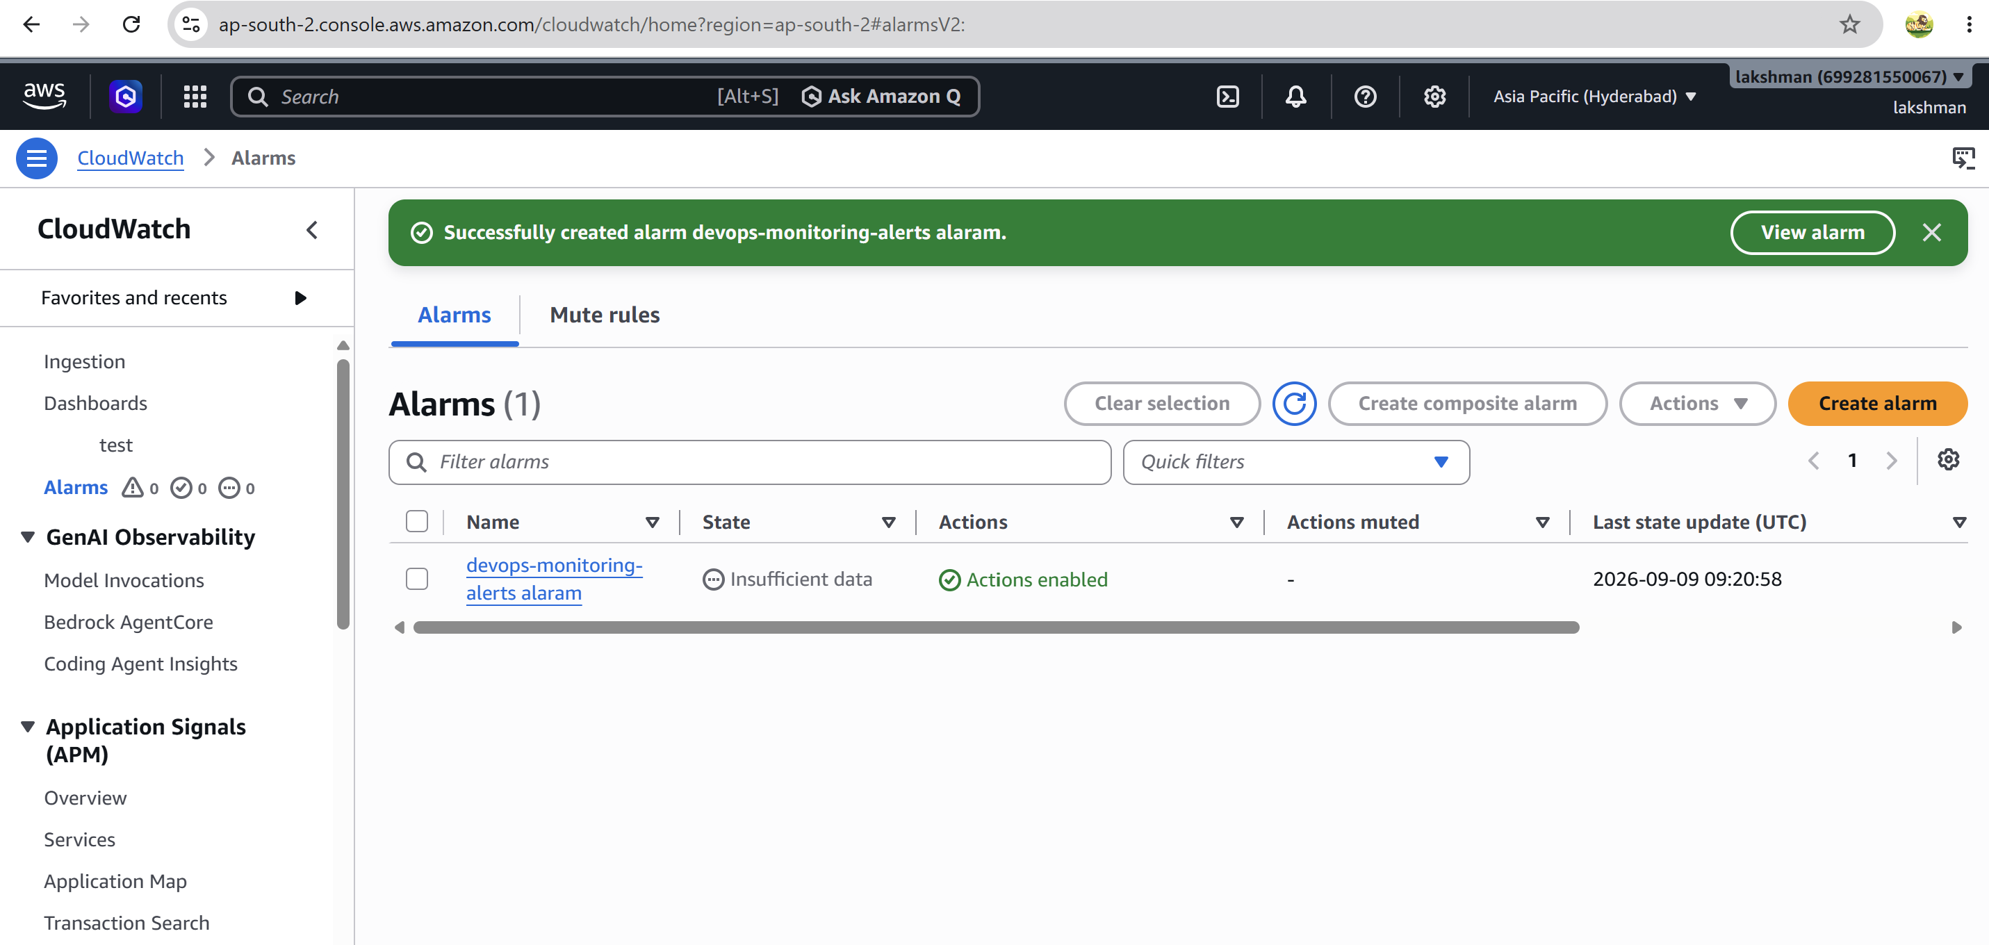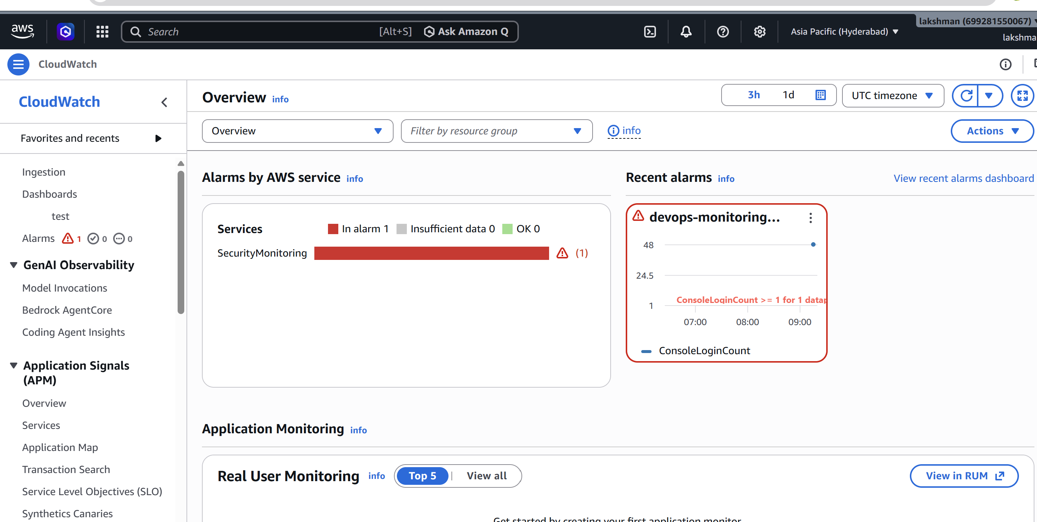
Note: The exact CloudTrail filter pattern should match the event you want to monitor. Avoid alerting on every API event because that can create excessive notifications.
7. Task 2 — Configure CloudWatch Monitoring for EC2 CPU and Other Metrics
7.1 Standard EC2 metrics
- CPUUtilization
- NetworkIn
- NetworkOut
- DiskReadOps
- DiskWriteOps
- StatusCheckFailed
- StatusCheckFailed_Instance
- StatusCheckFailed_System
Note: Standard EC2 metrics are available in CloudWatch without installing the CloudWatch Agent. Additional operating-system metrics such as memory and disk-space utilization generally require the CloudWatch Agent.
7.2 Open the EC2 metrics
- Open AWS Console → CloudWatch → Metrics.
- Choose EC2 → Per-Instance Metrics.
- Select the required instance.
- Choose CPUUtilization and other metrics.
- Set an appropriate time range, such as 1 hour or 3 hours.
- Use Statistic = Average for CPU monitoring unless your requirement calls for another statistic.
7.3 Install and configure CloudWatch Agent for additional metrics
- Attach an IAM role to the EC2 instance with the permissions required by the CloudWatch Agent.
- Install the CloudWatch Agent package for your Linux distribution.
- Configure collection of memory, disk, swap, and process metrics.
- Start and enable the CloudWatch Agent.
- Verify that custom/agent metrics appear under CloudWatch Metrics.
sudo systemctl status amazon-cloudwatch-agent
sudo systemctl enable amazon-cloudwatch-agent
sudo systemctl start amazon-cloudwatch-agent
Note: Use the current CloudWatch Agent installation method for your operating system. Package names and configuration paths can differ between Ubuntu and Amazon Linux.
8. Task 3 — Create an Alarm for EC2 CPU Utilization > 70%
8.1 Console steps
- Open CloudWatch → Alarms → All alarms → Create alarm.
- Select the EC2 instance and the CPUUtilization metric.
- Statistic: Average.
- Period: 5 minutes.
- Condition: CPUUtilization > 70%.
- Evaluation periods: 1 for a simple lab, or increase it to reduce transient alerts.
- For notification, choose the SNS topic cloudtrail-monitoring-alerts.
- Enter alarm name: EC2-CPU-Above-70.
- Create the alarm. 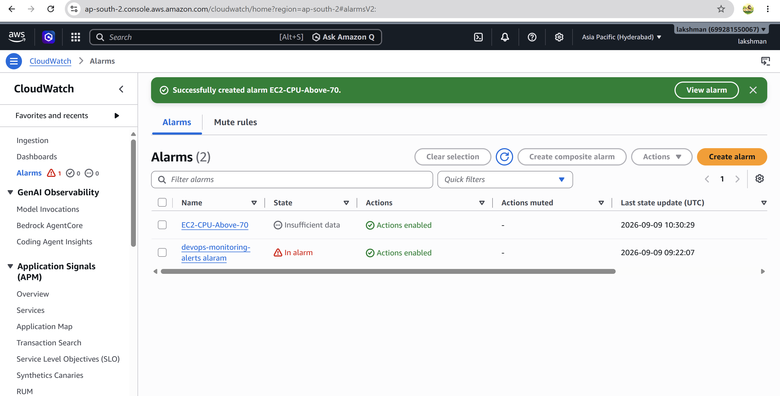
8.2 Test the CPU alarm
- Generate controlled CPU load on the EC2 instance only for testing.
- Watch CloudWatch → Alarms and confirm the alarm changes to ALARM when the configured condition is met.
- Confirm the SNS email is received.
- Stop the load and wait for the metric to return below the threshold.
Note: For production systems, use multiple evaluation periods and a suitable datapoint configuration to reduce false 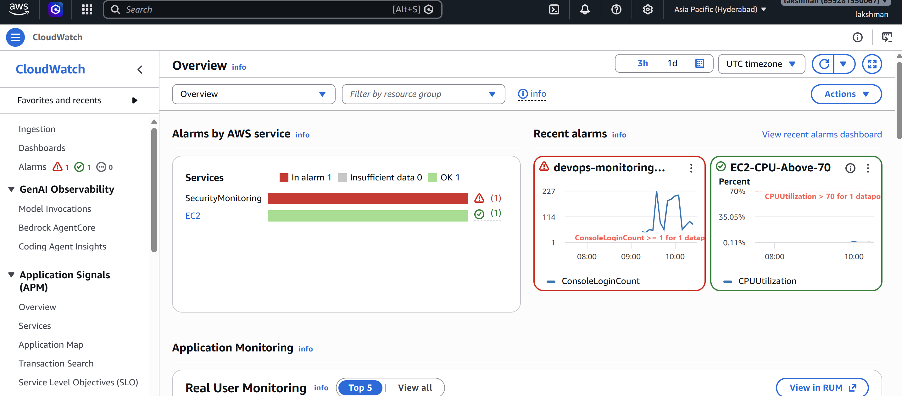positives.
9. Task 4 — Dashboard to Monitor Tomcat Service and Send an Alert
9.1 Important design point
CloudWatch's standard EC2 metrics do not directly tell you whether the Linux Tomcat service is active. Use the CloudWatch Agent with process/service monitoring, or publish a custom 1/0 health metric. A simple and reliable lab design is a scheduled health-check script that publishes 1 when Tomcat is running and 0 when it is not.
9.2 Create a Tomcat health metric
#!/bin/bash
if systemctl is-active --quiet tomcat; then
VALUE=1
else
VALUE=0
fi
aws cloudwatch put-metric-data \
--namespace "Custom/Services" \
--metric-name "TomcatStatus" \
--dimensions "InstanceId=$(curl -s http://169.254.169.254/latest/meta-data/instance-id)" \
--value "$VALUE" \
--unit Count \
--region ap-south-2 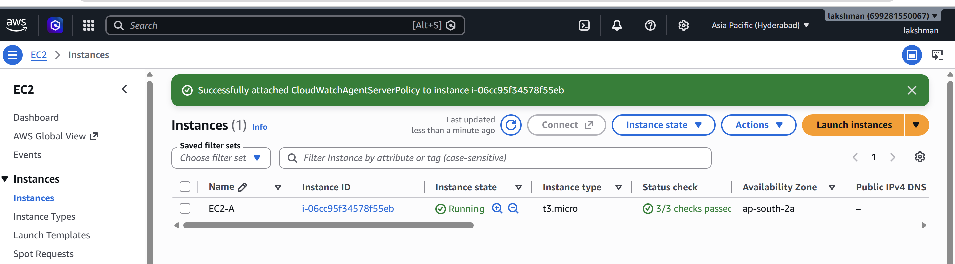 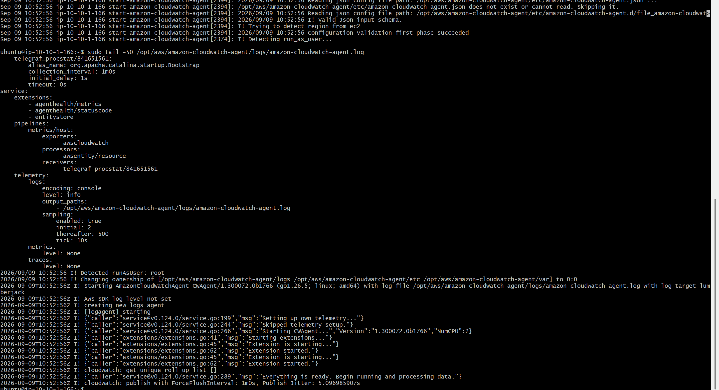 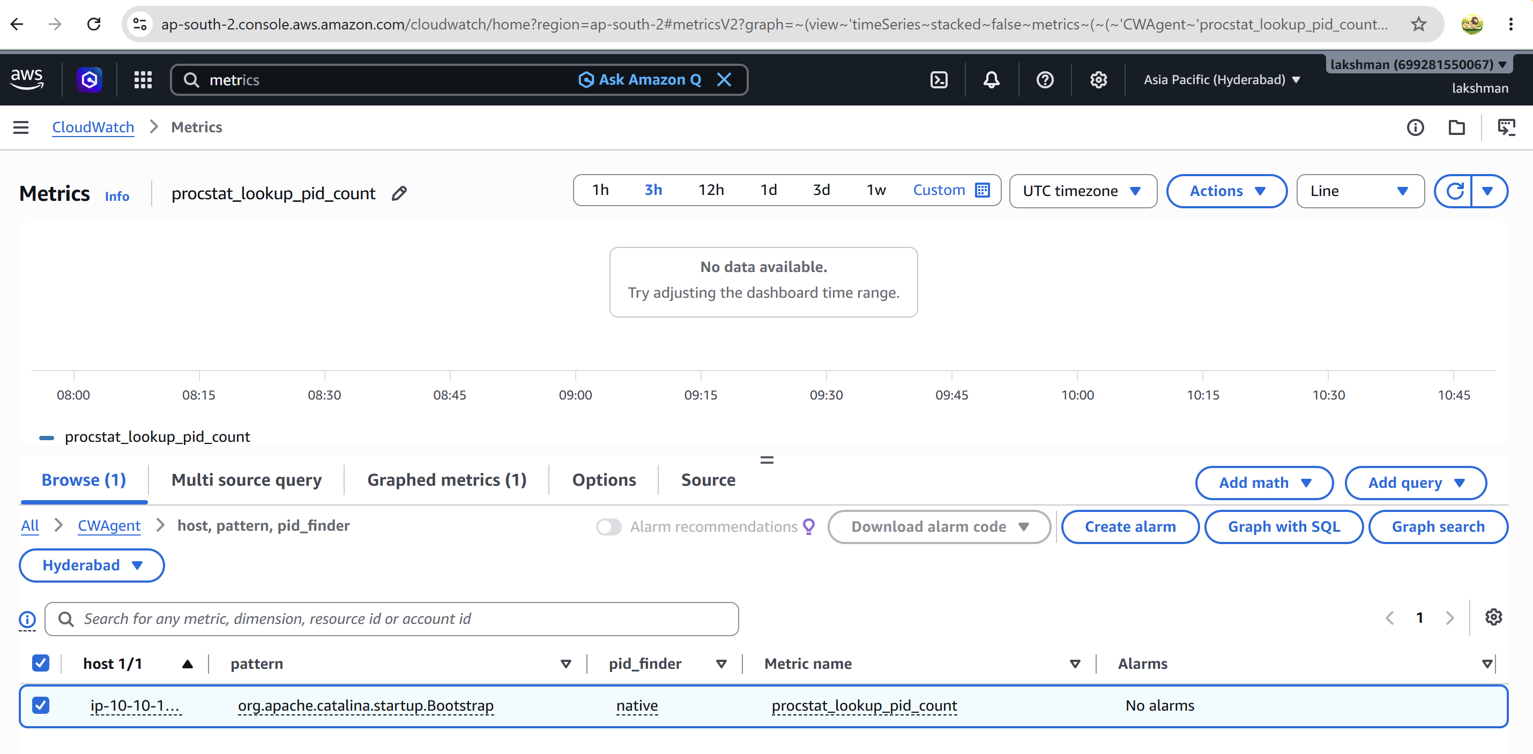
Note: If your service unit is named differently, replace tomcat with the actual systemd service name, such as tomcat.service.
9.3 Schedule the health check
- Save the script, for example as /usr/local/bin/check-tomcat.sh.
sudo chmod +x /usr/local/bin/check-tomcat.sh
- Schedule it with cron or a systemd timer to publish the metric every minute.
* * * * * /usr/local/bin/check-tomcat.sh
Note: The AWS CLI used by the script needs permission to perform cloudwatch:PutMetricData. Prefer an EC2 IAM role rather than hard-coded access keys. 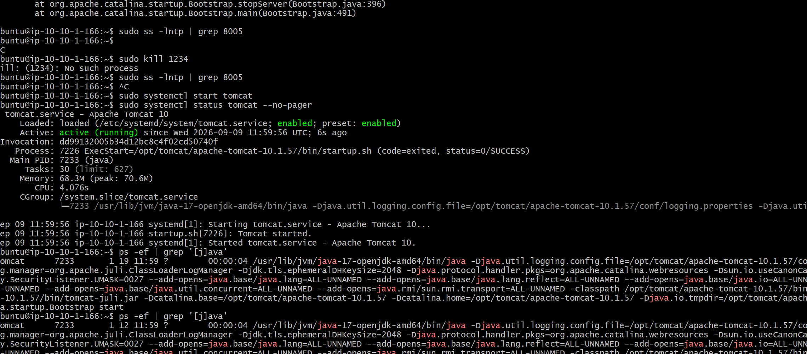
9.4 Create the Tomcat alarm
- CloudWatch → Alarms → Create alarm.
- Select Custom/Services → TomcatStatus.
- Condition: TomcatStatus < 1.
- Set an evaluation period appropriate for the one-minute metric.
- Select the SNS topic cloudtrail-monitoring-alerts.
- Alarm name: Tomcat-Service-Down.
- Create the alarm.
9.5 Create the dashboard
- CloudWatch → Dashboards → Create dashboard.
- Dashboard name: DevOps-Monitoring-Dashboard.
- Add a metric widget.
- Add TomcatStatus for the required EC2 instance.
- Use a line/number widget so 1 = Running and 0 = Not Running.
- Add the Tomcat-Service-Down alarm widget to the dashboard.
- Save the dashboard.
9.6 Test Tomcat monitoring
sudo systemctl status tomcat
sudo systemctl stop tomcat
- Wait for the next health-check datapoint and CloudWatch evaluation.
- Confirm TomcatStatus becomes 0.
- Confirm the Tomcat-Service-Down alarm enters ALARM.
- Confirm the SNS email is received.
sudo systemctl start tomcat 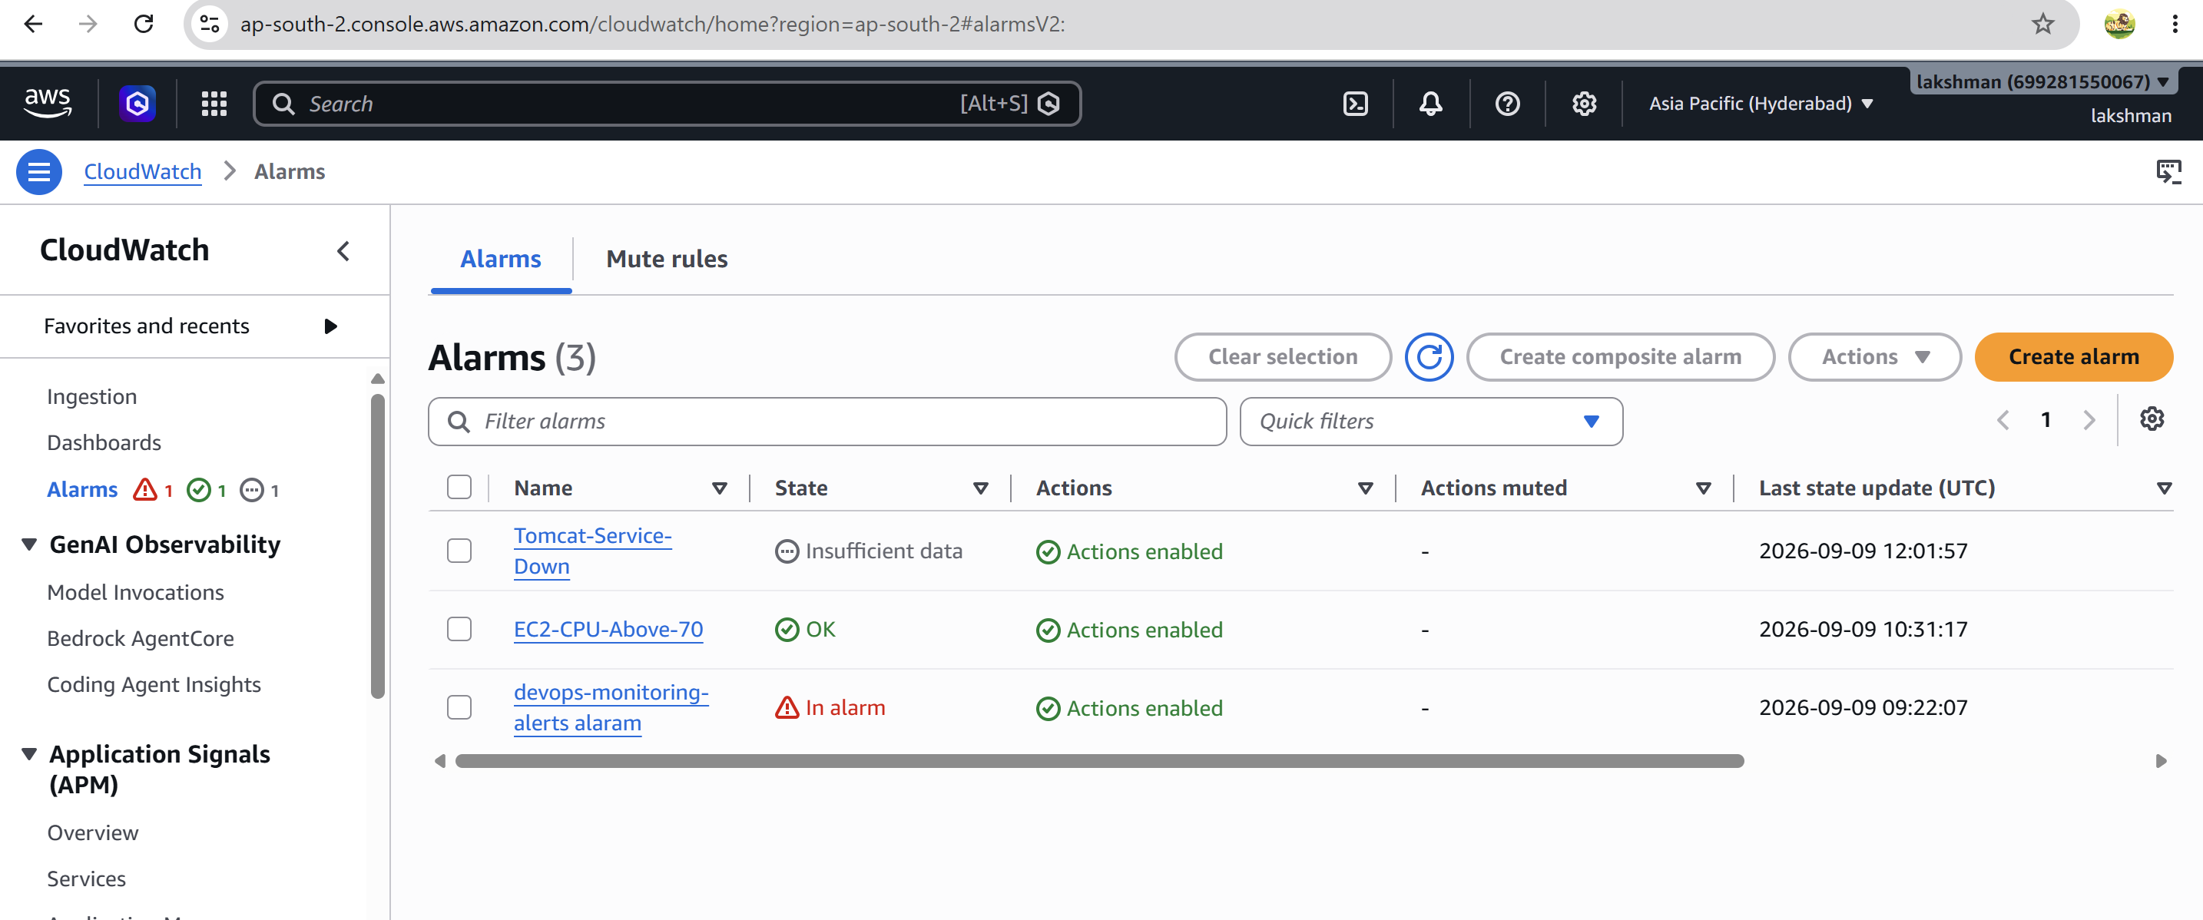
10. Task 5 — Dashboard to Monitor Nginx and Alert if Nginx Stops
10.1 Create an Nginx health metric
#!/bin/bash
if systemctl is-active --quiet nginx; then
VALUE=1
else
VALUE=0
fi
aws cloudwatch put-metric-data \
--namespace "Custom/Services" \
--metric-name "NginxStatus" \
--dimensions "InstanceId=$(curl -s http://169.254.169.254/latest/meta-data/instance-id)" \
--value "$VALUE" \
--unit Count \
--region ap-south-2
Note: The AWS CLI needs cloudwatch:PutMetricData permission through the EC2 instance role. 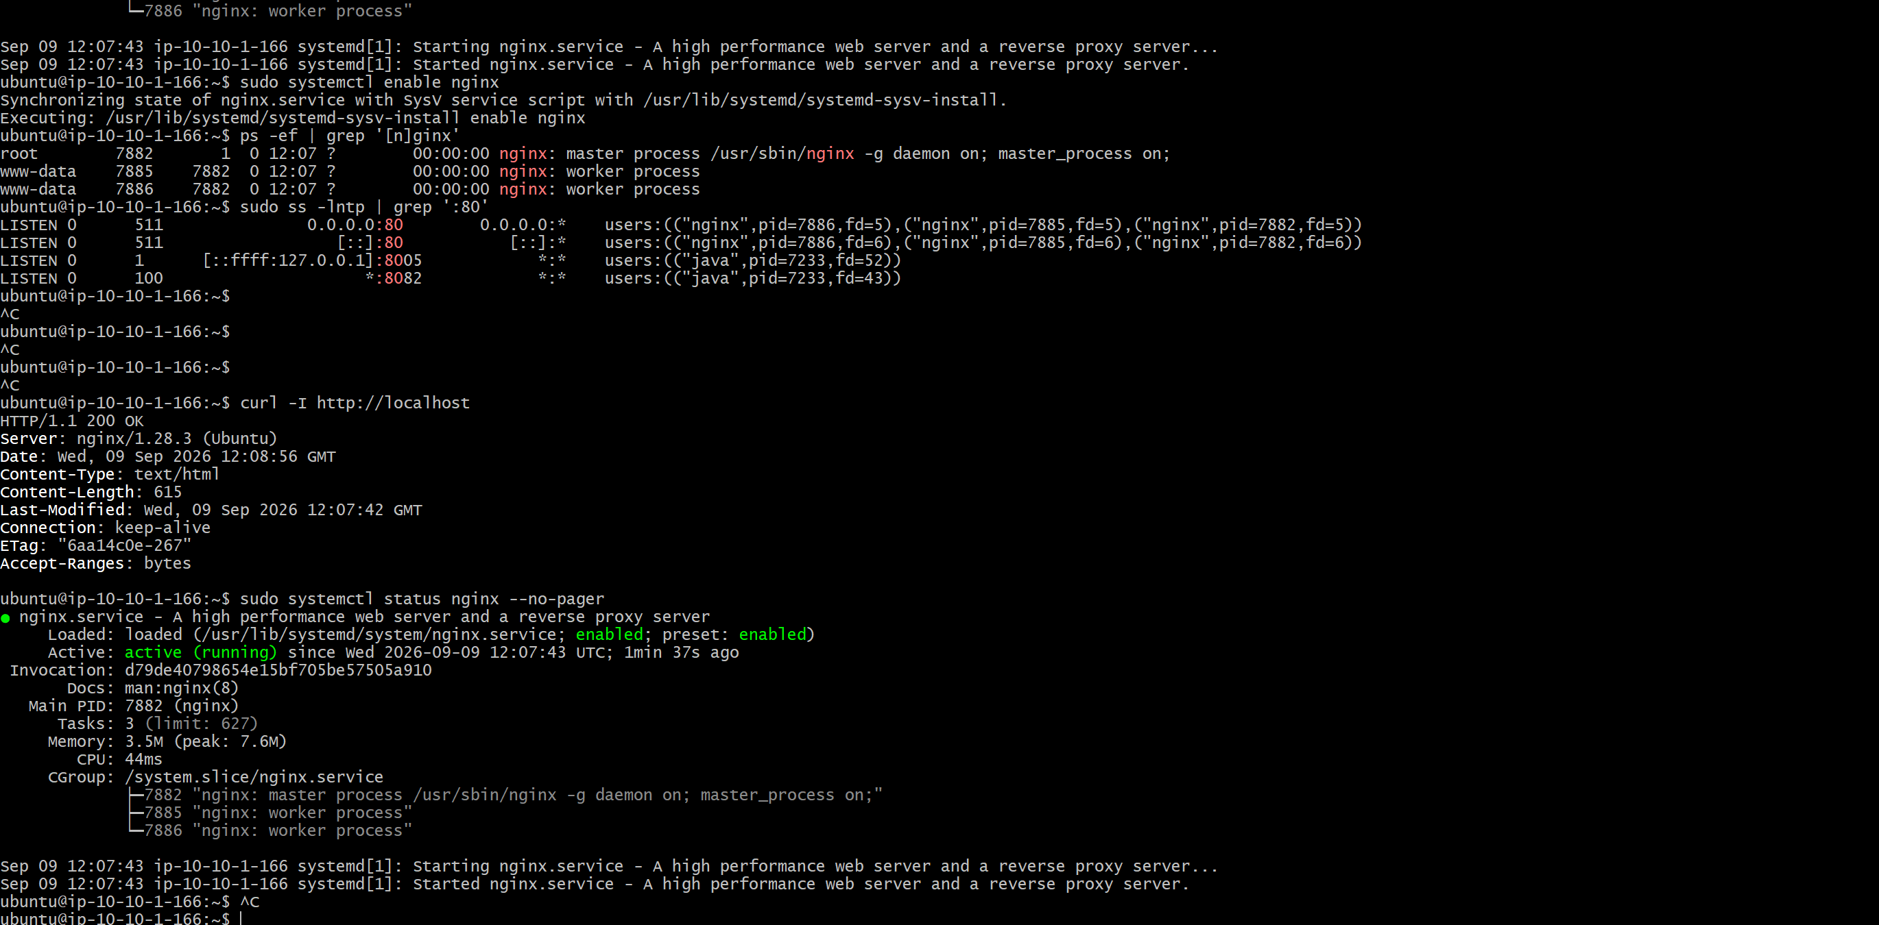 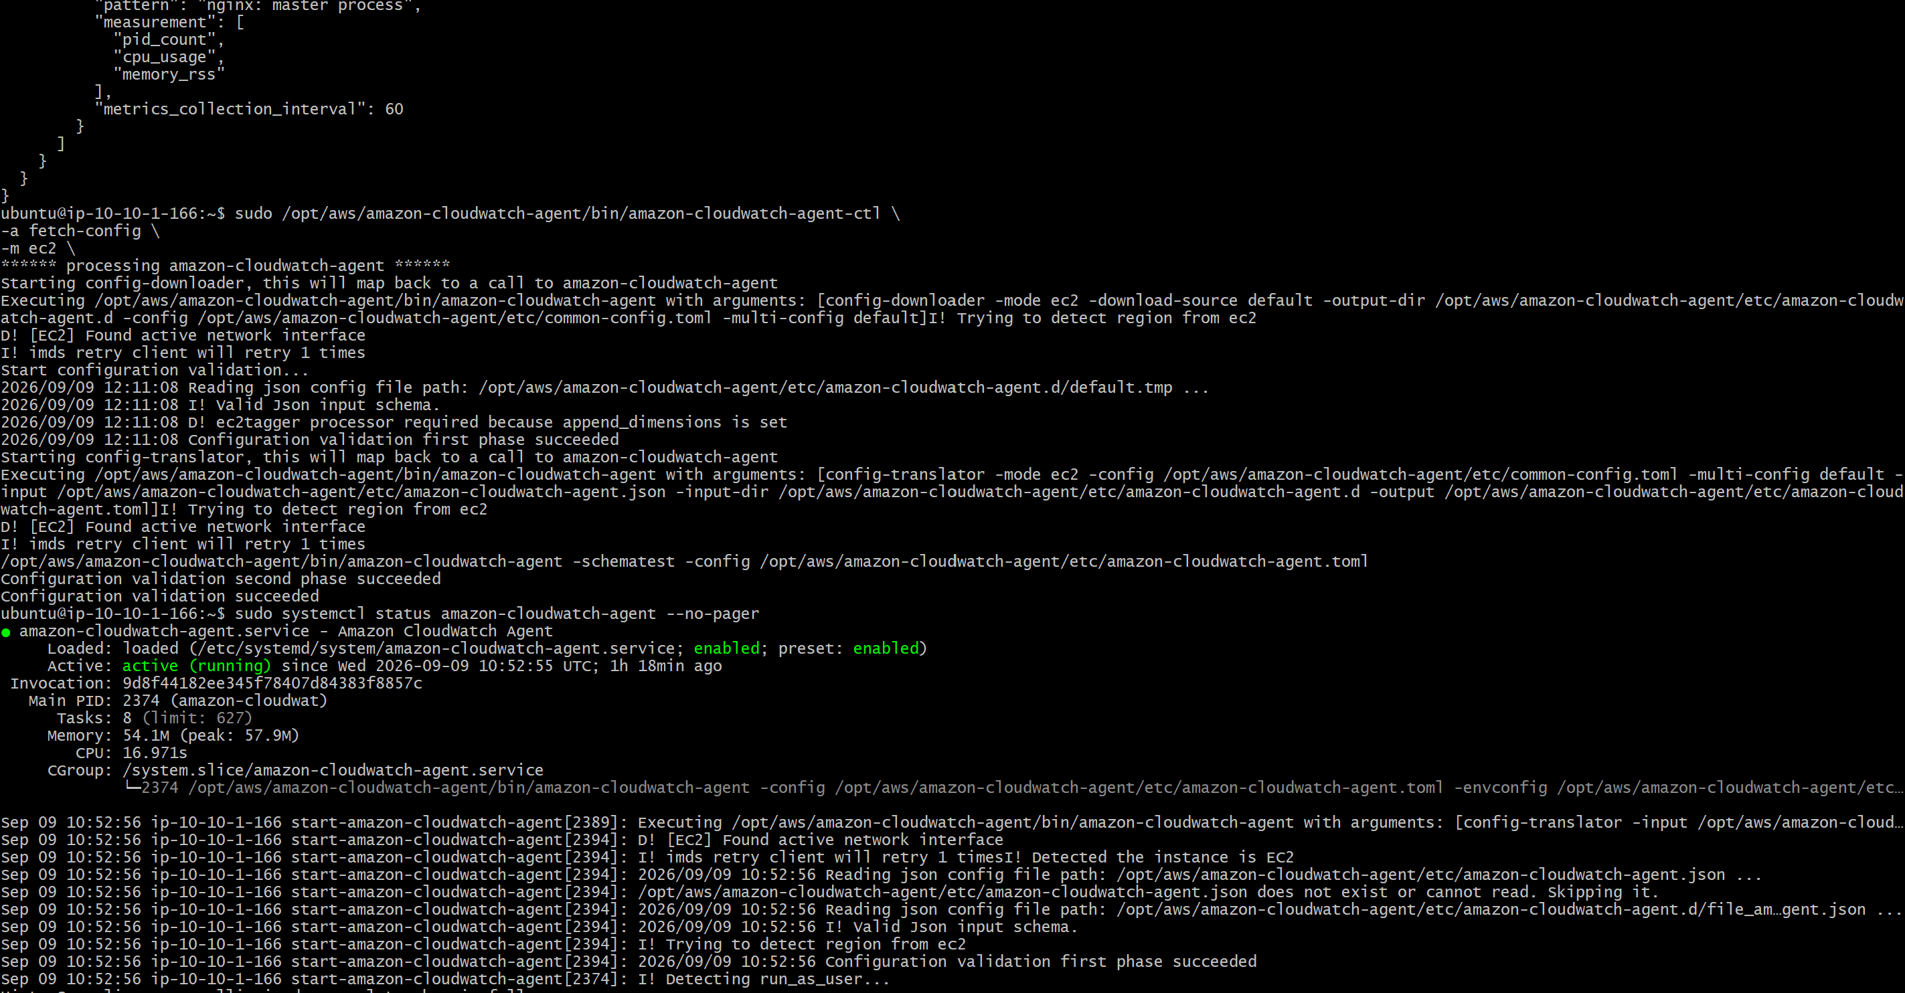
10.2 Schedule the Nginx health check
- Save the script as /usr/local/bin/check-nginx.sh.
sudo chmod +x /usr/local/bin/check-nginx.sh
* * * * * /usr/local/bin/check-nginx.sh
Note: Run the script once manually before relying on cron, and verify that the metric appears in CloudWatch.
10.3 Create the Nginx alarm
- CloudWatch → Alarms → Create alarm.
- Select Custom/Services → NginxStatus.
- Condition: NginxStatus < 1.
- Select SNS topic cloudtrail-monitoring-alerts as the alarm action.
- Alarm name: Nginx-Service-Down.
- Create the alarm. 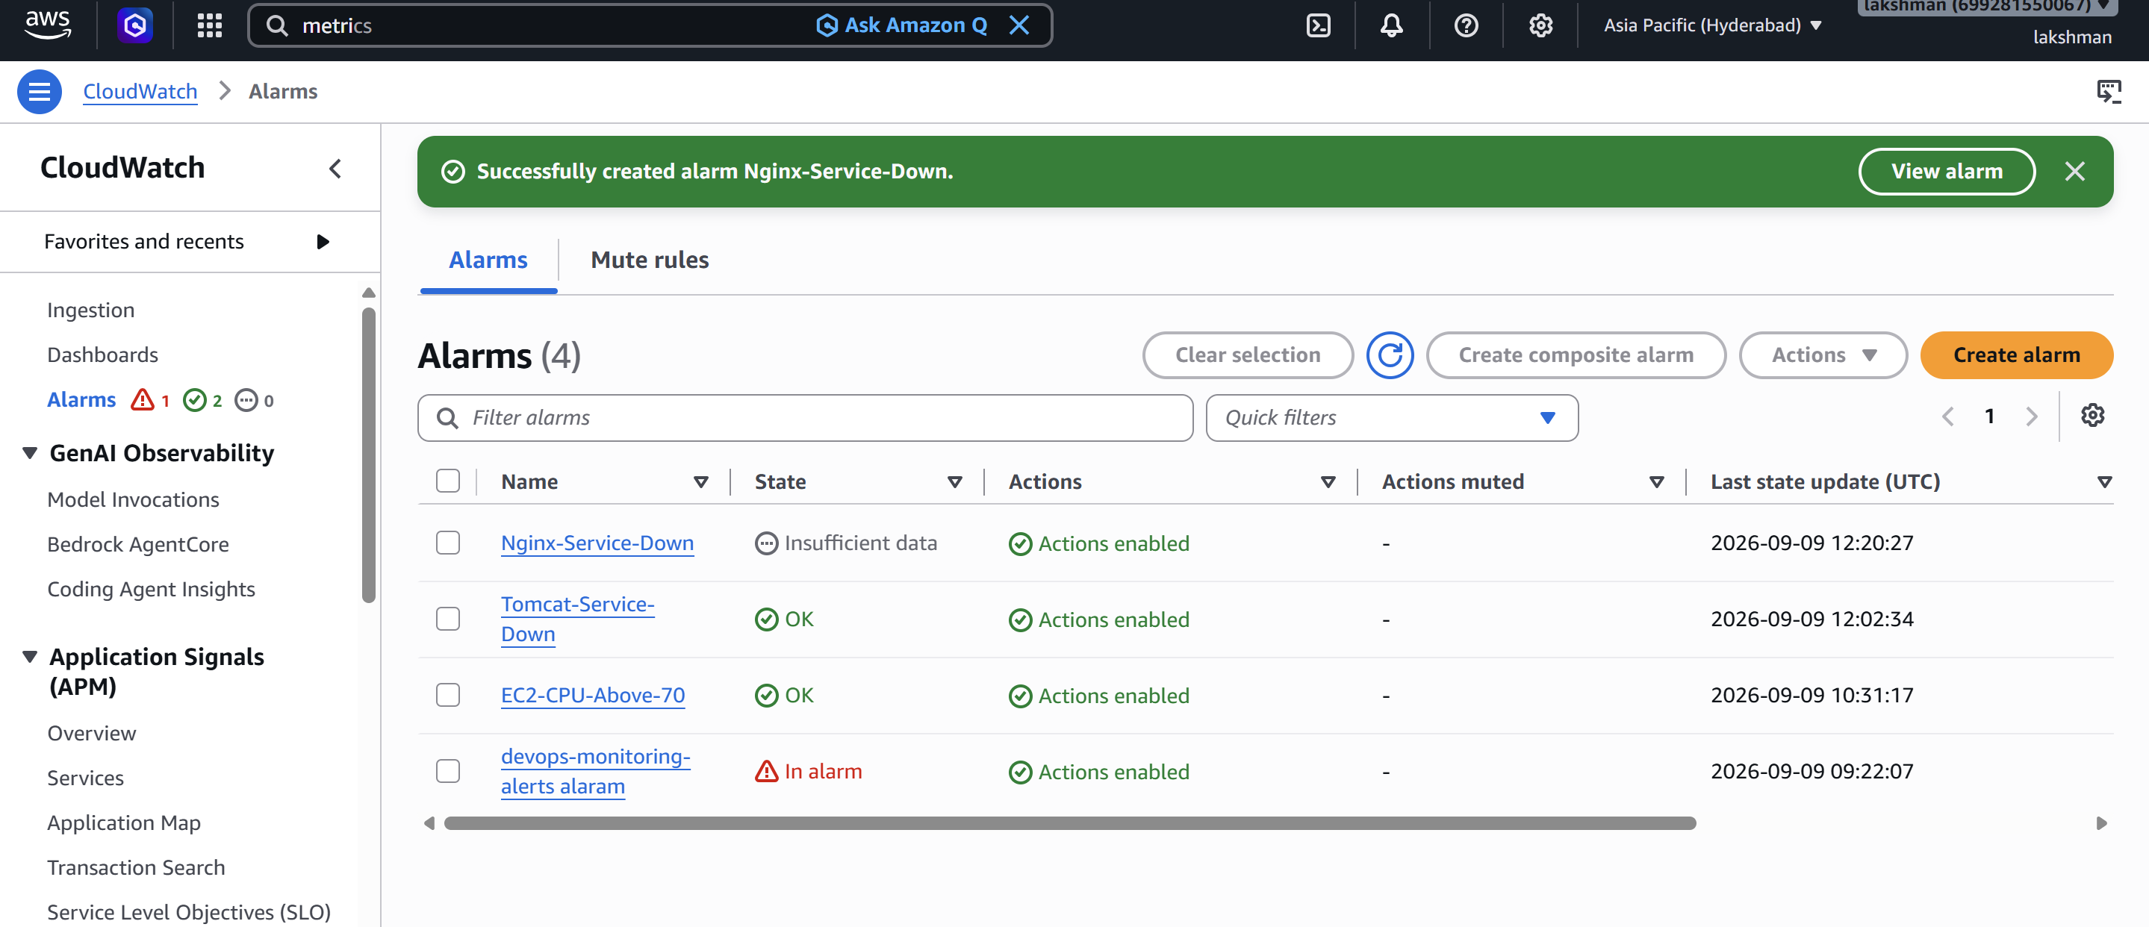
10.4 Add Nginx to the dashboard
- Open DevOps-Monitoring-Dashboard.
- Add NginxStatus as a metric widget.
- Add the Nginx-Service-Down alarm widget.
- Optionally add EC2 CPUUtilization, NetworkIn, NetworkOut, and status-check metrics.
- Save the dashboard. 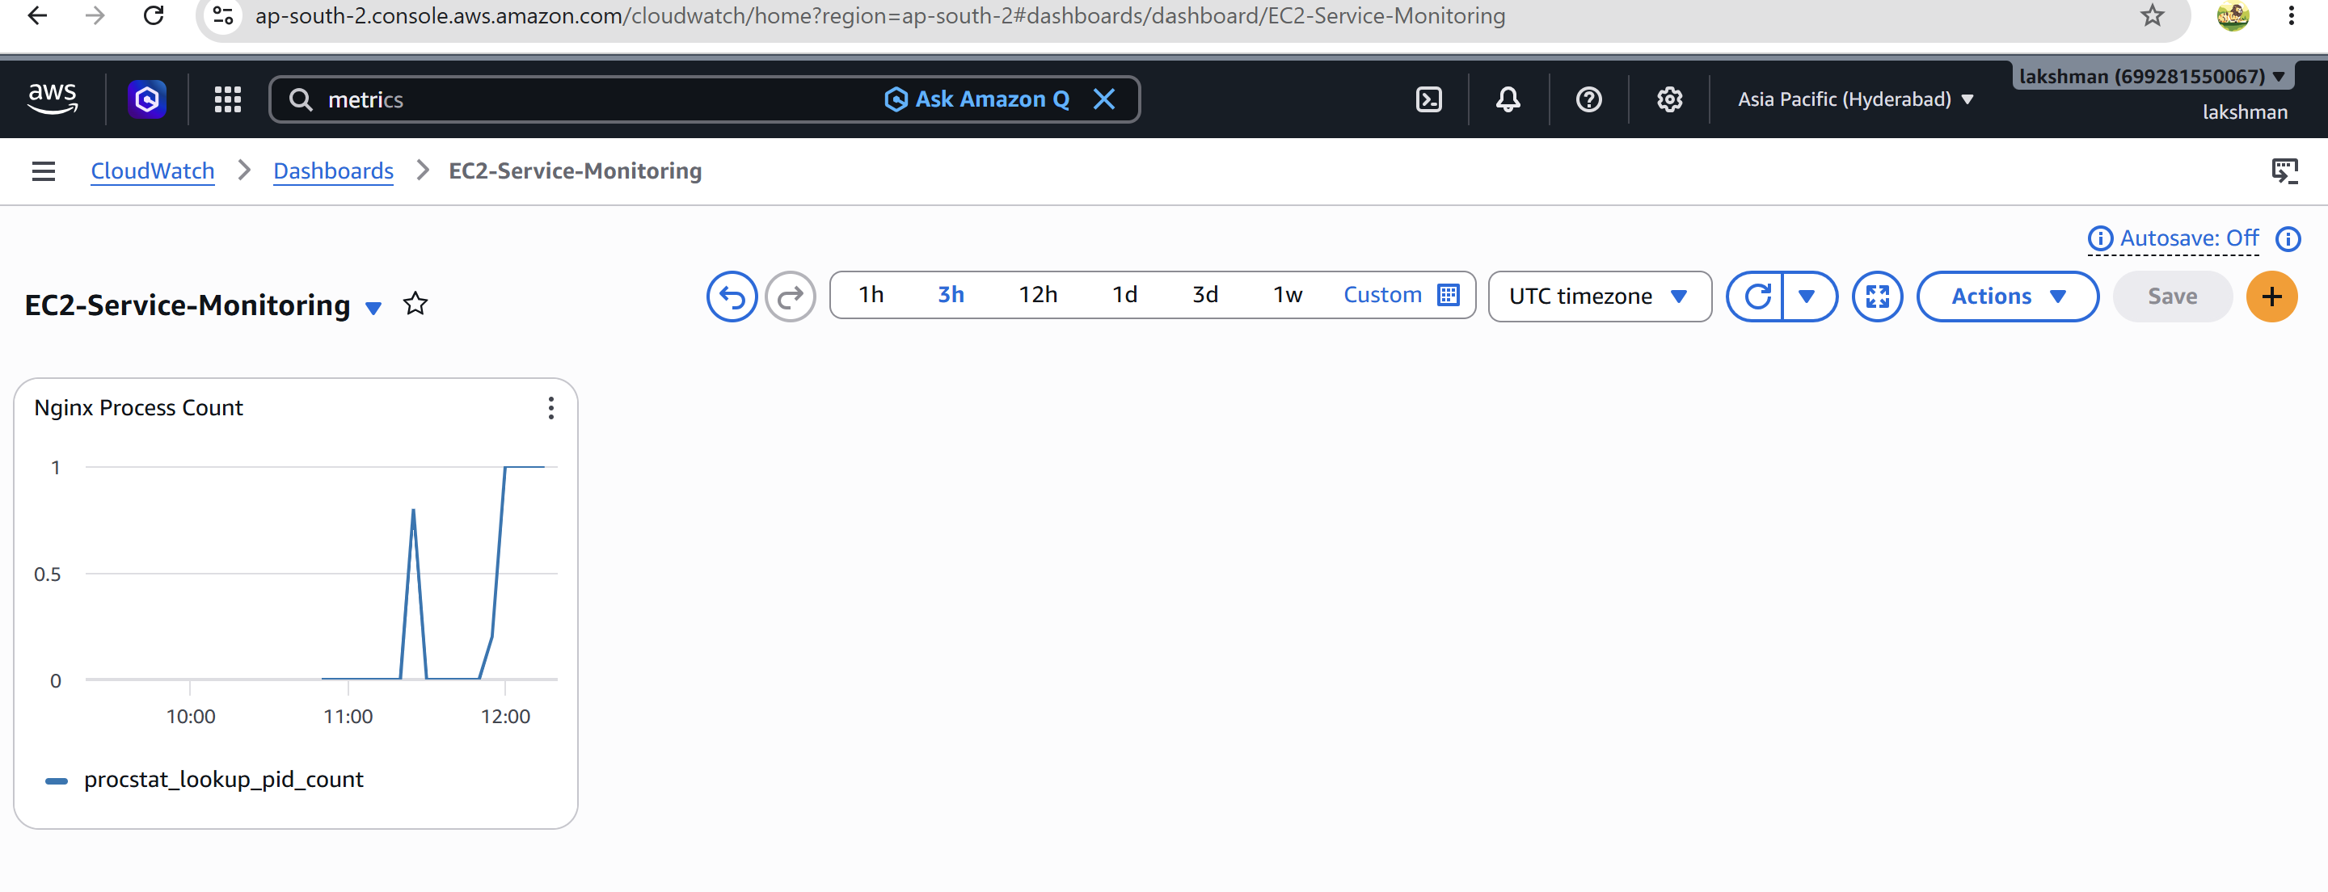 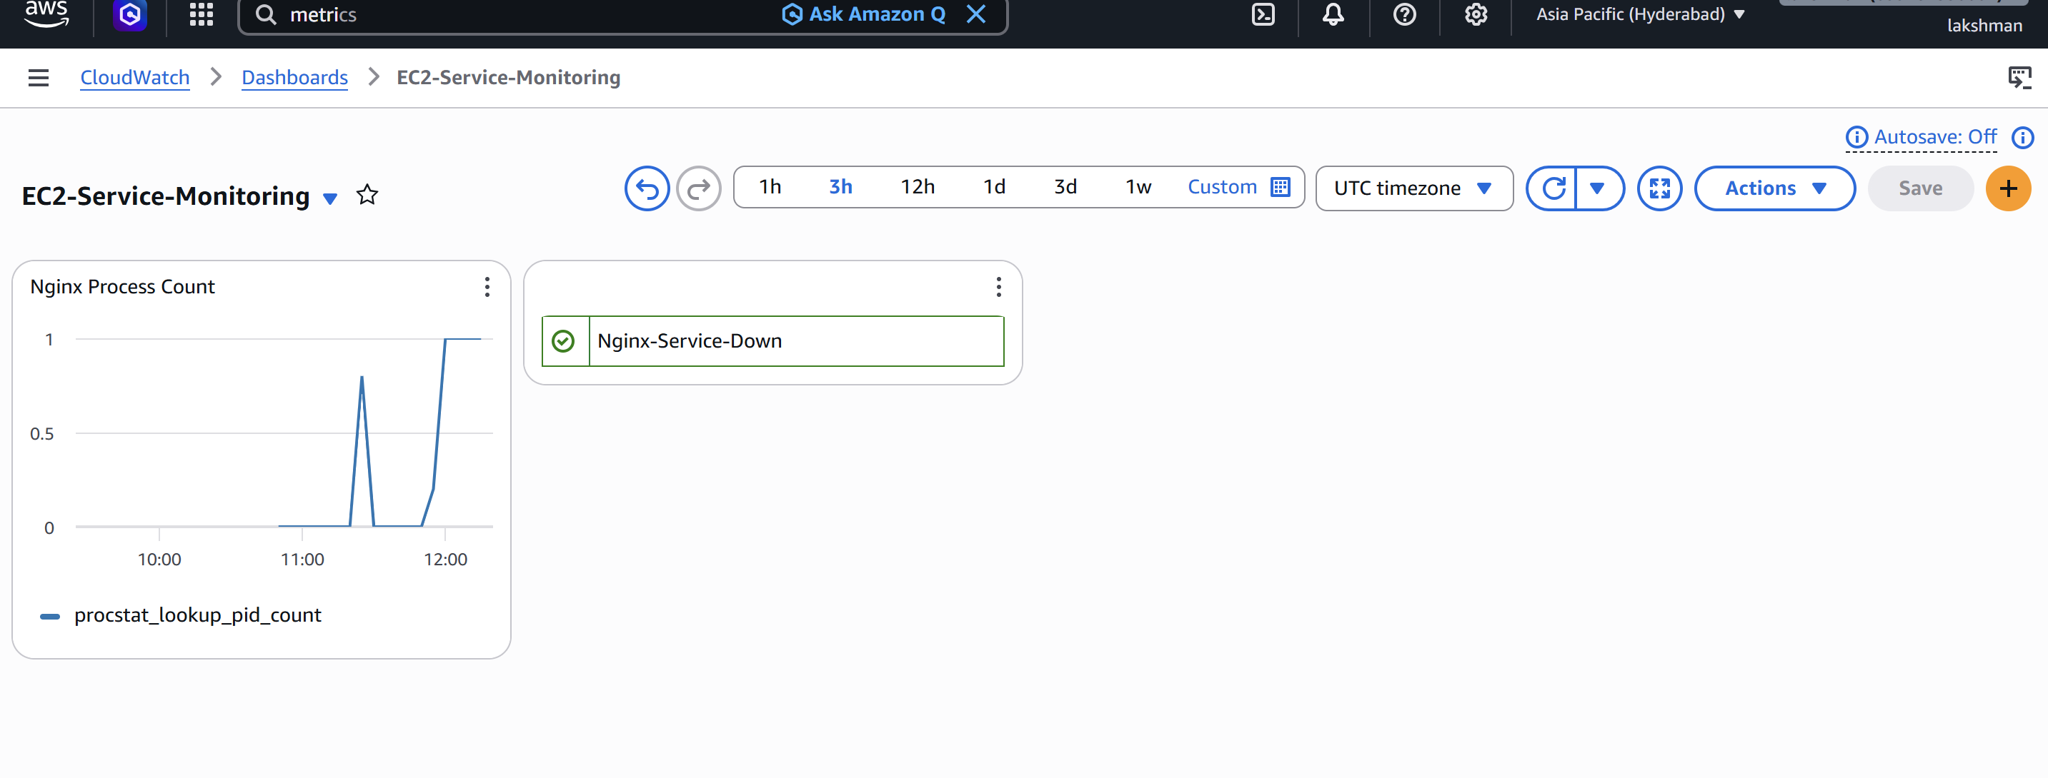
10.5 Test Nginx monitoring
sudo systemctl status nginx
sudo systemctl stop nginx
- Verify NginxStatus becomes 0.
- Verify Nginx-Service-Down changes to ALARM.
- Verify SNS email notification is received. 