🔥 Git Challenges
Practical Git & GitHub Hands-on Exercises
1. Resolve Merge Conflicts
Objective: Intentionally create a merge conflict by having two branches modify the same line, resolve the conflict, and push the resolved changes.

Steps:
1. Create a feature branch.
2. Modify the same line in the feature branch and in main.
3. Commit both changes.
4. Merge the feature branch into main.
5. Open the conflicted file and identify <<<<<<<, =======, and >>>>>>> markers.
6. Edit the file to keep the correct final content.
7. Run git add <file> and git commit.
8. Push the resolved main branch to GitHub. 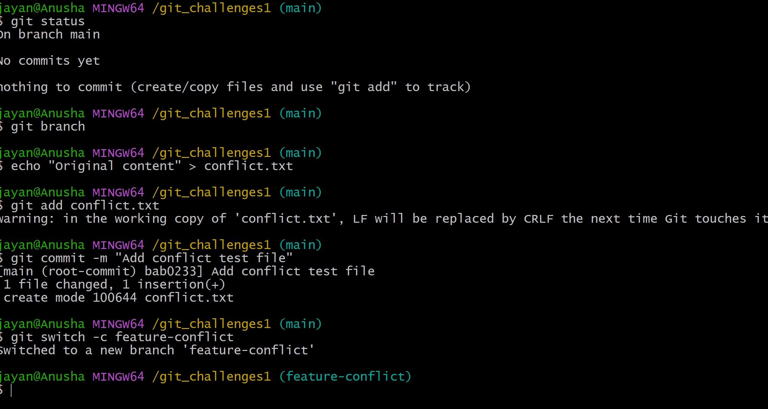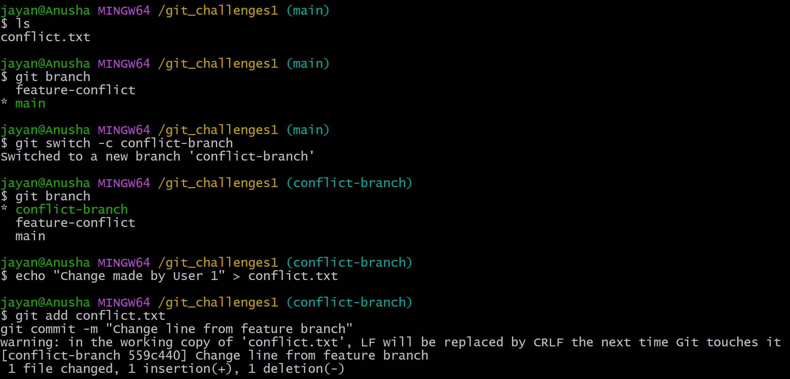

Useful commands:
git checkout -b feature-conflict
git add .
git commit -m "Create conflicting change"
git checkout main
git add .
git commit -m "Update same line"
git merge feature-conflict
git status
git add <file>
git commit -m "Resolve merge conflict"
git push origin main
2. Recover Deleted Branch
Objective: Delete a local branch and recover it using git reflog.

Steps:
1. Create and commit work on a branch.
2. Delete the branch.
3. Use git reflog to find the last commit belonging to the deleted branch.
4. Recreate the branch from that commit.

Useful commands:
git branch feature-recovery
git checkout feature-recovery
git add .
git commit -m "Work to recover"
git checkout main
git branch -D feature-recovery
git reflog
git checkout -b feature-recovery <commit-id>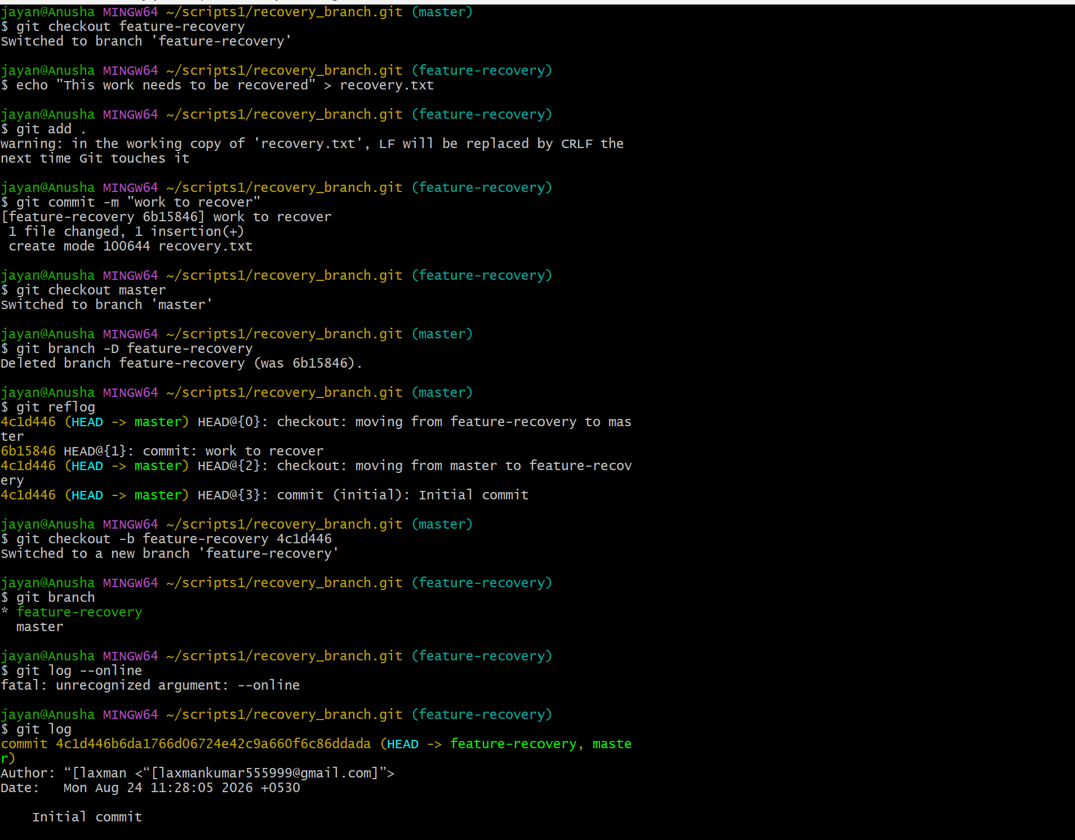
3. Undo Wrong Pushhttps://github.com/laxmankumar555999-source/git-training.git
Objective: Push an incorrect commit to GitHub and undo it without rewriting the existing history.

Recommended approach: use git revert. This creates a new commit that reverses the unwanted commit.

Useful commands:
git add .
git commit -m "Wrong change"
git push origin main
git revert <wrong-commit-id>
git push origin main

Verify the history with:
git log --oneline --graph --decorate --all 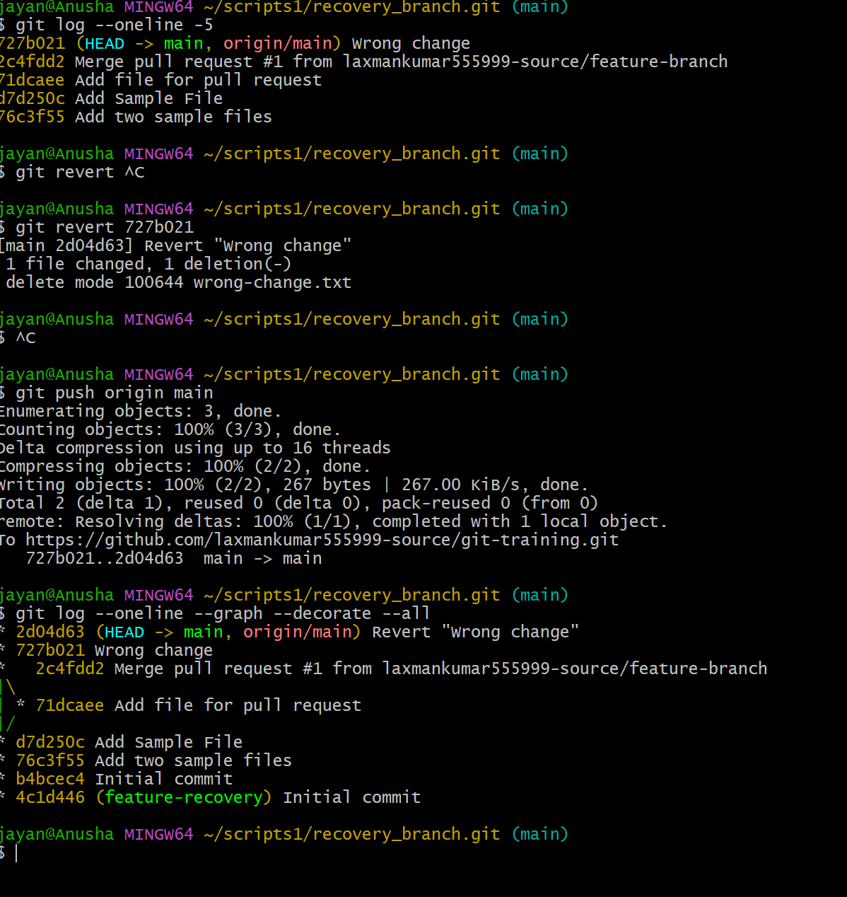
4. Amend a Commit
Objective: Add a missing file to the most recent commit.

Steps:
1. Make a commit without one required file.
2. Create or add the missing file.
3. Stage it.
4. Amend the previous commit.

Useful commands:
git add first-file.txt
git commit -m "Add project files"
git add missing-file.txt
git commit --amend --no-edit
git log --oneline -3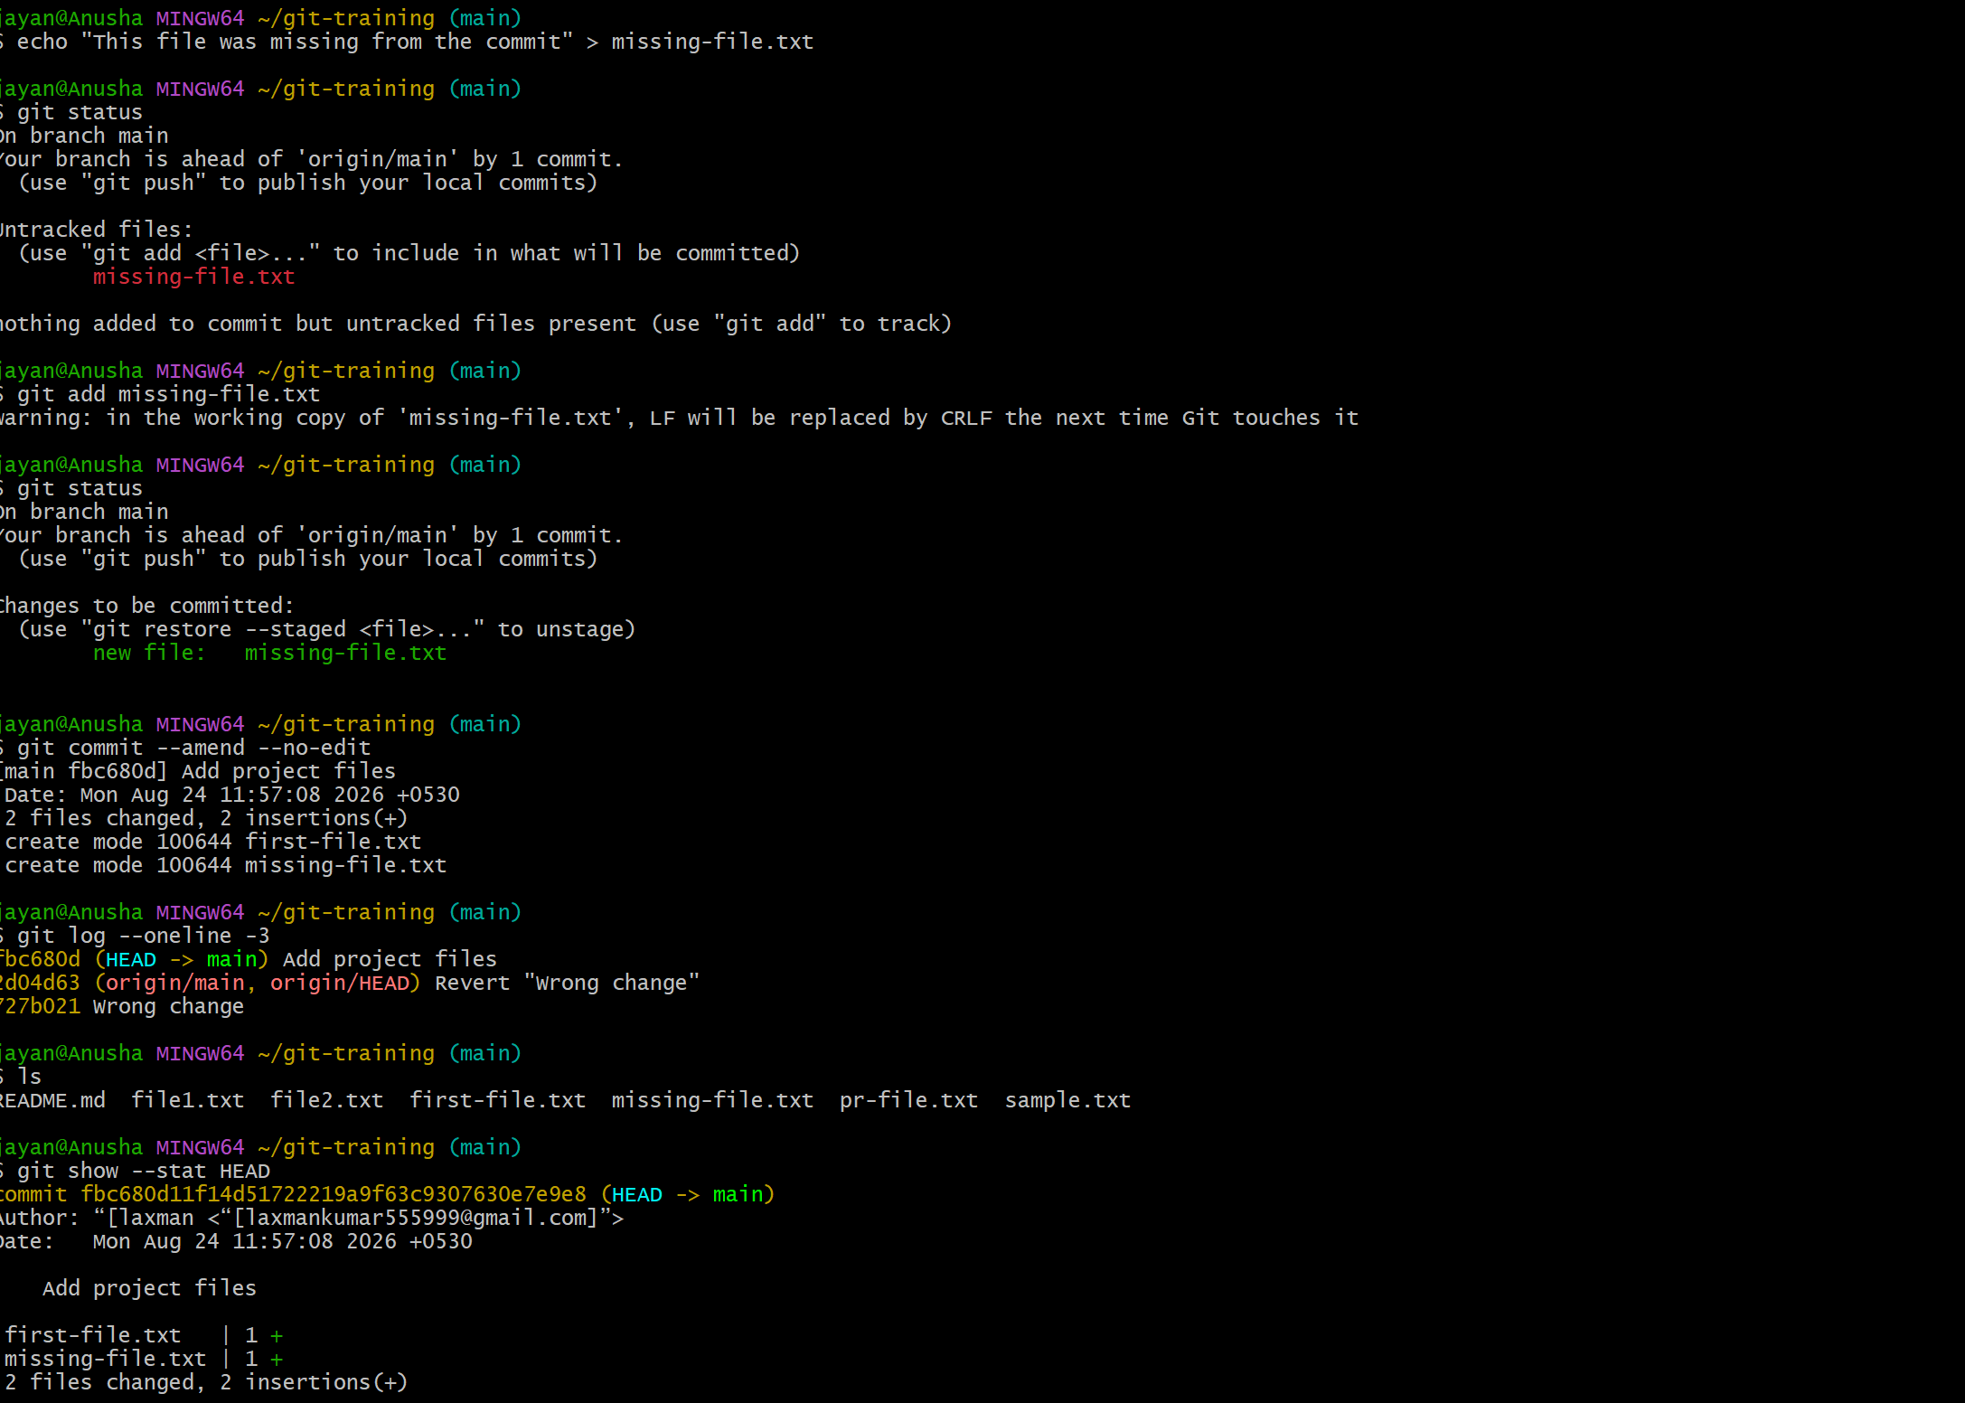
5. Cherry-pick a Commit
Objective: Take one specific commit from one branch and apply it to another branch.

Steps:
1. Create a commit on a feature branch.
2. Copy its commit ID.
3. Switch to the target branch.
4. Cherry-pick the commit.
5. Push the target branch.

Useful commands:
git log --oneline
git checkout main
git cherry-pick <commit-id>
git push origin main

If a conflict occurs:
git status
# Resolve the file
git add <file>
git cherry-pick --continue 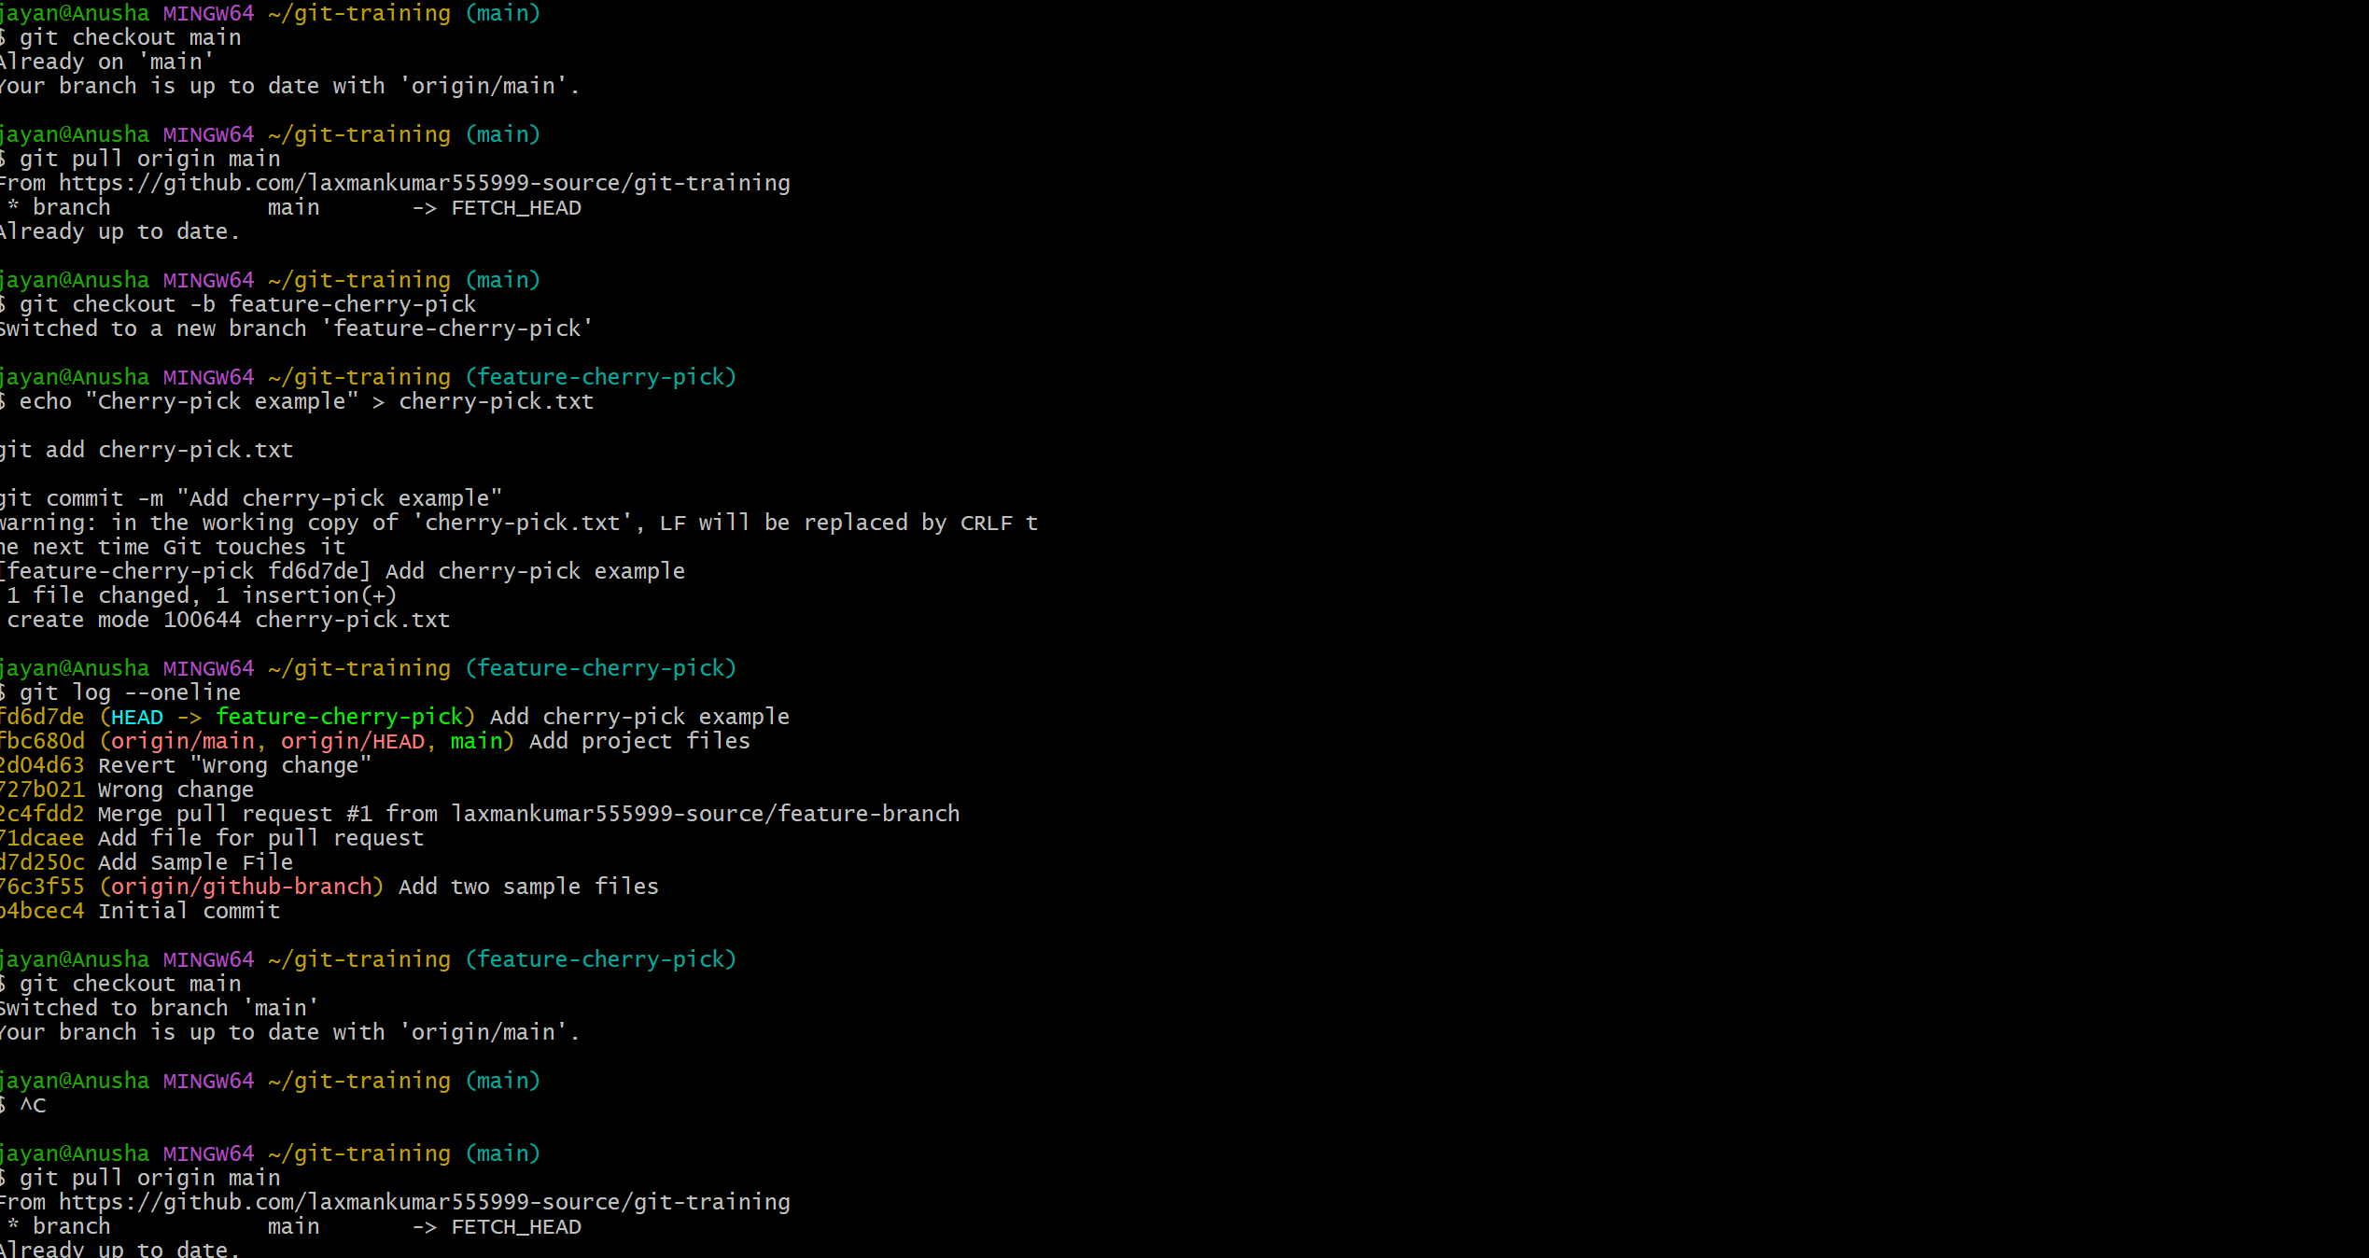 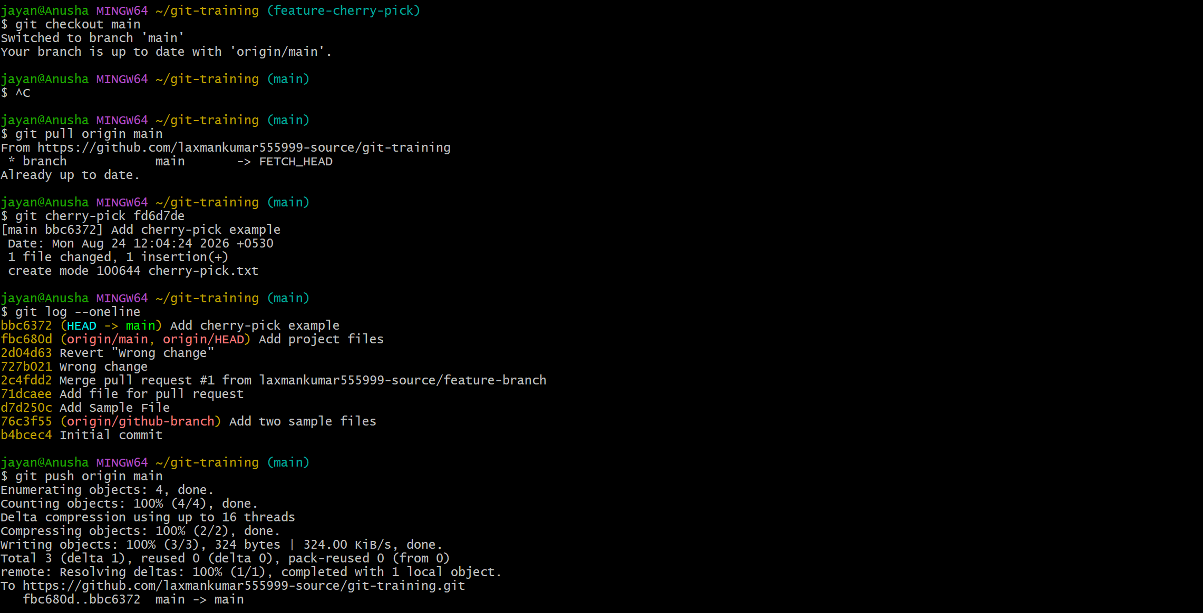
6. Interactive Rebase
Objective: Reorder and squash multiple commits into a clean commit history.

Steps:
1. Create several commits on a feature branch.
2. Start an interactive rebase.
3. Reorder commits if required.
4. Mark selected commits as squash or fixup.
5. Save the final commit message.
6. Verify the history.
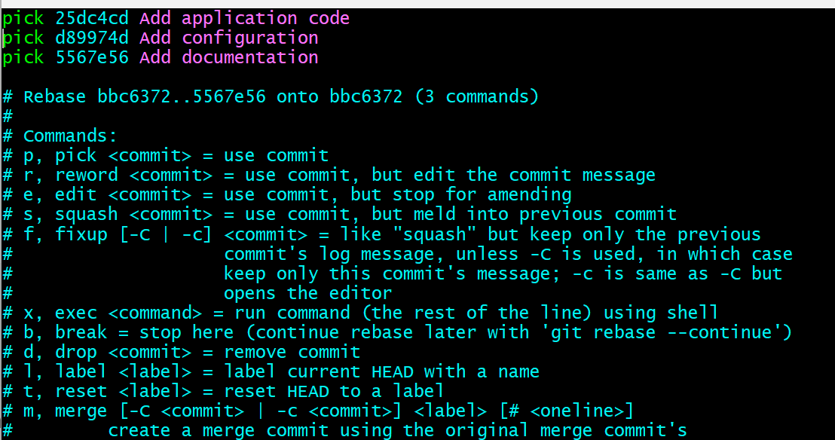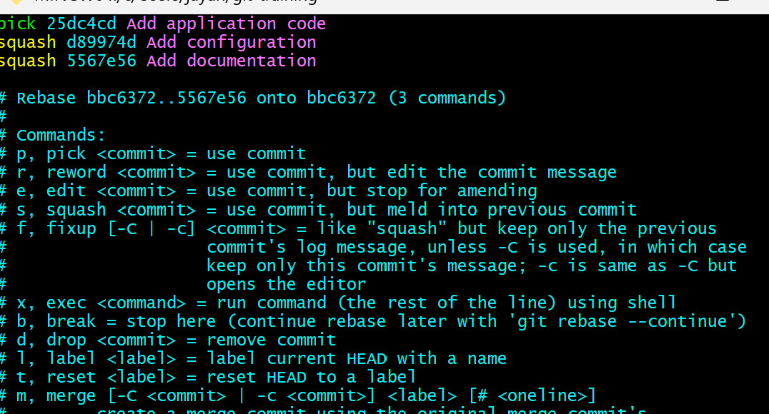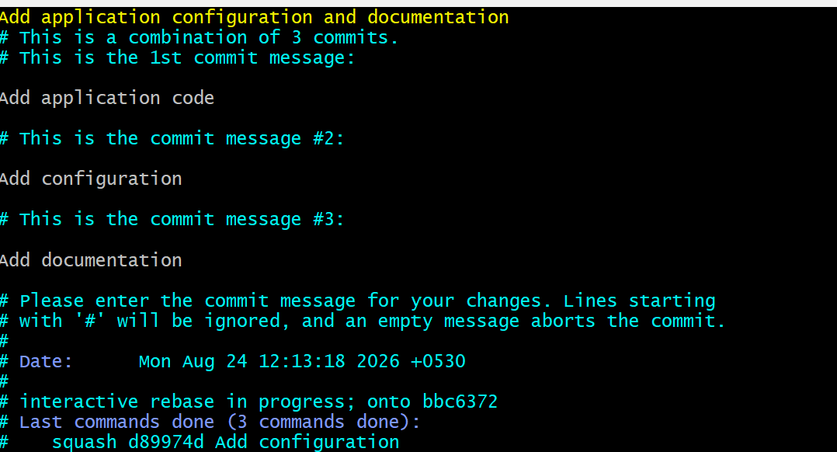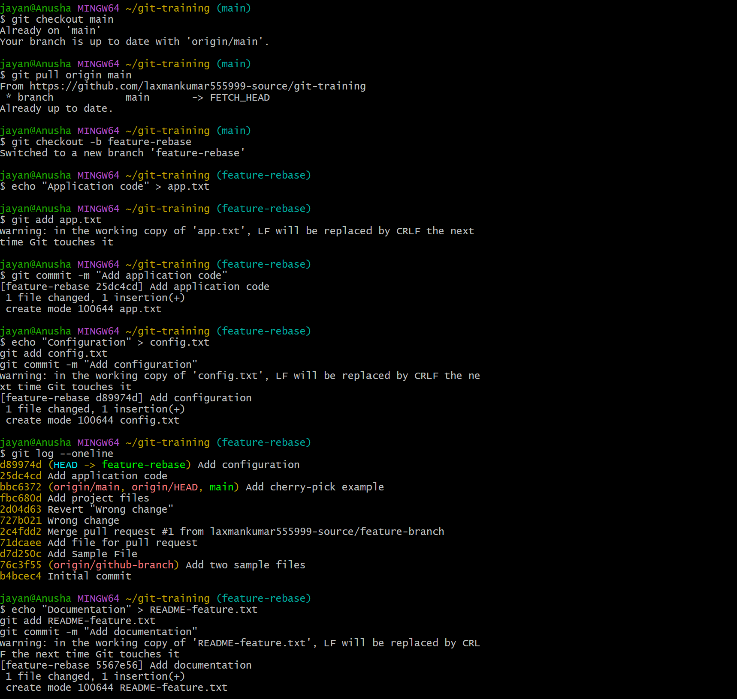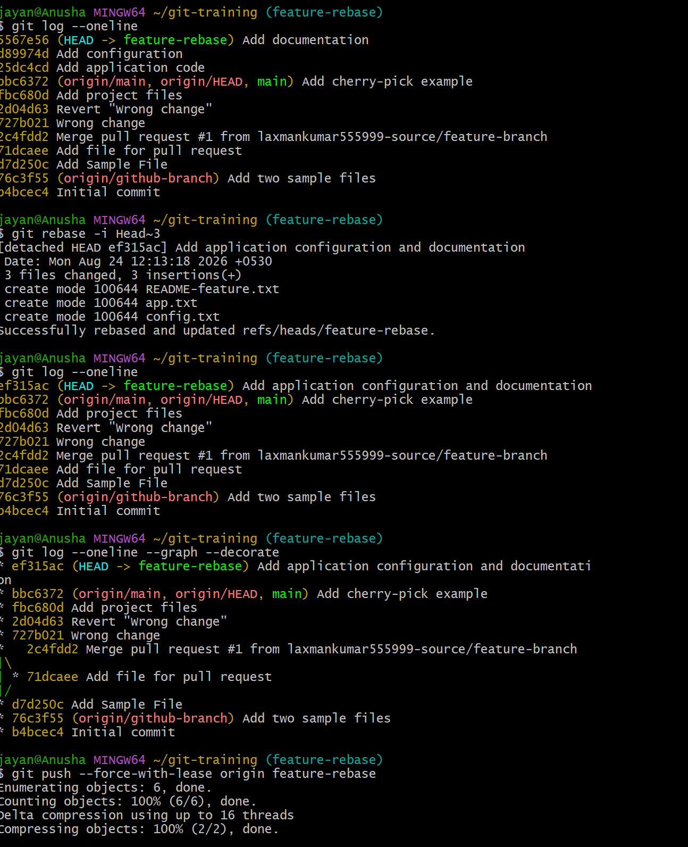
Useful command:
git rebase -i HEAD~3

Use commands such as pick, reword, squash, and fixup in the editor.

Verify:
git log --oneline --graph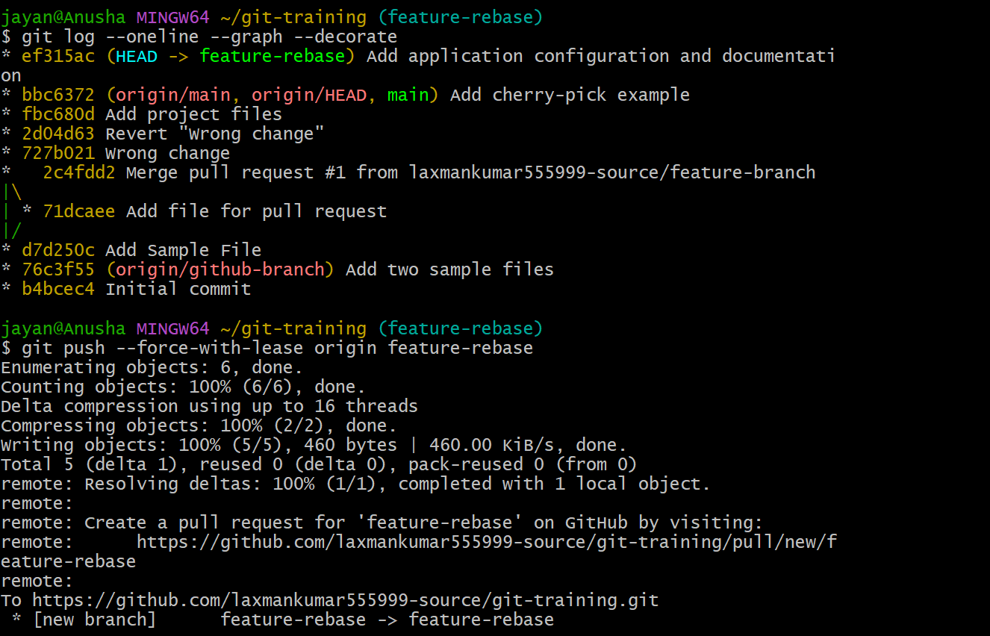
7. Tagging & Release
Objective: Create a version tag v1.0, push it to GitHub, then delete and restore the tag.

Create and push the tag:
git tag -a v1.0 -m "Release version 1.0"
git push origin v1.0

List tags:
git tag

Delete the local and remote tag:
git tag -d v1.0
git push origin --delete v1.0

Restore the tag:
git tag -a v1.0 -m "Release version 1.0" <commit-id>
git push origin v1.0

Verify:
git show v1.0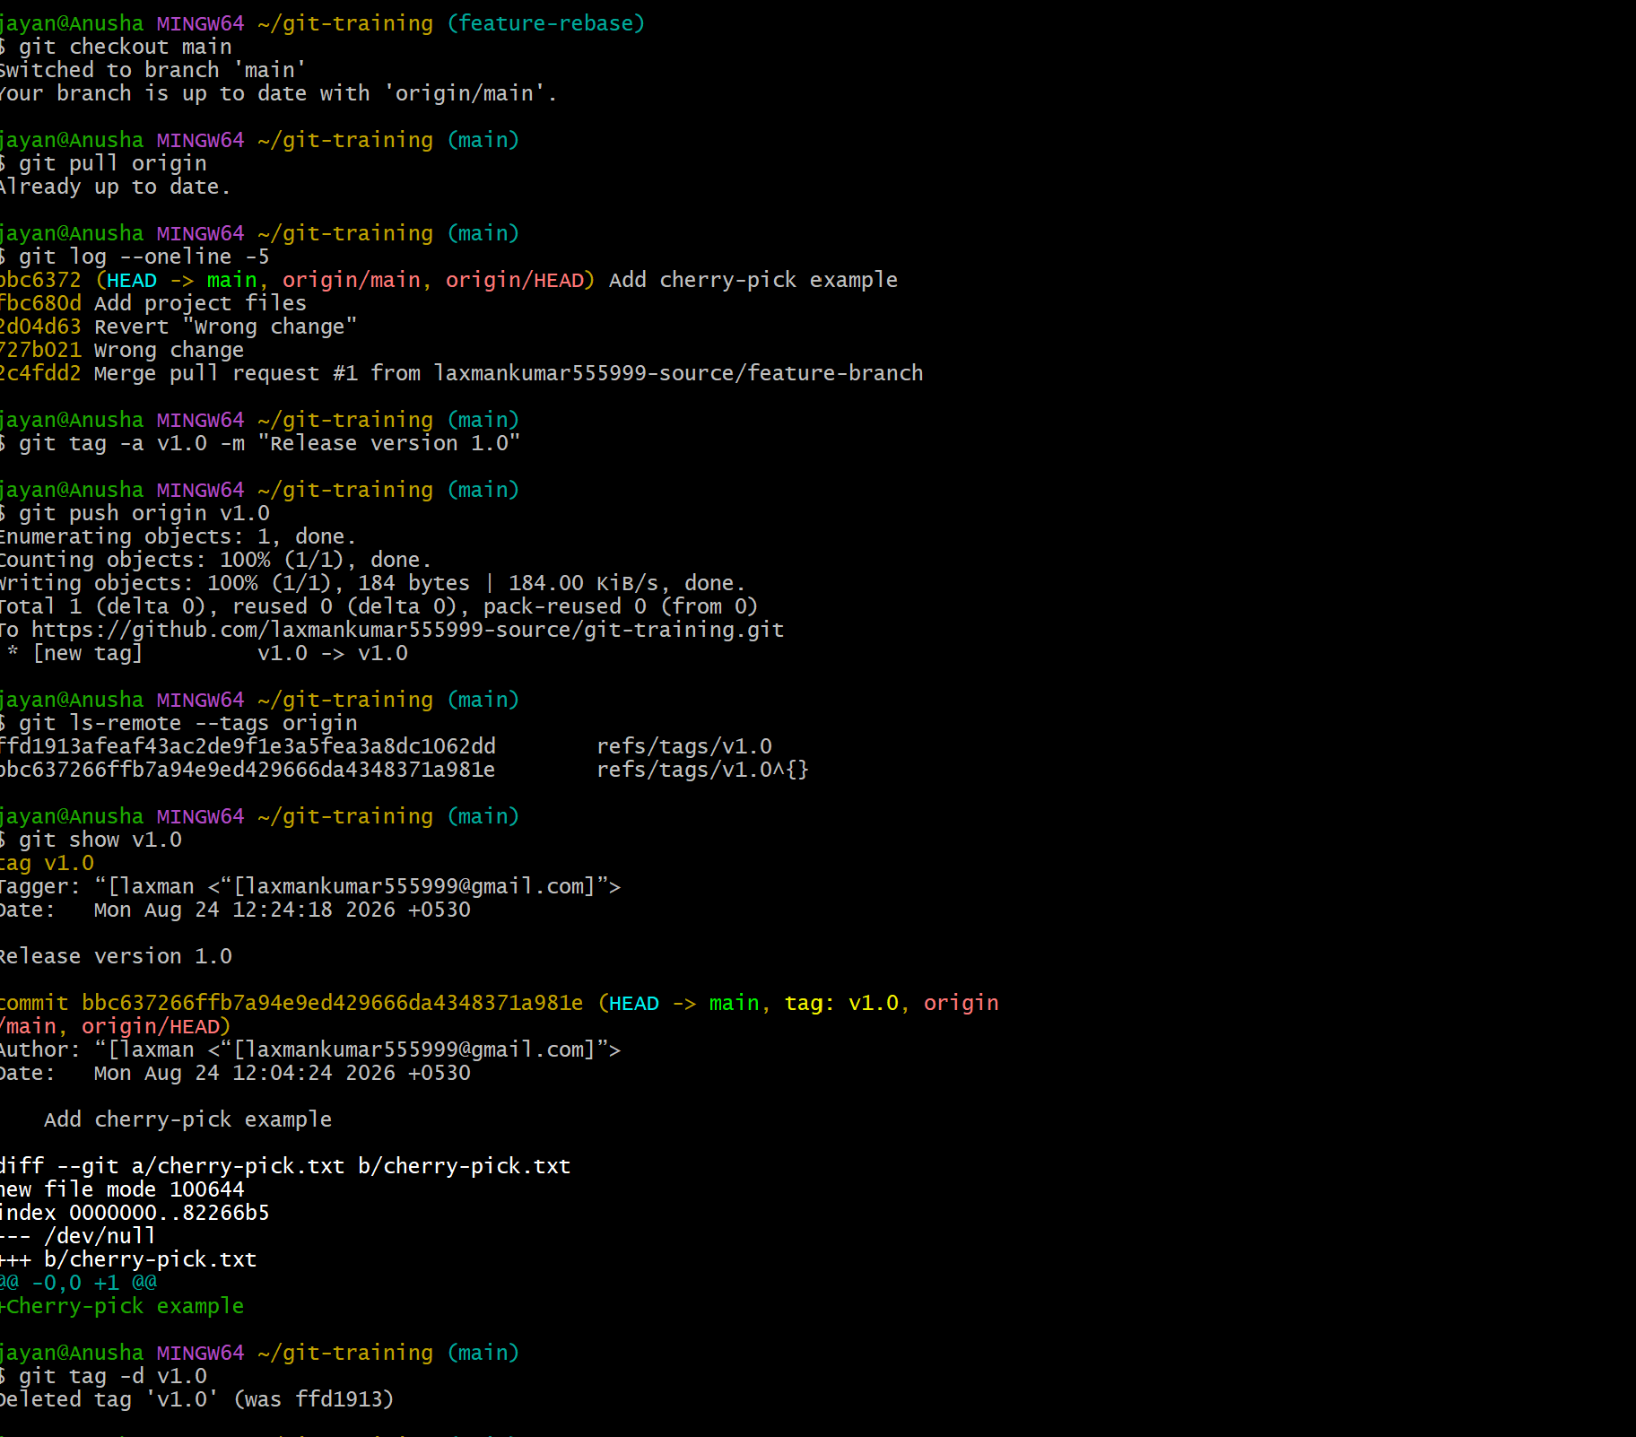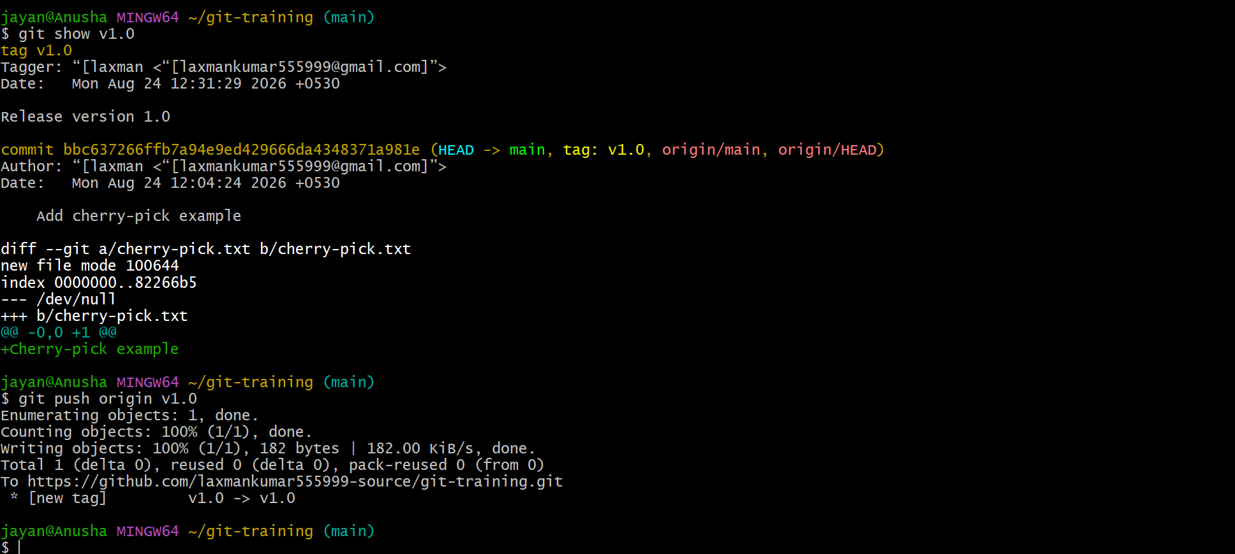8. Clone with Sparse Checkout
Objective: Clone a repository and check out only a required subdirectory instead of the entire working tree.

Useful commands:
git clone --no-checkout https://github.com/USERNAME/REPOSITORY.git
cd REPOSITORY
git sparse-checkout init --cone
git sparse-checkout set path/to/subdirectory
git checkout main

Verify the selected directory:
git sparse-checkout list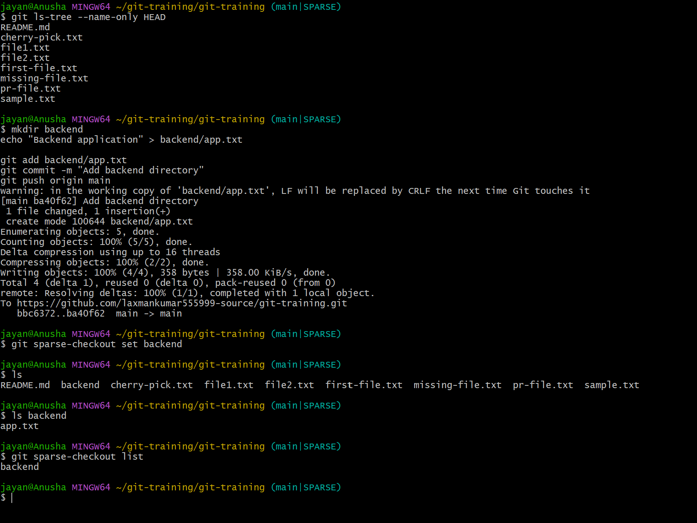
9. Reset vs Revert Challenge
Objective: Demonstrate the difference between git reset --hard and git revert.

Reset:
git reset --hard <commit-id>

A hard reset moves the branch pointer and changes the working tree. Avoid using it on shared history unless you understand the consequences.

Revert:
git revert <commit-id>

A revert creates a new commit that reverses an earlier commit and preserves the existing history.

Compare both using:
git log --oneline --graph --decorate --all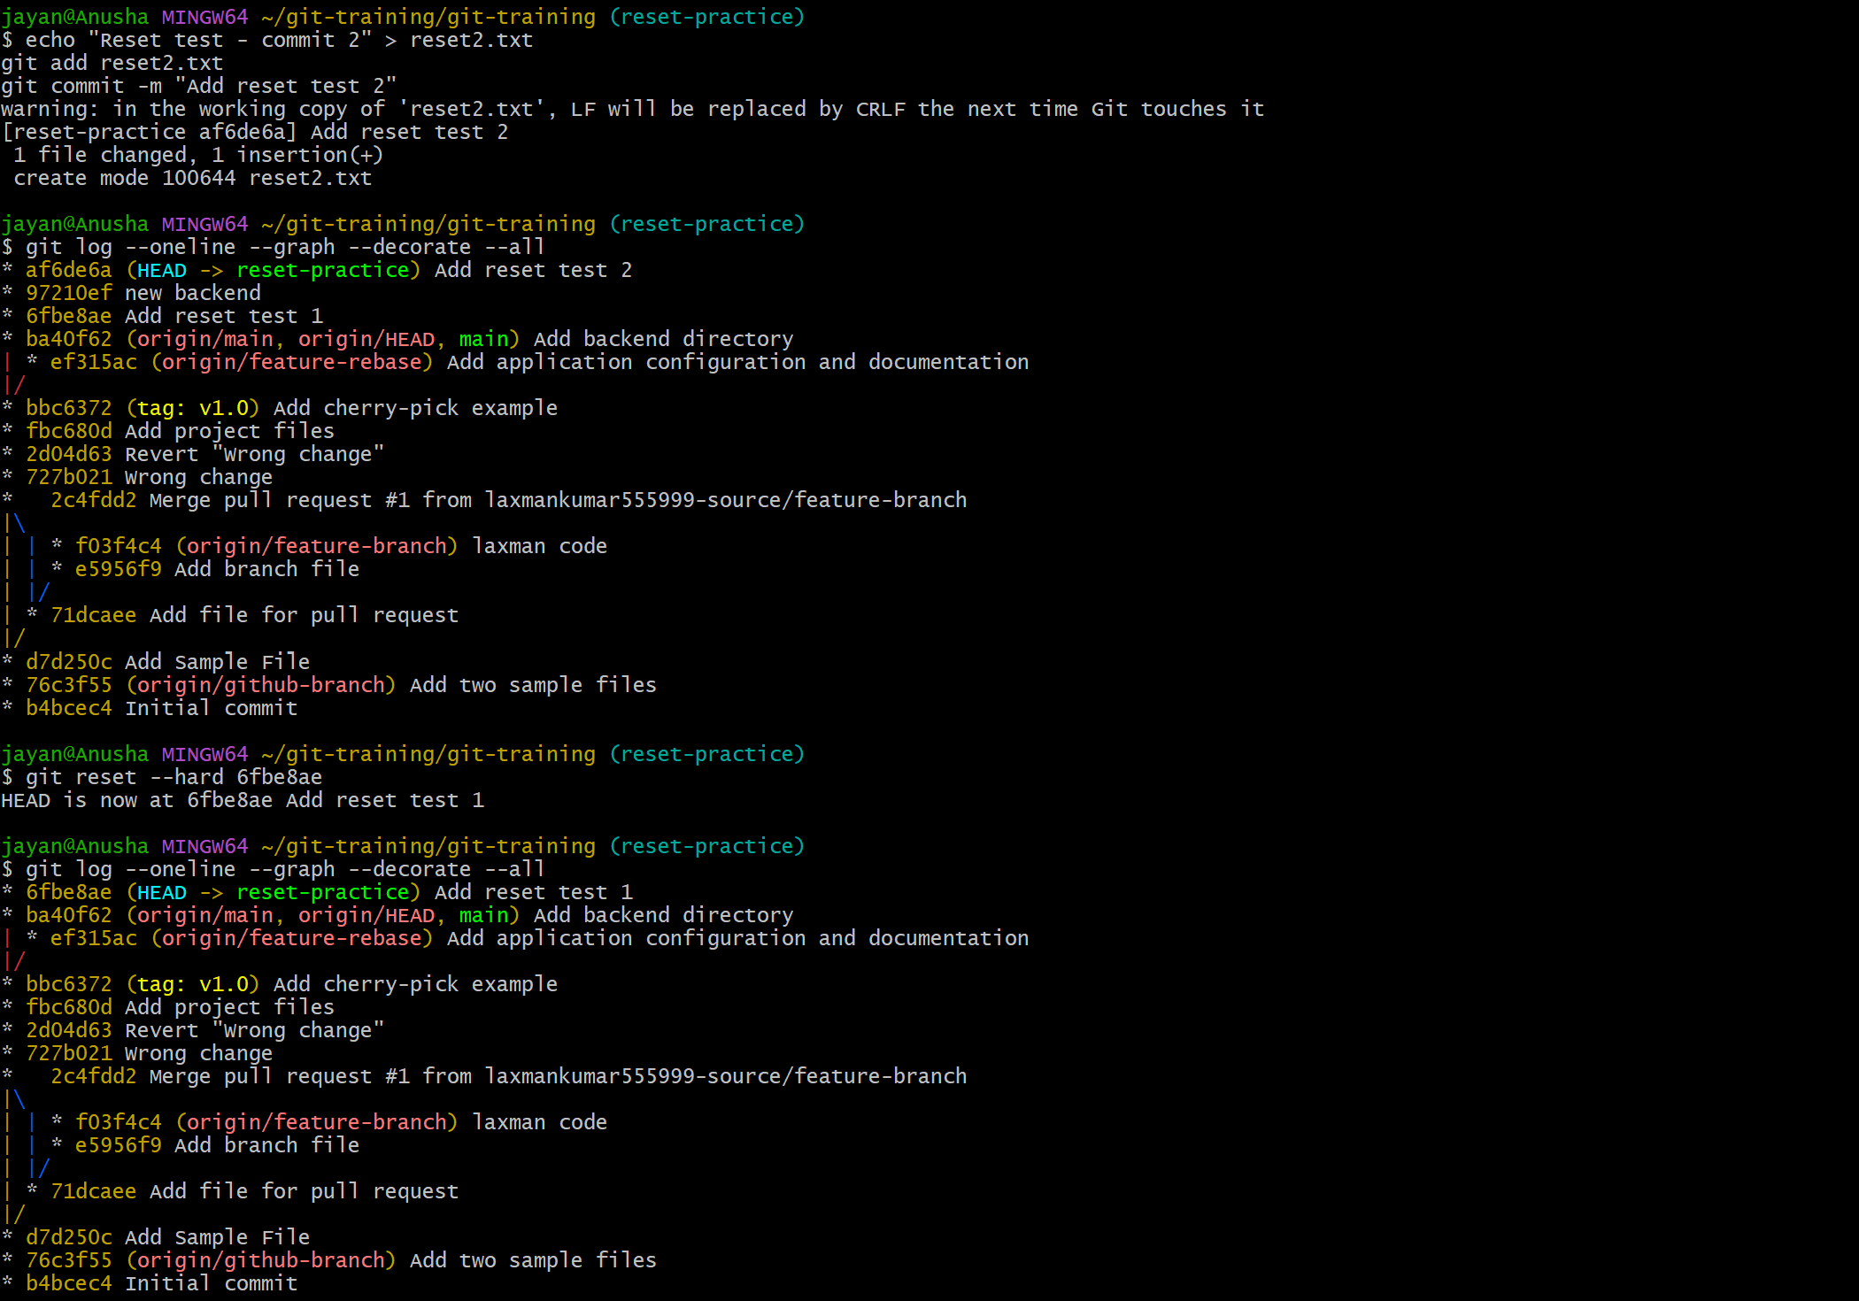
10. Detached HEAD Challenge
Objective: Check out a specific commit, observe the detached HEAD state, and create a new branch from that commit.

Useful commands:
git log --oneline
git checkout <commit-id>
git status

You should see a detached HEAD message.

Create a branch from the current commit:
git checkout -b branch-from-detached-head

Verify:
git branch
git log --oneline --decorate -5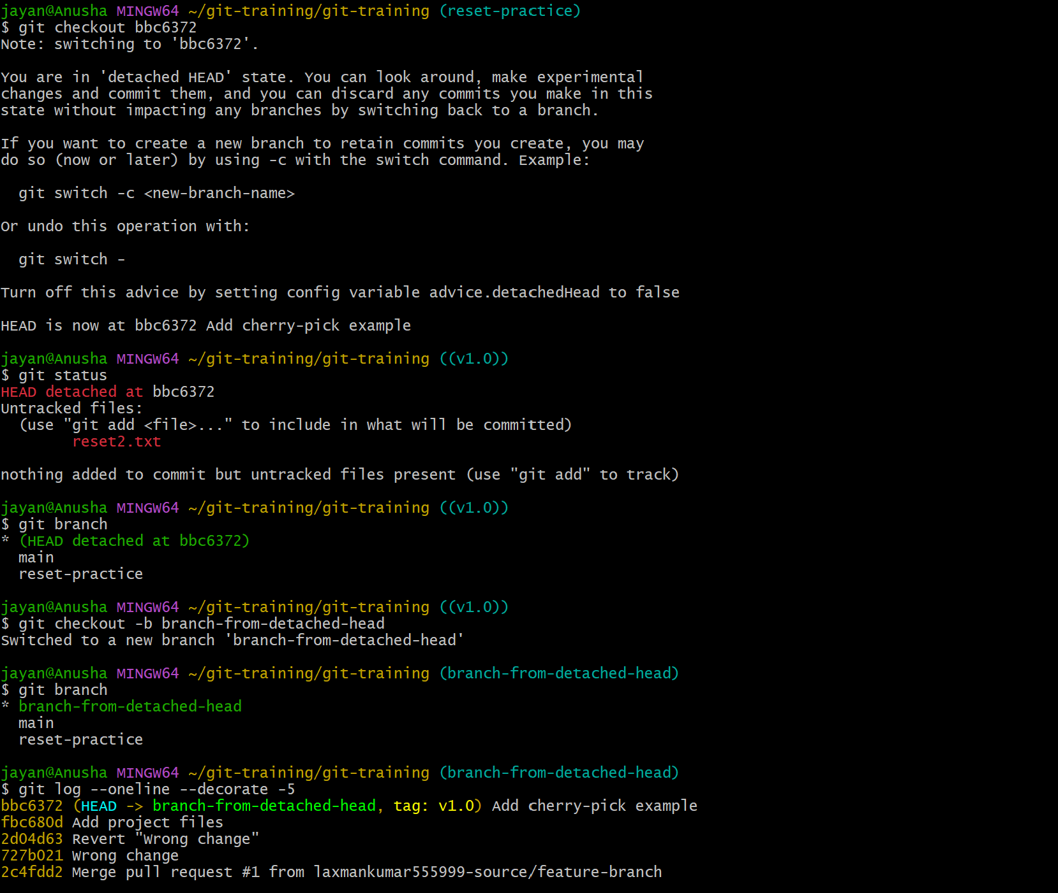
11. Git Hooks Challenge
Objective: Configure a pre-commit hook that rejects commits unless the commit message starts with a required format such as JIRA-XXX.

Important note: A pre-commit hook normally runs before the commit message is finalized. To validate the commit message itself, a commit-msg hook is the appropriate Git hook.

Create .git/hooks/commit-msg and add a script that checks whether the first line begins with JIRA- followed by digits.

Example shell logic:
#!/bin/bash
MESSAGE=$(head -n 1 "$1")

if ! echo "$MESSAGE" | grep -Eq '^JIRA-[0-9]+ '; then
echo "Commit message must start with JIRA-XXX"
exit 1
fi

exit 0

Make it executable:
chmod +x .git/hooks/commit-msg

Test:
git commit -m "Fix login bug"
# Expected: rejected

git commit -m "JIRA-123 Fix login bug"
# Expected: accepted 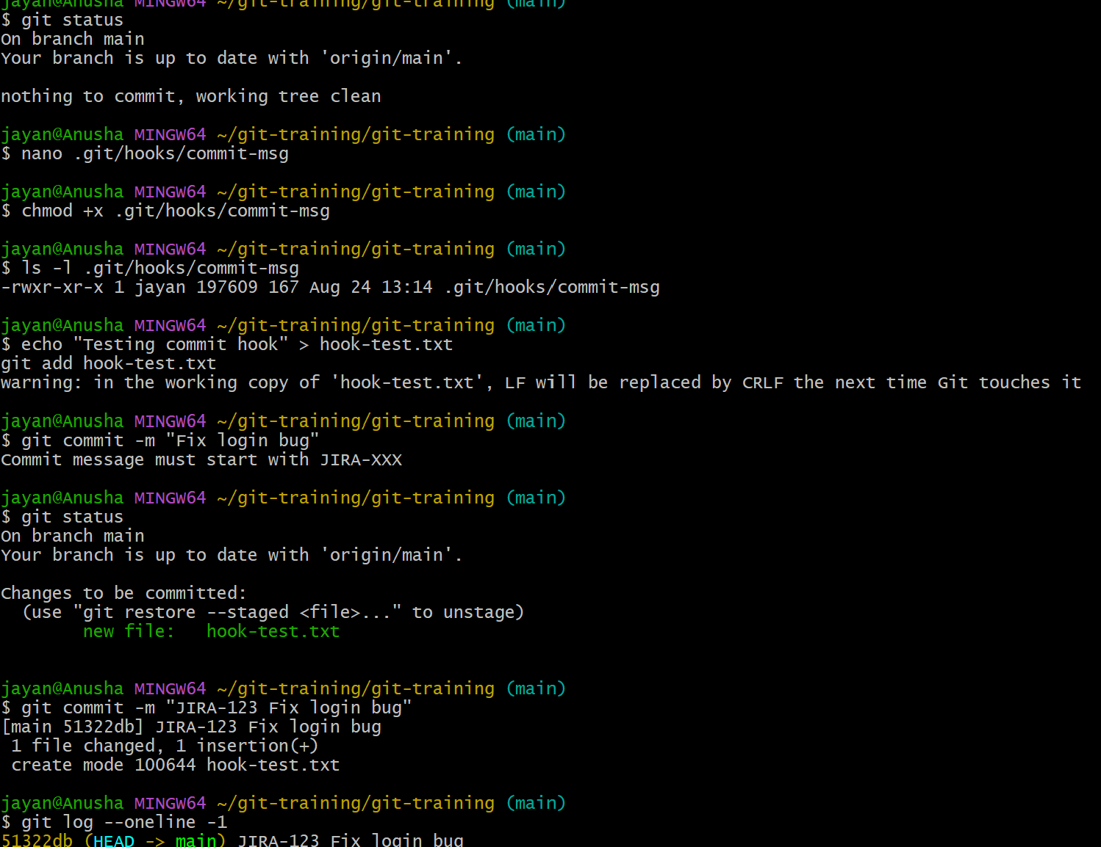
12. Squash Merge vs Rebase Merge
Objective: Compare squash merging and rebase merging and provide evidence of the resulting history.

Squash merge:
- Combines multiple feature commits into one commit on the target branch.
- The original feature-branch commit structure is not preserved on the target branch.

Rebase merge:
- Replays feature commits on top of the target branch.
- Keeps the individual commits while producing a linear history.

Evidence commands:
git log --oneline --graph --decorate --all
git show --stat <commit-id>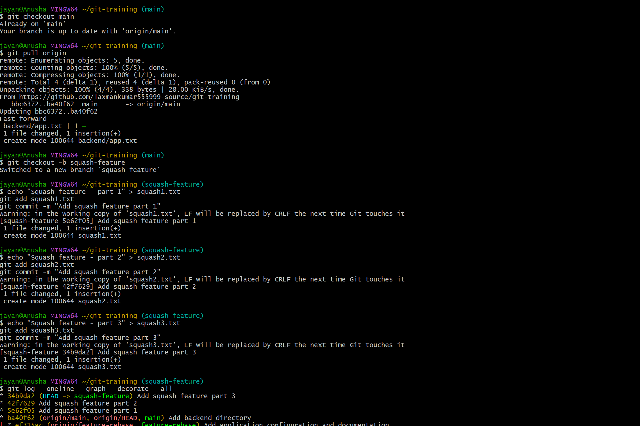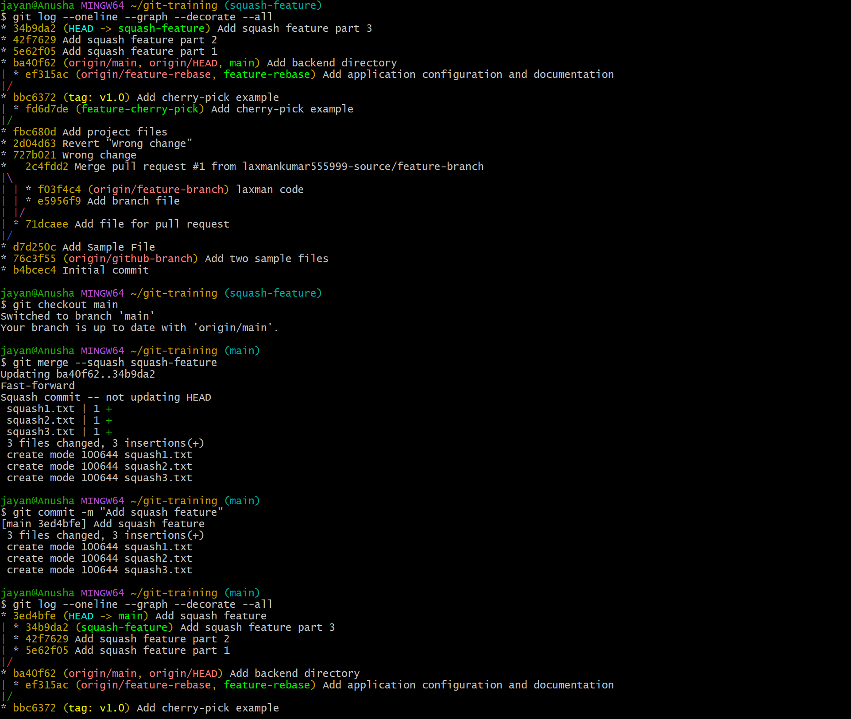
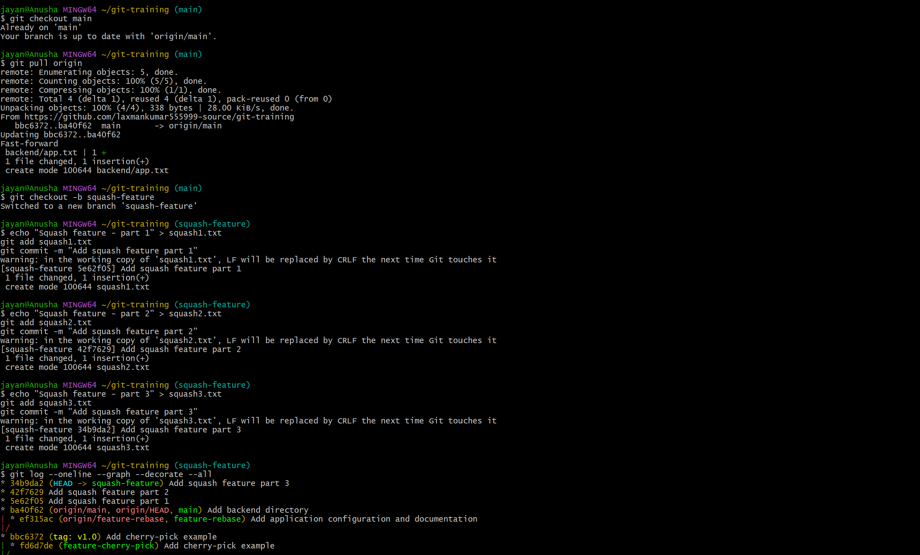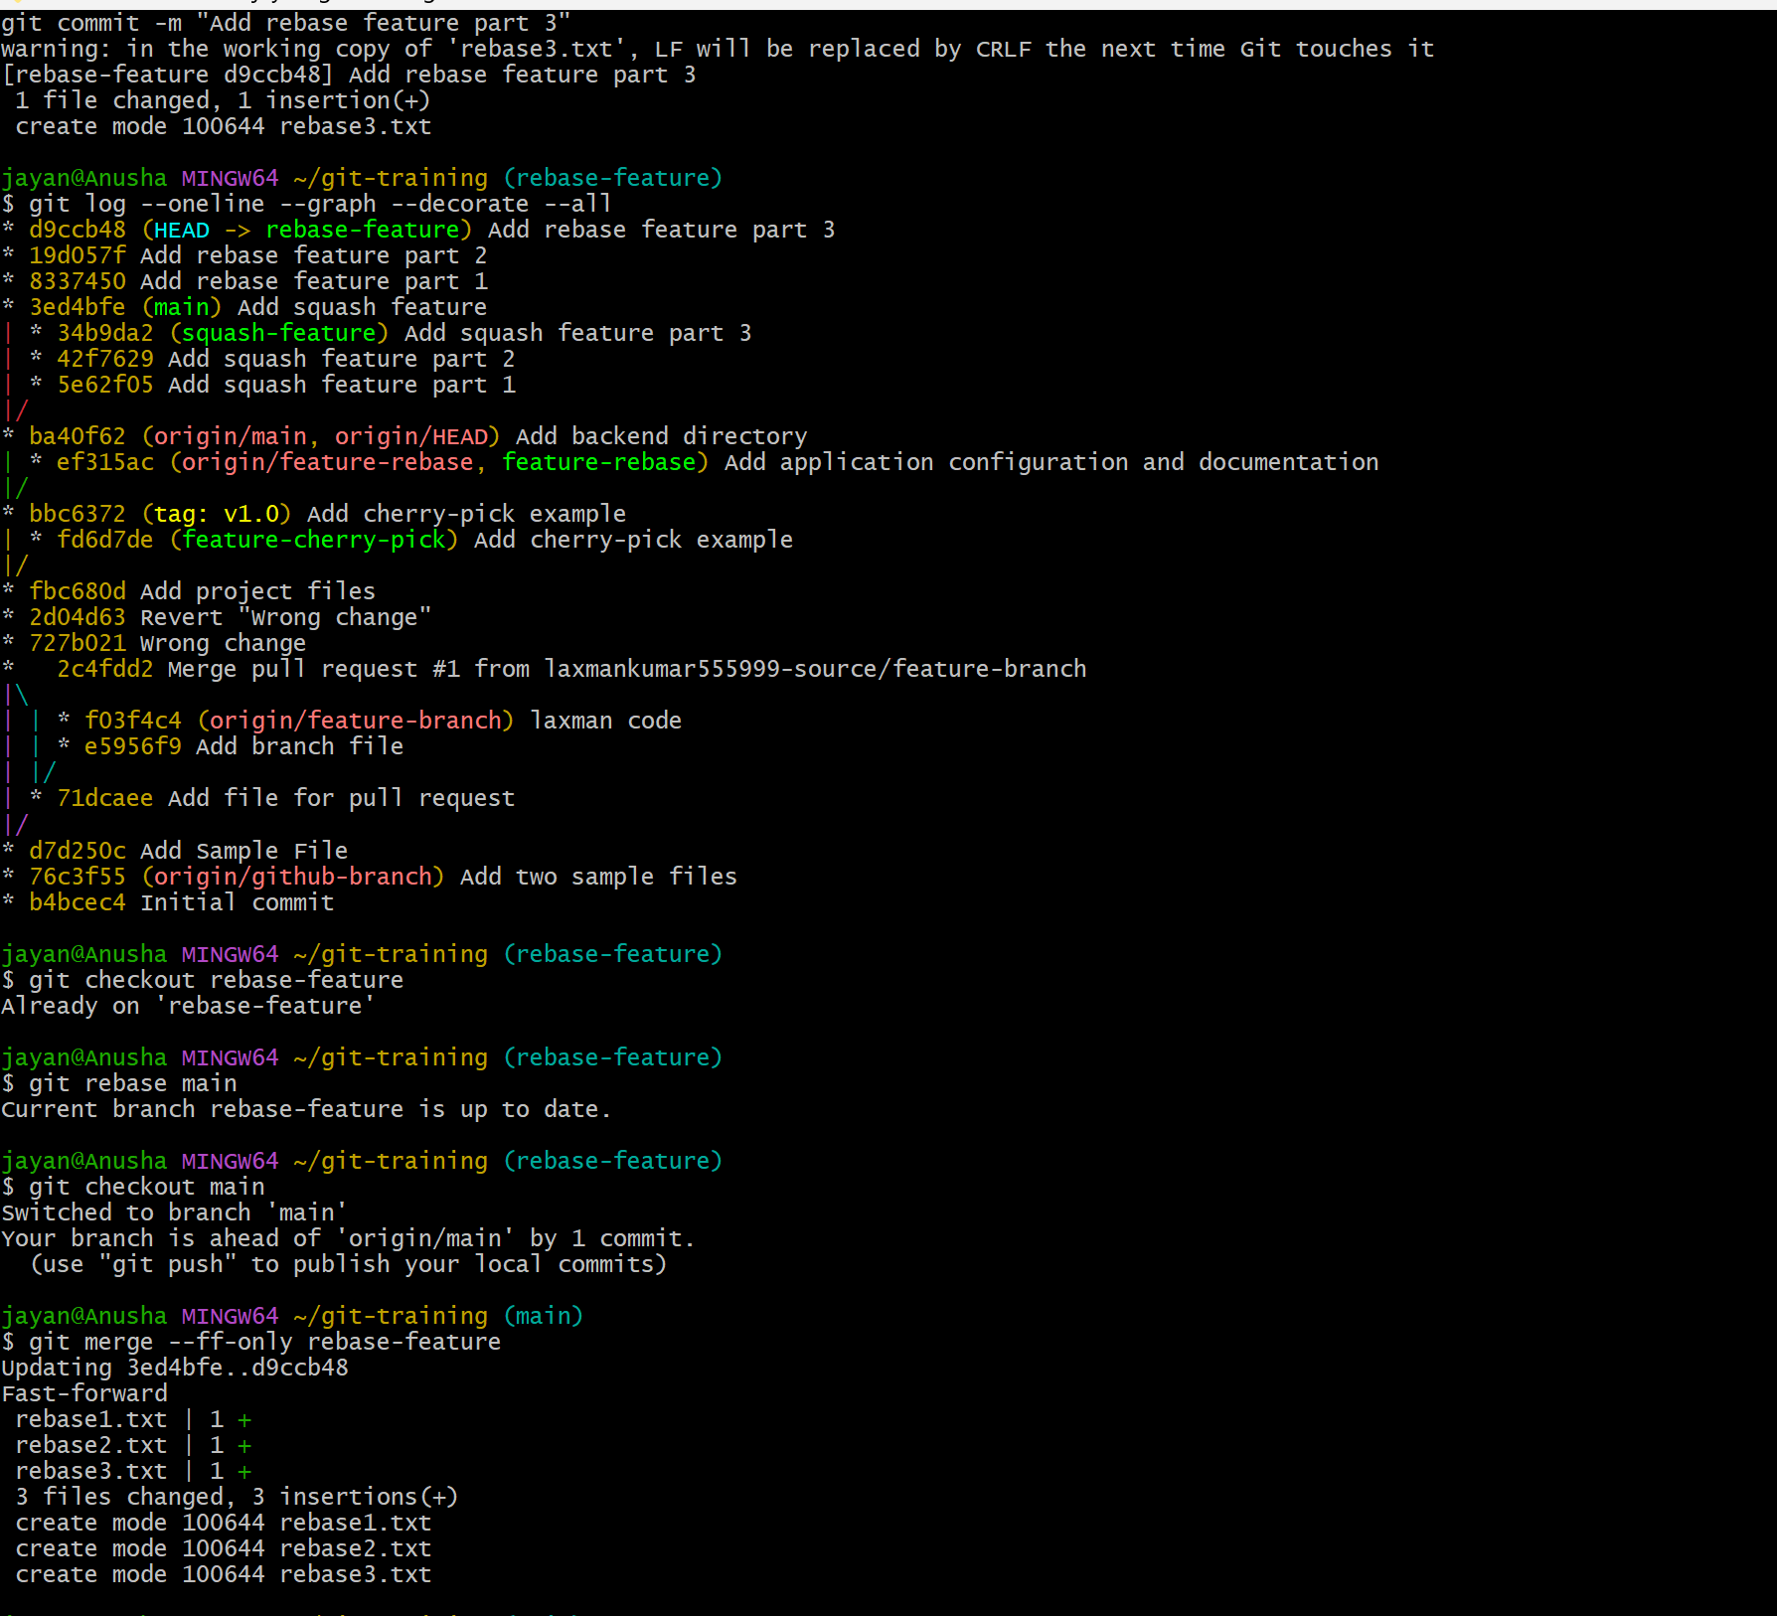
Perform each method in separate test branches/repositories so the histories can be compared clearly.
13. Fork & Pull Request Workflow
Objective: Fork a repository, make a change, and submit a pull request to the original repository.

Steps:
1. Open the original repository on GitHub.
2. Click Fork.
3. Clone your fork locally.
4. Create a feature branch.
5. Make and commit a change.
6. Push the feature branch to your fork.
7. Open a Pull Request from your fork's feature branch to the original repository's target branch.
8. Review the changes and submit the pull request.

Useful commands:
git clone https://github.com/YOUR-USERNAME/REPOSITORY.git
cd REPOSITORY
git checkout -b feature-change
git add .
git commit -m "JIRA-123 Add requested change"
git push -u origin feature-change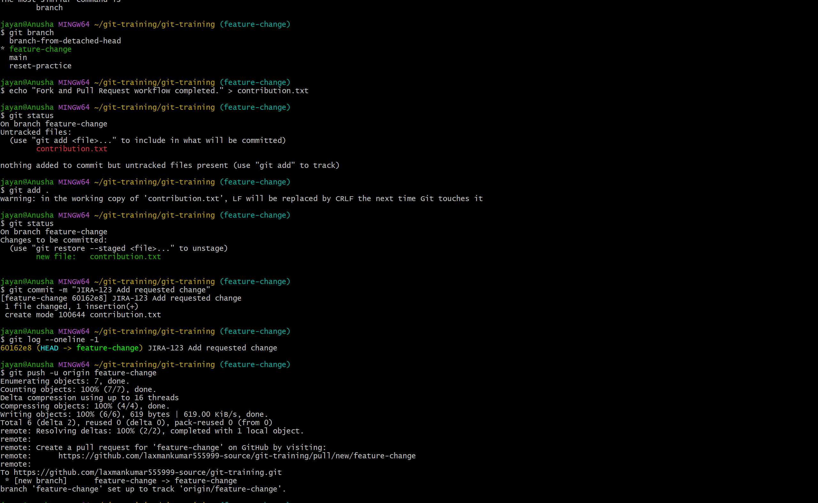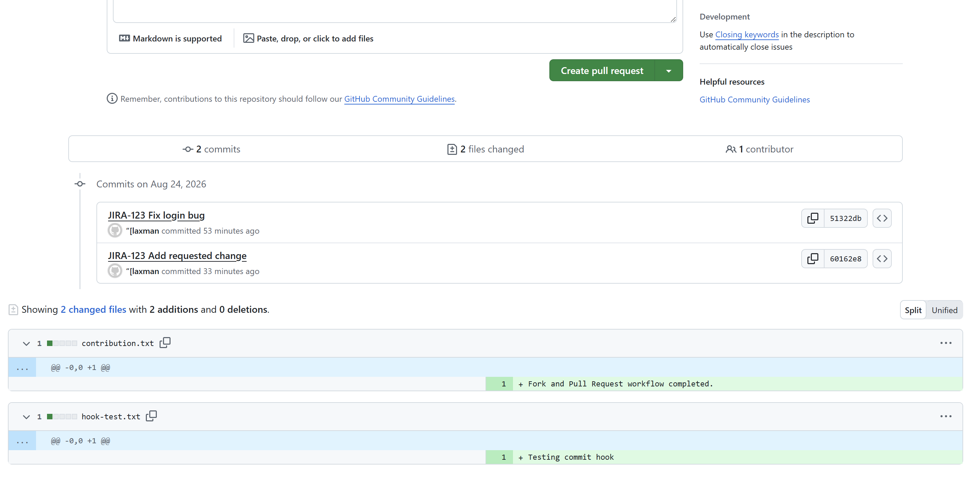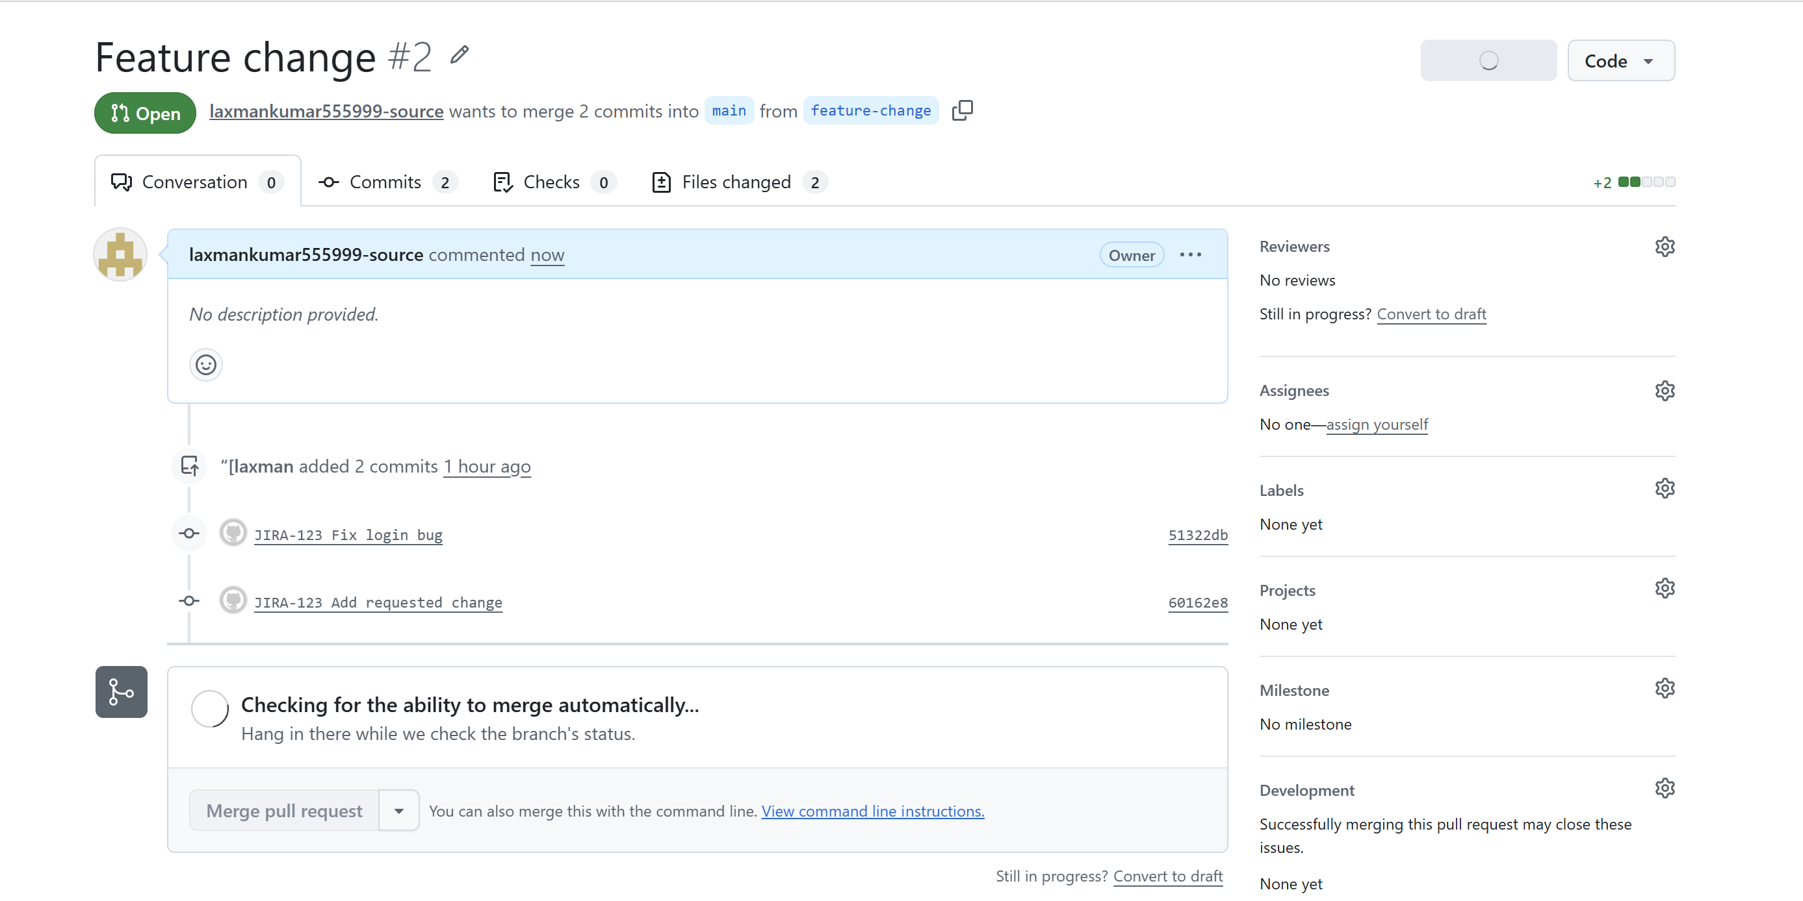
14. Recover Lost Commit
Objective: Create a commit, perform a hard reset, and recover the lost commit using git reflog.

Steps:
1. Make and commit a change.
2. Record the commit ID.
3. Reset the branch backwards.
4. Use git reflog to locate the lost commit.
5. Recover it by creating a branch or resetting to the recovered commit.

Useful commands:
git add .
git commit -m "Important work"
git log --oneline -3
git reset --hard HEAD~1
git reflog
git checkout -b recovered-work <lost-commit-id>

Verify:
git log --oneline --graph --decorate –all

2f1f209 51322db
Best Practice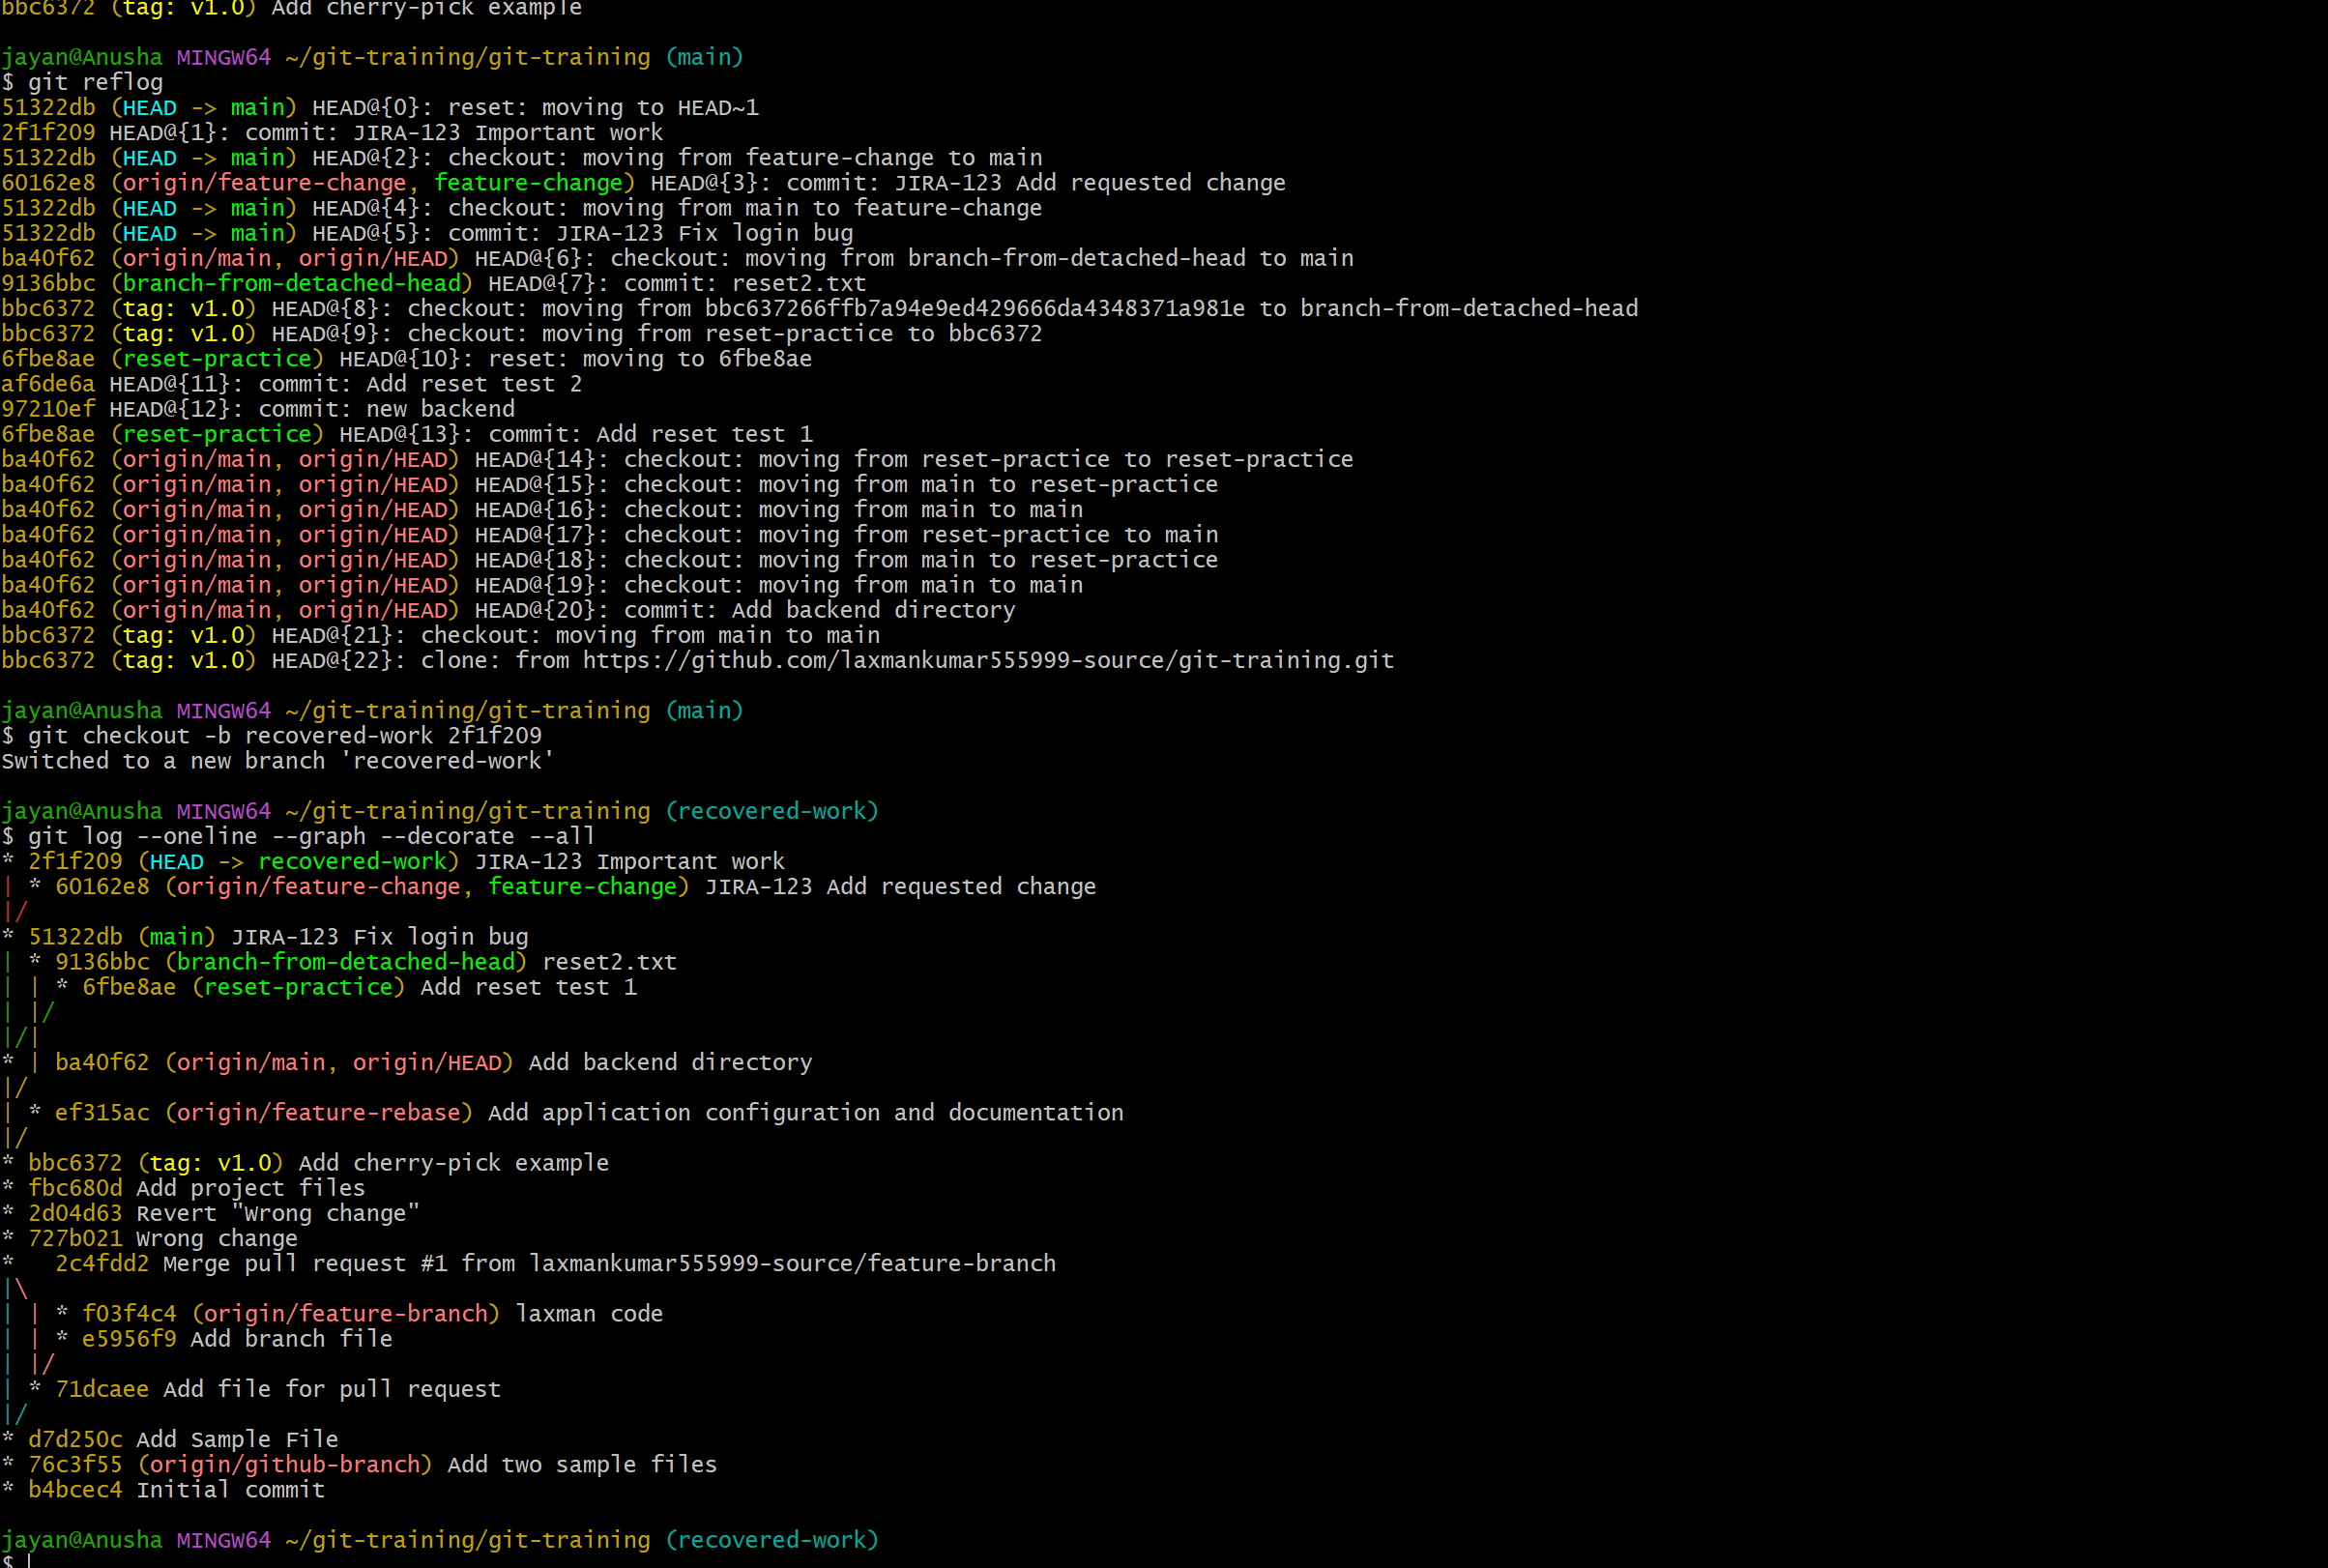
For shared GitHub branches, prefer git revert when undoing pushed changes because it preserves history. Use git reset --hard with care, especially on branches other people may have pulled.

