Git & GitHub Practical Tasks
Step-by-Step Lab Guide
This document provides practical exercises for learning Git and GitHub, including repository creation, branching, merging, pull requests, reset, revert, stash, SSH authentication, webhooks, logs, and commit history management.

Task 1: Install Git
- Update package information and install Git.
- Verify the installed Git version.
- Configure your Git username and email.
Commands:
sudo apt update
sudo apt install git -y
git --version
git config --global user.name "Your Name"
git config --global user.email "your-email@example.com"
git config --global --list 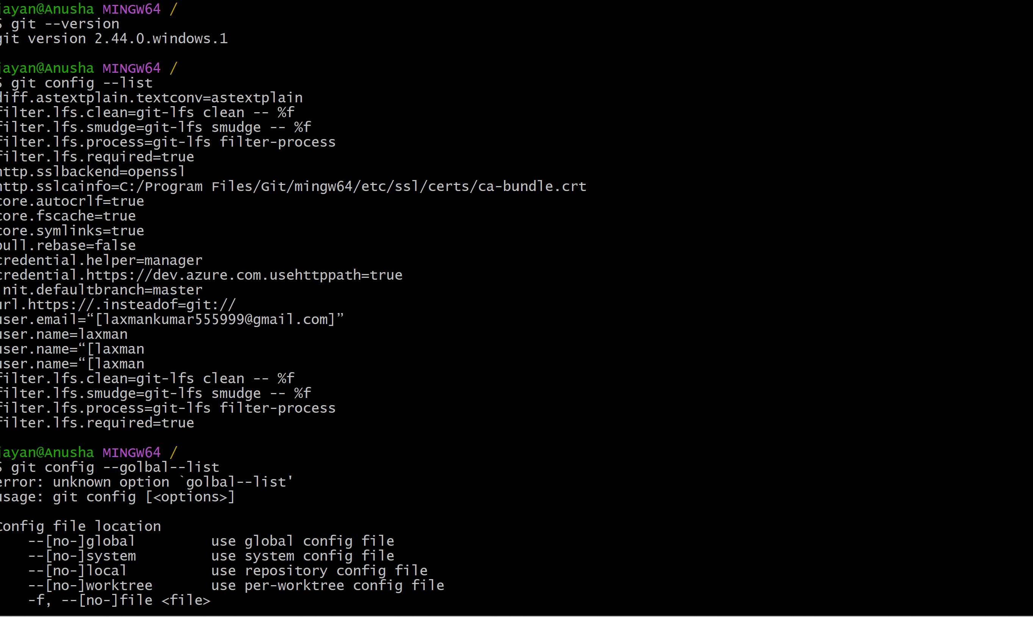

Task 2: Create a GitHub Repository with README.md and .gitignore
- Sign in to GitHub and create a new repository.
- Give the repository a suitable name.
- Select the option to add a README.md file.
- Select an appropriate .gitignore template.
- Create the repository.
Commands:
Repository example: git-training
README.md: project description
.gitignore: files and folders Git should ignore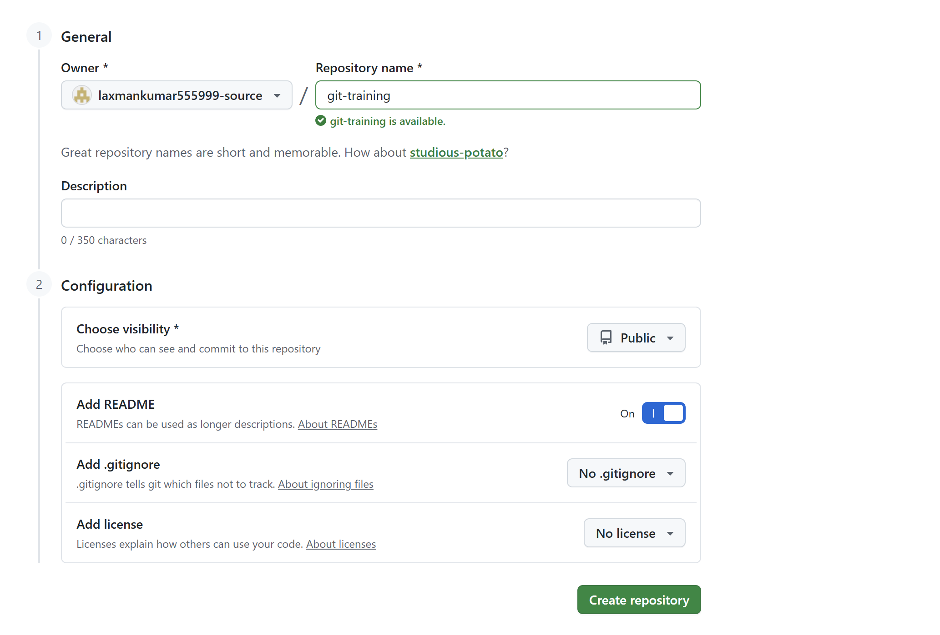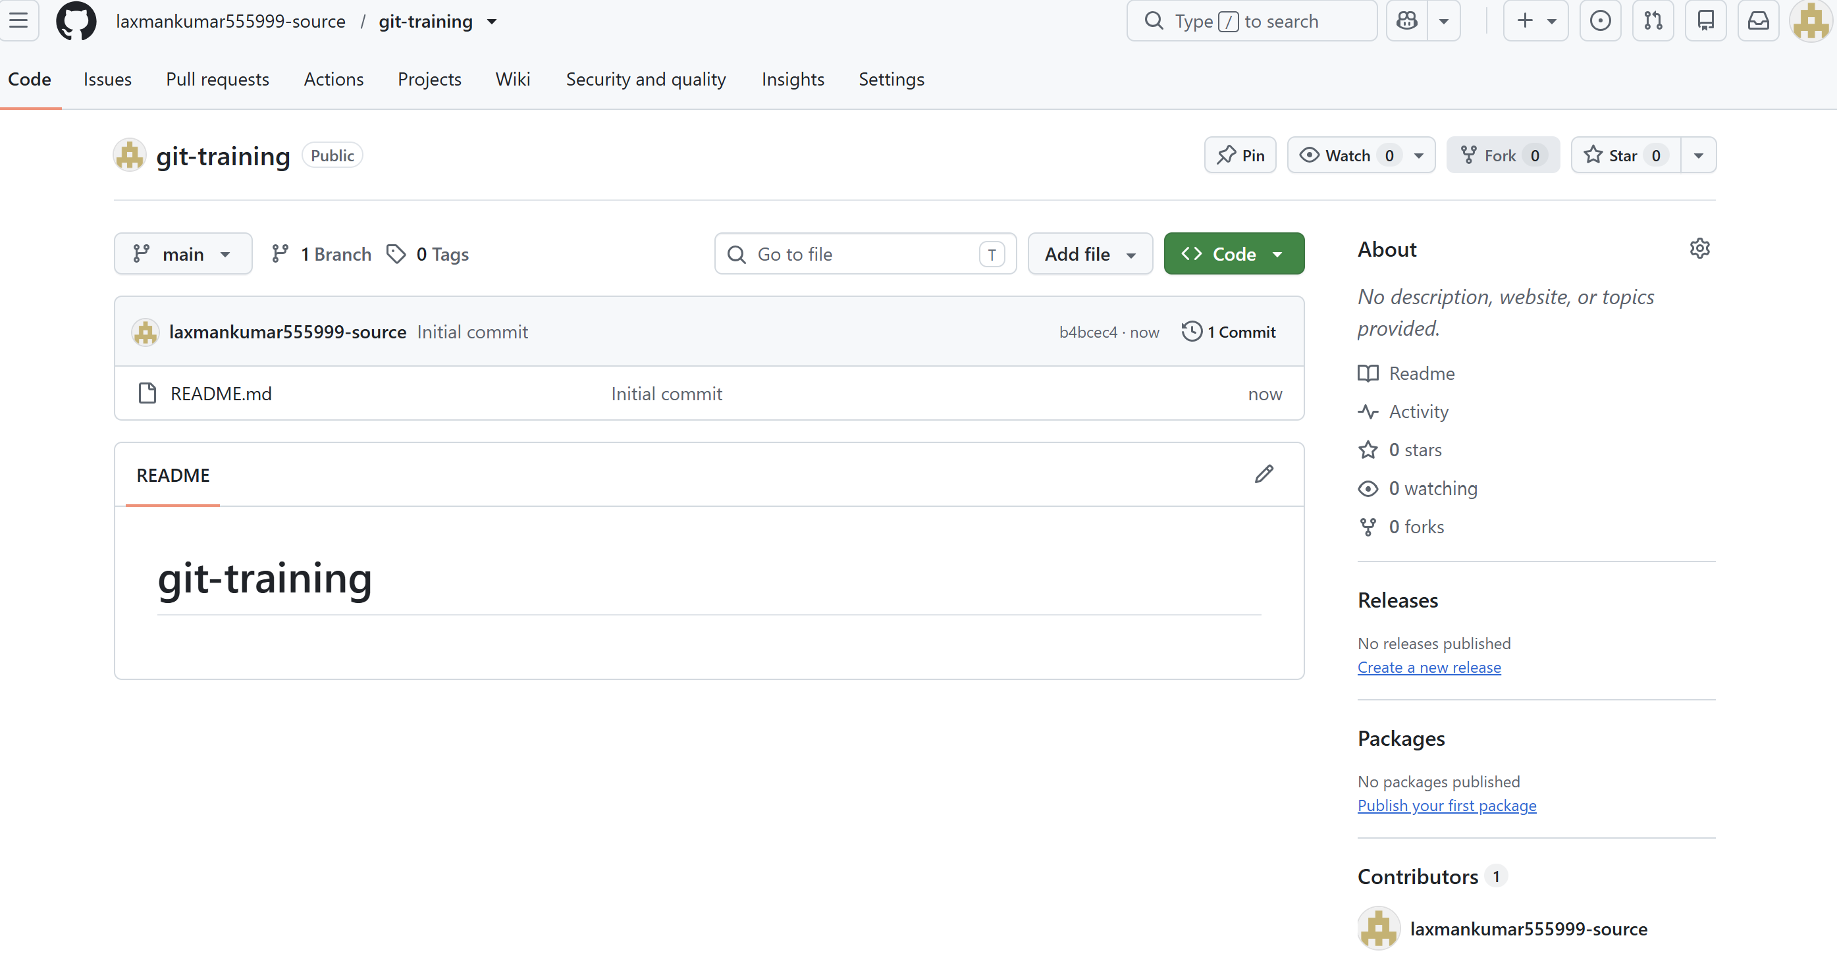

Task 3: Clone the Created Repository to Local
- Copy the repository URL from GitHub.
- Clone the repository to your local machine.
- Enter the cloned directory and verify its contents. 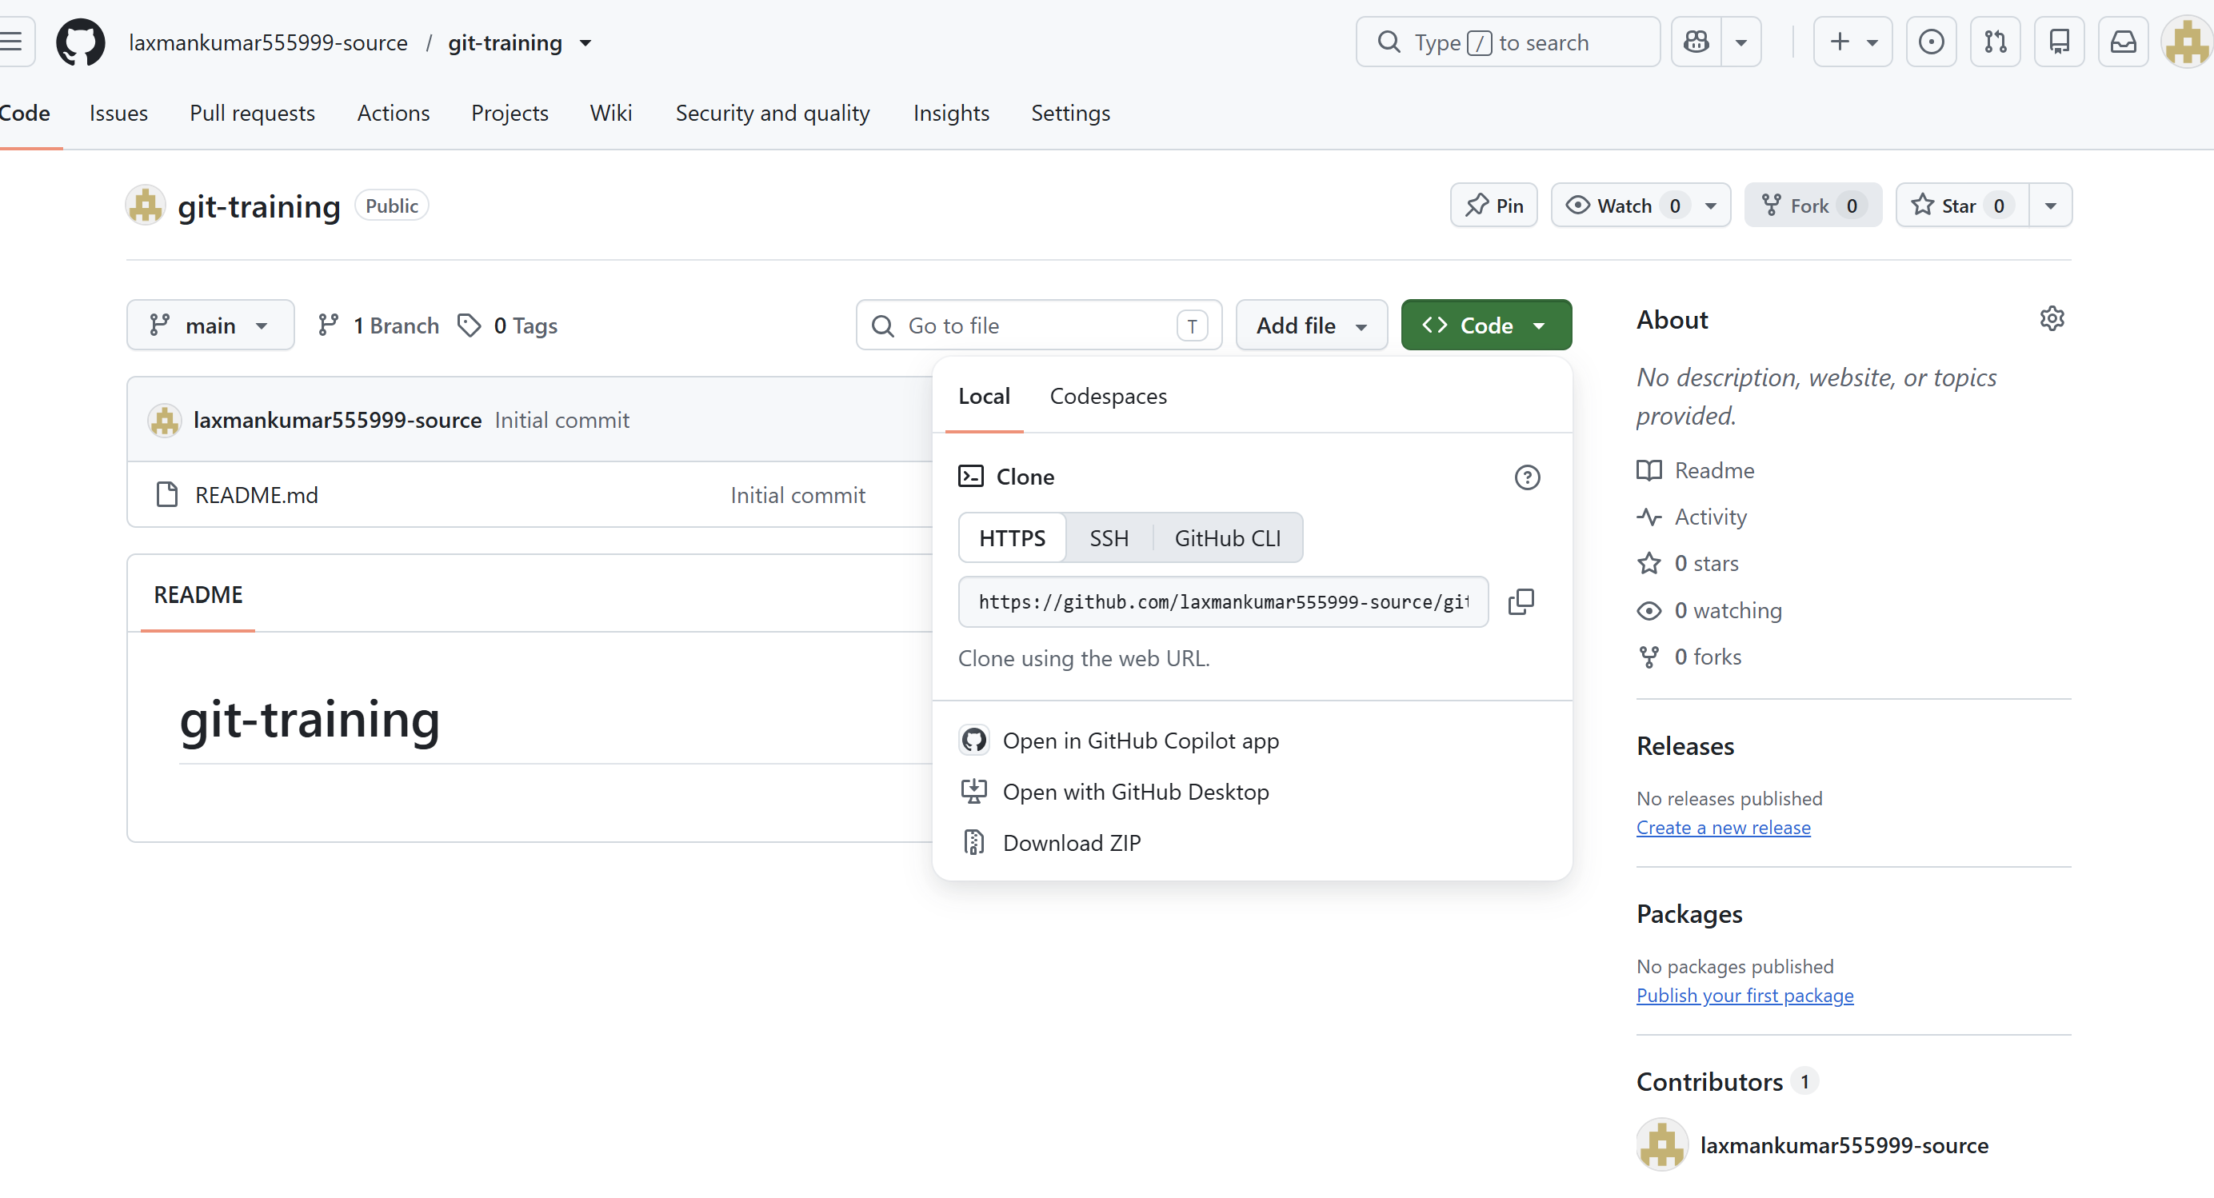 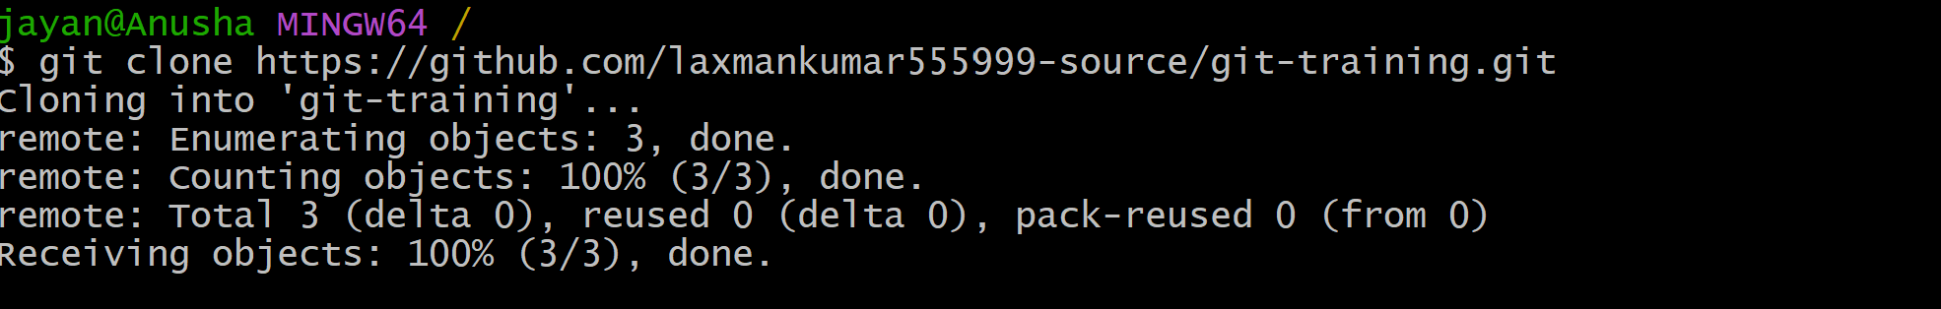
Commands:
git clone https://github.com/laxmankumar555999-source/git-training.git
cd REPOSITORY
ls -la 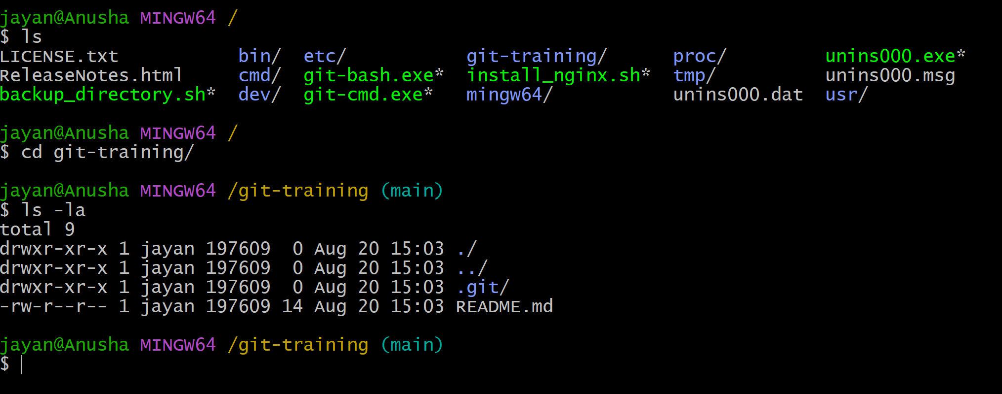

Task 4: Create Two Files, Commit, and Push
- Create two files inside the local repository.
- Check their status.
- Stage both files.
- Create a commit.
- Push the commit to the central GitHub repository. 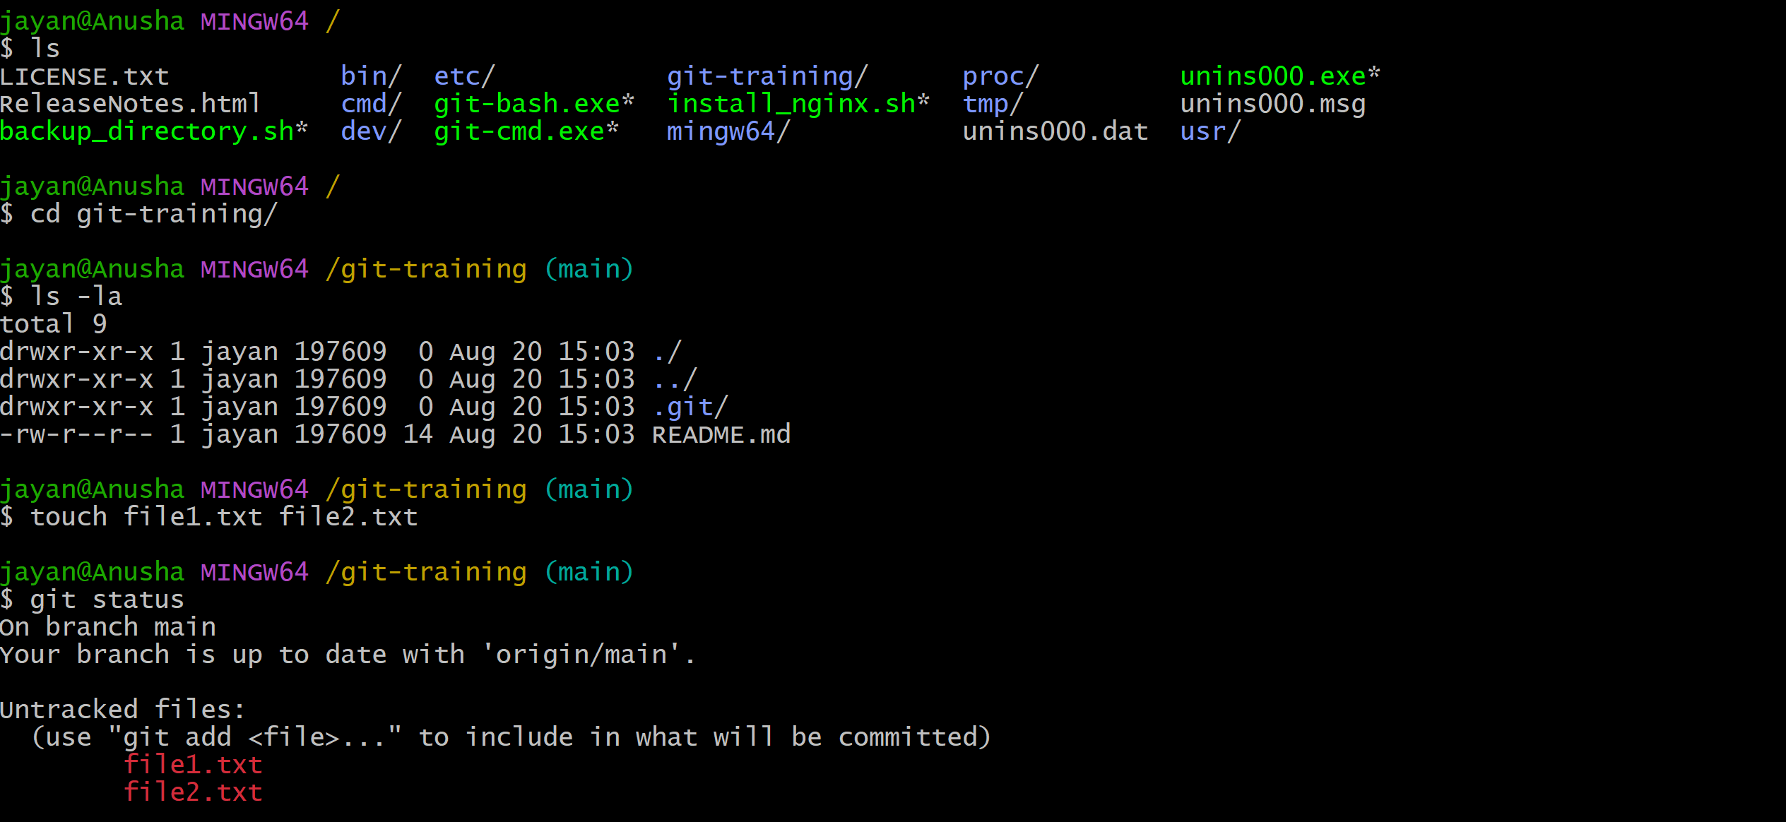 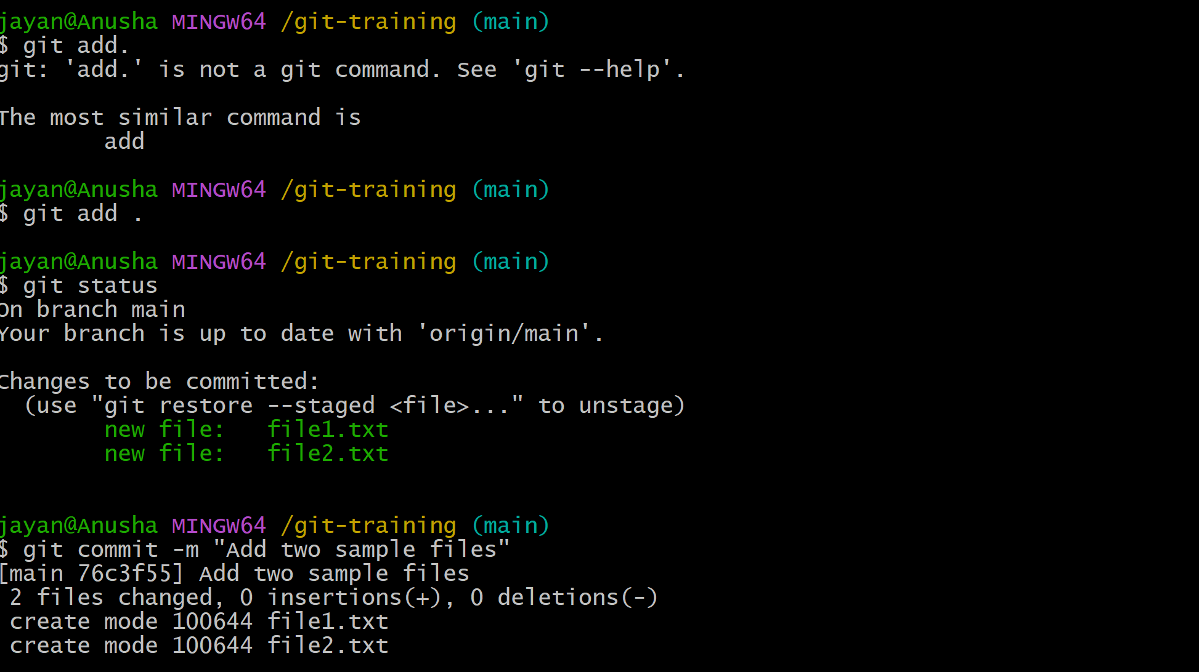 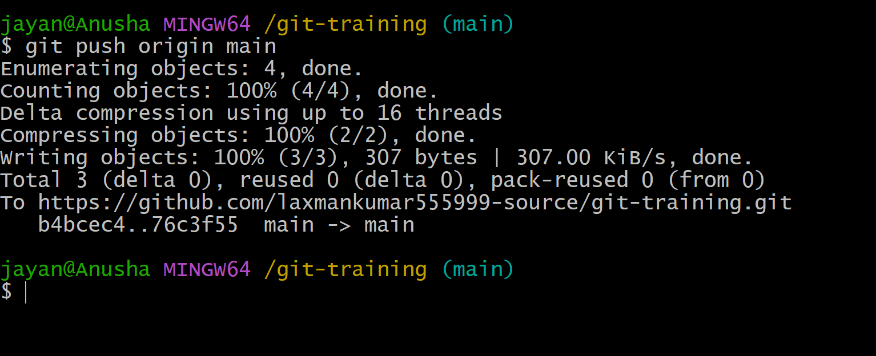
Commands:
touch file1.txt file2.txt
git status
git add .
git commit -m "Add two sample files"
git push origin main 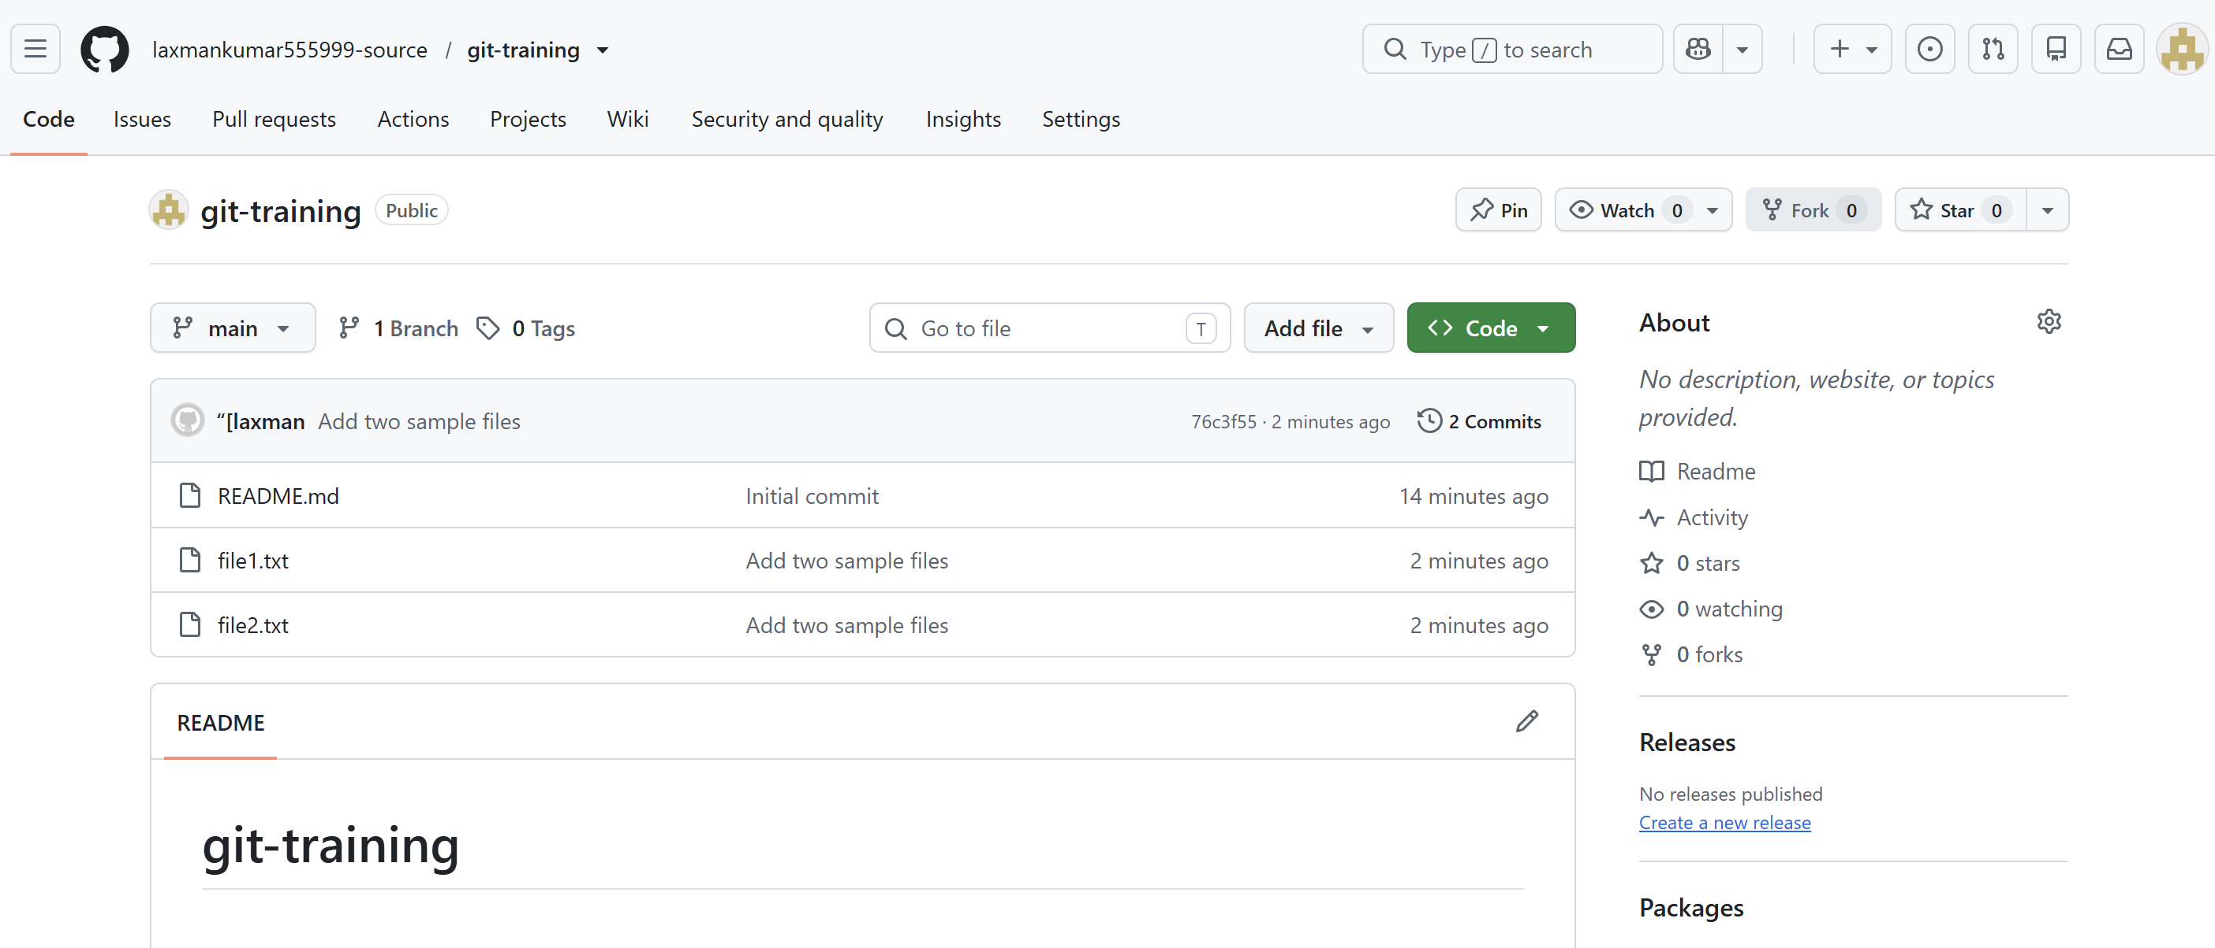

Task 5: Create a Local Branch, Add a File, and Push It
- Create and switch to a new branch.
- Create a sample file and add content.
- Commit the file.
- Push the new branch to GitHub. 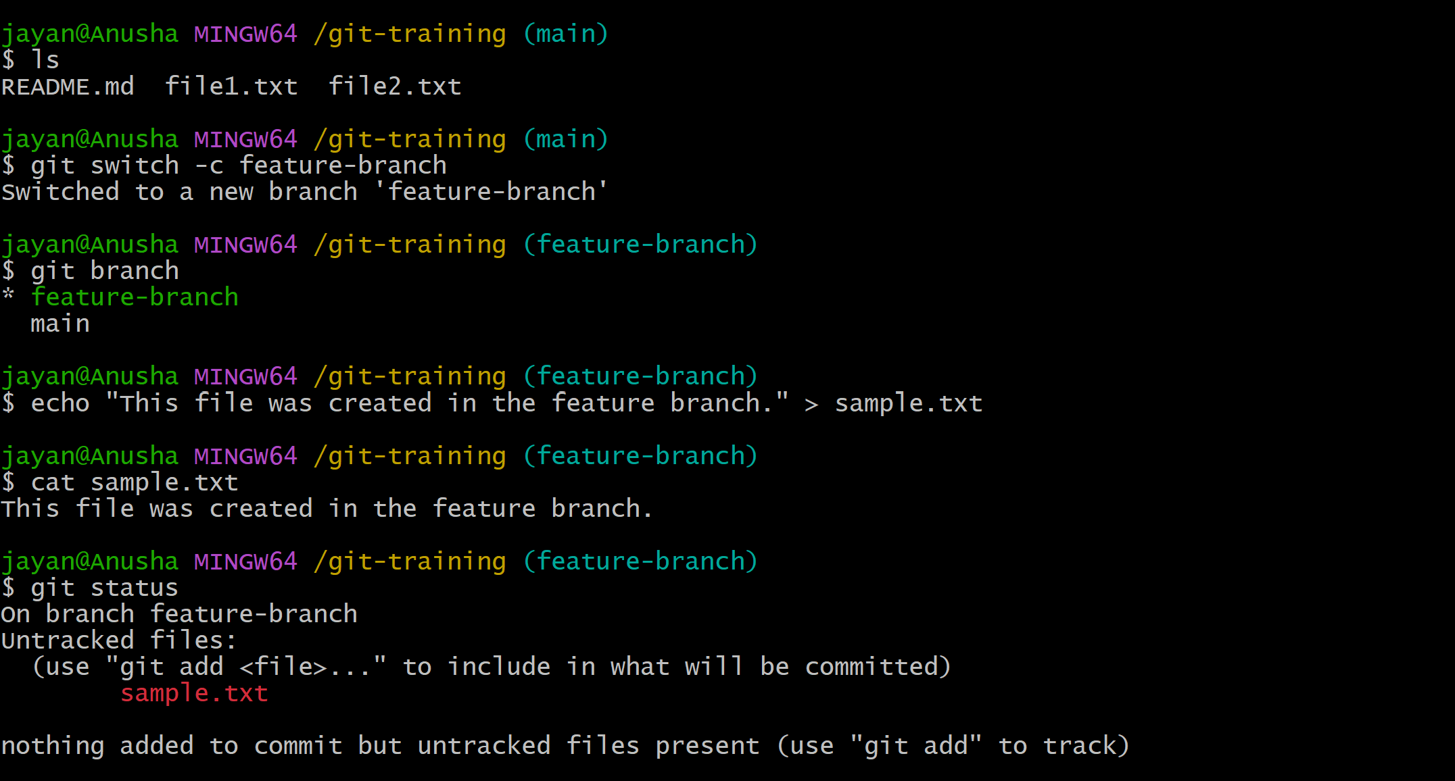 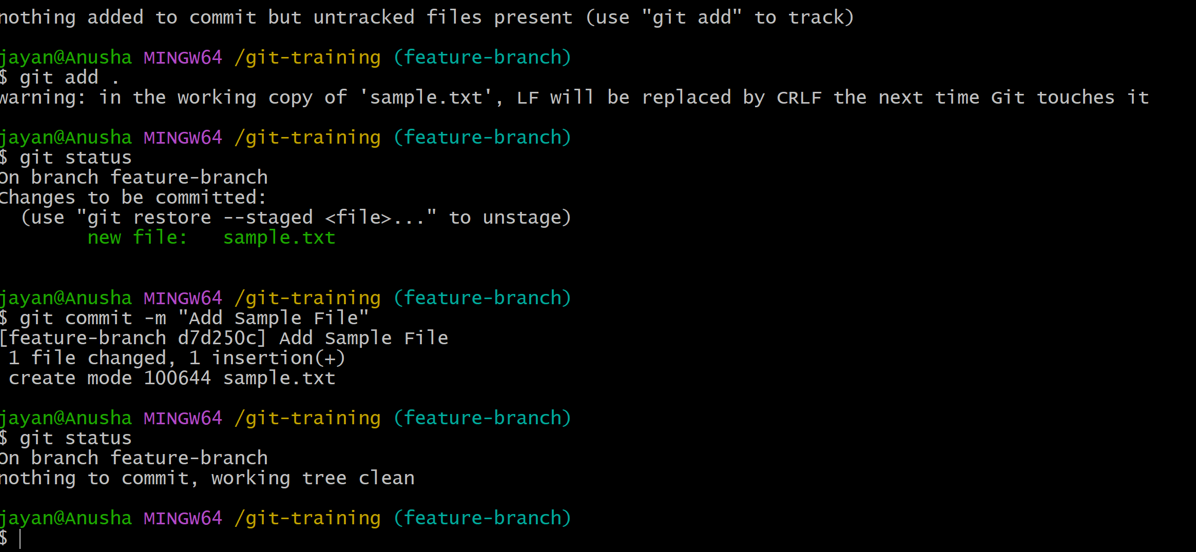 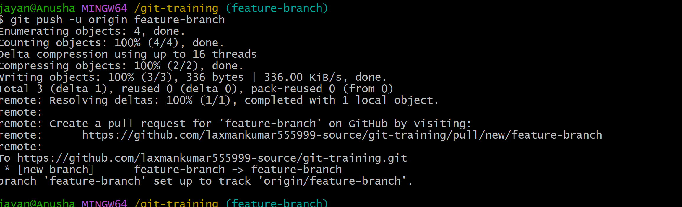
Commands:
git switch -c feature-branch
echo "Sample content" > sample.txt
git add sample.txt
git commit -m "Add sample file"
git push -u origin feature-branch 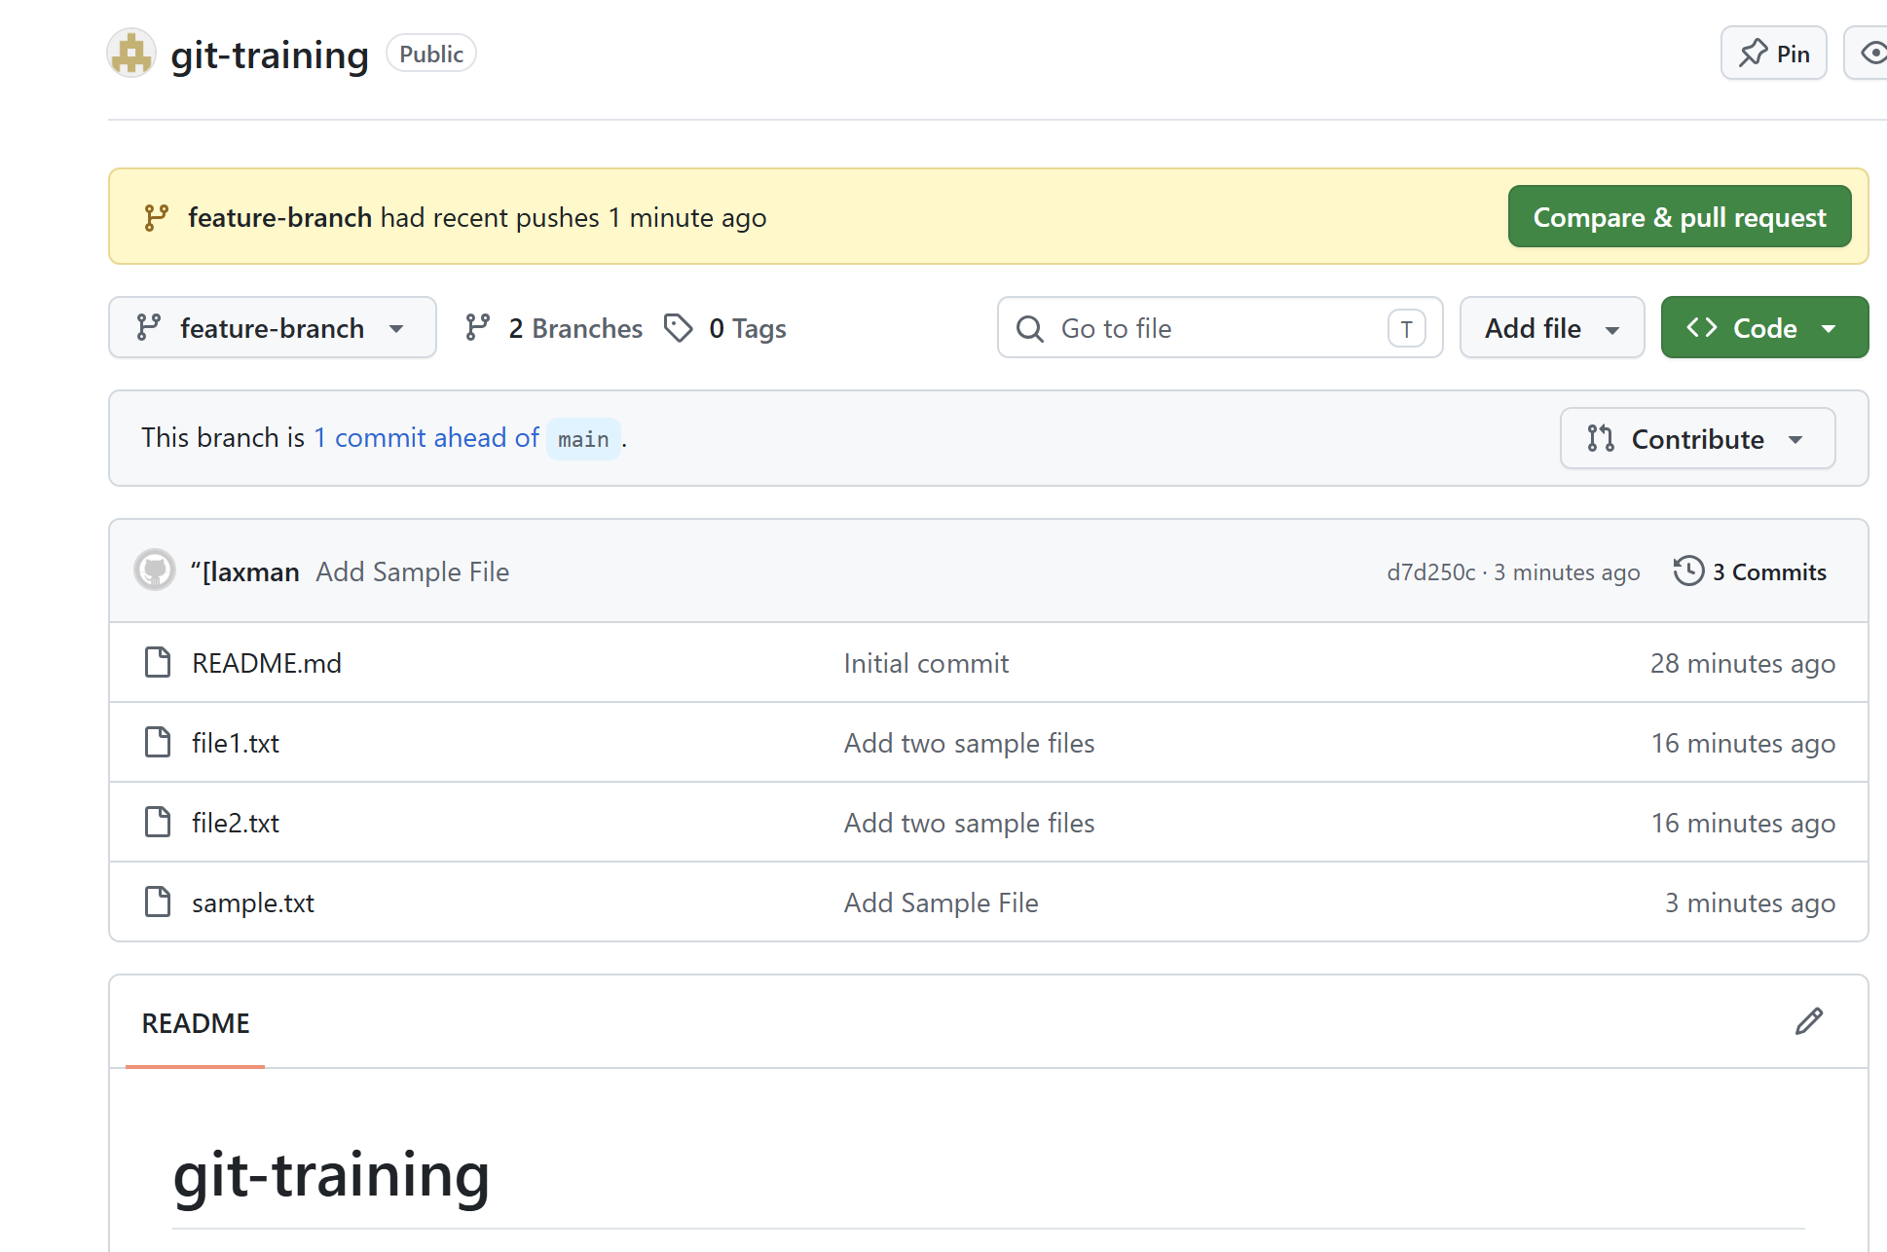

Task 6: Create a Branch in GitHub and Clone It to Local
- Create a branch from the GitHub repository interface.
- Fetch the remote branch locally.
- Switch to the branch. 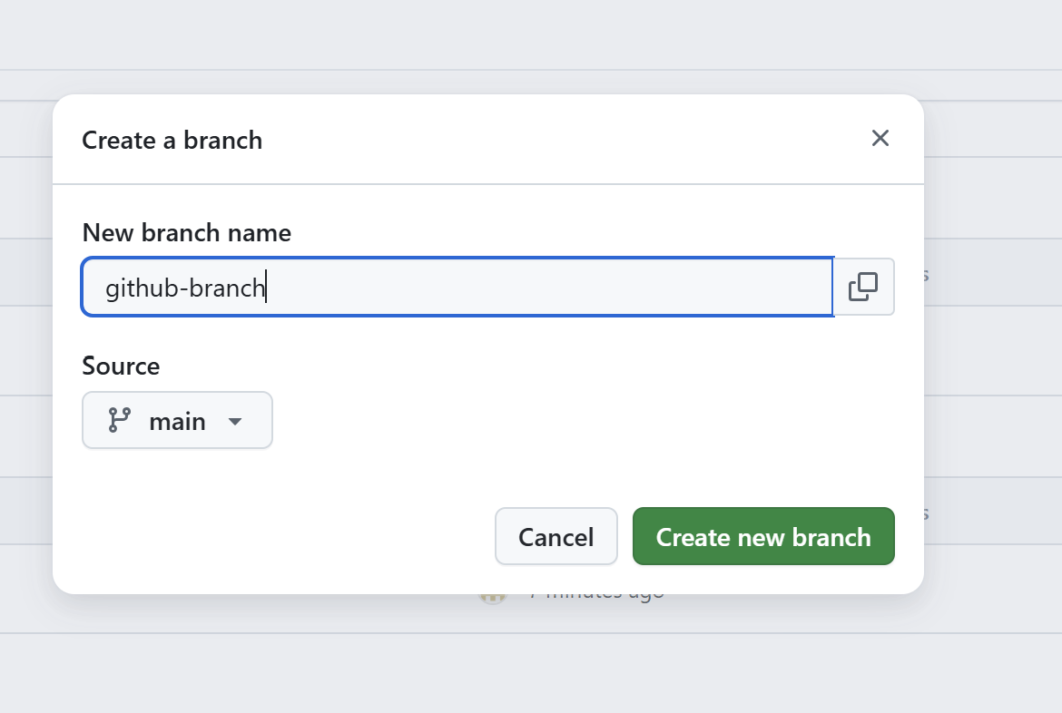 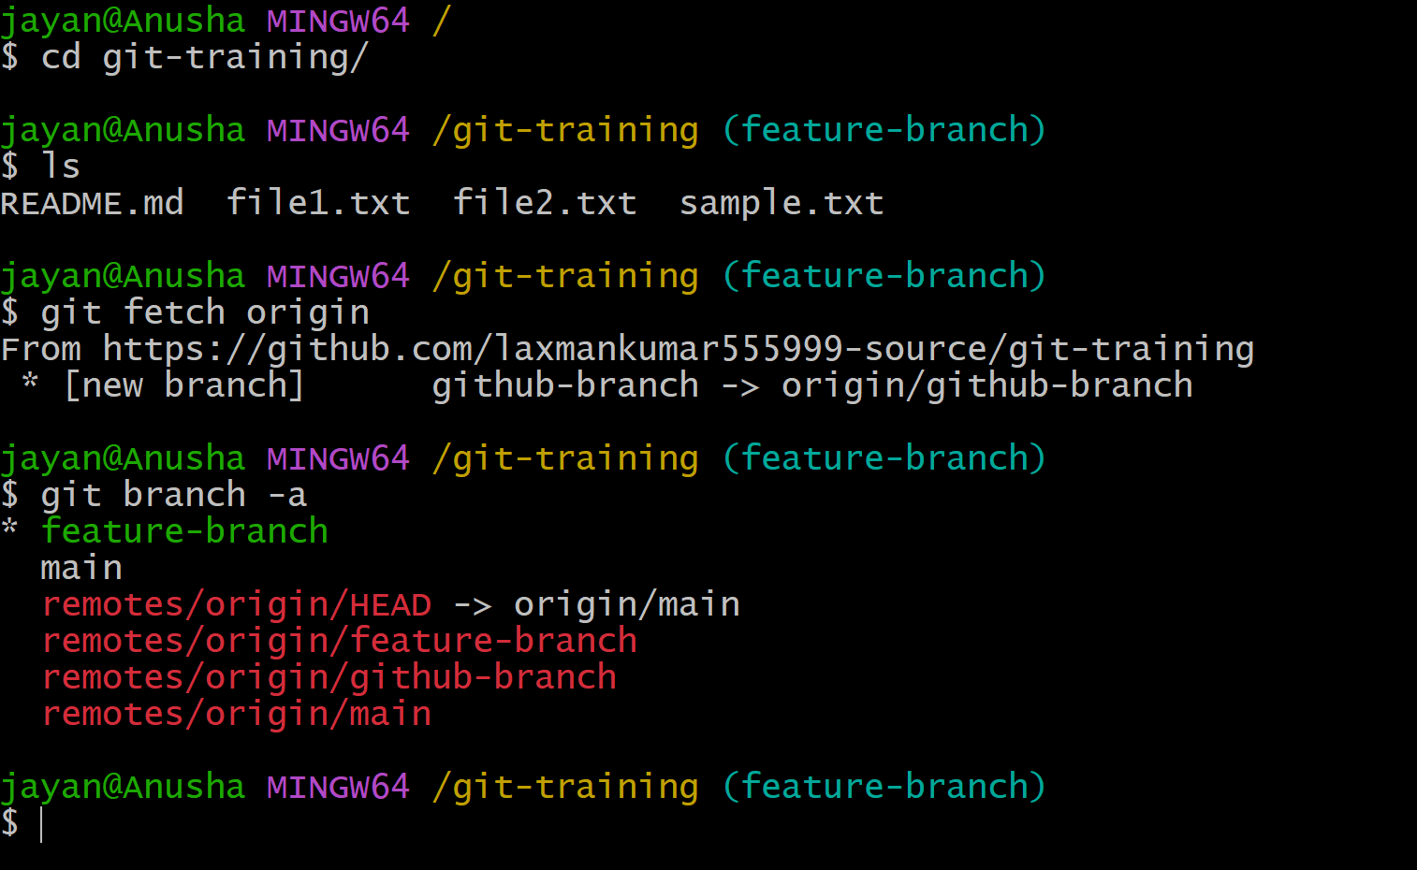 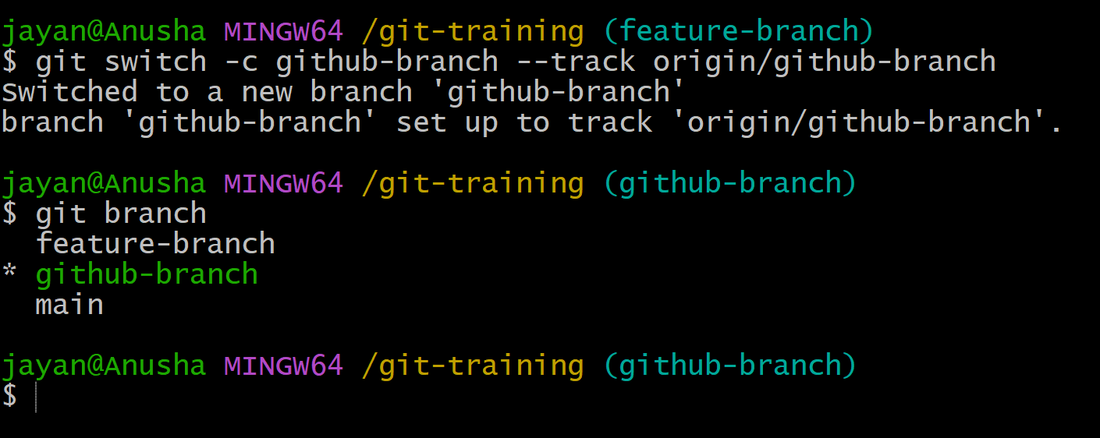 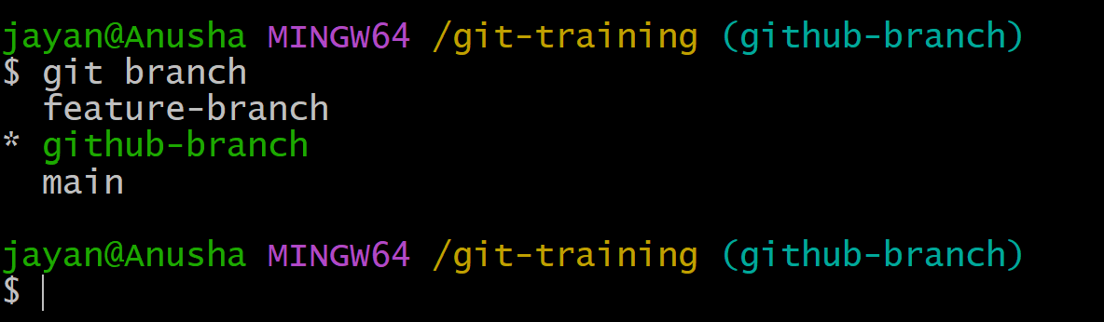Commands:
git fetch origin
git branch -a
git switch -c github-branch --track origin/github-branch

Task 7: Merge a Branch with Master/Main Locally
- Switch to the main branch. If your repository still uses master, replace main with master.
- Pull the latest changes.
- Merge the feature branch into main.
- Resolve conflicts if Git reports any, then commit the resolution.
- Push the merged result. 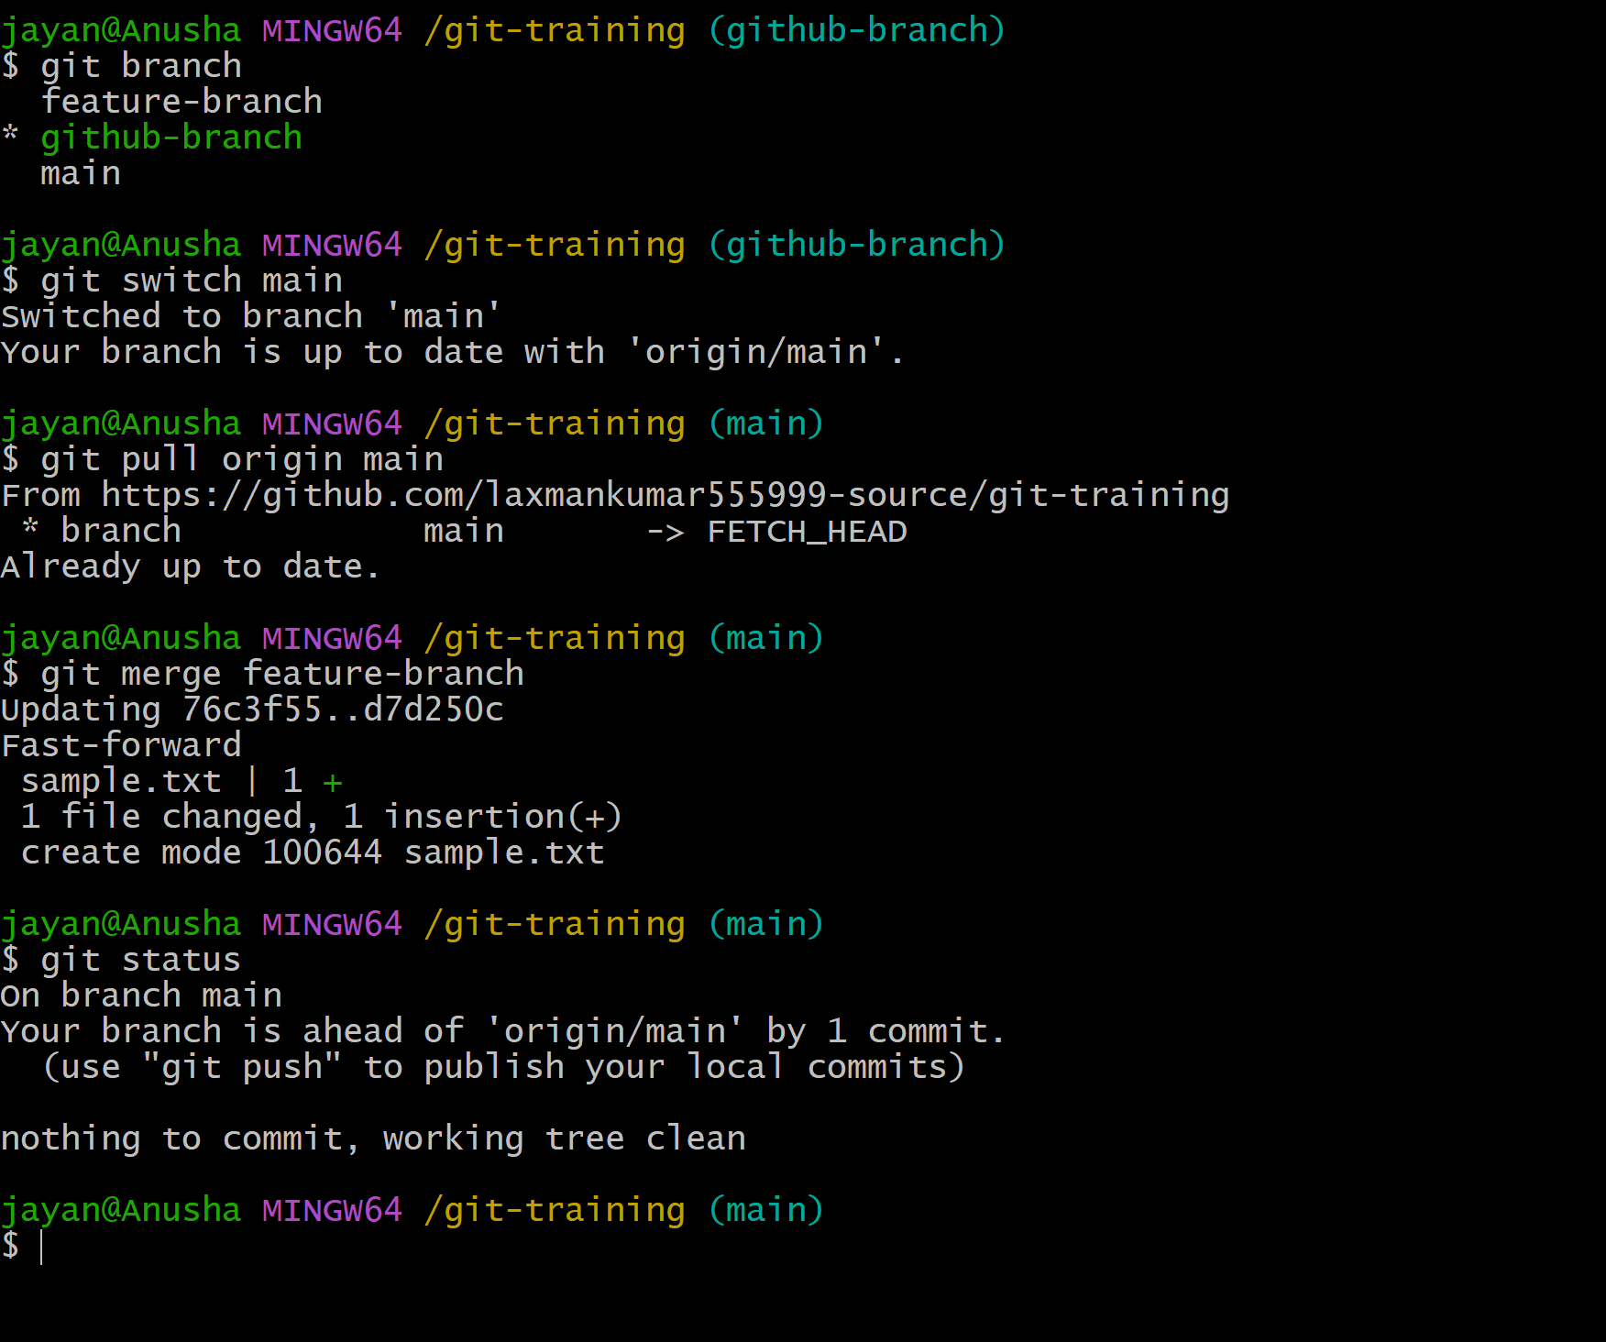 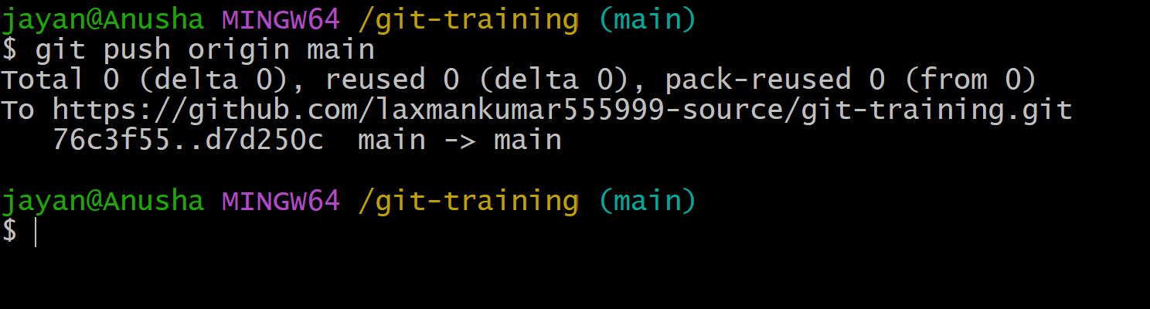
Commands:
git switch main
git pull origin main
git merge feature-branch
git push origin main

Task 8: Merge a Branch in GitHub Using a Pull Request
- Push the branch to GitHub.
- Open the repository on GitHub.
- Create a Pull Request from the feature branch to main.
- Review the changes and create the pull request.
- Merge the pull request after review.
- Delete the branch if it is no longer required. 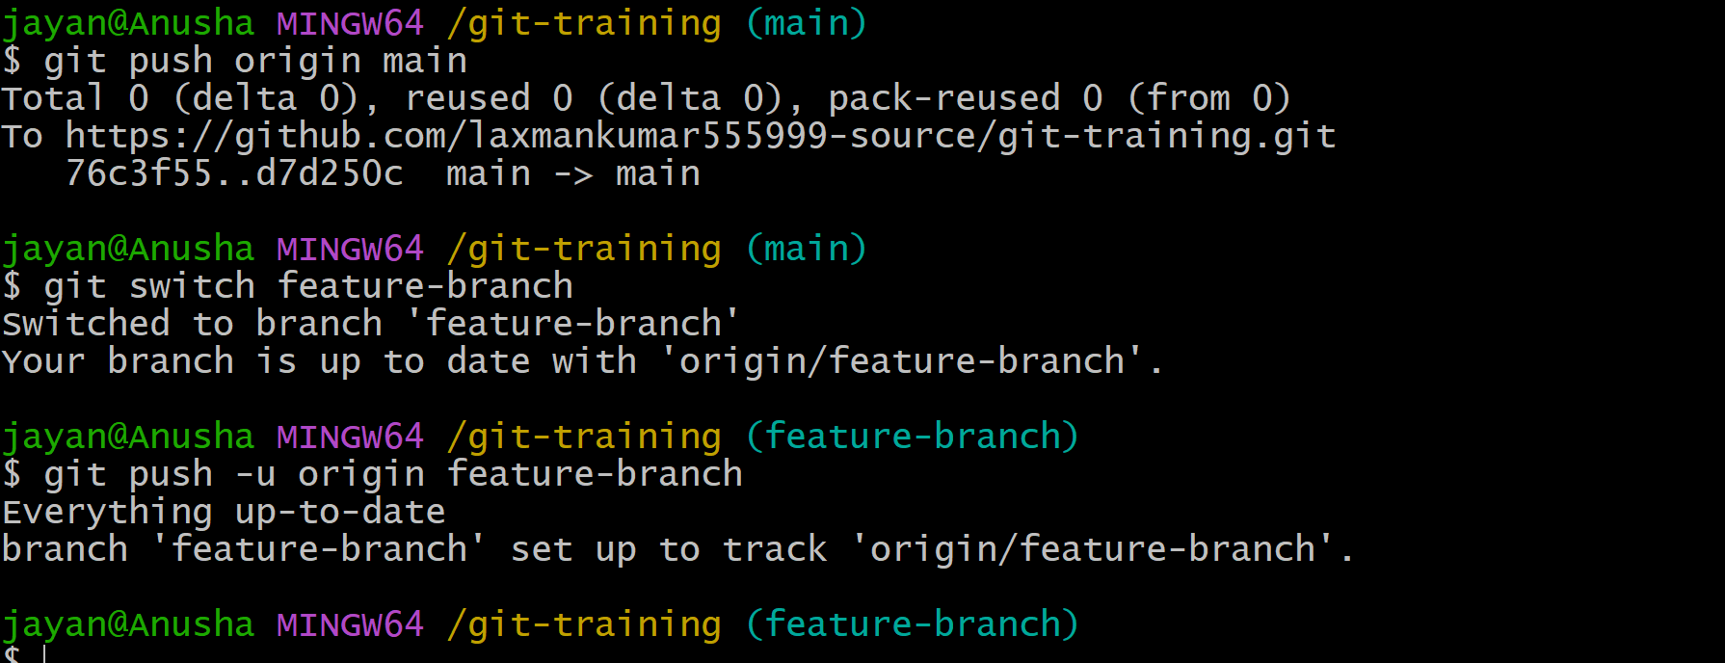 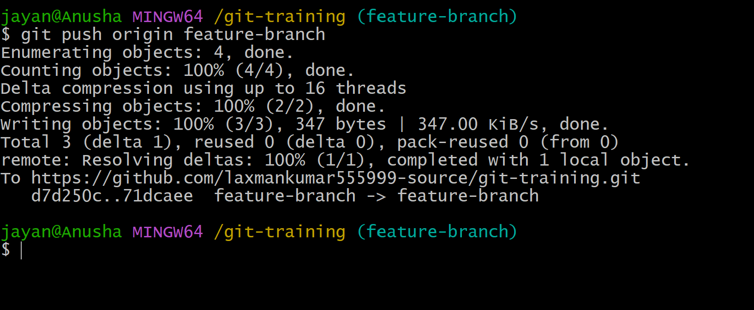 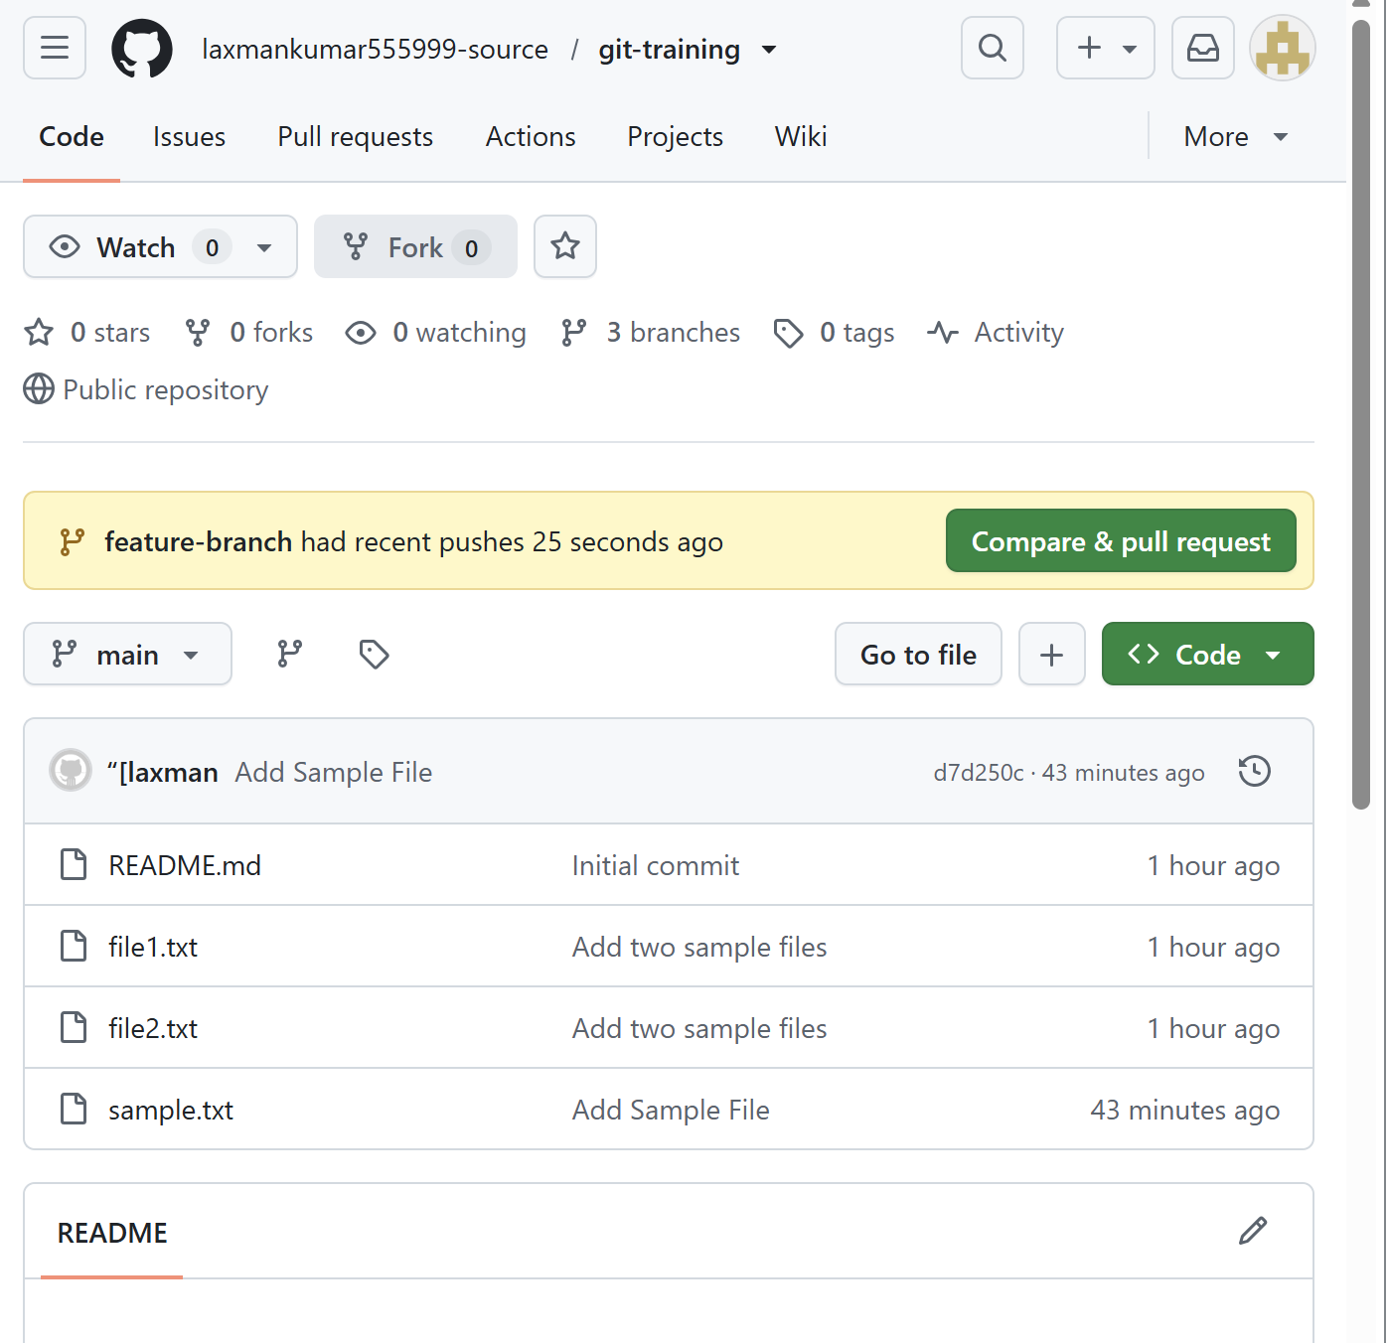 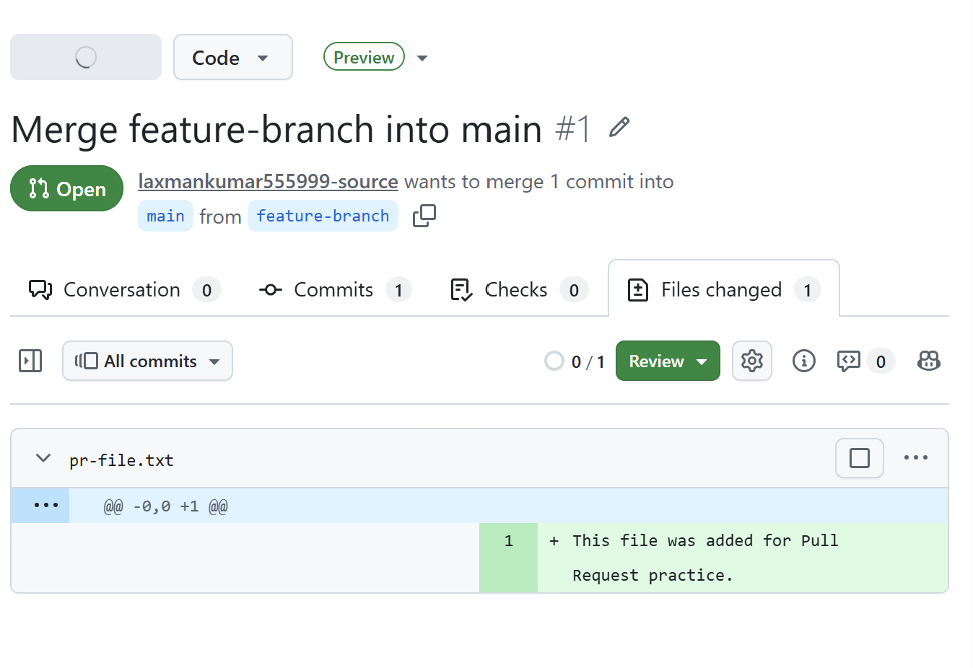 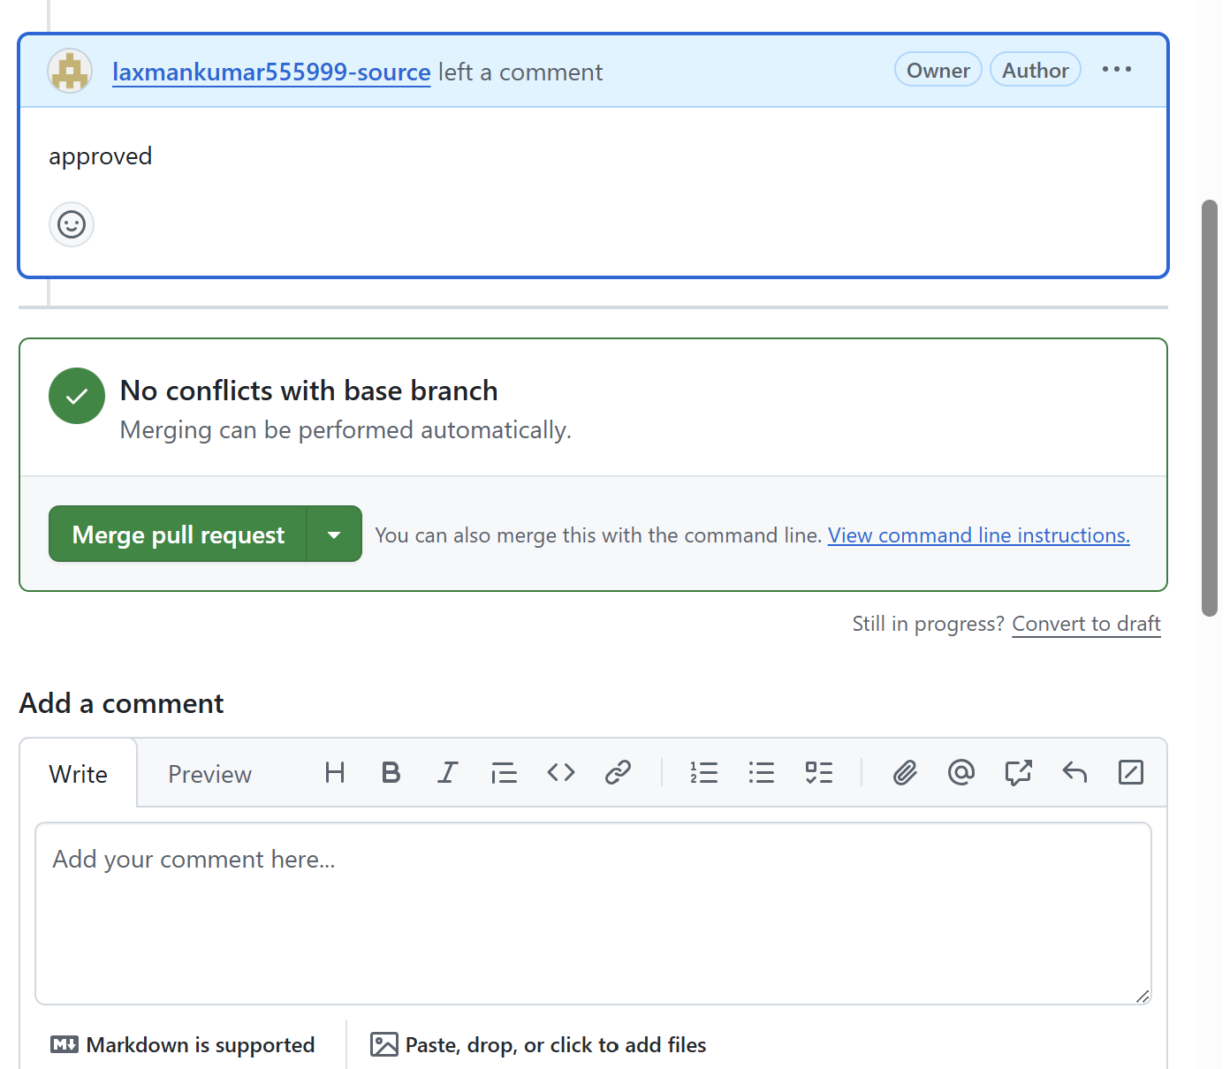 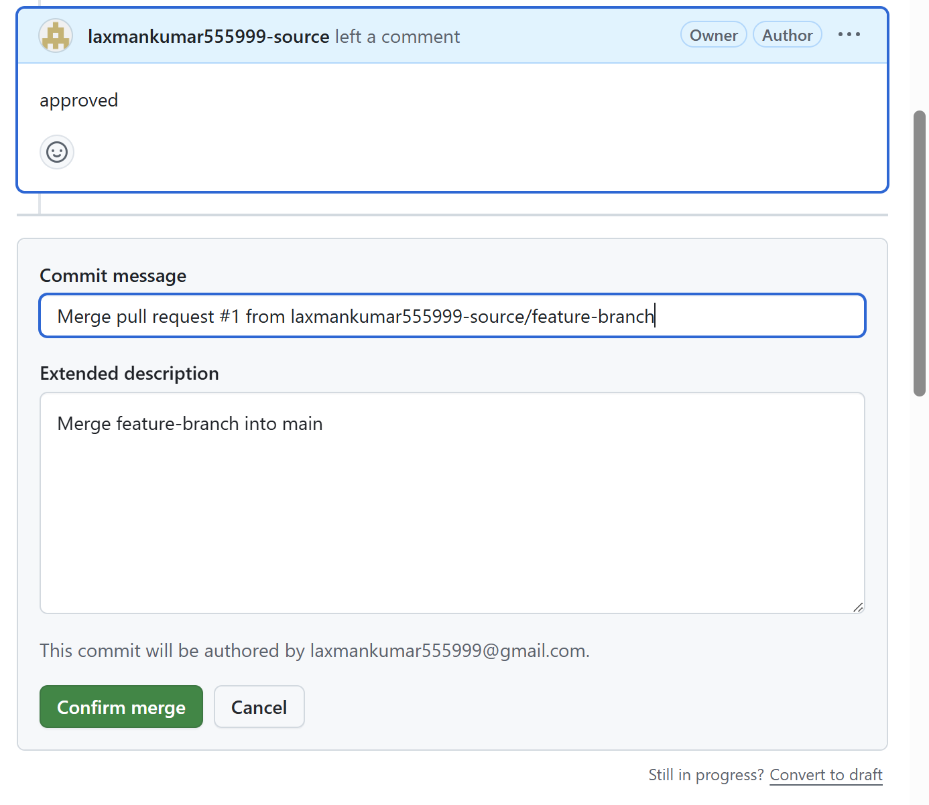
Commands:
git push -u origin feature-branch

Task 9: Create a Local File and Send It to a GitHub Branch
- Switch to the target branch.
- Create a new file.
- Stage and commit the file.
- Push the branch to GitHub. 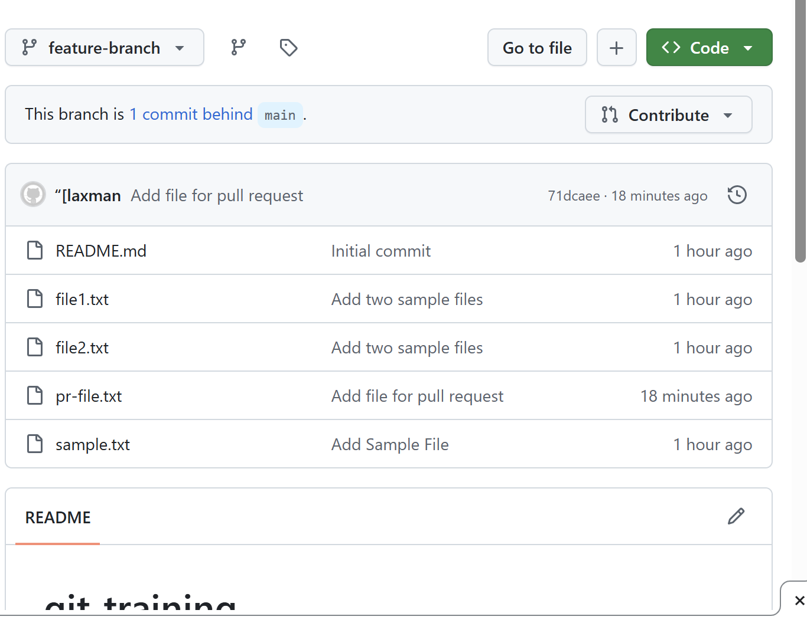 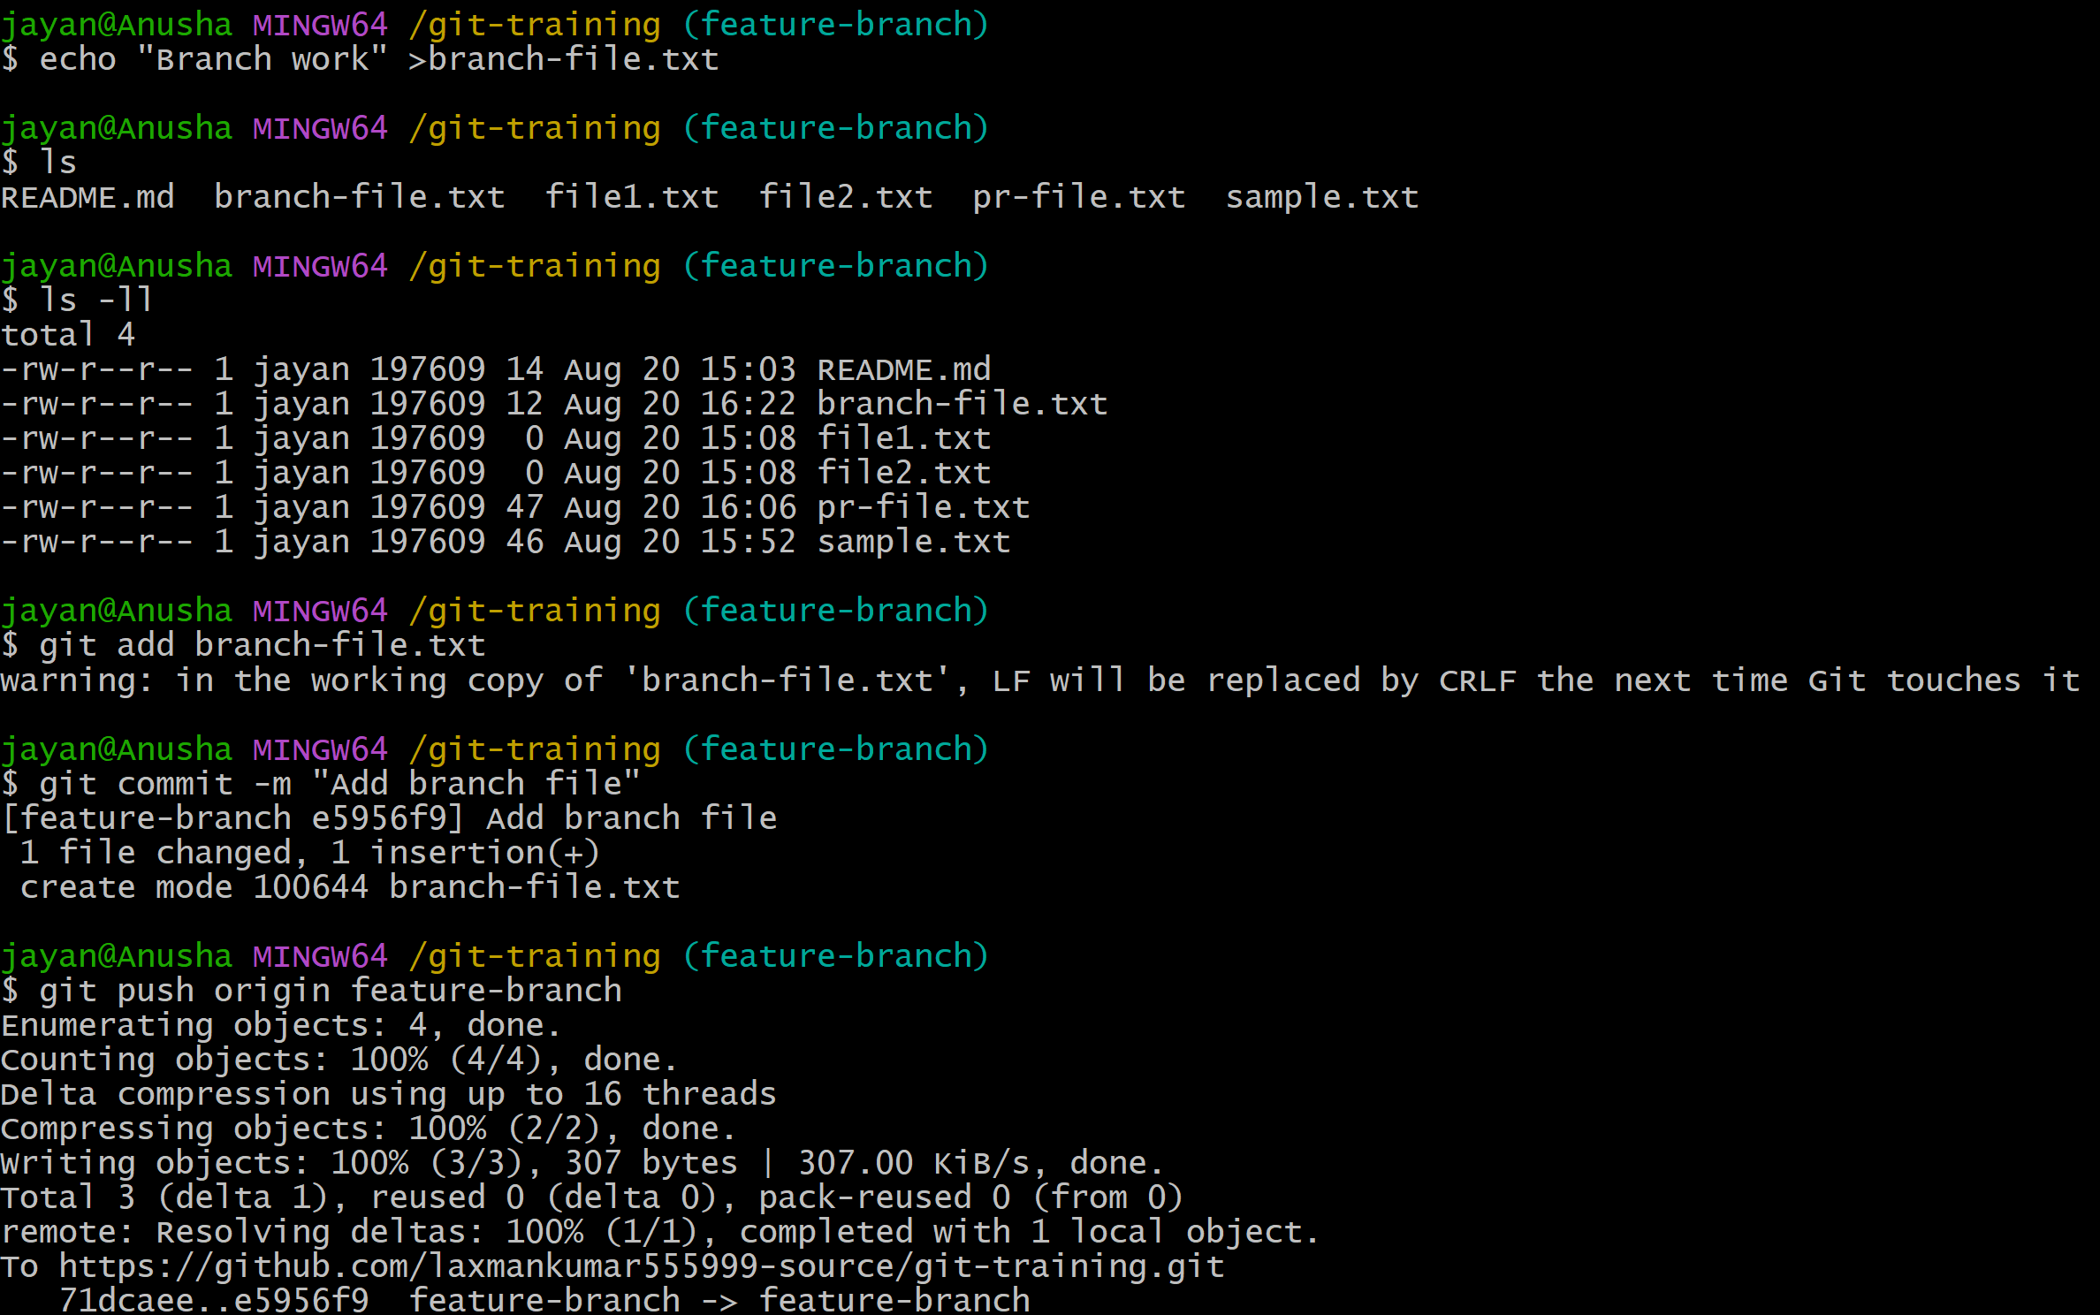 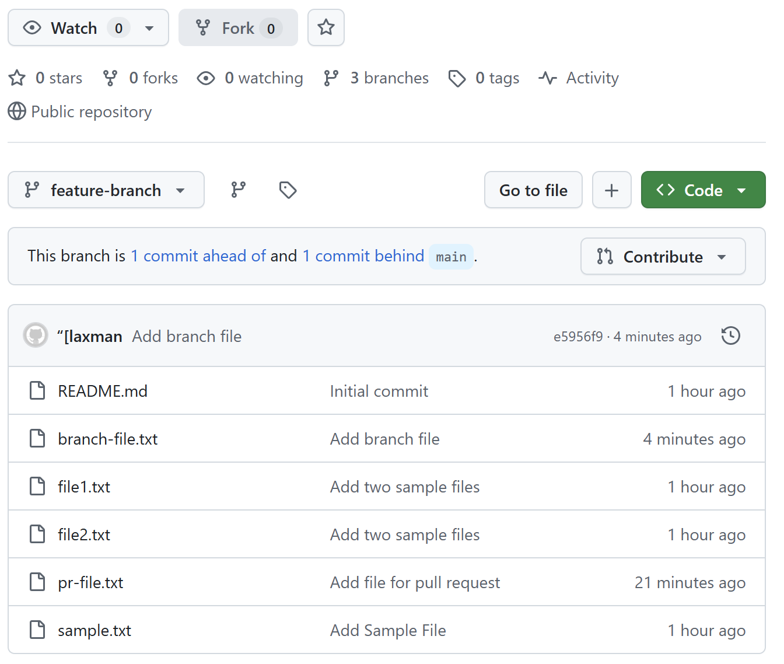
Commands:
git switch feature-branch
echo "Branch work" > branch-file.txt
git add branch-file.txt
git commit -m "Add branch file"
git push origin feature-branch

Task 10: Clone Only One Branch from GitHub
- Clone only the required branch instead of downloading all branches. 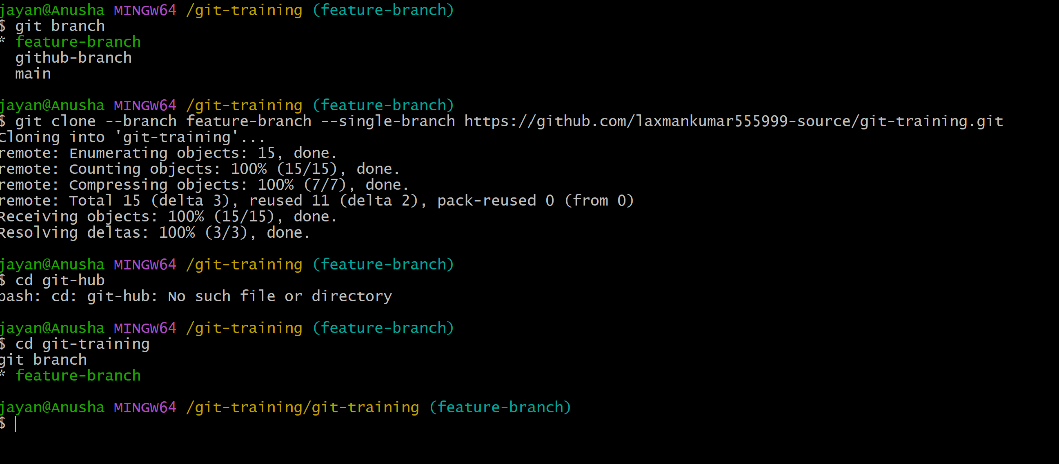
Commands:
git clone --branch feature-branch --single-branch https://github.com/laxmankumar555999-source/git-training.git

Task 11: Make a Password File Untrackable with Git
- Create a local password file.
- Add the password file to .gitignore.
- If the file was never committed, Git will ignore it.
- If it was already tracked, remove it from Git's index while keeping the local file. 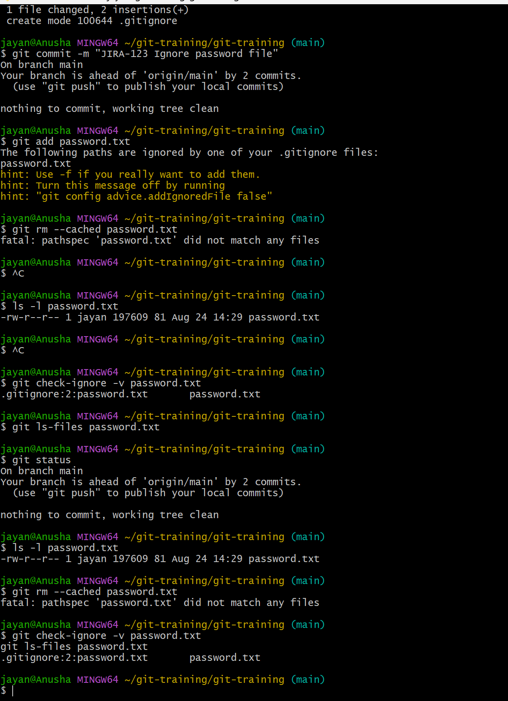
Commands:
echo "username=admin" > passwords.txt
echo "passwords.txt" >> .gitignore
git status
git rm --cached passwords.txt
git add .gitignore
git commit -m "Ignore password file"

Task 12: Reset a Commit Without Keeping Its Changes
- Create and commit a test change.
- Identify the commit hash using git log.
- Use a hard reset to move HEAD back and discard the committed changes.
- Use this carefully because uncommitted changes can be lost.
Commands: 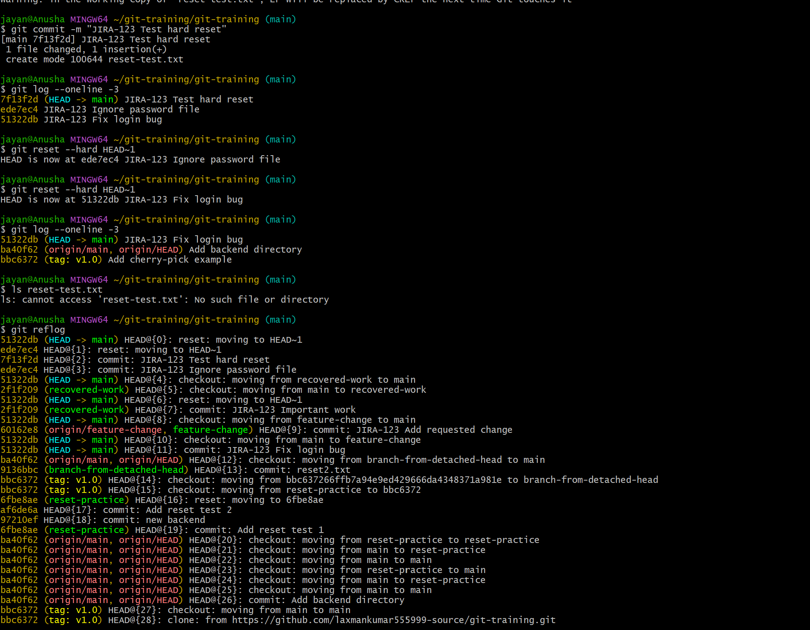
git log --oneline
git reset --hard HEAD~1

Task 13: Revert a Committed Commit to the Older Version
- Find the commit that should be reverted.
- Use git revert to create a new commit that reverses the selected commit.
- Push the new revert commit if the repository is shared. 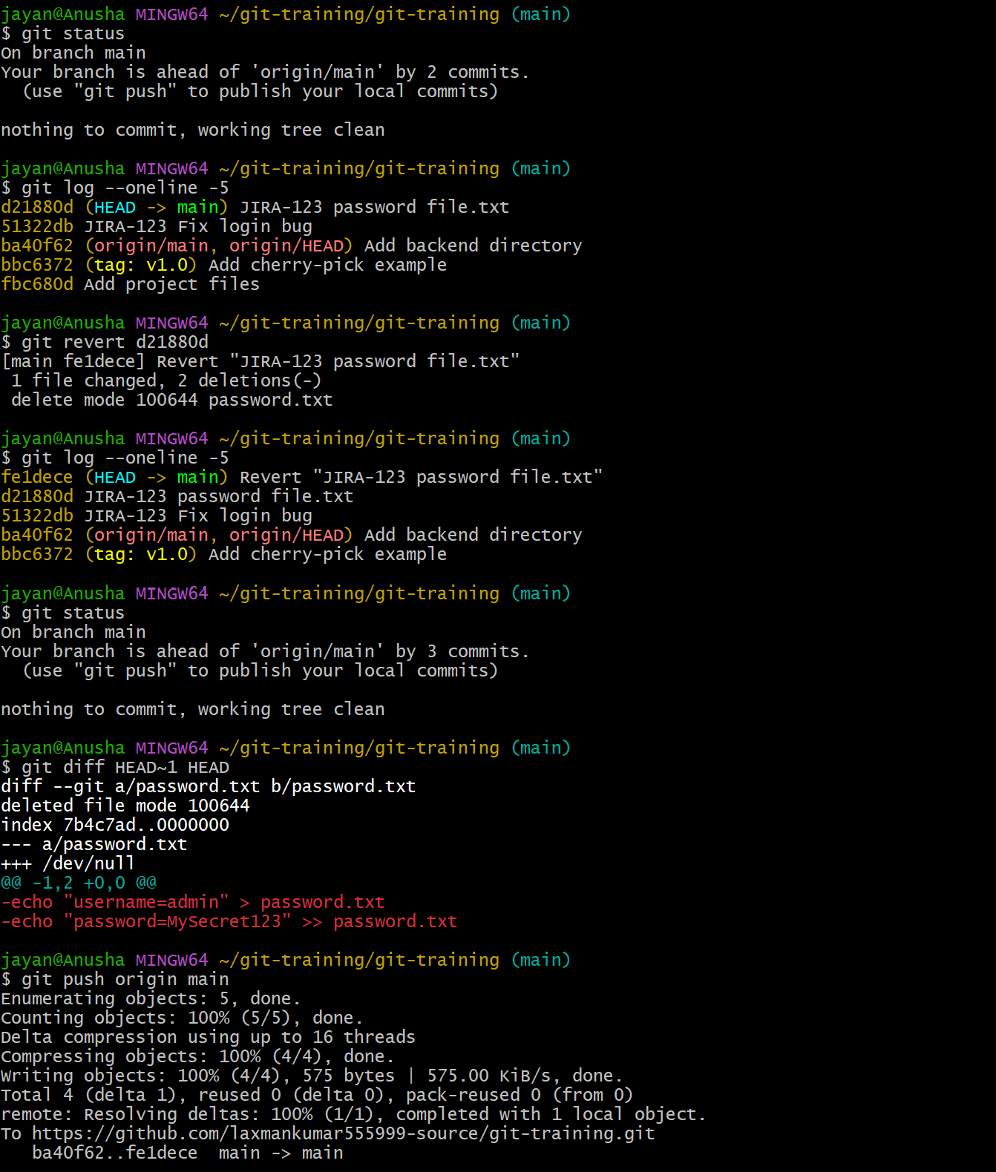
Commands:
git log --oneline
git revert COMMIT_ID
git push origin main

Task 14: Stash Changes and Work on Another File
- Modify a file without committing it.
- Save the uncommitted work in the stash.
- Work on another file and commit or push that work.
Commands:
git status
git stash push -m "Work in progress"
echo "Other work" > other-file.txt
git add other-file.txt
git commit -m "Add other file"
git push origin main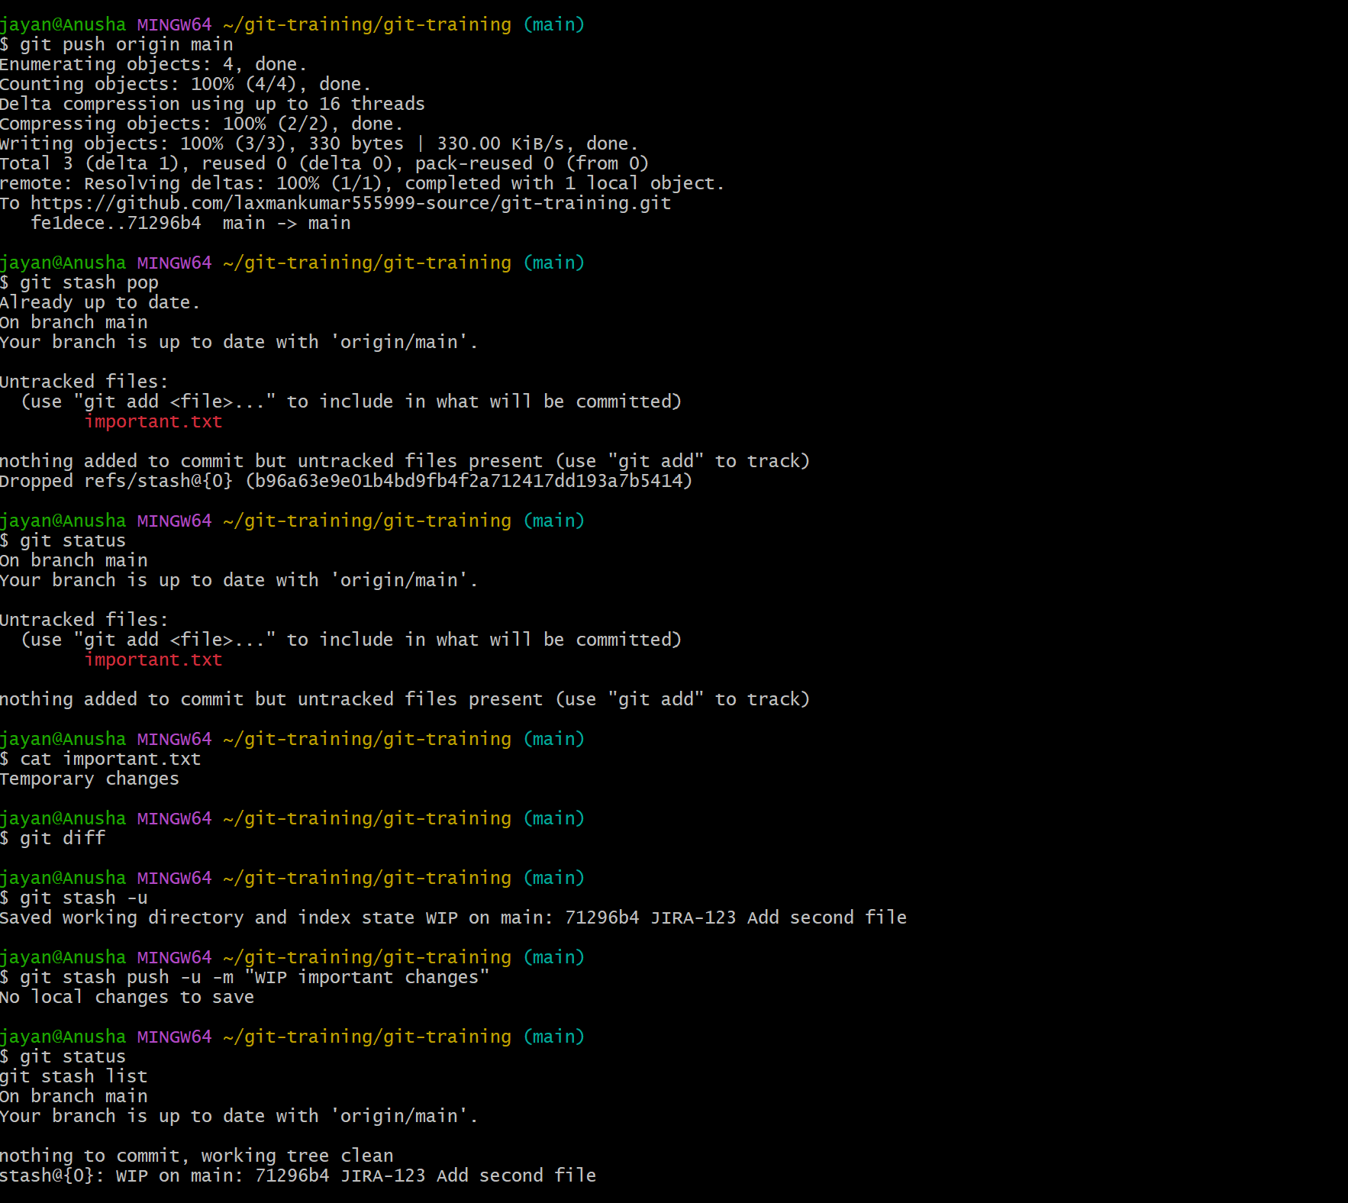

Task 15: Restore the Stashed File and Continue Working
- View available stashes.
- Apply the latest stash without deleting it, or pop it to apply and remove it.
- Continue editing and commit the restored work.
Commands: 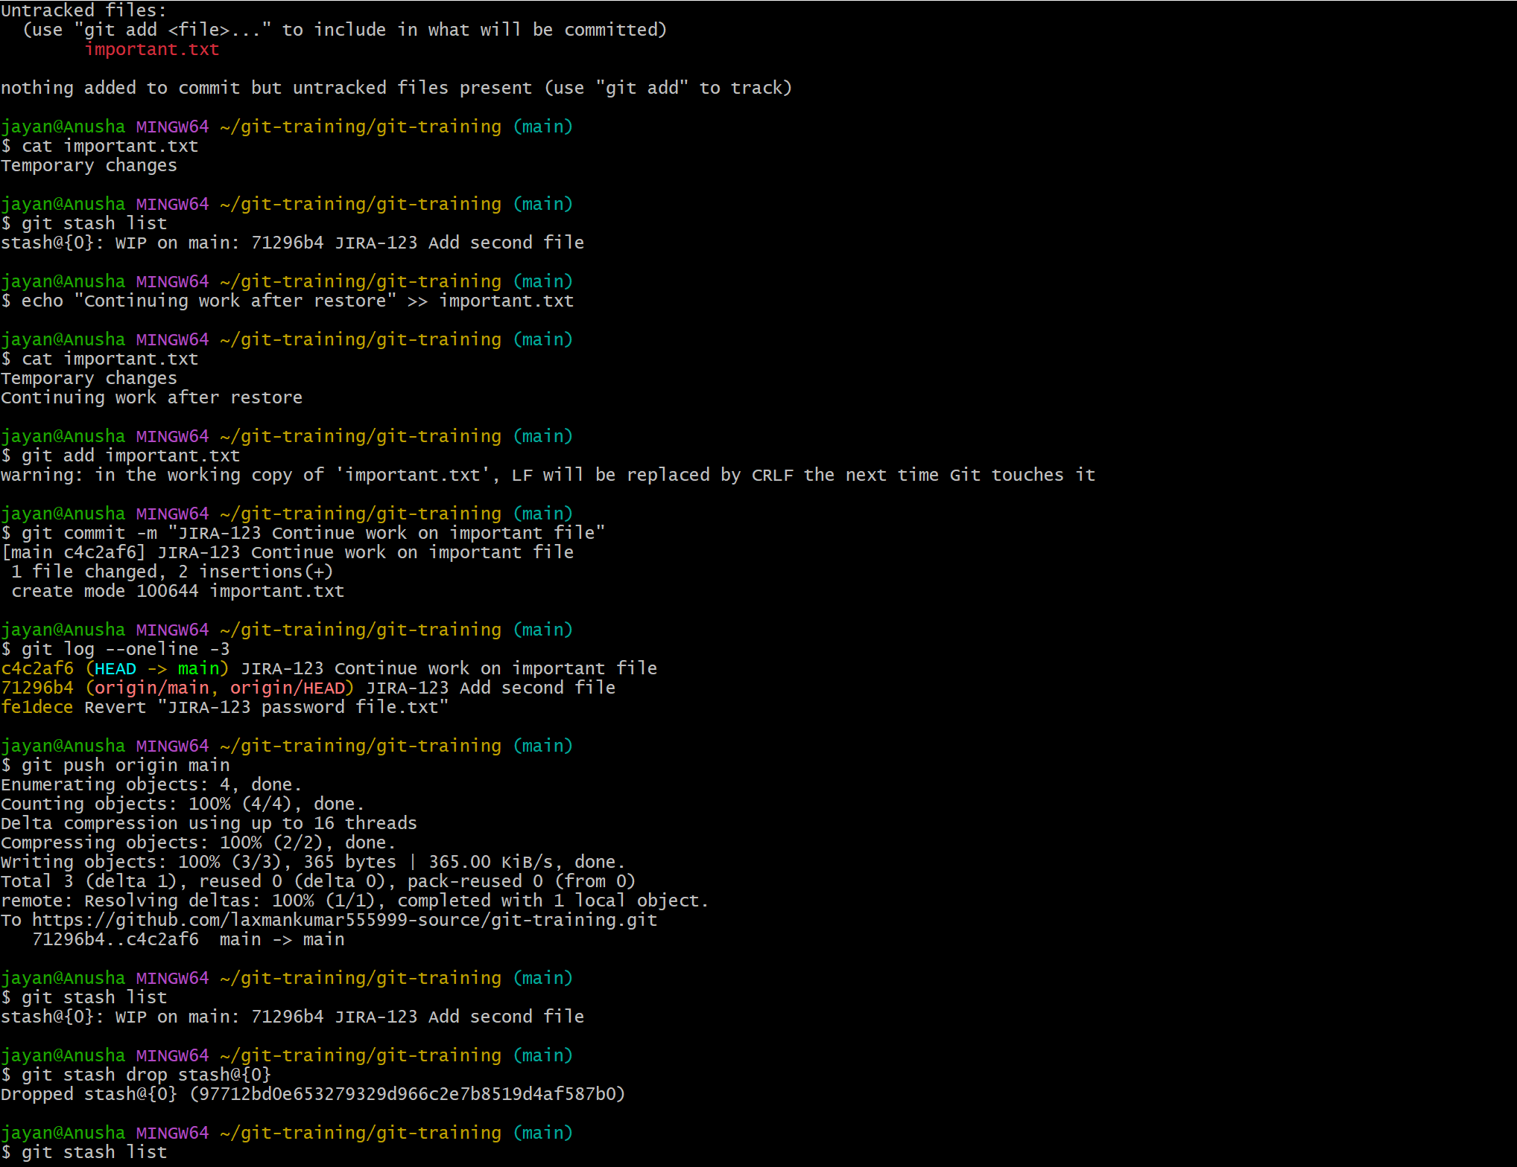
git stash list
git stash apply stash@{0}
# Or: git stash pop stash@{0}
git status

Task 16: Generate an SSH Key and Configure GitHub
- Generate an SSH key pair.
- Start the SSH agent and add the private key.
- Copy the public key and add it to GitHub under Settings > SSH and GPG keys.
- Test the SSH connection.
- Use the SSH repository URL for future pushes and pulls.
Commands:
ssh-keygen -t ed25519 -C "your-email@example.com"
eval "$(ssh-agent -s)"
ssh-add ~/.ssh/id_ed25519
cat ~/.ssh/id_ed25519.pub
ssh -T git@github.com
git remote set-url origin git@github.com:USERNAME/REPOSITORY.git 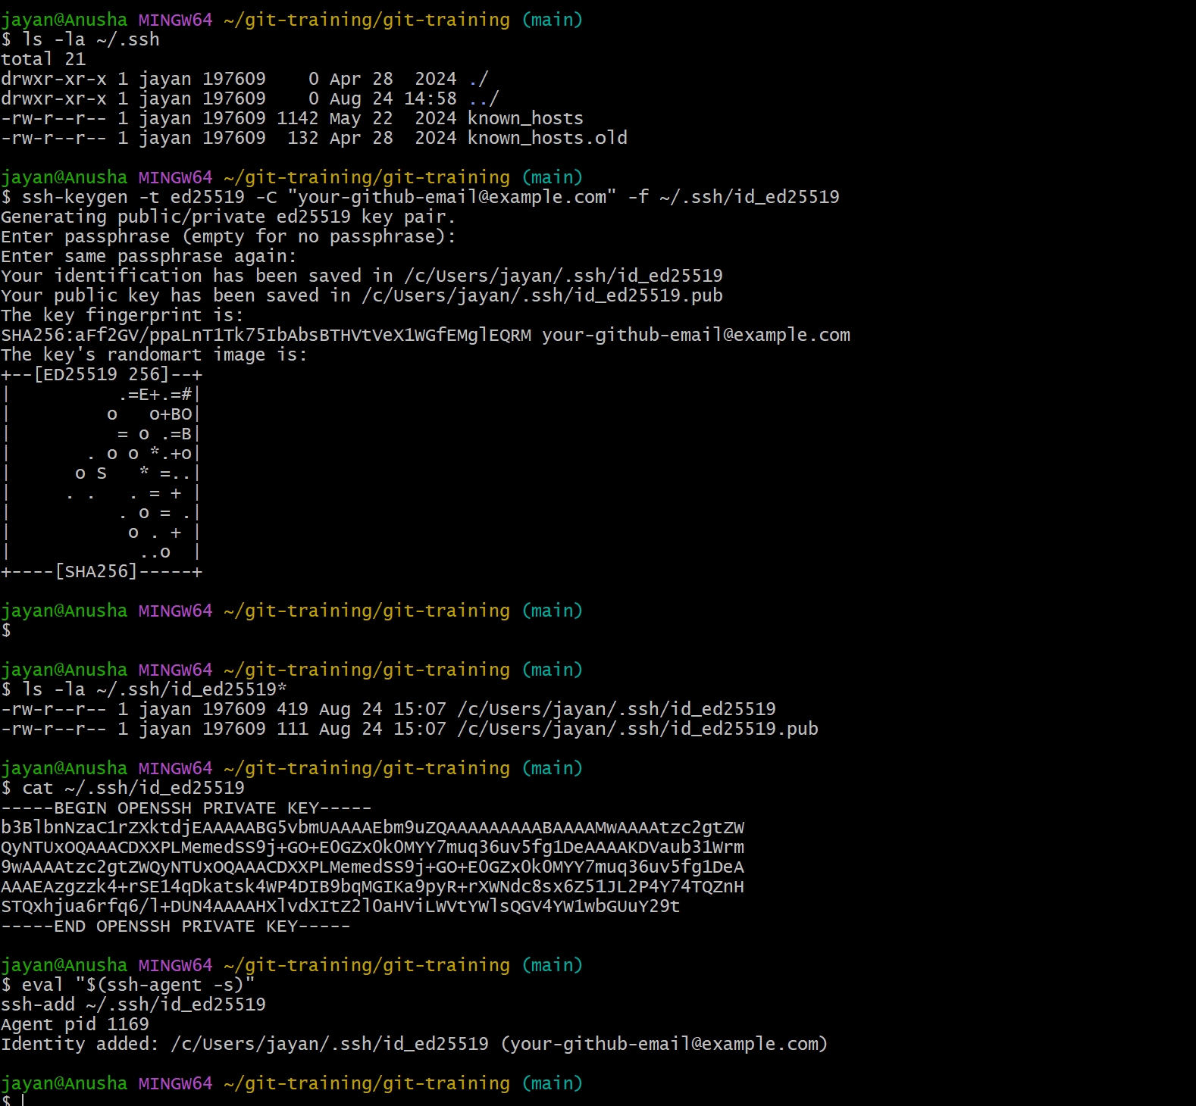

Task 17: Configure GitHub Webhooks
- Open the repository on GitHub.
- Go to Settings > Webhooks > Add webhook.
- Enter the payload URL of your webhook receiver.
- Choose the required content type and events.
- Save the webhook.
- Test the webhook delivery and inspect the response.
Commands:
Example payload URL: https://your-server.example.com/webhook
Use a secure HTTPS endpoint and a secret where appropriate. 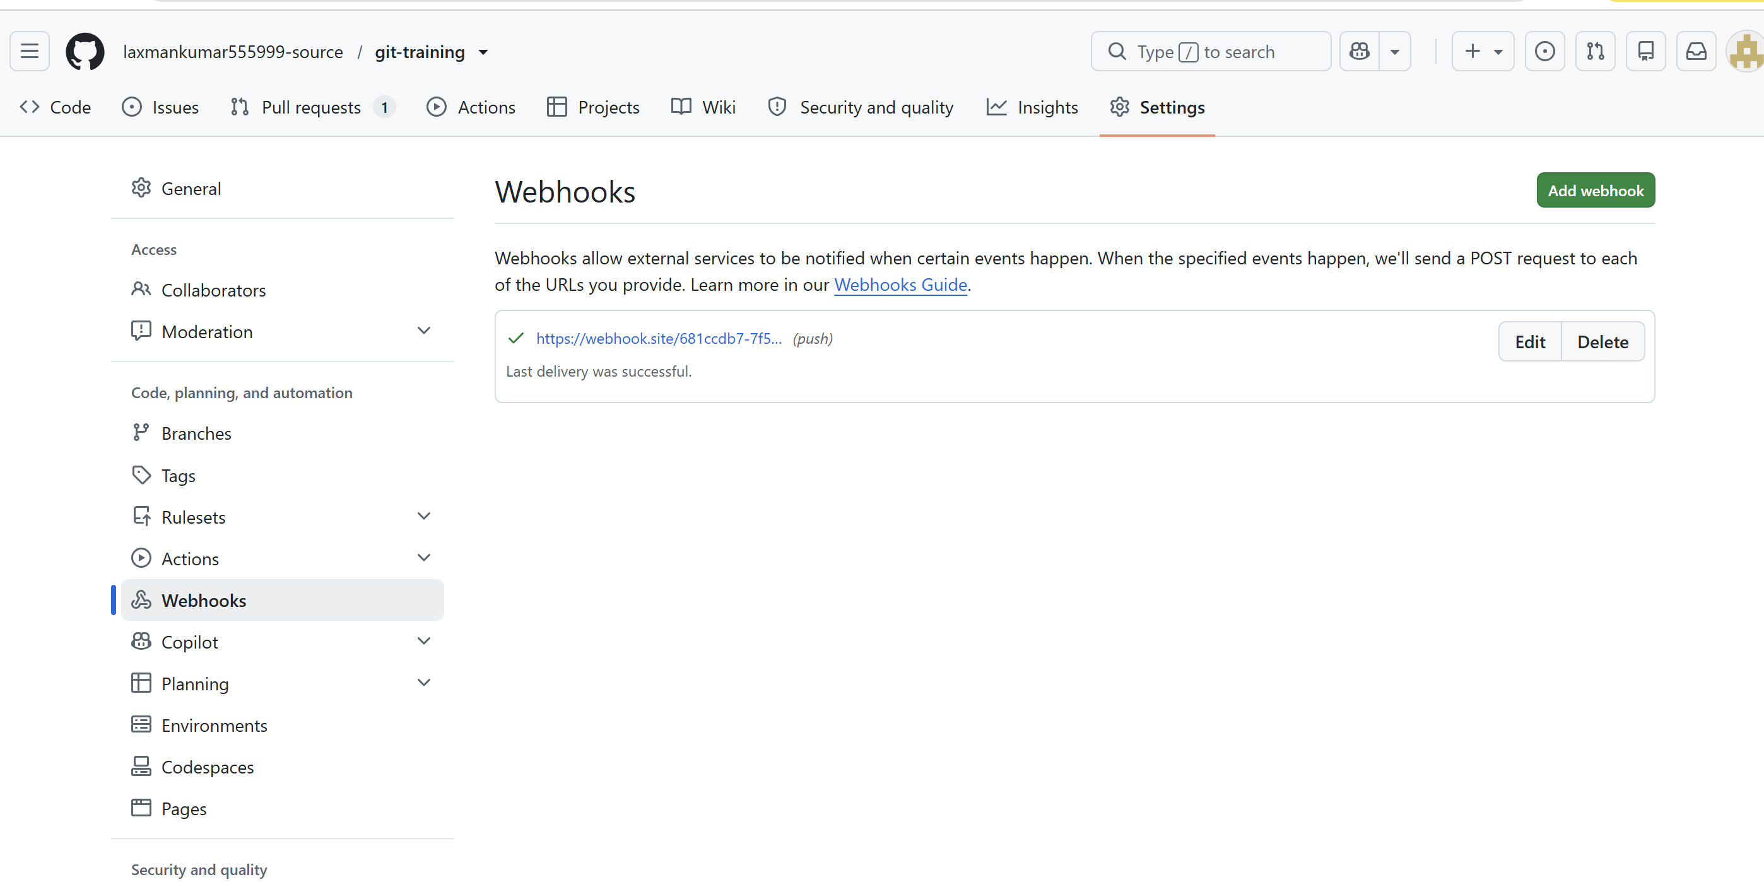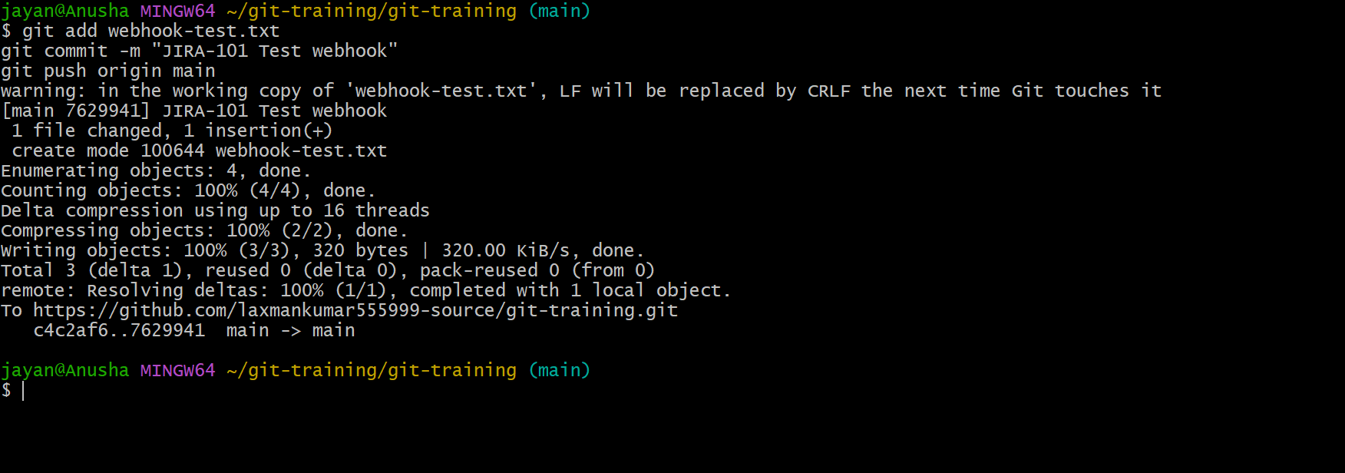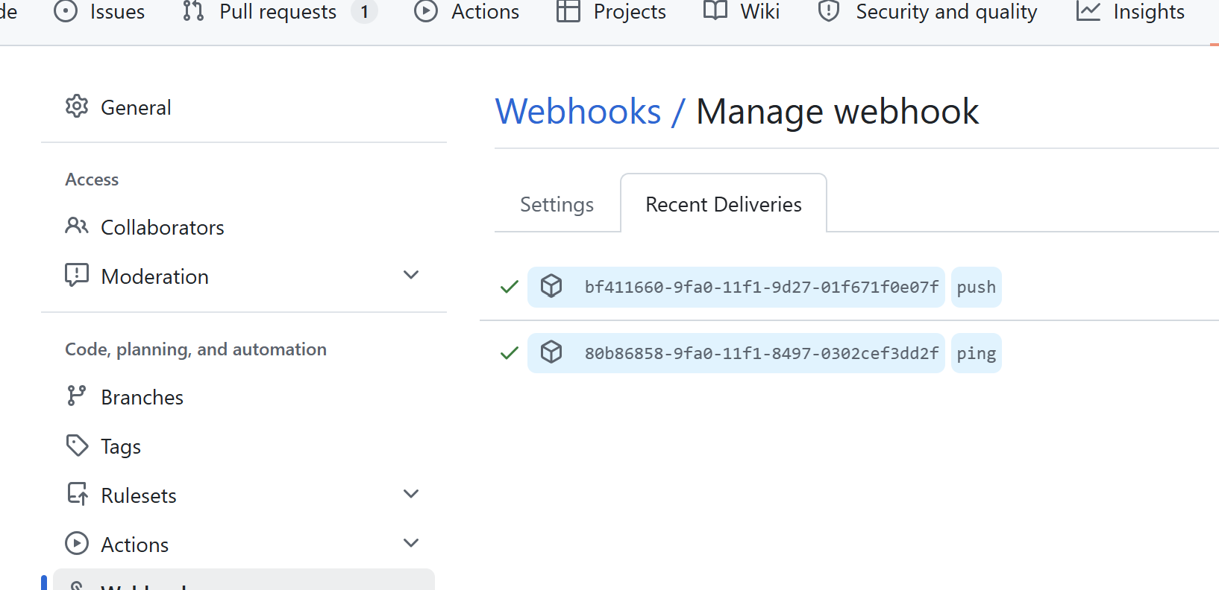

Task 18: Basic Understanding of the .git Directory
- The .git directory contains Git's repository metadata and history.
- HEAD identifies the current reference.
- refs contains references such as branches and tags.
- objects stores Git's content-addressed objects.
- index stores the staging area information.
- config contains repository-specific configuration. 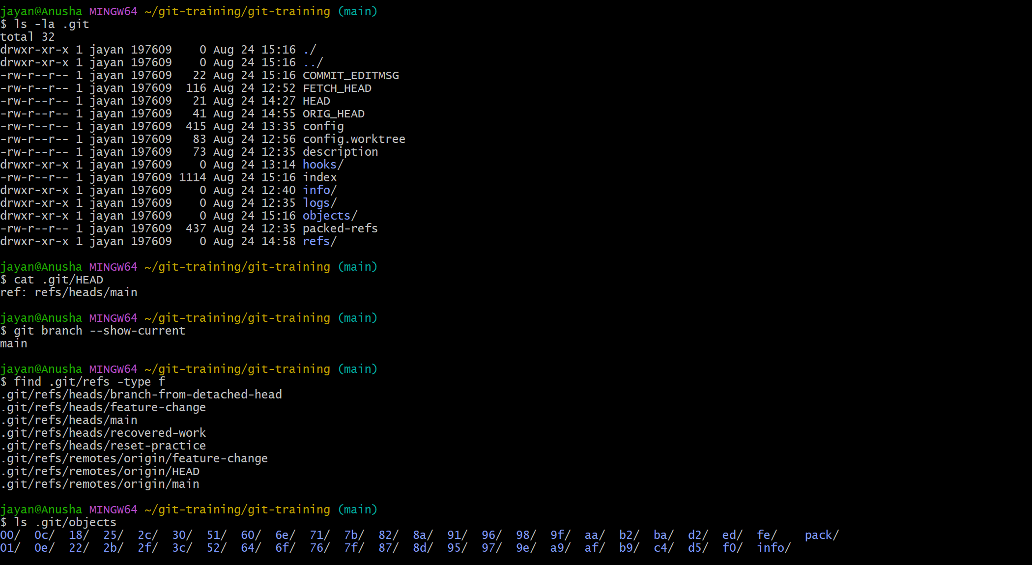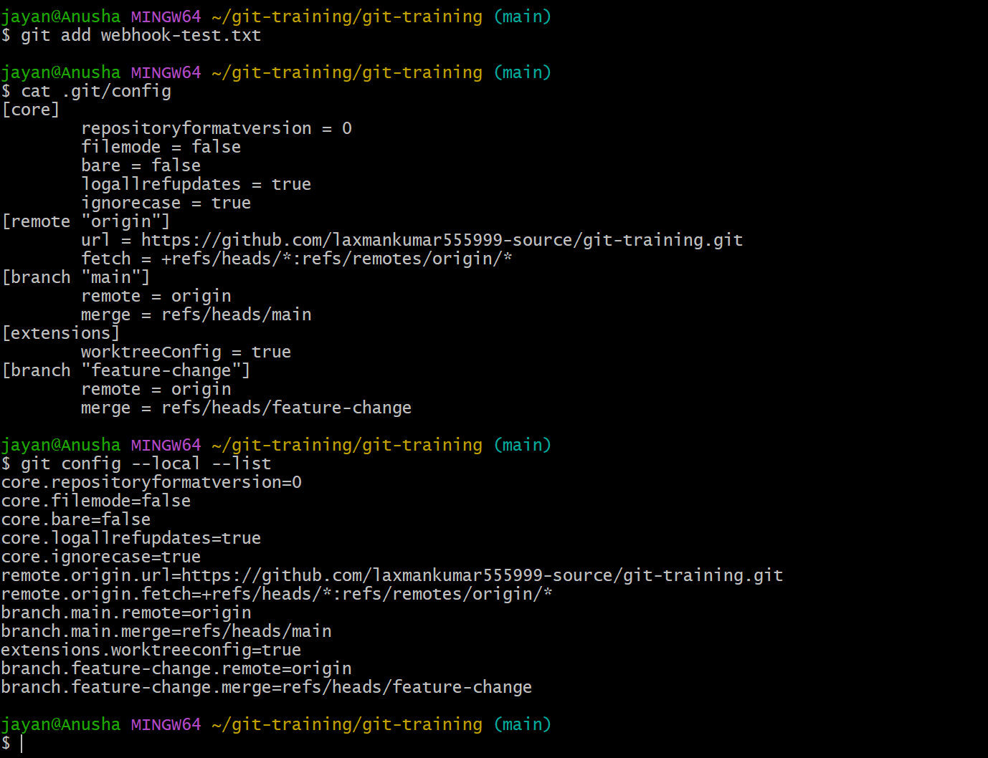
Commands:
ls -la .git
git status
git branch
git show HEAD

Task 19: Check Git Logs
- Display the complete commit history.
- Display a compact one-line history.
- Display branches and a graphical commit history.
Commands:
git log 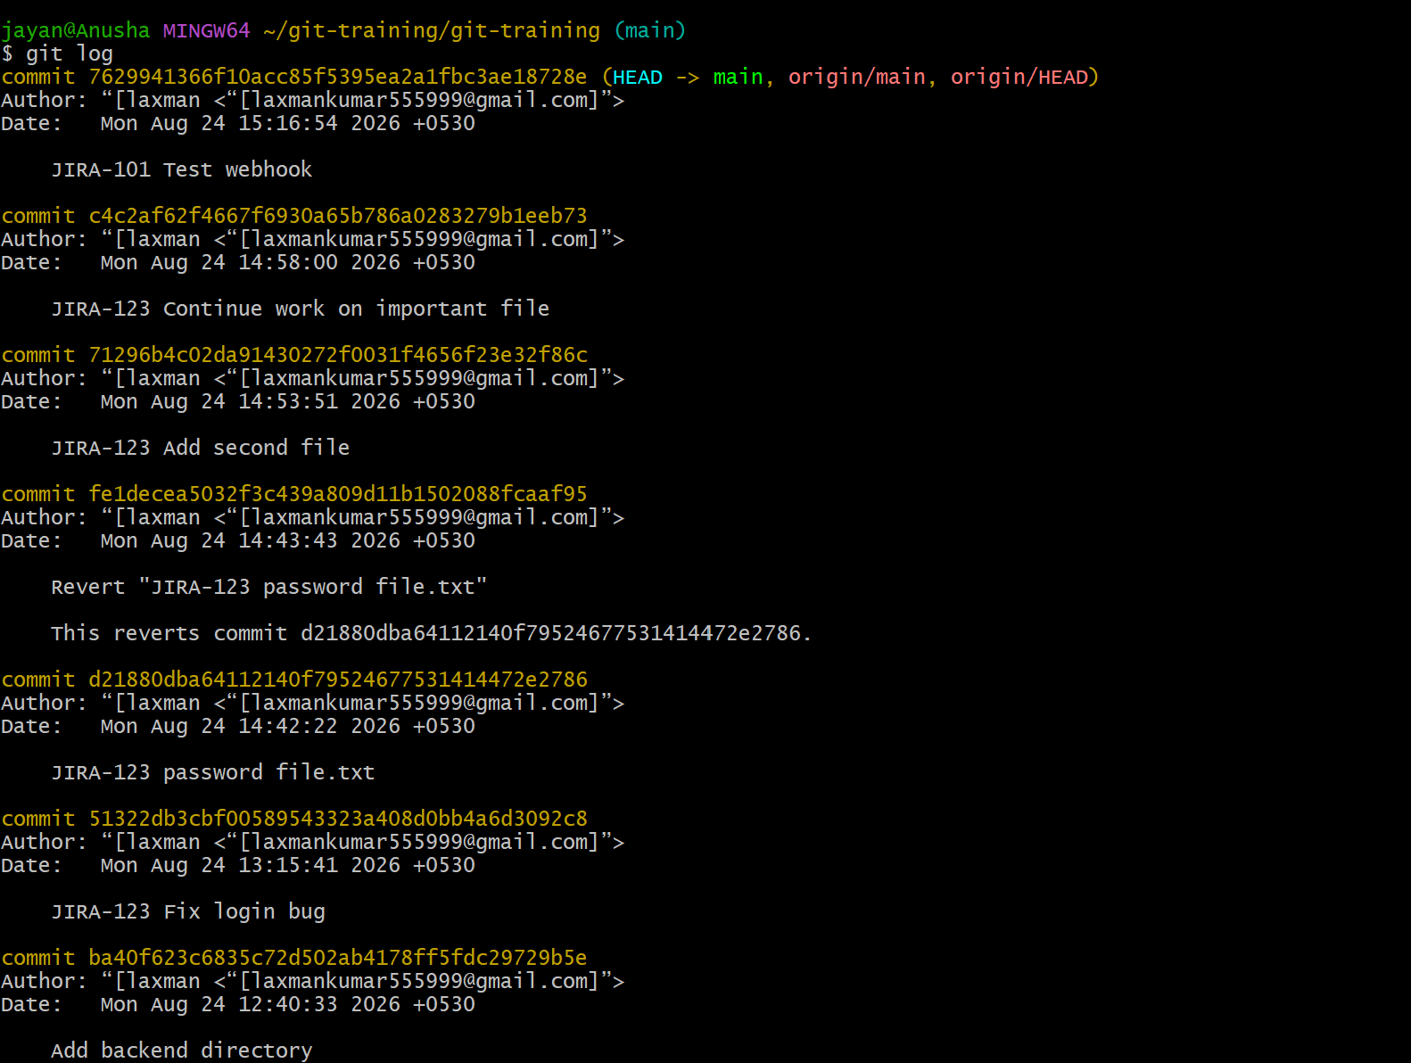
git log --oneline 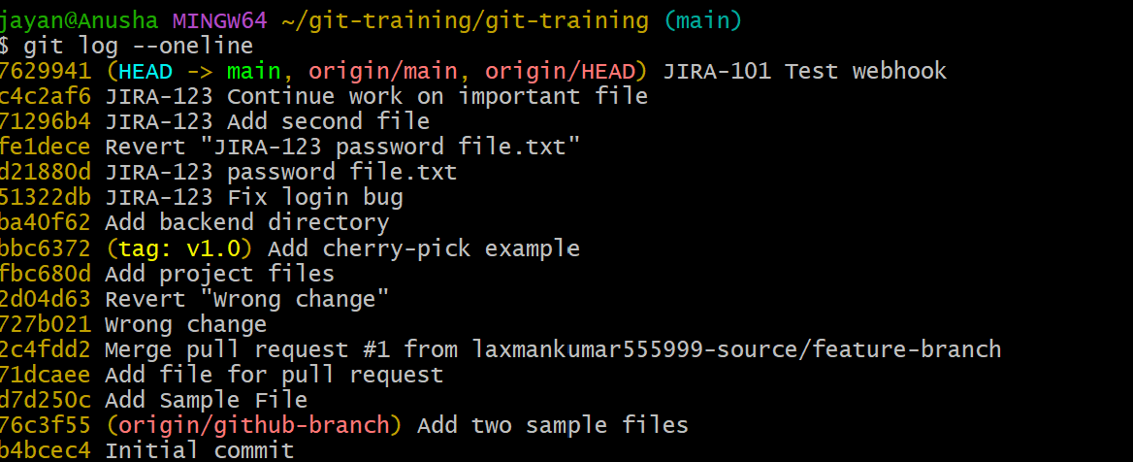
git log --oneline --graph --decorate --all 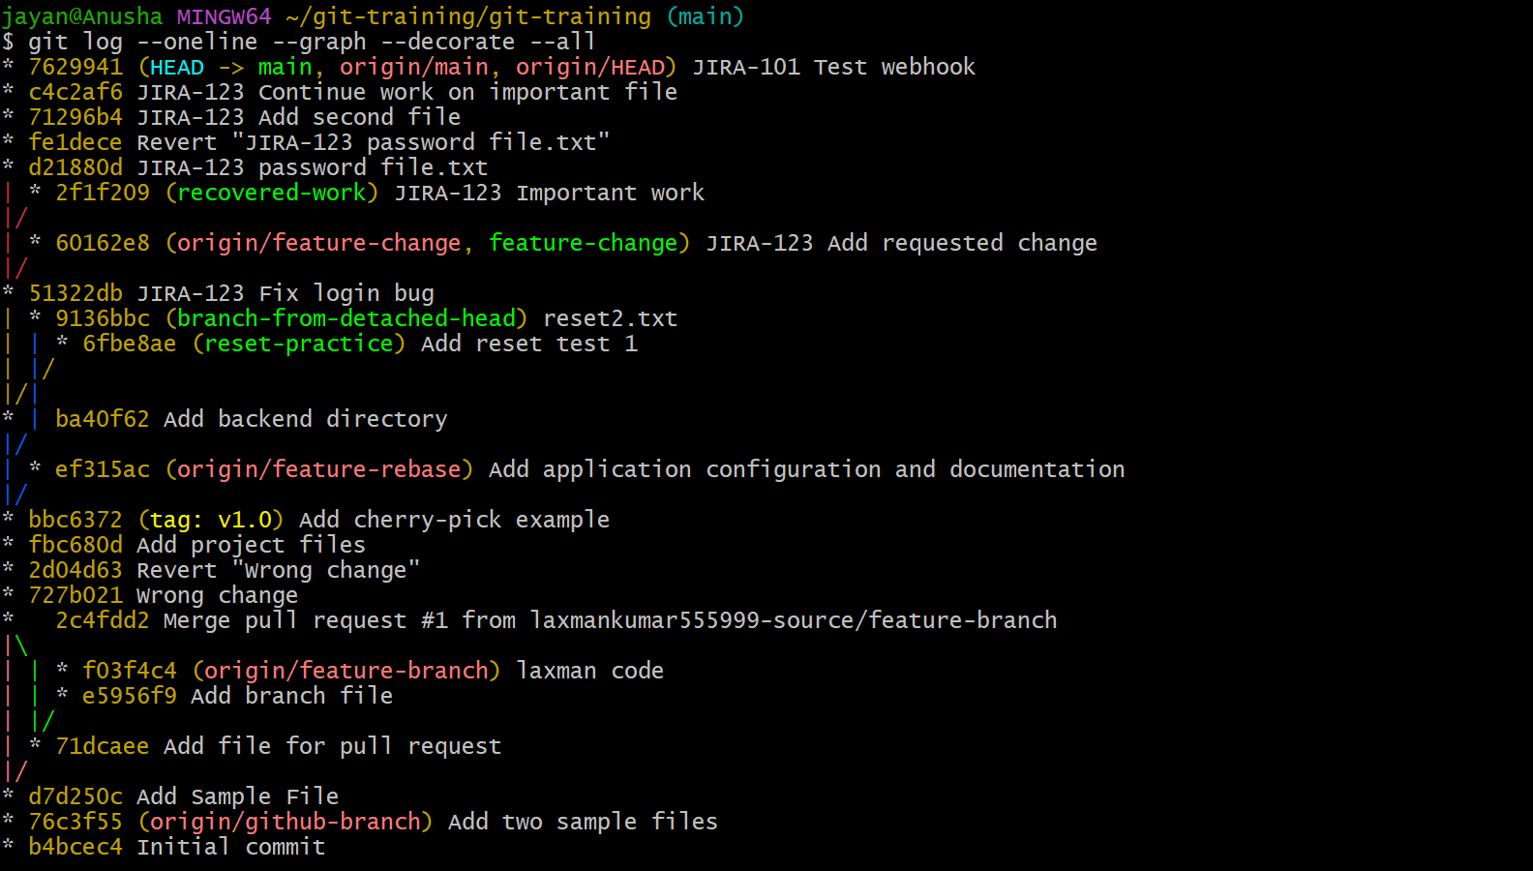

Task 20: Rename a Commit Message
- For the most recent commit, amend the commit message.
- If the commit has already been pushed, coordinate with collaborators before rewriting shared history.
- For an older commit, use interactive rebase. 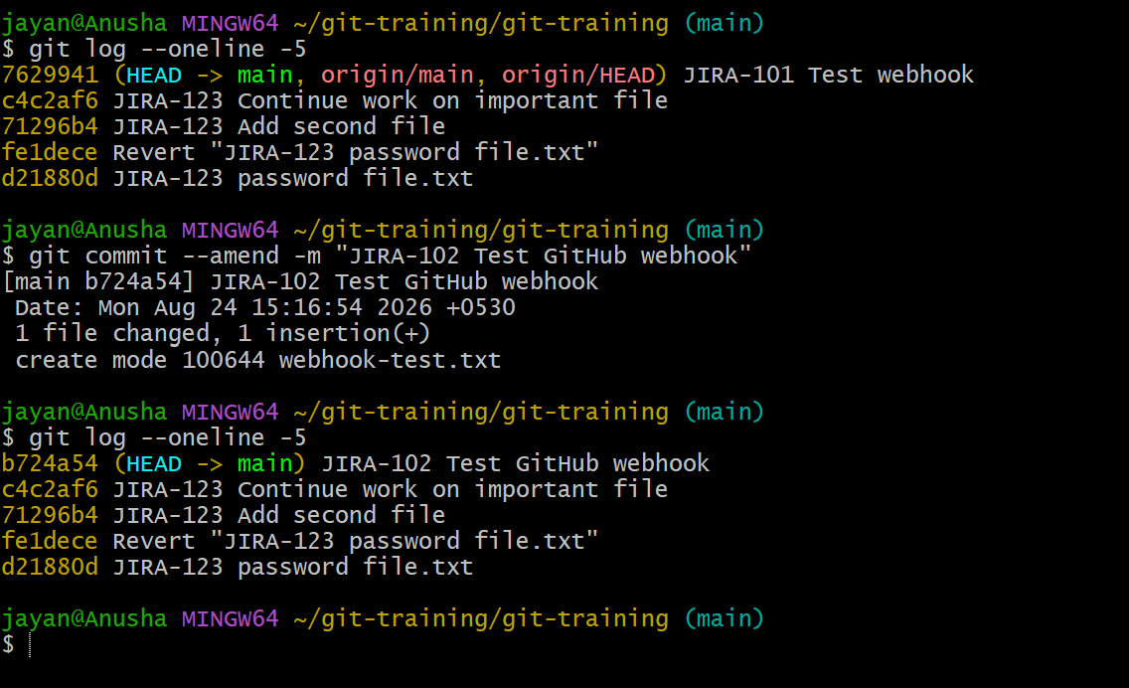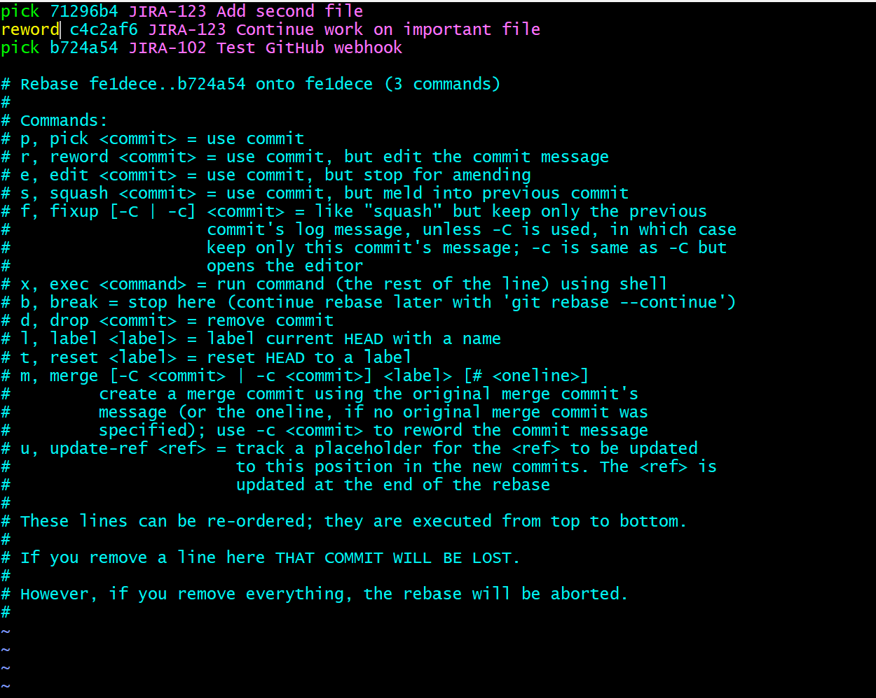
Commands:
git commit --amend -m "Updated commit message"
git rebase -i HEAD~3
# Change 'pick' to 'reword' for the commit to rename
git push --force-with-lease origin main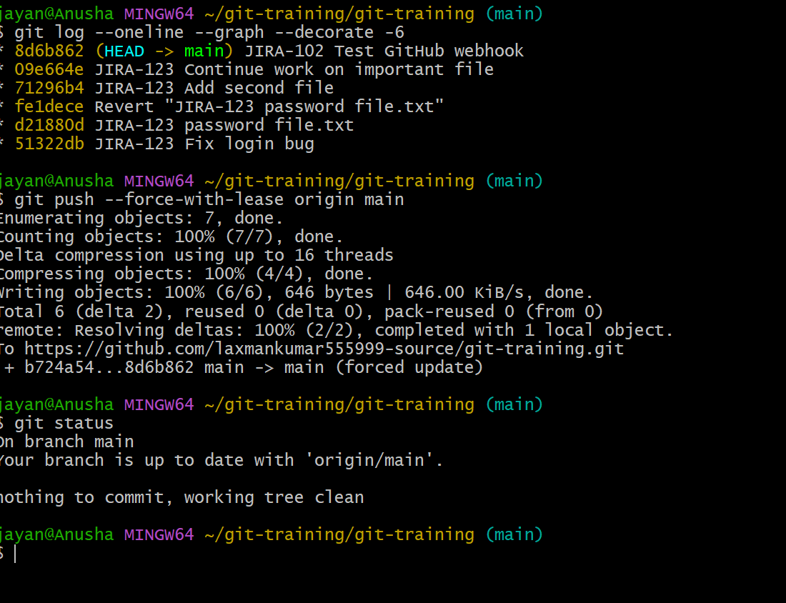

Task 21: Merge Multiple Commits into a Single Commit
- Use interactive rebase to combine recent commits.
- Keep the first commit as pick and change subsequent commits to squash or fixup.
- Edit the final commit message when Git prompts you.
- If the commits were already pushed, use force-with-lease carefully.
Commands:
git log --oneline -n 4
git rebase -i HEAD~4
# Keep the first line as pick; change later lines to squash/fixup
git push --force-with-lease origin main 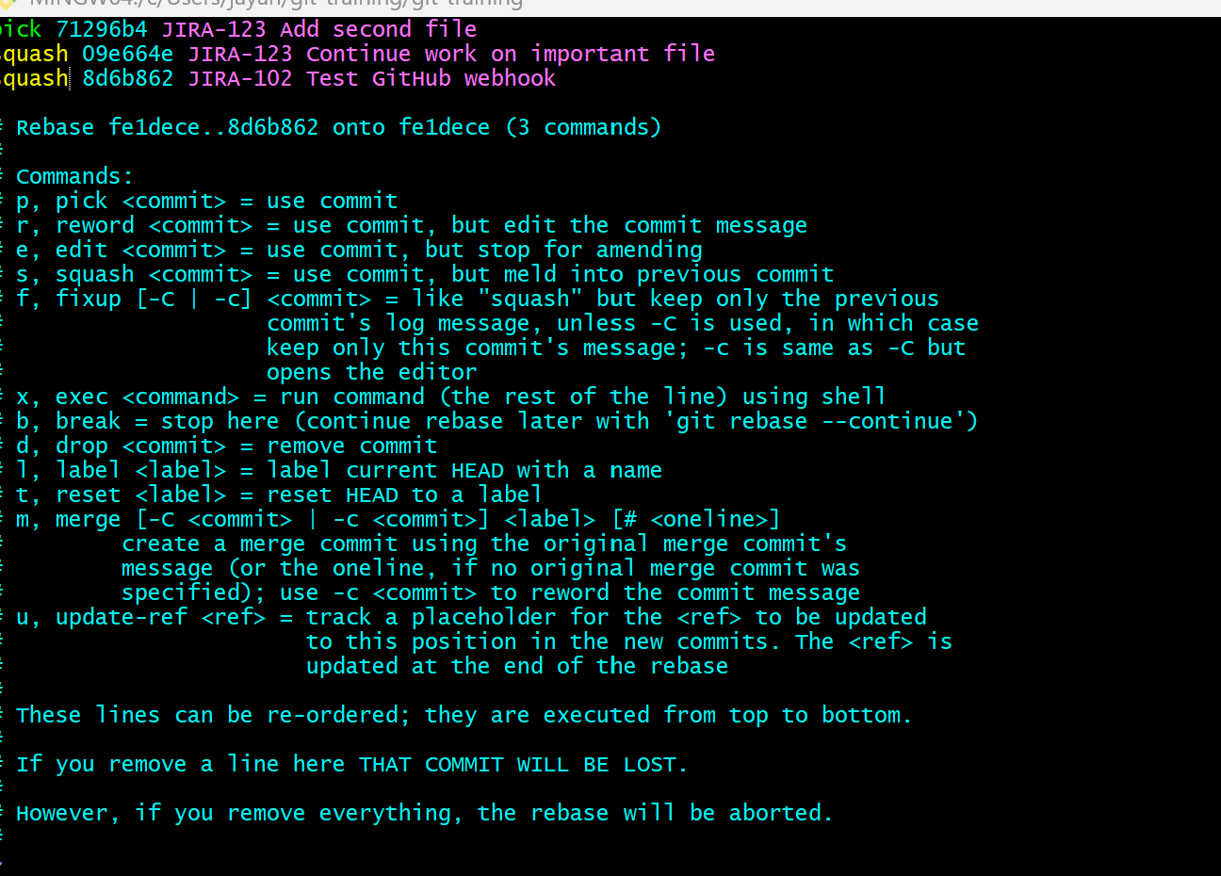 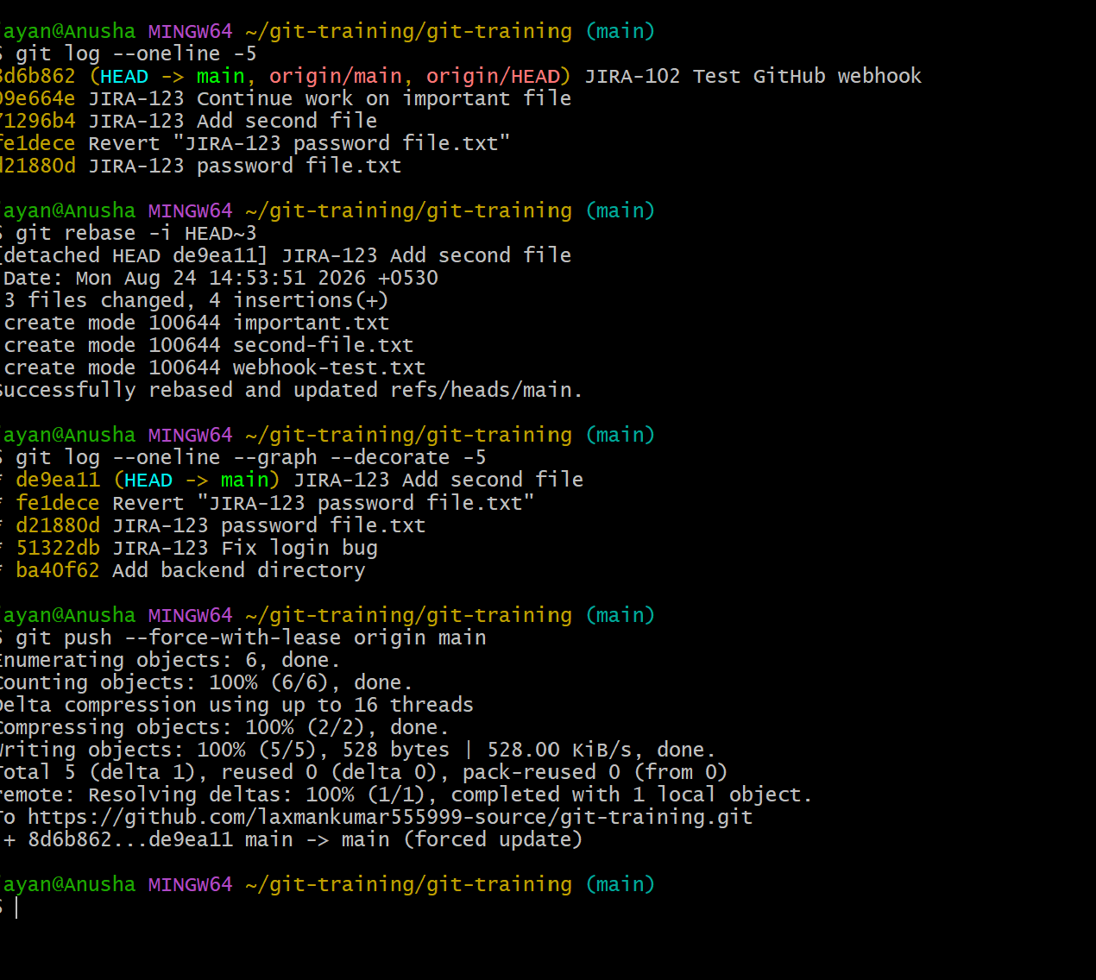

Important Git Concepts
Working Directory: Files you are currently editing.
Staging Area / Index: Changes prepared for the next commit.
Local Repository: The Git repository stored on your computer.
Remote / Central Repository: The GitHub repository used for collaboration.
Commit: A recorded snapshot of staged changes.
Branch: An independent line of development.
Merge: Combines changes from one branch into another.
Pull Request: A GitHub workflow for reviewing and merging changes.
Reset: Moves a branch reference and can modify the working tree depending on the reset mode.
Revert: Creates a new commit that reverses an earlier commit.
Stash: Temporarily stores uncommitted changes.
SSH Key: A secure authentication method for GitHub operations.

Recommended Practice Sequence
- Install and configure Git.
- Create and clone a GitHub repository.
- Create, stage, commit, and push files.
- Practice branches and merging.
- Practice pull requests.
- Practice clone --single-branch.
- Practice .gitignore and untracking sensitive files.
- Practice reset, revert, and stash.
- Configure SSH authentication.
- Configure and test a webhook.
- Inspect .git and Git logs.
- Practice amending and squashing commits.

Safety Notes
- Never commit real passwords, API keys, private SSH keys, or other secrets.
- Use .gitignore to prevent sensitive local files from being staged.
- git reset --hard can permanently discard uncommitted work; verify git status before using it.
- git push --force-with-lease rewrites remote history and should be used only when appropriate.
- For shared branches, prefer git revert over rewriting published history.
- Use HTTPS or SSH with proper authentication and protect webhook endpoints with secrets where supported.

