AWS VPC, EC2, NAT Gateway, Tomcat & VPC Flow Logs
Hands-on Task Guide

Objective
Create a custom AWS VPC with two public and two private subnets, configure routing and DNS, launch public and private EC2 instances, install PHP and Apache Tomcat, deploy a sample application, configure a NAT Gateway for private-subnet internet access, and enable VPC Flow Logs for delivery to S3 and CloudWatch.

Target Architecture
- VPC: 192.168.0.0/16
- Devops-publicSubnet 1: 192.168.1.0/24
- Devops-privatesubnet 1: 192.168.2.0/24
- Devops-publicsubnet 2 : 192.168.3.0/24
- Devopsp-privatesubnet 2: 192.168.4.0/24
- Internet Gateway attached to the VPC.
- Public Route Table: local VPC route + 0.0.0.0/0 to Internet Gateway.
- Private Route Table: local VPC route + 0.0.0.0/0 to NAT Gateway.
- NAT Gateway placed in Public Subnet 1 with an Elastic IP.
- Public EC2: t2.micro, used to install PHP.
- Private EC2: placed in Private Subnet 1, used to install Apache Tomcat and deploy a sample app.
- VPC Flow Logs: configure delivery to both Amazon S3 and CloudWatch Logs.

Prerequisites
- AWS account with permission to create VPC, EC2, IAM, NAT Gateway, S3, and CloudWatch resources.
- AWS Region selected consistently for all resources.
- An EC2 key pair for SSH access to the public instance.
- An IAM role/permissions suitable for VPC Flow Logs to CloudWatch Logs if using CloudWatch as a destination.
- For a private EC2, use the public EC2 as a bastion host or another approved private-access method; do not expose the private instance directly to the internet.

1. Create the VPC

1.1 Create a custom VPC
Open AWS Console → VPC → Your VPCs → Create VPC. Select VPC only and create a VPC using CIDR 192.168.0.0/16
- Enable DNS resolution and DNS hostnames for the VPC. 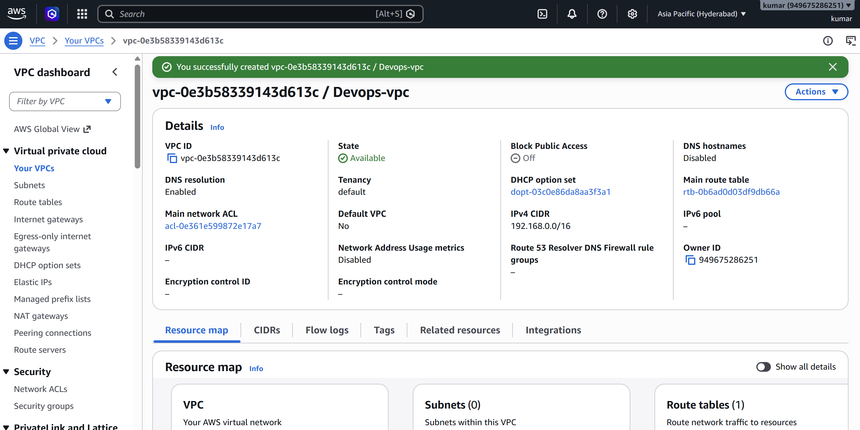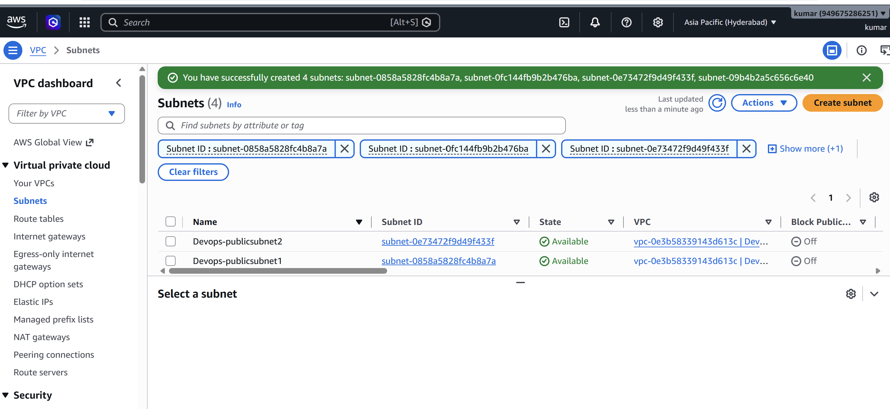

2. Enable DNS Hostnames

2.1 Configure VPC DNS
Select the VPC → Actions → Edit VPC settings. Enable DNS hostnames. Also ensure DNS resolution is enabled.
- DNS hostnames are useful for EC2 instances because AWS can provide DNS hostnames for instances that have public addressing where applicable. 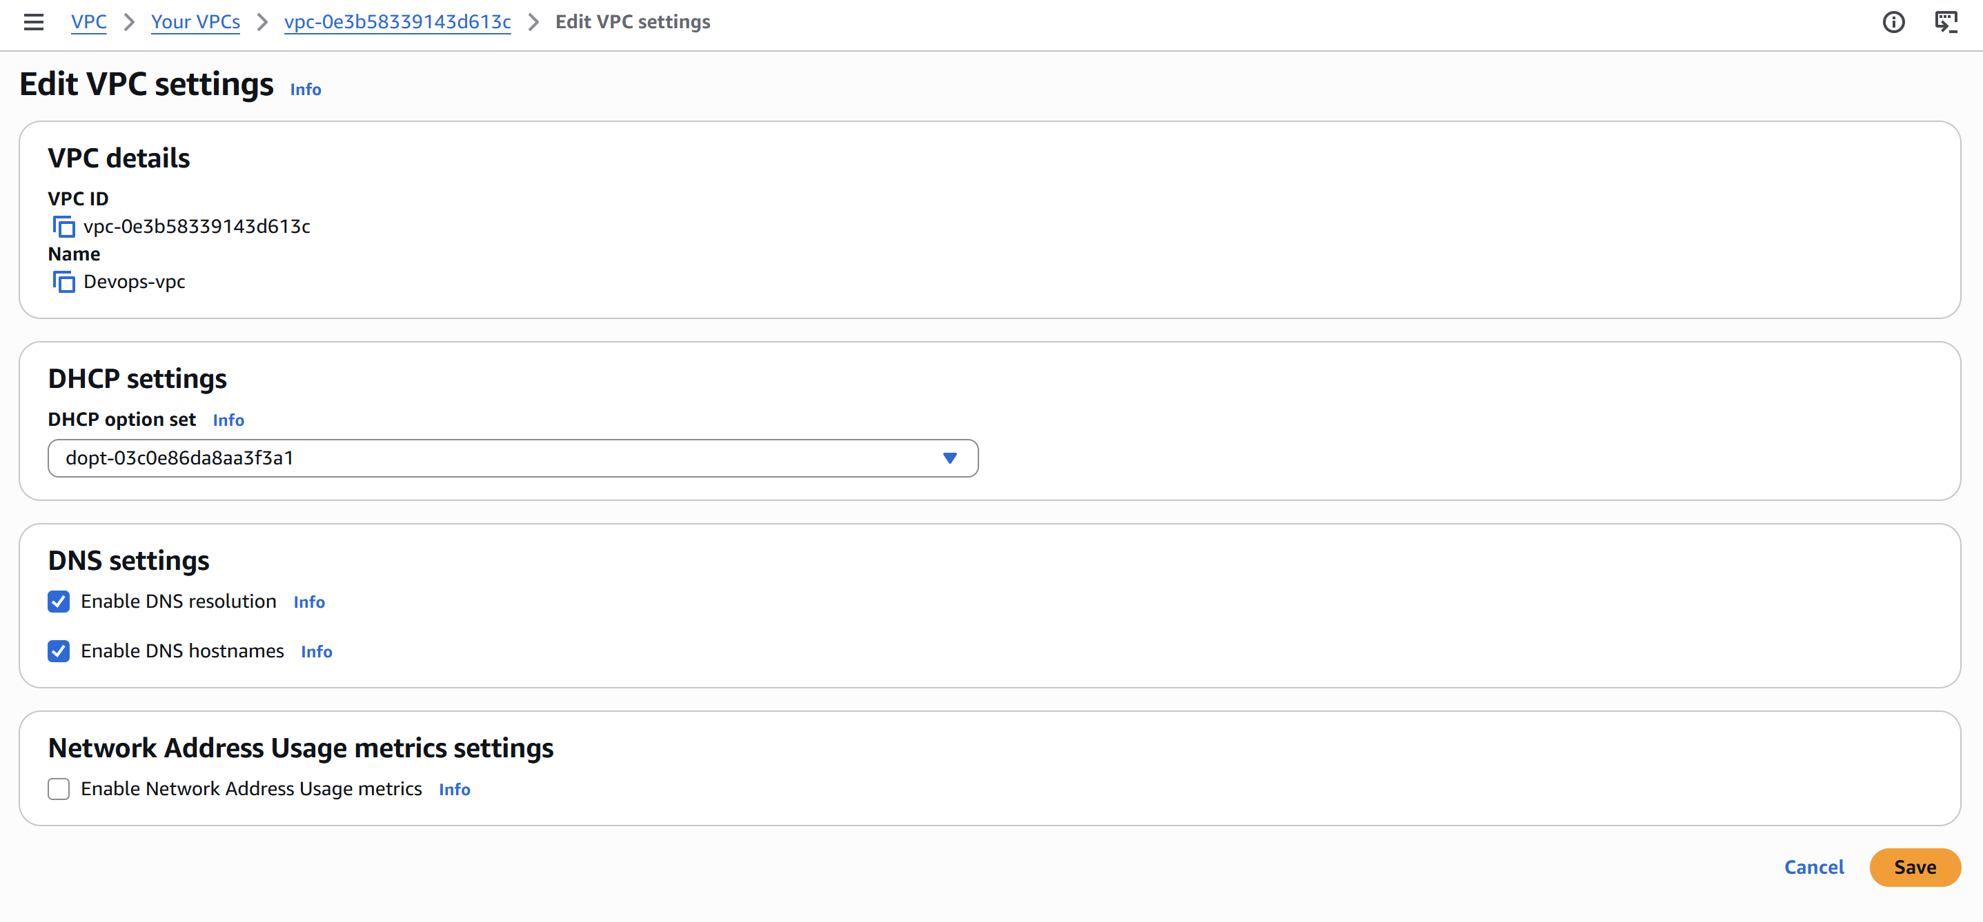

3. Create 2 Public and 2 Private Subnets
Create all four subnets under the same VPC and assign appropriate Availability Zones. For production-style designs, distribute subnets across at least two Availability Zones. 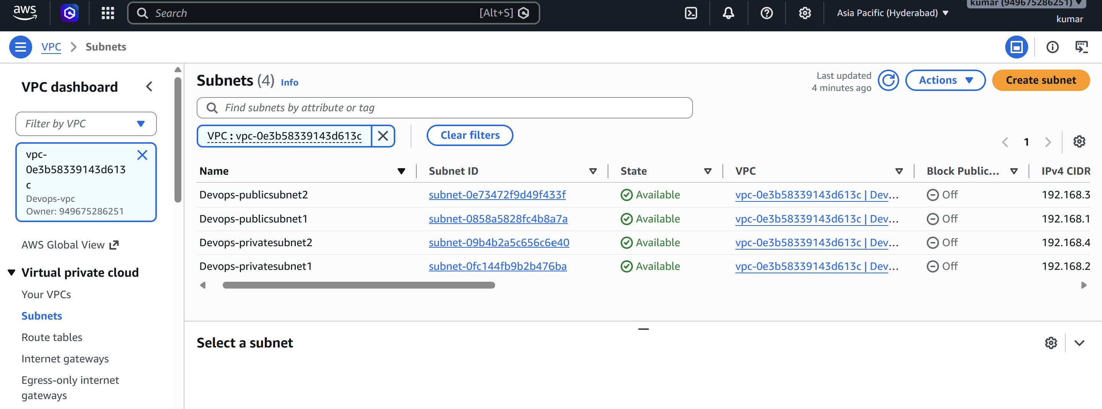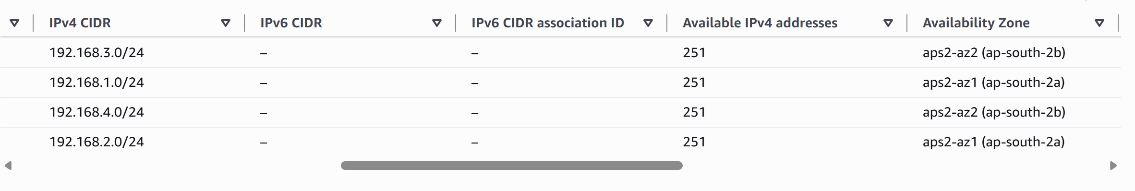

4. Enable Auto-Assign Public IPv4 Address

4.1 Configure public subnets
For Public-Subnet-1 and Public-Subnet-2, select each subnet → Actions → Edit subnet settings → enable Auto-assign public IPv4 address. 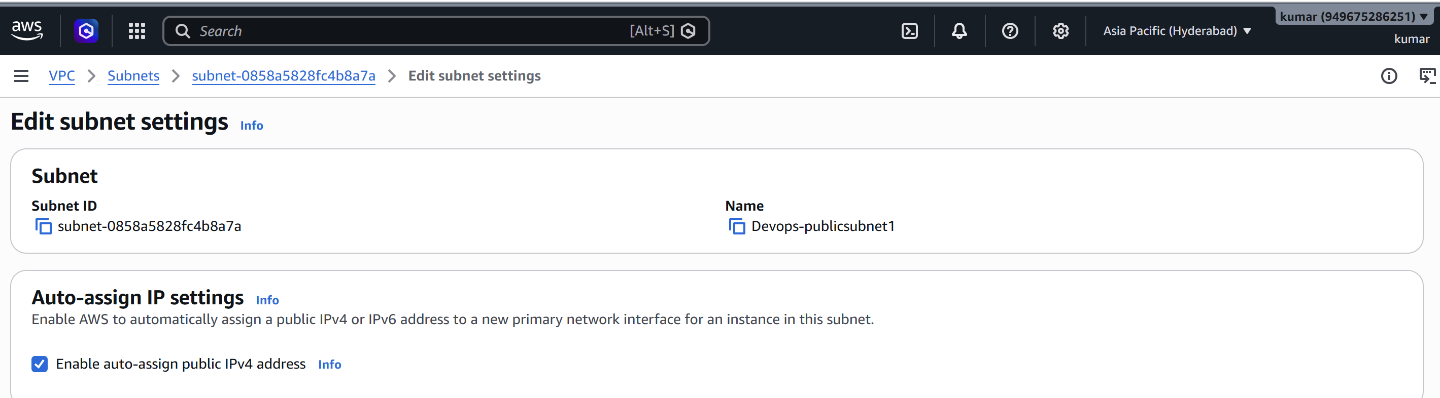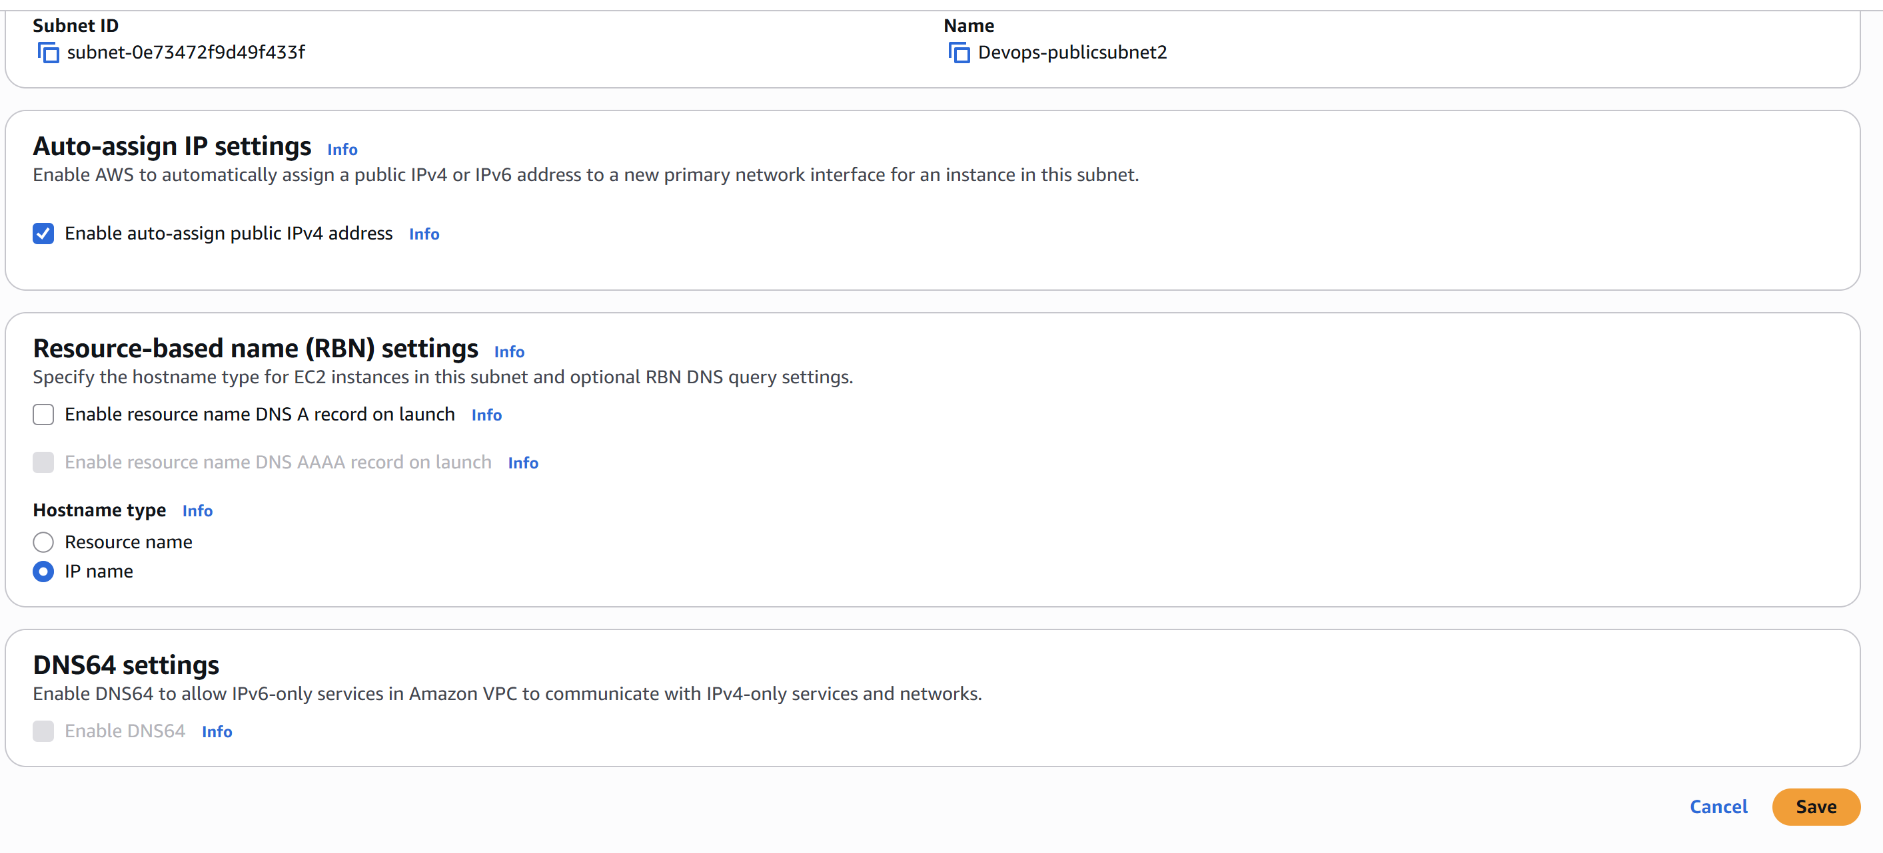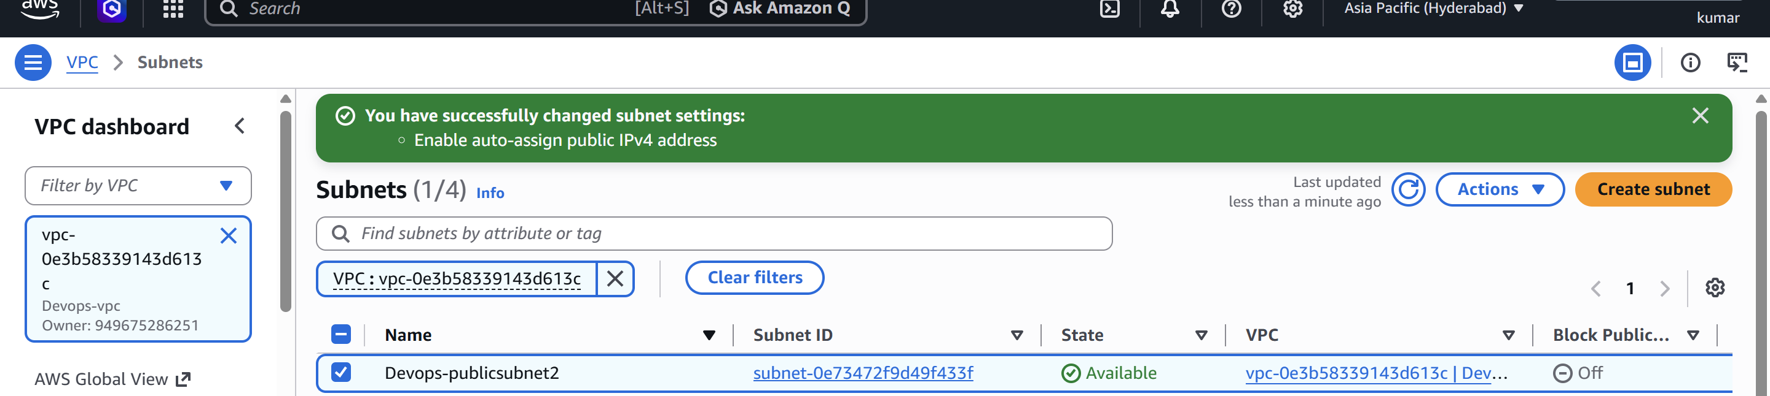
- Do not enable auto-assign public IPv4 on the private subnets.
- A public subnet is determined by its route to an Internet Gateway; the auto-assign setting gives instances public IPv4 addresses automatically.

5. Create and Attach an Internet Gateway

5.1 Create IGW
VPC Console → Internet Gateways → Create internet gateway. Attach the Internet Gateway to the custom VPC.
- The Internet Gateway is required for direct internet connectivity from resources in public subnets. 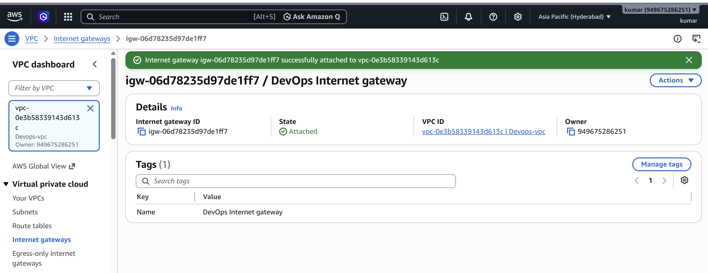

6. Create Public Route Table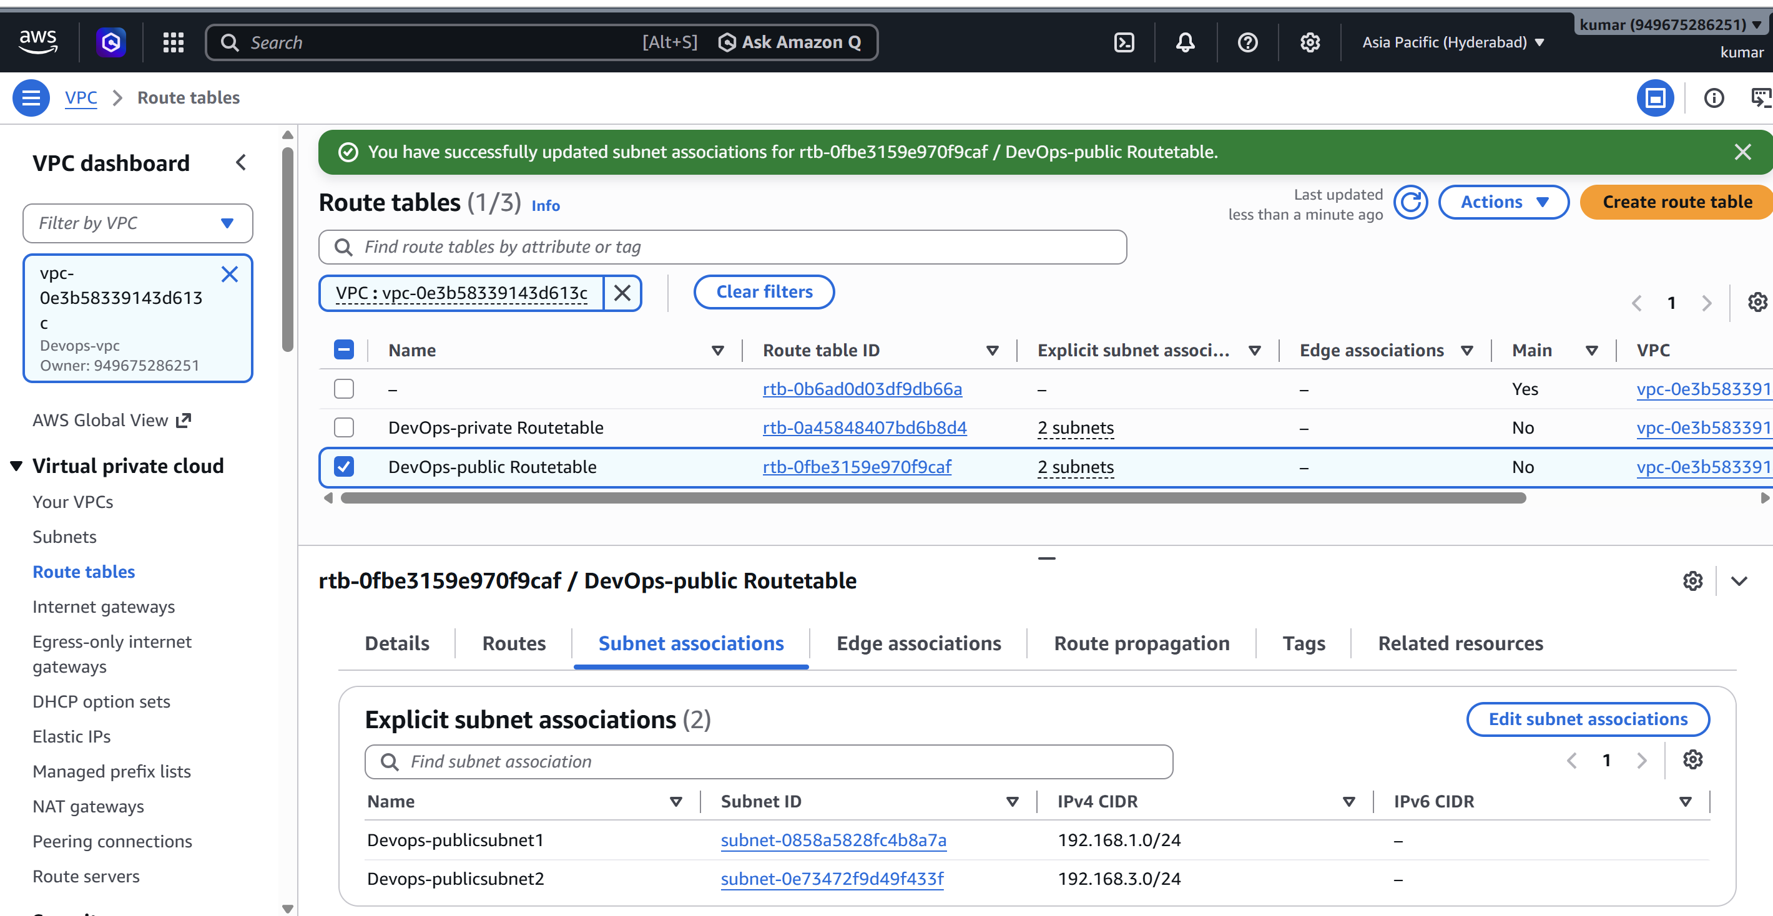

6.1 Configure public routes
Create a route table named Public-RT and associate Public-Subnet-1 and Public-Subnet-2 with it.
- Keep the automatically created local route for 10.0.0.0/16.
- Add 0.0.0.0/0 with target = Internet Gateway.
- The public route table therefore contains local VPC traffic plus internet-bound traffic through the IGW. 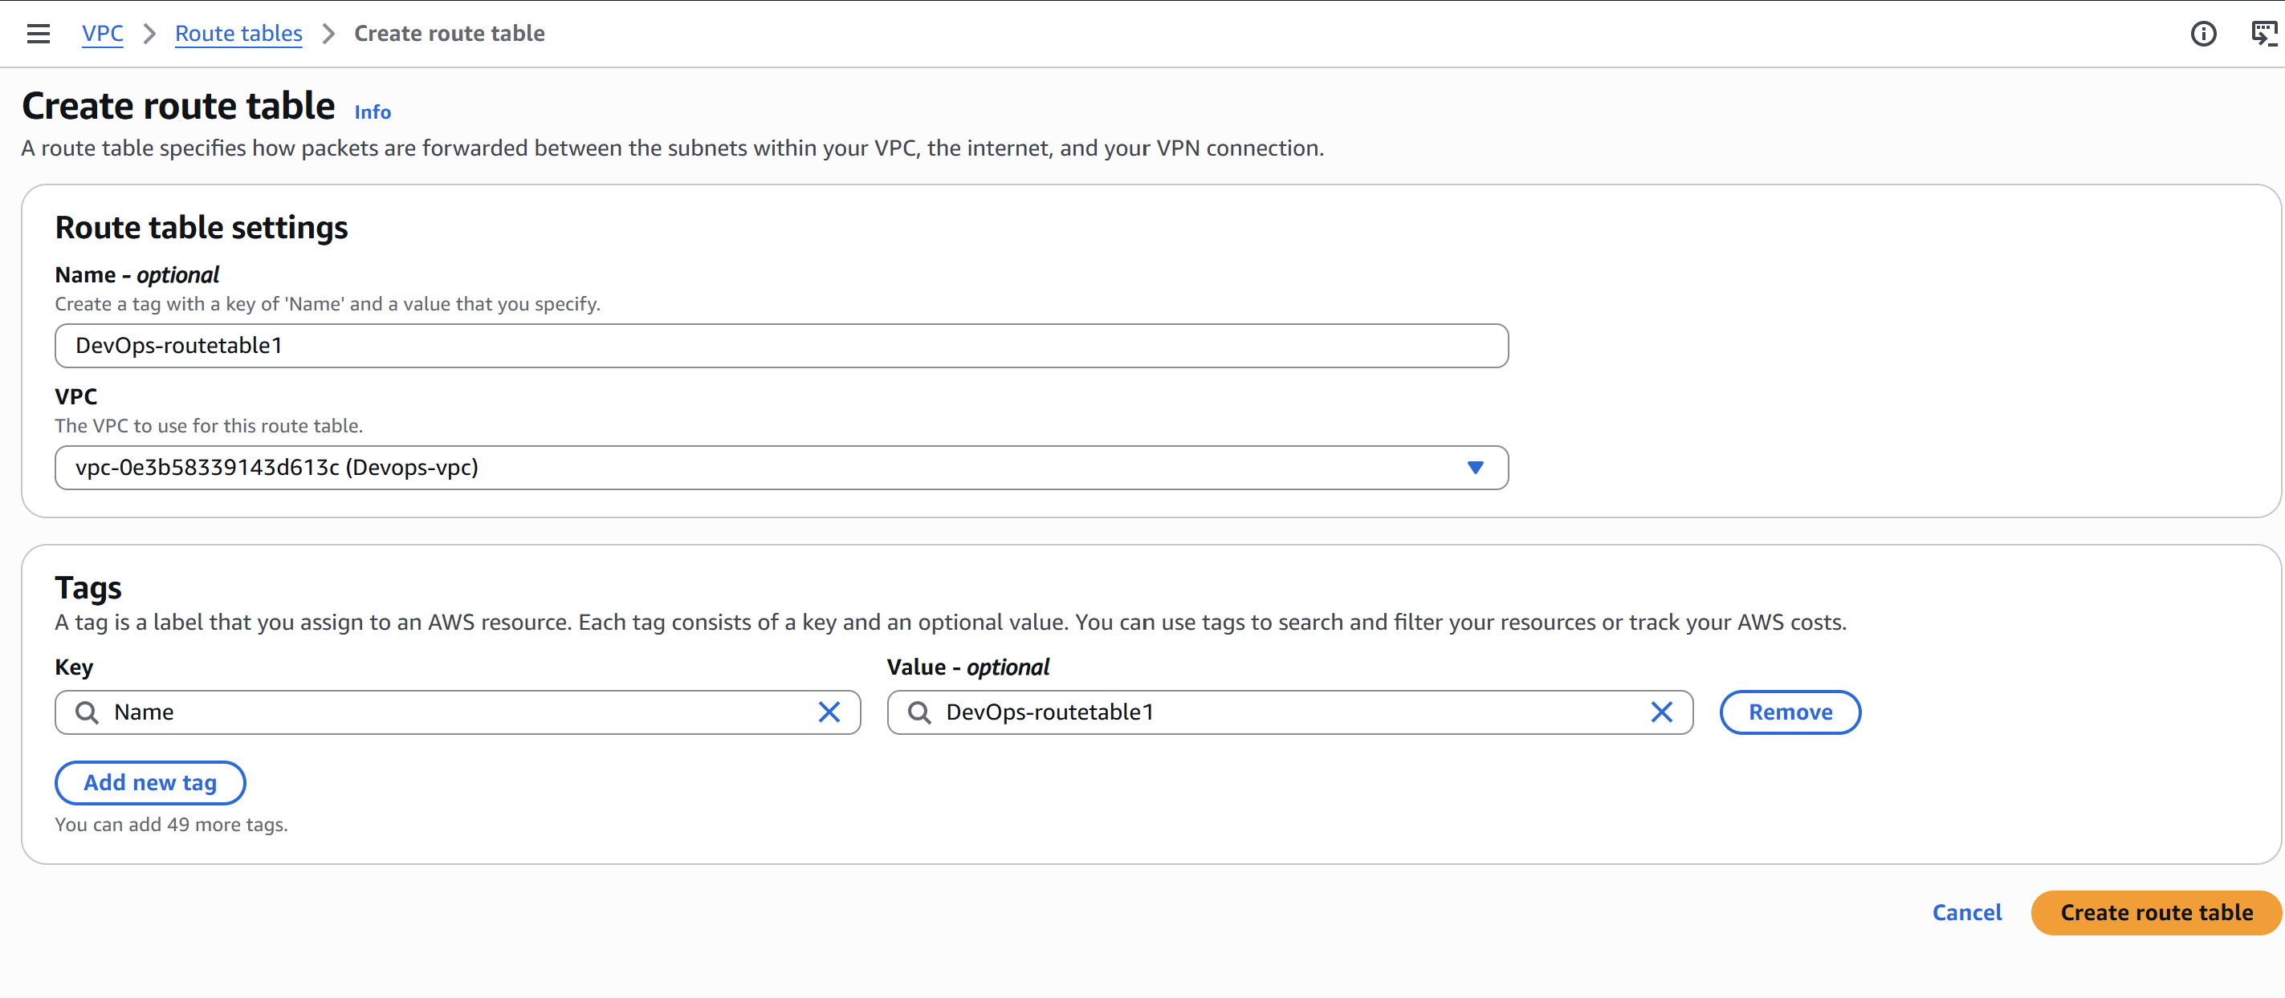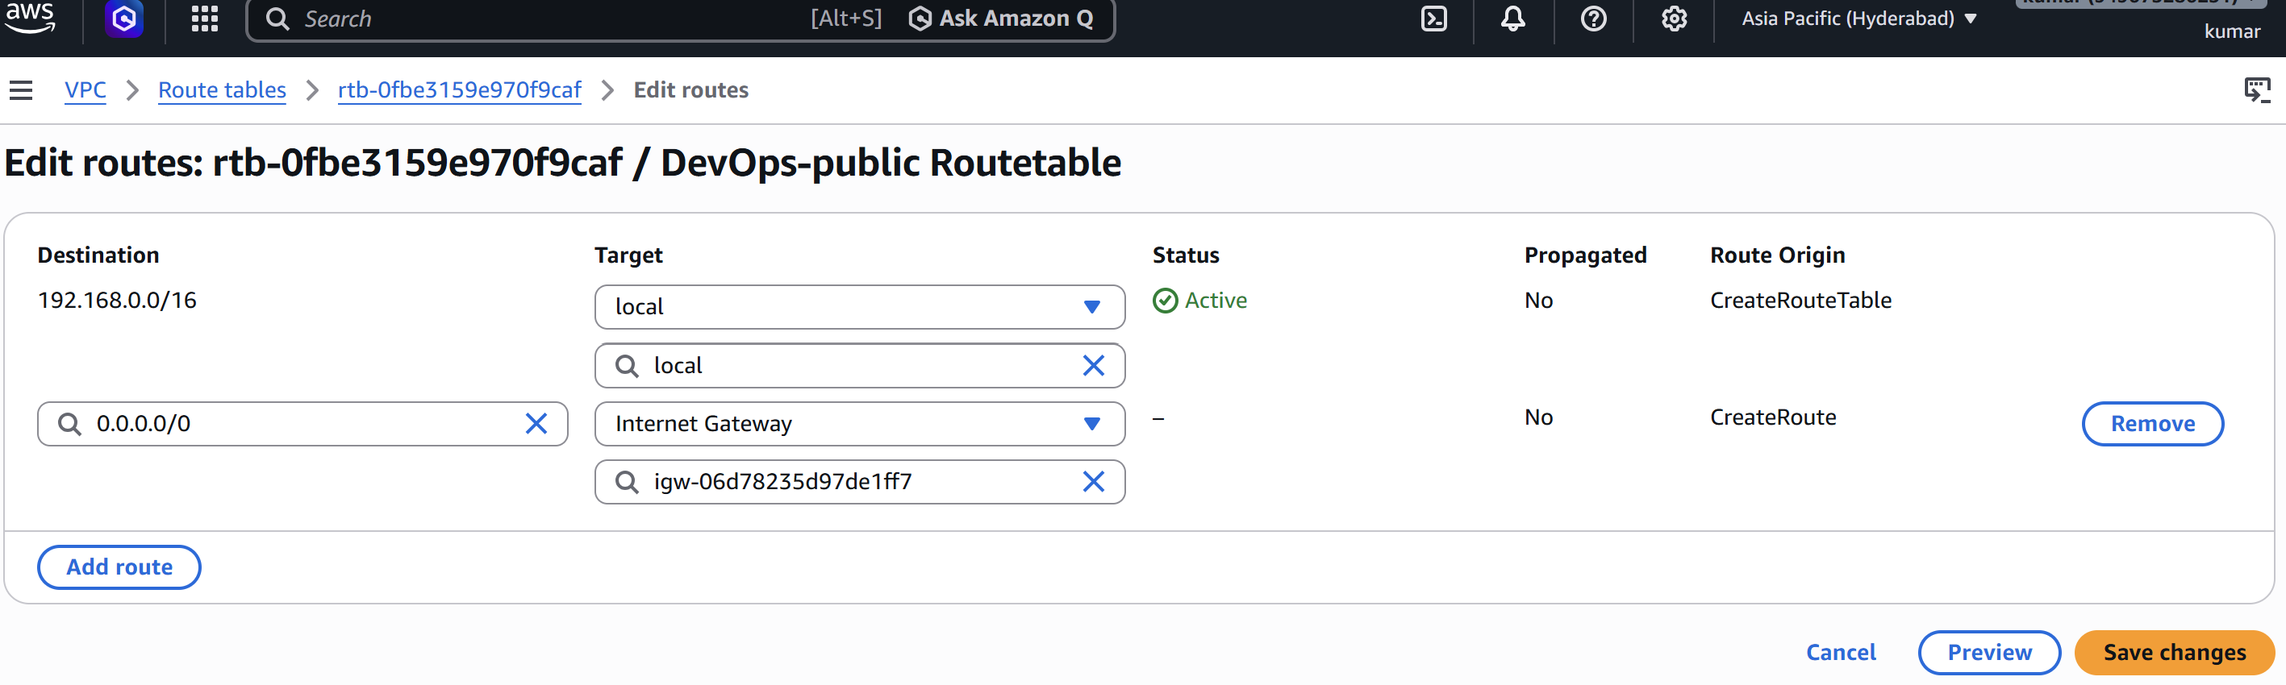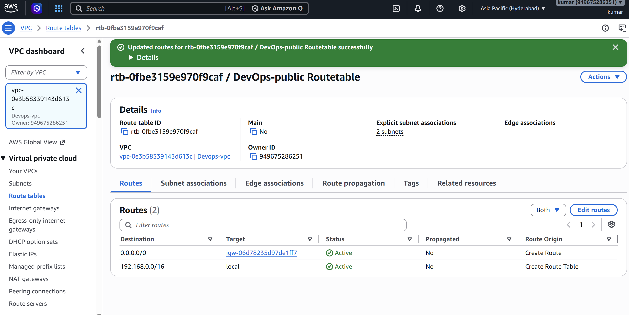

7. Create Private Route Table

7.1 Configure private subnets
Create a route table named Private-RT and associate Private-Subnet-1 and Private-Subnet-2 with it.
- Keep the automatically created local route for 10.0.0.0/16.
- After creating the NAT Gateway in the next step, add 0.0.0.0/0 with target = NAT Gateway.
- This lets private instances initiate outbound internet connections without assigning them public IPv4 addresses. 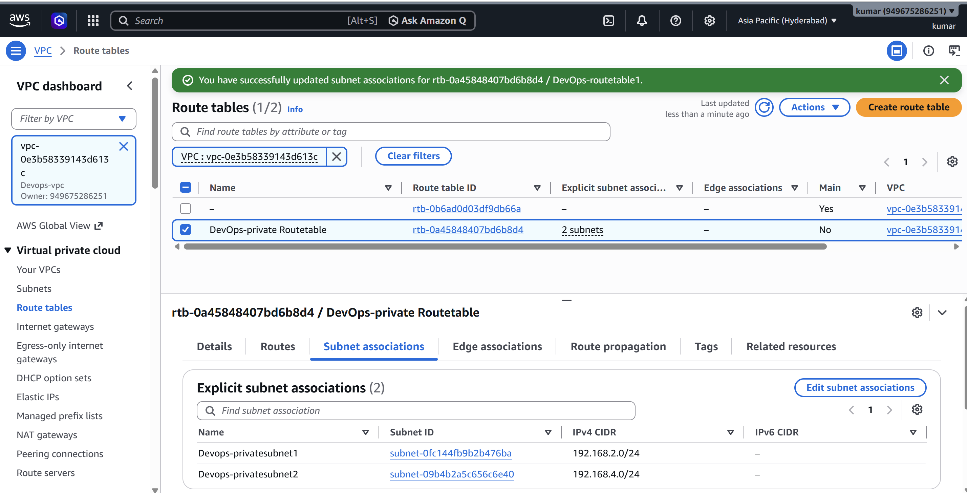

8. Create NAT Gateway

8.1 Allocate an Elastic IP
VPC Console → Elastic IPs → Allocate Elastic IP address.
- A public NAT Gateway requires an Elastic IP. 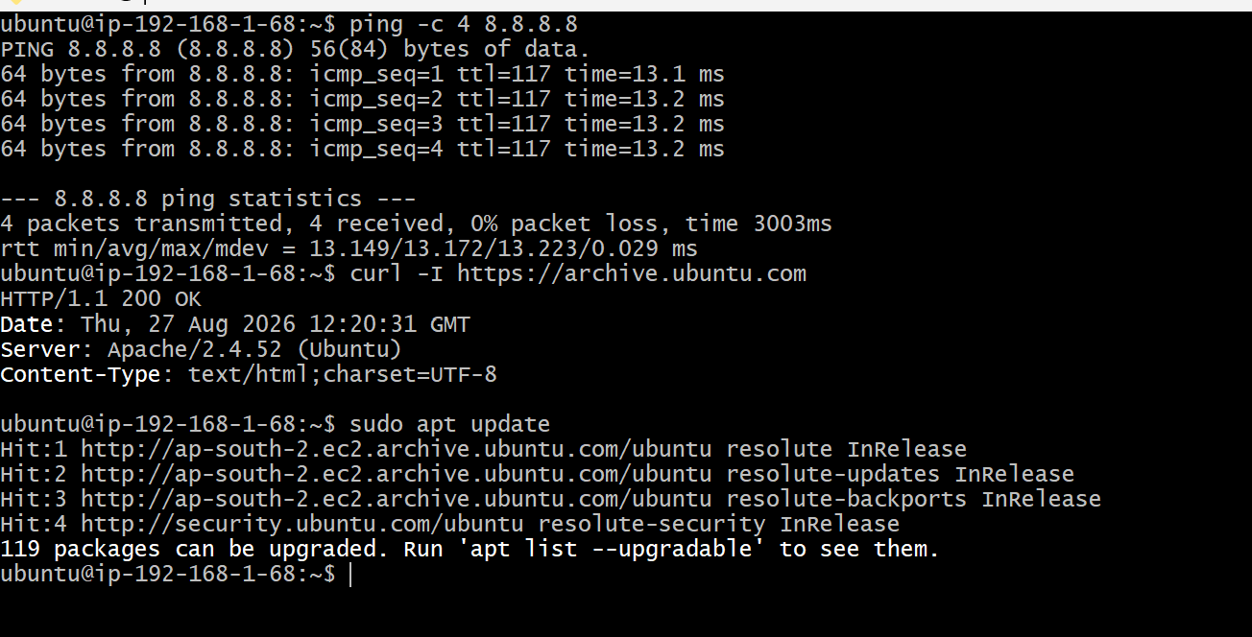

8.2 Create NAT Gateway
VPC Console → NAT Gateways → Create NAT Gateway. Select Public-Subnet-1 and attach the allocated Elastic IP.
- Use a public subnet whose route table sends internet traffic to the Internet Gateway. 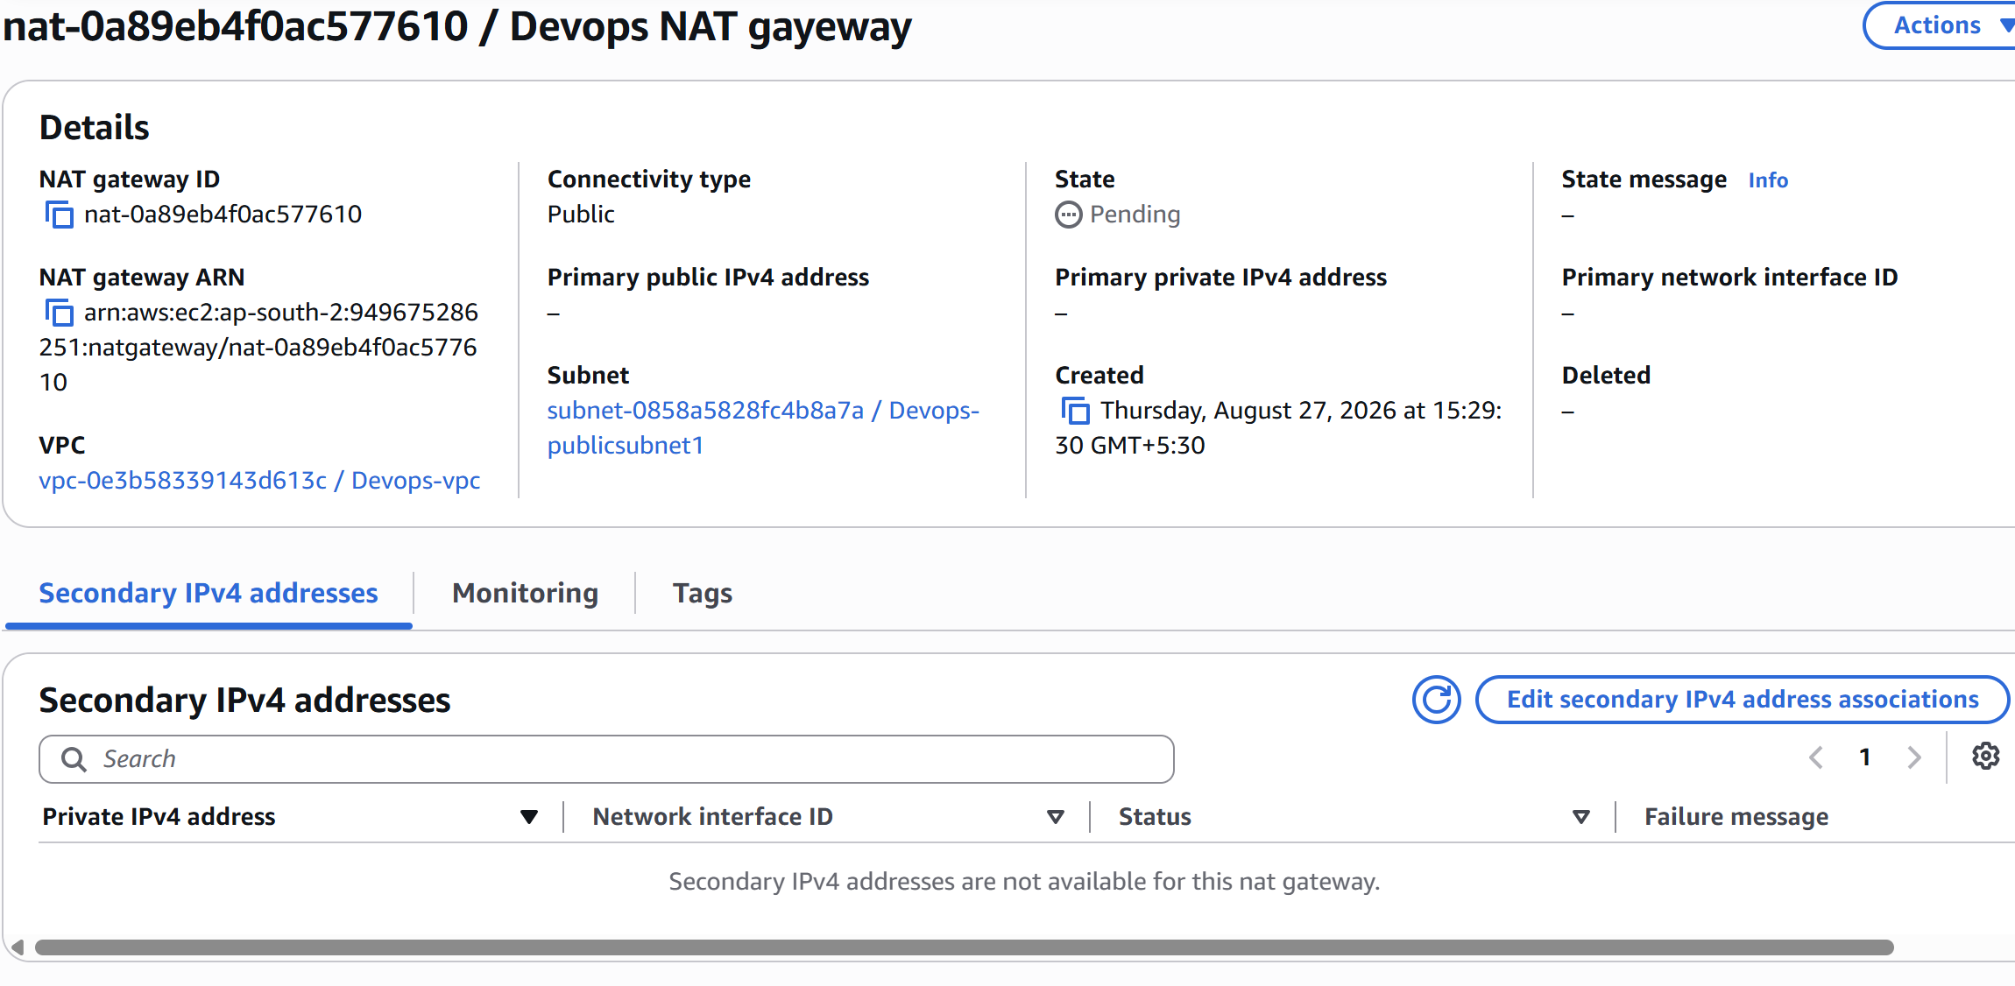

8.3 Complete private routing
Edit Private-RT → Routes → Add route: Destination 0.0.0.0/0 → Target: the NAT Gateway. 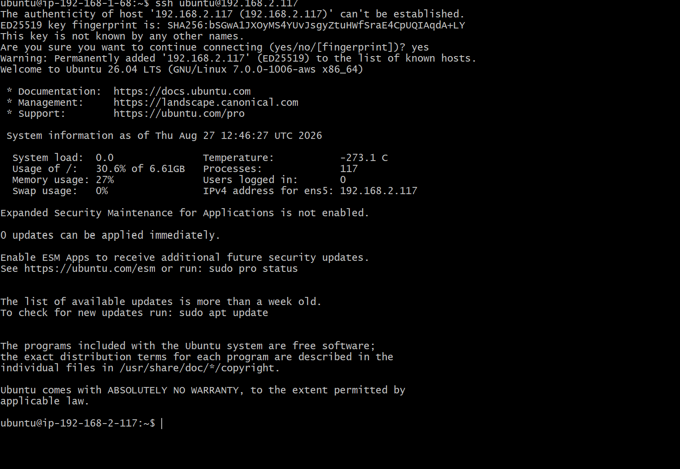
- Private EC2 instances can now reach external package repositories through the NAT Gateway while remaining without public IP addresses.

9. Launch Public EC2 and Install PHP

9.1 Launch public EC2
EC2 → Launch Instance. Use an Amazon Linux or Ubuntu AMI, instance type t2.micro as required by the task, your key pair, and Public-Subnet-1. Ensure the instance receives a public IPv4 address. 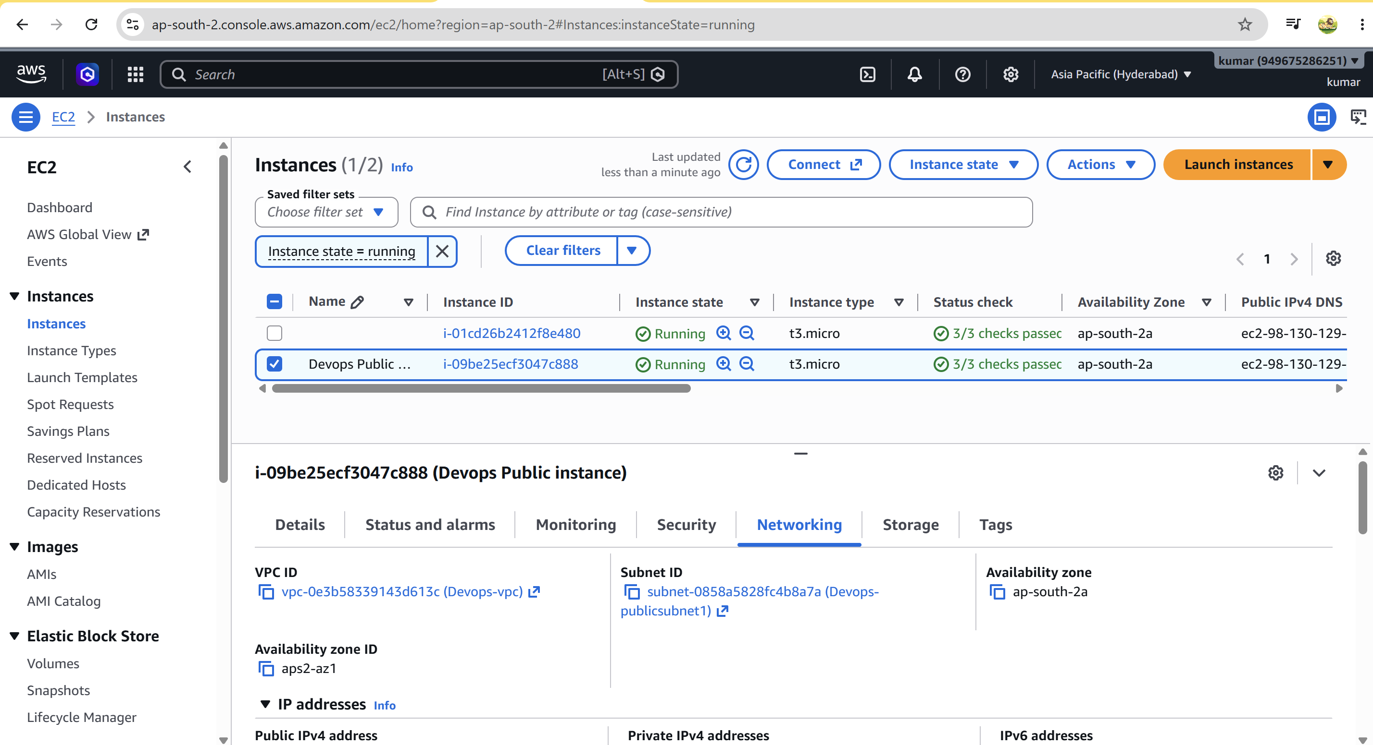 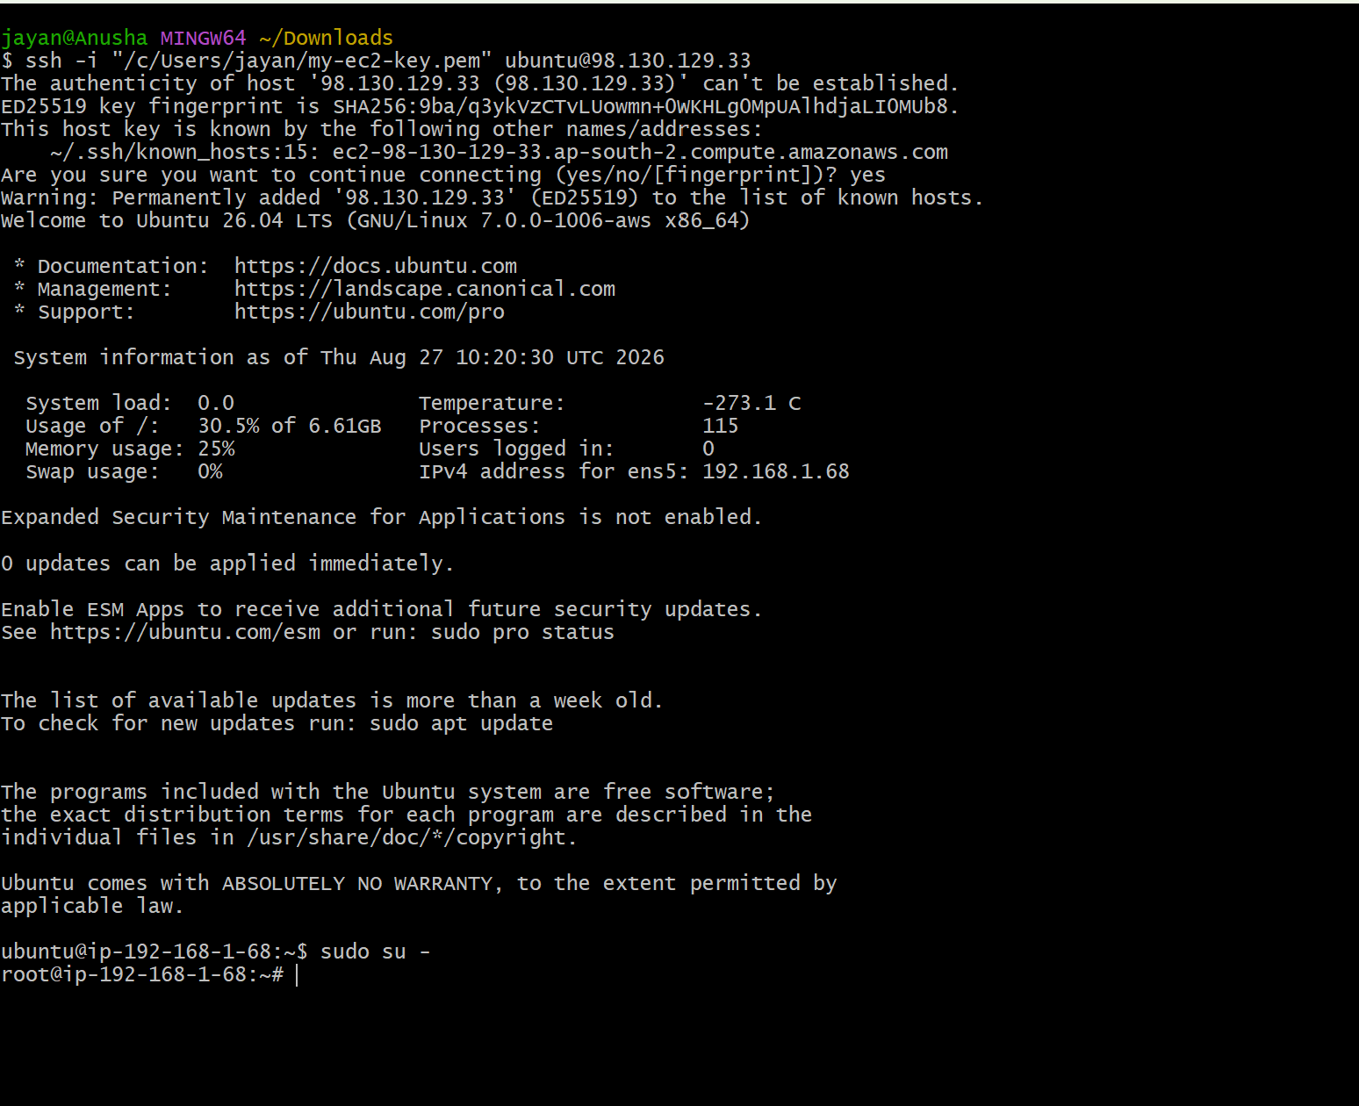
- Security Group: allow SSH (TCP 22) from your trusted IP. Allow HTTP (TCP 80) only if you intend to serve a web page.

9.2 Install PHP on Amazon Linux
Connect to the public EC2 and install PHP using the package manager.
sudo dnf update -y
sudo dnf install -y php
php -v
- Package commands can differ by AMI version. For Ubuntu, use: sudo apt update && sudo apt install -y php. 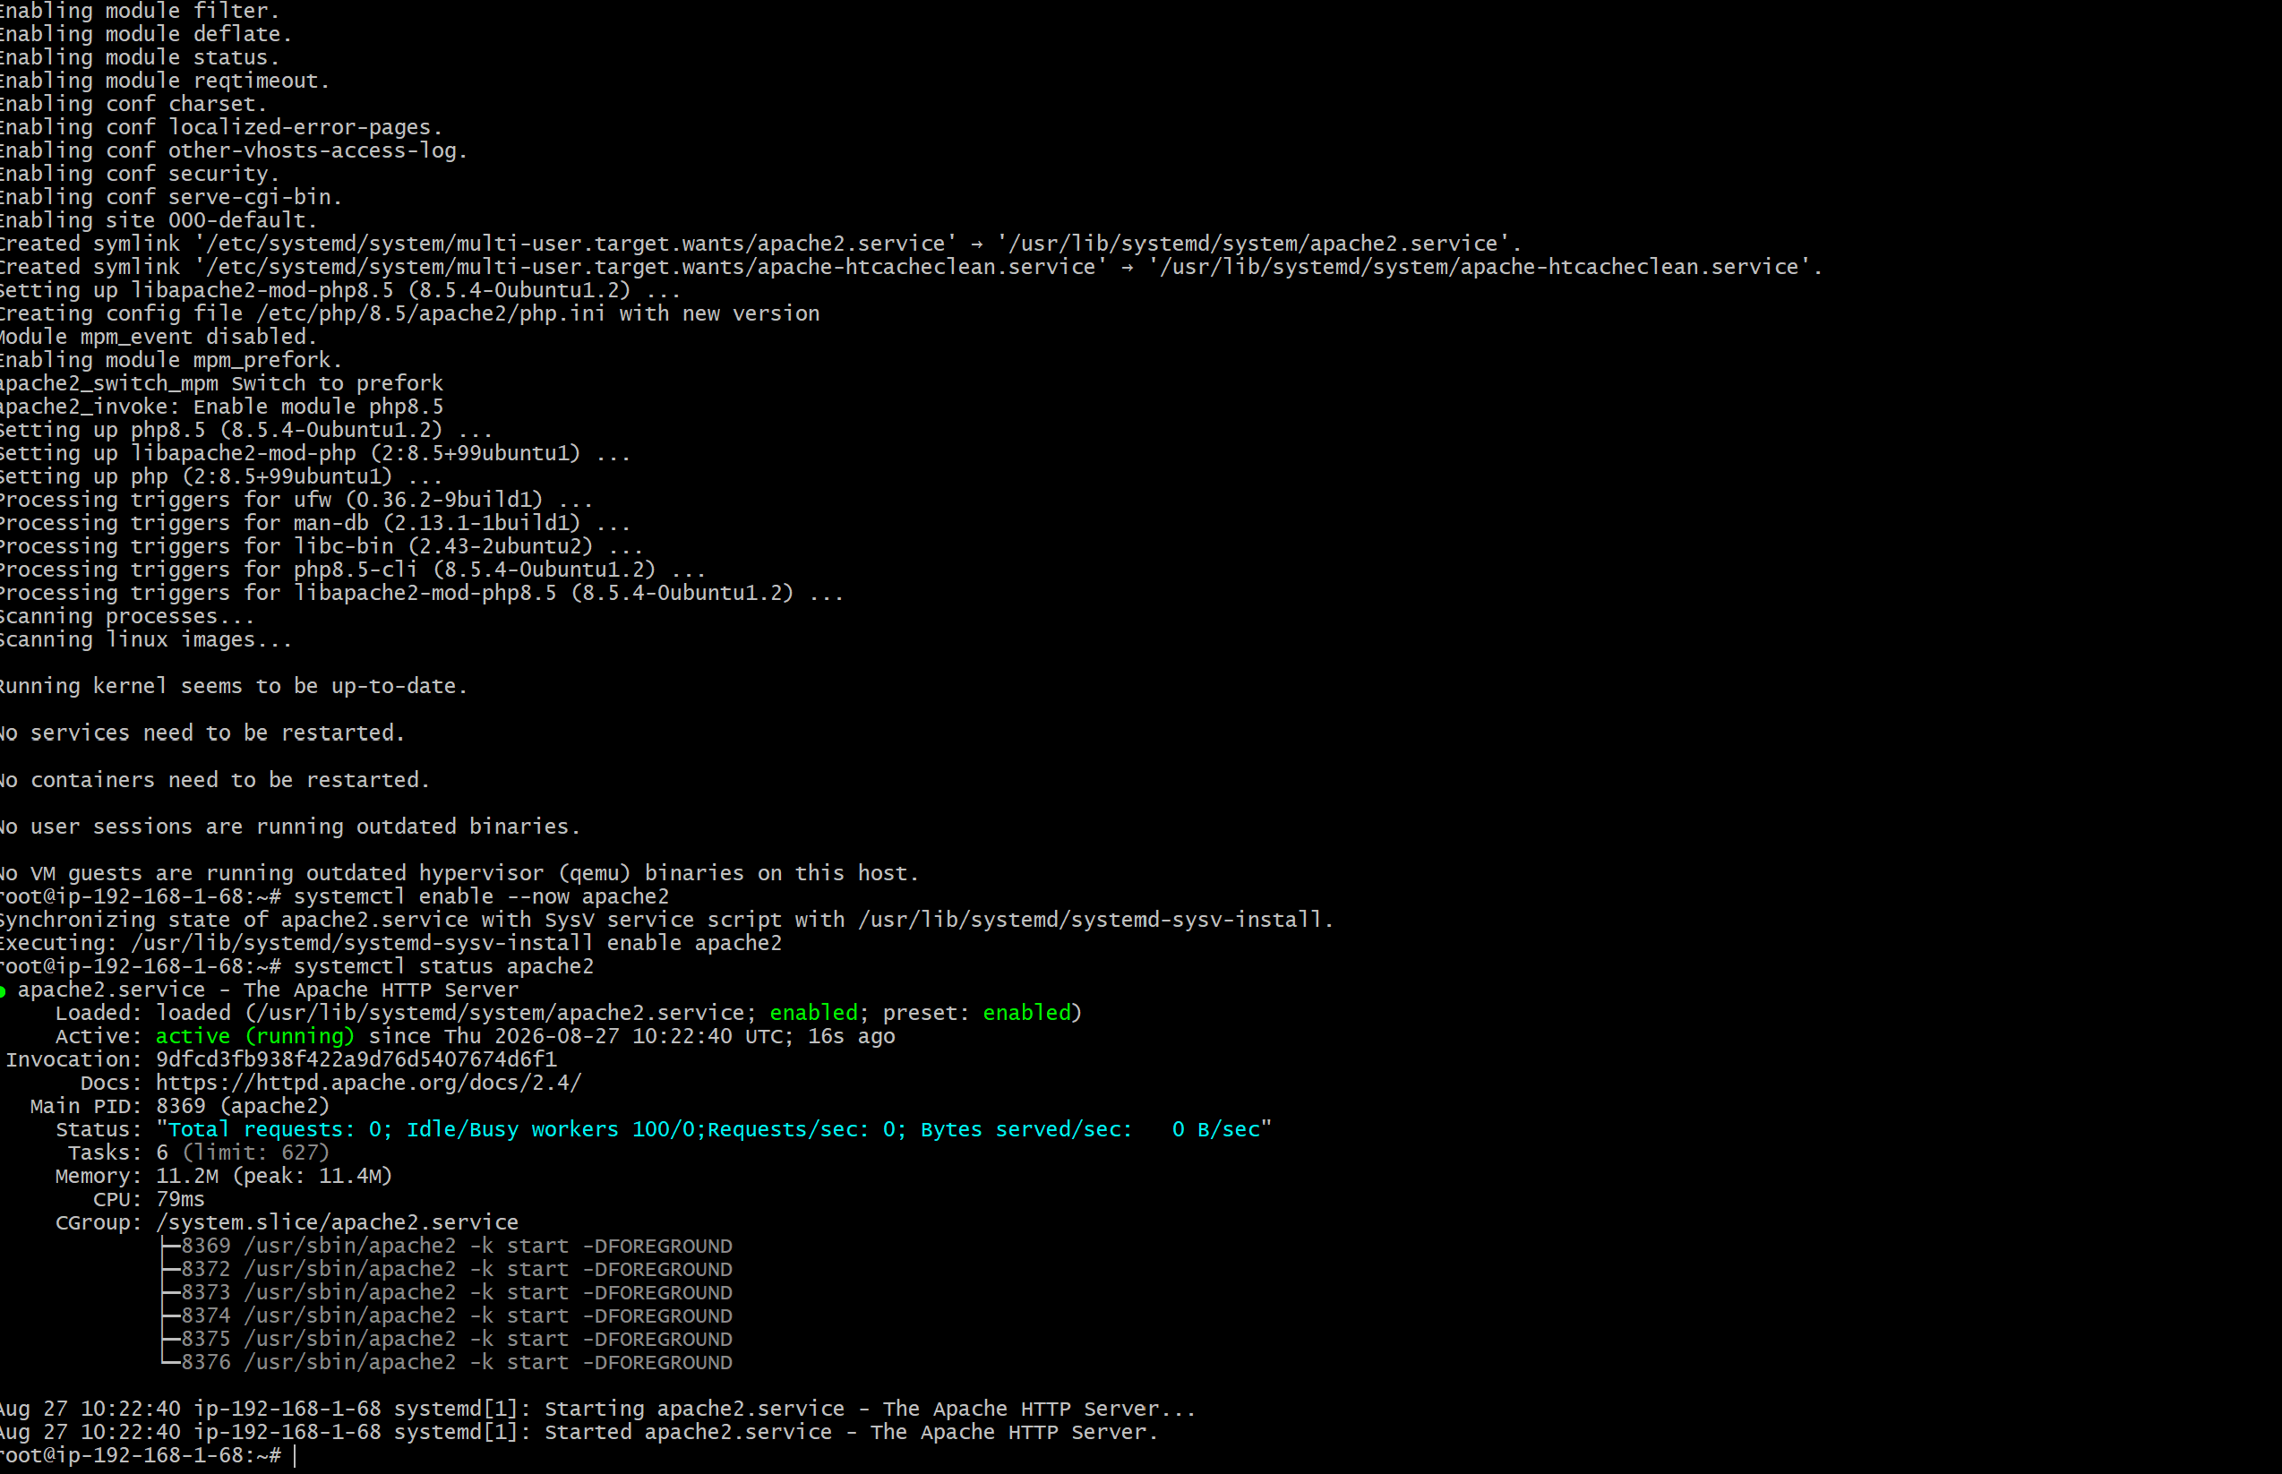

9.3 Optional PHP test page
Create a simple PHP file if Apache/Nginx is installed and configured to serve PHP.
echo '<?php phpinfo(); ?>' | sudo tee /var/www/html/info.php 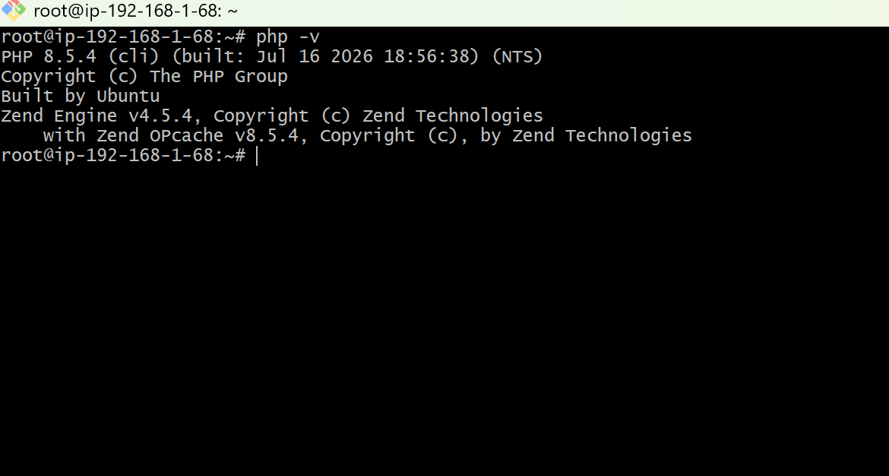
- Do not expose phpinfo() publicly in a production environment because it reveals server configuration details. 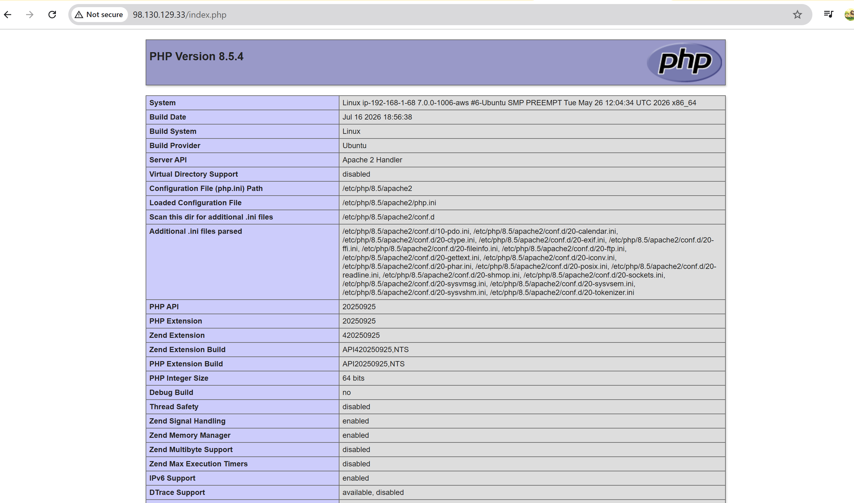

10. Launch Private EC2

10.1 Launch private instance
Launch a second EC2 instance using the same VPC, Private-Subnet-1, and the private route table. Disable public IPv4 assignment.
- Security Group should allow SSH from the public EC2 security group or another trusted administration source.
- For a simple lab, the public EC2 can act as a bastion host. Use SSH agent forwarding or a secure key-transfer method rather than broadly opening SSH to the internet. 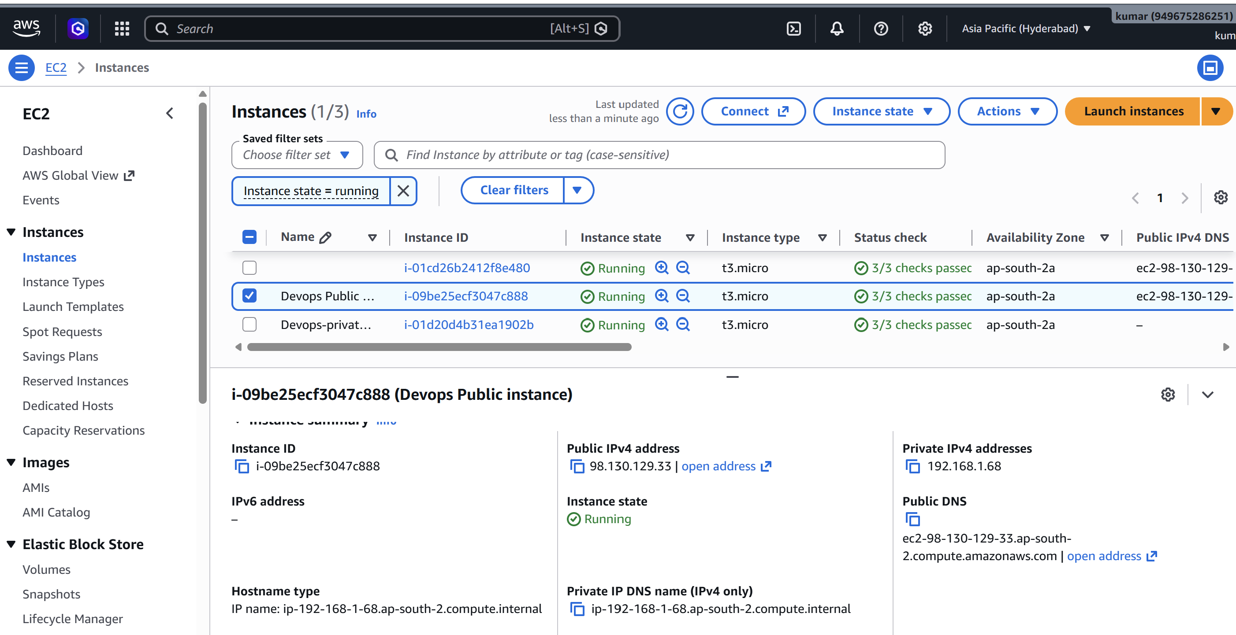 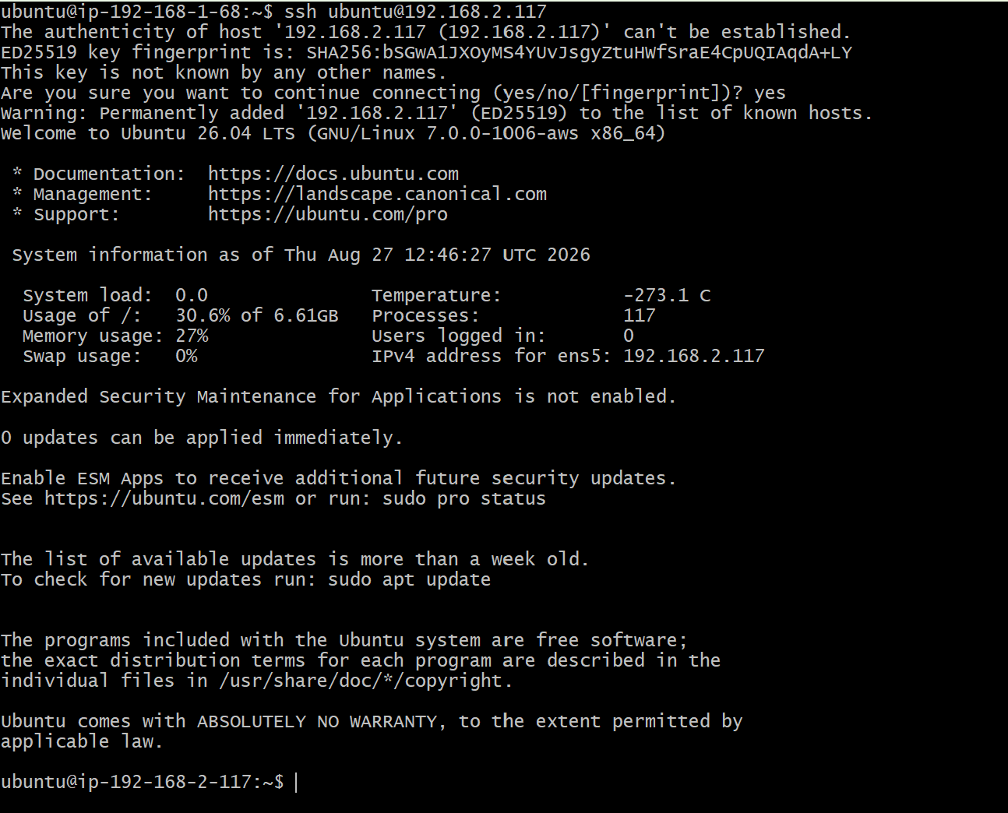

10.2 Test NAT connectivity
From the private EC2, verify outbound connectivity through the NAT Gateway.
curl -I https://www.apache.org
curl -I https://google.com
- The private instance should have outbound internet access through the NAT Gateway, but it should not have a public IP. 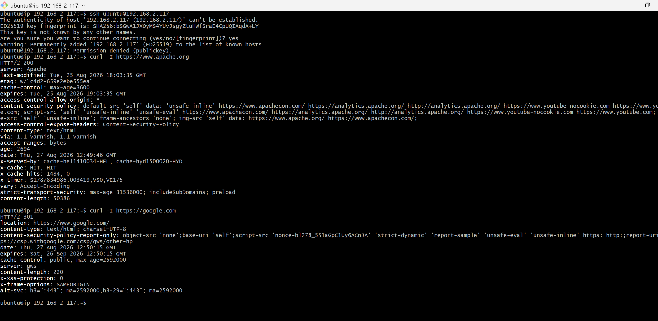

11. Install Apache Tomcat on Private EC2

11.1 Install Java
Install a supported Java runtime before installing Tomcat.
sudo dnf update -y
sudo dnf install -y java-17-amazon-corretto wget tar
java -version
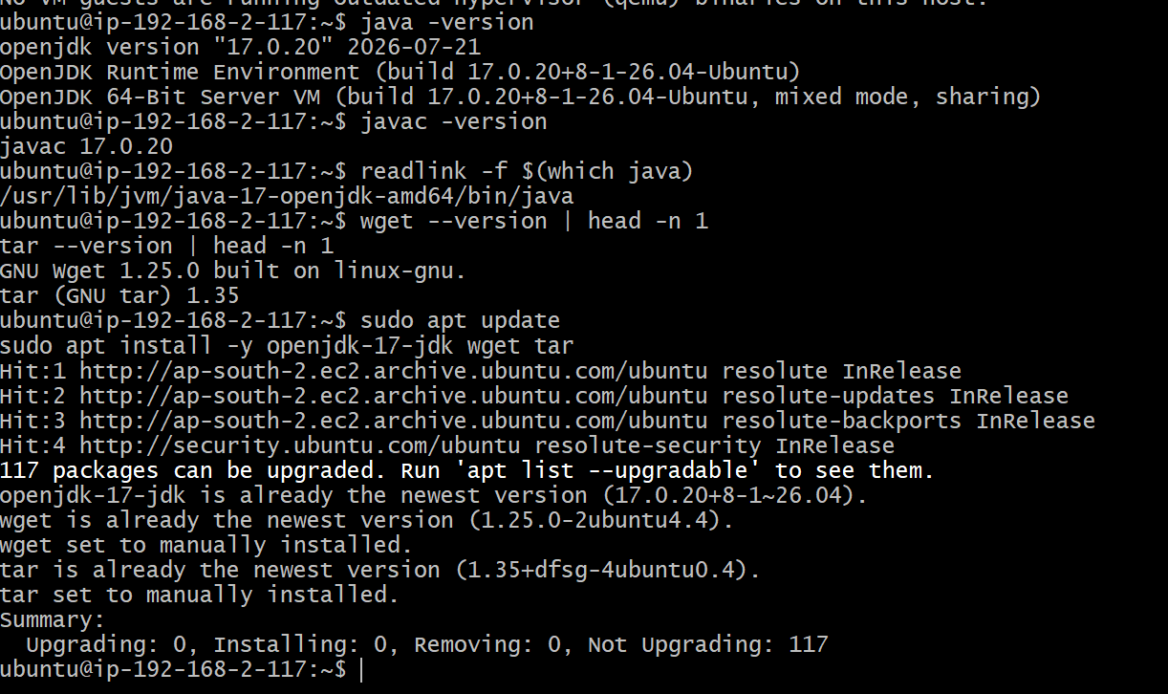
- On Ubuntu, an equivalent package is openjdk-17-jdk.

11.2 Download and install Tomcat
Download a current Tomcat release appropriate for your lab, extract it under /opt/tomcat, and create a dedicated tomcat user.
sudo useradd -r -m -U -d /opt/tomcat -s /bin/false tomcat
sudo mkdir -p /opt/tomcat
# Download the selected Tomcat tar.gz from the official Apache Tomcat site
sudo tar -xzf apache-tomcat-<VERSION>.tar.gz -C /opt/tomcat
sudo chown -R tomcat:tomcat /opt/tomcat
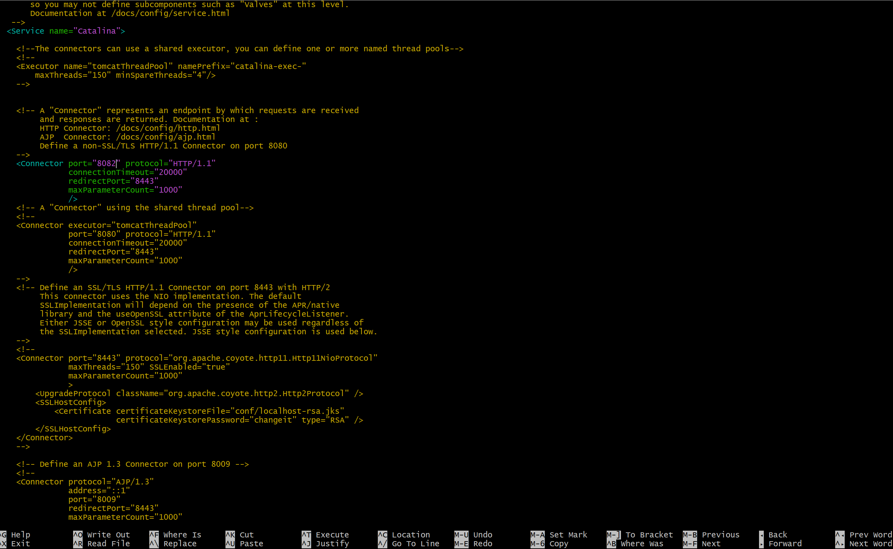 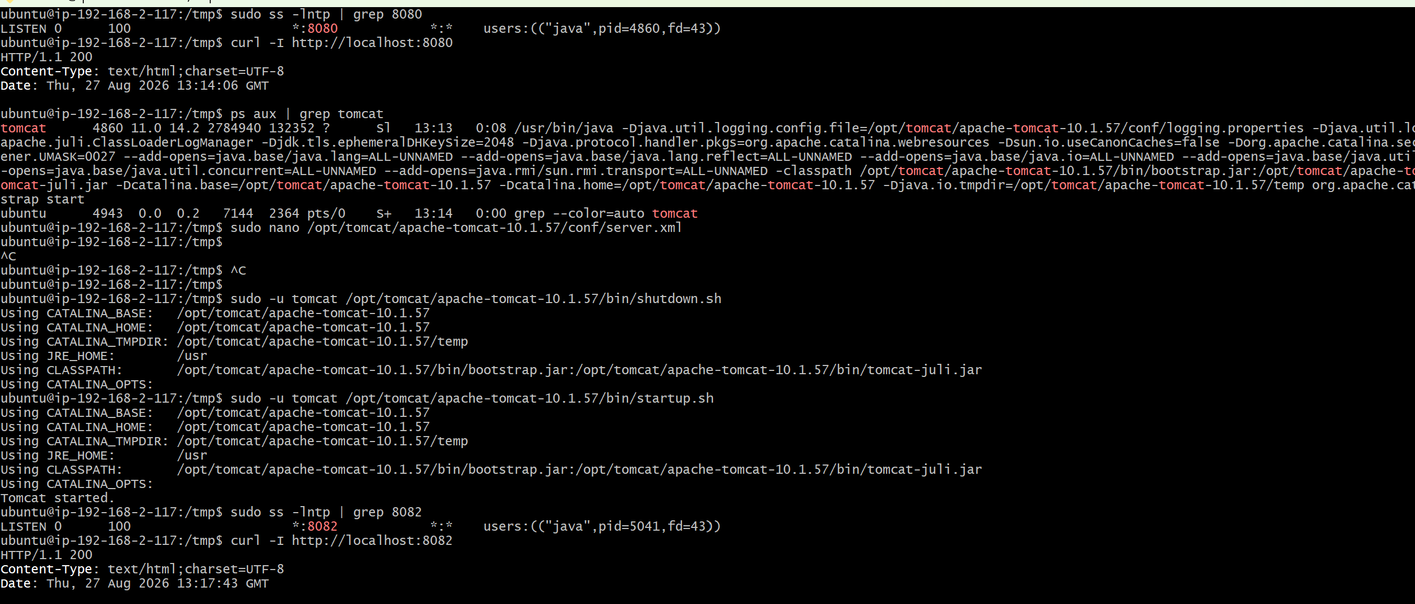
- Replace <VERSION> with the version selected for the lab. Avoid hard-coding an old download URL.

12. Deploy a Sample Tomcat Application

12.1 Create a sample application
Deploy a simple ROOT or myapp application under Tomcat's webapps directory.
sudo mkdir -p /opt/tomcat/webapps/myapp
echo '<html><body><h1>Private Tomcat Application</h1><p>Deployed successfully.</p></body></html>' | sudo tee /opt/tomcat/webapps/myapp/index.html
sudo chown -R tomcat:tomcat /opt/tomcat/webapps/myapp
sudo systemctl restart tomcat
curl http://localhost:8080/myapp/
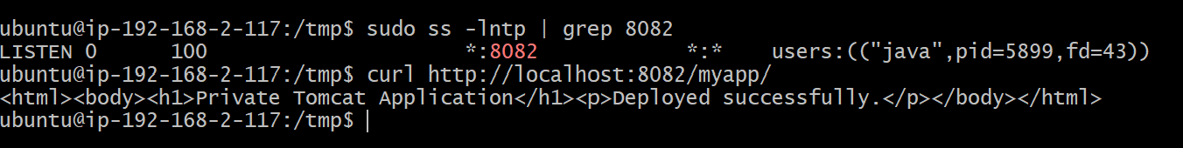
- The private application should not be directly reachable from the internet. Access it through an approved internal/bastion/load-balancer path.

13. Configure VPC Flow Logs to S3

13.1 Create an S3 bucket
Create an S3 bucket in the required AWS Region with a globally unique bucket name. Enable appropriate encryption and access controls. 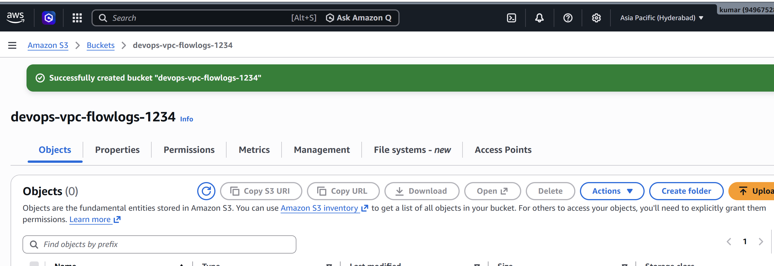
- Use least-privilege bucket policies. Avoid public access.

13.2 Create VPC Flow Log to S3
VPC Console → Your VPCs → select the VPC → Flow Logs → Create flow log. Select the desired traffic type (for example, ALL), choose S3 as the destination, and select the S3 bucket. 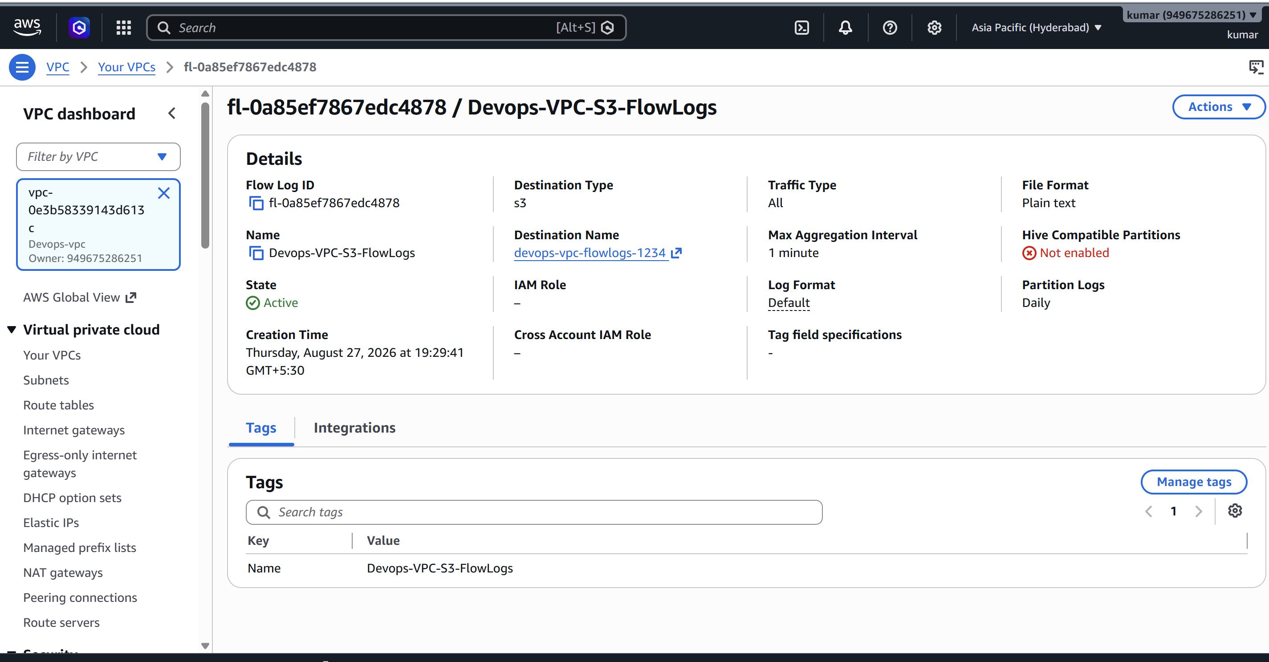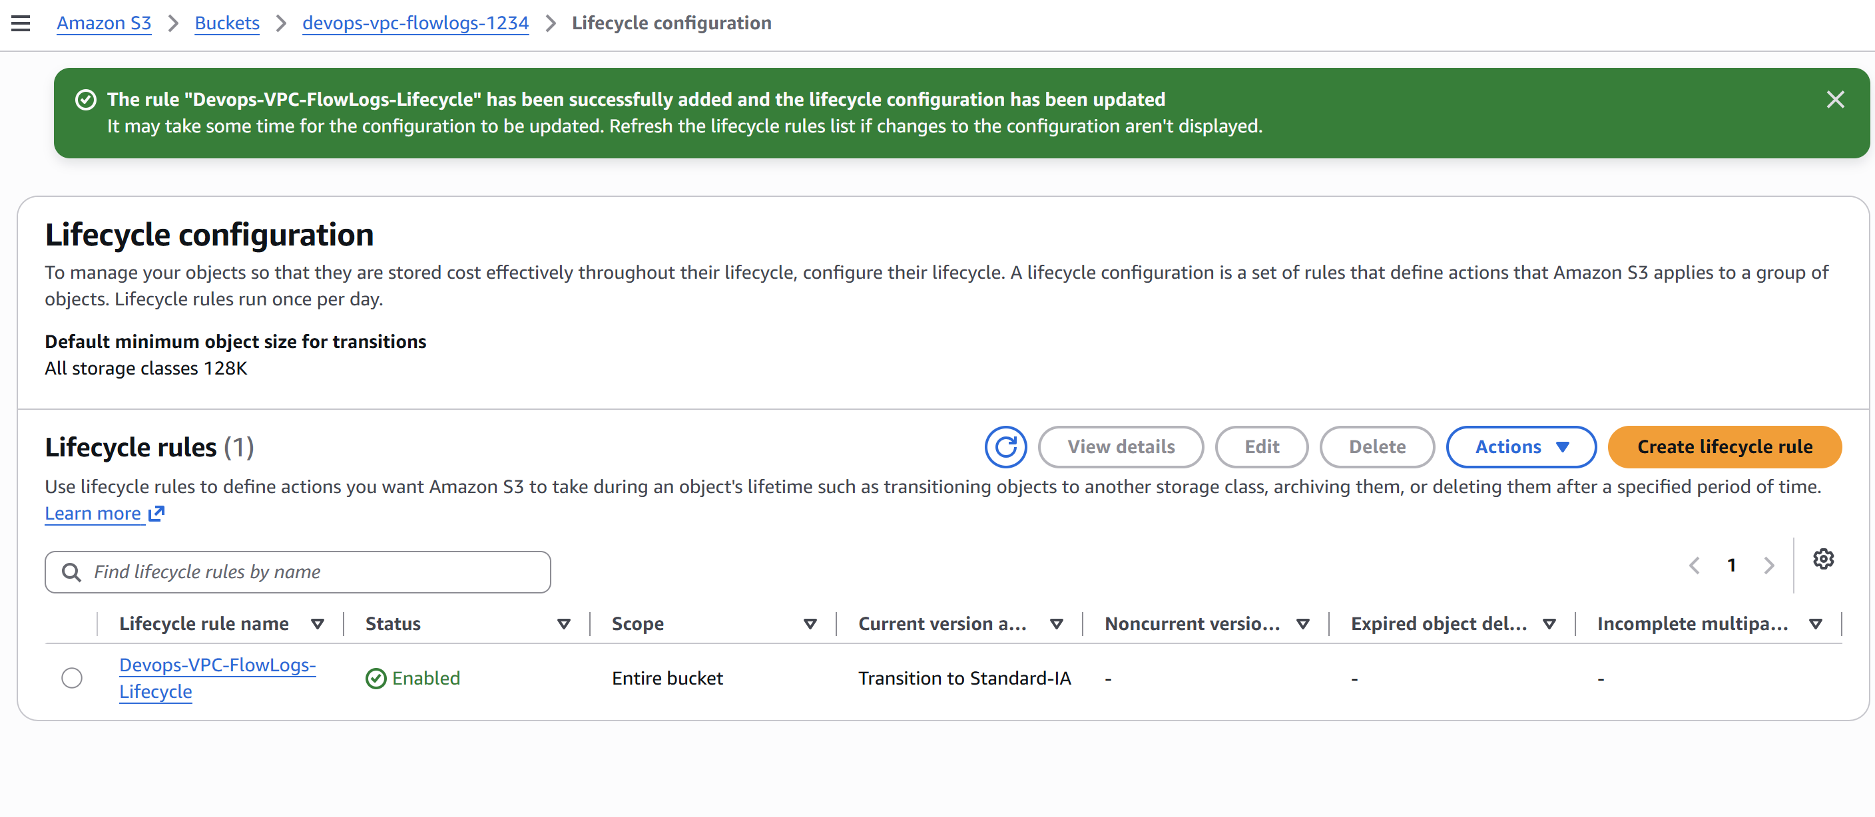
- Choose a retention/lifecycle strategy for logs to control storage cost.

14. Configure VPC Flow Logs to CloudWatch Logs

14.1 Create CloudWatch Log Group
CloudWatch → Logs → Log groups → Create log group, for example /aws/vpc/flowlogs. 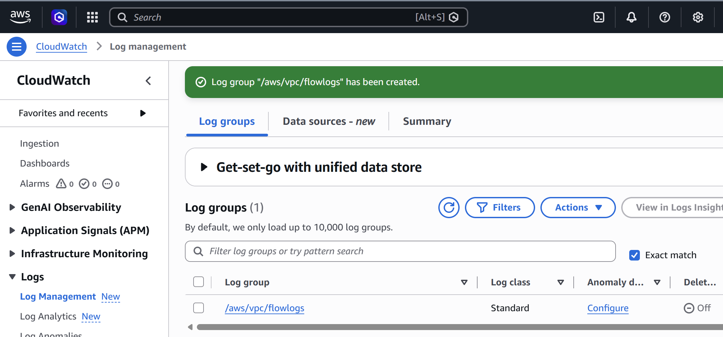
- Set an appropriate retention period.

14.2 Create Flow Log
VPC → select VPC → Flow Logs → Create flow log. Select CloudWatch Logs as the destination, select the log group, select the IAM role, and choose the desired traffic type. 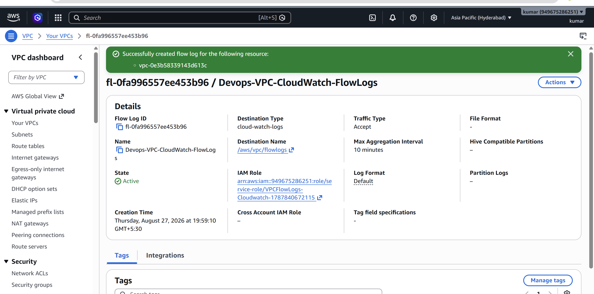
- You can maintain separate flow logs for S3 and CloudWatch. Avoid assuming that one flow-log configuration automatically sends the same records to both destinations.

