Amazon S3 Encryption & Advanced Data Access
SSE-S3 • SSE-KMS • SSE-C • Client-Side Encryption • KMS • Pre-signed URLs • S3 Select • Glacier Select • Partial Object Retrieval
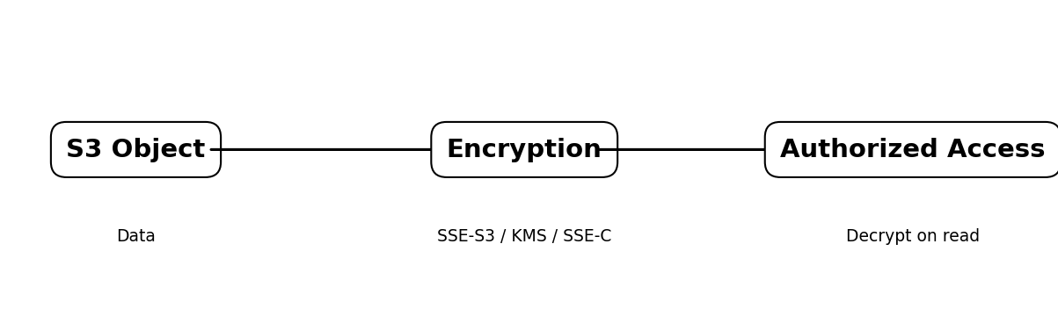

1. Encryption Overview
Amazon S3 supports server-side encryption and client-side encryption. Server-side encryption protects objects at rest after S3 receives them. Client-side encryption protects data before it is uploaded.
- SSE-S3 — S3 manages encryption keys.
- SSE-KMS — AWS KMS manages the selected KMS key.
- SSE-C — you provide the encryption key with the request.
- Client-Side Encryption — your application encrypts the data before S3 receives it.

2. SSE-S3
SSE-S3 is S3 server-side encryption using Amazon S3 managed keys.
- Open S3 → Buckets → select the bucket → Properties.
- Under Default encryption, choose Edit.
- Select SSE-S3 / Amazon S3 managed keys.
- Save changes.
aws s3api put-bucket-encryption --bucket my-bucket \
--server-side-encryption-configuration '{"Rules":[{"ApplyServerSideEncryptionByDefault":{"SSEAlgorithm":"AES256"}}]}'
- AES256 identifies SSE-S3.
- AWS manages the keys; you do not manage key rotation or key material directly.

3. SSE-KMS
SSE-KMS encrypts S3 objects using AWS Key Management Service.
- S3 → Bucket → Properties → Default encryption.
- Select SSE-KMS.
- Choose the required KMS key.
- Save changes.
aws s3api put-bucket-encryption --bucket my-bucket \
--server-side-encryption-configuration '{"Rules":[{"ApplyServerSideEncryptionByDefault":{"SSEAlgorithm":"aws:kms","KMSMasterKeyID":"alias/my-s3-key"}}]}'
- KMS permissions and the KMS key policy must allow the required operations.
- KMS provides centralized key control and audit visibility.

4. SSE-C
With SSE-C, S3 performs server-side encryption using a customer-provided key supplied with the request.
- S3 does not store the customer-provided key.
- You are responsible for securely managing and retaining the key.
- Losing the key can make the object inaccessible.
aws s3api put-object --bucket my-bucket --key data.txt --body data.txt --sse-c AES256 --sse-customer-key fileb://key.bin

5. Client-Side Encryption
Client-side encryption occurs before the object is uploaded to S3. The application encrypts plaintext and S3 stores the resulting ciphertext.
- The application controls the encryption process.
- S3 does not need the plaintext.
- Key management can be integrated with AWS KMS or another approved key-management system.

6. AWS KMS Integration
AWS KMS is a managed service for creating and controlling cryptographic keys. S3 can use KMS keys for SSE-KMS.
Typical flow:
- Application → S3 PutObject
- S3 uses the configured KMS key according to permissions.
- S3 stores the encrypted object.
- Authorized GetObject requests return decrypted content.

Common permissions to evaluate
s3:PutObject
s3:GetObject
kms:Encrypt
kms:Decrypt
kms:GenerateDataKey
The exact permissions depend on the operation, IAM policies, KMS key policy, and the identity making the request.

7. Default Bucket Encryption
Default bucket encryption automatically applies the selected encryption configuration to new objects uploaded to the bucket.
- S3 → Bucket → Properties.
- Find Default encryption → Edit.
- Choose SSE-S3 or SSE-KMS.
- If using SSE-KMS, select the KMS key.
- Save changes.
Default encryption is a baseline. A bucket policy can additionally reject uploads that do not meet your required encryption condition.

8. Enforcing Encryption Using Bucket Policies
A bucket policy can deny PutObject requests that do not use the required server-side encryption setting.

Example: require SSE-KMS
{
"Version": "2012-10-17",
"Statement": [{
"Sid": "DenyUnencryptedObjectUploads",
"Effect": "Deny",
"Principal": "*",
"Action": "s3:PutObject",
"Resource": "arn:aws:s3:::my-bucket/*",
"Condition": {
"StringNotEquals": {
"s3:x-amz-server-side-encryption": "aws:kms"
}
}
}]
}
Replace my-bucket with your bucket name. Test carefully because an explicit Deny can block clients that do not send the required header.

9. Pre-signed URLs
A pre-signed URL provides temporary access to a specific S3 object without making the bucket or object public.
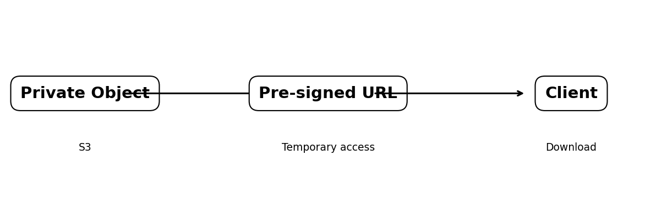

Generate a download URL
aws s3 presign s3://my-private-bucket/report.pdf --expires-in 900 --region ap-south-2
- 900 seconds equals 15 minutes.
- The underlying bucket can remain private.
- Anyone possessing a valid pre-signed URL may be able to use it until it expires, so protect URLs appropriately.

10. S3 Select
S3 Select allows an application to retrieve a filtered subset of data from a single supported S3 object using SQL expressions. It is intended for supported structured formats such as CSV, JSON, and Parquet.
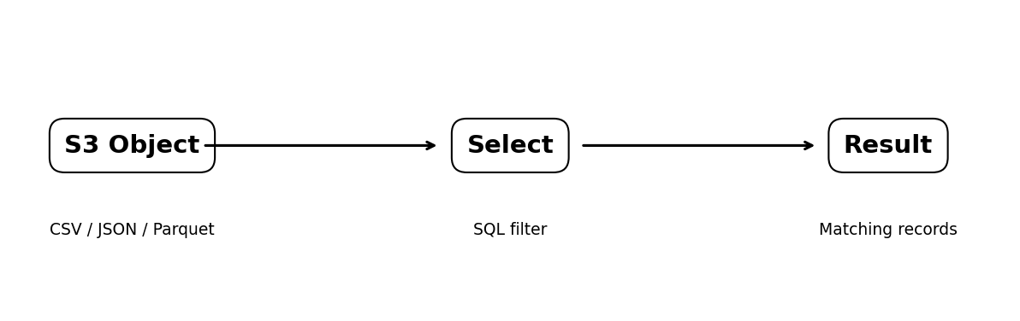
SELECT s.name, s.salary
FROM S3Object s
WHERE s.salary > 50000
S3 Select is not a generic ZIP-file extractor. It does not automatically locate an arbitrary file stored inside a compressed archive.

11. Glacier Select
Glacier Select is designed for querying/filtering supported archived data through a retrieval job rather than downloading the complete archived object to the client first.
- Useful for suitable structured archived data.
- The query is expressed using supported SQL-style functionality.
- The result is returned as the output of the retrieval/query job.
Always verify current AWS support and recommended workflows for the specific S3 Glacier storage class before building a new solution, because AWS features can change.

12. Partial Object Retrieval
S3 supports HTTP Range requests. A client can request only a specified byte range of an S3 object.
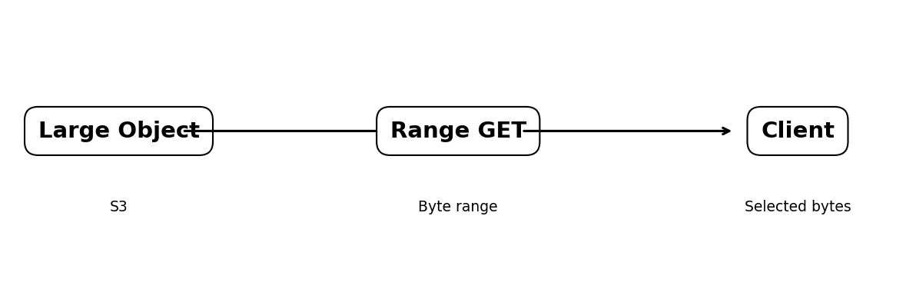
aws s3api get-object --bucket my-bucket --key large-file.bin --range bytes=0-1048575 partial.bin
This example requests the first 1 MiB. Range retrieval is byte-based; it does not understand logical files inside a ZIP/TAR archive.

13. Important Example — 1 GB Compressed Archive in Deep Archive
Suppose you have one S3 object in S3 Glacier Deep Archive:
backup.zip → 1 GB → 500 files
If you need only file250.pdf inside that ZIP, S3 does not provide a generic operation that directly restores that individual ZIP member as an independent S3 object.
- Restore/retrieve the archived S3 object according to the applicable Deep Archive retrieval process.
- Download or process the restored object.
- Open backup.zip.
- Extract file250.pdf.
If the 500 files are stored as 500 separate S3 objects, you can restore and retrieve only the required object. This is generally preferable when individual-file retrieval is common.
bucket/
file001.pdf
file002.pdf
...
file500.pdf

14. Comparison
Feature | Main purpose | Key point
SSE-S3 | Encryption at rest | S3 manages keys
SSE-KMS | Encryption with KMS | More key control and audit integration
SSE-C | Encryption with customer key | Customer manages key material
Client-side encryption | Encrypt before upload | Application controls plaintext encryption
Default encryption | Automatic encryption baseline | Applies to new uploads
Bucket policy | Enforce encryption | Can deny non-compliant uploads
Pre-signed URL | Temporary access | Does not make bucket public
S3 Select | Filter supported object data | Returns selected records
Glacier Select | Filter supported archived data | Uses retrieval/query job
Range GET | Retrieve selected bytes | Byte-level, not archive-member retrieval

15. Recommended Design
- Frequent individual file access → store files as separate S3 objects.
- Rare whole-collection access → an archive object may be reasonable.
- Structured data filtering → evaluate S3 Select where supported.
- Archived structured-data filtering → evaluate Glacier Select/current archive-query capabilities.
- Temporary sharing → use pre-signed URLs.
- Strong centralized key control → use SSE-KMS with appropriate KMS policies.
- Mandatory encryption → combine default encryption with an enforcing bucket policy.

16. Verification Checklist
- Confirm S3 Block Public Access remains enabled unless public access is intentionally required.
- Check an object's encryption setting in S3 object properties.
- For SSE-KMS, verify KMS key permissions and key policy.
- Test a pre-signed URL and confirm its expiry.
- Use S3 Select only with supported formats and expressions.
- For Deep Archive, verify the restore/query workflow for the chosen storage class.
- For Range GET, verify the requested byte range is returned.

17. Key Takeaways
S3 encryption protects data at rest; KMS adds centralized key management; pre-signed URLs provide temporary private access; Select features can reduce the data returned for supported formats; and Range GET retrieves selected bytes. Most importantly, S3 operations work at the object level. A file buried inside a compressed archive is not automatically an independently retrievable S3 object.

