AWS S3 HANDS-ON LAB
Create, Host, Replicate, Secure, Lifecycle, CLI & 1 GB Upload

Lab Overview
This lab covers eight practical Amazon S3 tasks: creating a bucket and uploading objects, hosting a static website, configuring Cross-Region Replication, restricting bucket access to an Admin user, configuring lifecycle policies, using the AWS CLI, creating a bucket with a Bash script, and uploading a 1 GB file.

Prerequisites
- An AWS account with permission to use Amazon S3, IAM, and related services.
- AWS CLI installed and configured.
- A Linux/Ubuntu terminal for the Bash and large-file exercises.
- An IAM user named Admin for the private-bucket access exercise (or change the name in the policy).

Lab Variables
Variable | Example Value
Primary Region | ap-south-1
Replication Region | us-east-1
Source Bucket | lakshman-s3-lab-2026
Destination Bucket | lakshman-s3-replica-2026
Private Bucket | lakshman-private-s3-2026
IAM User | Admin

1. Create an S3 Bucket and Upload Objects
Console method:
- Open AWS Console → S3 → Buckets → Create bucket.
- Enter a globally unique bucket name, for example lakshman-s3-lab-2026.
- Select ap-south-1 as the Region.
- For a normal private bucket, keep Block Public Access enabled.
- Create the bucket.
- Open the bucket → Upload → Add files.
- Upload files such as index.html, image.jpg, and test.txt. 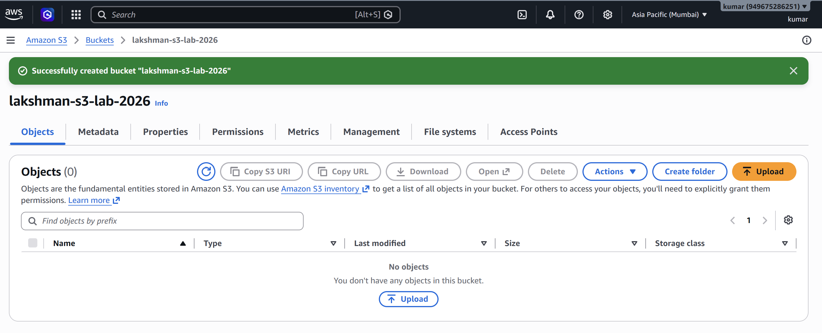 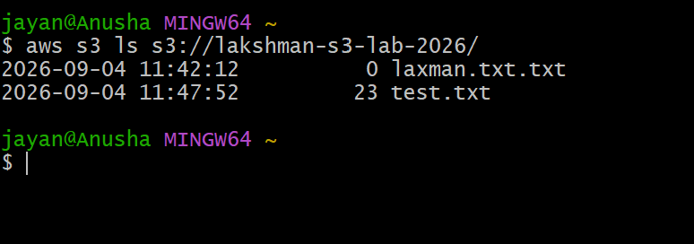
CLI verification:
aws s3 ls
aws s3 ls s3://lakshman-s3-lab-2026/

2. Deploy a Static Website in S3
Create index.html:
<!DOCTYPE html>
<html>
<head>
<title>AWS S3 Website</title>
</head>
<body>
<h1>Welcome to my AWS S3 Static Website</h1>
<p>This website is hosted using Amazon S3.</p>
</body>
</html>
Upload the file:
aws s3 cp index.html s3://lakshman-s3-lab-2026/ 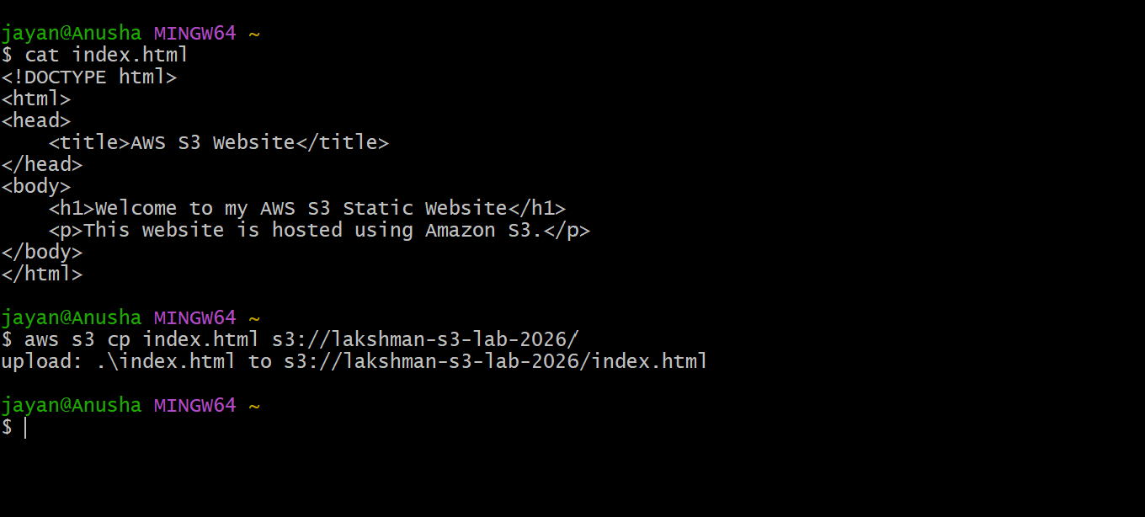
- Open S3 → Bucket → Properties.
- Find Static website hosting → Edit.
- Enable static website hosting.
- Select Host a static website.
- Set Index document to index.html.
- Save changes.
- For a direct public S3 website endpoint, configure public access and a public s3:GetObject bucket policy as required by the lab. 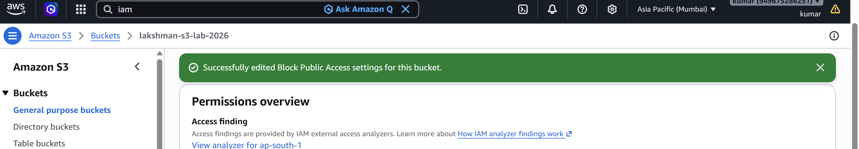
Example public-read bucket policy:
{
"Version": "2012-10-17",
"Statement": [
{
"Sid": "PublicReadGetObject",
"Effect": "Allow",
"Principal": "*",
"Action": "s3:GetObject",
"Resource": "arn:aws:s3:::lakshman-s3-lab-2026/*"
}
]
} 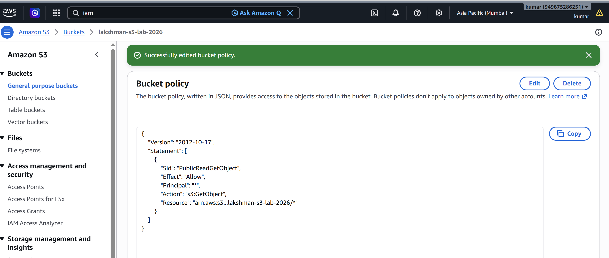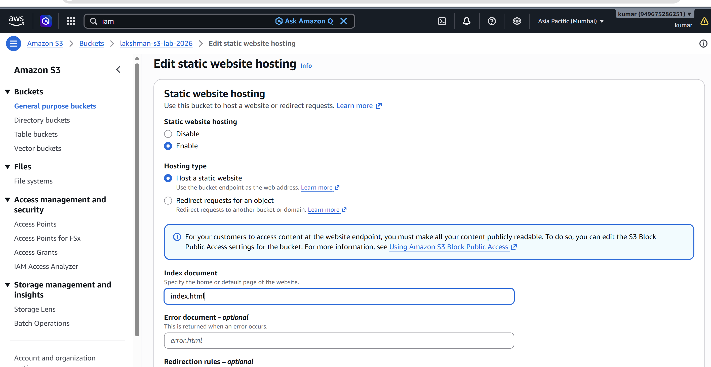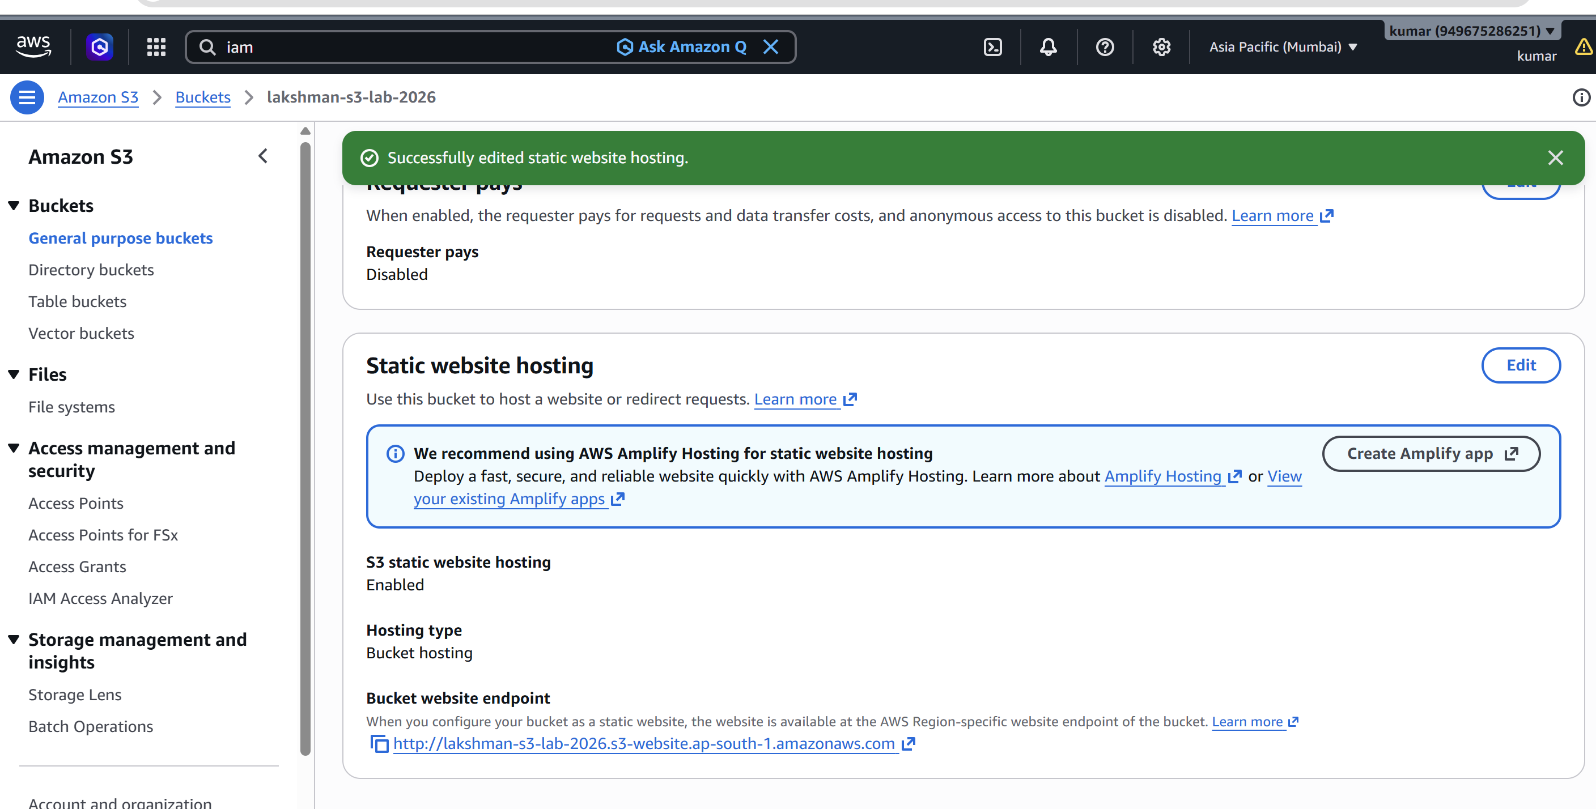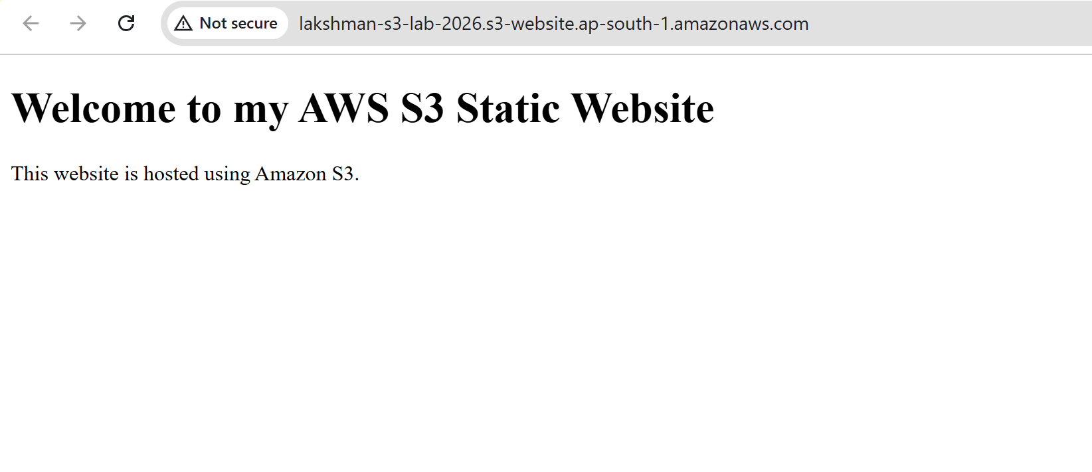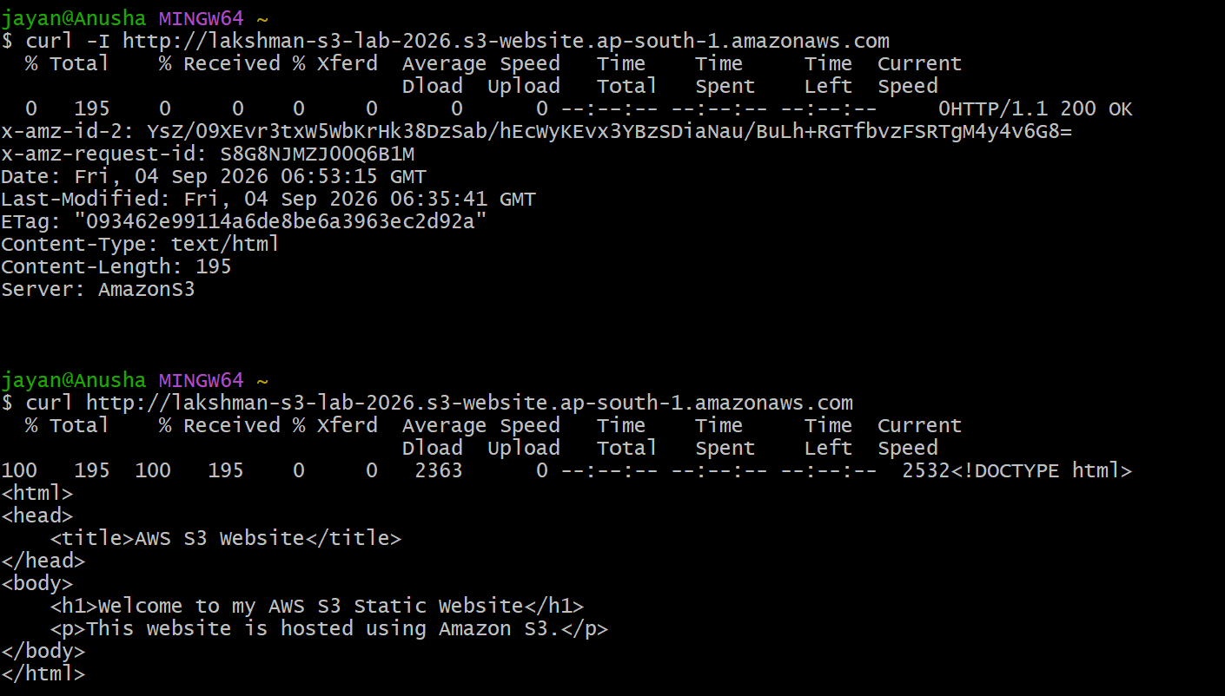
Security note: a public S3 website and an Admin-only private bucket are conflicting requirements when applied to the 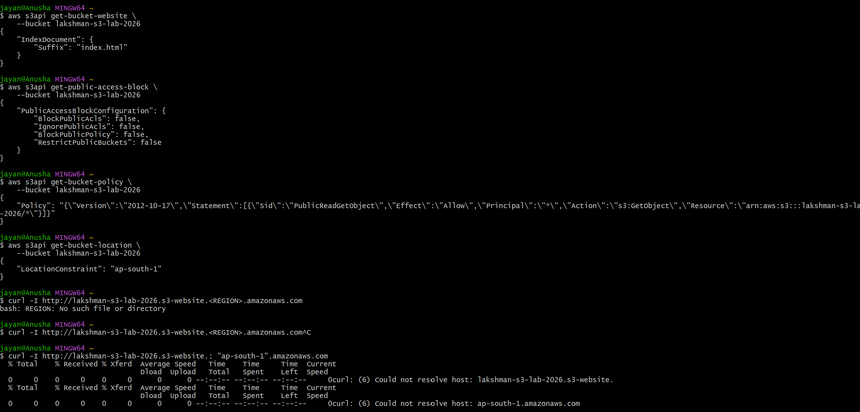same objects. For this lab, use a separate public website bucket and private bucket, or use CloudFront with a private S3 origin for a production design.

3. Enable Cross-Region Replication (CRR)
- Create a destination bucket named lakshman-s3-replica-2026 in us-east-1.
- Enable Versioning on the source bucket.
- Enable Versioning on the destination bucket.
- Open the source bucket → Management → Replication rules → Create replication rule.
- Name the rule CRR-Lab and enable it.
- Choose all objects or a suitable filter.
- Select the destination bucket lakshman-s3-replica-2026.
- Allow AWS to create the replication IAM role, or supply an appropriate role.
- Save the replication rule.
Test replication:
echo "Cross Region Replication Test" > replication-test.txt
aws s3 cp replication-test.txt s3://lakshman-s3-lab-2026/
aws s3 ls s3://lakshman-s3-lab-2026/
aws s3 ls s3://lakshman-s3-replica-2026/ 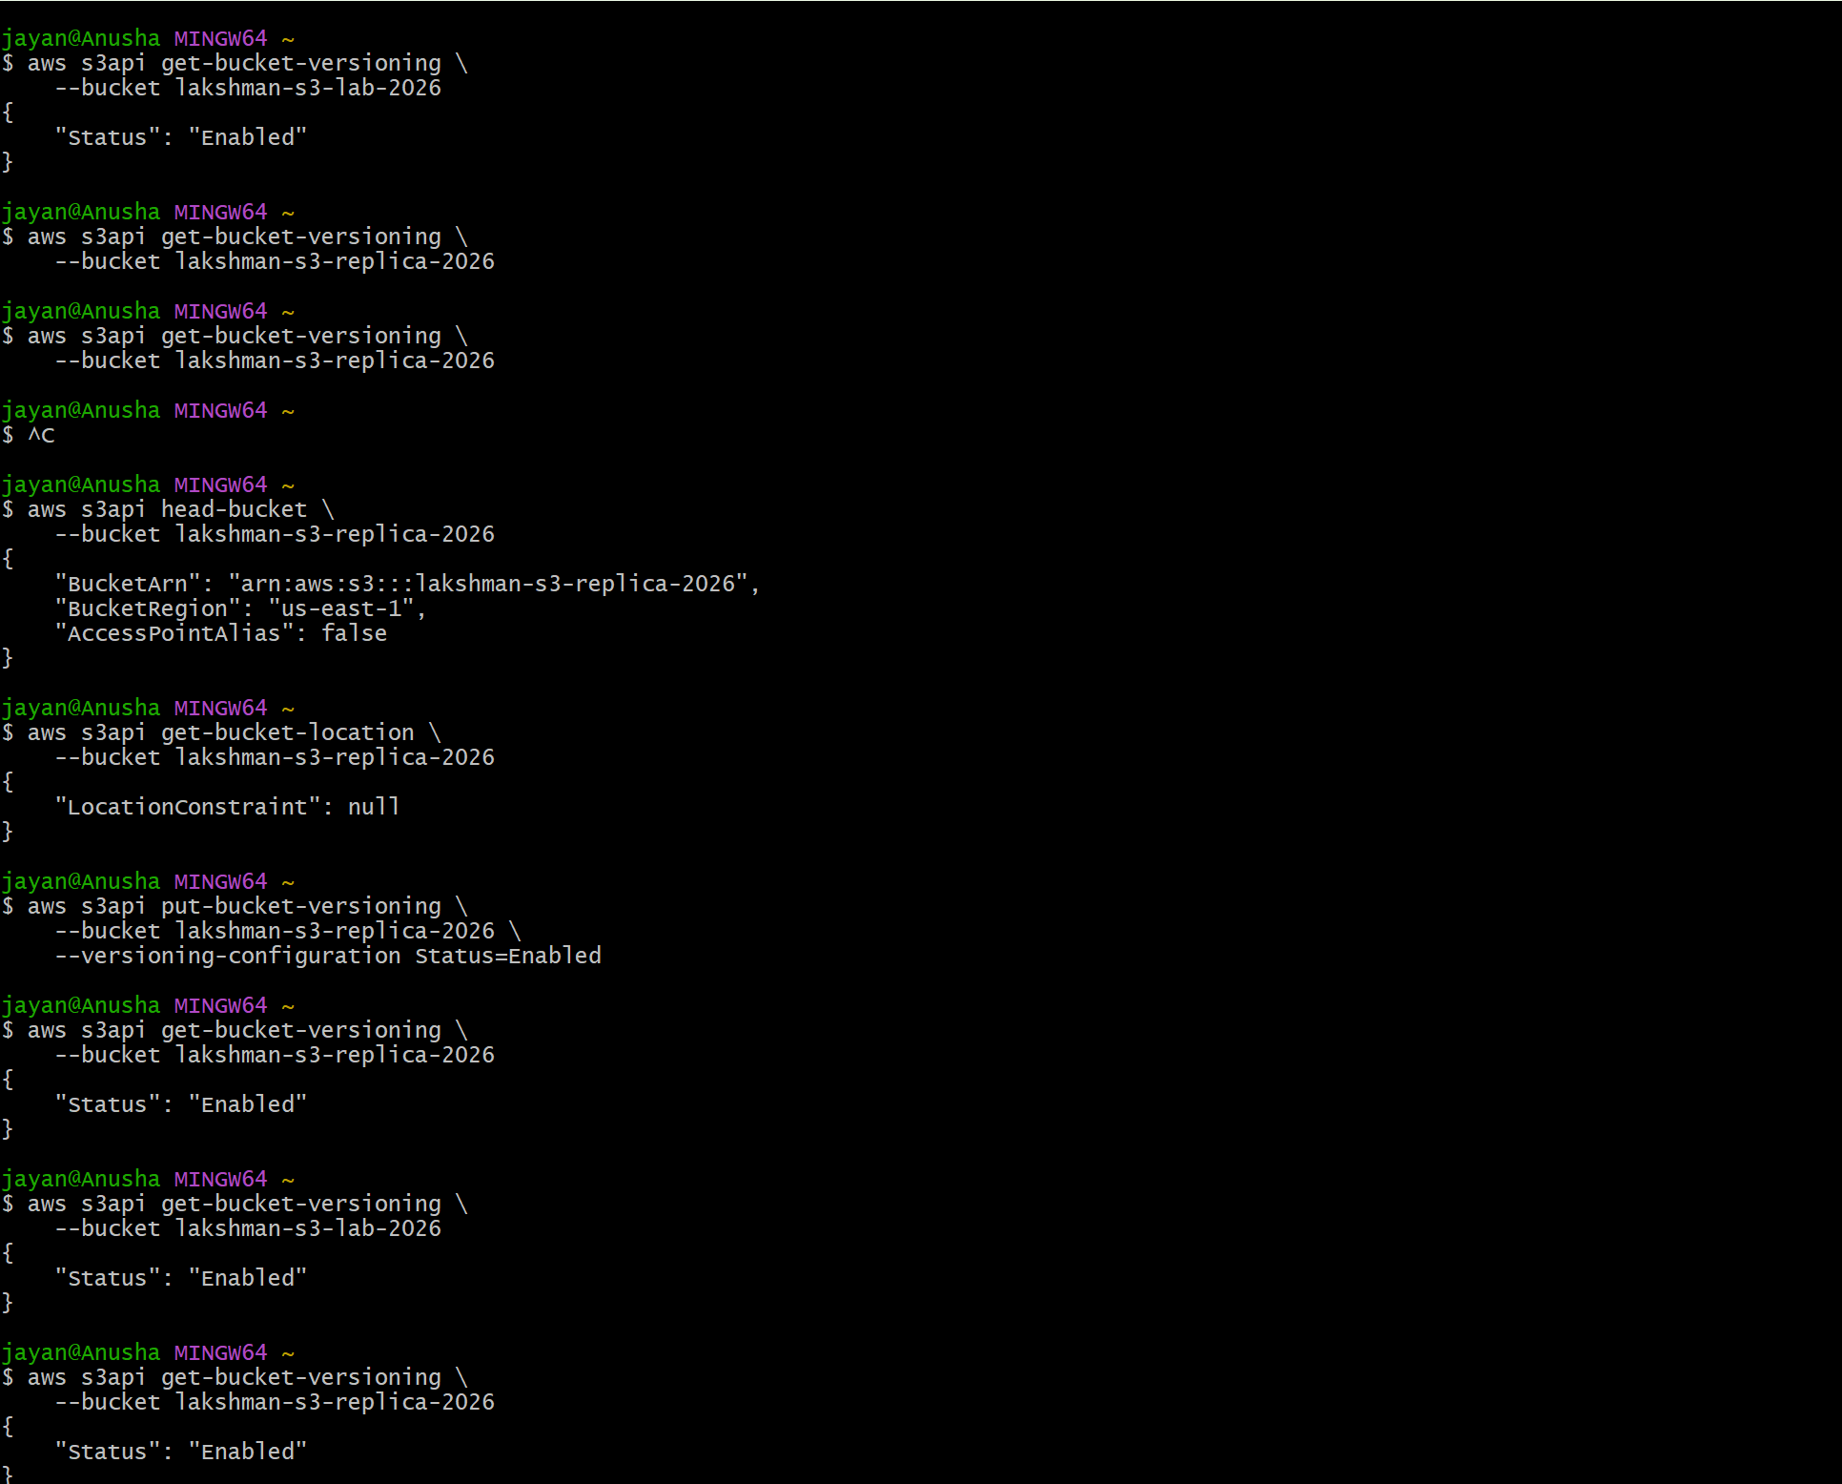 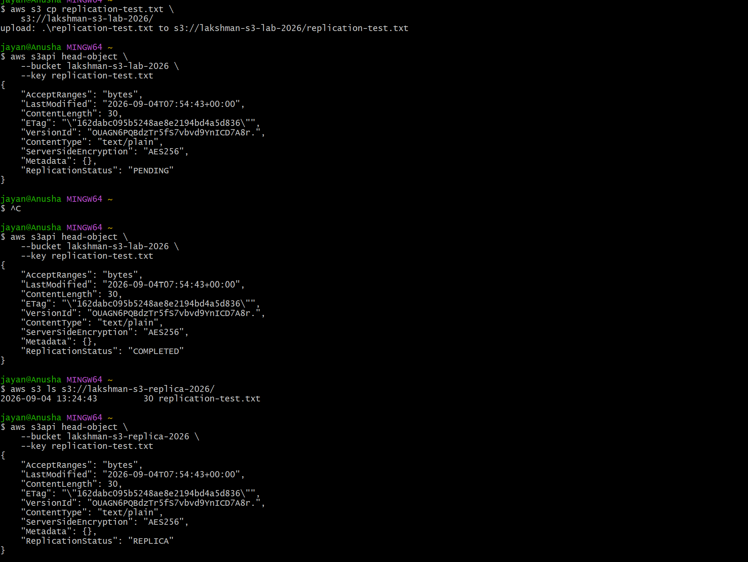
Note: normal live replication applies to objects according to the configured replication rule. Existing objects may require S3 Batch Replication if they need to be copied retroactively.

4. Allow Only the Admin User to Access Objects
Perform this exercise on a private bucket such as lakshman-private-s3-2026. Keep Block Public Access enabled.
Replace 123456789012 with your AWS Account ID.
{
"Version": "2012-10-17",
"Statement": [
{
"Sid": "AllowAdminBucketAccess",
"Effect": "Allow",
"Principal": {"AWS": "arn:aws:iam::123456789012:user/Admin"},
"Action": ["s3:ListBucket", "s3:GetBucketLocation"],
"Resource": "arn:aws:s3:::lakshman-private-s3-2026"
},
{
"Sid": "AllowAdminObjectAccess",
"Effect": "Allow",
"Principal": {"AWS": "arn:aws:iam::123456789012:user/Admin"},
"Action": ["s3:GetObject", "s3:PutObject", "s3:DeleteObject"],
"Resource": "arn:aws:s3:::lakshman-private-s3-2026/*"
}
]
}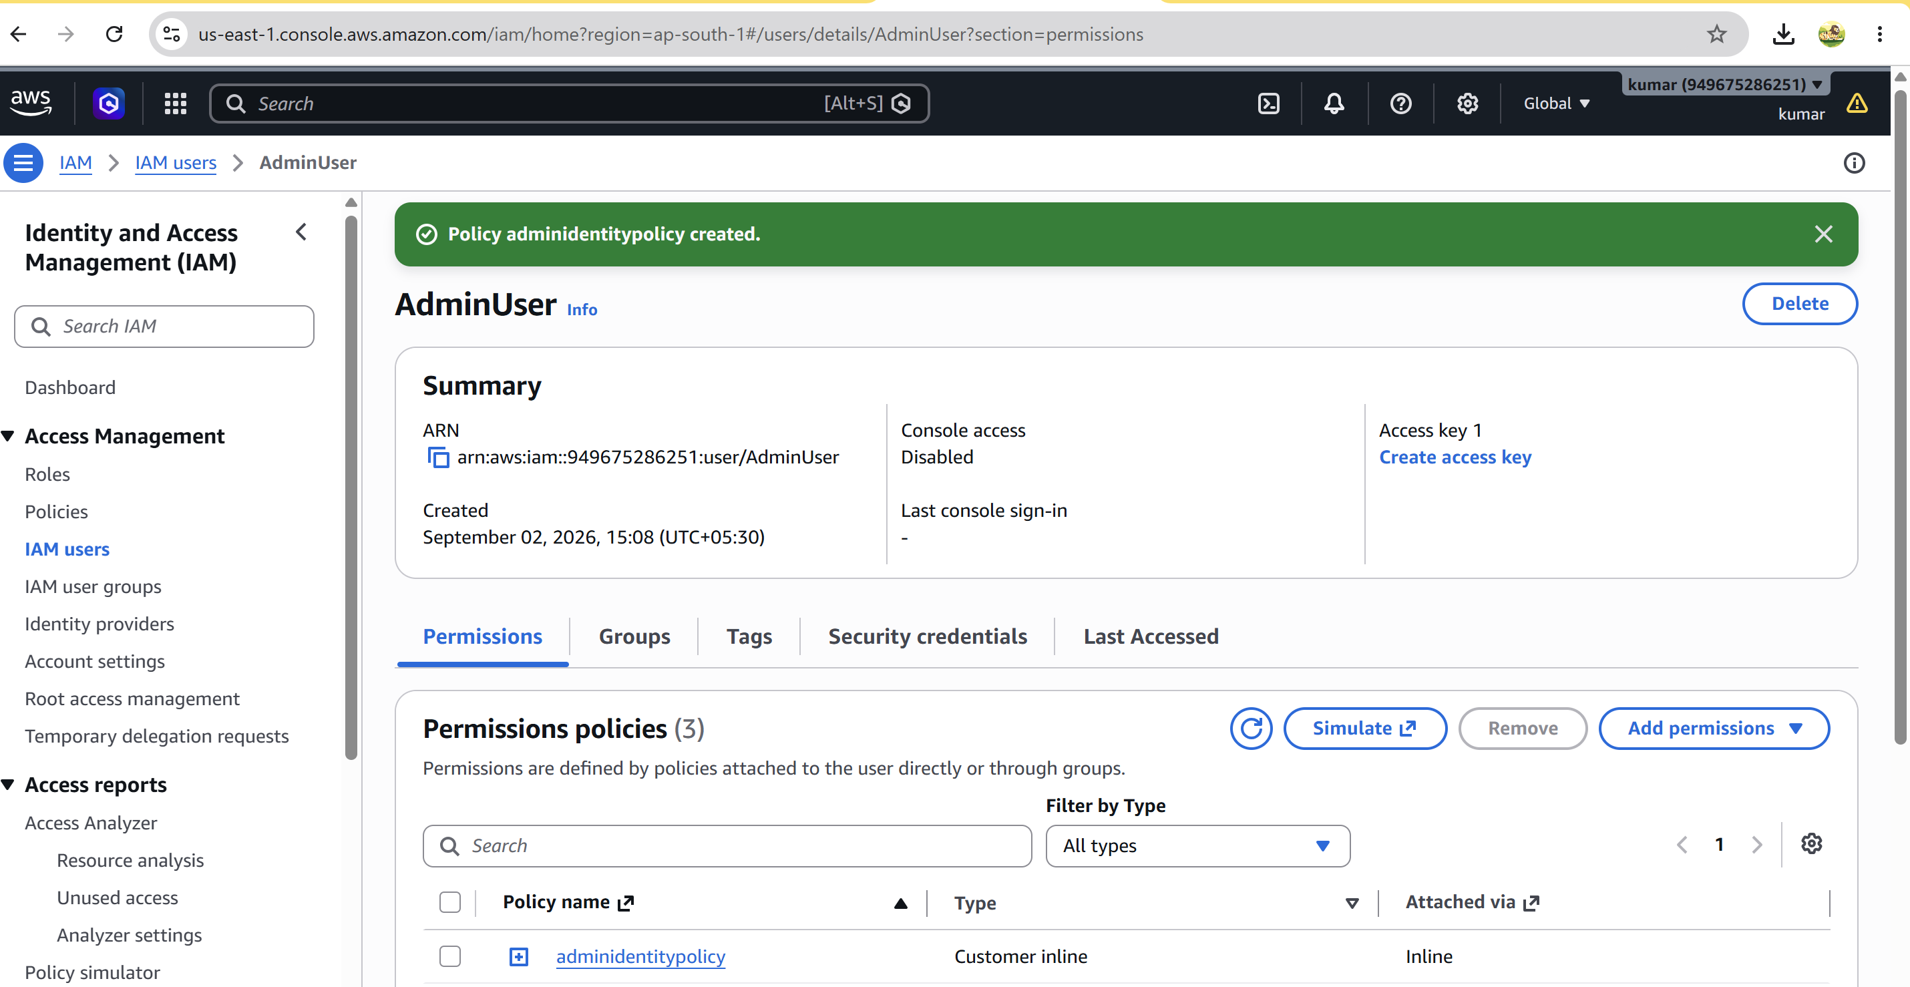 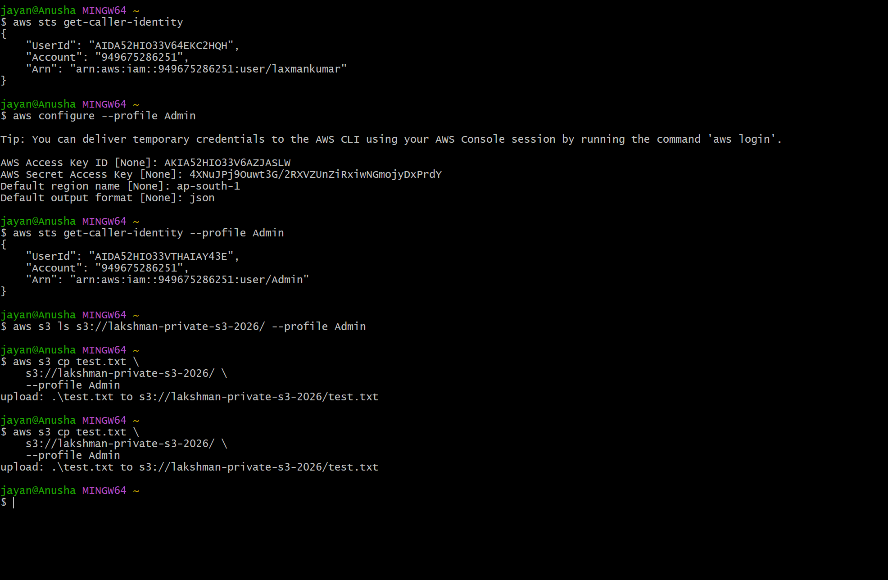
Verify the current identity:
aws sts get-caller-identity
IAM permissions and other bucket policies can also affect access. Test with the Admin identity and a separate non-admin identity to confirm the intended result.

5. Configure S3 Lifecycle Policies
Example lifecycle requirement:
- After 30 days → Standard-IA
- After 90 days → Glacier Flexible Retrieval
- After 365 days → Delete
- Open S3 → Bucket → Management.
- Select Create lifecycle rule.
- Name the rule Archive-and-Delete.
- Choose the required object scope or filters.
- Configure the transition and expiration actions.
- Create the rule.
CLI lifecycle configuration:
{
"Rules": [
{
"ID": "ArchiveObjects",
"Status": "Enabled",
"Filter": {"Prefix": ""},
"Transitions": [
{"Days": 30, "StorageClass": "STANDARD_IA"},
{"Days": 90, "StorageClass": "GLACIER"}
],
"Expiration": {"Days": 365}
}
]
}
Apply and verify:
aws s3api put-bucket-lifecycle-configuration --bucket lakshman-s3-lab-2026 --lifecycle-configuration file://lifecycle.json
aws s3api get-bucket-lifecycle-configuration --bucket lakshman-s3-lab-2026 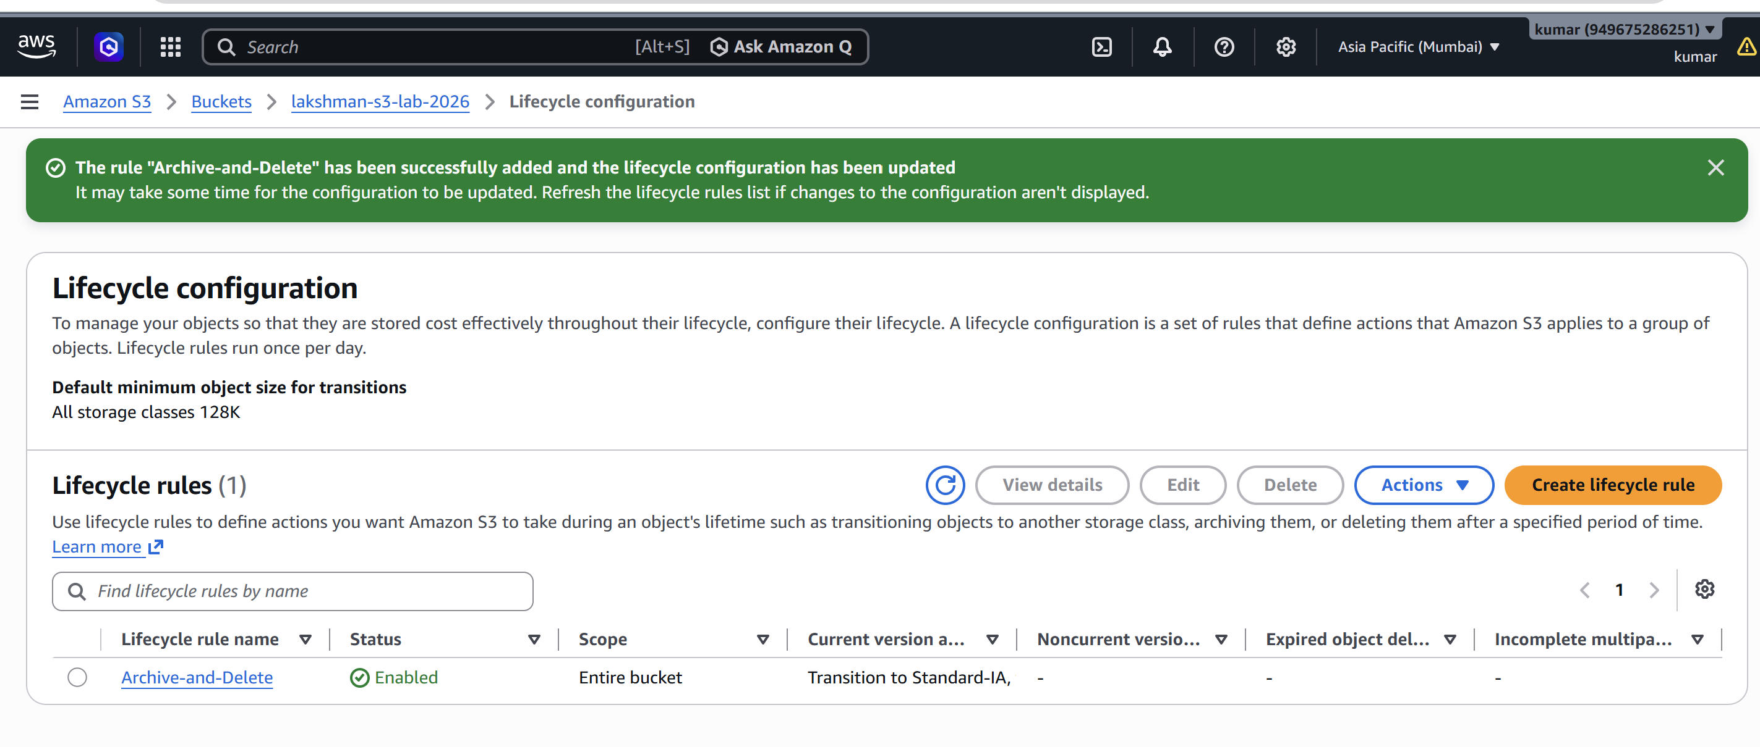 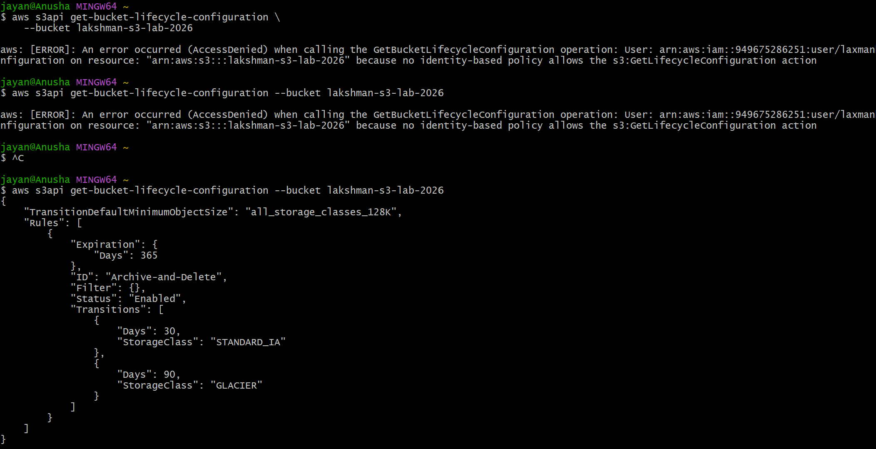

6. Push Objects to S3 Using the AWS CLI
aws sts get-caller-identity
aws configure get region
aws s3 ls
echo "Hello from AWS CLI" > test.txt
aws s3 cp test.txt s3://lakshman-s3-lab-2026/
aws s3 cp test.txt s3://lakshman-s3-lab-2026/documents/
aws s3 cp ./files/ s3://lakshman-s3-lab-2026/files/ --recursive
aws s3 sync ./website/ s3://lakshman-s3-lab-2026/
aws s3 ls s3://lakshman-s3-lab-2026/
aws s3 cp s3://lakshman-s3-lab-2026/test.txt . 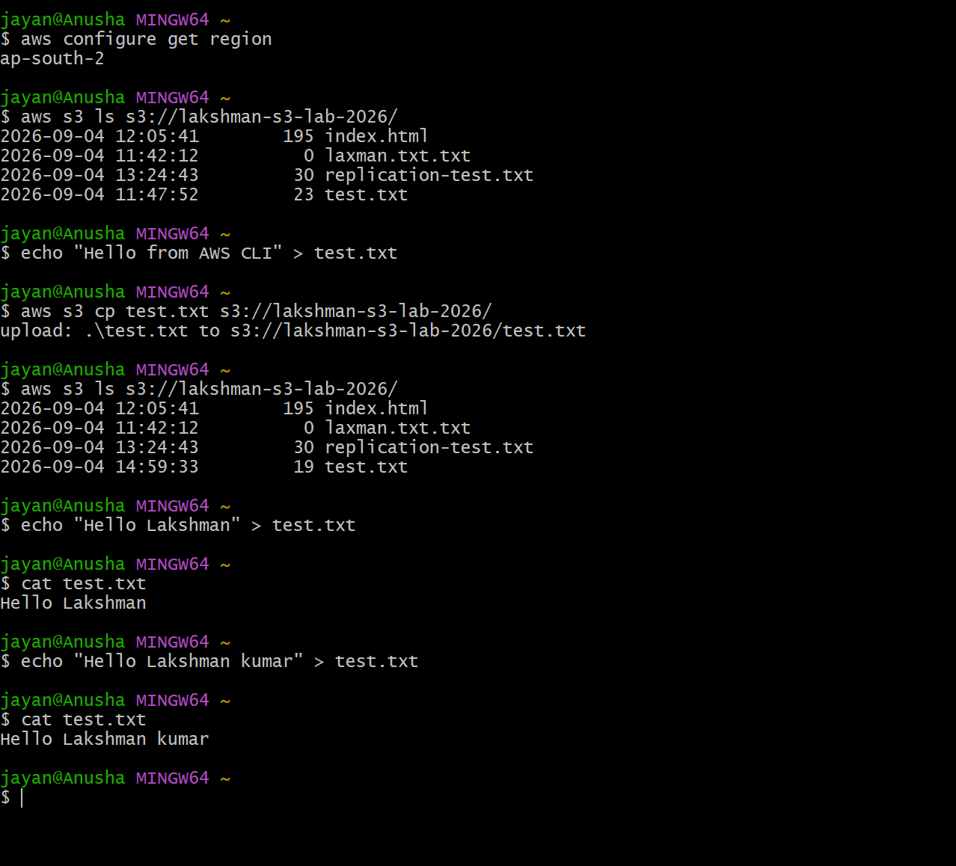

7. Bash Script to Create an S3 Bucket
Create the script:
nano create-s3.sh
#!/bin/bash
REGION="ap-south-1"
ACCOUNT_ID=$(aws sts get-caller-identity --query Account --output text)
BUCKET_NAME="devops-s3-${ACCOUNT_ID}-$(date +%s)"
echo "Creating bucket: $BUCKET_NAME"
aws s3api create-bucket \
--bucket "$BUCKET_NAME" \
--region "$REGION" \
--create-bucket-configuration LocationConstraint="$REGION"
if [ $? -eq 0 ]; then
echo "SUCCESS: $BUCKET_NAME created."
else
echo "ERROR: Bucket creation failed."
exit 1
fi
Run:
chmod +x create-s3.sh
./create-s3.sh
aws s3 ls 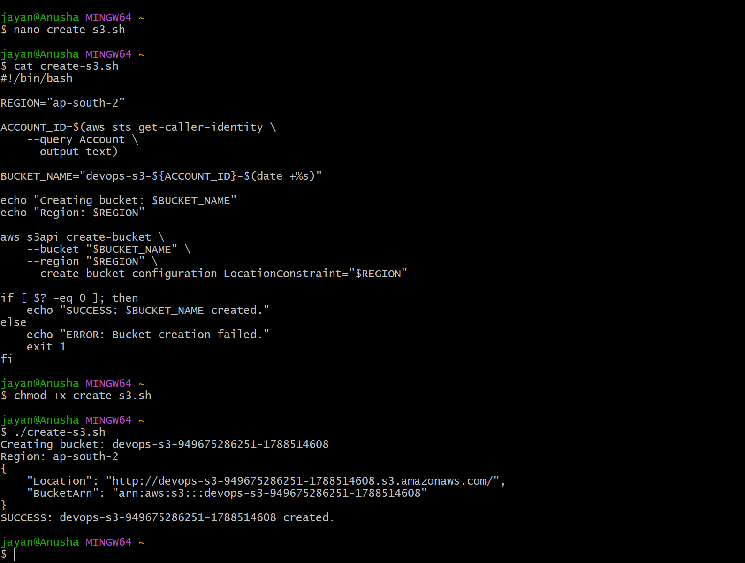

8. Upload a 1 GB File to S3 Using CLI
Check available disk space:
df -h
Create a 1 GB test file:
dd if=/dev/zero of=1gb-file.img bs=1M count=1024
Verify the file:
ls -lh 1gb-file.img
Upload:
aws s3 cp 1gb-file.img s3://lakshman-s3-lab-2026/
Verify:
aws s3 ls s3://lakshman-s3-lab-2026/ --human-readable
aws s3api head-object --bucket lakshman-s3-lab-2026 --key 1gb-file.img 