AWS IAM Tasks – Execution Guide

Task 1 – Create an IAM User with EC2 and S3 Full Access
Goal: Create AdminUser and attach the AWS managed policies AmazonEC2FullAccess and AmazonS3FullAccess.

Console Execution
- Open AWS Console → IAM → Users → Create user.
- Enter User name: AdminUser.
- Choose the required credential/access option for the lab.
- Under permissions, choose Attach policies directly.
- Attach AmazonEC2FullAccess and AmazonS3FullAccess.
- Review the configuration and create the user.
- Open AdminUser → Permissions and verify both policies are attached. 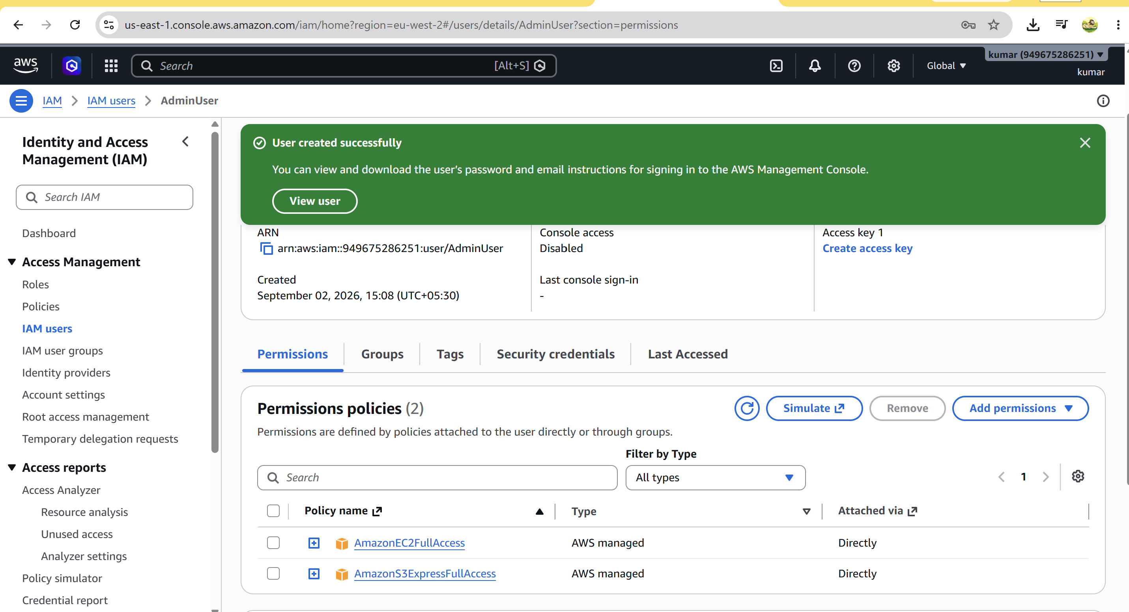

Task 2 – Create an IAM Group with EC2 Read Access
Goal: Create EC2-ReadOnly and attach AmazonEC2ReadOnlyAccess.

Console Execution
- Open IAM → User groups → Create group.
- Enter Group name: EC2-ReadOnly.
- Attach AmazonEC2ReadOnlyAccess.
- Create the group.
- Open the group and verify the policy under Permissions. 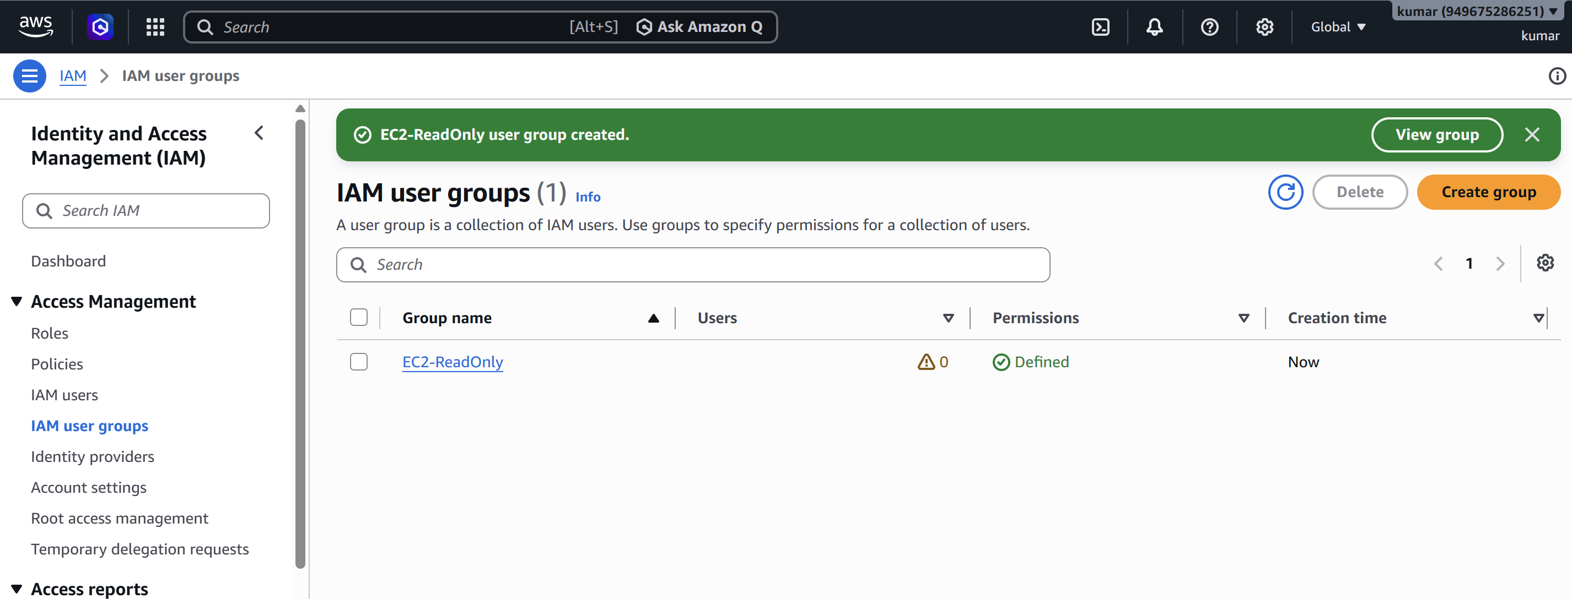

Task 3 – Create Devops User and Add It to the Group
Goal: Create the IAM user Devops and make the user a member of EC2-ReadOnly.

Console Execution
- Open IAM → Users → Create user.
- Enter User name: Devops.
- Create the user using the credential option required for the lab.
- Open IAM → User groups → EC2-ReadOnly.
- Choose Add users and select Devops.
- Verify that Devops appears as a group member. 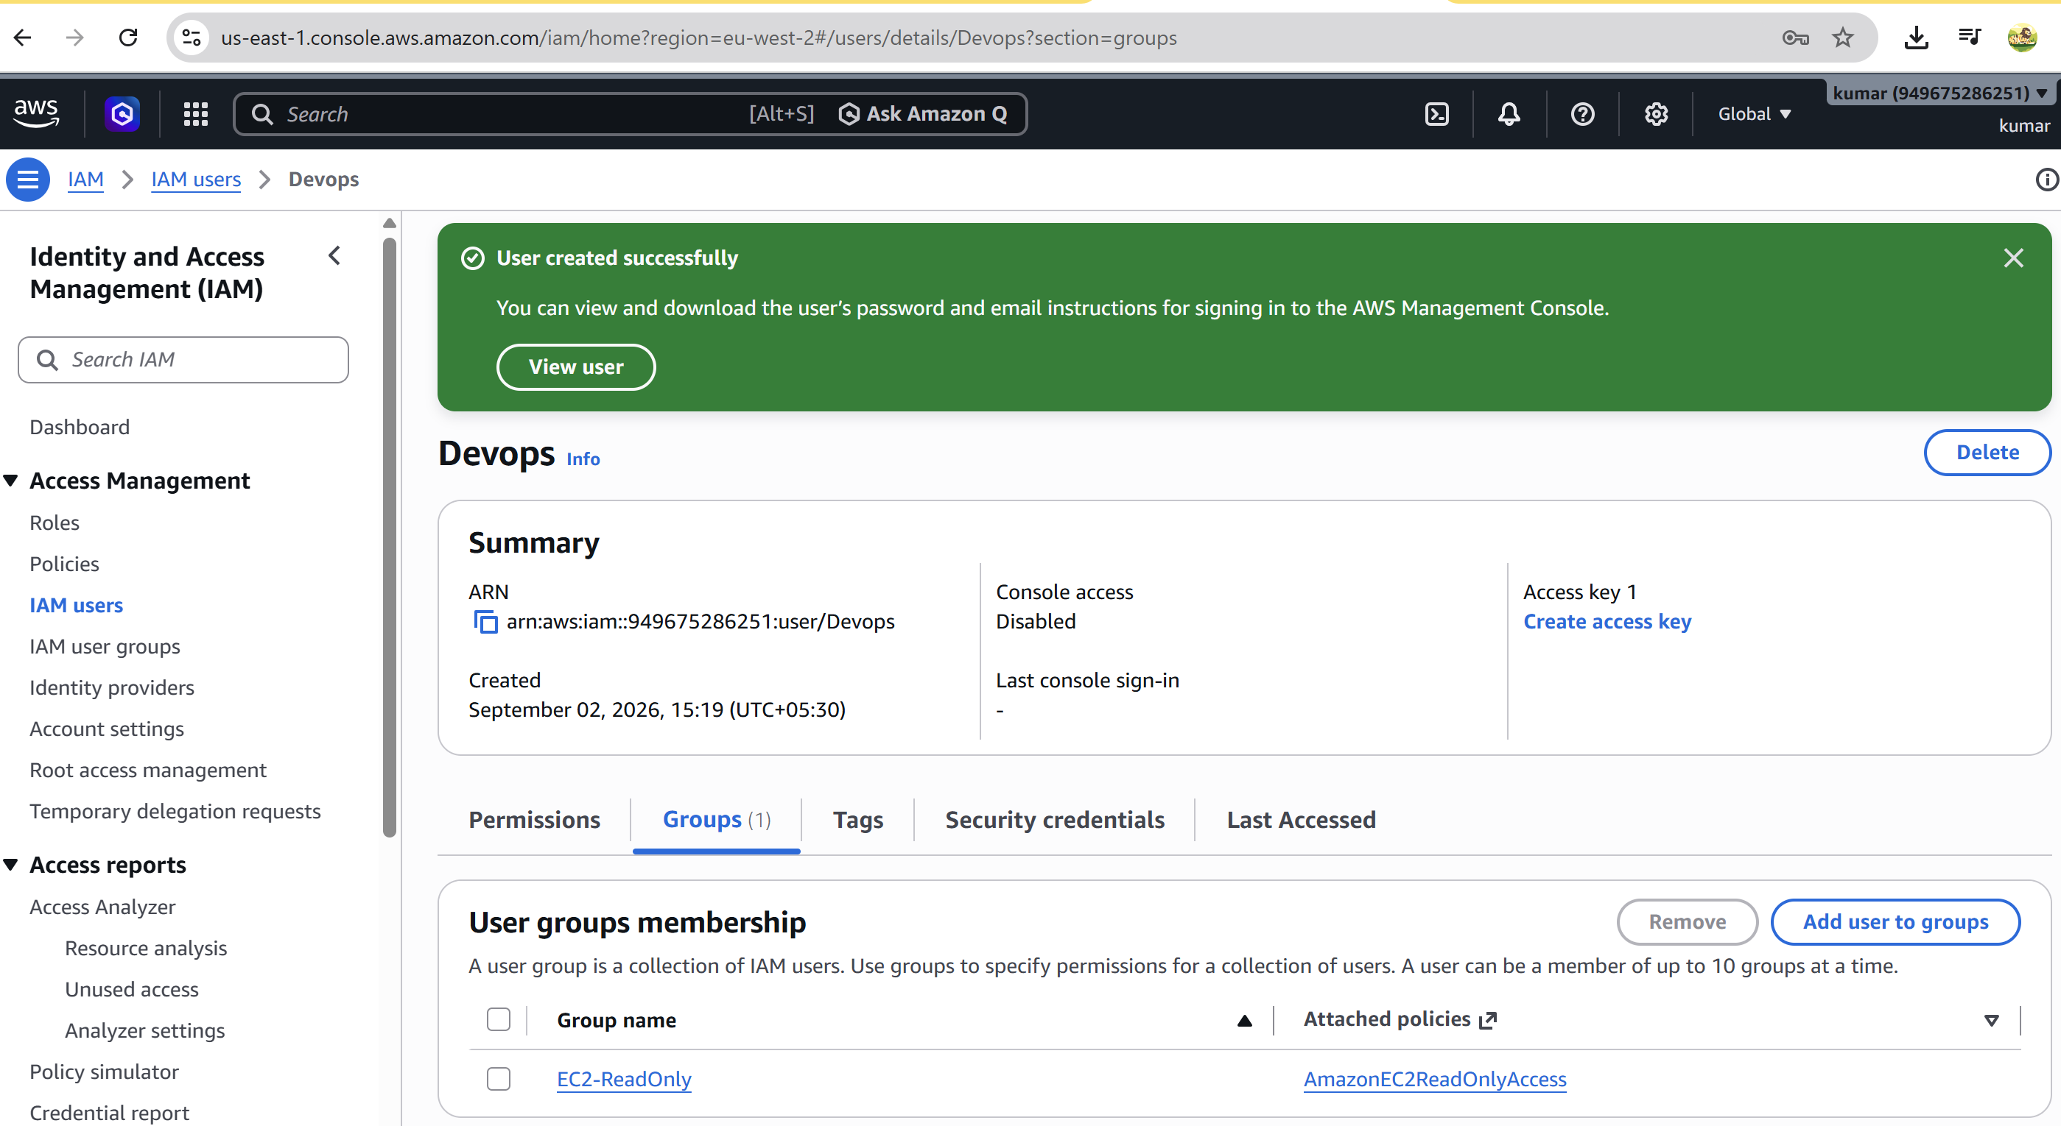 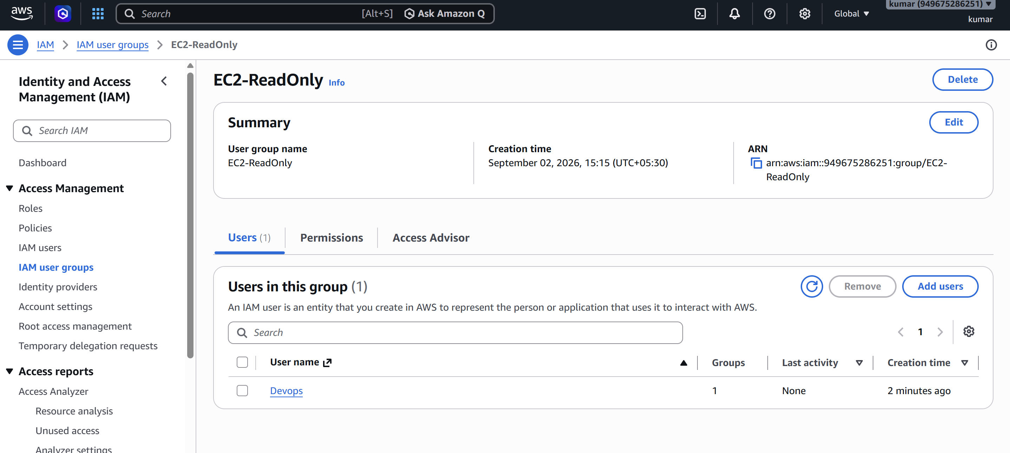

Task 4 – Bash Script to Create an IAM User with VPC Full Access
Goal: Automate creation of VPCUser and attach AmazonVPCFullAccess. 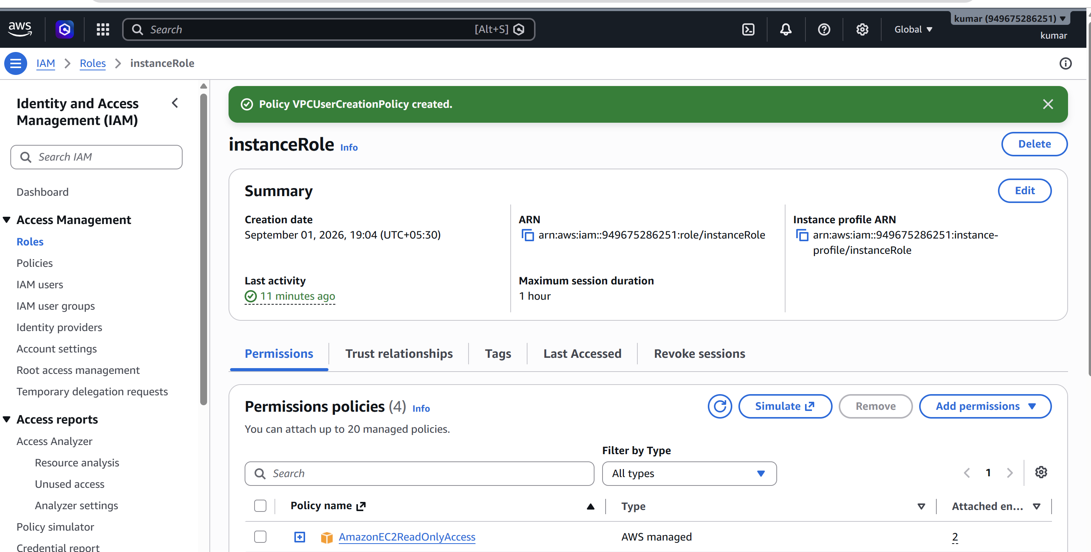

Create the Script
nano create-vpc-user.sh
#!/bin/bash
USER_NAME="VPCUser"
echo "Creating IAM user: $USER_NAME"
aws iam create-user --user-name "$USER_NAME"
echo "Attaching AmazonVPCFullAccess..."
aws iam attach-user-policy \
--user-name "$USER_NAME" \
--policy-arn arn:aws:iam::aws:policy/AmazonVPCFullAccess
echo "Verifying attached policy..."
aws iam list-attached-user-policies --user-name "$USER_NAME"
echo "IAM VPC user created successfully."

Run the Script
chmod +x create-vpc-user.sh
./create-vpc-user.sh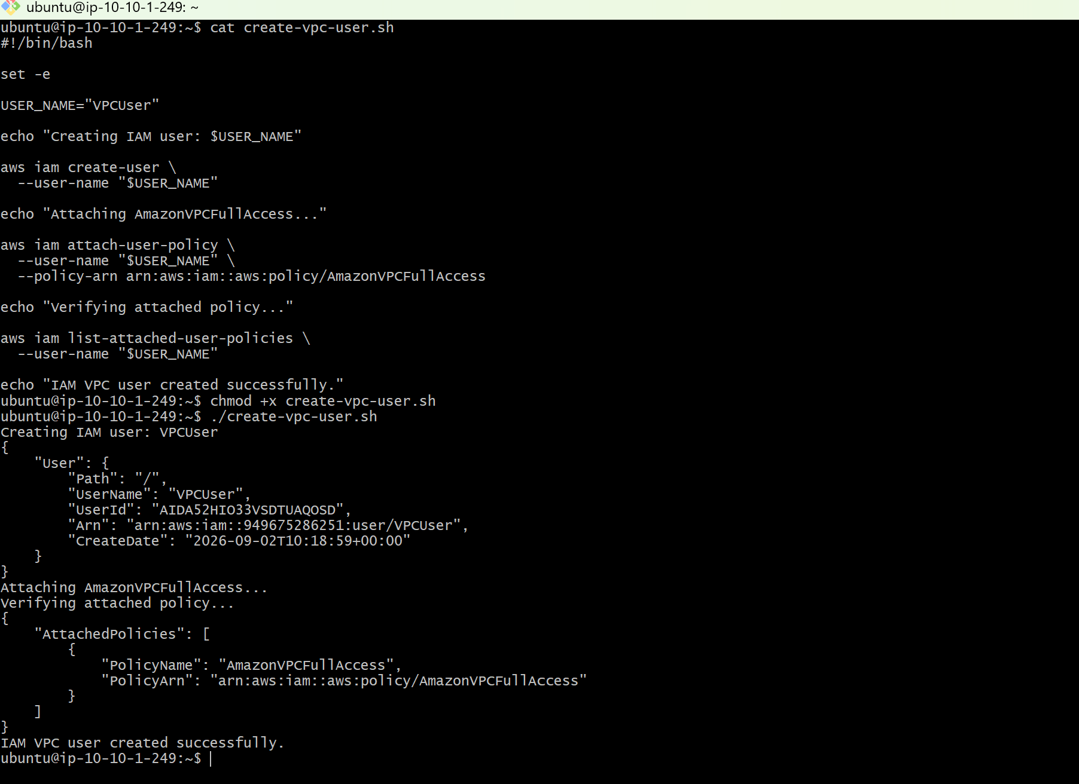

Verify
aws iam list-attached-user-policies --user-name VPCUser
Expected result: VPCUser has AmazonVPCFullAccess attached. 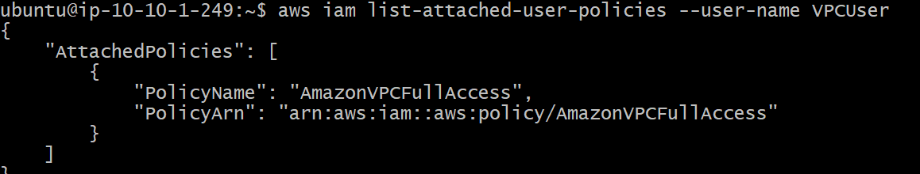

Task 5 – Allow EC2 Access for a User in Specific Regions Only
Example requirement: allow EC2 actions only in eu-west-2 (London). This policy can be attached to a specific IAM user.

Create Policy JSON
{
"Version": "2012-10-17",
"Statement": [
{
"Sid": "EC2AccessOnlyInLondon",
"Effect": "Allow",
"Action": "ec2:*",
"Resource": "*",
"Condition": {
"StringEquals": {
"aws:RequestedRegion": "eu-west-2"
}
}
}
]
}
Save as: ec2-region-policy.json

Create and Attach the Policy
aws iam create-policy \
--policy-name EC2-Region-FullAccess \
--policy-document file://ec2-region-policy.json
ACCOUNT_ID=$(aws sts get-caller-identity --query Account --output text)
aws iam attach-user-policy \
--user-name Devops \
--policy-arn arn:aws:iam::$ACCOUNT_ID:policy/EC2-Region-FullAccess 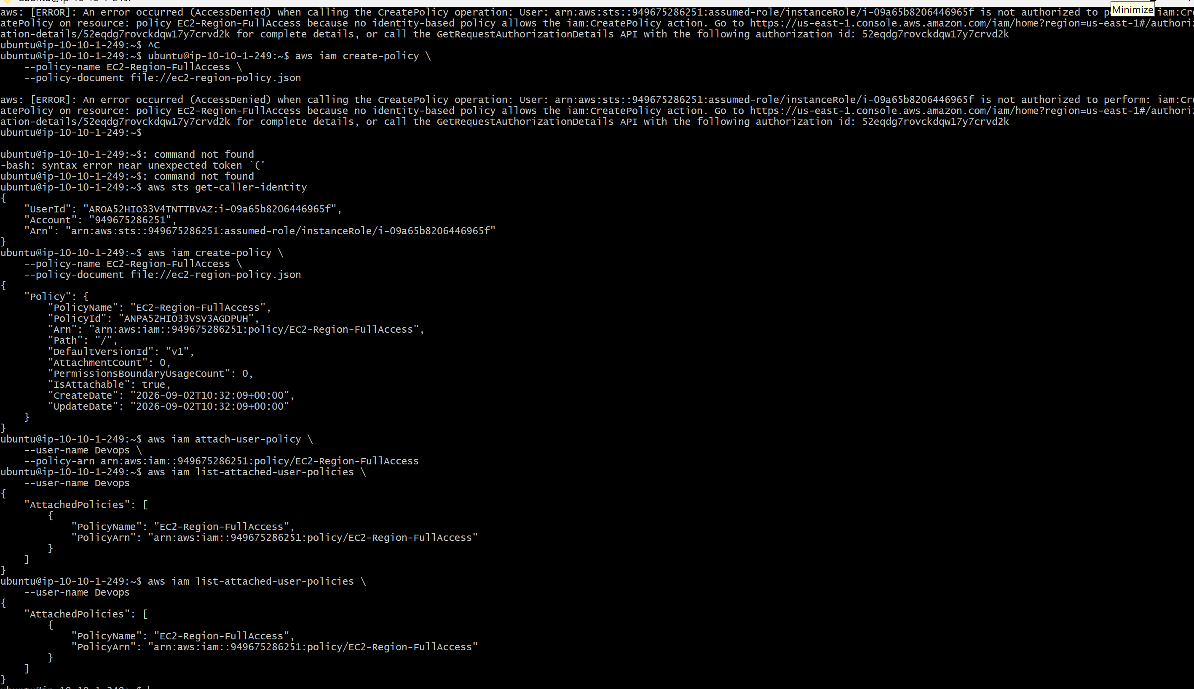

Test
aws configure set region eu-west-2
aws ec2 describe-instances
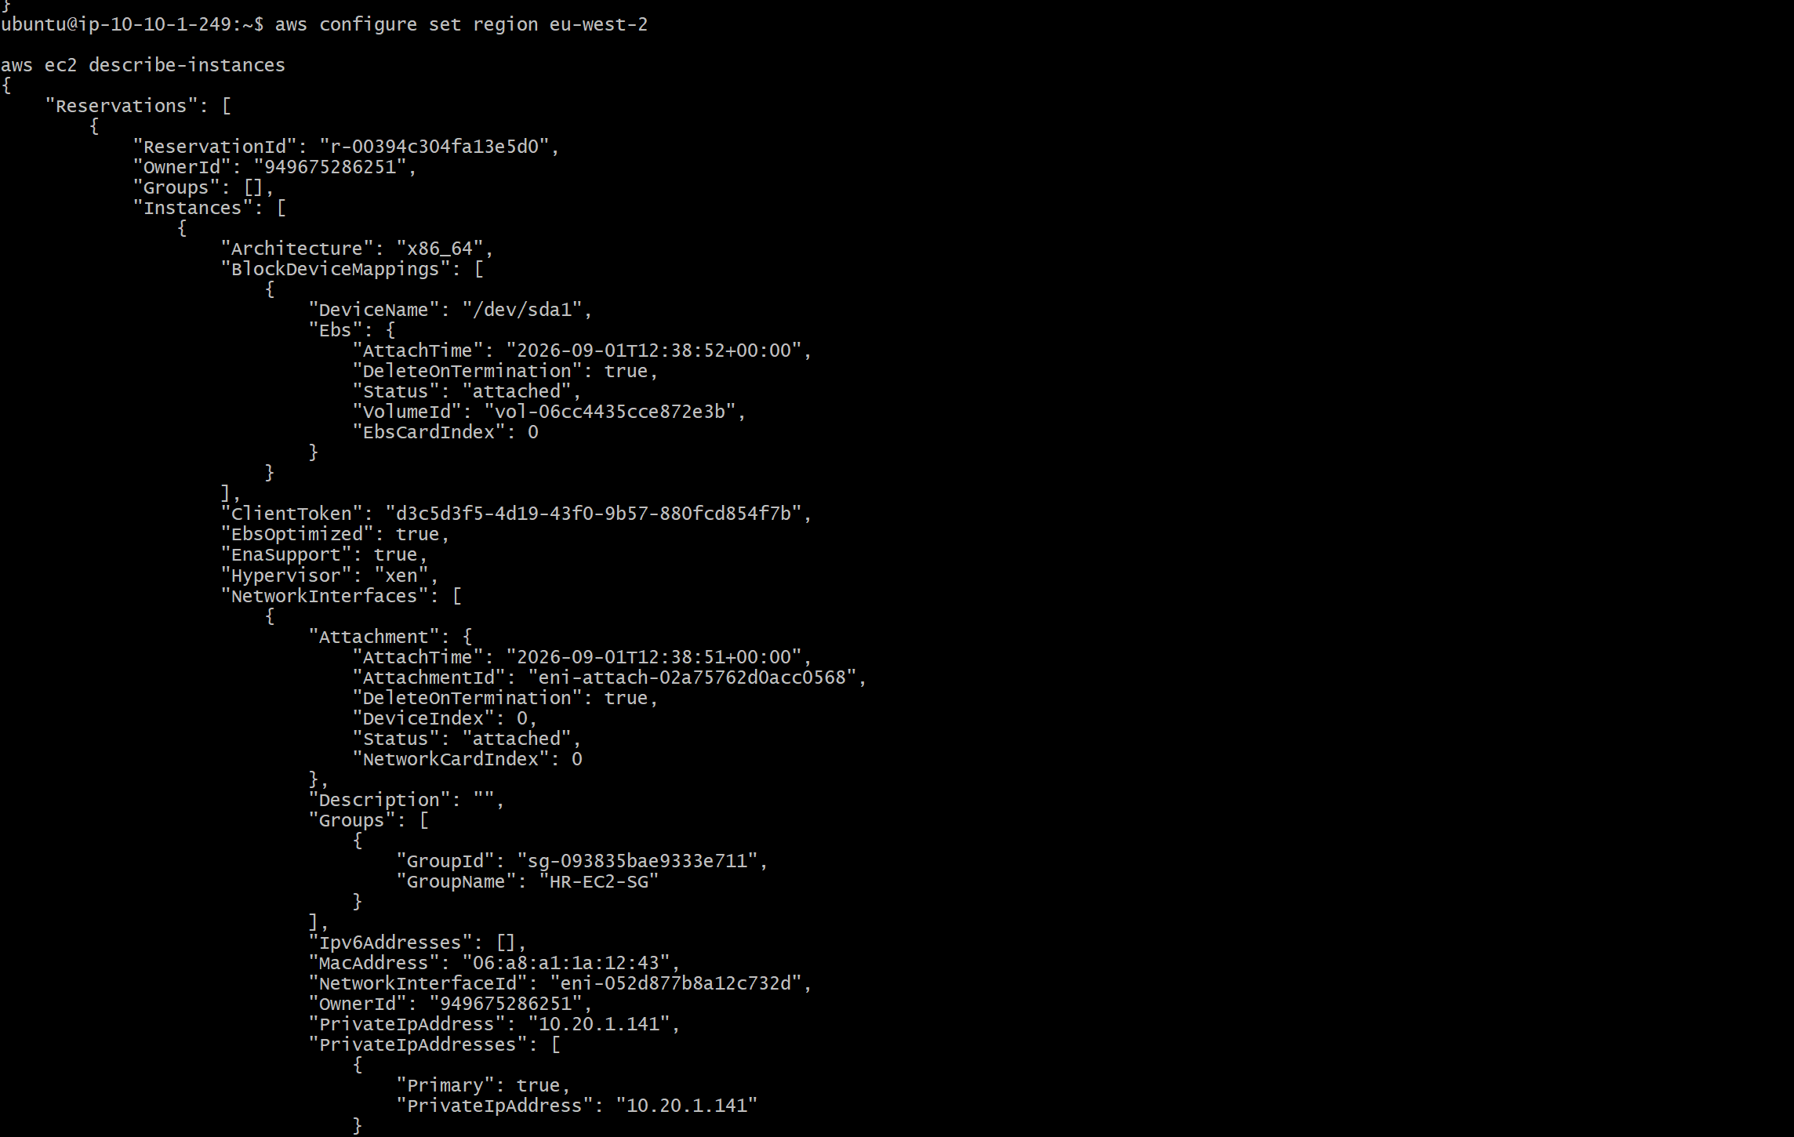
aws configure set region ap-south-2
aws ec2 describe-instances
Expected result: EC2 requests in eu-west-2 are allowed by this policy. Requests to other regions are not allowed by this policy. Remember that the effective IAM permission also depends on other identity policies, resource policies, permission boundaries, SCPs, and explicit denies. 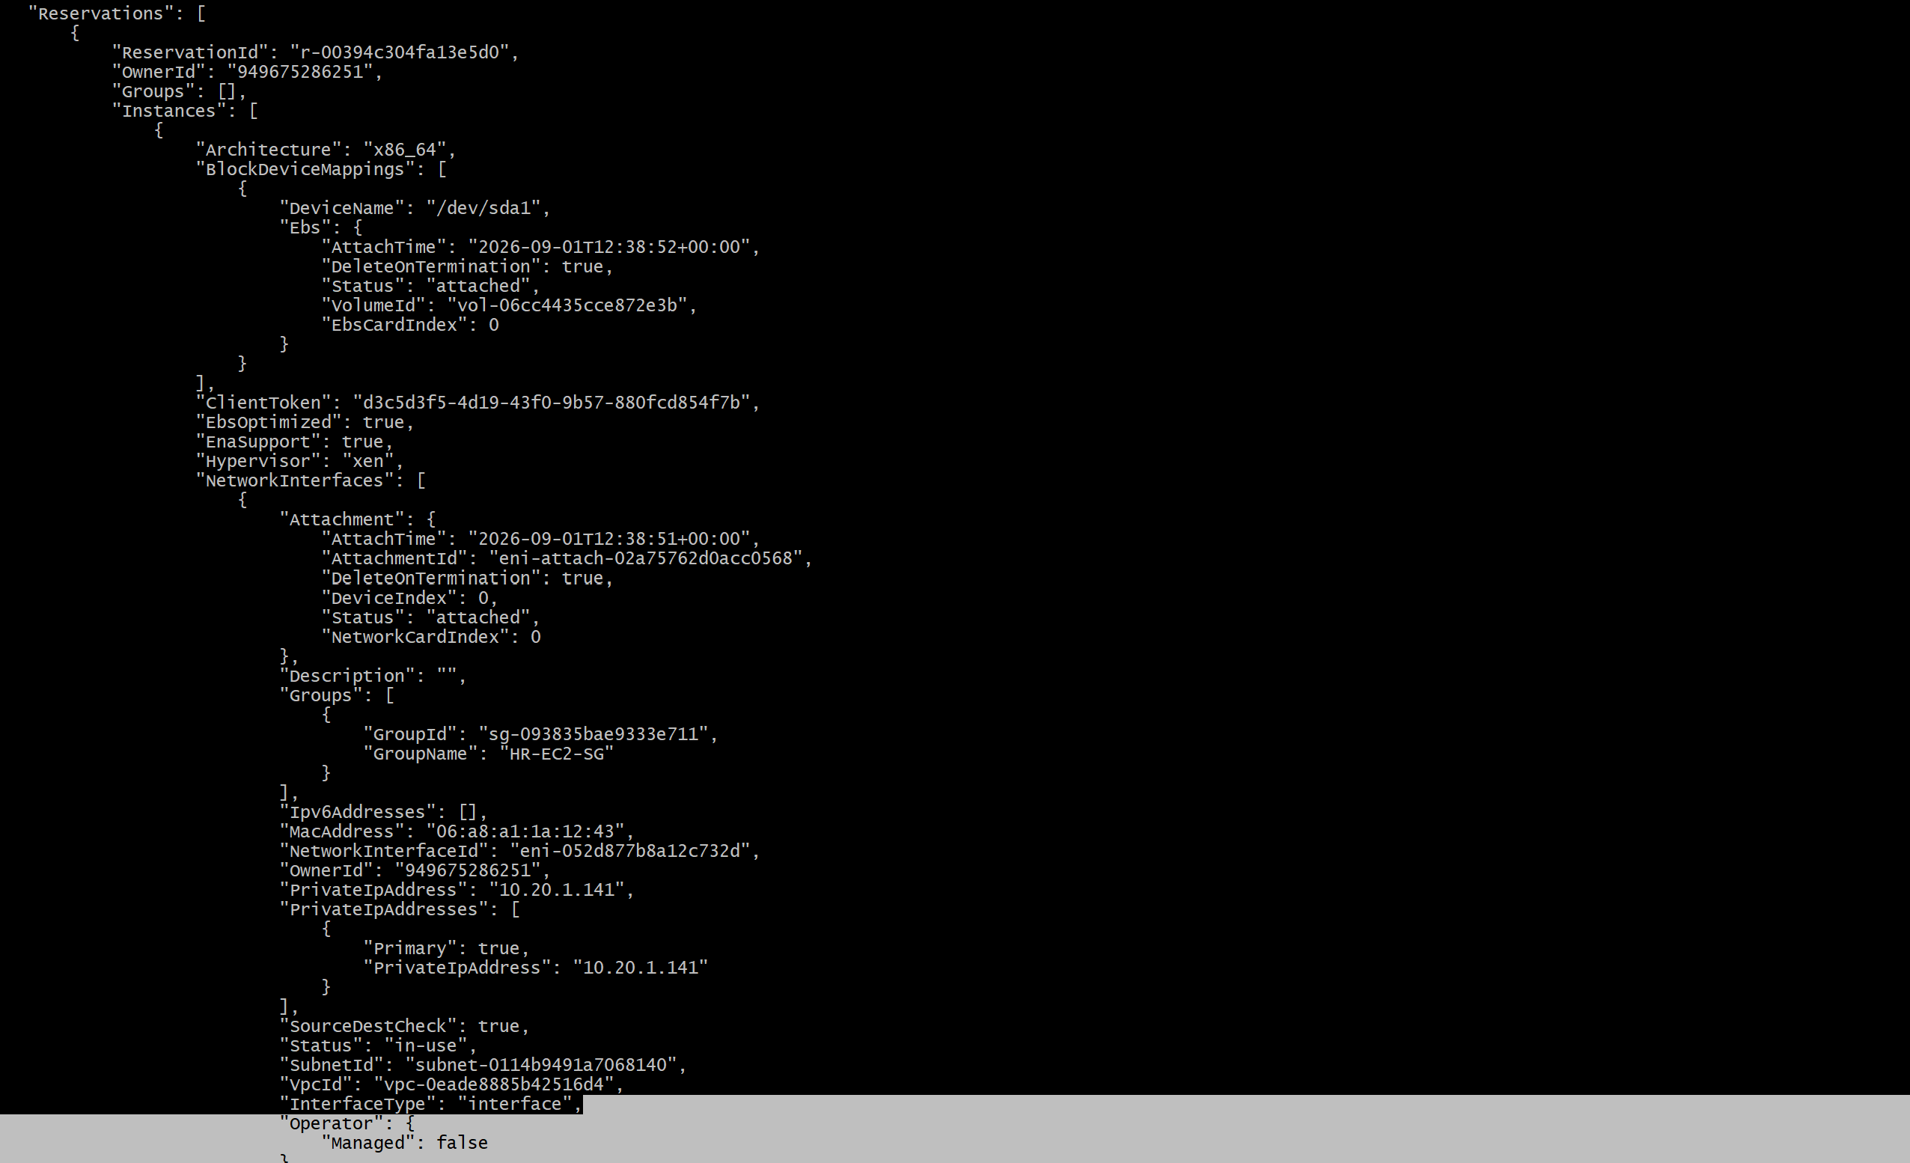

Task 6 – Cross-Account S3 Access (Account A → Account B)
Scenario: A user in Account A must access an S3 bucket owned by Account B. This is a key interview topic because it tests identity-based policies, resource-based policies, principals, and cross-account authorization.

Team Collaboration Plan
Team member | Account | Responsibility
Team Member 1 | Account A | Create/verify Devops user and test S3 access
Team Member 2 | Account B | Create bucket and configure bucket policy

Step 1 – Account B: Create the S3 Bucket
- Sign in to Account B.
- Open S3 → Create bucket.
- Create a bucket named account-b-demo-bucket-2026 (use a globally unique name if necessary).
- Upload a test object such as test.txt.
- Record Account B's AWS account ID and the exact bucket name.

Step 2 – Account A: Create/Use the Devops User
In Account A, ensure the IAM user Devops exists. For this lab, create a dedicated policy granting only the required S3 actions on the Account B bucket.
{
"Version": "2012-10-17",
"Statement": [
{
"Sid": "ListBucketInAccountB",
"Effect": "Allow",
"Action": "s3:ListBucket",
"Resource": "arn:aws:s3:::account-b-demo-bucket-2026"
},
{
"Sid": "ObjectAccessInAccountB",
"Effect": "Allow",
"Action": [
"s3:GetObject",
"s3:PutObject",
"s3:DeleteObject"
],
"Resource": "arn:aws:s3:::account-b-demo-bucket-2026/*"
}
]
}
Save as account-b-s3-access.json and attach the resulting policy to Devops in Account A.
aws iam create-policy \
--policy-name AccountB-S3-Access \
--policy-document file://account-b-s3-access.json
ACCOUNT_A_ID=$(aws sts get-caller-identity --query Account --output text)
aws iam attach-user-policy \
--user-name Devops \
--policy-arn arn:aws:iam::$ACCOUNT_A_ID:policy/AccountB-S3-Access

Step 3 – Account B: Add the Bucket Policy
Replace ACCOUNT_A_ID with Account A's real account ID and keep the bucket name identical to the actual bucket.
{
"Version": "2012-10-17",
"Statement": [
{
"Sid": "AllowAccountADevopsList",
"Effect": "Allow",
"Principal": {
"AWS": "arn:aws:iam::ACCOUNT_A_ID:user/Devops"
},
"Action": "s3:ListBucket",
"Resource": "arn:aws:s3:::account-b-demo-bucket-2026"
},
{
"Sid": "AllowAccountADevopsObjects",
"Effect": "Allow",
"Principal": {
"AWS": "arn:aws:iam::ACCOUNT_A_ID:user/Devops"
},
"Action": [
"s3:GetObject",
"s3:PutObject",
"s3:DeleteObject"
],
"Resource": "arn:aws:s3:::account-b-demo-bucket-2026/*"
}
]
}
In Account B, open S3 → the bucket → Permissions → Bucket policy, paste the policy, replace ACCOUNT_A_ID, and save it.

Step 4 – Test from Account A
aws sts get-caller-identity
aws s3 ls s3://account-b-demo-bucket-2026
echo "Cross-account test" > test2.txt
aws s3 cp test2.txt s3://account-b-demo-bucket-2026/
aws s3 ls s3://account-b-demo-bucket-2026
aws s3 cp s3://account-b-demo-bucket-2026/test.txt ./test.txt
Expected result: Devops in Account A can list the Account B bucket and perform the explicitly allowed object operations.

Cross-Account Authorization – Interview Explanation
For a cross-account request to succeed, Account A must have an identity-based policy that allows the requested S3 action, and Account B must have a resource-based bucket policy that trusts the Account A principal. The request must not be blocked by an explicit deny, SCP, permission boundary, or other applicable control.
Account A
Devops user
|
| Identity-based policy
| allows S3 actions
v
-------------------------------
Cross-account request
-------------------------------
|
v
Account B
S3 bucket
|
| Bucket policy
| trusts Account A / Devops
v
Access 