AWS SELF-LEARNING AND HANDS-ON IMPLEMENTATION ACTIVITY
AWS WAF and AWS Systems Manager Parameter Store
Implementation Document | Self-Learning & Practical Activity

1. Objective
The objective of this activity is to understand the purpose, architecture, configuration, security controls, and practical implementation of AWS Web Application Firewall (WAF) and AWS Systems Manager Parameter Store. The hands-on design uses an existing web application front end such as an Application Load Balancer (ALB) and demonstrates centralized application configuration using Parameter Store.

2. Services Covered
Service | Purpose | Hands-on outcome
AWS WAF | Inspect HTTP(S) requests and allow, count, challenge, or block traffic using rules. | Create a Web ACL, add managed/custom rules, associate it with the web application, and observe metrics/logs.
Systems Manager Parameter Store | Centrally store application configuration and encrypted SecureString values. | Create hierarchical parameters, retrieve them through console/CLI, verify versioning and encryption behavior.

3. Reference Architecture
The following architecture is suitable for the hands-on activity and aligns with a typical AWS web application design:
Internet
|
HTTPS :443
|
[AWS WAF Web ACL]
|
[Application Load Balancer]
|
[EC2 / Auto Scaling Group]
|
[Application]
|
[AWS Systems Manager Parameter Store]
|
[KMS encryption for SecureString]
Traffic first reaches the protected web entry point. AWS WAF evaluates the request against the Web ACL rules. Allowed traffic continues to the ALB and application targets. The application can retrieve centralized configuration from Parameter Store using IAM permissions. SecureString values are encrypted with AWS KMS.
[ SCREENSHOT PLACEHOLDER – Architecture diagram ]
Insert a screenshot or draw.io/Visio architecture diagram showing Internet → WAF → ALB → EC2/ASG and the application’s access to Parameter Store/KMS.

4. Part A – AWS Web Application Firewall (WAF)

4.1 Concept and Use Cases
AWS WAF is a web application firewall used to monitor HTTP(S) requests forwarded to protected AWS resources and control access to application traffic. A Web ACL contains rules and a default action. Rules can inspect characteristics such as IP addresses, headers, URI paths, query strings and other request components.
- Protect applications from common web exploits and unwanted traffic.
- Use AWS Managed Rules for common threat patterns.
- Create custom rules such as IP allow/block lists, URI restrictions, and rate-based controls.
- Use Count mode during testing to identify potential false positives before enforcing a Block action.
- Enable logging and CloudWatch metrics for operational visibility.
AWS documentation notes that AWS Managed Rules include baseline groups such as the Core Rule Set (CRS), Admin Protection, and Known Bad Inputs. Managed rule groups should be tested and tuned before production enforcement. citeturn1search0turn1search9

4.2 Prerequisites
- AWS account with permission to create/manage AWS WAF resources.
- A supported protected resource; for this exercise, use an Application Load Balancer in the same Region.
- An existing ALB listener and target group, preferably serving a test web page.
- Permission to view CloudWatch metrics and, if enabled, WAF logs.
- Choose a non-production/test environment for the exercise.

4.3 Create a Web ACL
- Open the AWS Management Console and search for AWS WAF.
- Open AWS WAF and choose the Web ACL / protection pack section.
- Choose Create Web ACL.
- Select the Regional scope when protecting a Regional resource such as an Application Load Balancer. For CloudFront, use the CloudFront/global scope as applicable.
- Provide a descriptive name, for example: WebApp-WAF-Lab.
- Set the default action to Allow so that requests not matching a blocking rule can continue.
- Configure visibility options such as sampled requests and CloudWatch metrics.
AWS WAF evaluates rules in their configured priority order. The Web ACL has a default action for requests that do not match a rule. citeturn1search6
[ SCREENSHOT PLACEHOLDER – WAF Web ACL creation ]
Insert the console screenshot showing the Web ACL name, scope, default action, and visibility configuration. 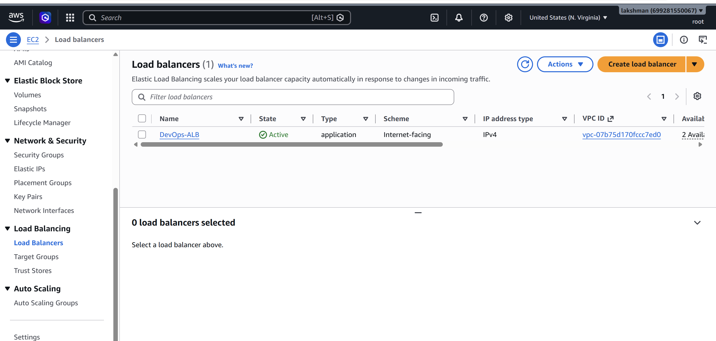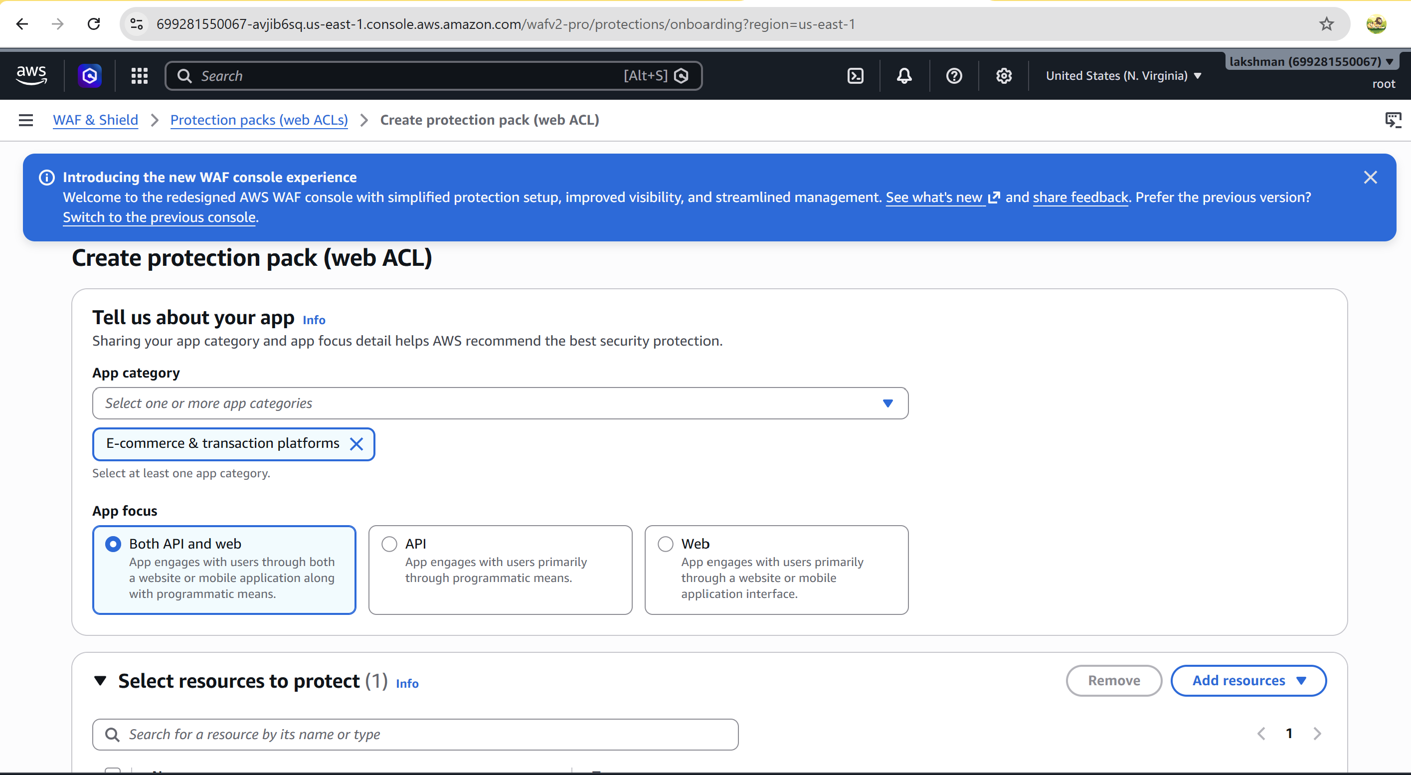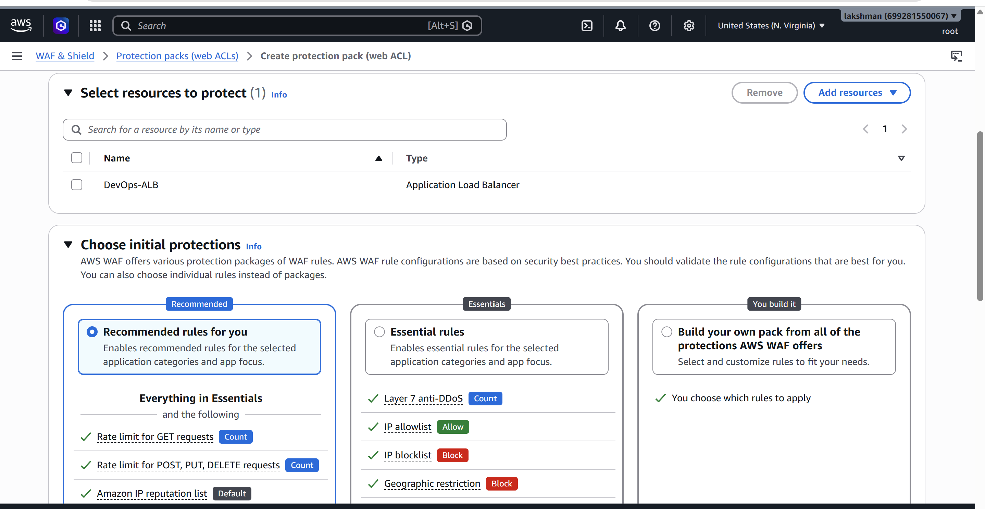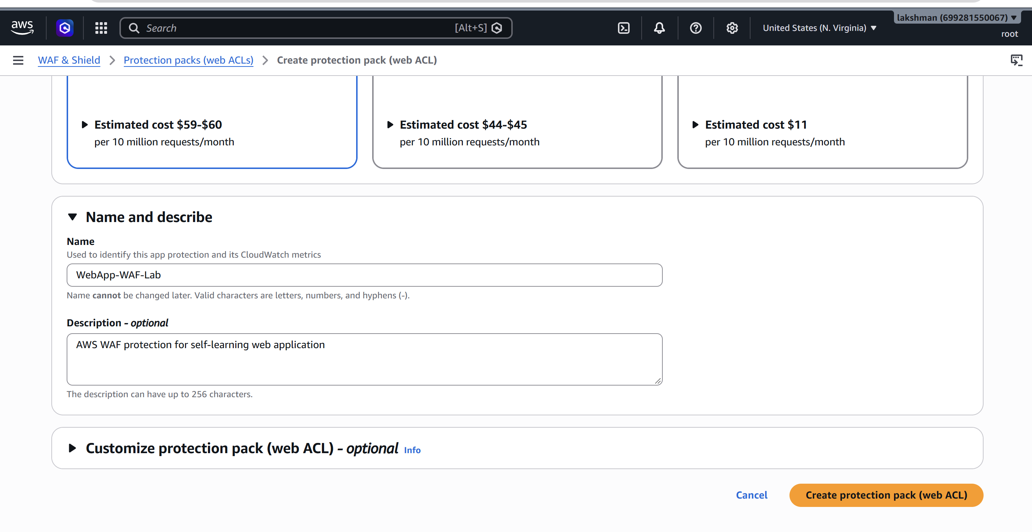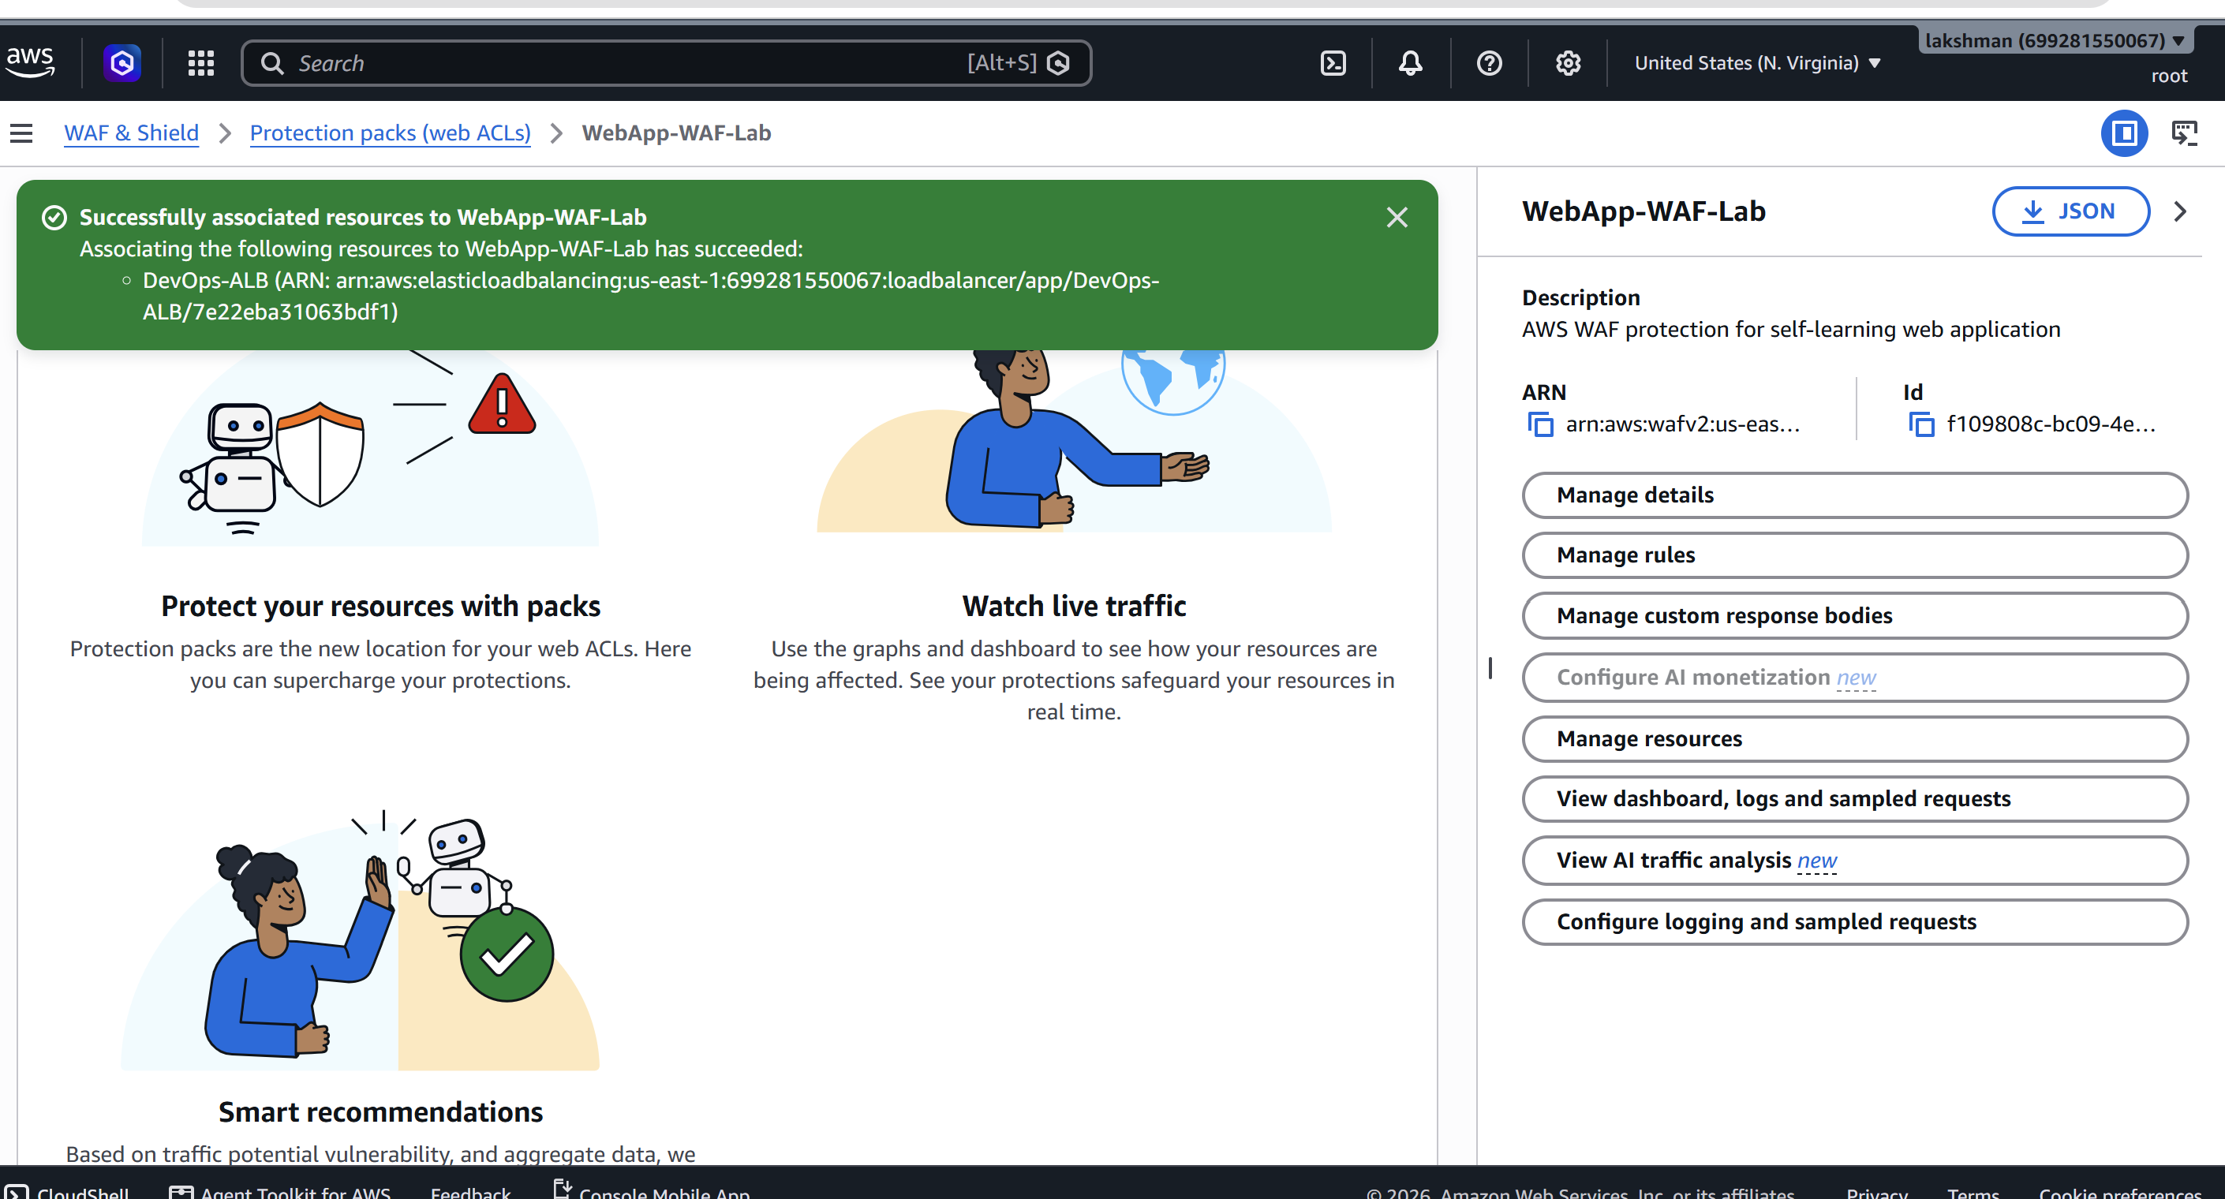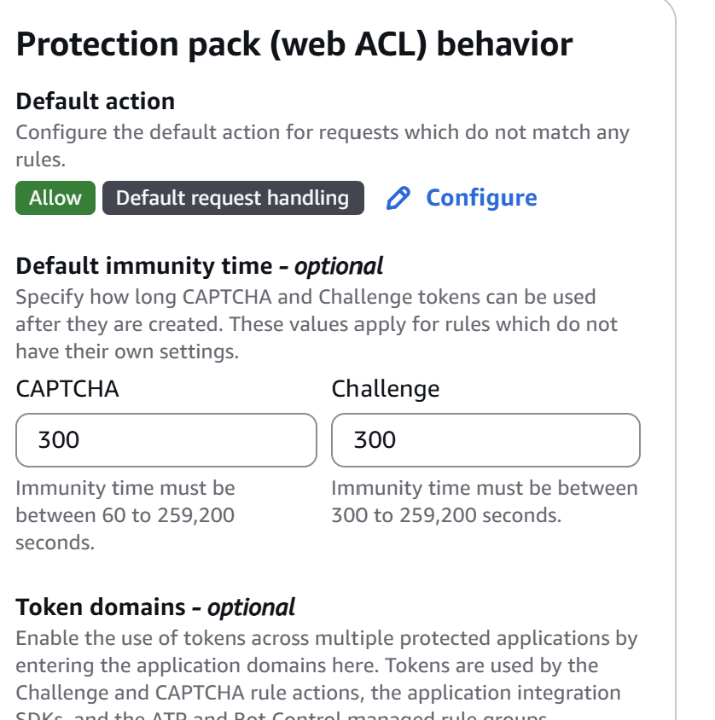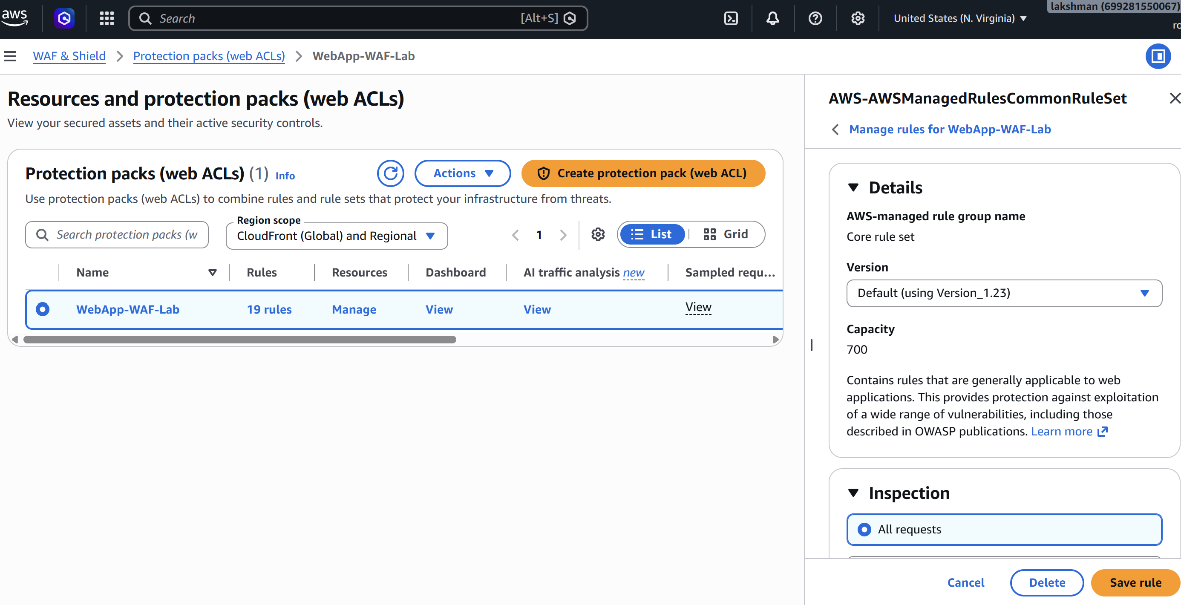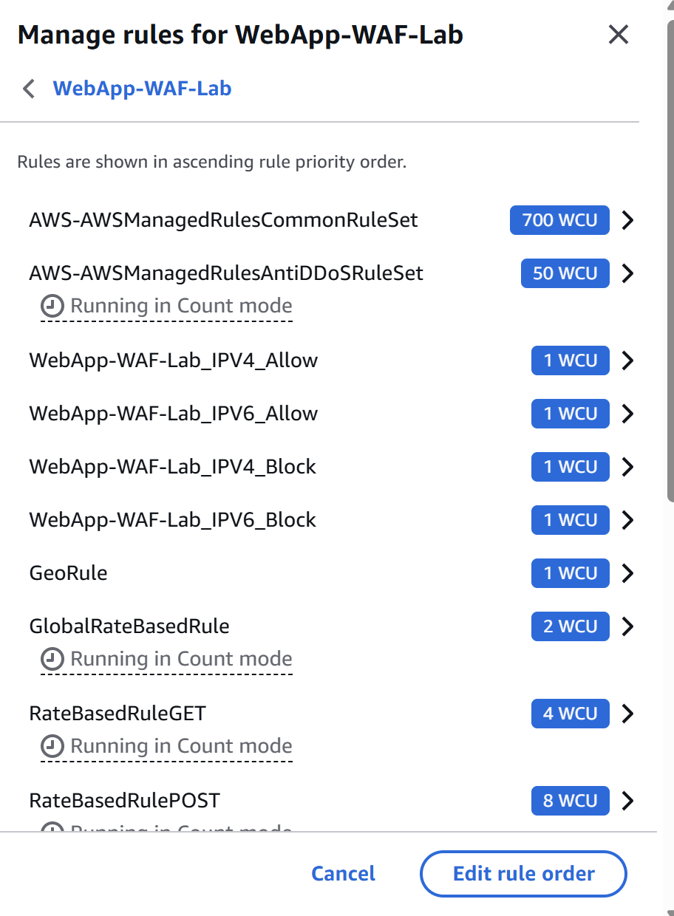

4.4 Add AWS Managed Rules
- In the Web ACL rules section, choose Add rules → Add managed rule groups.
- Select an AWS Managed Rules baseline group such as AWSManagedRulesCommonRuleSet.
- For the first test, consider overriding rule actions to Count rather than Block so that traffic can be observed safely.
- Save the rule and confirm its priority.
- After testing, review sampled requests and metrics and adjust the rule configuration before enabling blocking behavior.
AWS documents the Core Rule Set as a baseline managed rule group intended for general protection against a range of common threats. AWS also recommends testing and tuning managed rule groups before production deployment. citeturn1search9turn1search4
[ SCREENSHOT PLACEHOLDER – Managed rule group ]
Insert screenshot showing AWSManagedRulesCommonRuleSet added to the Web ACL and its action/override configuration. 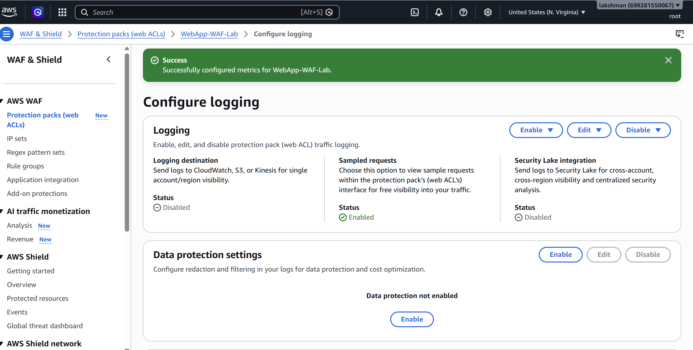

4.5 Create a Custom WAF Rule – Example IP Block
- Create an IP set containing a test IP address that you control or are authorized to block.
- Add a rule that matches the IP set.
- Set the rule action to Block.
- Give the rule an explicit priority above less-specific rules.
- Save the Web ACL and wait for propagation.
Do not use an IP address belonging to another person or production service without authorization. For a safe lab test, use a disposable/test source IP or use Count mode. 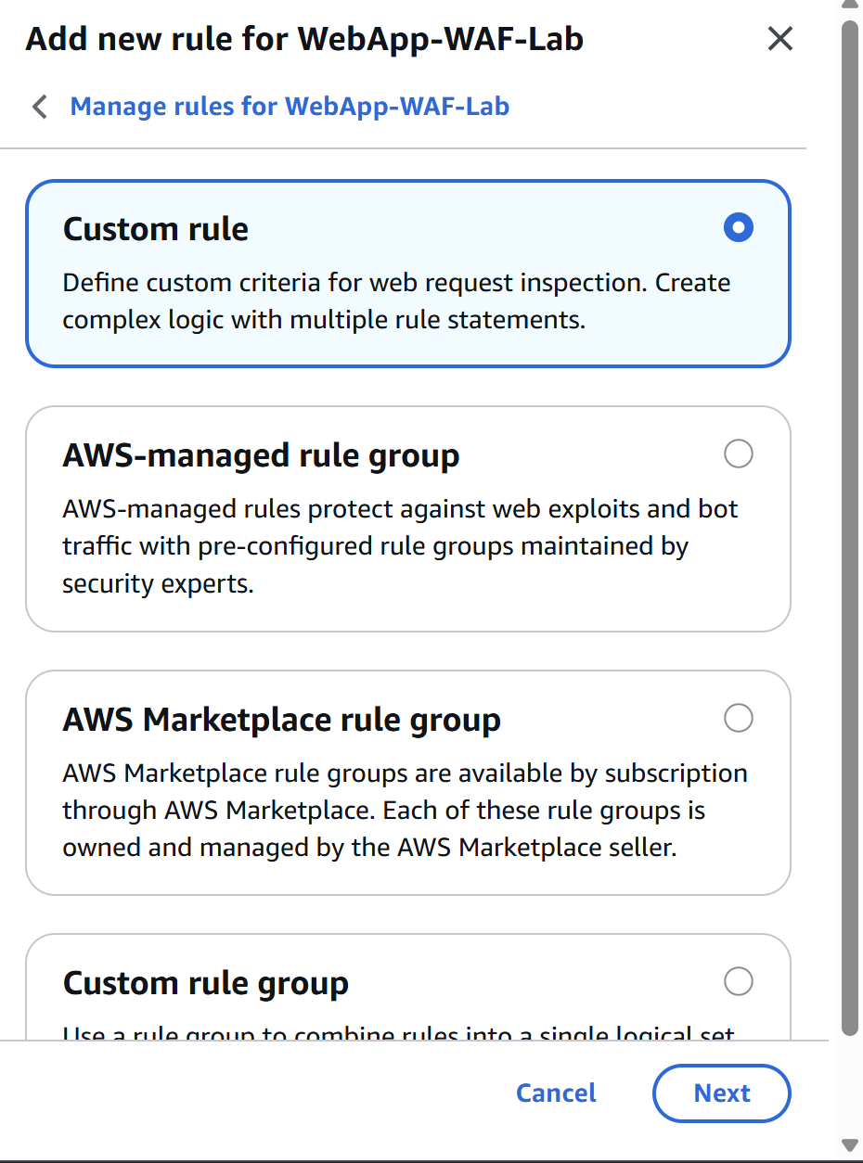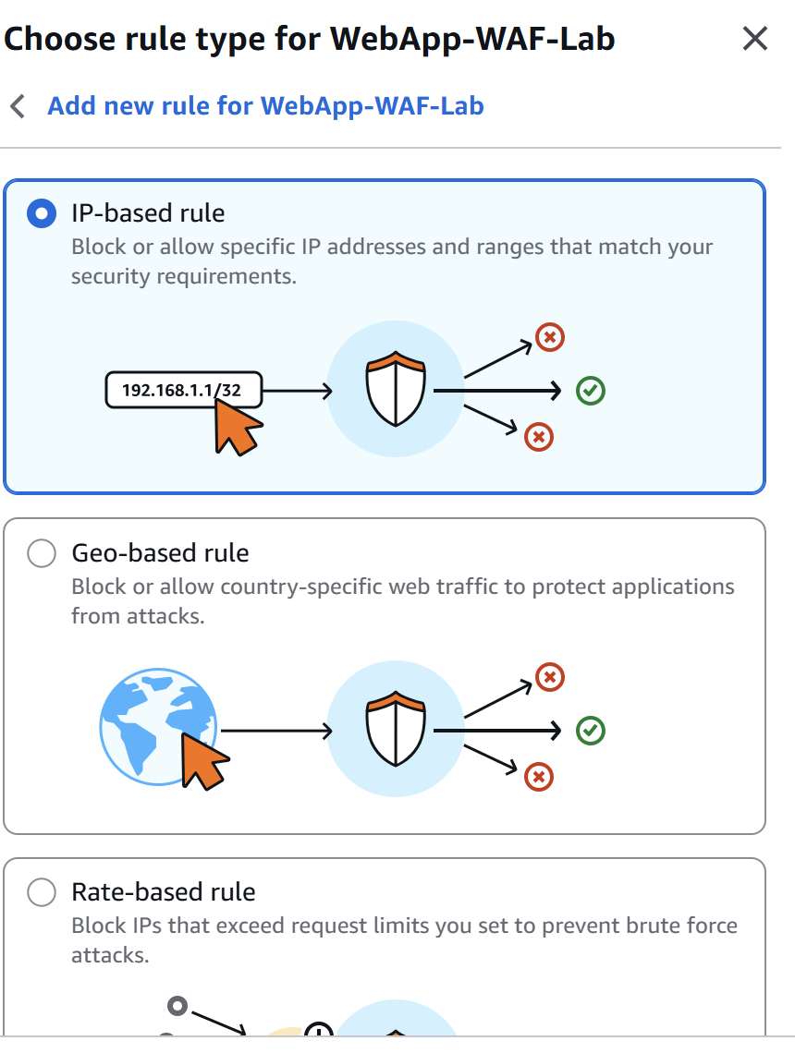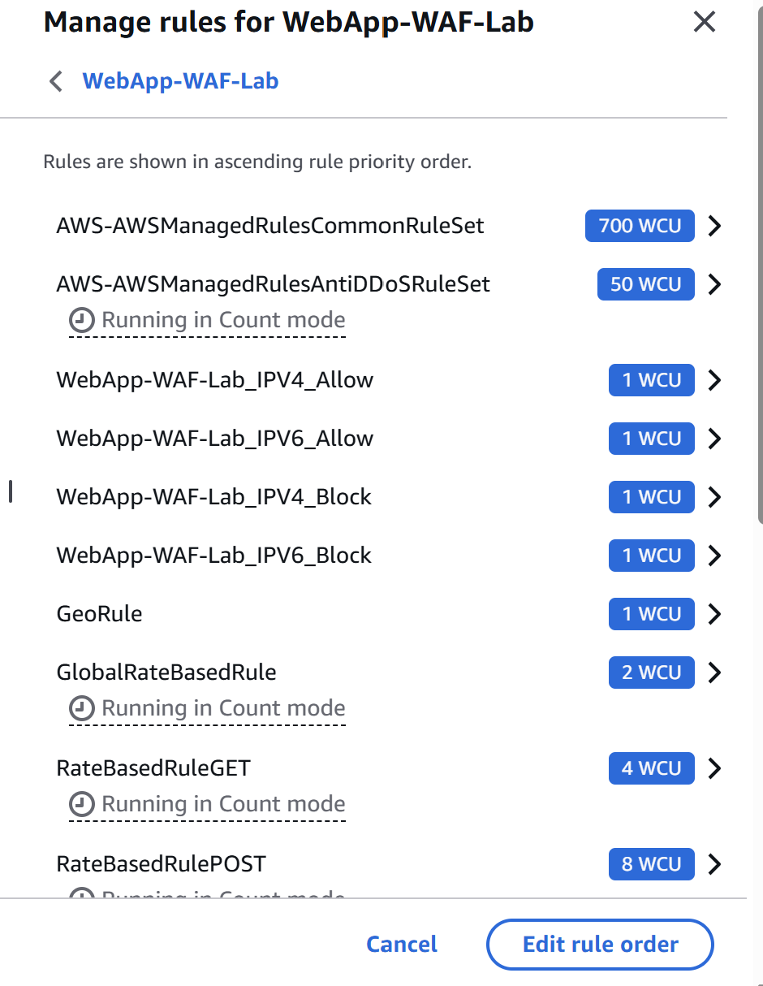
[ SCREENSHOT PLACEHOLDER – Custom WAF rule ]
Insert screenshot showing the custom rule, IP set reference, priority, and Block/Count action.

4.6 Associate WAF with the ALB
- Open the Web ACL and choose Add AWS resources / Associated AWS resources.
- Select the Application Load Balancer that hosts the test application.
- Confirm the association.
- Open the ALB DNS name in a browser and verify that normal requests still reach the application when they are allowed.
AWS WAF supports protecting Application Load Balancers with a Web ACL. After configuration changes, AWS notes that propagation can take from seconds to several minutes. citeturn1search6turn1search4
[ SCREENSHOT PLACEHOLDER – WAF associated resource ] 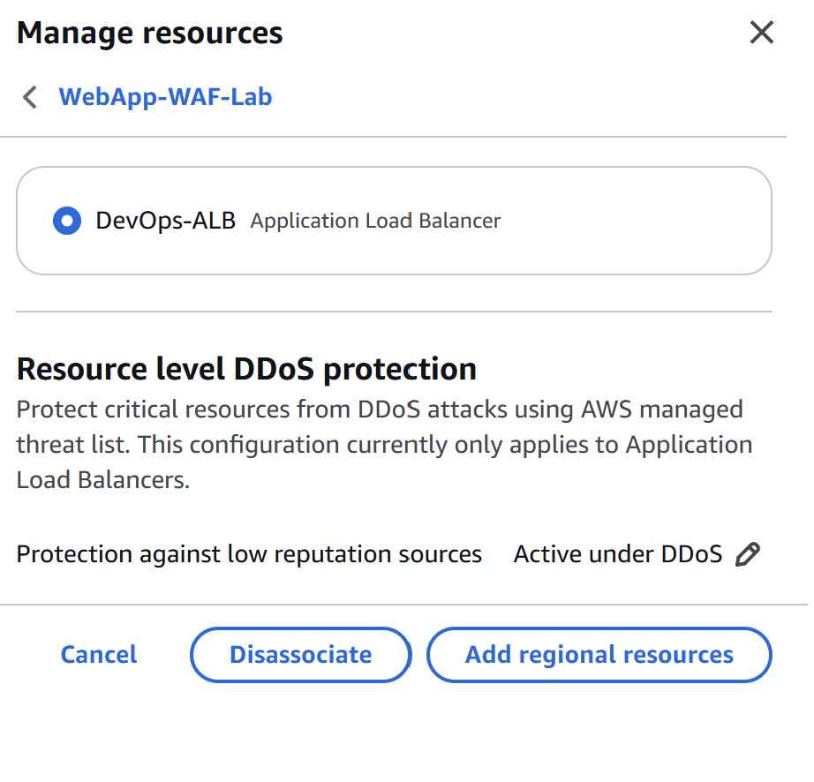
Insert screenshot showing the ALB listed as an associated protected resource. 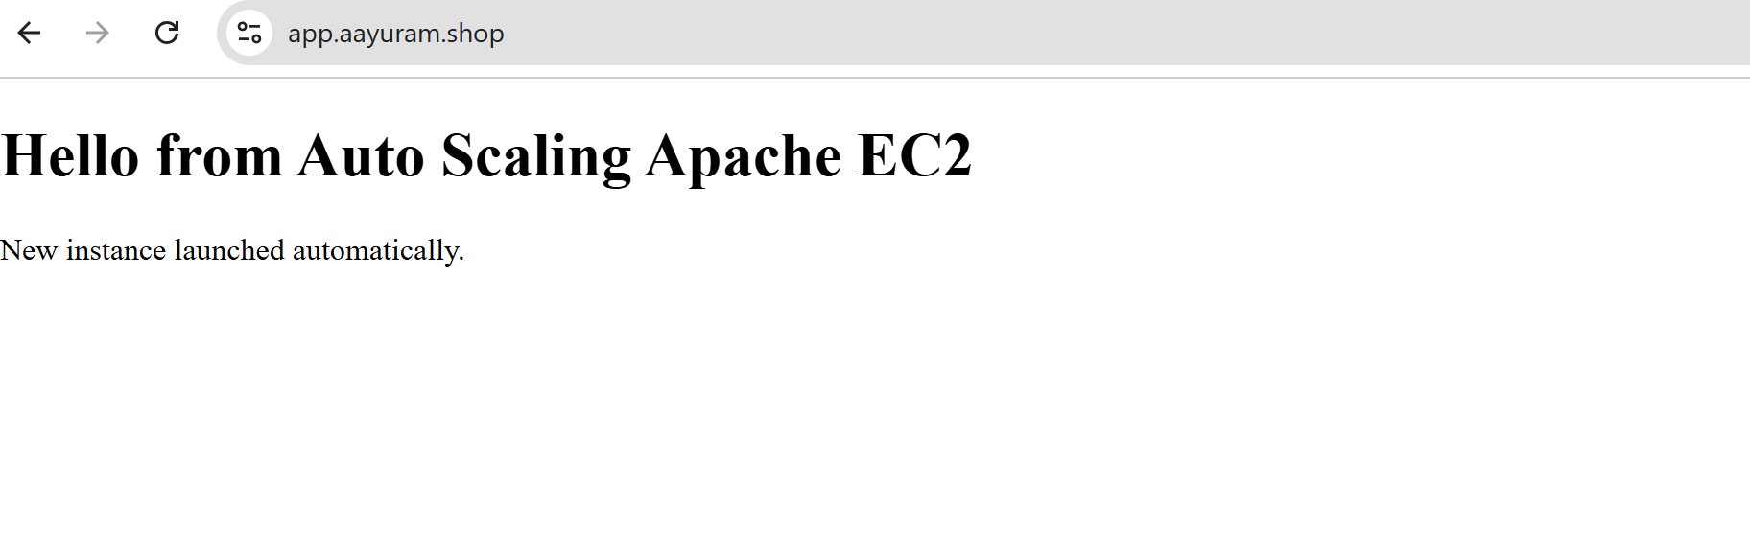

4.7 Enable WAF Logging and Monitoring
- Open the Web ACL logging configuration.
- Choose a destination such as CloudWatch Logs, Amazon S3, or Amazon Data Firehose.
- Configure the required destination permissions/resources.
- Generate test requests and inspect WAF logs.
- Review CloudWatch metrics and sampled requests to understand which rules are matching.
AWS WAF logging can capture detailed information about requests and the rules they matched, with destinations including CloudWatch Logs, Amazon S3, and Amazon Data Firehose. citeturn0search9
[ SCREENSHOT PLACEHOLDER – WAF logs/metrics ]
Insert screenshots of WAF sampled requests, CloudWatch metrics, and/or WAF log entries. 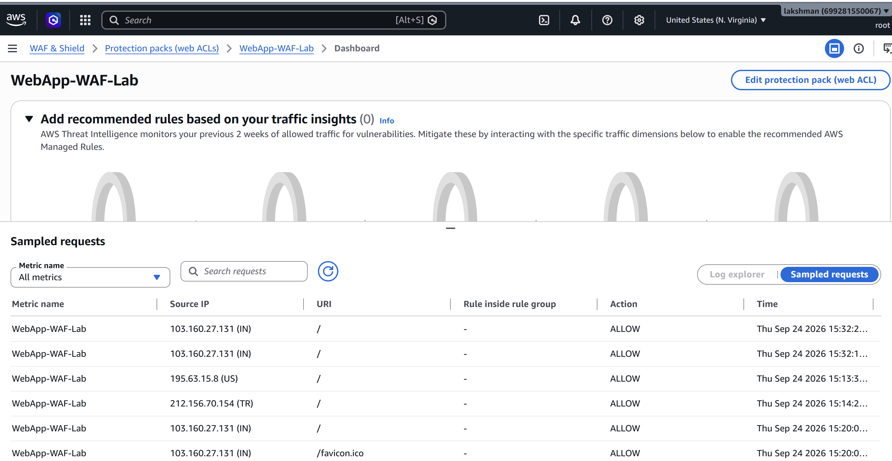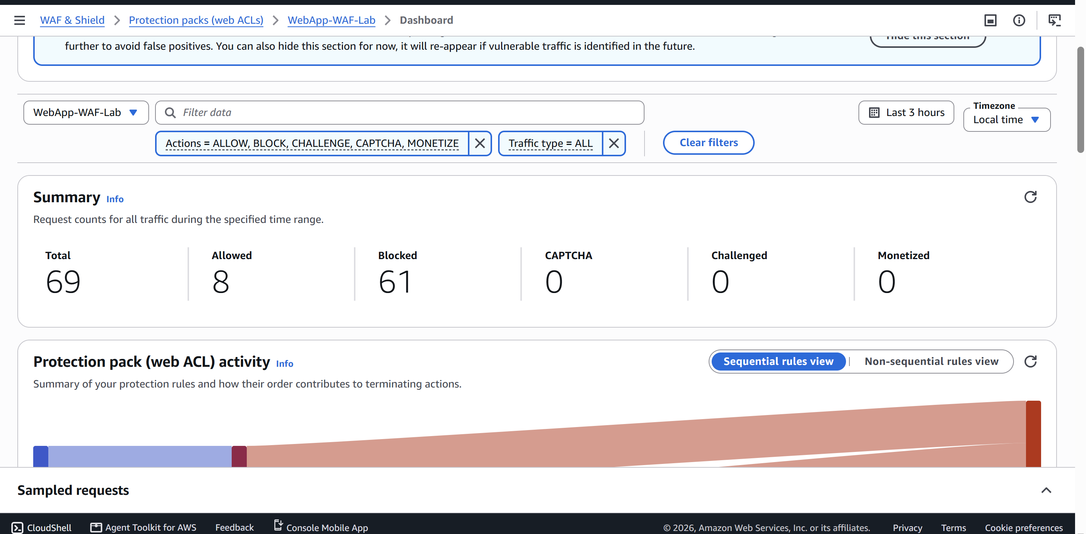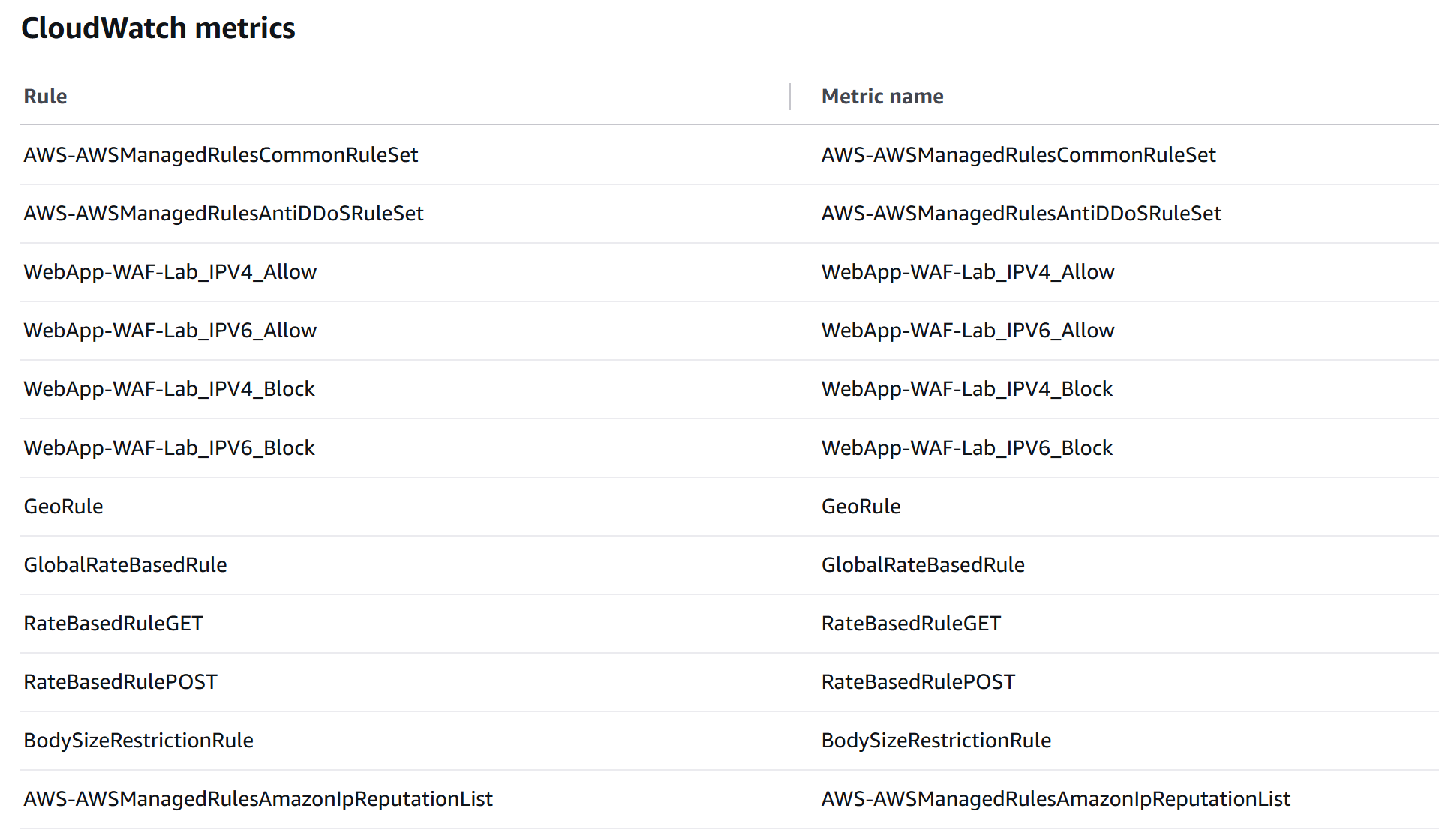

4.8 WAF Validation / Observations
Test | Expected result | Actual observation
Normal application request | Request is allowed and application responds normally. | Fill after testing.
Request matching Count rule | Request is allowed, but the WAF rule records a match. | Fill after testing.
Request matching Block rule | Request is blocked by WAF and does not reach the application. | Fill after testing.
CloudWatch/log verification | Matching rule/request details are visible in configured monitoring destination. | Fill after testing.

5. Part B – AWS Systems Manager Parameter Store

5.1 Concept and Use Cases
Parameter Store is a capability of AWS Systems Manager for centrally storing configuration values and parameters. It supports String, StringList, and SecureString parameter types and supports hierarchical names such as /myapp/dev/log-level. Parameter Store can reduce hard-coded configuration and allows applications and automation to retrieve centrally managed values subject to IAM permissions.
AWS currently documents standard and advanced parameter tiers. Standard parameters support values up to 4 KB and advanced parameters up to 8 KB; advanced parameters also support features such as parameter policies and cross-account sharing. citeturn0search3turn0search1
- String – normal configuration values such as environment names or endpoint URLs.
- StringList – comma-separated lists.
- SecureString – encrypted parameter values using AWS KMS.
- Hierarchical naming – organize parameters by application/environment.
- Versioning – maintain parameter versions when values change.

5.2 Parameter Store Hands-on – Create String Parameter
- Open AWS Systems Manager → Parameter Store.
- Choose Create parameter.
- Use a hierarchical name such as /selflearning/dev/log-level.
- Description: Application log level for the self-learning lab.
- Tier: Standard.
- Type: String.
- Value: INFO.
- Create the parameter. 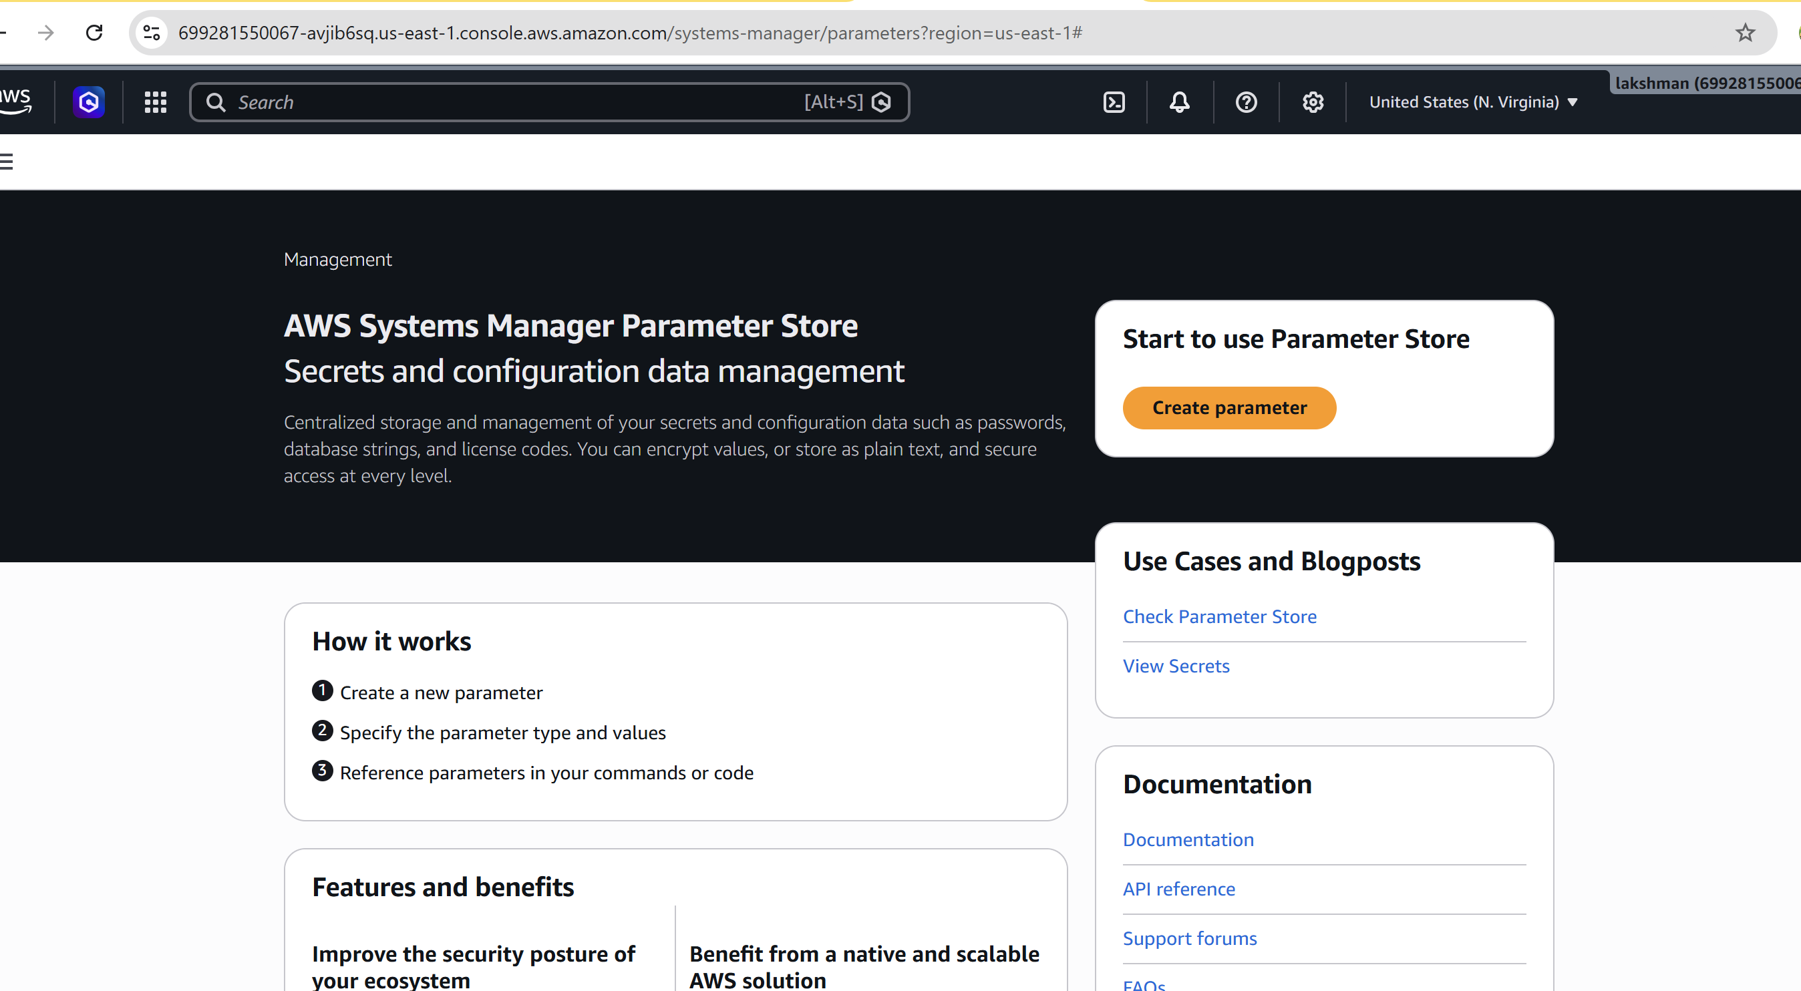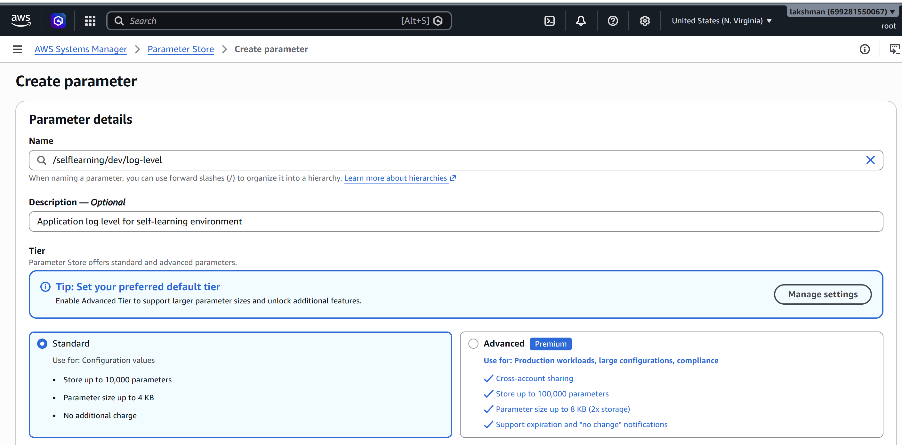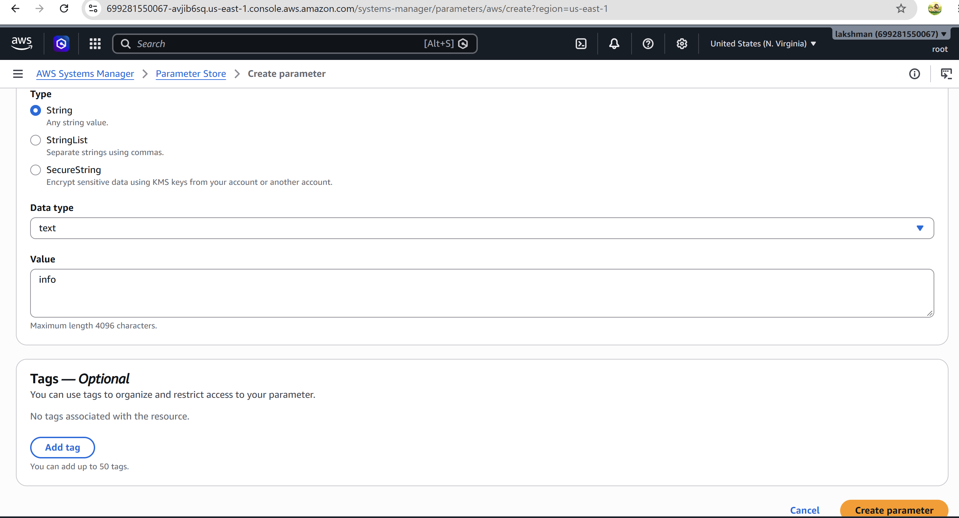
[ SCREENSHOT PLACEHOLDER – Parameter Store String ]
Insert screenshot showing /selflearning/dev/log-level, Standard tier, String type, and the created parameter. 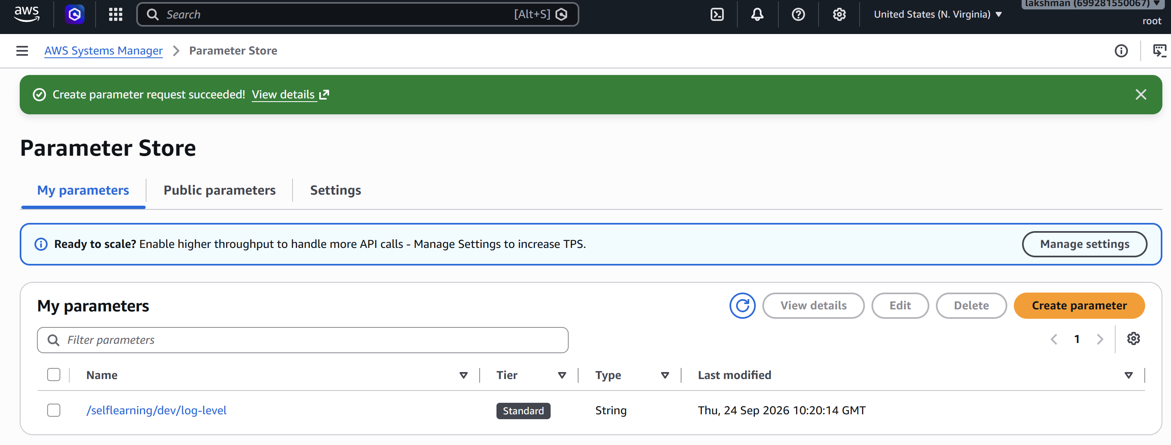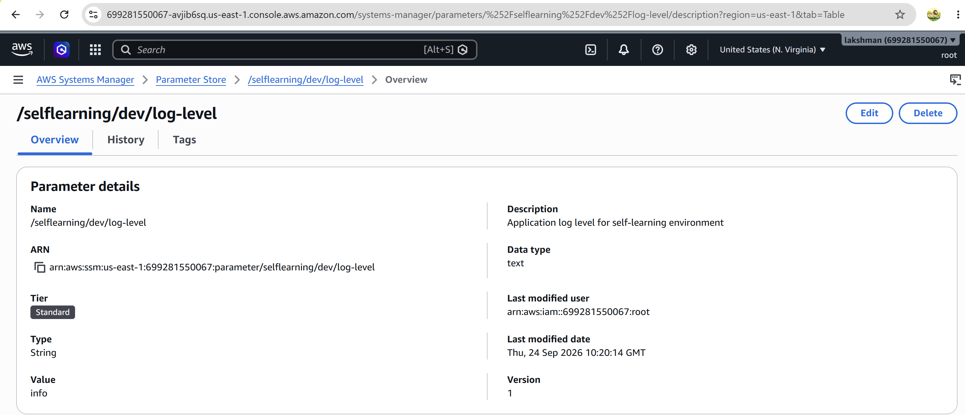

5.3 Create a SecureString Parameter
- Choose Create parameter again.
- Name: /selflearning/dev/app-config-token (use a non-production lab value).
- Tier: Standard.
- Type: SecureString.
- Use the default AWS managed KMS key for a simple lab, or select an approved customer managed symmetric KMS key when demonstrating fine-grained access control.
- Create the parameter.
SecureString values are encrypted with AWS KMS. AWS states that the parameter name and metadata are not encrypted, so do not place passwords or other secrets in parameter names/descriptions. For credentials requiring automatic rotation or other secret-management features, AWS recommends Secrets Manager. citeturn0search0turn0search2
[ SCREENSHOT PLACEHOLDER – SecureString parameter ]
Insert screenshot showing the SecureString configuration. Do not include or expose the actual secret value in the screenshot. 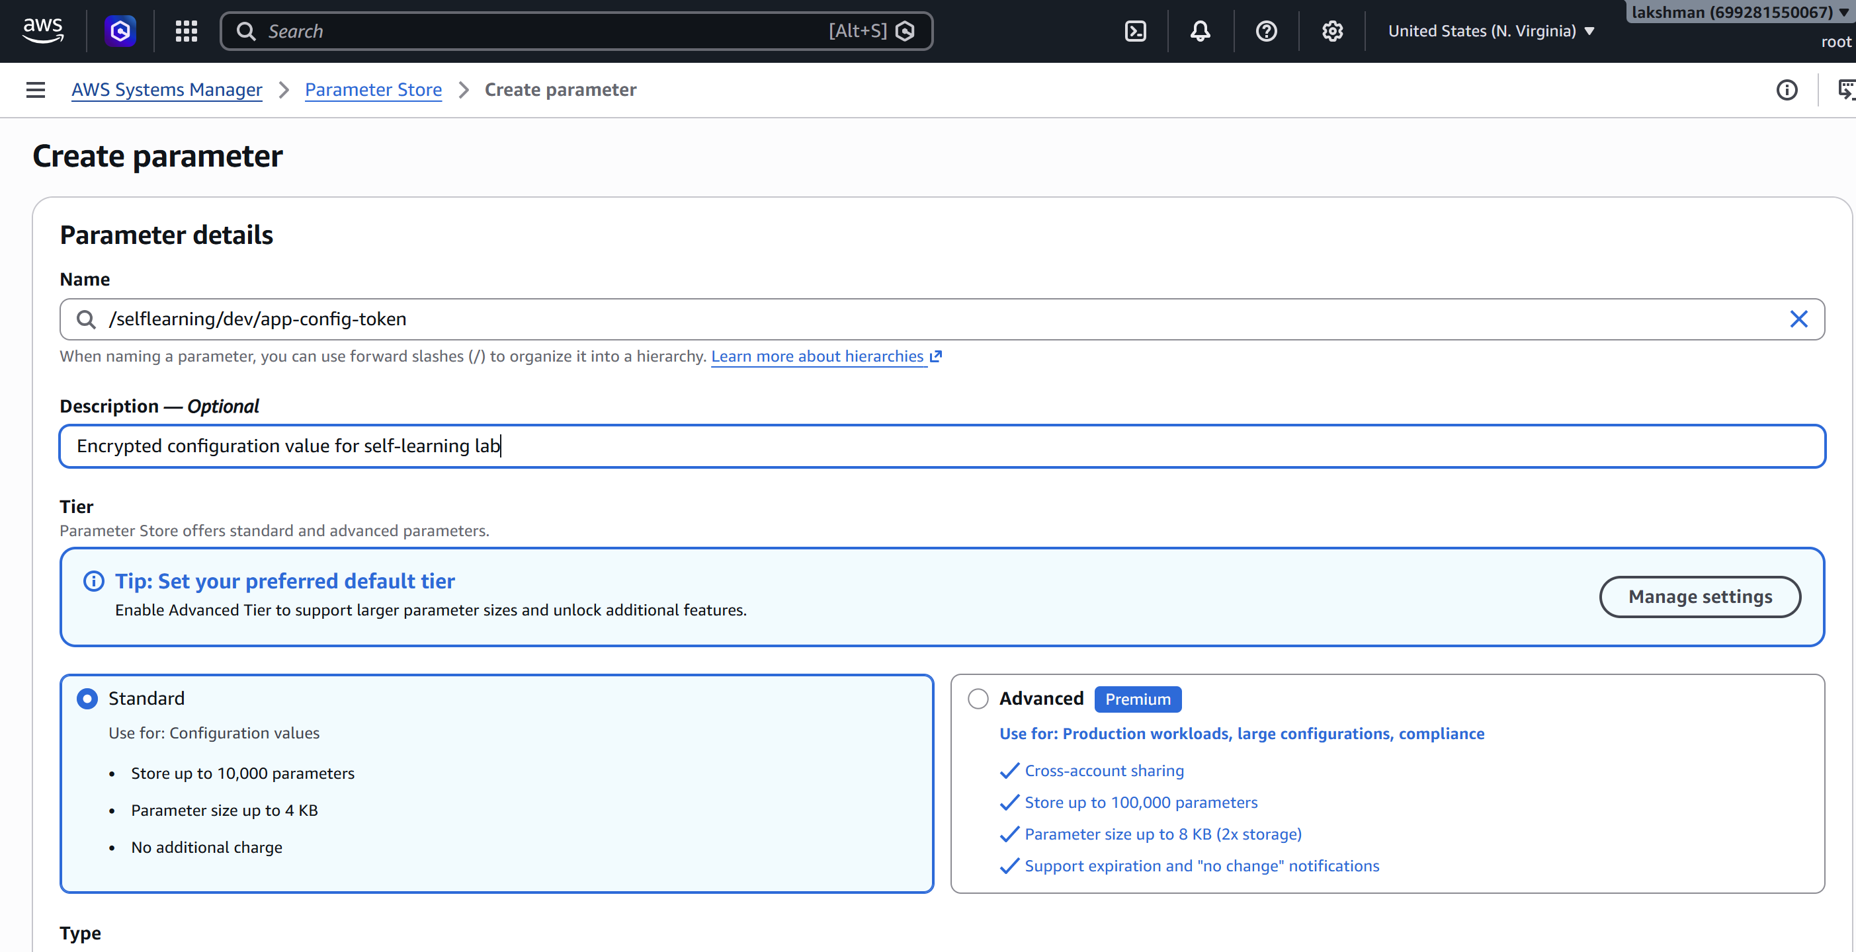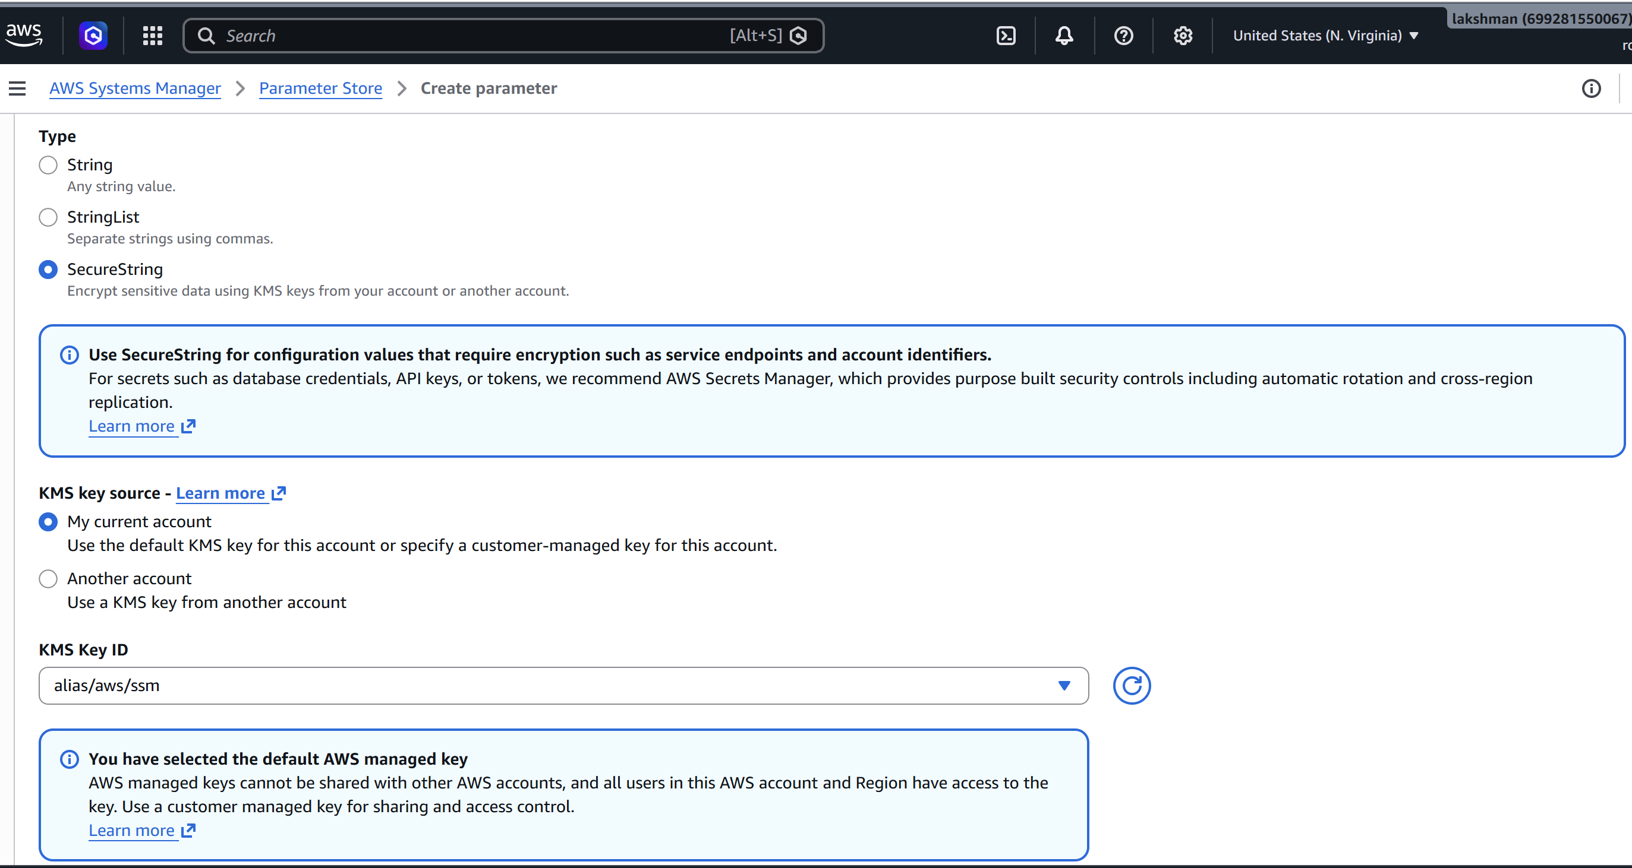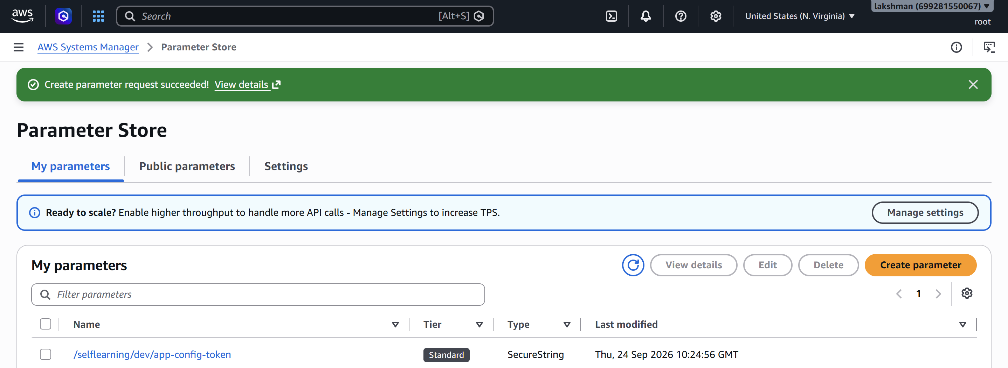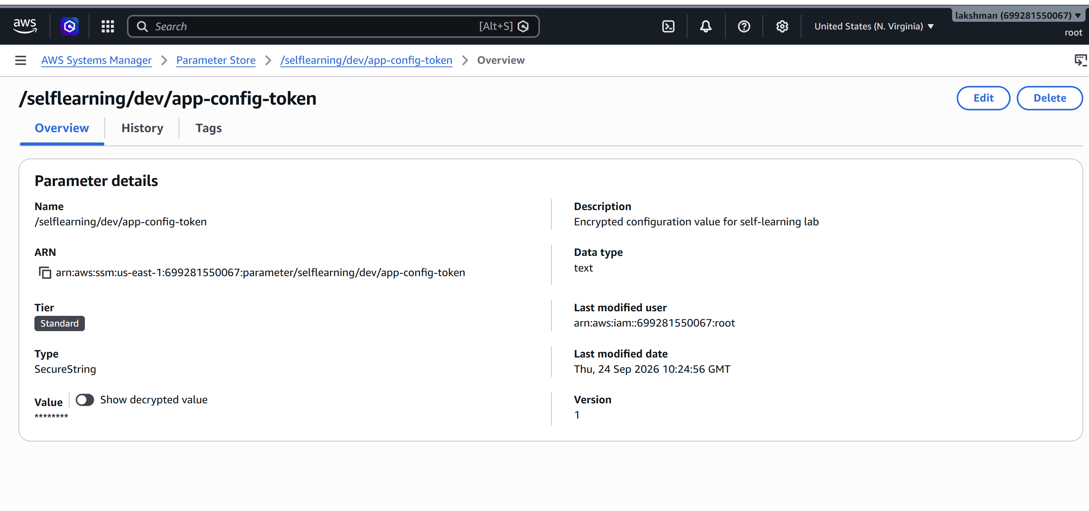

5.4 Retrieve Parameters Using AWS CLI
# Retrieve a normal String parameter
aws ssm get-parameter --name "/selflearning/dev/log-level"
# Retrieve a SecureString parameter without plaintext decryption
aws ssm get-parameter --name "/selflearning/dev/app-config-token"
# Retrieve a SecureString parameter with decryption
aws ssm get-parameter --name "/selflearning/dev/app-config-token" --with-decryption
The --with-decryption option requests plaintext retrieval for a SecureString when the caller has the required permissions. AWS documents this retrieval workflow for Parameter Store. citeturn0search7turn0search0
[ SCREENSHOT PLACEHOLDER – CLI retrieval ]
Insert terminal screenshot showing successful retrieval. Redact the SecureString value if displayed. 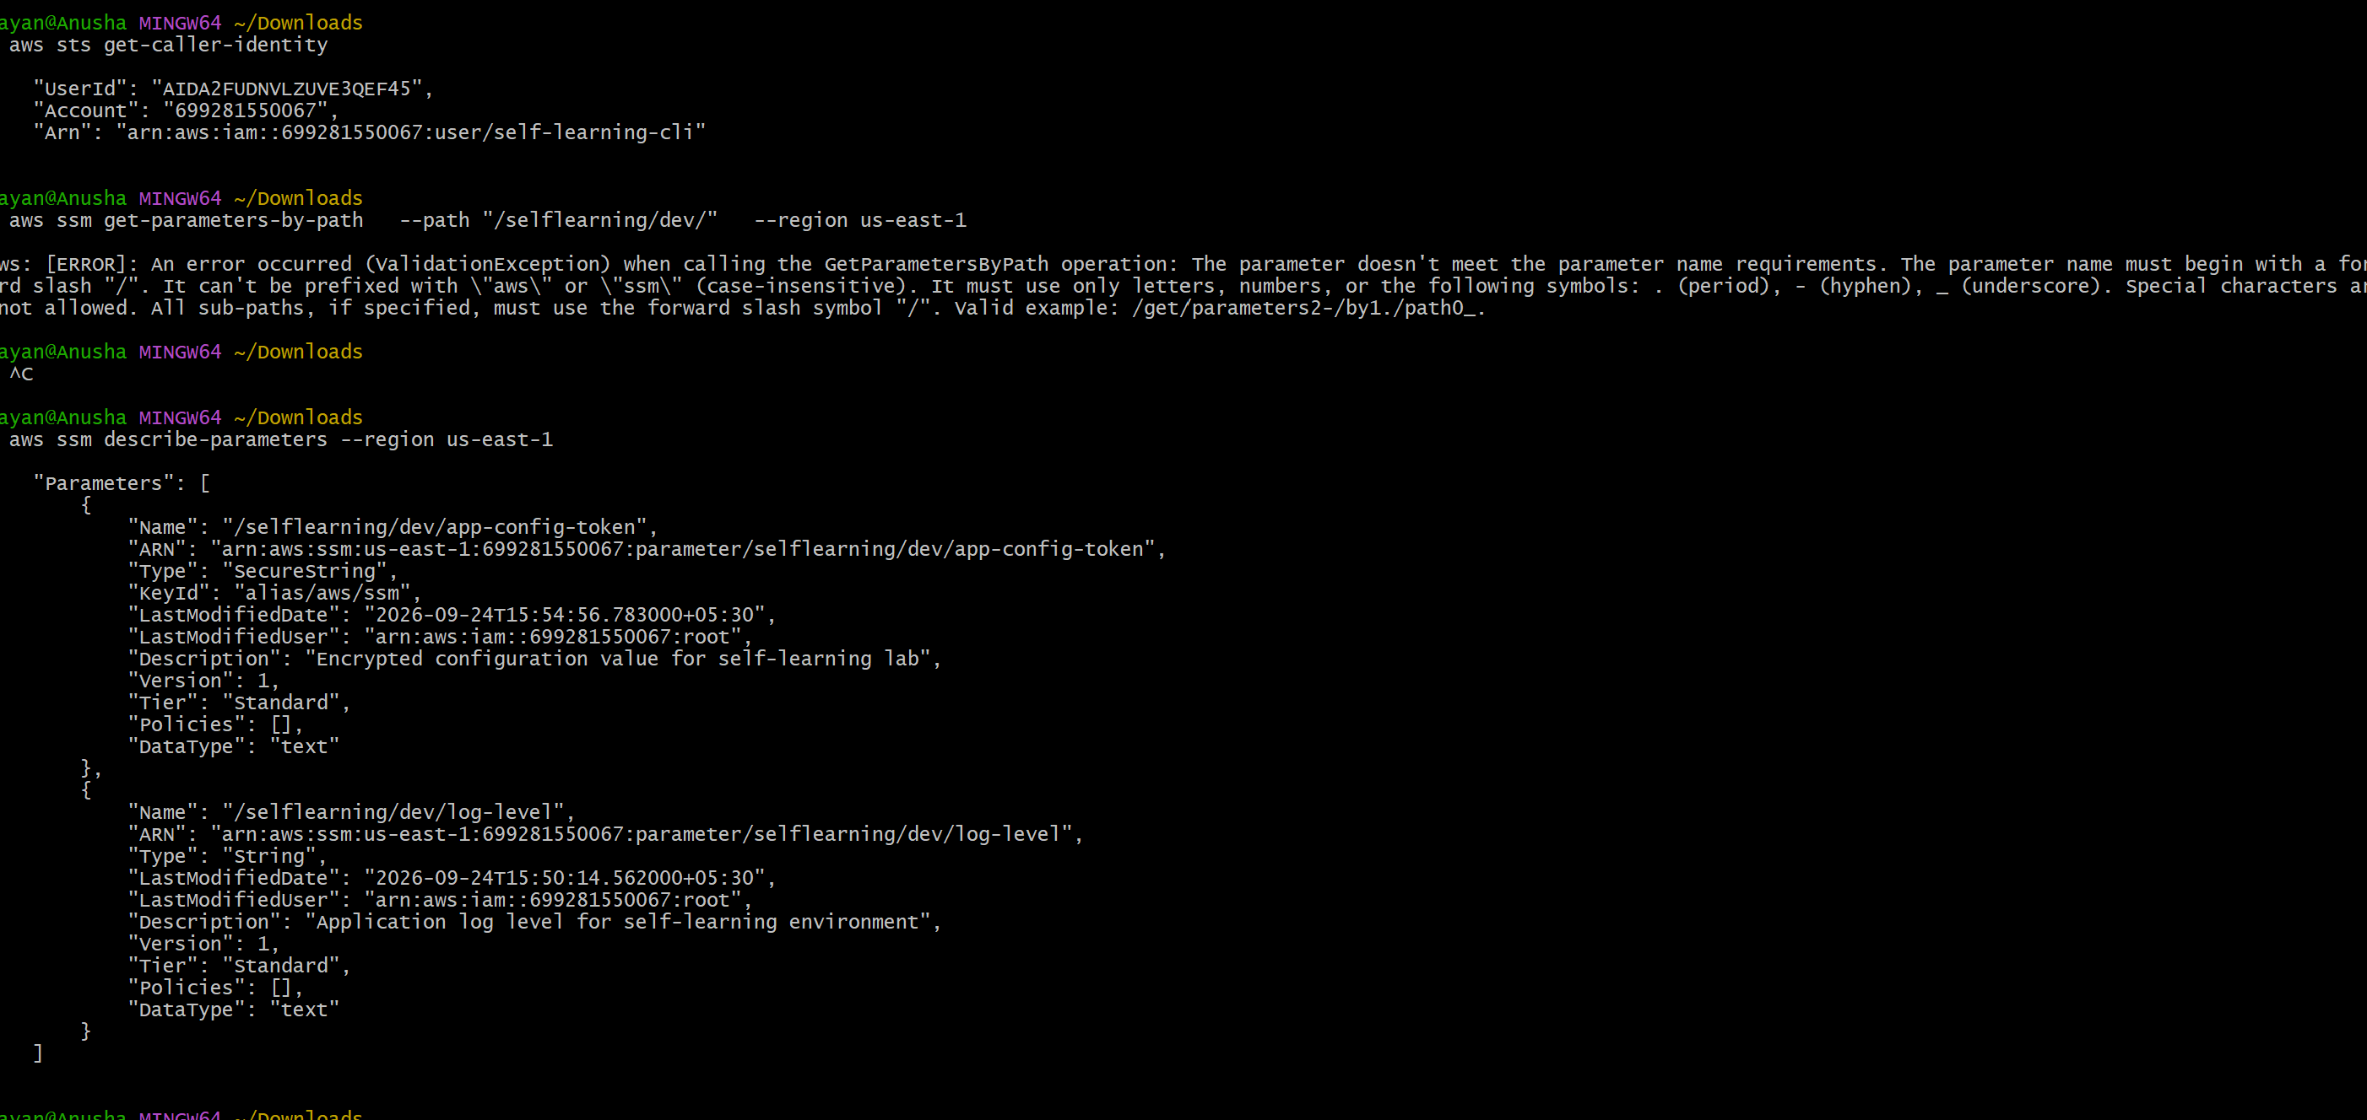

5.5 Parameter Versioning Test
- Open /selflearning/dev/log-level.
- Change the value from INFO to WARN.
- Save the parameter.
- Observe that a new version is created.
- Retrieve the parameter again and record the current version.
- Document the before/after value and version number. 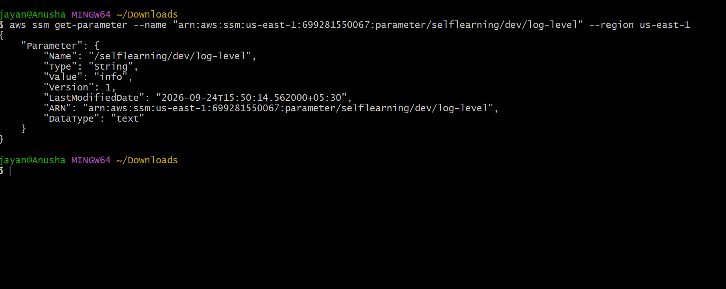
[ SCREENSHOT PLACEHOLDER – Parameter versioning ]
Insert screenshot showing the parameter history/version number. Do not expose sensitive values.

5.6 IAM and Security Validation
- Grant the application or EC2 IAM role only the ssm:GetParameter/GetParameters permissions required for its parameters.
- If using a customer managed KMS key with SecureString, grant the required KMS permissions separately.
- Use resource-level restrictions where practical, such as limiting access to /selflearning/dev/*.
- Use CloudTrail to monitor relevant Parameter Store API activity.
- Avoid storing production credentials in a learning environment.
AWS notes that customer managed KMS keys can be used to establish finer-grained access control for SecureString parameters, and recommends CloudTrail for monitoring SecureString parameter activity. citeturn0search5

6. Integrated Application Scenario
A practical combined scenario is to use WAF to protect the ALB while the application retrieves its environment-specific configuration from Parameter Store. For example, the application can read /selflearning/dev/log-level at startup or during configuration refresh. The application IAM role should be limited to the parameters it needs.
Internet
|
v
AWS WAF Web ACL
| Count / Block / Allow
v
Application Load Balancer
|
v
EC2 Auto Scaling Group
|
+----> IAM Role ----> Systems Manager Parameter Store
|
+---- SecureString
|
+---- AWS KMS
[ SCREENSHOT PLACEHOLDER – Integrated architecture ]
Insert final architecture screenshot/diagram showing WAF, ALB, EC2/ASG, IAM, Parameter Store, and KMS.

7. Configuration Summary
Area | Configuration | Purpose | Evidence
WAF | WebApp-WAF-Lab Web ACL | Inspect and control web requests | Web ACL screenshot
WAF | AWSManagedRulesCommonRuleSet | Baseline web threat detection | Rules screenshot
WAF | Custom IP rule | Controlled block test | Rule screenshot
WAF | Logging/metrics | Monitoring and troubleshooting | Logs/metrics screenshot
Parameter Store | /selflearning/dev/log-level | Centralized non-secret config | Parameter screenshot
Parameter Store | /selflearning/dev/app-config-token | Encrypted lab value | SecureString screenshot
KMS | AWS managed aws/ssm or approved CMK | Encrypt SecureString | KMS/parameter screenshot

8. Observations
- AWS WAF provides a policy-based inspection layer in front of the web application and can use managed and custom rules.
- Count mode is useful during testing because it allows observation of matches without immediately blocking traffic.
- WAF logging and CloudWatch metrics provide evidence for troubleshooting and rule tuning.
- Parameter Store centralizes configuration and supports hierarchical naming and versioning.
- SecureString protects parameter values using AWS KMS, but access is still controlled by IAM/KMS permissions.
- Secrets that require automatic rotation and purpose-built secret-management capabilities should be evaluated for AWS Secrets Manager rather than Parameter Store.
- Production changes should be tested in a non-production environment first and monitored before enforcement.

9. Cleanup / Cost Control
- Remove the test WAF association if the ALB should no longer be protected by this lab Web ACL.
- Delete the test WAF Web ACL if it is no longer required.
- Delete test parameters created for the exercise.
- If a customer managed KMS key was created solely for the lab, follow the approved key deletion schedule/process; do not immediately delete a key that may protect other data.
- Review AWS billing/cost dashboards after the exercise.

10. Final Submission Checklist
- Concept and use case explanation completed.
- Architecture diagram included.
- AWS WAF Web ACL created and documented.
- Managed/custom WAF rule configuration documented.
- WAF association with ALB documented.
- WAF logging/metrics evidence included.
- Parameter Store String parameter created.
- SecureString parameter created and encryption documented.
- CLI/console retrieval test completed.
- Parameter versioning test completed.
- IAM/KMS security considerations documented.
- Screenshots inserted and sensitive values redacted.
- Observations and validation results completed.
- Cleanup completed or resources clearly identified for removal.

11. Official AWS References
AWS WAF Developer Guide: https://docs.aws.amazon.com/waf/latest/developerguide/what-is-aws-waf.html
Creating a WAF Web ACL: https://docs.aws.amazon.com/waf/latest/developerguide/web-acl-creating.html
AWS Managed Rules: https://docs.aws.amazon.com/waf/latest/developerguide/aws-managed-rule-groups.html
WAF Logging: https://docs.aws.amazon.com/waf/latest/developerguide/logging.html
AWS Systems Manager Parameter Store: https://docs.aws.amazon.com/systems-manager/latest/userguide/systems-manager-parameter-store.html
Parameter Store Reference: https://docs.aws.amazon.com/systems-manager/latest/userguide/what-is-a-parameter.html
SecureString and KMS: https://docs.aws.amazon.com/systems-manager/latest/userguide/secure-string-parameter-kms-encryption.html
Parameter Store setup/security: https://docs.aws.amazon.com/systems-manager/latest/userguide/parameter-store-setting-up.html

