VARIABLES IN BASH SCRIPTING
Notes, Syntax, Examples, and Practical Exercises
A variable in Bash stores data such as text, numbers, file paths, command output, and user input. Variables make scripts easier to write, reuse, and maintain.

1. What is a Variable?
A variable is a named location used to store a value. Bash does not require a separate data type declaration for variables.

2. Creating a Variable
Basic syntax:
VARIABLE_NAME="value"
Example:
name="Lakshman"
age=25
Important: Do not put spaces around the = sign.
name="Lakshman" # Correct
name = "Lakshman" # Incorrect

3. Accessing a Variable
Use the $ symbol to access a variable's value.
name="Lakshman"
echo "$name"
Output:
Lakshman

4. Variables with Numbers
a=10
b=20
sum=$((a + b))
echo "A = $a"
echo "B = $b"
echo "Sum = $sum"
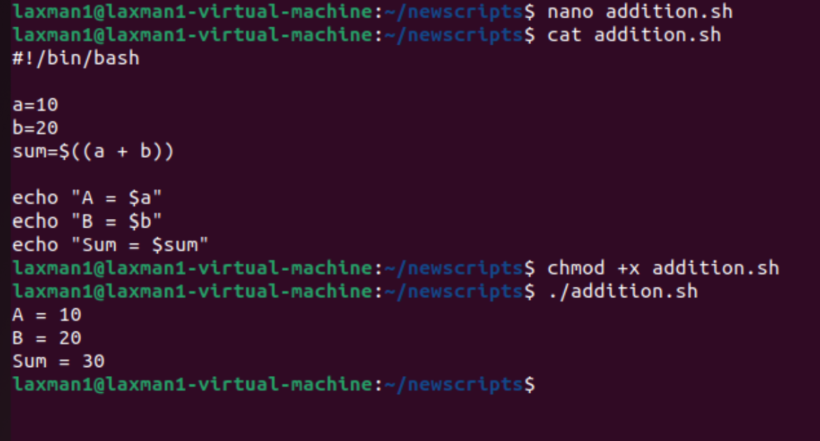

5. Taking User Input
The read command accepts input from the user.
#!/bin/bash
read -p "Enter your name: " name
echo "Hello, $name"
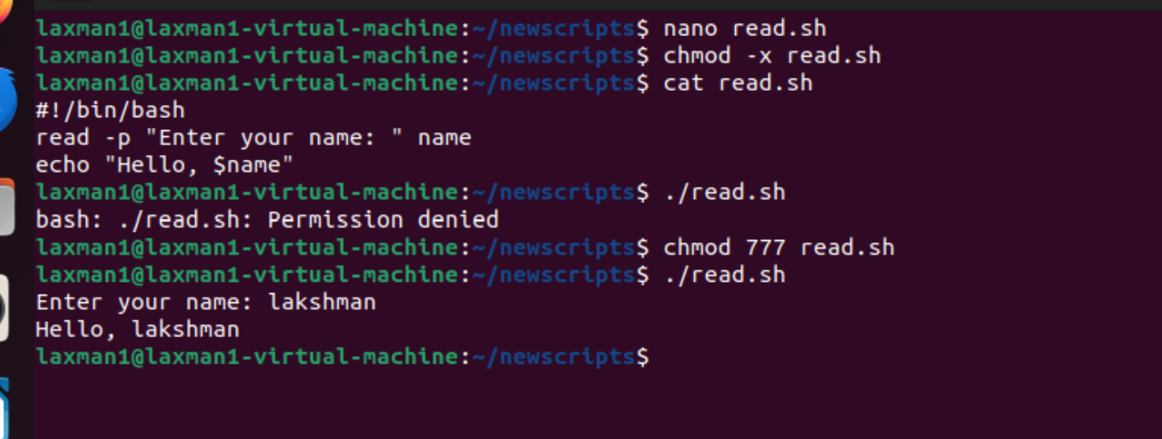

6. Command Substitution
Command substitution stores command output in a variable.
current_date=$(date)
current_user=$(whoami)
current_directory=$(pwd)
echo "Date: $current_date"
echo "User: $current_user"
echo "Directory: $current_directory"
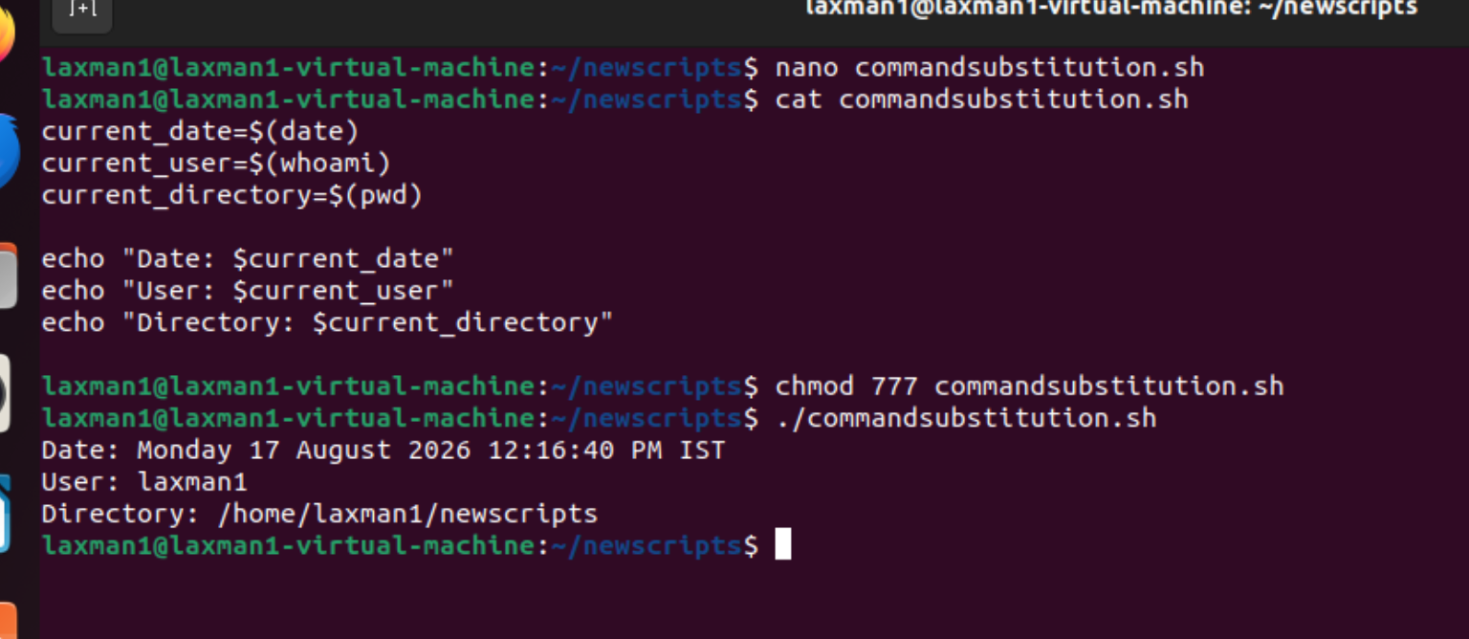

7. Environment Variables
Common environment variables include HOME, USER, PATH, SHELL, and PWD.
echo "$HOME"
echo "$USER"
echo "$PATH"
echo "$SHELL"
echo "$PWD"
To view environment variables:
printenv 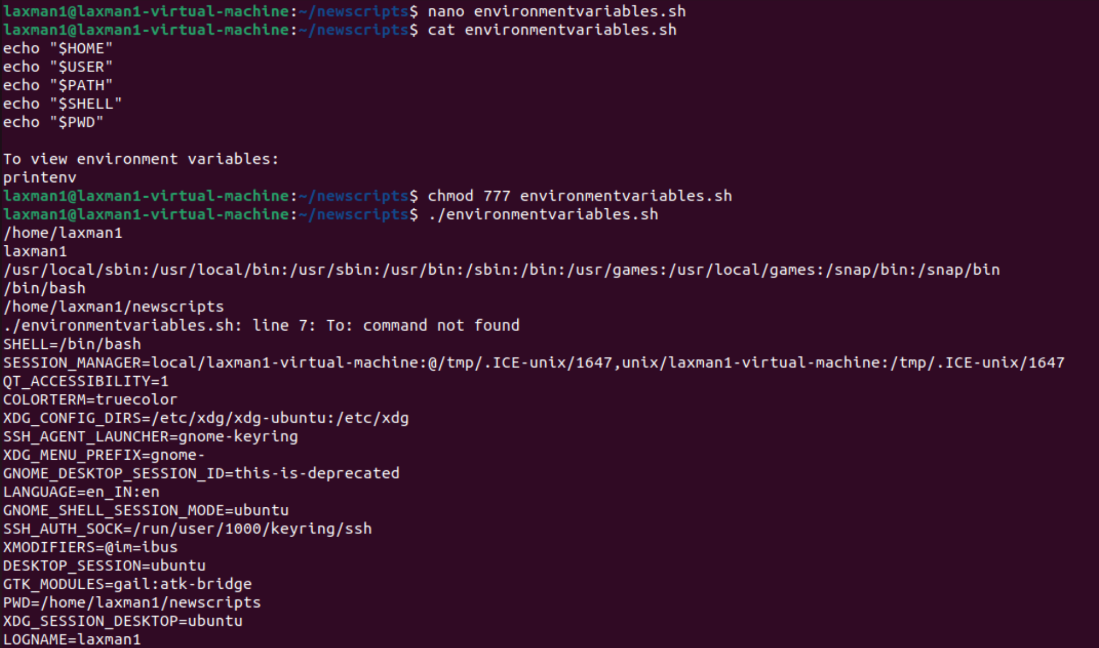 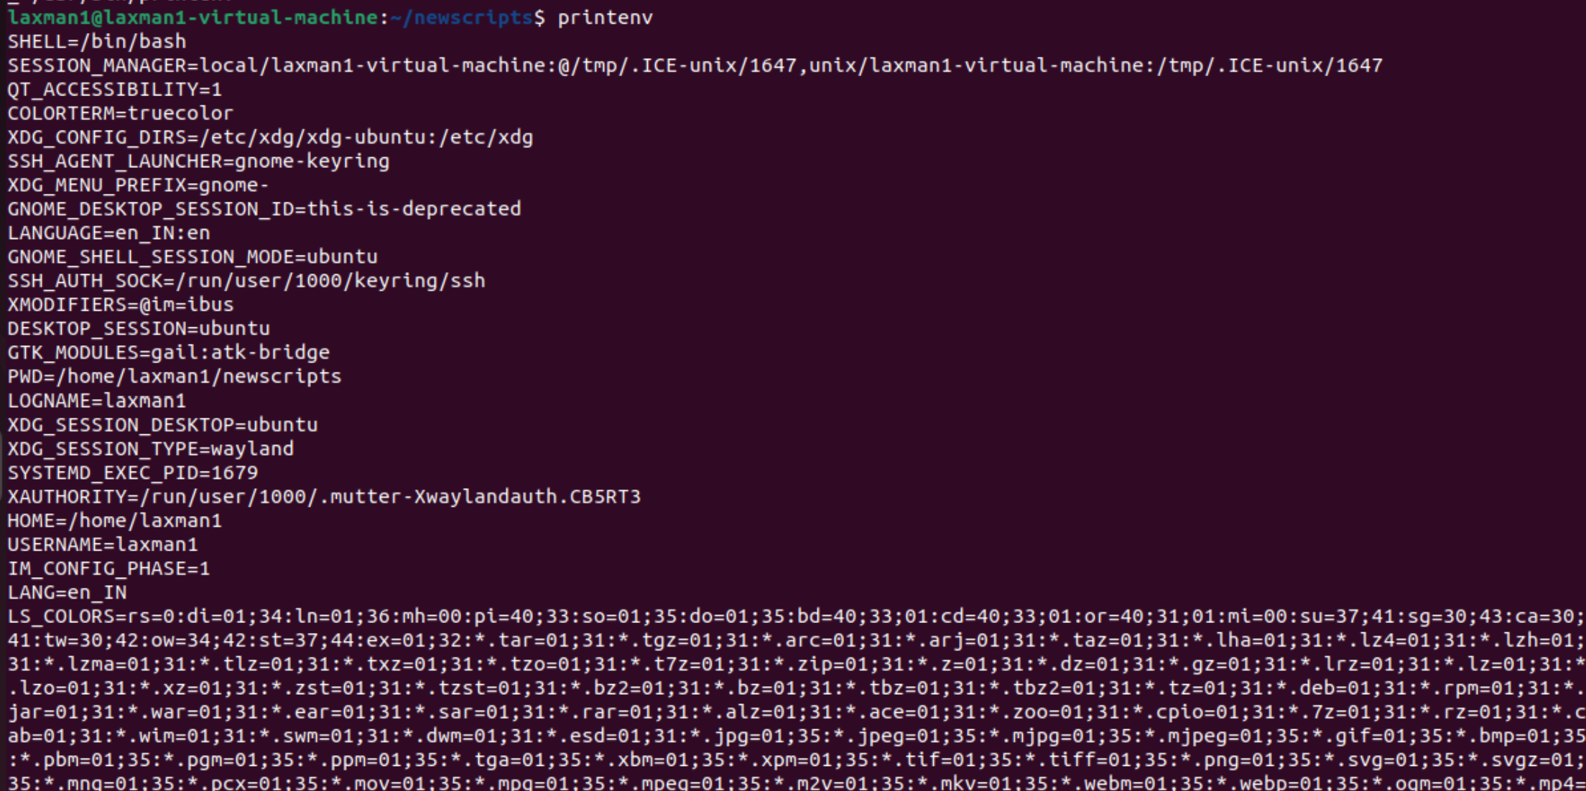

8. Local and Exported Variables
APP_NAME="MyApplication"
export APP_NAME
echo "$APP_NAME"
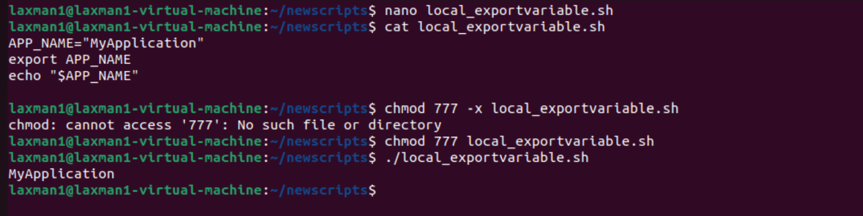

9. Special Bash Variables
Variable | Meaning
$0 | Name of the script
$1, $2, ... | Positional arguments
$# | Number of positional arguments
$@ | All positional arguments
$? | Exit status of the last command
$$ | Process ID of the current shell
$USER | Current username
$HOME | User's home directory
$PWD | Current working directory

10. Positional Parameters
#!/bin/bash
echo "Script name: $0"
echo "First argument: $1"
echo "Second argument: $2"
echo "Number of arguments: $#"
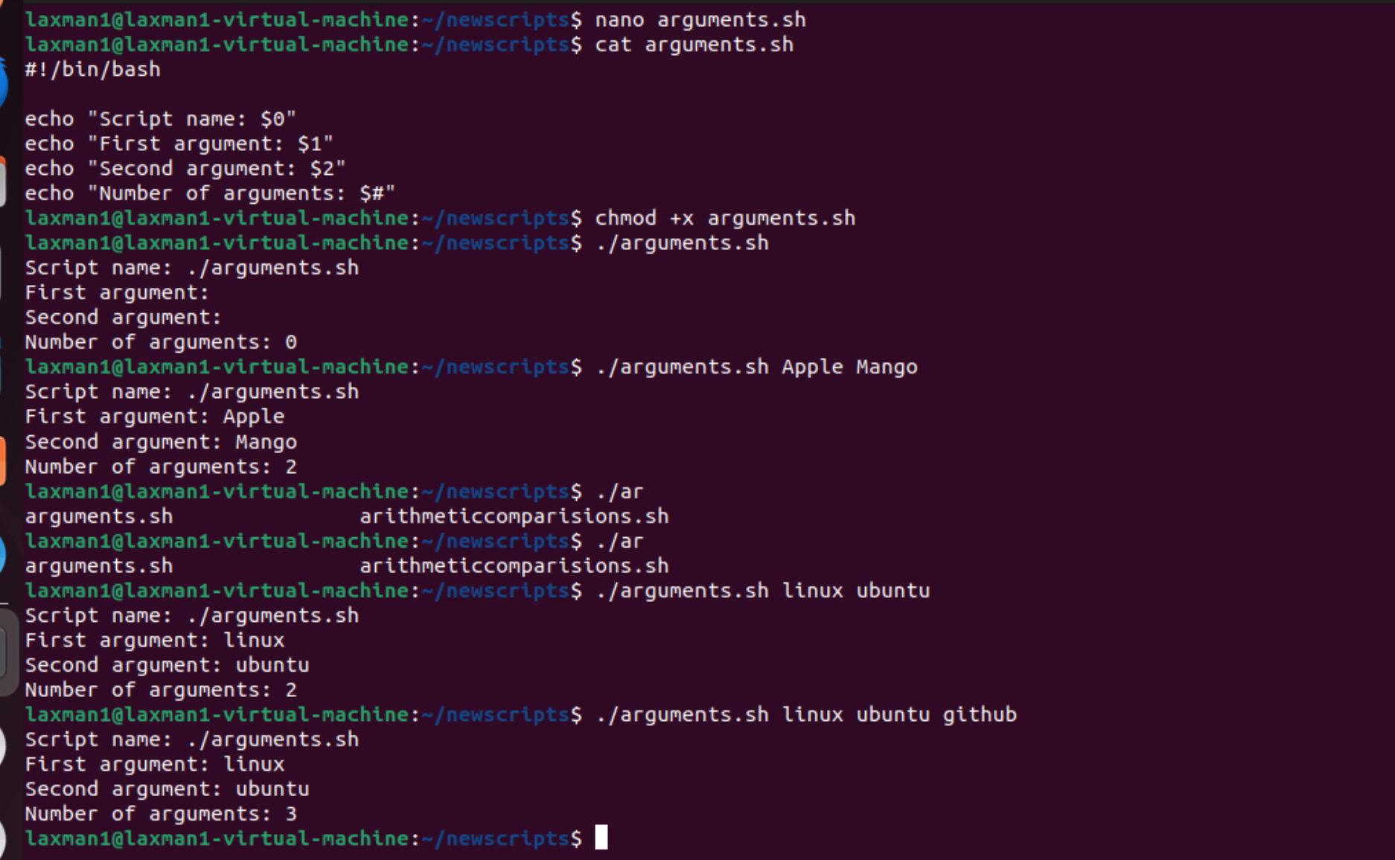
Run:
./script.sh Linux Bash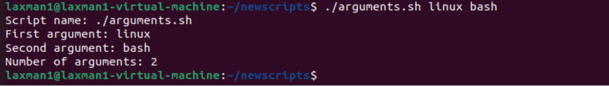

11. Read-Only Variables
#!/bin/bash
readonly VERSION="1.0"
echo "Version: $VERSION"
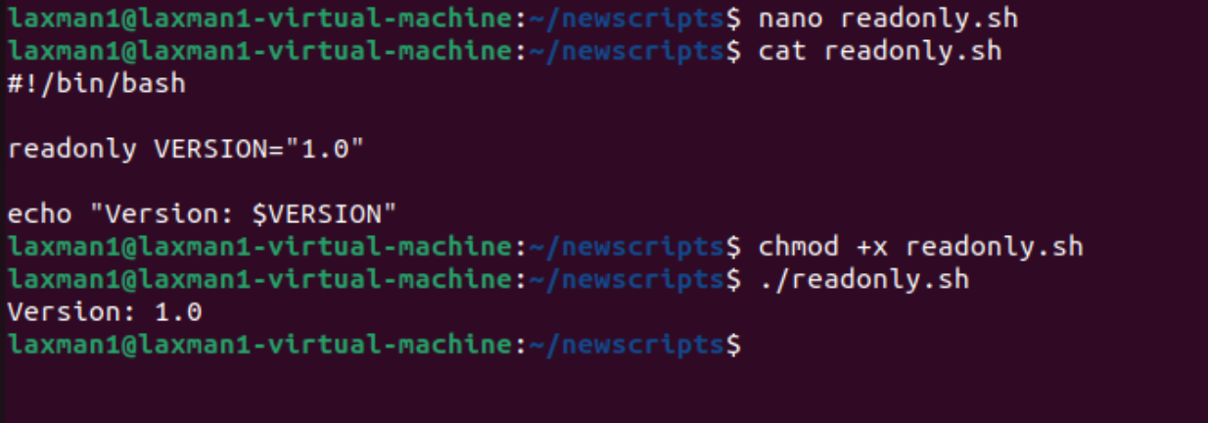

12. Unsetting a Variable
name="Lakshman"
echo "$name"
unset name
echo "$name"
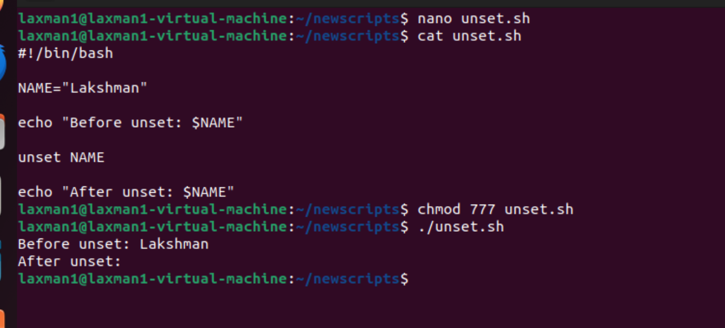

13. String Variables
first_name="Lakshman"
last_name="Kumar"
full_name="$first_name $last_name"
echo "Full Name: $full_name"
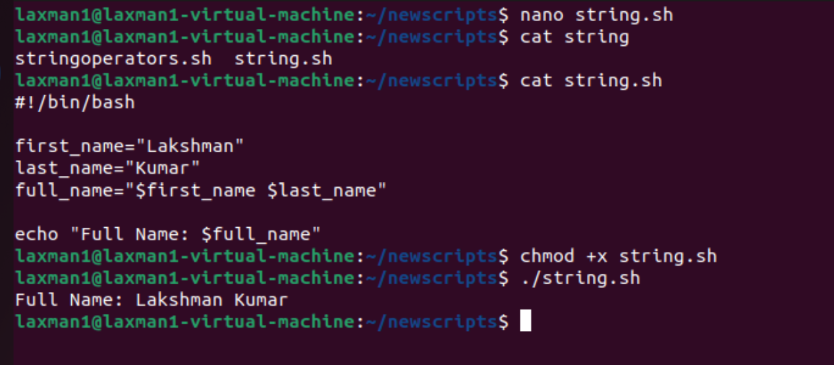

14. Arrays
#!/bin/bash
servers=("web1" "web2" "web3")
echo "First server: ${servers[0]}"
echo "All servers: ${servers[@]}"
echo "Number of servers: ${#servers[@]}"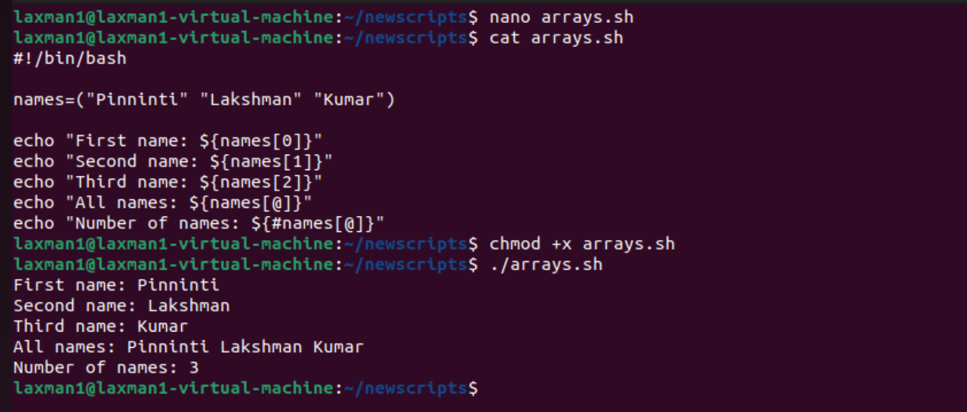

15. Variable Expansion
name="Lakshman"
echo "$name"
echo "${name}"
echo "Hello, ${name}!"
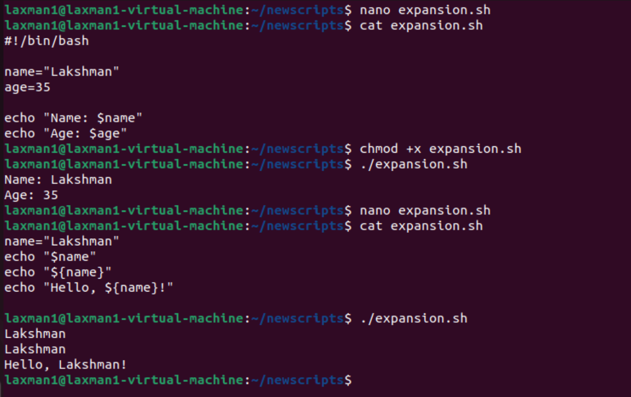

16. Default Values
#!/bin/bash
echo "User: ${USER_NAME:-Guest}"
If USER_NAME is unset or empty, the script displays Guest. 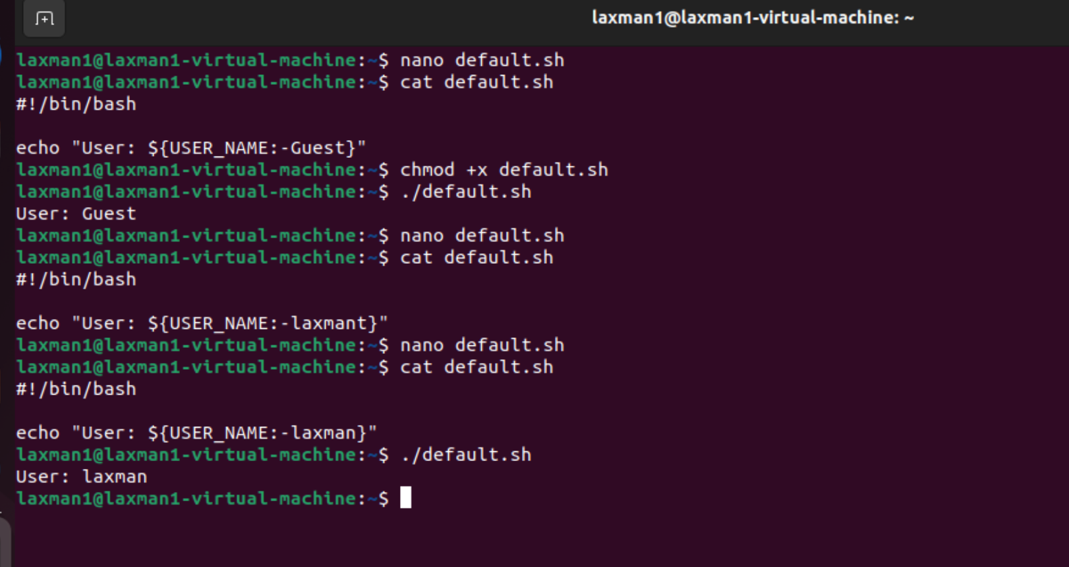

17. Practical Example: Add Two Numbers
#!/bin/bash
read -p "Enter first number: " a
read -p "Enter second number: " b
sum=$((a + b))
echo "Sum = $sum"
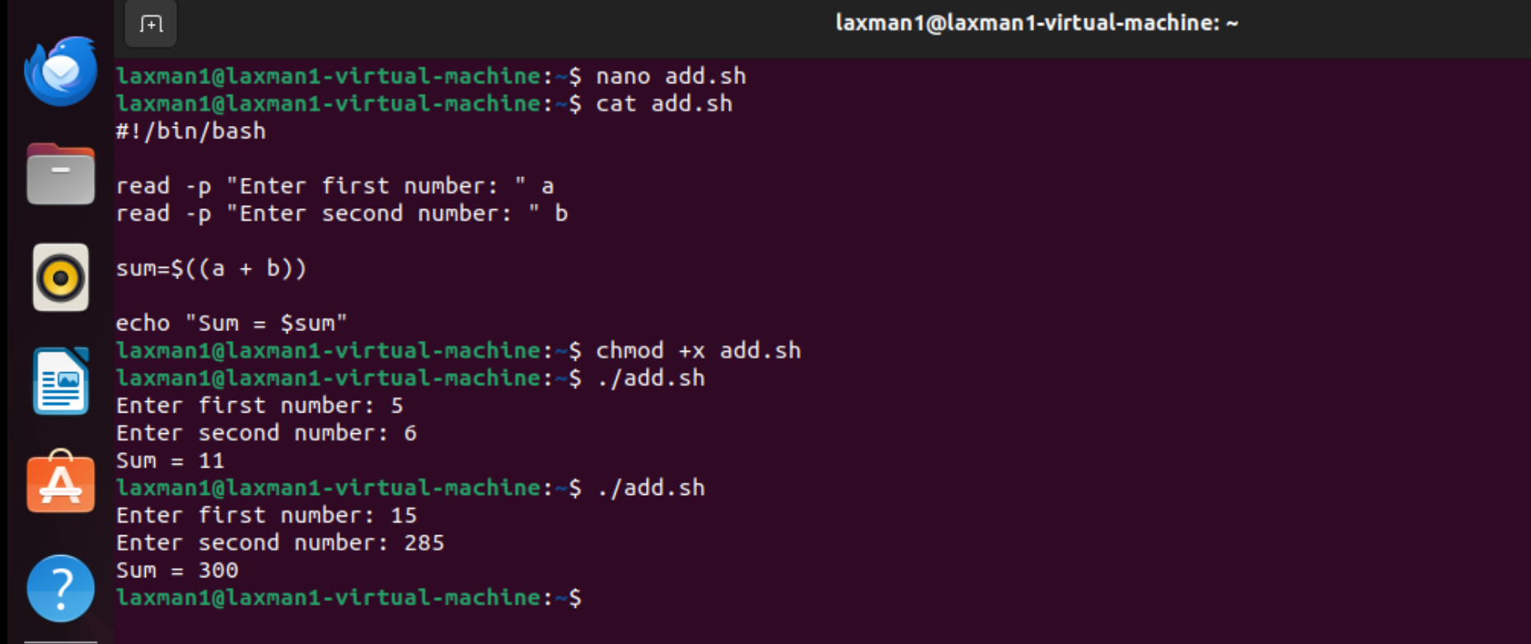

18. Practical Example: Check Directory
#!/bin/bash
DIR="/home/ec2-user/test"
if [ -d "$DIR" ]
then
echo "Directory exists: $DIR"
else
echo "Directory does not exist: $DIR"
fi
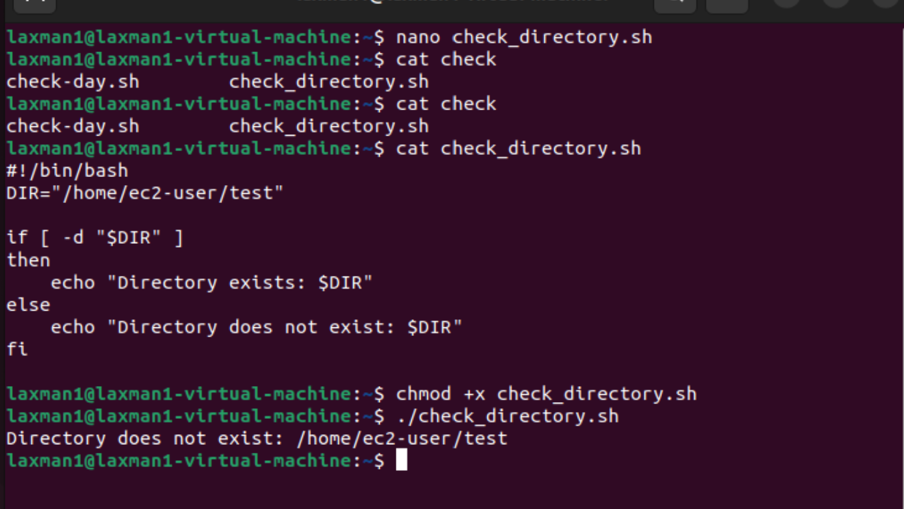

19. Practical Example: System Information
#!/bin/bash
hostname=$(hostname)
user=$(whoami)
date_now=$(date)
directory=$(pwd)
echo "Hostname: $hostname"
echo "User: $user"
echo "Date: $date_now"
echo "Current Directory: $directory"
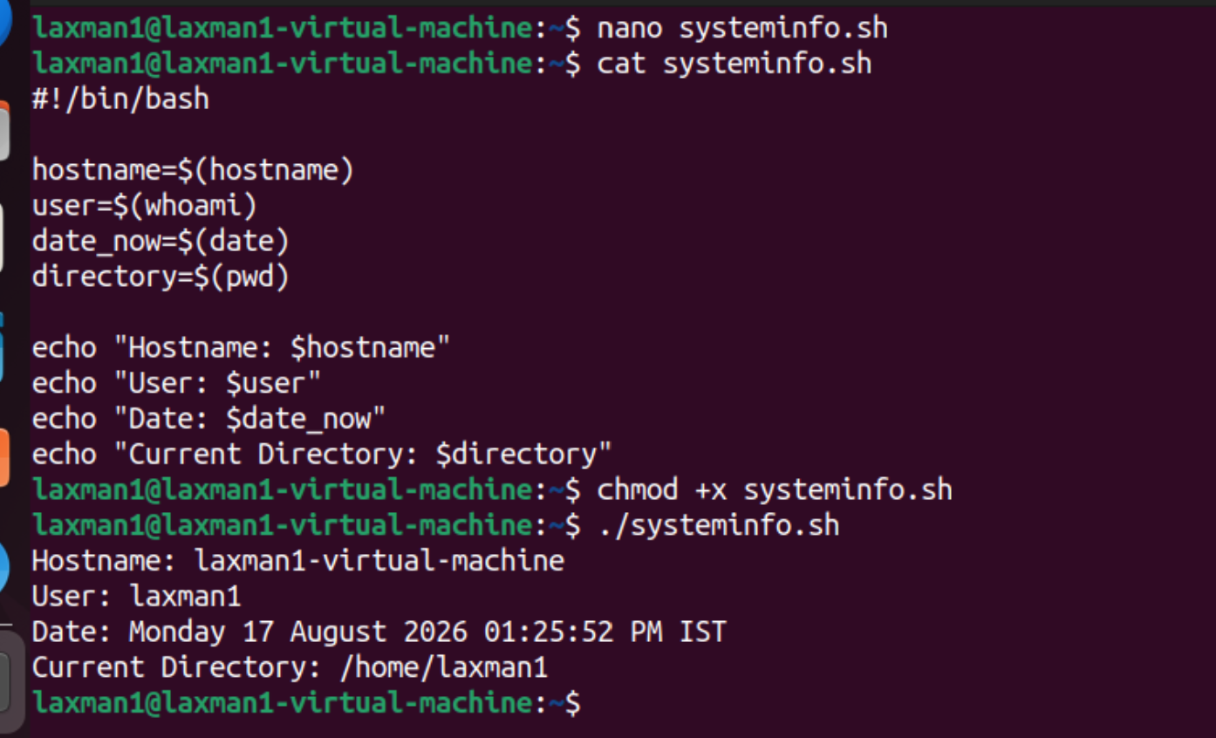

20. Practical Example: Backup File Name
#!/bin/bash
SOURCE="/home/ec2-user/test"
DATE=$(date +"%Y-%m-%d")
BACKUP="/home/ec2-user/test_backup_$DATE.tar.gz"
tar -czf "$BACKUP" "$SOURCE"
echo "Backup created: $BACKUP"
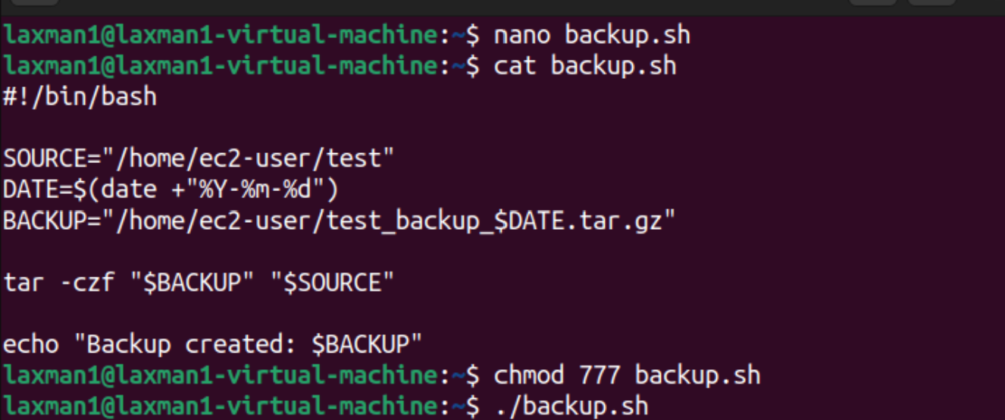

21. Variable Naming Rules
- Variable names can contain letters, numbers, and underscores.
- A variable name should not start with a number.
- Do not use spaces around the = sign.
- Variable names are case-sensitive.
- Use meaningful names such as BACKUP_DIR.
- Avoid Bash reserved words as variable names.

22. Common Mistakes
Type | Example | Explanation
Incorrect | name = "Lakshman" | Spaces around = are not allowed.
Correct | name="Lakshman" | No spaces around =.
Incorrect | echo name | Prints the word name.
Correct | echo "$name" | Expands the variable value.

23. How to Execute a Bash Script
nano variables.sh
chmod +x variables.sh
./variables.sh
Alternatively:
bash variables.sh

24. Quick Reference
Operation | Example
Create | name="Lakshman"
Access | echo "$name"
Input | read name
Command output | DATE=$(date)
Export | export NAME
Remove | unset NAME
Read-only | readonly VERSION="1.0"
Arithmetic | sum=$((a + b))
Script argument | echo "$1"

