If-then Scripts:

Check the variable

#!/bin/bash

count=100
if [ $count -eq 100 ]
then
echo Count is 100
else
echo Count is not 100
fi
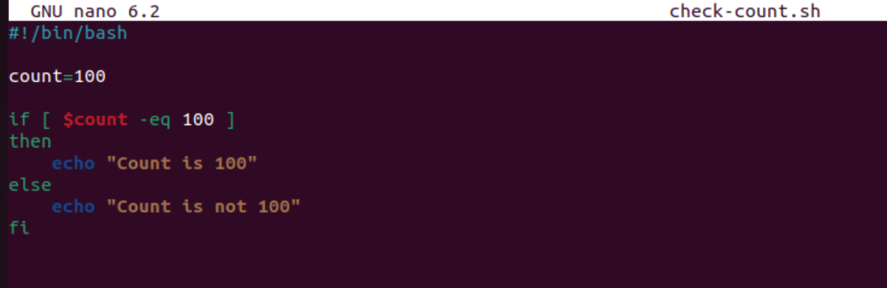


Check if a file error.txt exist

#!/bin/bash

clear
if [ -e /home/iafzal/error.txt ]

then
echo "File exist"
else
echo "File does not exist"
fi
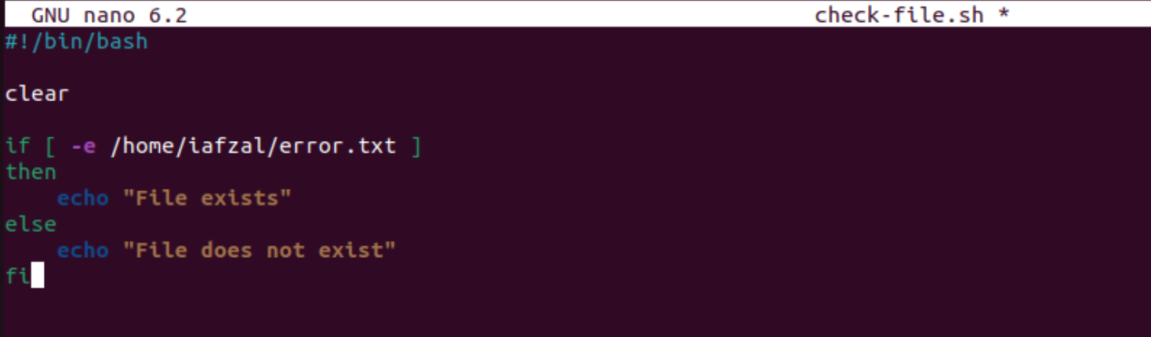
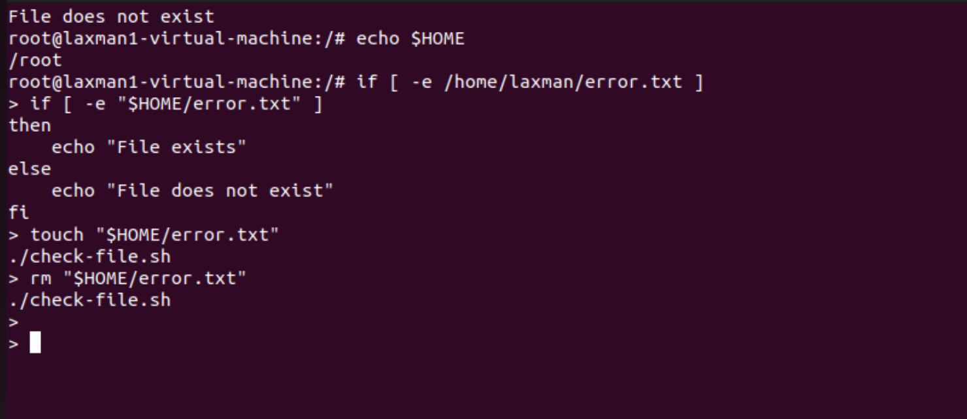

Check if a variable value is met

#!/bin/bash

a=`date | awk '{print $1}'`

if [ "$a" == Mon ]

then
echo Today is $a
else
echo Today is not Monday
fi

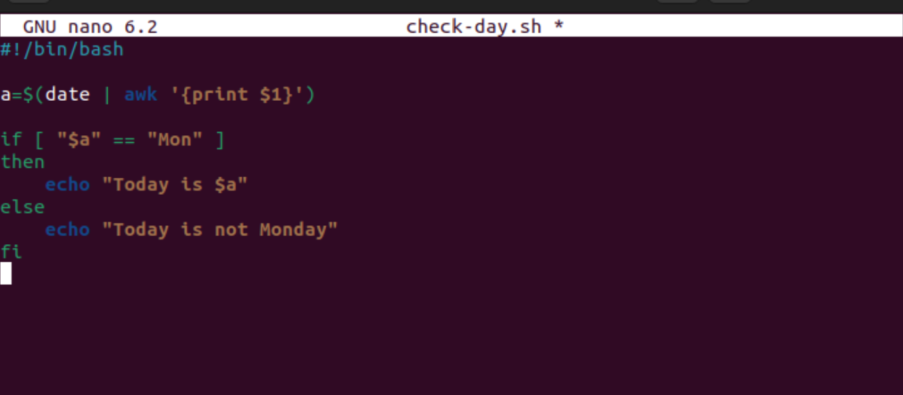


Check the response and then output

#!/bin/bash

clear
echo
echo "What is your name?"
echo
read a
echo

echo Hello $a sir
echo

echo "Do you like working in IT? (y/n)"
read Like
echo

if [ "$Like" == y ]
then
echo You are cool

elif [ "$Like" == n ]
then
echo You should try IT, it’s a good field
echo
fi
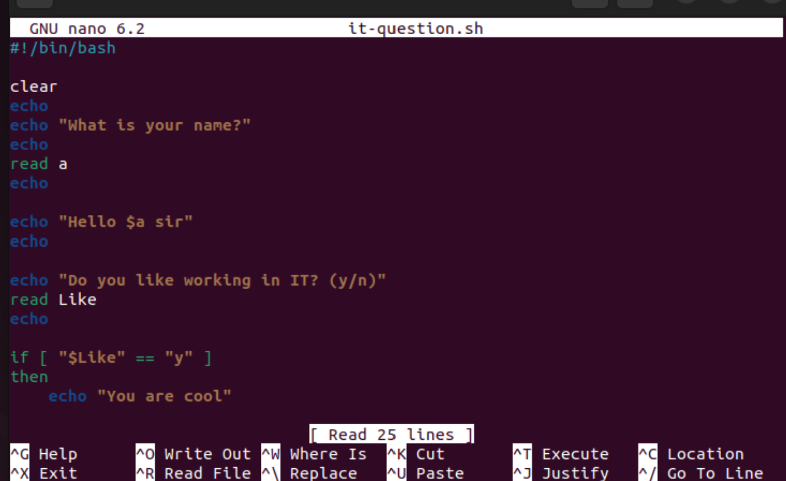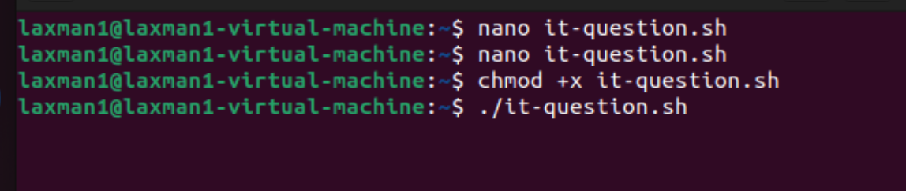

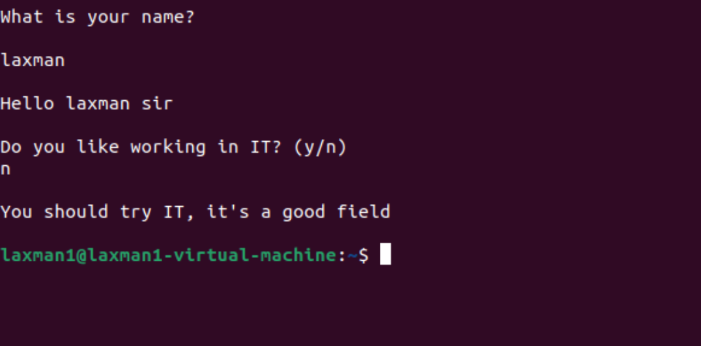

Other If statements

If the output is either Monday or Tuesday
if [ “$a” = Monday ] || [ “$a” = Tuesday ]

Test if the error.txt file exist and its size is greater than zero
if test -s error.txt

if [ $? -eq 0 ] If input is equal to zero (0)
if [ -e /export/home/filename ] If file is there
if [ "$a" != "" ] If variable does not match
if [ error_code != "0" ] If file not equal to zero (0)

Comparisons:
-eq equal to for numbers
== equal to for letters
-ne not equal to
!== not equal to for letters
-lt less than
-le less than or equal to
-gt greater than
-ge greater than or equal to

File Operations:
-s file exists and is not empty
-f file exists and is not a directory
-d directory exists
-x file is executable
-w file is writable
-r file is readable

