AWS Elastic Load Balancing – Practical Tasks
Classic Load Balancer, Application Load Balancer, Network Load Balancer, SSL/TLS, Route 53, and ALB Access Logs

1. Objectives
- Configure a Classic Load Balancer (CLB) and register EC2 instances.
- Configure an Application Load Balancer (ALB) using a target group and listener.
- Configure a Network Load Balancer (NLB) for TCP-based traffic.
- Attach an SSL/TLS certificate to an Application Load Balancer.
- Map a Route 53 DNS name to the Application Load Balancer.
- Enable Application Load Balancer access logs and deliver them to an Amazon S3 bucket.

2. Suggested Lab Architecture
Use two EC2 web servers in different Availability Zones for the ALB lab. Keep the application instances in private subnets when possible and expose only the load balancer to the internet.
Internet / Client
|
v
Application Load Balancer (HTTP 80 / HTTPS 443)
|
+----+----+
| |
v v
EC2-AZ1 EC2-AZ2
Apache Apache
| |
+----+----+
|
Target Group

Route 53: app.example.com -> ALB
ALB Access Logs -> S3

3. Prerequisites
- An AWS account with permissions for EC2, Elastic Load Balancing, Route 53, Certificate Manager (ACM), and S3.
- A VPC with at least two subnets in different Availability Zones for an internet-facing ALB.
- At least two EC2 instances running a web server such as Apache or Nginx for the ALB lab.
- Security groups allowing HTTP/HTTPS to the ALB and application traffic from the ALB security group to the EC2 instances.
- A registered domain name and a Route 53 hosted zone if DNS mapping is required.
- For HTTPS, an ACM certificate covering the DNS name you will use.

4. Task 1 – Configure a Classic Load Balancer
Classic Load Balancer (CLB) is a legacy Elastic Load Balancing option. It is useful for learning the older ELB model, but for new application designs AWS generally uses ALB or NLB.

4.1 Create the Classic Load Balancer
1. Open AWS Console → EC2 → Load Balancers.
2. Choose Create Load Balancer.
3. Select Classic Load Balancer.
4. Enter a name such as Classic-Web-LB.
5. Choose an internet-facing load balancer if clients are on the internet.
6. Select the required VPC and at least two subnets.
7. Configure the listener, for example HTTP : 80 → HTTP : 80.
8. Select or create a security group that permits HTTP from the required source.
9. Configure the health check. Example: HTTP, path /, port 80.
10. Select the EC2 instances that host the application.
11. Review and create the load balancer. 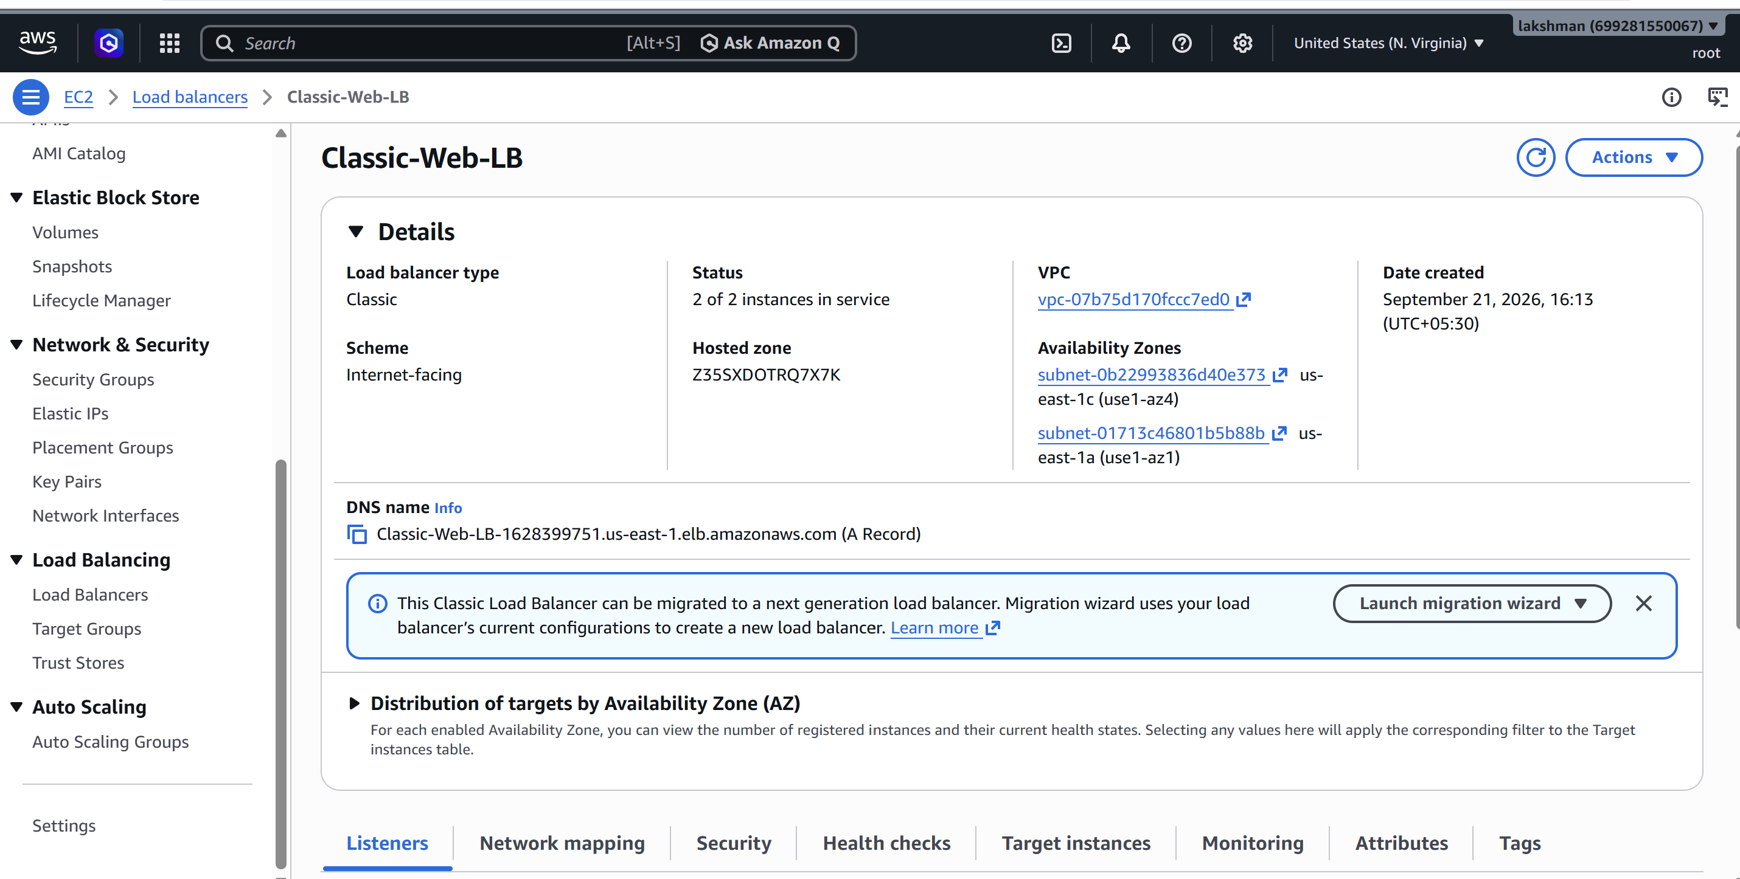

4.2 Verify the CLB
- Wait until the load balancer state is Active.
- Check the registered instances and their health.
- Open the CLB DNS name in a browser.
- Confirm that the request reaches a healthy EC2 web server.
- If the instance is unhealthy, verify the web server, instance security group, subnet routing, and health-check path. 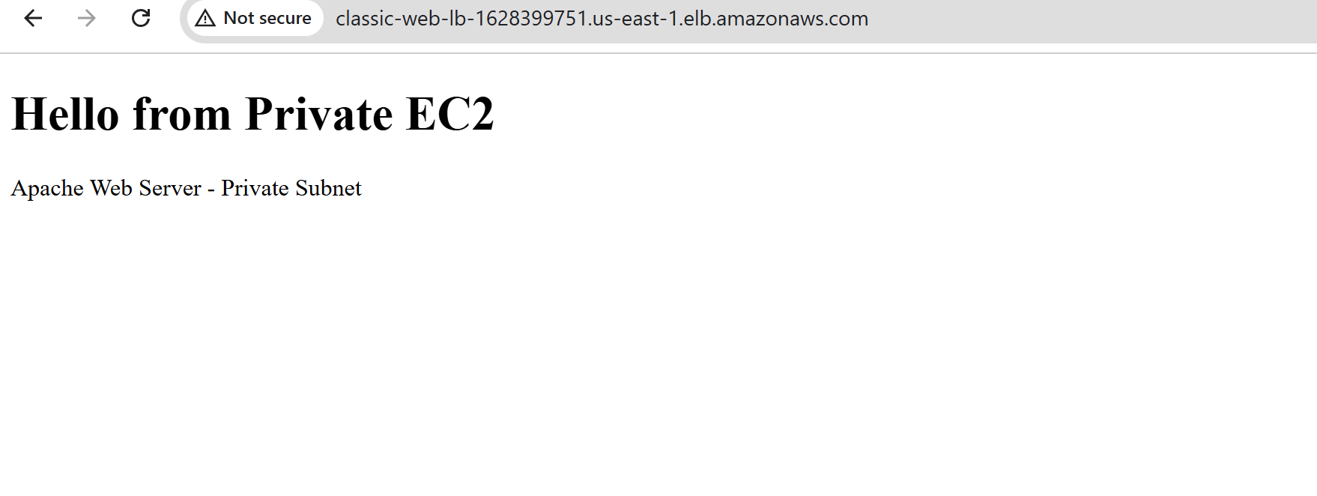

5. Task 2 – Configure an Application Load Balancer
An ALB operates at Layer 7 and supports HTTP/HTTPS routing, host-based routing, path-based routing, redirects, and modern application traffic patterns.

5.1 Create the Target Group
1. EC2 Console → Target Groups → Create target group.
2. Choose Instances as the target type.
3. Select HTTP as the protocol and port 80.
4. Select the correct VPC.
5. Set a target group name such as Apache-TG.
6. Health check protocol: HTTP.
7. Health check path: /.
8. Register the required EC2 instances and create the target group. 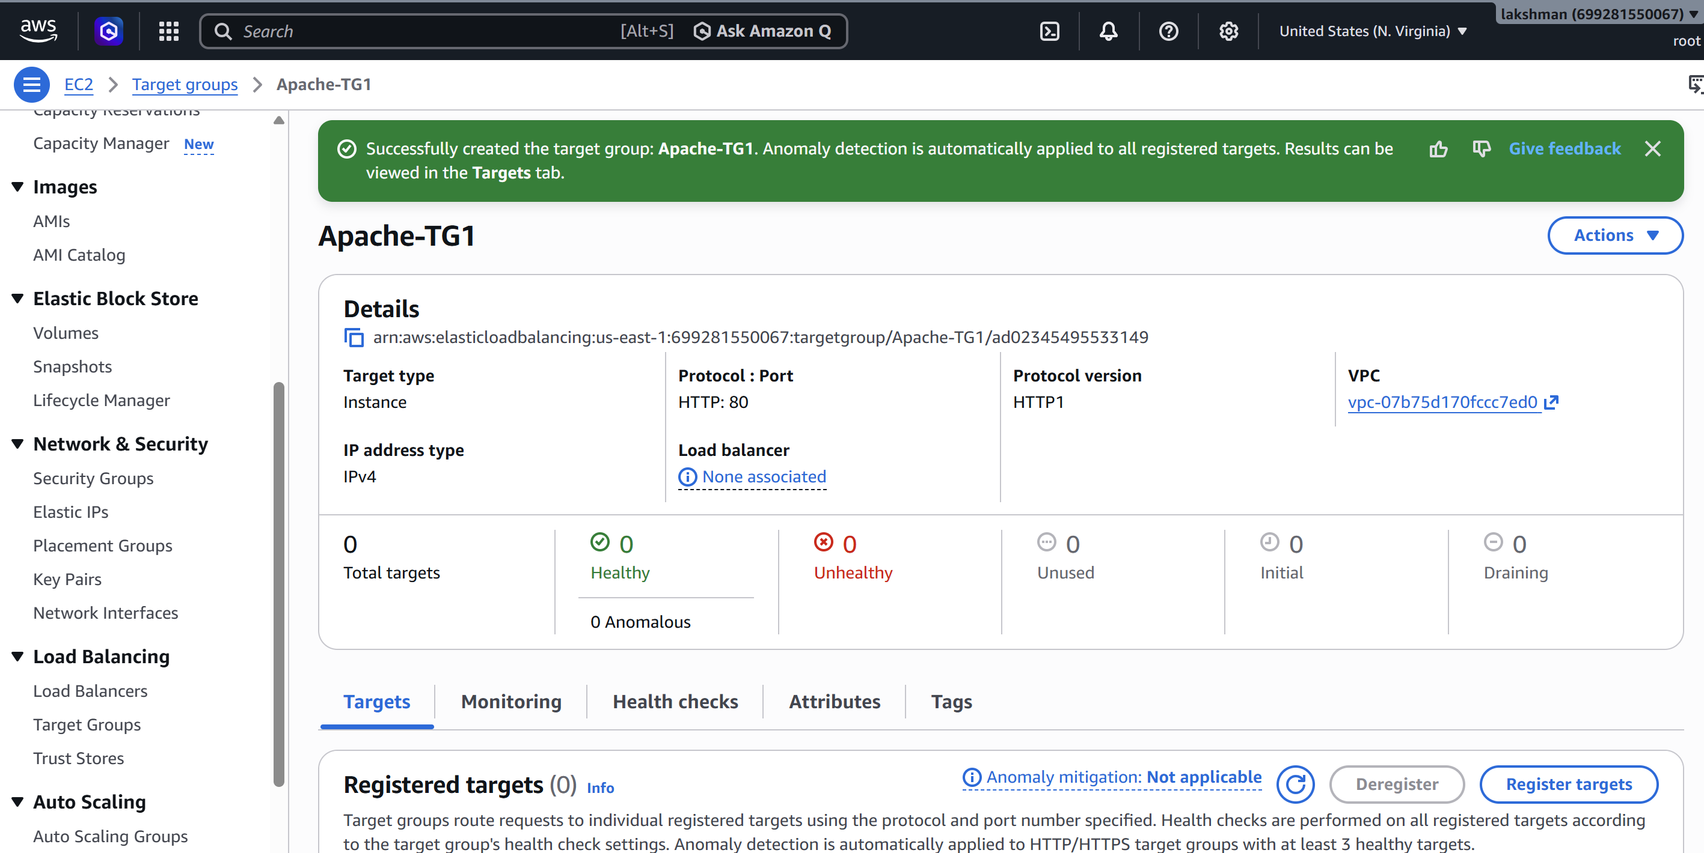

5.2 Create the ALB
1. EC2 → Load Balancers → Create Load Balancer → Application Load Balancer.
2. Name it, for example, Apache-ALB.
3. Choose Internet-facing for public client access, or Internal for private application traffic.
4. Select IPv4 unless dual-stack IPv6 is required.
5. Select the VPC and at least two subnets in different Availability Zones.
6. Select an ALB security group that permits HTTP 80 and, after SSL is configured, HTTPS 443.
7. Add an HTTP listener on port 80 and forward traffic to Apache-TG.
8. Create the load balancer. 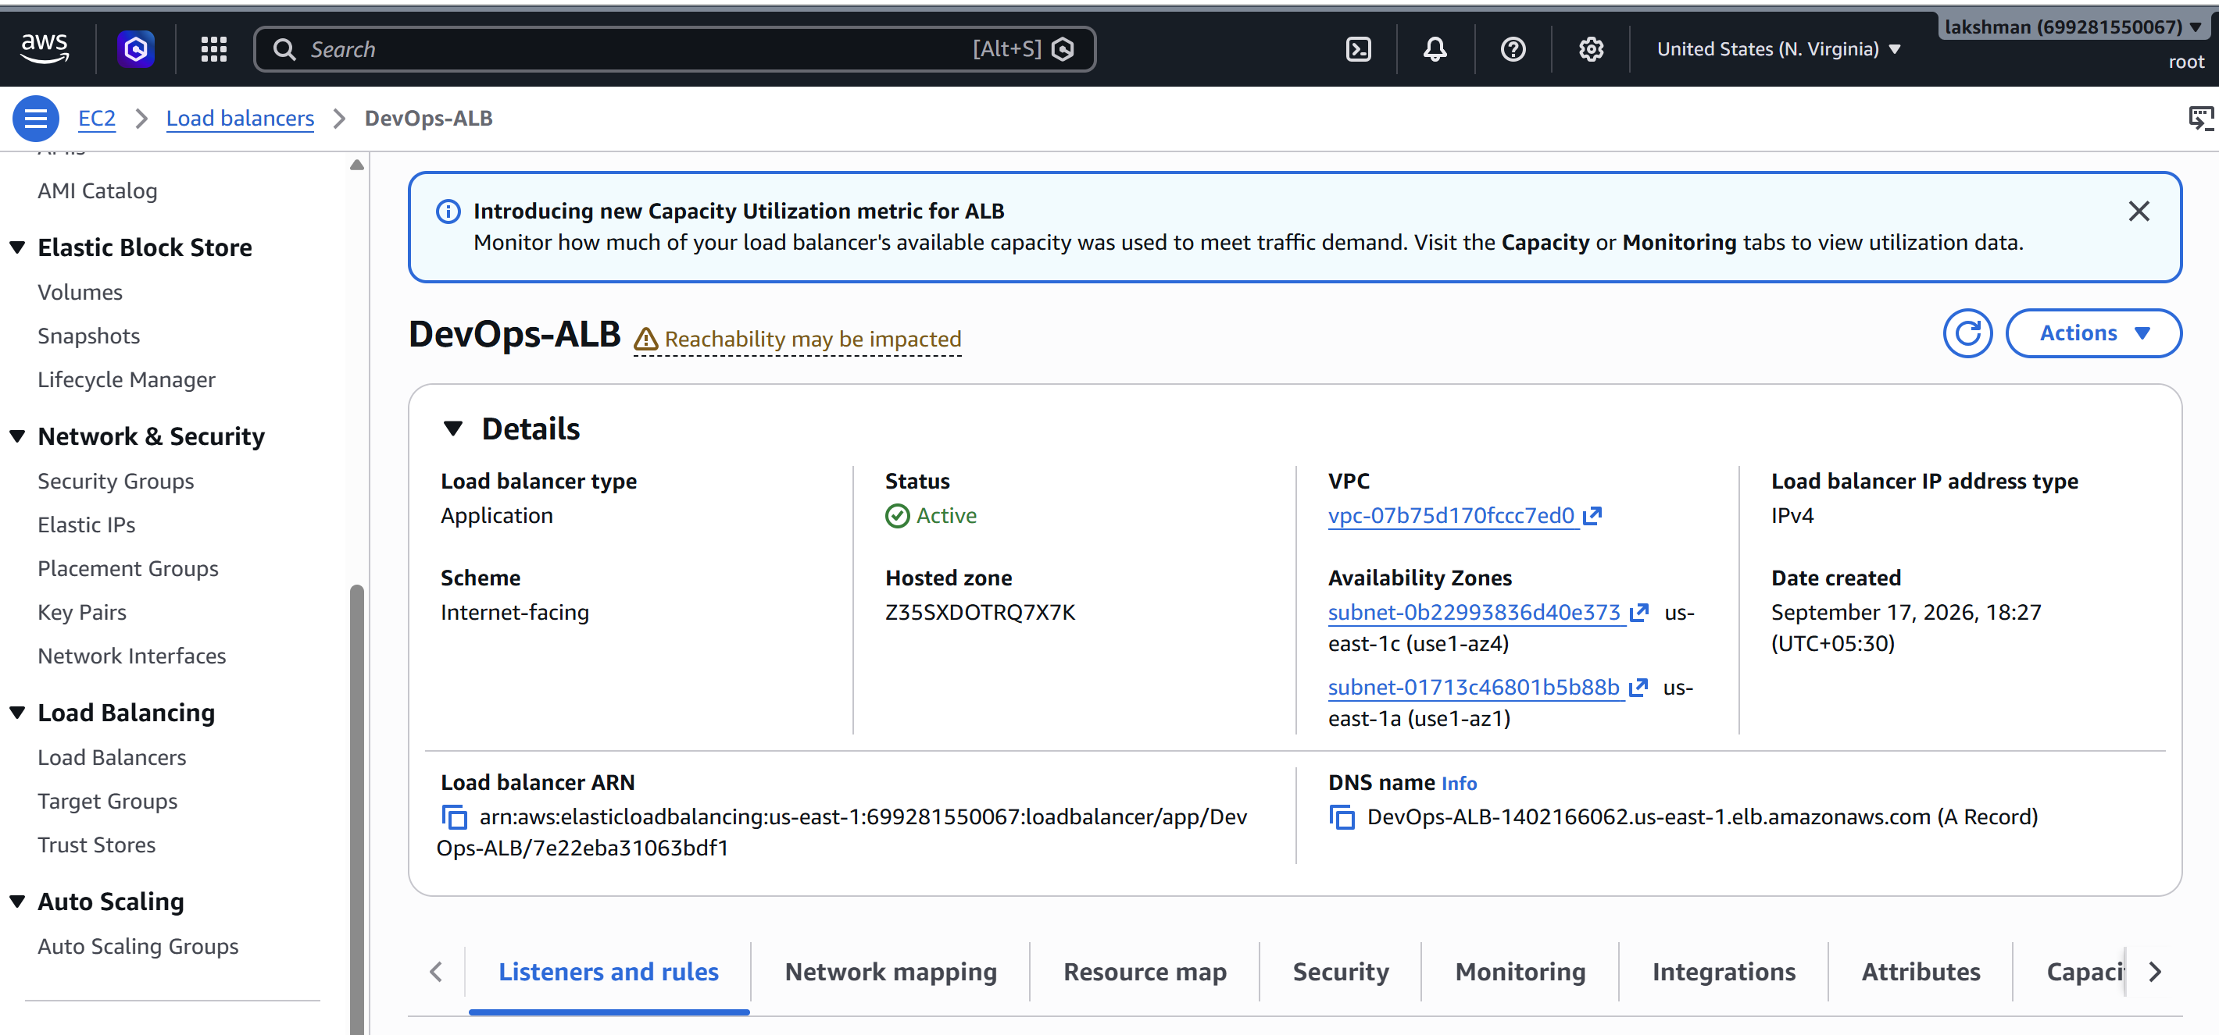

5.3 Verify ALB
- Wait for the ALB to become Active.
- Open Target Groups → Apache-TG → Targets and verify the targets are Healthy.
- Open the ALB DNS name and verify the application page.
- If targets are unhealthy, check that Apache is running and that EC2-SG allows port 80 from the ALB security group. 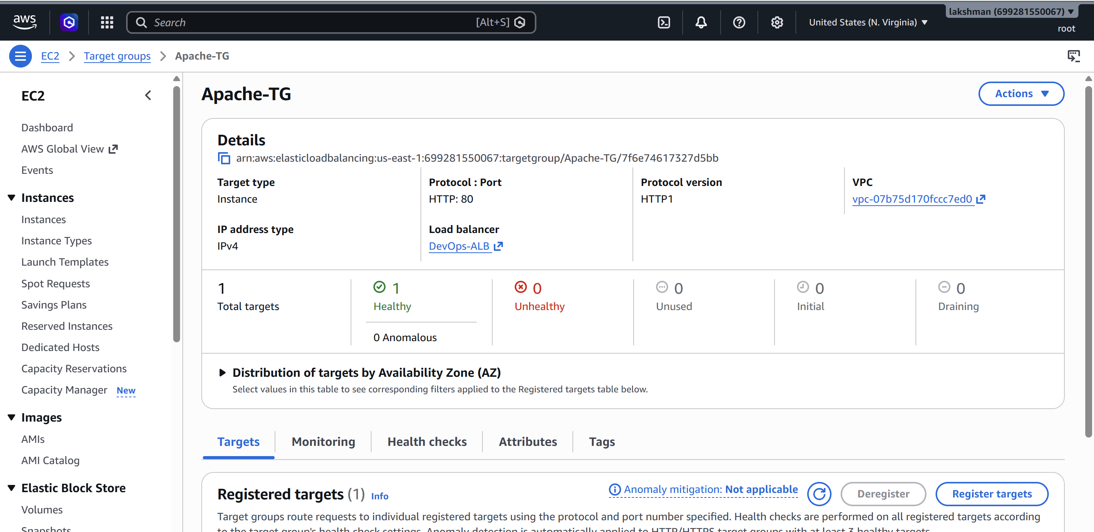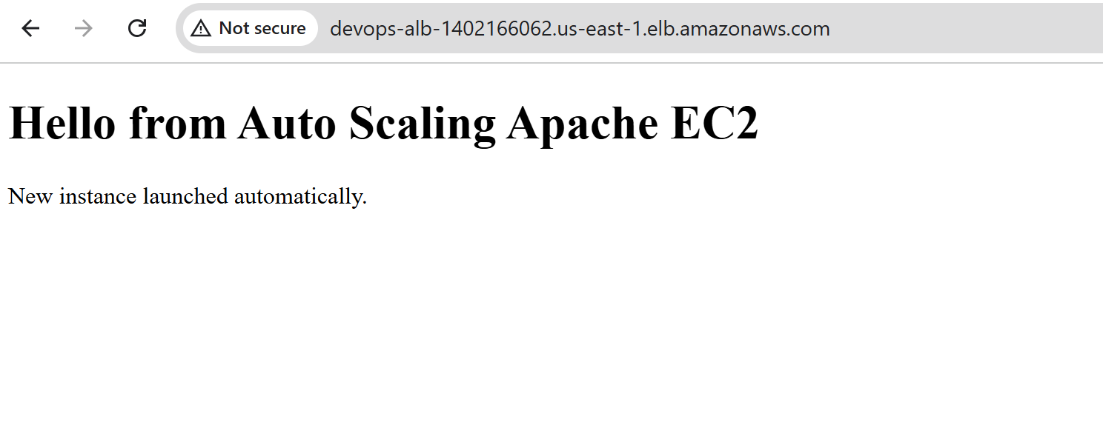

6. Task 3 – Configure a Network Load Balancer
A Network Load Balancer operates at Layer 4 and is designed for high-performance TCP/UDP/TLS traffic and use cases that need static IP addresses or very high connection rates.

6.1 Create the NLB Target Group
1. EC2 → Target Groups → Create target group.
2. Select Instances.
3. Choose TCP as the protocol and the application port, for example 80.
4. Select the VPC.
5. Configure health checks, for example TCP or HTTP depending on the application.
6. Register the EC2 instances and create the target group. 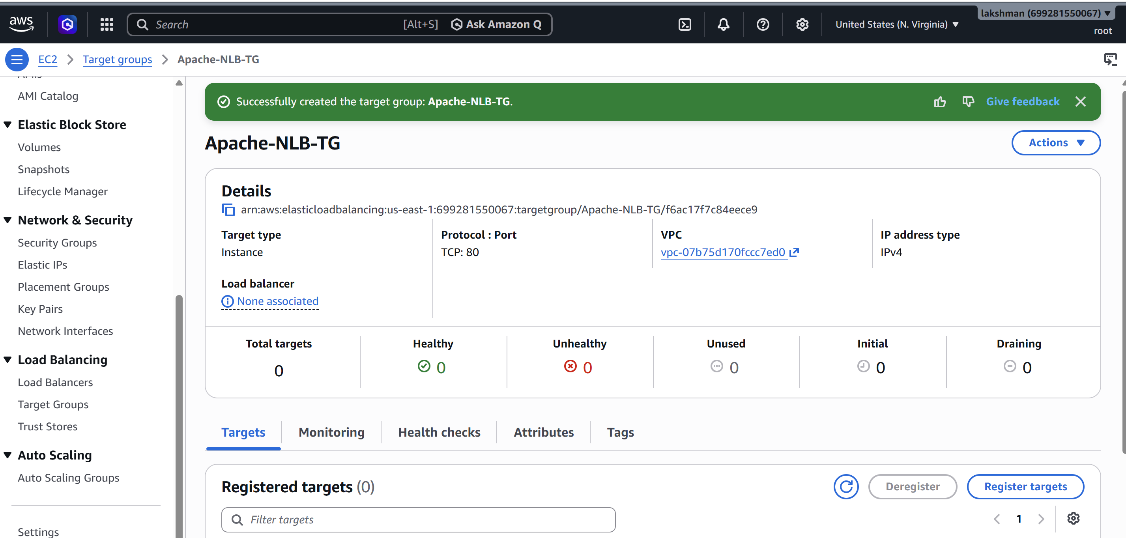

6.2 Create the NLB
1. EC2 → Load Balancers → Create Load Balancer → Network Load Balancer.
2. Enter a name such as Apache-NLB.
3. Choose Internet-facing or Internal as required.
4. Select the VPC and Availability Zone subnets.
5. Create a listener such as TCP : 80 and forward it to the NLB target group.
6. Review and create the NLB. 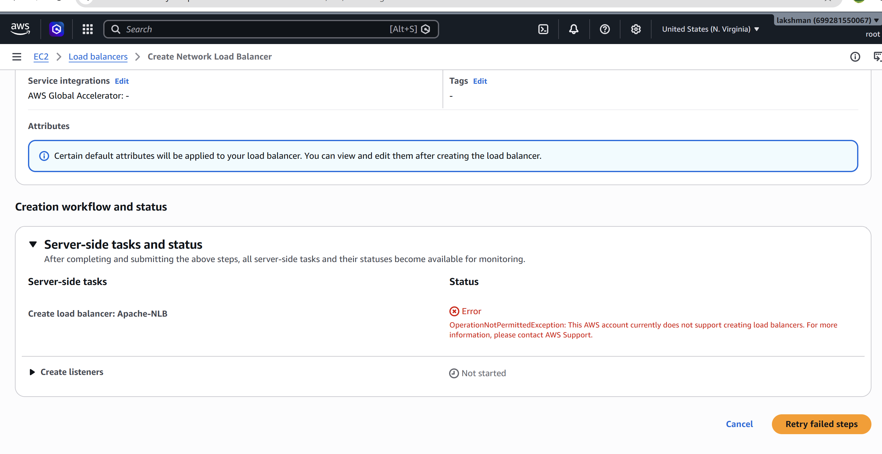

6.3 Verify NLB
- Confirm the NLB state is Active.
- Confirm targets are healthy.
- Use the NLB DNS name to test the application.
- For TCP traffic, make sure the target instance security group/network ACL permits the application traffic.

7. Task 4 – Attach SSL/TLS to the Application Load Balancer
Use AWS Certificate Manager (ACM) to request or import a certificate. For an internet-facing ALB, request the certificate in the same AWS Region as the ALB.

7.1 Request an ACM Certificate
1. Open AWS Certificate Manager (ACM).
2. Choose Request → Request a public certificate.
3. Enter the DNS name, for example app.example.com. Add a wildcard such as *.example.com only if required.
4. Choose DNS validation.
5. Create the certificate request.
6. If the domain is hosted in Route 53, choose Create records in Route 53 when available.
7. Wait until the certificate status becomes Issued. 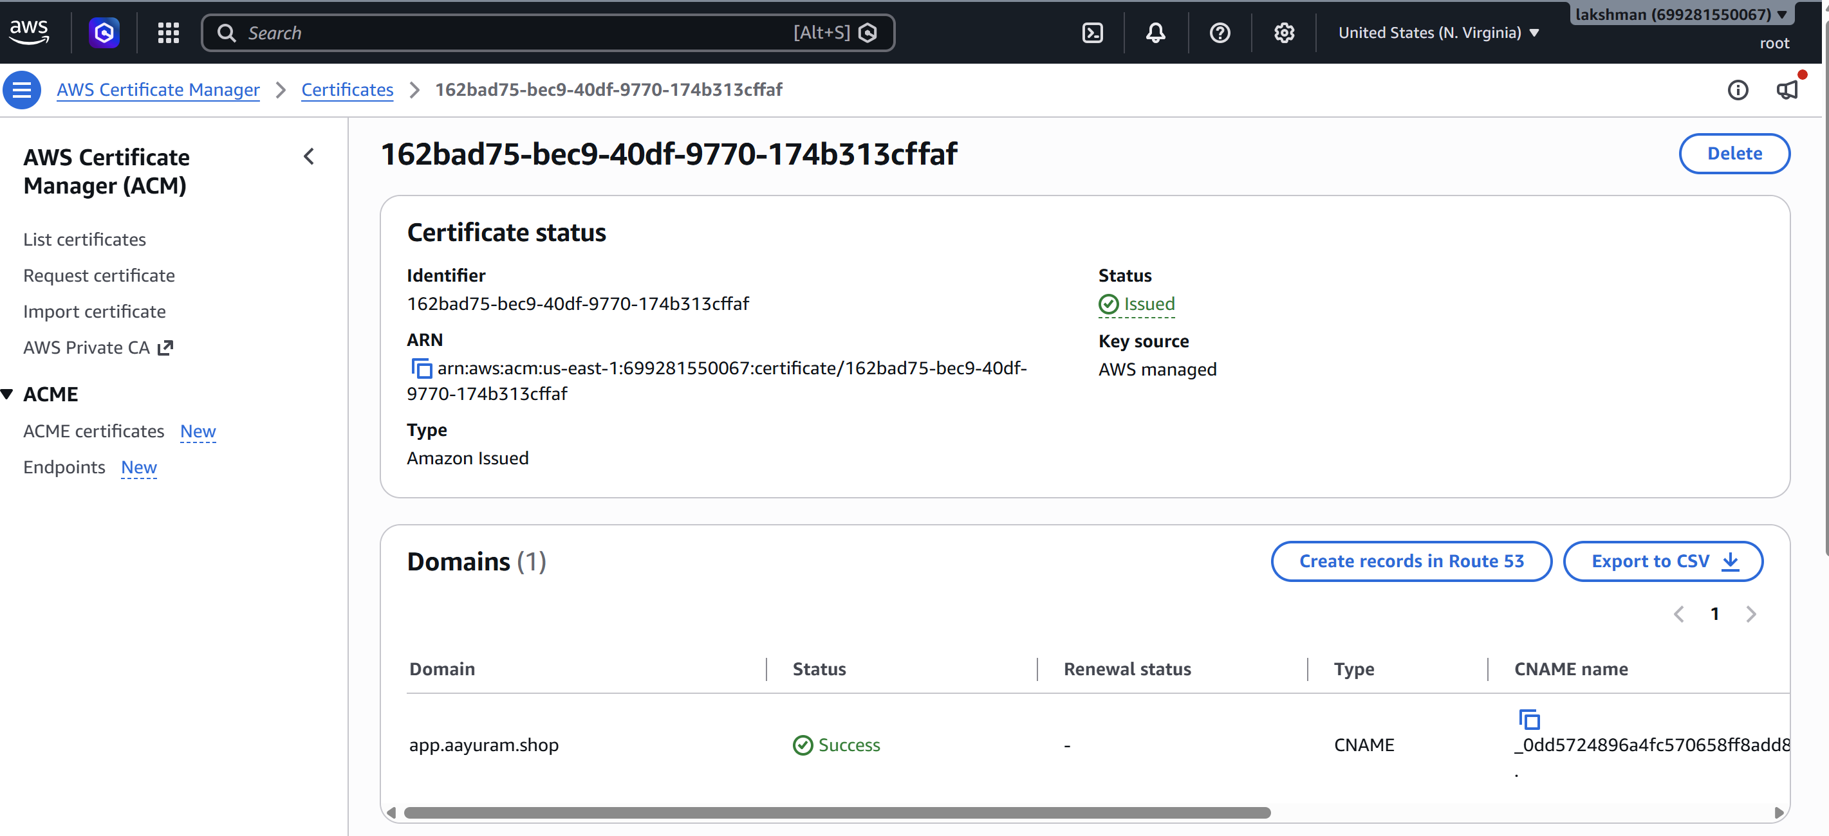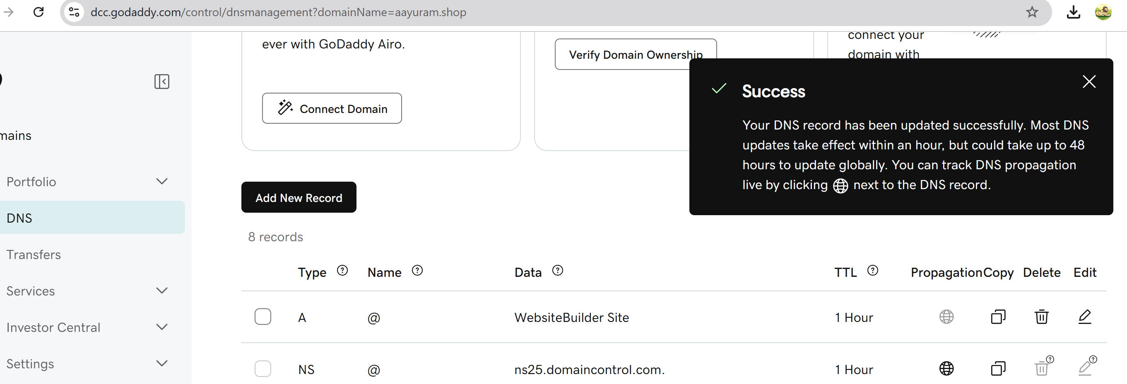

7.2 Add HTTPS to the ALB
1. EC2 → Load Balancers → select the ALB → Listeners and rules.
2. Add listener → HTTPS : 443.
3. Select the ACM certificate.
4. Set the default action to Forward to Apache-TG.
5. Save the listener.
6. Optional: edit the HTTP : 80 listener to Redirect HTTP to HTTPS, using HTTPS port 443.
Security group requirement: ALB-SG should allow TCP 443 from the intended clients. EC2-SG should allow application traffic from ALB-SG rather than from the whole internet. 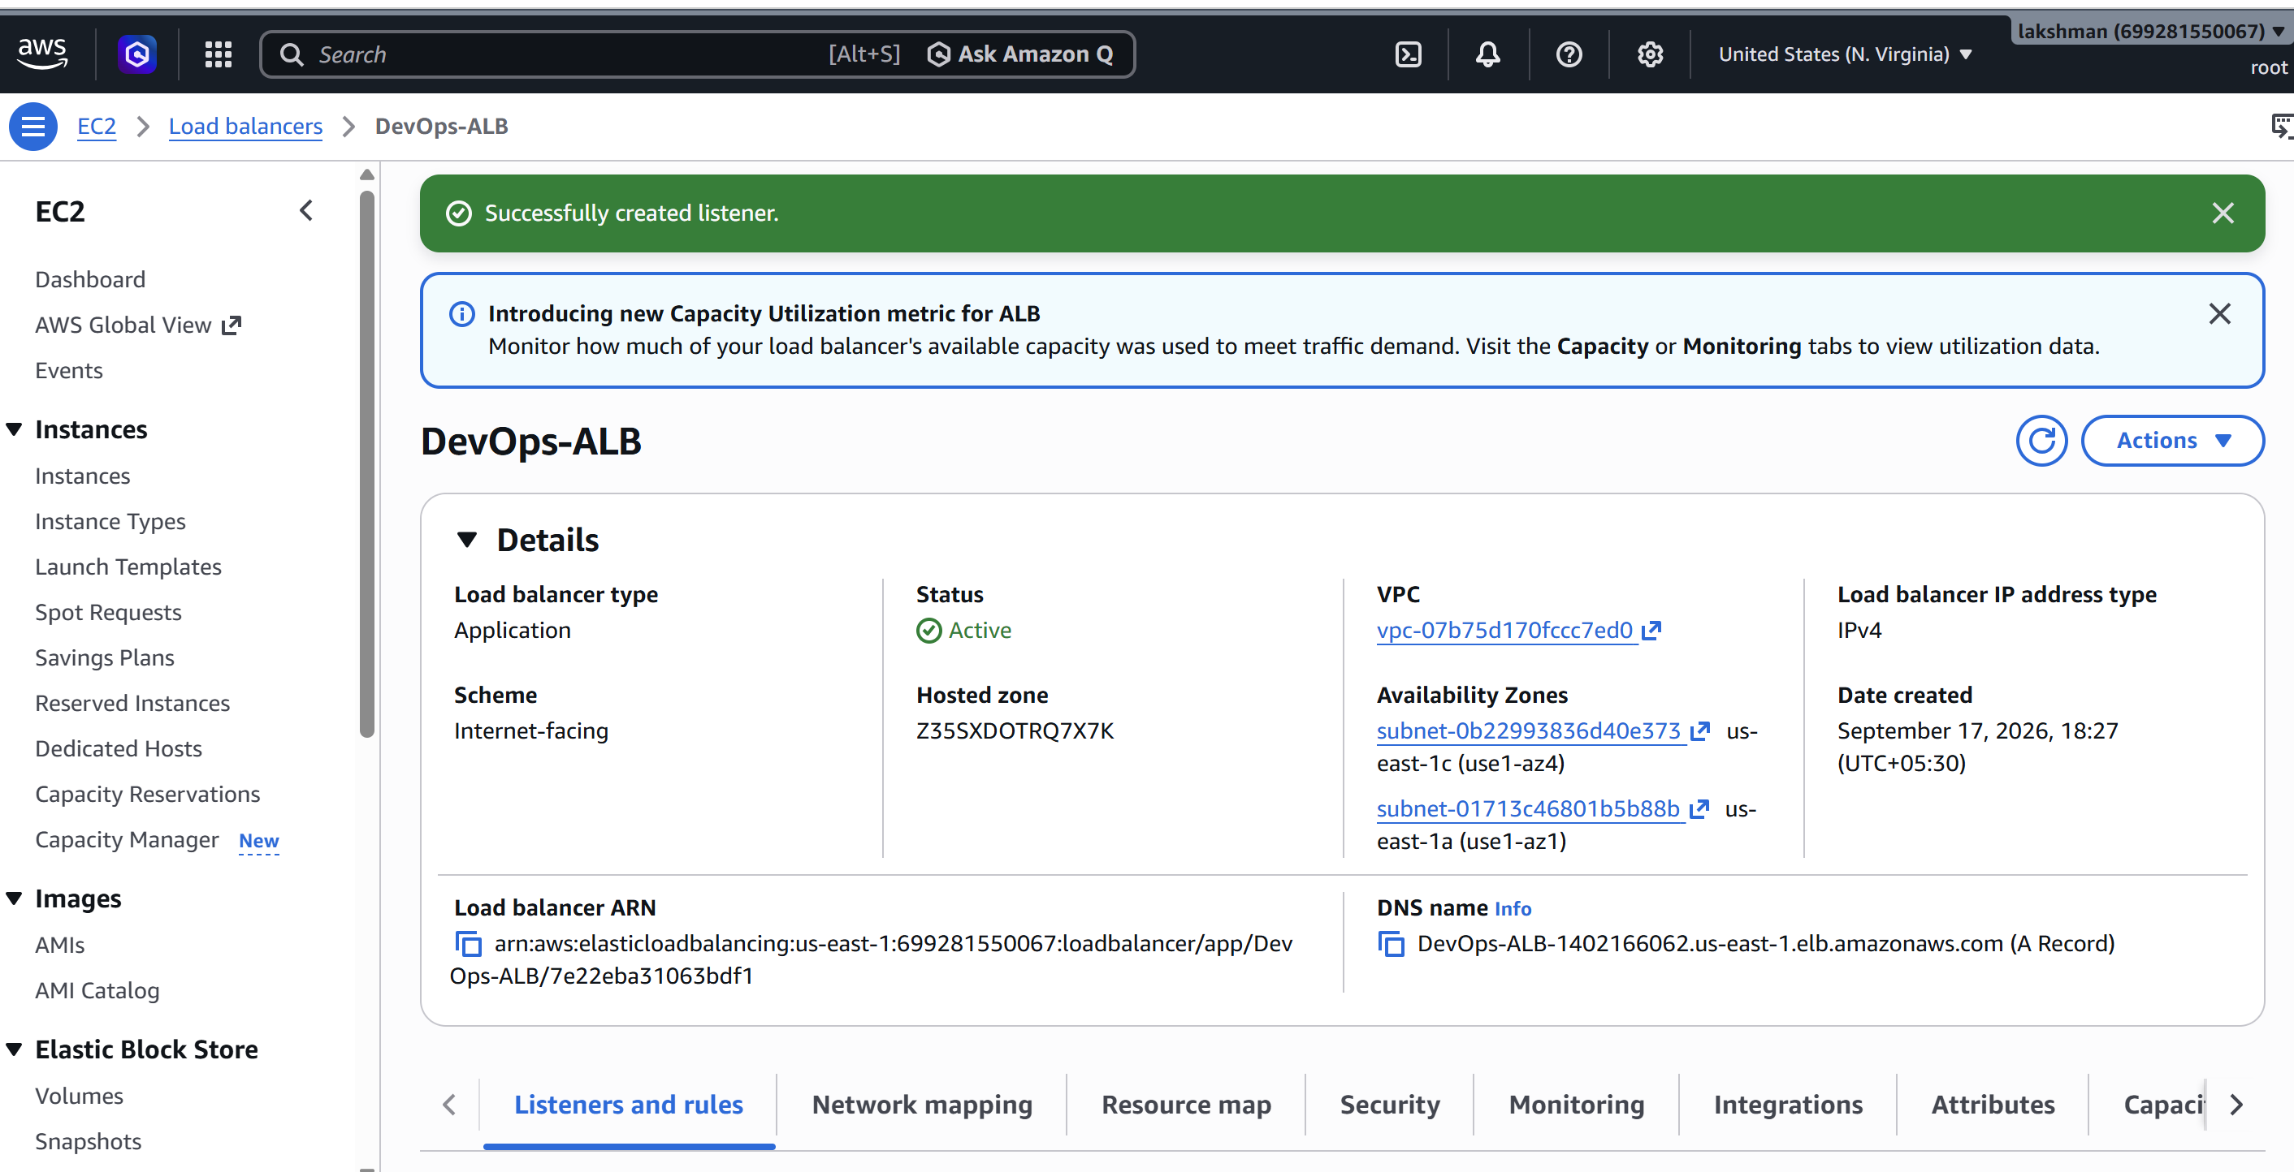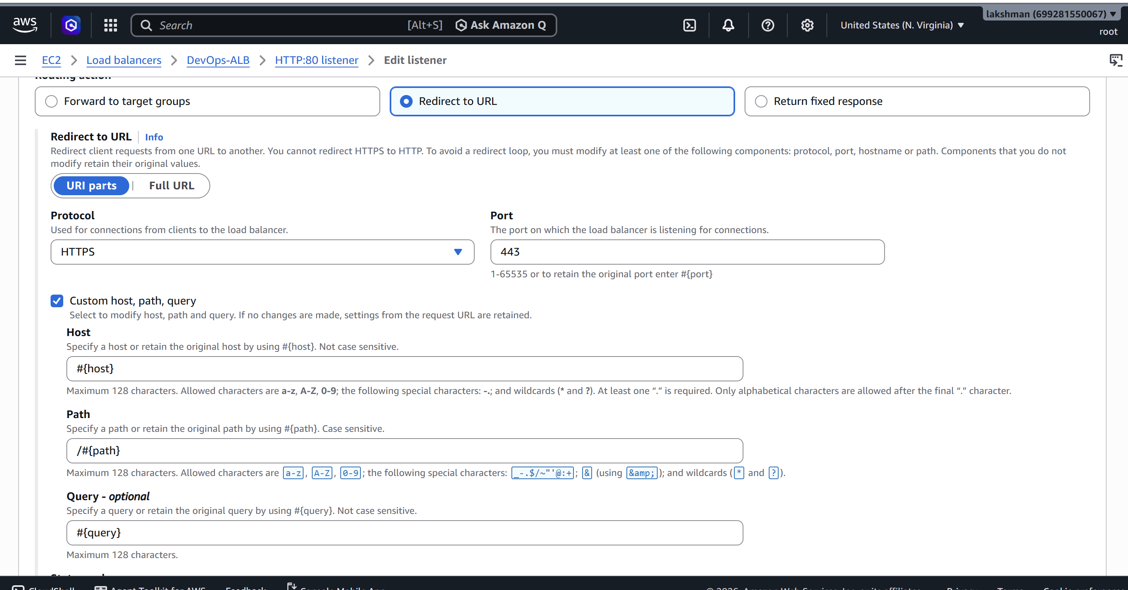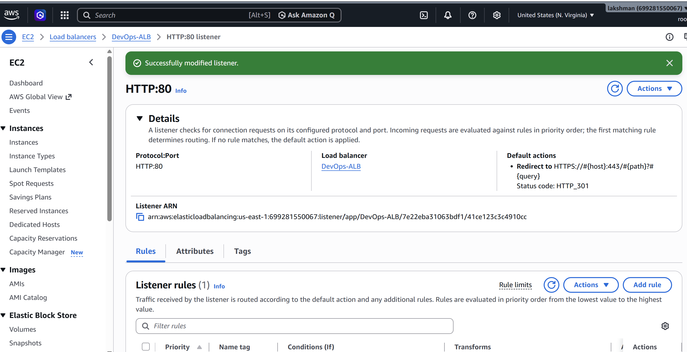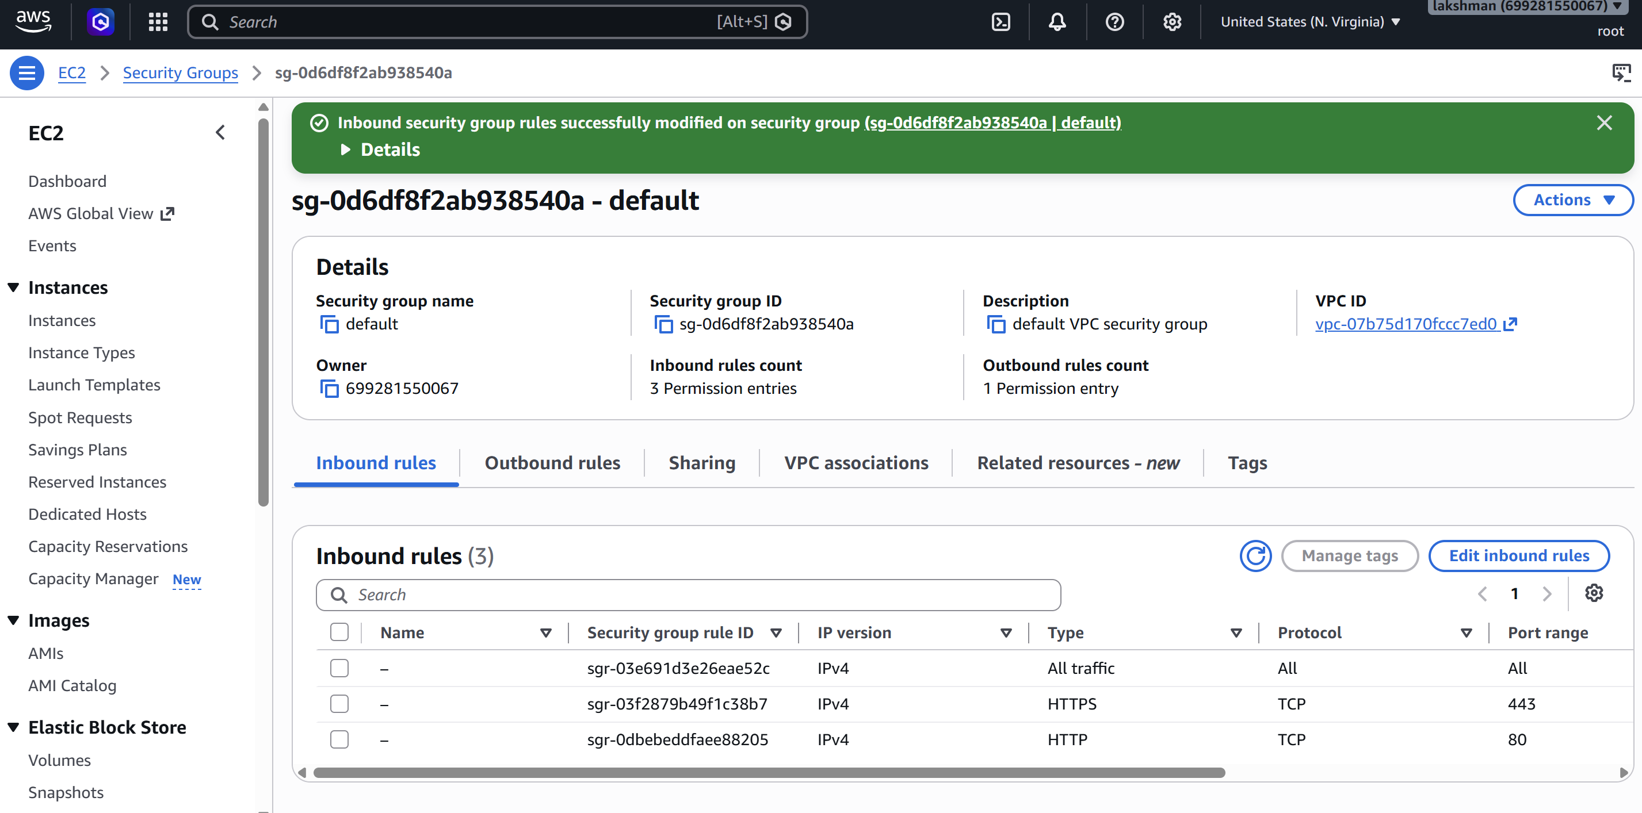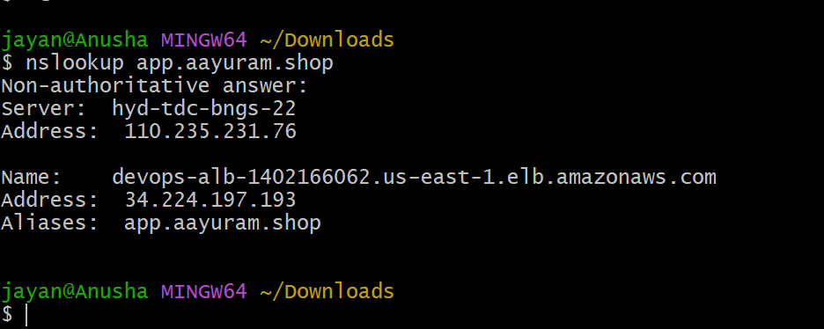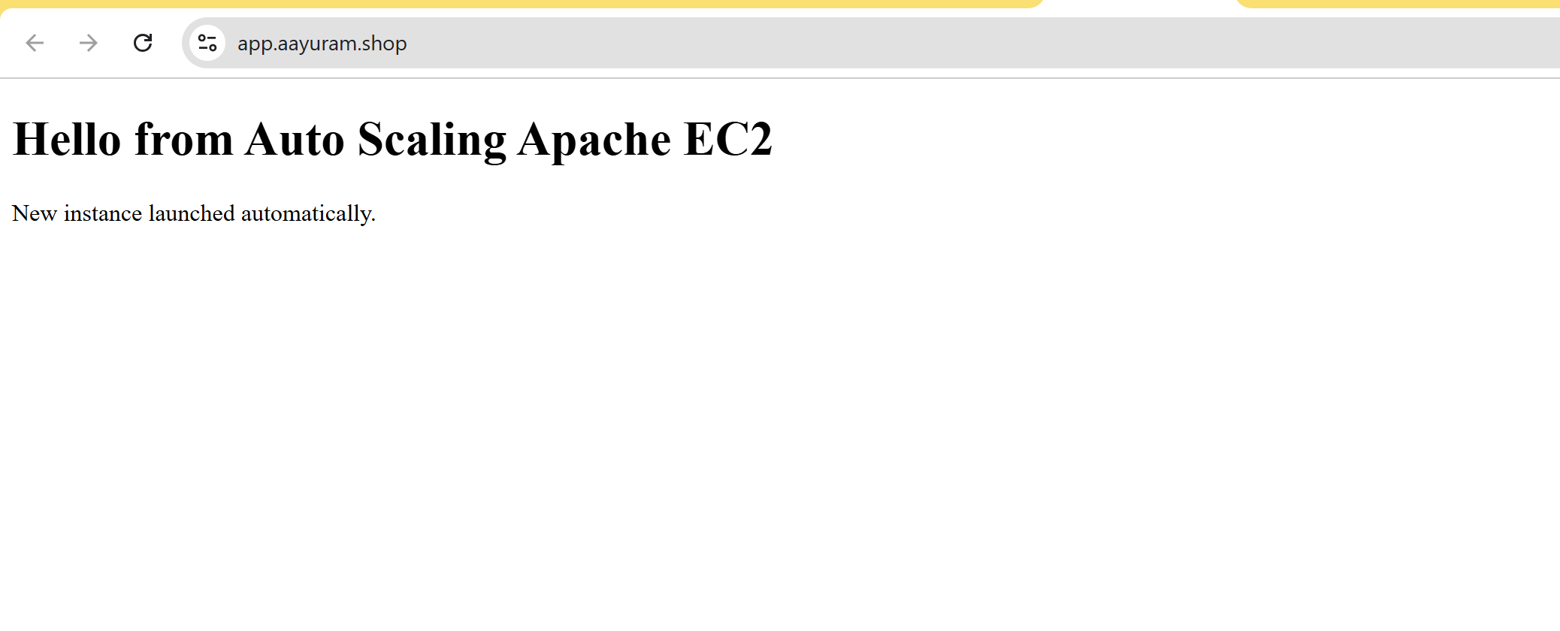

8. Task 5 – Map the Application Load Balancer to Route 53
1. Open Route 53 → Hosted zones.
2. Open the hosted zone for your domain.
3. Choose Create record.
4. Enter the record name, for example app.
5. Record type: A – IPv4 address.
6. Enable Alias.
7. Choose Alias to Application Load Balancer.
8. Select the AWS Region and the ALB.
9. Create the record.
10. Test the DNS name, for example https://app.example.com.
For IPv6 clients, create an AAAA Alias record pointing to the same ALB when appropriate.
Note: Route 53 Alias records are preferred for AWS load balancers because the record points to the load balancer without requiring you to manage changing load-balancer IP addresses. 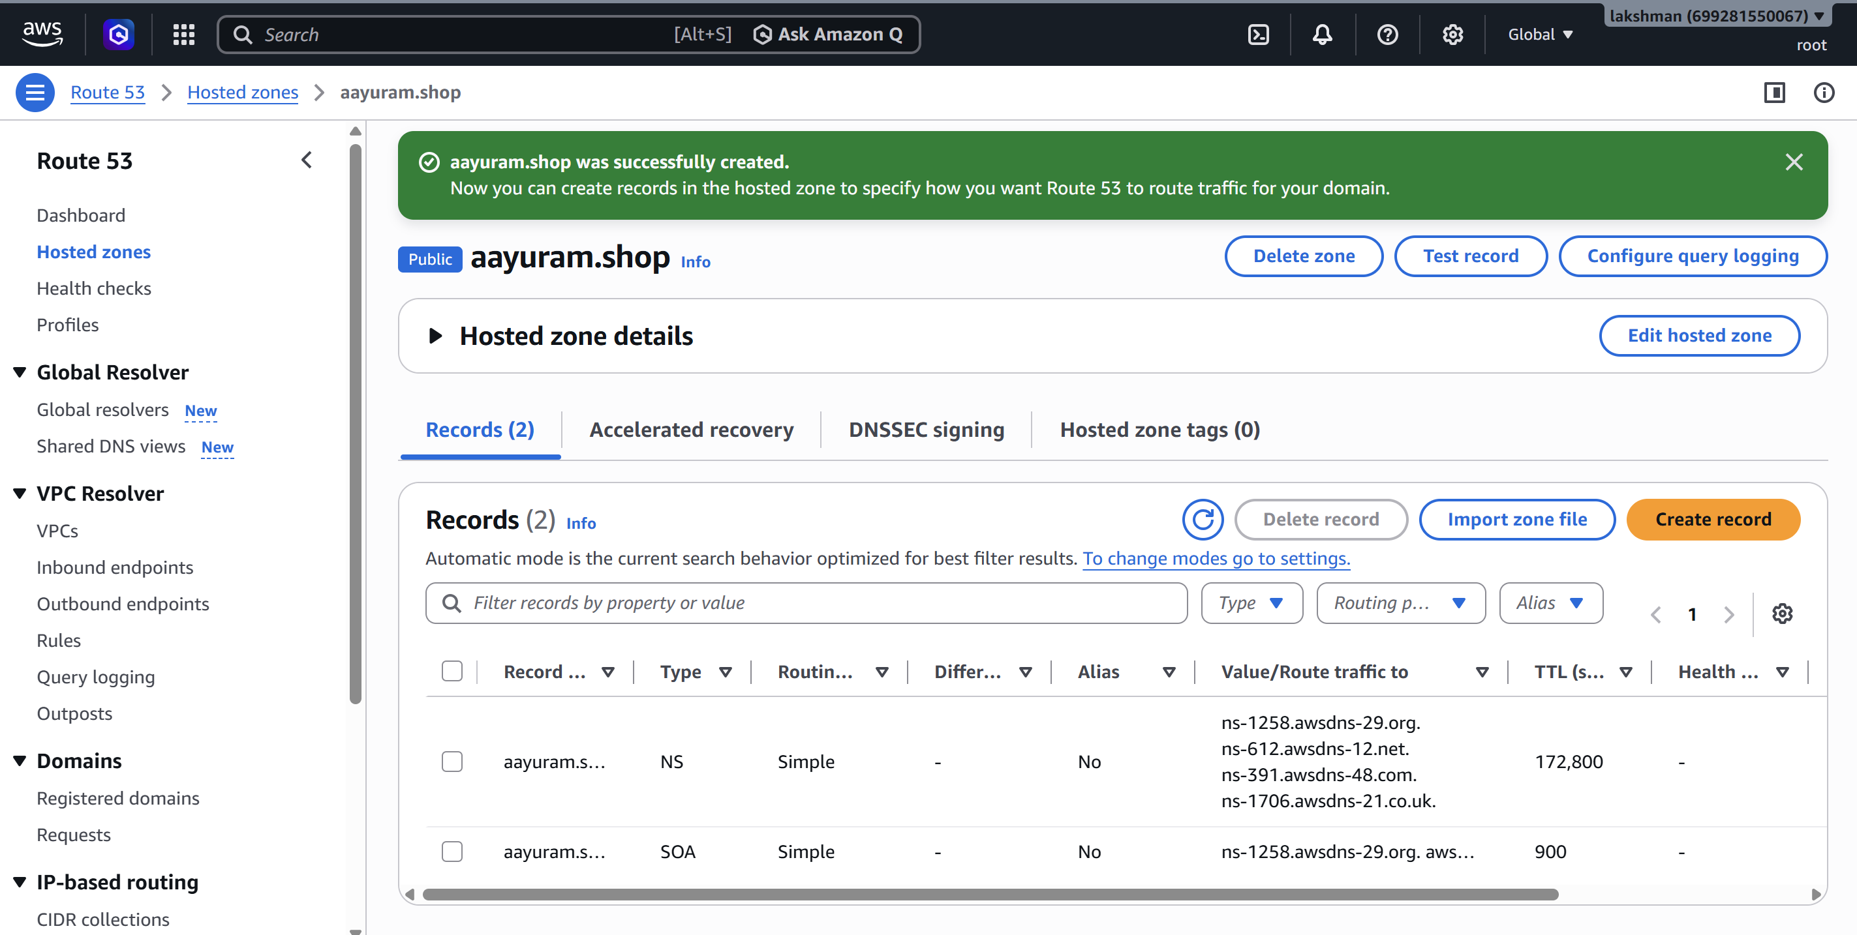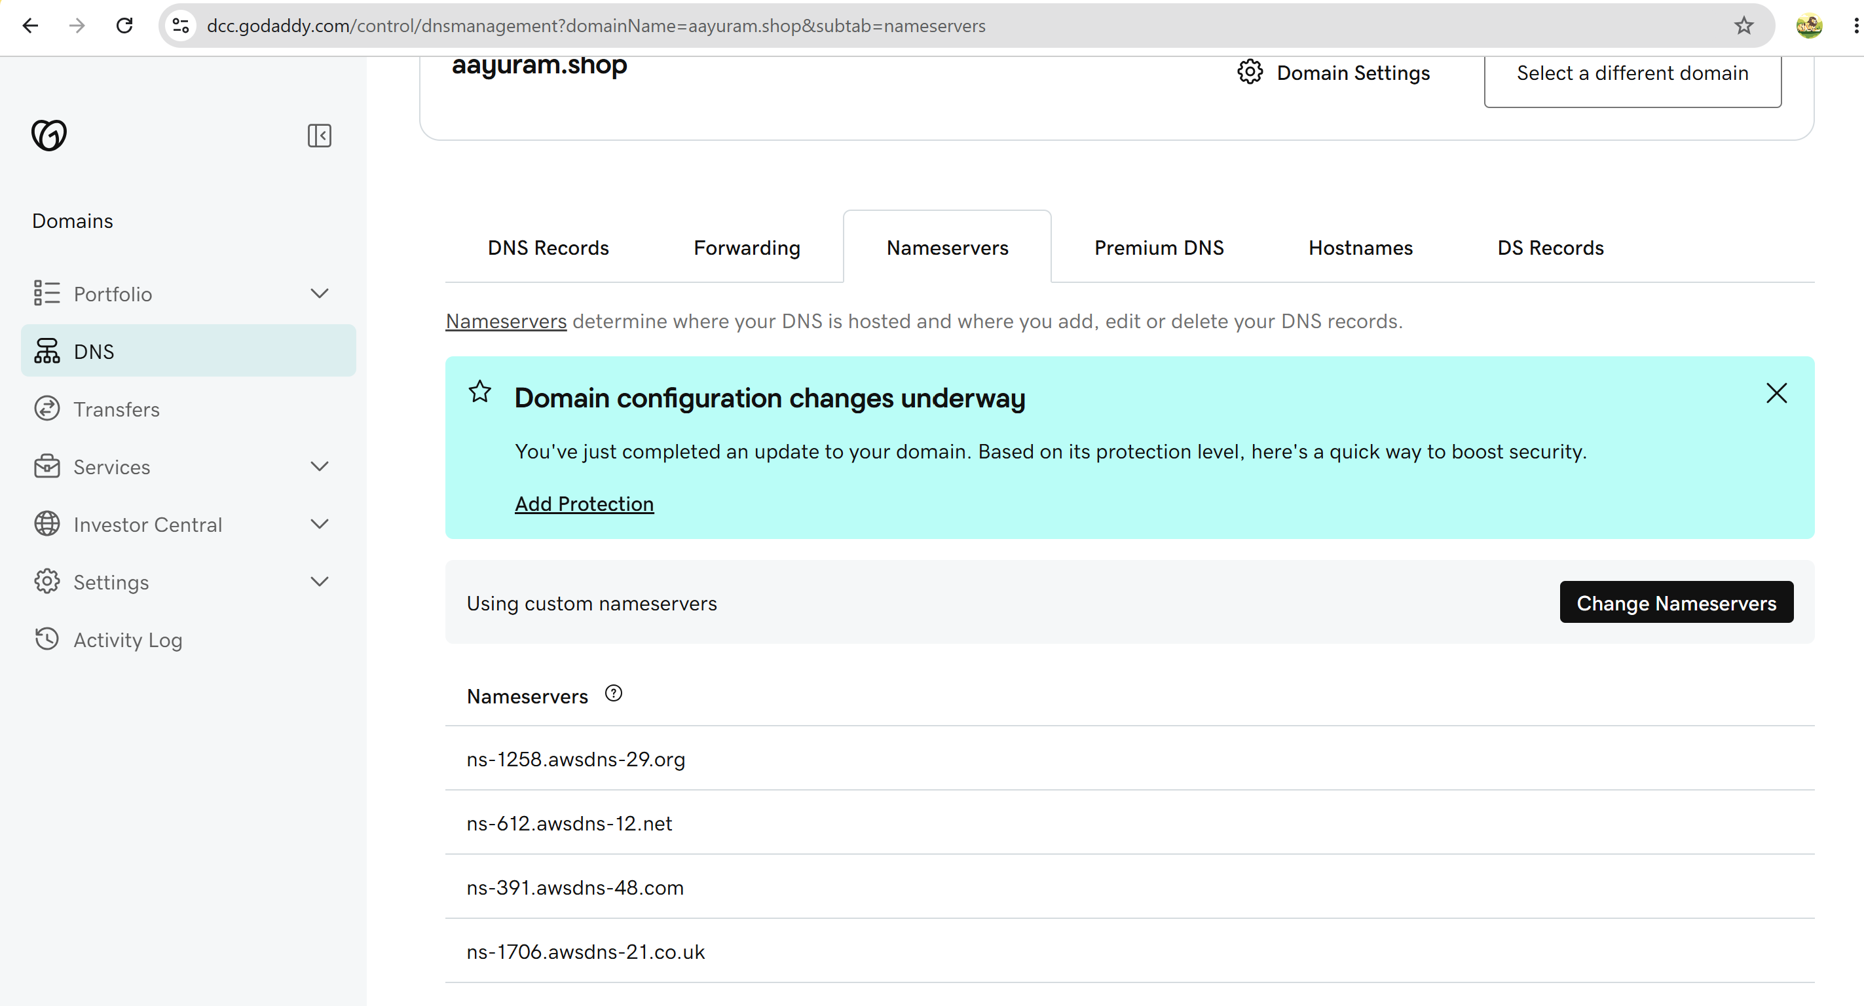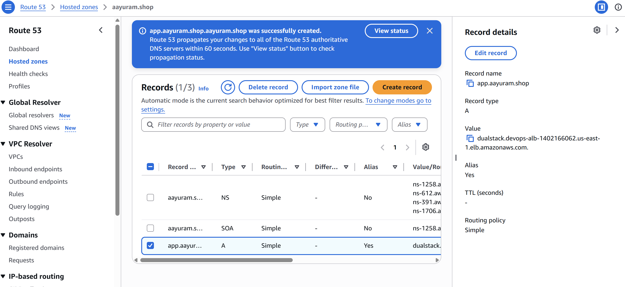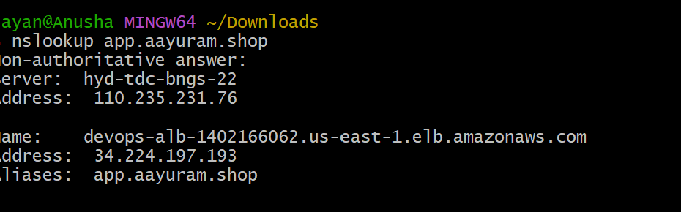

9. Task 6 – Push ALB Access Logs to S3
ALB access logging writes request information to Amazon S3. The S3 bucket must be in the same AWS Region as the load balancer.

9.1 Create the S3 Bucket
1. Open S3 → Create bucket.
2. Choose a globally unique bucket name, for example devops-alb-logs-2026-yourname.
3. Select the same Region as the ALB.
4. Keep Block Public Access enabled. ALB logging does not require making the bucket public.
5. Create the bucket.
6. Do not use S3 Object Ownership settings that prevent the AWS logging service from delivering logs; follow the current ALB logging documentation for the required bucket policy. 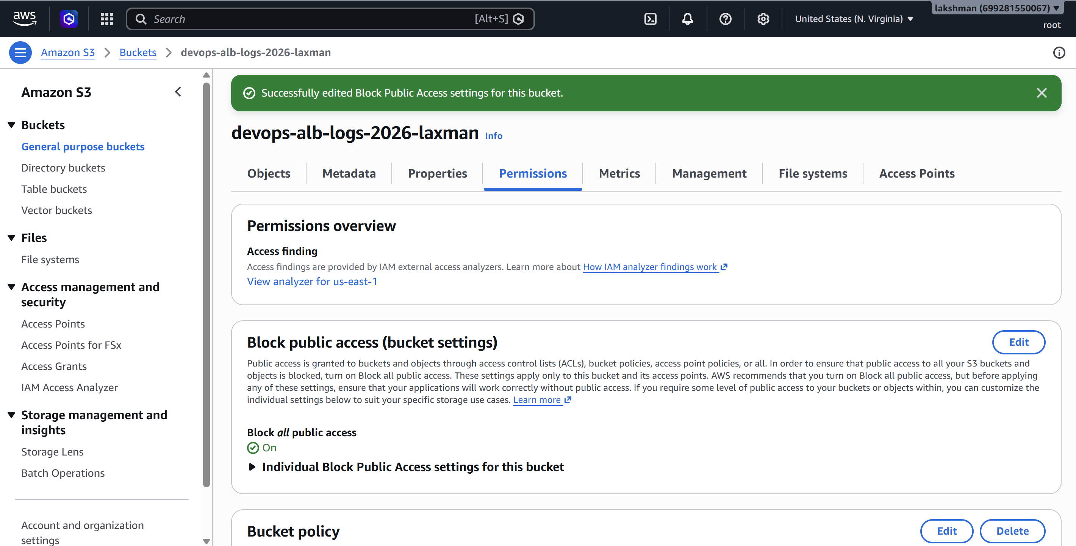 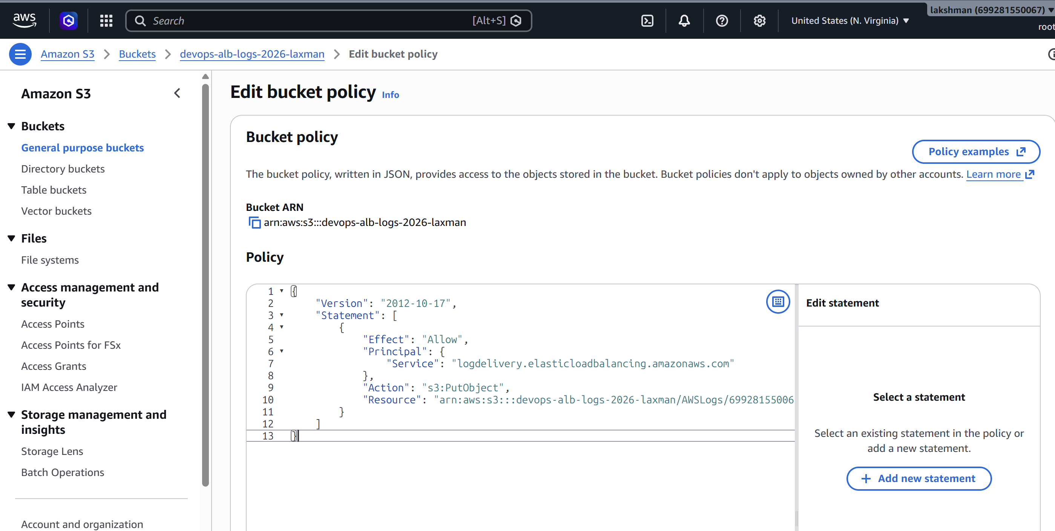

9.2 Enable ALB Access Logging
1. EC2 → Load Balancers → select the Application Load Balancer.
2. Open the Attributes section.
3. Find Access logs.
4. Enable access logs.
5. Select the S3 bucket created for ALB logs.
6. Optionally specify a prefix such as alb-logs.
7. Save changes. 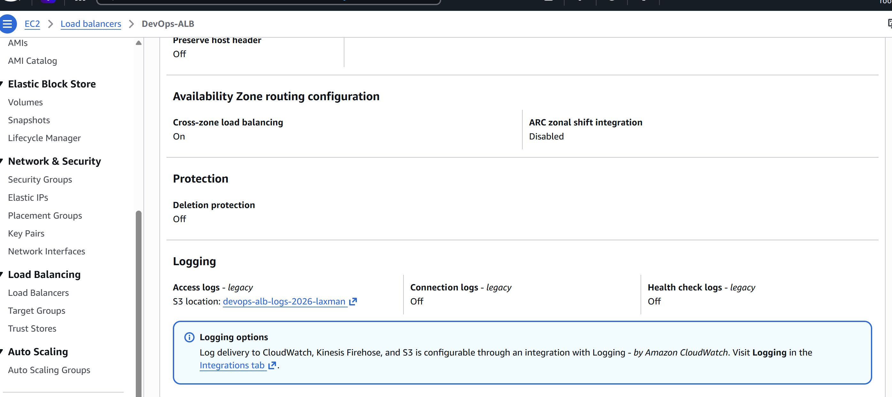

9.3 Verify Logs
- Generate several requests to the ALB or Route 53 DNS name.
- Wait for log delivery; logs are not necessarily visible immediately.
- Open S3 and browse the bucket/prefix.
- Confirm that ALB log objects are being created.
- Review the log records for client address, request time, target information, status codes, and request details. 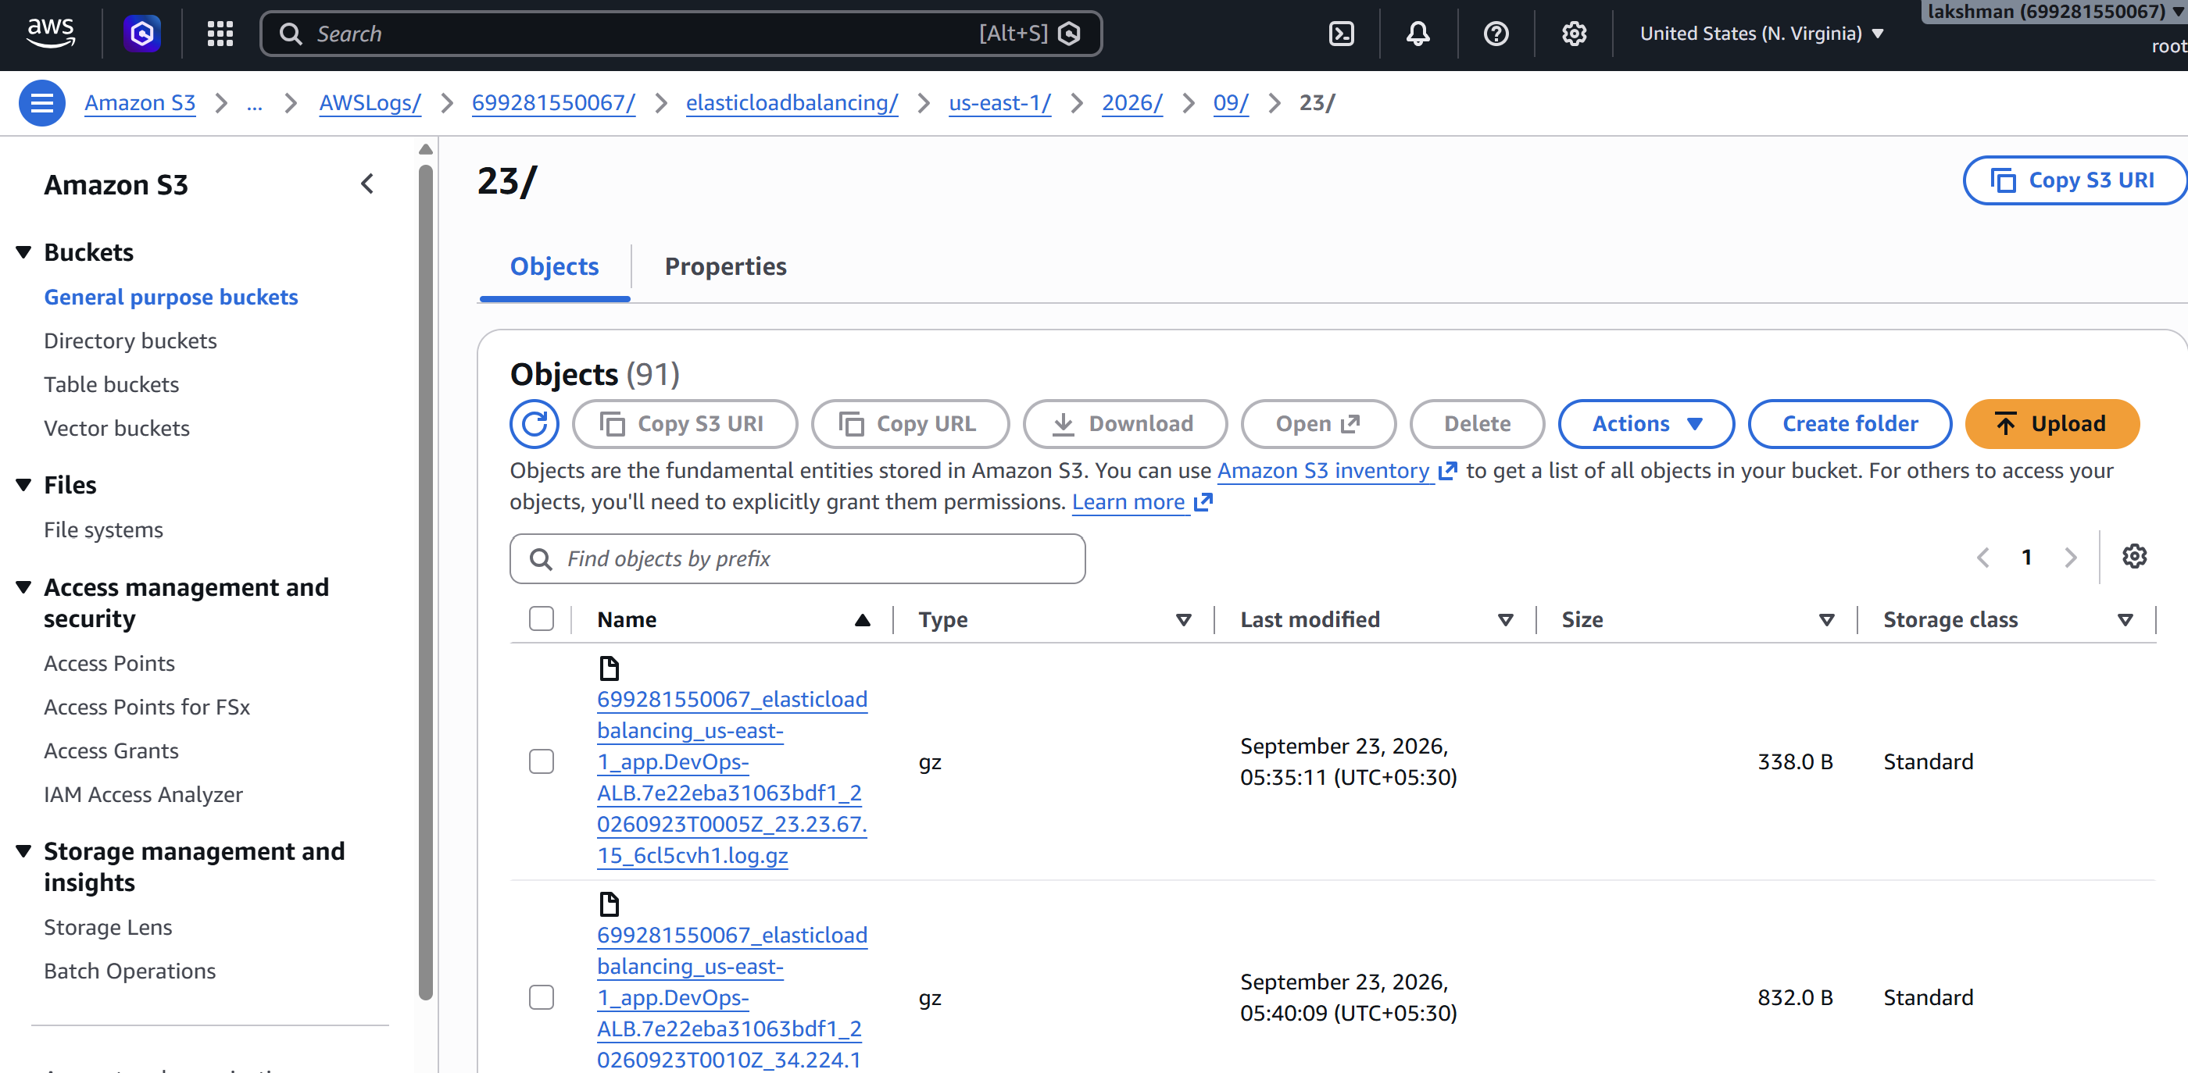

10. Recommended Security Groups
Component | Protocol/Port | Source | Purpose
ALB-SG | TCP 80 | 0.0.0.0/0 (if public HTTP) | HTTP access / redirect
ALB-SG | TCP 443 | 0.0.0.0/0 (if public HTTPS) | HTTPS access
EC2-SG | TCP 80 | ALB-SG | Application traffic from ALB
EC2-SG | TCP 22 | Approved admin source only | Administration, if required

11. End-to-End Validation Checklist
☐ CLB is Active and registered instances are healthy.
☐ ALB is Active and target group targets are Healthy.
☐ NLB is Active and its target group is Healthy.
☐ HTTP request to the ALB reaches the application.
☐ HTTPS listener on port 443 is Active and uses an ACM certificate with status Issued.
☐ HTTP redirects to HTTPS if a redirect listener rule was configured.
☐ Route 53 A/AAAA Alias record resolves to the ALB.
☐ Application is reachable using the Route 53 DNS name.
☐ ALB access logging is enabled.
☐ ALB log objects appear in the S3 bucket.
☐ EC2 instances are not directly exposed to the internet when private-subnet architecture is used.

12. Troubleshooting
Problem | Checks
Targets unhealthy | Check Apache/Nginx is running, verify the health-check path, confirm EC2-SG allows traffic from ALB-SG, and verify the instance is listening on the expected port.
ALB DNS works but application fails | Check target health, listener forwarding action, target-group port, and instance web-server status.
HTTPS certificate cannot be selected | Confirm ACM certificate is Issued and is in the same Region as the ALB.
Route 53 name does not work | Check the hosted zone, Alias target, record name, DNS propagation, and that the ALB is Active.
ALB logs are not appearing in S3 | Verify logging is enabled, bucket Region matches the ALB Region, bucket permissions/policy meet the current ALB logging requirements, and allow time for delivery.
NLB traffic fails | Check listener/target-group ports, target health, NACLs, security groups, and whether the selected protocol matches the application.

13. Final Architecture Flow
Client
|
| HTTPS 443
v
Route 53 (app.example.com)
| Alias
v
Application Load Balancer
|
+--> Listener 443 + ACM certificate
|
v
Target Group
|-------------------|
v v
EC2 in AZ-1 EC2 in AZ-2
Apache/Nginx Apache/Nginx

ALB Access Logs ---> S3

14. Important Notes
- Classic Load Balancer is a legacy option. For new HTTP/HTTPS application architectures, use an ALB unless a specific requirement calls for CLB.
- Use an NLB when Layer 4 behavior, TCP/UDP/TLS handling, very high performance, or static IP requirements are important.
- ACM certificates used by an ALB must be available in the same Region as the ALB.
- Keep EC2 application instances private when they do not need direct internet access.
- For production, place application instances in multiple Availability Zones and use health checks and Auto Scaling where appropriate.
- Review the current AWS documentation for the exact ALB-to-S3 log delivery bucket policy because AWS logging permissions and recommended policies can change.

End of Lab Document

