OPERATORS IN BASH SCRIPTING

Operators in Bash are symbols and keywords used to perform calculations, comparisons, logical operations, string operations, and file tests. They are commonly used with if statements, loops, and case statements.

1. Arithmetic Operators
Arithmetic operators are used to perform mathematical calculations.
Operator | Purpose | Example | Output
+ | Addition | echo $((10 + 5)) | 15
- | Subtraction | echo $((10 - 5)) | 5
* | Multiplication | echo $((10 * 5)) | 50
/ | Division | echo $((10 / 5)) | 2
% | Modulus (remainder) | echo $((10 % 3)) | 1
** | Exponentiation | echo $((2 ** 3)) | 8
Example script:
#!/bin/bash
a=20
b=5
echo "Addition: $((a + b))"
echo "Subtraction: $((a - b))"
echo "Multiplication: $((a * b))"
echo "Division: $((a / b))"
echo "Remainder: $((a % b))"
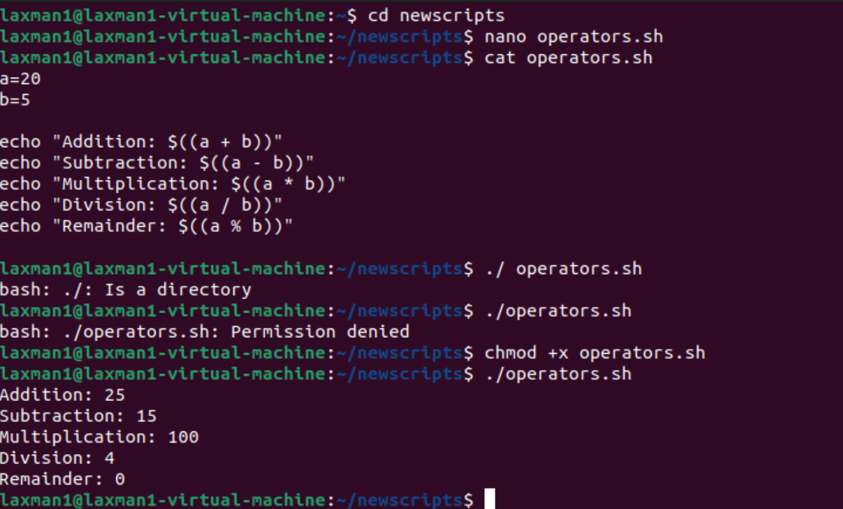

2. Relational / Comparison Operators
Relational operators compare numeric values. They are commonly used inside [ ] or [[ ]] in if statements.
Operator | Meaning | Example
-eq | Equal to | [ $a -eq $b ]
-ne | Not equal to | [ $a -ne $b ]
-gt | Greater than | [ $a -gt $b ]
-ge | Greater than or equal to | [ $a -ge $b ]
-lt | Less than | [ $a -lt $b ]
-le | Less than or equal to | [ $a -le $b ]
#!/bin/bash
a=20
b=10
if [ "$a" -gt "$b" ]
then
echo "$a is greater than $b"
else
echo "$a is not greater than $b"
fi
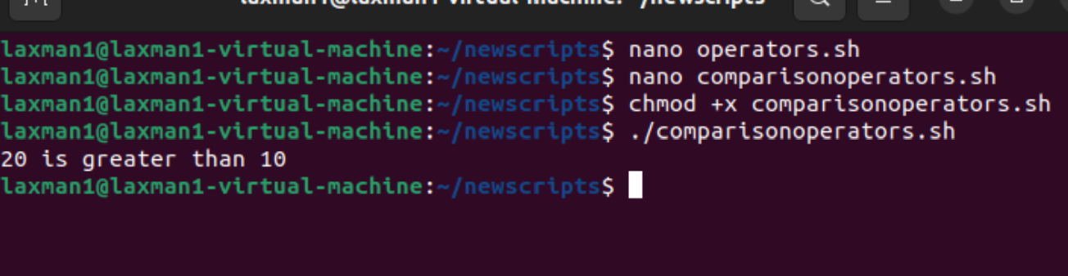

3. Arithmetic Comparison Operators
Bash also supports mathematical comparison operators such as <, >, <=, >=, ==, and != when using arithmetic evaluation (( )).
#!/bin/bash
a=10
b=20
if (( a < b ))
then
echo "$a is less than $b"
fi
if (( a != b ))
then
echo "The numbers are different"
fi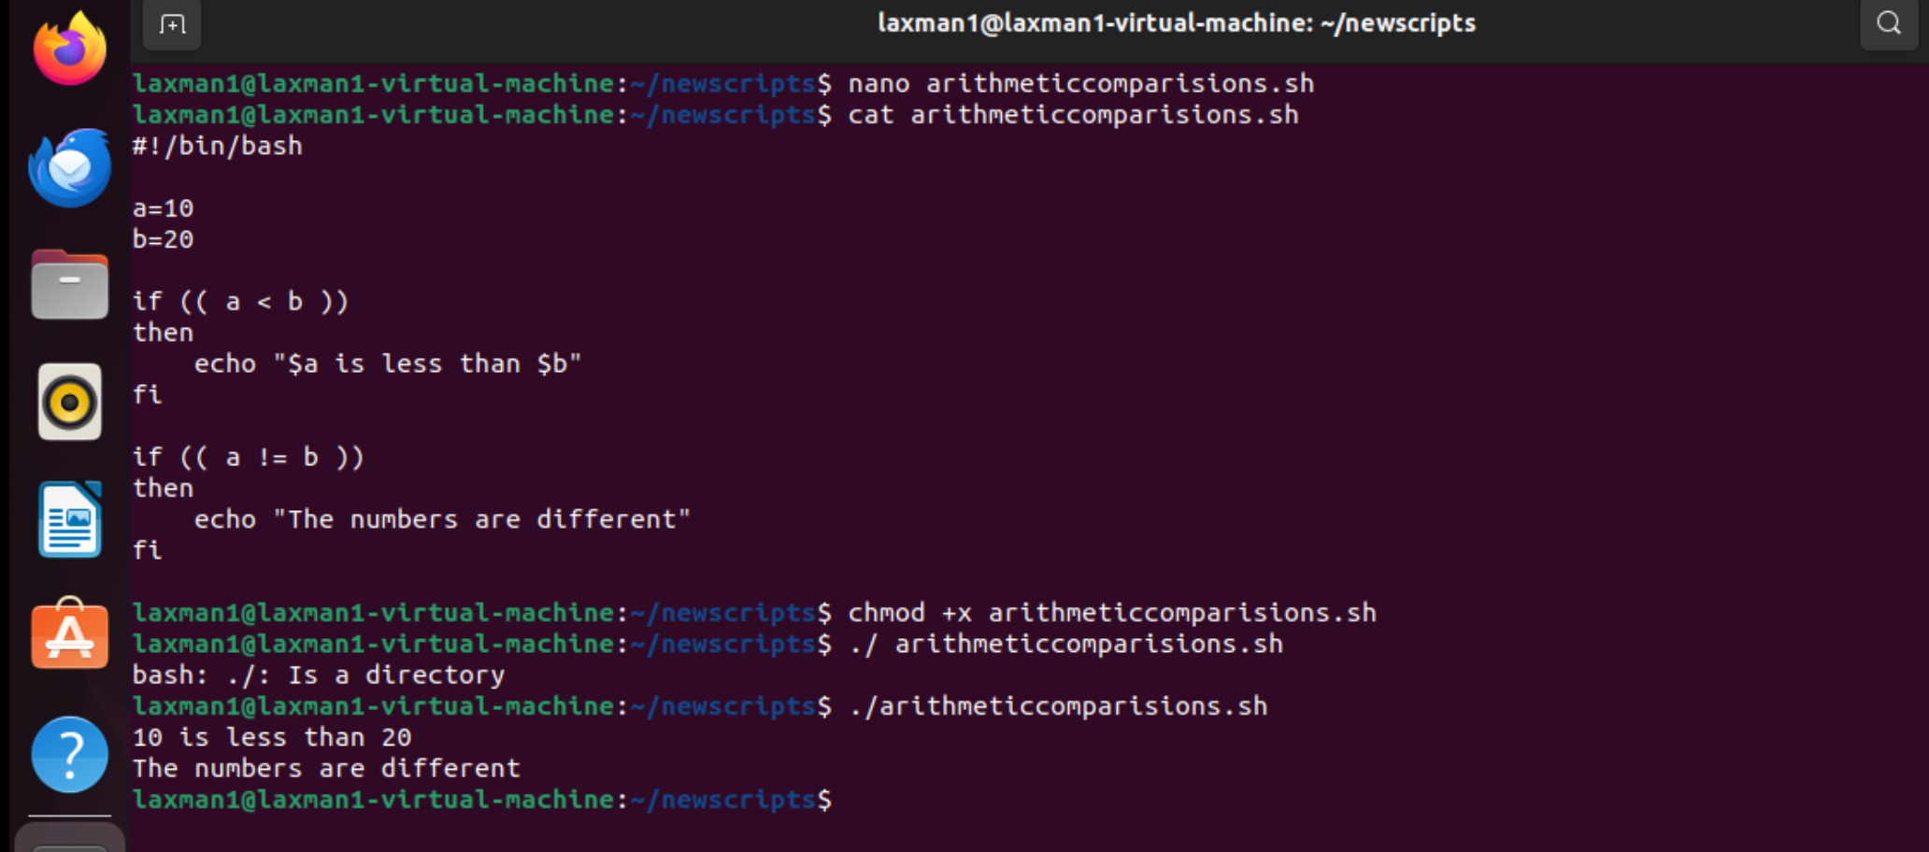

4. Logical Operators
Logical operators combine multiple conditions.
Operator | Name | Purpose
&& | AND | Both conditions must be true
|| | OR | At least one condition must be true
! | NOT | Reverses the condition
#!/bin/bash
AGE=25
if [ "$AGE" -ge 18 ] && [ "$AGE" -le 60 ]
then
echo "Age is between 18 and 60"
fi
if [ "$AGE" -lt 18 ] || [ "$AGE" -gt 60 ]
then
echo "Age is outside the range"
fi
if ! [ "$AGE" -lt 18 ]
then
echo "Age is not less than 18"
fi
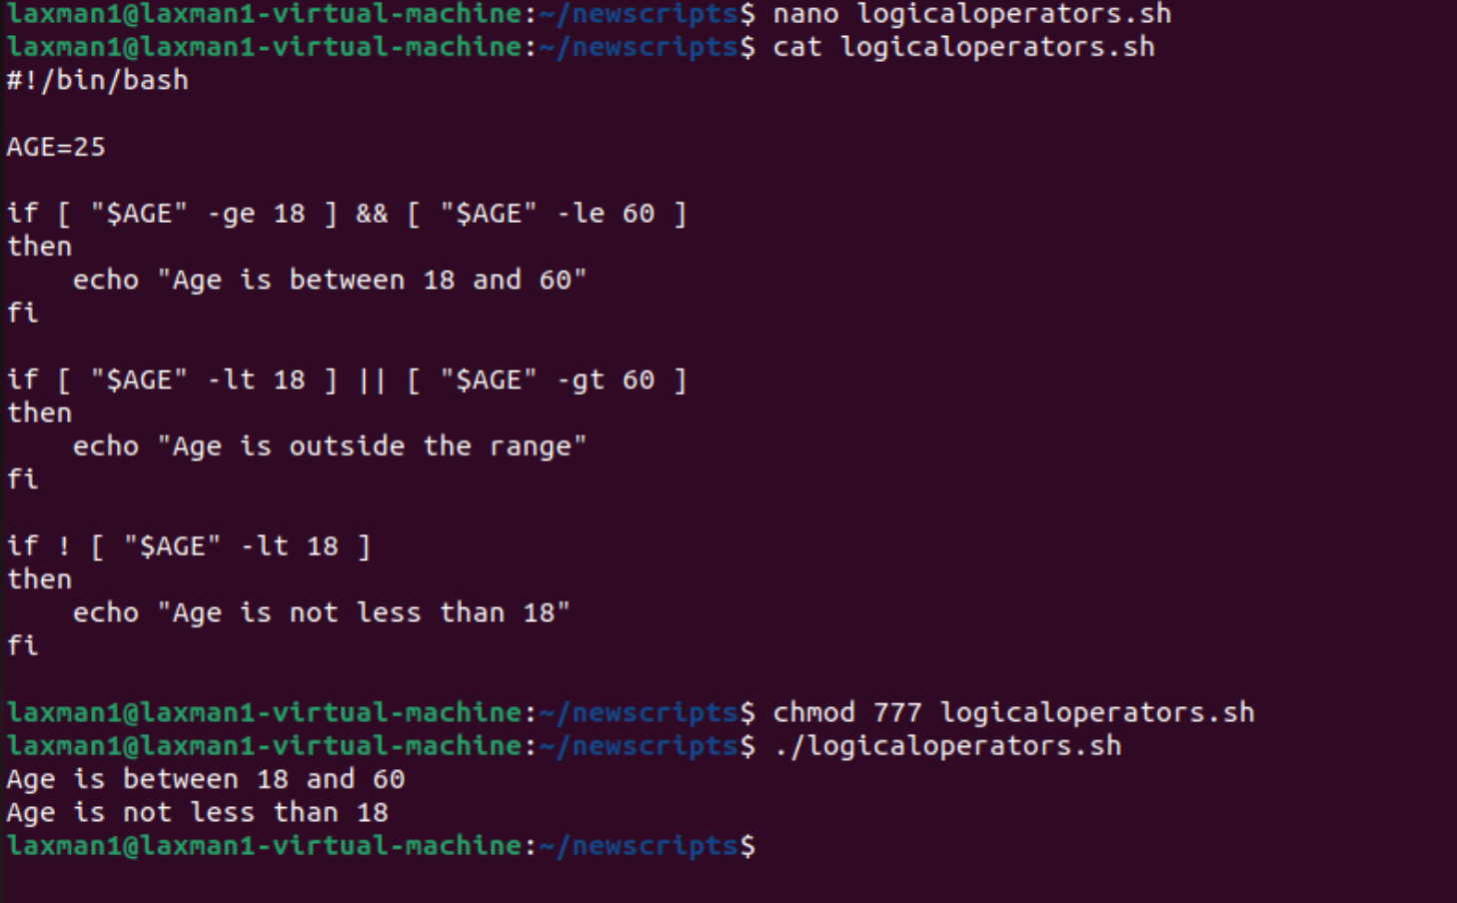

5. String Operators
String operators are used to compare text values.
Operator | Meaning
= | Strings are equal
== | Strings are equal (commonly used with [[ ]])
!= | Strings are not equal
-z | String is empty
-n | String is not empty
#!/bin/bash
name="Lakshman"
if [ "$name" = "Lakshman" ]
then
echo "Name matches"
fi
if [ -n "$name" ]
then
echo "Name is not empty"
fi
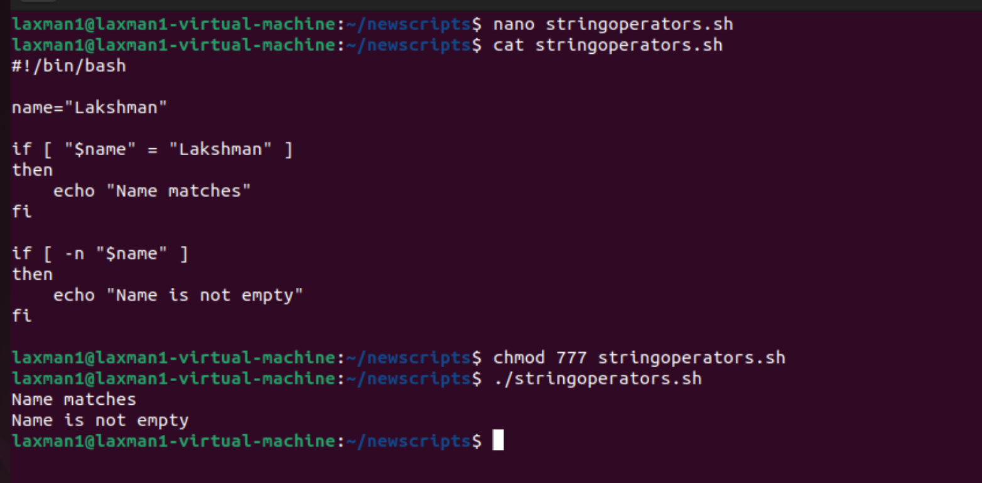

6. File Test Operators
File operators check whether a file or directory exists and determine its properties.
Operator | Meaning
-e | Path exists
-f | Regular file exists
-d | Directory exists
-r | File is readable
-w | File is writable
-x | File is executable
-s | File exists and is not empty
#!/bin/bash
FILE="/home/ec2-user/test.txt"
DIR="/home/ec2-user/test"
if [ -f "$FILE" ]
then
echo "File exists"
fi
if [ -d "$DIR" ]
then
echo "Directory exists"
else
echo "Directory does not exist"
fi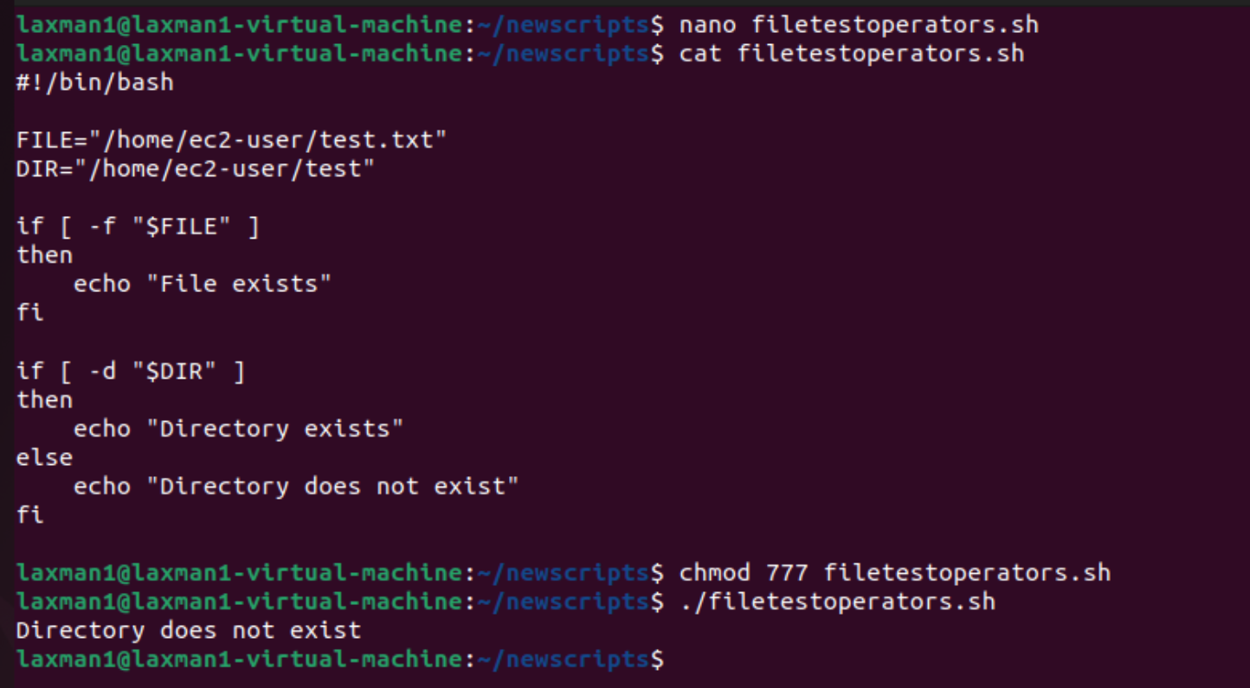

7. Assignment Operators
Assignment operators assign values to variables.
Operator | Purpose | Example
= | Assign a value | x=10
+= | Add and assign | ((x += 5))
-= | Subtract and assign | ((x -= 5))
*= | Multiply and assign | ((x *= 5))
/= | Divide and assign | ((x /= 5))
%= | Modulus and assign | ((x %= 3))
#!/bin/bash
x=10
(( x += 5 ))
echo "After += : $x"
(( x -= 3 ))
echo "After -= : $x"
(( x *= 2 ))
echo "After *= : $x"
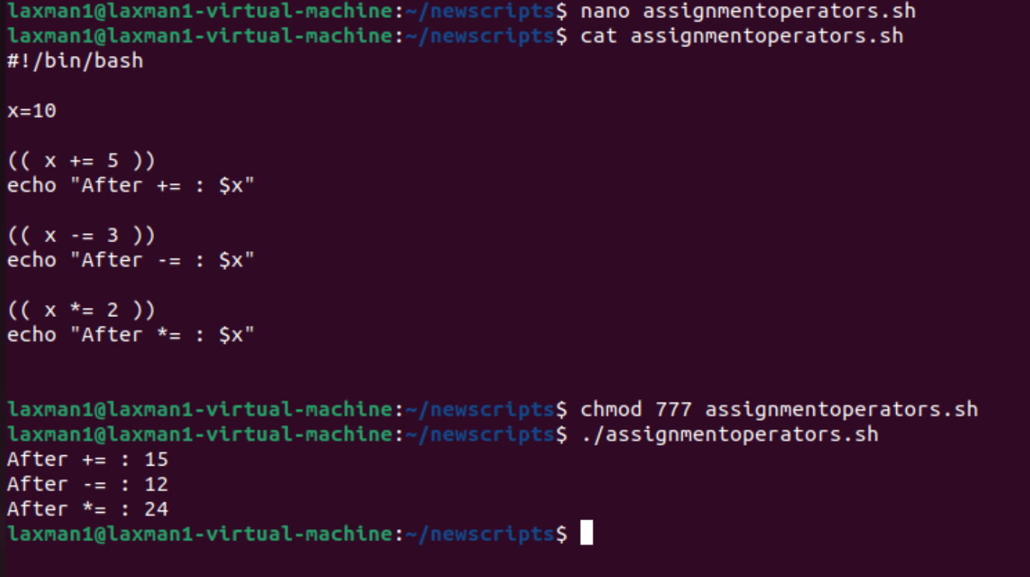

8. Increment and Decrement Operators
These operators increase or decrease a numeric value by 1.
#!/bin/bash
count=1
(( count++ ))
echo "After increment: $count"
(( count-- ))
echo "After decrement: $count"
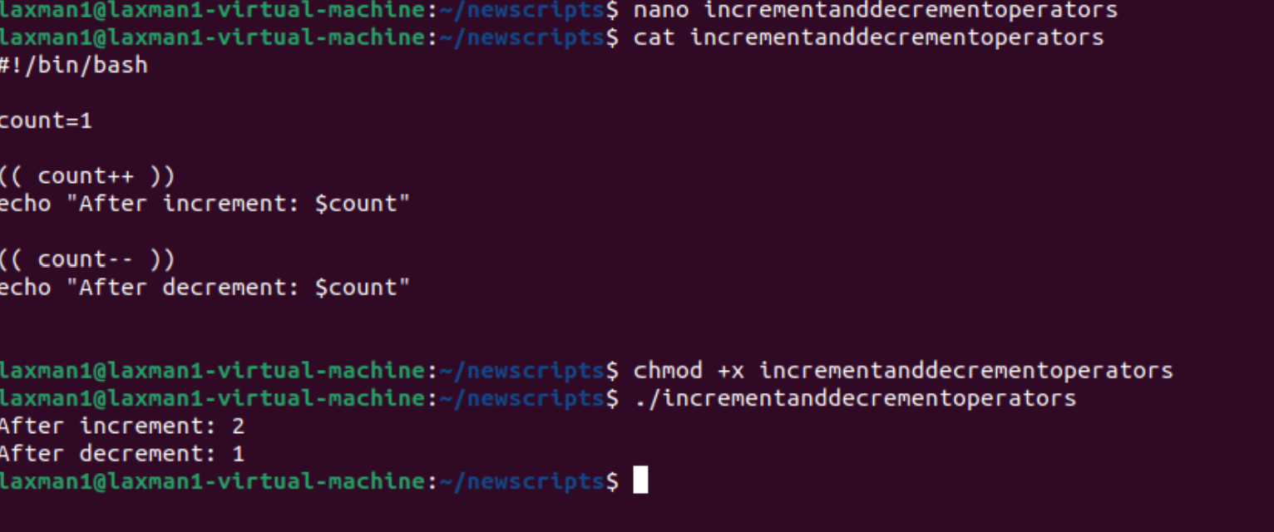

9. Conditional Operator
The conditional operator follows the form condition ? true_value : false_value inside arithmetic expressions.
#!/bin/bash
a=10
b=20
result=$(( a > b ? a : b ))
echo "Greater value: $result"
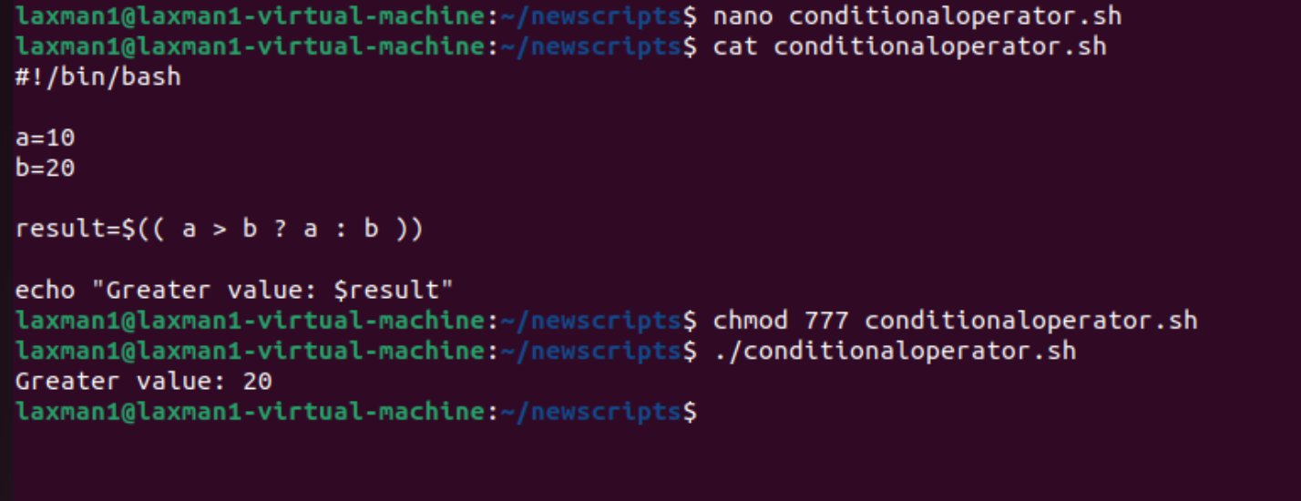

10. Practical Example: Check Number
#!/bin/bash
read -p "Enter a number: " num
if (( num > 0 ))
then
echo "Positive number"
elif (( num < 0 ))
then
echo "Negative number"
else
echo "Zero"
fi
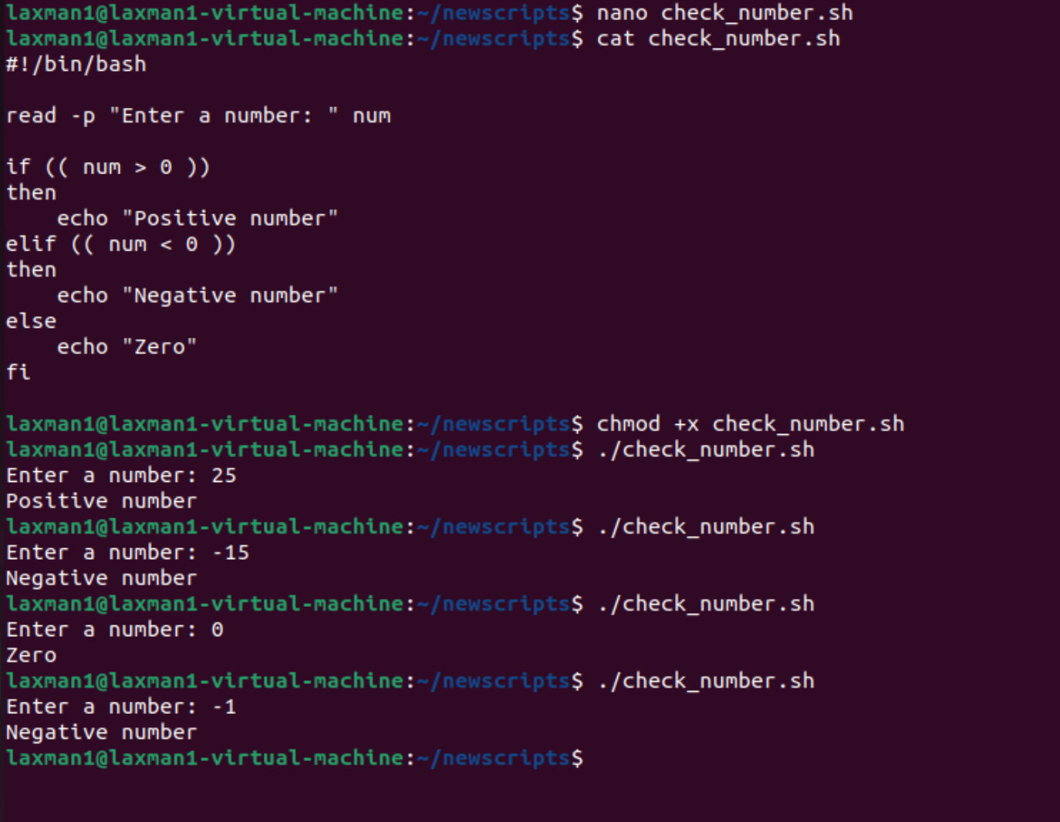

11. Practical Example: Check File and Directory
#!/bin/bash
read -p "Enter a path: " path
if [ -f "$path" ]
then
echo "It is a regular file."
elif [ -d "$path" ]
then
echo "It is a directory."
elif [ -e "$path" ]
then
echo "The path exists but is not a regular file or directory."
else
echo "Path does not exist."
fi
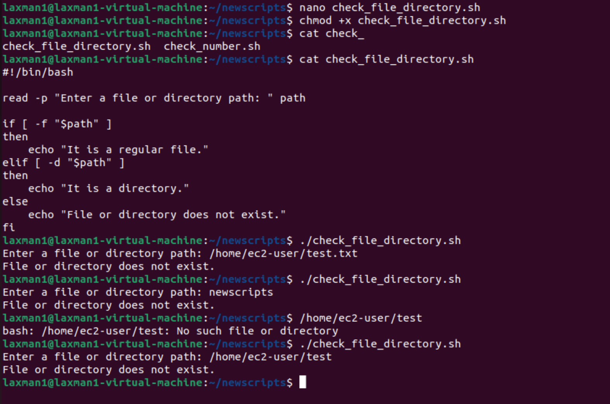

12. Important Bash Operator Tips
- Use spaces around [ and ]: if [ "$a" -eq "$b" ]
- Quote variables when testing strings or paths: [ -f "$FILE" ]
- Use (( )) for arithmetic calculations and numeric comparisons.
- Use [[ ]] for more flexible string and pattern comparisons.
- Do not use = for numeric comparison inside [ ]; use -eq instead.
- Use && for AND and || for OR when combining shell commands or conditions.

13. Quick Reference
Category | Operators | Example
Arithmetic | + - * / % ** | (( a + b ))
Numeric comparison | -eq -ne -gt -ge -lt -le | [ $a -gt $b ]
Logical | && || ! | [ condition ] && echo OK
String | = == != | [ "$a" = "$b" ]
String test | -z -n | [ -n "$name" ]
File test | -e -f -d -r -w -x -s | [ -d "$DIR" ]
Assignment | = += -= *= /= %= | (( x += 5 ))
Increment | ++ | (( count++ ))
Decrement | -- | (( count-- ))

14. How to Execute a Bash Script
Save the script, give it execute permission, and run it:
nano operators.sh
chmod +x operators.sh
./operators.sh
Alternatively, a script can be executed directly with Bash without changing permissions:
bash operators.sh

