AWS EC2 Hands-On Tasks
EC2 Launch, User Data, Snapshot, Authentication, Spot Instance, Termination Protection & AWS CLI

Objective
Complete seven AWS EC2 administration tasks using the AWS Management Console and AWS CLI. Record the instance IDs, public IP addresses, AMI details, and verification results as evidence for each task.

Prerequisites
- An AWS account with permission to launch and manage EC2 instances, snapshots, and security groups.
- An AWS Region selected for all tasks (use the same Region where practical).
- An existing EC2 key pair for Linux instances.
- AWS CLI installed and configured with credentials for Task 7.
- For Windows/Tomcat, allow TCP port 8080 in the Windows instance security group if Tomcat will be accessed from a browser.

Task 1 — Launch Amazon Linux 2 EC2 and Install Apache Using User Data
Objective: Launch one EC2 instance using an Amazon Linux 2 image and use EC2 User Data to install and start Apache automatically at first boot.
- Open the AWS Management Console → EC2 → Instances → Launch instance.
- Enter an instance name such as AmazonLinux-Apache.
- Select an Amazon Linux 2 AMI (where available in the selected Region).
- Choose a suitable instance type such as t2.micro/t3.micro, subject to account availability and AWS pricing.
- Select or create a key pair.
- Configure a security group allowing SSH (TCP 22) from your IP address and HTTP (TCP 80) from the required source.
- Expand Advanced details and locate User data.
- Paste the following script.
#!/bin/bash
yum update -y
yum install -y httpd
systemctl enable httpd
systemctl start httpd
echo "<h1>Apache installed using EC2 User Data</h1>" > /var/www/html/index.html
- Launch the instance.
- Wait for the instance to pass its status checks.
- Copy the instance Public IPv4 address and open http://<PUBLIC-IP> in a browser.
- Expected result: the Apache test page displays the message configured above.
- Verify from the instance, if required, with: systemctl status httpd 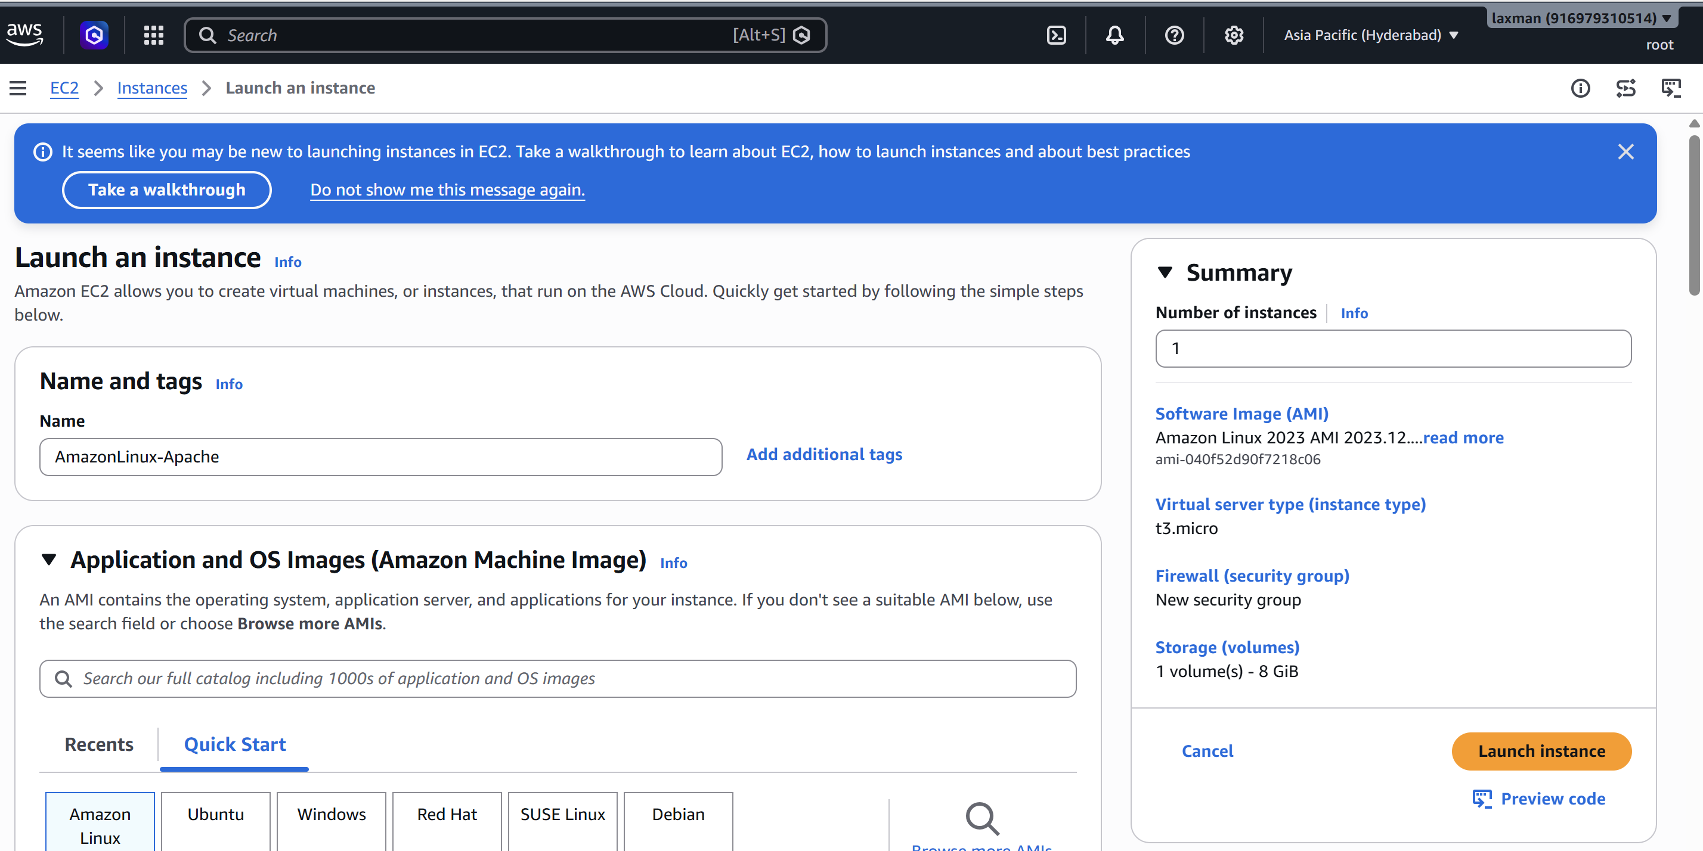 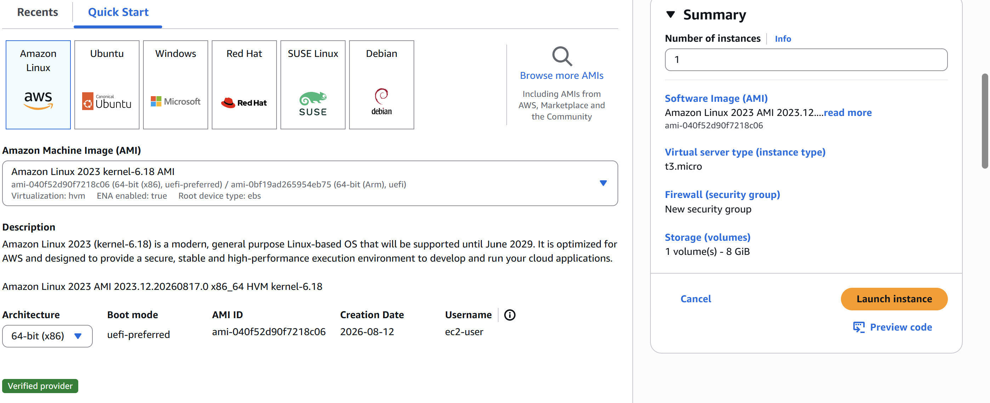 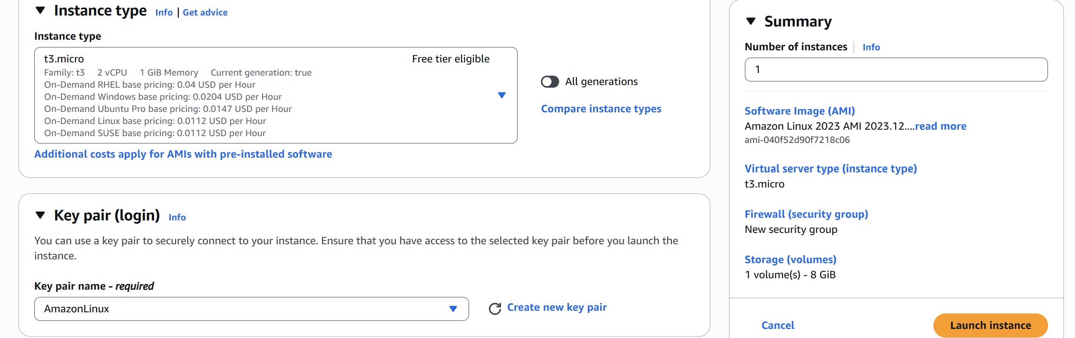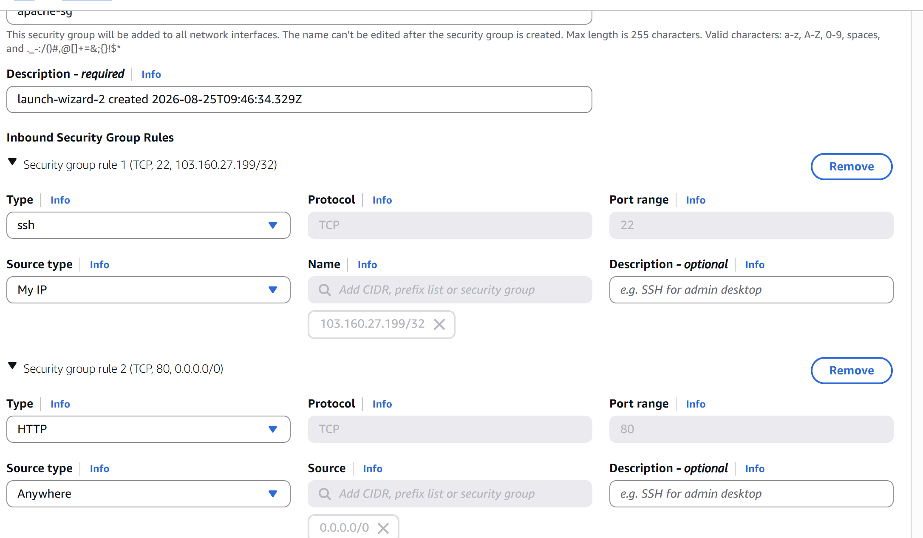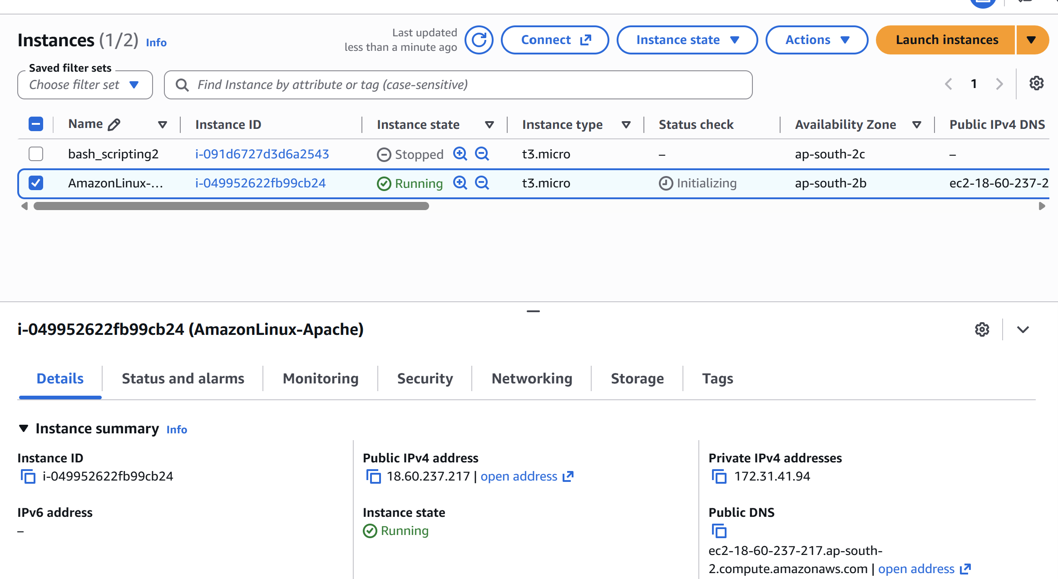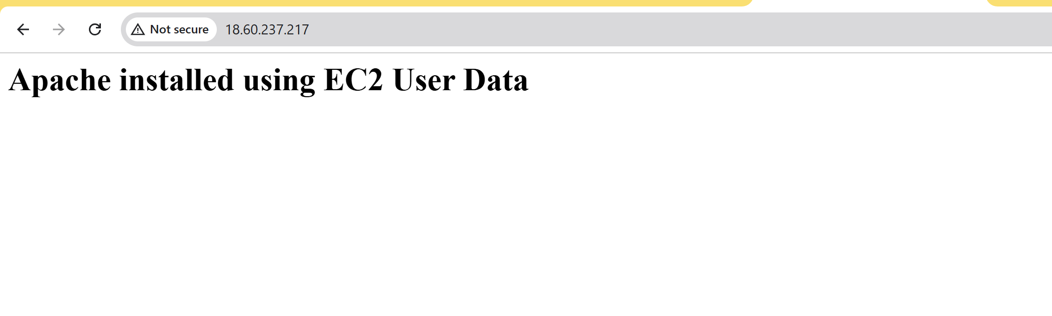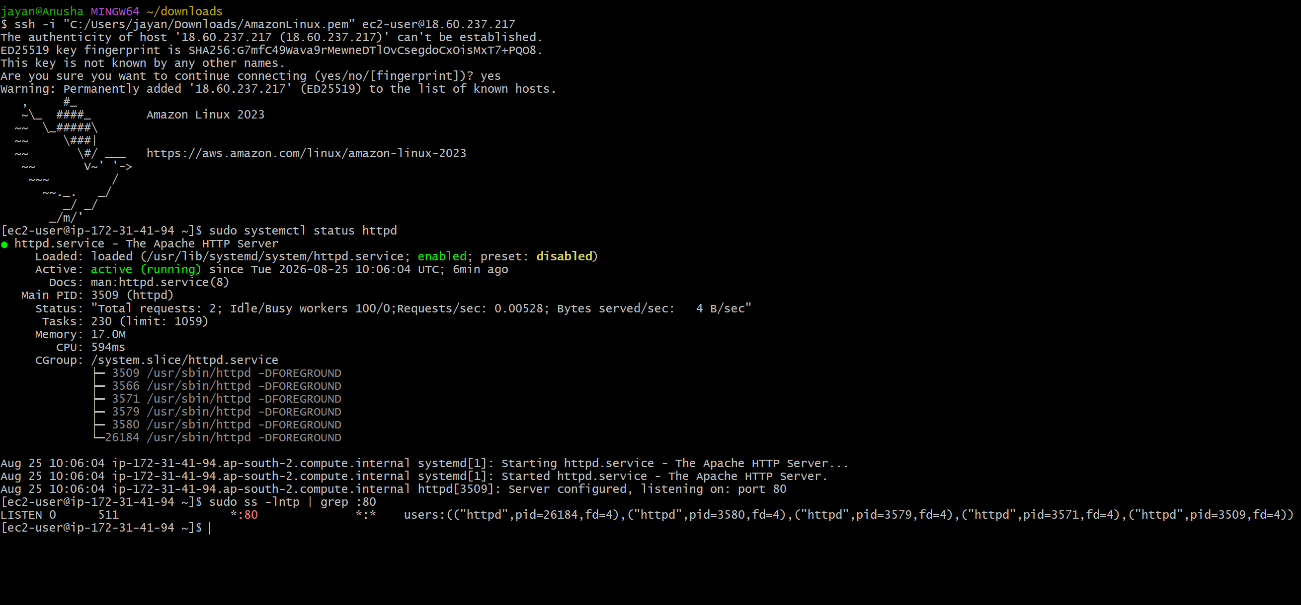

Task 2 — Launch Ubuntu EC2 and Install Nginx Using User Data
Objective: Launch one EC2 instance using an Ubuntu image and install Nginx automatically with User Data.
- Go to EC2 → Instances → Launch instance.
- Enter an instance name such as Ubuntu-Nginx.
- Select a current Ubuntu Server LTS AMI.
- Choose a suitable instance type.
- Select an appropriate key pair.
- Configure a security group allowing SSH (TCP 22) from your IP address and HTTP (TCP 80) from the required source.
- Under Advanced details → User data, enter the following script.
#!/bin/bash
apt-get update -y
apt-get install -y nginx
systemctl enable nginx
systemctl start nginx
echo "<h1>Nginx installed using EC2 User Data</h1>" > /var/www/html/index.html
- Launch the instance and wait for the status checks to pass.
- Open http://<PUBLIC-IP> in a browser.
- Expected result: the Nginx page displays the custom message.
- Verify with: systemctl status nginx 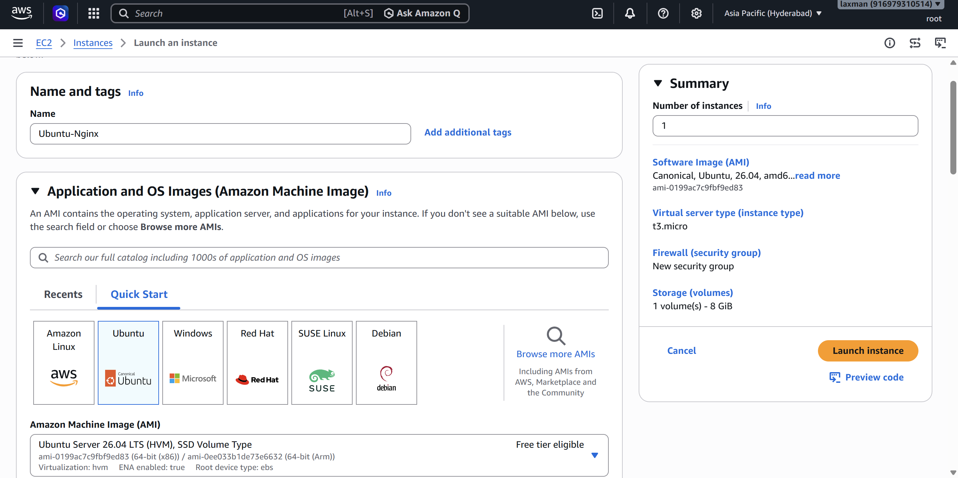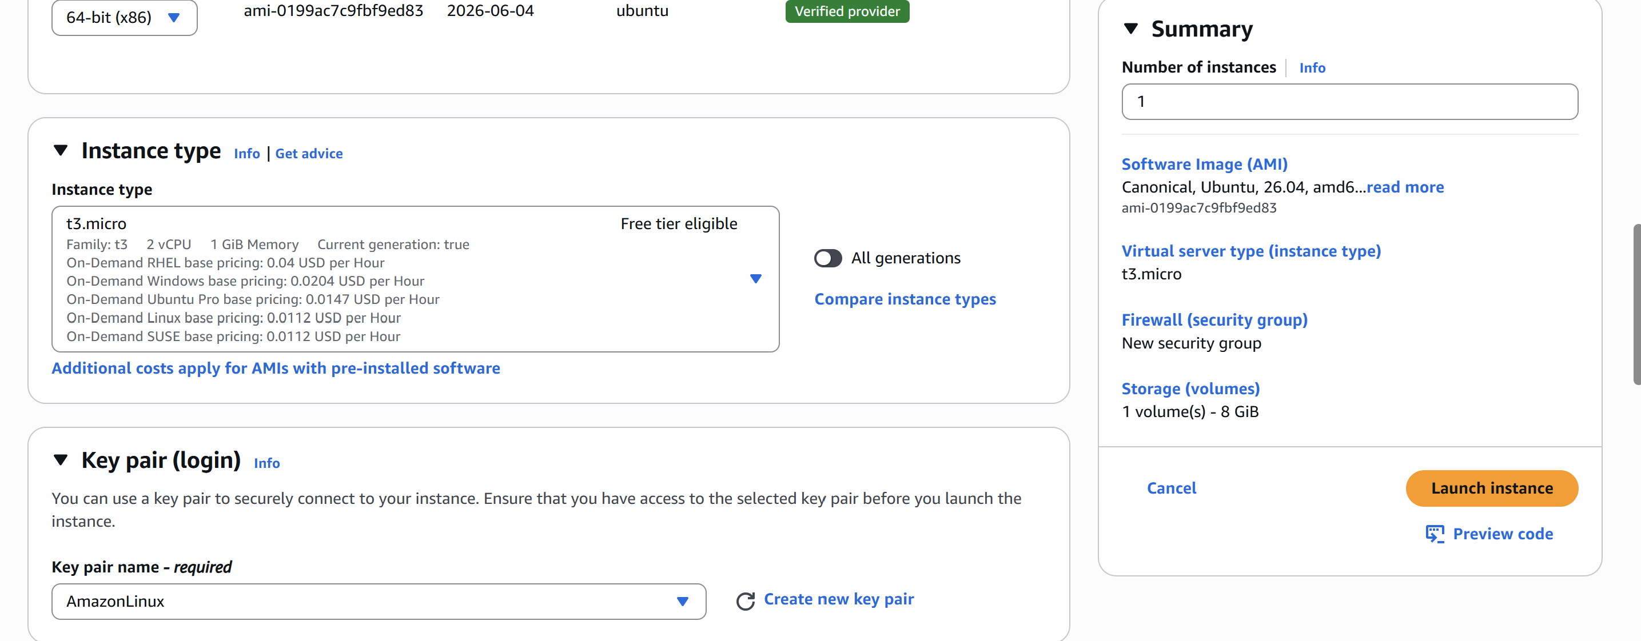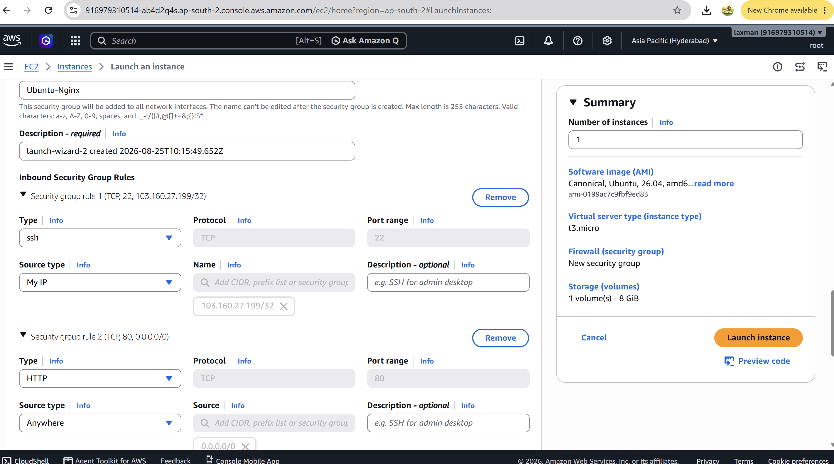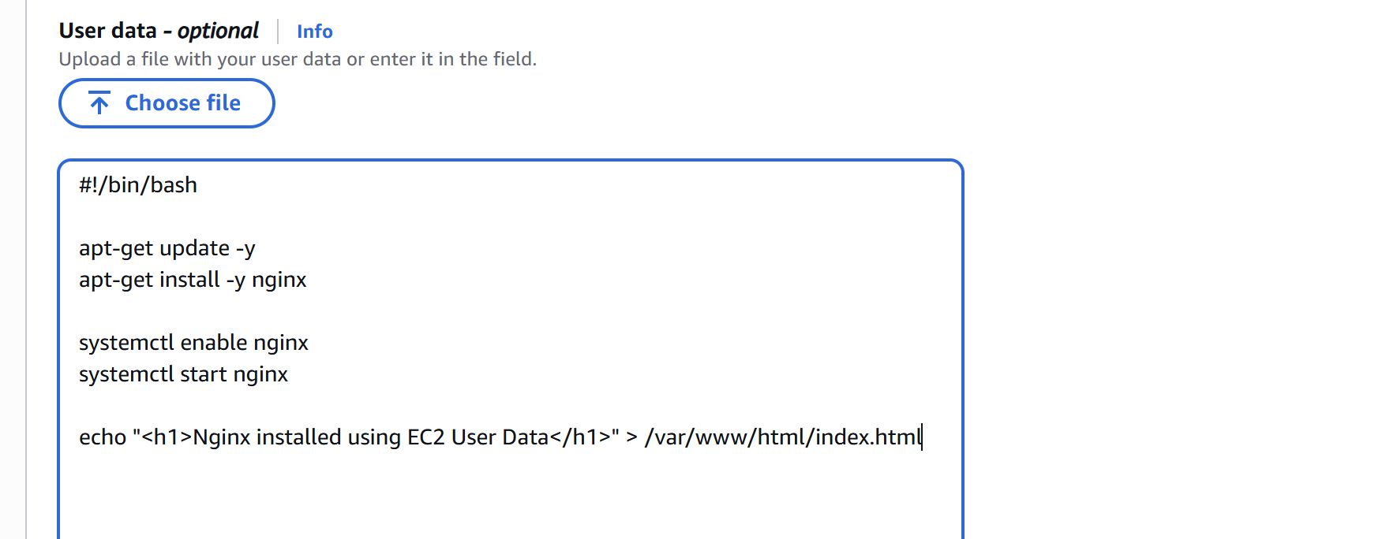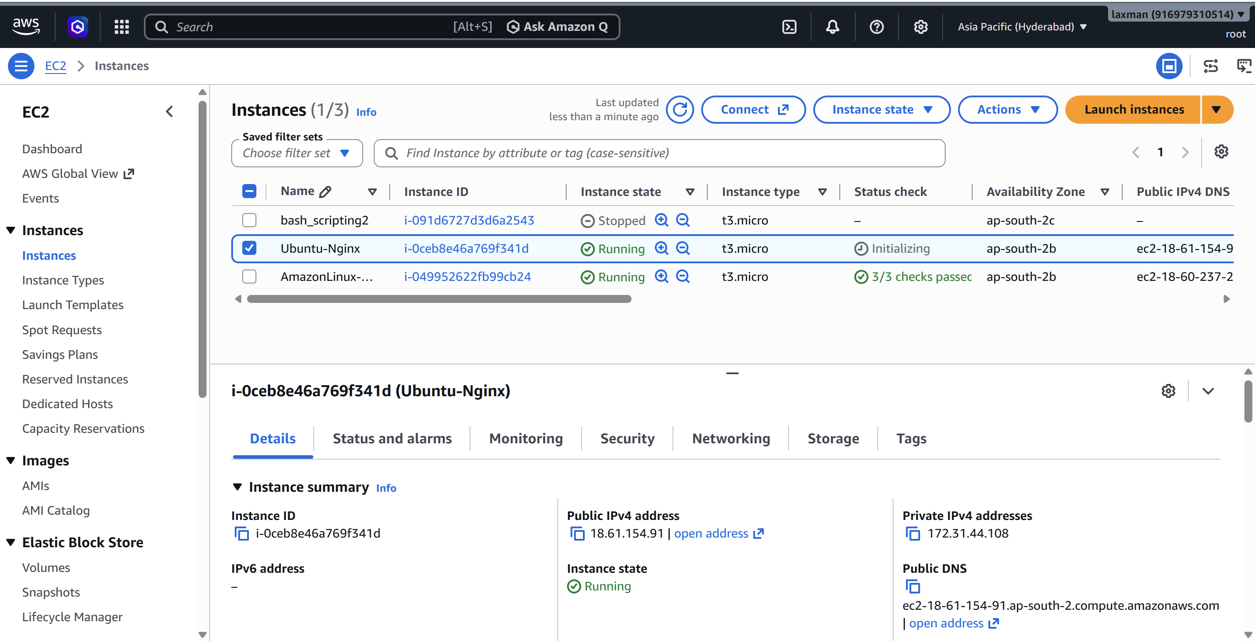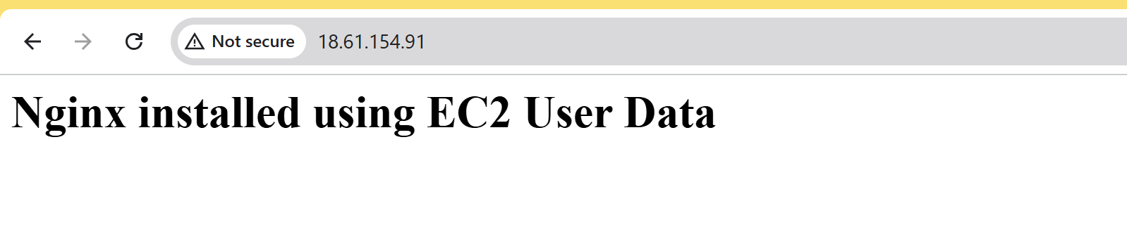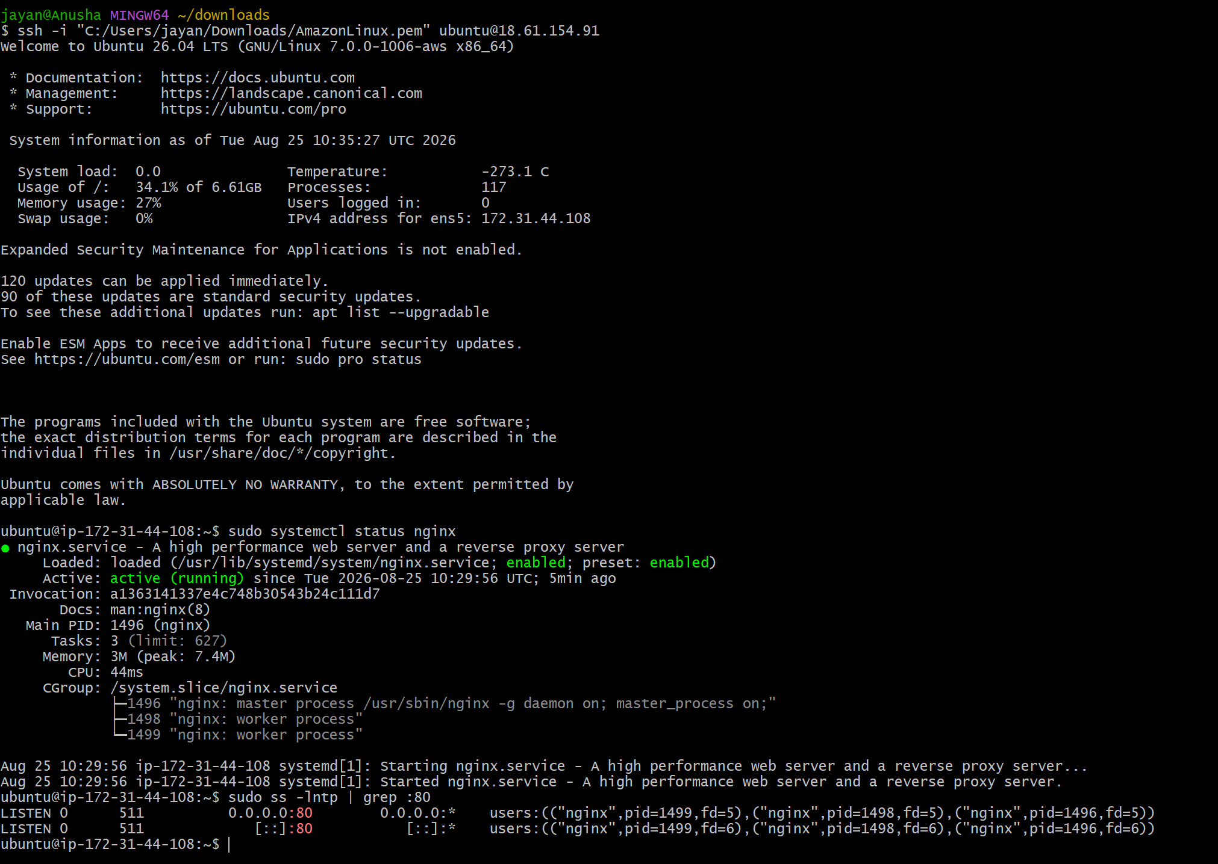
- Task 3 — Launch Windows Server and Install Tomcat
Objective: Launch a Windows Server EC2 instance and install Apache Tomcat on it.
- Open EC2 → Launch instance.
- Enter an instance name such as Windows-Tomcat.
- Select a supported Windows Server AMI.
- Choose a suitable instance type and key pair.
- Configure the security group to allow RDP (TCP 3389) from your IP address.
- Add a custom TCP rule for Tomcat, normally TCP 8080, from your required source.
- Launch the instance.
- After the instance is running, select it and choose Connect → RDP client.
- Retrieve the Windows Administrator password using the EC2 key pair, then connect through Remote Desktop.
- On the Windows server, install a supported Java JDK/JRE required by your chosen Tomcat version.
- Download Apache Tomcat from the official Apache Tomcat website and extract it to a directory such as C:\Apache-Tomcat.
- Set JAVA_HOME if required and configure Tomcat as a Windows service using the Tomcat service installer.
- Start the Tomcat service.
- Open http://<PUBLIC-IP>:8080 in a browser.
Expected result: the Apache Tomcat welcome page is displayed. 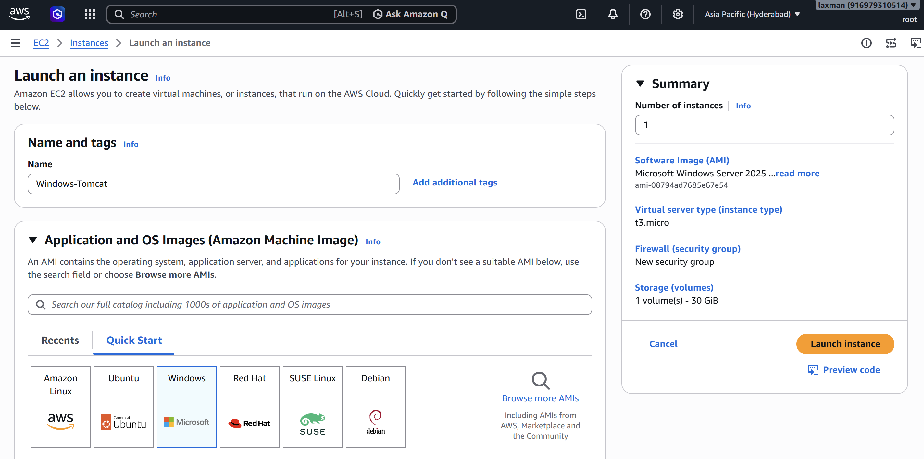 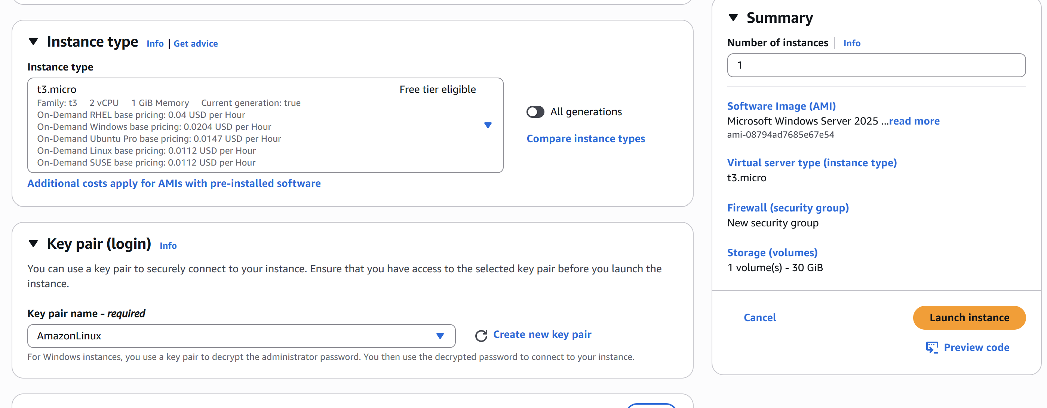 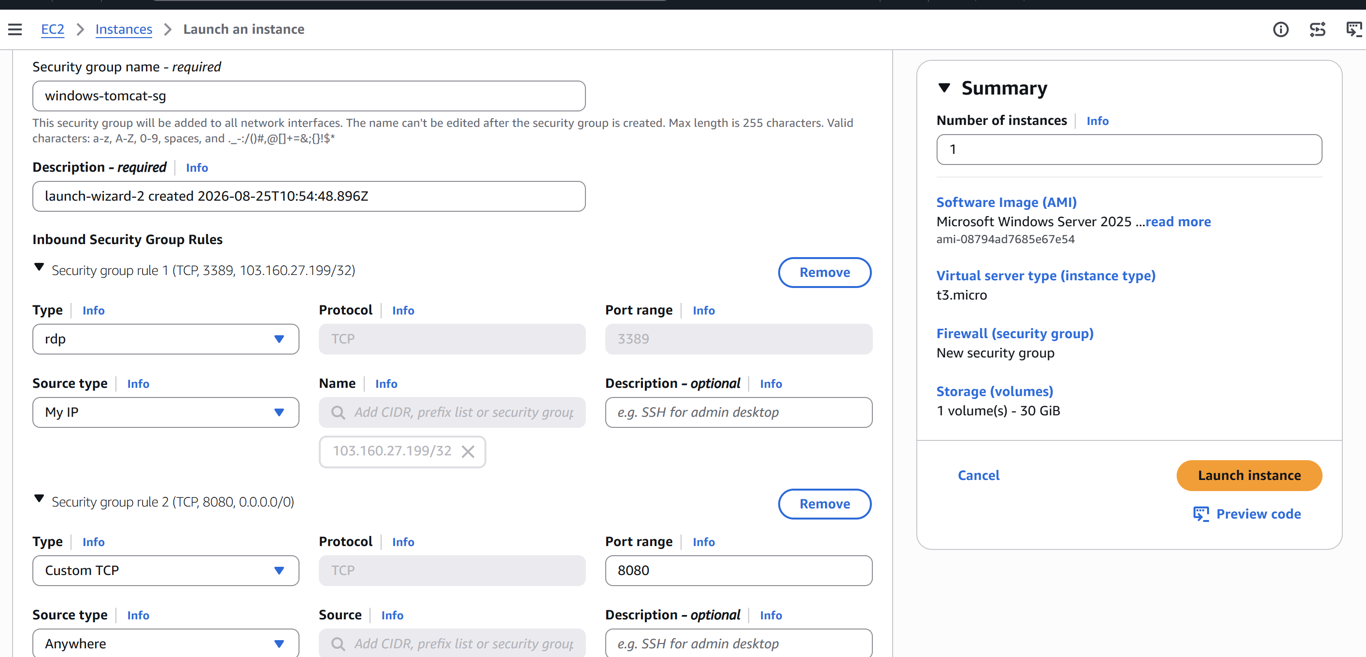 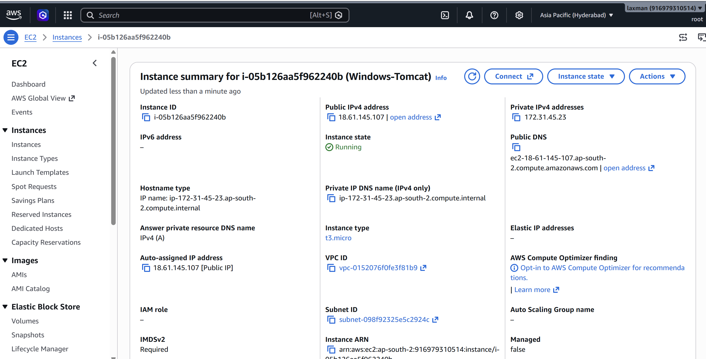 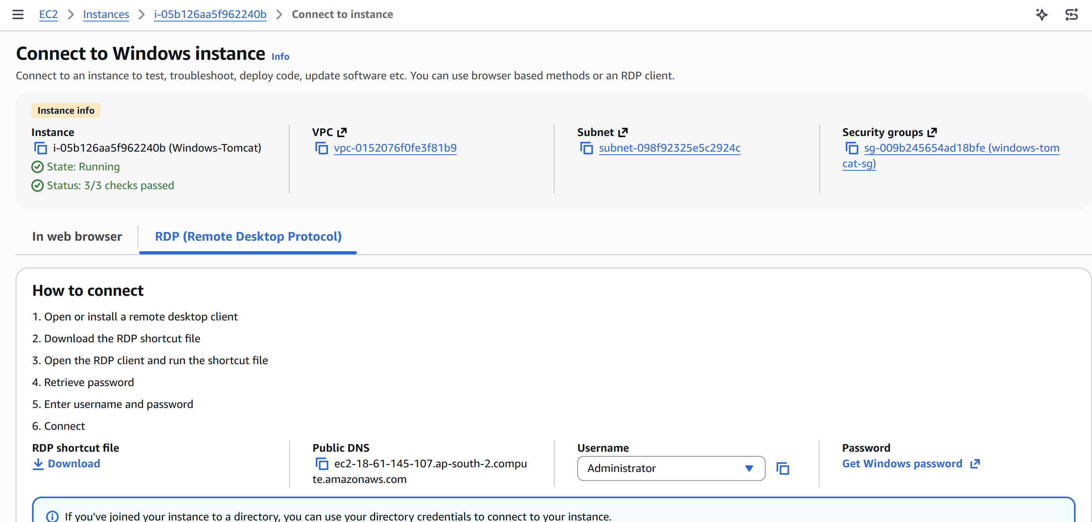 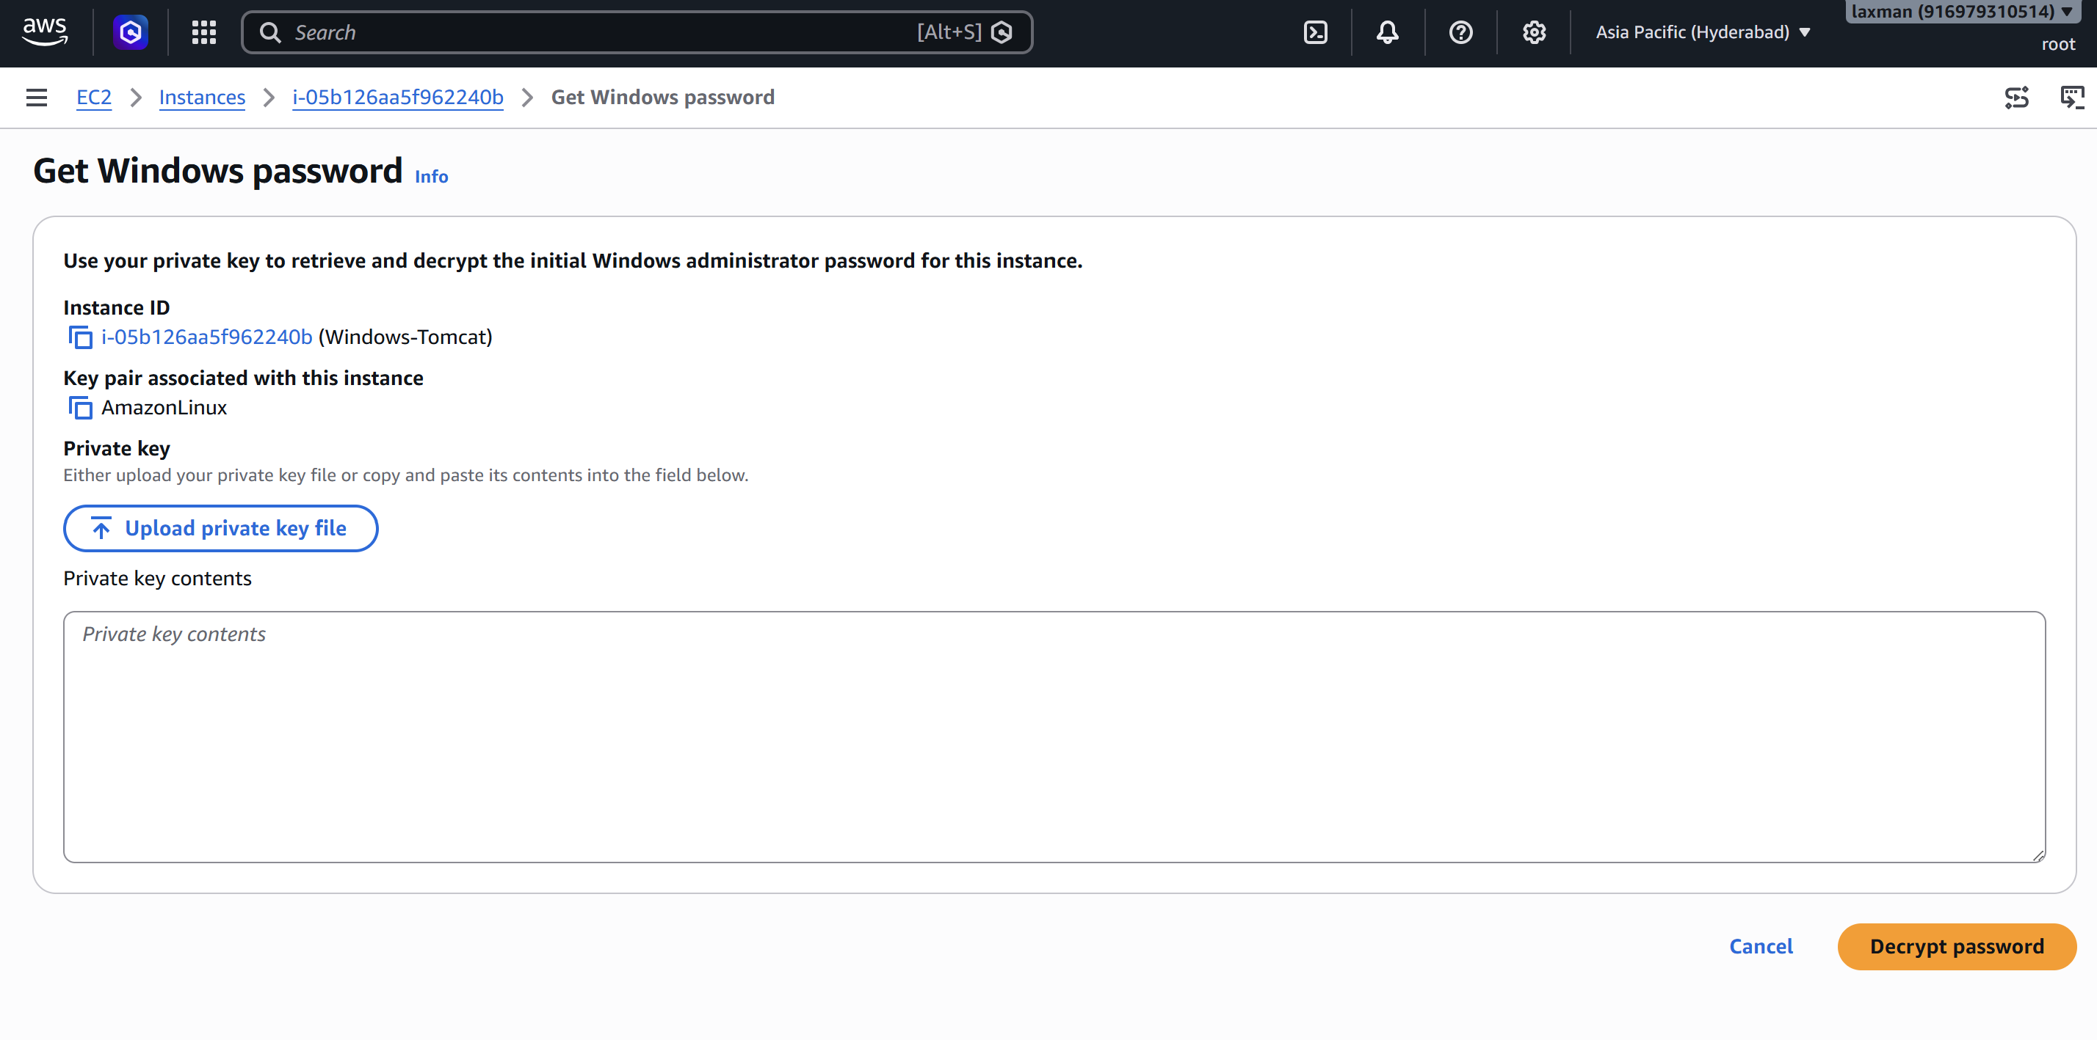 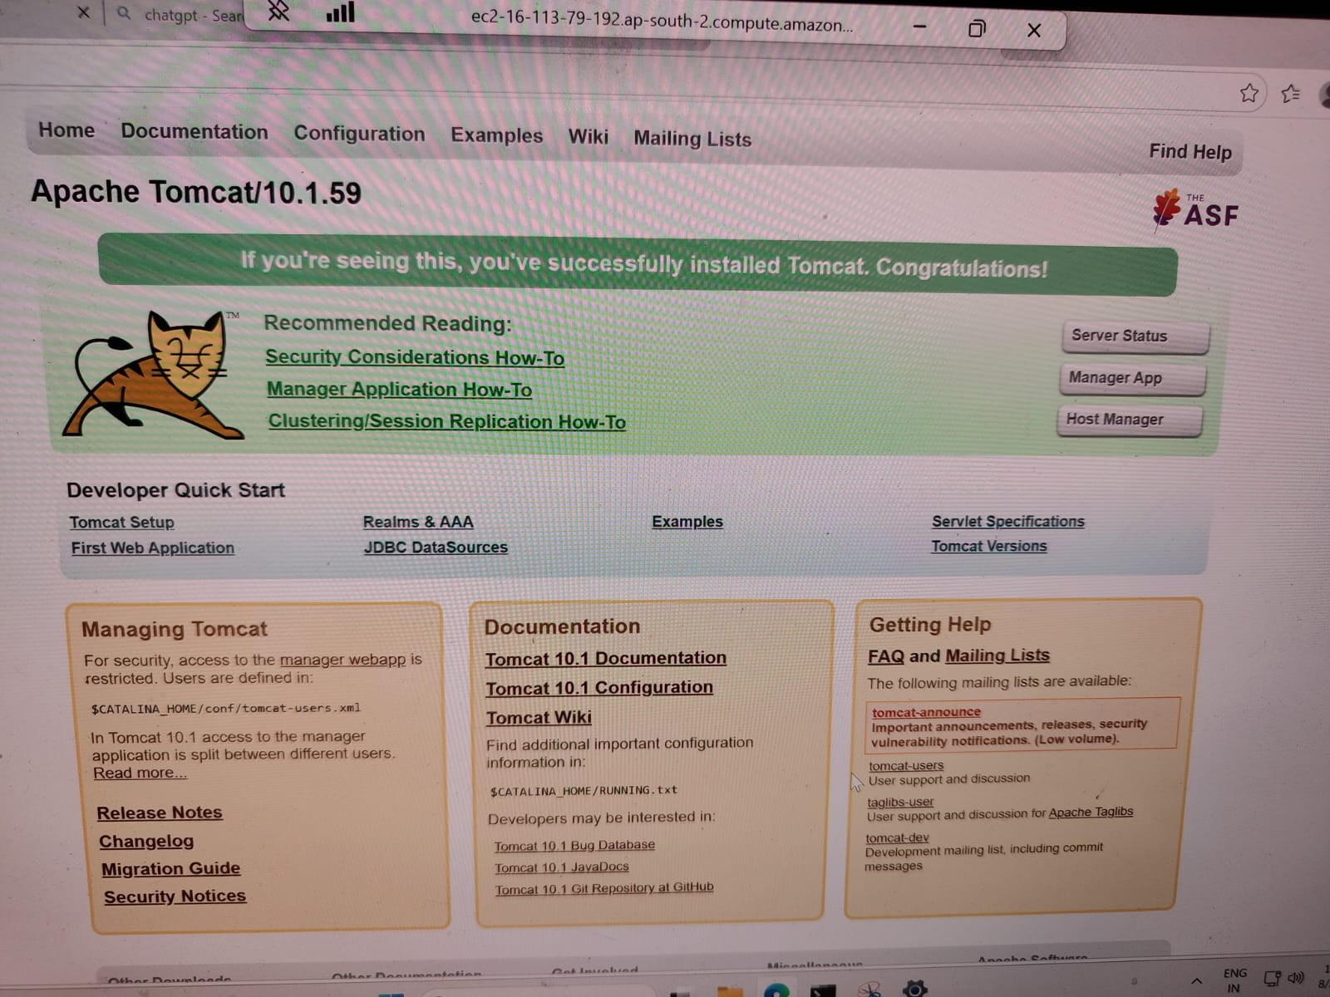

Task 4 — Take a Snapshot of the Instance Created in Task 1
Objective: Create an EBS snapshot from the Amazon Linux instance created in Task 1.
- Go to EC2 → Instances and select the AmazonLinux-Apache instance.
- Open the Storage tab and identify the EBS volume attached to the instance.
- Select the volume or use Actions → Create snapshot.
- Enter a descriptive snapshot name, such as Apache-Instance-Snapshot.
- Add an optional description and tags.
- Create the snapshot.
- Go to EC2 → Snapshots and confirm that the snapshot is available/completed.
- Record the Snapshot ID as evidence.
Note: A snapshot is a point-in-time backup of an EBS volume. Snapshot completion can take time depending on the amount of data. 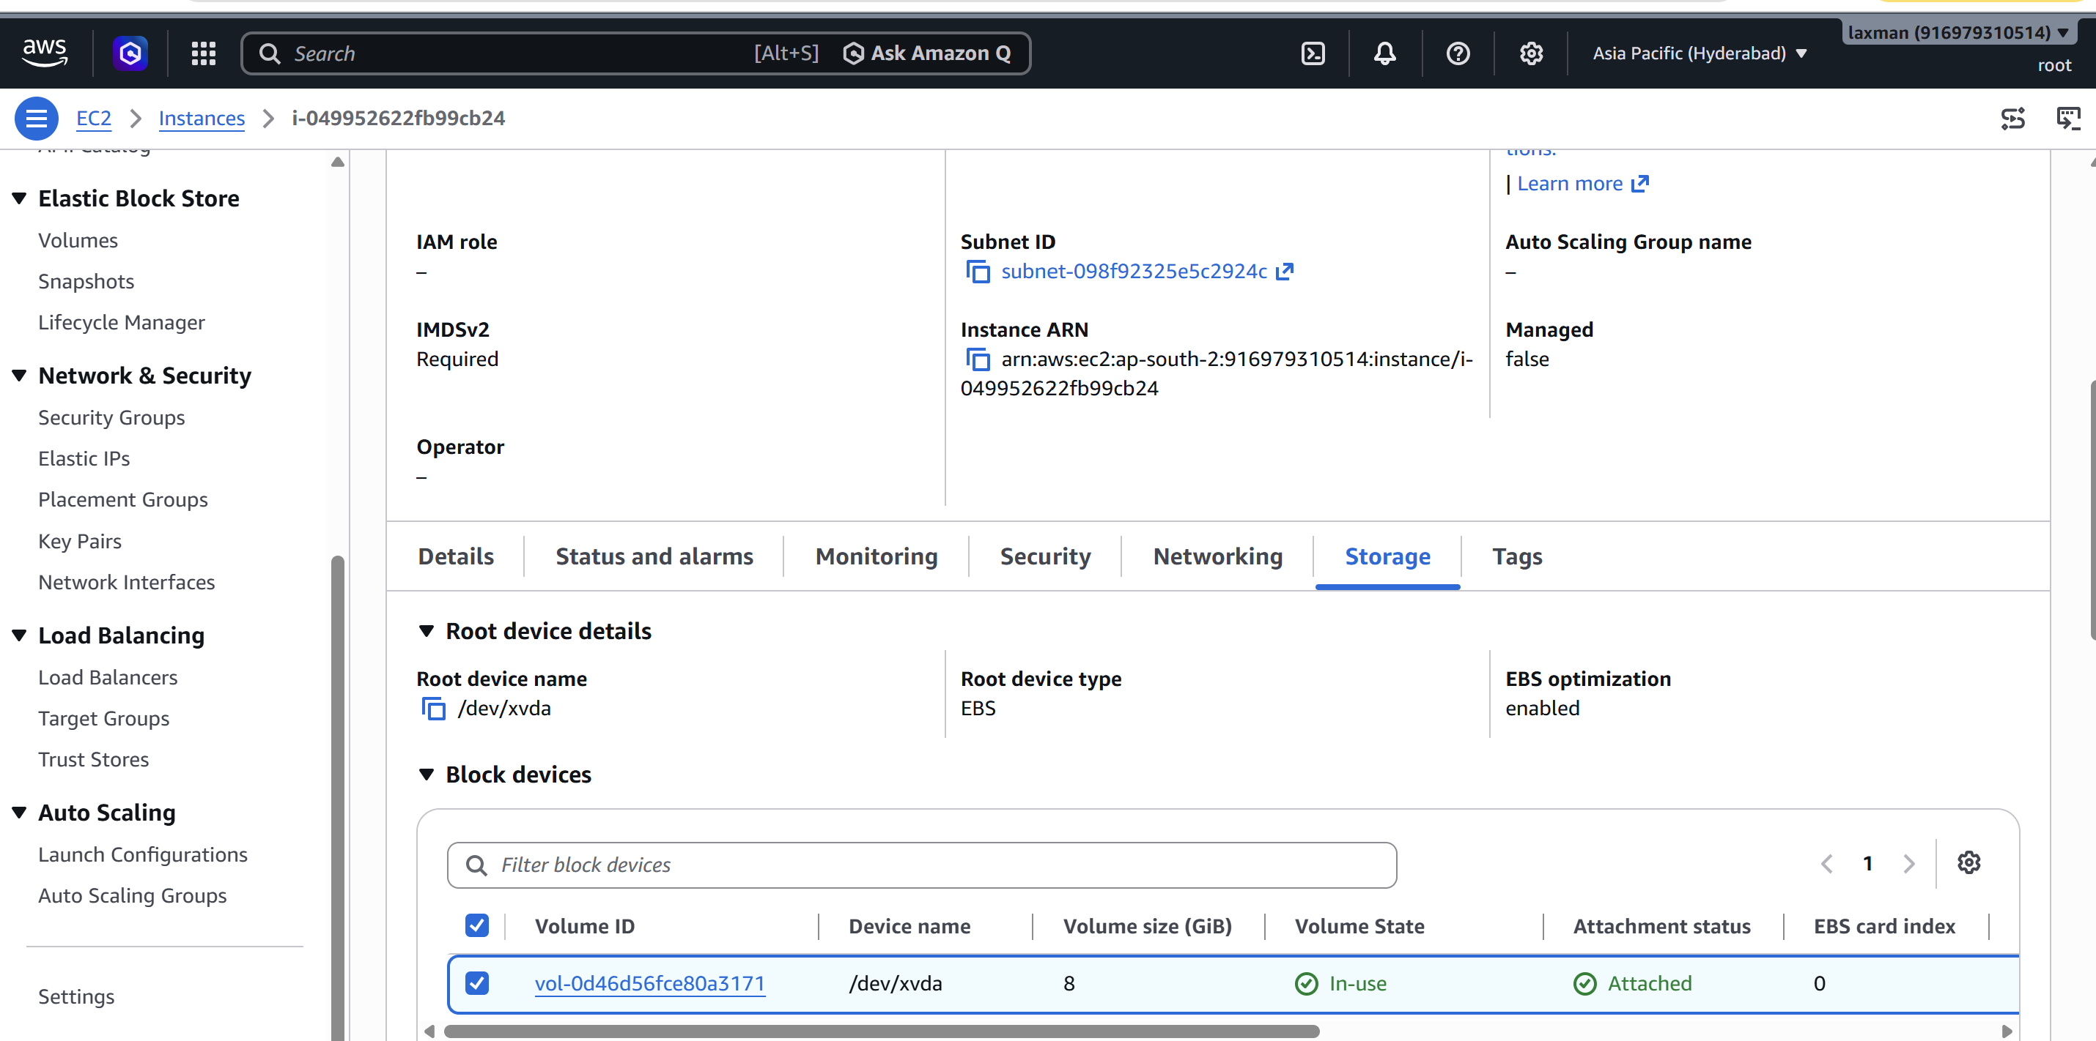 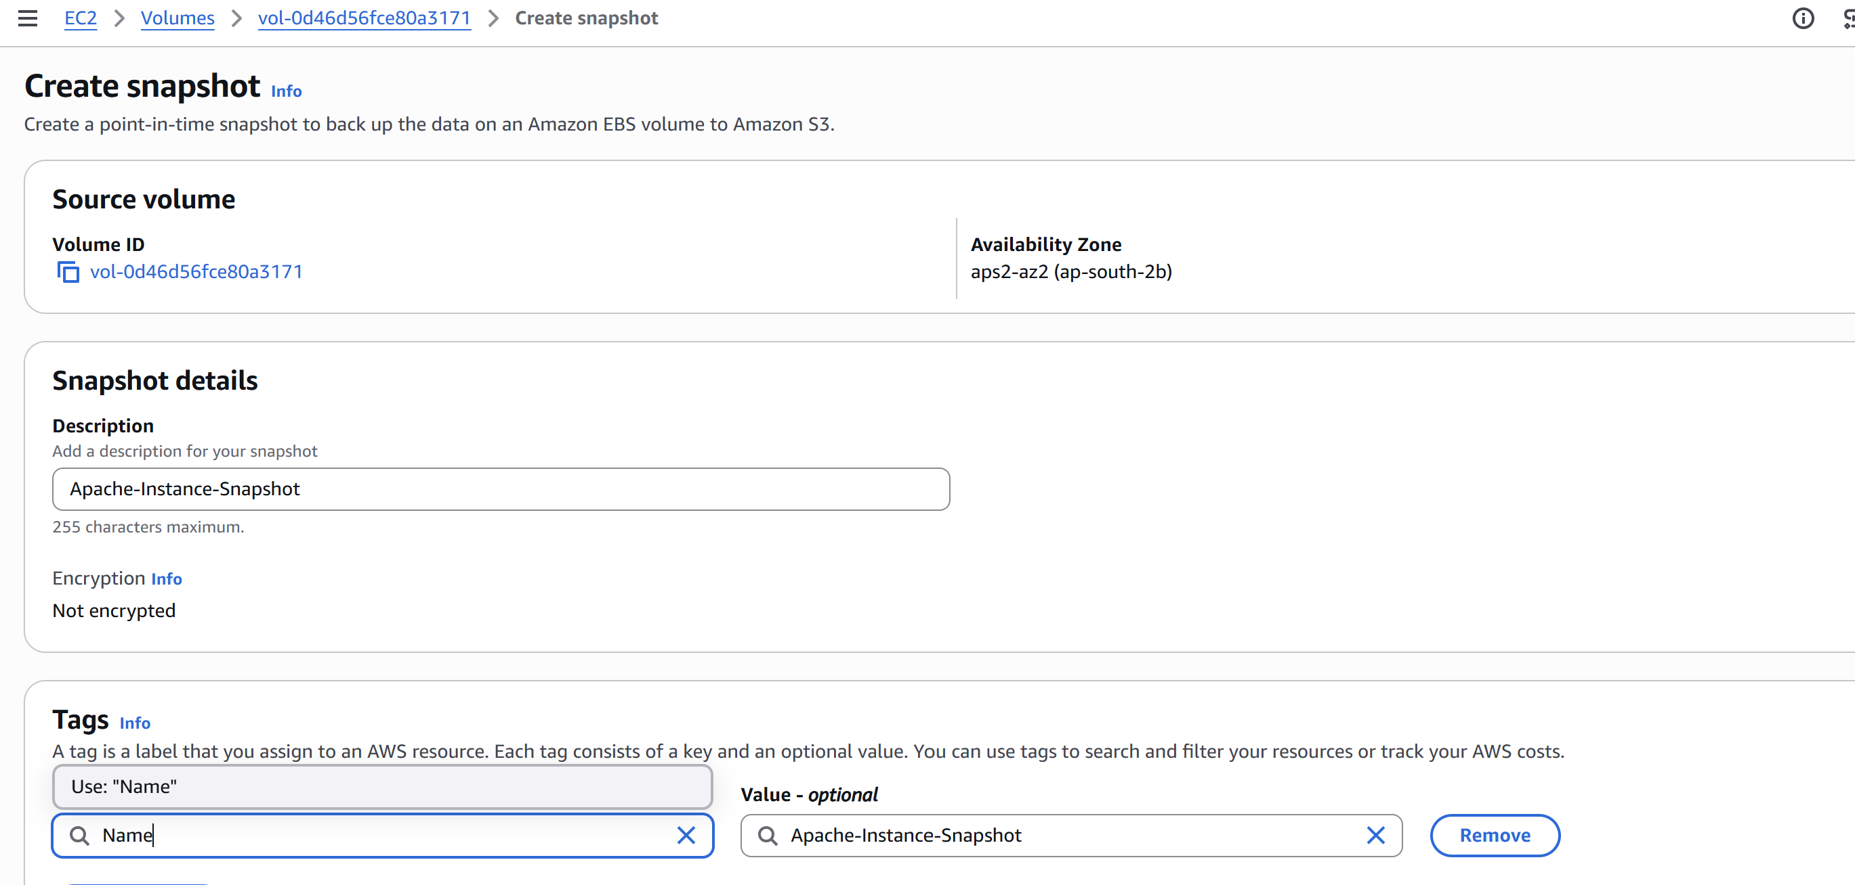 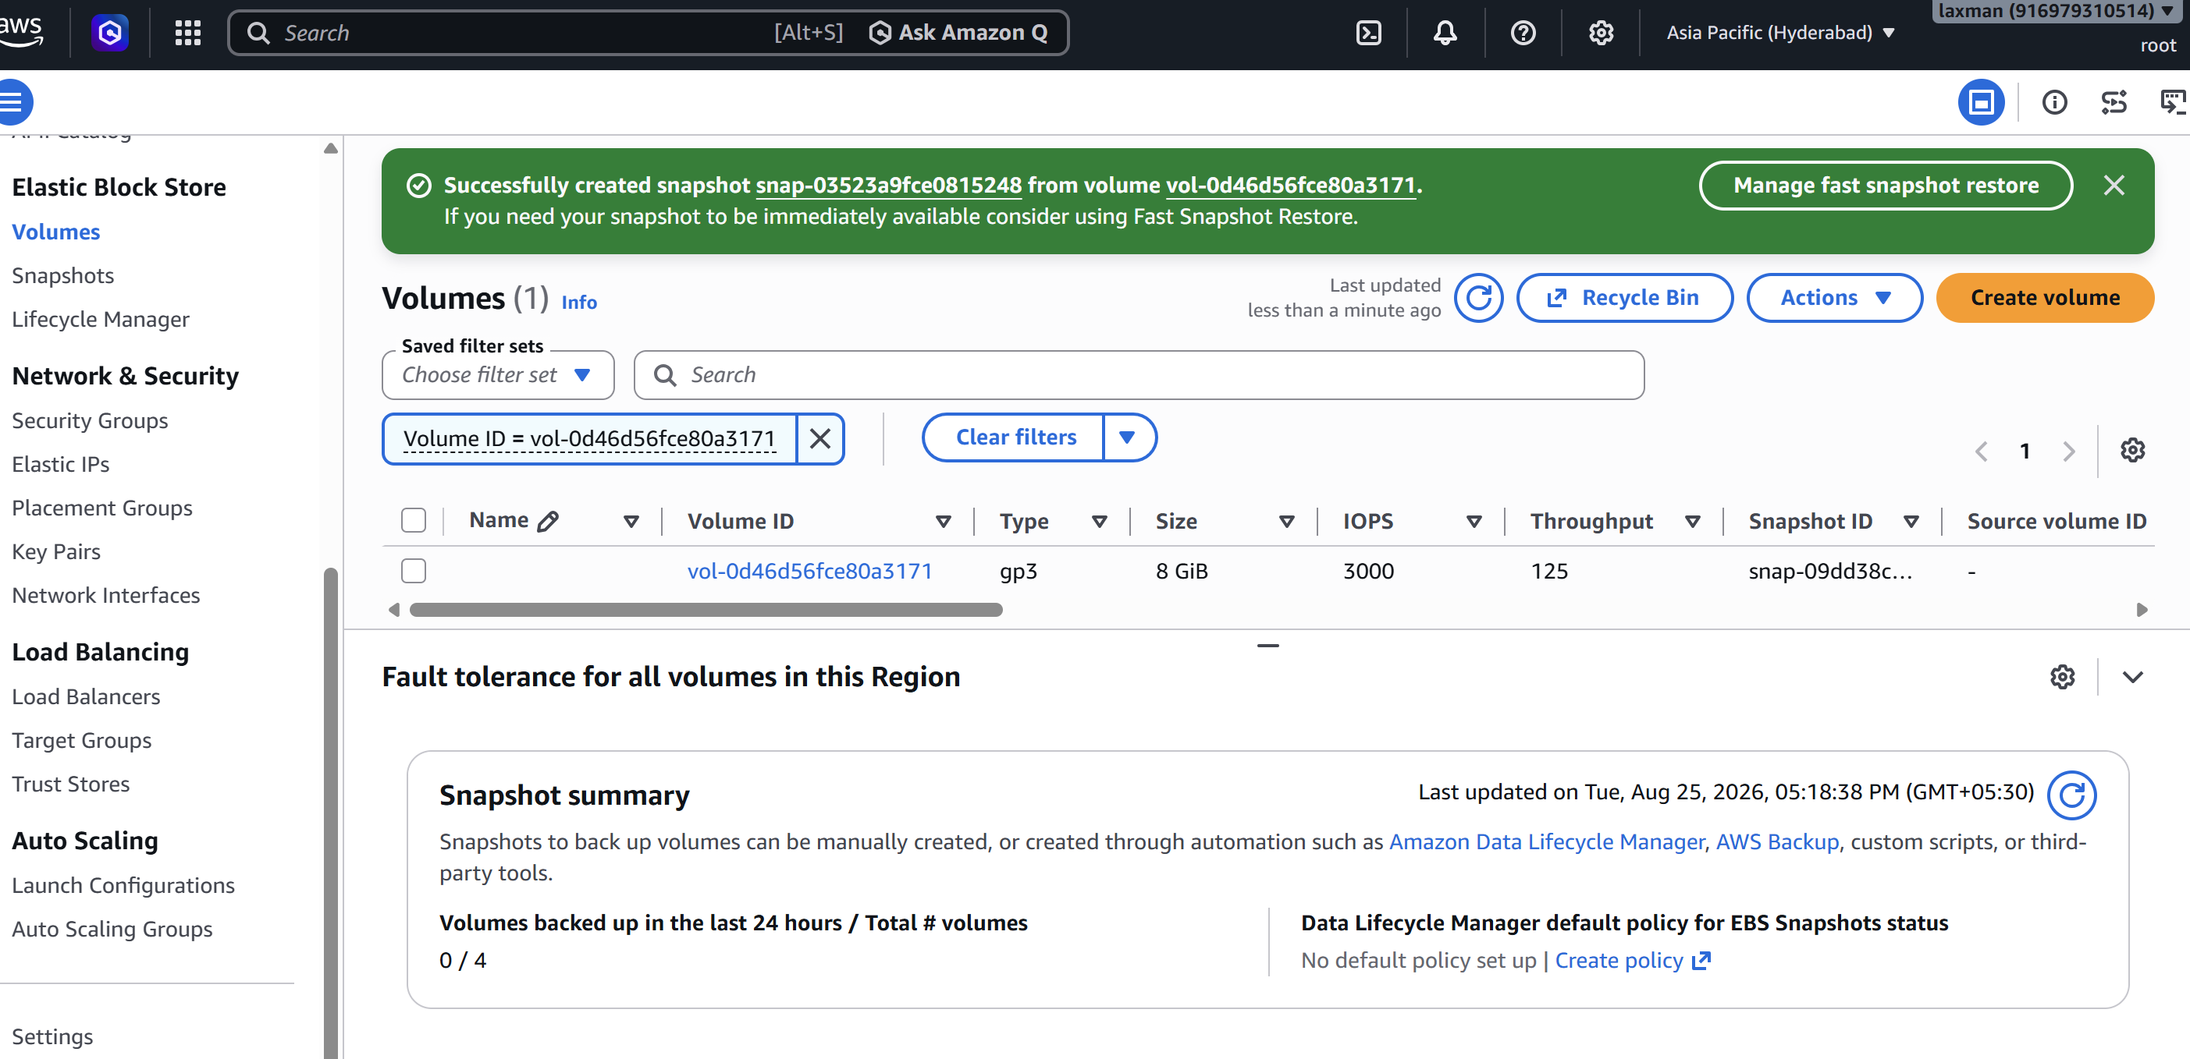 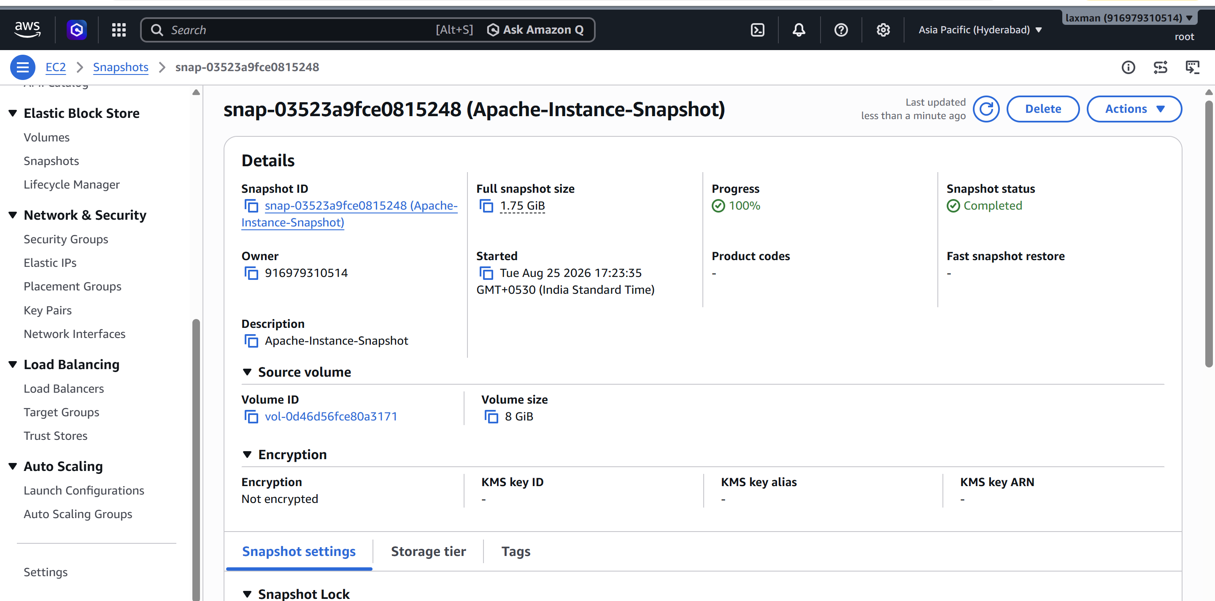

Task 5 — Assign Passwordless Authentication to the EC2 Created in Task 2
Objective: Configure SSH key-based authentication for the Ubuntu instance so that login does not require a password.
- Ensure the Ubuntu instance was launched with an EC2 key pair.
- On your local Linux/macOS system, set restrictive permissions on the private key: chmod 400 <key-file>.pem
- Connect using SSH and the key pair: ssh -i <key-file>.pem ubuntu@<PUBLIC-IP>
- If password authentication is enabled and you want to enforce key-only authentication, edit /etc/ssh/sshd_config.
- Set PasswordAuthentication to no.
- Validate the SSH configuration before restarting the service.
- Restart SSH using the service name appropriate to the Ubuntu release, for example: sudo systemctl restart ssh
- Open a new terminal and test key-based login again.
sudo nano /etc/ssh/sshd_config
PasswordAuthentication no
sudo sshd -t
sudo systemctl restart ssh
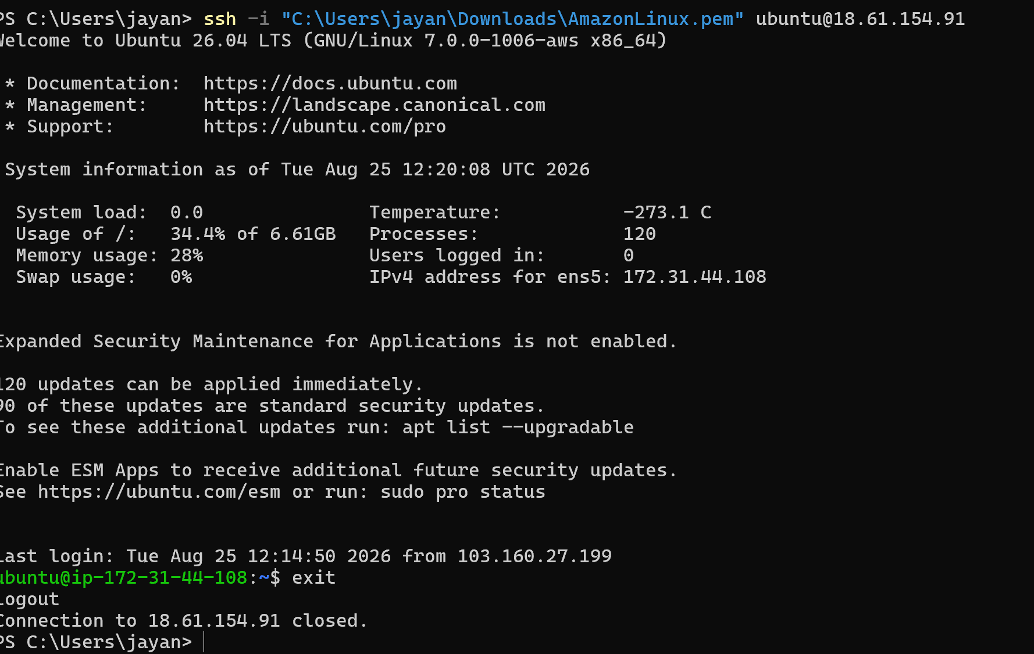 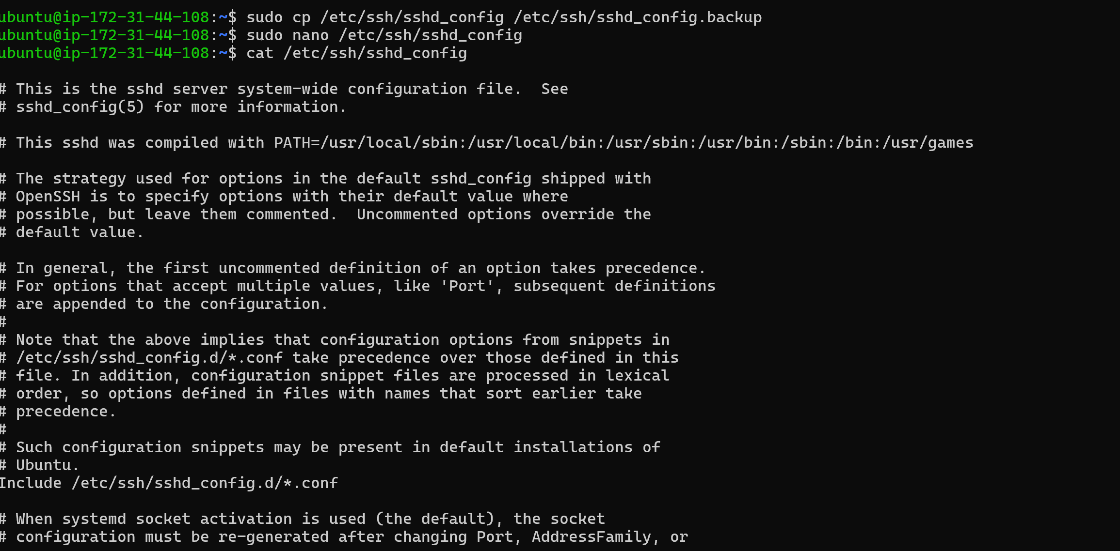 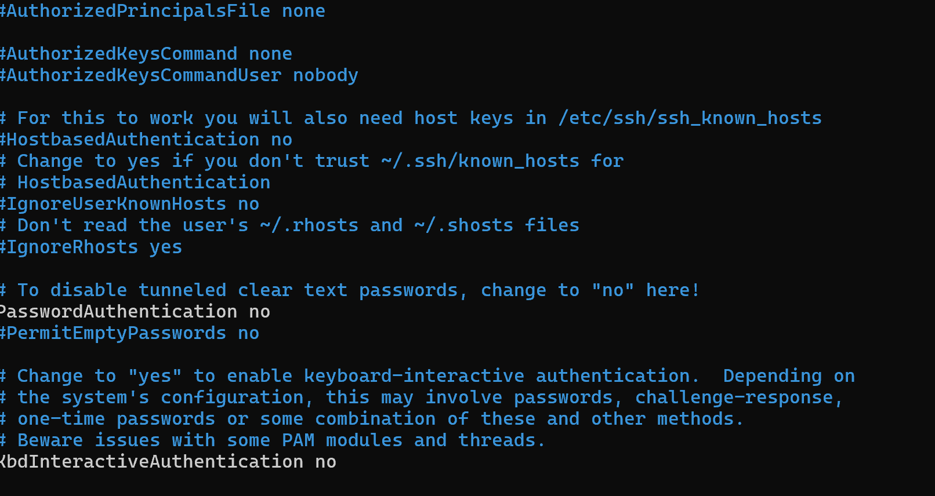 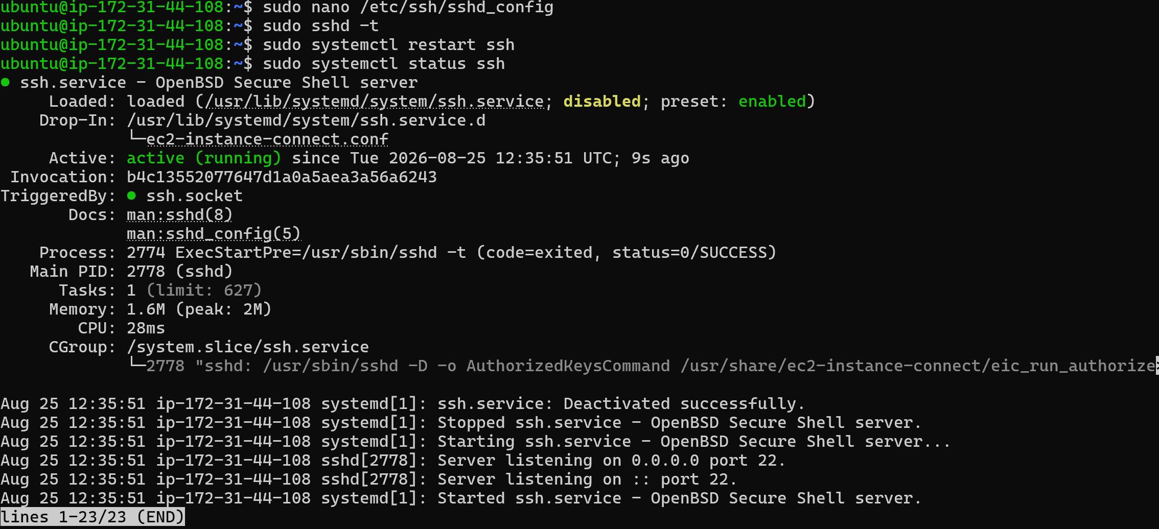 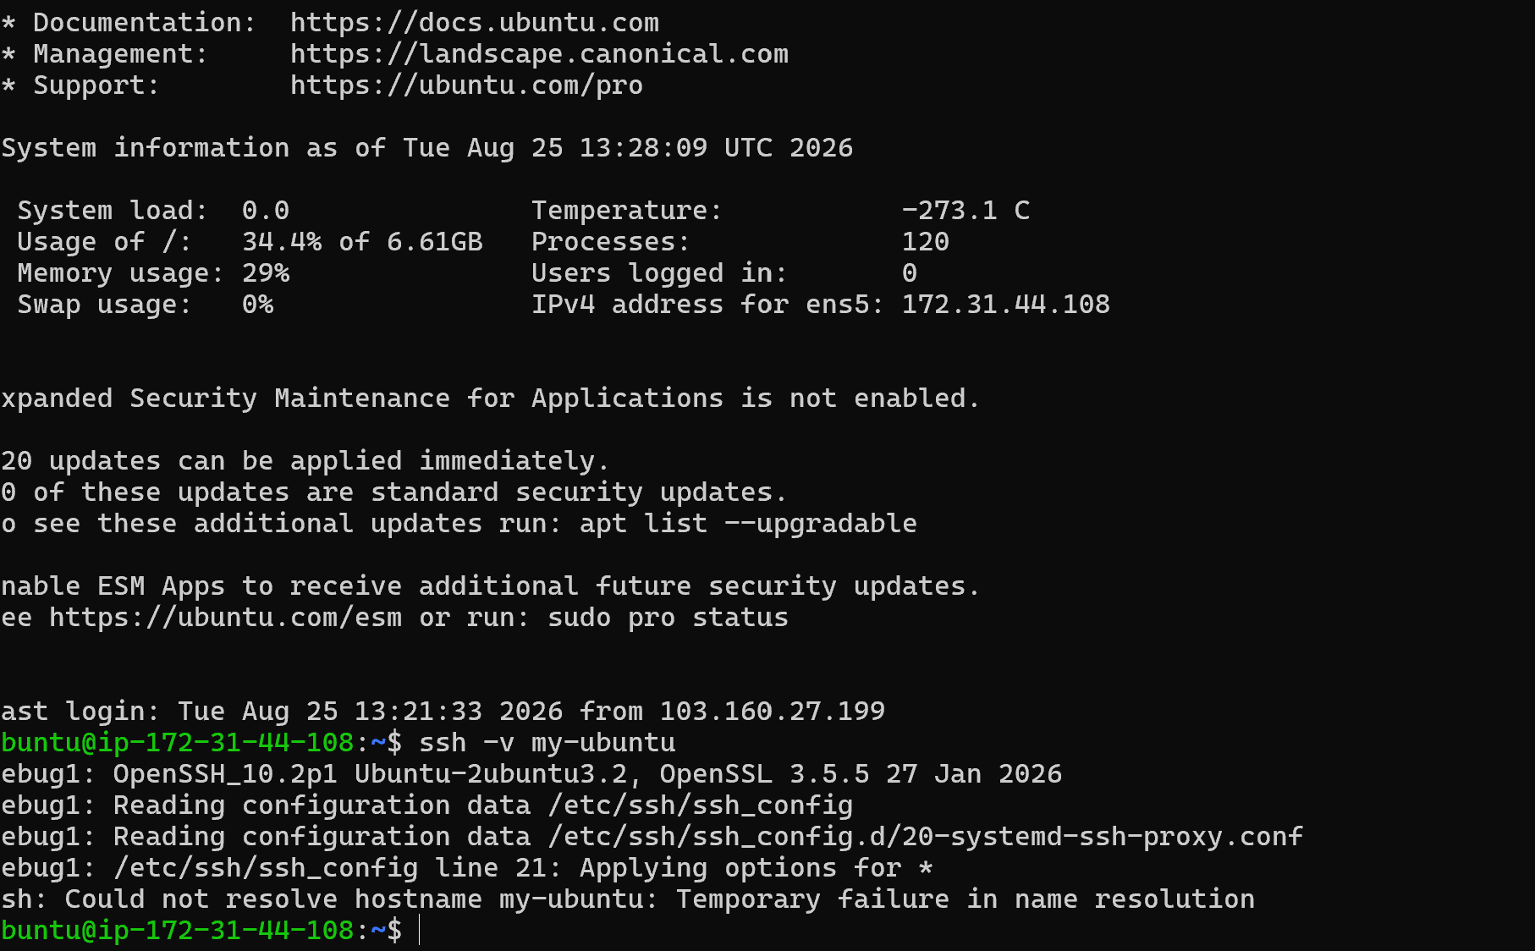
Expected result: SSH access works with the private key, while password-based SSH authentication is disabled. Keep an existing SSH session open until the new key-based login has been successfully tested.

Task 6 — Launch an EC2 Using the Spot Purchasing Option
Objective: Launch an EC2 instance using Amazon EC2 Spot pricing.
- Open EC2 → Instances → Launch instance.
- Select an AMI and instance type suitable for the lab.
- Under purchasing/options, select the Spot purchasing option where available.
- Review the Spot request/instance settings and maximum price behavior presented by the console.
- Configure a suitable key pair and security group.
- Launch the Spot instance.
- Confirm that the instance appears with Spot purchasing information.
- Record the Instance ID and current state.
- Do not use Spot Instances for workloads that cannot tolerate interruption unless you have designed for interruption and recovery. 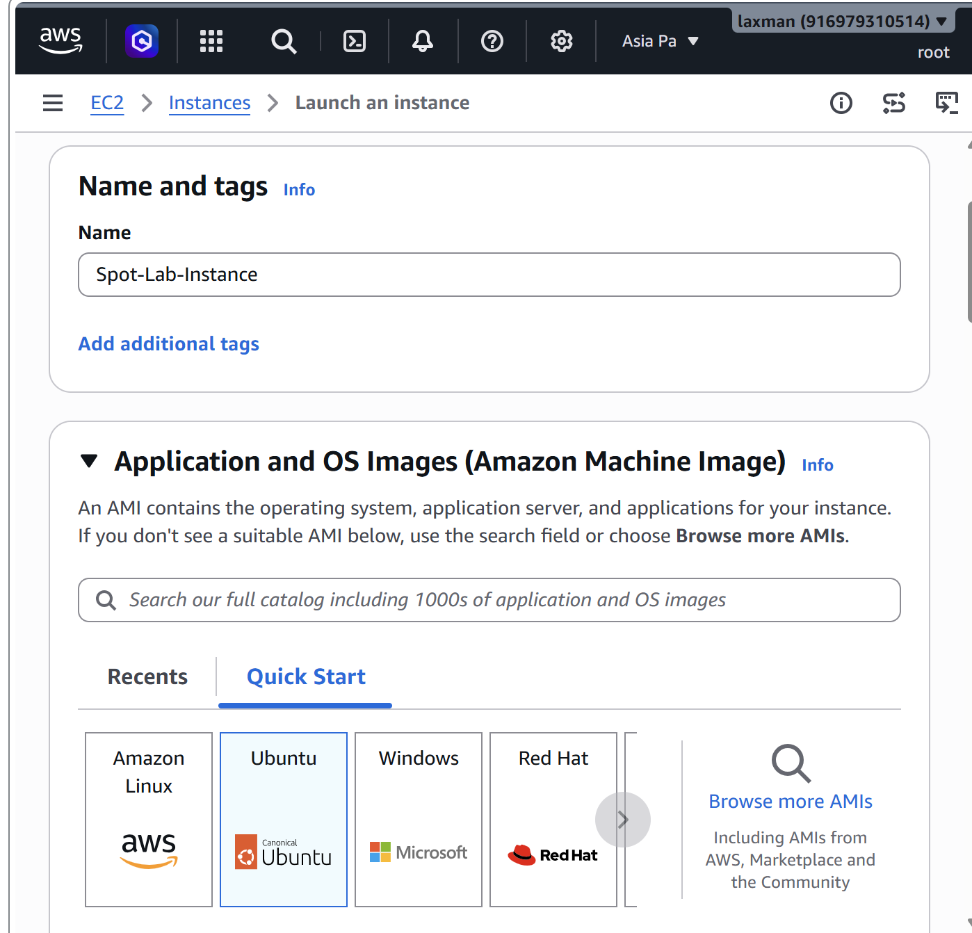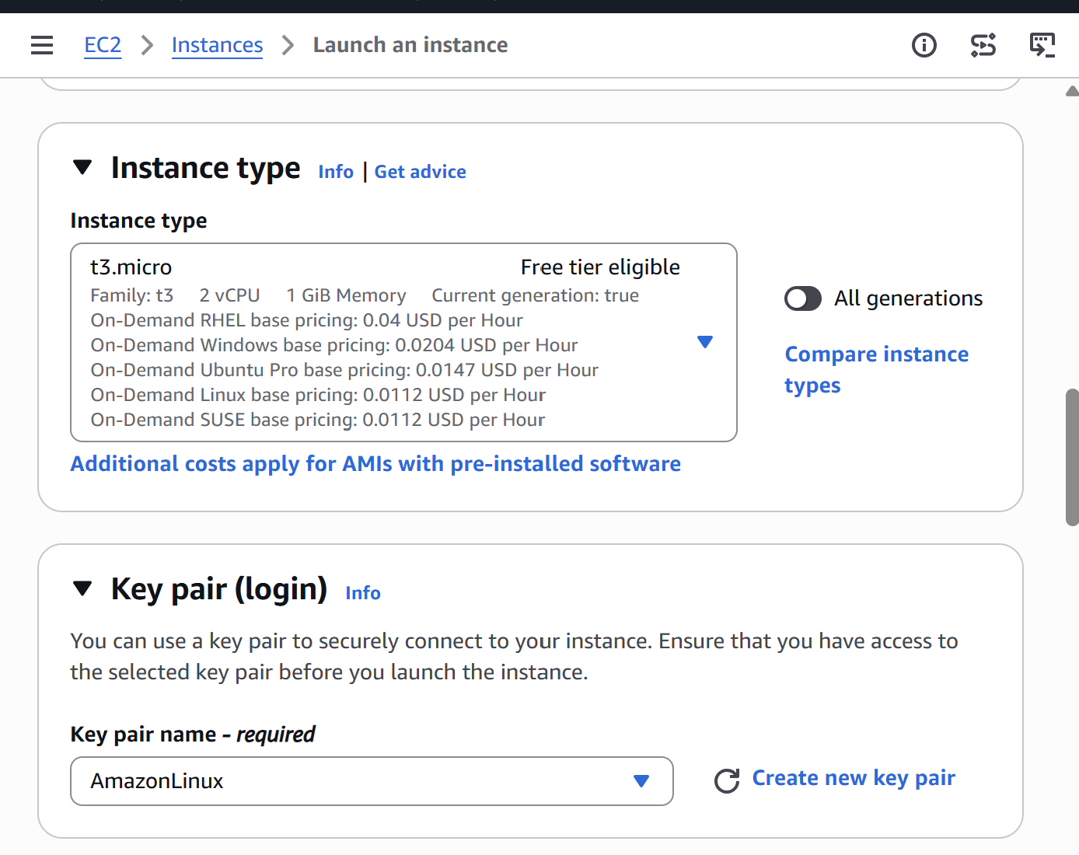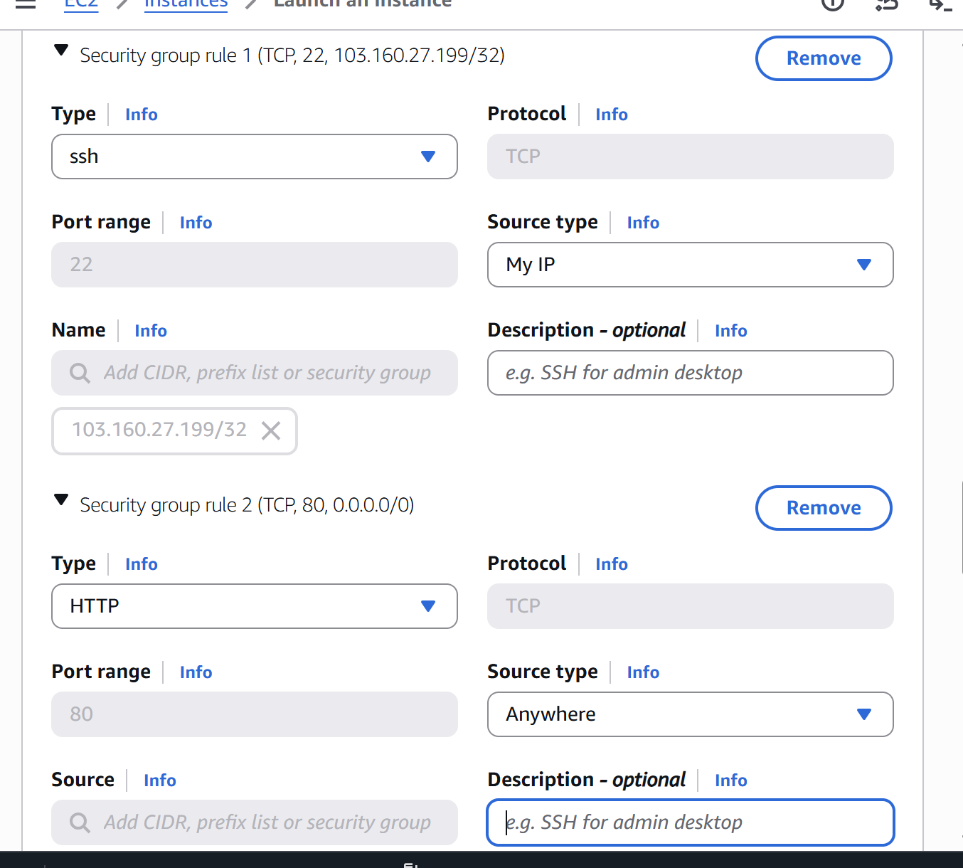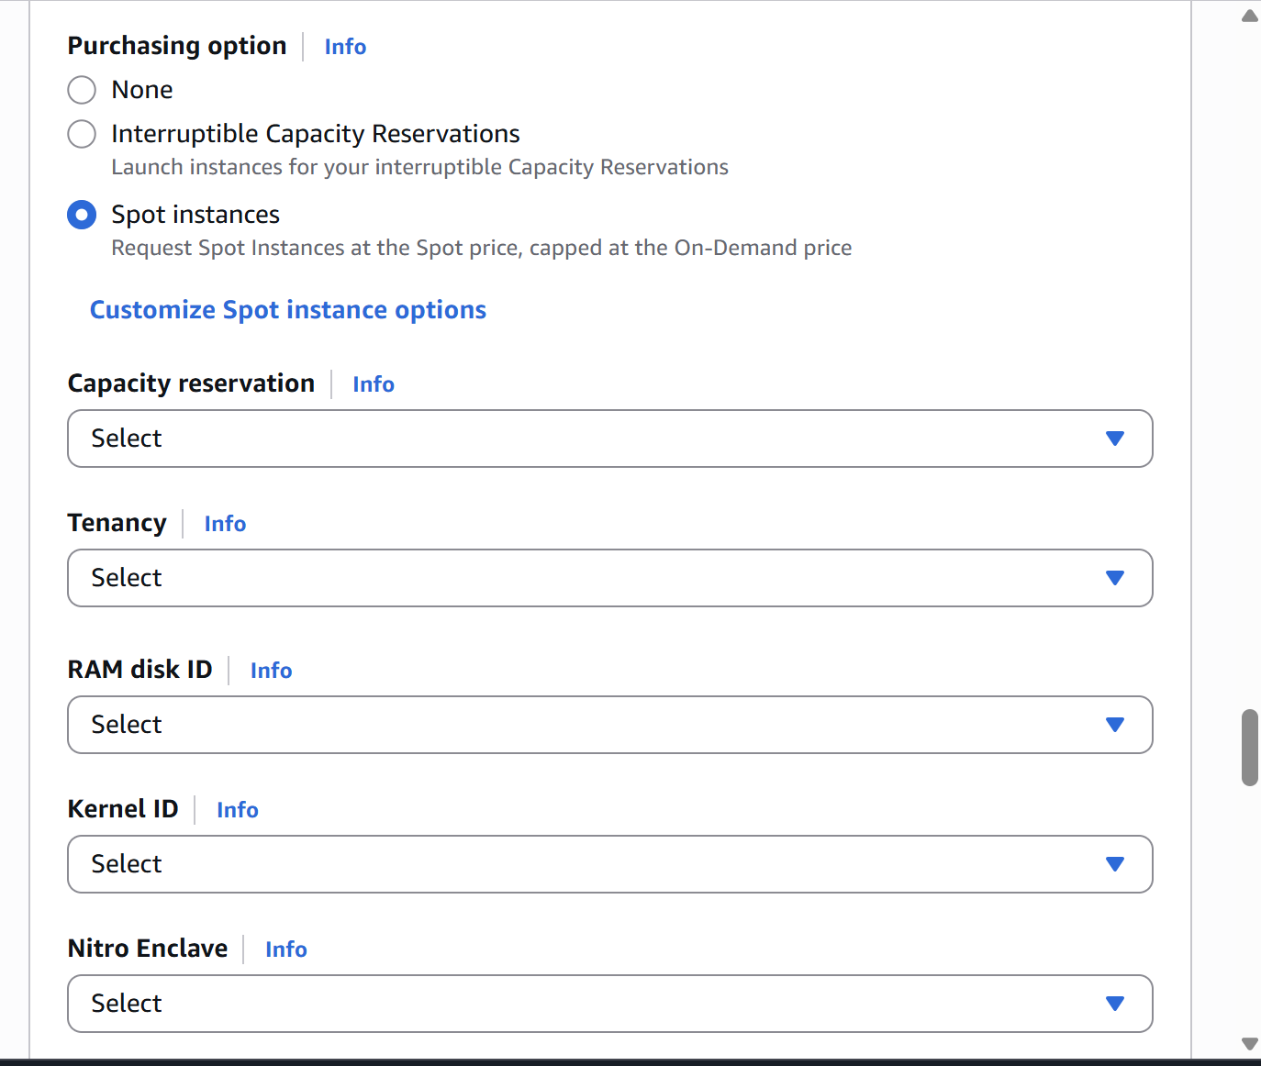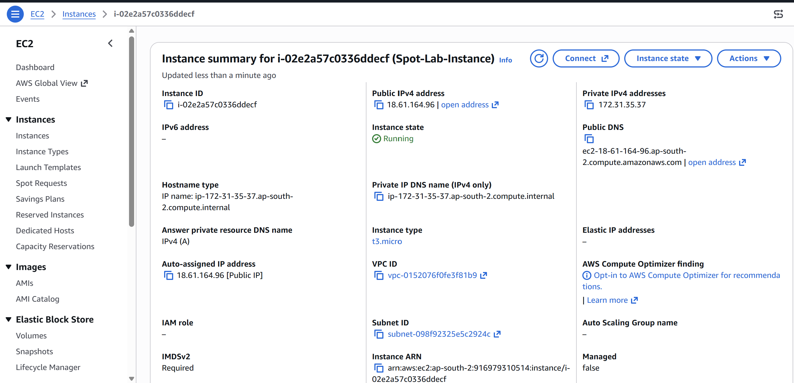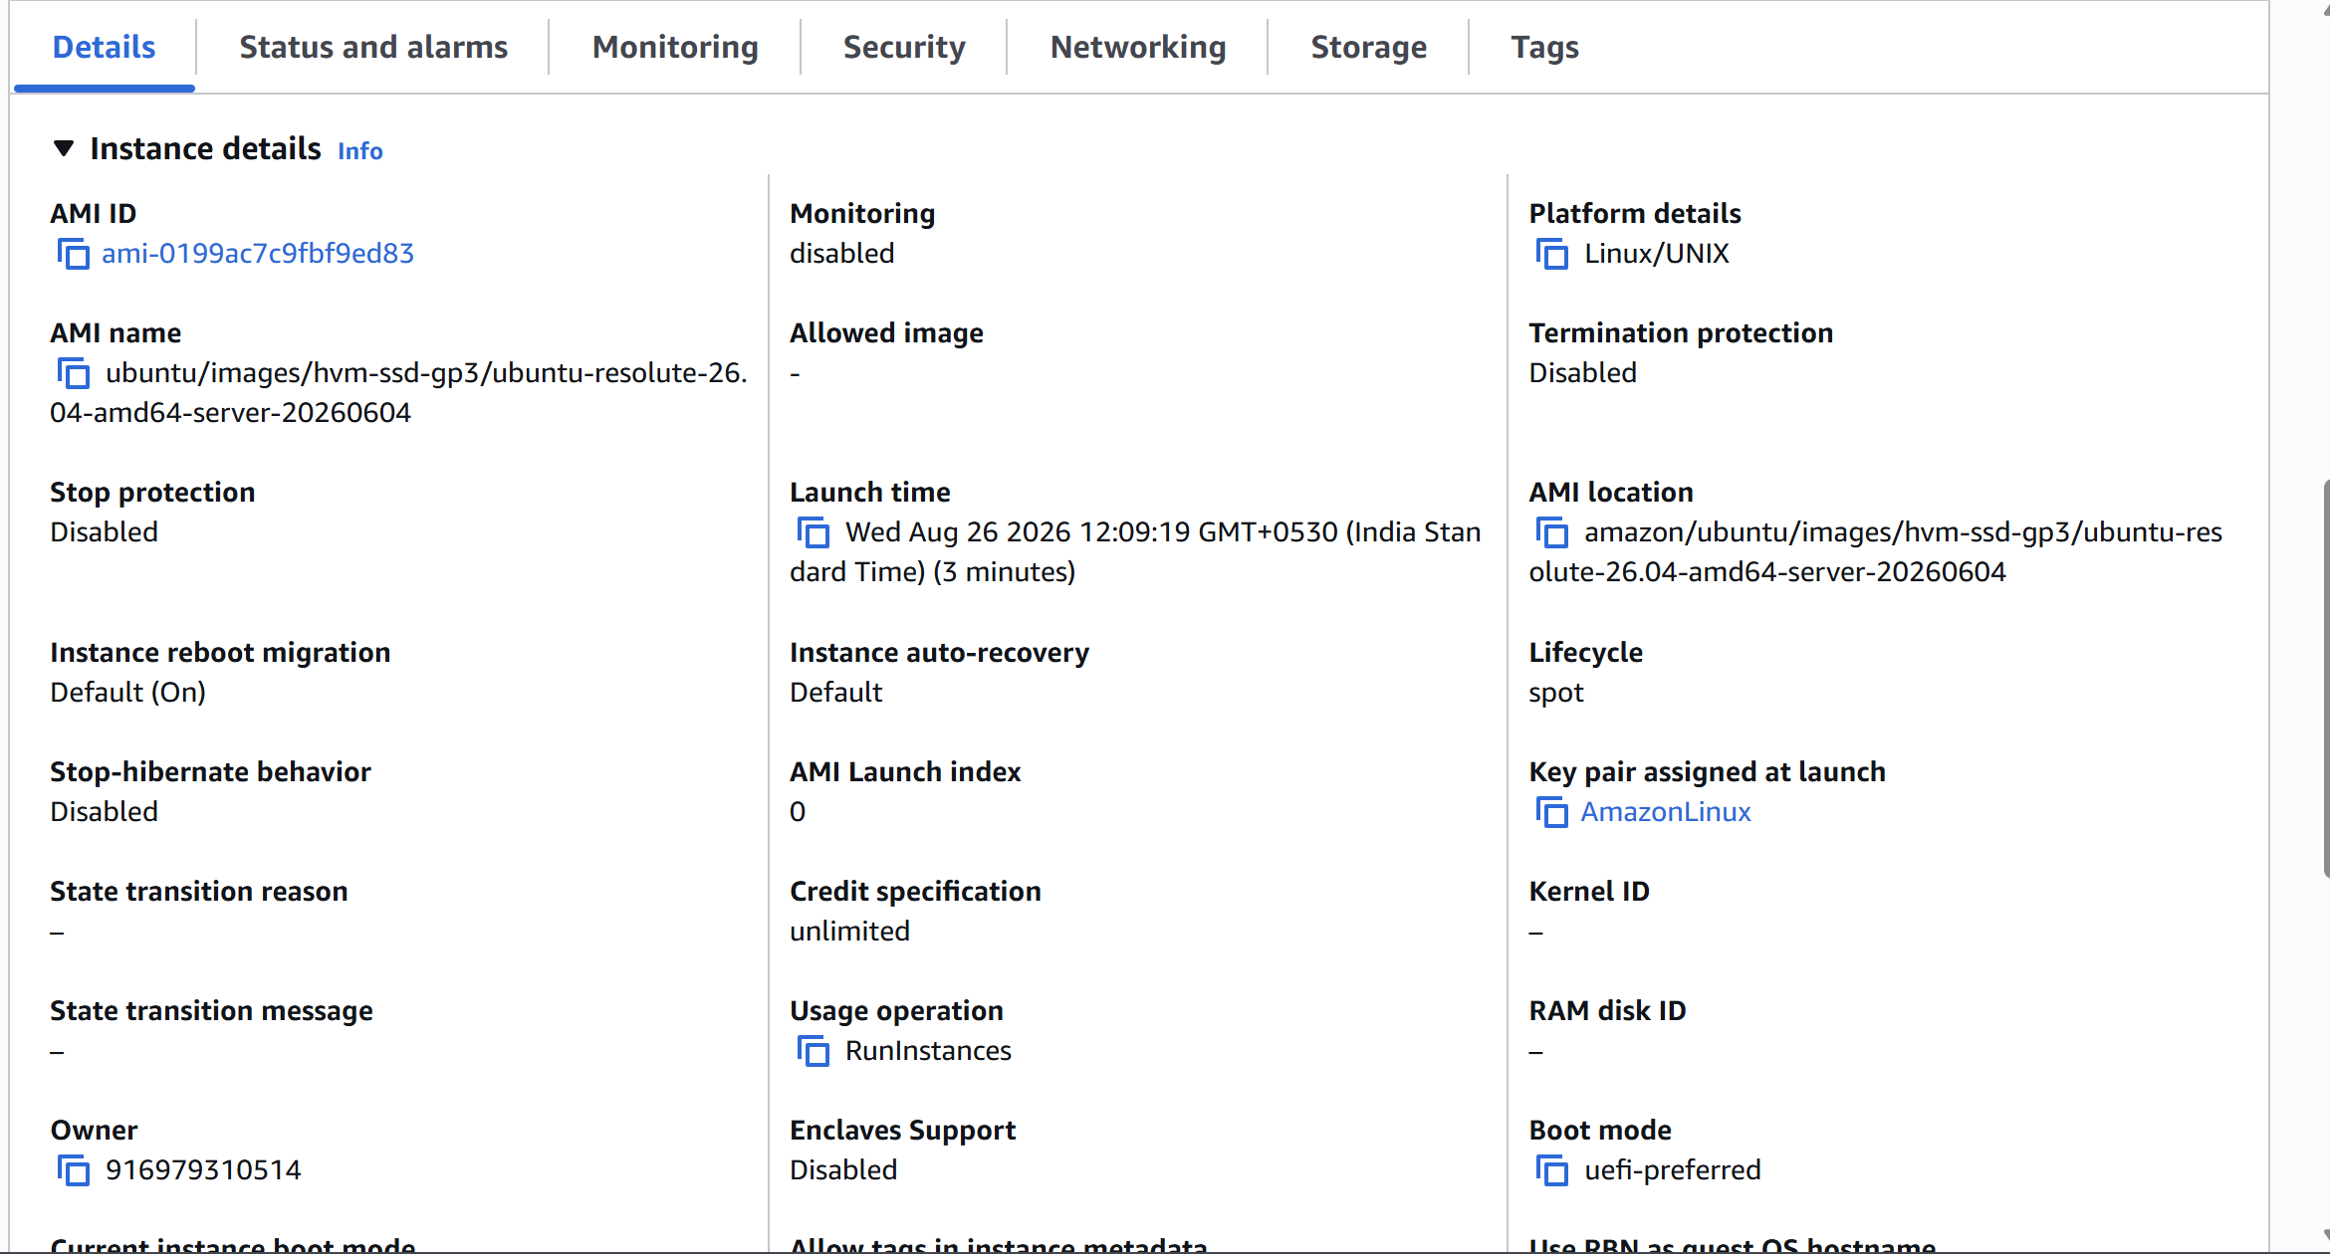

Task 7 — Enable Termination Protection on the EC2 Created in Task 3
Objective: Protect the Windows/Tomcat instance from accidental termination.
- Go to EC2 → Instances.
- Select the Windows-Tomcat instance created in Task 3.
- Choose Actions → Instance settings → Change termination protection.
- Enable termination protection and save the setting.
- Verify the setting from the instance details or by using the AWS CLI command below.
aws ec2 describe-instance-attribute \
--instance-id <WINDOWS_INSTANCE_ID> \
--attribute disableApiTermination
Expected result: disableApiTermination is returned as true. Termination protection helps prevent accidental API/console termination; it is not a substitute for backups. 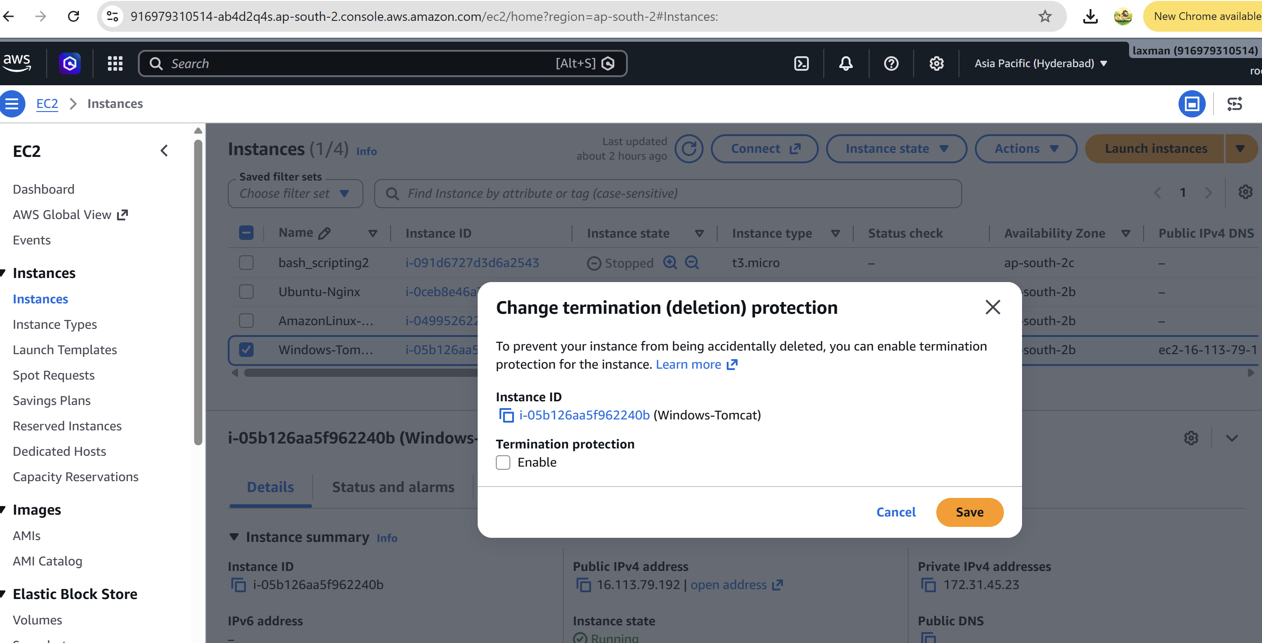 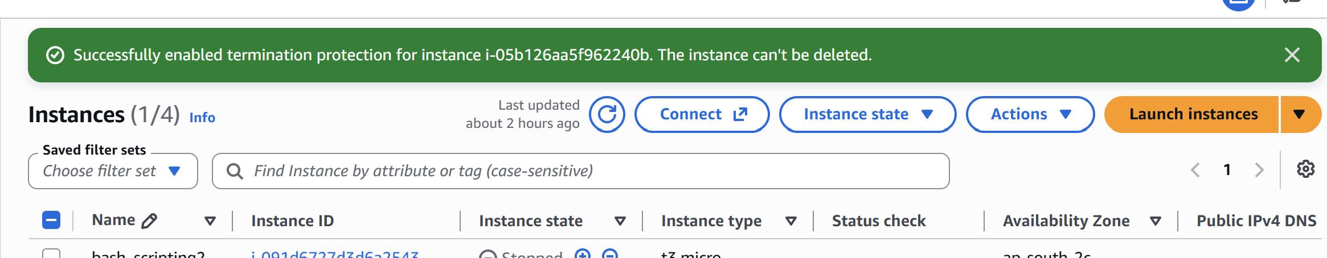

Task 8 — Launch an EC2 Instance Using AWS CLI
Objective: Launch an EC2 instance from the command line using the AWS CLI.
- Install AWS CLI and configure credentials if not already configured.
- Verify the current AWS Region: aws configure get region
- Identify a valid AMI ID in your selected Region.
- Identify an existing key pair and security group.
- Run the following command, replacing the placeholders.
aws ec2 run-instances \
--image-id <AMI_ID> \
--instance-type t3.micro \
--key-name <KEY_PAIR_NAME> \
--security-group-ids <SECURITY_GROUP_ID> \
--subnet-id <SUBNET_ID> \
--count 1
- Copy the returned InstanceId.
- Check the instance state: aws ec2 describe-instances --instance-ids <INSTANCE_ID>
- Wait until the instance is running and its status checks pass.
- Record the Instance ID, AMI ID, instance type, subnet, security group, and public IP address if assigned. 