AWS SELF-LEARNING &
HANDS-ON IMPLEMENTATION
AWS SQS • Amazon MQ • AWS Secrets Manager

Implementation Document
Prepared for AWS self-learning and hands-on activity
Submission: End of Day (EOD)

Participant Name | Lakshman Kumar
Environment | AWS Console / AWS Account
Services Covered | Amazon SQS, Amazon MQ, AWS Secrets Manager
Document Purpose | Concepts, architecture, configuration, validation, observations and screenshots

1. Activity Overview
This document records the self-learning and hands-on implementation activity for three AWS services: Amazon Simple Queue Service (SQS), Amazon MQ, and AWS Secrets Manager. The objective is to understand the purpose and use cases of each service, implement representative configurations in AWS, validate the configuration, and capture evidence through AWS Console screenshots.

Expected Deliverables
- Understand the concepts and use cases of each service.
- Perform hands-on implementation in AWS.
- Prepare architecture diagrams and configuration steps.
- Capture AWS Console screenshots as implementation evidence.
- Record observations, validation results, and key learnings.

2. Service Comparison
Service | Primary Purpose | Typical Use Case | Key Concept
Amazon SQS | Managed message queuing | Decouple producers and consumers | Queues, visibility timeout, DLQ
Amazon MQ | Managed message broker | Applications requiring broker protocols/features | ActiveMQ/RabbitMQ, broker, connections
Secrets Manager | Secure secret storage | Database/API credentials and application secrets | IAM access, encryption, rotation

3. Amazon SQS
Amazon SQS is a fully managed message queuing service used to decouple and scale distributed software components. Producers send messages to a queue and consumers retrieve and process them independently.

3.1 Architecture
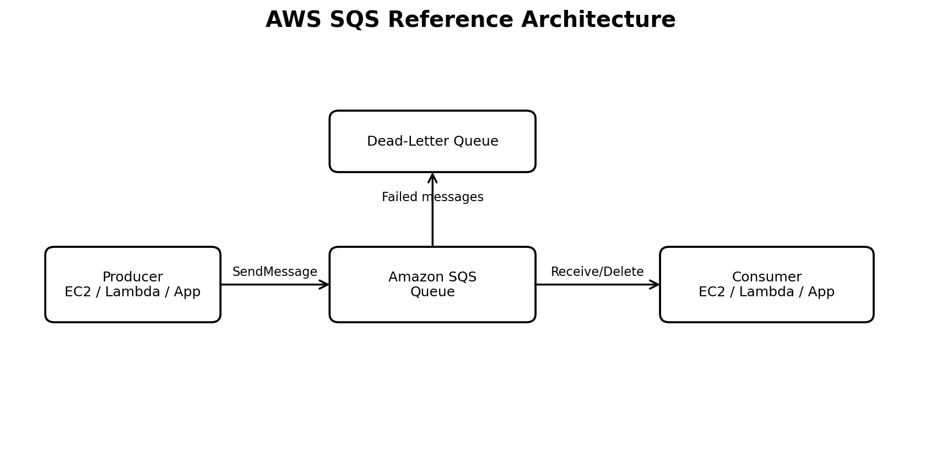
Figure 1: Representative SQS architecture.

3.2 Key Concepts
- Standard Queue: high throughput with at-least-once delivery and best-effort ordering.
- FIFO Queue: supports ordered processing and deduplication capabilities.
- Visibility Timeout: temporarily hides a received message while a consumer processes it.
- Dead-Letter Queue (DLQ): stores messages that cannot be successfully processed after configured receive attempts.
- Long Polling: reduces empty receives by waiting for messages to become available.
- Encryption: messages can be protected using AWS-managed or customer-managed KMS keys depending on configuration.

3.3 Hands-On Implementation
1. Open Amazon SQS: AWS Console → SQS → Queues → Create queue.
2. Choose queue type: For a basic lab, create a Standard queue. A FIFO queue can be used when strict ordering is required.
3. Configure queue: Enter a name such as AWS-SQS-Lab-Queue. Review visibility timeout, message retention, delivery delay and receive settings.
4. Configure DLQ: Create a separate queue such as AWS-SQS-Lab-DLQ and configure the main queue's redrive policy if required.
5. Create queue: Review the settings and create the queue.
6. Send a test message: Open the queue → Send and receive messages → enter a test body such as 'SQS hands-on test message' → Send.
7. Receive and delete: Use Poll for messages to retrieve the message. After successful processing, delete the message.
8. Validate: Observe message counts and verify that the message is no longer available after deletion.

3.4 Validation / Observations
- The queue was created successfully and was visible in the SQS Queues list.
- A test message could be sent to the queue.
- The message could be received by a consumer/poll operation.
- After successful processing, the message was deleted from the queue.
- A DLQ provides a separate location for messages that repeatedly fail processing. 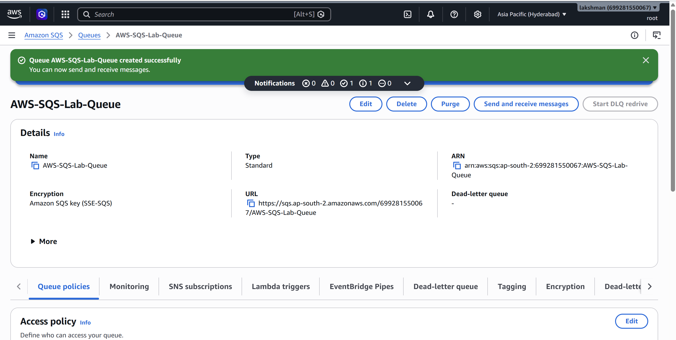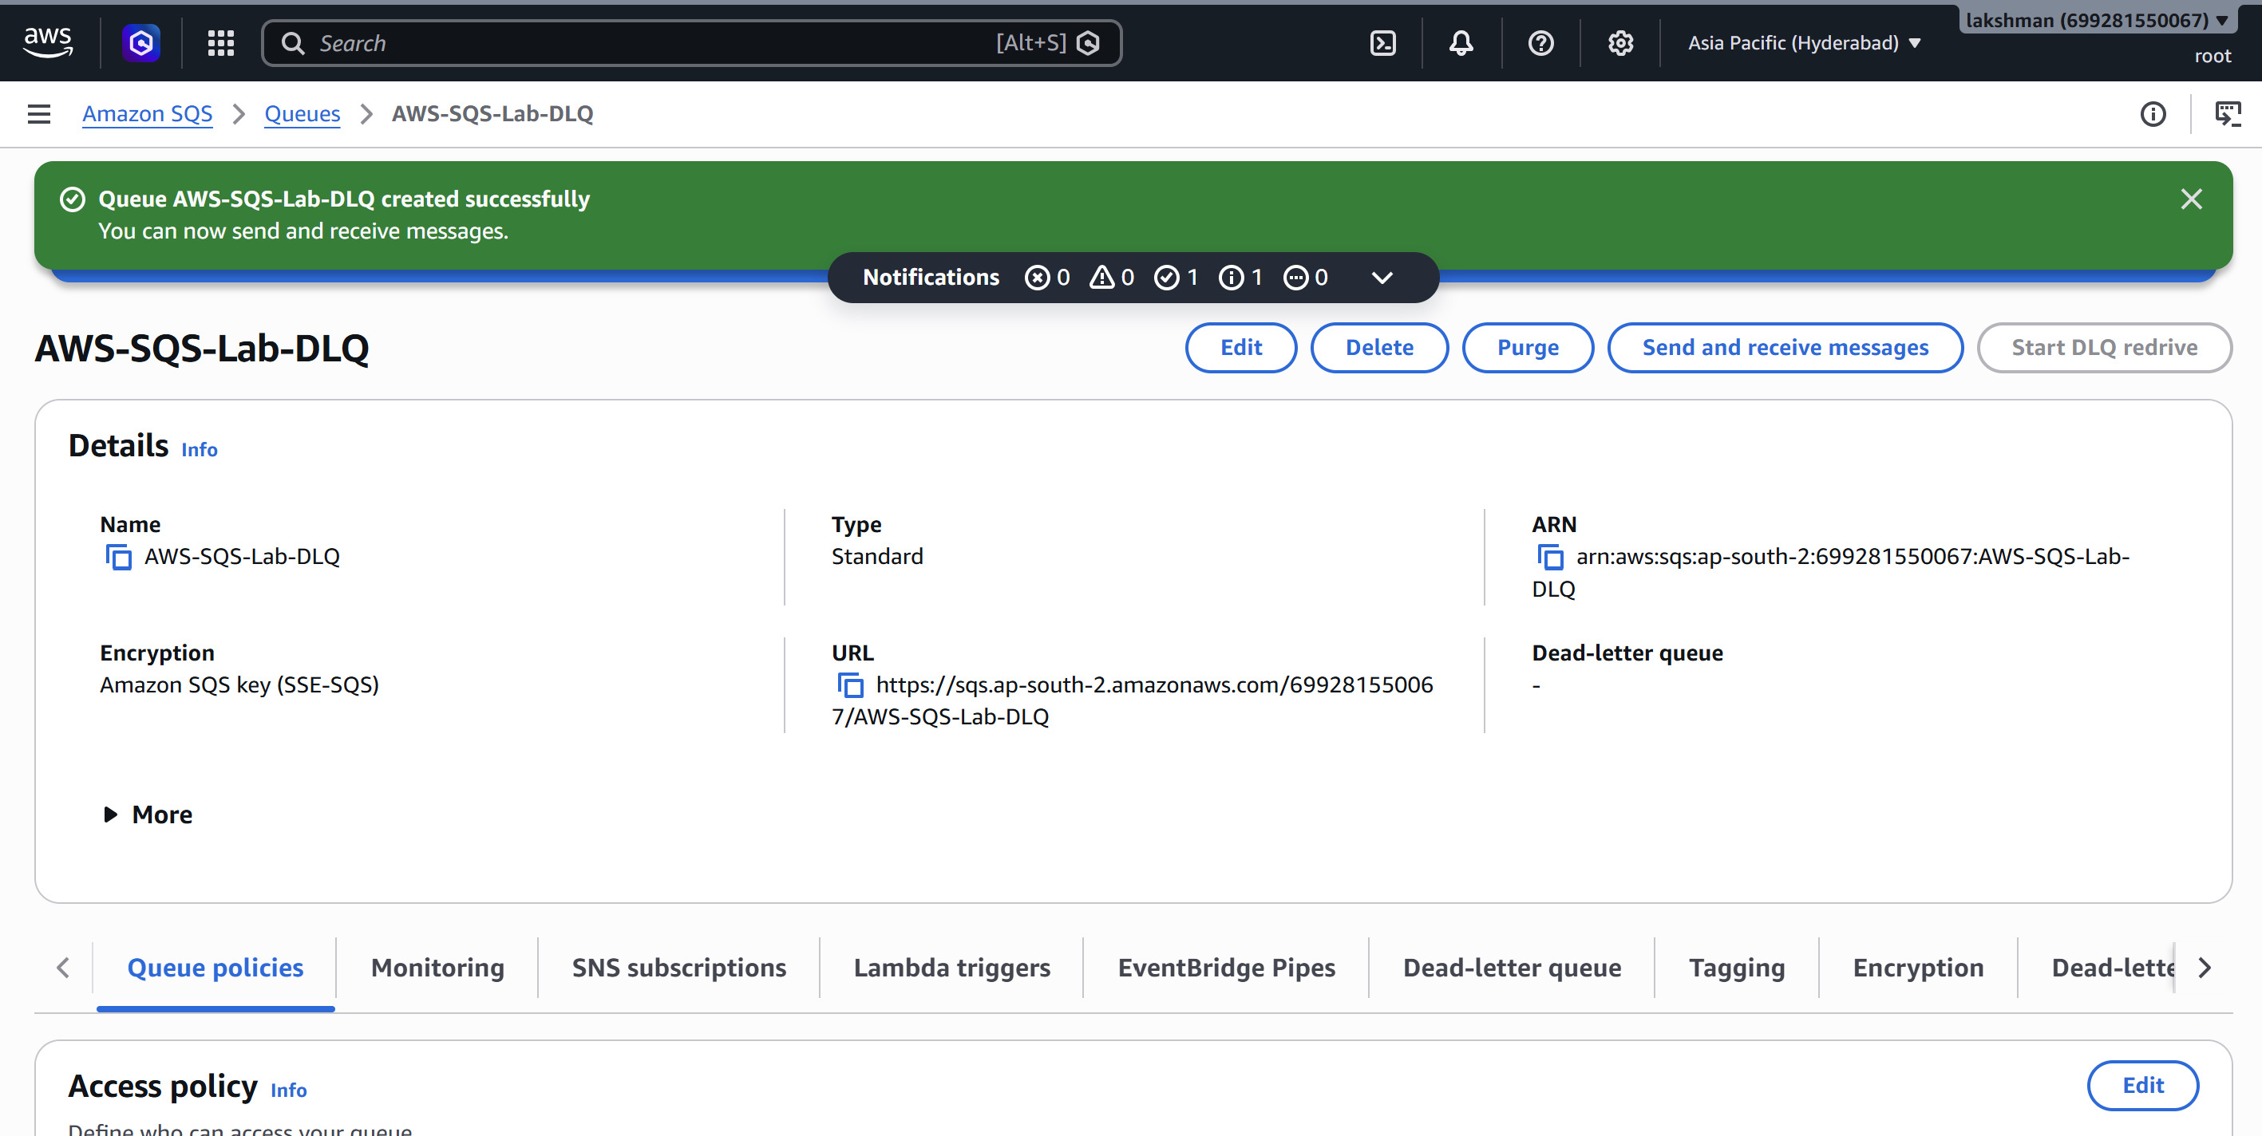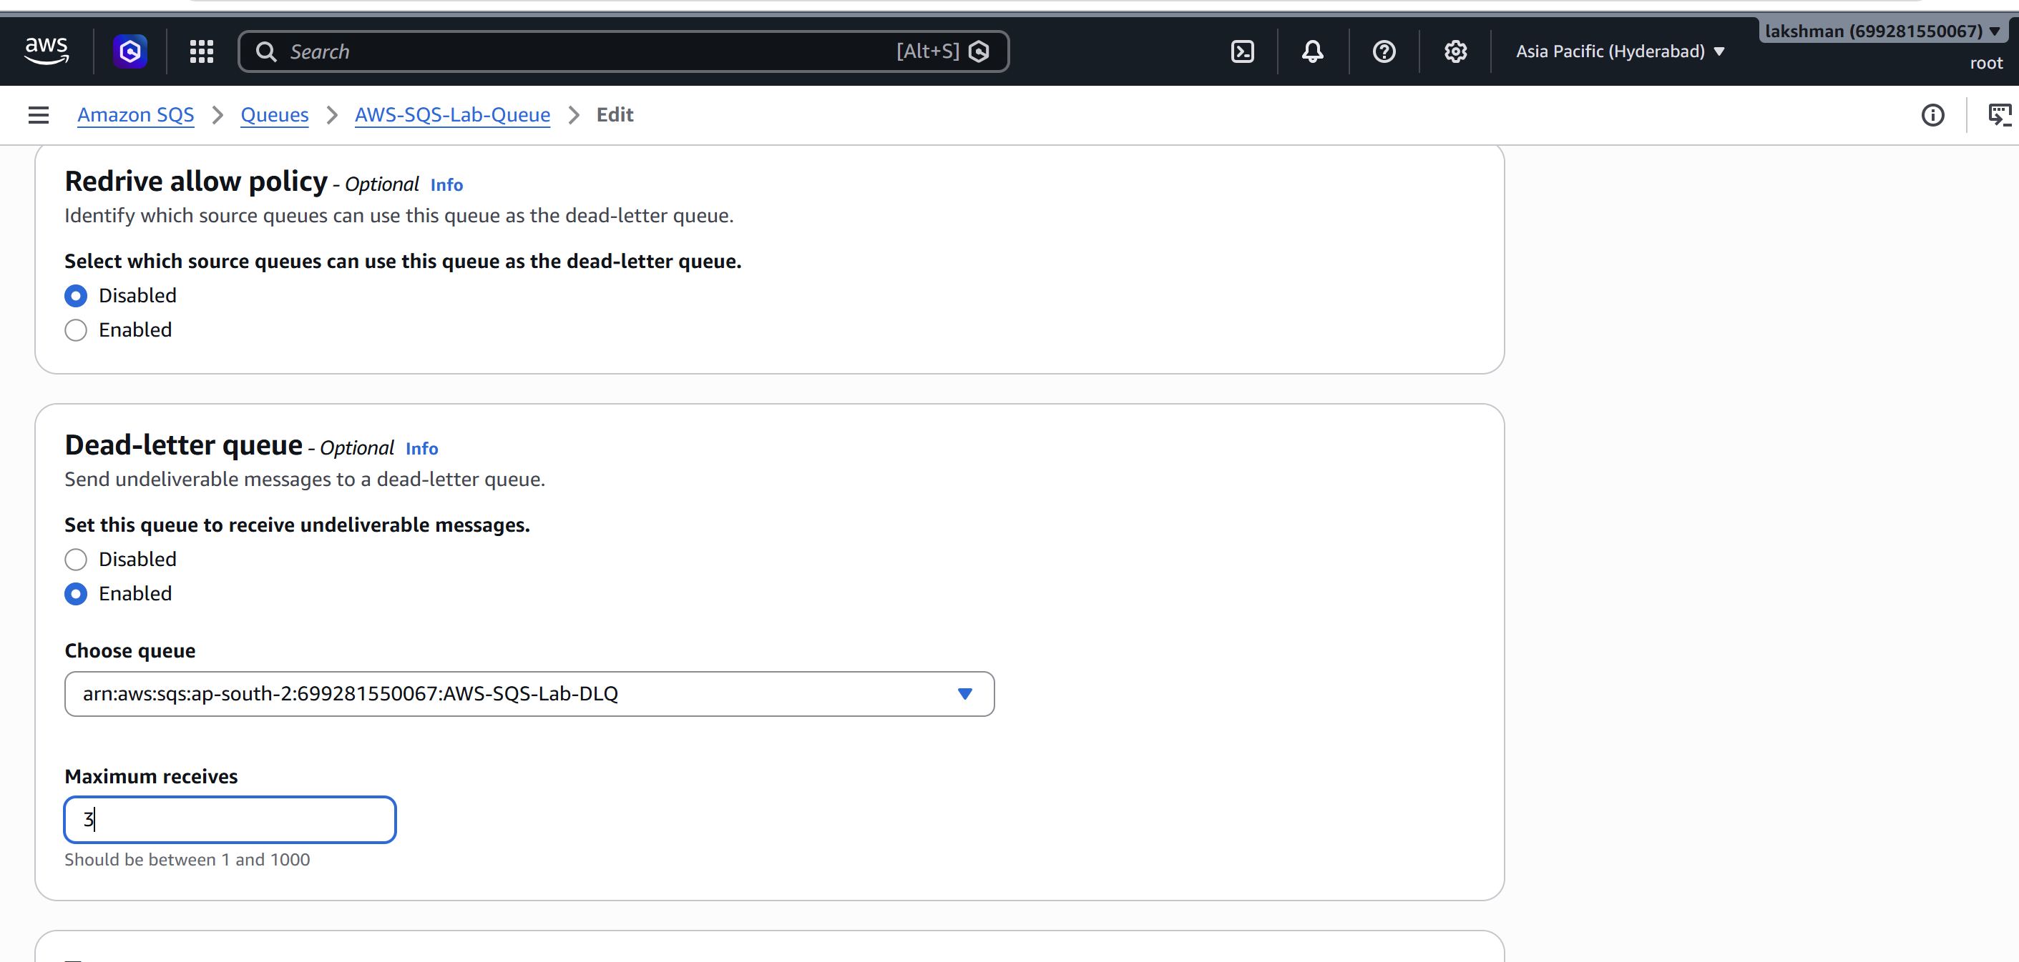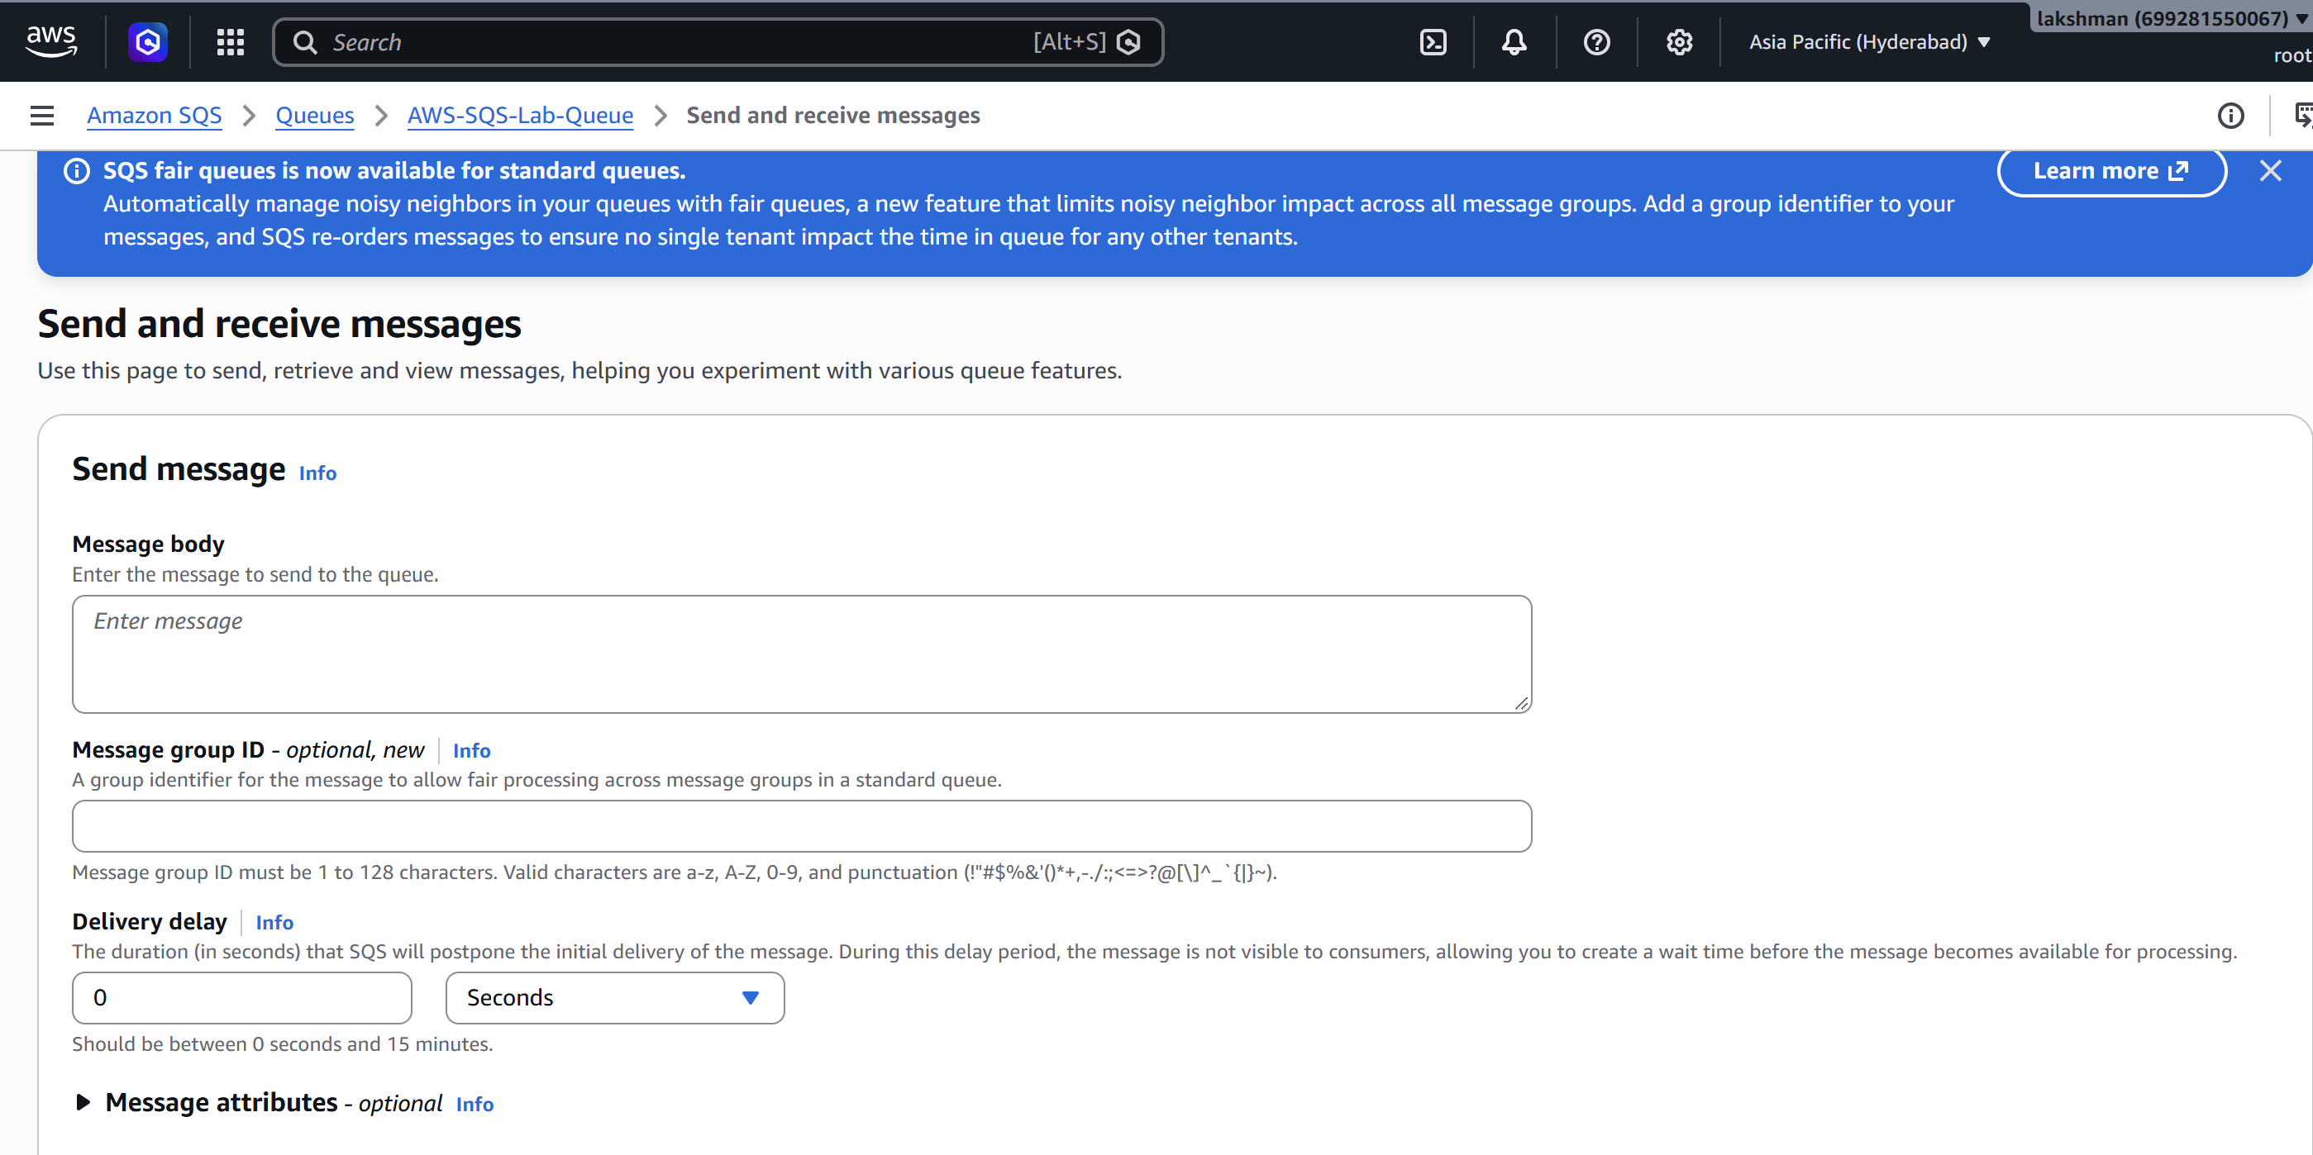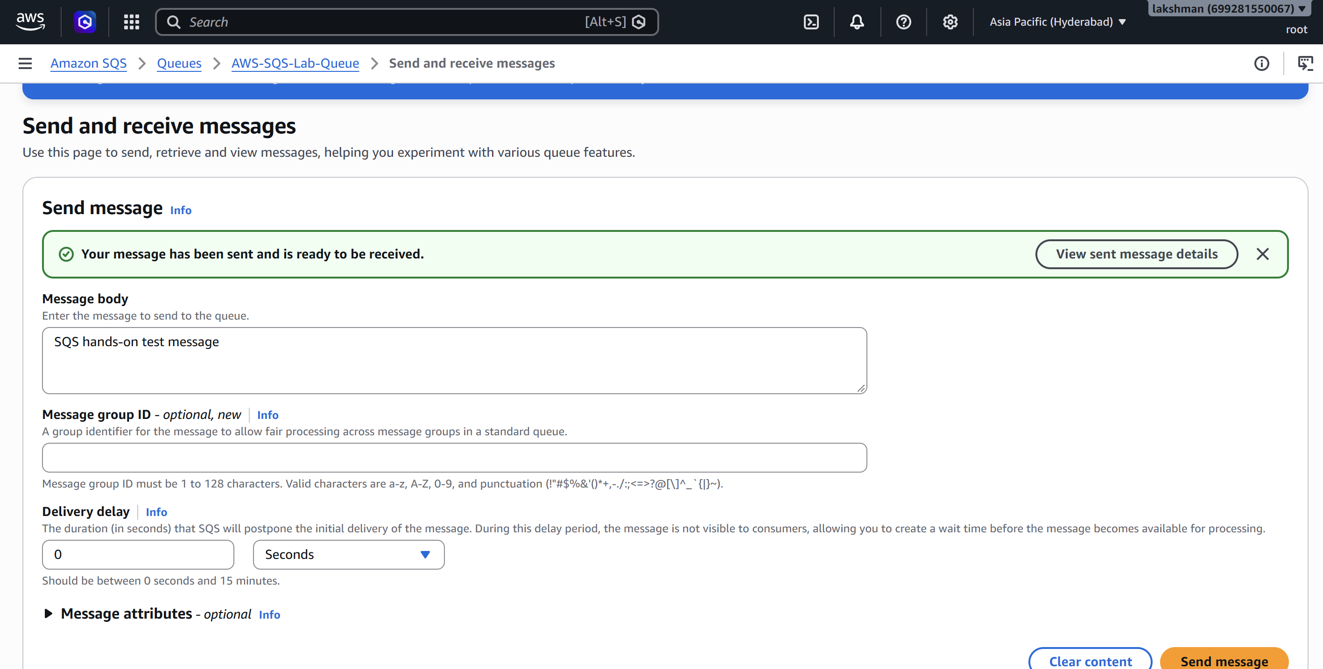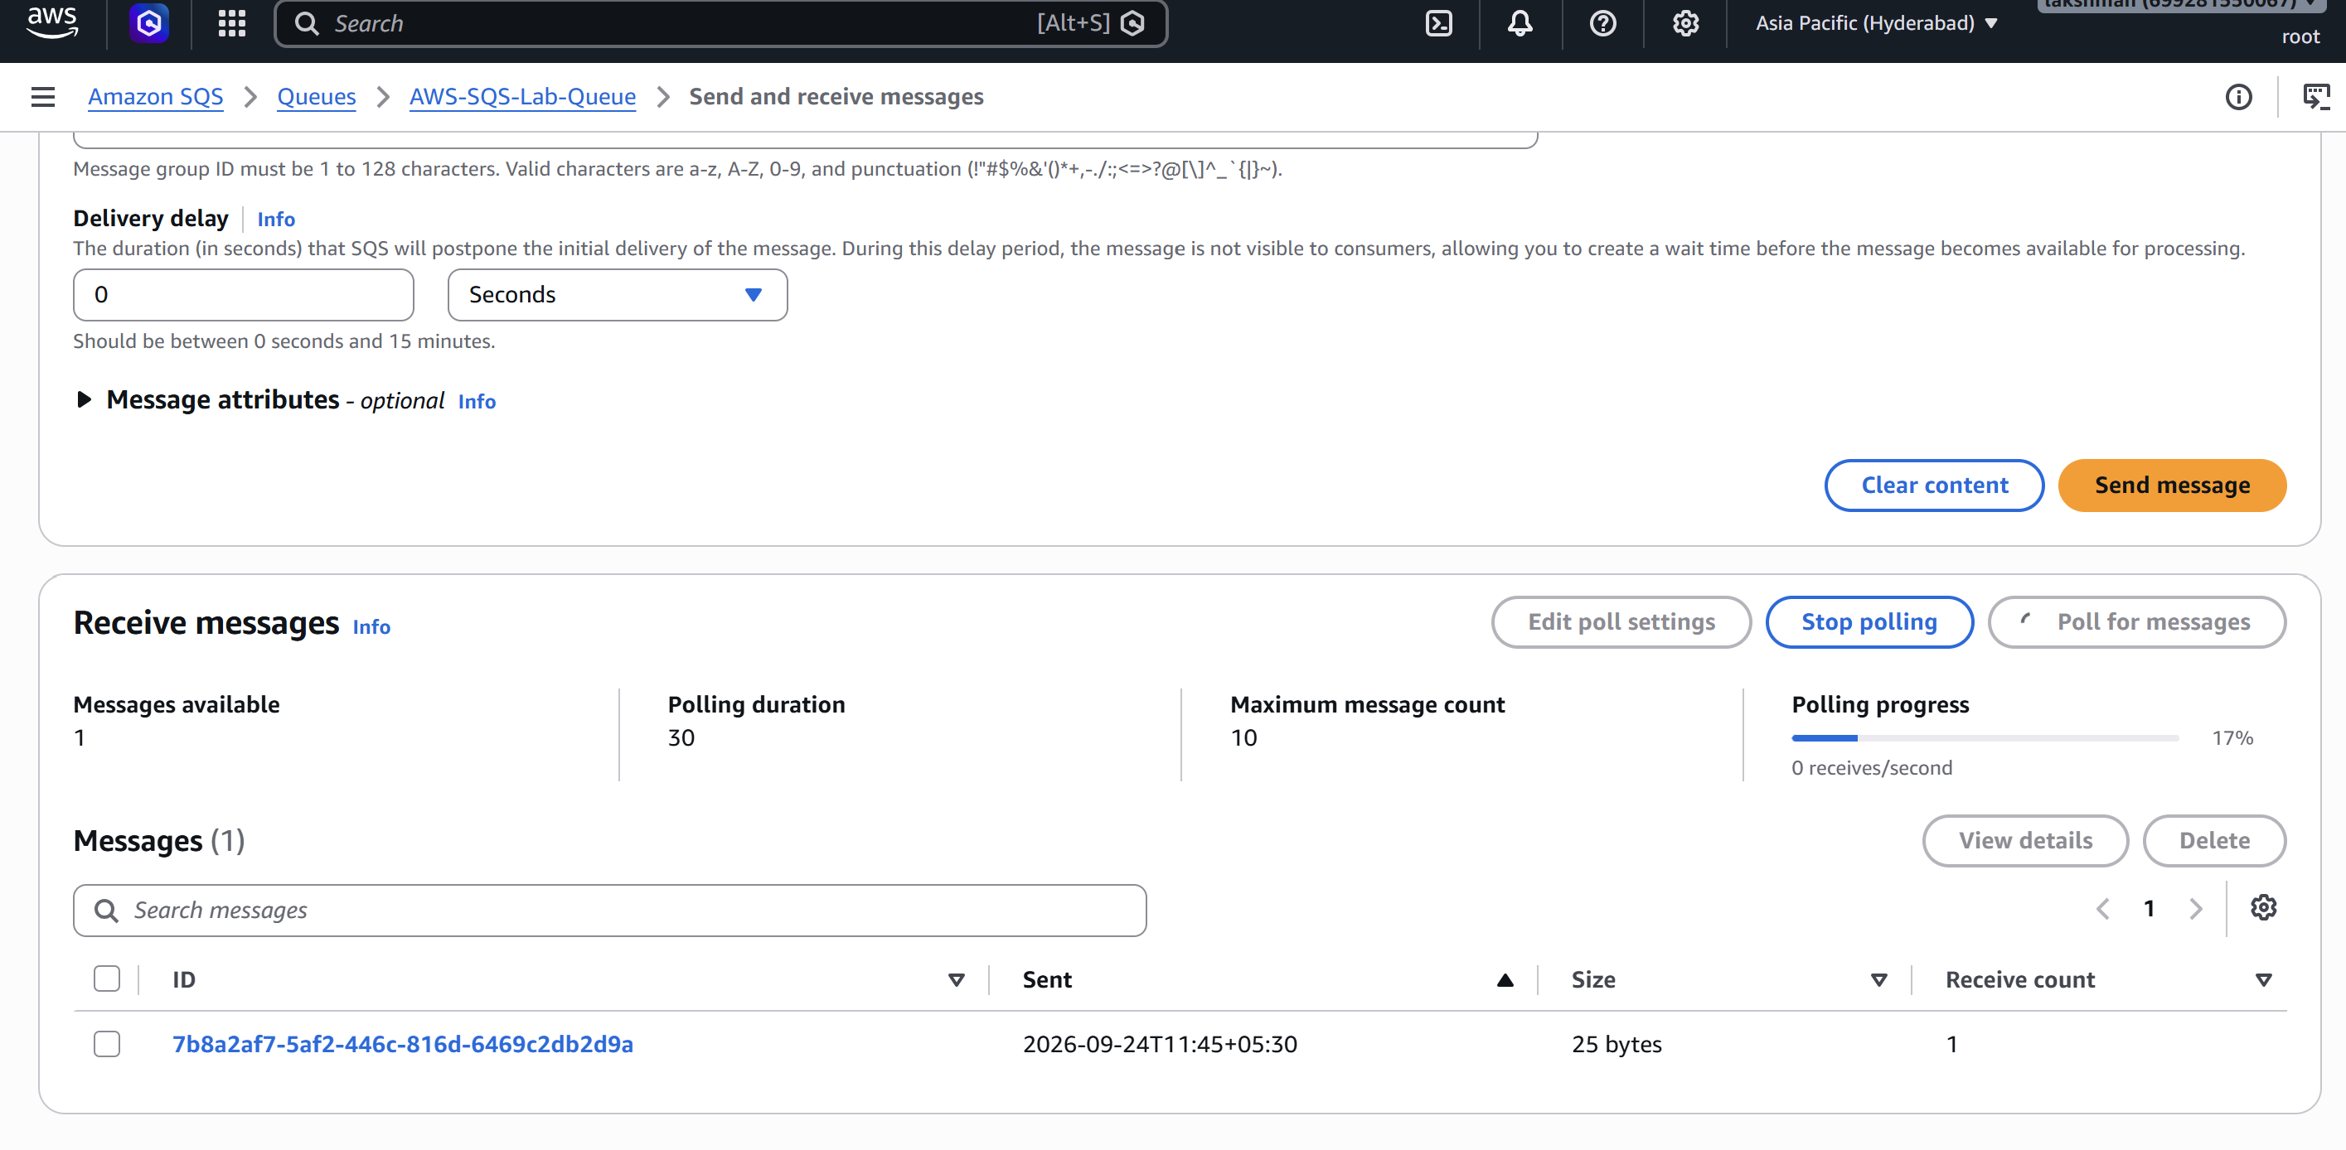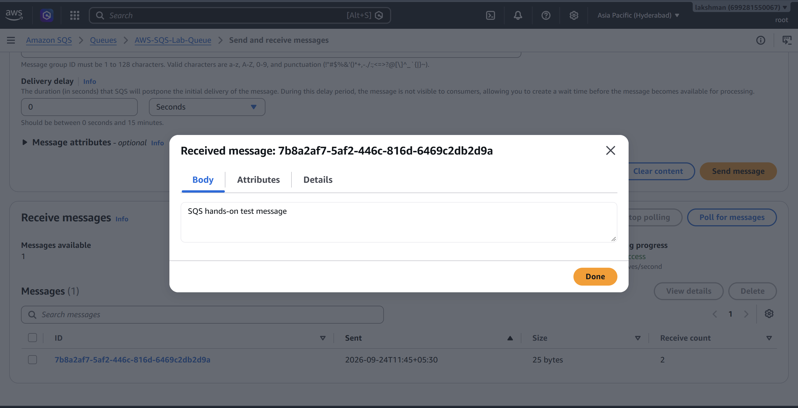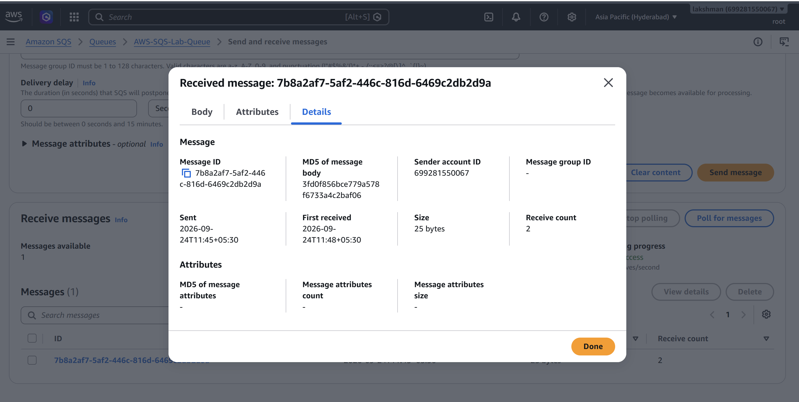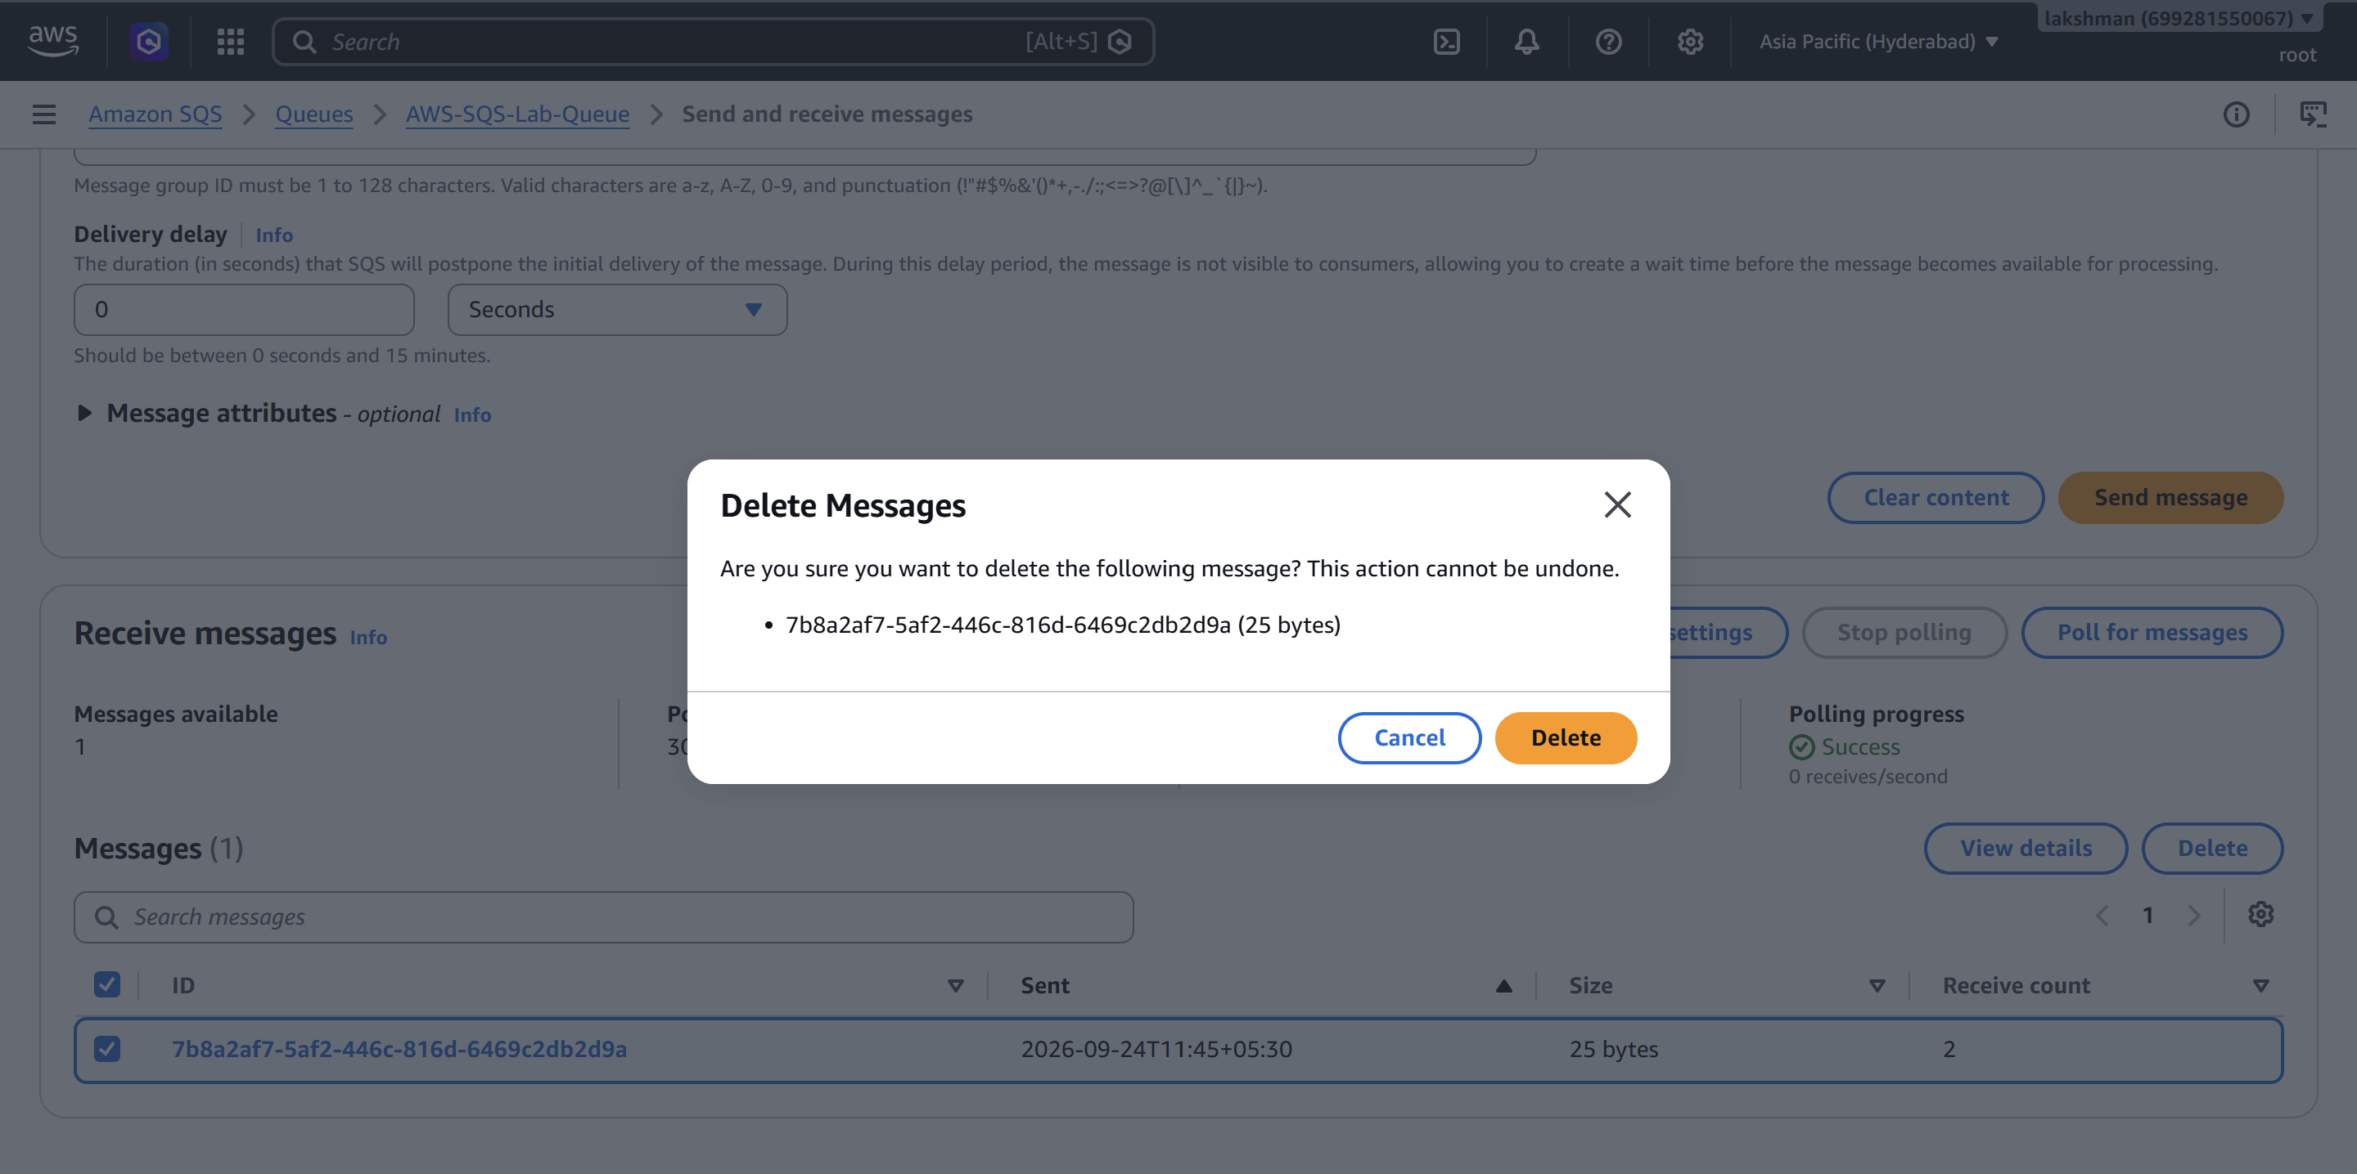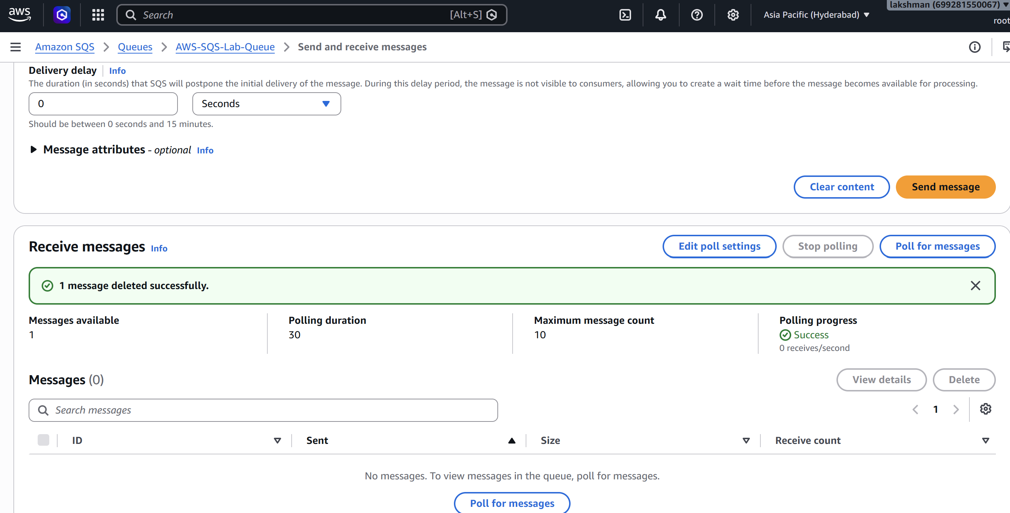

3.5 Screenshot Evidence
☐ Screenshot: SQS queue creation and queue name.
☐ Screenshot: Queue configuration / attributes.
☐ Screenshot: Send and receive messages page.
☐ Screenshot: Message received and processed.
☐ Screenshot: DLQ and redrive configuration (if implemented).

4. Amazon MQ
Amazon MQ is a managed message broker service designed for applications that use established messaging protocols and broker capabilities. It can reduce the operational effort required to install, patch and operate a message broker while retaining broker-oriented application patterns.

4.1 Architecture
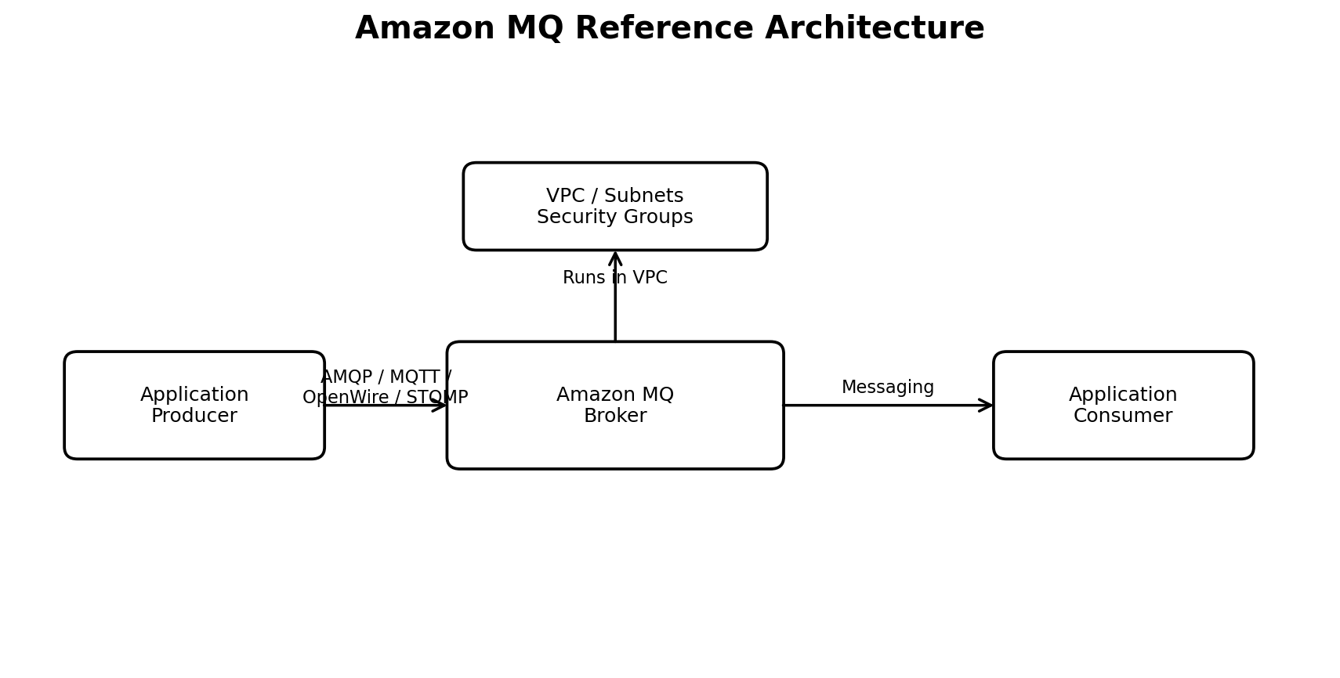
Figure 2: Representative Amazon MQ architecture.

4.2 Key Concepts
- Amazon MQ supports managed brokers for Apache ActiveMQ and RabbitMQ.
- A broker is deployed into a VPC and is associated with networking and security controls.
- Security groups control network access to broker endpoints.
- Applications connect using supported broker protocols and client libraries.
- Broker choice should be based on application compatibility, protocol requirements, topology and operational needs.

4.3 Hands-On Implementation
1. Open Amazon MQ: AWS Console → Amazon MQ → Brokers → Create broker.
2. Select broker engine: Choose ActiveMQ or RabbitMQ based on the application requirement. For a learning lab, use the engine available in the account and region.
3. Choose deployment option: Select a suitable deployment option presented by the console. For a simple lab, use the appropriate single-instance option if available and acceptable.
4. Configure broker: Provide broker name, instance size, admin username/password, VPC, subnet and security group settings.
5. Configure networking: Place the broker in the selected VPC/subnet and allow only required application/client traffic in the security group.
6. Create broker: Review settings and create the broker. Broker provisioning can take time.
7. Connect / validate: After the broker is available, use the broker's connection information and a compatible client/application to validate connectivity.
8. Observe status: Confirm the broker status is available and review monitoring/connection information in the console.

4.4 Security and Networking Notes
- Use private subnets where appropriate for internal application messaging.
- Restrict security-group inbound rules to required source security groups or approved CIDRs and ports.
- Do not expose broker administration or application ports to 0.0.0.0/0 unless there is a documented requirement.
- Store broker credentials securely and avoid embedding passwords in application source code.

4.5 Validation / Observations
- The broker was created and reached an available/operational state.
- The selected VPC, subnet and security group were associated with the broker.
- Broker connection information was available for application/client configuration.
- Network access should be tested from an approved client location rather than from an unrestricted public source. 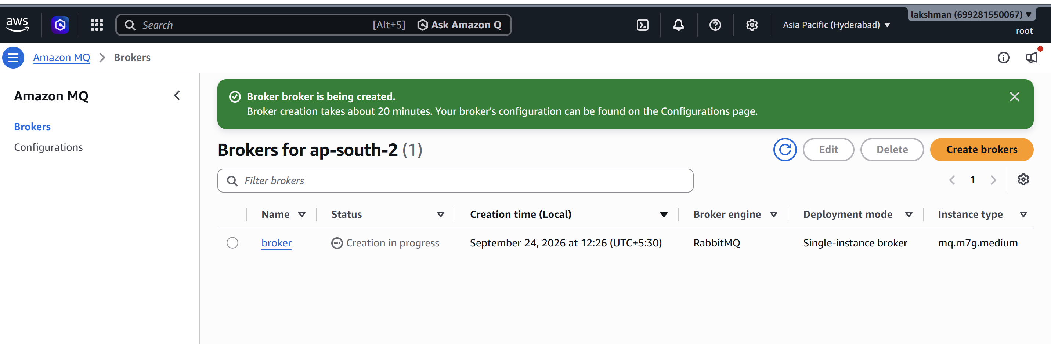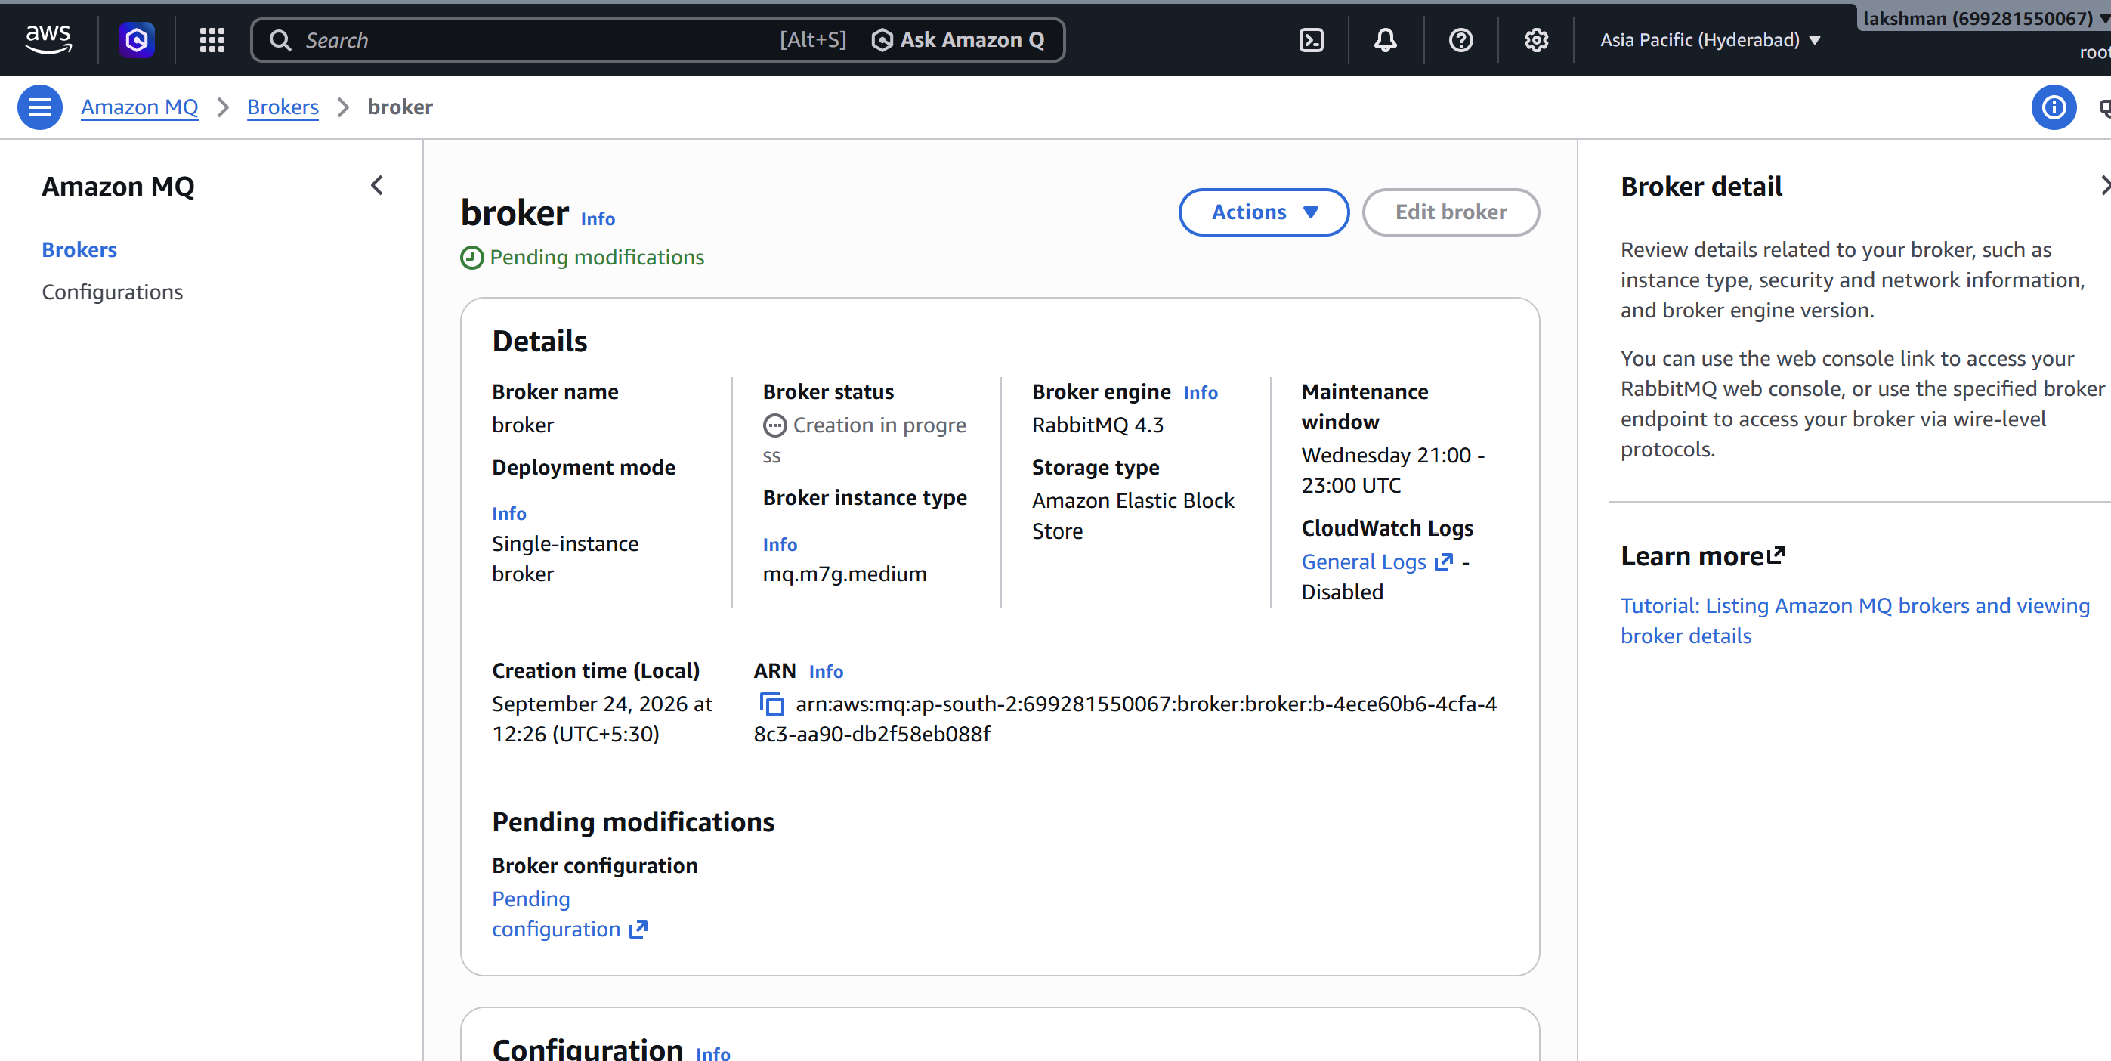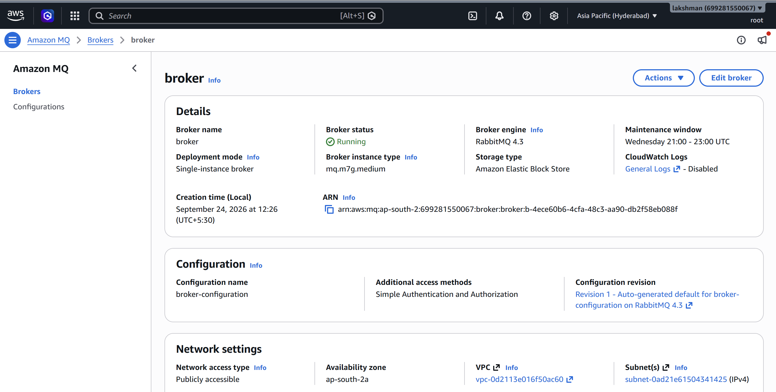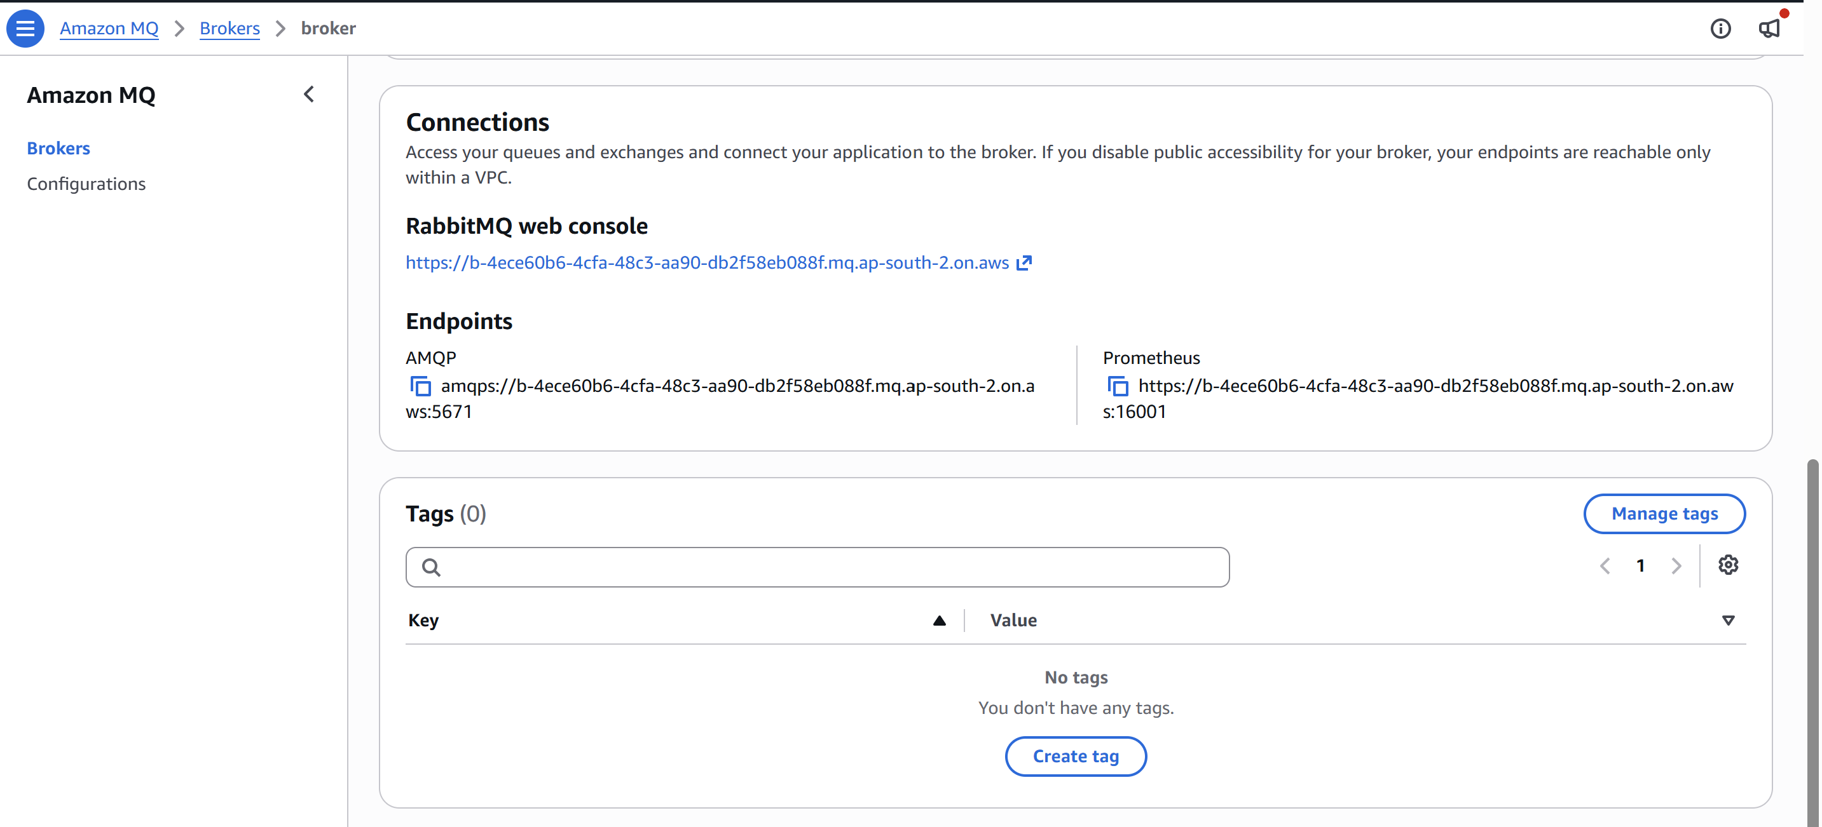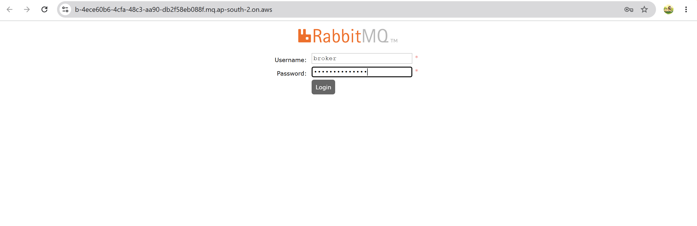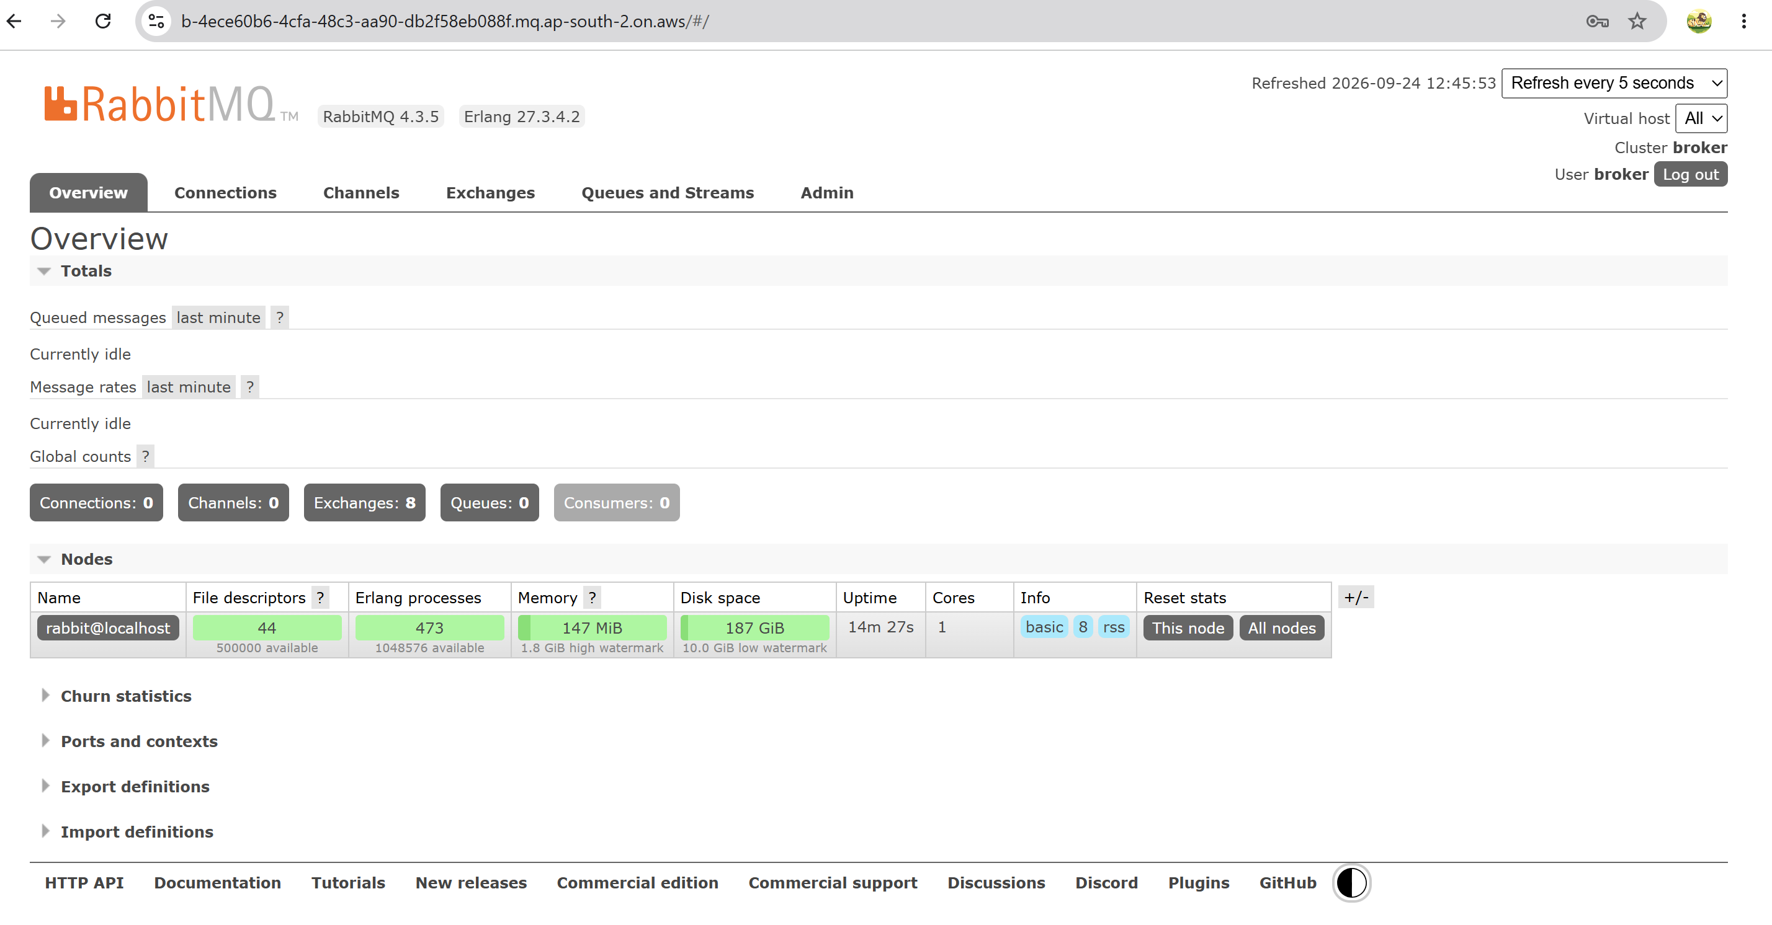 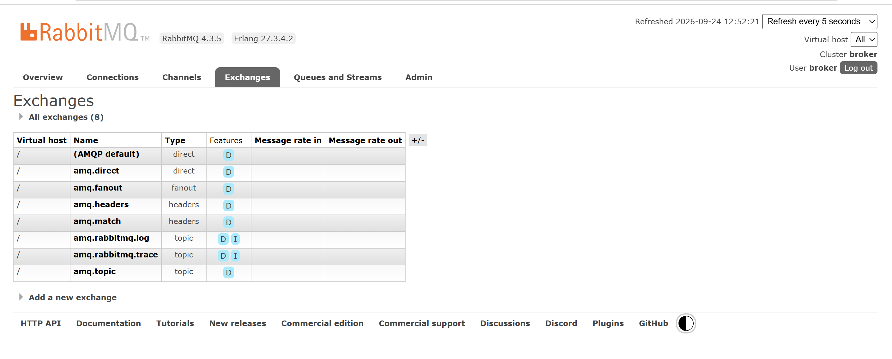 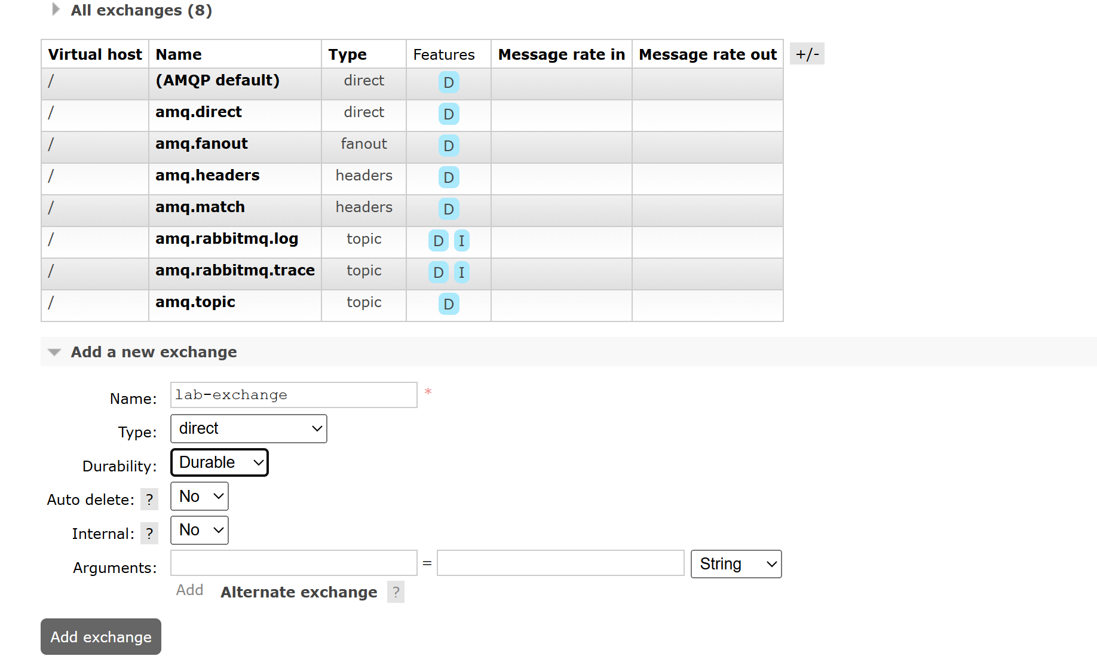 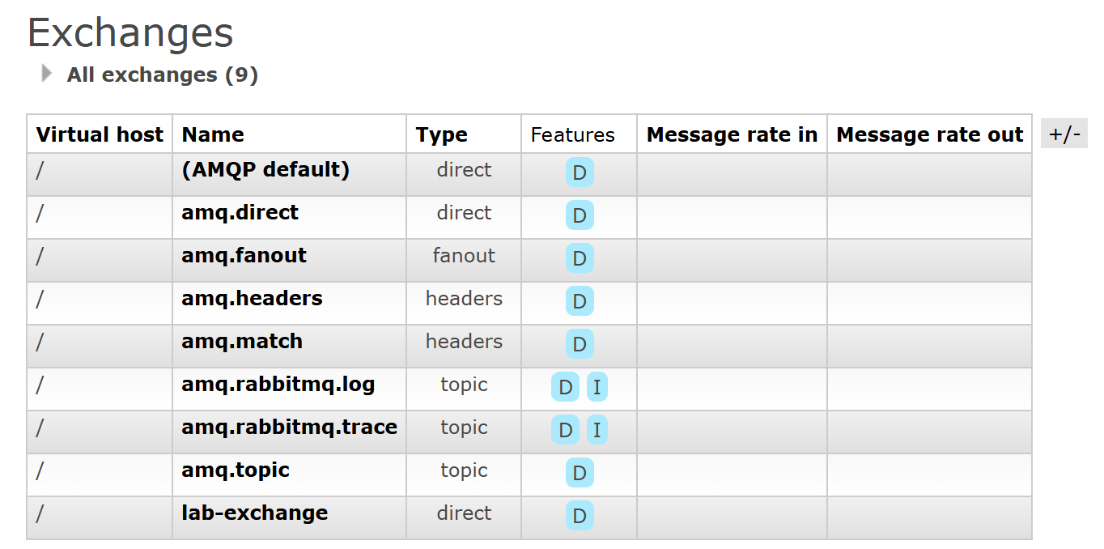 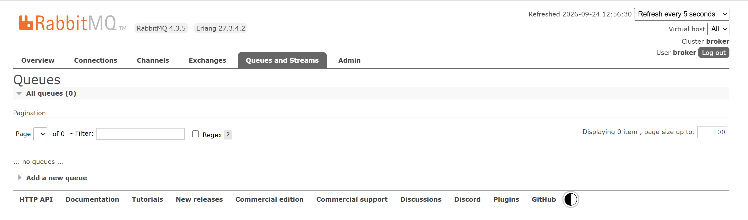 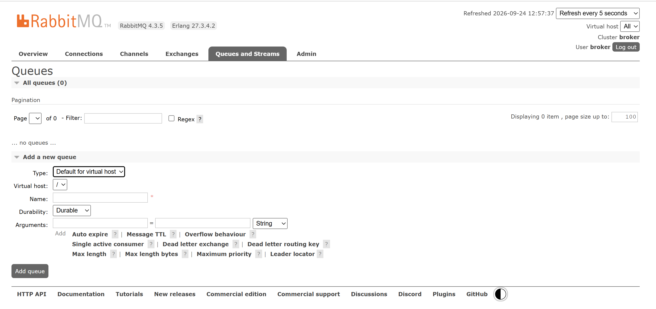 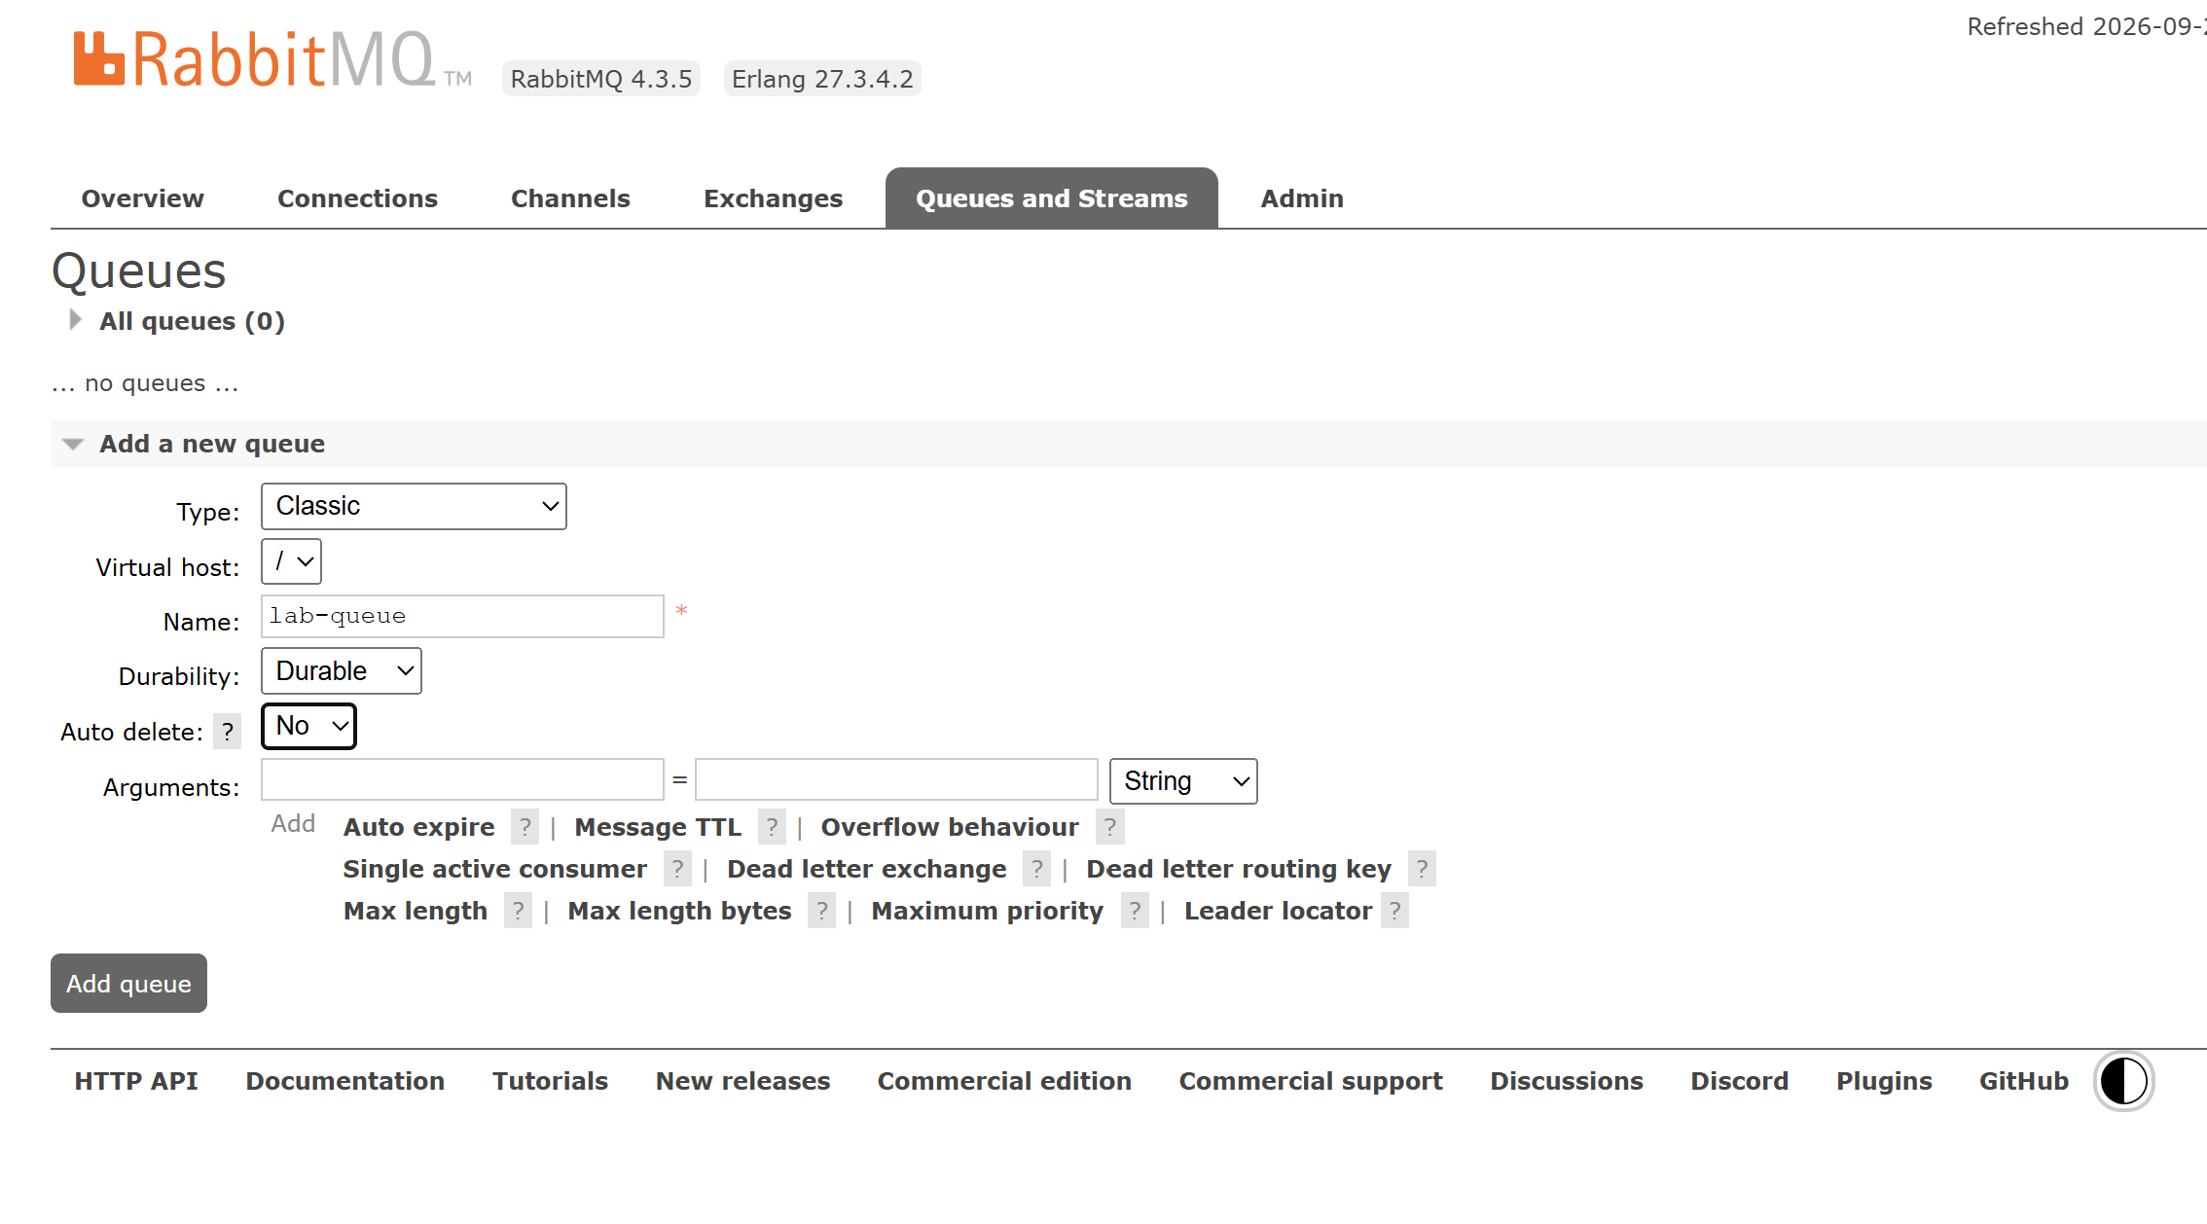 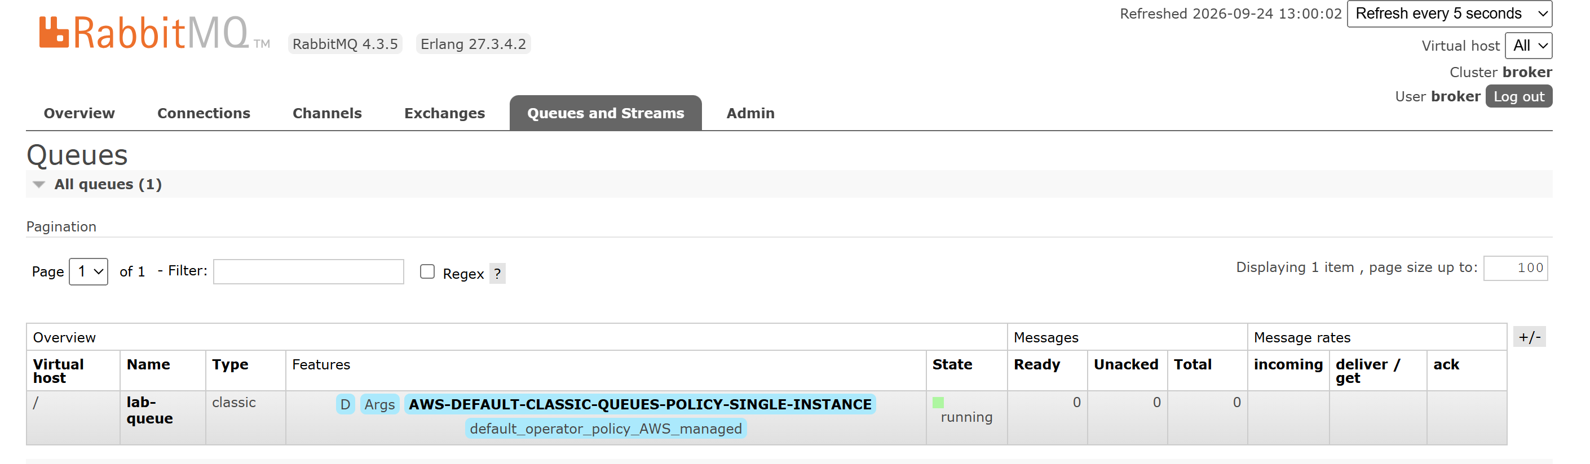 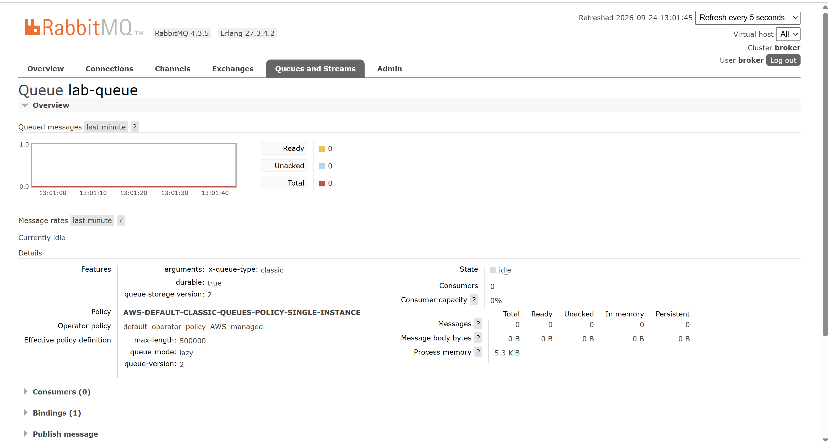 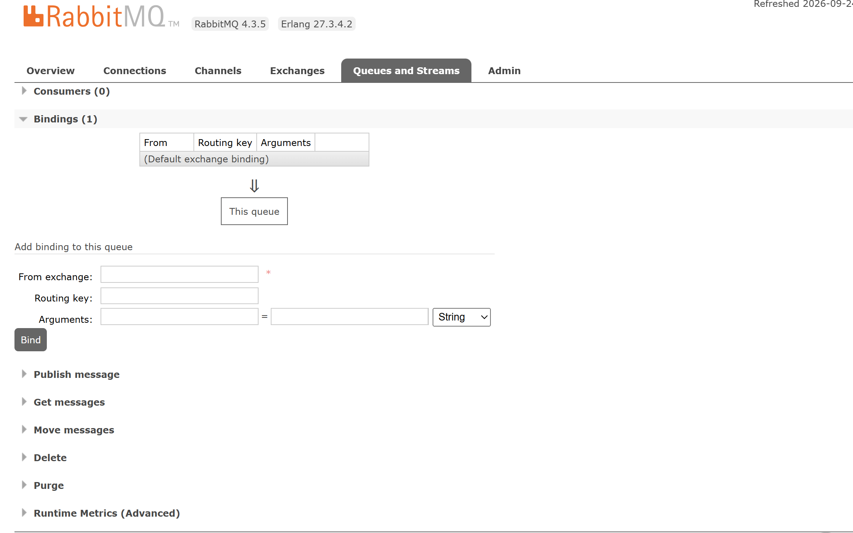 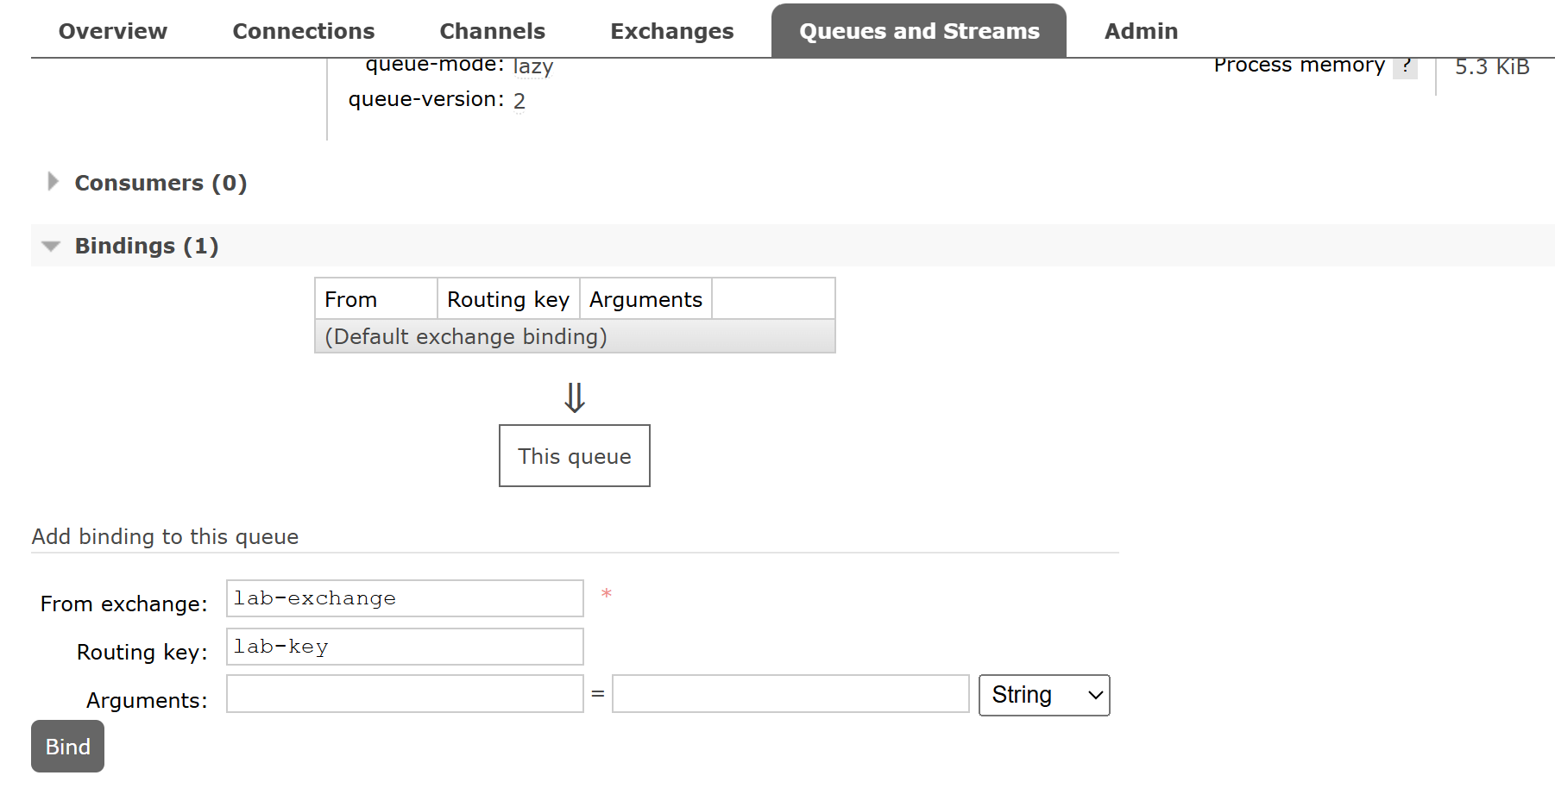 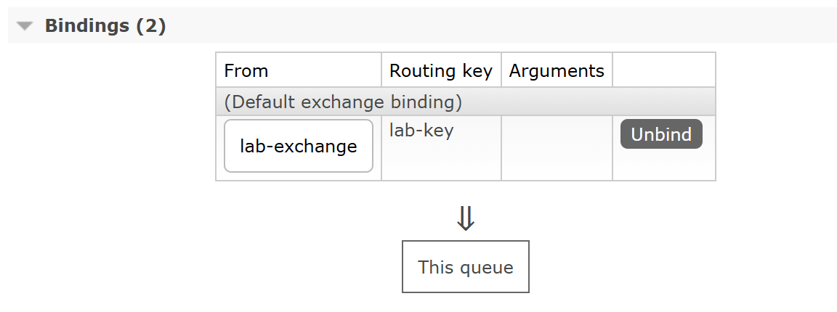 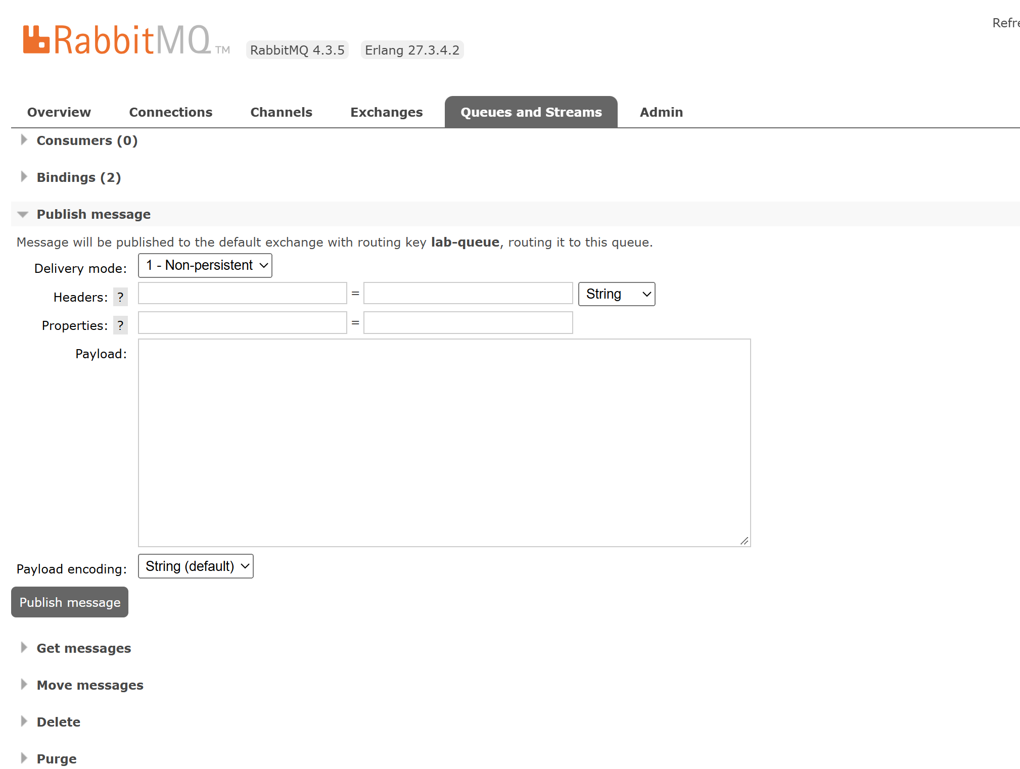 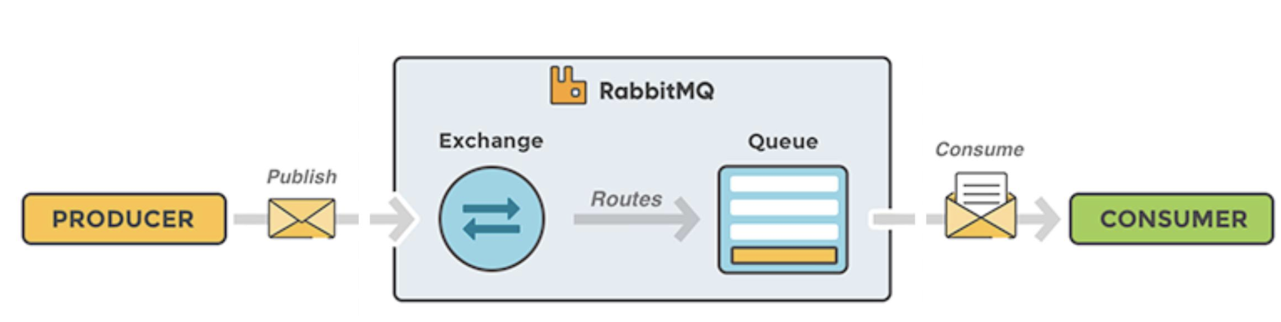 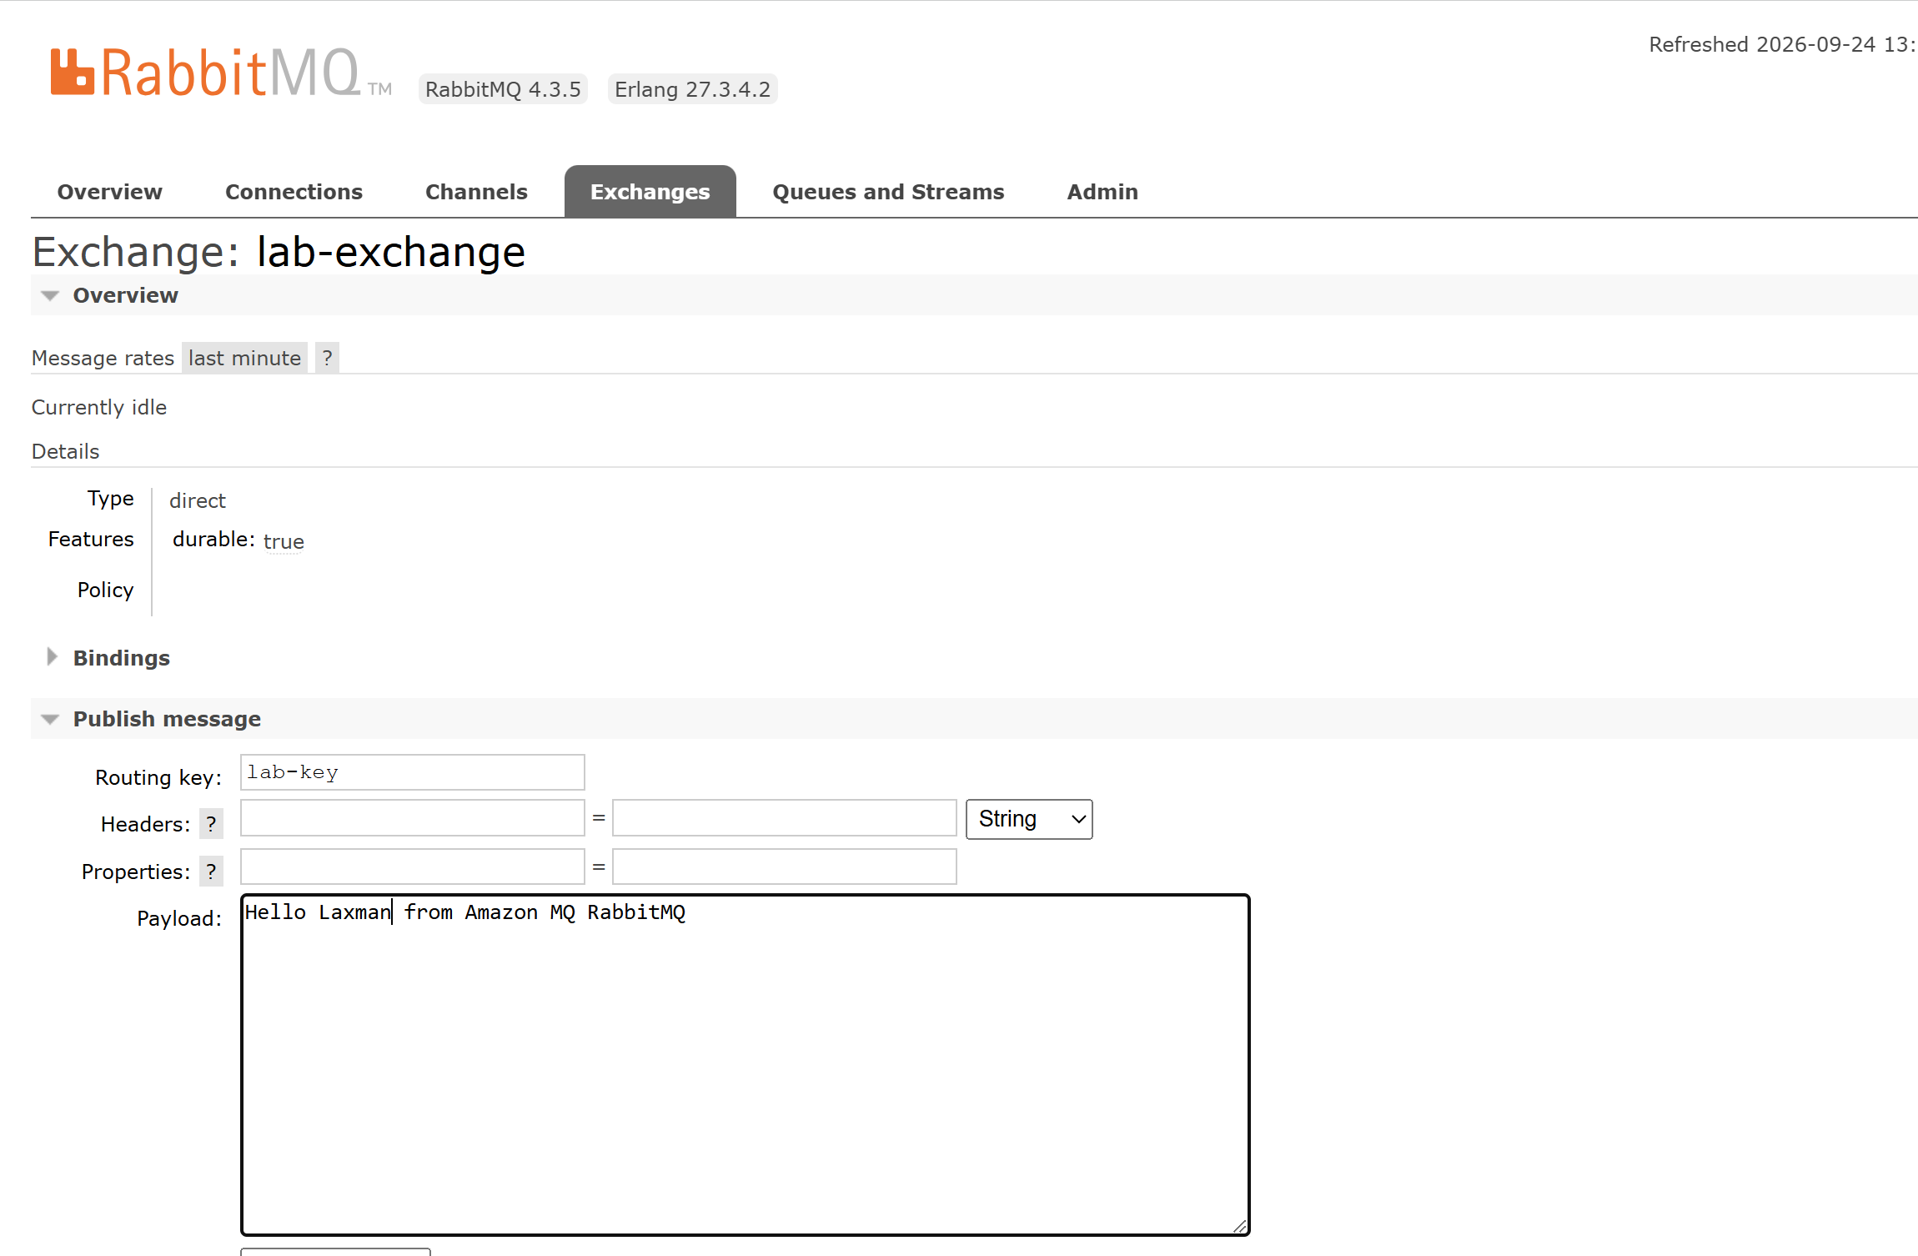 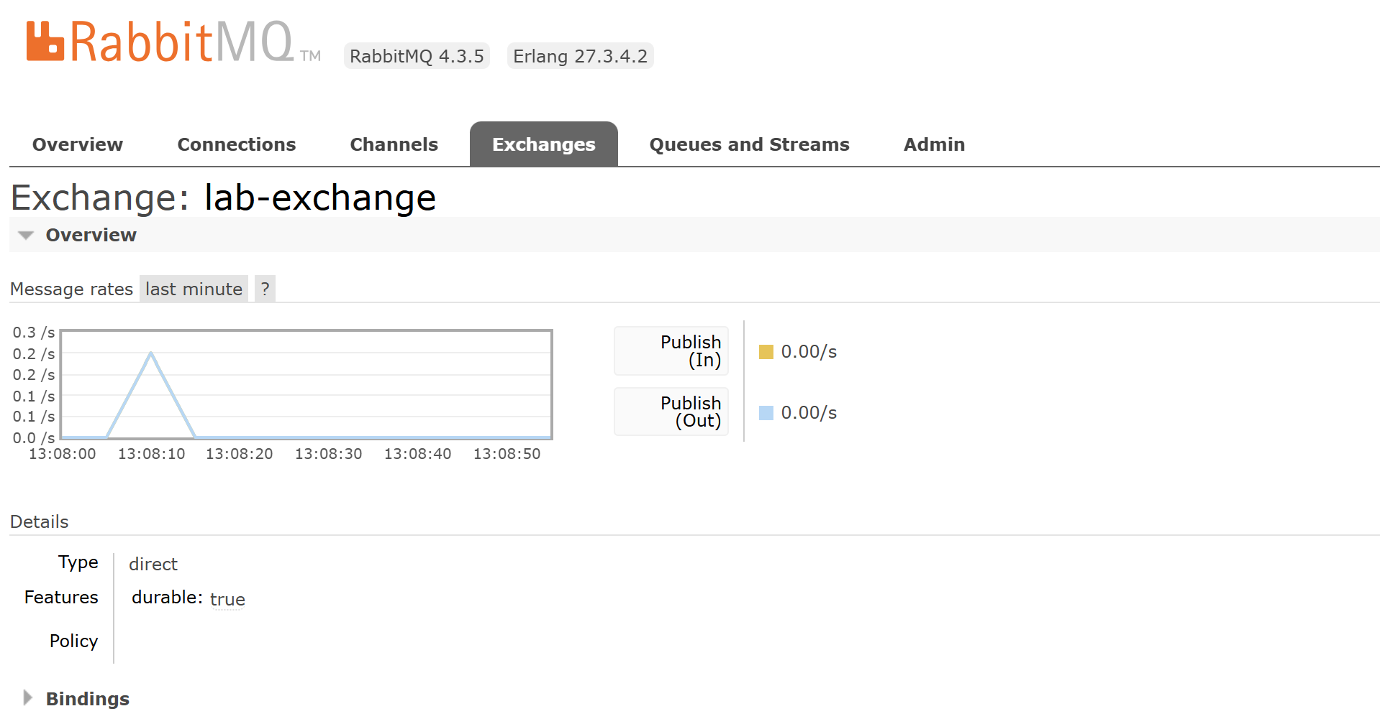 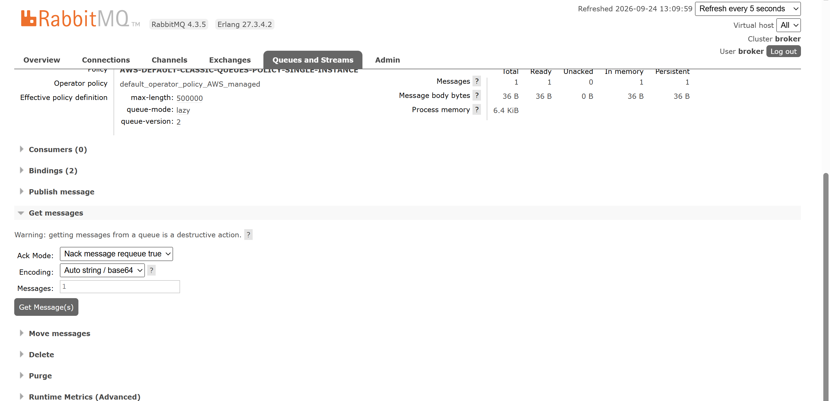 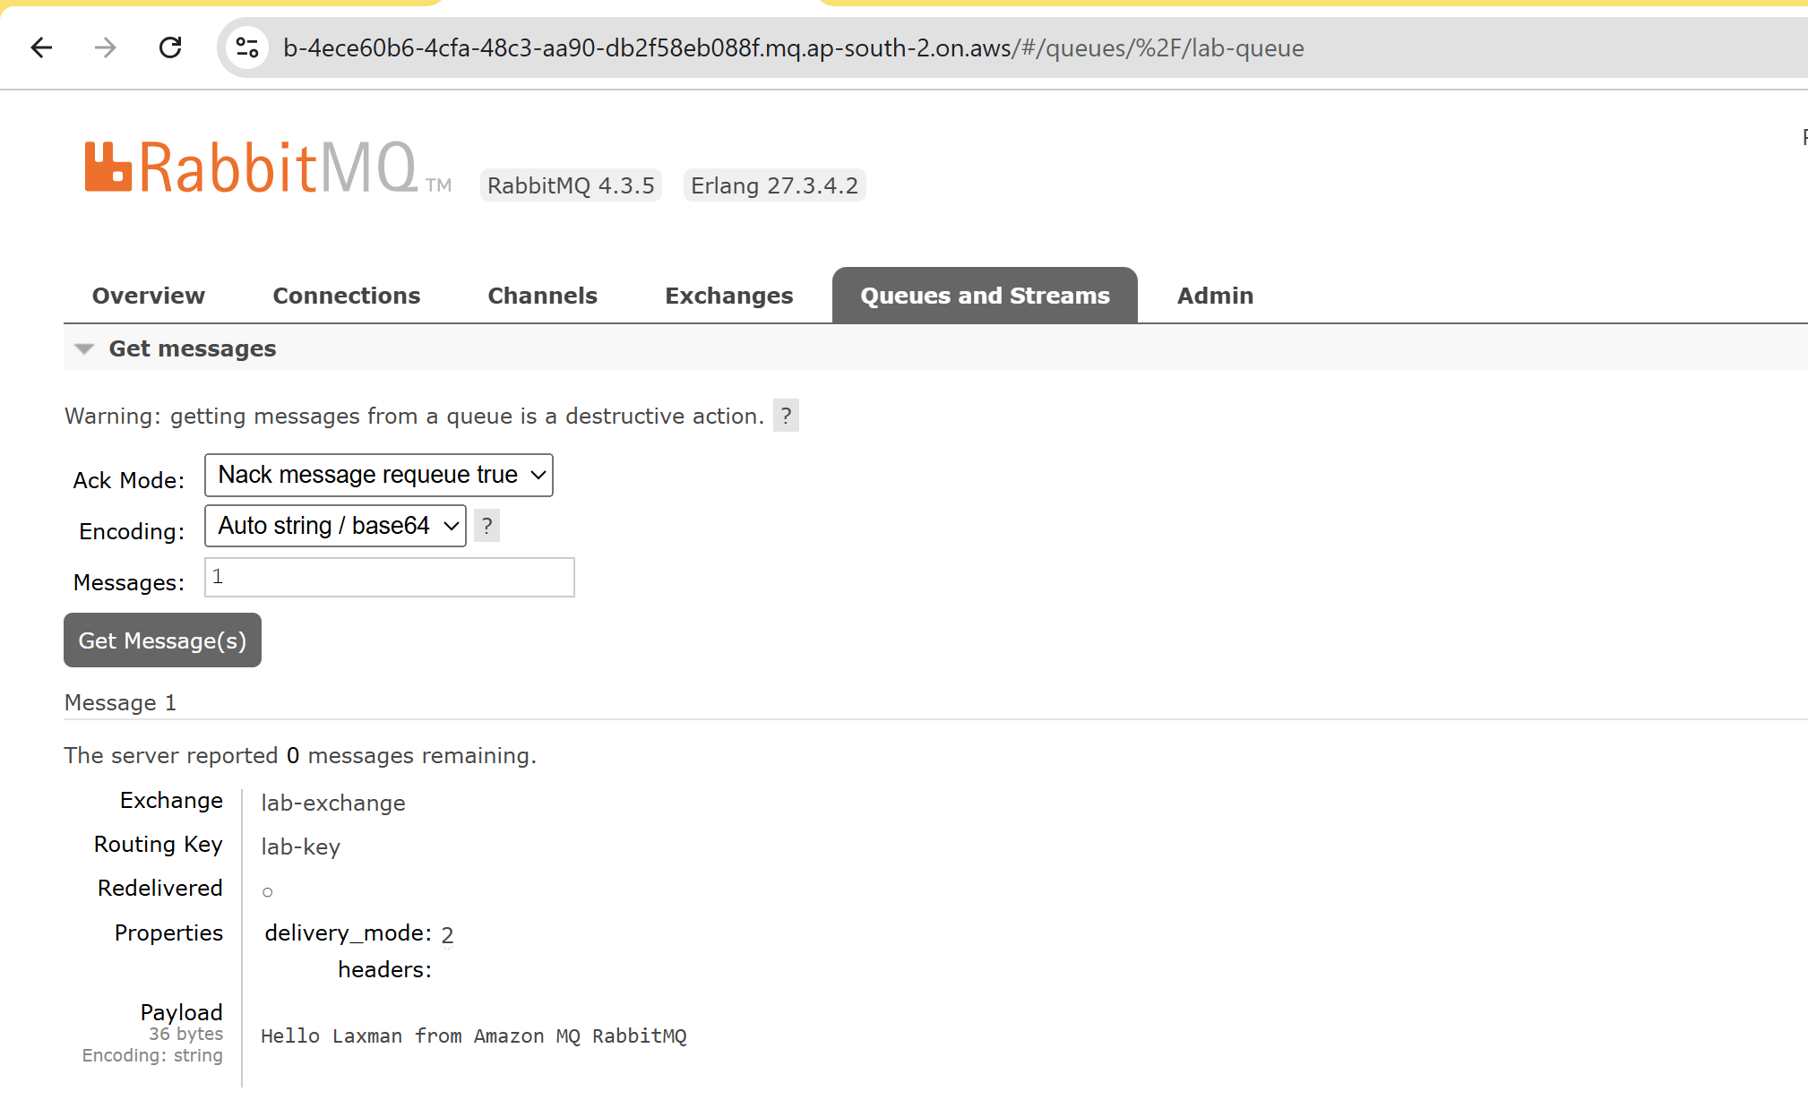
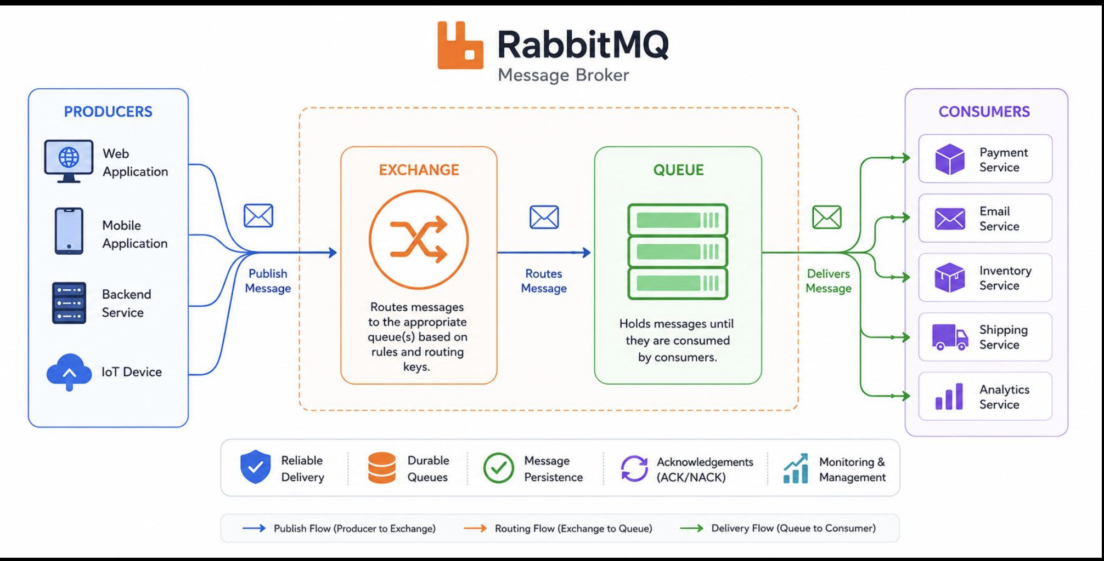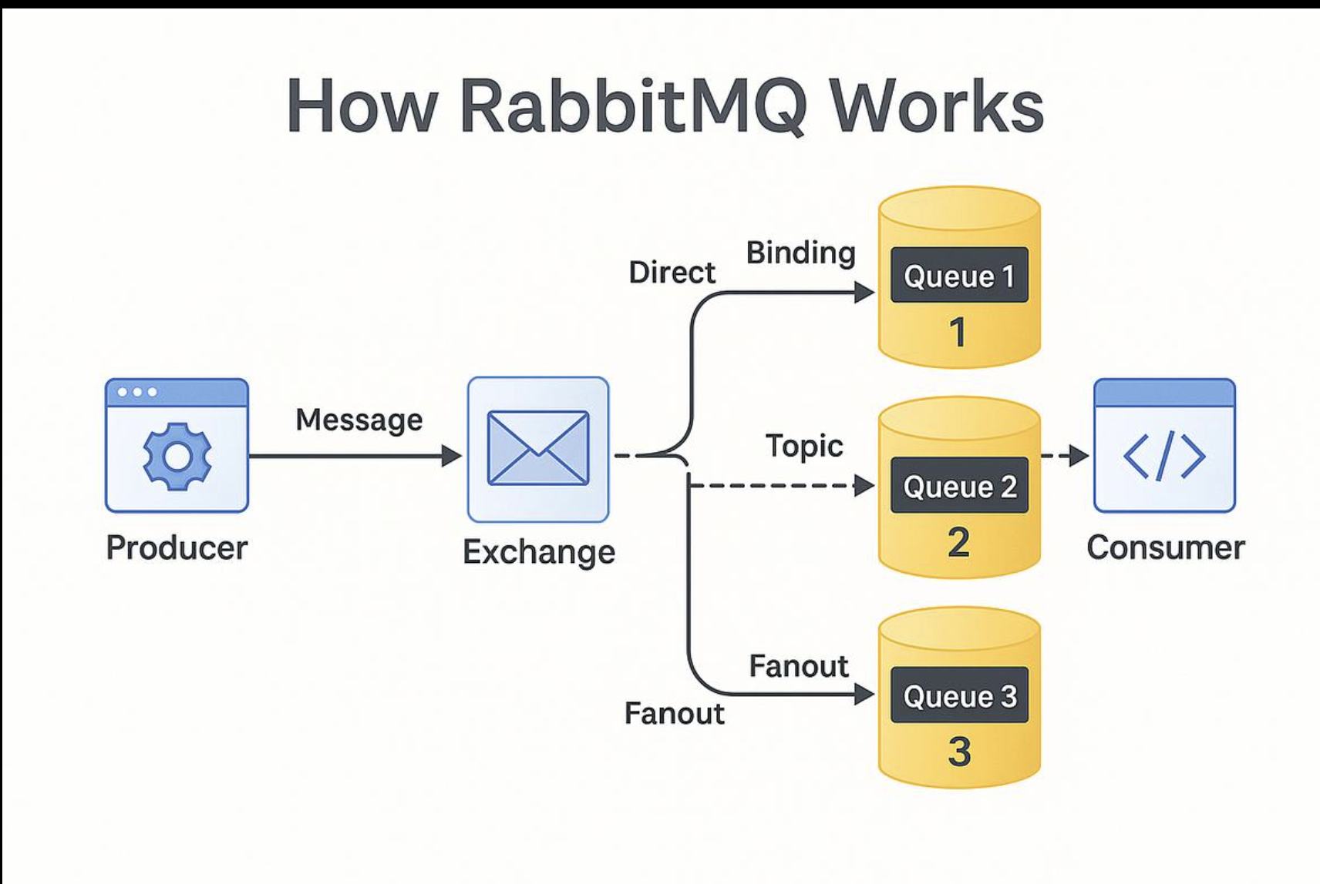

5. AWS Secrets Manager
AWS Secrets Manager helps securely store, manage and retrieve sensitive information such as database credentials, API keys and application secrets. Applications can retrieve secrets at runtime instead of hard-coding credentials in source code or configuration files.

5.1 Architecture
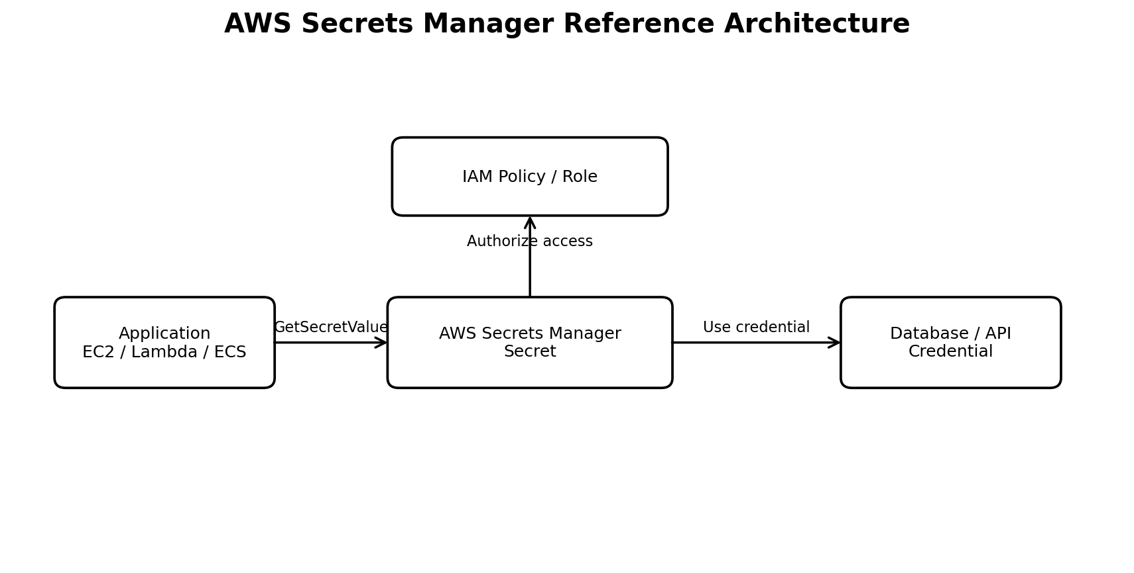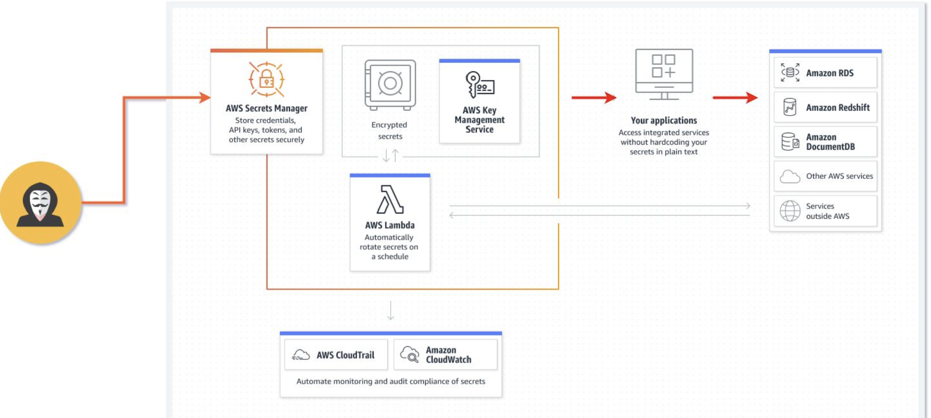
Figure 3: Representative Secrets Manager architecture.

5.2 Key Concepts
- Secret: a managed object containing sensitive values.
- IAM permissions: determine which users, roles or workloads can retrieve or manage a secret.
- Encryption: secrets are encrypted at rest; AWS KMS can be used as part of the encryption configuration.
- Secret versions: support controlled updates to secret values.
- Rotation: can automate periodic credential changes for supported scenarios and integrations.
- GetSecretValue: an API operation commonly used by an authorized application to retrieve a secret at runtime.

5.3 Hands-On Implementation
1. Open Secrets Manager: AWS Console → Secrets Manager → Secrets → Store a new secret.
2. Select secret type: For a lab, choose the credentials or other secret type appropriate to the demonstration.
3. Enter secret values: Enter a test username/password or application secret. Do not use production credentials in a training lab.
4. Name the secret: Use a clear name such as AWS-Lab/DatabaseCredentials.
5. Configure encryption: Review the KMS encryption option and use the account's approved key configuration.
6. Configure rotation: If supported and required for the lab, configure rotation; otherwise record that rotation was not enabled.
7. Store the secret: Review the configuration and store the secret.
8. Retrieve and validate: Open the secret and use Retrieve secret value to verify the stored value. For application testing, use an IAM role with least-privilege permissions.
9. Test access control: Confirm an authorized identity can retrieve the secret and an identity without the required permission cannot.

5.4 IAM Least-Privilege Example
For an application workload, grant only the required Secrets Manager permissions to the workload IAM role. A typical read-only application permission is secretsmanager:GetSecretValue for the specific secret ARN, with KMS permissions added only when required by the selected encryption configuration.

5.5 Validation / Observations
- The secret was created successfully and appeared in the Secrets Manager console.
- The stored secret could be retrieved by an authorized identity.
- Access should be limited to the intended IAM principal and secret resource.
- Production credentials should not be exposed in screenshots, source code, chat messages or documentation.
- Rotation can reduce the operational risk associated with long-lived credentials when the application and secret type support it. 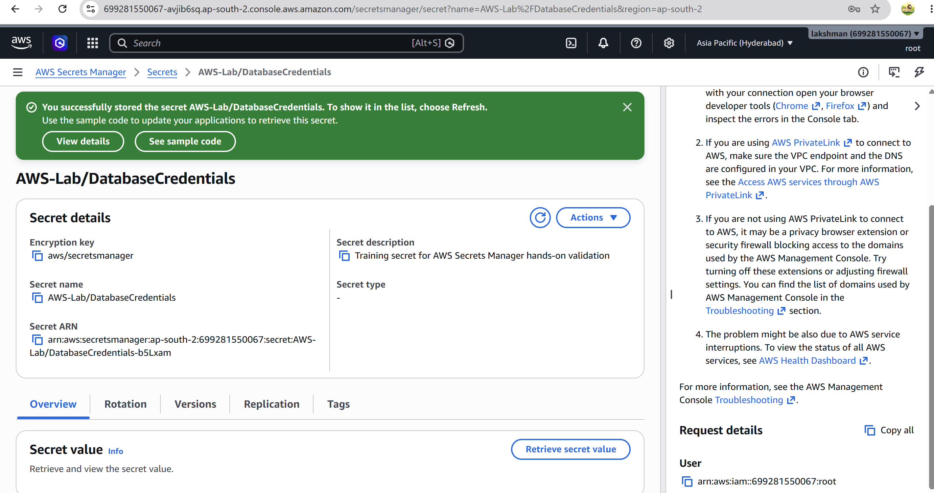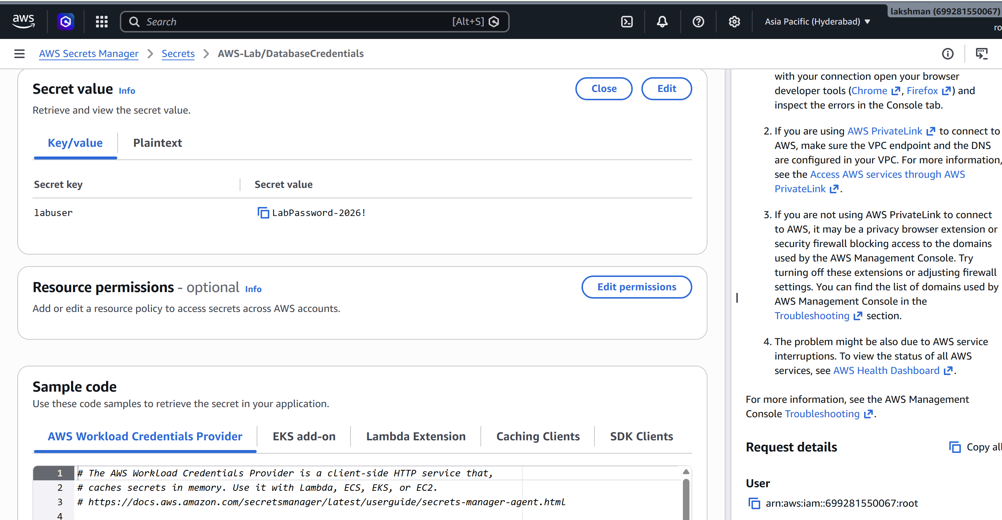

5.6 Screenshot Evidence
☐ Screenshot: Create secret / secret type selection.
☐ Screenshot: Secret configuration and name (mask sensitive values).
☐ Screenshot: Secret details page.
☐ Screenshot: Retrieve secret value page with sensitive values hidden/redacted.
☐ Screenshot: IAM policy/role permissions showing least-privilege access.

