Integration Steps for Android

Getting Started:
Follow these simple steps to integrate with EBS Gateway on Android. Please compile your Android project with API level 14 or above to integrate with EBS Gateway.

System Prerequsites:
Eclipse with ADT (or)
Android Studio with ADT.

Download EBS Android SDK
- Download the EBS Android SDK.
- Unzip the file into your workspace.
- Demo refers sample application project and EBS refers android sdk(Library)

Eclipse

The SDK will work in all version of eclipse and the sdk has tested with v4.4.0.

Starting
- Import the project using the option File -> Import -> Existing Android Code into Workspace
- If your IDE complains that the project already exists, select the 'Copy projects into workspace' option while importing the library.

Import Library
- Right click on your project and select Properties.
- Add the EBS Android library project to your application project.

Configure
- Open the file named project.properties under your application project.
- Add the property manifestmerger.enabled=true.

Android Studio
The SDK will work in all version of studio and the sdk has tested with v1.5.1.

Step1: Import Demo
- Import the project using the option File -> Open existing project into Studio
- Add the Demo project to your studio.

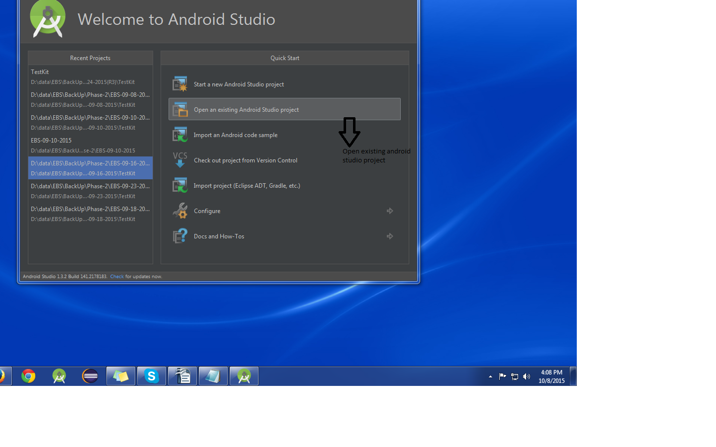

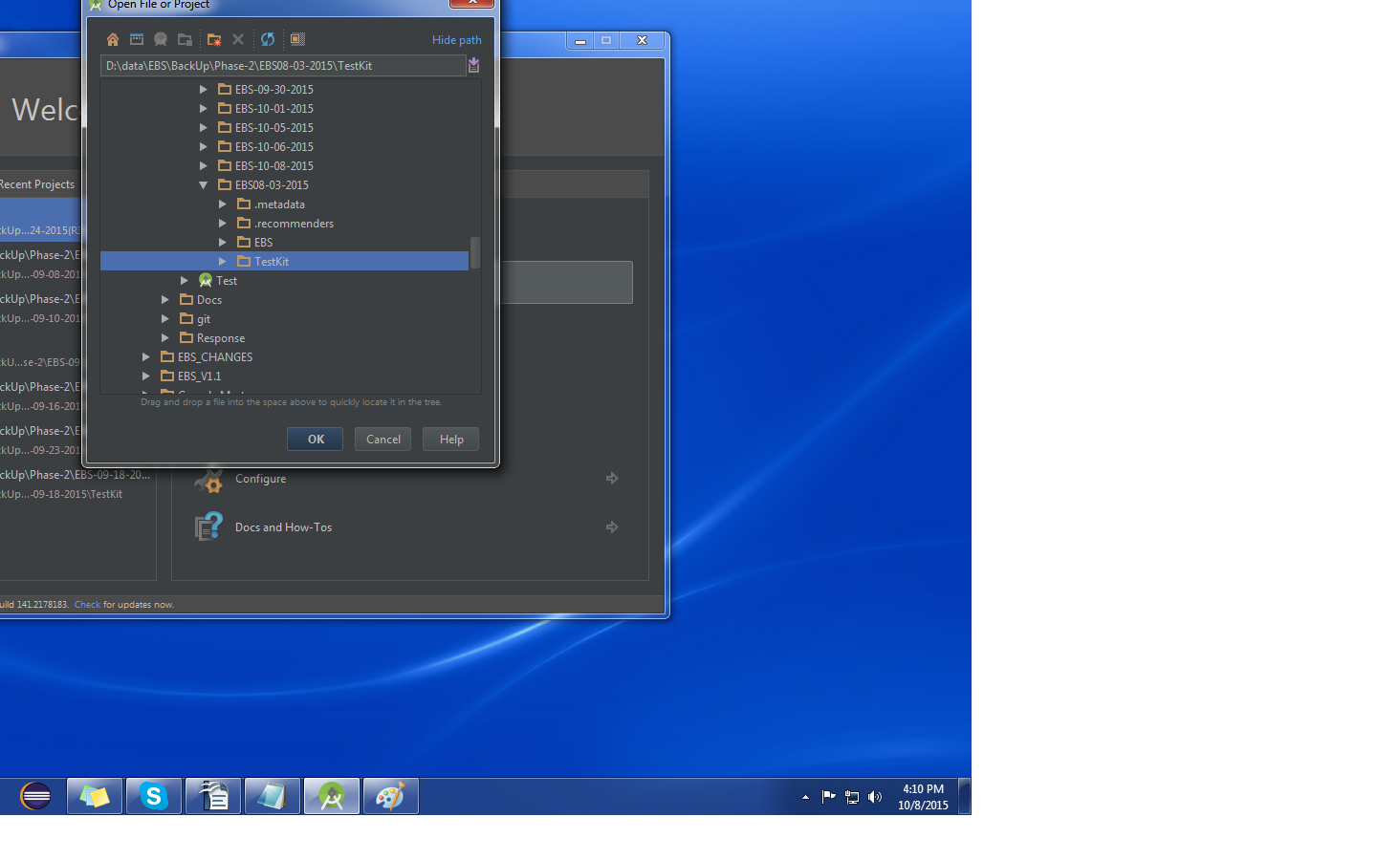
Step2: Import Library(Module)
- Import the Module using the option File -> Import Module into Studio
- Add the EBS Android library project to your Demo project.

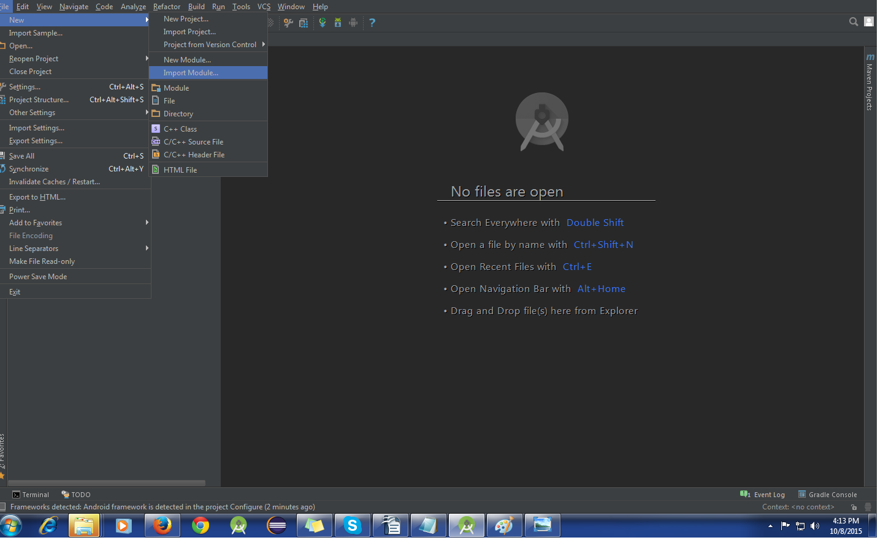

Step 3: Configure
- Open the file named build.gradle under your application project.
- Add the property compile project(':EBS') in dependencies.
Sample Code:
dependencies {
compile fileTree(dir: 'libs', include: '*.jar')
compile project(':EBS’)
}
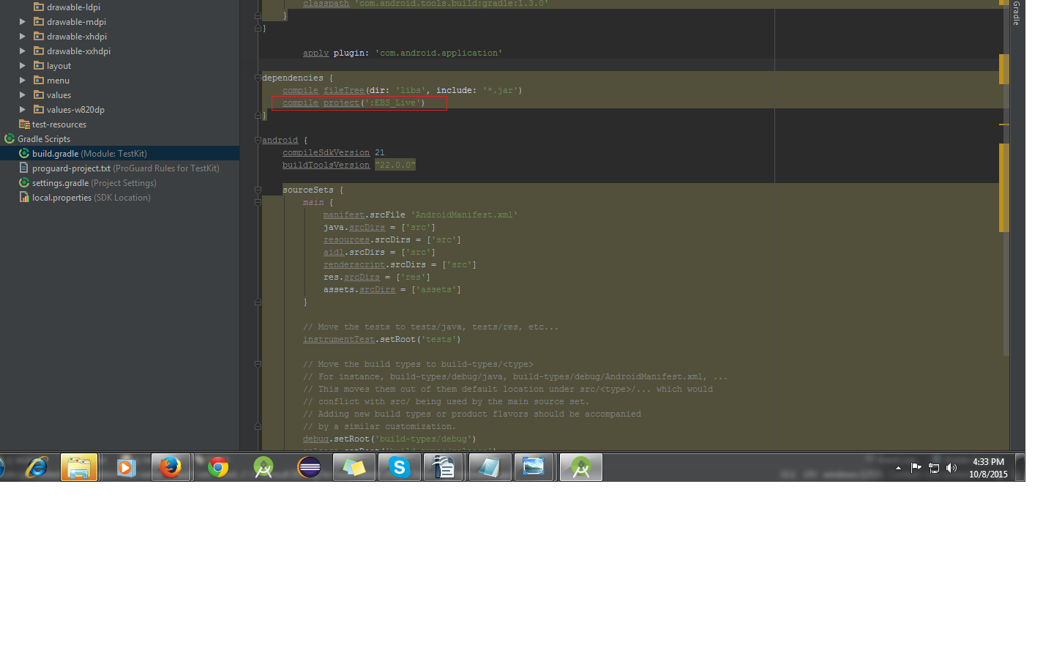
And finally writing code

TEST Mode:
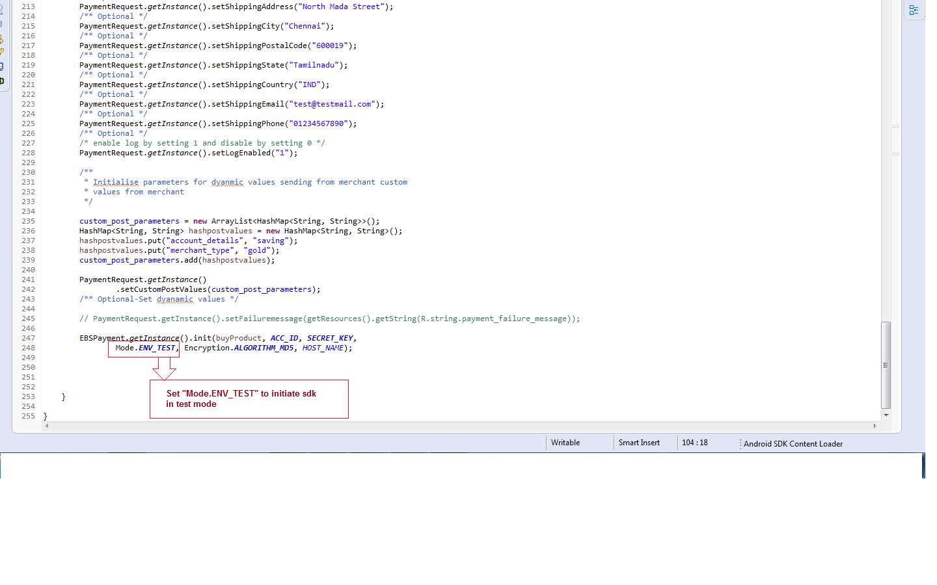
Please ensure the following values are available or checked in the SDK:

LIVE Mode:

Please ensure the following values are available or checked in the SDK:

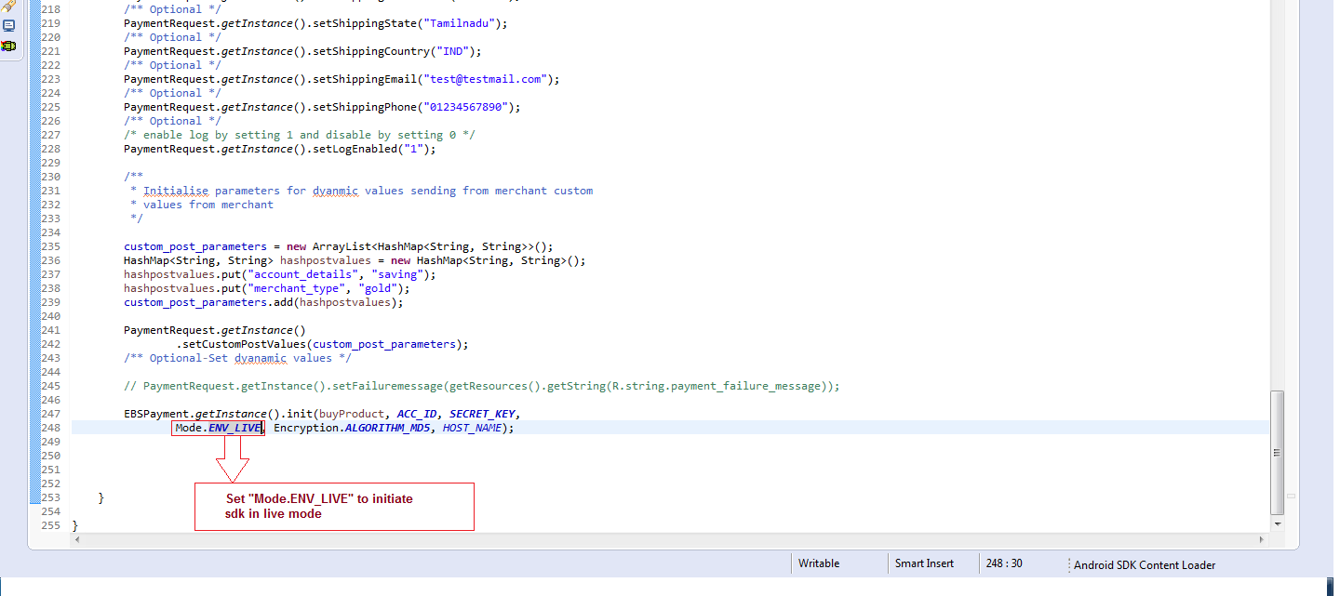

EBS PG Prerequisites:
Make sure that you have obtained following parameters from EBS admin
- Merchant SECRET_KEY
- Merchant ACC_ID
Following parameters from Mercant Side
- Merchant REFERENCE_NO(Generated by Merchant on each payment)

Note: Above three Parameters are Mandatory.

OnCreate() method:
PaymentRequest.getInstance().setTransactionAmount(<Payment_amount>);
PaymentRequest.getInstance().setReferenceNo(Refernce_No);

Sample code:
PaymentRequest.getInstance().setTransactionAmount(1.0);
PaymentRequest.getInstance().setReferenceNo(“223”);

Initializing the EBS Gateway :
EBSPayment.getInstance().init(<activity>, <merchant_account_ID>, <mercent_SECRET_KEY>, <Mode>, <Encryption_Type>, <host_name> );

Sample code:
EBSPayment.getInstance().init(BuyProduct.this, ACC_ID, SECRET_KEY, Mode.ENV_LIVE,
Encryption.ALGORITHM_MD5, HOST_NAME );
where,
ACC_ID – Account Id provided by EBS
SECRET_KEY – Secret Key associated with the account ID
HOST_NAME – host name used for deeplinking used for Redirecting to app from Webview.
Mode – payment Mode (LIVE or TEST)
Encryption - Encrypting algorithm (ALGORITHM_MD5, ALGORITHM_SHA1, ALGORITHM_SHA512)
Custom Parameters:
User can post their custom parameters for the payment process
Sample code:
ArrayList<HashMap<String, String>> custom_post_parameters = new ArrayList<HashMap<String, String>>();
HashMap<String, String> hashpostvalues = new HashMap<String, String>();
hashpostvalues.put("account_details", "saving");
hashpostvalues.put("merchant_type", "gold");
custom_post_parameters.add(hashpostvalues);

PaymentRequest.getInstance()
.setCustomPostValues(custom_post_parameters);

Failure Page:
User will be redirected to failure page incase of the transaction has been timed out or cancelled. Merchant can configure the contents to be displayed on failed transaction page

Sample code:

- If the Merchant wants to show the reference number and amount means set failure id as follow
PaymentRequest.getInstance().setFailureid("1");

- If the Merchant do not want to show the reference number and amount means set failure id as follow
PaymentRequest.getInstance().setFailureid("0");
- If the Merchant wants to show the customized message for failed transaction set failure message as follow
PaymentRequest.getInstance().setFailuremessage( getResources().getString(R.string.payment_failure_message));

Log:
Enable Log by setting 1 and disable by setting 0

Sample Code:
PaymentRequest.getInstance().setLogEnabled("1");

Webview to Merchant Activity :
The landing page(Success page) could be configurable by client and neccessary changes to be added as given below

Access Payment Response After Payment Completed:

Merchant can create own success Activity.
- The payment response for failed or successfull transaction will be getting here.

- Merchant can parse the response and use the individual parameters throught the app.

OnCreate() method:
Intent intent = getIntent();
String payment_id = intent.getStringExtra("payment_id");

where,
payment_id contains PaymentId,AccountId,Mode,BillingDetails,DeliveryDetails etc..

In AndroidMainfest.xml:

<intent-filter>
<data
android:host="<host_name>"
android:scheme="<package_name>" />

<action android:name="android.intent.action.VIEW" />

<category android:name="android.intent.category.DEFAULT" />
<category android:name="android.intent.category.BROWSABLE" />
</intent-filter>

Sample code:
<intent-filter>
<data
android:host="@string/hostname"
android:scheme="com.merchantapp.testkit" />
<action android:name="android.intent.action.VIEW" />
<category android:name="android.intent.category.DEFAULT" />
<category android:name="android.intent.category.BROWSABLE" />
</intent-filter>

Color Scheme Configuration:
Color of EBS payment methods layouts can be configurable in EBS library project in the below path
EBS -> res -> values -> colors.xml

Layout of the payment page can be changed in the below path
EBS -> res-> Layout ->activity_payment

Payment Option Configuration:

User can hide payment options to set true or false to the following parameters.

PaymentRequest.getInstance().setHidePaymentOption(false);
PaymentRequest.getInstance().setHideCashCardOption(false);
PaymentRequest.getInstance().setHideCreditCardOption(false);
PaymentRequest.getInstance().setHideDebitCardOption(false);
PaymentRequest.getInstance().setHideNetBankingOption(false);
PaymentRequest.getInstance().setHideStoredCardOption(false);

