# Online Grocery Store

Submitted in partial fulfillment of the requirements of

**PG Diploma in Advanced Computing**

By

|  |  |
| --- | --- |
| **1. Laxman Narkhede** | **- 210541281094** |
| **2. Kunal Kathalkar** | **- 210541281083** |

Guides:

**Mr. Chetan Pardeshi**

Supervisor/Guide

#### **Ms.Manjiri Deshpande**

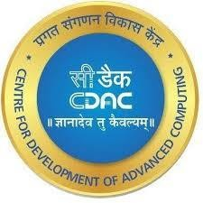 Faculty Supervisor/Guide

# Centre for Development of Advanced Computing

**IACSD,Pune**

**May-2021**

**CERTIFICATE**

# This is to certify that the project entitled “Online Grocery Store”

is a bonafide work of **Laxman Narkhede, Kunal Kathalkar** submitted to C-DAC Pune in partial fulfillment of the requirement for the award of the Post Graduate Diploma in Advanced Computing.

Mr. Chetan Pardeshi Ms.Manjiri Deshpande Supervisor/Guide Faculty Supervisor/Guide

### ABSTRACT

This Online Grocery Store project will basically be an easy to use web application that will allow customers to easily purchase and order items for home delivery . It is basically for providing a platform for registering users, categories, products, managing stocks and orders and an end to end system from order-to –delivery-to –payment services.

This project presents a theoretical framework for online grocery store, it discussed about ordering grocery items from our store just like from vendors like `Bigbasket` and `Grocers`.After Ordering,the details are processed and a delivery person is assigned for carrying out the delivery available in that region.The Order goes through various stages like“PLACED,PACKING,READY,OUT_FOR_DELIVERY,DELIVE RED & CANCELED”.

This project discussed the tool and technology used in developing the proposed system (the system has a front end by REACT to display the content structure and a back end of database using MySQL and Spring Boot i.e. J2EE). Two online grocery stores were compared to identify their similarities and differences. A number of development methodologies were discussed and why one of the methodologies was chosen for this project. Methods used to gather the requirement specification was also discussed and how the researcher will use this as a guideline in developing the proposed system.

## INDEX

|  |  |  |
| --- | --- | --- |
| **1** | **INTRODUCTION** |  |
|  | 1.1 Introduction | **1** |
| **2** | **PRODUCT OVERVIEW AND SUMMARY** |  |
|  | 2.1 Purpose | **3** |
|  | 2.2 Scope | **3** |
|  | 2.3 User Classes and Characteristics | **3** |
|  | 3 2.4 Technologies Used | **3** |
| **3** | **REQUIREMENTS** |  |
|  | 3.1 Functional Requirements | **4** |
|  | 3.1.1 Use case for Administrator. | **5** |
|  | 3.1.3 Use case for Customer.  . | **6** |
|  | 3.1.4 Use case for Employee. | **7** |
| **4** | **PROJECT DESIGN** |  |
|  | 4.1 Data Model | **8** |
|  | 4.1.1 Class Design | **8** |
|  | 4.1.2 ER-Design | **9** |
|  | 4.1.3 Database Design | **10** |
| **5** | **PROJECT SCREENSHOTS** | **15** |
| **6** | **TEST REPORT** | **23** |
| **7** | **CONCLUSION** | **24** |

**LIST OF TABLES**

|  |  |  |
| --- | --- | --- |
| **SECTION** | **TABLE LIST** | **PAGE** |
| 1 | **USER** | **9** |
| 2 | **ADDRESS** | **9** |
| 3 | **CART** | **10** |
| 4 | **CATEGORIES** | **10** |
| 5 | **ORDER_DETAILS** | **10** |
| 6 | **ORDERS** | **11** |
| 7 | **PAYMENTS** | **11** |
| 8 | **PRODUCTS** | **12** |
| 9 | **STOCK** | **13** |

## LIST OF FIGURES

|  |  |  |
| --- | --- | --- |
| **SECTION** | **TABLE TITLE** | **PAGE** |
| **1** | **UML for Admin** | **4** |
| **2** | **UML for Customer** | **5** |
| **3** | **UML for Employee** | **6** |
| **4** | **Class Diagram** | **6** |
| **5** | **ER Diagram** | **7** |

### INTRODUCTION TO PROJECT

The web based “Online Grocery Store System” project is an attempt to stimulate the basic concepts of Grocery Store. The system enables the customer to do the things such as search for Products category wise, choose products based on description and add that product into cart.

The system provides you details about product. If user want to buy product, he must have registered account.

The system shows the product that are available or that are in stock, the system displays price, quantity, availability of product to user as well as employees of store

Here we provided products by category wise that allows customer to choose a particular product easily. The product which are not in stock, user cannot add that products into cart. If the products are available then the system allows the user to add product into cart.

To place order system, ask user to select the address and payment mode. If address is not provided the user can’t place order, User have to specify the address before placing order. After selecting address and payment mode user can place order and the same updates will be done in database.

The system has admin who can add new employees or can remove employees, also admin can add or can remove products. Also, he can see the availability of products. Admin can change other employees Role to "Moderator" or "Admin.

The System have employee also who can perform tasks like add or remove products. Also, employee can add delivery person. Employee can edit product details.

1. **PROJECT OVERVIEW AND SUMMARY**

## PURPOSE

The purpose of this project is to provide Grocery products more effectively than the existing system. There are some disadvantages of the existing Grocery store system. These disadvantages are overcome by the Online Grocery Store System. And it can be made handily available to every person. Previously people have to go to Grocery Store and purchase the products and bring that product to home is very tough task due to size of products. Thus, Online Grocery Store is proposed to assist people and fulfill their requirements easily. This project enables the user to keep track of all the activities of a purchase order. It is a web-based application which helps the user to check products available in the store, check for order details, delivery etc. It maintains order history and order time. It also manages the status of the orders. It has secured access to admin. The admin shall be able to keep track of different users like employee, Delivery person, user and also able to track category and products etc. It is a smart web UI which could assist the Grocery store to keep track of all the events in the store

## SCOPE

* Currently Purchasing Grocery items has become a tedious job in city due to traffic.
* Small and medium scale store, have to manage data about customers, services offered to them.
* It is difficult for small scale businesses to maintain data for longer time as they are using paper-based system.
* Customers also need to find nearest store which provide authentic service.
* Using this system, they will be able to maintain customer and services data.
* Also, multiple services centers which are using the same system will be able to synchronize their work.
* We are also solving the problem from customer's end by making ease of choice. They can choose the products from different category and from different brands

## USER CLASSES AND CHARACTERISTICS

In this software, there is an Admin. Admin can add new Employees which is also another part of system. Admin can see stock and sales. The admin user can edit Employee details. Employees can add Delivery person

for delivery of orders. Employees can see order list and order status. Employee can add new category of products. Customer can use the software for registering to the system. Customer can purchase different products and can place order.

## TECHNOLOGIES USED

MySQL

React- JS Spring Boot

## REQUIREMENTS

**FUNCTIONAL REQUIREMENTS**

The major functionality of this product is divided into three categories.

* Administrative Functions.
* Employee Functions.
* Customer Functions.

In this application each and every user must have their own Email ID and Password, using these Email ID and Password only they can directly enter into their corresponding Login forms.

System analysis will be performed to determine if it is feasible to design information based on policies and plans of the organization and on user requirements and to eliminate the weaknesses of the present system.

**Administrative Function**

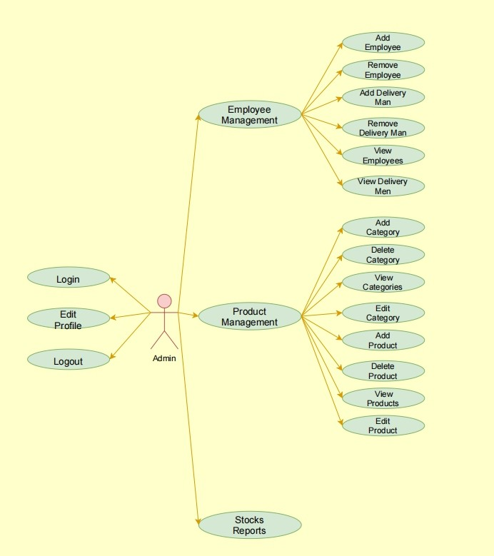

**Employee Function**

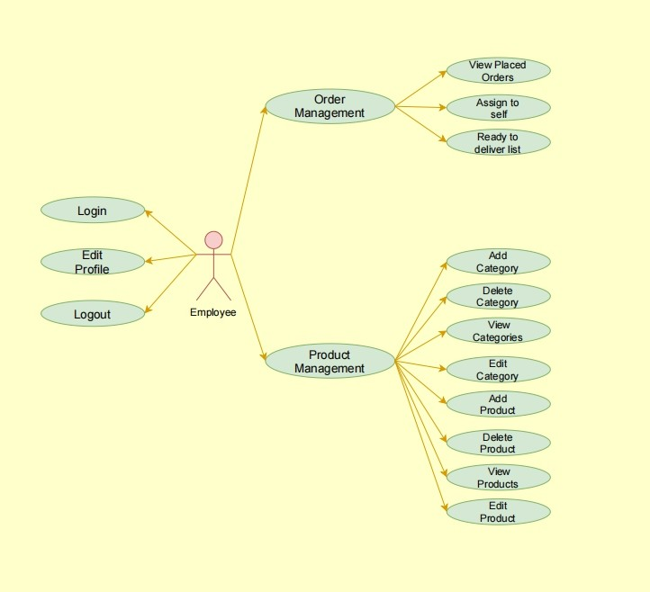

## Customer Function

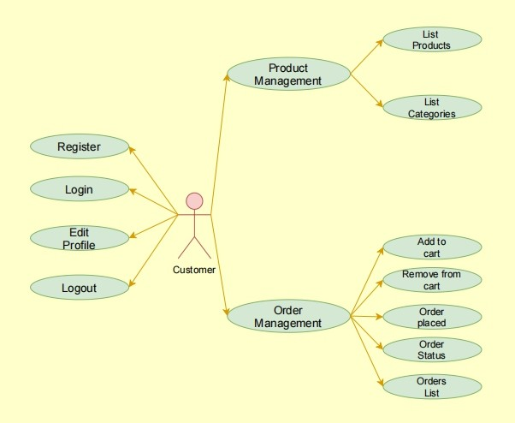

**Delivery Function**

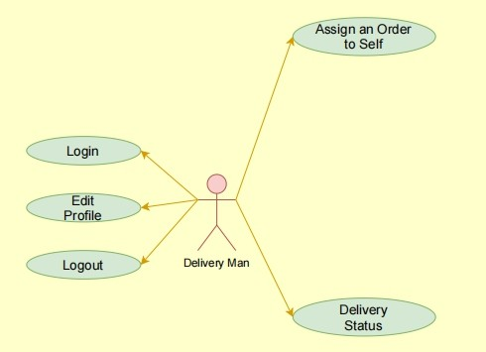

## ER-DIAGRAM

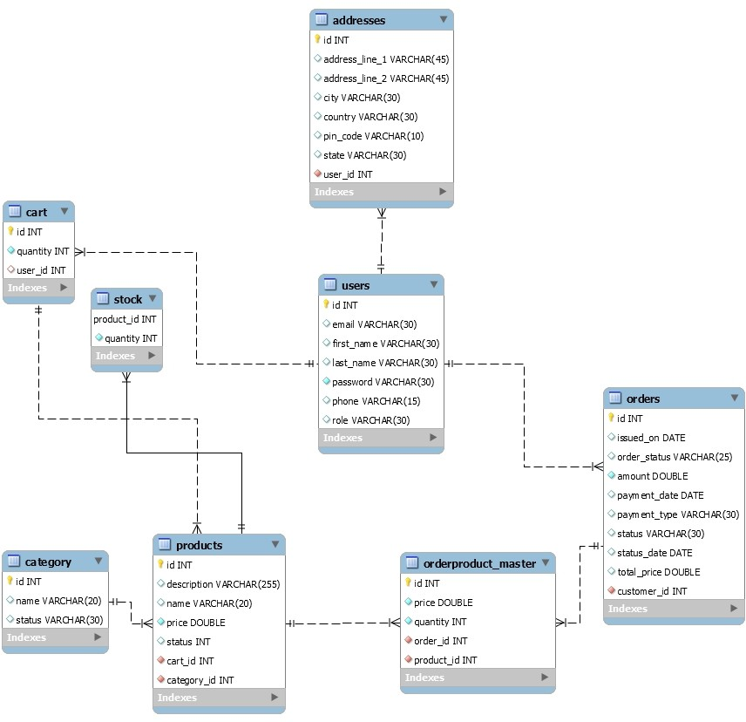

**USE-CASE**

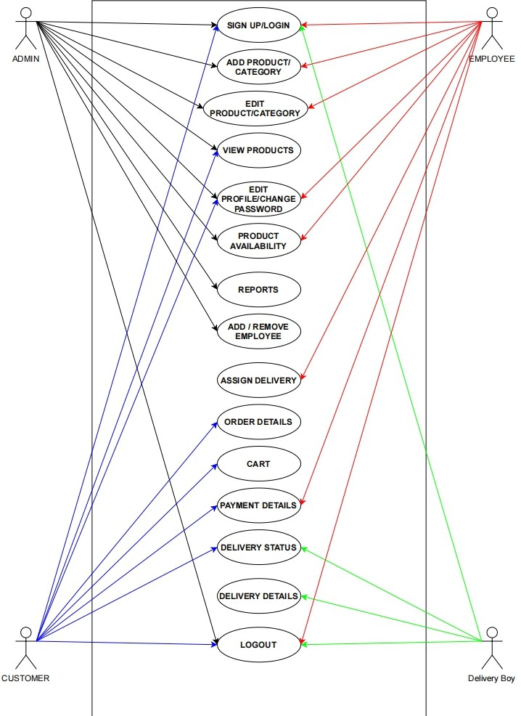

## DATABASE DESIGN

### USER

|  |  |  |  |  |  |
| --- | --- | --- | --- | --- | --- |
| **Field** | **Type** | **Null** | **Key** | **Default** | **Extra** |
| id | int | No | PRI | NULL | auto_increment |
| email | varchar(30) | Yes | UNI | NULL |  |
| First_name | varchar(30) | Yes |  | NULL |  |
| Last_name | varchar(30) | Yes |  | NULL |  |
| password | varchar(30) | No |  | NULL |  |
| phone | varchar(15) | Yes |  | NULL |  |
| role | varchar(255) | Yes |  | Null |  |

**Addresses**

|  |  |  |  |  |  |
| --- | --- | --- | --- | --- | --- |
| **Field** | **Type** | **Null** | **Key** | **Default** | **Extra** |
| id | int | No | PRI | NULL | auto_increment |
| address_line_1 | varchar(30) | Yes | UNI | NULL |  |
| address_line_2 | varchar(30) | Yes |  | NULL |  |
| city | varchar(30) | Yes |  | NULL |  |
| country | varchar(30) | No |  | NULL |  |
| Pin_code | varchar(15) | Yes |  | NULL |  |
| state | varchar(255) | Yes |  | Null |  |
| User_id | int | No | MUL | NULL |  |

**CART**

|  |  |  |  |  |  |
| --- | --- | --- | --- | --- | --- |
| **Field** | **Type** | **NULL** | **Key** | **Default** | **Extra** |
| id | int | NO | PRI | NULL | auto_increment |
| quantity | int | NO |  | NULL |  |
| customer_id | int | YES | MUL | NULL |  |
| Product_id | int | YES | MUL | NULL |  |

**Categories**

|  |  |  |  |  |  |
| --- | --- | --- | --- | --- | --- |
| **Field** | **Type** | **NULL** | **Key** | **Default** | **Extra** |
| id | int | NO | PRI | NULL | auto_increment |
| name | varchar(30) | YES |  | NULL |  |
| status | Varchar(30) | YES |  | NULL |  |

**Products**

|  |  |  |  |  |  |
| --- | --- | --- | --- | --- | --- |
| **Field** | **Type** | **Null** | **Key** | **Default** | **Extra** |
| id | int | No | PRI | NULL | auto_increment |
| description | varchar(100) | Yes | UNI | NULL |  |
| name | varchar(30) | Yes |  | NULL |  |
| price | double | Yes |  | NULL |  |
| status | varchar(30) | No |  | NULL |  |
| category_id | int | Yes |  | NULL |  |

**Stocks**

|  |  |  |  |  |  |
| --- | --- | --- | --- | --- | --- |
| **Field** | **Type** | **Null** | **Key** | **Default** | **Extra** |
| Product_id | int | No | PRI | NULL |  |
| quantity | int | No |  | NULL |  |
| unit | varchar(10) | Yes |  | NULL |  |

## PROJECT SCREENSHOTS

**USER HOME SCREEN**

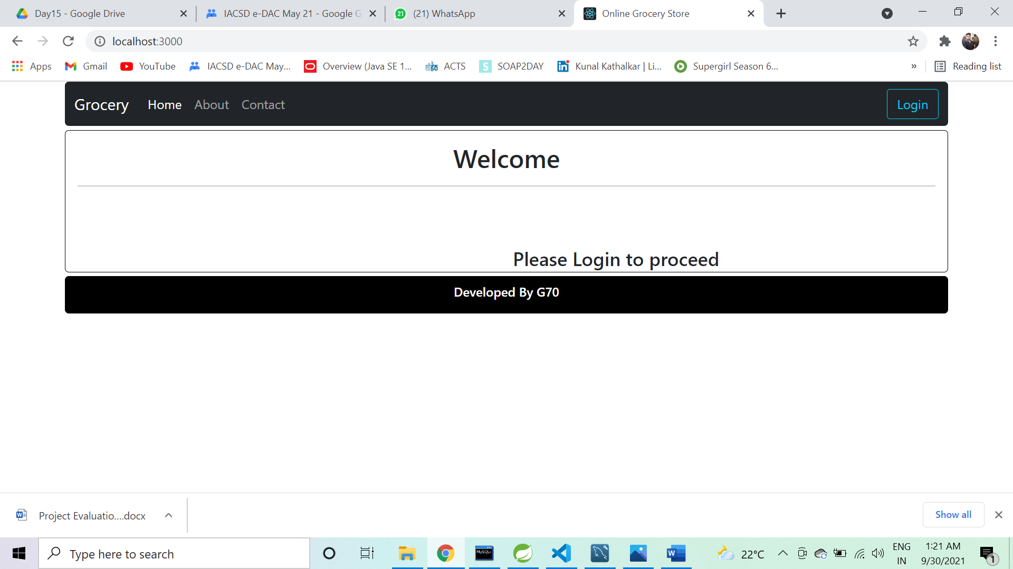

## About-Us

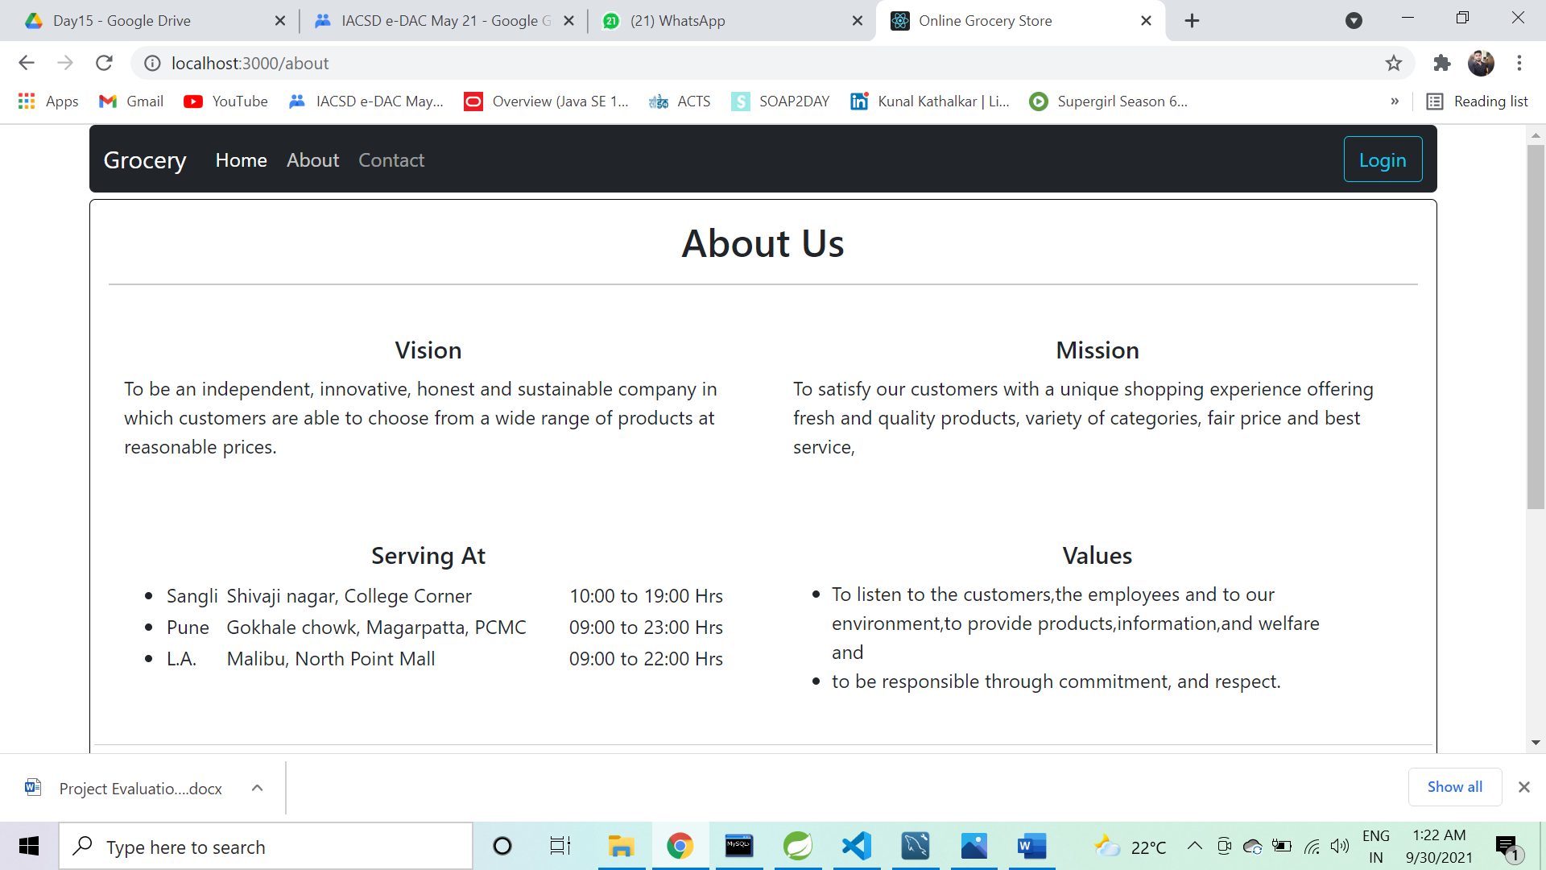

**Contact-Us**

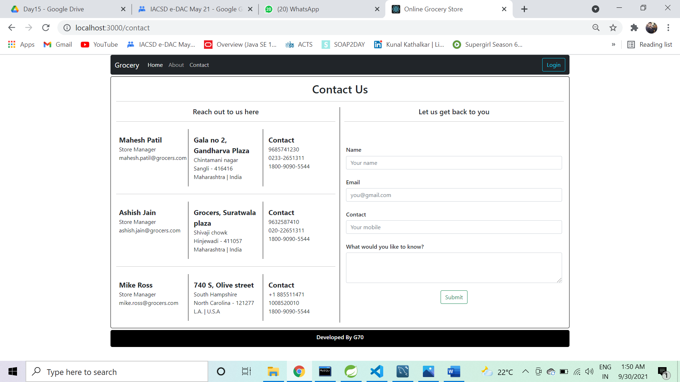

**LOG-IN**

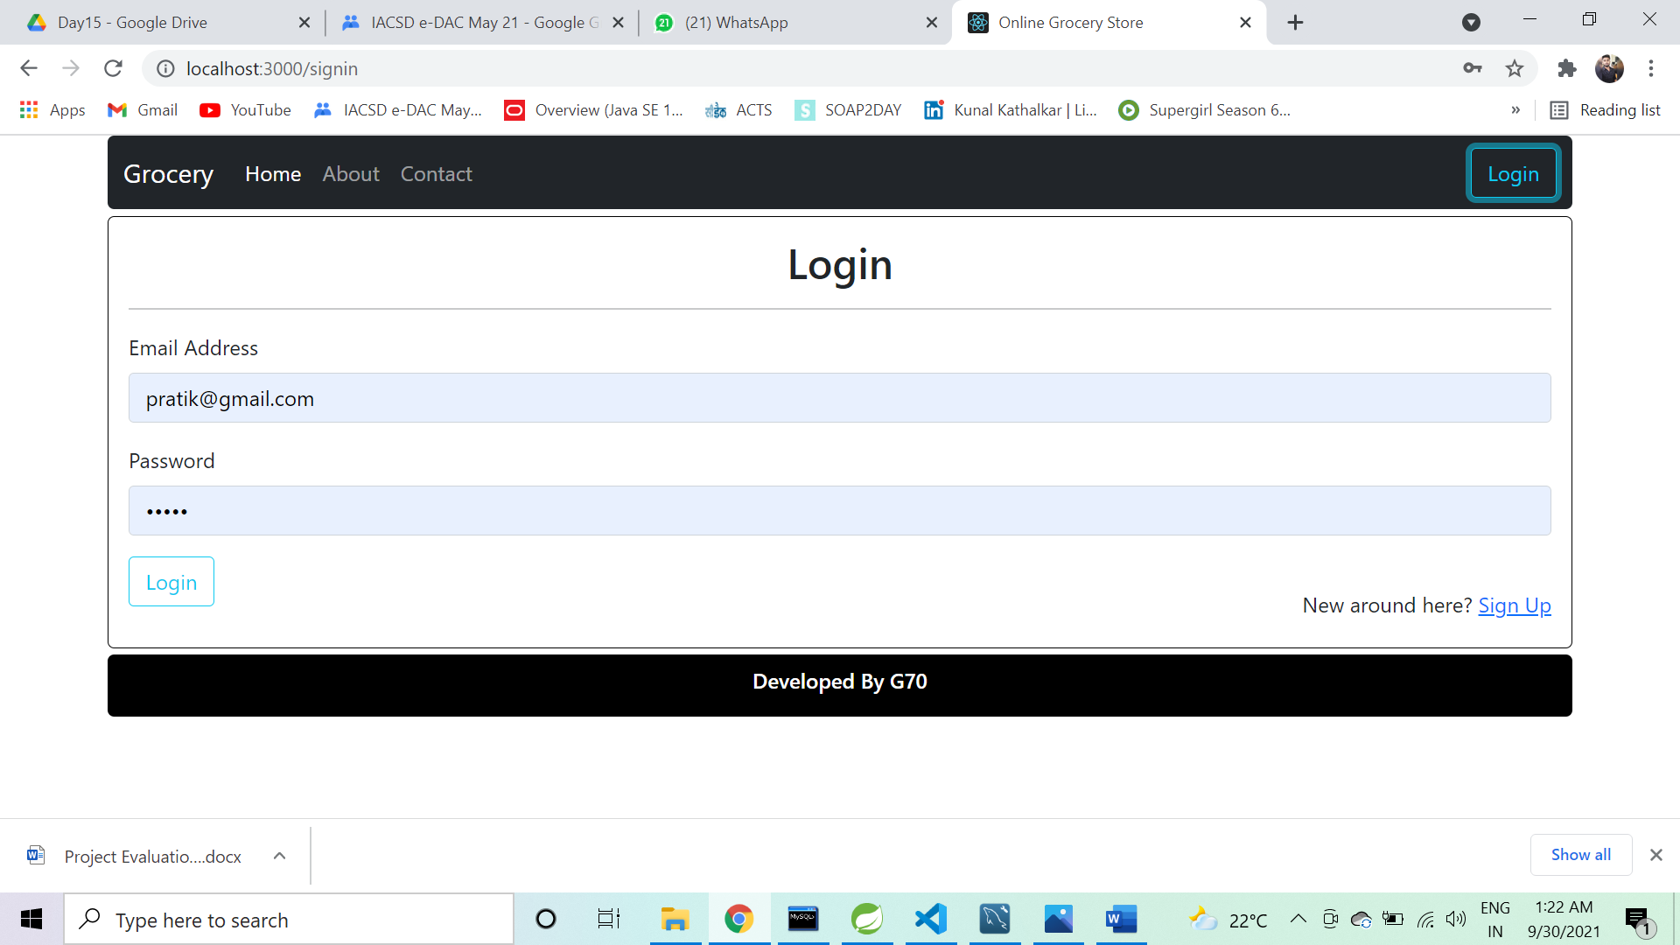

**ADMIN-EDIT-PROFILE**

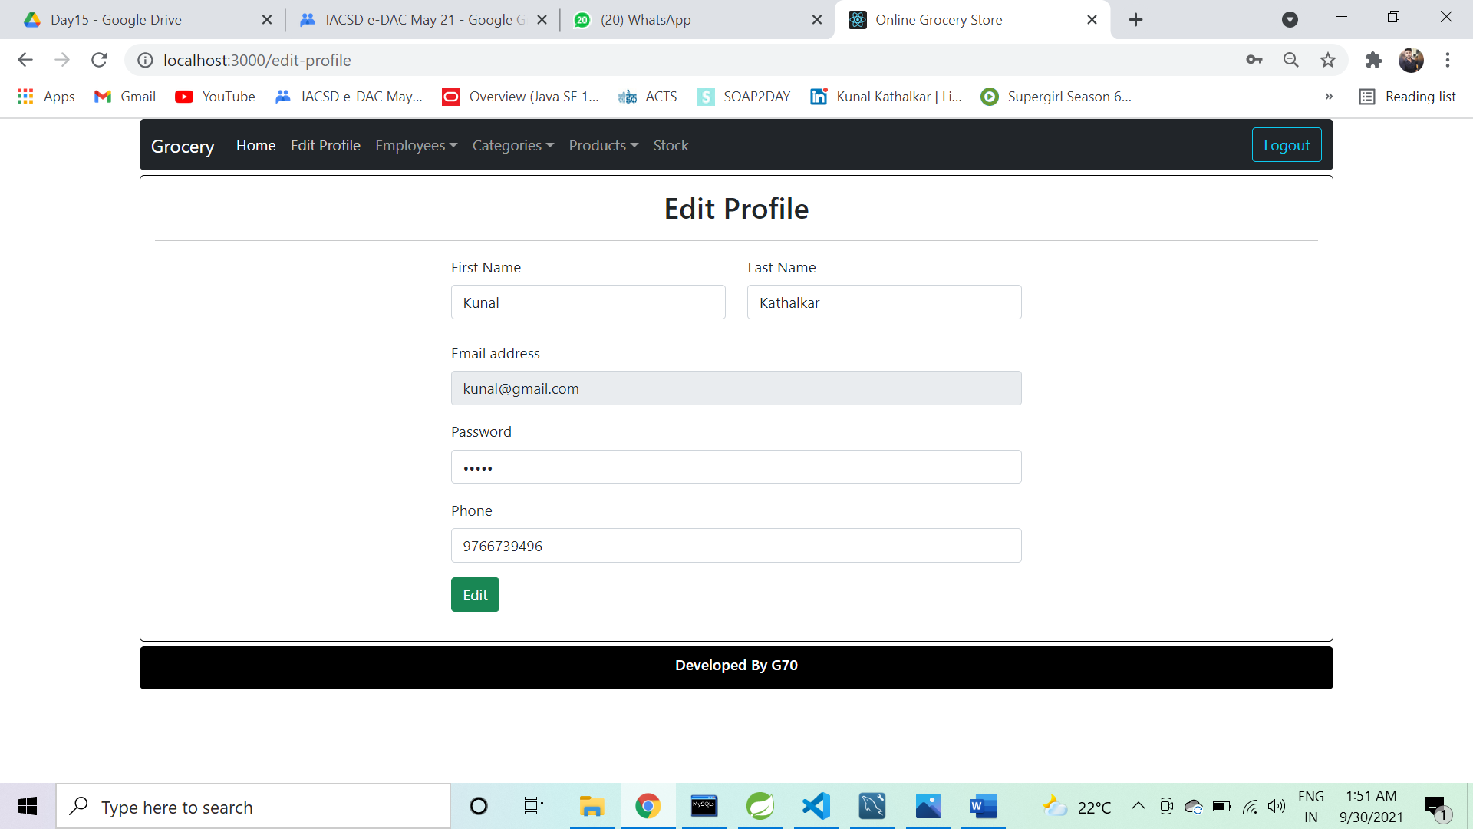

**ADD-PRODUCT**

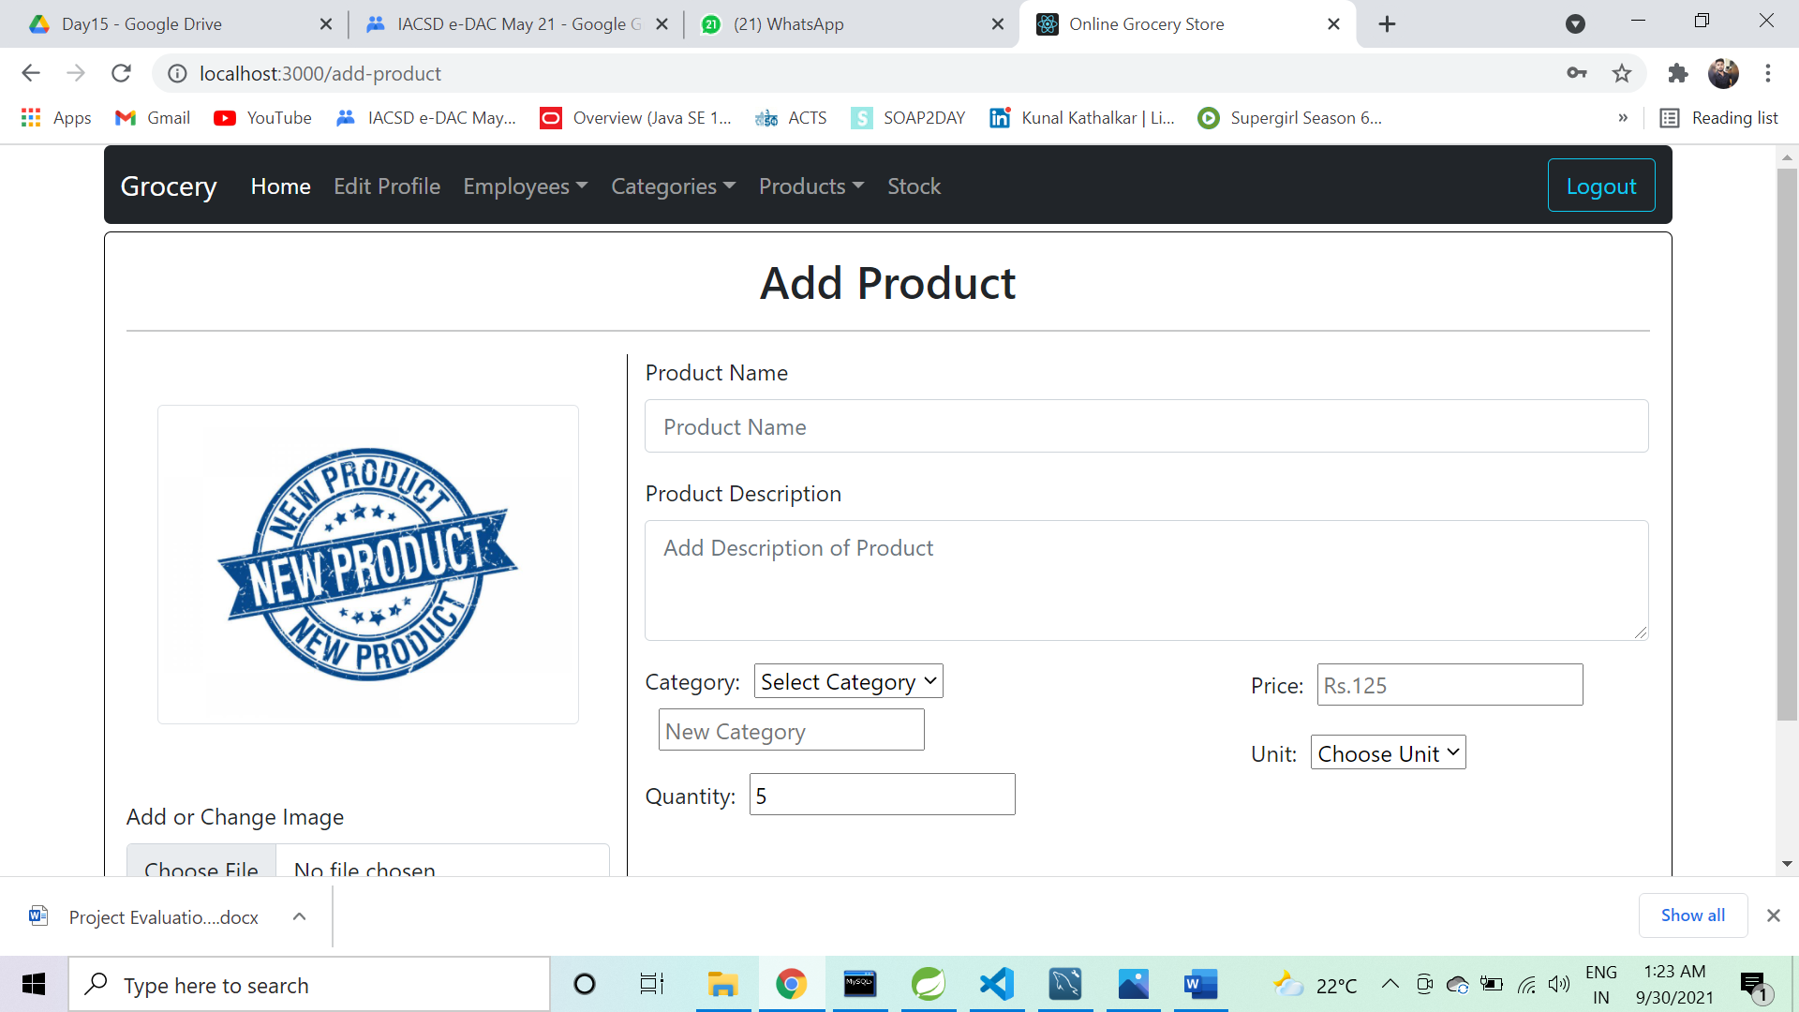

**STOCK-REPORT**

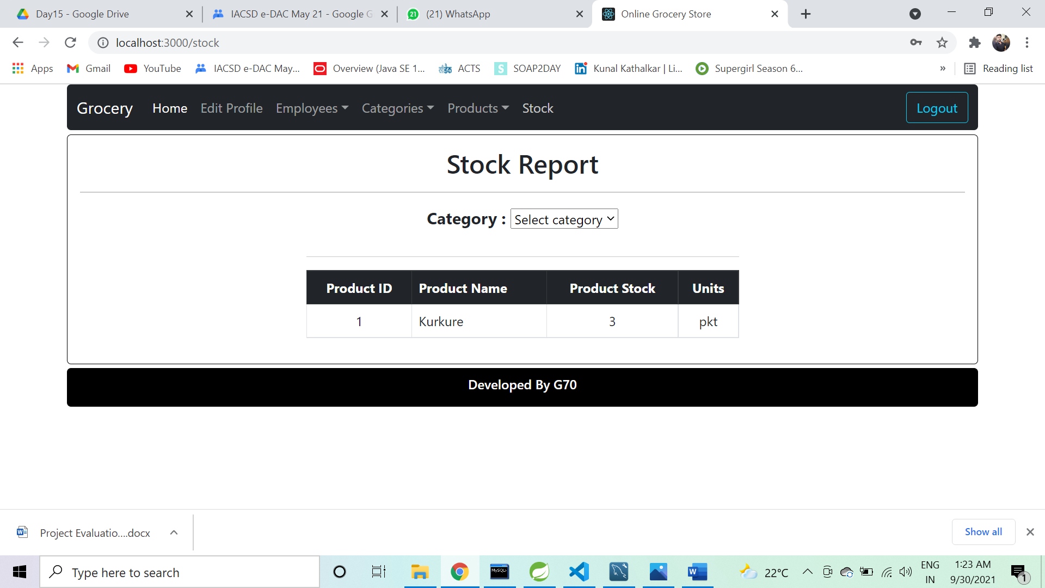

**ADD-REMOVE CATEGORIES**

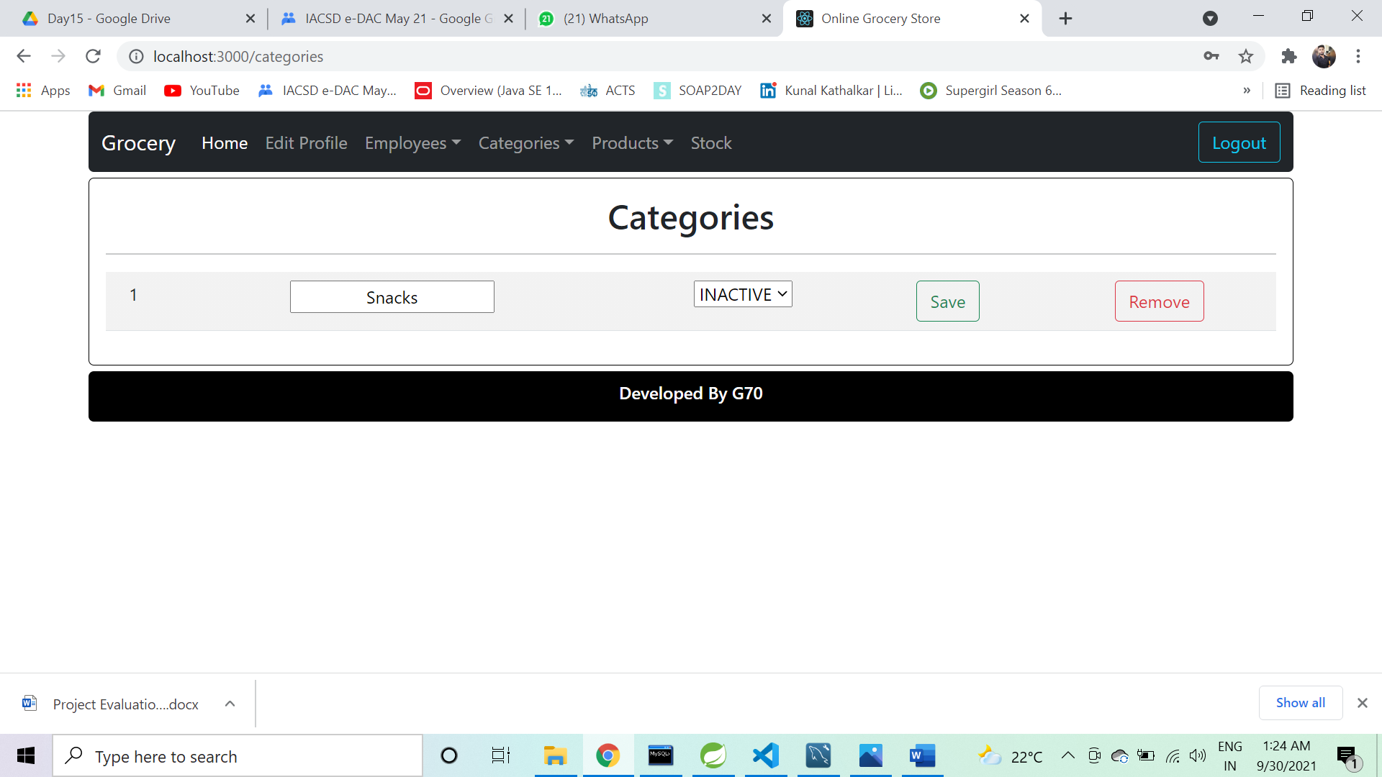

**EDIT-PRODUCTS**

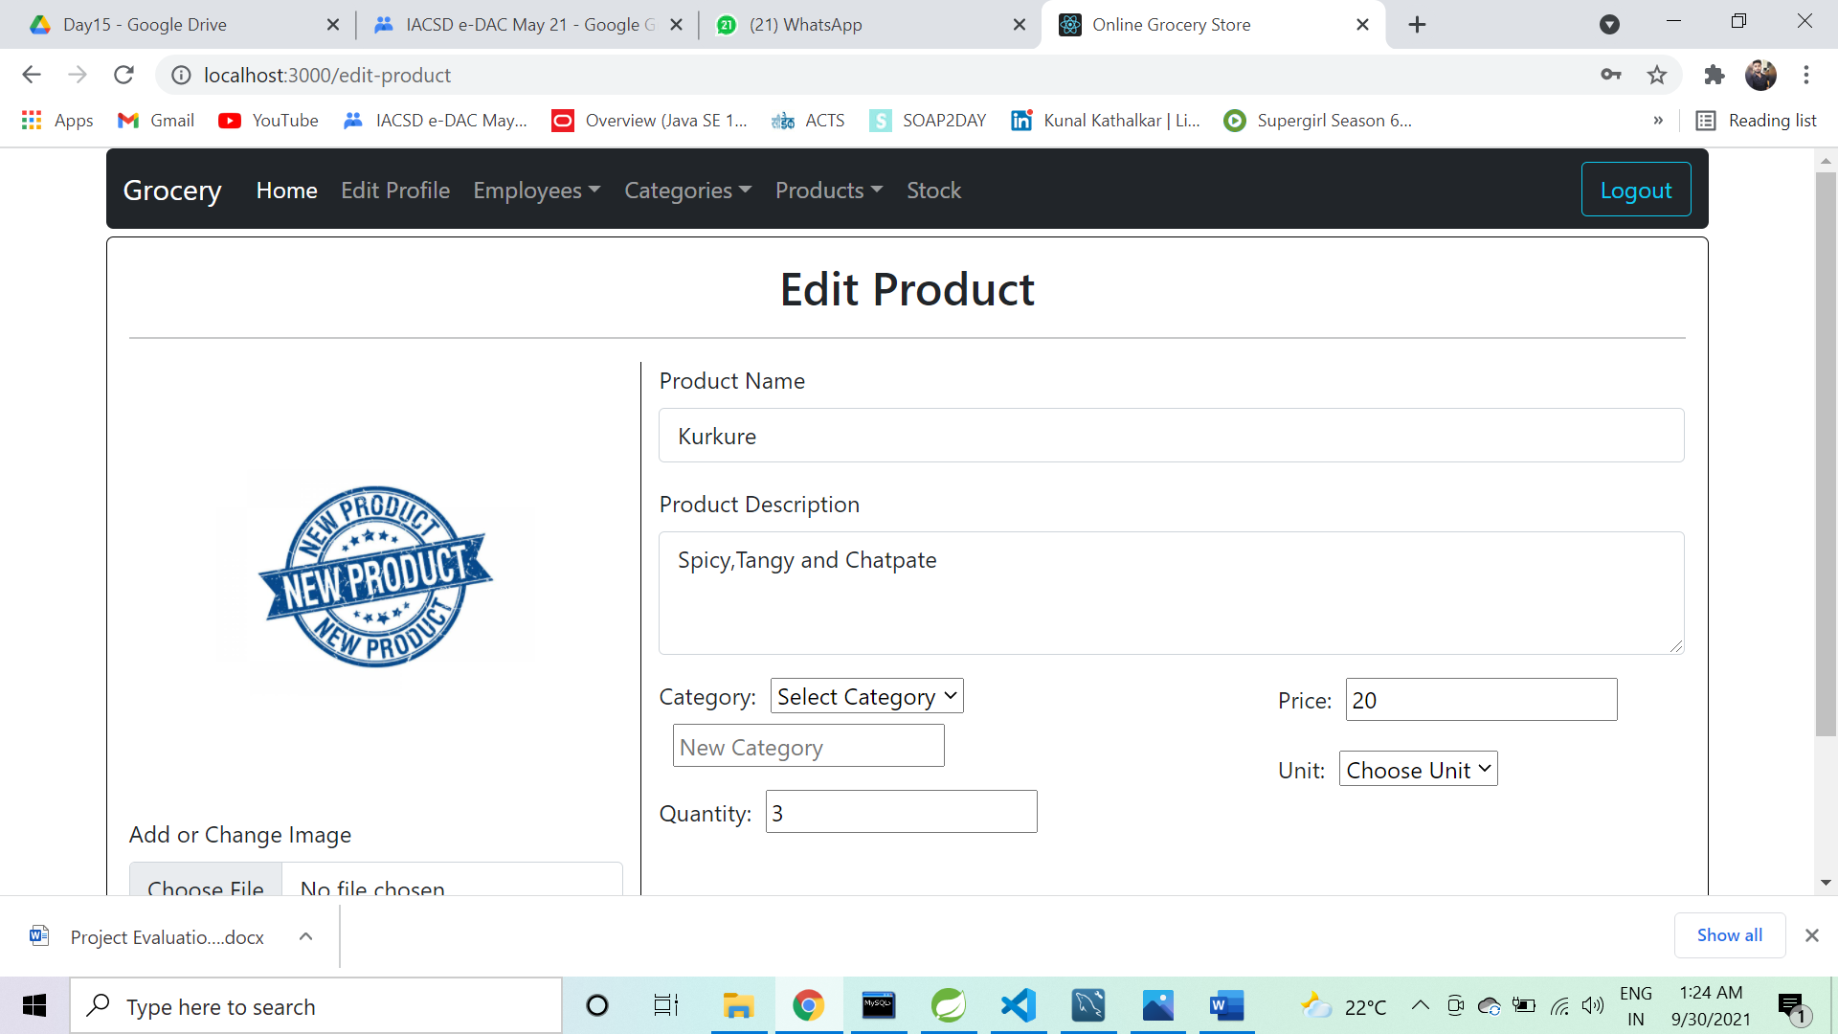

**DELIVERY-PERSON**

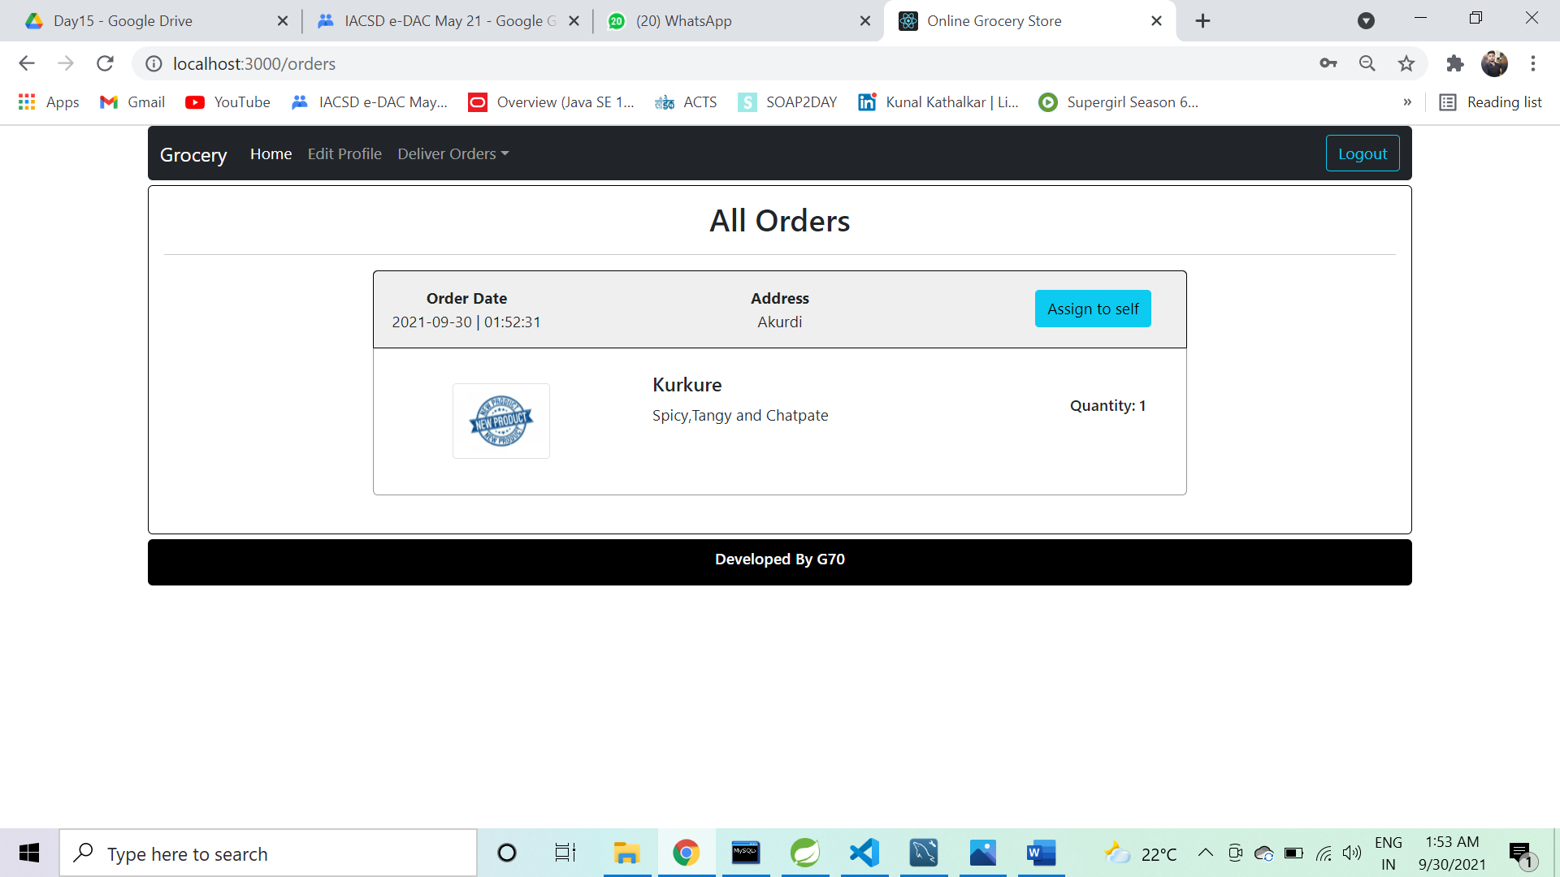

**PICKED-ORDERS**

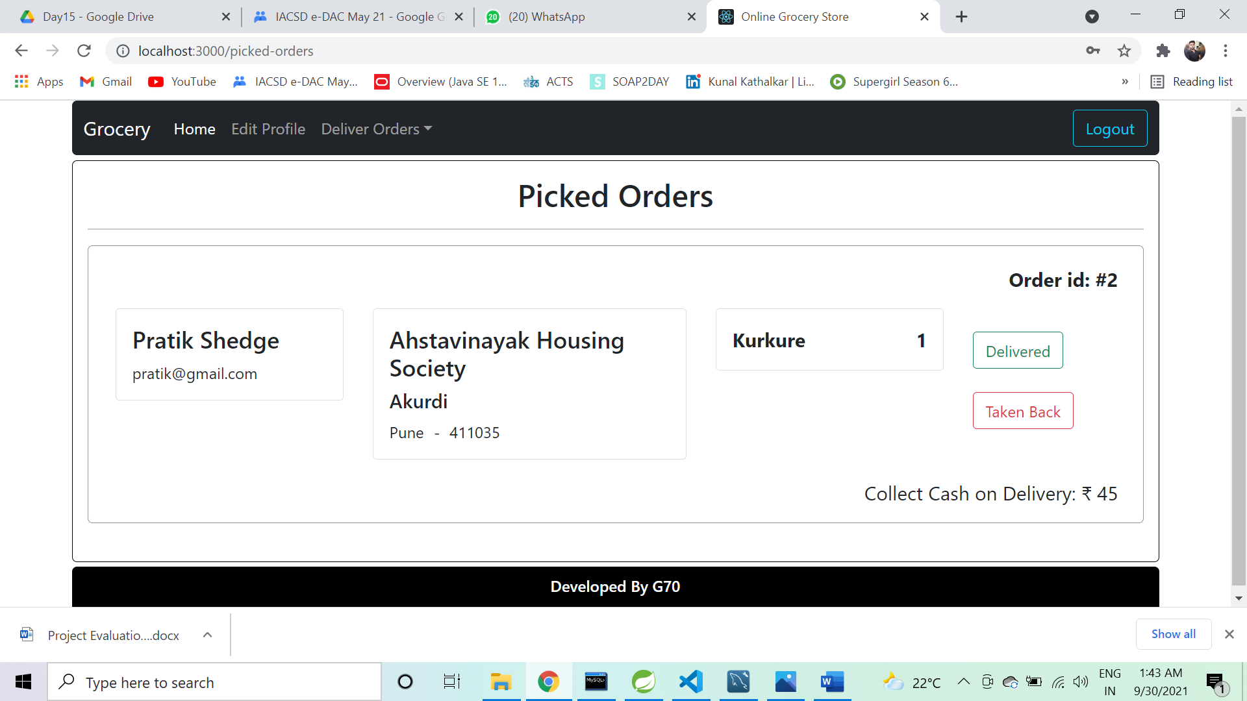

**CUSTOMER**

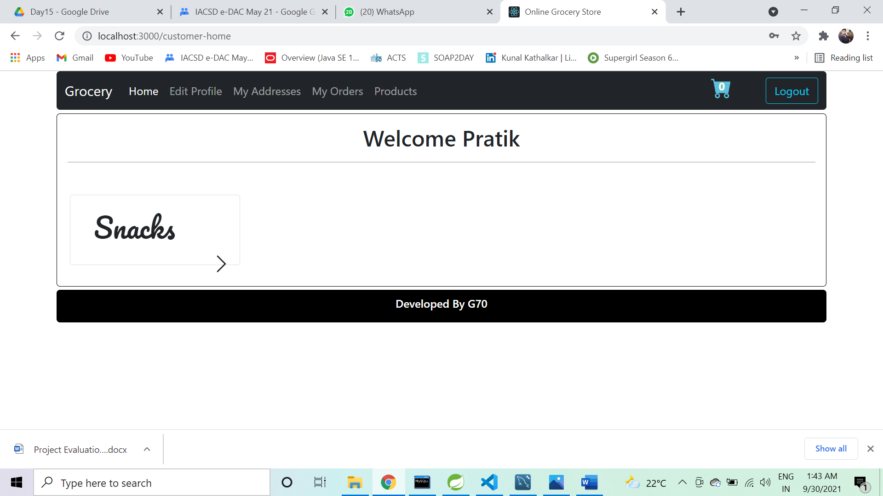

**ADD-TO-CART**

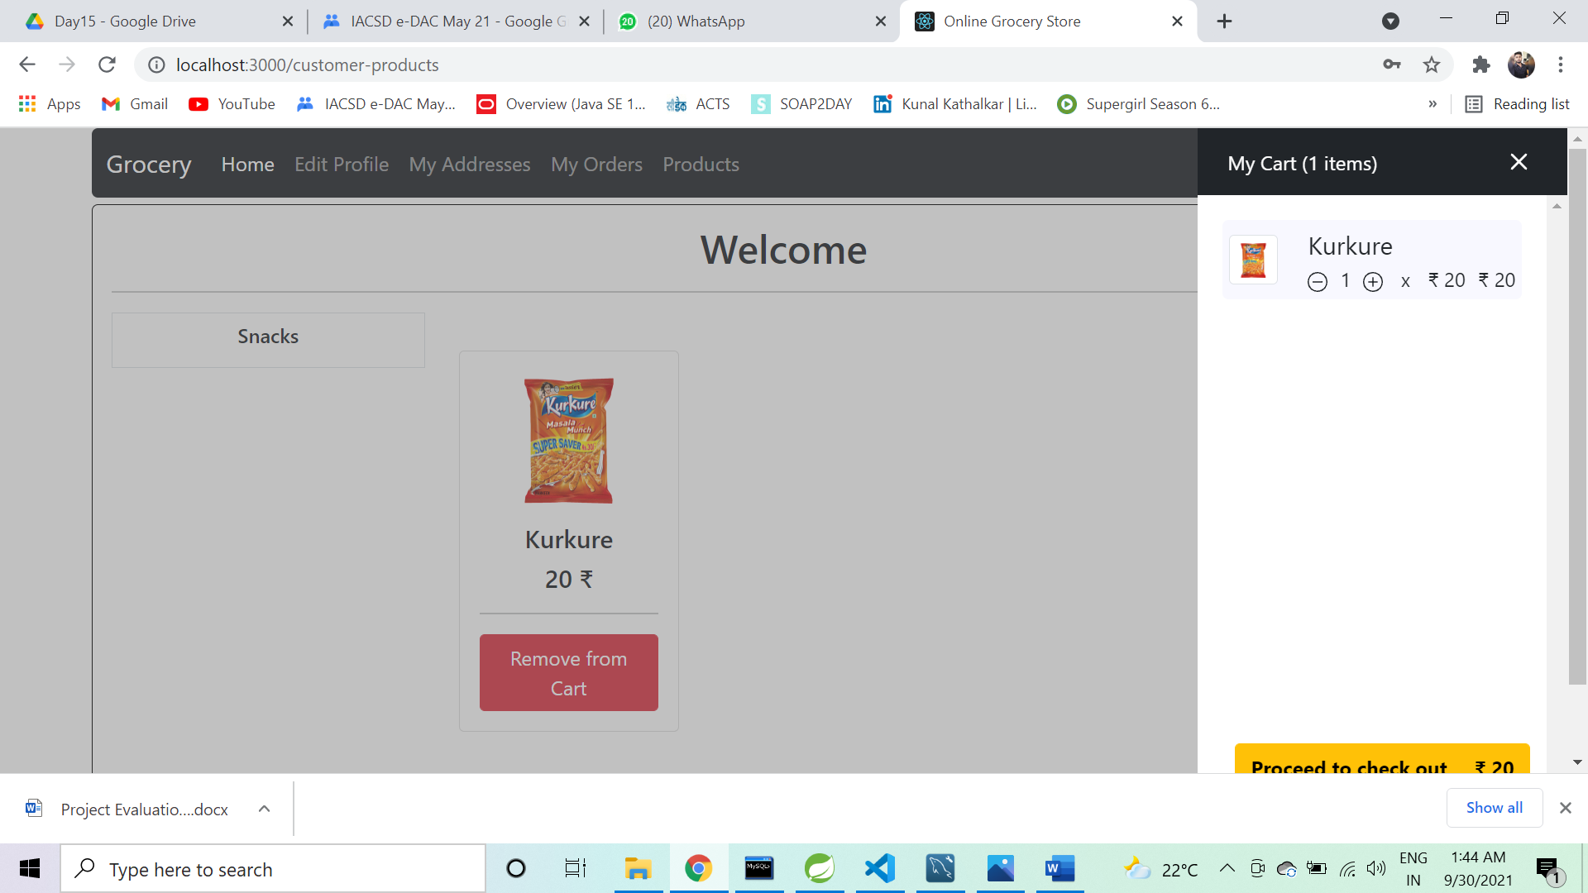

**ADDRESS** 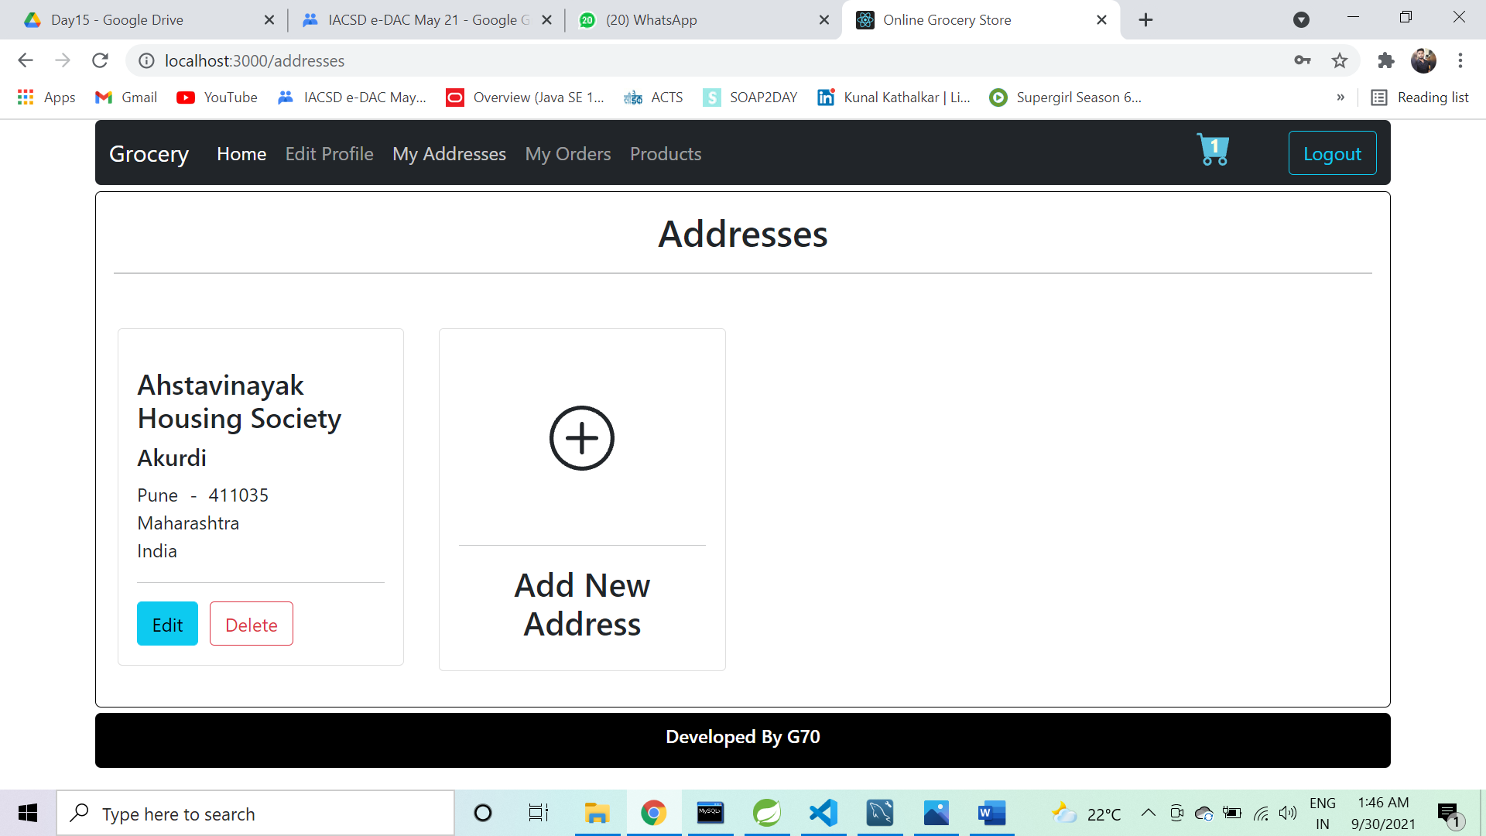

**ORDER-HISTORY**

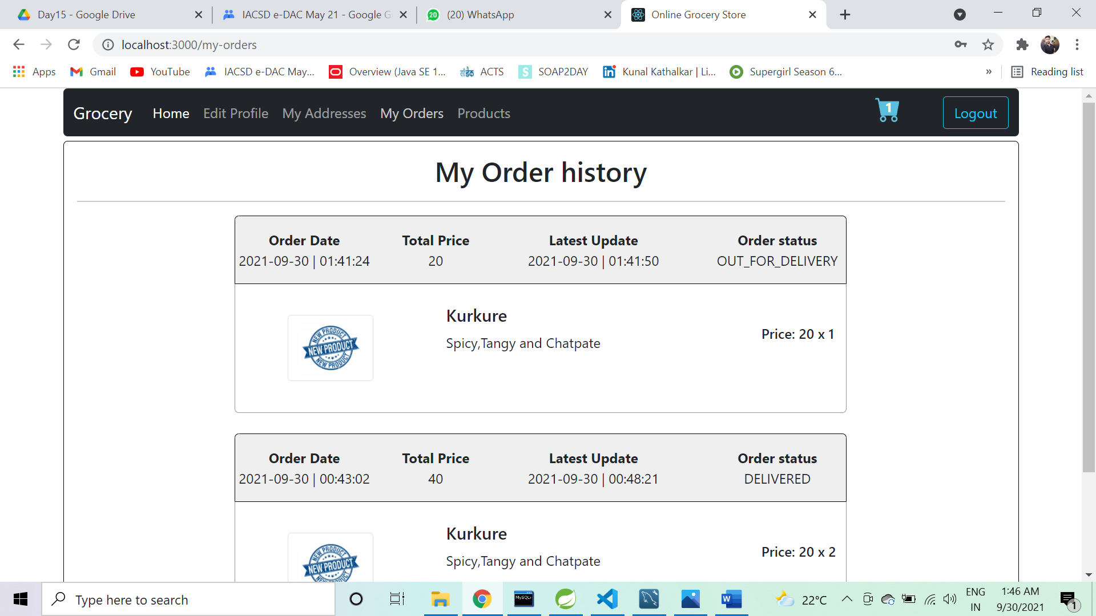

**CART**

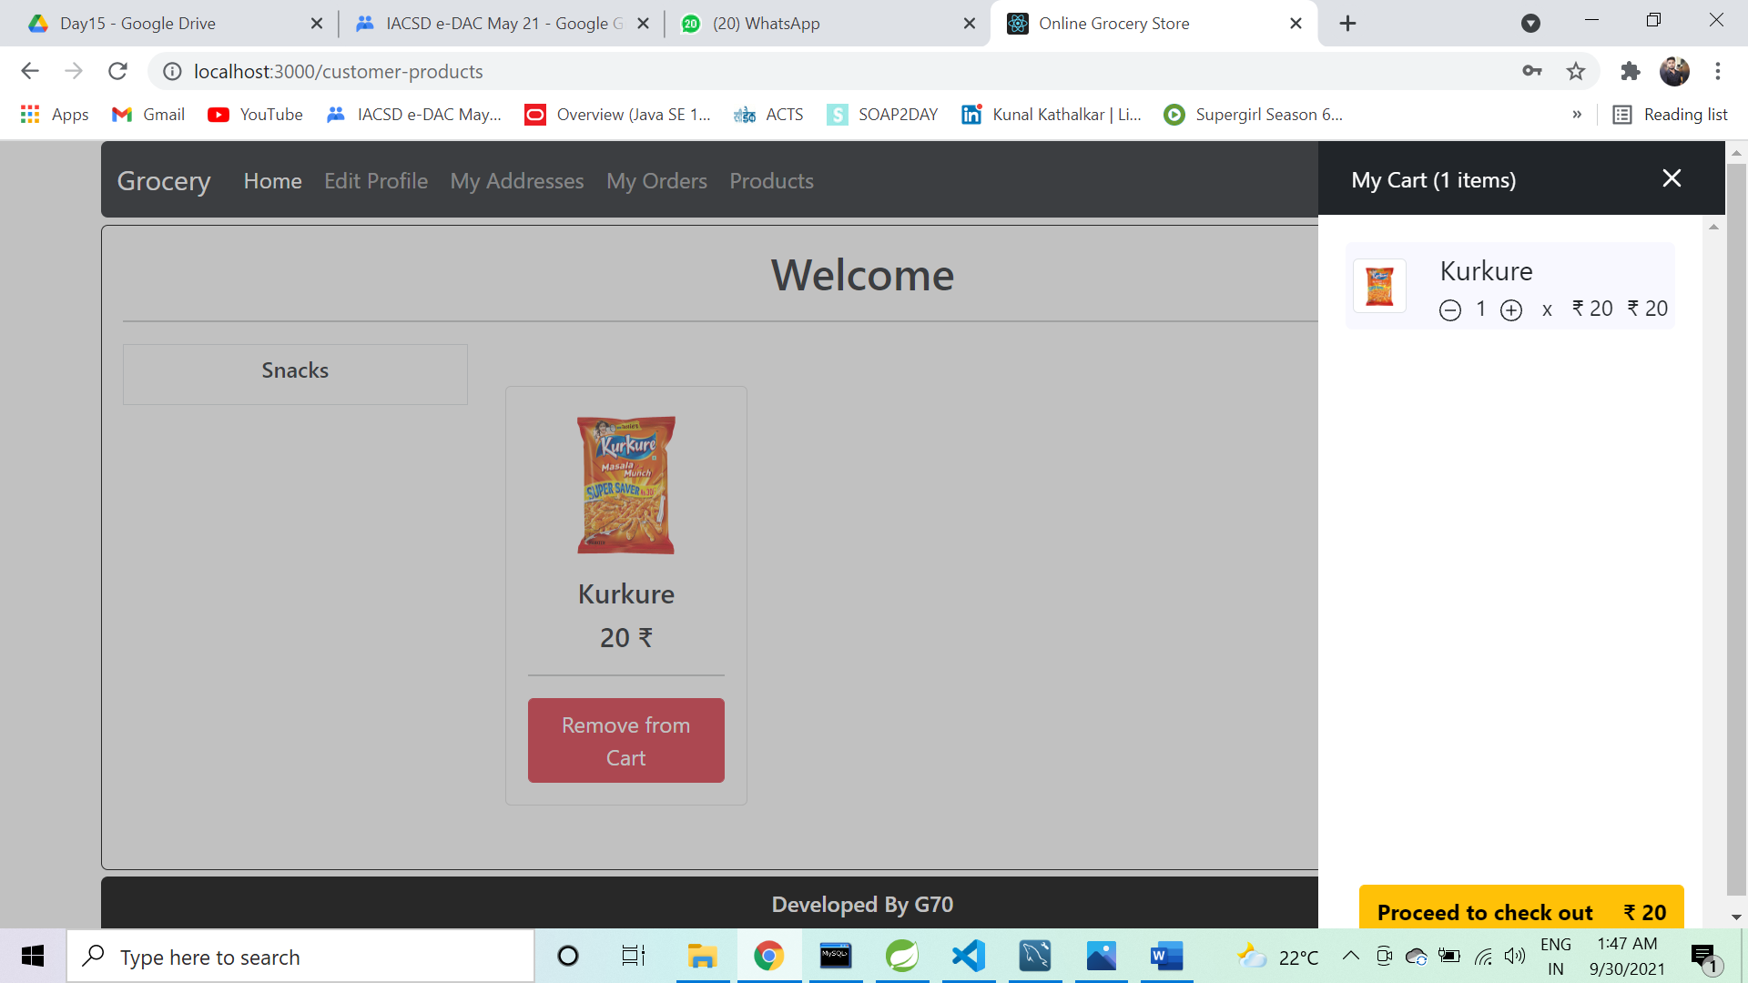

**REVIEW-ORDER**

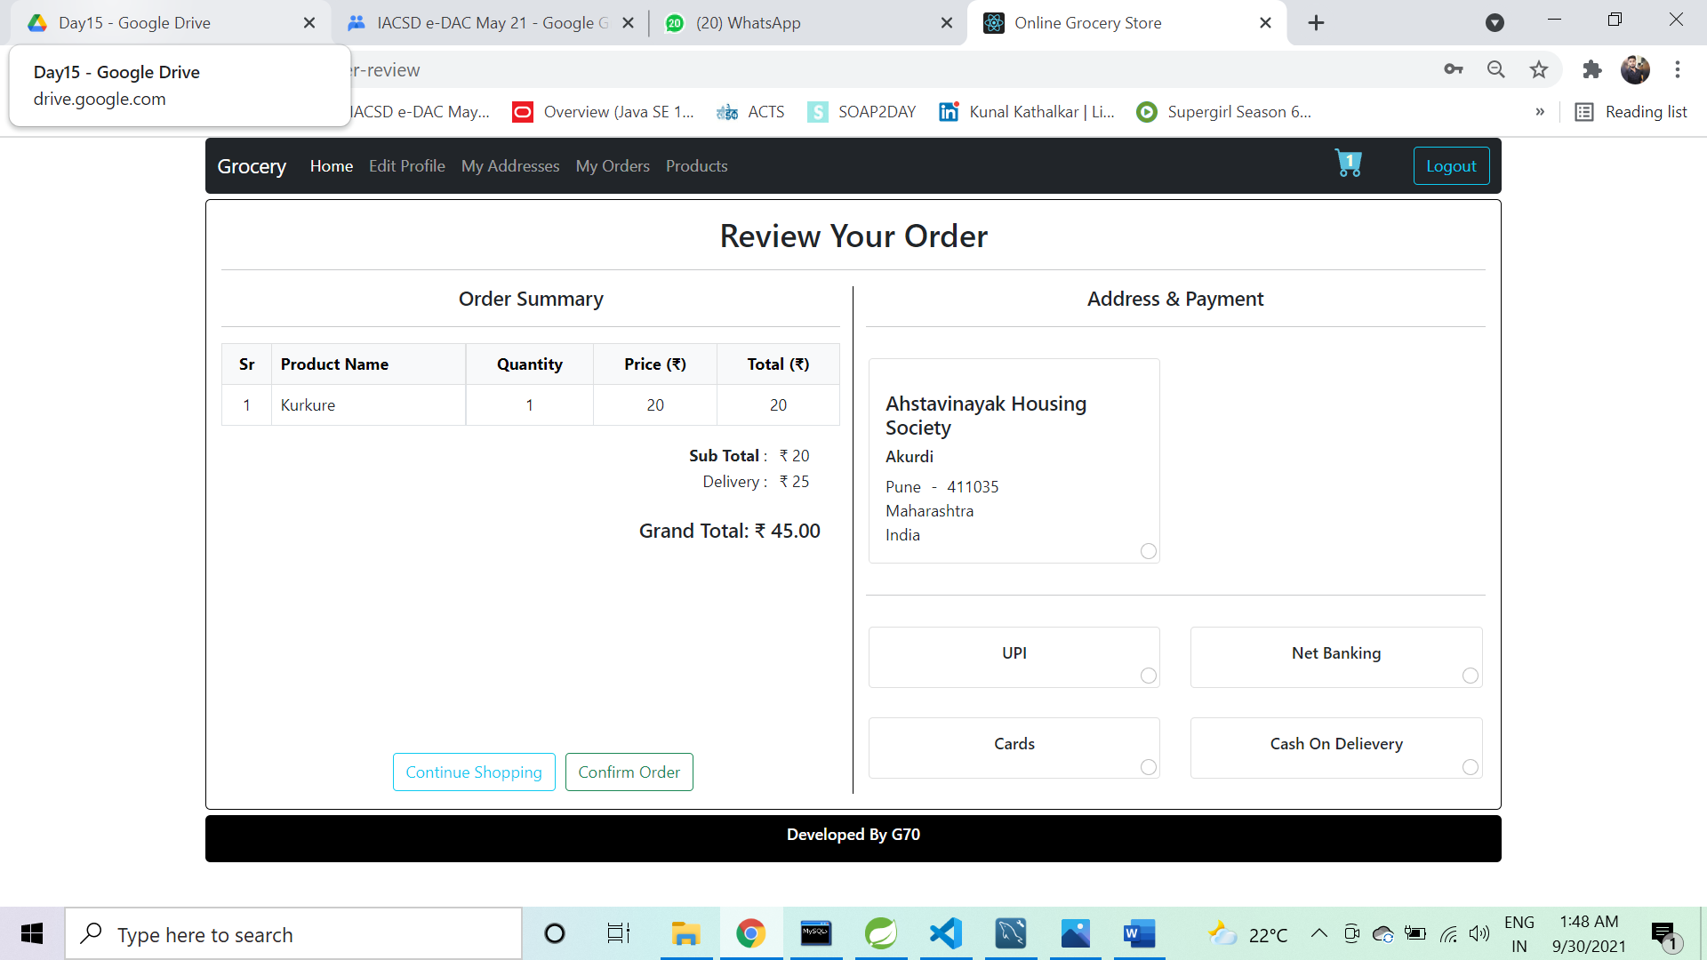

# TESTING

To build up our project we used software testing process for executing a program with the intent of finding error that is uncovering errors in a program makes it a feasible task and also typing to find the errors (whose presence is assumed) in a program. As it is a destructive process.

Types of testing we use in our project

Here we just mentioned that how the testing is related to this software and in which way we have test the software? In our project we have used five types of testing this are listed below –

### UNIT TESTING –

Unit testing where individual program units or object class are tested here by using this testing, we have focus on testing functionality of the methods.

### MODULE TESTING–

Where this is the combination of unit program is called module. Here we tested unit program is where the module program have dependency.

### SUB SYSTEM TESTING –

Then we combined some module for the preliminary system testing in out project.

### SYSTEM TESTING –

Where it is combination of two or more sub system and then it is tested here we tested the entire system a per requirement.

### ACEEPTANCE TESTING –

Normally this type of testing is done to verify if system meets the customer specified requirements. After submitting this project to the user then they tested and to determine whether to accept the application. It is the system of testing performed by the customer to determine where they should accept the delivery of system.

**CONCLUSION**

Currently small and medium scale grocery store don’t have synchronization between their task and customer.

By making online grocery store system we have solved the problem

from grocery store and customer end and more convenience is added to the existing system.

In future scope this system will be available with large scale database and can accommodate many customers and stores.

To find the location of new customer for that particular city we can add Google API to find nearest grocery store.

This system can also be developed on mobile application so that it can be access remotely.