Name: Deep Vaviya
Class:TY-4
Roll no: 72
PRN:124BTCM2011
Batch C

Experiment No - 01
Hosted Virtualization

Aim: Implement Hosted Virtualization using VirtualBox and KVM

Learning Outcome: Implement Hosted Virtualization by creating and managing virtual machines using various hypervisors.

Theory:
- Virtualization is a technology that allows the creation of a virtual version of computing resources, such as operating systems, servers, storage devices, or network resources.It enables multiple virtual machines (VMs) to run on a single physical machine, each operating independently with its own operating system and applications.
- A hypervisor (also known as a Virtual Machine Monitor) is the software or firmware that creates and manages virtual machines.
There are two main types of hypervisors:
1] A Type 1 hypervisor, also known as a bare-metal hypervisor, runs directly on
the host's physical hardware without the need for a host operating system as it
interacts directly with the hardware, it offers better performance, efficiency, and
is commonly used in enterprise environments or data centers.
Example:VMware ESXi, Microsoft Hyper-V (bare-metal version), and Xen
2] A Type 2 hypervisor, also called a hosted hypervisor, runs on top of a
conventional operating systems such as Windows or Linux. It relies on the host
OS to access system resources and is easier to set up and manage, making it
ideal for desktop users, testing, and learning purposes.
Example:Oracle VirtualBox, VMware Workstation, and KVM.
In this experiment, we will implement Hosted Virtualization using Oracle VirtualBox and KVM (Kernel-based Virtual Machine).VirtualBox is a Type 2 hypervisor, which runs on top of an existing OS and allows us to create and manage virtual machines easily.
KVM can act as both Type 1 and Type 2, but in most desktop Linux environments, it is used as a Type 2 hypervisor, managed through tools like virtual-Manager.

Procedure:

Step 01: Create a Virtual machine named ubuntu_1
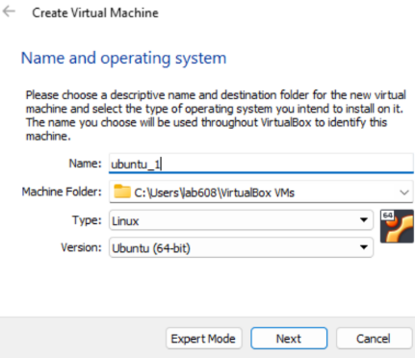

Step 02: Selecting Memory Size(1024MB)
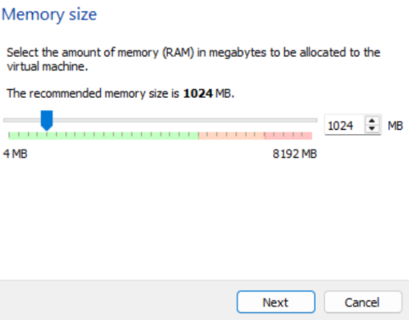

Step 03 :Adding virtual hard disk on new machine
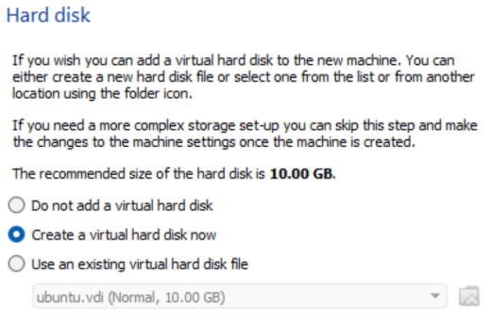

Step 04: Allocate it Dynamically and set size
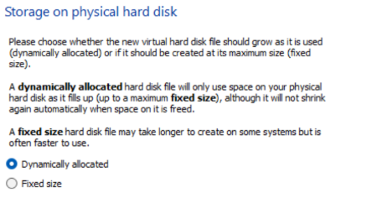

Step 05: Add a secondary IDE Device
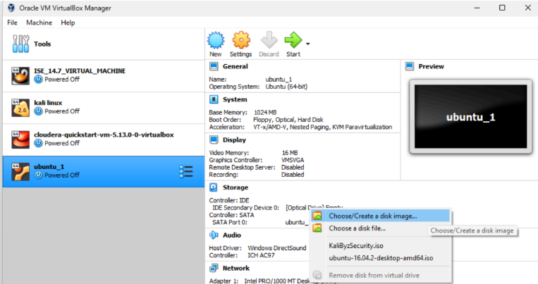

Step 06:Add the ubuntu iso image (5.91GB) which you downloaded:
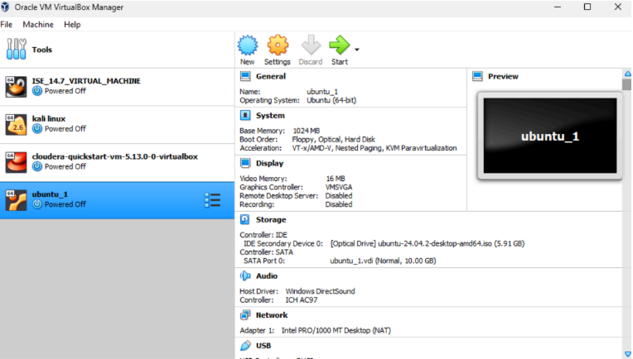

Step 07:Ubuntu screen
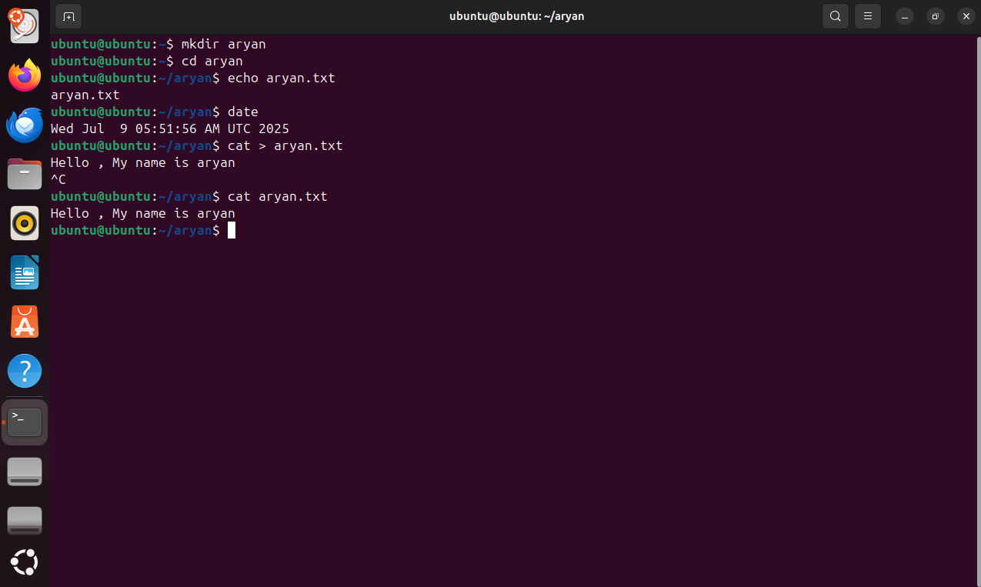

Conclusion:In this experiment, we successfully implemented hosted virtualization using Oracle VirtualBox and KVM. We created and managed virtual machines on a host operating system, demonstrating the practical use of Type 2 hypervisors. This helped us understand how virtualization allows multiple operating systems to run simultaneously on a single physical machine, improving resource utilization and flexibility. We also explored the differences between Type 1 and Type 2 hypervisors, identifying that VirtualBox and KVM (in a desktop environment) function as Type 2 hypervisors. Overall, this experiment enhanced our hands-on skills in virtualization and provided a solid foundation for working with various hypervisors in real-world scenarios.

