Name: Deep Vaviya
Class:TY-4
Roll no: 72
PRN:124BTCM2011
Batch C

Aim: Use Docker Application.

LO: Create dockers with containerization.

Theory: Docker is a containerization platform that allows packaging of applications and their dependencies into portable containers. Containers share the host OS kernel but remain isolated, making them lightweight and efficient compared to virtual machines.

Inthisexperiment,weusedDockeronWindowsto:
- Windows Subsystem for Linux (WSL): Provides a Linux environment inside Windows, enabling developers to run Linux commands natively. Docker Desktop integrates with WSL for better performance.
- Ubuntu Image: Pulled and used inside Docker to execute Linux commands without needing a full Linux VM.
- Alpine Image: A very small Linux-based image, ideal for testing lightweight containers.
- Nginx Image: Used to host and serve a custom HTML page from within a Docker container.

Key Docker concepts used:
  - Image: Read-only template to create containers (e.g., nginx, alpine).
  - Container: Running instance of an image.
  - Volumes(-v):Usedtosharelocalfiles(HTMLpage)withthe container.
  - Port Mapping (-p): Maps container port (80) to host machine port (8080).
  - ThisdemonstrateshowDockersimplifieswebapplicationdeploymentwithminimal setup.

Advantages of Docker containerization:
- Portability:Runsthesame wayacrossdifferent environments.
- Efficiency:UsesfewerresourcesthanVMs.
- Scalability: Supports microservices and distributed architectures.
- Faster deployments: Quick start and stop of containers.

Procedure:
- Update WSL
Ran the following command to make sure WSL was updated and ready for Docker: wsl --update
- Run Ubuntu Container
PulledandranUbuntuimagewithinteractiveshell:dockerrun-itubuntu/bin/bash Inside the container, basic Linux commands were executed
- TestwithAlpineImage
PulledAlpineimage:dockerpullalpine Ran a quick test command in Alpine:
docker run --rm alpine echo "Docker is working on Windows!"
- Create Custom HTML Page
On the local system, created a file index.html
- DeployNginxContainerwithCustomPage Pulled the latest Nginx image: docker pull nginx
RantheNginxcontainer,mappingportsandmountingthelocalHTML file:
docker run -d --name myweb -p 8080:80 -v ${PWD}:/usr/share/nginx/html:ro nginx
- VerifyinBrowser
Open a browser → http://localhost:8080.
VerifiedthatthecustomHTMLpagewasservedsuccessfullyfrominsidetheNginx container.

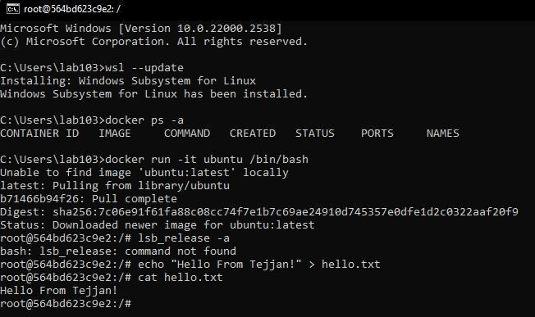
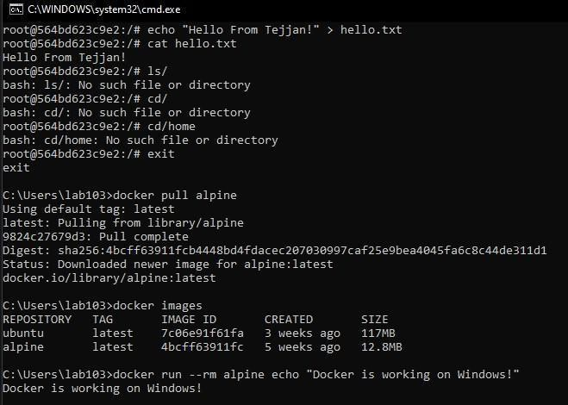

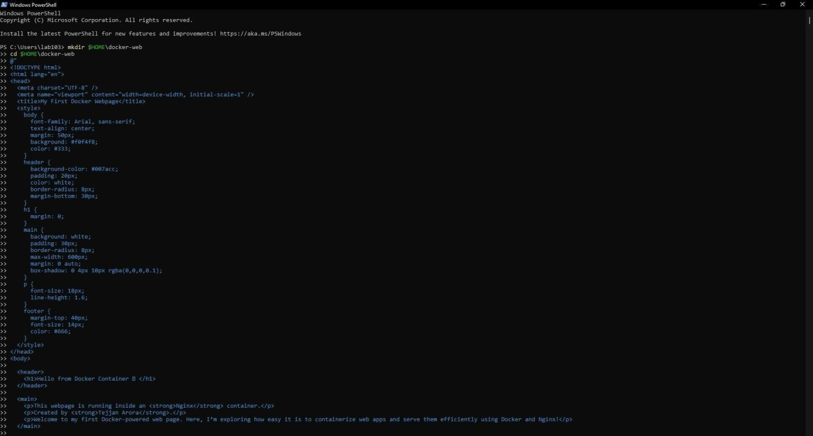
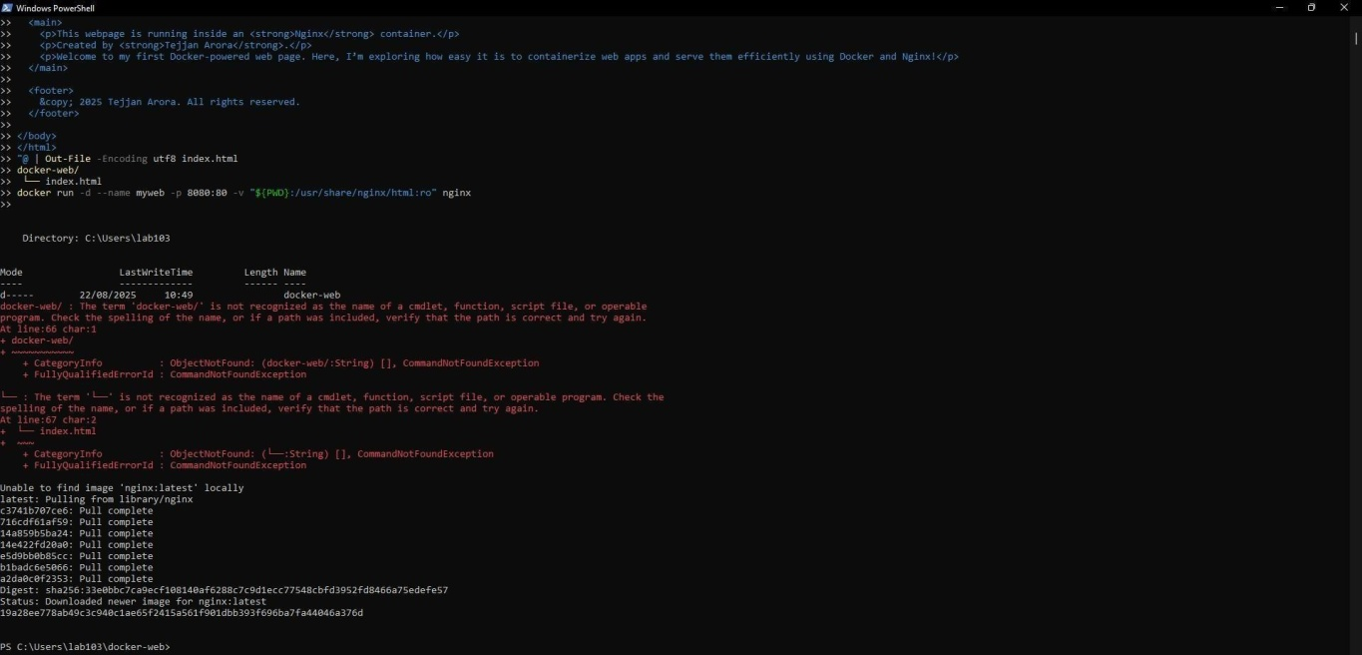

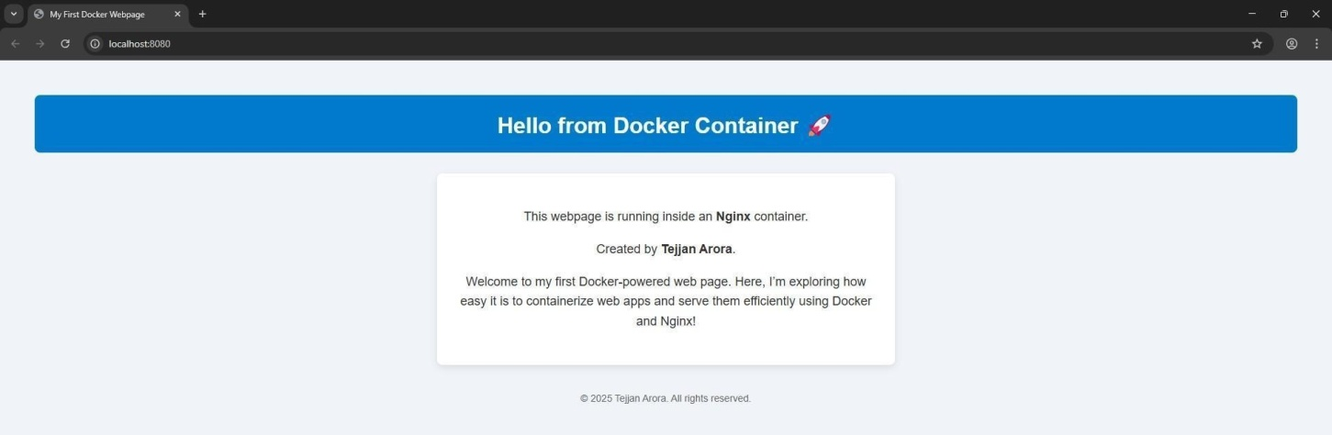

Conclusion:

This experiment demonstrated how Docker, combined with WSL, creates a powerful development environment on Windows. By pulling and running different images (Alpine, Ubuntu, and Nginx), we explored both testing Linux commands and deploying web applications.
Using the Ubuntu container, we practiced Linux commandexecutionwithoutneedingaseparate VM. The Nginx container allowed us to serve a custom HTMLwebpage,showinghowDocker makes application deployment fast and consistent.Inreal-worldscenarios,thisapproachenables developers to build, test, and deploy applications seamlessly across platforms, makingDockera cornerstone of modern cloud-native development.

