Name: Deep Vaviya
Class:TY-4
Roll no: 72
PRN:124BTCM2011
Batch C

Experiment No - 02
IAAS

Aim : Implement Infrastructure as a Service using AWS/Microsoft Azure

Learning Outcome: Apply Infrastructure as a Service (IaaS) concepts by deploying and managing virtual machines and related resources using AWS or Microsoft Azure.

Theory:
IaaS is a form of cloud computing that provides virtualized computing resources over the internet. It delivers basic infrastructure services such as:
- Virtual Machines (VMs)
- Storage
- Networking components
- Operating Systems
Users can rent these resources on-demand and scale them based on their needs, without investing in physical hardware.
Two of the most widely used IaaS providers are Amazon Web Services (AWS) and Microsoft Azure. AWS is known for its services like Amazon EC2 for virtual servers, Amazon S3 for object storage, and Amazon VPC for networking. Microsoft Azure offers equivalent services such as Azure Virtual Machines, Azure Blob Storage, and Azure Virtual Network.
To implement IaaS in AWS, a user begins by logging into the AWS Management Console. A virtual server is launched using Amazon EC2 (Elastic Compute Cloud). The user selects the operating system, instance type (based on required CPU and memory), and storage volume. After configuring the network settings like VPC, subnet, and security groups, the virtual machine is launched. Users can connect to the VM using SSH (for Linux) or RDP (for Windows).
IaaS is used in a wide variety of real-world scenarios. Developers use it to create testing and development environments. Businesses host their websites and enterprise applications on cloud-based VMs. It is also used for running analytics, data warehousing, and high-performance computing tasks. Startups and enterprises alike benefit from the flexibility of IaaS, especially for disaster recovery and remote data backups, without the burden of managing physical infrastructure.
Procedure:
Step 01:Launch an Instance
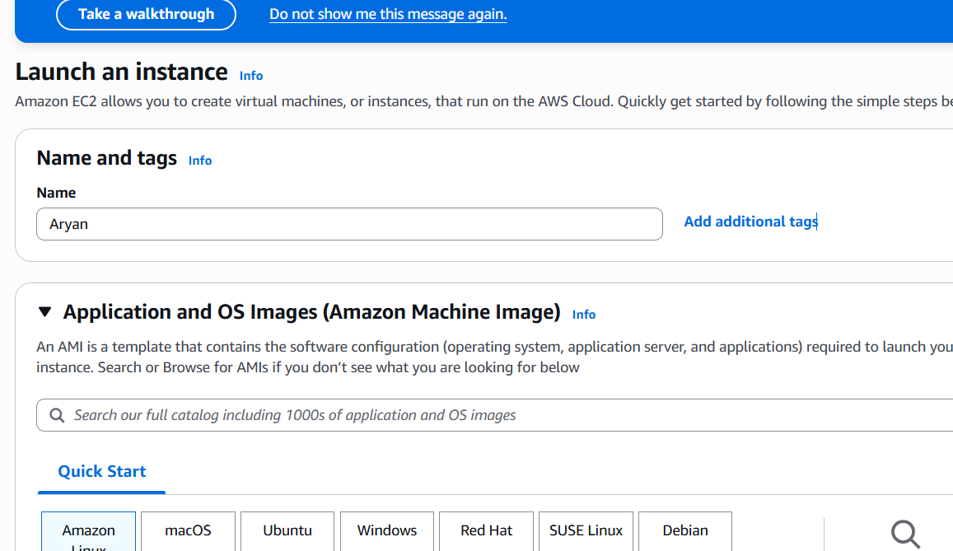

Step 02: Creating a key pair name

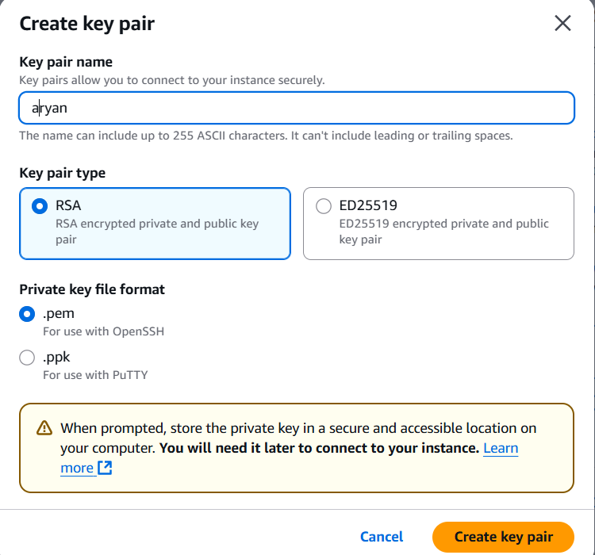
Step 03:Key pair name created
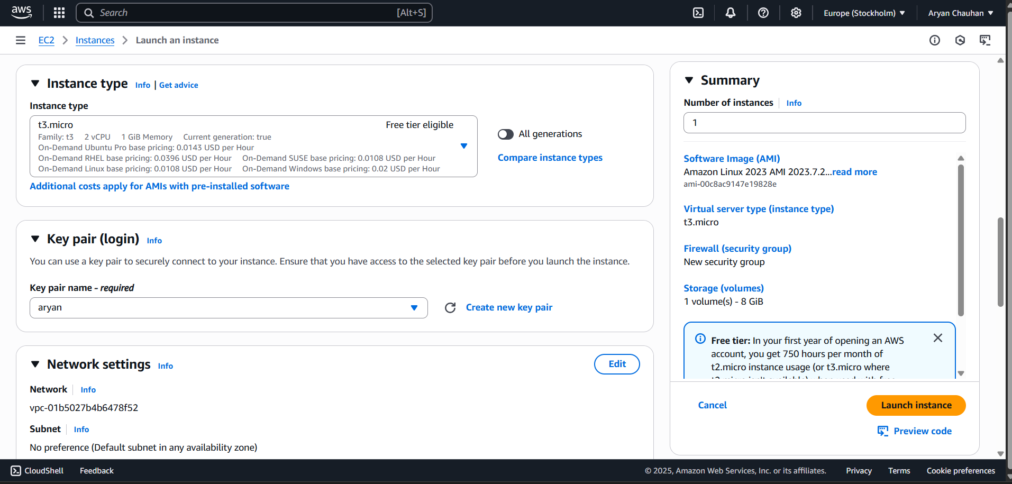

Step 04:Change network settings
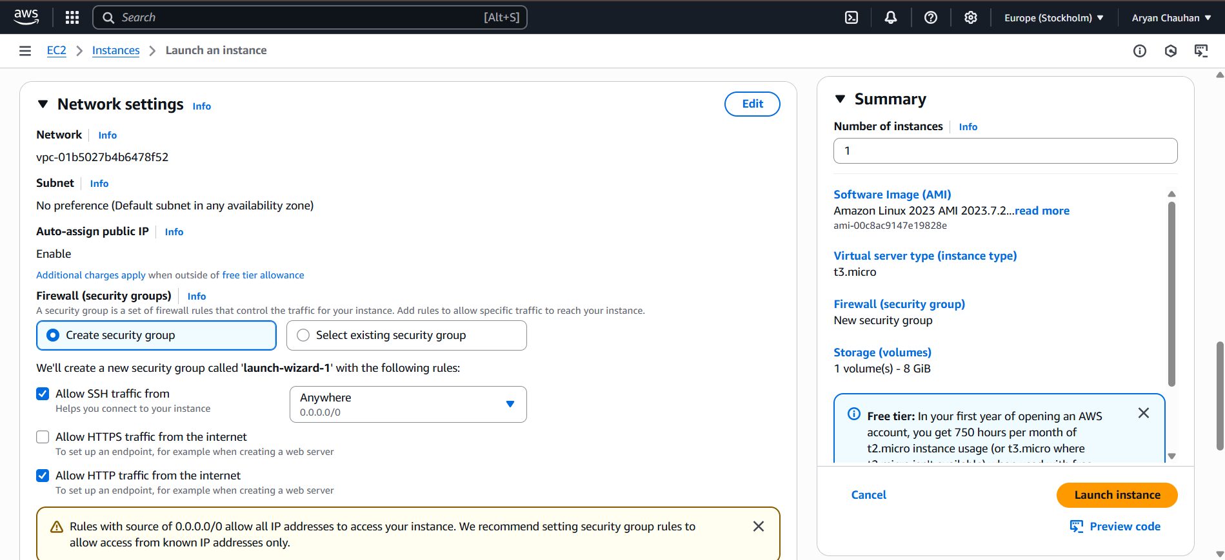

Step 05:Launch an instance
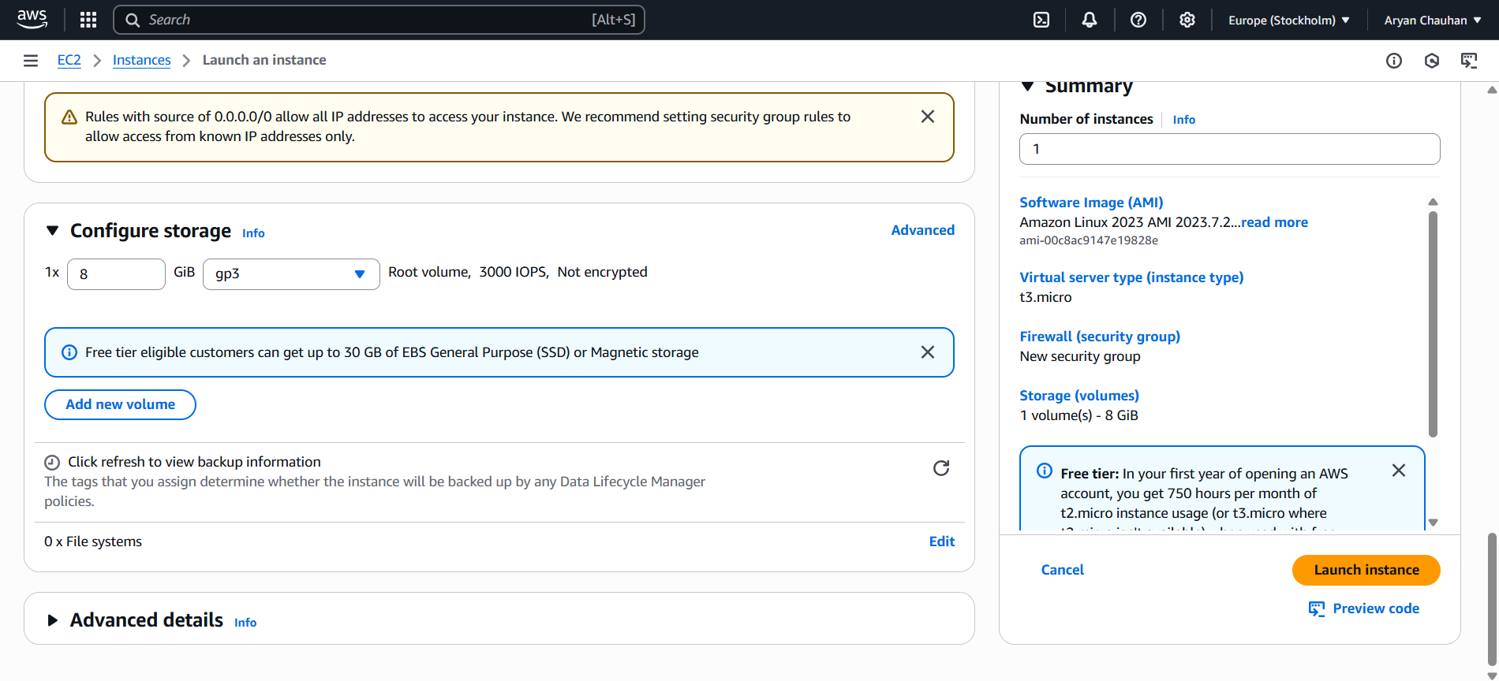
Step 06:Instance launched(click on instance id)
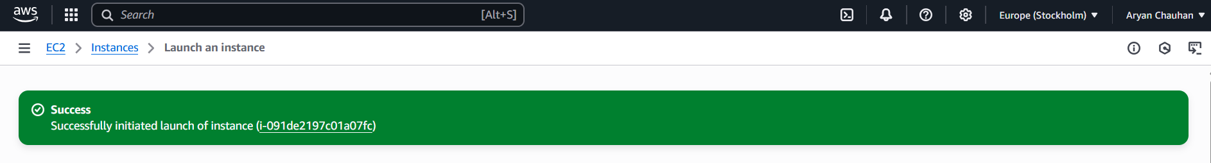

Step 07:Instance page
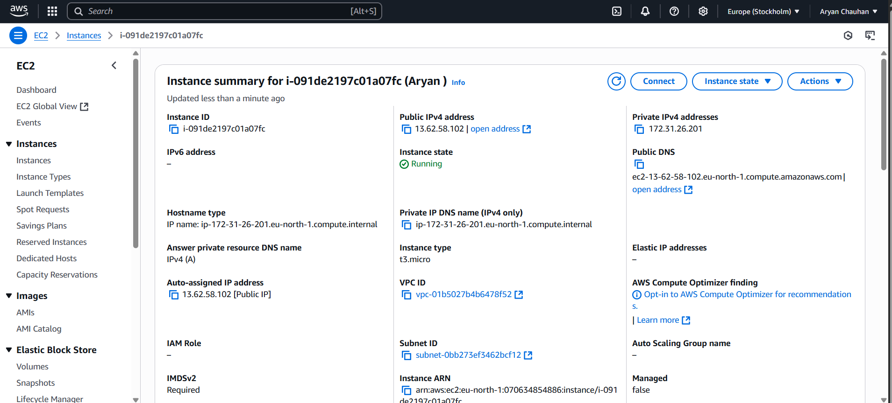

Step 08:Connect to the instance(EC2 instance connect)
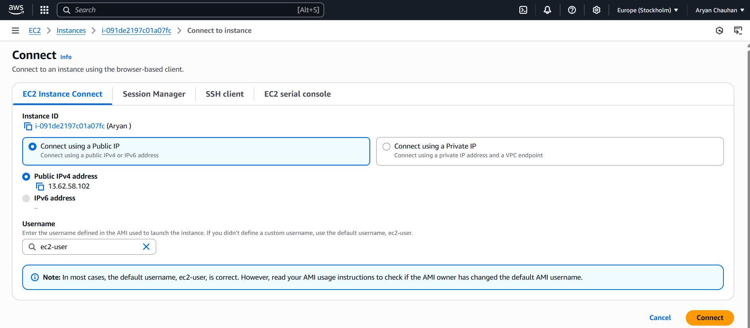

Step 09:Your terminal
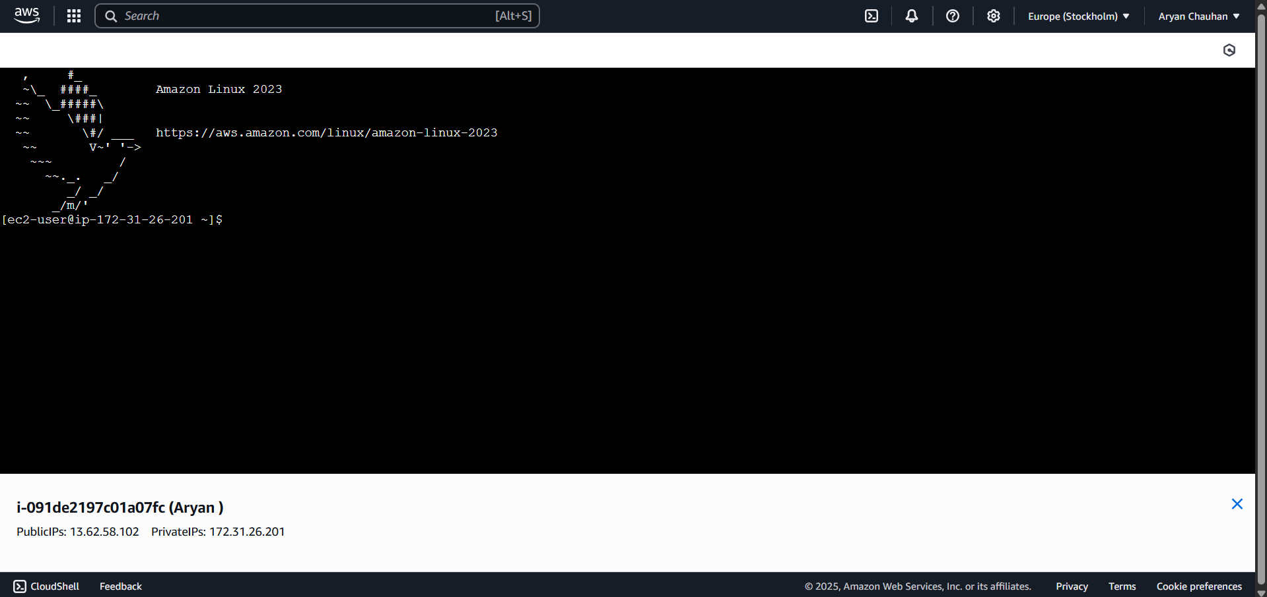

Step 10:Basic Linux commands
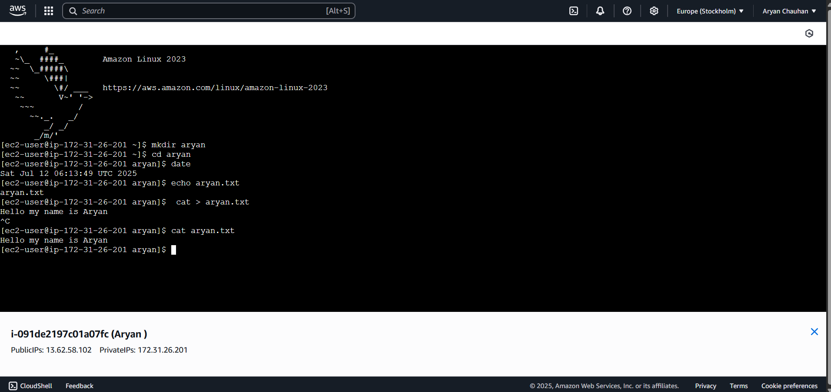

Step 11:Check your instance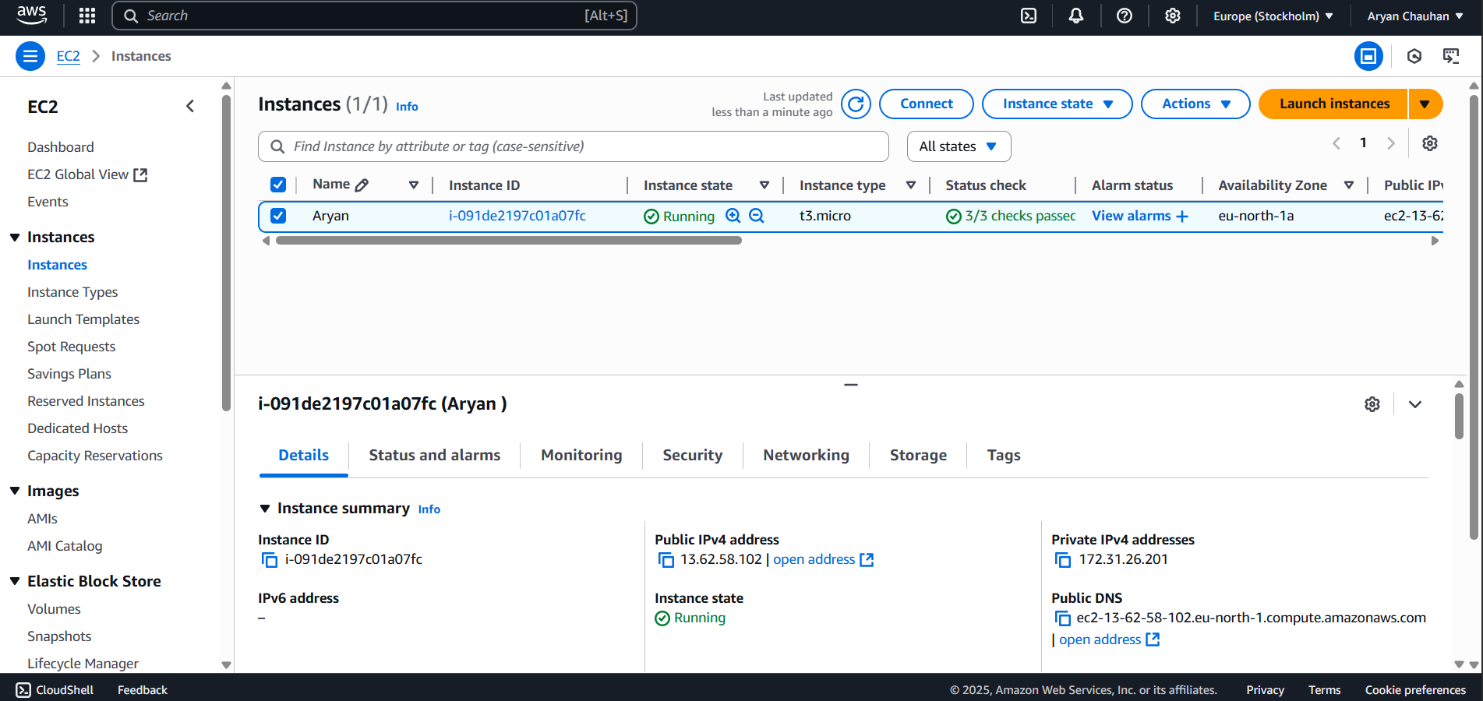

Step 12:Terminate your Instance
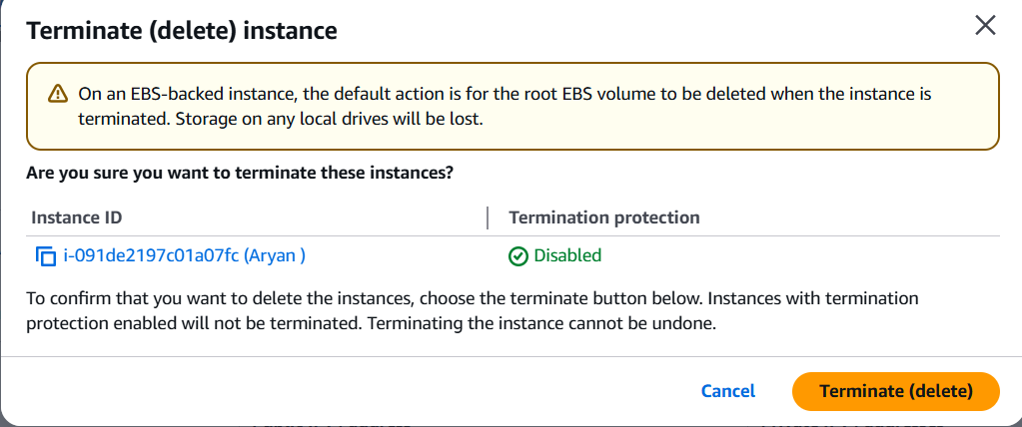

Step 13:Instance Terminated
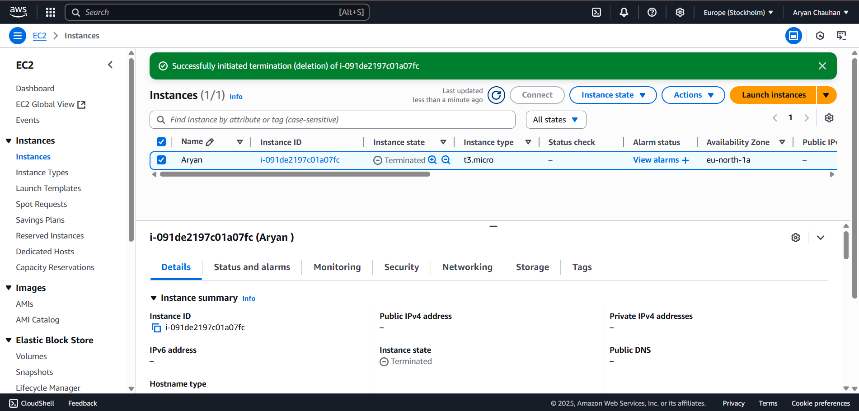

Conclusion:
Implementing Infrastructure as a Service (IaaS) using platforms like AWS or Microsoft Azure provides users with deep insights into virtual infrastructure management. By deploying virtual machines, configuring networking, and handling storage services, learners gain hands-on experience in managing cloud environments. IaaS not only reduces the cost and complexity of physical infrastructure but also equips users with scalable and secure resources that adapt to evolving business and development needsThis experiment helped to enhance my skills in cloud infrastructure management and gave me valuable insights into how organizations can efficiently use cloud services by these improved techniques

