Name: Deep Vaviya
Class:TY-4
Roll no: 72
PRN:124BTCM2011
Batch C

Experiment No - 04
Title: Implement Platform as a Service using AWS Elastic Beanstalk/Microsoft Azure

Learning Outcome : Implement Platform as a Service (PaaS) to deploy and manage applications by using AWS Elastic Beanstalk or Microsoft Azure

Theory:
Platform as a Service (PaaS) is a cloud computing model that provides developers with a platform to build, deploy, and manage applications without the complexity of maintaining the underlying infrastructure. PaaS offers a complete development and deployment environment in the cloud, enabling faster development and easier management of applications. Popular PaaS providers include AWS Elastic Beanstalk and Microsoft Azure App Services, both of which support multiple programming languages and frameworks.AWS Elastic Beanstalk is an easy-to-use PaaS offering that allows quick deployment and management of applications in the AWS Cloud. It automatically handles the details of capacity provisioning, load balancing, scaling, and application health monitoring.

Characteristics of PaaS:
- Application Hosting: Allows users to deploy applications without worrying about the underlying hardware or OS.
- Scalability: Automatically handles scaling of applications based on demand.
- Development Tools: Provides integrated development tools and services like version control, build pipelines, and CI/CD.
- Multi-language Support: Supports various programming languages (e.g., Python, Java, Node.js, .NET).
- Managed Environment: Handles infrastructure provisioning, patching, load balancing, and monitoring automatically.

Elastic Beanstalk is Amazon Web Services' PaaS offering that allows you to deploy and scale web applications and services quickly. It handles deployment, from capacity provisioning to load balancing, auto-scaling, and application health monitoring.

Azure App Service is a fully managed PaaS by Microsoft used to host web apps, REST APIs, and mobile backends.
Supports multiple languages like Java, Python, PHP, Ruby, Go, Node.js, .NET.

Procedure: Step-wise explanation with screen shots

Step 01:Search Amazon Elastic Beanstalk
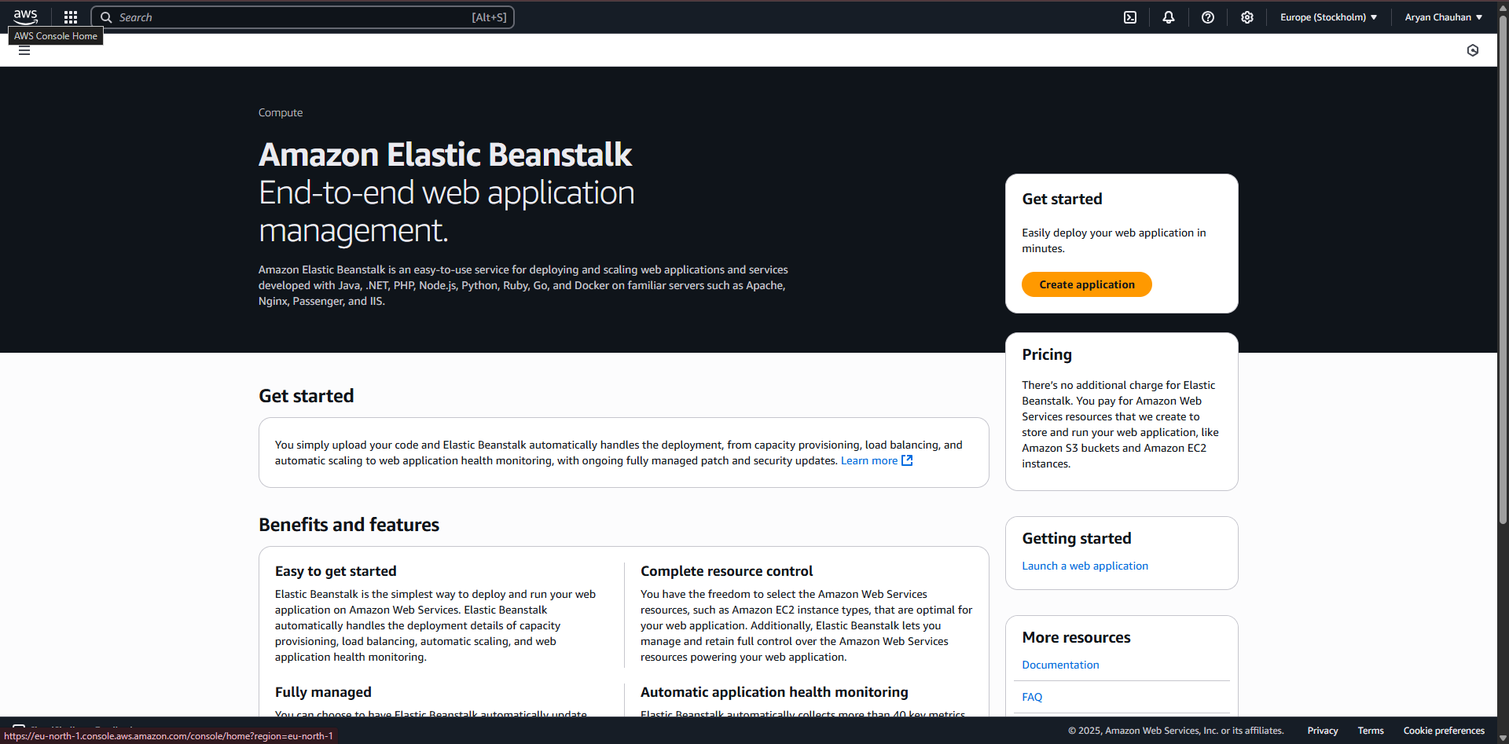

Step 02:Click on create Environment and fill Application Information
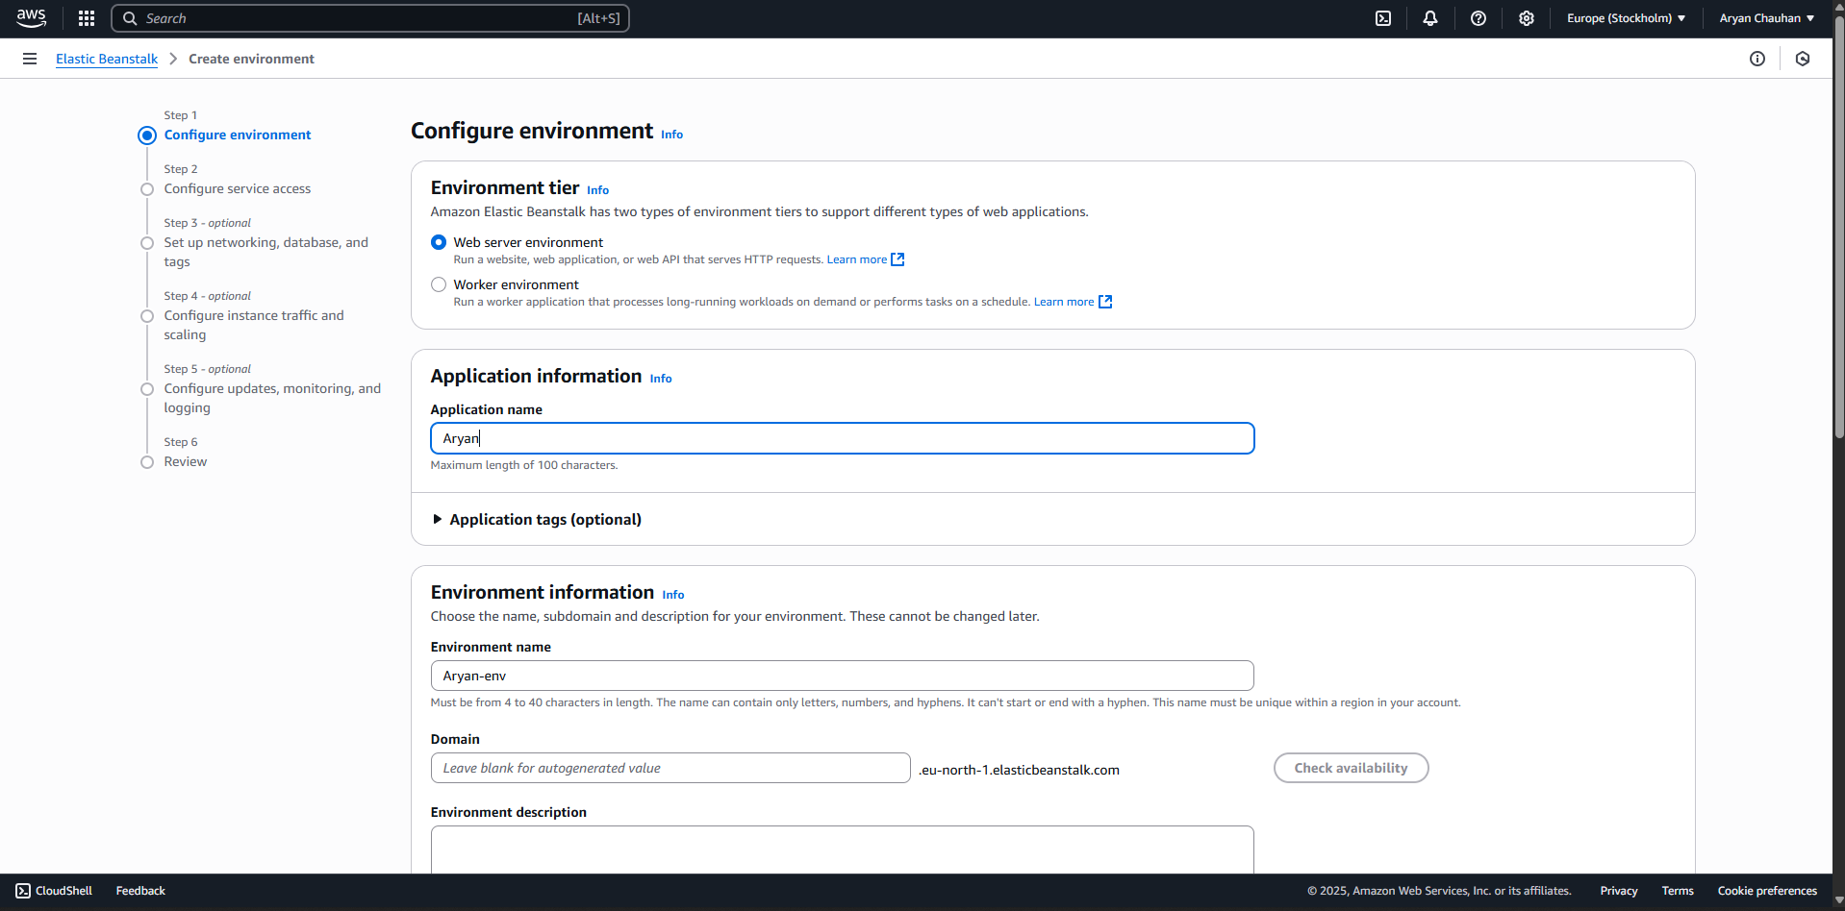
Step 03:Select the platform
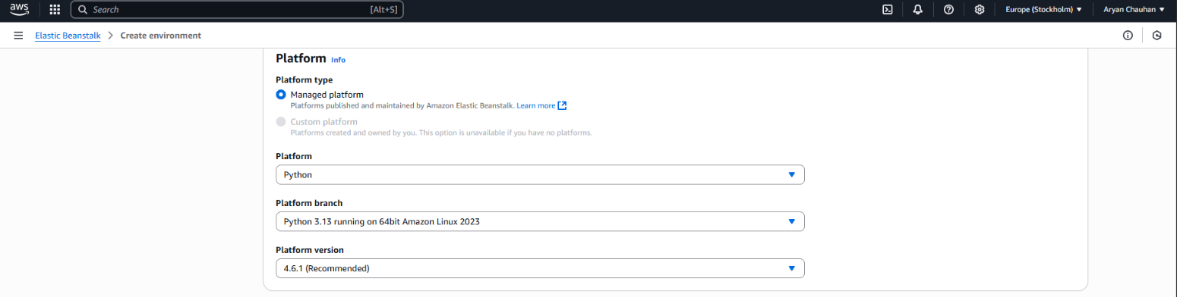

Step 04:Upload your code
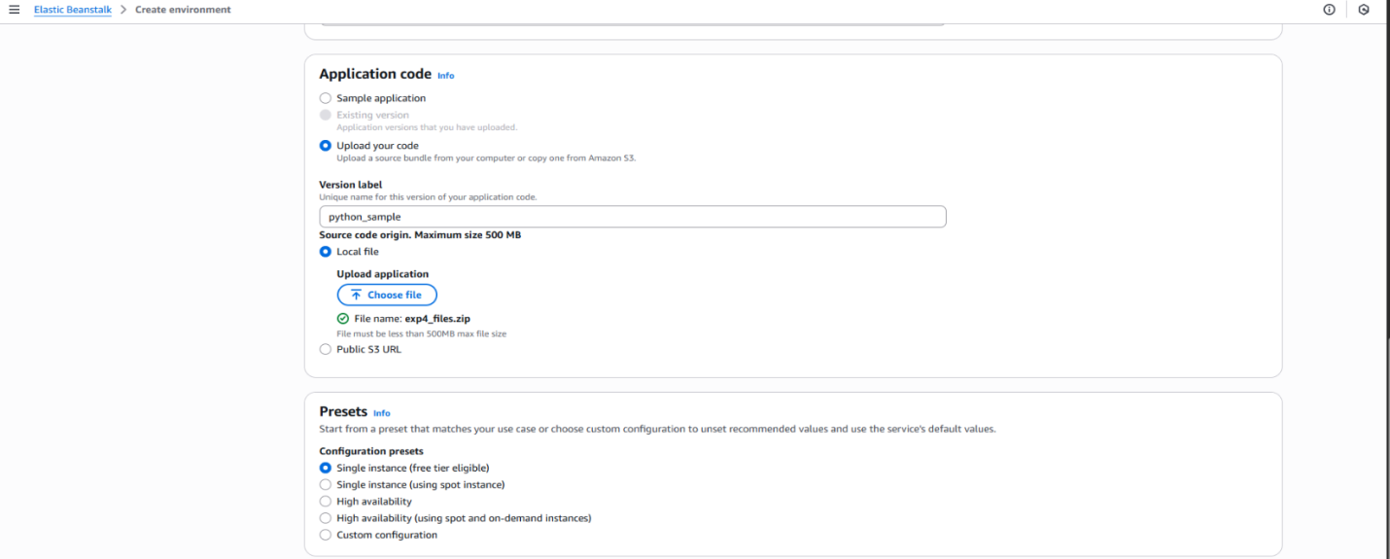
Step 05:Configure Service Access
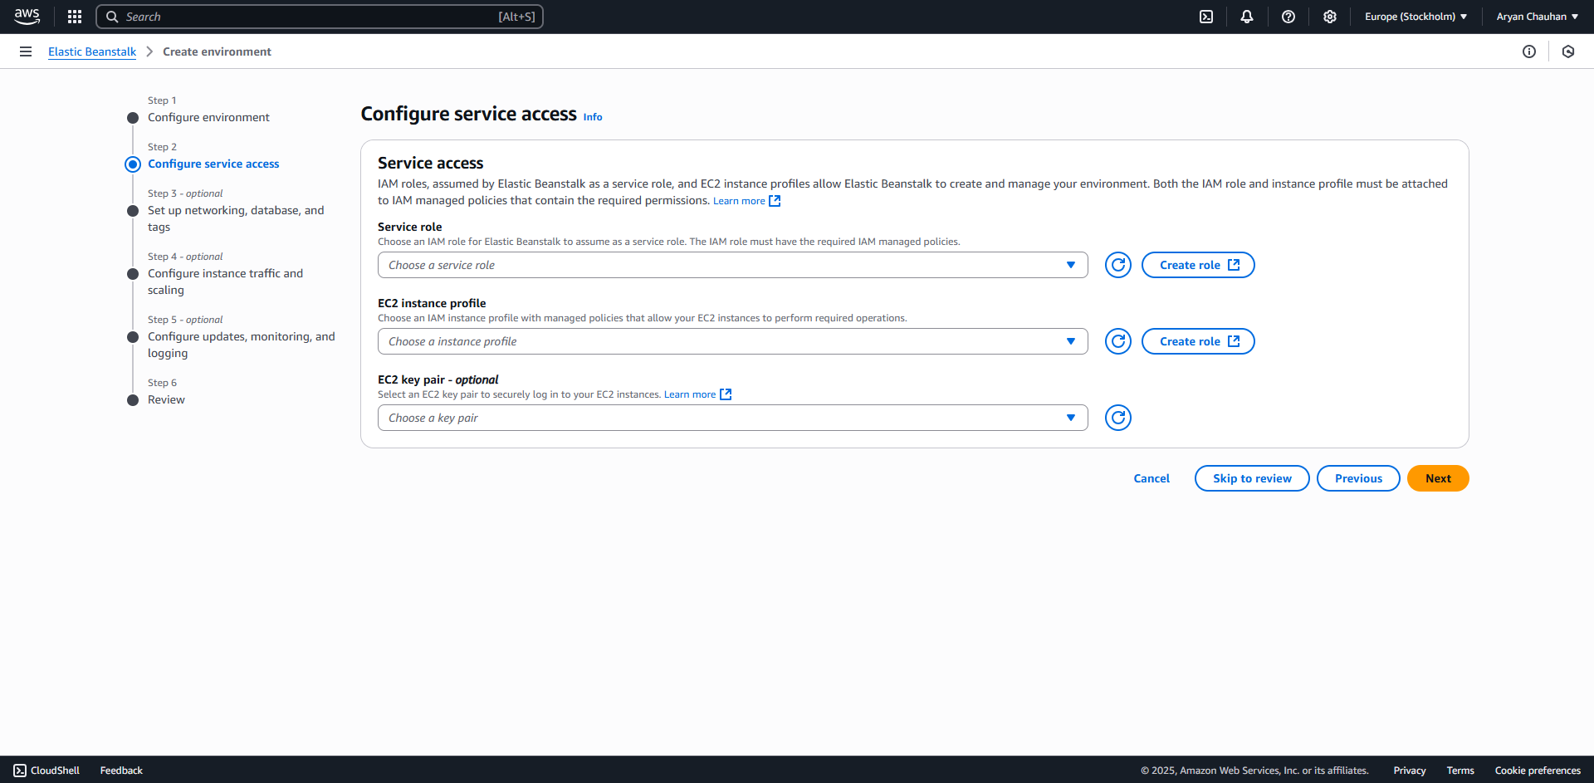

Step 06:Create a service role
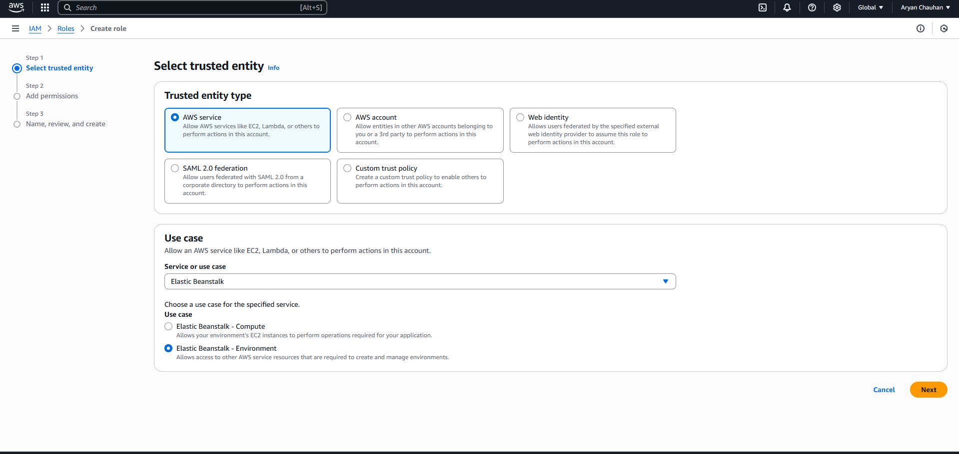
Step 07:Give a Role name
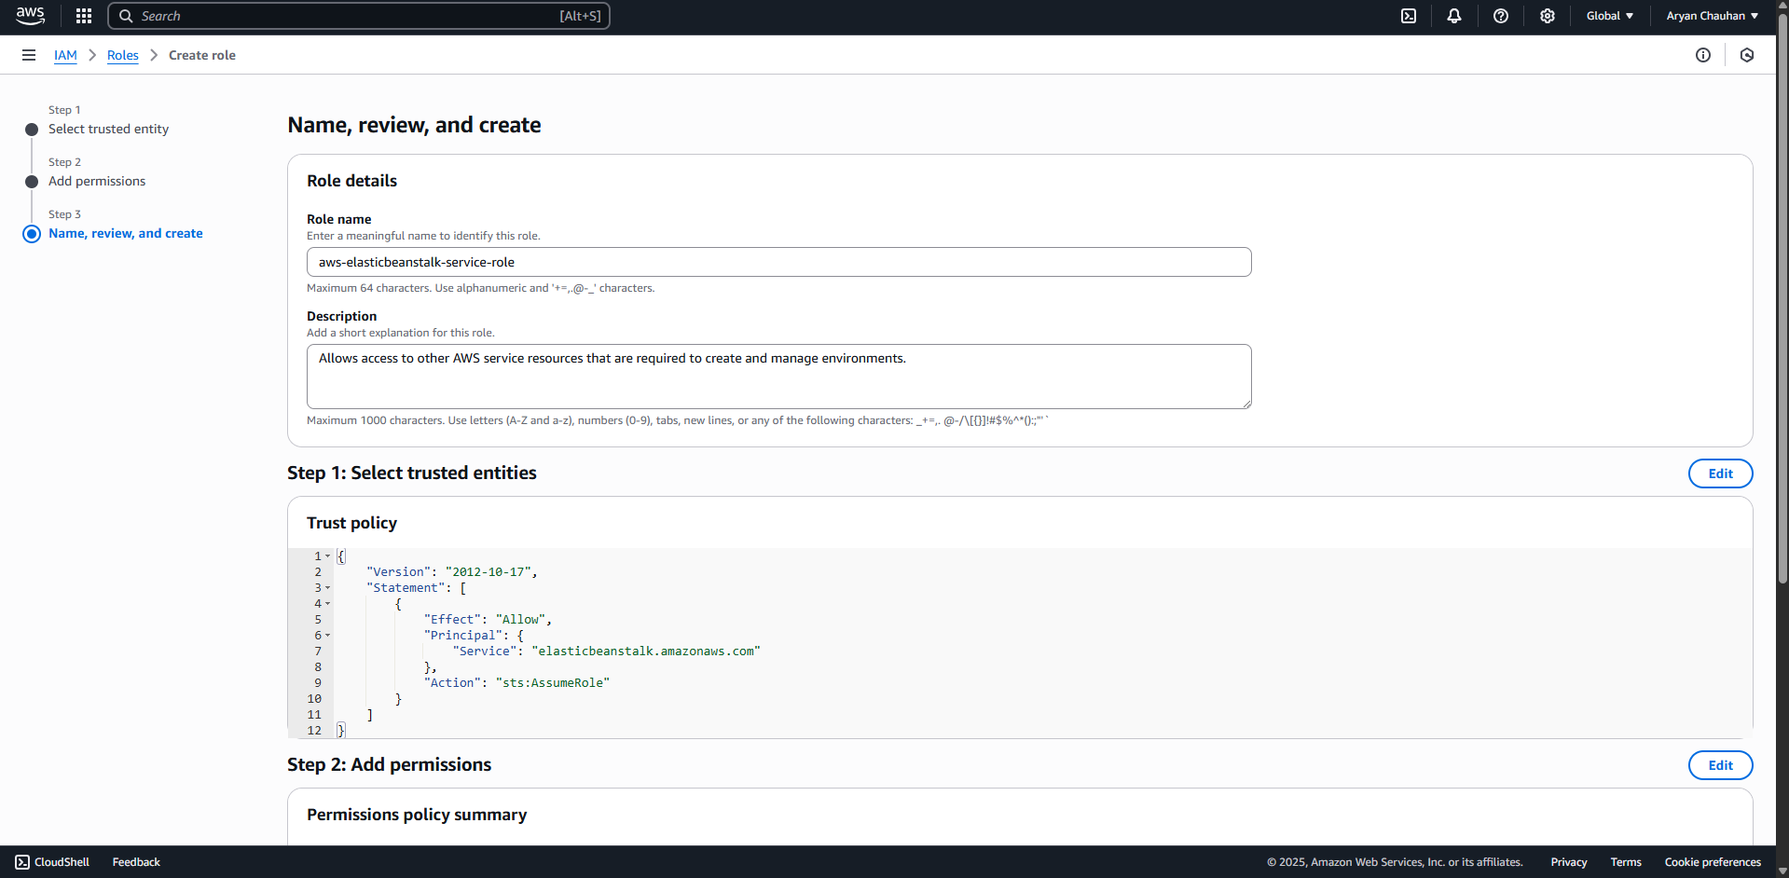

Step 08:Click create role
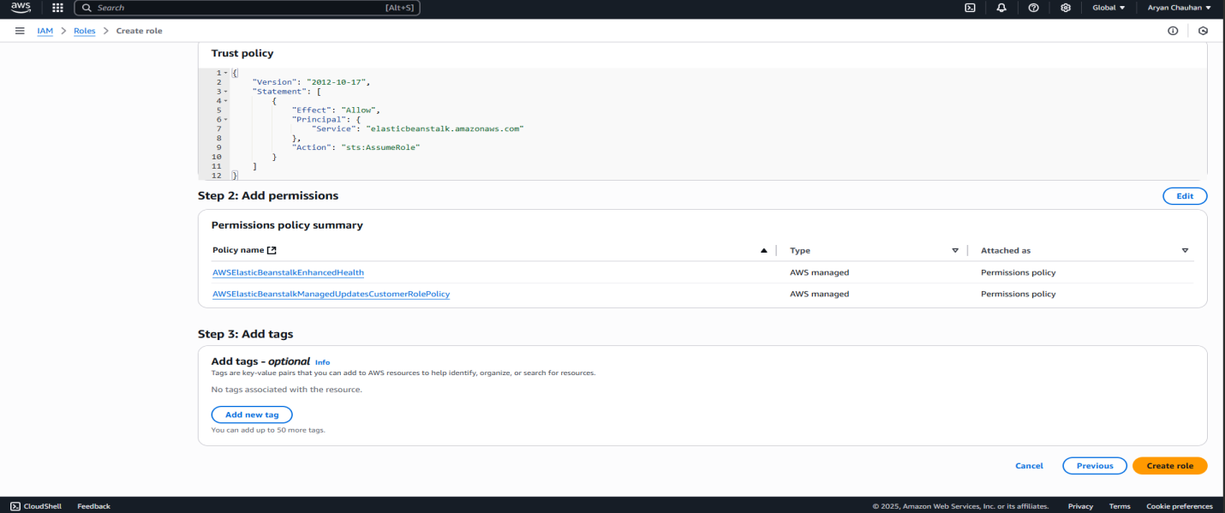
Step 09:Service role Created
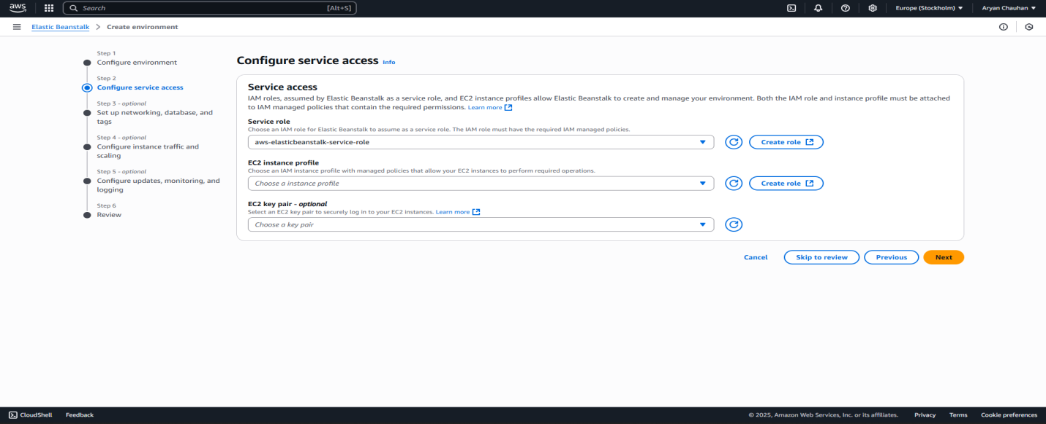
Step 10:Create Role for EC2
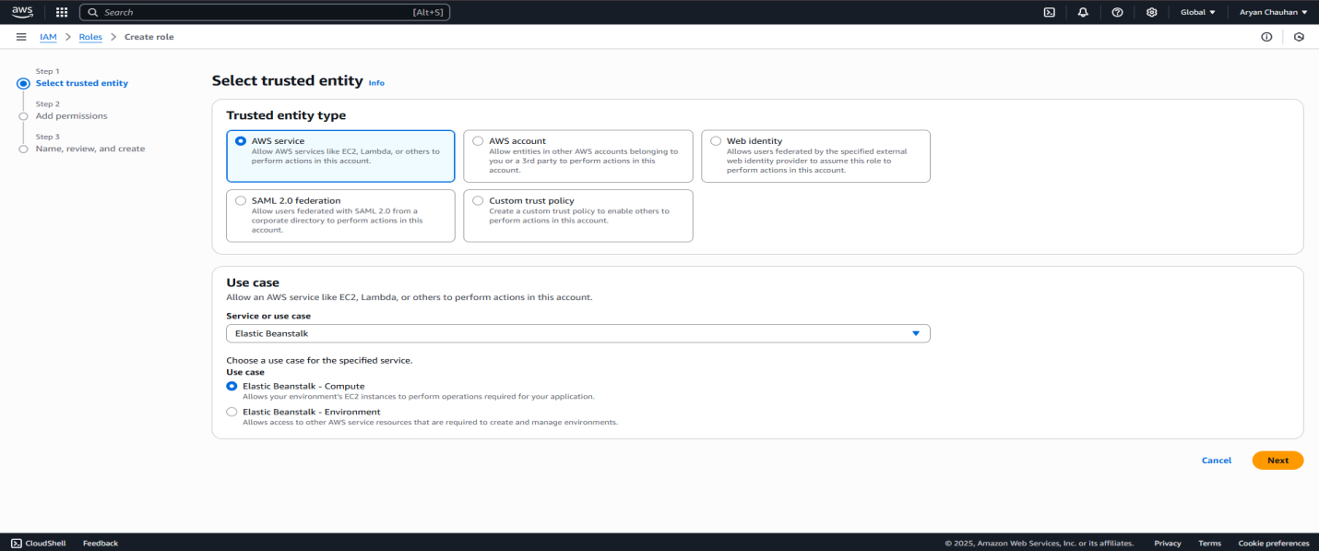
Step 11:Role for EC2 created (Select a Key pair if it already exist)
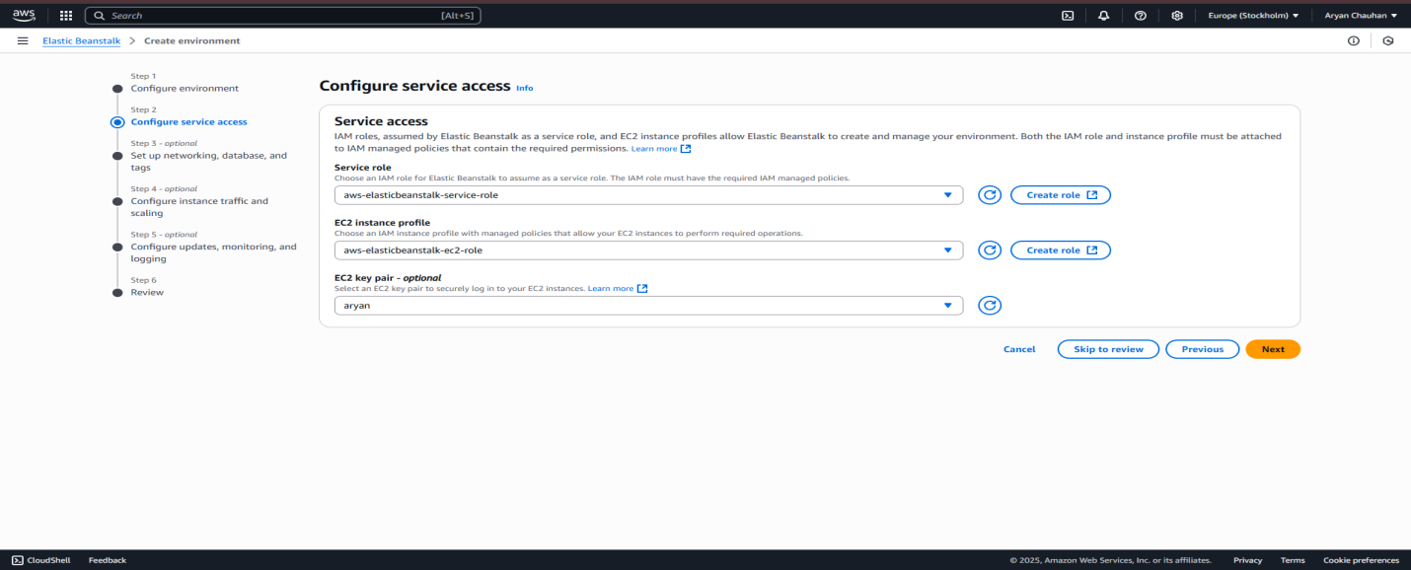
Step12:Keep Step3 as it is
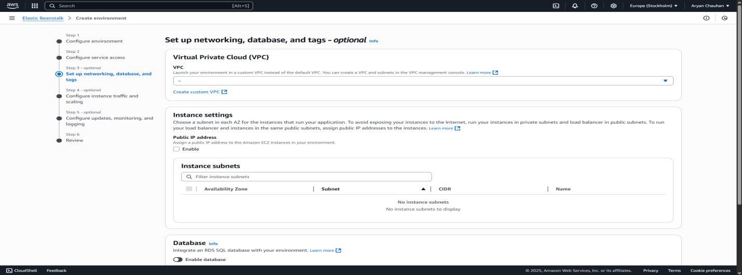
Step 13:Keep Step4 as it is
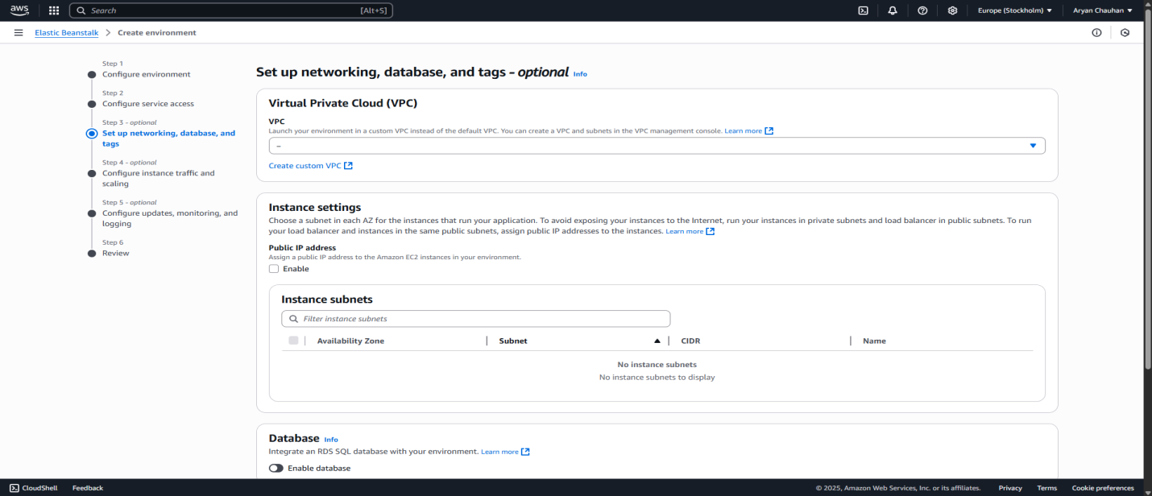

Step 14:Keep Step5 as it is
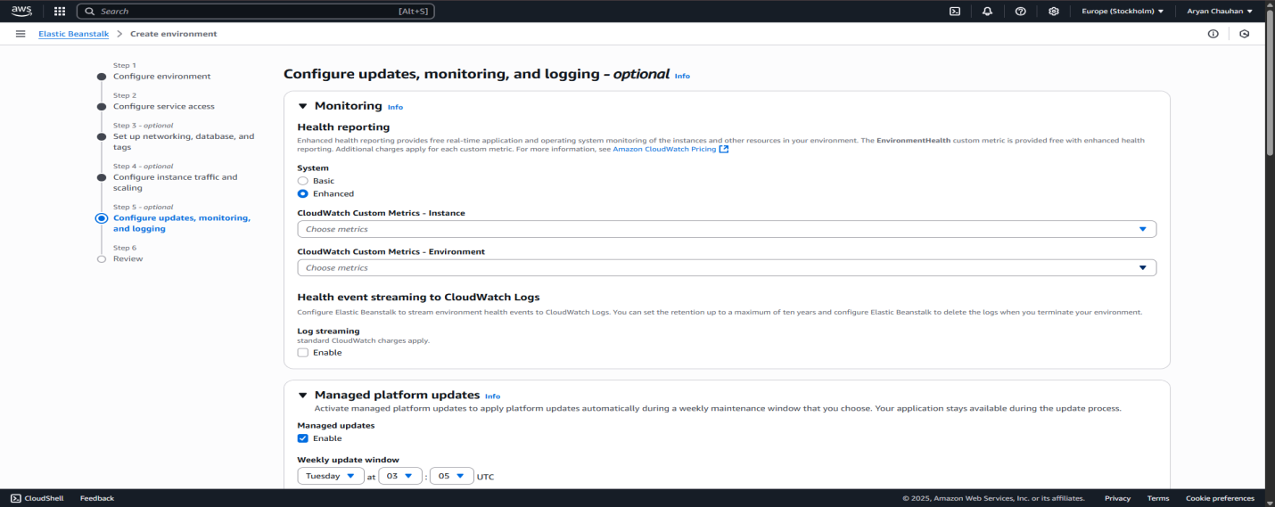
Step 15:Click on create to create Environment
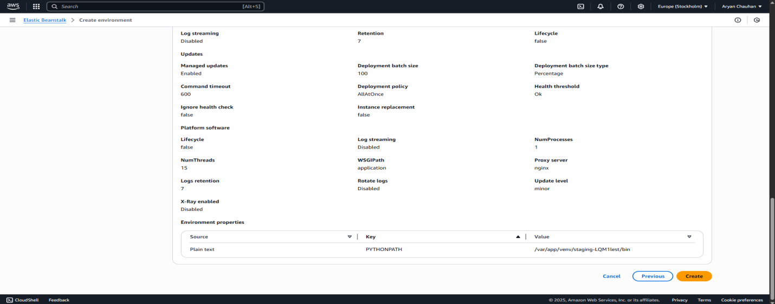
Step 16:Environment Successfully launched
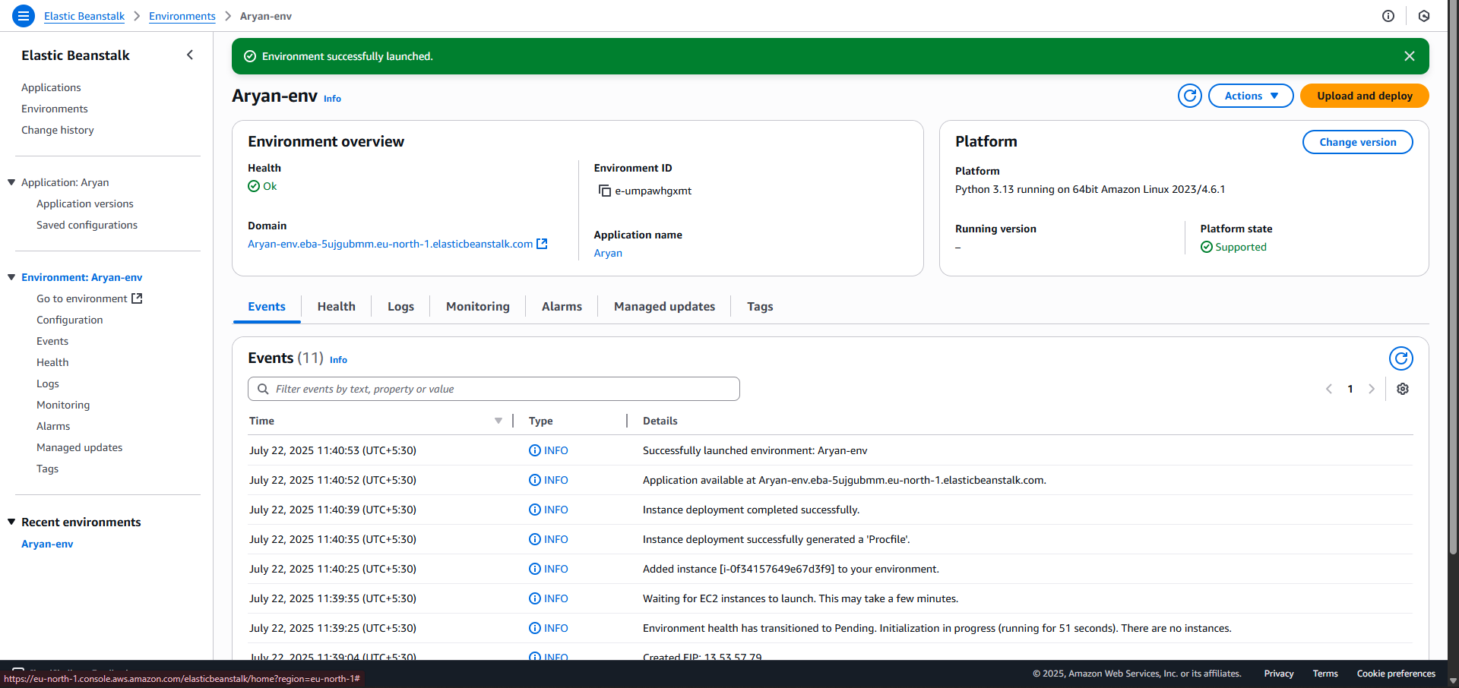

Step 17: Click on domain link

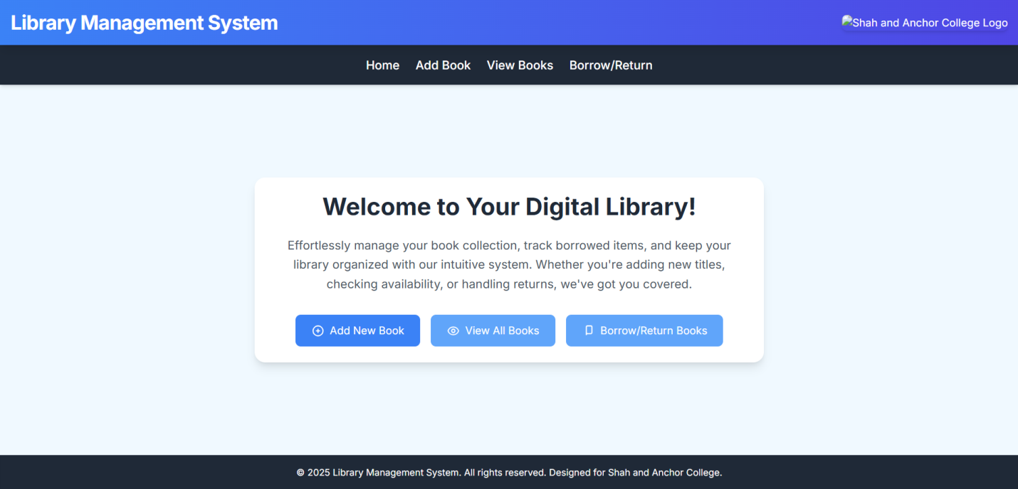

Conclusion:
PaaS enables developers to focus on writing code and logic without worrying about hardware, networking, and infrastructure management. In this experiment, by using AWS Elastic Beanstalk or Microsoft Azure, we experience how cloud platforms streamline the deployment, scaling, and management of applications with minimal manual intervention. This provides a hands-on understanding of how PaaS simplifies application lifecycle management and supports modern software development practices.The deployment process demonstrated how cloud platforms handle crucial aspects like infrastructure provisioning, load balancing, auto-scaling, and health monitoring without manual configuration.

